**UNIVERZITA PALACKÉHO V OLOMOUCI**

PEDAGOGICKÁ FAKULTA

Ústav cizích jazyků

Bakalářská práce

**The Use of Online Quizzes in ESL Teaching at Lower-Secondary Schools**

Tereza Vaňkátová

Olomouc 2021

Vedoucí práce: Mgr. Barbora Bačíková

Prohlášení

Prohlašuji, že jsem bakalářskou práci na téma Využití online kvízů ve výuce anglického jazyka na 2. stupni základních škol vypracovala samostatně s využitím uvedených literárních zdrojů.

V Olomouci dne: ………………………… Podpis autora: …………………………

Acknowledgements

I would like to thank my supervisor Mgr. Barbora Bačíková for her patience and valuable advice on the content and style of my bachelor thesis. My gratitude belongs also to the respondents for their willingness and participation in the research.

Contents

Introduction 5

THEORETICAL PART 6

1. Gamification 6

2. Online quizzes 7

2.1 Definition of a quiz 7

2.2 The use of a quiz 8

3. Description of selected platforms 8

3.1 Kahoot! 8

3.2 Quizizz 10

3.3 Quizlet 11

3.4 Google Forms 12

3.5 Integrations 13

4. Overview of previous research 14

PRACTICAL PART 17

5. The aims of the research 17

5.1 Research questions 17

5.2 Hypotheses 18

6. Methodology 19

6.1 The method of the research 19

6.2 The structure of the questionnaire 19

6.3 Subjects of the research 20

6.4 Description of the research procedure 20

7. Research results 21

7.1 Influence of Covid-19 and the consequent introduction of online schooling 21

7.2 The relationship of age and the usage of online quizzes 25

7.3 The ways how teachers use online quizzes 28

8. Discussion 31

Conclusion 33

Bibliography 34

Appendices 38

Resumé 46

Annotation 47

# Introduction

The main idea of the bachelor thesis is to analyse the use of online quizzes in ESL teaching at lower-secondary schools. The theoretical part will describe gamification, provide a definition of an online quiz, describe selected platforms for creation of online quizzes and present an overview of previous research about the topic.

The research will be focused around these research questions:

1. What impact has Covid-19 and the consequent introduction of online schooling had on the usage of online quizzes in the English classes at lower-secondary schools?
2. What is the relationship between the teacher´s age and their usage of online quizzes at lower-secondary schools?
3. How do teachers of English at lower-secondary schools use online quizzes?

An extensive research has been done about the topic of online quizzes. The bachelor thesis focused on the topic from a less explored point of view.

# THEORETICAL PART

# Gamification

Gamification is the *“application of game elements and principles in non-game contexts (…) Its aim is to make a non-game activity, such as learning, as fun, as engaging and as motivating as a game.”* (Zounek, 2016, p. 136)

The concept of gamification has existed for a long time. However, the term gamification is relatively new. It was coined by Nick Pelling and it was not added into English lexicon until the 21st century (Merriam-Webster, 2021). As Kalhous (2005) claims, people have been trying to find alternative approaches to teaching and gamification has experienced an incread use.

Gamification is capable of heightening motivation and attention and therefore students can acquire knowledge faster. Not only they can learn more, the ESL classes can be more entertaining and therefore students may enjoy them even more.

One of the common problems students encounter during their studies is the lack of motivation. Gamification is able to increase their motivation. According to Kalhous (2005), gamification is capable of mobilizing students´ cognitive potential. It can have such a positive impact that it can make students enthusiastic towards ESL learning. Jiménez-Sánchez (2020) agrees with the strong potential of gamification. He claims that it improves both intrinsic and extrinsic motivation. Gamification can give a meaning to the things studied in the classes. (Monte, 2017)

Gamification is about making something potentially tedious, for example a traditional learning environment, into an engaging and entertaining learning context, into a game. (Jiménez-Sánchez, 2020; Merriam-Webster, 2021)

Jiménez-Sánchez (2017) stated that students *“hold a favourable attitude towards the introduction of gamification in the EFL classroom.“* According to Kalhous (2015), it is possible and useful to find time for a didactic game in each subject.

Gamification is effective because it *“taps into peoples natural desires for competition and desire.”* (Merriam-Webster, 2021). It takes advantage of the human inborn nature, of enjoying winning and hating to be defeated. According to Jiménez-Sánchez (2020), the competitiveness makes students pay attention in order to gain the knowledge necessary to succeed in the game. Not only the competitiveness makes a student learn more. If a student perceives a class as enjoyable and innovating, his motivation to acquire knowledge grows accordingly. (Monte, 2017)

# Online quizzes

## Definition of a quiz

A quiz is a type of a didactic test which helps to activate students and at the same time measure their level of comprehension in a predetermined area. It consists of a set of tasks from a selected area of educational context.

Oxford dictionary defines a quiz as *“a competition or game in which people try to answer questions to test their knowledge.”* and as *“an informal test given to students”*. (Oxford Learner´s Dictionaries, 2021)

A quiz is the most casual form of evaluation. A quiz implies an informal test, such as an unscheduled quiz, that is a pop quiz. Actually, the Merriam-Webster incorporates it into its definition of a quiz, which is “*taken without preparation.*” (Learner´s Dictionary, 2021)

A quiz is the shortest way of examination and it usually consists of around 10 questions. Some online quizzes might be graded, others not. However, they are usually not very impactful on the final grade.

A formal standard for distinguishing between a test, an exam and a quiz does not exist. A test is often used as a general term, therefore it can incorporate quizzes. However, in academic setting these terms refer to “*a hierarchy of evaluations*” (Tierney, 2021) A quiz is the most informal and the shortest type of evaluation which does usually not impact the grade a lot. Common question types of quizzes are fill-in-the-blank, true or false, multiple choice answers etc. Long answers are not common in quizzes, but they can be found often in exams which are more serious, often long and have a big impact on final grade. The significance of tests is higher than the significance of quizzes but it is lower than the significance of exams. (Tierney, 2021)

## The use of a quiz

A quiz in pedagogy is used by a teacher during classes or assigned as a homework. A quiz is a tool that is used to activate students, practise English with them or test their knowledge. According to Tierney (2021), quizzes help keep students engaged and prepare them for tests. There are online quizzes that are student-paced, others are teacher-paced.

Quizzes are a way to keep track of progress, which is useful for both teachers and students. Students can check how well they understand the material and can determine the areas they need to focus on to prepare themselves better for tests. They are used by a teacher who can use them to gain a better understanding regarding the problematic topics. He can also realize which students struggle with the topics discussed and might need more practice. (Tierney, 2021)

Some teachers may schedule quizzes regularly, others may prepare an unscheduled quiz, a pop quiz. In fact, Merriam-Webster dictionary defines a quiz as a *“short spoken or written test that is often taken without preparation.”* (Learner´s Dictionary, 2021)

Quizzes are also a fun and engaging. Modern technologies are omnipresent. According to Zounek (2016), the research implies that *“students prefer to study through visual or audio materials over learning from a text”* and that *“they give a priority to interactive activities or activities carried out via internet.”* (Zounek, 2016, p. 44) Online quizzes are capable of providing these things.

# Description of selected platforms

There are many different platforms for creating online quizzes. This chapter describes four of them - Kahoot, Quizizz, Quizlet and Google Forms. All of them have experienced a massive growth in 2020. This section is primarily based on information available at the platforms.

## Kahoot!

*“Play is the first language we learn.*

*It´s how we discover the world and understand our place in it.”* (Kahoot!, 2021)

Kahoot was founded in 2012 by Morten Versvik, Johan Brand and Jamie Brooker. It was launched one year later, in 2013. Its technology is based on a research conducted by Morten Versvik for his Master´s degree at NTNU. Since Kahoot! is concerned with learning, the company initially focused on school environment. However, Kahoot! and game-based learning have become a pop culture phenomenon. It has grown far beyond school use - it is played in business training sessions, events of all kinds, and basically in any social and learning context, both in person and online. (Kahoot!, 2021)

As stated above, Kahoot! has become a pop culture phenomenon which means that it must have experienced a massive growth. It did. Since its launch, 5 billion players have played it. In 2020, over 7 million teachers used Kahoot! and over 1.5 billion players participated. In the US, half of the teachers and students hosted or played a game. (Kahoot!, 2021)

Kahoot!´s mission is to “*make learning awesome (…) and to build the leading learning platform in the world”*. (Kahoot!, 2021) They aim to combine lifelong learning, curiosity and play. They suppose that this way, they can unlock the learning potential within all of us. Most of us are able to learn anything, regardless our age. All we need is the motivation, persistence and the right tools. How does Kahoot make learning awesome? By *“creating engaging and impactful experiences for the users”*. (Kahoot!, 2021)

One of the Kahoot!´s core concepts is so-called learners to leaders pedagogy. It is the idea that a student becomes a teacher. Students, traditionally the passive consumers of knowledge, become researchers, creators, facilitators, and leaders. They not only develop their soft skills on the way, but also learn more about the topic itself. It allows them to deepen their understanding of the concepts. The whole process works this way:

1. Teacher hosts a Kahoot! in a class.

2. Students create their own Kahoots!.

3. Students host their Kahoots! with the class.

4. Teacher gives them feedback. (The K!rew, 2018)

The traditional mode of Kahoot! is the Live mode. In this mode, all the students play and answer the questions at the same time. The questions are shown on a board or a conferencing tool and the students compete between each other. The faster they answer, the more points they get. The Live mode is teacher-paced, which allows the teacher to give assessment to the students in real time and review the content right after each question. Timely feedback is important and makes Kahoot! a strong teaching tool.

There are several drawbacks of the Live mode. Although it enhances competition and engagement, it can put some students under unnecessary pressure. Furthermore, it is only possible to play with all the students logged in at the same time which makes it impossible for the students to practise by themselves in their free time, or for the teacher to assign a quiz as homework. That is why a new feature has been added and since February 2020 it has been possible to play a student-paced challenge, with the possibility to see both questions and answers on students´ devices since March 2021.

Not only is Kahoot! used to create online quizzes, it can also be used to create lectures and introduce new topics or preview content directly in Kahoot!. Just as other platforms for online quizzes, Kahoot! offers game reports so that the teacher knows the statistics and can determine the problematic topics as well as the students who might need more practise.

## Quizizz

*“We´re on a mission to motivate every student.”*

(Quizizz, 2021)

Quizizz was founded by Ankit Gupta and Deepak Joy Cheenath in 2015 in Banglore, India. The platform is used by over 20 million students worldwide. Half of the schools in the US use it and half a billion questions are answered per month. (Quizizz, 2021)

Unlike in a traditional Kahoot! game, students always see questions on their own devices. The database contains over a million quizzes and the users can freely use them for their own use or combine them with their own quiz. Since Quizizz is traditionally student-paced, students engage at their own pace, the element of time pressure characteristic for Kahoot! games is eliminated here .

It is possible to play a live game or assign a quiz as homework. The homework mode allows teachers to set deadlines, extend them, or reopen quizzes for students who missed them. It is also possible to create question banks and get adaptative feedback. In this mode, every student is assigned different questions randomly selected from question banks and the system creates adaptative retakes if a student makes a mistake. It is also possible to add video or audio to any quiz.

Similarly to Kahoot!, in 2020 Quizizz added a feature called lessons. Lessons are teacher-paced, and it is possible to combine them with a quiz and ask follow-up questions. There are 5 types of questions – multiple choice, checkbox, fill-in-the-blank, open-ended and a poll.

One distinctive feature of Quizizz is the possibility to add meme sets to quizzes. The memes appear after some of the questions answered. This feature can make the quiz even more enjoyable.

As Jiménez-Sánchez (2020) suggests, the competitiveness of Quizizz makes students more attentive during the lessons. They want to acquire the knowledge that is necessary in order to win. He also suggests that Quizizz makes lessons more engaging and fun.

## Quizlet

*“Anyone can learn anything. All it takes is a tenacious spirit, the right guidance, and the tools to see it through.”* (Quizlet, 2021)

The history of Quizlet dates back into 2005 when Andrew Sutherland created a studying tool to help him study for his French vocabulary test. It was launched on the 17th of January 2007. In the beginning the platform offered Flashcards mode, with different modes and games being added gradually. Nowadays, the most used game in classroom setting is Quizlet Live, launched in 2016. (Quizlet, 2021)

The platform is used by 50 million monthly learners who participated in over 3 billion study sessions. Not only are there many users, the database counts over 350 million different study sets. Quizlet claims to be highly useful since 90% of the students who use it report higher grades. (Quizlet, 2021)

During the years of its existence, Quizlet has grown into 5 study modes (Learn mode, Flashcards mode, Write mode, Spell mode and Test mode) and 3 games (Quizlet Live, Match, Gravity). For example, Quizlet Learn lets users create diagrams, which is an interesting alternative to covering labels with thumbs on paper illustrations. As stated above, the game used the most in the classroom setting is Quizlet Live.

Quizlet Live was originally a game that blends competition and cooperation. It offered only Team mode where teams compete with each other. In the Team mode, teams are grouped randomly. Every team member sees a different possible answer to the same questions, and only one of them has the right one. The students must cooperate to find the right answer and win. Quizlet Live gives preference to accuracy over speed. If a team makes a mistake, they have to start all over again. The team who answers correctly all questions wins. Since the students in a team have to cooperate, Team mode enhances their communication and other soft skills.

Online quizzes platforms experience a fast development in the last years. Although Quizlet Live was originally a cooperative game, Individual mode has been added recently. Individual mode not only provides one more way to play Quizlet Live, it also makes playing remotely possible. This option has been of high importance since 2020 and the introduction of online schooling.

## Google Forms

*“Google Forms. Forms that you create surveys to gather classroom data and monitor students´ progress.”* (Google for education, 2021)

Google is a company whose services are used by billions of people worldwide. (Georgiev, 2021) It was not always this way, though. The history of Google dates back into 1995 when Larry Page struck a partnership with Sergey Brin. Together they built Backrub from their dorm. Backrub, later renamed Google, was a search engine that used links to determine the importance of individual pages on the internet. Google got officially born after an investment of Andy Bechtolsheim. At that time, the dorm room ceased to be sufficient, and the company was moved to a garage. Google expanded rapidly. Nowadays it has nearly 150 offices worldwide and makes hundreds of products used by billions of people across the globe.*”* (Google, 2021).

Google is known mostly for its search engine, which carries the same name, Google. Furthermore, it offers other well-known products and applications such as Gmail, Google Maps, Google Earth, Google Translate, Google Drive, Google Docs, Youtube and many more. Google is behind Android mobile operating system and Google Chrome web browser. Not only they create software and web-based applications, but the company also creates hardware such as mobile phone Pixel, computer Chromebook, Google assistant and Google Nest. Google Forms is one of Google’s products as well.

Google Forms was not created primarily for classroom use. It allows people to collect, organise and analyse information, create sign-ups, feedback forms, quizzes and to conduct research.

Google Forms allow teachers to get classroom data and monitor students‘ progress. The data is automatically collected in the form of graphs and spreadsheets. There are several settings which make Google Forms a powerful tool for teaching. For example, it is possible to add a point value for individual questions and have a quiz graded automatically. This automatization can save teachers some precious time which they can spend with the students or preparing other materials for the classes. The grades can be released immediately or after a manual review with the possibility to add feedback to each individual questions. It is also possible to import the grades from quizzes into Google Classroom or set up a quiz so that people only see certain sections based on their answers.

There are 11 different question types, not all of them are used for the purpose of online quizzes, though. They range from checkbox, through multiple choice to short answer or a longer entry.

## Integrations

Integrations make platforms more convenient and easier to use in a day-to-day life. They save time. They make it simple to create classes, organize the data and limit the distractions. Some integrations allow teachers to import data, such as grades, to LMSs.

Integrations might bring more users to the platforms. In 2020, teachers were suddenly forced to transfer to an online way of teaching due to Covid-19. They were not prepared for this situation. Nobody was. As Mynaříková (2020) stated, the implementation of ICTs in teaching in the Czech Republic was low. Under such conditions we can expect that many teachers did not know how to react to the situation. Yet, they had to learn fast and almost instantly move the classes from classrooms to online settings. Most of them were possibly not searching for a complicated solutions and at first used the tools that were easily accessible to them from the platforms they were already familiar with. That would mean that some of the teachers used Google Forms just because of its integration in the Google Classroom and the possibility to use them almost automatically, without any prior set up. Below I show a table of the integrations.

|  |  |
| --- | --- |
| Platforms | Integrations |
| Kahoot! | Microsoft Teams, Hopin, PowerPoint, Zoom, Google Classroom, Google Search |
| Quizizz | Microsoft Teams, Google Classroom, Remind, Scholar, Canvas |
| Quizlet | Microsoft Teams, Google Classroom |
| Google Forms | Google Classroom |

Table 1: Integrations

* As of May, 2021, Kahoot! was still not integrated into Google Classroom and Google Search. It had been already announced though, that is why it is included in the table also.

# Overview of previous research

The majority of the previously conducted research focuses on the effect that online quizzes have on students in various types of schools and in various subjects. Most research concentrates on one or several platforms, predominantly Kahoot!, Quizizz and Quizlet.

The research results indicate that students who take online quizzes in their classes gain knowledge faster and have generally higher average results than the students who do not take online quizzes (Dobston, 2008; Sánchez, 2017; Boulaid, 2019; Cinar, 2019; Poláková, 2019; Jiménez-Sánchez, 2020; Kapsalis 2020; Quizlet, 2021). For example Boulaid (2019) claimed that 92% participants reported learning more vocabulary when using online quizzes. Kapsalis (2020) agrees that the improvement when using online quizzes is significant. However, he claims that it is not significantly higher compared to the students who use the traditional method of paper and pencil tests in the classes. The paper and pencil tests must be used on a regular basis for them to be as effective as online quizzes, though.

Motivation is crucial in ESL teaching and several papers have indicated increased motivation in majority of students (Boulaid, 2019; Cinar, 2019; Jiménez-Sánchez, 2020). Boulaid (2019) said that 97% of the participants reported to be highly motivated when using Kahoot!. Jiménez-Sánchez (2020) suggests that not only online quizzes, but gamification in general significantly improves both intrinsic and extrinsic motivation.

The results have also revealed higher engagement of the students while using online quizzes than when using the traditional methods (Hamilton-Hankins, 2017; Jiménez-Sánchez, 2020). As Jiménez-Sánchez (2020) suggests, the competitiveness of Quizizz makes students more attentive during the lessons because they want to gain the knowledge that is required to succeed in the game.

Not only were the lessons with online quizzes more engaging, they were also more fun (Cinar, 2019; Jiménez-Sánchez, 2020). As Cinar stated, Quizlet made a significant contribution to students’ positive attitudes towards their English course.

Language skills are enhanced by online quizzes significantly. Quizzez may serve as a method of consolidation of grammar (Sánchez, 2017; Ulla, 2020; Kapsalis, 2020), vocabulary (Sánchez, 2017; Boulaid, 2019; Cinar, 2019; Poláková, 2019; Ulla, 2020), listening and reading (Sánchez, 2017; Ulla, 2020). According to Ulla (2020), Kahoot!, Socrative, Google Forms, Quizizz and Quizlet were the platforms used most often. Kahoot!, Quizizz and Quizlet were used mostly for vocabulary and grammar practices, Google Forms for reading assessment and Socrative for vocabulary, reading and listening. (Ulla, 2020). However, it is impossible to make any general conclusions since the research had a small number of participants.

Mynaříková (2020) and Herlina (2021) indicate that the use of online quizzes and information and communication technology in teaching are low (Mynaříková, 2020; Herlina, 2021). In order to implement technology in teaching, both teachers and students have to have appropriate equipment such as computer, tablet or a mobile and a stable connection to the internet. Furthermore, being a skilful user of the internet does not appear to be sufficient. Teachers must be educated in the use of technology in ESL. Mynaříková (2020) found out that although many teachers had an average understanding of ICTs, they used them rather occasionally in teaching. Herlina (2021) suggests that the skills needed for implementing information technology in teaching are low.

Some research has shown a positive correlation between the age and technology implementation (Henry, 2008; Mynaříková, 2020). Mynaříková (2020) reports the highest perceived level of digital competencies to be found in the age group of 26 or younger and the lowest in the age group of 56 and older. Similarly, the age group of 56 and older reported the least use of ICTs in teaching, while the age group of 27-35 reported to use ICTs in teaching the most often. Mynaříková (2020) claims that the older generation of teachers mostly refuses to use ICTs since they perceive it only as a separate subject. She also suggests that the investments in hardware needs to be accompanied by educational programs for teachers in order for them to learn how to use the technology in their teaching. Furthermore, the faculties of education should place a greater emphasis on the teaching of ICTs. (Mynaříková, 2020)

# PRACTICAL PART

# The aims of the research

The aim of the research is to analyse the current state of use of online quizzes in the classes of English at lower-secondary schools in the Czech Republic. The topic of online quizzes is current and often discussed. According to Oblinger (2005), research implies that members of so-called net generation prefer to study through visual or audio materials over learning from a text. It also implies that they give priority to interactive activities or activities carried out via internet. (Oblinger, 2005) It is possible, especially in today´s world, that the students who attend lower-secondary schools nowadays have similar preferences as the members of net generation.

In 2020, the world experienced an outbreak of Covid-19 which led to the introduction of online schooling. Suddenly, teachers had to move the classes from classrooms to online settings. The research considered the situation and aims to find out the impact of Covid-19 and the consequent introduction of online schooling on the usage of online quizzes.

The research also tries to find out whether a relationship between the usage of online quizzes and the age of a teacher exists. Mynaříková (2020) suggests that it does. Teachers who are 56 or older use online quizzes less often than their younger colleagues, according to her. This research wants to study the topic further and either support or refute the previous findings.

Another aim of the research is to find out how techers actually use online quizzes in their classes of English. It wonders what platforms teachers use, whether they use online quizzes for practicing or testing and what language area they use it mostly for – grammar, vocabulary, reading or listening. Not many studies have been done about the state of usage of online quizzes in the Czech Republic from the same point of view as this research.

## Research questions

In this subchapter I will present the research questions and explain why I decided to conduct a research around them. The research is based on 3 research questions mentioned below.

* Research question 1: What impact has Covid-19 and the consequent introduction of online schooling had on the usage of online quizzes in the English classes at lower-secondary schools?
* Research question 2: What is the relationship between the teacher´s age and their usage of online quizzes at lower-secondary schools?
* Research question 3: How do teachers of English at lower-secondary schools use online quizzes?

An extensive research has been done on the topic of online quizzes. It focused mostly on the effects of online quizzes on the students. Similarly, many papers have been published on the effect of Covid-19 and the consequent introduction of online schooling. This research aimed to analyse the topic of online quizzes from a less explored point of view.

## Hypotheses

This subchapter will present the hypotheses of the research. There are 2 hypotheses in total.

* Hypothesis 1: More teachers of English at lower-secondary schools use online quizzes in English classes than before the outbreak of Covid-19 and the consequent introduction of online education.

* Hypothesis 1.1- The teachers´ awareness of online quizzes has risen since the outbreak of Covid-19.
* Hypothesis 1.2 – The number of teachers using online quizzes in their English classes has risen.
* Hypothesis 1.3 – Teachers of English who had been using online quizzes before the outbreak of Covid-19 and the consequent introduction of online schooling started to use them more often.
* Hypothesis 2: Younger teachers of English at lower-secondary schools will report higher usage of online quizzes than their older colleagues.

There is no hypothesis for the research question 3. A hypothesis expresses the relationship between two variables. Since the research question 3 is a descriptive research question, it does not compare two variables. Instead, descriptive research problem *“identifies and describes a situation, condition or occurrence of a particular phenomenon.”* (Gavora, 26)

# Methodology

This chapter will present the methodology of the research. First, it will describe the method of the research and why the method seemed suitable. Then, it will discuss the structure of the questionnaire and the subjects of the research. Finally, the research procedure and the problems that were encountered during the process will be mentioned.

## The method of the research

The research was conducted by means of quantitative method. A questionnaire was used as the research tool. It is a relatively fast and simple way to contact many potential respondents.

It seemed as an appropriate method since the research aimed to contact people throughout the Czech Republic. Furthermore, during the pandemic of Covid-19, personal contact was not recommended. By using a quantitative method and a questionnaire it was possible to eliminate the personal contact and prevent spreading the virus.

## The structure of the questionnaire

As stated above, a questionnaire was used as the research tool for collecting data. There were 12 questions in total. Different types of questions were used for a greater diversity - open-ended questions, close-ended questions and mixed questions. Some of the questions had a single possible answer, others multiple answers.

The questionnaire was made both in Czech and English language. There would have been several disadvantages if I had not used a bilingual questionnaire. Provided that all the Czech teachers of English would understand it even if it was written only in English, the understanding itself would not be a problem. However, I worked on the assumption that the respondents might give more specific answers if they are allowed to answer in their native language. Furthermore, participants are probably more likely to respond to a questionnaire in their first language.

However, using a questionnaire that would be solely in Czech did not seem sufficient. There was no way I could omit the native teachers of English who form a part of many lower-secondary schools in the Czech Republic. Some of them might not understand Czech well enough to respond the Czech version of the questionnaire. Making the questionnaire only in Czech would place some native teachers at disadvantage. It would be unwanted since they form an important part of the Czech lower-secondary schools and therefore the research would be incomplete.

## Subjects of the research

The target group of the research were teachers of English at Czech lower-secondary schools. According to the MSMT, lower-secondary schools are classified under ISCED 2. In the Czech Republic, it includes “2. stupeň základní školy” and several grades of “gymnázium”. Gymnázium can last 4, 6 or 8 years. To the lower-secondary education belong only the first 4 years of a 8-year gymnázium and the first 2 years of a 6-year gymnázium. (MSMT, 2021)

The majority of schools that I contacted was located in the Moravian-Silesian Region, Olomouc Region, South Moravian Region and Prague. Therefore we can expect that the majority of respondents comes from these regions. I also contacted several schools in Karlovy Vary Region and Ústí and Labem Region since these regions show significantly worse educational outcomes than the rest of the Czech Republic. To certain extent, these outcomes are given by economic and social problems of these regions. However, the economic and social status of students´ families explains only 47% of the differences between the regions, according to MSMT. The biggest reason for it is expected to be the quality of schools in those regions - the skills and motivation of the teachers, schools equipment etc. (MSMT, 2021)

Altogether, the research had 50 respondents, out of which 38 (76%) teach in town schools and 12 (24%) in village schools. Considering their age, 5 respondents were younger than 30, 10 respondents (20%) belonged to the age category of 30 - 40 years old, 22 respondents (44%) to the age category of 40 - 50 years old and 13 respondents were older than 50.

## Description of the research procedure

The research was done during the time of online schooling in the Czech Republic and the Covid-19 pandemic. On one hand it made it problematic to approach the potential respondents personally. On the other hand it made them more open and used to online communication which made it easier to contact teachers in several regions of the Czech Republic.

Overall, 30 schools were contacted from which 50 respondents participated. This means 1,67 respondents from every contacted school. The data collecting phase lasted from 18th February 2020 to 16th March 2020. The answers were analysed by means of statistical methods, namely absolute and relative frequency and the results were presented in the form of tables and graphs.

There were 2 issues encountered during the research, which means that the improvement is possible. Apparently, the questionnaire needed to state explicitly that answering the question 5 (*If you have not heard about online quizzes, would you like to learn more?*)was not obligatory. Several respondents have not realized that and answered this question even while using online quizzes in their classes. In another case a person simultaneously claimed that they do use quizzes and that they do not use them at all. This proves that the questionnaire used in this thesis was not completely free of errors and calls for future revision perhaps in the authors future research.

# Research results

In this chapter, research results will be presented. This chapter is organized into subsections each of which introduces the answers to one of the research questions. It will display only the data relevant to them. Complete questionnaire and its responses can be found in the appendices.

## Influence of Covid-19 and the consequent introduction of online schooling

This subchapter will aim to answer the research question 1: What impact has Covid-19 and the consequent introduction of online schooling had on the usage of online quizzes in the English classes at lower-secondary schools?

There is a hypothesis connected to this research question with several sub-hypotheses. Each of them is represented by one question in the questionnaire. First, the hypotheses and sub-hypotheses will be presented. Then, the results will be analysed.

H1: More teachers of English at lower-secondary schools use online quizzes in English classes than before the outbreak of Covid-19 and the consequent introduction of online education.

* H1.1 - Teachers´ awareness of online quizzes has risen since the outbreak of Covid-19.
* H1.2 - The number of teachers using online quizzes in their English classes has risen.
* H1.3 - Teachers of English who had been using online quizzes before the outbreak of Covid-19 and the consequent introduction of online schooling started to use them more often.

### Awareness of online quizzes

The data in the table 2 is combined from answers to question 4 (Have you ever heard about online quizzes?) and question 6 (Had you heard about online quizzes before the introduction of online education?). The questions were included in the questionnaire in order to assess the difference in awareness of online quizzes before and after the introduction of online schooling. It strives to give answers regarding the sub-hypothesis 1.1 which is that the teachers´ awareness of online quizzes has risen since the outbreak of Covid-19. It could be expected that Covid-19 and the consequent introduction of online schooling affected the awareness of online quizzes. Possibly more teachers learned about them since they had to find new ways and tools for teaching.

|  |  |  |  |  |
| --- | --- | --- | --- | --- |
| Have you ever heard about online quizzes? | March 2020 | | February - March 2021 | |
| Absolute frequency | Relative frequency | Absolute frequency | Relative frequency |
| Yes | 35 | 70% | 48 | 96% |
| No | 12 | 24% | 2 | 4% |
| I don´t remember. | 3 | 6% | 0 | 0% |

Table 2: Awareness of online quizzes as of March 2020 and February - March 2021

As can be seen in the table 2, 35 respondents (70%) had heard about online quizzes before the introduction of online education while in February and March 2021, 48 respondents (96%) reported having heard about them. It means that the awareness of online quizzes has risen by 26%. Before March 2020 and the introduction of online schooling, 12 respondents (24%) had never heard of online quizzes. As of March and February 2021 only 2 respondents (4%) had never heard about online quizzes. Therefore, the number of respondents who have never heard about online quizzes has decreased by 20 %. It can be concluded that the sub-hypothesis 1.1 was proven. Teachers´ awareness of online quizzes has risen since the outbreak of Covid-19.

### Usage of online quizzes

The table 3 combines responses to question 4 (Have you ever heard about online quizzes?) and question 7 (Were you using online quizzes before March 2020 when online schooling was introduced?). The questions were included in the questionnaire in order to assess the difference in number of ESL teachers using online quizzes in March 2020 and February – March 2021. That is, before and after the outbreak of Covid-19 and the introduction of online schooling. The results in the table are connected with the sub-hypothesis 1.2 which says that the number teachers using online quizzes in their English classes has risen.

|  |  |  |  |  |
| --- | --- | --- | --- | --- |
| Have you been using online quizzes? | March 2020 | | February - March 2021 | |
| Absolute frequency | Relative frequency | Absolute frequency | Relative frequency |
| Yes | 18 | 36% | 40 | 80% |
| No | 30 | 60% | 10 | 20% |
| I don´t remember. | 2 | 4% | 0 | 0% |

Table 3: Usage of online quizzes as of March 2020 and February - March 2021

As shown in the table 3, in March 2020 online quizzes were used by 18 respondents (36%). In February and March 2021 when the research was conducted it was used by 40 respondents (80%). It means that the usage of online quizzes has risen by 44%. As of March 2020, 30 respondents (60%) were not using online quizzes in their classes at all, while in February and March 2021 only 10 respondents (20%) were not using online quizzes. 2 respondents (4%) did not remember if they were or were not using online quizzes before March 2020. The research indicates that the number teachers using online quizzes in their English classes has risen since

the outbreak of Covid-19 and the consequent introduction of online education.

Below there is a graph which portrays the same data as are shown in the table 3.

Figure 1: Usage of online quizzes as of March 2020 and February – March 2021

### Influence of online schooling

The table 4 corresponds to the question 9 from the questionnaire: How did the introduction of online schooling influence your usage of online quizzes? It aims to give answers regarding the sub-hypothesis 1.3 - Teachers of English who had been using online quizzes before the outbreak of Covid-19 and the consequent introduction of online schooling started to use them more often.

|  |  |  |
| --- | --- | --- |
| How did the introduction of online schooling influence your usage of online quizzes? | Absolute frequency | Relative frequency |
| I started to use them. | 20 | 40% |
| I use them more often. | 12 | 24% |
| It had no influence. | 18 | 36% |

Table 4: Influence of online schooling

The data shows that 20 respondents (40%) started to use online quizzes with the introduction of online schooling. 12 respondents (24%) had been using online quizzes already before the introduction of online schooling and started to use them more often. 18 respondents (36%) reported no influence at all. Since 9 or 10 respondents (exact number is unknown due to a misleading answer) were not using online quizzes in February and March 2021, it can be supposed that 8 or 9 teachers were using online quizzes but the introduction of online schooling did not cause an increase in its usage.

It appears that teachers of English who had been using online quizzes before the outbreak of Covid-19 and the consequent introduction of online schooling started to use them more often.

The data suggests that more teachers of English at lower-secondary schools use online quizzes in English classes than before the outbreak of Covid-19 and the consequent introduction of online education. Therefore, the hypothesis was proven right.

## The relationship of age and the usage of online quizzes

The table 5 combines the question 1 (How old are you?) and question 4 (Have you ever heard about online quizzes?). These questions were included in the questionnaire in order to find out whether a relationship between the age of an ESL teacher and the usage of online quizzes exists. It is set around the second hypothesis: younger teachers of English at lower-secondary schools will report higher usage of online quizzes than their older colleagues.

|  |  |  |  |  |  |  |
| --- | --- | --- | --- | --- | --- | --- |
| Have you ever heard about online quizzes? | | | | | | |
|  | I have heard about online quizzes and I use them in my classes. | | I have heard about online quizzes but I do not use them in my classes. | | I have never heard about online quizzes. | |
| Younger than 30 | 5 | 100% | 0 | 0% | 0 | 0% |
| 30-40 years old | 9 | 90% | 0 | 0% | 1 | 10% |
| 40-50 years old | 20 | 90,91% | 2 | 9,09% | 0 | 0% |
| 50 years old+ | 6 | 46,15% | 6 | 46,15% | 1 | 7,69% |

Table 5: The effect of age on the usage of online quizzes

As can be seen in the table 5 and figure 2, all of the respondents who were younger than 30 used online quizzes in their classes. 90% of the respondents who were 30-40 years old used online quizzes in their English classes, 10% of them had never heard about them. Similarly, 90,91% of the respondents who were 40-50 years old used online quizzes and 9,09% of them reported having heard about online quizzes but decided not to use them in their classes. The respondents who were older than 50 used online quizzes significantly less than the other age groups. 46,15% used them in their classes, another 46,15% have heard about them but have decided not to use them. Only 1 respondent from this age group, that is 7,69%, has never heard about online quizzes before.

Figure 2: The effect of age on the usage of online quizzes.

The obtained results indicate that the teachers older than 50 years old use online quizzes significantly less than their younger colleges. In other age groups there were not any statistical differences. Although all the respondents who were younger than 30 used online quizzes in their classes, it could be misleading to make any conclusions since the number of respondents under 30 was low. It would be advisable to conduct a similar research with more respondents. Nevertheless, the research suggests that the teachers of English at lower-secondary schools who are above 50 years old use quizzes less than their younger colleges.

The table 6 displays a relationship of the usage of online quizzes and the year of finishing pedagogical education. This question complements the previous one since age of a teacher and the year of finishing pedagogical education can be related.

|  |  |  |  |  |  |  |
| --- | --- | --- | --- | --- | --- | --- |
| When did you finish your pedagogical education? | Teachers who have heard about online quizzes and use them in their classes. | | Teachers who have heard about online quizzes but do not use them in their classes. | | Teachers who have never heard about online quizzes. | |
| Absolute frequency | Relative frequency | Absolute frequency | Relative frequency | Absolute frequency | Relative frequency |
| Before 2010 | 23 | 71,88% | 8 | 25% | 1 | 3,13% |
| 2010-2015 | 9 | 90% | 0 | 0% | 1 | 10% |
| 2015-2020 | 3 | 100% | 0 | 0% | 0 | 0% |
| I have not finished pedagogical education yet. | 5 | 100% | 0 | 0% | 0 | 0% |

Table 6: The effect of pedagogical education

As can be seen on the table 6, majority of the respondents who finished their pedagogical education in 2010 or later and the people who have not finished their pedagogical education yet use online quizzes in ESL classes. In this group, only 1 respondent (5,6%) reported that they had never heard of online quizzes before. (The respondents who have not finished their pedagogical education yet were all teaching in town schools, 3 of them were younger than 30, 2 belonged to the age group 40 – 50 years old.)

Online quizzes were used less among the respondents who finished their pedagogical education before 2010. There were 31 respondents who belong to this group. 23 of those respondents (71,88%) used online quizzes in their classes, 8 respondents (25%) were aware of their existence but decided not to use them and 1 respondent (3,13%) had never heard about them. These data show similar tendencies as the results about effect of age on the usage of online quizzes. One thing necessarily influences the other one, however, it might be connected with the education received at universities as well. Do universities teach students how to use ICTs and online quizzes in ESL teaching or the students learn about them from somewhere else? To find it out, further research would be necessary.

## The ways how teachers use online quizzes

This subchapter will present the research results regarding the research question no. 3: How do teachers of English at lower-secondary schools use online quizzes? It will analyse the questions 10, 11 and 12 from the questionnaire.

### Which online quizzes do you use?

The table 7 corresponds to the question 10 from the questionnaire: Which online quizzes do you use? This question was included in the questionnaire since each platform has its particularities and it is important to know which platforms teachers use in order to analyse how teachers of English at lower-secondary schools use online quizzes. The question aimed to find out which platforms were used mostly and whether the teachers of English at lower-secondary schools used only the mainstream platforms or some found use for lesser known platforms also.

|  |  |  |
| --- | --- | --- |
| Which online quizzes  do you use? | Absolute frequency | Relative frequency |
| I don´t use any. | 10 | 20% |
| Kahoot! | 29 | 58% |
| Google Forms | 19 | 38% |
| Quizlet | 10 | 20% |
| Quizizz | 9 | 18% |
| MS Forms | 4 | 8% |
| MS Teams | 3 | 6% |
| Life Worksheets | 3 | 6% |
| Socrative | 2 | 4% |
| Wordwall | 2 | 4% |
| Mentimetr | 2 | 4% |
| Flippity | 2 | 4% |
| Learning apps | 2 | 4% |

Table 7: Use of different platforms

As can be seem in the table 7, the most used platform was Kahoot!. It was used by 29 respondents (58%). Other highly used platforms between teachers of English at lower-secondary schools were Google Forms, used by 19 respondents (38%), Quizlet 10 respondents (20%) and Quizizz 9 respondents (18%). 4 respondents (8%) used MS Forms, 3 respondents (6%) MS Teams and Life Worksheets, 2 respondents (4%) used Socrative, Wordwall, Mentimetr, Flippity and Learning apps. Some platforms were used only by only 1 respondent (2%): Bamboozle, program Alf, Edookit quiz, Agenda web, písemky online and wizer.me. These singular answers were not included in the table.

According to the results it is possible to say that Kahoot!, followed by Google Forms, Quizlet and Quizizz were the most commonly used platforms. However, there are many other platforms that teachers use. Usually each teacher would use more than one platform.

### What activities do you use online quizzes for?

The table 8 corresponds to the question 11 from the questionnaire: What activities do you use online quizzes for? One of the important things in answering the research question 3: How do teachers of English at lower-secondary schools use online quizzes? is to examine the activities during which the teachers use them. It is crucial to find out whether the teachers use them mostly to practice English with their students or to test the knowledge of their students.

|  |  |  |  |
| --- | --- | --- | --- |
| What activities do you use online quizzes for? | Absolute frequency | Relative frequency | Relative frequency |
| I do not use online quizzes. | 9 | 18% | - |
| I use online quizzes to practise English with my students. | 38 | 76% | 92,68% |
| I use online quizzes to test knowledge of my students. | 29 | 58% | 70,73% |

Table 8: Activities

The table 8 counted relative frequency in two different ways. In the third column of the table the relative frequency was counted from all the respondents (50). It included the respondents who did not use online quizzes in their classes. In the fourth column only the respondents (41) who used online quizzes in their classes were included.

As shown in the table 8, the respondents use online quizzes to practice English with students as well as to test them. According to the table 8, 9 respondents (18%) does not use online quizzes. 38 respondents (76%; 92,68%) use them to practise English with their students and 29 respondents use them as tests (58%; 70,73%). 3 respondents clarified their answers and said that they use online quizzes also as a homework, for fast finishers and as entertaining quizzes to make the class more interesting.

### I use online quizzes for…

The table 9 corresponds to the question 12 from the questionnaire. The respondents were supposed to complete the sentence: I use online quizzes for. This question aims to find out if the teachers of English tend to use online quizzes for teaching vocabulary, grammar, listening or reading.

|  |  |  |  |
| --- | --- | --- | --- |
| I use online quizzes for teaching… | Absolute frequency | Relative frequency | Relative frequency |
| Vocabulary | 40 | 80% | 97,6% |
| Grammar | 38 | 76% | 92,68% |
| Listening | 18 | 36% | 43,90 % |
| Reading | 12 | 24% | 29,27% |

Table 9: Language area

Similarly to the table 8, relative frequency was counted in two different ways. In the third column of the table the relative frequency was counted from all the respondents (50). It included the respondents who did not use online quizzes in their classes. In the fourth column only the respondents (41) who used online quizzes in their classes were included.

According to the table 9, 40 respondents (80%; 97,6%) used online quizzes to teach vocabulary, 38 respondents (76%; 92,68%) to teach grammar, 18 respondents (36%; 43,90 %) to assess listening and 12 respondents (24%; 29,27%) reading.

A certain analogy between the research results and previous research can be noticed. Previous research claimed online quizzes to serve as a method in consolidation of vocabulary (Sánchez, 2017; Boulaid, 2019; Cinar, 2019; Poláková, 2019; Ulla, 2020), followed by grammar (Sánchez, 2017; Ulla, 2020; Kapsalis, 2020). The possibility to use them to assess reading and listening was mentioned less (Sánchez, 2017; Ulla, 2020).

It can be concluded that although preference is given to using online quizzes for vocabulary and grammar, they are used to practise, test and assess listening and reading skills also.

# Discussion

The research tried to give insights into the way how online quizzes are used in ESL teaching at lower-secondary schools.

The results implied that Covid-19 and the consequent introduction of online schooling had an effect on the usage of online quizzes. The awareness of online quizzes has grown by 26% and the number of teachers who use online quizzes has grown by 44%. 24% of the respondents started to use online quizzes more often. Thus, the hypothesis 1 was confirmed. According to the research, more teachers of English at lower secondary schools use online quizzes in English classes than before the outbreak of Covid-19 and the consequent introduction of online education.

One of the most surprising findings was that teachers of English at Czech lower-secondary schools use online quizzes often in their classes. Already before the introduction of online education 36% of the respondents had been using online quizzes. By March 2021 the number of users have risen up to 80%. It goes against the findings of Mynaříková (2020) and Herlina (2021) who indicated that the use of online quizzes and ICTs in teaching are low.

It is necessary to mention that the results might be affected by some distortions. Firstly, it would be advisable to repeat the research with more respondents. Secondly, it is possible that the teachers who use online quizzes were more likely to answer to the questionnaire than the teachers who have never heard about online quizzes.

The second part of the research aimed to find out whether there is a relationship between the age of a teacher and the usage of online quizzes. The research results indicate that there is a positive correlation between the two. It is possible to notice that especially the teachers who were older than 50 used online quizzes less than their colleges. The research indicates that the hypothesis 2 was right and that younger teachers of English language at lower-secondary schools will report higher usage of online quizzes than their older colleagues. It also support previous research done by Mynaříková (2020). She indicated that the age group of 56 and older uses the least ICTs in teaching. (Mynaříková, 2020) It has to be taken into consideration that the difference was not very noticeable between the younger age groups.

The third part of the research aimed to answer how teachers use online quizzes in ESL. It wanted to discover the most popular platforms and the reasons for which the teachers use online quizzes.

The most used platform was Kahoot!, followed by Google Forms, Quizlet and Quizizz. The research suggests that the teachers use online quizzes both for practicing and testing the knowledge of students but more teachers use them as a way of practice. The teachers used online quizzes to practice or test vocabulary, grammar, teaching and writing. However, they were used mostly for the practice of vocabulary and grammar.

# Conclusion

The main idea of this bachelor thesis was to analyse the current state of use of online quizzes in the classes of English at Czech lower-secondary schools.

The theoretical part was the basis for the research. It described gamification, provided a definition of an online quiz, described selected platforms for creation of online quizzes and presented an overview of previous research about the topic. Although extensive studies have been done about online quizzes, this research focused on the topic from a less explored point of view.

Probably the most surprising result of the research was the amount of teachers who use online quizzes in their ESL classes. It was not expected since other papers have indicated that the usage of ICTs in teaching was rather low. The amount of teachers who use online quizzes doubled between March 2020 and March 2021. One of the reasons for this increase in their use was the global pandemic of Covid-19 and the consequent introduction of online schooling. Teachers were in search for new tools since they had to move from classrooms to online setting. One of the tools that they started using more were online quizzes.

# Bibliography

BOULAID, Fouad a Mohammed MOUBTASSIME. Investigating the Role of Kahoot in the Enhancement of English Vocabulary among Moroccan University Students: English Department as a Case Study*. International Journal of Innovation and Applied Studies* [online]. 2019, vol. 27, no. 3, s. 797-808. Available online:

<http://www.ijias.issr-journals.org/abstract.php?article=IJIAS-19-302-01>

CINAR, Ismail a Asim ARI. The Effects of Quizlet on Secondary School Students Vocabulary Learning and Attitudes Towards English. *Asian Journal of Instruction* [online]. 2019, 7(2), s. 60-73 [cit. 2021-01-24]. ISSN 2148-2659. Available online:

<https://dergipark.org.tr/en/pub/aji/issue/51548/647002>

DOBSON, John L. The use of formative online quizzes to enhance class preparation and scores on summative exams*. Advances in Physiology Education* [online]. 2008, vol. 32, no. 4: 297-302. ISSN 10434046. DOI: [10.1152/advan.90162.2008](https://doi.org/10.1152/advan.90162.2008)

GAVORA, Peter. *Úvod do pedagogického výzkumu.* Brno: Paido, 2000. Edice pedagogické literatury. ISBN 80-85931-79-6.

GEORGIEV, Deyan. 111 Google Statisctics and Facts That Reveal Everything About the Tech Giant. In: *review42.com* [online]. 19.2. 2021 [cit. 30.5. 2021]. Available online: <https://review42.com/resources/google-statistics-and-facts/>

Get started with Google Forms. *Google For Education* [online]. ©2021 [cit. 11.5. 2021]. Available online: <https://edu.google.com/teacher-center/products/forms/?modal_active=none>

HAMILTON-HANKINS, Octavia. *The Impact of Technology Integration on the Engagement Levels of Ten Second Grade Students in an English Language Arts Classroom*. Ann Arbor: University of South Carolina, 2017. Order No. 10602146. ISBN 978-0-355-66573-4. Available online: [https://www.proquest.com/docview/2018340162/6A278C21EACB4FD7PQ/2?accountid=16730#](https://www.proquest.com/docview/2018340162/6A278C21EACB4FD7PQ/2?accountid=16730)

HENRY, Amber M. *The relationship of age, gender, and personality style with the level of technology implementation at the university level* [online]. Ann Arbor: Walden University, 2008. Order No. 3324558. ISBN 978-0-549-75623-1. Available online:

<https://www.proquest.com/docview/304390056/2FABFBAA678E4164PQ/1?accountid=16730>

HERLINA et al. Training and implementation of google applications for online learning in the pandemic covid-19*. Journal of Physics: Conference Series* [online]. 2021, vol. 1832, no. 1. ISSN 17426588. DOI: [10.1088/1742-6596/1832/1/012049](https://doi.org/10.1088/1742-6596/1832/1/012049)

JIMÉNEZ-SÁNCHEZ, María a Noelia GARGALLO-CAMARILLAS. Gamification and Students´ Motivation: Using Quizizz in the English as a Foreign Language (EFL) Classroom. *Studia Universitatis Petru Maior.Philologia* [online]. 2020, no. 2, s. 143-157. ISSN 15829960.

Available online:

<https://www.proquest.com/docview/2475532461/26052C038B41482BPQ/7?accountid=16730>

*Kahoot!* [online]. ©2021 [cit. 4.5. 2021]. Available online: <https://kahoot.com/company/>

KALHOUS, Zdeněk, Otto OBST. *Školní didaktika.* Praha: Portál, 2009. ISBN 978-80-7367-571-4.

KAPSALIS, Georgios D., Alexandra GALANI a Olga TZAFEA. Kahoot! As a Formative Assessment Tool in Foreign Language Learning: A Case Study in Greek as an L2*. Theory and Practice in Language Studies* [online]. 2020, vol. 10, no. 11, s. 1343-1350. ISSN 17992591. Available online:

<https://www.proquest.com/docview/2457703686/26052C038B41482BPQ/5?accountid=16730>

*Learner´s Dictionary*. [online]. Springfield: Merriam-Webster. ©2021 [cit. 31.5. 2021]. Available online: <https://www.learnersdictionary.com/definition/quiz>

*Merriam-Webster* [online]. Springfield: Merriam-Webster. ©2021 [cit. 30.5. 2021]. Available online: <https://www.merriam-webster.com/dictionary/gamification>

MONTE, W.S., M.M.BARRETO, A. B. ROCHA. Gamification e a web 2.0: planejando processo ensino-aprendizagem*. Holos* [online]. 2017, vol. 33, no. 3, s. 90-97. ISSN 15181634. DOI:10.15628/holos.2017.5759

MYNAŘÍKOVÁ, Lenka, Lukáš NOVOTNÝ. Knowledge Society Failure? Barriers in the Use of ICTs and Further Teacher Education in the Czech Republic. *Sustainability* [online]. 2020, vol. 12, no. 17, s. 6993. ISSN 2071-1050. DOI: [10.3390/su12176933](http://doi.org/10.3390/su12176933)

OBLINGER, Diana G., James L. OBLINGER. *Educating the Net Generation* [online]. EDUCAUSE, 2005 [cit. 30.5. 2021]. ISBN 0-9672853-2-1. Available from:

<https://www.educause.edu/ir/library/PDF/pub7101.PDF>

Our story. *Google* [online]. ©2021 [cit. 11.5. 2021]. Available online: <https://about.google/our-story/>

*Oxford Learner´s Dictionaries* [online]. Oxford: Oxford University Press. ©2021 [cit. 30.5. 2021]. Available online:

<https://www.oxfordlearnersdictionaries.com/definition/english/quiz_1?q=quiz>

POLÁKOVÁ, Petra a Blanka KLÍMOVÁ. Mobile Technology and Generation Z in the English Language Classroom - A Preliminary Study*. Education Sciences* [online]. 2019, vol. 9, no. 3. DOI: 10.3390/educsci9030203

*Quizizz* [online]. ©2021 [cit. 9.5. 2021]. Available online: <https://quizizz.com/>

*Quizlet* [online]. ©2021 [cit. 9.5. 2021]. Available online: <https://quizlet.com/>

SÁNCHEZ, María Jesús, Carmen DIEGO a Alfredo FERNÁNDEZ-SÁNCHEZ. Using quizzes to assess and enhance learning of English as a foreign language*. Revista Española De Lingüística Aplicada* [online]. 2017, vol. 30, no. 1, s. 325-341. ISSN 02132028. DOI: [10.1075/resla.30.1.13san](https://doi.org/10.1075/resla.30.1.13san)

Strategie vzdělávací politiky ČR do roku 2030+. *Ministerstvo školství, mládeže a tělovýchovy* [online]. MŠMT: ©2021 [cit. 6.5. 2021]. Available online:

<https://www.msmt.cz/vzdelavani/skolstvi-v-cr/strategie-2030?lang=1>

The K!rew. Learners to leaders: closing the learning loop with Kahoot!´s app. In: [kahoot.com](kahoot.com/) [online]. 13.6. 2018 [cit. 4. 5. 2021]. Available online:

<https://kahoot.com/blog/2018/06/13/learners-to-leaders-create-kahoot-app/>

TIERNEY, Kimberley. Quiz vs test vs exam: What´s the difference? In: *jotform.com* [online]. 5.5. 2021 [cit. 31. 5. 2021]. Available online: <https://www.jotform.com/blog/quiz-vs-test/>

ULLA, Mark B., William F. PERALES a Veronico N. TARRAYO. Integrating Internet-based applications in English language teaching: Teacher practices in a Thai university*. Issues in Educational Research* [online]. 2020, vol. 30, no. 1, s. 365-378. ISSN 03137155. Available online: <http://www.iier.org.au/iier30/2020conts.html>

Vzdělávací soustava. *Ministerstvo školství, mládeže a tělovýchovy* [online]. MŠMT: ©2021 [cit. 6.5. 2021]. Available online: <https://www.msmt.cz/vzdelavani/skolstvi-v-cr/vzdelavaci-soustava>

ZOUNEK, Jiří, Libor JUHAŇÁK, Hana STAUDKOVÁ, Jiří POLÁČEK. *E-learning: učení (se) s digitálními technologiemi.* Praha: Wolters Kluwer, 2016. ISBN 978-80-7552-217-7.

# Appendices

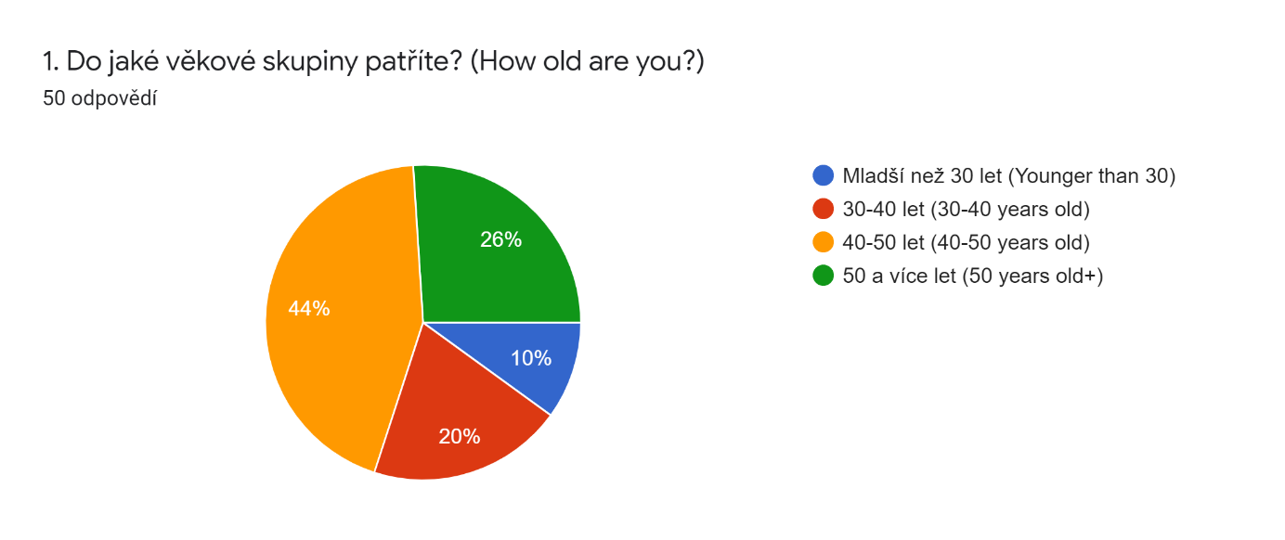

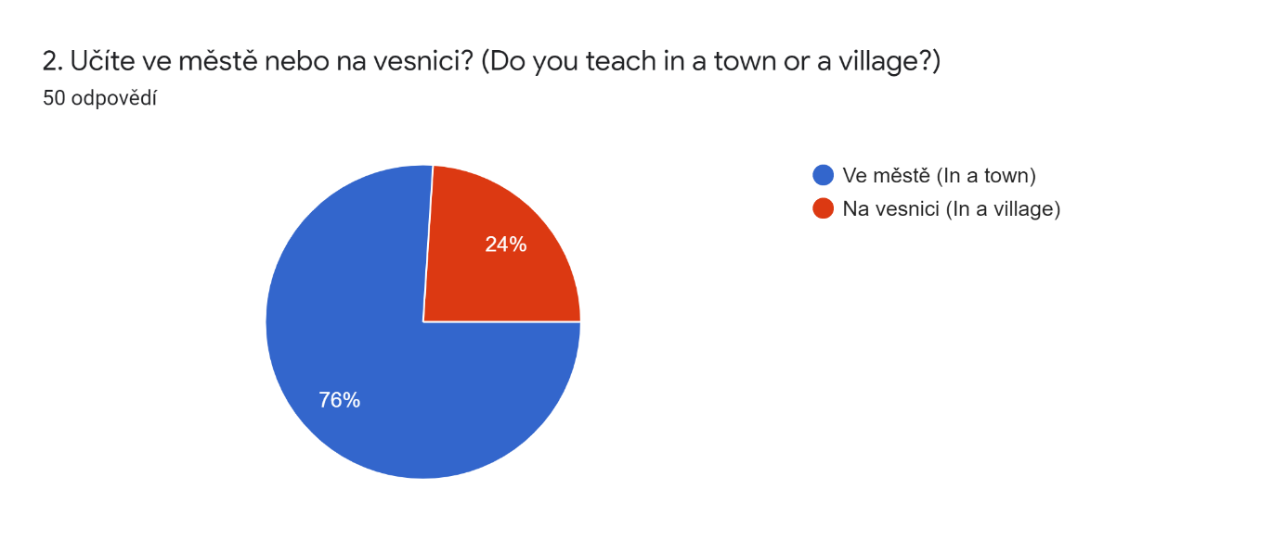

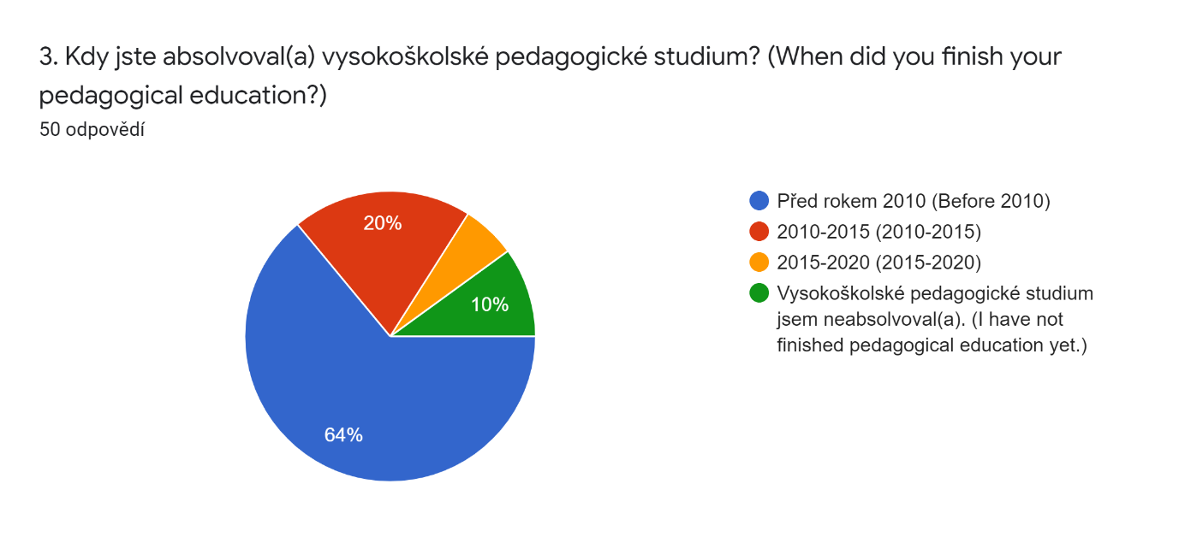

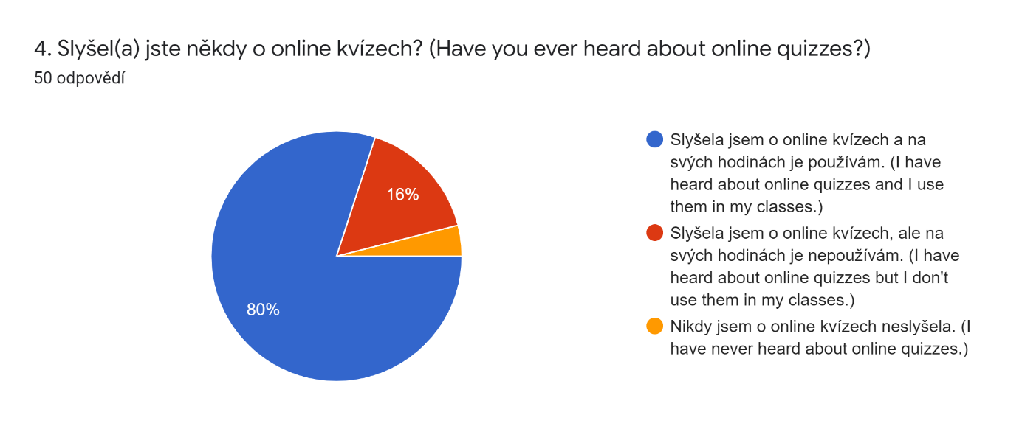

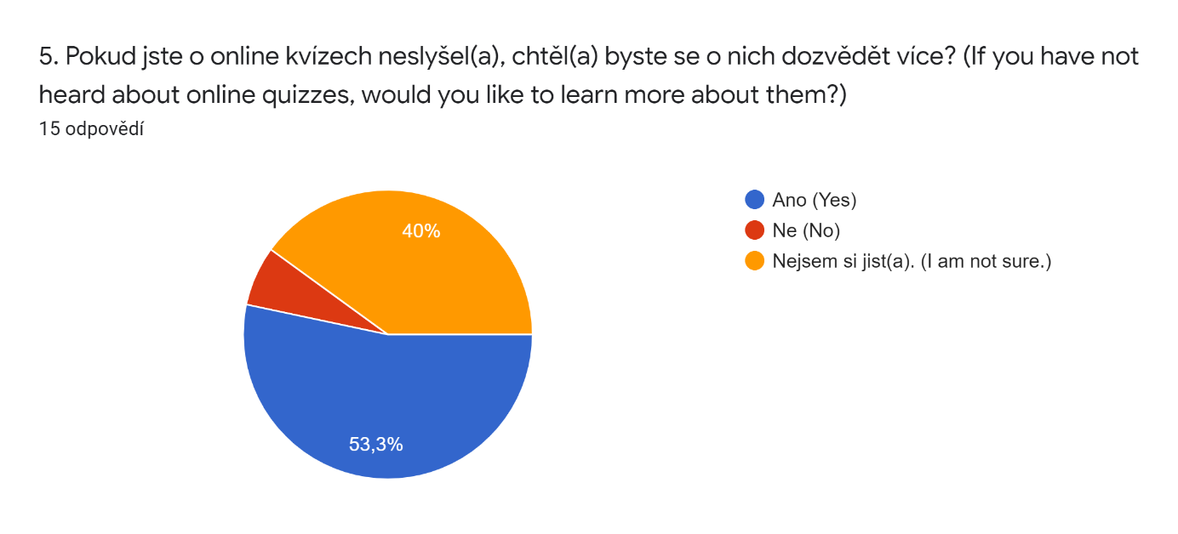

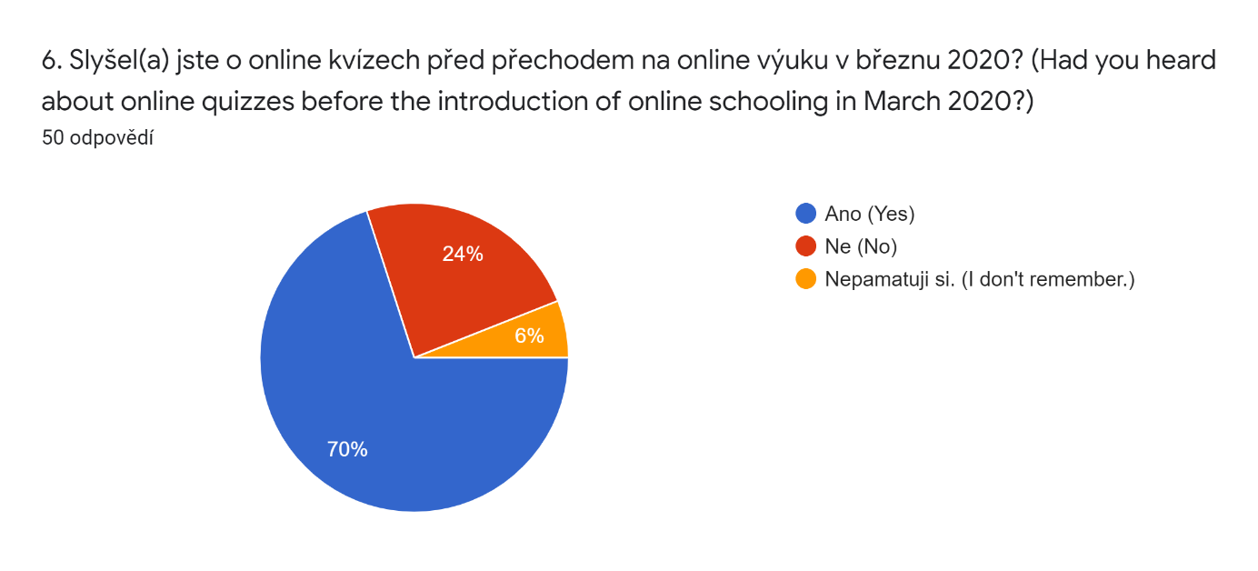

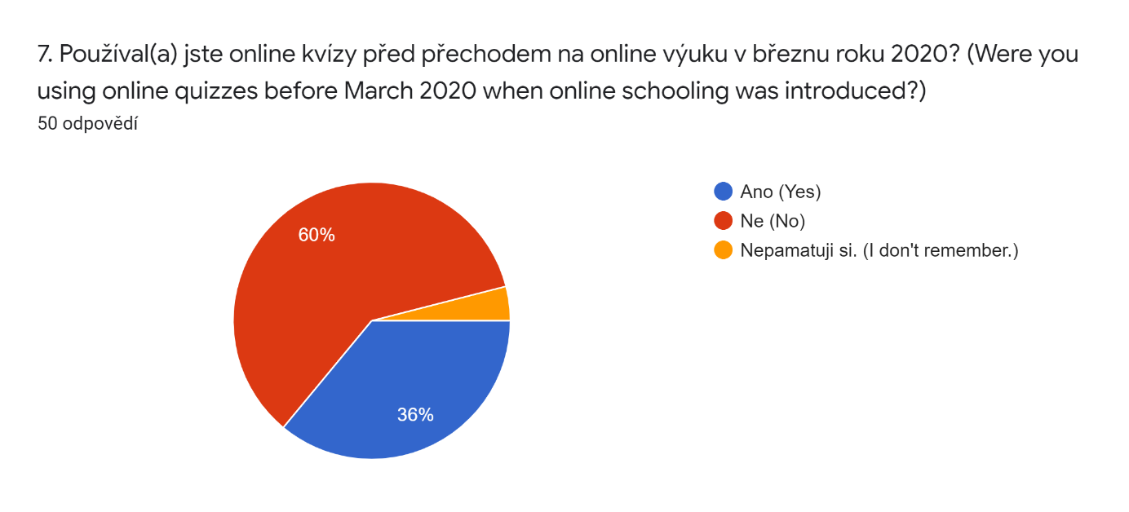

8. Pokud online kvízy nepoužíváte, proč ne? (If you do not use online quizzes, why not?)

Nemají výpovědní hodnotu.

Jejich tvorba je příliš náročná a řešení ze strany žáků není objektivní.

Neznám je.

Neznala jsem je.

Jejich tvorba je časově náročná, žáci mezi sebou mohou snadno opisovat.

Moc jim nerozumím.

Neznám je moc dobře.

Mám své postupy.

Jejich řešení není objektivní.

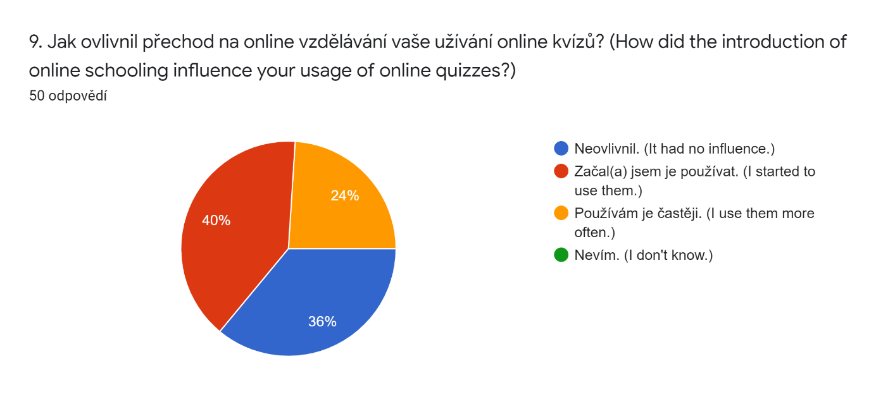

A list of abbreviations

ESL English as a second language

ICT Information and communication technologies

ISCED – International standard classification of education

LMS Learning management system

MSMT Ministerstvo školství, mládeže a tělovýchovy

A list of tables

Table 1: Integrations

Table 2: Awareness of online quizzes as of March 2020 and February - March 2021

Table 3: Usage of online quizzes as of March 2020 and February - March 2021

Table 4: Influence of online schooling

Table 5: The effect of age on the usage of online quizzes

Table 6: The effect of pedagogical education

Table 7: Use of different platforms

Table 8: Activities

Table 9: Language area

A list of figures

Figure 1: Usage of online quizzes  as of March 2020 and February-March 2021

Figure 2: The effect of age on the usage of online quizzes

# Resumé

Tato bakalářská práce se zabývá využitím online kvízů ve výuce anglického jazyka na 2. stupni ZŠ a nižších stupních gymnázií. Výzkumnou metodou dotazníku bylo zjištěno, že většina učitelů v současnosti online kvízů na svých hodinách využívá. Nejčastěji používané platformy byly Kahoot!, Google Forms, Quizlet a Quizizz. Učitelé je používají jak k procvičování probírané látky, tak k jejímu zkoušení, přičemž používání online kvízů k procvičování je učiteli upřednostňováno. Učitelé angličtiny používají online kvízy především k procvičování a zkoušení slovní zásoby a gramatiky, jejich použití k procvičování a zkoušení poslechu a čtení však není v žádném případě ojedinělé. Dále bylo zjištěno, že propuknutí nemoci Covid-19 a následné zavedení online výuky v březnu 2020 mělo na využívání online kvízů zásadní vliv. Více učitelů angličtiny o online kvízech získalo povědomí a více učitelů je následně začalo používat. Zároveň učitelé, kteří je používali už před zavedením online výuky je jejím vlivem začali používat častěji. Věk hrál zásadní roli v četnosti užívání kvízů. Mladší učitelé používali online kvízy častěji než jejich starší kolegové.

# Annotation

|  |  |
| --- | --- |
| **Jméno a přímení:** | Tereza Vaňkátová |
| **Pracoviště:** | Ústav cizích jazyků (UCJ) |
| **Vedoucí práce:** | Mgr. Barbora Bačíková |
| **Rok obhajoby:** | 2021 |

|  |  |
| --- | --- |
| **Název diplomové práce:** | Využití online kvízů ve výuce anglického jazyka na 2. stupni ZŠ |
| **Název diplomové práce v anglickém jazyce:** | The Use of Online Quizzes in ESL Teaching at Lower-Secondary Schools |
| **Anotace diplomové práce:** | Bakalářská práce se zabývá využíváním online kvízů ve výuce anglického jazyka na 2. stupni ZŠ a nižších stupních gymnázií. Teoretická část popisuje online kvízy, jednotlivé platformy pro jejich tvorbu a předchozí výzkumy na téma již provedené. Výzkum zkoumá využití online kvízů ve výuce anglického jazyka, zejména pak vliv přechodu na online výuku, závislost věku učitele a jejich užívání a způsob, jakým jsou online kvízy na hodinách anglického jazyka využívány. |
| **Klíčová slova:** | Výuka anglického jazyka, gamification, online kvízy, Kahoot!, Quizizz, Quizlet, Google Forms, online výuka, Covid-19 |
| **Anotace v angličtině:** | The bachelor thesis deals with the use of online quizzes in ESL teaching at lower-secondary schools. The theoretical part describes online quizzes, the platforms for their creation and previous research on the topic. The research analyses the use of online quizzes in ESL teaching, particularly the effect of the introduction of online schooling, the relationship of teacher´s age and the usage of online quizzes and the ways how online quizzes are used in English classes. |
| **Klíčová slova v angličtině** | ESL, gamification, online quizzes, Kahoot!, Quizizz, Quizlet, Google Forms, online schooling, Covid-19 |
| **Přílohy vázané v práci:** | Research results |
| **Rozsah práce:** | 47 stran |
| **Jazyk práce:** | Angličtina |