**UNIVERZITA PALACKÉHO V OLOMOUCI**

**FILOZOFICKÁ FAKULTA**

**KATEDRA DĚJIN UMĚNÍ**

**PORTRAIT OF THE GEM-CUTTER DIONYSIO MISERONI AND HIS FAMILY: A PAINTING IN CONTEXT OF THE TWENTIETH-CENTURY METHODOLOGY**

Bachelor’s Thesis

**PODOBIZNA ŘEZAČE DRAHOKAMŮ DIONYSIA MISERONIHO A JEHO RODINY: OBRAZ V KONTEXTU METODOLOGIE 20. STOLETÍ**

Bakalářská diplomová práce

Natálie Trtíková BA

Vedoucí práce: prof. Mgr. Ondřej Jakubec, Ph.D.

Olomouc 2024

Prohlašuji, že jsem předloženou bakalářskou diplomovou práci vypracovala samostatně

za použití citovaných zdrojů.

Rozsah práce: 90,245 znaků (včetně mezer)

V Olomouci dne:

................................................

Natálie Trtíková BA

Acknowledgments

I would like to thank prof. Mgr. Ondřej Jakubec, Ph.D. for his professional guidance, valuable advice and patience. Many thanks also go to him for motivating and enabling me to write my bachelor's thesis in English.

Contents

INTRODUCTION 5

KAREL ŠKRÉTA AND HIS IMAGE IN HISTORIOGRAPHY 8

KAREL ŠKRÉTA 12

AN ANALYSIS OF THE PORTRAIT 16

THE CIRCUMSTANCES OF THE CREATION OF THE PORTRAIT 18

BAROQUE PORTRAITS IN THE CZECH LANDS AND EUROPE 23

AN ANALYSIS OF THE PORTRAIT IN THE CONTEXT OF SVETLANA ALPERS 28

AN ANALYSIS OF THE PORTRAIT IN THE CONTEXT OF WOLFGANG KEMP’S RECEPTION AESTHETICS AND ALOIS RIEGL’S BEHOLDER’S SHARE 34

CONCLUSION 42

LIST OF IMAGES 44

LITERATURE BEFORE 1800 46

LITERATURE AFTER 1800 46

MASTER THESES AND DISSERTATIONS 48

INTERNET SOURCES 49

# INTRODUCTION

The *Portrait of the Gem-Cutter Dionysio Miseroni and His Family* is a significant painting by a Czech Baroque painter Karel Škréta (1610–1674) dated 1653. Its importance is not only in its rich reflection of Prague society in the seventeenth century but also in its uncommon composition in the Czech Lands, for which the painting is frequently referred to as Dutch or Dutch-inspired in the specialist art historical literature. However, this opinion is seldom being elaborated on and often is stated without further explanation leaving the beholder relying on their own experience with Dutch painting. In the early years of art history, it was Italian art which was given the most attention among scholars. Dutch painters were known for evolving their approaches to composition regardless of Italian concepts and therefore were often perceived as an opposition to Italian art. Greater attention was given to the specifics of Dutch painting at the turn of the 19th and 20th centuries when the Vienna school proposed groundbreaking approaches in the field of art history mainly by their interest in a scientific approach to art, in research into the development of artistic styles, and a comprehensive study of art history and contemporary art[1]. One of the leading representatives of the Viennese school was Alois Riegl (1858–1905), who in 1902 published the book *The Group Portraiture of Holland*[2], in which he analyses in detail the determining aspects and elements of Dutch portraits, thereby proving the scientific approach of the Viennese school and providing researchers with a guide to the specifics of Dutch portraiture.

In the 20th century, Alois Riegl’s studies were brought to attention in connection with the research of Svetlana Alpers (*1936), an American art historian, whose great contribution lies in distinguishing the Albertian and Keplerian picture modes[3], thus responding to the opposition of Italian and Dutch composition and attributing the Albertian picture mode to Italy, whereas the Keplerian to Dutch art. The connection between Svetlana Alpers and Alois Riegl is represented by Wolfgang Kemp (*1946), who is the author of the foreword to Riegl’s book *The Group Portraiture of Holland*. Kemp is also the author of the foreword to Svetlana Alpers’ key work, *The Art of Describing: Dutch Art in the Seventeenth Century*[4], where he deals with the historiography of Dutch painting with reference to Alois Riegl, mentioning that when the historiography of Dutch painting developed, Riegl’s legacy was not considered at all. Wolfgang Kemp’s key contribution to the field of art history is the presentation of his theory of *Reception Aesthetics*[5], referring to the important role of the relationship between the viewer and the image, an aspect both Alpers and Riegl allude to in connection with Dutch portraits. Within the framework of *Reception Aesthetics*, Kemp presents several elements by which the painting establishes communication with the viewer and presents this theory using the example of Dutch paintings. It is important to note, that the mentioned authors are not the only ones examining the relationship between the beholder and the art piece. Among others, one might name Michael Fried (*1939) and his concept of Theatricality[6].

Within the framework of the mentioned authors and their publications related to Dutch painting, this thesis will aim to outline the way in which it is possible to analyse the painting of Karel Škréta, *Portrait of the Gem-Cutter Dionysio Miseroni and His Family*. I believe that several important steps have been taken in the field of methodology in the context of Dutch painting that should be responded to in the art historical literature.

Firstly, this thesis presents the existing literary sources devoted to Karel Škréta as well as the portrait of Dionysio Miseroni, which will be followed by a brief outline of Škréta’s life and work, and an introduction and a description of Dionysio Miseroni’s portrait. Furthermore, the thesis aims to present the circumstances of the creation of the portrait, including an evaluation of Škréta’s other work, possible inspirations and influences key to the creation of this painting, as well as an introduction to the Miseroni family, with an emphasis on the personality of Dionysio Miseroni and his relationship with the painter of the picture, which will be followed by a chapter on Baroque portraits in relation to Karel Škréta and methodological analysis of the portrait in context of Svetlana Alpers, Wolfgang Kemp and Alois Riegl.

The methodologies are not presented in chronological order, but in an order that responds to the way the image and its inclusion are approached in the literature. We often come across the formulation stating that *the Portrait of the Gem-Cutter Dionysio Miseroni and His Family* is not influenced by Italy but by Holland. This implies a contradiction between these two areas, which is well reacted on by Svetlana Alpers. By presenting Alpers’s research, it will be possible to better understand the specifics of Italian and Dutch composition and their application in other countries. It is followed by an analysis of the *Reception Aesthetics* by Wolfgang Kemp, identifying the interaction of Škréta’s painting with the viewer, which is considered an important element of Dutch painting. With this theory, Kemp refers to the studies of Alois Riegl, describing in detail the frequent elements of group portraits from Holland, according to which the portrait of Dionysio Miseroni is further analysed.

In the methodological part of this thesis, I would like to demonstrate to what extent it is possible to analyse Škréta’s *Portrait of the Gem-Cutter Dionysio Miseroni and His Family* through the lens of specifically Dutch visuality. The purpose is therefore not to describe the entire work of Karel Škréta, but to present some approaches to how can Škréta’s portrait work be viewed. The main objective of this thesis is to initiate the use of methodological texts in art-historical practice in order to provide a more complex perspective on specific works, which can be exemplified by this analysis of the *Portrait of the Gem-Cutter Dionysio Miseroni and His Family* by Karel Škréta.

# KAREL ŠKRÉTA AND HIS IMAGE IN HISTORIOGRAPHY

The life and work of Karel Škréta received recognition in literature already during his lifetime. The author of his biography was a German painter and art historian of the time Joachim von Sandrart[7] (1606–1688), whom Škréta met on his travels to Italy. Karel Škréta’s fame, however, began primarily during the 18th century, a period of significant patriotic interest combined with an interest in learning about local artistic monuments and their authors. From this period comes a publication by Jaroslaus Schaller (1738–1809)[8], a Czech historian with an interest in topography, which significantly helped the attribution of several of Škréta’s works*.* In 1889, Gustav E. Pazurek (1865–1935), an art historian and museologist, published the first comprehensive publication on Karel Škréta[9].

In the 20th century, baroque received critical scrutiny, often interpreted as a foreign import and a tool of counter-reformation and national oppression[10]. An important scholar who studied the work of Karel Škréta was Vincenc Kramář (1877–1960)[11], a Czech art theorist and director of the Picture Gallery of the Society of Patriotic Friends of the Arts. He was then followed by Jaromír Neumann (1924–2001)[12], a Czech art historian and pedagogue, specializing mainly in Baroque art, primarily by Karel Škréta and Petr Brandl. Neumann considered the personality of Karel Škréta to be the only creative personality of his time and the bearer of stylistic development[13] and proposed that from the end of the Middle Ages until the nineteenth century, there was no painter born in Bohemia, except for Petr Brandl, whose place in the process of artistic development among the accomplished artistic achievements would appear to the viewer as unshakable as it is in the case of Škréta[14]. Regarding the *Portrait of the Gem-Cutter Dionysio Miseroni and His Family*, Neumann suggests both Italian and Dutch artists as influences on Škréta, namely Leandro Bassano, Bartolomeo Passarotti, and Bartholomeus van der Helst[15].

As a very beneficial publication, I consider the book *Baroque Portraits* from 1960, where Olga Pujmanova-Strettiova (*1928) presents an opposite opinion to the inclusion of the *Portrait of the Gem-Cutter* among the paintings influenced by Dutch painting and proposes that Dutch portraits at that time showed much more formality even when being set in a domestic environment. Another element that she mentions is the view into the workshop, which she attributes to Italian rather than Dutch painting[16]. Although this is the opposite opinion to the one presented by the majority of art historical literature, this is the source in which the influence on Škréta’s portrait is probably given the greatest attention.

Among other significant researchers on the topic of Karel Škréta’s work is Oldřich Jakub Blažíček[17] (1914 - 1985), a Czech art historian devoted primarily to Baroque art. A significant figure in Czech art history is also Zdeněk Hojda[18] (*1953), a Czech art historian and pedagogue who deals, among other things, with Czech-Scandinavian relations.

A valuable study has been made by Jana Zapletalová[19] (*1981), researching archival materials in Italian archives with a beneficial contribution to knowledge about Karel Škréta’s time spent in Italy, about which could have been only speculated in previous years.

Since 2000, three publications edited by Lenka Stolárová have been published that probably summarise all the knowledge available about Karel Škréta. They are *Karel Škréta 1610–1674. His Work and His Era*, edited by Lenka Stolárová and Vít Vlnas published in 2010[20], *Karel Škréta (1610–1674). Studies and Documents from 2011*[21], and *Karel Škréta (1610–1674). His Work and His Era. Studies, Documents, Sources*, also edited by Lenka Stolárová, together with Kateřina Holečková[22]. These are publications that comprehensively summarize the entire work of Karel Škréta, in the context of the political situation, the Czech and European Baroque and admirably present Škréta’s importance. Regarding the *Portrait of the Gem-Cutter Dionysio Miseroni and His Family*, the publications agree in assigning it to Dutch-influenced painting, while not responding to the methodological publications that were introduced during the 20th century.

Furthermore, the publication *In the Shadow of Karel Škréta. Prague Painters in 1635–1680* by Štěpán Vácha (*1976) and Radka Heisslerová (*1980) from 2017[23], which masterfully presents other painters of baroque art in Škréta’s time, should not be disregarded. The most recent study written about Škréta’s work was published by the National Gallery in Prague in 2023, which covers Škréta’s thesis prints and was edited by Petra Zelenková[24].

Regarding the literature focusing on Baroque art in the Czech lands, the publication *The glory of the Baroque in Bohemia: Essays on art, culture and society in the 17th and 18th centuries*, edited by Vít Vlnas[25] should be mentioned, which focuses on Baroque architecture, sculpture, painting, but also music, theatre and artistic craftsmanship, it is, among other things, a publication from which we learn not only about Karel Škréta, but also about the Miseroni family, as artistic craftsmen of the time.

Specifically, the publication *Face to Face: Baroque Portrait in the Lands of the Czech Crown*[26] further discusses baroque portraits. Also, the publication *Renaissance Portrait Painting in the Czech Lands – its Iconography and Role in Aristocratic Representation*[27] by Blanka Kubíková offers an overview of portrait painting, specifically in the 16th and 17th centuries, focusing on portraits of members of the nobility. Recent literature on the Baroque portrait also includes Ingrid Halászová's publication entitled *Pred Portretom*[28], devoted to the contents, meanings, functions and representational strategies of portraits. One can understand this mentioned literature as an expression of high interest in the topic of baroque portraits, since these mentioned publications were published in the last ten years.

Regarding the *Portrait of the Gem-Cutter Dionysius Miseroni and His Family* and its analysis in the mentioned publications, the reader will very often come across wording asking about possible influences on Karel Škréta. While the mention of Dutch vilvas prevails[29], when the painting is linked to the painting art of Bartholomeus Spranger, Jaromír Neumann, for example, mentions the influences of both Italian and Dutch painting and does not deny the connection with the circle of Velásquez[30]. On the other hand, Olga Strettiová presents a completely opposite opinion and states that the portrait by Karel Škréta could not have been painted in a connotation with Dutch painting, as mentioned earlier. However, the publications dealing more closely with this painting are all of the same opinion that this composition is very unusual in Central Europe. Nor is there any reference to the literature in the field of methodology in any of them, although in the course of the 20th century significant discoveries were made in connection with the art of this period.

# KAREL ŠKRÉTA

Karel Škréta was an esteemed Czech painter, generally considered the founder of Czech Baroque painting. There is an uncertainty that surrounds the exact date of his birth, which is believed to be between 1608 and 1611[31]. He was born as a member of a Prague noble family as a grandson of a senator of the Old Town council Jan Škréta and a son of the Rationum praefectus[32] Kundrat Škréta. Karel’s father died in 1613 after which his guardian became his uncle, Pavel Škréta, master minter of Kutná Hora, who is believed to have ensured an education to his nephew. The information regarding his early education remains incomplete, although it is speculated that he received comprehensive schooling, mastering languages such as Latin, German, Italian, and possibly French. His artistic training is similarly obscure, with conjecture suggesting apprenticeships with renowned figures like Aegidius Sadeler (1570–1629) or Johann Georg Hering (1587–1644)[33].

In the life of Karel Škréta, one might consider one of the most important events the act of renewing the Land Ordinance in 1627, by which the emperor Ferdinand II (1578–1637) declared Catholicism as the only Christian confession the inhabitants of the Bohemian Kingdom were allowed to profess, as a result of which the Evangelists had to choose between conversion or exile, regardless of their social status[34]. Karel too, with his mother and siblings, was one of those who decided to go into exile, seeking refuge in Saxony and Italy. During the Thirty Years’ War[35], Škréta immersed himself in the vibrant artistic milieu of Italian cities like Venice, Bologna, and Rome. During his stay, he got acquainted with foreign artists and also joined a Dutch painters’ association called the Bent. The years that Karel Škréta spent in Italy and the important contacts he established there are discussed in more detail in the chapter The Circumstances of the Creation of the Portrait.

Returning to Prague in the thirties of the seventeenth century, Škréta faced the challenge of reclaiming family property confiscated during the war. Despite his Protestant upbringing, he converted to Catholicism, after which he was able to navigate the legal complexities of restitution. Back in Prague, he swiftly ascended the ranks of the city’s artistic elite, earning commissions from influential patrons such as Supreme Burgrave Bernard Ignaz von Martinitz (1603–1695) and the Augustinian monks of Zderaz Monastery[36]. It can be also assumed that after his return to Prague, Škréta especially sought contacts with Prague citizens of Italian origin, among whom was the Miseroni family, whose friendship with Karel Škréta is frequently mentioned in the literature. In 1645, Škréta married Veronika Grönberger, a daughter of a burgher of the lesser Town in Prague. He died on July 30, 1674, and was buried in the Old Town of Prague [37].

The development of Škréta's work can be classified into three periods. While his work of the 1940s and 1950s is characterised by Venetian colorism and Caravaggio chiaroscuro, in the 1960s there are more influences from Bolognese and classicising painting. The works from the end of his life contain meditative elements with an emphasis on the psychology of the characters[38]. His oeuvre encompasses a diverse range of subjects, from portraits of nobility to religious commissions. After the Thirty Years War, the visual arts of the entire Central Europe were significantly marked by Catholicism. Škréta reflected the contemporary artistic tendencies in an attempt to capture the life of Christ and the saints as attractively and engagingly as possible using bright colours, which, together with work with light and shadow enhances the drama of the scenes. Among his famous works with religious themes are, for example, *St Martin Sharing His Cloak with a Beggar* (after 1650), *Holy Family with St Catherine and St Barbara* (first half of the 1660s), or *The Birth of St Wenceslas* (1640). Besides that, Karel Škréta also played a fundamental role in the formation of Baroque graphics in the Czech lands. As an inventor[39], he designed free graphic sheets and book illustrations, which were engraved especially by famous Augsburg graphic artists[40].

Škréta’s portrait work is considered innovative and often intriguing for its time. An important portrait work is the double portrait entitled *Franz Anton Hovora Count Berka of Dubá and Lipá and Aloisia Ludovica Anna de Montecuccoli as Paris and Helena* (1672), where Škréta masterfully captures the moment of looking at the viewer. The characters communicate with the viewer in a moment of surprise, which departs the image from conventional studio portraits. In addition, it also in a certain sense anticipates the way of painting influenced by photography- the figure in the left part of the painting is cropped, thus suggesting a cut from the scene instead of the compositional layout specific to the “theatrical” scene of Italian painting. Instead, there is a view into another space - the landscape in the background, referring to the story of Paris and Helena. Other portrait work by Karel Škréta includes *Portrait of the Maltese Knight Bernard de Witte* (after 1650), *Portrait of a Mathematician and His Wife* (1640s) and *Portrait of a Miniature Painter* (1640). Significant is also Škréta’s painting *St Karel Borromeo visits the plague patients in Milan* from 1647 which often highlighted for its diagonal composition, but it is mainly known because the viewer can find there a crypto-portrait of Karel Škréta.

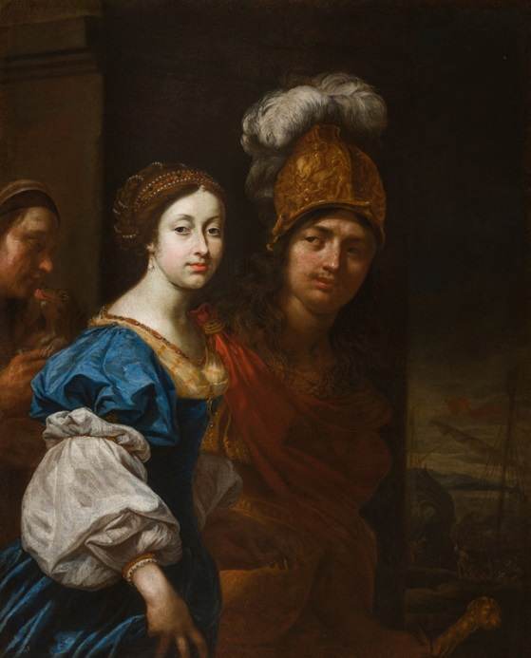

[I] Karel Škréta, Franz Anton Hovora Count Berka of Dubá and Lipá and Aloisia Ludovica Anna de Montecuccoli as Paris and Helena, 1672, National Gallery Prague

# Karel Škréta - Sv. Karel Boromejský navštěvuje nemocné morem v Miláně

[II] Karel Škréta, St Charles Borromeo Visiting Plague Victims in Milan, 1647, National Gallery Prague

# AN ANALYSIS OF THE PORTRAIT

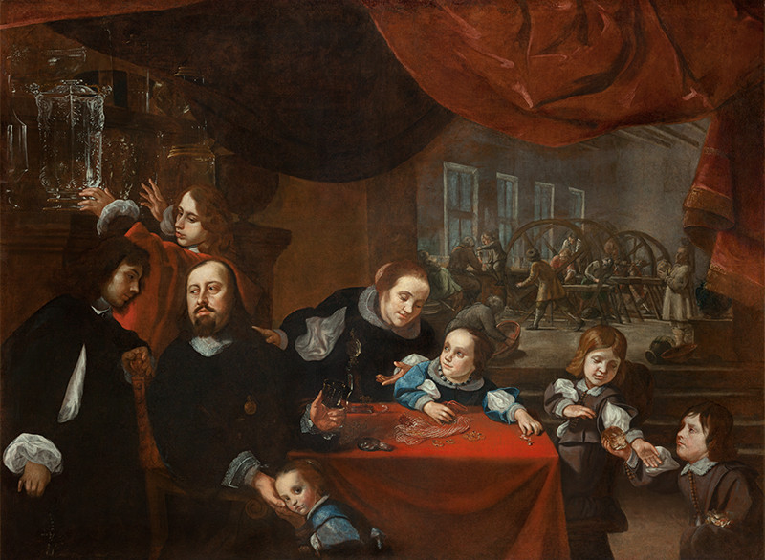

[III] Karel Škréta, Portrait of the Gem-Cutter Dionysius Miseroni and His Family, 1653, National Gallery Prague

The *Portrait of the Gem-Cutter Dionysio Miseroni and His Family[41]* is a painting of a detailed composition that impresses the viewer at first sight with its composition and an emphasis on sophisticated processing of details. The foreground of the painting occupying the majority beautifully captures the Miseroni family in an intimate domestic setting. Positioned at the left with a distinguished presence is Dionysio Miseroni, surrounded by his sons, Johann Octavius and Ferdinand Eusebius. The eldest son, Johann Octavius[42], leans towards his father. In the following years, he will be embodying his role as a secretary of the court office and a key member of the inspection and liquidation committee of the Kingdom of Bohemia. Ferdinand Eusebius[43], the younger son, reaches towards a crystal vase on a sideboard, an actual artefact produced by the Miseroni workshop. It can be assumed that Karel Škréta was already indicating Ferdinand Eusebius’s future position as his father’s colleague and chosen successor in the gem-cutting enterprise. Dionisio, positioned as the respected father figure, directs his gaze towards his older sons, likely imparting words of wisdom and encouragement. In the centre, behind a table, stands Dionysio’s second wife, Marie Ludmila[44], displaying devotion by placing her hand on her husband’s shoulder. The family tableau extends to include daughters Maria Laura[45], and Krista Jana Renata[46]. Marie Ludmila is leaning towards the older daughter, who is paying attention to her mother while playing with jewellery laid on the tablecloth. Krista Jana Renata, the younger daughter, is leaning towards her father’s palm while making eye contact with the beholder. The youngest sons, Wenzel Eusebius[47] and Ignaz Franz[48] engage with a large crystal of smoky quartz on the right side. In the background, the painting reveals a view into the gem-cutting workshop, where craftsmen and apprentices work diligently. In the top right corner of the painting is placed a red illusive curtain, covering most of the top of the painting, which makes the lighting of the frontal scene stand out and contributes to the overall warm composition. The painting beautifully intertwines elements of professional activity, familial togetherness, and material well-being, creating a vivid and compelling depiction of the Miseroni family’s life. In essence, the portrait becomes a visual testament to the family’s tradition, a source of inspiration, and a model for future generations.

As it was indicated in the previous chapter, the concept of the composition displays Škréta’s inventiveness and his inclination to Netherlandish group portraiture[49], as the painting combines familial interactions with a representation of the family’s professional life, which, on top of the window in the background showing Miseroni’s gem-cutting workshop, also showcases the workshop’s products, such as the mentioned crystal vase or small pieces of jewellery on the table[50]. Jaromír Neumann does not comment directly on the composition regarding the influence on Škréta’s *Portrait of the Gem-Cutter*, however, he mentions the similarity with Dutch and Italian artists[51]. The publication *Baroque Portraits* by Olga Strettiova which was published in 1960 opposes the inclusion of Dionysio Miseroni’s portrait among paintings influenced by the Netherlands. In the assessment of the picture, in addition to the composition and colour, she also emphasizes the naturalness of the depicted characters[52]. According to Strettiova, this distinguishes the *Portrait of Dionysio Miseroni* from the Dutch painting, which seems much more representative in comparison. On the contrary, she highlights the similarity of Škréta’s painting with Italian work in the way the workshop is depicted[53].

# THE CIRCUMSTANCES OF THE CREATION OF THE PORTRAIT

Following the introduction of Karel Škréta’s life and a description of the *Portrait of the Gem-Cutter Dionysio Miseroni and His Family*, this chapter aims to propose a further understanding of possible determining circumstances which led to the creation of the portrait in the Czech lands, where it possibly had no predecessors. In order to achieve this, this chapter aims to discuss the possible influence on Karel Škréta at that time, beginning with an outline of his travels to Italy, where he got acquainted with foreign painters, followed by the story of the Miseronis in Prague and their relationship with Karel Škréta, as well as an acknowledgement of other portrait work by the painter.

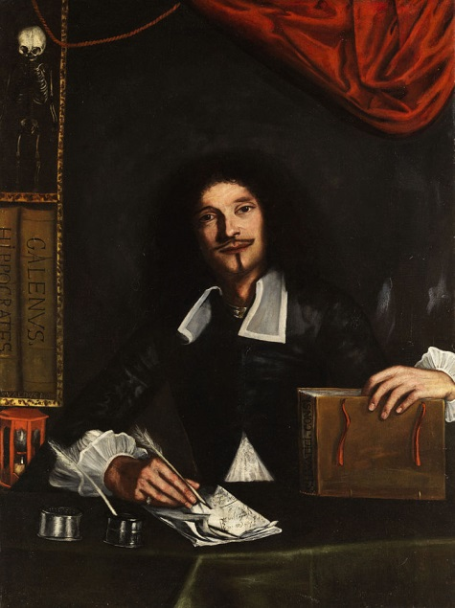As insufficient information sources are providing the scholars with an insight into Škréta’s artistic training from his early age, it 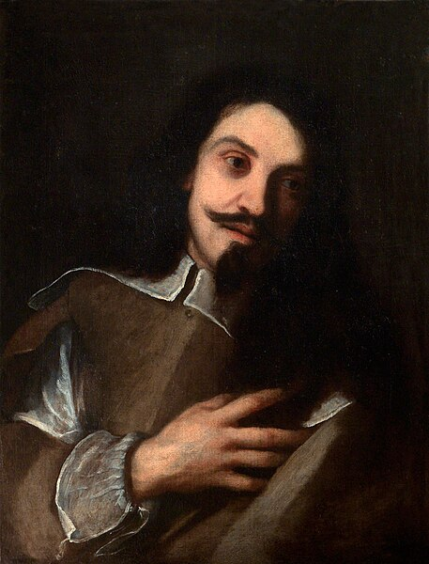might be adequate, to begin with considering possible influences on Škréta’s work on his travels to Italy. According to Pazurek, Škréta went to Venice in 1630 where he spent his first years. As Neumann states, Škréta got to know Joachim von Sandrart there, who, when writing Škréta’s monography, devoted most of his attention to this period[54]. During his travels to Italy, the painter also met Tiberio Tinelli (1586–1639), who was a highly respected portraitist and whose work was a model for European portrait practice at the time. Their close relationship is evidenced by, among other things, the portrait of Karel Škréta painted by Tinelli (1635). Among Tinelli's other portraits are *Portrait of a Young Medic* (1636) or *Portrait of Carlo Ridolfi* (1638). After the time spent in Venice, Škréta travelled further to Bologna, as evidenced by Sandrart. The influence of Bolognese painting is noticeable in Škréta’s work, especially in his later paintings created in Prague. Among the painters influencing Škréta’s work can be included, for example, the Carraccis, Ludovico and Annibale, or their student, Guido Reni[55].

[V] Tiberio Tinelli, Portrait of a Young Medic, 1636,

[IV] Tiberio Tinelli, Portrait of Karel Škréta, 1635, National Gallery Prague

After Škréta’s time spent in Venice and Bologna, the painter travelled to Rome, where he joined a Dutch painting association called the Bent[56]. As Neumann states, this association was composed of Flemish, Dutch, French and German painters. It was a multiconfessional association founded between 1623 and 1627[57]. The group was unofficial, it is believed that it had not one office designed for meetings but hosted their gatherings in a room in an inn. There were also no written rules or a committee. The association had about thirty to forty members, who, upon entering the association were baptized with wine by a mock priest and every member also received their own Bent nickname[58]. The group existed till 1720[59]. According to Neumann, Škréta also got his Bent name, which was Slackzwart or Espadron, both signifying that the bearer of this nickname was an explosive and conflictual person[60]. Some of the Dutch members of the Bentvueghels were Abraham Brueghel, Jacob van Staverden, Dirck van Baburen, Jan Theunisz Blanckerhoff, Pieter van Bloemen, from the Germans one could name for instance Franz Ludwig Raufft, Christian Reder or Franz Werner von Tamm. The 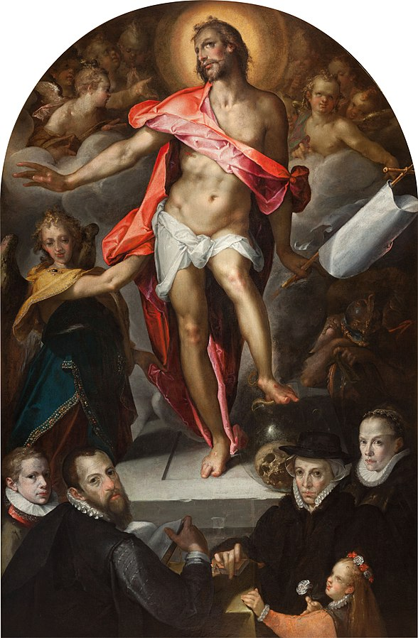members devoted themselves to painting as well as engraving, and printmaking praxis. Many also pursued other kinds of art, such as poetry or music or studied the theory of art.

It could be assumed that this group shaped Škréta’s approach to portraiture, which was reflected in his *Portrait of the Gem-Cutter*. Jaromír Neumann suggests specific painters who influenced Škréta in this work. In portraiture, he states the works of Joseph Heinz and Bartholomeus Spranger as his models. Among Škréta’s contemporaries, he mentions the Italian painters Leandro Bassano and Bartolomeo Passarotti and a Dutch group portraitist Bartholomeus van der Helst[61]. It should also be noted that the Prague Castle Picture Gallery of that time included a collection of Dutch paintings, offering a certain source of inspiration.

[VI] Bartholomeus Spranger, Epitaph of Goldsmith Nicolas Müller, 1593

The similarity of the painting art of Karel Škréta and Bartholomeus Spranger can be seen especially when comparing the *Portrait of a Gem-Cutter* with Spranger's *Epitaph of Goldsmith Nicolas Müller* (1593), where a family portrait is depicted under the scene of the Risen Christ. When comparing, the viewer can notice a similar arrangement of individual family members. On the contrary, Leandro Bassano is more concerned with the depiction of individuals in his portrait work. An example is *Portrait of Tiziano Aspetti Holding a Statuette* (1592 – 1593). However, this can also be compared to Škréta’s painting, as it is a depiction of the artist’s character as well as his occupation. As for Bartolomeo Passarotti, one can name, for example, the group portrait *Ritratto dei Fratelli Monaldini* (16th century), in which he depicts the likenesses of four brothers together with objects indicating a certain activity, such as musical instruments.

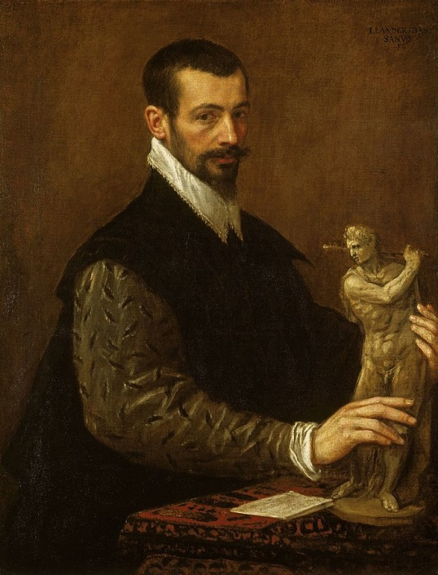Apart from Škréta’s relationship with other artists, it is also important to pay attention to Škréta’s relationship with the portrayed Miseroni family. The painter’s good relationship with the gem-cutter was already stated in the oldest literature written about Karel Škréta, such as in Sandrart’s or Pazurek’s publications. Moreover, Neumann mentions that the Miseroni family was portrayed by Škréta more than once[62]. Four portraits are known to have been created by this painter of the family of gem-cutters. As Neumann states, it was probably a portrait of Dionysio Miseroni by himself, a portrait of Dionysio’s first wife and a portrait of the Miseroni brothers. Allegedly, there were effigies of the brothers Jeroným, Jan Ambrož and František on the painting. It can be assumed that after his return to Bohemia, Karel Škréta sought contacts with Italians living in Prague at the time. Dionysio Miseroni (1607–1661) belonged to the second generation of gem-cutters from the Miseroni family living in Prague. He was a son of Octavian Miseroni (1567–1624), who was invited to Bohemia from Milan in 1588 and settled in Pisecka Street in Prague[63]. Besides his gem-cutting praxis, Octavian became a chief of the Imperial Treasure Camera[64], signifying that the family was close to the royal court of Rudolf II. (1552–1612).

[VII] Leandro Bassano, Portrait of Tiziano Aspetti Holding a Statuette, 1592 – 1593

The beginning of Dionysio’s career is not known in much detail, it is assumed that he was born in the early seventeenth 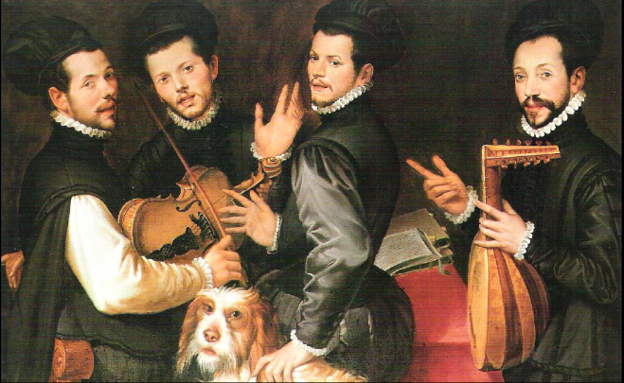century since there is evidence of a statement of his father Octavian from 1623, which claims that his son is no worse in the trade than he himself[65]. At that time, Dionysio is believed to be already in charge of the gem-cutting workshop. In 1630, he also became the aid of the Schatzmeister in Prague. Records prove that Škréta left Italy in 1635[66] and in 1638, his presence is documented in Prague[67]. In the following fifteen years, Karel Škréta not only made one portrait of Dionysio Miseroni and another one of his first wife Judit Mayer von Burgrieden, but he probably became a close acquaintance of the Miseroni family, as it is believed that the family portrait was a gift from Karel Škréta to Dionysio Miseroni. Karel Chytil presents two possible theories. The first explains the reason for the creation of the portrait as a gift for Dionysio’s fiftieth birthday, whereas the second connects the creation of the painting to Dionysio’s merits in the service of the emperor during the Swedish occupation when he organised a transfer of Prague collections to Vienna, for which was Dionysio ennobled with a coat of arms and the predicat „de Lisone”, evidenced in 1653[68]. Given that the birth year of Dionysio is uncertain, one might consider the second theory as more probable.

[VIII] Bartolomeo Passarotti, Ritratto dei Fratelli Monaldini, 16th century

# BAROQUE PORTRAITS IN THE CZECH LANDS AND EUROPE

Karel Škréta was likely the only Czech artist at that time who had such extensive contacts with foreign countries. As Olga Strettiová observes, Karel Škréta was the first artist since the Rudolfinian period to bring new elements from abroad toBohemia, and at a time when art was rather unfavourable[69]. After the Gothic period, when portraits in sculpture dominated in Bohemia and were considered to be one of the most innovative in Europe[70], the Renaissance began, during which more painterly portraiture was used in the Czech lands, represented by artists who came to Prague from areas north of the Alps, who also had experience with Italian painting, as they studied or worked in Italy[71]. In both eras, under the reign of Charles IV and Rudolf II, Prague was considered a significant artistic centre. During the Baroque period, however, the artistic situation in Bohemia was rather complicated. Not only were the Czech lands significantly weakened economically, as they were the country most marked by the Thirty Years’ War[72], there was also no monarch who would invite foreign artists to Prague. In addition, Baroque was considered a manipulative art, namely a tool serving the re-Catholicization and ideological subjugation of the country’s population[73].

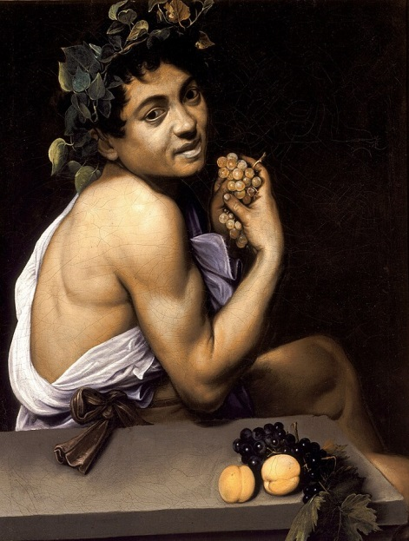Although there were no foreign artists, who would come to the Czech lands and bring new trends in painting, there was Karel Škréta, who, as described in the previous chapters, travelled to Italy and Germany, where he became acquainted with the works of 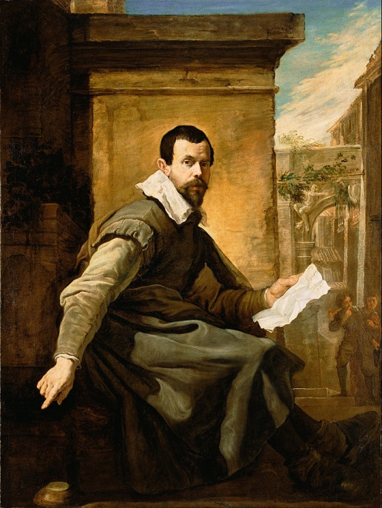Italian artists and artists active in the north of the Alps. At that time, several important painters were active in Italy, whose work Karel Škréta could follow. While in Venice, where Škréta travelled first among the Italian cities, it was Domenico Fetti (1589–1623), who was during that time one of the leading authors of many portrait works, such as the *Ideal Portrait of Gonzaga* (1620), *Portrait of an Actor* (1621), or *Portrait of a Man with a Sheet of Music* (1620), in Rome Škréta got acquainted with the legacy of Michelangelo Merisi Caravaggio (1571–1610), whose work, characterised by strong drama achieved with the use of light and shadow, significantly influenced painting not only in Italy, where he was active but also abroad[74].

[IX] Domenico Fetti, Portrait of a Man with a Sheet of Music, 1620

Caravaggio wanted to depart from the Mannerist tradition, which he considered limited, academic and artificial and introduced new realistic and theatrical ways of painting with an emphasis on the dramatic moment[75]. Apart from his well-known painting *Young Sick Bacchus* (1593), which is his self-portrait, Caravaggio's portrait work can be named *Portrait of a Gentleman* (1598 – 1604) or *Portrait of a Prelate* (1592 – 1599). In both cases, Caravaggio's use of light and shadow can be seen, as is also the case with Karel Škréta in the following years. A direct influence on Karel Škréta’s work, however, had Caravaggio’s followers, such as Guercino (1591–1666) or Simon Vouet (1590–1649)[76].

[X] Michelangelo Merisi da Caravaggio, Young Sick Bacchus, 1593

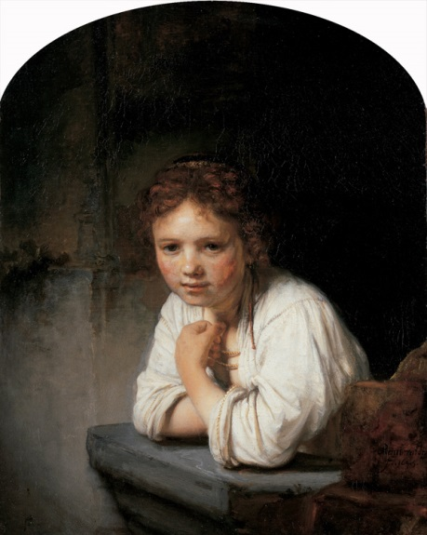Caravaggio’s work led to the creation of a group called the Utrecht Caravaggisti, consisting of artists originally from the Dutch city of Utrecht, who studied in Rome. The 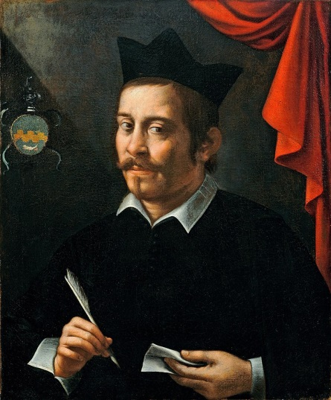three premier Utrecht Caravaggisti were Hendrick ter Brugghen (1588–1629), Gerrit van Honthorst (1529–1656) and Dirck van Baburen (1595–1624)[77]. Whereas Hendrick ter Brugghen and Dirck van Baburen devoted themselves mainly to genre painting, Gerrit van Honthorst is the author of several portraits of members of the court, among which are the *Portrait of William II, Prince of Orange, and Maria Stuart*, *Portrait of Frederick Henry, Prince of Orange* (1650), or *Portrait of Margareta de Roodere and Her Parents* (1652). Among the Utrecht Caravaggisti was also painter Jan van Bijlert (1597–1671), who, as well as Dirck van Baburen, was one of the first members of the Bentvueghels. The Bent society, however, mainly consisted of landscape painters, draughtsmen and engravers[78].

[XI] Michelangelo Merisi da Caravaggio, Portrait of a Prelate, 1592 - 1599

In the Dutch Republic, the leading painter of the 17th century is considered Rembrandt Harmenszoon van Rijn (1606–1669), who is believed to never travel to Italy. His work is nevertheless characterised by chiaroscuro, which he used across themes, from portraits and self-portraits to genre scenes, allegorical and historical scenes. Apart from numerous self-portraits, his famous likenesses include the *Portrait of Jan Six* (1654), *An Old Man in Red* (1652–1654), and *Young Girl at the Window* (1654), which are characterized by significant realism and dramatic light, while using a simple setting to highlight the character.

[XII] Rembrandt Harmenszoon van Rijn, Girl in the Window, 1645

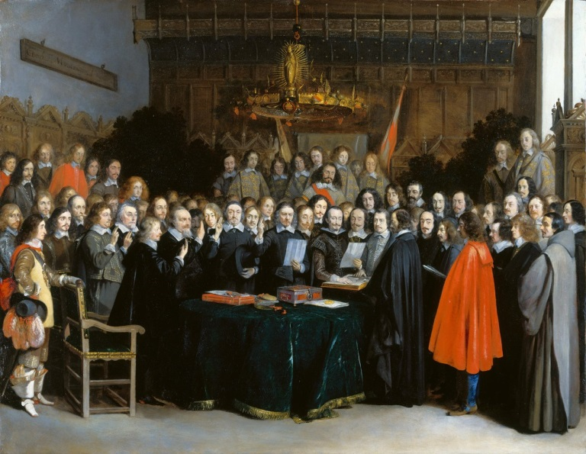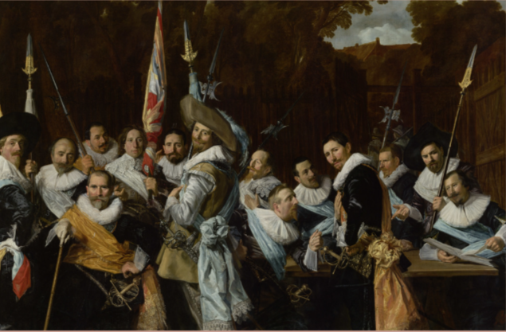Among other famous Dutch painters, Frans Hals (1582–1666) was known for his portraits. He is the author of the individual likenesses of many wealthy townspeople, for example, Jacob Pietersz Olycan, Aletta Hanemans, Dorothea Berck, or Joseph Coymans. These are not as starkly chiaroscuro, nor are they as simple as Rembrandt’s portraits. This might be due to the fact that they are wealthy members of society, the emphasis is on depicting the difference between different materials accentuating the richness. The background remains, as with Rembrandt, uniform. However, it appears here as a frequent element and a coat of arms, which is shown on a small scale, as it were, on the wall behind the figure. In addition to individual portraits, Frans Hals is also the author of many group portraits, among which are included *The Woman Regents* (1644), *Meeting of the Officers and Sergeants of the Civic Cavalry Guard* (1633), or *Regents of the Old Men's Alms House* (1664).

[XIV] Gerard ter Borch, The Ratification of the Treaty of Münster, 15 May 1648, 1648

[XIII] Frans Hals, Meeting of the Officers and Sergeants of the Civic Cavalry Guard, 1633

Holland group portraits at that time depicted groups of various kinds, from families, through members of guilds, militias, charitable institutions, or other civic groups to important historical events. An example of depicting such a significant political event is *The Ratification of the Treaty of Münster, 15 May 1648* (1648) by Gerard ter Borch (1617–1681), originally from the Dutch Republic, who was active in Germany, France, Spain, Italy and England. As some of the portraits of members of a company, one can name the *Regents of the Burgerweeshuis orphanage* (1633) by Abraham de Vries (1590–1649) or *Regents of the Walenweeshuis orphanage in Amsterdam* (1637) painted by Bartholomeus van der Helst (1613–1670). The form of group portraits was evolving over time and took on new forms in terms of narrative qualities, interactions between thosedepicted, composition of the scene and use of symbolism. Alois Riegl distinguishes three different phases of Dutch group portraits, which will be presented in more detail in the following chapters[79].

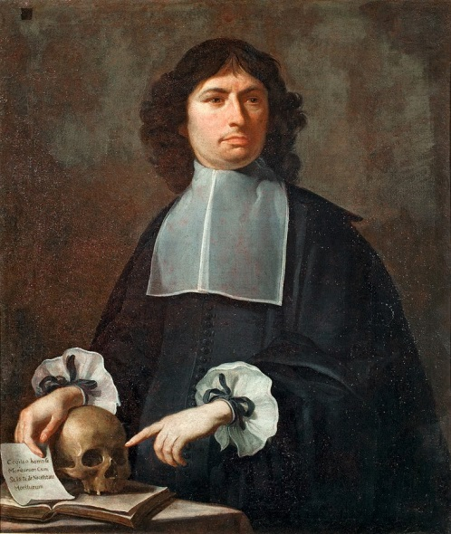In the Czech Lands, Karel Škréta is considered the leading figure of Baroque portraits. It was also Johann Georg Hering (1587–1644), who at the same time was an active painter in the field of altarpieces and portraits, among which are, for example, portraits of Strahov abbots Jan Lohel and Kašpar Questenberg[80]. Antonín Stevens (1608–1675) was, in addition to several altarpieces, the author of a portrait of Emperor Ferdinand III and Archduke Leopold Vilém. However, these portraits did not survive, the only known portrait works of Stevens are his self-portrait from 1670 and the portrait of Strahov abbot Kryšpín Fuck from 1653[81]. Jan Bedřich Hess (1622–1673) is the author of the *Three Court Craftsmen* (1600). In addition, he was the author of several altarpieces and graphics. As proposed by Vácha and Heisslerová, Hess, although he was not Škréta’s student, nor did he probably collaborate with him, is, among their contemporaries, the most comparable to Škréta’s work, especially in terms of composition[82]. Matěj Zimprecht (1624–1680) was a painter originally from Munich, but active in the Czech lands, who was the author of several portraits, among which was believed to be also a portrait of family members of Jan Octavio Miseroni de Lisone. However, his only surviving portrait is *Karel Kunata Dobřenský from Dobřenice* (1677)[83].

[XV] Matěj Zimprecht, Karel Kunata Dobřenský from Dobřenice, 1677

Among Škréta’s followers can be named Jan Jiří Heinsch (1647–1712), who received many ecclesiastical commissions, mainly altar paintings. For the 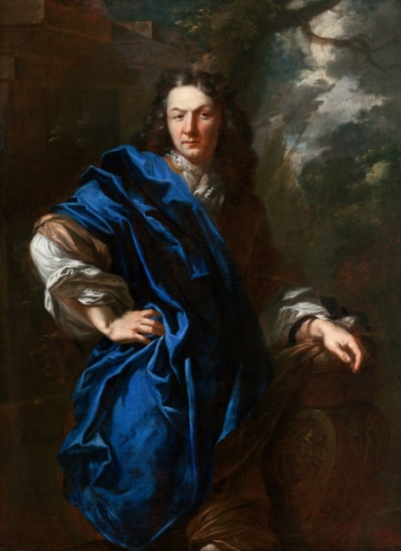Jesuit order, Heinsch was also commissioned to paint 34 portraits. The life anf work of Heinsch is discussed in the publication *Jan Jiří Heinsch (1647 – 1712). Painter of Baroque Piety*, which aims to liberate Heinsch from the traditional dependance on Karel Škréta[84]. In the late Baroque period, Petr Brandl (1668–1735) and his contemporary Michael Václav Halbax (1661–1711) were also ranked significant painters in the Czechlands. Both painters are considered to be influenced by the work of Karel Škréta, and in both painters, but especially in Petr Brandl, a distinct dynamism is present with rich colours, flowing draperies and chiaroscuro. In the case of Brandl, this can be seen, for example, in his *Portrait of a Nobleman in a Blue Cloak* (1710), signifying the importance of Karel Škréta's legacy in the Czech lands.

[XVI] Petr Brandl, Portrait of a Nobleman in a Blue Cloak, 1710, National Gallery Prague

# AN ANALYSIS OF THE PORTRAIT IN THE CONTEXT OF SVETLANA ALPERS

When Svetlana Alpers published her book *The Art of Describing: Dutch Art in the Seventeenth Century* in 1983, she proposed a new methodological model that offered a brand new perspective on understanding the visual arts. The publication distinguishes two picture modes standing in contradiction in the seventeenth century, that being, Holland and Italy. Naturally, Alpers is not the first one to pursue the fact that there have been notable differences in the Italian and the Dutch visual arts putting those two streams into contradiction, not only from the aesthetical point of view but also in the circumstances and the historical context causing the unlikeness in the motives and the approach to the painting. On the contrary, Alpers responds to this division and to the general view among art historians of the Dutch mode of representation as the “other” mode.There are significant differences between the southern and the northern paintings that can be observed, for which Svetlana Alpers provides the reader with clarificatory theories. The following chapter therefore aims to introduce Svetlana Alpers and her research, followed by a brief history of Holland and Italy at the time of the division of the southern and northern ways of painting, followed by stating the main differences between the two picture modes defined by Svetlana Alpers as well as an analysis of *The Portrait of the Gem-Cutter Dionysio Miseroni and His Family* in the context of Alpers’s studies.

[XVII] Svetlana Alpers, The Art of Describing: Dutch Art in the Seventeenth Century, 1983

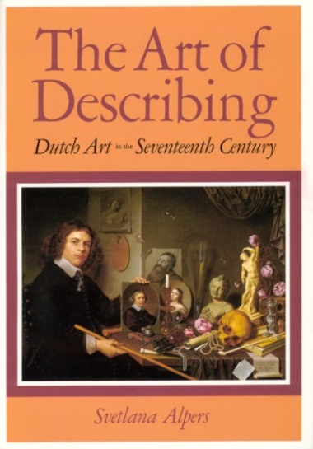

Svetlana Alpers is a distinguished art historian known for her insightful analysis of Dutch art of the seventeenth century. She is particularly renowned for her influential book *The Art of Describing: Dutch Art in the Seventeenth Century*[85]. In addition to that, Alpers is the author of the book *Rembrandt’s Enterprise: The Studio and the Market*[86], published in 1988, which explores the economic and social context of Rembrandt’s art, focusing on his studio practices and interactions with patrons and customers. Alpers has also written extensively on other topics within art history, including landscape painting, the relationship between art and science, and the intersection of art with broader cultural and intellectual movements. Her diverse body of work reflects a deep engagement with the complexities of visual representation and its connections to society, politics, and philosophy. Characteristic of Alpers’s work is her interdisciplinary approach, combining rigorous art historical analysis with insights from cultural studies, sociology, and historical context. Considering the thoughts and approach of Svetlana Alpers is assumed to be crucial when studying the specifics of Dutch painting, especially when comparing it to the Southern style of work. It allows the researcher to go beyond the visuality and gain an insight into the cultural contexts leading towards a deeper understanding.

The visual component of northern art can be significantly different from the southern at first glance. Generally speaking, Dutch paintings can be referred to as primarily sober, simple and realistic, compared to the luxuriance of overflowing forms in the South[87]. Although the focus here is the painting of the 17th century, to understand the difference between Italian and Northern painting, one must look for the beginnings in the 15th century. Peter Bokody talks about the Renaissance as the rebirth of realistic representation[88]. He follows on with an analysis of the three-dimensionality contributing greatly to realism. Although by three-dimensionality and perspective, we understand primarily the domain of Italian painting, the statement does not exclude the ways of realistic depiction in the Northern visual arts. One of the first significant realist works of the Renaissance is considered to be the *Trés Riches Heures du Duc de Berry* by the Limbourg Brothers. What followed in Alpine art after that could be called not only realism but even naturalism and extreme expressionism. This can be evidenced by depictions of Christ’s suffering or old age and death, for example in the *Allegory of Vanity*, attributed to Gregor Erhart (1500). In the book The Northern Renaissance, Jeffrey Chipps Smith deals with the idea not of visuality but of the artist and proposes that the Renaissance is characterized by the appearance of “self-aware artists”[89] represented by Albrecht Dürer (1471–1528), who, not only with his painting skills and innovations in the field of painting but also with his thinking and development of the theory of artistic genius, perfectly demonstrates the spirit of Renaissance thinking[90]. Although representative of northern painting, Dürer’s style of painting has been compared to that of the Florentine architect and theorist Leon Battista Alberti primarily in his attempt to capture perspective with the help of various optical constructions[91].

It is at this very time that there is an effort to integrate the viewer into the depicted scene. „Making the viewer feel they were in the presence of the sitter was an artistic goal of Holbein, Metsys and many of their contemporaries. Renaissance portraiture was pushing the threshold between living fact and pictorial fiction.”[92].

Svetlana Alpers contrasts the Albertian and Keplerian picture modes, which are two distinct ways of representing space in painting. According to Alpers, the Albertian picture mode, which was dominant in the Italian Renaissance, is based on a system of perspective that creates an illusion of depth and space within the painting. The Keplerian picture mode, on the other hand, which is more closely associated with Northern European art, emphasizes the flatness of the picture surface and the individual objects within the painting. Alpers argues that the Albertian picture mode, which is named after the Renaissance artist and theorist Leon Battista Alberti (1404–1472), is characterised by a desire to create the illusion of a three-dimensional space within the painting. This is achieved through the use of linear perspective, which involves the construction of a grid of lines and vanishing points that create the illusion of receding space. The viewer is meant to be drawn into this space, experiencing a sense of depth and immersion in the painting. In contrast, the Keplerian picture mode, named after the astronomer Johannes Kepler (1571–1630), emphasizes the flatness of the picture surface and the individual objects within the painting. This approach rejects the idea of a unified, continuous space within the painting and instead emphasizes the separate and distinct objects that are depicted. The viewer is not meant to be drawn into a unified space but rather is encouraged to focus on the individual objects and their relationships to one another.

Alpers argues that these two picture modes reflect different cultural and artistic traditions. The Albertian picture mode is closely tied to the Italian Renaissance, which was characterised by a renewed interest in classical ideals and a desire to create a new visual language based on mathematical and scientific principles. Besides geometry, Leon Battista Alberti proposes that the artist should have a good notion of ‚historia’, meaning, a painting should represent a window to a world that is, in some sense, rhetorical or fictional, with some sense of beauty and harmony. The Keplerian picture mode, on the other hand, reflects the more individualistic and practical concerns of Transalpine artists, who were less interested in idealised depictions of space and more concerned with representing the world as they saw it.

As the possible main difference between the Albertian and Keplerian picture modes, one might consider imagining Keplerian pictures as a mirror or a lens, whereas Albertian as a window. *The Portrait of Dionysio Miseroni* gives the viewer the impression of a world that continues beyond the canvas. The interior is depicted as it is, as if the author had a mirror according to which he painted the portrait, similarly to a photographic practice. As rightly commented by Johnatan Friday in the *Photography and the Representation of Vision*, the Keplerian picture mode could be viewed as an image, where „someone sets out to paint what she or he sees, quite literally to put onto a flat surface the world just as it appears in his or her visual field”[93]. Contrary to an Albertian picture, which encloses a fictionalised world that can be only viewed into, the Keplerian picture mode is „viewed from the outside but also what is viewed is someone’s viewing”[94]. It can be rightly assumed when looking at Škréta’s portrait that without any difficulty the viewer can imagine themselves or the painter standing in an interior and seeing everything that fits into their field of vision. Wolfgang Kemp goes beyond this notion and develops a study concerning the relationship between the beholder and the painting he or she is looking at. This theory will be discussed further in the following chapter.

When studying literature concerning the Albertian and Keplerian picture modes, one might notice certain signs indicating that the Albertian picture has been considered more valued than the Keplerian. The theory is, that Leon Battista Alberti had a specific vision of what a ‚good’ painting should represent. Johannes Kepler, on the other side, had no such theory and concerned himself with the field of optics. One might consider that as a crucial factor, suggesting that the southern painting, represented by Alberti, had the criteria it was supposed to meet. Since it was a theory of painting, it was valued as a ‚direction’, signifying that paintings which did not meet these criteria could have been labelled as ‚other’, paintings attempting a ‚correct’ depiction according to Alberti’s criteria, but without success. The important factor, however, is Alberti’s concept of a ‚histora’, giving value not only to the use of a perspective in a picture but also to engaging its viewers intellectually through incorporating narrative elements into their works, such as depicting historical events, mythological stories or allegorical themes. Leonardo da Vinci (1452–1519) once made a statement about paintings made in the Keplerian way: „The painter who draws merely by practice and the eye, without any reason, is like a mirror which copies everything placed in front of it, without being conscious of their existence.”[95]. What he means is that the painting is lacking the ‚historia’ that Alberti writes about. It would be difficult to tell whether there is absolutely no ‚historia’ present in Northern paintings. One might argue that Škréta’s portrait of Dionysio Miseroni, similar to younger Dutch group portraits, is not a mere representation of the family members but also indications referring to a certain storyline defining the Miseroni’s everyday life. Therefore, it could be speculative to call the painting neutral and unimaginative, lacking, according to da Vinci, a reason.

The Keplerian picture mode, as described by Svetlana Alpers, has a characteristic of meticulous attention to detail, a focus on accurate representation, and a commitment to objective observation. This picture mode is often referred to as a photographic image in the literature[96]. There is some speculation that in the seventeenth-century painters used some form of photographic apparatus to capture the image, such as the camera obscura or the pinhole camera, although it is believed that none of these apparatus survived from this period[97]. Without going into further detail of the technical means and inventions and their development from the seventeenth to the nineteenth century, it should be noted that this technical approach to painting and the method of visualisation can be considered as very innovative and ahead of its time. When Alpers calls this picture mode after Johannes Kepler, she implements a statement made by the astronomer, who was of the opinion that sight and psychological processes are not pounds to each other, transferring this theory to the understanding of painting, juxtaposing the canvas, the retina of the eye and the predecessors of photographic devices such as the camera obscura, where the reflection of the real world is merely projected. In this regard, the image works, whatever technique it is created with, as an index, and not as an icon or symbol[98], as opposed to the Albertian picture mode. It might occur as almost impossible to picture a world without photography, therefore it should be mentioned that overcoming the idea noted in the previous paragraph discussing the possible incomprehension of Keplerian picture mode and the emergence of photography, as well as its incorporation into the technique of art, might be closely associated.

To conclude this chapter, Svetlana Alpers and her publication *The Art of Describing: Dutch Art in the Seventeenth Century* offers an in depth understanding of the Southern and the Northern visual cultures, based on which the designation of the *Portrait of the Gem-Cutter Dionysio Miseroni and His Family* in the art historical literature has been made. Through her research, Alpers provides art historians with an assistance in classifying Dutch and Italian painting by introducing into the study the historical, social and cultural context, labelling these two streams as Albertian picture mode and Keplerian picture mode and providing their characteristics. Familiarity with her understanding of Dutch painting is crucial for a closer study of Škréta’s portrait and paintings in Keplerian picture mode in general. It is vital above all to understand the connection between these types of images and the theory behind them. However, for the purposes of this thesis, an evaluation of other literature will be appropriate, on the basis of which the individual elements that characterise Keplerian painting and their subsequent comparison with the portrait by Karel Škréta will be brought closer.

# AN ANALYSIS OF THE PORTRAIT IN THE CONTEXT OF WOLFGANG KEMP’S RECEPTION AESTHETICS AND ALOIS RIEGL’S BEHOLDER’S SHARE

Besides Svetlana Alpers’s methodological theories of the Albertian and Keplerian picture modes discussed in the previous chapter, the thesis takes into consideration studies written by Wolfgang Kemp that could provide some explanation regarding perceiving Škréta’s portrait as a Dutch-influenced picture. Wolfgang Kemp (*1946) is a German art historian and author known for his writings on various aspects of art history, particularly focusing on European art of the Renaissance and Baroque periods. His works often delve into the cultural, social, and historical contexts surrounding art movements and individual artists. One of his studies focuses on the subject of Reception Aesthetics[99]. It is a theoretical framework that is, according to Kemp, suitable mainly in literature, but applicable in the visual arts as well. The theory aims to present the importance of the role of the audience or viewer in formulating an interpretation of a particular piece of art, suggesting that the meaning is not solely determined by the intentions of the author but that the role of the spectator should be taken into consideration. Given the circumstances of the determination of Dutch painting in the seventeenth century, such as increased attention to the audience as a result of the art market development, one might understand Dutch paintings as interactive, striving for the active involvement of the viewer, interacting with certain parts of the composition and leaving room for one’s thoughts. Wolfgang Kemp’s Reception Aesthetics presents those individual parts of a composition applied to a Dutch painting by responding and building upon Alois Riegl’s concept of beholder’s share, according to whom, viewers actively participate in the creation of meaning when encountering artworks, influencing their interpretation and emotional response. It is especially beneficial when analysing a work in which multiple figures are depicted, such as group portraits or genre paintings. Therefore, this chapter aims to present the Reception theory, which will be followed by an analysis of Škréta’s painting compared to Dutch portraits through an evaluation of the elements presented by Wolfgang Kemp’s theory. This will be achieved through an analysis of elements that both Kemp and Riegl evaluate when observing Dutch paintings, especially group portraits, which will be followed by their application to the Portrait of the Gem-Cutter Dionysio Miseroni and His Family. Besides an in-depth analysis of the northern elements which are present in Škréta’s portrait, this chapter pursues a more throughout explanation of the painting’s inclusion among Dutch-inspired portraits in order to avoid simply placing it among them on the basis of not meeting the criteria for an Italian-inspired painting.

Before making an analysis of Škréta’s painting in the context of the Reception Aesthetics, it is important to state the individual elements that Kemp presents in his studies. As stated earlier, the theory suggests the importance of the role of the beholder. Instead of considering the mere intention with which the author composes the picture, the viewer of the artwork is here to make his contribution. Kemp suggests the idea of an implicit beholder, to whom the piece has been made. For this, the Reception Aesthetics has three main tasks to complete, which are to show, in what ways the picture communicates with us, to state the sociohistorical context and to state the aesthetical statement[100]. As Kemp proposes, there are several ways, in which the author states his position towards the implicit beholder. First to mention is what is called Digesis, meaning an ‚extensive discussion’ between the depicted figures, which they are leading while omitting the spectator from the conversation[101]. By this, the author states the principal communicators in this situation. Related to this, the second element of a painting discussed by Kemp is a ‚figure of reception’[102], who, on the contrary, is excluded from the action in the painting and is put on the theoretical side of the beholder. They can make eye contact with the spectator, point at him and create a bridge between him and the depicted world. Besides the figures in the picture, Kemp states as 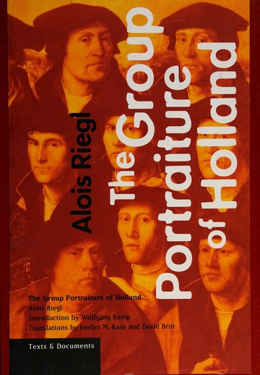an important element the perspective, thanks to which the beholder seemingly belongs to the depicted space as the perspective connects the two worlds in one. The picture can present a mere fragment of the imaginary world and the author, as can be assumed, is faced with the decision of what to present to the viewer from his world; what too is important and what is less, and does not need to fit within the frame. That is how the scene is cropped, and what draws attention to the details in the picture[103]. Lastly, there is what Kemp calls the blank space[104]. That also creates a place that is left unknown to the beholder, although in this case the uncertainty is intentional and constructed by the painter[105]. It would be inaccurate to presume that the Reflection Aesthetics applies only to a certain spatial or temporal limitation in art history and therefore it is important to note that the main area where this theory can be implemented is literature, as Kemp proposes. However, as an example in the Reception Aesthetic, a painting by Nicolas Maes is analysed, moreover, the study *Group Portraiture of Holland* is closely linked to Kemp’s theory, indicating that it might be especially applicable to seventeenth-century Dutch art. It is also an intriguing occurrence that Svetlana Alpers, discussed in the previous chapter, perceives the Dutch visual arts as descriptive, proposing it is particularly close to literary art.

[XVIII] Alois Riegl, The Group Portraiture of Holland, 1999

The first mentions of Reception aesthetics, as described by Kemp, appear in the foreword to Alois Riegl’s *The Group Portraiture of Holland*. Alois Riegl (1858–1905) was an Austrian art historian, who made significant contributions to art history through his pioneering work on the concept of the ‚beholder’s share’ or ‚beholder’s involvement’ by distinguishing the ‚internal coherence’ and the ‚external coherence’. While the internal coherence indicates a composition in which the depicted are gathered in one common action and as a result there are no bridges connecting the painting to the viewer, the external coherence composes the group as unconnected, evolving a dependence on the painting on the viewer, which, according to Riegl, is a tendency noticeable in Dutch group portraiture[106]. Riegl differentiates several periods in the group portraiture: the symbolic period in years 1529–1566, the genre period ongoing between 1580 and 1624 and finally the third time period set in years 1624–1662[107]. In the third period, which covers the time when Škréta painted the *Portrait of the Gem-Cutter*, Riegl identifies a coincidence in the external and internal coherence. Kemp states: „‘Internal coherence’ is created not so much by interlocked motifs of action as through the adroit and sensitive directorial control of eye contact.” And follows by stating that the „gazes of those portrayed no longer meet that of the viewer, as they did in the earlier period; instead, the viewer is enabled to identify with them.”[108]. Leaving aside the impossibility of strictly separating elements appearing in painting according to individual time periods, it can be seen that in Škréta’s portrait, there are noticeable elements of earlier forms of group portraiture, such as a direct eye contact or gestures leading the thoughts of the viewer in a particular way. However, similarities between the portrait of Dionysio Miseroni and the work of Škréta’s contemporaries as well as the shift from the previous tendencies in Dutch portraits are evident.

From Škréta’s contemporaries, one can name for example the work of Tobias Pock (1609–1683) or Jan de Bray (1627–1697), who were active in the creation of family group portraits such as the *Portrait of the Gem-Cutter Dionysio Misseroni and His Family*. When comparing them to the early forms of Dutch group portraiture, there are noticeable differences. Firstly, in the younger portraits, there are less depicted figures that make direct eye contact with the beholder. There can be spotted people whose faces the viewer cannot fully see, such as Marie Ludmila, the wife of Dionysio Miseroni. It can be assumed that this element was what Olga Strettiova was referring to when proposing Škréta’s portrait as not resembling Dutch group portraits precisely[109]. The only depicted figure making eye contact with the beholder is Škréta’s youngest child, Krista Jana Renata, having the role of a Rezeptionsfigur, as termed by Wolfgang Kemp. The overall composition is less formal and amenable to the beholder, figures are composed more naturally compared to the earlier periods, where the depicted often appear in one row or other well- proportioned arrangement. The more natural composition creates space for a depiction of people in the position of a Reflexionsfigur, that is, figures engaging with each other and not necessarily with the viewer himself. Mentioning Strettiova’s opposing opinion in the debate of whether Škréta’s portrait should be classified as „Dutch”, there is another aspect that Riegl mentions. Referring to Svetlana Alpers, Riegl proposes that the nature of Dutch painting is a lack of any action[110]. One might notice that when comparing the depiction of the Miseroni family, for instance, to Tobias Pock’s *Self Portrait with His Family* or paintings of other Škréta’s contemporaries, there is an unusual action as well as interaction between the figures; a son reaching for the crystal vase, a mother talking to her daughter, children interacting with each other. However, it might be argued, that although there is a notable action depicted in Škréta’s painting, it is the components referring to Miseroni’s wealth and signs of prosperity that are being interacted with, the action itself is not the motive.

As Alois Riegl mentions, there is one aspect of Dutch group portraiture, that differentiates it from Italian painting- at first glance, no one is able to tell, who is the leading figure in the portrait, and what is the hierarchy in the depicted group. That being, according to Riegl, there is no action signifying the leader. Setting aside family portraits as every beholder can assume each person’s role and automatically perceive the father as the main figure, there is an element in Dutch portraits that is important to note, that being a given composition of the depicted. The prominent position is mostly the place that is most to the left, or in the left half of the painting. When comparing the portrait of the Miseronis to other group portraits, it can be noticed that the composition of the depicted figures is in agreement. Assuming that Škréta pursued this rule, one might identify the fact, that leftmost is the eldest son of Dionysio Miseroni, Johann Octavius, suggesting that not Dionysio, but the son occupies the most eminent place in the composition. An opposing opinion might be that the face of Johann Octavius is overshadowed and therefore not visible enough, which might leave space for assumptions of considering the second oldest son, Ferdinand Eusebius, having a prominent place. This presumption would be appropriate, given that the second oldest son took over Miseroni’s gem-cutting workshop in the following years.

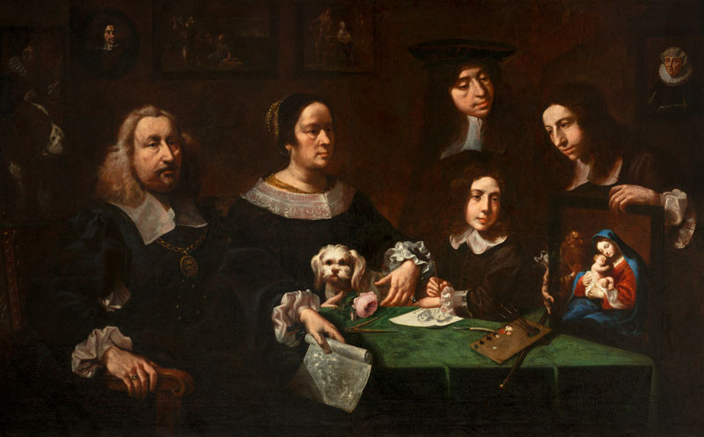

[XIX] Tobias Pock, Self Portrait with His Family, 1683, National Gallery Prague

As suggested by Wolfgang Kemp, a reference to the ancestors in a form of pictures hanging on the wall is quite common in Dutch family portraits[111], which, however, is not the case in the portrait of the Miseroni family. Such element could be, however, found in the self portrait of Tobias Pock and his family, which otherwise exhibits similar features with Škréta’s portrait of Dionysio Miseroni. This is particularly interesting in the case of the Miseroni family, taking into consideration that Dionysio was from the second generation of gem cutters in Prague after inheriting the workshop from his father. On the contrary, there is a visible emphasis on the descendants of the Miseroni’s family.

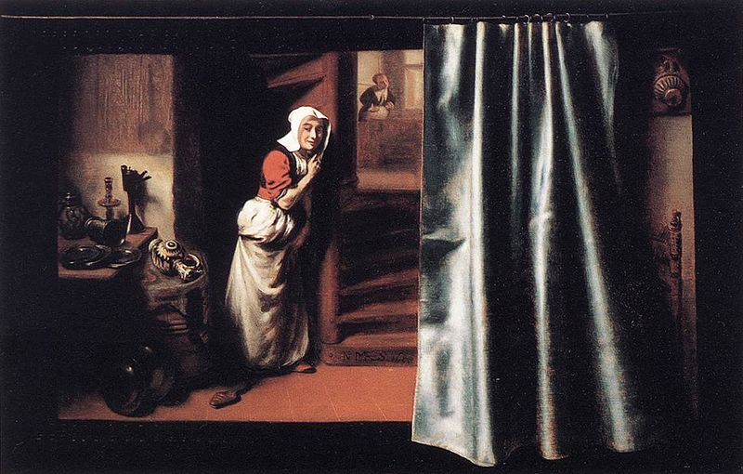

[XX] Nicolaes Maes, The Eavesdropper, 1655, Private collection

Another element whose frequency Riegl mentions when evaluating the Dutch group portraiture is its distinctive scene composition. It is not unusual to find the main motive happening in a window or door in the background[112]. This motive is sometimes accompanied by an illusive curtain. Although there are paintings such as *The Eavesdropper,* painted by Nicolaes Maes (1634–1693) in 1655, where an illusive curtain covers half the image, more common are paintings in which the painted curtain is pulled aside. As Riegl aptly comments, a Baroque painting always submits to the viewer that everything that is depicted is depicted there for them alone. Given the division of the composition of the *Portrait of the Gem-Cutter* into two different scenes- the family and the workshop, the curtain might signify two different worlds, that, although usually divided by a massive curtain, are connected to the beholder just for this one moment, presenting to the visitor the full insight into Dionysio’s life[113].

Both Wolfgang Kemp and Alois Riegl shaped the discipline’s methodology and understanding of artistic production, perception and reception. Riegl’s concept of the beholder’s share can be considered a groundbreaking idea which challenged traditional notions of artistic authorship and highlighted the active role of the viewer in the creation of meaning. Wolfgang Kemp has built upon Riegl’s insights and expanded them in his own theoretical framework. Kemp’s work explores the complex relationship between art and perception, focusing on understanding the ways in which the depicted communicates meaning. Kemp’s Reception Theory suggests that the meaning of a text or artwork is not solely determined by the intentions of the creator or the intrinsic qualities of the work itself, but is co-created through the interaction between the work and its audience. By foregrounding the role of the viewer, Riegl and Kemp are believed to have opened up new avenues for research and dialogue within the field of art history, prompting scholars to consider the ways in which art both reflects and shapes the societies in which it is produced. For the purposes of this thesis, Riegl’s Beholder’s share, as well as Kemp’s theory of Reception Aesthetics, is very beneficial. It allows us to examine more closely the specifics of Dutch painting and to compare the portrait of Dionysio Miseroni with Dutch group portraits based on its criteria and common features. These include the presence of a reception figure, a reflection figure, the so-called place of the unknown and the empty space, omitted by the author on purpose to encourage the viewer to interact with the work. Also mentioned is the use of perspective, the limitations of depicting an action, indicating the importance of people and their hierarchy through their placement on the picture, showing the main plot hidden, or at least partially hidden, the reference to the ancestors and finally the frequent use of an illusory curtain covering a certain part of the work.

# CONCLUSION

The *Portrait of the Gem-Cutter Dionysio Miseroni and His Family* is exceptional for its unusual composition, which often sticks in the memory of the audience. Nevertheless, the specific layout of the image has not yet received closer attention. As professional art historical literature often refers to this painting as a Dutch type of portrait without further explanation or analysis, the aim of this thesis was to address this classification by approaching the specifics of Dutch painting and comparing individual elements, thereby outlining the methodological background of this designation together with an insight into the reasoning behind the statement.

For the purposes of this thesis, the publications of three authors devoted to a thorough understanding of painting were mapped. Firstly, this thesis introduced the book *The Art of Describing* by Svetlana Alpers, which provided an in-depth understanding of the division of the southern and the northern painting compositions, that being the Albertian picture mode and the Keplerian picture mode. Her studies are considered groundbreaking in the field of methodology, as they challenge conventional approaches to art history by advocating for a more focused and rigorous method of analysis. They are especially beneficial for the purposes of this thesis as they provide the reader with guidance in a close examination of the cultural, historical, and social circumstances of each picture mode. However, as it was found out, the publications are seldom taken into account in art historical literature concerning this time period.The examination of Svetlana Alpers’ work was followed by presentations of Wolfgang Kemp’s Reception Aesthetics and Alois Riegl’s The Beholder’s Share, as well as his thorough work *The Group Portraiture of Holland*. Both are considered very beneficial when understanding a portrait, through emphasising the viewer’s role. Building upon Riegl’s Beholder’s share, Kemp presents the theory of the Reception Aesthetics which identifies certain elements such as a reception figure, a reflection figure, the so-called place of the unknown and a space that is left intentionally blank. In the context of this, as well as Riegl’s observed elements common to Dutch portrait praxis, which include limitation of action, depiction of hierarchy, using a view to another scene and an illusory curtain, the *Portrait of the Gem-Cutter Dionysio Miseroni and His Family* was analysed.

To conclude, the Keplerian picture mode as described by Svetlana Alpers as well as Alois Riegl’s observations of Dutch group portraits resonate to great extent with the visual components of Škréta’s portrait of Dionysio Miseroni. Elements of Wolfgang Kemp’s theory of Reception Aesthetics show how extensively the author is initiating communication with the viewer, which is comparable to the specifics of Dutch painting as well.Therefore, individual analyses of Dutch painting as a whole and its individual components and comparisons with elements appearing in the *Portrait of the Gem-Cutter Dionysio Miseroni and His Family* suggest that the painting exhibits similar components to the Late Netherlandish portraits, some of which play a theoretical rather than an aesthetic role. Considering that what is usually referred to as Dutch painting is not characterised merely by visual components, but also by the theory that underpins the mentioned visuality, it is possible to presume that Škréta’s portrait meets the assumptions of methodologists about Dutch painting.

# LIST OF IMAGES

[I] Karel Škréta, *Franz Anton Hovora Count Berka of Dubá and Lipá and Aloisia Ludovica Anna de Montecuccoli as Paris and Helena*, 1672, oil on canvas, 110 × 89 cm. National Gallery Prague. Photo: National Gallery Prague

[II] Karel Škréta, *St Charles Borromeo Visiting Plague Victims in Milan*, 1647, oil on canvas, 210 × 247. 5 cm.National Gallery Prague. Photo: National Gallery Prague

[III] Karel Škréta, *Portrait of the Gem-Cutter Dionysius Miseroni and His Family*, oil on canvas, 1653, 185 × 251 cm. National Gallery Prague. Photo: National Gallery Prague

[IV] Tiberio Tinelli, *Portrait of Karel Škréta*, 1635, oil on canvas, 70 × 53 cm. National Gallery Prague. Photo: National Gallery Prague

[V] Tiberio Tinelli, *Portrait of a Young Medic,* 1636, oil on canvas, 114 × 85 cm. Private collection. Photo: Wikimedia Commons, <https://commons.wikimedia.org/wiki/File:Tiberio_Tinelli_Portrait_eines_jungen_Mediziners.jpg>, researched May 13 2024.

[VI] Bartholomeus Spranger, *Epitaph of the Prague Goldsmith Nicholas Müller*, 1592 – 1593, oil on canvas, 243 × 160 cm. National Gallery Prague. Photo: National Gallery Prague

[VII] Leandro Bassano, *Portrait of Tiziano Aspetti Holding a Statuette*, 1592 – 1593, oil on canvas, 88 × 67. 2 cm. Royal Collection. Photo: Royal Collection, <https://www.rct.uk/collection/405988/portrait-of-tiziano-aspetti-holding-a-statuette>, researched May 13 2024.

[VIII] Bartolomeo Passarotti, *Ritratto dei fratelli Monaldini*, 16th century, oil on canvas, 94 × 150 cm. Lord Linlithgow Collection. Photo: Wikimedia Commons, <https://commons.wikimedia.org/wiki/File:Bartolomeo_Passarotti,_Ritratto_dei_fratelli_Monaldini.png>, researched June 9 2024.

[IX] Domenico Fetti, *Portrait of a Man with a Sheet of Music*, 1620, oil on canvas, 172. 7 × 129. 9 cm. J. Paul Getty Museum. Photo: Wikimedia Commons, <https://de.wikipedia.org/wiki/Datei:Domenico_Fetti_(Italian_-_Portrait_of_a_Man_with_a_Sheet_of_Music_-_Google_Art_Project.jpg>, researched June 10 2024.

[X] Michelangelo Merisi da Caravaggio, *Young Sick Bacchus*, 1593, oil on canvas, 67 × 53 cm. Galleria Borghese. Photo: Wikimedia Commons, <https://cs.wikipedia.org/wiki/Soubor:Young_Sick_Bacchus-Caravaggio_(1593).jpg>, researched June 21 2024.

[XI] Michelangelo Merisi da Caravaggio, *Portrait of a Prelate*, 1592 – 1599, oil on canvas, 68 × 53 cm. Location not known. Photo: Wikimedia Commons, <https://commons.wikimedia.org/wiki/File:Michelangelo_Merisi_da_Caravaggio,_Portrait_of_a_Prelate.jpg?uselang=de>, researched June 21 2024.

[XII] Rembrandt Harmenszoon van Rijn, *Girl in the Window*, 1645, oil on canvas, 81. 8 × 66. 2 cm. Dulwich Picture Gallery. Photo: Wikimedia Commons, <https://commons.wikimedia.org/wiki/File:Rembrandt,_Girl_in_the_Window,_1645,_Dulwich_Picture_Gallery,_London.jpg>, researched 21 June 2024.

[XIII] Frans Hals, *Meeting of the Officers and Sergeants of the Civic Cavalry Guard*, 1633, oil on canvas, 20. 7 × 33. 7 cm. Frans Hals Museum. Photo: Wikimedia Commons, <https://commons.wikimedia.org/wiki/File:Frans_Hals_-_De_officieren_van_de_Sint-Adriaansdoelen.jpg>, researched 21 June 2024.

[XIV] Gerard ter Borch, *The Ratification of the Treaty of Münster, 15 May 1648*, 1648, oil on copper, 45. 4 × 58. 5 cm. Rijksmuseum. Photo: Rijksmuseum, <https://www.rijksmuseum.nl/en/rijksstudio/artists/gerard-ter-borch/objects#/SK-C-1683,0>, researched June 22 2024.

[XV] Matěj Zimprecht, *Karel Kunata Dobřenský from Dobřenice*, 1677, medium not known. Location not known. Photo: Wikimedia Commons, <https://commons.wikimedia.org/wiki/File:Karel_Kunata_Dob%C5%99ensk%C3%BD_z_Dob%C5%99enic.jpg>, researched June 21 2024.

[XVI] Petr Brandl, *Portrait of a Nobleman in a Blue Cloak*, 1710, oil on canvas, 144 × 106.5 cm. National Gallery Prague. Photo: National Gallery Prague

[XVII] Svetlana Alpers, *The Art of Describing: Dutch Art in the Seventeenth Century*, 1983, book cover. Photo: The University of Chicago Press

[XVIII] Alois Riegl, *The Group Portraiture of Holland*, 1999, book cover. Photo: Getty Publications Virtual Library, <https://www.getty.edu/publications/virtuallibrary/089236548X.html>, researched April 12 2024.

[XIX] Tobias Pock, *Self Portrait with His Family*, 1683, oil on canvas, 124 × 198 cm. National Gallery Prague. Photo: National Gallery Prague

[XX] Nicolaes Maes, *The Eavesdropper*, 1655, oil on panel, 46. 3 × 72. 2 cm. Private collection. Photo: Wikimedia Commons, <https://commons.wikimedia.org/wiki/File:Nicolaes_Maes_-_Eavesdropper_with_a_Scolding_Woman_-_WGA13817.jpg>, researched April 12 2024.

# LITERATURE BEFORE 1800

Joachim von Sandrart, *Teutsche Academie der Edlen Bau- Bild- und Mahlerey-Künste*, Nürnberg – Franckfurt 1675.

Jaroslaus Schaller, *Topographie des Königreiches Böhmen, darinn alles Städte, Flecken, Herrschaften, Schlösser, Landgüter, Edelsitze, Klöster [...] beschreiben werden.* Prag – Wien 1787.

# LITERATURE AFTER 1800

Svetlana Alpers, *The Art of Describing: Dutch Art in the Seventeenth Century*, Chicago 1983.

Svetlana Alpers, *Rembrandt’s Enterprise: The Studio and the Market*, Chicago 1988.

Oldřich Jakub Blažíček, *Karel Škréta. Die Familie des Edelsteinschneiders*, Praha 1964.

Peter Bokody, *Images-within-Images in Italian Painting (1250-1350): Reality and Reflexivity*, Burlington 2015.

Jonathan Friday, Photography and the Representation of Vision, *The Journal of Aesthetics and Art Criticism,* Vol. 59, No. 4, Autumn 2001, pp. 351-362.

Michael Fried, *Absorption and Theatricality: Painting and Beholder in the Age of Diderot*, Berkley and Los Angeles 1980.

Teréz Gerszi, *17th-Century Dutch and Flemish Drawings*, Budapest 1976.

Ernst Gombrich, *The Story of Art*, New Jersey 1985.

Ingrid Halászová, *Pred portrétom*, Trnava 2020.

Anděla Horová (ed), *Nová encyklopedie českého výtvarného umění II*, Praha 1995.

Karel Chytil, Dionys Miseroni, Pražský řezač drahokamů, a jeho vztahy k malířům, in: Eugene Vitzhum Bercel, *Maria Etel Guzik Genealogy Book 3*, Naples 2014.

Wolfgang Kemp, *Der Betrachter ist im Bild: Kunstwissenschaft und Rezeptionsästhetik*, Berlin 1992.

Wolfgang Kemp in: Alois Riegl, *The Group Portraiture of Holland,* Los Angeles 1999.

Vincenc Kramář, *Výstava obrazů Karla Škréty* (exh. cat.), Praha 1938.

Blanka Kubíková, *Portrét v renesančním malířství a českých zemích – jeho ikonografie a funkce ve šlechtické reprezentaci*, Praha 2016.

Gilles Lambert, *Caravaggio*, Köln 2005.

Erik Larsen, *Calvinistic Economy and 17th Century Dutch Art,* Kansas 1979.

Wolfgang Lefévre (ed), *Inside the Camera Obscura–Optics and Art under the Spell of the Projected Image,* Berlin 2007.

Louis Marin–Richard Miller (rev.), Svetlana Alpers, *The Art of Describing: Dutch Art in the Seventeenth Century*, Chicago 1983.

Jaromír Neumann, *Karel Škréta (1610 – 1674)* (exh. cat.), Prague 1974.

Jaromír Neumann, *Škrétové. Karel Škréta a jeho syn*, Praha 2000.

Zuzana Macurová – Lenka Stolárová – Vít Vlnas (eds), *Tváří v tvář: Barokní portrét v zemích Koruny české*, Brno 2017.

Gustav E. Pazaurek, *Carl Screta (1610–1674). Ein Beitrag zur Kunstgeschichte des XVII. Jahrhunderts*, Prag 1889.

Matthew Rampley, *The Vienna School of Art History: Empire and the Politics of Scholarship, 1847–1918*, University Park 2013.

Alois Riegl, *The Group Portraiture of Holland,* Los Angeles 1999.

Seymour Slive, *Dutch painting 1600-1800,* New Haven 1995.

Jeffrey Chipps Smith, *The Northern Renaissance*, London 2004.

Lenka Stolárová–Vít Vlnas (eds), *Karel Škréta 1610–1674. Doba a dílo*, (exh. cat.), Praha 2010.

Vít Vlnas – Lenka Stolárová (eds), *Karel Škréta 1610 – 1674 His Work and His Era* (exh. cat.), Praha 2010.

Richard Shone – John-Paul Stonard (eds), *The Books That Shaped Art History: from Gombrich and Greenberg to Alpers and Kraus,* London 2013.

Lenka Stolárová–Vít Vlnas (eds), *Karel Škréta 1610–1674. Studies and Documents*, Praha 2011.

Lenka Stolárová–Kateřina Holečková (eds), *Karel Škréta (1610–1674). Dílo a doba. Studie, dokumenty, prameny*, Praha 2013.

Olga Strettiova, *Baroque Portraits,* London 1960.

Michal Šroněk, *Jan Jiří Heinsch (1647 – 1712). Malíř barokní zbožnosti*, Exhibition catalogue, Praha 2006.

Štěpán Vácha – Radka Heisslerová, *Ve stínu Karla Škréty*, Praha 2017.

Vít Vlnas (ed), *Sláva barokní Čechie: Stati o umění, kultuře a společnosti 17. a 18. Století*, (exh. cat.), Praha 2001.

Jana Zapletalová, Škréta, Sandrart, Oretti: poznámka ke Škrétovu působení v Itálii, *Umění LVII*, 2009, pp. 398–402.

Petra Zelenková (ed), *Karel Škréta a univerzitní teze v českých zemích*, Praha 2023.

# MASTER THESES AND DISSERTATIONS

Jasmine Böhm, *The provocation in art as a political and social act with a focus on Iran* (master thesis), Universidade de Coimbra, Colégio das Artes, Coimbra 2018.

Marie Opatrná, Umělecká tvorba malíře Jana Jiřího Heringa (dissertation), Ústav dějin křesťanského umění KTF UK, Praha 2011.

# INTERNET SOURCES

Katie Brooke Frazier, We are the Reckless, We are the Wild Youth: Decadence and Debauchery in the Art of the Utrecht Caravaggisti, *University of Mary Washington*, https://scholar.umw.edu/cgi/viewcontent.cgi?article=1020&context=student_research, researched May 12, 2024.

ANNOTATION

|  |  |
| --- | --- |
| Author | Natálie Trtíková BA |
| Faculty | Faculty of Arts, Palacký University Olomouc |
| Department | Department of Art History |
| Supervisor | prof. Mgr. Ondřej Jakubec, Ph.D. |
| Title of the thesis | Portrait of the Gem-Cutter Dionysio Miseroni and His Family: A Painting in Context of the Twentieth-Century Methodology |
| Title of the thesis in Czech | Podobizna řezače drahokamů Dionysia Miseroniho a jeho rodiny: obraz v kontextu metodologie 20. století |
| Annotation of the thesis | This bachelor’s thesis focuses on the Portrait of the Gem-Cutter Dionysius Miseroni and his family by Karel Škréta. In addition to the art-historical description, the work aims to outline a methodological analysis of the painting using the literature of Svetlana Alpers, Wolfgang Kemp and Alois Riegl. The thesis responds to the existing literature devoted to this portrait. Since the description often includes an assignment to a Dutch or Italian painting, the text includes an evaluation of the Albertian and Keplerian type of painting according to Svetlana Alpers. Furthermore, the thesis deals with the elements of Dutch painting described first by Alois Riegl and later by Wolfgang Kemp, who in this respect focuses on the relationship between the painting and the viewer. The main objective of this thesis is to initiate the use of methodological texts in art-historical practice in order to provide a more complex perspective on specific works. |
| Annotation of the thesis in Czech | Tato bakalářská práce se zaměřuje na Podobiznu řezače drahokamů Dionysia Miseroniho a jeho rodiny od Karla Škréty. Kromě uměleckohistorického popisu si práce klade za cíl představit metodologickou analýzu obrazu za použití literatury Svetlany Alpers, Wolfganga Kempa a Aloise Riegla. Bakalářská práce reaguje na dosavadní literaturu věnující se tomuto obrazu. Jelikož v popisu mnohdy figuruje přiřazení k holandské, případně italské malbě, zahrnuje text zhodnocení Albertiánského a Kepleriánského typu obrazu podle Svetlany Alpers. Dále se práce zabývá prvky holandské malby popsaných nejprve Aloisem Rieglem a poté na něj navazujícím Wolfgangem Kempem, který se v tomto ohledu zaměřuje na vztah obrazu a diváka. Hlavním cílem této práce je podnítit využití metodologických textů v uměleckohistorické praxi s cílem poskytnout komplexnější pohled na konkrétní díla. |
| Number of pages | 51 |
| Number of characters in the main text, including breaks | 90,245 |
| Number of pictures attached | 20 |
| Key words | Baroque portraits, Methodology, Albertian picture mode, Keplerian picture mode, Reception Aesthetics, Beholder's Share |
| Language of the thesis | English |

1. Matthew Rampley, *The Vienna School of art history: empire and the politics of scholarship, 1847–1918*, University Park 2013, pp. 1 – 8.
2. Alois Riegl, *The Group Portraiture of Holland,* Los Angeles 1999., The book was originally published in 1902 and later with the foreword written by Wolfgang Kemp, in 1999.
3. Svetlana Alpers, *The Art of Describing: Dutch Art in the Seventeenth Century*, Chicago 1983, pp. 26 – 71.
4. The book was originally published in 1983, and later, with the foreword written by Wolfgang Kemp, in 1998, pp. 1 – 19.
5. Wolfgang Kemp, *Der Betrachter ist im Bild: Kunstwissenschaft und Rezeptionsästhetik*, Berlin 1992.
6. Michael Fried, *Absorption and Theatricality: Painting and Beholder in the Age of Diderot*, Berkley and Los Angeles 1980., In this publication, Michael Fried focuses on the relationship between the image and the viewer with an emphasis on French painting of the 18th century.
7. Joachim von Sandrart, *Teutsche Academie der Edlen Bau- Bild- und Mahlerey-Künste*, Nürnberg – Franckfurt 1675.
8. Jaroslaus Schaller, *Topographie des Königreiches Böhmen, darinn alles Städte, Flecken, Herrschaften, Schlösser, Landgüter, Edelsitze, Klöster [...] beschreiben werden*. Prag – Wien 1787.
9. Gustav E. Pazaurek, *Carl Screta (1610–1674). Ein Beitrag zur Kunstgeschichte des XVII. Jahrhunderts*, Prag 1889. It was a published dissertation written in 1888 by Gustav E. Pazurek at the faculty of arts of the German University in Prague. In his dissertation, Pazurek evaluates Škréta's painting skills with a considerable amount of criticism. The monograph provoked many reactions from Czech scholars, one of whom was Jaromír Neumann, who criticised Pazaurek's research in the catalogue of the National Gallery exhibition from 1974. Jaromír Neumann, *Karel Škréta 1610 – 1674* (exh. cat.), National Gallery in Prague 1974, p. 11.
10. Štěpán Vácha – Radka Heisslerová, *Ve stínu Karla Škréty*, Praha 2017, p. 26.
11. Vincenc Kramář, *Výstava obrazů Karla Škréty* (exh. cat.), Praha 1938.
12. Jaromír Neumann, *Karel Škréta (1610 – 1674)* (exh. cat.), National Gallery in Prague 1974., Jaromír Neumann, *Škrétové. Karel Škréta a jeho syn*, Praha 2000.
13. Štěpán Vácha – Radka Heisslerová, *Ve stínu Karla Škréty*, Praha 2017, p. 26.
14. Jaromír Neumann, *Škrétové. Karel Škréta a jeho syn*, Praha 2000, p. 6.
15. Jaromír Neumann, *Škrétové. Karel Škréta a jeho syn*, Praha 2000, p. 71.
16. Olga Strettiova, *Baroque Portraits,* London 1960, unnumbered. The book was first published in 1957 in Prague. Although Olga Strettiova’s publication can be considered as valuable, as it was elaborated on in later literature dealing with this topic, it should be emphasized in the context of an evaluation of Karel Škréta’s painting that the main focus of Pujmanova-Strettiova is Italian painting. In addition to comprehensive publications on the subject, she is also the author of texts on Girolamo Romanino, Cosimo Roselli, or Paolo da Visso.
17. Oldřich Jakub Blažíček, *Karel Škréta. Die Familie des Edelsteinschneiders*, Praha 1964., Oldřich Jakub Blažíček, *Umění baroku v Čechách*, Praha 1971.
18. Zdeněk Hojda, *Švédové před Prahou a Karel Škréta*, in: Lenka Stolárová (ed), *Karel Škréta a malířství 17. Století v Čechách a v Evropě*, Praha 2010.
19. Jana Zapletalová, Škréta, Sandrart, Oretti: poznámka ke Škrétovu působení v Itálii, *Umění LVII*, 2009, pp. 398–402.
20. Lenka Stolárová – Vít Vlnas (eds), *Karel Škréta 1610–1674. Doba a dílo*, (exh. cat.), Praha 2010.
21. Lenka Stolárová – Vít Vlnas (eds), *Karel Škréta 1610–)1674. Studies and Documents*, Praha 2011.
22. Lenka Stolárová – Kateřina Holečková (eds), *Karel Škréta (1610–1674). Dílo a doba. Studie, dokumenty, prameny*, Praha 2013.
23. Štěpán Vácha – Radka Heisslerová, *Ve stínu Karla Škréty*, Praha 2017.
24. Petra Zelenková (ed), *Karel Škréta a univerzitní teze v českých zemích*, Praha 2023.
25. Vít Vlnas (ed), *Sláva barokní Čechie: Stati o umění, kultuře a společnosti 17. a 18. Století*, (exh. cat.), Praha 2001.
26. Zuzana Macurová – Lenka Stolárová – Vít Vlnas (eds), *Tváří v tvář: Barokní portrét v zemích Koruny české*, Brno 2017.
27. Blanka Kubíková*, Portrét v renesančním malířství a českých zemích – jeho ikonografie a funkce ve šlechtické reprezentaci*, Praha 2016.
28. Ingrid Halászová, Pred portrétom, Trnava 2020.
29. Marcela Vondráčková, Portrait of the Gem-Cutter Dionysius Miseroni and His Family, 1653, in Vít Vlnas – Lenka Stolárová (eds), *Karel Škréta 1610 – 1674 His Work and His Era* (exh. cat.), Praha 2010, pp. 290 – 291., It is an example of this opinion occuring in more recent literature.
30. Jaromír Neumann, *Škrétové. Karel Škréta a jeho syn*, Praha 2000, pp. 71 – 72.
31. Lenka Stolárová – Vít Vlnas, Artist and a Man in a Time of Transition, in Lenka Stolárová – Vít Vlnas (eds), *Karel Škréta 1610–1674. His Work and His Era*, (exh. cat.), Praha 2010, p. 17.
32. Account officer.
33. Ibidem.
34. Ibidem, p. 18.
35. 1618 – 1648.
36. Sylva Dobalová – Lubomír Konečný in: Lenka Stolárová – Vít Vlnas (eds), *Karel Škréta 1610–1674. Doba a dílo*, (exh. cat.), Praha 2010, p. 29.
37. Ibidem.
38. Michal Šroněk, ‘Škréta‘, in Anděla Horová (ed), *Nová encyklopedie českého výtvarného umění II*, Praha 1995, p. 830.
39. An author of drawings.
40. Petra Zelenková (ed), *Karel Škréta a univerzitní teze v českých zemích*, Praha 2023.
41. The painting is dated to 1653. Its dimensions are 185 x 251 cm. It is an oil painting on canvas and it currently belongs to the Old Masters collection in the Schwarzenberg Palace in the National Gallery in Prague.
42. Dionysio's son from the first marriage (1630-1690).
43. Dionysio's son from the first marriage (1639-1684).
44. Marie Ludmila nee Majorová from Grosenava (1621-1667).
45. Dionysio's daughter from the second marriage (1648-1667).
46. Dionysio's daughter from the second marriage, whose effigy was, as discovered in 2001, to have been painted later.
47. Dionysio's son from the first marriage (1644-1661), about whose disproportionately large head there is frequent speculation in the art historical literature; a frequent comment is a possible physical disability of the boy, a change in the composition of the picture or the need to finish the picture in a short time, which accidentally caused the disproportion, however, what could be also taken into account is similarly disproportionately large head of a man in the background, which could signify a certain specific Škréta’s style.
48. Dionysio's son from the second marriage (1647-1717).
49. Marcela Vondráčková, Portrait of the Gem-Cutter Dionysius Miseroni and His Family, 1653, in Vít Vlnas – Lenka Stolárová (eds), *Karel Škréta 1610 – 1674 His Work and His Era* (exh. cat.), Praha 2010, pp. 290 – 291.
50. Marcela Vondráčková, Portrait of the Gem-Cutter Dionysius Miseroni and His Family, 1653, in Vít Vlnas – Lenka Stolárová (eds), *Karel Škréta 1610 – 1674 His Work and His Era* (exh. cat.), Praha 2010, pp. 290 – 291.
51. Jaromír Neumann, *Škrétové. Karel Škréta a jeho syn*, Praha 2000, pp. 71 – 72.
52. Olga Strettiova, *Baroque Portraits,* London 1960, unnumbered.
53. Ibidem.
54. Jaromír Neumann, *Škrétové. Karel Škréta a jeho syn*, Praha 2000, p. 26.
55. Ibidem.
56. The group was called the Bent or Schilderbent, Dutch for „Band of Painters“, whose members were referred to as Bentweughels, Dutch for „Gang of Birds“ and at one point in history, the association was also called Bohemians.
57. Jasmine Böhm, *The provocation in art as a political and social act with a focus on Iran* (master thesis), Universidade de Coimbra, Colégio das Artes, Coimbra 2018, p. 19.
58. Seymour Slive, *Dutch painting 1600-1800*, New Haven 1995, p. 234.
59. The association was prohibited by a papal decree in 1720 as their ceremonies were interpreted as a mockery of the sacrament of baptism. Ibidem, p. 235.
60. Jaromír Neumann, *Škrétové. Karel Škréta a jeho syn*, Praha 2000. p. 32.
61. Ibidem, p. 71.
62. Ibidem, p. 72.
63. Karel Chytil, Dionys Miseroni, Pražský řezač drahokamů, a jeho vztahy k malířům, in: Eugene Vitzhum Bercel, *Maria Etel Guzik Genealogy Book 3*, Naples 2014, p. 155.
64. Schatzmeister, Karel Chytil, Dionys Miseroni, Pražský řezač drahokamů, a jeho vztahy k malířům, in: Eugene Vitzhum Bercel, *Maria Etel Guzik Genealogy Book 3*, Naples 2014, p. 155.
65. Ibidem, p. 156.
66. Jaromír Neumann, *Škrétové. Karel Škréta a jeho syn*, Praha 2000, p. 38.
67. Ibidem, p. 40.
68. Karel Chytil, Dionys Miseroni, Pražský řezač drahokamů, a jeho vztahy k malířům, in: Eugene Vitzhum Bercel, *Maria Etel Guzik Genealogy Book 3*, Naples 2014, p. 169.
69. Olga Strettiova, *Baroque Portraits,* London 1960, unnumbered.
70. Ibidem, unnumbered. From this period, for example, 21 portrait busts by Petr Parléř, which are located in the inner triforium of the Cathedral of St. Vitus in Prague.
71. Ibidem, unnumbered. During the reign of Rudolph II, the prominent portraitist Bartholomeus Spranger, who was born in Antwerp but studied in Italy, worked in Bohemia. in addition to his Self-portrait, for example, his Portrait of Zdeněk Vojtěch of Lobkovice, Portrait of the artist's wife Kristina, née Müllerová, and Painting on the tomb of the goldsmith Müller are known. Another example is Hans von Aachen, who was born in Cologne and also studied in Italy. He is the author of portraits of Rudolph II, Kryštof of Lobkovice junior, and painted the Portrait of a young man in a dark dress. The third painter worth mentioning is Josef Heinz, who came from Basel and worked in Italy for Corregio and Parmiggianino and also, like Hans von Aachen, painted portraits of Rudolph II.
72. Olga Strettiova, *Baroque Portraits,* London 1960, unnumbered.
73. Author not given, Ve válce a v míru, Štěpán Vácha – Radka Heisslerová, *Ve stínu Karla Škréty*, Praha 2017, pp. 41 – 65, esp. p. 42.
74. Gilles Lambert, *Caravaggio*, Köln 2005, p. 23.
75. Caravaggio’s paintings with religious themes are known, for which he chooses an unprecedented setting, for example, he paints the Death of the Virgin (1604–1606) as a night scene, the same with the Ecstasy of St. Francis (1595) . Although it was an unconventional painting that was characteristic of Caravaggio, it was precisely his way of painting that was later used to emphasize the drama of the triumph of the Catholic faith. The use of chiaroscuro in Catholic subjects following the example of Caravaggio appears extensively in Škréta’s work, for example in the paintings Our Lady of Sorrows (1670–1674), Crucifixion (1670), and The Lamentation (1673–1674).
76. Petr Přibyl, Karel Škréta in Italy, in Lenka Stolárová – Vít Vlnas (eds), *Karel Škréta 1610–1674. Doba a dílo* (exh. cat.), Praha 2010, p. 99.
77. Katie Brooke Frazier, We are the Reckless, We are the Wild Youth: Decadence and Debauchery in the Art of the Utrecht Caravaggisti, *University of Mary Washington*, https://scholar.umw.edu/cgi/viewcontent.cgi?article=1020&context=student_research, researched May 12, 2024, p. 2. They were assumed to bring Caravaggio’s chiaroscuro to the Netherlands, however, as Frazier proposes, in 1532, Jan Cornelisz Vermeyen (1503 – 1559) painted his Marriage at Cana, where he anticipated Caravaggio’s use of light and shadow in the night scene.
78. It is believed that these were artists who came to Rome to get inspiration, so they mostly devoted themselves to drawing, and based on their preparations, they painted only after returning to Holland. Teréz Gerszi, *17th-Century Dutch and Flemish Drawings*, Budapest 1976.
79. Alois Riegl, *The Group Portraiture of Holland,* Los Angeles 1999.
80. Marie Opatrná, *Umělecká tvorba malíře Jana Jiřího Heringa* (dissertation), Ústav dějin křesťanského umění KTF UK, Praha 2011, pp. 184 – 185.
81. Štěpán Vácha – Radka Heisslerová, *Ve stínu Karla Škréty*, Praha 2017, pp. 95 – 98.
82. Ibidem, p. 130.
83. Ibidem, p. 31.
84. Michal Šroněk, *Jan Jiří Heinsch (1647 – 1712). Malíř barokní zbožnosti* (exh. cat.), Praha 2006, p. 143.
85. Svetlana Alpers, *The Art of Describing: Dutch Art in the Seventeenth Century*, Chicago 1983.
86. Svetlana Alpers, *Rembrandt's Enterprise: The Studio and the Market*, Chicago 1988.
87. Erik Larsen, *Calvinistic Economy and 17th Century Dutch Art,* Kansas 1979, p. 3.
88. Peter Bokody, *Images-within-Images in Italian Painting (1250-1350): Reality and Reflexivity*, Burlington 2015, p. 1.
89. Jeffrey Chipps Smith*, The Northern Renaissance*, London 2004, p. 15.
90. Ibidem, p. 277.
91. Ibidem, p. 278.
92. Ibidem, p. 286.
93. Jonathan Friday, Photography and the Representation of Vision, *The Journal of Aesthetics and Art Criticism,* Vol. 59, No. 4, Autumn 2001, pp. 351-362.
94. Ibidem.
95. Jonathan Friday, Photography and the Representation of Vision, *The Journal of Aesthetics and Art Criticism,* Vol. 59, No. 4, Autumn 2001, pp. 351-362., esp. p. 356
96. Louis Marin – Richard Miller (rev.), Svetlana Alpers, *The Art of Describing: Dutch Art in the Seventeenth Century*, Chicago 1983, p. 104.
97. Wolfgang Lefévre (ed), *Inside the Camera Obscura – Optics and Art under the Spell of the Projected Image,* Berlin 2007, p. 6.
98. This division was proposed by C. S. Peirce, who calls photographs instructive as they are exactly like the objects they represent. It was followed by Notes on the Index: Seventies Art in America. Part 2 by Rosalind Krauss.
99. The Reception Aesthetics is also known as Reception Theory or Aesthetics of Reception.
100. Wolfgang Kemp, *Der Betrachter ist im Bild: Kunstwissenschaft und Rezeptionsästhetik*, Berlin 1992, p. 183.
101. Reflexionsfigur.
102. Rezeptionsfigur.
103. Unbestimmtheitsstelle.
104. Leerstelle.
105. Wolfgang Kemp, *Der Betrachter ist im Bild: Kunstwissenschaft und Rezeptionsästhetik*, Berlin 1992, p. 188.
106. Wolfgang Kemp in: Alois Riegl, *The Group Portraiture of Holland,* Los Angeles 1999, p. 13.
107. Ibidem, p. 14.
108. Ibidem, p. 14.
109. Olga Strettiova, *Baroque Portraits,* London 1960, unnumbered.
110. Alois Riegl, *The Group Portraiture of Holland,* Los Angeles 1999, p. 41.
111. Wolfgang Kemp in: Alois Riegl, *The Group Portraiture of Holland,* Los Angeles 1999, p. 37.
112. Alois Riegl, *The Group Portraiture of Holland,* Los Angeles 1999, p. 274.
113. Ibidem.