Czech University of Life Sciences Prague

Faculty of Economics and Management

Department of management

Master's Thesis

Financial Analysis of the business organization: ŠKODA AUTO

Myat Shwe Yee Thit

© 2023 CZU Prague

Declaration

I declare that I have worked on my master's thesis titled "Name of the master's thesis" by myself and I have used only the sources mentioned at the end of the thesis. As the author of the master's thesis, I declare that the thesis does not break any copyrights.

In Prague on date of submission ___________________________

Acknowledgement

I would like to thank name of the supervisor and all other persons, for their advice and support during my work on this thesis.

Financial Analysis of the business organization: ŠKODA AUTO

Abstract
The current thesis holds significance because it highlights the importance of financial analysis in an organization. Conducting financial analysis enables financial analysts and investors to review important statements, which can help them make better investment decisions. Financial analysis is not only important for financial statements, but also for strategic decision-making within a business. This is because it provides detailed information on profits, losses, revenues, and sales, which can be used to predict future performance and make decisions for improving business performance. The thesis focuses on the financial analysis of a selected company using a systematic literature review analysis based on sales revenues figures, to identify the strengths and weaknesses and provide relevant research outcomes. To ensure authenticity and reliability, secondary sources were used. Given the pandemic's impact on business stability, it is essential to conduct financial analysis in recent years to make comparisons and find solutions to major fluctuations. This can help businesses maintain stability in the marketplace.
Positivism is the selected research philosophy and deductive is an applied research approach. Moreover, quantitative mono method is followed as research choice and systematic literature review is decided to be as research strategy. Furthermore, secondary research data collection is chosen for the current study and financial ratios, vertical analysis, horizontal analysis, common size statement, cash flow statement and trend analysis are being used for data analysis.
Skoda auto has faced various different challenges during the last recent years which includes in the decrement of the revenue and profitability. But the company has still maintained its strong liquidity position and also has continued to invest in the department of research and development. Moreover, apart from all the challenges, the company was still able to maintain its number of market share in many of the different regions. The recent previous years has resulted in suffering of the major challenges by the Skoda auto and also the entire automotive industry as a whole. Although the company has put their efforts in implementing several Strategies for better mitigation their pitfalls for example diversifying their supply chain and also diversifying their products portfolio as well. They have also adopted the different types of digital tools to overcome the challenges like remote collaboration and also focusing on the electric and hybrid vehicles for better meeting up the change in demands of the customers.
Keywords: financial, analysis, business, organization, pitfalls, recommendations, ŠKODA AUTO, Automobile, manufacturer

Title of Master's Thesis in Czech

Abstrakt

Summary in the Czech language (approx. 15 lines).

Klíčová slova: Keywords in the Czech language (approx. 10)

Table of Contents
Abstract 4
Table of Contents 6
List of figures 8
List of tables 9
Chapter 1: Introduction 10
1.1 Research background and rationale 10
1.2 Research Aim 12
1.3 Research Objectives 12
1.4 Research Questions 12
1.5 Methodology outline 12
1.6 Research Scope and significance 13
1.7 Anticipated outcome 14
1.8 Research chapter structure 14
Chapter 2: Literature Review 16
2.1 Concept of financial analysis 16
2.2 Needs of conducting financial analysis 18
2.3 Methods of conducting financial analysis 20
2.4 Impact of financial analysis on business organization 24
Chapter 3: Research methodology 27
3.1 Research onion framework (Theoretical part) 27
3.1.1 Research philosophy 27
3.1.2 Research approach 28
3.1.3 Research strategy 28
3.1.4 Research choice 29
3.1.5 Research data collection 29
3.1.6 Research data analysis 30
3.1.7 Research time horizon 30
3.1.8 Research ethics 30
3.1.9 Research gaps 31
3.1.10 Research limitations 31
3.2 Systematic literature review 33
3.2.1 Research question (PICO table) 33
3.2.2 Preliminary research 35
3.2.3 Inclusion and exclusion criteria 36
3.2.4 Search strategy 37
3.2.5 Searching databases 38
3.3 Financial analysis (Practical part) 38
3.3.1 Liquidity Ratios 38
3.3.2 Solvency Ratios 39
3.3.3 Profitability Ratios 39
3.3.4 Vertical analysis 40
3.3.5 Horizontal analysis 40
3.3.6 Trend analysis 41
3.3.7 Cash flow statement 41
3.3.9 Common size statement 41
Chapter 4: Data collection and analysis 43
4.1 Financial ratios 43
4.2 Vertical analysis 52
4.3 Horizontal analysis 53
4.4 Common size statement 56
4.5 Cash flow statement 57
4.6 Trend analysis 61
Chapter 5: Findings and discussions 67
5.1 Financial analysis of ŠKODA AUTO during last recent years 67
5.2 Pitfalls faced by the company during last recent years 69
5.3 Future recommendations for overcoming the pitfalls 70
5.4 Future recommendations for grabbing the opportunities in the marketplace 72
Chapter 6: Conclusion 74
References 80

List of figures
Figure 1: Financial statement analysis process 16
Figure 2: Financial statement frameworks 17
Figure 3: Importance of financial reporting 18
Figure 4: Objectives financial statement analysis 19
Figure 5: Users of financial statements 20
Figure 6: Tools of financial statement analysis 20
Figure 7: Ratio analysis formula 21
Figure 8: Trend analysis formula 21
Figure 9: ratio analysis comparisons 22
Figure 10: Common size financial statement 23
Figure 11: Statement of cash flows 23
Figure 12: Organizational climate and performance 24
Figure 13: Factors of company comparison 25
Figure 14: Financial analyst 26
Figure 15: Research onion model 27
Figure 16: Cash flow statement of 2020 57
Figure 17: Cash flow statement of 2022 59
Figure 18: Financial results with record deliveries and sales revenue in 2018 61
Figure 19: Financial results with record deliveries and sales revenue in 2020 62
Figure 20: Financial results with record deliveries and sales revenue in 2021 65
Figure 21: Financial results with record deliveries and sales revenue in 2022 66
Figure 22: Financial analysis of ŠKODA AUTO during last 3 years 67

List of tables
Table 1: PICO table of aim 33
Table 2: PICO table of RQ1 34
Table 3: PICO table of RQ2 34
Table 4: PICO table of RQ3 35
Table 5: Inclusion and exclusion criteria 37
Table 6: Current ratio 43
Table 7: Quick ratio 44
Table 8: Debt to equity ratio 45
Table 9: Debt to asset ratio 46
Table 10: Gross profit margin 47
Table 11: Operating profit margin 48
Table 12: Net profit margin 49
Table 13: Return on assets 50
Table 14: Return on equity 51
Table 15: Vertical analysis 52
Table 16: Horizontal analysis 54
Table 17: Common size statement 56

Chapter 1: Introduction

1.1 Research background and rationale
Financial analysis is defined as the procedure which helps in evaluating the business and projects along with the budgets and also the other financial associated transactions for determining the suitability and performance of the company (Chadima, 2021). Financial analysis conducted of a particular company is used to undertake analysis to decide whether the entity has stability or is solvent or liquid or maybe profitable enough to warrant the money investment. This is a type of analysis that is performed by professionals who generally prepare financial reports with the help of ratios and other methods so that the information can be used in the proper systematic financial statements. There is a high requirement and need to conduct the financial analysis (Bokšová and Horák, 2019). This is because it helps in providing better decision-making to decide about the stability and solvency of the entity along with its liquidity and profitability following the money investment done by the company. This is a type of analysis that helps in evaluating the trends of the economy and also supports setting up the financial policy. It is further needed in building up long-term plans for business activities and also for the identification of profitable projects or investments (Deshmukh and Tharkude, 2023). It is highly required by the internal as well as external management of the company to analyze the financial statements. These are the people who include the analyst and creditors along with the investors.
The current thesis is based on the automobile manufacturer company named Skoda Auto. It is a multinational automobile manufacturing company established in 1925 and headquartered in the Czech. It manufactures different cars and vehicles along with its production and selling with its brand name. Skoda Auto has faced various fluctuations in its financial statements in the last recent years. The current study have calculated and analysed their finances using different methods of financial analysis (KUČERA and TICHÁ, 2022). These are the approaches to the financial statements analysis such as the horizontal analysis and vertical analysis along with the ratio analysis and trend analysis and also volume profit analysis as well. It is important to conduct the current study because it will help in understanding the different methods of financial analysis and also to find out the pitfalls experienced by the company since the last recent years (Gao, 2019). The last recent years were of pandemic where the coronavirus pandemic 2019 is a disease that spreads in a communicable form. It is such a deadly disease that the government has even announced the lockdown in different nations and also social distancing as well. The reason is that there was a high rate of deaths and the people who are in contact are the victim of it. This entire situation has resulted in the breakdown of several businesses in which the companies have suffered losses and also even the shutdown as well (Fava, 2021). Several businesses have faced large fluctuations in their financial statements during the last recent years of pandemic.
The reason behind evaluating all such areas is so that future solutions can be recommended to the company in the form of research outcomes. The following research will answer the research questions by conducting a financial analysis using the financial statements of the company for different years with the help of systematic literature review. Hence the main goal or purpose of the thesis is to conduct the financial analysis of the selected company since the last recent years for the examination of the pitfalls to provide future recommendations to the company (Svobodová and Bednarska-Olejniczak, 2021). It includes the understanding of the concepts and needs of conducting the financial analysis and also exploring the methods of financial analysis as well.

1.2 Research Aim
To conduct a financial analysis of the business organization for examining pitfalls and providing future recommendations: A study on ŠKODA AUTO (Automobile manufacturer)

1.3 Research Objectives
- To understand the concept, need and methods of conducting financial analysis and its impact on business organization
- To conduct the financial analysis of ŠKODA AUTO for determining the pitfalls faced by the company
- To provide future recommendations for overcoming the pitfalls and for grabbing the opportunities in the marketplace

1.4 Research Questions
RQ1: What is the concept, need and methods of conducting financial analysis and its impact on business organization?
RQ2: How to conduct the financial analysis of ŠKODA AUTO for determining the pitfalls faced by the company?
RQ3: What can be the future recommendations for overcoming the pitfalls and for grabbing the opportunities in the marketplace?

1.5 Methodology outline
Positivism is the selected research philosophy and deductive is an applied research approach. Moreover, quantitative mono method is followed as research choice and systematic literature review is decided to be as research strategy. Furthermore, secondary research data collection is chosen for the current study and financial ratios, vertical analysis, horizontal analysis, common size statement, cash flow statement and trend analysis are being used for data analysis.

1.6 Research Scope and significance
The current thesis has the scope to the reader and investigator along with the company based on which the research is conducted. The scope to the reader is such that the reader may be able to understand the importance of financial analysis and how it can be conducted accurately for a specific company (Hornungová and Milichovský, 2019). This is because the current report contains several academic and financial analyses (deliveries and sales revenues, financial ratios) to answer the research questions. This will help the reader in clarifying the research outcomes and recommendations as well. The scope of the investigator is such that it will help in undertaking future thesis based on the same topic but with a different company so that comparisons among the different companies can be made of the same industry. These comparisons may help the investigator to find out the research outcomes in a broader manner as compared to the narrow view. The scope of the company is such that it will help the company in analyzing its pitfalls in the recent different years (Krabec and Čižinská, 2020). This analysis will help in implementing the recommended solutions and the thesis for a better future and profitable business. Hence it can be said that the current thesis has great scope in the new future and to the different people associated with the investigation.
The significance of the current thesis is related to the importance of financial analysis. The reason is that financial analysis is significant to conduct in the organization so that its important statements can be reviewed by the financial analyst and investors to better invest in the company (Čizinská and Neset, 2021). Financial analysis is not only significant for the financial statements but also for the entire company to make strategic decision-making within the business. The reason is that the company comes to know about the losses and profits along with the revenues and sales in a very in-depth manner. This further helps in the future prediction that ultimately supports and makes the decisions for the improvement of the business performance (Bohata and Zemplinerova, 2019). Hence the current thesis is significant because it is entirely based on the financial analysis of the selected company with the help of systematic literature review analysis based on the deliveries and sales revenues figures so that merits and demerits can be found out for better finding out the research outcomes in a relevant manner. Secondary sources have been used to better maintain the authenticity and reliability of the data used in the current report. A pandemic is considered the biggest fluctuation in the stability of the business and that is why conducting the financial analysis during the recent previous years is significant for better making the comparisons and also providing the solutions to overcome the major fluctuations (Strouhal, Horák, and Bokšová, 2021). This can also help businesses to again be on the track while maintaining stability within the marketplace.

1.7 Anticipated outcome
It is anticipated that the research outcome expected for the current thesis is such that the financial statements of the company would have been not up to the mark during recent previous years. The reason can be low demands from the customer’s side or the inefficient supply chain. The people have reduced their purchases for their savings and minimised the extra expenses during pandemic. This would have been resulted a low demand which can have led in the low sales and low revenues with unstable financial conditions. In order to test such anticipation, the current thesis is conducted using the above mentioned research methods and steps to conduct the thesis. Then accordingly, recommendations are given at the end as per the financial analysis of the firm conducted in the next chapters.

1.8 Research chapter structure
- Introduction: It is the first chapter of the current report in which the overview of the entire research is provided including the aims and objectives. It has also provided the research background and rationale along with the research questions and chapter structure. Moreover, a simple outline of the methodology is also provided with the proper scope and significance of the whole thesis.
- Literature Review: It is the second chapter of the current thesis in which academic authentic information is reviewed and delivered by different authors on the research topic. It is critically analyzed so that the different views on the same topic can be provided by maintaining the authenticity of the well-known authors.
- Research methodology: It is the third chapter of the current thesis in which the way of conducting the thesis is provided. The methods are described which are selected in terms of research philosophy and Research approach along with the research strategy and Research choice. Other methods include the research data collection and Research data analysis along with the research sampling and Research ethics. Financial ratios are also discussed for the financial analysis.
- Data analysis and interpretation: It is the fourth chapter of the current report in which the data is collected and analyzed using different methods of finances and then the information is interpreted to answer the research questions.
- Findings and discussion: It is the fifth chapter of the current thesis in which the analyzed and interpreted data is being discussed and the final research outcomes have been found. It helps in identifying the exact problems and recommending the solutions while better presenting the research outcomes.
- Conclusion and recommendations: It is the sixth chapter of the current thesis in which the entire investigation is concluded and also the recommendations are given following the future work. It also includes the whole summary of the information provided in the thesis from its introduction to the research outcomes so that the recommendations can be provided in an improved manner.

Chapter 2: Literature Review

2.1 Concept of financial analysis
According to (Kartini et al., 2021), The concept of financial analysis is defined as the procedure of interpreting and evaluating the financial data of the company. It includes the financial statements and accounting records along with the other relevant information in order to assess the financial performance and health of the company. As per the view of (Peiris, Dewasiri and Banda, 2020), It basically provides the insights into the financial position of the company to examine the profitability and liquidity along with the solvency. It helps the investors and analysts and also the management for making the strategic and informed decisions regarding the operations and investments of the company.
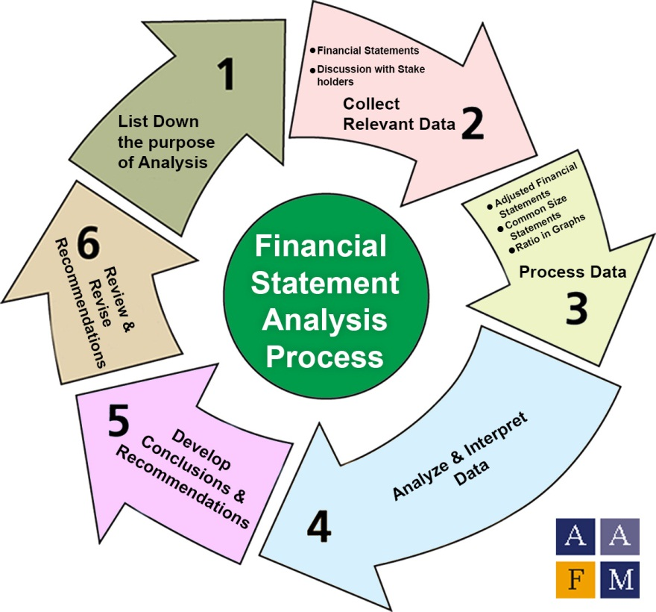

Figure 1: Financial statement analysis process
According to (Corbet et al., 2022), Analysis of the finances in the company involves the assessment of the financial statements and ratios and also the other matrix for better gaining the comprehensive understanding of the financial position of the organisation. This is analysis that supports the organisation for identifying the financial weaknesses and strengths along with the growth and opportunities and also the potential risk associated with it. As per the view of (Goyal and Kumar, 2021), Organisational analysis of the finance basically involves the examination of the different types of financial ratios which includes the liquidity ratios and profitability ratios along with the solvency ratios for better evaluating the financial health of the company along with its performance as well.
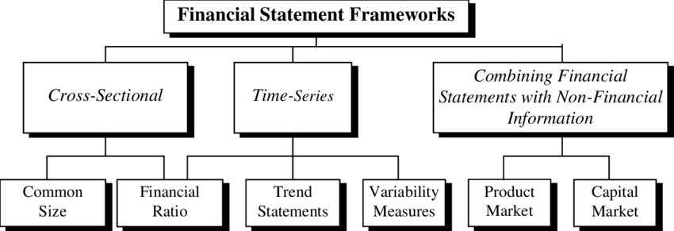

Figure 2: Financial statement frameworks
According to (Kazakova and Sivkova, 2019), Apart from the ratio analysis there are many other concepts of financial analysis which are used by the organisations to determine their financial performance for example vertical and horizontal analysis. The main objective of the financial analysis is to provide the company with the valuable insights into the organisational performance and financial position. As per the view of (Majernik et al., 2020), It is important to conduct because it further helps the analyst and management along with the investors to make the informed and strategic decisions. These are the decisions which are essential to make in terms of mergers and acquisitions along with the strategic planning and investments. Furthermore financial analysis is also considered essential for maintaining the investor relations and following up the regulatory compliance.

2.2 Needs of conducting financial analysis
As per the view of (Friedrich and Almeling, no date), There is a high requirement of financial analysis because it is essential in making the strategic and informed decisions in regards with the strategic planning and mergers and acquisitions along with the investment decisions. It is needed because it provides the clear picture of the financial position of the company that further helps in the identification of the certain areas which need improvement and also supports in forecasting the future financial performance. According to (Dul, 2019), It is highly needed to maintain the investor relations and regulatory compliance as well. The below are some of the following areas where the financial analysis is highly required and needed by the organisation.
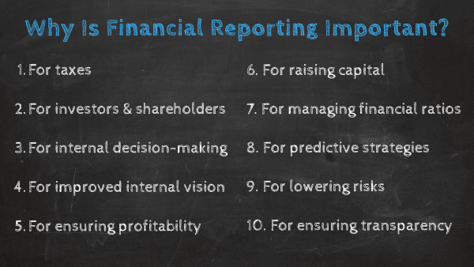

Figure 3: Importance of financial reporting
- As per the view of (Andrade et al., 2020), The financial analysis is needed to assess the financial health of the company. Financial health of the company can be assessed by analysing its performance using the different financial ratios for example solvency ratios and profitability ratios along with the liquidity ratios. According to (Huy and Thuy, 2021), The management of the company and the investors makes use of the analysis so that they can determine that actually how the company’s performance will and also for making the identification in the areas that highly needs the improvement.
- As per the view of (Ali, 2021), The financial analysis of the company is highly required in its planning and budgeting process. Every business is required to formulate and develop the business plan and also its budget to make initiation and also to make improvement in the near future. According to (Gu et al., 2019), Financial analysis helps in analysing the historical financial data that helps the organisations in projecting the future financial performance so that they can make the strategic and informed decisions related with the targets and expenses along with the revenues and investments.
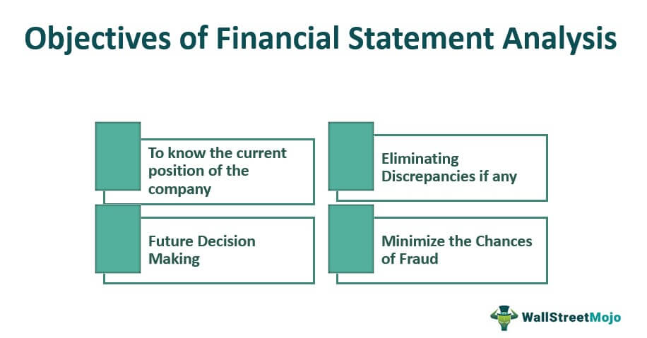
Figure 4: Objectives financial statement analysis
- As per the view of (Zhu and Yang, 2022), The financial analysis of the company is highly needed to make the investment decisions. It is highly creative for the company to make the investment decision in a wise and accurate manner and the reason being is that the investors have the ability to evaluate the financial health and performance of the company before investing into the particular organisation or area. According to (Gálvez-Sánchez et al., 2021), Financial analysis of the company helps in making the strategic decision making which helps in deciding whether to invest in a particular organisation, bonds or stock of the company.
- According to (Huy and Thuy, 2021), The financial analysis of the company is also highly required in maintaining and following up the regulatory compliance. There are various publicly traded companies which are highly needed to make sure that the organisation is actually meeting the requirements of laws and legislations of the particular Nation. As per the view of (Ali, 2021), In this case the financial analysis of the company helps in making sure that organisations are actually complying with the financial reporting requirements or not. This helps in maintaining the ethical and legal business for a long term.
- According to (Gu et al., 2019), Financial analysis is required to maintain the industrial relations with the business. It is essential because it helps in providing transparent and accurate financial information so that the company can build up the trust with the investors and also helps in maintaining the long term relationships with them.
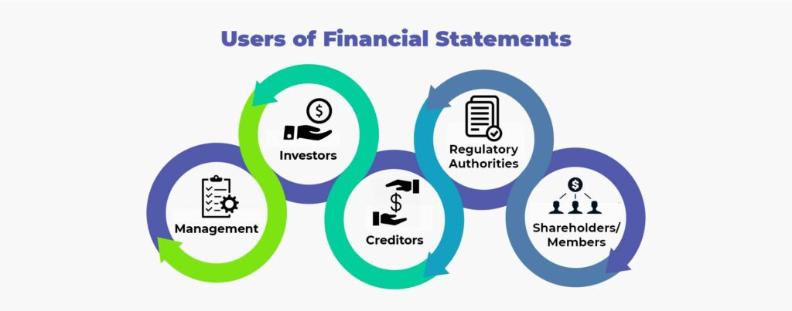
Figure 5: Users of financial statements
Hence, financial analysis is considered as one of the most critical and important tools for the investors and also for the business for assessing the financial performance. The reason being is that it helps in identifying the opportunities for improvement and also in making the informed decision making in regards with the financial Strategies and investments.

2.3 Methods of conducting financial analysis
According to (Anderson and Lemken, 2023), There are different types of methods of financial analysis which can be used by the organisation to perform a better evaluation of the financial health of the business organisation. The following are some of the methods of financial analysis which are usually followed up by many of the business organisations.
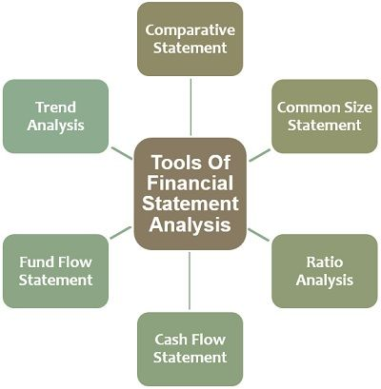
Figure 6: Tools of financial statement analysis
- As per the view of (Pandey and Sharma, 2022), Ratio analysis is one of the methods of financial analysis which involves the analysis of the different financial ratios for better assessing the financial performance and health of the company. According to (Pinto da Costa, 2021), There are certain types of financial ratios which are most commonly used by the organisation and these includes the efficiency ratios and solvency ratios along with the profitability ratios and liquidity ratios
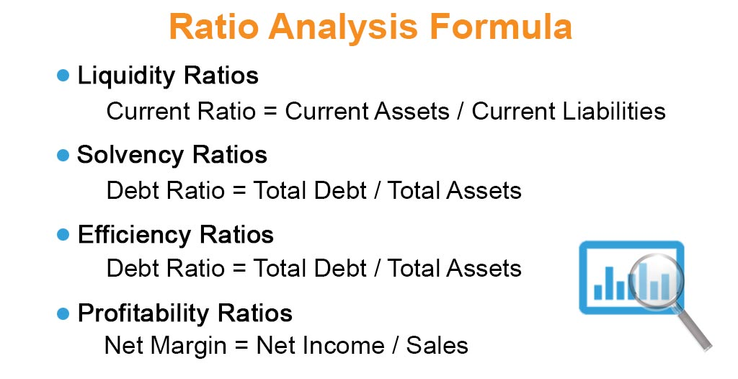
Figure 7: Ratio analysis formula
- As per the view of (Klychova et al., 2019), Trend analysis is another type of financial analysis which is mostly conducted by the business organisation because it involves the analysis of the large amount of financial data over time for better identification of the complicated trends and patterns within the company. According to (Barauskaite and Streimikiene, 2021), It further helps in identifying the fluctuations and the large changes in the expenses and revenues along with the profitability and the many other keep financial matrix as well.
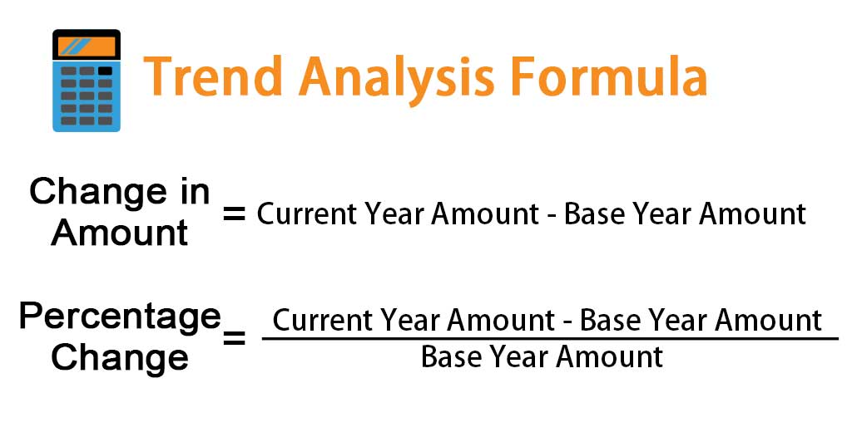
Figure 8: Trend analysis formula
- As per the view of (Marmilova et al., 2020), Comparative analysis is also another method of financial analysis which are majorly used by the organisations because it involves the comparisons among the financial performance of the company with its industry average and tough competitors available in the marketplace. According to (Stryukov, Alekseychik and Bogachev, 2021), It is a type of analysis which helps in identifying the areas where the company is actually under performing as compared to its competitors so that they can develop the Strategies for improvement.
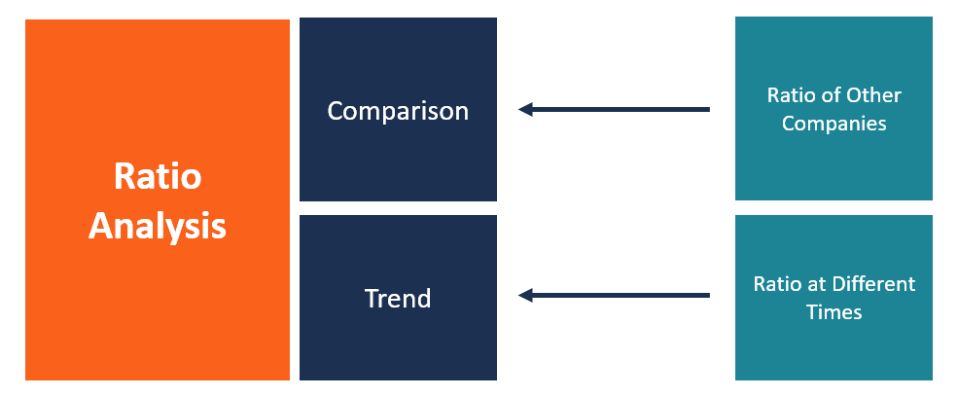
Figure 9: ratio analysis comparisons
- According to (Pinto da Costa, 2021), Common size analysis is also one of the methods of financial analysis which is being used by the organisations because it involves expressing the financial statements of the company in the form of percentage. As per the view of (Marmilova et al., 2020), It means that it helps in identifying the complicated patterns and trends of the financial performance of the company that were the helps in identifying the areas where the company is actually overspending and under spending for better developing the Strategies for improvement.
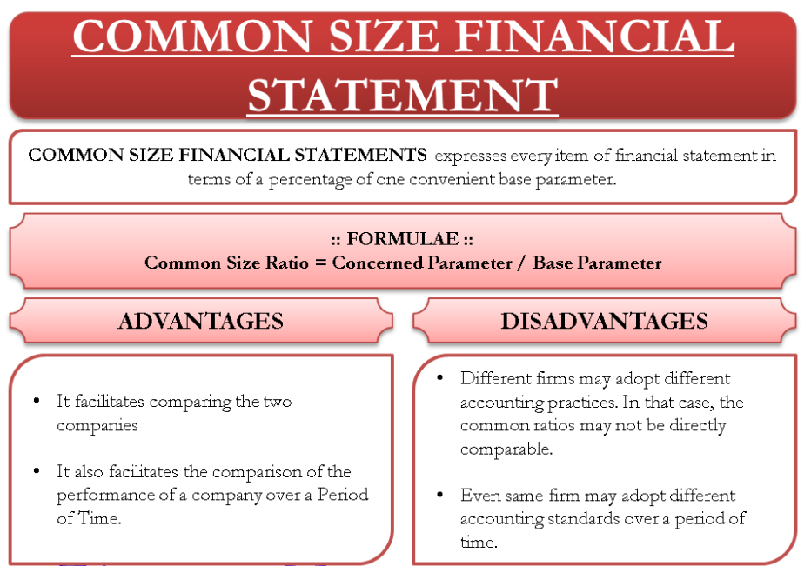
Figure 10: Common size financial statement
- According to (Barauskaite and Streimikiene, 2021), Cash flow analysis is one of the most common methods of an analysis which is almost used by every organisation because it involves analysis of the cash flow of the company statements for better assessing the ability to meet its obligations and also to generate the cash as well. As per the view of (Klychova et al., 2019), It further helps in identifying the areas where the company is actually facing the problems in their cash flow so that they can develop the strategies in order to improve its entire cash flow within the organisation.
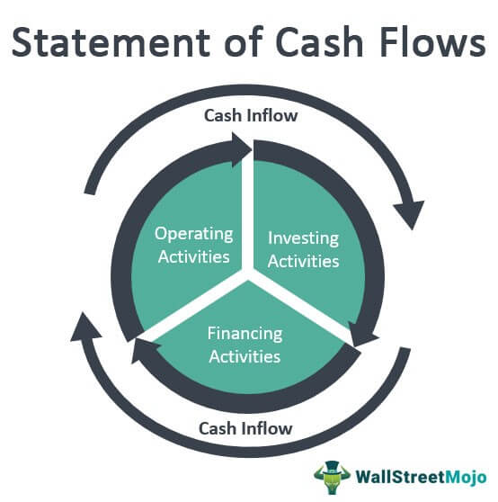
Figure 11: Statement of cash flows
Hence the above discussed are some of the methods of financial analysis which are majorly used in evaluating the financial health of the company and also for identifying the strength and weaknesses of the organisation. After conducting this financial analysis the company developed their Strategies for improvement and also makes the strategic decisions in terms of their financing and operations.

2.4 Impact of financial analysis on business organization
There is a crucial role of financial analysis played by it in the success of the business organisation. Some of the impacts of the financial analysis that can have on the business organisation are as follows.
- As per the view of (Iliemena and Okolocha, 2019), It has a positive impact on the decision making process because financial analysis has the ability to provide insights into the organisational performance and financial health. This is a type of information which is majorly used by the business leaders for making the strategic decision making in terms of investment and expenditures.
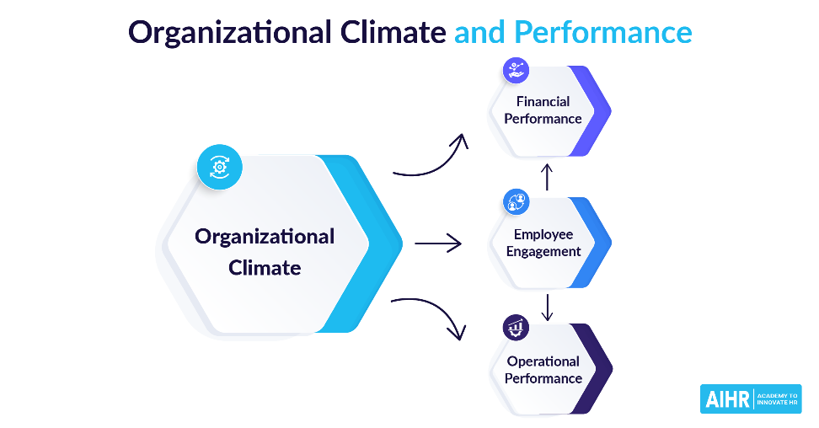
Figure 12: Organizational climate and performance
- According to (Rai, Dua and Yadav, 2019), Financial analysis of the business organisation helps in improving the resource allocation that further helps the businesses in understanding the outgoing and incoming of the money and also how it is being used. As per the view of (Bartolacci, Caputo and Soverchia, 2020), It provides the positive impact while providing the knowledge that enables business to allocate the sufficient and relevant resources in a more effective manner while reducing waste and also increasing the efficiency as well.
- According to (Agrawal, Bansal and Kathpal, 2020), Financial analysis has the positive impact on the increment of profitability as well because it helps the businesses in identifying the areas where it is necessary to reduce the cost for increasing the revenue. It is a type of information which helps in developing the strategies for better improving the profitability and also supports in growing and development of the business.
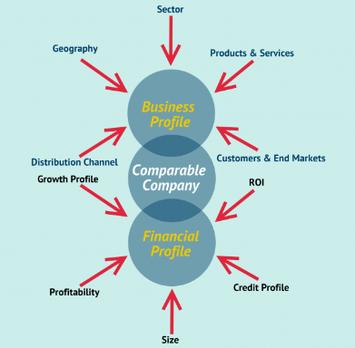
Figure 13: Factors of company comparison
- As per the view of (Young, 2020), Financial analysis helps in improving risk management because there are many businesses which make use of different tools for better identifying the potential risk and developing the strategies so that they can mitigate them on an immediate basis. These are the strategies which majorly include the diversification of investments and development of the contingency plans along with the improvement in the internal controls of the business.
- According to (Seiler, Papanagnou and Scarf, 2020), Financial analysis also has a positive impact on the communication strategies with stakeholders. Communication with the investors and lenders along with the employees are positively impacted because it is related with the financial performance analysis by the stakeholders. As per the view of (Paais and Pattiruhu, 2020), It helps in developing the transparency and building up the trust and confidence within the business organisation for better improving the long term relationship with the stakeholders.
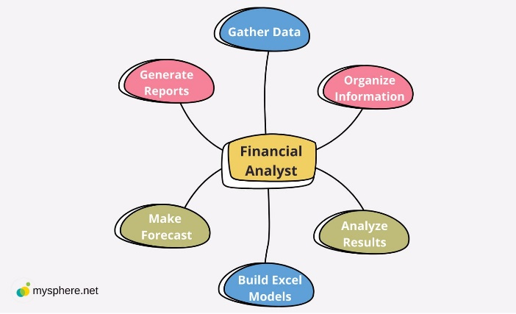
Figure 14: Financial analyst
Financial analysis is the very important and critical tool which business organisations use to improve their strategic decision making and also to allocate there a sources for better gaming of the profit ability and managing the risk while maintaining the stakeholder communication.

Chapter 3: Research methodology

3.1 Research onion framework (Theoretical part)
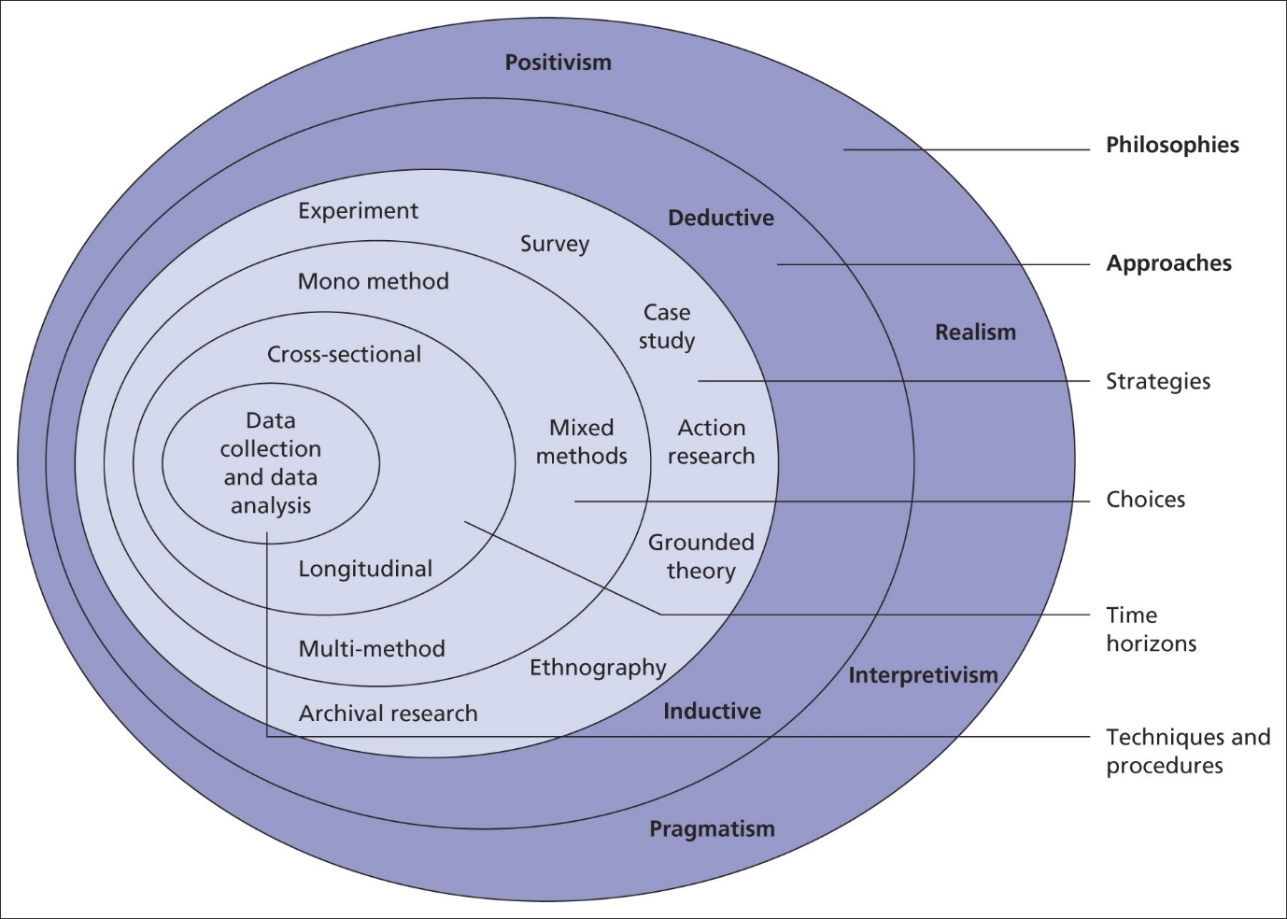
Figure 15: Research onion model
The research methodology which has been used in the current thesis has been discussed following the selection of different research philosophies and approaches. The selection is also done in terms of the different research Strategies and choices. Moreover, decisions are also made concerning the different research data collection and analysis (Newman and Gough, 2020). The decisions have also been made in terms of whether sampling and ethics of the entire thesis have been followed or not.

3.1.1 Research philosophy
The researcher has adopted the positivism research philosophy. This is a type of philosophy which helps the researcher and assumes the actual reality of the organisation and its financial performance by objectivity measuring through the quantitative data (Newman and Gough, 2020). This requires the researcher to rely on the empirical data which mutually includes the accounting records and financial statements along with the market trends related to the company. Another assumption which researcher has undertaken is the consideration of Independence financial data in which then analysis must be objective and unbiased (Pandey and Pandey, 2021). Therefore, the positivist research philosophy majorly focuses on the quantity of analysis of the financial performance of the company and also makes use of the objective data in order to identify the pitfalls and provide recommendations to the company for the future actions. It is selected because it has been decided that the data collection should be in a numeric form so that financial analysis can be done accurately and easily.

3.1.2 Research approach
Deductive research approach has been adopted for the current study because it involves the testing of the pre-existing theory by conducting the empirical observation and data analysis for identifying the pitfalls and financial performance of the company (Mukherjee, 2019). The researcher applies this research approach by beginning with the development of the set of research questions on the previous financial theories and the relevant literature which would help in the current study for collecting and analysing the entire process of answering the research questions (Mishra and Alok, 2022). The financial collected are the balance sheet and income statements along with the cash flow statements in order to provide the future recommendations to the company. It is selected because it has been decided that the data analysis should have a financial measure which is in a numeric form (Pandey and Pandey, 2021).

3.1.3 Research strategy
The systematic literature review is the adopted research strategy which includes the identification and evaluation of the relevant literature so that it’s synthesizing can be done with the current research topic (Snyder, 2019). It will provide the comprehensive few of the already published literature based on the organizational performance and financial analysis along with the automobile manufacturing. It contains several steps which are necessary to perform and are explained in the next section in a very in that manner. Such steps include the development of the research questions and searching of the keywords with better search results while predefining the inclusion and exclusion criteria and many more important stages which can provide the authentic knowledge on the current topic (Säfsten and Gustavsson, 2020). The findings which are gained from this research strategy can help in informing the financial analysis and pitfalls of the financial performance of the company along with the future recommendations which can be based on the current knowledge and best practices in the current field. It has been decided to collect the quantitative financial data from the past thesis conducted of previous different years associated with pandemic crises. It critically discusses about the assorted viewpoints of different well-known authors related to the research aim and objectives in order to fulfil them.

3.1.4 Research choice
Quantitative mono method is adopted by the researcher as the research choice because the current study is entirely based on the quantitative data along with its collection and analysis (Patel and Patel, 2019). The researcher has collected the different quantitative data from various financial statements and accounting records along with the other financial documents of the company. Eating towards the balance sheets and income statements as well. The quantitative data can help the researcher to objectively conduct the measurement of financial performance and also provide the accurate recommendations based on the research findings (Babii, 2020). It is advantageous for the current study because it is replicable and makes it easier to compare the findings of the different studies. It is selected because it has been decided that only one form of data is suitable for the current financial analysis. The one form which is decided for the current thesis is the quantitative data which is collected and analysed. It is a type of data that has a numeric form that contains figures and numbers.

3.1.5 Research data collection
Secondary research is the adopted data collection in the current study in which the data is connected which has already been collected and published by the other authors or researchers. In accordance with the current study, the sources of secondary data includes the industrial reports and government reports along with the financial reports and statements and also the academic articles as well (Gupta and Gupta, 2022). It includes the financial statements and annual reports and also the other financial data published by Skoda auto. Industry reports are published by the trade association and consulting firms which provide the information regarding the industry trends and benchmarks. Government reports include the information related to the regulation and taxes and also the economic trends which can impact organisational financial performance. Academic articles provide the information from the perspective of theory and the best practices in financial analysis (Zawacki-Richter, Kerres, Bedenlier, Bond and Buntins, 2020). This information can help the researcher in evaluating the different techniques of analysis appropriately which includes the ratio analysis and trend analysis and also many more for better gaining the insights into the organisational financial performance. It is selected because it has been decided that secondhand data would be collected which is an indirect collection of information. It has sources like authentic internet sites and published books or journals or articles for better conducting the systematic literature review (Mishra and Alok, 2022).

3.1.6 Research data analysis
Financial ratios and other statements are majorly used for the current study to analyse the financial performance of the Skoda auto. They can provide valuable insights into the organisational liquidity and profitability along with the efficiency and solvency (Greening, 2019). It also includes the horizontal and vertical analysis which further also involves the trend analysis and cash flow statement along with the common size statement and comparative statement as well. The calculations of all such measurements will then be compared with the industry averages since the last previous years in order to identify the different areas of concern and improvement. Then the findings would be drawn out in order to find out the pitfalls and the future recommendations for the company (Thomas, 2021). These ratios and analysis have the further sub parts are provided with the detailed description in the next given section. All these calculations are conducted using the Microsoft Excel tool for better tabular representation and graphical view of the data. Financial data which is collected from the secondary sources (SLR) can be analysed by developing the profit and loss statements containing the deliveries and sales revenues figures and comparing them in accordance with different years. The calculation will also be done using the several financial ratios as well.

3.1.7 Research time horizon
Cross sectional is the adopted research time horizon which involves the data collection at a specific point in time. This is a research design which majorly involves the collection of the financial data at a single point of time which includes the end of the most recent fiscal year (Sileyew, 2019). It allows the investigator to make comparisons of the financial performance of Skoda auto with the industry benchmarks or any competitors at a specific point in time. It provides the snapshot to the financial health of the company and also allows the efficient analysis and quick identification of the pitfalls and the future recommendations (Acharyya and Bhattacharya, 2019). It is effective to conduct when the research has to be completed within a shorter period of time that is within maximum of 1 year while drawing out the relevant findings and Research outcomes without delaying it to the decades.

3.1.8 Research ethics
Avoiding plagiarism is one of the research ethics which is being followed by the researcher in order to make sure that any of the data taken from any of the external sources must be properly referenced and cited (Mackey and Gass, 2021). Data privacy is another ethical concern in which the researcher has made sure that the financial data which is collected from the external sources must be used as per the terms and conditions of the data provider. Data accuracy is the ethic in which the investigator makes sure that the gathered information must be accurate and reliable with proper updates in it. No bias is the ethic in which a researcher avoids any type of bias while selecting and interpreting the data (Nayak and Singh, 2021). The researcher has gone through the ethical review by institutional review board or any of the ethics committee which involves the human subjects or sensitive data.

3.1.9 Research gaps
There are certain research gaps because of which the current research is conducted to fulfil those gaps. Previous research has the Limited focus on the emerging financial risk on the specific sector or a company which is to be fulfilled in the current study. Moreover they were also the Limited ancient attention to the environmental and social impact with also the lack of efficient comparative analysis as well. There was also the Limited examination of the future financial trends and also the Limited consideration of the non-financial factors as well. These are the major reasons for undertaking the current study on the specific topic so that the quantitative financial analysis on the particular company can be undertaken in a potential manner.

3.1.10 Research limitations
Some of the research limitations which the current study could have can be the lack of accurate data availability and comparability. This is due to the currency fluctuations and not meeting up the actual accounting standards while analysing the financial data of the company. Moreover it has the Limited scope as well because it is specific to one particular company and it only focuses on the quantitative data which has ignored the brand reputation and management quality as well.
Steps used in the current thesis to successfully accomplish it are:
- The conceptual phase: This is the first step in which background is developed and literature is reviewed and also the research purpose is mentioned.
- The design and planning phase: This is the second step in which research design is selected and study procedures are developed and also the data collection plan is made.
- The empirical phase: This is a third step in which data is collected and also the data for analysis is prepared.
- The analytic phase: This is a fourth step in which the data is analysed and also the results are interpreted.
- The dissemination phase: This is a fifth step in which results are communicated to appropriate audience.

3.2 Systematic literature review

3.2.1 Research question (PICO table)

$$Aim$$
$$PICO Element$$ | $$Description$$
$$Population/Participants$$ | $$Business organizations, specifically ŠKODA AUTO (Automobile manufacturer)$$
$$Intervention/Exposure$$ | $$Conducting a financial analysis$$
$$Comparison$$ | $$N/A$$
$$Outcome$$ | $$Identifying pitfalls faced by ŠKODA AUTO and providing future$$  $$recommendations for improvement and opportunities in the marketplace$$

Table 1: PICO table of aim

$$RQ1$$
$$PICO Element$$ | $$Description$$
$$Population/Participants$$ | $$Business organizations, especially ŠKODA AUTO (Automobile manufacturer)$$
$$Intervention/Exposure$$ | $$Understanding the concept, need and methods of conducting financial analysis$$
$$Comparison$$ | $$N/A$$
$$Outcome$$ | $$To evaluate the impact of financial analysis on business organization, with a focus on$$  $$ŠKODA AUTO.$$

Table 2: PICO table of RQ1

$$RQ2$$
$$PICO Element$$ | $$Description$$
$$Population/Participants$$ | $$Business organizations, especially ŠKODA AUTO (Automobile manufacturer)$$
$$Intervention/Exposure$$ | $$Conducting financial analysis$$
$$Comparison$$ | $$N/A$$
$$Outcome$$ | $$Determining the pitfalls faced by the company$$

Table 3: PICO table of RQ2

$$RQ3$$
$$PICO Element$$ | $$Description$$
$$Population/Participants$$ | $$ŠKODA AUTO (Automobile manufacturer)$$
$$Intervention/Exposure$$ | $$Future recommendations for overcoming the pitfalls and for grabbing the$$  $$opportunities in the marketplace$$
$$Comparison$$ | $$N/A$$
$$Outcome$$ | $$Improved performance and competitiveness of ŠKODA AUTO in the marketplace$$

Table 4: PICO table of RQ3

3.2.2 Preliminary research
- There are some of the preliminary studies on the current research topic which is conducted by the researcher conducting the current systematic literature review. It has been found out that there are various studies which are available on another source of the automobile manufacturers which also includes the Skoda auto (Fava, 2021). There are some of the studies which have focused on the particular aspects of the financial analysis for example liquidity or profitability while the other studies have focused on conducting the comprehensive analysis.
- Some of the studies have examined the financial performance of Skoda auto and its competitors within the Indian market (Doležal, 2021). They have used the ratio analysis for better evaluating the financial performance and also for identifying the areas for improvement.
- There is another study which has also analysed the financial performance of Skoda auto within the European market which has also studied about the financial ratios and different analysis in order to evaluate the performance of the company over the last 5 years (Joshi, 2019).
- One of the previous studies has also conducted the financial analysis of Skoda auto in regards with the international automobile industry (Pavlica, Bokšová, Bokša, Horák, et.al, 2020). It has made the use of ratio analysis and swot analysis or better identifying the areas for improvement and also making the recommendations for the future strategy to the company.
- They are some of the specific studies which have also conducted the different literature reviews on the financial analysis and its importance to the business organisation (Hornungová and Milichovský, 2019). They have reviewed and highlighted the benefits of financial analysis for example improving the decision making and identification of the improvement areas.
- In the current literature on the financial analysis will help in suggesting the effective evaluation of the financial performance and health of the business organisation which is an important tool and mainly based on the automobile manufacture that is Skoda auto (Lefebvre, Glanville, Briscoe, Littlewood, et.al, 2019). Because of conducting the financial analysis the organisations can identify the improvement areas and also can meet the informed decisions in terms of the future strategy.

3.2.3 Inclusion and exclusion criteria
Inclusion criteria | Exclusion criteria
Peer reviewed articles are included which are specifically published in the English language. | Studies are excluded which are not peer reviewed articles or the articles which are not published in specifically the English language.
Studies are included which analyses the financial performance of Skoda auto in the quantitative manner and also which makes the use of ratio analysis and trend analysis. | Studies are excluded which focus on the financial performance of the automobile manufacturer but other than Skoda auto.
Studies are included which can identify the potential weaknesses and pitfalls in the financial performance of Skoda auto. | Studies are excluded which majorly focuses on the non-financial aspects of the performance of the company which includes the human resources or marketing areas.
Studies are included which can provide the recommendations for better improving the financial health of the Skoda Auto and also help in recommending the Strategies for taking the advantage of the marketplace opportunities. | Studies are excluded which do not provide the recommendations on the improvement areas to the financial performance of the company and also not recommending any strategies which can help in grabbing the marketplace opportunity.
Studies are included which are majorly focused on the automobile industry or the related Industries as well. | Studies are excluded which are not relevant to the research topic and are outdated or are even published before the year of 2017.
Studies are included which covers the period from 2017 to 2022.

Table 5: Inclusion and exclusion criteria

3.2.4 Search strategy
- One of the search strategies which has been followed by the researcher is research in the identified appropriate databases. It includes the “web of science” and “Scopus” is along with the “Google scholar”.
- Researchers have also developed some of the keywords for better searching out and appropriate literature papers. Some of the keywords include the “financial analysis” and “Skoda auto” along with the “automobile manufacturer” and “pitfalls” and also the “recommendations” and “financial performance” or “ratio analysis” as well.
- The researcher has also combined the different phrases and the keywords using some of the Boolean operators. These Boolean operators includes “AND” and “OR” along with the “NOT”.
- The researcher has also refined its research by adding some of the additional search terms which includes the “trend analysis” and “comparative analysis”.
- The researcher has also searched out some of the research results with the help of the inclusion and exclusion criteria which was developed in the previous section.
- The researcher has also evaluated the study quality in order to meet the inclusion criteria and eliminate the exclusion criteria.
- The research has extracted the relevant data from the previous studies and has also synthesized the findings in a comprehensive and systematic manner.

3.2.5 Searching databases
- They are some of the following databases which are useful to conduct the current systematic literature review. These include the "web of science" and "scopus" along with the "Google scholar" and "proquest" and also the "Ebs cohost" and "jstor". Other databases include the "oecd ilibrary" and "factiva" along with the "Lexis Nexis" and "ABI / inform".
- It is highly important to search the different multiple databases to make sure that the current systematic literature review can have a comprehensive review of the relevant literature. Moreover, it is highly useful to consult with the authentic and the accurate relevant website and industry reports. It further helps in hand searching the reference list of the identified articles and journals for better identifying the additional relevant studies as well.

3.3 Financial analysis (Practical part)
Financial analysis of Skoda auto during the last recent years will be calculated in the current study. The following are the certain ratios which will be calculated in the next chapter for better conducting the analysis and finding out the results.

3.3.1 Liquidity Ratios
The liquidity ratio is defined as the financial matrix that helps in measuring the ability of a company in order to pay off its short term obligations with the help of its current assets. This result is indicated in the form of percentage that is the organizational liquidity position.
  - $a. Current Ratio = Current Assets / Current Liabilities$
This is a ratio which helps in measuring the ability of the company to pay off its current liabilities with the help of its current assets. If the current ratio is one or more than that then it indicates that the organisation has the sufficient current assets in order to cover its current liabilities.
  - $b. Quick Ratio = (Current Assets - Inventory) / Current Liabilities$
This is a ratio which helps in measuring the ability of the company to pay off its current liabilities with the help of its liquid assets. If it has a value of one or more than that then it indicates that the company has the sufficient liquid assets in order to cover the current liabilities without depending on the inventory sales.

3.3.2 Solvency Ratios
The solvency ratio is defined as the financial metric which helps in measuring the ability of the company for better meeting up its long term financial obligations. It depicts that whether the company has the sufficient assets in order to cover its long term debts.
  - $a. Debt-to-Equity Ratio = Total Liabilities / Total Equity$
This is a ratio which helps in measuring the debt amount of the company which is related to the equity. If there is a high debt to equity ratio then it indicates that there is more debt of the company as compared to equity which is the indication of financial risk.
  - $b. Debt-to-Asset Ratio = Total Liabilities / Total Assets$
This is a ratio which helps in measuring the debt amount of the company which is related to its total assets. If there is a high debt to asset ratio then it indicates that the company has a lot of debt which is related to its assets that can be the indication of financial risk.

3.3.3 Profitability Ratios
Profitability ratio is defined as the financial metric which is used by the company to evaluate its ability to generate the profit related to the cost and other expenses. These are the ratios which are essential for the stakeholders and the investors who want to access the financial sustainability and health of the organisation.
  - $a. Gross Profit Margin = (Gross Profit / Revenue) x 100$
This is a type of ratio which indicates the revenue percentage which remains after detecting the cost of goods sold. If there is a high gross profit margin then it indicates that the company is effectively conducting its management of its production cost.
  - $b. Operating Profit Margin = (Operating Profit / Revenue) x 100$
This is a type of ratio which measures the ability of the company to generate sufficient profits from its operations. It demonstrates the revenue percentage that remains after reducing the operating expenses but before deducting any of the non-operating expenses. If there is a higher operating profit margin then it indicates that the company is generating sufficient profits in a more efficient manner from its operations.
  - $c. Net Profit Margin = (Net Income / Revenue) x 100$
This is a type of ratio which measures the profitability of the company by simply calculating the revenue percentage while remaining the profit after reducing all the expenses which includes taxes and interest.
  - $d. ROA = Net Income / Total Assets$
This is a type of ratio which measures the efficiency of the company while using its assets in order to generate its profits. If there is a high return on assets then it indicates that the organisation is generating the sufficient profits related to its investment in assets.
  - $e. ROE = Net Income / Total Equity$
This is a type of ratio which measures the effectiveness of the company while using the equity in order to generate the profits. If there is a high return on equity then it indicates that the company is generating sufficient profit related to its investment in equity.

3.3.4 Vertical analysis
$$(Statement line item / Total base figure) X 100$$
It is the type of analysis which represents the changing nature of company’s finances over the periods or years on the recent basis. It examines many reporting periods

3.3.5 Horizontal analysis
$$\{(Comparison year amount - Base year amount) / Base year amount\} X 100$$
It is the type of analysis which represents the changing nature of company’s finances in the form of percentages of a base figure. It examines one reporting periods
The above ratios will be calculated for the company for more than one years which will include the last recent years. This will help in comparing the financial performance of an organisation over time. Moreover the ratios will help in comparing the industry averages for a better determinant than how the Skoda auto is actually performing in relation with its competitors.
After interpreting the financial ratios of Skoda autos, it will help in identifying the areas that were actually the organisation facing the challenges either in their solvency or liquidity issues so that the future recommendations can be provided for better improving the financial performance of the organisation during the previous recent years.
The ratios will provide insights into how the efficient organisation is actually generating the profits from its equity and assets. If there will be a higher return on assets and return on equity then it will be good for the organisation. It is highly important to note that the above ratios will be compared in accordance with the industry average and also the historical data so that the more accurate picture of the organisation performance can be analysed.

3.3.6 Trend analysis
Trend analysis is defined as a technique which is used to predict and examine the movements of the item which are based on the historical and the current data. This is majorly used to improve the business performance while making the informed decisions.
$$Trend Percentage = ((Current Period Value - Base Period Value) / Base Period Value) * 100$$
$$Current Period Value: This is the most recent data point in the series$$
$$Base Period Value: This is the first data point in the series.$$

3.3.7 Cash flow statement
A cash flow statement is defined as the financial statement which helps in providing the aggregate data in regards with all the cash flow which a company receives from its continuous operations and also the external investment sources as well. It also includes the cash out flows which are being paid for the business activities and also the investments at a time of the specified given period.
$$Net Cash Flow = Total Cash Inflows – Total Cash Outflows$$

3.3.9 Common size statement
The common size statement is defined as the form of interpretation and analysis of the financial statement document which is used to compare the specific financial statement with the prior period statements in which it represents amounts as percentages of a base figure. Previous financial statements are displayed alongside the recent figures in the side by side column that helps the investors in order to identify the trends and track the progress of the company while comparing it with the industrial rivals. It typically focuses on one reporting period.
Key figures from the Skoda auto group from January to December during the last recent years are also collected and analysed for better financial analysis of the company. It will include the figures of delivery to customers and production along with the sales and sales revenue which is also followed by the operating profit and return on sales and also the investments in tangible assets and then finally net cash flow as well. It will be represented in the tabular form of different years which will also display the change in percentage from one year to another year in the next chapter of analysis.

Chapter 4: Data collection and analysis

4.1 Financial ratios
 | 2020 | 2021 | 2022
LIQUIDITY RATIOS
Current Ratio | 0.833608 | 0.781477 | 0.657185

Table 6: Current ratio
- If the current ratio has the value of one or more than that then it is considered to be the good for the company because it indicates that the company has the sufficient current asset in order to cover up its current liability.
- In accordance with the calculations above, it has been interpreted that there has been a decrease of the current ratio of Skoda auto since the past 3 years that is from 0.83 in the year of 2020 to 0.78 in the year of 2021 and then 0.66 into 2022.
- It simply means that the current assets of the company are becoming less enough for coping up its current liabilities.
- 0.66 is the current ratio which signifies that the company may suffer problems in paying off its short term obligations in terms of its current assets.
- This can result in liquidity issues and even bankruptcy as well. These are the consequences if the company is unable to obtain the sufficient finding or may increase its value of current assets in the future.

Quick Ratio | 0.526392 | 0.551569 | 0.526392

Table 7: Quick ratio
- It is a type of ratio which majorly excludes the inventory from the current assets because it is not considered to be the highly liquid asset.
- In accordance with the above data, it has been interpreted that the quick ratio of the Skoda auto is relatively stable since the past 3 years but having the slide increment from 0.53 in the year of 2020 to 0.5 in the year of 20 21 and then it decreased to 0.53 into 2022.
- This measurement signifies that the organisation has the most liquid assets which are enough for covering up its short term obligations but it is still important to note that the ratio is still relatively low.
- The value of quick ratios 0.53 means that for every $1 of the current liabilities, the company has $0.53 of the highly liquid assets for covering them. The value of the quick ratio is considered to be lower than one which is the ideal quick ratio. Hence it simply indicates that the organization has the ability to fully cover up its current liabilities while using its most of the liquid assets. But still there is a requirement for the company to improve its liquidity position in the future.

SOLVENCY RATIOS
Debt to equity ratios | 0.828343 | 0.940708 | 1.08412
debt | 84100 | 89292 | 100254
equity | 101528 | 94920 | 92475

Table 8: Debt to equity ratio
- Quick ratio measures that up to which extent the company is financed in terms of its debt as compared to the equity. If there is a high value of debt to equity ratio then it means that the company has a higher amount of debt as compared to equity.
- In accordance with the calculations above, it has been interpreted that there is the increment of the depth to equity ratio over the past 3 years that is from 0.83 in the year of 2020 to 0.94 in the year of 2021 and then to 1.08 in 2022.
- This demonstrates that the company is becoming more heavily financed in regards with debt which could result in the financial distress if the company would not be able to overcome its debt obligation in the future.
- The provided figures can also be used to actually interpret the amount of debt and equity of the company. It means that there is an increment of debt in the year of 2020 of 84100 to 100254 in the year of 2022 and then its equity decreased from 101528 in the year of 2020 and then to 92457 in the year of 2022. It majorly focuses on the increment of the reliance on debt financing for better supporting the operations of the company.
- It is highly important for the company to consider the strategies for better reducing the debt levels and also improving its equity position for making sure of its long term financial stability.

Debt to assets ratio | 0.363341 | 0.391661 | 2.538178
Assets | 231463 | 227983 | 234718

Table 9: Debt to asset ratio
- If the value of debt to asset ratio is high then it indicates that the company has a higher amount of debt as compared to its asset.
- In accordance with the data, it has been interpreted that there is the increment of the value of debt to assets ratio over the past 3 years that is from 0.36 in the year of 2020 to 0.39 in the year of 2021 and then again the increment to 2.54 in the year of 2022.
- This demonstrates that the company is becoming heavily financed by debt which is considered to be risky as a ratio is quite high for the company.
- With the data provided of the actual amount of assets of the company, it has been observed that the assets of the company has decreased slightly from 231463 in the year of 2020 and then to 227983 in the year of 2021 and then it is increased to 234 718 in the year of 2022.
- It can be analysed that the company may face financial distress in the future if it is not able to generate sufficient cash flow to overcome its debt obligations. It is highly important for the company to consider the strategies so that they can reduce the level of debt and improve its base of a set for making sure there financial stability for the long term.

PROFITABILITY RATIOS
Gross profit margin | 10.15126 | 9.918908 | 8.935256

Table 10: Gross profit margin
- Gross profit margin indicates that the generation of the amount of profit by the company before the accounting of its operating expenses.
- In accordance with the calculations above, it has been interpreted that there is a decrement of gross profit margin over the past 3 years that is from 10.15% in the year of 2020 and then to 9.92% in the year of 2021 and then it is again decreased to 8.94% in the year of 2022.
- This demonstrates that the cost of goods sold of the company has increased faster as compared to its sales revenue which is highly affecting its profitability.
- If there is a decrease in the gross profit margin then it indicates the decreasing pricing power which highly increases the competition and also the rising cost of goods sold as well. Currently the company is facing challenges in its management of supply chain and also in the manufacturing process as well.
- It is highly important for the company to make a review on its cost structure and also improve its efficiency for better maintaining and improving its profitability. They need to adopt the Strategies for reducing its cost of goods sold which includes the optimisation of the supply chain and renegotiating its contracts with the suppliers.

Operating profit margin | 4.081152 | 6.203399 | 3.967773

Table 11: Operating profit margin
- Operating profit margin indicates how efficiently and effectively the organisation is managing its operation.
- In accordance with the calculation above, it has been interpreted that there is a fluctuation over the past 3 years of the operating profit margin that is from 4.08% in the year of 2020 and 6.2 0% in 2021 and then it decreased to 3.97% in the year of 2022.
- It demonstrates that operating expenses of the company are fluctuating over the years which are affecting its profitability.
- The increased value of the operating profit margin indicates that the organisation is generating the most profit per dollar of its sales. If there is a decrease in the operating profit margin then it indicates that the organisation is facing the challenges in managing its operating expenses and are also experiencing the pricing pressures as well.
- It is highly required for the company to take a quick review in its cost structure for better improving its efficiency and maintaining its profitability. It is important to adopt some of the strategies to reduce their operating expenses which includes the streamlining of the supply change process.

Net profit margin | 3.576546 | 5.302799 | 2.874193

Table 12: Net profit margin
- If there is the high net profit margin then it indicates that the organisation is generating more profit per dollar of IT sales but when it is having the low net profit margin then it demonstrates that the company is facing challenges in its management of expenses and is also experiencing the pricing pressures.
- In accordance with the calculations done above, it has been interpreted that there is a fluctuation in the value of net profit margin since the last 3 years, in the year of 2020 the value of net profit margin was 3.58% and then it has increased to 5.30% in 2021 and then it is again decreased to 2.87% in the year of 2022.
- It demonstrates that the organisational expenses are fluctuating over the years which are affecting its profitability.
- It is highly required for the company to review its cost structure and improve its profitability while considering some of the strategies to reduce its expenses like optimising the applied chain and reducing the cost of administration. It is highly important for the company to explore the new markets and the product lines for better diversification of its revenue streams for improving the profitability.

Return on assets | 0.066562 | 0.096819 | 0.054039

Table 13: Return on assets
- If there is a high value of return on assets then it indicates that the company is generating more profit per dollar of its assets but when there is a low value then it demonstrates that the company is facing problems in managing its assets and also experience in the pricing pleasures.
- In accordance with the data, it has been interpreted that the value of return on assets has increased from 0.066 in the year of 2020 and then in the year of 2021 it was 0.0968 and then it decreased to 0.0540 in the year of 2020.
- It demonstrates that the company is successful in generating its profit from its assets in the year of 2021 but it has seen the decline in its profitability in 2022.
- It is highly required for the company to take a review of its asset utilisation Strategies for better maintaining its profitability. It is essential for the company to consider the optimisation of the asset allocation and also to explore the new markets and product lines for better diversifying its revenue streams while focusing on improving its operational efficiency as well.

Return on Equity | 0.159871 | 0.220727 | 0.13807

Table 14: Return on equity
- If there is the higher value of return on equity then it indicates that the organisation is generating more profit per dollar of its shareholders equity but if there is the lower value of return on equity then it indicates that organisation is facing issues in generating the profits and experiencing the pricing pressures.
- In accordance with the calculations above, it has been interpreted that there is the increment of return on equity from 0.1599 in the year of 2020 to 0.2207 in the year of 2021 and then it is decreased to 0.1381 in the year of 2022.
- It demonstrates that the company is successful in generating its profits for the shareholders in the year of 2021 but still has experienced the decline in its profitability in the year of 2022.
- It is highly required for the company to take the review on the equity utilisation Strategies for improving its profitability. It is required for the company to consider the optimisation in its equity allocation while reducing its debt or buying back the shares for improving the return on equity. The company is highly required to emphasize on the improvement of the operation efficiency and also exploring the new product lines for diversifying its revenue streams.

4.2 Vertical analysis
Vertical analysis
 |  | 2020 | 2021 | 2022
Net sales | CZK million | 424292 | 422607 | 444229
Net sales ( in %) |  | 100 | 100 | 100
Cost of sales | CZK million | 381221 | 380689 | 404536
Cost of sales (In %) | % of revenues | 89.80% | 90.10% | 91.10%
Gross profit | CZK million | 43071 | 41918 | 39693
Gross profit (In %) | % of revenues | 10.20% | 9.90% | 8.90%
Distribution expenses | CZK million | 12349 | 10287 | 11097
Distribution expenses (in %) | % of revenues | 2.91 | 2.43 | 2.49
Administration expenses | CZK million | 13565 | 12271 | 12353
Administration expenses (in %) | % of revenues | 3.19 | 2.9 | 2.78
Operating profit | CZK million | 17316 | 26216 | 17626
Operating profit (in | % of revenues | 4.1 | 6.2 | 4
%)
Profit before tax (PBT) | CZK million | 17863 | 27320 | 16036
Profit before tax (in %) | % of revenues | 4.2 | 6.5 | 3.6
Income tax expense | CZK million | 2688 | 4910 | 3268
Income tax expense (In %) | % of revenues | 0.63 | 1.16 | 0.74
Profit for the year | CZK million | 15175 | 22410 | 12768
Profit for the year | % of revenues | 3.6 | 5.3 | 2.9

Table 15: Vertical analysis
- The vertical analysis of the Skoda auto has the base amount of net sales and the financial items are expressed in the percentage of the net sales.
- It has been interpreted that there is an increment of the cost of sales of net sales from 89.80% in the year of 2020 to 91.10% in the year of 2022. It demonstrates that the company has more spending on its product production because of the higher input cost and inefficiencies in the production process.
- There is a decrease in the gross profit margin of net sales from 10.2 0% in the year of 2020 to 8.90% in the year of 2022. It indicates that the organisation is generating less profit from its sales because of the increased cost of sales and pricing pressures in the market.
- There is increment of the distribution expenses and administration expenses of net sales in the year of 2021 as compared to 2020 but has a slight increase in 2022. This indicates that the company has better expense management in 2021 but needs to control its expenses in 2022 for maintaining its profitability.
- There is the increase of operating profit margin of net sales from 4.1% in the year of 2020 to 6.2% in the year of 2021 but then it decreased to 4% in 2022. This indicates that the organisation has experienced some improvements in its operations in 2021 but then has faced challenges in maintaining its profitability in 2022.
- There is a similar trend of profit before tax of net sales as the operating profit margin because it has the significant increase in 2021 and then decrease in 2022. It indicates that organizational profitability has been volatile in the past few years.
- There is the increment of income tax expense of net sales over the past 3 years which indicates that the organisation is paying more in Texas because of the higher profits and changes in the tax regulations.
- There is a similar train of profit for the year of net sales to the gross profit margin because it is experiencing a decrease from 3.6% in the year of 2020 to 2.9% in the year of 2022. This indicates that the profitability of the company has been decreasing since the last few years.

4.3 Horizontal analysis
Horizontal analysis
 |  | 2019 | 2020 | Taking base as 2019 (in %) | 2021 | Taking base as 2020 | 2022 | Taking base as 2021
Net sales | CZK million | 459122 | 424292 | 92.41 | 422607 | 99.6028678 | 444229 | 105.116337
Cost of sales | CZK million | 397086 | 381221 | 96 | 380689 | 99.8604484 | 404536 | 106.264168
Gross profit | CZK million | 62036 | 43071 | 69.42 | 41918 | 97.3230248 | 39693 | 94.6920177
Distribution expenses | CZK million | 14735 | 12349 | 83.81 | 10287 | 83.3022917 | 11097 | 107.874016
Administration expenses | CZK million | 13234 | 13565 | 102.5 | 12271 | 90.4607446 | 12353 | 100.668242
Operating profit | CZK million | 37220 | 17316 | 46.52 | 26216 | 151.397551 | 17626 | 67.2337504
Profit before tax (PBT) | CZK million | 38498 | 17863 | 46.34 | 27320 | 152.941835 | 16036 | 58.6969253
Income tax expense | CZK million | 6809 | 2688 | 39.48 | 4910 | 182.66369 | 3268 | 66.5580448
Profit for the year | CZK million | 31689 | 15175 | 47.89 | 22410 | 147.6771 | 12768 | 56.9745649

Table 16: Horizontal analysis
- It has been interpreted that the net sales of the company has been decrease by 7.59% in 2020 as compared to 2019. In the year of 2021, the net sales was almost the same as the year of 2020 but a decreased percent of 0.4. The net sales increased by 5.1% in 2022 as compared to 2021.
- The cost of sales of the company was decreased by 4% in 2020 as compared to 2019. In the year of 20 21 the cost of sales was the same as 2020 but a decrease of 0.14%. The cost of sales increased by 6.26% in 2022 as compared to 2021.
- The gross profit has faced a decrease of 30.58% in 2020 as compared to 2019. In the year 2021 it remain the same as 2020 but a decrease of 2.68%. The gross profit has further faced the decrease by 5.31% in 2022 as compared to 20 21.
- The distribution expenses decreased by 16.19% in the year of 2020 as compared to 2019. But in the year of 2021 the distribution expenses were increased by 20.88% as compared to the year of 2020. The distribution expenses were increased by 7.87% in 2022 as compared to 2021.
- The administration expenses were increased by 2.5% in the year of 2020 as compared to 2019. But in the year of 2021 it decreased by 9.69% as compared to 2020. There was an increase of 0.67% in 2022 as compared to 2021.
- Operating profit was decreased by 53.48% in the year of 2020 as compared to 2019. But in 20-20 one it has significantly increased by 51.41% as compared to 2020. There is a decrease of operating profit by 32.77% in 2022 as compared to 2021.
- The profit before tax was decreased by 53.6% in the year of 2020 as compared to 2019. In the year of 2021 it was significantly increased by 53.36% as compared to 2020. There was a decrease by 41.3% in 2022 as compared to 2021.
- The income tax expense has decreased by 60.5% in the year of 2020 as compared to 2019. In the year of 2021 it was significantly increased by 82.25% as compared to 2020. There was a decrease of 33.46% in 2022 as compared to 2021.
- Profit for the year was decreased by 52.1 one percent in the year of 2020 as compared to 2019. But in the year of 2021 it has significantly increased by 47.67% as compared to 2020. The profit for the year decreased by 43.01% in the year of 2022 as compared to the year of 2021.

4.4 Common size statement
Common size statement
Year | 2020 | 2021 | 2022
Sales | 424292 | 422607 | 444229
(-) Cost of sales | 381221 | 380689 | 404536
Gross profit | 43071 | 41918 | 39693
(-)Distribution expenses | 12349 | 10287 | 11097
(-)Administration expenses | 13565 | 12271 | 12353
(+)Net operating result | 159 | 6856 | 1383
Operating profit | 17316 | 26216 | 17626
(+)Net financial result | 547 | 1104 | -1590
Profit before tax | 17863 | 27320 | 16036
(-)Income tax expense | 2688 | 4910 | 3268
Profit after tax | 15175 | 22410 | 12768

Table 17: Common size statement
- In accordance with the above data and calculations conducted, it has been interpreted that the cost of sales has remained consistent over the years and revolving around 90 to 91% of the total sales revenue. On the other hand, gross profit has been decreasing with the sales person dropping from 10.2% in the year of 2020 to 8.90% in the year of 2022. There are several reasons for this which includes some of the factors like increased competition and rising production cost along with the changes in the market demand.
- In terms of the distribution and the administration expenses, they are also fluctuating. Distribution expenses has faced the decrease from 2.91% of the sales revenue in the year of 2020 to 2.43% in the year of 2021 but has also faced an increment in the year of 2022 up to 2.49%. Administration expenses have faced a decrease from 3.19% of the sales revenue in the year of 2020 and in 2021 it was up to 2.9%. Then it has slightly increased up to 2.78% in the year of 2022. The reasons behind such changes are because of the management decisions done for cutting out the cost and changes made in the operations of the company.
- The net operating result has significantly increased from 0.04% in the year of 2020 to the year of 2022 of 1.27%. It has indicated that the Skoda auto has significantly improved its operating efficiency. But considering the net financial result, it has been negative which indicates that the company has incurred more financial expenses as compared to income.

4.5 Cash flow statement

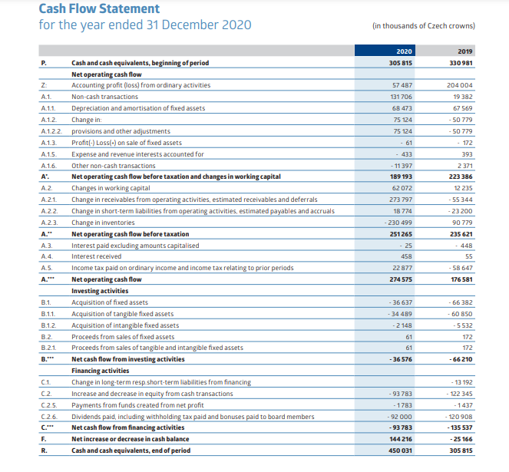
Figure 16: Cash flow statement of 2020
- In accordance with the above cash flow statement of Skoda auto for the year ended 31st December 2020, it has expressed in thousands of Czech crowns.
- It has been interpreted that the beginning of the cash and the cash equivalent balance for the year was CZK 305815. In regards with the net increase and decrease in the cash balance was czk 144216. Considering the ending cash and cash equivalent balance was czk 450031.
- In terms with the net operating cash flow, it was generated by the organisation during the year was czk 204004. After that the organisation has acquired the tangible fixed assets for czk 274575. There was an Acquiring of intangible fixed assets for czk 8138 as well. In regards with the sale of fixed assets, it has preceded with czk 61.
- There was the negative net cash flow from the financing activities which has indicated that the company has paid more cash for the financing activities as compared to its receivables. The value of net cash flow was czk 120908. It basically includes the payments of short term and long term liabilities and also the payments which are made for the bonuses and dividends paid to the board members.
- There is the positive cash flow generation by the company from the operations but the negative cash flow from the financing activities and the investments which has resulted in the net increase in the cash and cash equivalents.

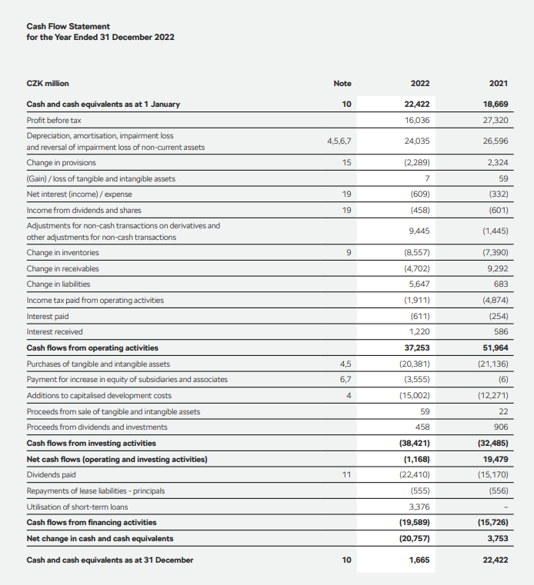

Figure 17: Cash flow statement of 2022
- The above presented is the cash flow statement for the company for the year ended 31st December 2022 which is presented in CZK million. The current cash flow statement is mainly divided into three main categories which are named as the operating activities and investing activities along with the financing activities.
- The cash balance at the beginning was czk 22422 million and the company has generated czk 37 253 million cash inflow from its all over operating activities. This inflow is majorly from the profit before tax which was of CZK 16036 million and also the adjustments have also been done for the non-cash transactions which are valued of czk 9445 million. The net cash inflow of the company from the operating activities was less than the previous year because of the various changes made in the provisions of receivables and inventories.
- Skoda auto has potentially invested its czk 20381 million during the current year for purchasing the intangible and tangible assets. The value of czk 15002 million was invested in the capitalised development cost which has resulted in the net cash outflow of czk 38421 million from the different investing activities. Organisation has also made certain payments for the equity for better increasing the associates and subsidies that has resulted in the net cash outflow that is czk 3555 million.
- In regards with the financing activities, the night cash outflow of the company was czk 19589 million in which the dividends have been paid of czk 22410 million and also the repayments are also done for the lease liabilities which has the value of czk 555 million. There is a net decrease of czk 20575 million in cash and cash equivalents during the current year which has resulted in the ending cash balance for the company which was valued at czk 1665 million.
- The cash flow statement of the Skoda auto demonstrates that there is a generation of positive cash flow from its operating activities but also has faced the net cash outflows from its financing and investing activities which has decreased in its cash balance.

4.6 Trend analysis
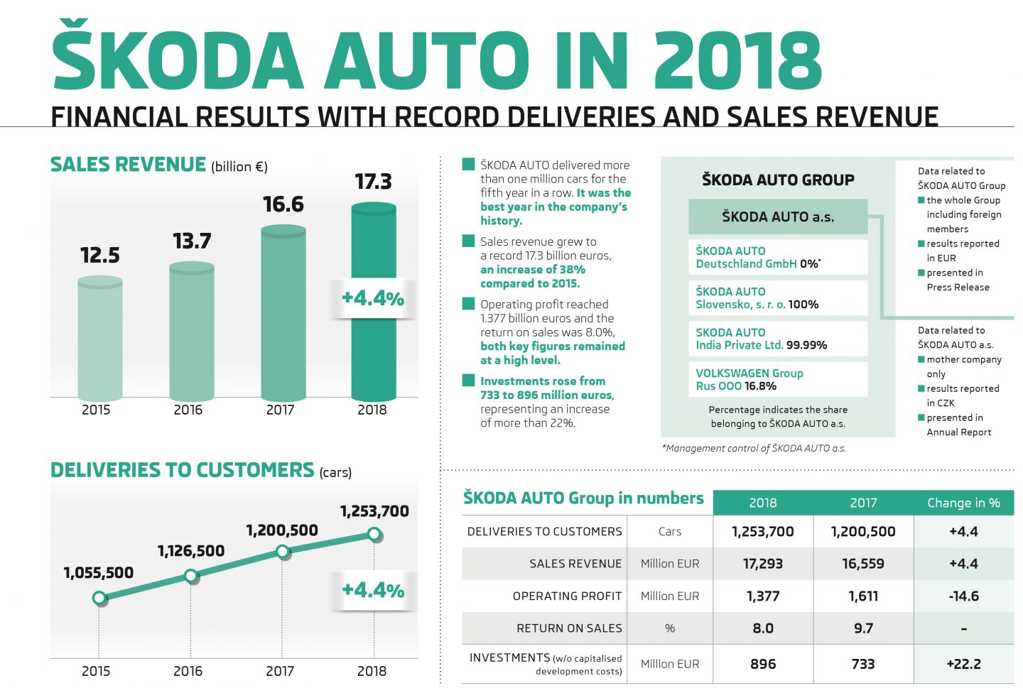

Figure 18: Financial results with record deliveries and sales revenue in 2018

- The current report provides the financial results of the Skoda auto in the year of 2018. The company has delivered multiple million cars in this year which was considered as one of the best years in the history of the company.
- There is an increase of the sales revenue to a record of 17.3 billion euros which was an increase of 38% as compared to 2015 data. The operating profit was 1.377 billion euros having the return of sales of approximately 8.0% which indicates that the company was profitable in that year.
- Moreover the investments also Rose by more than 22% that is 896 million euros.
- The current report also provides the information on the delivery to the customers and the sales revenues along with the operating profit and also the investments for the company. The report basically reflects and highlights the management control of the company which has a majority share of the different foreign members of the entire group of Skoda auto.
- The current report demonstrates the increment in the deliveries to customers and also the sales revenue by 4.4% as compared to 2017. But it has also faced a decrease in its operating profit by 14.6%.
- The report states that the company is performing well in terms of its investments and sales revenue but it is highly required for the company to improve the operating profit in the near future.
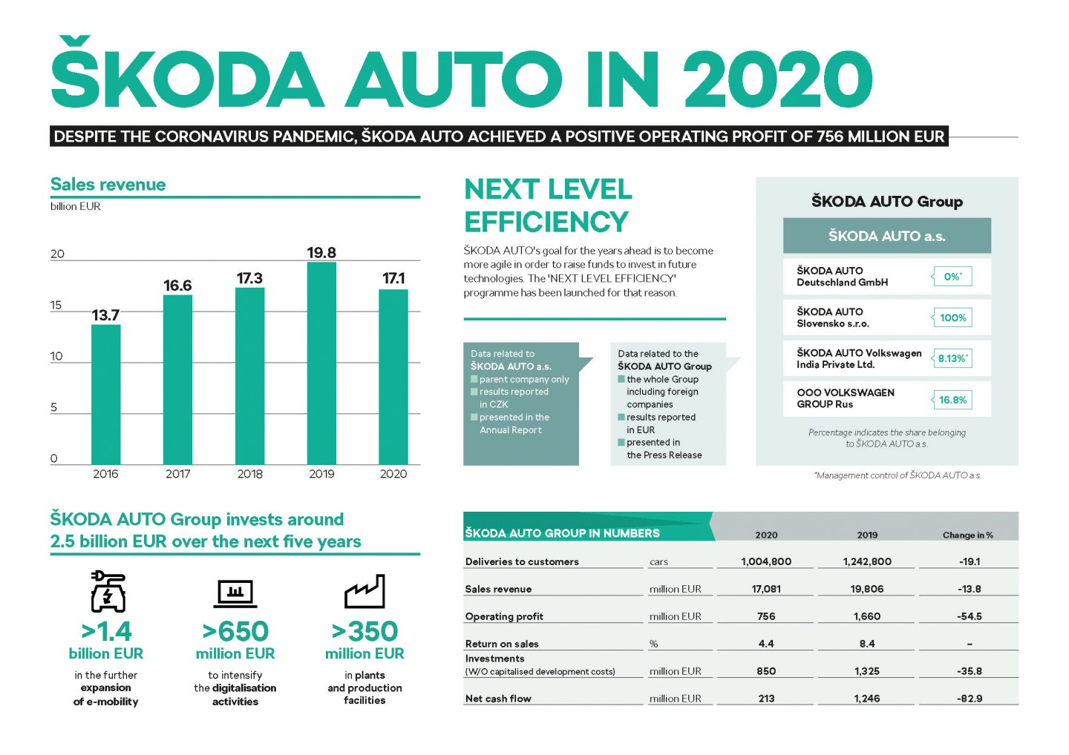
Figure 19: Financial results with record deliveries and sales revenue in 2020

- The above table provides the information in terms of the financial results of Skoda auto in the year of 2020. There were various challenges which were posed by the covid-19 pandemic still the company has continued its operations and has achieved a positive operating profit of 756 million euros. The company has achieved the sales revenue for the year was approximately 17.1 billion euros but it decreased 13.8% as compared to the last year.
- The organisation has launched the program for becoming more agile and conducting the investment in future technology which was named as the next level efficiency program. The group of Skoda auto plants to conduct the investment of approximately 2.5 billion euros over the next 5 years and majorly in the expansion of the electronic mobility and activities of digitalisation.
- The return on sales of the organisation was 4.4% which was a decrease from the last year. The net cash flow of the company was 213 million euros which was also a significant decrease from last year. In the year of 2020 there were deliveries to customers which were around 1004 800 and it was a decrease of 19.1% as compared to the last year.
- In regards with investments which majorly includes the cost of capitalise development in the year of 2020 was about 850 million euros which was a decreased amount of 35.8% as compared to the last year.
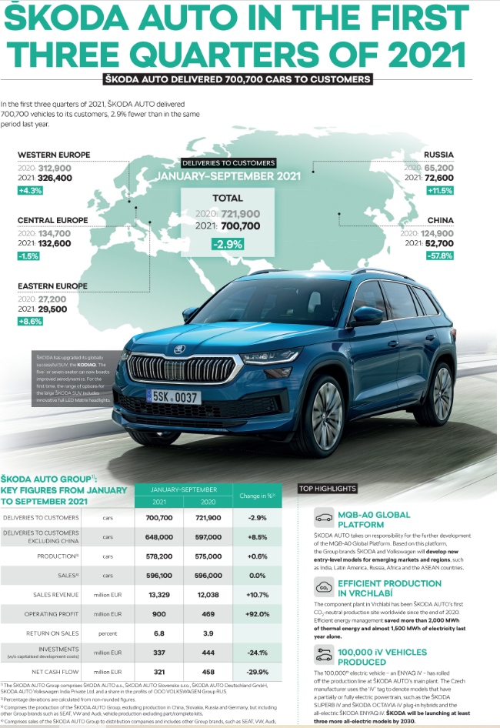

Figure 20: Financial results with record deliveries and sales revenue in 2021
- The above table provides the information that Skoda auto has delivered 700700 vehicles to their customers during the first three quarters in the year of 2021. It represents a 2.99% decrease as compared to the same period of the previous year.
- The company has experienced the development in the Western Europe and Russia with an increase of 4.3% deliverance to the customers in those particular regions. Whereas the delivery to customers in China has decreased by 57.8%. There is also an increase by 2.9% and 8.6% of the deliveries to customers in central and Eastern Europe respectively.
- The report also reflects regarding the upgrading of the kodiaq SUV which now has in hand its aerodynamics and provides a broader range of options. Moreover, the report also provides and highlights the key figures which are related to the entire group of Skoda auto performance from the month of January to the month of September in the year of 2021.
- The company has delivered 721 900 cars to their customers which represents a 2.9% decrease as compared to the same period of the previous year.
- They are delivered to the customers which excludes China and has increased by 8.5%. The company has also reported the increment in their sales revenue and operating profit along with the return on sales but at the same time decrease in their net cash flow and investments as well.
- The above report displays the production of the 100000th electric vehicle and the company is still planning to launch at least three types of more all electric models by the year of 2030. The report also keep the notes that the responsibility of the company for the further development of the mqb-ao the global platform will be utilised for the development of the new entry level models which are now emerging in the markets and regions.

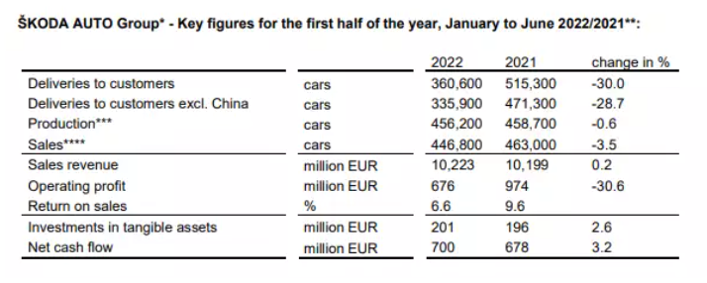
Figure 21: Financial results with record deliveries and sales revenue in 2022
- The above provided data highlights the key figures for the group of Skoda auto at the time of the first half of the year 2022 as compared to the same period in the year of 2021.
- There are certain deliveries which are done by the company to the customers and it has increased by 7.3% that is 3606000 vehicles but if China is excluded then the deliveries fall by 28.7% that is 471 300 vehicles.
- The company has decreased its production by 0.6% of the cars 456200 in which it has decreased their sales by 3.5% that is 446 800 vehicles.
- There is a sales revenue which has increased slightly by 0.2% that is up to 10223 million euros.
- Operating profit for the company has increased by 974 million euros which is considered as a substantial increase from the same period of the previous year which was about minus 30.6%.
- There was the return on sales which was about 6.6% and this is a decreased amount from 9.6% from the year of 2021.
- Finally there is the investment in the tangible assets of the company which grows slightly by the percent of 2.6 that is up to 201 million euros. There is the net cash flow which increased by 3.2% and that is up to 700 million euros.

Chapter 5: Findings and discussions

5.1 Financial analysis of ŠKODA AUTO during last recent years
According to (STRNAD, 2019), Covid-19 pandemic were the last previous years which has resulted in a crisis in the entire world and that is why there are many businesses who have faced different challenges due to such a crisis. Skoda auto is the company based on which the current review of literature is conducted by analysing its financial analysis during previous years. As per the view of (KUČERA and TICHÁ, 2022), the last recent years has impacted significantly on the automotive industry as a whole. There are many other different factories which were closed on a temporary basis and the demand for the cars were also declining because of the economic uncertainty situation. The below discussed is the financial analysis of Skoda auto during the last recent years.
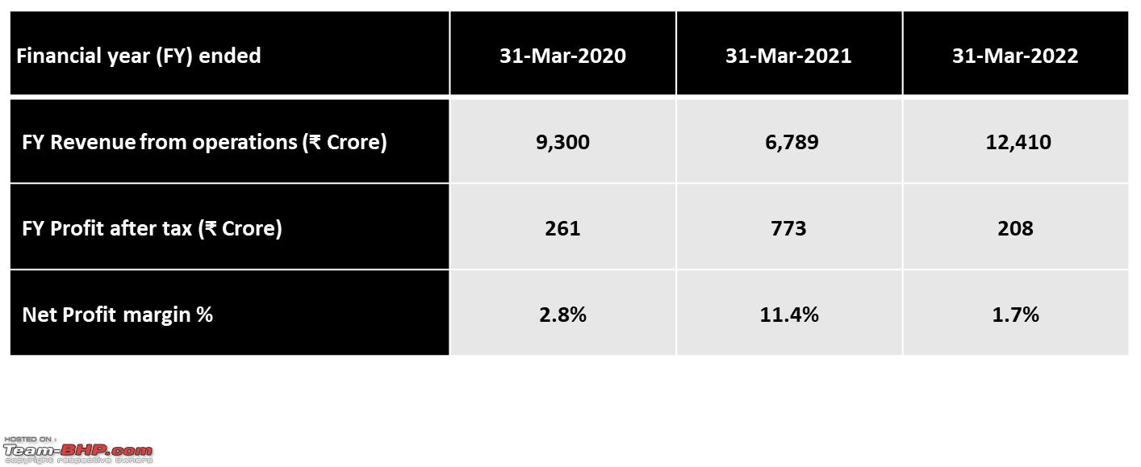
Figure 22: Financial analysis of ŠKODA AUTO during last 3 years
- According to (Velinov, 2020), in terms of revenue, as per the organisational financial reports, the company was having a revenue of 14.8 billion Euros in the year of 2020. It was the decreased amount if it is compared to the previous year of 2019 by 13.6%. The reason behind declining in the revenue amount was majorly because of the decrease in the vehicle deliveries and also the lower demand for the automotive services in the international market.
- As per the view of (Rahman, 2021), in the context of profitability, the last recent years has drastically impacted the profitability of Skoda auto. It was having its operating profit in the year of 2020 that is 756 million euros which was considered as the decreased amount if it is compared to the previous year of 2019 by 77.9%. The reason behind decrease in the profitability was because of the lower amount of sales volume and also the disruptions in the production area which has increased in the cost associated with the safety measures which were implemented to protect the employees.
- According to (Rogowska, 2022), In regards with the liquidity, there were many challenges brought up by the last recent years but still the Skoda auto was having the ability to maintain its strong liquidity position. They have experienced the increment in their cash and cash equivalents from 1.7 billion Euros in the year of 2019 to 2.5 billion in the year of 2020. Moreover the net cash position of the company was also improved from 1.1 billion Euros in the year of 2019 to 2.2 billion Euros in the year of 2020.
- As per the view of (Vyklyuk, Manylich, Škoda, et.al, 2021), In relation to the investment, the company has still continued to make their investment in the department of research and development during last recent years. The investment done by the company in the department of research and development amounted to 676 million in the year of 2020 which was the decrease if it is compared to the previous year of 2019 by 6.1%.
- According to (Kufelová and Raková, 2020), in context with the market share, there are many challenges because of which the Skoda auto is still suffering and facing the problems. But still the company has the ability to maintain its market share in many of the different regions. The market share of the company has been increased from 5.3% in the year of 2019 to 5.4% in the year of 2020 within Europe.
Skoda auto has faced various different challenges during the last recent years which includes in the decrement of the revenue and profitability. But the company has still maintained its strong liquidity position and also has continued to invest in the department of research and development. Moreover, apart from all the challenges, the company was still able to maintain its number of market share in many of the different regions.

5.2 Pitfalls faced by the company during last recent years
Skoda auto has faced many challenges in the last recent years due to the pandemic crisis and some of them are as follows.
- As per the view of (Velinov, Bleicher and Forrester, 2021), Disruptions in the supply chain is one of the challenges faced by the Skoda auto which has resulted in the significant problems within the company to its international supply chain. According to (Rogowska, 2022), the pandemic has made it challenging for the company to source different types of parts and components which are highly required for the vehicles manufacturing. It has resulted in the large delays in the production and also even in the delivery times as well.
- As per the view of (Boston, 2022), Declining in the sales amount is another challenge faced by the Skoda auto during the last recent years. The major reason was the long term lock downs and also the uncertainty in the economy. There were many customers who started saving their income and were reluctant in purchasing the new luxury things in which cars are one of the luxury products. According to (Kunovjanek and Wankmüller, 2021), this is a reason that customers were held off from purchasing the new cars which has ultimately resulted in the large decline in the sales for the company.
- As per the view of (Nowacki and Krawczyk, 2022), Shutdown of the factories is also one of the challenges faced by the Skoda auto because it was the company who was a victim of the drastic impact of last recent years because it had to shut down its production at its factories. According to (Kołsut and Stryjakiewicz, 2019), the major reason behind shutting down of the factories was the concern of the health and safety of their employees which has further resulted in the reduction of the output and also the major losses in the revenues.
- As per the view of (Pelikánová and MacGregor, 2021), Shifting to remote work is also another challenge faced by the Skoda auto. Due to a lock down and the application of social distancing in the entire world, employees were shifted to work from home or on the remote basis which has disturbed the flow of communication and also the collaboration among the diversified teams and it had become more challenging for the company. As per the view of (Boston, 2022), This has negatively impacted the efficiency and speed of the company while making the strategic decision making and also while implementing any of the running projects.
- According to (Kołsut and Stryjakiewicz, 2019), Reduction in the demand of diesel cars is one of the challenges faced by the Skoda auto during the previous years. During the period of pandemic rises there were large fluctuations and changes in consumer preferences along with their regulations. It has reduced the demand for the diesel cars which has highly affected the sales of the Skoda auto.
The recent previous years has resulted in suffering of the major challenges by the Skoda auto and also the entire automotive industry as a whole. As per the view of (Velinov, Bleicher and Forrester, 2021), Although the company has put their efforts in implementing several Strategies for better mitigation their pitfalls for example diversifying their supply chain and also diversifying their products portfolio as well. They have also adopted the different types of digital tools to overcome the challenges like remote collaboration and also focusing on the electric and hybrid vehicles for better meeting up the change in demands of the customers.

5.3 Future recommendations for overcoming the pitfalls
In the previous section it was discussed about the pitfalls which were faced by the Skoda auto during the previous recent years. In the current section of literature review the future recommendation for Skoda auto is provided for overcoming the pitfalls of the pandemic.
- According to (Noor, 2022), It is recommended that the company must strengthen its supply chain resilience. The last recent years has resulted in the drastic vulnerability of the international supply chains. That is why it is considered to be important to mitigate the disruption of the supply chain, which is why it is recommended that the company must consider diversifying its supplier base and also must focus on increasing its inventory levels while establishing the strategic partnerships with their local suppliers.
- As per the view of (Swartz, Barbosa, Crawford, et,al, 2021), It is recommended to embrace the transformation in digitalisation. Digitalisation is only one of the positive results of the pandemic because it has accelerated the shift towards the transformation of it. As per the view of (CERNICOVA-BUCA and COCEA, 2020), the company should focus on leveraging the advanced digital technology for better improving the flow of communication and strategic collaboration among their teams. This is because it will help in automating the processes and also improves the customer experience.
- According to (Doležal, 2021), It is recommended for the company to emphasize on the production and timely delivery of electric and hybrid vehicles. Sustainable mobility is another positive result of the pandemic which has shifted its acceleration towards the trend of electric or hybrid vehicles. According to (Brauner, Mindermann, Sharma, et.al, 2021), the company must focus on the development and the promotion of the hybrid and electric vehicles for meeting up the fluctuating and changing demands of the customers. This will also help in better complying with the regulatory requirements as well.
- As per the view of (CERNICOVA-BUCA and COCEA, 2020), It is recommended for the company to invest in the wellbeing of their employees. Employees are considered as one of the greatest assets for the organisation and that is why it is important to take care of them during pandemic times. The company must prioritize the development of the employee benefit programs which must include the health and safety of their employees. According to (Szabo, Deák, Szalavetz and Túry, 2021), the company must also provide the work from home options wherever possible as per the comfortable and convenience of the employees. Moreover, the company must also invest in the training and development programmes of the employees.
- According to (Brauner, Mindermann, Sharma, et.al, 2021), It is recommended to the company for enhancing the experience of the customers. The reason being is that the last recent years has resulted in the frequent changed expectations of the customers. As per the view of (Mastoi, Zhuang, Munir, et.al, 2022), the company should emphasize on improving the customer experience by rendering them with the contactless service options and also improving the advanced digital interfaces. They must also offer flexible options for financing and payment as well.
If the company strengthens its supply chain resilience and embraces its digital transformation while focusing on the development and promotion of electric and hybrid vehicles then they can easily overcome the challenges of the pandemic. Moreover if the company also focuses on the investment in the employee wellbeing and improves the customer experience then it can also simply overcome the pitfalls of the previous recent years and then also emerge stronger in the near future.

5.4 Future recommendations for grabbing the opportunities in the marketplace
There are various opportunities to the company to grab in the marketplace and the below presented at the recommendations for the same.
- As per the view of (Peiris, Dewasiri and Banda, 2020), It is recommended that the company must focus on innovation to stay ahead of the competition. The company is recommended to continue to make its investment in the department of research and development so that they can bring innovative and new products to the market. This should also include the exploration of new technologies for example autonomous vehicles and should also improve its existing products with the innovative features and designs.
- According to (Ali, 2021), It is recommended to enhance the customer experience because it plays an important role in creating brand loyalty and also implementing word of mouth marketing. They must focus on providing a personalized experience to the customers so that they can build up strong relationships.
- As per the view of (Barauskaite and Streimikiene, 2021), It is recommended to the company to expand its product range while considering expanding its existing products and catering it to the broader range to the customers. This must include the introduction of the new variants of the existing products or the new models which must appeal to various different segments of the current market.
- According to (Paais and Pattiruhu, 2020), It is recommended to the company to emphasize on the sustainable activities and focus on its corporate social responsibility. This is because sustainability is one of the most important factors which is becoming increasingly significant in making the purchase decisions by the consumer. It is important for the company to continue with the emphasis on the reduction of the carbon footprint and using the materials which are eco-friendly in nature. The company must incorporate its sustainable practices throughout its entire supply chain management.
- As per the view of (KUČERA and TICHÁ, 2022), It is recommended that the company must leverage digital technology. This will help the company and improve its operations and also significantly connect with the customers. Data analytics must be focused by the company in order to gain the insights of the customer preferences with the help of social media engagement with the customers and also while making the use of the online channels for selling up their products and services to the customers.
- According to (Rogowska, 2022), It is recommended for the company to expand into the new markets by tapping up in the new opportunities for growth and development. This includes the targeting of the emerging markets and the regions where currently the company has its smaller presence.
- As per the view of (Brauner, Mindermann, Sharma, et.al, 2021), It is recommended for the company to collaborate with the other companies. This helps in leverage in the strength and combining the strength of both of the companies for better bringing the new product and services to the marketplace. It basically includes to develop and formulate the partnership in incorporating and integrating the technology for developing the new features. This requires collaboration with the other automakers for better sharing of the resources and expertise.

Chapter 6: Conclusion
It is concluded that Skoda Auto, an automobile manufacturer, is the basis for the aforementioned theory. It is a multinational automobile manufacturing business with its headquarters in the Czech Republic that was founded in 1925. In addition to producing and selling goods under its own brand, it also makes various cars and vehicles. In recent years, Skoda Auto's financial records have experienced a number of changes. Various financial analysis techniques were used to calculate and analyse the participants' finances in the present study. These are the methods for analysing financial records, including horizontal and vertical analysis, ratio analysis, trend analysis, volume profit analysis, and more.
The above study have been done because it can aid in understanding the various approaches to financial analysis and reveal the pitfalls the business has fallen into in recent years. The coronavirus pandemic 2019 is an illness that spreads in a communicable form, and the most recent years were those of pandemic. Because it is such a fatal illness, the government has even declared that there will be social isolation as well as lockdowns in various countries. The cause is that there was a high death rate, and those who were in touch with it suffered from it. A number of businesses have collapsed as a result of the overall situation, causing losses to the businesses as well as their shutdown. Several companies have experienced significant changes in their financial statements in recent pandemic years.
All of these areas have been evaluated in order to suggest potential solutions to the business in the form of research findings. The above study responds to the research questions by performing a financial analysis using the company's financial records from various years with the aid of a thorough literature review. Therefore, the primary objective of the thesis is to perform a financial analysis of the chosen company going back a few years in order to examine the pitfalls and offer future advice to the company. It involves comprehending the principles and requirements for performing financial analysis as well as investigating the available techniques.
The importance of financial analysis is related to the significance of the present thesis. The reason is that it is essential for an organisation to conduct financial analysis so that investors and financial analysts can review the company's key financial statements and make more informed investments. When making strategic decisions for the firm as a whole, financial analysis is important for more than just the financial statements. The business learns about the gains and losses as well as the revenues and sales in great detail, which is the reason. This also aids in future projection, which in turn supports and directs decisions for enhancing company performance. The current thesis is significant for this reason because it is entirely based on the financial analysis of the chosen company with the aid of a systematic literature review analysis based on the deliveries and sales revenues figures so that merits and demerits can be discovered for a better finding out the research outcomes in a relevant manner.
To better preserve the validity and dependability of the data used in the current study, secondary sources have been used. The greatest change in the stability of a company is thought to be a pandemic, so it is important to perform financial analyses in the most recent years in order to make comparisons that are more accurate and to offer solutions for dealing with significant changes. This can assist companies in getting back on track while preserving market equilibrium.
The methods used are such that researcher has adopted the positivism research philosophy. This is a type of philosophy which helps the researcher and assumes the actual reality of the organisation and its financial performance by objectivity measuring through the quantitative data. Deductive research approach has been adopted for the above study because it involves the testing of the pre-existing theory by conducting the empirical observation and data analysis for identifying the pitfalls and financial performance of the company.
The systematic literature review is the adopted research strategy which includes the identification and evaluation of the relevant literature so that it’s synthesizing can be done with the current research topic. Quantitative mono method is adopted by the researcher as the research choice because the current study is entirely based on the quantitative data along with its collection and analysis. Secondary research is the adopted data collection in the current study in which the data is connected which has already been collected and published by the other authors or researchers. In accordance with the current study, the sources of secondary data includes the industrial reports and government reports along with the financial reports and statements and also the academic articles as well.
Financial ratios and other statements are majorly used for the current study to analyse the financial performance of the Skoda auto. They can provide valuable insights into the organisational liquidity and profitability along with the efficiency and solvency. It also includes the horizontal and vertical analysis which further also involves the trend analysis and cash flow statement along with the common size statement and comparative statement as well. Positivism is the selected research philosophy and deductive is an applied research approach. Moreover, quantitative mono method is followed as research choice and systematic literature review is decided to be as research strategy. Furthermore, secondary research data collection is chosen for the current study and financial ratios, vertical analysis, horizontal analysis, common size statement, cash flow statement and trend analysis are being used for data analysis.
It has been found that if the current ratio has the value of one or more than that then it is considered to be the good for the company because it indicates that the company has the sufficient current asset in order to cover up its current liability. In accordance with the calculations above, it has been interpreted that there has been a decrease of the current ratio of Skoda auto since the past 3 years. This can result in liquidity issues and even bankruptcy as well. These are the consequences if the company is unable to obtain the sufficient finding or may increase its value of current assets in the future. It is a type of ratio which majorly excludes the inventory from the current assets because it is not considered to be the highly liquid asset. In accordance with the above data, it has been interpreted that the quick ratio of the Skoda auto is relatively stable since the past 3 years. This measurement signifies that the organisation has the most liquid assets which are enough for covering up its short term obligations but it is still important to note that the ratio is still relatively low. Hence it simply indicates that the organization has the ability to fully cover up its current liabilities while using its most of the liquid assets. But still there is a requirement for the company to improve its liquidity position in the future.
Quick ratio measures that up to which extent the company is financed in terms of its debt as compared to the equity. If there is a high value of debt to equity ratio then it means that the company has a higher amount of debt as compared to equity. It has been interpreted that there is the increment of the depth to equity ratio over the past 3 years. This demonstrates that the company is becoming more heavily financed in regards with debt which could result in the financial distress if the company would not be able to overcome its debt obligation in the future. It is highly important for the company to consider the strategies for better reducing the debt levels and also improving its equity position for making sure of its long term financial stability.
If the value of debt to asset ratio is high then it indicates that the company has a higher amount of debt as compared to its asset. It has been interpreted that there is the increment of the value of debt to assets ratio over the past 3 years. This demonstrates that the company is becoming heavily financed by debt which is considered to be risky as a ratio is quite high for the company.
It can be analysed that the company may face financial distress in the future if it is not able to generate sufficient cash flow to overcome its debt obligations. It is highly important for the company to consider the strategies so that they can reduce the level of debt and improve its base of a set for making sure there financial stability for the long term. Gross profit margin indicates that the generation of the amount of profit by the company before the accounting of its operating expenses. It has been interpreted that there is a decrement of gross profit margin over the past 3 years. This demonstrates that the cost of goods sold of the company has increased faster as compared to its sales revenue which is highly affecting its profitability. If there is a decrease in the gross profit margin then it indicates the decreasing pricing power which highly increases the competition and also the rising cost of goods sold as well.
Currently the company is facing challenges in its management of supply chain and also in the manufacturing process as well. It is highly important for the company to make a review on its cost structure and also improve its efficiency for better maintaining and improving its profitability. They need to adopt the Strategies for reducing its cost of goods sold which includes the optimisation of the supply chain and renegotiating its contracts with the suppliers. Operating profit margin indicates how efficiently and effectively the organisation is managing its operation. It has been interpreted that there is a fluctuation over the past 3 years. It demonstrates that operating expenses of the company are fluctuating over the years which are affecting its profitability. The increased value of the operating profit margin indicates that the organisation is generating the most profit per dollar of its sales. If there is a decrease in the operating profit margin then it indicates that the organisation is facing the challenges in managing its operating expenses and are also experiencing the pricing pressures as well. It is highly required for the company to take a quick review in its cost structure for better improving its efficiency and maintaining its profitability. It is important to adopt some of the strategies to reduce their operating expenses which includes the streamlining of the supply change process.
If there is the high net profit margin then it indicates that the organisation is generating more profit per dollar of its sales but when it is having the low net profit margin then it demonstrates that the company is facing challenges in its management of expenses and is also experiencing the pricing pressures. It has been interpreted that there is a fluctuation in the value of net profit margin since the last 3 years. It demonstrates that the organisational expenses are fluctuating over the years which are affecting its profitability. It is highly required for the company to review its cost structure and improve its profitability while considering some of the strategies to reduce its expenses like optimising the applied chain and reducing the cost of administration. It is highly important for the company to explore the new markets and the product lines for better diversification of its revenue streams for improving the profitability.
If there is a high value of return on assets then it indicates that the company is generating more profit per dollar of its assets but when there is a low value then it demonstrates that the company is facing problems in managing its assets and also experience in the pricing pleasures. It is highly required for the company to take a review of its asset utilisation Strategies for better maintaining its profitability. It is essential for the company to consider the optimisation of the asset allocation and also to explore the new markets and product lines for better diversifying its revenue streams while focusing on improving its operational efficiency as well.
If there is the higher value of return on equity then it indicates that the organisation is generating more profit per dollar of its shareholders equity but if there is the lower value of return on equity then it indicates that organisation is facing issues in generating the profits and experiencing the pricing pressures. It is highly required for the company to take the review on the equity utilisation Strategies for improving its profitability. It is required for the company to consider the optimisation in its equity allocation while reducing its debt or buying back the shares for improving the return on equity. The company is highly required to emphasize on the improvement of the operation efficiency and also exploring the new product lines for diversifying its revenue streams.
The vertical analysis of the Skoda auto has the base amount of net sales and the financial items are expressed in the percentage of the net sales. There is a similar trend of profit before tax of net sales as the operating profit margin because it has the significant increase in 2021 and then decrease in 2022. It indicates that organizational profitability has been volatile in the past few years. There is the increment of income tax expense of net sales over the past 3 years which indicates that the organisation is paying more in Texas because of the higher profits and changes in the tax regulations. There is the positive cash flow generation by the company from the operations but the negative cash flow from the financing activities and the investments which has resulted in the net increase in the cash and cash equivalents. The cash flow statement of the Skoda auto demonstrates that there is a generation of positive cash flow from its operating activities but also has faced the net cash outflows from its financing and investing activities which has decreased in its cash balance. The report states that the company is performing well in terms of its investments and sales revenue but it is highly required for the company to improve the operating profit in the near future.
It is advised that the business improve the resilience of its supply network. The international supply networks are now extremely vulnerable as a result of the recent years. Because of this, it is thought to be crucial to minimise supply chain disruption, so it is advised that the business think about diversifying its supplier base and concentrating on raising its inventory levels while forming strategic alliances with their local suppliers. It is advised that the business put a focus on the creation and prompt supply of electric and hybrid vehicles. Another benefit of the pandemic is sustainable mobility, which has accelerated the tendency towards electric or hybrid vehicles.
To satisfy the shifting and fluctuating customer demands, the business must concentrate on the creation and promotion of hybrid and electric vehicles. Additionally, greater compliance with legal requirements will result from this. The business can easily overcome the challenges of the pandemic if it improves the resilience of its supply chain, embraces its digital transformation, and focuses on the creation and promotion of electric and hybrid vehicles. The business can also easily avoid the pitfalls of the previous recent years and then also emerge stronger in the near future if it also concentrates on the investment in the wellbeing of the employee and enhances the customer experience.
To remain competitive, it is advised that the business concentrate on innovation. It is advised that the business maintain its investment in the R&D division so that they can introduce cutting-edge and novel goods to the market. This should also involve investigating novel technologies, such as autonomous vehicles, and enhancing the functionality and aesthetics of the company's current goods. The business is advised to broaden its product offering while taking into account broadening its existing products and catering to a wider range of customers. This includes the release of new iterations of current goods or new models that must appeal to a variety of different market segments.
It is advised that the business tap into the new possibilities for growth and development in order to expand into the new markets. This involves focusing on developing economies and areas where the company currently has a less significant presence. Collaboration with other businesses is advised for the firm. This makes it easier to combine and leverage the strengths of the two businesses to more effectively promote new goods and services. In essence, it entails creating and formalising a collaboration to incorporate and integrate technology for the development of new features. For improved resource and expertise sharing, this calls for cooperation with other automakers.

References
Bohata, M. and Zemplinerova, A., 2019. Internationalization of Czech companies via outward investment. In Facilitating transition by internationalization (pp. 111-132). Routledge.
Bokšová, J. and Horák, J., 2019. Is it Possible to Identify High-Risk Suppliers from Financial Statements? International Advances in Economic Research, 25(1), pp.131-132.
Chadima, J., 2021. Řízení vybraných zásob ve ŠKODA AUTO as.
Čizinská, R. and Neset, P., 2021. Analysis of the Key Financial Value Drivers of Automotive Companies in Selected EU Countries. In International Conference at Brno University of Technology, Faculty of Business and Management.
Deshmukh, R. and Tharkude, D., 2023. Dealer process efficiency, revenue generation and customer satisfaction utilizing gamification models: An empirical study-With special emphasis on Skoda Auto Volkswagen India Private Limited. Journal of Contemporary Issues in Business and Government Vol, 29(01).
Fava, V., 2021. A tale of two socialist enterprises: production and decision-making at Škoda Auto and AvtoVAZ, 1960-1980. Entreprises et histoire, (2), pp.90-106.
Gao, M., 2019. Assessment of Profitability of the Company Škoda Auto as.
Hornungová, J. and Milichovský, F., 2019. Evaluations of financial performance indicators based on factor analysis in automotive. Periodica Polytechnica Social and Management Sciences, 27(1), pp.26-36.
Krabec, T. and Čižinská, R., 2020. Empirical Analysis of the Market Value Added in the Czech Automotive Industry. International Advances in Economic Research, 26(1), pp.123-124.
KUČERA, J. and TICHÁ, S., 2022. CZECH AUTOMOTIVE INDUSTRY AND COVID-19. Ad Alta: Journal of Interdisciplinary Research, 12(1).\
Mishra, S.B. and Alok, S., 2022. Handbook of research methodology.
Newman, M. and Gough, D., 2020. Systematic reviews in educational research: Methodology, perspectives, and application. Systematic reviews in educational research: Methodology, perspectives and application, pp.3-22.
Pandey, P. and Pandey, M.M., 2021. Research methodology tools and techniques. Bridge Center.
Strouhal, J., Horák, J. and Bokšová, J., 2021. Corporate perceptions on digitalization of public services: from the perspective of Czech SMEs. WSEAS Trans. Bus. Econ, 18, pp.231-236.
Svobodová, L. and Bednarska-Olejniczak, D., 2021. Corporate Social Responsibility and Automotive Industry in the Czech Republic. In Proceedings of the International scientific conference Hradec Economic Days (pp. 710-719).
Iliemena, R.O. and Okolocha, C.B., 2019. Effect of audit quality on financial performance: Evidence from a developing capital market. International journal of recent research in commerce economies and management (IJRRCEM), 6(3).
Rai, K., Dua, S. and Yadav, M., 2019. Association of financial attitude, financial behaviour and financial knowledge towards financial literacy: A structural equation modeling approach. FIIB Business Review, 8(1), pp.51-60.
Bartolacci, F., Caputo, A. and Soverchia, M., 2020. Sustainability and financial performance of small and medium sized enterprises: A bibliometric and systematic literature review. Business Strategy and the Environment, 29(3), pp.1297-1309.
Agrawal, P., Bansal, P. and Kathpal, S., 2020. Effect of financial performance on corporate social responsibility and stock price: A study of BSE listed companies. International Journal on Emerging Technologies, 11(1), pp.286-291.
Young, S.D., 2020. Financial statement fraud: motivation, methods, and detection. In Corporate Fraud Exposed (pp. 321-339). Emerald Publishing Limited.
Seiler, A., Papanagnou, C. and Scarf, P., 2020. On the relationship between financial performance and position of businesses in supply chain networks. International Journal of Production Economics, 227, p.107690.
Paais, M. and Pattiruhu, J.R., 2020. Effect of motivation, leadership, and organizational culture on satisfaction and employee performance. The Journal of Asian Finance, Economics and Business, 7(8), pp.577-588.
STRNAD, D., ŠKODA AUTO VYSOKÁ ŠKOLA ops.
KUČERA, J. and TICHÁ, S., 2022. CZECH AUTOMOTIVE INDUSTRY AND COVID-19. Ad Alta: Journal of Interdisciplinary Research, 12(1).
Velinov, M.B.E., New Approaches in Marketing Communications: The Case of Skoda Auto India.
Rahman, A., IMPACT OF COVID-19 ON WORKING CAPITAL MANAGEMENT IN SELECTED FOUR-WHEELER AUTOMOBILE COMPANIES IN INDIA.
Rogowska, B., 2022. The role of the state during the Covid-19 pandemic in Poland and the Czech Republic. A comparative analysis. Nierówności Społeczne a Wzrost Gospodarczy, (69), pp.101-126.
Vyklyuk, Y., Manylich, M., Škoda, M., Radovanović, M.M. and Petrović, M.D., 2021. Modeling and analysis of different scenarios for the spread of COVID-19 by using the modified multi-agent systems–Evidence from the selected countries. Results in Physics, 20, p.103662.
Kufelová, I. and Raková, M., 2020. Impact of the Covid-19 pandemic on the automotive industry in Slovakia and selected countries. In SHS Web of Conferences (Vol. 83, p. 01040). EDP Sciences.
Velinov, E., Bleicher, J. and Forrester, P.L., 2021. Creating and Managing International Virtual Teams of Students in Management Education. In Developments in Virtual Learning Environments and the Global Workplace (pp. 124-140). IGI Global.
Rogowska, B., 2022. The role of the state during the Covid-19 pandemic in Poland and the Czech Republic. A comparative analysis. Nierówności Społeczne a Wzrost Gospodarczy, (69), pp.101-126.
Boston, W., 2022. Ukraine war plunges auto makers into new supply-chain crisis. Wall Street Journal, 3.
Kunovjanek, M. and Wankmüller, C., 2021. An analysis of the global additive manufacturing response to the COVID-19 pandemic. Journal of Manufacturing Technology Management, 32(9), pp.75-100.
Nowacki, G. and Krawczyk, M., 2022. Selected Rescue Problems including means of transport during Pandemic of the Covid-19. Journal of Civil Engineering and Transport, 4(2), pp.9-22.
Kołsut, B. and Stryjakiewicz, T., Conclusions, policy recommendations and future challenges in the context of the COVID-19 pandemic. In The Economic Geography of the Car Market (pp. 177-188). Routledge.
Pelikánová, R.M. and MacGregor, R.K., 2021. The COVID-19 as interpretation instrument for the content of corporate social responsibility and its reporting in the EU?. The Lawyer Quarterly, 11(2).
Noor, T., 2022. Reviewing the Challenging Factors of Survival During COVID 19 Uncertainty. International Journal on Social Science, Economics and Art, 11(4), pp.150-164.
Swartz, S., Barbosa, B., Crawford, I. and Luck, S. eds., 2021. Developments in Virtual Learning Environments and the Global Workplace. IGI Global.
Doležal, J., 2021. Analysis of the ŠKODA brand perceptions on different markets.
CERNICOVA-BUCA, M. and COCEA, E., PUBLIC ENGAGEMENT STRATEGIES IN THE AUTOMOTIVE INDUSTRY: THE CASE OF ROMANIA.
Brauner, J.M., Mindermann, S., Sharma, M., Johnston, D., Salvatier, J., Gavenčiak, T., Stephenson, A.B., Leech, G., Altman, G., Mikulik, V. and Norman, A.J., 2021. Inferring the effectiveness of government interventions against COVID-19. Science, 371(6531), p.eabd9338.
Mastoi, M.S., Zhuang, S., Munir, H.M., Haris, M., Hassan, M., Usman, M., Bukhari, S.S.H. and Ro, J.S., 2022. An in-depth analysis of electric vehicle charging station infrastructure, policy implications, and future trends. Energy Reports, 8, pp.11504-11529.
Szabo, J., Deák, A., Szalavetz, A. and Túry, G., The future of the European automobile industry.
Ali, S.A. (2021) ‘Financial elements in job satisfaction of special education teachers in Malaysia’, Turkish Journal of Computer and Mathematics Education (TURCOMAT), 12(11), pp. 5229–5233.
Anderson, M.H. and Lemken, R.K. (2023) ‘Citation context analysis as a method for conducting rigorous and impactful literature reviews’, Organizational Research Methods, 26(1), pp. 77–106.
Andrade, C. et al. (2020) ‘Designing and conducting knowledge, attitude, and practice surveys in psychiatry: practical guidance’, Indian Journal of Psychological Medicine, 42(5), pp. 478–481.
Barauskaite, G. and Streimikiene, D. (2021) ‘Corporate social responsibility and financial performance of companies: The puzzle of concepts, definitions and assessment methods’, Corporate Social Responsibility and Environmental Management, 28(1), pp. 278–287.
Corbet, S. et al. (2022) ‘Financial contagion among COVID-19 concept-related stocks in China’, Applied Economics, 54(21), pp. 2439–2452.
Dul, J. (2019) ‘Conducting necessary condition analysis for business and management students’, Conducting Necessary Condition Analysis for Business and Management Students, pp. 1–160.
Friedrich, J. and Almeling, C. (no date) ‘1 Modulname Financial statements and financial statement analysis: conducting empirical accounting research’.
Gálvez-Sánchez, F.J. et al. (2021) ‘Research advances on financial inclusion: A bibliometric analysis’, Sustainability, 13(6), p. 3156.
Goyal, K. and Kumar, S. (2021) ‘Financial literacy: A systematic review and bibliometric analysis’, International Journal of Consumer Studies, 45(1), pp. 80–105.
Gu, Z. et al. (2019) ‘Friends in need are friends indeed: An analysis of social ties between financial analysts and mutual fund managers’, The Accounting Review, 94(1), pp. 153–181.
Huy, D.T.N. and Thuy, N.T. (2021) ‘Education for students to enhance research skills and meet demand from workplace-case in vietnam.’, Ilkogretim Online, 20(4).
Kartini, K. et al. (2021) ‘Analysis of the Financial Literacy Behavior Model’, Golden Ratio of Finance Management, 1(2), pp. 114–122.
Kazakova, N. and Sivkova, A. (2019) ‘Financial security of economic activity: analysis, control, risk management’, in Global Trends of Modernization in Budgeting and Finance. IGI Global, pp. 110–130.
Klychova, G. et al. (2019) ‘Conducting personnel audit in compliance with international standards’, in E3S Web of Conferences. EDP Sciences, p. 02015.
Majernik, M. et al. (2020) ‘MANAGEMENT WITH APPLICATION OF THE FINANCIAL ANALYSIS IN THE FOOD INDUSTRY IN SLOVAKIA.’, Annals of DAAAM & Proceedings, 7(1).
Marmilova, E. et al. (2020) ‘Methods for conducting an audit of the effectiveness of internal control’, Journal of Security and Sustainability Issues, volume 9, issue: May [Preprint].
Pandey, N.N. and Sharma, S. (2022) ‘Conducting and critically appraising a high-quality systematic review and Meta-analysis pertaining to COVID-19’, Current Medical Research and Opinion, 38(2), pp. 317–325.
Peiris, M.S., Dewasiri, N.J. and Banda, Y.W. (2020) ‘Book review: IM Pandey (Ed.), Financial Management’. SAGE Publications Sage India: New Delhi, India.
Pinto da Costa, M. (2021) ‘Conducting cross-cultural, Multi-Lingual and Multi-Country focus groups: guidance for researchers’, International Journal of Qualitative Methods, 20, p. 16094069211049928.
Stryukov, M.B., Alekseychik, T.B. and Bogachev, T.V. (2021) ‘The Fuzzy-Multiple Technique for Conducting an Aggregated Assessment of the Financial Stability in an Enterprise Employing a Spectrum-Point Model’, in Complex Systems: Innovation and Sustainability in the Digital Age: Volume 2. Springer, pp. 41–50.
Zhu, H. and Yang, L. (2022) ‘portfolio: A command for conducting portfolio analysis in Stata’, The Stata Journal, 22(4), pp. 941–957.
Newman, M. and Gough, D., 2020. Systematic reviews in educational research: Methodology, perspectives and application. Systematic reviews in educational research: Methodology, perspectives and application, pp.3-22.
Pandey, P. and Pandey, M.M., 2021. Research methodology tools and techniques. Bridge Center.
Mukherjee, S.P., 2019. A guide to research methodology: An overview of research problems, tasks and methods.
Mishra, S.B. and Alok, S., 2022. Handbook of research methodology.
Snyder, H., 2019. Literature review as a research methodology: An overview and guidelines. Journal of business research, 104, pp.333-339.
Säfsten, K. and Gustavsson, M., 2020. Research methodology: for engineers and other problem-solvers.
Patel, M. and Patel, N., 2019. Exploring Research Methodology. International Journal of Research and Review, 6(3), pp.48-55.
Babii, A., 2020. Important aspects of the experimental research methodology. Вісник Тернопільського національного технічного університету, 97(1), pp.77-87.
Gupta, A. and Gupta, N., 2022. Research methodology. SBPD Publications.
Zawacki-Richter, O., Kerres, M., Bedenlier, S., Bond, M. and Buntins, K., 2020. Systematic reviews in educational research: Methodology, perspectives and application (p. 161). Springer Nature.
Greening, N., 2019. Phenomenological research methodology. Scientific Research Journal, 7(5), pp.88-92.
Thomas, C.G., 2021. Research methodology and scientific writing. Thrissur: Springer.
Sileyew, K.J., 2019. Research design and methodology (pp. 1-12). Rijeka: IntechOpen.
Acharyya, R. and Bhattacharya, N. eds., 2019. Research methodology for social sciences. Taylor & Francis.
Mackey, A. and Gass, S.M., 2021. Second language research: Methodology and design. Routledge.
Nayak, J.K. and Singh, P., 2021. Fundamentals of research methodology problems and prospects. SSDN Publishers & Distributors.
Fava, V., 2021. A tale of two socialist enterprises: production and decision-making at Škoda Auto and AvtoVAZ, 1960-1980. Entreprises et histoire, (2), pp.90-106.
Doležal, J., 2021. Analysis of the ŠKODA brand perceptions on different markets.
Joshi, M.J., COMPARATIVE STUDY OF FINANICIAL REPORT OF BANKING AND AUTOMOBILE SECTOR. European Journal of Molecular & Clinical Medicine, 10(02), p.2023.
Pavlica, K., Bokšová, J., Bokša, M., Horák, J., Strouhal, J. and Šaroch, S., 2020, November. EGOVERNMENT AND CITIZENS’APPROACH IN THE CZECH REPUBLIC: PREFERENCES, OBSTACLES AND SOLUTIONS. In International Scientific Conference (p. 103).
Hornungová, J. and Milichovský, F., 2019. Evaluations of financial performance indicators based on factor analysis in automotive. Periodica Polytechnica Social and Management Sciences, 27(1), pp.26-36.
Lefebvre, C., Glanville, J., Briscoe, S., Littlewood, A., Marshall, C., Metzendorf, M.I., Noel‐Storr, A., Rader, T., Shokraneh, F., Thomas, J. and Wieland, L.S., 2019. Searching for and selecting studies. Cochrane Handbook for systematic reviews of interventions, pp.67-107.

