Palacký University Olomouc
Faculty of Science
Department of Development Studies

MASTER THESIS
ANTICIPATION OF HUMAN CAPITAL FLIGHT IN BOTSWANA

Olomouc 2021 KAONE KOODIBETSE

DECLARATION
I hereby declare that this diploma thesis titled Anticipation of Human Capital Flight in Botswana was written by me. All collaborative contributions have been acknowledged and referenced.
Olomouc, 21st June 2021

….………………………………………….
Signature

ACKNOWLEDGEMENTS
I would like to thank my supervisor Mr Pavel Novacek for his patience and guidance in compiling this work. Also an expression of gratitude to One Leepile and Kwame Nkrumah for your valuable support and contribution in writing this thesis.

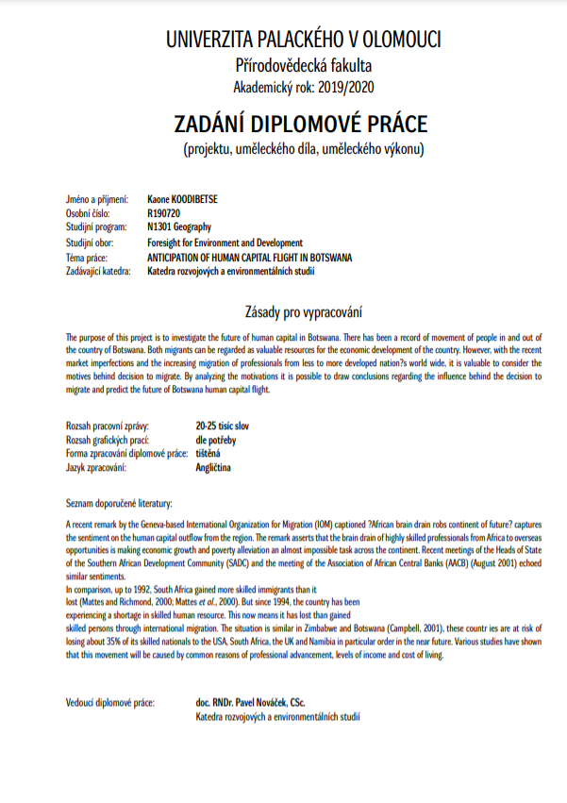

ABSTRACT
The diploma thesis aims to examine the status of human capital flight in Botswana. Human resources are an essential asset to any country's economy. Therefore, governments invest millions in education to develop citizens' skills and training to better suit the economy's benefit. Since 1980, skilled people have been migrating between borders in large volumes that exceed past centuries within sub-Saharan Africa. Most African countries face demanding situations that may push their citizens to consider migrating for greener pastures, but Botswana has been marked as an attractive destination. With a consistent history of a long-standing stable democratic political government and an improving economy, it may appear to be prone to brain gain other than brain drain, but, recently, there have been indications pointing toward a possible brain drain. This study, therefore, attempts to determine three factors, first if the skilled personnel persist in leaving the country and the reasons that motivate this thought. Second is to study if those who temporarily migrated would eventually relocate back to the home country and circulate their skills within the country. And lastly, observe if foreigners are getting more attracted to migrating to Botswana.
Keywords; Migration, Human capital flight, labour migration, brain drain, brain gain, brain circulation, Botswana, destination countries, pull factors, push factors, climate change, environmental problems, socio-economic issues,

TABLE OF CONTENTS
ACRONYMS AND ABBREVIATIONS...........................................................................................9
LIST OF FIGURES.....................................................................................................................12
CHAPTER 1.............................................................................................................................13
1.0 BACKGROUND STUDY........................................................................................................13
1.1 GENERAL FACTORS CONTRIBUTING TO MIGRATION.........................................................17
1.2 OBJECTIVES OF STUDY.......................................................................................................19
1.3 RESEARCH METHODOLOGY................................................................................................20
1.3.1 SAMPLING STRATEGY................................................................................................20
1.3.2DATA COLLECTION......................................................................................................20
1.3.3 DATA ANALYSIS...........................................................................................................21
1.3.4 RESEARCH FEASIBILITY...............................................................................................21
1.3.5 FORESIGHT METHOD APPROACH...............................................................................22
CHAPTER 2................................................................................................................................23
2.0 GEOGRAPHY.........................................................................................................................23
2.1 HISTORY OF BOTSWANA.......................................................................................................25
2.2 POPULATION OF BOTSWANA................................................................................................27
2.3 ECONOMIC HISTORY..............................................................................................................29
2.4 SOCIAL CHALLENGES.............................................................................................................31
2.5 ENVIRONMENTAL ISSUES......................................................................................................34
2.5.1 WASTE MANAGEMENT................................................................................................35
2.5.2 CLIMATE CHANGE.........................................................................................................36
2.5.3. INFLUENCE OF CLIMATE CHANGE ON THE ENVIRONMENT AND LIFE IN BOTSWANA.37
2.5.4 AIR POLLUTION..............................................................................................................39
2.5.5 WATER POLLUTION.........................................................................................................40
CHAPTER 3....................................................................................................................................42
LITERATURE REVIEW......................................................................................................................42
3.0 LITERATURE REVIEW METHOD.................................................................................................42
3.0.1 BOTSWANA MIGRANTS DESTINATION COUNTRIES........................................................42
3.1 MIGRATION PROTOCOLS IN SOUTHERN AFRICAN DEVELOPMENT COMMUNITY (SADC)........47
3.1.2 ANTICIPATED PUSH FACTORS IN THE SADC REGION.......................................................48
3.2 MIGRATION ANALYSIS IN BOTSWANA......................................................................................49
3.2.0 OPEN MIGRATION POLICY .............................................................................................52
3.3 CASE STUDY; BRAIN GAIN THROUGH ZIMBABWE....................................................................53
3.4 IMMIGRATION IN THE NEW MILLENNIUM........................................................................55
CHAPTER 4...................................................................................................................................56
4.0 OVERVIEW OF HUMAN CAPITAL FLIGHT STATUS IN BOTSWANA............................................56
4.1.0 QUALITY OF EDUCATION................................................................................................58
4.1.1 QUALITY OF MEDICAL SERVICE......................................................................................58
4.1.2 ENVIRONMENTAL PROBLEMS........................................................................................58
4.1.3 INCOME INEQUALITY.....................................................................................................59
4.1.4 UNEMPLOYMENT RATE..................................................................................................59
4.2 BOTSWANA AS RECEIVING REGION.........................................................................................61
4.2.0 ECONOMY......................................................................................................................61
4.2.1 POLITICAL STABILITY.......................................................................................................61
4.2.2 CORRUPTION..................................................................................................................62
4.3.CASE STUDY; BRAIN DRAIN IN BOTSWANA HEALTH SECTOR....................................................63
4.3.0 OVERVIEW AND CONDUCT OF HEALTH CARE IN BOTSWANA........................................65
4.4.0 SWOT ANALYSIS............................................................................................................68
CHAPTER 5..................................................................................................................................70
SCENARIOS OF POTENTIAL FUTURE DEVELOPMENT...................................................................70
5.0 POPULATION AND DEMOGRAPHY SHIFT................................................................................71
5.1 URBANIZATION RISE TO CRISIS...............................................................................................72
5.2 FOOD SECURITY FAILURE........................................................................................................73
5.3 INCOME INEQUALITY ETERNITY..............................................................................................75
5.4 CLIMATE CHANGE AND AGRICULTURE....................................................................................78
CHAPTER 6...................................................................................................................................80
6.0 RESULTS AND DISCUSSION......................................................................................................80
6.1 RECOMMENDATION ................................................................................................................86
CHAPTER 7...................................................................................................................................87
CONCLUSION.................................................................................................................................87
REFERENCE LIST............................................................................................................................88

ACRONYMS AND ABBREVIATIONS
ARAP Accelerated Rainfed Arable Program
ALDEP Arable Land Development Programme
ART Antiretroviral Therapy
BCA Botswana College of Education
BCL Bamangwato Consolidated Limited
BDS Botswana Demographic Survey
BDP Botswana Democratic Party
BHPC Botswana Health Professions Council
BIAC Botswana Institute of Accounting and Commerce
DPPME Department of Policy, Planning, Monitoring and Evaluation
DTEF Department of Tertiary Education Financing
FDI Foreign direct investment
GDP Gross domestic product
HCI Human Capital Index
HDI Human Development Index
HIV/AIDS Human immunodeficiency virus infection and acquired immunodeficiency syndrome
IOM International Organization for Migration
MESD Ministry of Education and Skills Development
NMCB Nursing and Midwifery Council of Botswana
SADC Southern African Development Community
SACU Southern African Customs Union
SO2 Sulphur Dioxide
UB University of Botswana
UNICEF United Nations Children’s Fund
UNHCR United Nations High Commissioner for Refugees
WHO World Health Organization
WMA Waste Management Act
WUC Water Utilities Corporation

LIST OF FIGURES
Fig 1. geography of Botswana......................................................................................................23
Fig 2. poverty rate trend from 1985 to 2015.................................................................................30
Fig 3. unemployment rate trend 1999 - 2020................................................................................31
Fig 5. Migrant stock by destination...............................................................................................41
Fig 6. Batswana destination countries...........................................................................................42
Fig 7. Tertiary students by destination...........................................................................................43
Fig 8. Botswana international emigrant stock................................................................................44
Fig 9. Asylum applications from Botswana, 2019.........................................................................45
Fig 10. Asylum applications of foreign refugees in Botswana, 2019............................................45
Fig 11. percentage of work permit holders by country of origin...................................................49
Fig 12. total number of work permit holders 2010 to 2019...........................................................50
Fig 13. percentage of Migrants and Non-Migrants in Botswana by Sex and Citizenship.............50
Fig 14. Percentage Distribution of People 15+ years by Employment, Migrant Status and Sex………....59
Fig 15. Healthcare workers trained locally and internationally.....................................................65
Fig 16. Healthcare workers by country of origin...........................................................................66
Fig 17. Botswana population by year (historical)..........................................................................69
Fig 18. Botswana population by year (projections).......................................................................70
Fig 19. Botswana population by year (projections).......................................................................70
Fig 20 . 2016 maize production deficit in SADC countries...........................................................73
Fig 21. Income Ginis Bechuanaland 1921-2010............................................................................75
Fig 22. Analysis of inequality by country......................................................................................76
Fig 23. Mean annual rainfall (mm) distribution in Botswana........................................................77

CHAPTER 1

1.0 BACKGROUND STUDY

This diploma thesis is meant to investigate the future of human capital flight in Botswana. There has been a record of the movement of people in and out of Botswana, of which are migrants and locals who can be regarded as valuable resources for the country's economic development. However, with the recent market imperfections and the increasing migration of professionals from less to more developed nations worldwide, it is valuable to consider the motives behind the decision to migrate. By analyzing the motivations, it is possible to conclude the influence behind the decision to relocate and predict the future of Botswana human capital flight.
It is also important to highlight two types of migration; economic movement fostered mainly by the need for employment, better living, and non-economic movement influenced by factors such as family, refugee status, etc. Human resources flight falls under economic movement, but since non-economic elements may also add to both the push and pull factors that encourage the decision of migration, this study is not limited to one form of movement. Economic migration also comes with mass migration that includes people who could be uneducated or lack skills. They migrate out of seeking survival in other places, hence they take any employment that arises. This situation has been on the rise, with Botswana receiving high numbers of mass migrants from Zimbabwe, most being illegal migrants.
Botswana is landlocked and a country located in the southern part of Africa with a rich migration history. Citizens of this country have been migrating across international borders for decades for various reasons, which, in the end, may lead to permanent relocation. Botswana has also experienced a large number of internationals relocating to fulfill scarce skills experienced by the country. This then brings a question of the value of human capital, which poses a threat to economic development. The increasing movement of people could cause either brain drain or brain gain. With good observation and documented statistics, it would also be easy to navigate and anticipate issues like population dynamics, the volume of foreign workers, pensioners' population, and what potential growth or decline they can reach.
Joseph (2011) defines brain drain in the quote as "the international transfer of resources in the form of human capital and mainly applies to the migration of relatively highly educated individuals from developing to developed countries”. Every developing country should be aware of the effects and incentives of brain drain on the growing economy. Adopted from UNICEF Botswana (2018) in the financial year 2017/18, the education sector was allocated 22 percent of public expenditure, the financial year 2018/2019 was given 20 per cent. For a country that invests a lot of funds in their education sector, it is worth investigating if it is an investment for their own economy or other countries' gain.
Dictionary.com (2021) referred to brain gain in the quote as "an increase in the number of highly trained, foreign-born professionals entering a country to live and work where greater opportunities are offered". This well is a positive gain for a developing country, in this case, Botswana, which is of low population, low-end quality of education, etc. As this is a good gain, it can also negatively impact the livelihood of the locals in terms of unemployment as preference is given to those who better meet labour requirements of quality of education and skills and training.
Brain circulation involves professionals who leave their home country to work or study in another country then later relocate permanently to their home country. This serves as a benefit to both countries; the receiving country benefits for the time the migrant is in their territory. But when they return home, after obtaining their advanced education and work experience, the country of origin benefits from the expertise applied by the returning migrants. Immigrants may come to choose to return to their country of origin for various reasons, like to take advantage of better career opportunities or lower taxes; in that regard, new skills and knowledge are brought back to the original country to benefit the job market and economy.
The world becoming a global village has necessities and made migration much more effortless. There has been a remark by the Geneva-based International Organization for Migration (IOM) titled 'African brain drain robs continent of future?' This remark asserts that the brain drain of highly skilled professionals from Africa to overseas makes economic growth and poverty reduction an almost impossible task across the continent. It, therefore, adds to the curiosity to question the future of human capital in Botswana, as the whole continent is affected mainly by brain drain. Gaillard and Gaillard (1997) mentioned that most African countries are affected by both brain gain and brain circulation, but it is the continent with the most little research done to document this data. This factor also added to the difficulties experienced during the compilation of this thesis; it was not easy to find and compile relevant data as the movement of people, especially out of Botswana, is rarely documented.
In the year 1992, South Africa was said to have gained more skilled immigrants than it lost in the past years (Mattes and Richmond, 2000), meaning more qualified people were relocating to the country to contribute to the labour demands. But since 1994, the country experienced a decline in volumes of migrants, and they have ever since been experiencing a shortage in skilled human resources. The highly trained professionals are now more often choosing to migrate around the globe; this is how South Africa has lost more skilled persons through international migration, the volume of decline is said to be more than they have gained up to 1992. The situation is similar in Zimbabwe and Botswana (Campbell, 2001); these countries are at risk of losing about 35 percent of their skilled nationals to the USA, South Africa, the UK and Namibia in particular in the near future. Various studies have shown that this movement will be caused by common reasons of professional advancement, income levels, and cost of living amongst the rest.
All the sectors in Botswana have been affected by a shortage of skilled professionals, but the most affected have been proven to be the health sector. This is despite the country's efforts of employing a more significant number of foreign doctors. Motlhatlhedi: et al. (2018) stated in a quote that "in 2012, Botswana's doctor-to-patient ratio was estimated to be 4:10000 of the population and at the same time the nurse-to-patient ratio was 42:10 000." In addition to that, only 21 percent of doctors registered to practice in Botswana were local citizens, and the remaining 79 percent are doctors from abroad. The standard explanation for this is that many Batswana doctors who trained abroad have not returned to Botswana. They instead decided to settle in foreign countries after completing their studies. This has majorly contributed to the acute shortage of healthcare workers. Migration has also depleted the locally trained healthcare workers. Motlhatlhedi: et al. (2018) has estimated that 7 percent of Botswana nurses and midwives are working in high-income / developed countries. To emphasize this impact, Motlhatlhedi et al. (2018) also stated that Botswana is affected the same way as most low-resource countries; they are faced with a challenge of shortage in human resources, specifically the health sector, which is caused by migration.
Tumkaya (2009) anticipated in that year that, in a quote, "the number of net international migrants is projected to slightly increase from I 097 per annum in 1981 to I 264 per annum in 1991 before it declined to 872 in 2011". This study projected that this would be due to the continued incoming movement of foreign workers along with their dependents and the return of Botswana citizens from abroad. Tumkaya (2009)'s study only gave an idea of the flow of migration and anticipation that was up to 2011, it is worth discovering if the anticipation came to reality since 2011 has passed.
Some chapters in this study will explore the topics covered in the background study. It will analyze more of migration movement in Africa; comparison of labour migration of Botswana and South Africa, a country destination of Botswana migrants; impacts of labour migration on Botswana health sector; and anticipation of labour migration that covers from 2021 to the future.

1.1 GENERAL FACTORS CONTRIBUTING TO MIGRATION
For the past 15 years, research has pointed out that the general leading reason for migration has been to search for a better life. According to the United Nations (2002), it is estimated that around 175 million people live in countries they were not born in. As the world changes and opportunities arise, diverse reasons now play a role in the motivation behind labour migration. Some of the most apparent reasons like poverty, wars and famine certainly serve among the major push factors. There has been a recognized rise in push factors being;
- population pressures on scarce natural resources
- income inequality
- growing urbanization
-reduction in the cost of transport and communications, resulting in increasing interactions among societies
-the absence of respect for human rights in some countries
-in the future, climate change may raise migration pressures.
The global economic recession that occurred in 2008 has resulted in hiring freezes and workers being dismissed in high numbers. Currently, with the Covid 19 pandemic, the world is yet to face another economic recession. The cycle is yet repeating itself with more people being laid off from work and more interruptions on business operations, which causes them to collapse in worst-case scenarios. Failure in people finding employment contributes to a lot of pressure in the households as well. A source of income is mandatory to maintain and upkeep a home to necessary resources. And according to ILO (2010), in poor areas in most underdeveloped countries, families come to decide to send a member abroad, with hopes to increase their economic security. In most cases, however, only a few are able to afford it. In the point where it is possible, the main aim of the one abroad is to be able to send most of their earnings back home to their families. It is often young people who are prone to these migration pressures (ILO, 2010).
Economies have now become much more interdependent and integrated, hence the formation of economic integrations like SADC, which Botswana is a part of. Also, the growth of technology has played an essential role in centralizing and controlling access to share communication/information and developments quickly. This can be viewed as globalization, which has impacted all areas of the globe, be it politics, education, culture, etc. All countries are easily affected by the process. Therefore, globalization has led to more opportunities that are visible to people in all parts of the world, thus motivating them to move across to pursue the opportunities found.

1.2 OBJECTIVES OF STUDY
The main objective is to examine the future of human capital flight in Botswana (are people generally willing to live and work outside the country, what and which age group of people are more interested in travelling outside the country, etc.). The specific objective is to investigate the causes of migration to and from Botswana. The secondary aim is to analyze the effects of human capital flight in the country.
Research Questions
At the end of the research, the following significant research questions will be addressed:
To what extent does the standard of living influence people's decision to travel outside the country?
Under what conditions are Batswana willing to stay and work in Botswana
The research hypotheses are present as follows:
Ho: Standards of living has no relationship with human capital flight, which measures willingness to travel and work abroad.
Ha: standard of living has a relationship with human capital flight, which measures willingness to travel and work abroad.
Ho: willingness to stay in the home country has no relationship with human capital flight, which measures desire to travel and work abroad.
Ha: willingness to stay in the home country has a relationship with human capital flight.

1.3 RESEARCH METHODOLOGY
This chapter explains how data was collected for this diploma thesis. It aims to outline in detail the research methods and approaches used, the practices of data collection, the selection of the sample size, the research process, data analysis, ethical considerations, research limitations of the project and the foresight method used.
RESEARCH DESIGN
Survey research was used to collect information in the form of a questionnaire. To fully satisfy the objectives, both qualitative and quantitative research was held. More emphasis was on qualitative as it offers a complete description and analysis of the subject without limiting the scope of the study or the participant's responses.

1.3.1 SAMPLING STRATEGY
The data was obtained from a sample of randomly selected citizens and non-citizens of Botswana. Initially, preference was to be given to those in tertiary training institutions in a few years, and they will enter the economic market. The targeted institutions included the
University of Botswana (UB), Botswana College of Education (BCA), Botswana Institute of Accounting and Commerce (BIAC), Botho University and Institute of Health Sciences, all situated in Gaborone. However, it is crucial to highlight that this survey research was not limited only to students. The survey was targeted from months January to End of February 2021, and initially, the estimated cover was around 1000 participants, but only 200 participants were reached.

1.3.2DATA COLLECTION
Primary data was collected through distribution questionnaire samples using semi-structured questionnaires. All the questions to be asked and additional questions related to the research were written in advance and carried during data collection. The audience was reached through emails, Facebook and Instagram, which was limiting as well as physical distribution of the survey. The questionnaire was divided into four sections, demographic, long term migration history, reasons for leaving and perception of quality of life. The demographic part was to get details such as gender, age, level of qualifications, occupation, etc. Long term migration history was meant to evaluate if the participants had worked or studied abroad before. Reasons for leaving were intended to assess common push factors in Botswana. The last part, perception of quality of life, was meant to evaluate and compare Botswana with the destination choices of participants.
Besides primary data, secondary data was collected using different websites, research papers, newspapers and books. Searches of databases including Web of Science, the Science Direct and the University of Jyväskylä's database JYKDOK were used. Collecting data on migration is a difficult task, and data sources also have certain limitations. Giving an example, most references were based on population censuses which was the primary and only easily accessible data source. But population censuses are conducted once every ten years, which in the end affects the timeline of the data. It would have been helpful to get easy access to other administrative data like registers of foreigners, border collection data, visa types at entry or exit, and data obtained from consular databases. Preference was also given to scientific publications; however, Botswana seems to have minimal research done, mainly based on migration.

1.3.3 DATA ANALYSIS
The data was transcribed into written form after interviews. The transcription was not manipulated or assumed, and research ethics were respected. The discussion of the research result was accompanied by critical analysis and support from the literature. Content analysis was used to analyze the data which was gathered from the survey. The data gathered was ranked in themes so that it can easily be compared. This method was also preferred because it helps reduce and simplify data collected, making it easier to work within the accomplishment of research objectives.

1.3.4 RESEARCH FEASIBILITY
There were no language and cultural barriers while collecting data as researchers are familiar with the culture and language of the people. Both ethical and political concerns can be availed as the research does not involve any sensitive issue. The main obstacle to carrying out the study was that many people did not have internet access in their homes. The questionnaire was distributed through the internet. Those who participated were only able to do so at their workplaces or school. The researcher could not travel to Botswana, which could have been easier to collect the initially targeted population. The population that responded to the survey was small, and therefore there is a possibility that the information provided by the respondents may not accurately represent the vast population. It would have been ideal for interviewing face to face some of the respondents to better bring to light any issues that are particular to them and may have been missed by the surveyor. Interviews could have also given an opportunity to raise further questions. The targeted audience could also not be reached as the questionnaire was distributed during the Covid-19 time, which might have caused biased responses from the participants.

1.3.5 FORESIGHT METHOD APPROACH
Trend Analysis is the proposed method to be used in this study. The researcher will collect information from the past that forms patterns and possibly make anticipation based on the conclusion drawn.

CHAPTER 2
This chapter focuses on the general overview of the history of Botswana. It further discusses the geography of Botswana, the past from the earliest records, population dynamics, economic history from post-colonial, environmental challenges, which include waste management, climate change and air pollution.

2.0 GEOGRAPHY
As stated before, Botswana is a landlocked country, and it is in the centre of Southern Africa, spreading an area of ​​581730 km². It shares borders with four countries, Namibia on the west, Zimbabwe in the northeast and South Africa on the south. The last frontier is with Zambia, and there is a formed border triangle where four countries meet, forming two mini borders, one being Botswana, Namibia and Zambia; the second one is only 100 meters away and joins Zambia, Botswana and Zimbabwe. The country is a similar size to Madagascar and is just slightly smaller than Texas and only slightly larger than France. The country is divided into 17 districts which are identified by their unique features based on culture, geography and economic activities. The capital city is Gaborone which is located in the southeast district. Before Gaborone, Lobatse was the first capital city, located 70km south of Gaborone. The second-largest city is located in the northeast district, namely Francistown.
The Botswana weather is semi-arid, meaning it is hot and dry most of the year. There are two seasons, summer and winter. The summer season runs from November and ends in March, in which it usually brings very high temperatures up to 40 degrees and sometimes rain which is highly scarce. The winter season runs from April to October, with temperatures reaching a minimum of -1 degrees. One of the economic drivers of Botswana is Agriculture, which will be discussed later in detail, but the weather already indicates an unfavourable condition to the agricultural sector. High temperatures and scares rainfall negatively affect both crop production and animal rearing.
The Kalahari desert and Kalahari basin cover the country. The desert part is mostly heaps of sand with almost no vegetation, and the basin part is less sandy than the desert, and trees can grow. The typical vegetation that grows is grass, shrub and tree savannah, there are no mountains, but there are hills, the largest one being Monalanong Hill.
The area can be further divided into four natural regions. The Okavango Delta is the world's largest inland delta with an area of ​​approximately 15,000 km². It is located in the northwest part of the country. There are also Makgadikgadi and Nxai pans. Makgadikgadi is the largest salt pan in the country and lies in the north-central area. They resulted from a dried lake whose inflow was blocked by soil. In 2020, the salt layers in the Makgadikgadi pan were up to 5m thick (info Botswana; 2021). The third region is the Kalahari which consists of the Central Kalahari Game Reserve and the Kgalagadi Transfrontier Park National Parks. The area is considered to be one of the largest contiguous sand areas on earth and is often called a desert (Kalahari desert). The Khoisan people have occupied this area; more details on the inhabitants are discussed in the history of the Botswana chapter. Lastly, there is the tree savannah region which is located around the Okavango delta. Most of the country's prime wildlife can be found in this region, housed in the Chobe national park.
Even though Botswana hardly has water, there are four recognized drainage regions. The Chobe River is located on the border of the Caprivi Strip of Namibia, and it is connected with the swampy area of the Zambezi basin. Most of the north region forms part of the Okavango inland drainage basin, and the eastern part falls under the Limpopo drainage basin. The remaining southern and southwestern areas are the driest. They are drained by the Molopo river, which is found along the South African border, and the Nossob river, which crosses through the Kalahari Gemsbok National Park and forms a part of the basin of the Orange River.
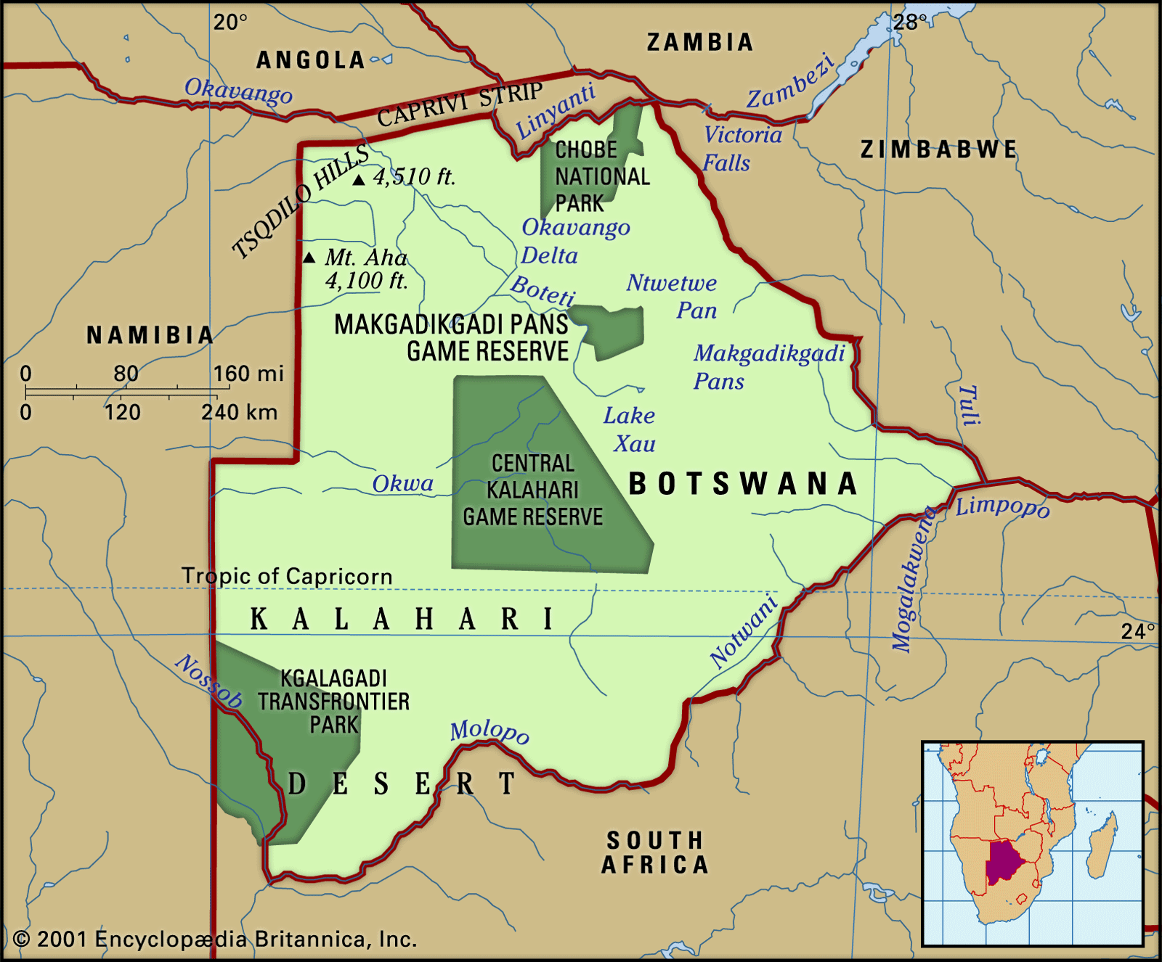
Fig 1. geography of Botswana. source; Parsons, N. (2021) Botswana, Encyclopædia Parsons, Inc

2.1 HISTORY OF BOTSWANA
The history of Botswana can be traced back to as early as 17 000 bc. According to Parsons (2017), the present-day Botswana area was occupied by the Khoisan (Khoi and San) people for many thousands of years. Research showed evidence that this was backed up by Tsodilo hills, which date back to 17,000 bc. The Khoisan made paintings on the Tsodilo hills, which indicated their ways of life; these paintings are still visible today and serve as one of the major tourist attractions in the country. The Khoisan lived by hunting and gathering, but around that time, Africans were nomadic. At some point, they got exposed to pastoralism, herding of cattle and sheep then adopted it. By 190 AC, some farmers were making and using iron tools. Fast forward to the 1840s, and there was a rise in the trade of ivory and ostrich feathers with the Cape colony (which is now a part of South Africa). That trade also brought Christian missionaries and Boers to Botswana, and that was the first record of the British reaching Botswana, who later colonized Botswana land (Tlou; 1984).
White miners and prospectors from neighbouring South Africa flooded Botswana in 1867–69 after discovery and intention to start deep gold mining. This was, however, short-lived; there was not a lot of gold to mine; therefore, it ran out. Around the same era when the gold ran out, diamonds were discovered in an area called Kimberley in South Africa, white miners relocated back to operate in that mine, and it became Southern Africa's first great industrial area from 1871 (Parsons, 2017). This mine attracted Batswana men workers and those from Lesotho and Eswatini to relocate to Kimberly to work in the mines. According to W G Morapedi (2018), it was discovered that about 2 135 Batswana were working in the mines in 1870, and by 1881, there was already a record of an increase of up to 2 571. From the years of 1920s to the 1970s, the flow of men from Botswana to South Africa took a progressively upward trend, and the annual recruits kept on rising, there were various records of 7 314 men in 1936, 10 354 in 1956, 19150 in 1966, 39 044 in 1976 and 40 000 in 1978 (W G Morapedi; 2018).
Still, around the 1880s, the British used their missionary and trade connections in Botswana to keep the route to Zimbabwe and the Zambezi open. These countries had natural resources in abundance and were worth keeping, and there was nothing for the British in Botswana. It was just sandy land and people and a route to other countries, nothing more to use for economic benefit. Botswana, therefore, remained a protectorate temporarily. This was until it could be handed over to Rhodesia or, after 1910, to the new Union of South Africa (Tlou; 1984).
Tlou (1984) stated that from the late 1950s, events made it clear that Bechuanaland would not be handed over to South Africa. Instead, it must be developed toward political and economic self-sufficiency. For 80 years, Bechuanaland was a British protectorate, but later on, attained self-government in 1965, and became independent and renamed the Republic of Botswana on September 30, 1966. Sir Seretse Khama, who was a prominent influential elite on self-governance, was elected the first president and served until he died in 1980. Since independence, Botswana has maintained a thriving democracy, good governance, up-right judiciary, peace, and stability, all of which have been pull factors for both foreign and locals to make establishments contribute to the economy and settle in Botswana.
Present-day, Botswana is considered a well-off country through diamond mining. It is the place to find one of the wealthiest mines called the Jwaneng mine, operated by the Debswana diamond mining company. It is a 50/50 joint partnership between DeBeers and the Botswana government. Botswana tourism is a secondary earner of foreign exchange after diamond mining, followed by subsistence farming. The currency in Botswana is known as the Pula (P), which has been in circulation since 1976. Before Pula circulation, the South African Rand was in use.

2.2 POPULATION OF BOTSWANA
The most significant inhabitants in Botswana are people of Tswana origin, collectively called "Batswana". In Botswana demographic survey (2017) report, the total population was around 2,154,863, of which 1,034,578 were males and 1,120,285 females. The population of non-Batswana amounted to 85,414, which was a decline from 111,846 that was recorded in a 2011 survey report. Most non-Batswana come from SADC countries, only a tiny fraction (0.6 per cent) hail from other African countries and other continents. 57.4 percent of the Batswana population live in cities/towns and urban villages, and 42.6 percent stay in rural areas. For the non-Batswana, the majority of 52 per cent live in cities and towns, and only around 20 percent of them reside in rural areas. The majority of Batswana are concentrated in specific districts, which are, in a particular order, Kweneng East, Central Serowe-Palapye, Gaborone, Central Tutume, Ngwaketse South and Central Mahalapye. At the same time, non-Batswana are primarily found in Gaborone, Kweneng East, Francistown, South East and Central Serowe- Palapye.
The capital city, Gaborone, has a recorded in-migration rate of 8.7 per cent. It is also the single most attractive district in the country (C. Kerven,2014). BDS (2011) publication stated that the common purpose for the migration to the city was to join parents and relatives, and the secondary reason is associated with the assumption of employment duties or job transfer. Therefore, this movement is so people could have access to good basics of living. On the other hand, non-citizens primarily migrated to Botswana for job-related reasons, which in this case, can be referenced as brain gain.
Botswana is currently on stage 3 of demographic transition. The crude birth rate is at 24.23 births per thousand population which is high, and a low crude death rate of 5.71 deaths per thousand population. Mortality continues to decline slightly over the years. Analytical Report on Life expectancy at birth in 2001 was 55.6 and increased to 68 in 2011. Pneumonia was the leading cause of deaths of all ages. This is referred to as an infection that inflames the lungs' air sacs, and it accounted for 7.1 per cent of all deaths of all ages. The second leading cause of death was identified to be Septicaemia at 5.2 per cent, followed by the third leading cause at 3.4 percent Tuberculosis of the lung without mention of bacteriological or histological. The Botswana Government has introduced programs like a robust immunization program and periodic prevention campaigns to promote health, hence the recognized decrease in mortality rates. HIV/AIDS used to be the leading cause of death, but the government of Botswana introduced various programs like free condom provision, ART treatment, etc., freely available for the citizens, which assisted in lowering infections/transmissions.
A decrease in fertility rate is associated with increased access to contraception since the government of Botswana offers it for free in public health care facilities. Education is also free in Botswana; therefore, many are literate; educated women have been found to have fewer children than those who have not received an education. There has also been an increase of women in the working environment, hence lowering the fertility rate. The transition has co-occurred with other demographic changes, and this includes an increase in life expectancy, low death rates, etc.

2.3 ECONOMIC HISTORY
When gaining independence in 1966, Botswana was one of the poorest countries in Africa, with a per capita gross domestic product (GDP) of around $70. The growth has been considered one of the most significant. Backed up by strong governance, the country witnessed good economic development of about 9 per cent per year from 1966 to 1999 (KPMG, 2014). The discovery of diamonds boosted the economy, moving the country to the rank of upper-middle-class income countries. To date, mineral mining is the primary driver of the economy.
In history, according to G Morapedi (2018 ), a study conducted by Schapera in the 1930s and 1940s revealed that migrant labour was the most critical source of cash in the country. It was the most common reason why people relocated to various areas, either locally or abroad. During that time, between the years 1938 and 1947, Botswana had only four primary sources of income. There was employment outside the country, which accounted for 42.9 per cent of total revenue; sale of agricultural produce at a total income of 31.5 percent of total income; Allotments from army pay at 7.9 per cent of total income and lastly, employment within Botswana bringing in 7.7 per cent of total revenue. Consequently, Botswana benefited from a larger share of income from human resource flight within this period. Schapera also estimated in his research that Batswana working on the country's white farms earned about £54,000, whilst migrant labourers accumulated £333,000 in the form of cash or goods. Combining the two makes a contribution of labour at about 54 per cent of the country's total income ( G Morapedi, 2018).
C Kerven(2014) also carried research from post-colonial Botswana until the mid-1980s on human resource flight. He noted that, in a quote, "much of the workforce is employed abroad", which was also highlighted around that period. A lot of men moved to South Africa to work in the mines. He also backed up Schapera's study that human resource labour played a significant economic role, specifically to C Kerven,2014. It assisted with the accumulation of cattle and the provision of education to Batswana children. The society was able to herd a large number of livestock and use the sales to invest in their children's education. In return, these educated children would then be able to secure salaried employment in the modern sector of Botswana's economy and continue with the accumulation of cattle in the rural sector, consolidating the superior position held by this segment of the society (C Kerven; 2014).
Kate Lefko-Everett (2004) also supported (C Kerven; 2014). He stated that around the 19th century, the rural population mainly survived through subsistence farming and cattle herding. This is the era where the accumulation of cattle measured wealth. Farming at this time was still overwhelming due to the constant threat by years of drought; the situation was still better compared to recent events. This condition serves as motivation for thousands of Batswana men to become contract labourers in South Africa's gold and diamond mines and other workers from different countries like Angola in the west, Mozambique in the southeast, Zambia Lesotho, Swaziland and Zimbabwe in the south. The work contracts were regulated by a bilateral agreement between South Africa and Botswana. The built-in system deferred pay channelled significant remittances back into the national economy of Botswana. In 1984, 18,691 Batswana miners generated nearly R17 million ($2.6 million) in officially recorded remittances alone, which helped to grow Botswana's economy (Kate Lefko-Everett (2004).
A year after independence, a diamond mine was founded in a city called Orapa in Botswana, which over the years was followed by the opening of similar mines in the Letlhakane and Jwaneng cities. The discovery of mineral wealth accelerated the country's rate of growth, and in 1972, that was the critical point when Botswana achieved economic self-sufficiency.
Unfortunately, the limitations of Botswana's diamond-led development model have become more apparent; a statement adapted from G Morapedi (2018 ). Economic growth is much slower, other social challenges like inequality remain high, and job creation is limited. These factors are possible push factors for Batswana. In addition, there are more challenges like increased diamond market volatility, reduced Southern African Customs Union transfers, and fiscal expansion that have resulted in eroded fiscal buffers. It is, therefore, difficult to envision what the future holds for Botswana (C Kerven; 2014).

2.4 SOCIAL CHALLENGES
According to the World Bank(2020), ever since independence, living conditions have slowly improved for the Botswana people. However, specific issues make life more challenging for the occupants of the country. The most predominant being poverty and unemployment. These issues are also one of the push factors for labour migration.
Poverty has a variety of definitions, but in this case, the area of focus is on poverty headcount. The poverty datum line calculates it at the national level and Human Development Index (HDI). Statistics Botswana (2013) explains Poverty headcount as the percentage of the population living below the poverty datum line. Botswana is currently set at two income levels—$1.90 and $3.10 (World Bank, 2017). Over the years, poverty has been slowly decreasing in Botswana; however, it is not in sufficient significant volumes. According to macro trends (2020) shown by figure 2 below, Botswana poverty rate for 1993 was 74.70 per cent, a 5.9 per cent decline from 1985; in 2002, it was recorded at 65.30 per cent, 9.4 per cent decline from 1993; in 2009, it reached 55.80 per cent, a 9.5 per cent decline from 2002 and in 2015 was listed at 59.10 per cent, a 3.3 per cent increase from 2009. Even though Botswana is not technically a poor nation, a considerable amount of poverty remains in rural areas, and it is a cause for concern.
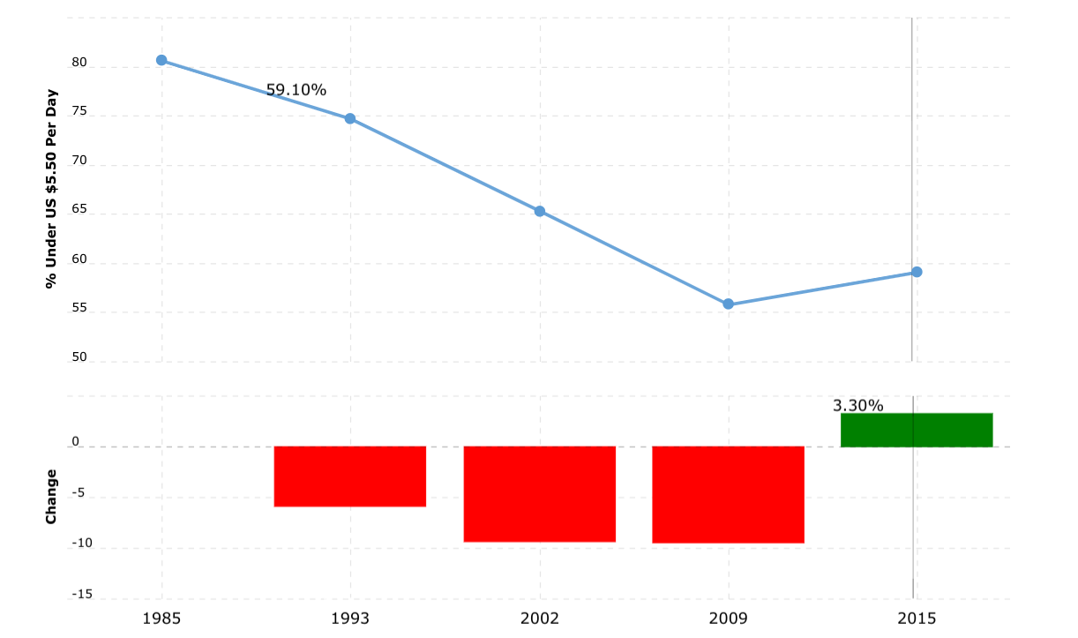
Fig 2. poverty rate trend from 1985 to 2015 . source; macrotrends. Botswana poverty rate 1985-2015.
Kuzniak and Grable (2017) stated in a quote, "unemployment rate measures the number of people actively searching for jobs as a percentage of the labour force". The labour force concept excludes the retired, children and those who are not looking for work.
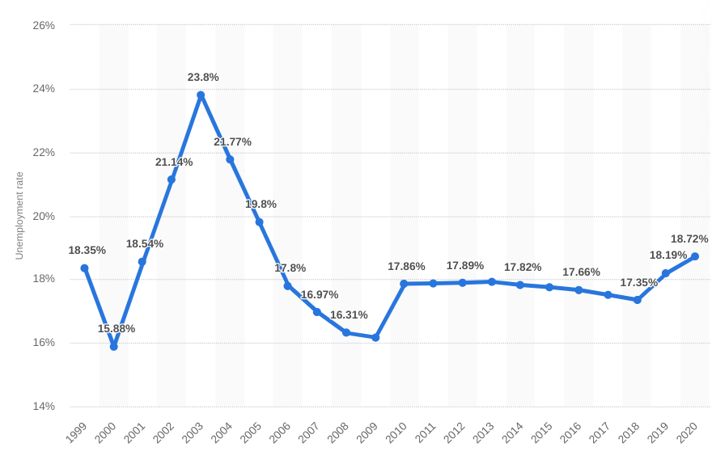
Fig 3. unemployment rate trend 1999 - 2020. source O’Neil, 2021. Botswana: Unemployment rate from 1999 to 2020.statista
According to the graph above (figure 3), Botswana Unemployment Rate increased from 18.19 per cent in 2019 to 18.72 per cent in 2020. Botswana hit the lowest rate of unemployment at 13.82 per cent in 1991 and the highest of 23.80 per cent in 2003. Youth unemployment seems to be posing a critical challenge, and most of those who are unemployed have secondary education but no training. The World Bank(2020) recorded unemployment in urban villages at 31 per cent, followed by rural areas listed at 28.3 per cent, and the lowest is in the cities/towns at 20.5 percent. With these figures, unemployment is high in the urban towns and villages, and this is where the majority of the population is concentrated and in search of a better life. Citizens of Botswana face higher unemployment rates at 28 per cent as compared to 10.4 percent of non-citizens ( World Bank, 2020).
Currently, the biggest employers are Agriculture, wholesale and retail, respectively. Even though mining is the economy's driving force, it only contributes 3.3 per cent of the labour force. The World Bank's Human Capital Index (HCI) scores Botswana at 0.42. In linking labour productivity and economic competitiveness, the World Bank (2019) stated that, in a quote, "a child born in Botswana will be 41 per cent as productive when she grows up as she could be if she enjoyed complete education and full health". Botswana education expenditure is among the highest in the world, and it is also completely free at the primary level, but it has not been successful in producing a skilled workforce that meets the industry and world standards.
An effort to address all these challenges will require improving other areas like the quality of infrastructure, water and electricity, education, health, as well as implementing reforms to promote business environment and entrepreneurship at large.

2.5 ENVIRONMENTAL ISSUES
Botswana, as an already dry area, is highly vulnerable to climate change. Drought and water scarcity are the leading major environmental problems in Botswana. Throughout the years, evidence building up shows that temperatures are increasing and rainfall, which has already been uneven, continues to change distribution patterns. These changes also further accelerate the shortage of water. There are only a few surfaces and underground sources of water that are expected to supply around 70 per cent of the population (Baraedi,2016). This target is hard to fulfil as water is unevenly distributed. There are eight dams that provide surface water; Dikgatlhong is the largest in the country and has a capacity of 400Mm3. Drought and water scarcity also majorly disadvantage the agriculture sector, which is one of the resources a more significant population depends on. This sector depends on rain-fed for production; with increased temperatures and uneven, reduced rainfall crops hardly stand a chance to survive.
As the population grows, there is a growing demand for new land use. The people in rural areas mainly depend on agriculture, which takes up large land for residential, grazing and farming purposes. Communal land is left degraded due to unsustainable land practices like mono-cropping in rural areas. Mono cropping refers to growing the same crop every year on the same soil (Garrity, 2020). This method may be simple and high yielding in the beginning, but in the long run, it upsets the natural balance of soils; hence, crops cannot grow. This adds an additional problem of a growing number of underprivileged people who have lost access to communal land, cattle that die from lack of water and food and access to subsistence hunting and gathering (C Vanderpost, 1995). Therefore, the underprivileged people have difficulties coping with the existing environmental problems, hence an increase in government programs dependency.

2.5.1 WASTE MANAGEMENT
Botswana has the Waste Management Act (WMA), which is intended to regulate collection, disposal, and recycling measures. Even with this law in place, Botswana still has a long way to go in practising proper waste management, and it is in a poor state for a middle-class country. It is managed and collected by the Gaborone city council by giving an example of household waste management in the capital city. Every household is supposed to have garbage containers outside their buildings where they can drop off waste for the city council to collect. The first problem is that waste is never separated and sorted at homes; it is all treated as mixed waste. Once the trash is mixed, it is challenging to try and split it. There is no fee for garbage to be collected, which is another disadvantage. Council trucks are supposed to collect the waste once every week, but that rarely has been seen to happen. If one household is lucky, the waste is collected once a month because the number of trucks available is not sufficient to cover the rounds required in the city. The trucks are also always reported to be not roadworthy. The fee that could be paid for the collection could be invested in maintaining the trucks. The collected waste is transported to Gamodubu landfill for disposal without any pre-treatment, as Gaborone does not provide any existing recycling or treatment units. The government needs to work on investing in recycling facilities as these could make a significant difference in generating money from waste and creating employment. The idea of a landfill should also be reconsidered. Gamodubu is an open landfill; therefore, it produces a lot of methane emissions and causes concentrated air pollution in the landfill surroundings.
Mishandling of waste has a variety of consequences on our everyday lives. Apart from creating an unhealthy and unhygienic living environment, there is also a possibility for the spread of diseases, pollution of lakes and water bodies leading to loss of biodiversity and the inefficient use of land and resources. Most importantly, it serves as a significant contribution to climate change.

2.5.2 CLIMATE CHANGE
Climate Change has been the most talked about topic in recent years, and it poses a significant challenge that affects every factor of life. Its impacts are visible today and felt across all sectors in Botswana, just like the rest of the world. The country is experiencing rainfall shortages, increased temperatures and reduced soil moisture; all these factors are associated with internal migration in the country and could possibly be associated with cross border movement in the near future. In the case of Botswana, the impacts prevail because of high dependence on resources that are climate-sensitive, hence the urgent need for the implementation of adaptation and mitigation methods. As mentioned before, Botswana's climate is semi-arid. It is hot and dry for most of the year, with highly unpredictable and uneven rainfall.
Humans or human actions are accused of being the main contributors to climate change. This is because humans are responsible for the social, economic and environmental events that accumulate and result in climate change. Botswana climate change Policy (2017) stated that in quotes, " vulnerability of Botswana to the effects of climate change ranging from economic sectors to the society is evident from the pressure on major GDP drivers such as agriculture, water, biodiversity and ecosystems as they are climate-dependent." As high temperatures have been predicted for future events, the impacts are likely to increase as results of increased variability in precipitation. Precipitation variability comes with implications on flooding risks as well as reduced water availability and quality.

2.5.3. INFLUENCE OF CLIMATE CHANGE ON THE ENVIRONMENT AND LIFE IN BOTSWANA
Agriculture in Botswana mainly depends on rainfall, and people residing in rural areas depend on agriculture. Continuous severe droughts, therefore, cause a rise in poverty levels, especially among rain-fed small scale farmers who live in rural areas. The majority of the population now are facing challenges as they can no longer produce food and rear animals in the traditional way they have been. Commercial farmers are also affected as they cannot make as much to keep up profits, and some have decided to discontinue because of the hardships that come with this situation. The condition has increased the population of those who are dependents on government social grants programs aimed at poverty eradication. High temperatures also affected the small-scale farmers, and there has been an increase in veld fires which destroy large areas used for grazing and access to firewood as a source of energy. This causes displacement of livestock as the destroyed pastures are unsuitable for livestock; therefore, the livestock is displaced to avoid livestock mortality. It is important to note that livestock is wealth to small scale farmers; the amount of value they attach to their livestock is greater and dates back to pre-colonial times. As mentioned before, parents sold their cattle to send their children to school; the community sold their livestock to assist in building the first university in Botswana, hence the greatness of value in livestock.
The tourism sector is another critical economic driver of the country. Transport and beef production sectors also play a role, yet they are all also vulnerable to climate change. Prolonged droughts will increase wild animals and livestock mortalities. It is natural for livestock and wildlife to migrate to areas where there are suitable grazing conditions and water; this will cause a shift of the nature-based tourism dynamics, therefore affecting revenue generation from the tourism sector, including loss of jobs.
Infrastructure is planned with expectations of being able to sustain all pressure, but in reality, many infrastructures show unsatisfactory performance. Botswana faces diverse infrastructure challenges, and infrastructure networks are more affected by the physical impacts of climate change. The current infrastructure is prone to floods and high temperatures; for example, drainage networks do not function properly, often blocked and failed to accommodate surface water runoff after high rainfalls, which are always unexpected. The local community is, therefore, more vulnerable due to their low adaptive capabilities to deal with natural disasters, and disruption of transportation and electricity supply affects business operations.
Research has shown that warmer, polluted air affects our health. Air quality degrades from wildfires, extreme summer heat causes deaths from the heatwave, and warm freshwater is prone to bacteria and water contamination. Most houses in Botswana have poor insulation against heat and cold; the walls are from bricks and roofings from corrugated iron and have no ceiling, fans or air conditioners. The same building structure is used in most government school classrooms. In hot weather, these buildings get warmer than the outdoor temperature and cooler in the cold season; hence people develop heat-related health problems.

2.5.4 AIR POLLUTION
In most cases, industrialized and developed countries with high populations are associated with high levels of pollution. It is a rude awakening that Botswana, with a small population of slightly over 2 million, is ranked amongst the most polluted countries with severe air pollution (Witson, 2017) as industrial developments increase across the continent, air pollution from vehicle exhaust, wood burning, dusty dirt roads, power plants, etc. also increase. Mentioned before in this thesis, Pneumonia is the leading cause of deaths in Botswana. On the other hand, people in rural areas still depend on wood for cooking and heating. This causes indoor air pollution, which irritates the lungs and could lead to mortality cases. Witson, 2017 in his publication, stated that, in a quote, "about 40 per cent of an estimated 330 child deaths that are caused by acute lower respiratory infections are attributable to household air pollution." Even though mining is the leading GDP contributor, it is also a significant contributor to air pollution. The copper-nickel mine located in Selibe Phikwe, Bamangwato Consolidated Limited (BCL), serves as an example. The mining activities release sulphur dioxide (SO2 ) and other toxic gases through the smoke released into the atmosphere. The smoke causes respiratory problems for the town and surrounding areas residents. Vehicle ownership has been increasing for the past few years. In 2012, the vehicle ownership rate was recorded at 179 vehicles per 1,000 people; in 2019, ownership increased to 274.4 vehicles per 1,000 people. These are primarily cheap used Japanese vehicles bought from South Africa. This has led to increased traffic congestion, emission of nitrogen oxide, carbon monoxide and other pollutants. All these examples show the seriousness of the negligence of air pollution in Botswana. It affects people's health; therefore, specified regulation levels should be implemented.

2.5.5 WATER POLLUTION
The supply of water and sewage is managed by the Water Utilities Corporation, which is a parastatal organization. It is a problematic situation for Botswana as the quality and quantity of both groundwater and surface water are majorly affected by worsening changes in climate. Other factors like land use, economic activity and rapid urbanization also play a role. A large part of the population is affected by severe water shortage, as well known that it is due to prolonged drought in the country.
There are times when WUC is forced to implement water rationing, where residents can go for consecutive days, in worse cases, weeks without any supply of water. Due to the continued climate change, this is likely to continue over the years. However, people do not have to travel long distances like in the past to have access to water. According to Statistics Botswana (2015), more than one-third of the population in Ramotswa have potable water piped indoors, and about half access potable water using an outdoor pipe. The residents do make an effort to easily access water, but the situation is not always favourable to provide consistency of water access.
More people move to cities and towns, hence causing pressure on already lacking infrastructure and lagging sanitation. Demand for water is also growing, posing a severe problem to the country, which is drought-prone. According to Ontebetse (2019), the United Nations Special Rapporteur reported that water meant for human consumption in Botswana is not safe. Before the 2019 report, in 2013, the United States Embassy based in Botswana advised their staff to avoid drinking tap water because it is unsafe and harmful for their health. The residents, however, continue to drink the water as it is not easy to access clean recommended water. This situation extends to health services getting pressure from time to time in treating infections caused by contaminated water. Well-known contamination is through pit latrines (Baraedi, 2016). Giving an example with a major settlement, Ramotswa, McGill (2019) stated that in 2011, 56 per cent of the population used either pit latrines or ventilated improved pit latrines (VIP). This means human waste disposal contaminated underground water, specifically nitrate (NO3-), which is the common pollutant in this case. This contaminated underground water is the same one that is meant for human consumption; hence this situation threatens human health as well. In a quote, Ontebetse (2019) stated that "there are low compliance levels of microbiological analysis of water sources, and the insufficiency of existing wastewater treatment facilities in Gaborone and Francistown". In addition to the scarcity of water, the WUC seems to not be efficient in providing and following quality measures for the provision of safe drinking water. Surface water is treated through water treatment facilities and is disinfected with chlorine dioxide. There have been reports of high chlorine detected in the water, which gives a bad taste and discourages people from consuming it. Underground water is treated through reverse osmosis technology, but according to Muthu (2020), WHO has warned against drinking reverse osmosis water. It causes more harm to humans than contaminants found in tap water.

CHAPTER 3

LITERATURE REVIEW

3.0 LITERATURE REVIEW METHOD
This section provides an explanation of the method used for the literature review. The search included peer-reviewed academic articles with no specification of the year of study. The keywords used for the search included labour migration, brain gain, brain drain, Botswana, to mention a few. The term labour migration was used alternatively for human resource flight as human resource flight is much broader, and not many researchers have used the term as often. As the leading search databases, Web of Science, the Science Direct and the University of Jyväskylä's database JYKDOK were used. In order to narrow down the extensive search results to the specific area of study, the main keyword was Botswana. Other areas like South Africa and Zimbabwe we also used as studies made in the context of these countries can also apply in Botswana.

3.0.1 BOTSWANA MIGRANTS DESTINATION COUNTRIES
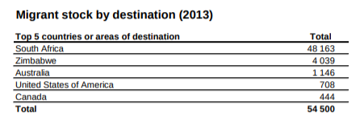 Fig 5. Migrant stock by destination. Source: unicef (2013) Botswana Migration profiles.
The graph above (fig 5), derived from UNICEF (2013), indicates that most Batswana have emigrated to South Africa with a total of 48 163 migrants in the year 2013. It is understandable why South Africa would be the first choice for Botswana migrants. Despite it being closer to home, quality of life, career progress and the favourable climate are amongst the attractive factors of South Africa. The second choice country for Batswana migrants is Zimbabwe. This is a bit surprising looking at the rates at which Zimbabweans migrate to Botswana trying to escape their country. There is a dedicated chapter on migrants from Zimbabwe in Botswana, which explores more on this topic. Australia is the most preferred country across the African continent, according to (UNICEF;2013). "Immigration to Australia from Botswana has grown at a yearly rate of 11.88 percent, and this makes it one of the biggest migration routes for skilled human capital in the World", quoted from Australia made simple site (Mc Manus;2021). Nevertheless, comparing data from UNICEF 2013 to the country economy 2019 below, the increase of migrants increased only up to 366 migrants, which appears to be a modest increase for a period of 6 years. Looking back at a study done by Cambell (2001) mentioned in the background study, he stated that Botswana is at risk of losing skilled nationals to the USA, South Africa, the UK and Namibia in a particular order in the near future. This does not tally with the order formulated by the country economy (2019) and UNICEF (2013); the destination countries are the same, the difference is the order.

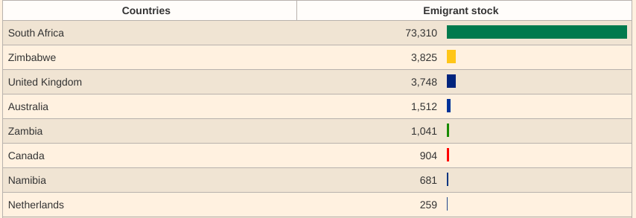 Fig 6. Batswana destination countries. Source; country economy 2019. migrants from Botswana according to the destination country.

Comparing data drawn from the country economy (2019) to UNICEF (2013), the number of Batswana migrants to South Africa kept on increasing from 48 163 migrants in 2013 to 73 310 migrants in 2019. There is a decrease for migrants in Zimbabwe from 4 039 in 2013 to 3 825 in 2019, a difference of 214 migrants. It is not a significant decrease for a period of six years, but it is worth questioning the possible justification for the decline.
Another interesting route of growth of migrants is to Canada; UNICEF (2013) recorded 444 migrants, then six years later, the country economy (2019) recorded 904 migrants, a growth of 460 migrants. There is missing information about migrants in the United States of America from the country's economy (2019), it could also be possible that migrants shifted from moving to the United States of America to Canada, but it would still be worth justifying the availability of data. It is also interesting to find Zambia on the country economy (2019), same with United States of America case, and it would have been alluring to compare the progress if there was information from UNICEF (2013). It is possible that it could be a new emerging route that may outrun South African in the long run.
From the researcher's perspective, I had anticipated that the United Kingdom would have high numbers of migrants from Botswana, reasons being, specifically, Botswana and England, have more relaxed policies on entry requirements. Batswana are eligible for a free tourist visa for a stay less than six months in the United Kingdom (British council;2021). Usually, migrants from developed countries take advantage of this policy. There are also yearly offered scholarships to the United Kingdom, for example, Chevening scholarships offered by the British council and Commonwealth scholarships dedicated to universities in the United Kingdom. With the only visa-free travels with the only country in the European region, I had considered a similar situation of growing volumes of South Africa to also happen with the United Kingdom.
The information on the country economy (2019) and UNICEF (2013) does not give reasons for Migration; however, migration policies require valid reasons behind the movement. Therefore it is safe to associate the volumes given on the publications to labour migration. UNICEF (2013) provided data on the table below (fig 7) on University students' destination. Of which, quality of education serves as a push factor behind Migration. South Africa still serves as the top destination for Botswana migrants who would like to acquire better quality education. The other destinations are developed countries, which in most cases offer scholarships; hence it could be the attractive pull factor for Batswana migrants.
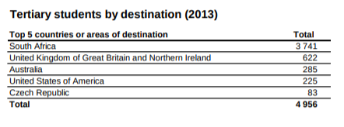 Fig 7. Tertiary students by destination. 2013. source: UNICEF (2013) Botswana Migration profiles.
In summary of migrant movement from Botswana, country economy (2019) has indicated in the graph below (fig 8) that the amount of migrants has been growing over the years, from 1995 to 2015. An interesting steep increase was recorded from 2010 to 2015. The total number of migrants was 47 832 in 2010 and rose to 80 103 migrants in 2015. Also, more males have been migrating than females, and the trend has never been close to a change; by the data from the country economy (2019), males will continue to migrate at higher numbers than females in Botswana.
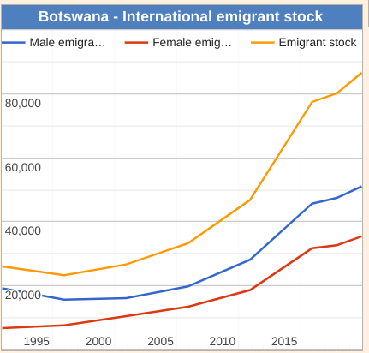 Fig 8. Botswana international emigrant stock. Source; country economy 2019. migrants from Botswana according to the destination country.

Asylum applications of refugees from Botswana
Asylum applications of refugees from Botswana
According to Cambridge dictionary (2021), asylum refers to "protection or safety, especially that given by a government to people who have been forced to leave their own countries for their safety or because of war". Worlddata.info (2019) has recorded a total of 66 applications in 2019 alone. The top three countries are the United Kingdom, Ireland and Canada respectively. In the data from the table below (fig 9), the number of accepted and rejected applications do not correlate because of the open cases that we carried over from the previous year. Therefore, in 2019, only ten migrants escaped to the United Kingdom, while no applications were accepted for those to Ireland and Canada.

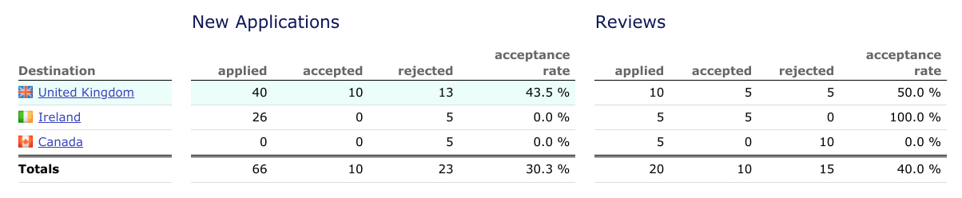 Fig 9. Asylum applications from Botswana, 2019. source: worlddata.info (2019) Asylum applications and refugees in Botswana.
Asylum applications of foreign refugees in Botswana
Botswana also attracts asylum applications from other African countries, the most common being Congo, Zimbabwe and Burundi, respectively (worlddata.info; 2019). Most of the asylums reside in the Dukwi refugee camp, located in the central district of Botswana. In 2019, a total of 70 asylum applications were accepted from Congo applicants, followed by 26 applicants from Burundi.

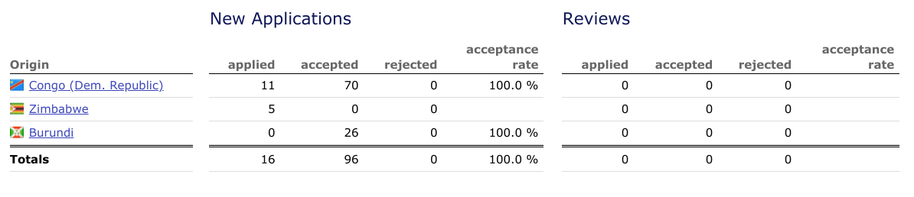 Fig 10. Asylum applications of foreign refugees in Botswana, 2019. source: worlddata.info (2019) Asylum applications and refugees in Botswana.
In 2016, UNHCR (United Nations High Commissioner for Refugees) published a report that Botswana hosted a total of 731 asylum-seekers. The order of main applicant countries differ from those published by worlddata.info ( 2019); in volume order, the main countries of origin are Namibia at 938 migrants, Zimbabwe at 736 migrants, the remaining originate from the Democratic Republic of the Congo and Somalia (UNHCR; 2016). This data, however, is only for the accepted asylum applications. Botswana refugee policy does not allow asylum-seekers to work; therefore, they do not have access to work permits. Instead, they solely depend on the UNHCR and Botswana government for necessities, e.g. food aid.

3.1 MIGRATION PROTOCOLS IN SOUTHERN AFRICAN DEVELOPMENT COMMUNITY (SADC)
SADC (Southern African Development Community) is a regional organization consisting of 14 Member Countries, namely Angola, Botswana, Congo (DR), Lesotho, Malawi, Mauritius, Mozambique, Namibia, Seychelles, South Africa, Swaziland, Tanzania, Zambia and Zimbabwe. This region alone is estimated to have a population of 353.9 million people, of which 7.9 million are international migrants (UN DESA, 2019).
According to the migration data portal (2021), Migration that occurs around Southern African countries is also driven by economic opportunities, political instability and environmental problems, among others. South Africa, Botswana and Zambia are considered to have Industrial developments, which is the mining sector, that attract both skilled and unskilled people, as well as the oil wealth of Angola. The most economically industrialized country is South Africa; according to UN DESA (2019), it was estimated that 4.2 million migrants resided in South Africa by mid-year 2019.
Even with the high number of movements between SADC, no free movement of persons is yet in force. There have been reports that this initiative has been in discussion since early 1990, but even in 2021, it is still not in effect. Oucho & Crush (2001), in their study, have stated that this is in delay due to reasons that there are complexities of migration dynamics and legacies of the colonial migrant labour systems in place. However, there are said to be Special Dispensation Permit (SDP) that are issued among South Africa, Zimbabwe and Mozambique migrants to enable them to be able to secure jobs in any of these countries (migration data portal; 2021).
Because of the recognized pull factors, South Africa is therefore under pressure and concerned about the flow of refugees and irregular migrants fleeing countries that are affected by economic crises and political instability. The country has therefore established preferential bilateral trade and labour migrant agreements with SACU region members (Southern African Customs Union) being Angola, Botswana, Lesotho and Eswatini. However, there has been xenophobic attacks in South Africa targeted on migrants in the years 2008, 2015 and 2019 of which induced displacement among the migrant populations in South Africa. In response, South Africa formulated South Africa National Action plan in 2019, aiming to Combat Racism, Racial Discrimination, Xenophobia and Related Intolerance (Williams, 2002).

3.1.2 ANTICIPATED PUSH FACTORS IN THE SADC REGION
IPCC (2018) has anticipated that Southern Africa will be acutely impacted by climate change. The northeast part will likely experience intense floods. The southwest part is already drying and warming at a rate twice the global average (IPCC, 2018). Water is also scarce, and hence water stress has been identified as a major migration driver. Also, the effects of climate change will cause large portions of Namibia, Botswana and South Africa to no longer be suitable for cereal crop production in the next sixty years (IPCC, 2018). These shifts will also affect the livelihoods of those who largely depend on Agriculture and therefore causing food scarcity, which may become a major push factor in Migration across the whole region.
As mentioned before, it has been estimated that Southern Africa's temperature is rising at twice the global rate; this could therefore mean an increased drought period predicted for Namibia, Botswana, northern Zimbabwe and southern Zambia. According to Oucho & Crush (2001), 41.2 million people in 13 countries in the region, which is a rise of 28 percent, over the previous year faced food insecurity in 2019. Botswana, Lesotho and Namibia then declared a State of Drought Disaster, and Botswana has been facing its most severe drought in 30 years (IPCC, 2018).
In the midst of changing environmental conditions, (IPCC 2018) also anticipated that residents that have weak tenure rights have low chances of making long term investments in their land that includes climate change adaptation. Therefore, when arable land depletes, Migration then becomes the only risk diversifying strategy. Food and water scarcity, as well as droughts, floods and cyclones, have been displacing thousands of people in the region; this currently occurred in Mozambique. These challenges may become the impetus for enhanced integration, but they could also motivate protectionist behaviours among member states (IPCC, 2018).

3.2 MIGRATION ANALYSIS IN BOTSWANA
Since 1966, Botswana has experienced volume fluctuations as both a sending and receiving country. It has become a destination for refugees, mainly from the Southern African region, this will be discussed in detail in the following chapter (4). Not forgetting that its own expatriate nationals came back home. It has attracted skilled professionals from across the continent, which will be discussed in this chapter. The main reason behind the transition from migrant-sending to migrant-receiving has been mainly associated with the rapid growth of the economy. This chapter also discusses open policy migration and Migration into the new millennium.
In becoming the receiving region, Botswana faced a number of critical limitations. For example, factors like underdeveloped infrastructure, a lack of capital, a population of less than one million in the early 1980s, and a largely unskilled workforce. The government then decided to adopt an open approach to migration policy which allowed unrestricted entry to visitors, tourists, and job seekers. In addition, the government also decided to source foreign investment through incentives for multinationals, e.g. DeBeers. Some of the experienced limitations improved after these decisions. For example, since the majority of the population received basic education over the years, there was an increase in educated people. As a result, it appears that the value of Botswana's "open" migration policy has begun to decline. There has also been an unforeseen arrival of thousands of undocumented Zimbabweans who fled their country because of an economic meltdown of Zimbabwe. Therefore, the Botswana government introduced new border controls and harsher punishment for illegal migrants.
As discussed previously in chapter 1, international Migration was predominantly of unskilled labour from Botswana to South Africa. This changed in the 1980s as the country became a major destination of skilled migrants from Africa and beyond. Developing countries like Botswana and Lesotho also transformed to attract migrants for labour purposes. These Movements have had significant implications for economic, social and demographic changes in the country. The figure below (fig 11) shows work permit holders by country of origin. The majority of work permit holders were from Zimbabwe at 2,315 persons (48.6 percent), followed by South Africa at 638 persons (13.4 percent) and Other Africa with 431 persons (9.0 percent), according to Statistics Botswana (2019). The work permits are issued and authorized by the department of labour. Valid reasons are eligible to be issued a permit before residing in Botswana, and they could be education, work, family, etc. The department of labour collaborates with Statistics Botswana to keep up with the documentation of issued work permits to help reflect skills that are short among nationals and taken up by migrants.
In the total number of work permits issued, 87.8 percent of the holders served as employees, while 12.2 percent were self-employed. Per sector, the top three were Agriculture which had the largest number of permit holders at 27.6 percent, followed by education at 15.7 percent, then lastly construction at 12. 1 percent.
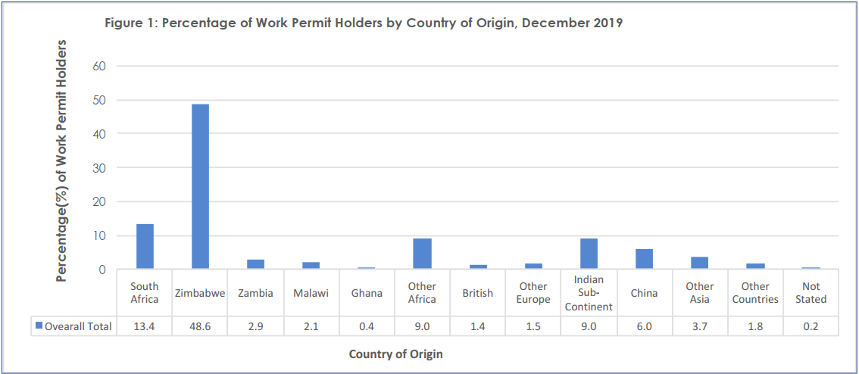 Fig 11. percentage of work permit holders by country of origin. Source: Statistics Botswana (2019). Botswana demographic survey.
From the year 2010, the number of total permit holders were at 17 286, as according to Statistics Botswana (2019) and experienced a significant fall to 6 516 in 2014, which in total equates to a fall of 62.3 percent. The reasons behind the decline are worth the research and could give a better position for future anticipation. The numbers kept on declining, as from 2014 to 2019, there was a 26.8 percent decline as indicated in figure 12 below.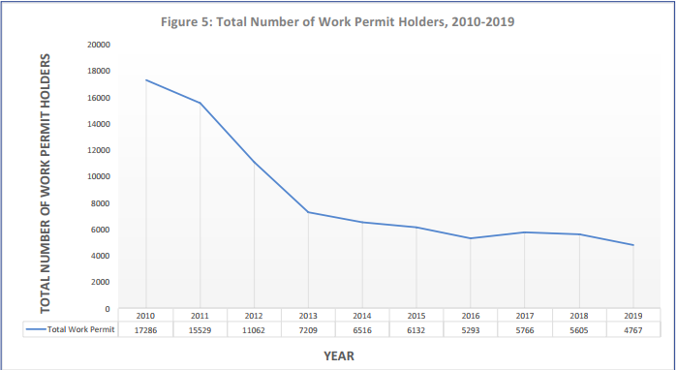 Fig 12. total number of work permit holders 2010 to 2019. Source: Statistics Botswana (2019). Botswana demographic survey.
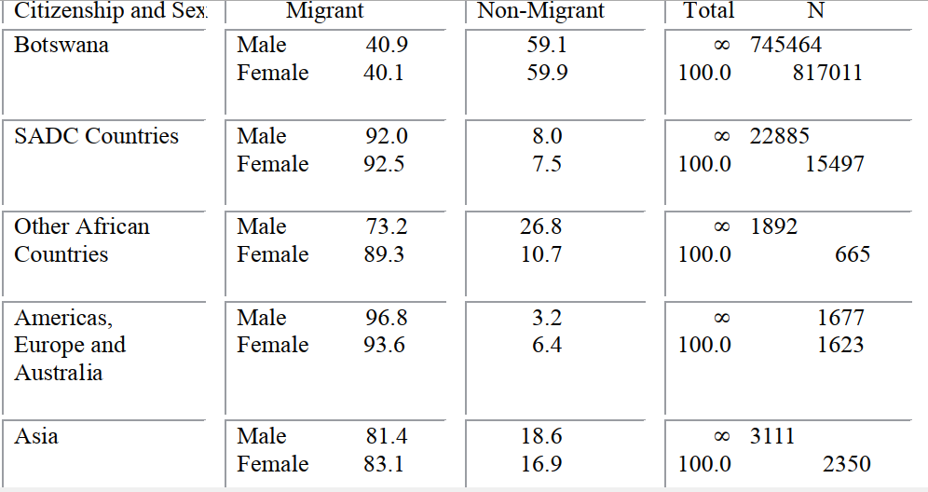
Fig 13. percentage of Migrants and Non-Migrants in Botswana by Sex and Citizenship. Source: Statistics Botswana (2019). Botswana demographic survey.

According to Botswana Demographic Survey Report (2017), high numbers of mobility in Botswana involves inter districts while an estimated number of fewer than ten thousand movements was recorded involving cross border movement. Out of a total population, 42 percent migrated within Botswana (internal migrants) at least once; therefore, 58 percent of the population had never migrated since they were born (Botswana Demographic Survey Report; 2017). Comparison of the 1998 Botswana Demographic Survey, 2001 Population & Housing Census and 2006 Botswana Demographic Survey, Internal Migration was predominantly from rural to urban areas. The situation changed in 1981 when 37 percent of internal Migration was rural-urban. This also changed by 1991 when urban to urban Migration became dominant; urban to urban Migration was 34 percent while rural to urban Migration was 26 percent.
According to the census, the population of Botswana is made up of 96.0 percent of Batswana and a rate of 4.0 percent of non-Batswana. However, in 2006, BDS published that Batswana accounted for 96.6 percent of the total population, and non-Batswana was at 3.3 percent; this has shown an increase of non-Batswana from 2006 to 2017. On the other hand, despite the decline in the number of migrants, net Migration was recorded at 1.317 per 1000 population in 2019, giving a positive value. This, therefore, concludes that there are more people entering than leaving the country.

3.2.0 OPEN MIGRATION POLICY
From the 1970s, Botswana's economic growth needed labour and expertise, and the government's open migration policy approach was formulated to secure these from across the continent successfully. A significant in-migration flow included Batswana expatriates returning home, skilled foreign workers filling gaps in professional sectors, and refugees from Namibia, Zimbabwe, and South Africa. Political repression that occurred in Zimbabwe and the bloody civil wars of Angola resulted in a large number of refugees in the region during this period. The pattern has changed to attract more refugees from as far as Burundi and Congo. As mentioned by the United Nations High Commissioner for Refugees (2004), before Zimbabwe independence in 1980 and that of Namibia in 1990, up to 45,000 migrants were housed at the Dukwi Refugee Camp outside Francistown, Botswana. In this period, the national census declared that the recorded nationals living in foreign declined from 45,735 in the year 1971, to 38,606 in the year 1991, and to 28,210 by 2001 (Kate Lefko-Everett (2004). Foreign workers were pursued to fill skill gaps in sectors including technology, engineering, law, and healthcare and were offered satisfying benefits, which included competitive salaries, subsidized housing, cars, etc. In summary, the number of legal non-nationals living in Botswana tripled between 1971 and 1991 from 10,861 to 29,557 and had increased by six-fold to 60,716 by 2001 (Kate Lefko-Everett,2004).

3.3 CASE STUDY; BRAIN GAIN THROUGH ZIMBABWE
On many occasions, reference has been given with Zimbabwe in this thesis. As discussed in chapter 3.2, most permit holders in Botswana are from Zimbabwe, a research done by (Clemens and Pettersson, 2008) also indicated that 51 percent of physicians and 24 percent of nurses are Zimbabweans are estimated to be working elsewhere in the world. It can therefore be concluded that the country is facing a significant human resource flight, specifically brain drain. As stated by the World Bank, the population of Zimbabwe in 2019 amounted to 14.65 million. The main top 3 destination country for Zimbabweans was the United Kingdom at 3,486 migrants, Botswana with 1,524 and South Africa with 1,502. Zanamwe and Devillard (2009) found out that 36 per cent of the Zimbabweans from ages of 3 years and above had completed secondary education or higher education. This indicates that a fair amount of the population is educated, and they are losing these educated people to other countries. The economy of Zimbabwe has not been performing well since the year 2000. The gross domestic product reduced by 46 per cent between the years 2000 and 2007. The country also experienced an extreme shortage of basic resources like medical drugs, food, fuel etc. Poverty cases, on the other hand, kept on increasing; from 1995, the poverty line rose from 61 percent to 72 percent in 2003. (zanamwe and Devillard, 2009).
The situation was different before the economic crisis of Zimbabwe. In colonial times, Zimbabwe served as a destination country, receiving migrants in large numbers from the United Kingdom and the rest of Europe. Also, large numbers came from Africa; immigrants from Malawi, Zambia and Mozambique came to Zimbabwe to work on mines and commercial farms established in Zimbabwe. Botswana, in some cases, has benefitted from brain drain from Zimbabwe after the year 2000. In 2003, Botswana recorded 1 177 work permits issued to Zimbabweans, and already in 2009, the numbers rose to 8 779, the proportion of work permit holders of Zimbabweans rose from 20 percent to 46 percent of the total. (Campbell and Crush,2012). There is a concerningly high number of illegal immigrants entering Botswana from Zimbabwe. Despite that, people legally entering Botswana from Zimbabwe increased in numbers over time; the volumes more than doubled from 477,000 in 2000 to over 1 million in 2008. These are total numbers without specification of the reason for entry. Some of them are said to give visitors or holidays as a purpose of entry. This reason allows them to stay legally for up to 90 days in Botswana. Those entering for the purpose of business have been increasing in large volumes as well. The numbers rose from around 12,500 in 2005 to over 40,000 in 2008. The same trend has been happening with those entering for employment. Their numbers increased from 4,110 to 13,586 between 2005 and 2008. In summarising the migration volumes, 43 percent of the migrants came for the purpose of seeking work, followed by 14 percent who came for employment, only in a period between 2005 and 2008 (Campbell and Crush, 2012). Zanamwe and Devillard (2009), in their study, also found out that the other reasons Zimbabweans migrate to Botswana are related to livelihoods. Out of the 43 percent that migrate seeking work and the 14 percent that migrate to take up a job, 11 percent migrate because living conditions were better in Botswana than in Zimbabwe.
Looking at the situation in Zimbabwe, it is better for the citizens to migrate, seeing that there is the availability of work opportunities that are not available at home; therefore, they can put their skills to use. In that way, they are able to increase the inflow of remittances back to their country, hence improving the lives of their families. The disadvantage is that Zimbabwe is robbed of its human capital stock, especially those with valuable professionals like doctors and teachers. This reduces the quality of essential services, e.g. health and education. Just like Botswana, Zimbabwe loses its investments in subsidized education to citizens who migrate after graduation. Even though Zimbabwe has a rich history of Migration, the migrants have faced a lot of complex challenges. For example, they are prone to xenophobia attacks that constantly take place in South Africa, one of their prominent destination places. Most Zimbabweans also do not hold passports; therefore, they are limited in obtaining visas, work and residence permits. This has led to many Zimbabwean migrants migrating and working abroad in a distinctive way, hence high deportation rates from countries like Botswana and South Africa.

3.4 IMMIGRATION IN THE NEW MILLENNIUM
Since the significant improvements in the living conditions of Botswana, the migration patterns of the population maintained consistently low levels of emigration. Of course, Batswana continued to travel outside national borders, but migration data suggest that the trips were mostly short and "purpose-oriented" for the likes of shopping, visits, and holidays, with few seeking employment or extended residence abroad. Also, this is when the value of the open migration policy declined.
According to Navaneetham and Dwivedi (2011), it was found that between 2006 and 2011, about 1,359 Batswana people migrated to other countries and 20,268 persons came from other countries to Botswana. With the total migrations that took place during the interval, only three-fourths of them were of age above five and one-fourth of them were children of less than age five who migrated along with their parents. Urban areas such as Gaborone, Francistown and Ngamiland East experienced significant net-out Migration during 2006-2011.
Also, the remarkable economic growth of Botswana may suggest that Botswana has the capacity for full employment of skilled citizens. This is in consideration that the government invested in educating its citizens, where they were offered free access to education and government sponsorship at the tertiary level. The national educational policy was designed to educate every citizen in the country, but annual school enrolment has always exceeded expectations. According to Campbell, Eugene K. and Oucho, John O (2003), the total enrolment at the University of Botswana rose from 648 in 1984/85 to 15,350 in 2003/04. In 2002, the University had planned to reach an enrollment of 15,000 in 2007, but they achieved this target four years early. Unemployment has been increasing, especially among university graduates. Before the mid-1990s, every Motswana who had a university degree was guaranteed employment within government and private sectors. This situation has changed today, partly due to rapidly increasing university enrollment in a market continuously having trouble employing all its eligible skilled citizens. University degree holders no longer have much opportunity to negotiate over the jobs that they get.

CHAPTER 4
Chapter 4 covers the dynamics of human resource flight relating to Botswana. Botswana as a sending region is evaluated further with noticed push factors. There is also an evaluation of Botswana as a sending region with possible pull factors. Finally, a case study on the most affected sector in Botswana is included further to verify the sources of pull and push factors.

4.0 OVERVIEW OF HUMAN CAPITAL FLIGHT STATUS IN BOTSWANA
The brain drain phenomenon in developing countries is associated with significant issues like political instability, lack of resources and high unemployment rate, to mention a few. Some regions are referred to as sending regions, which experience a high number of out-migration of their highly educated citizens to the receiving regions (staff writers;2011). Taking, for example, Nigeria, a country in the west of Africa, has been found to be majorly impacted by brain drain. According to staff writers (2011), over 2 million Nigerians live in the US. It has also been found that about 20 000 of them are doctors. This is a major loss for the Nigerian nation that already has inadequate medical facilities and a lack of human resources.
On the other hand, the receiving regions are mostly developed countries like the United States of America. These countries are more promising in labour opportunities. They offer attractive life opportunities like their reputation of education systems or just good quality of life, compared to the sending region.
Globalization also brought lower transportation and communication costs, making the movement of people and ideas much easier. A good example is the European Union, where there is complete free movement of people. Therefore, skilled migrants, especially from developing countries, now find it much easier to move from one country to another. This movement of workers has not only facilitated brain drain; it has also favoured related phenomena of brain regain. Lindberg. et al. (2014) describes brain regain as the return of skilled workers to a region that previously lost human resources. There are two categories to classify the factors driving mobility of workers, and there are push factors which are unfavourable conditions that cause workers' mobility, for example, high youth unemployment. Second are the pull factors, which are those favourable structural conditions like high GDP per capita that lead to the immigration of human capital (Bana, 2016)
According to Todisco et al. (2003), when mobility concerns highly skilled workers, pull factors play a more relevant role than push factors, this is so because the movement of highly skilled people is mostly temporary as it depends on the attractiveness of the location and economic status, amongst the others.
4.1 BOTSWANA AS A SENDING REGION
This chapter aims to discuss push factors of Botswana migrants, such as quality of education, quality of medical service; environmental problems; income inequality and unemployment rate. The main effect is that Botswana, as a sending region, loses human capital, which took time and resources to produce for its benefit. As discussed earlier, Botswana allocated 22 percent of public expenditure on education in the financial year 2017/18. Education is also free in Botswana until the secondary level. This is, therefore, a major loss for the nation, and of course, the Migration causes a shortage of labour and serves as a reason for concern. According to research done by Motlhatlhedi and Nkomazana (2018) on Botswana's return of migration health workers, they have found out that most of the doctors trained abroad never return to work in Botswana; hence there is a shortage of doctors in Botswana, all due to emigration. The government sends these health workers across the border to study and train on their specifications, and this is the government's effort trying to bridge the gap of skill shortage. Also, as a low population country, Botswana, brain drain causes further reduction of market size, making it difficult for companies to survive and foreign investors to reconsider operating in an area of low consumption (the Republic of Botswana, 2012; World Factbook, 2014). In their research, Andres Artal-tr et al. (2014) also confirmed the negative relationship between human capital flight and economic growth in developing states. Despite the country's remarkable economic growth, it has been said that it does not reflect on the lives of the citizens. There is still poor infrastructure, poor medical facilities, etc. However, Andres Artal-tr et al. (2014) research showed a positive effect when a significant number of the immigrants decide to return home, taking into effect the concept of brain circulation.

4.1.0 QUALITY OF EDUCATION
Education in Botswana is free for a period of the first 12 years. This has resulted in 90 percent of Primary school enrollment; therefore, there is a high literacy level in Botswana. Despite the progress in enrollment, Botswana still lags behind in student learning outcomes according to the international benchmarking. The country is currently faced with the problem of educated unemployment because the quality of education does not meet international standards. The unemployment rate was recorded at 17.89 percent in 2012 and has risen to 18.19 percent in 2019. Low-quality education and training have caused inadequate skills to meet the current labour demands resulting in a shortage of skilled labour. Giving a real-life example, I, as the researcher, was driven to study abroad by the desire to acquire high-quality education and be able to meet international standards. Such a high unemployment rate reduces the gross domestic product (GDP) and moves the country away from the efficient allocation of its resources. When educated people are unemployed, their families also do not have wages to sustain life.

4.1.1 QUALITY OF MEDICAL SERVICE
The Health system in Botswana comprises a public, profitable private and non-profitable sector. The public sector provides the largest share of healthcare for free. According to Motlhatlhedi and Nkomazana (2018), the public health sector is faced with compromised quality of services, shortage of human resource, inexperienced staff, inadequate planning, to mention a few. Therefore, these factors are a threat to human life and have led to failure to attract and retain skilled or trained personnel. The private sector is more advanced, hence provides better health care. This, however, comes at very high costs, which most of the population cannot afford. More on medical service in Botswana is discussed in chapter 4.3.

4.1.2 ENVIRONMENTAL PROBLEMS
Over the years, drought has been a significant problem in Botswana. According to Parsons (2020), three-quarters of the human population and animal populations depend on groundwater which is scarce, as well as surface water which is also scarce. Agriculture in the country is also sustainable by rainfall. On the other hand, rural income is through raising livestock; approximately 71 percent of the country's land is used for communal grazing. This has been said to be a major cause of desertification and the accelerating soil erosion of the country (Parsons,2020). All these bring to conclude that the country faces difficulty in being food sufficient as environmental problems make agricultural production problematic. Those who are unemployed could feed themselves through agriculture, but the weather and environment also serve disadvantages, which leads to poverty and starvation.

4.1.3 INCOME INEQUALITY
According to the World Bank(2015), inequality in Botswana is the world's third-highest, after South Africa and Seychelles. There are various debates on the possible reasons behind the topic, but, majority anticipate that high inequality levels occur because the mineral sector (which drives the economy) is capital intensive and also employs a very low proportion of the labour force. As discussed earlier, the mining sector employs only 3.3 percent of the whole population. This is the same sector that accounts for more than one-third of GDP, and reasonable to expect it to employ more and not be discriminative. According to Statistics Botswana (2015), in between the years "1985/86 and 1993/94 disposable income inequality declined marginally from a Gini-coefficient of 0.556 to 0.537", while in urban areas, it was increasing over the years. Between the years 1993/94 and 2002/03, disposable income inequality recorded a marginal increase as it rose from 0.537 to 0.573. As inequality and poverty are highly linked, poverty has also remained high over time, even though it has slowly decreased over the years. It declined from about 59 percent in 1985/86 to about 47 percent in 1993/94 (the World Bank;2015). As mentioned before, high forms of poverty are concentrated in the country's most remote/rural areas, and these are areas where a high degree of dependence on government welfare exists. As the social structure changes, reasons such as labour division due to the intensive effort need to be revised. This issue goes as far as affecting individual investments in education and health, all of which also affect capabilities of human resources, hence, worth the attention.

4.1.4 UNEMPLOYMENT RATE

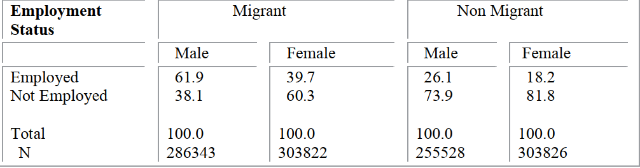
Fig 14. Percentage Distribution of People 15+ years by Employment, Migrant Status and Sex. Source; Statistics Botswana (2011).

According to Statistics Botswana (2011), figure 14 above shows that 69 percent of migrants and 44 percent of non-migrants were employed in that year. Forty-eight percent of the migrants and 20 percent of non-migrants were employed. Therefore, the conclusion that can therefore be formulated is that the publication supports reports of very high unemployment among citizen youth in Botswana. This may be because employment, in general, has specific requirements of education and training levels, which is mostly possessed by migrants. It, therefore, makes sense to relocate as a citizen of Botswana to get education and training elsewhere since the opportunities are less in their own country.

4.2 BOTSWANA AS RECEIVING REGION
Not all is lost as Botswana serves as a receiving region as well. There is an increase in innovation potential as those who relocate to the country come with innovative ideas for their respective professions. The few that decide to operate businesses or apply their much-needed skill in their field impart to the economic growth and add on to the competitive advantage with other countries. The attracting factors for skilled migrants to Botswana discussed in this chapter include advanced economy, political stability, low corruption cases.

4.2.0 ECONOMY
Since 1966, Botswana has maintained significant economic growth until the beginning of the global recession in 2008. It has impressively transitioned itself from being among the poorest countries in the world around five decades ago. Today it is considered a middle-income country with a per capita GDP of approximately $18,100 recorded in 2017. This growth has been contributing to the lowering of poverty and improving living standards. It has also enabled access to free education and medical services.

4.2.1 POLITICAL STABILITY
Botswana has not suffered civil wars, coups or ethnic violence and expropriation. As a multi-party state, elections are held every five years and have never caused havoc as other African countries. The ruling party has been the Botswana Democratic Party (BDP) since 1966, which has been for 55 years to date. This serves as an attractive forum for those who want to settle in a safe country to offer services or pursue a market investment.

4.2.2 CORRUPTION
According to the 2019 Corruption Perceptions Index compiled by Transparency International, Botswana is the 34 least corrupt nations out of 180 countries. This is a good record as corrupted economies are not able to function correctly. These acts cause flaws in the basic functioning of laws of the economy, therefore, preventing an economy from functioning freely. It causes wastage of taxpayer funds as well as loss of goods and services flow. Botswana, therefore, serves as an excellent place to do business and provision of goods and services.

4.3.CASE STUDY; BRAIN DRAIN IN BOTSWANA HEALTH SECTOR
Various reports have indicated that developing countries lose a substantial number of healthcare professionals to developed countries. Taking the reference from chapter 4.0 by the staff writers (2011) reporting that 20 000 Nigerian doctors are practicing in the United States of America. Shortage of staff results in compromised delivery of service, and Botswana is no exception to this situation. Clemens and Pettersson (2008) pointed the finger at low wages, unbearable working and living conditions as push factors for health care professionals in developing countries. Hence they seek better salaries, safer working conditions, better living conditions and a better life in other countries, mostly the developed ones. Looking at Zimbabwe, there has been political instability dating as far as the year 2000. Because of this instability, 51 percent of physicians and 24 percent of nurses of Zimbabwean nationalities are working in foreign countries, according to (Clemens and Pettersson, 2008). This chapter is aimed to explore the situation of brain drain that occurs in Botswana in detail, focusing on the majorly impacted yet important sector, health.
Botswana, like Nigeria and Zimbabwe, has battled with the loss of healthcare professionals to high-income countries as well. As stated in chapter 1, Motlhatlhedi: et al. (2018) reported that in 2012 the doctor-to-patient ratio was 4:10 000 of the population and the nurse-to-patient ratio was 42:10 000 of the population, while the recommended ratio by the world health organization is 1:1000 of the population. Nurses are primarily trained in Botswana, but other skilled healthcare workers, e.g. doctors, psychologists have mostly trained abroad, at least until 2009. After the effort, only 21 percent of local doctors are registered to practise in Botswana. Those who trained abroad hardly return home, causing a critical shortage of healthcare workers. Motlhatlhedi: et al. (2018) estimated that 7 percent of Batswana nurses and midwives are working in high-income countries. In comparison to what Motlhatlhedi: et al. (2018) estimated, the director of the Department of Tertiary Education Financing (DTEF) reported that more than 800 Botswana doctors decided to work abroad. In a quote, "They refused to return home following the completion of their studies" (Botlhoko,2013). DTEF statistics confirmed that in Britain, there are around 130; In Ireland, there are about 110; and close to 47 are residing in Australia after finishing their studies (Botlhoko,2013). In 2002, the Minister of Health declared the situation an emergency and called upon health workers who settled in foreign countries to reconsider and move back home to assist with the shortage. It came as a surprise that after a few months of this call, the same Minister resigned and left to work with the United Nations in Europe. In order to ease this brain drain, Botswana established its first medical school known as the University of Botswana School of Medicine in 2009. This is with hopes of producing sufficient numbers of healthcare professionals, especially doctors that can serve their country. However, the establishment of a medical school does not always solve the brain drain problem. Countries like South Africa are evidence. They do have medical schools, but they still lose medical professionals to high-income countries. This, therefore, acts as proof that increasing local training output as the only effort may not be reason enough to train healthcare workers. A multi-faceted approach may be necessary, especially the one that is based on the push factors, those that explain why those who are trained choose to stay and practise in foreign countries. Hence, thorough research is necessary following the opening of the medical school in 2009.

4.3.0 OVERVIEW AND CONDUCT OF HEALTH CARE IN BOTSWANA
Health services in Botswana are mostly public and are free of charge, as mentioned in chapter 2. The private sector is small but has been growing over the years. At present, there are three private hospitals and several specialists and general private outpatient clinics, which are primarily located in towns and urban villages. The whole country has three referral hospitals, seven district hospitals, 14 primary hospitals. There are also three mine hospitals, two mission hospitals, 265 primary care clinics, 343 health posts and 861 mobile clinic sites. This makes health care easily accessible, but at the same time, accessibility, in this case, does not always translate to access to good health service, as many of the facilities are severely short-staffed. For the training of health care professionals, the Ministry of Education and Skills Development (MESD) provides scholarships for tertiary education, both locally and internationally. The Department of Tertiary Education Funding (DTEF) administers these scholarships. The Ministry of Health, as the governing body of the healthcare sector, there are also subdivisions, each responsible for a particular aspect to ensure the better running of the ministry. There is the Department of Policy, Planning, Monitoring and Evaluation (DPPME), which is responsible for human resources; Botswana Health Professions Council (BHPC) serving as the regulatory body for all doctors and other health professionals and lastly the Nursing and Midwifery Council of Botswana (NMCB) that is accountable for registering and regulating practices of nurses and midwives.
From 1997 to 2010, DTEF has administered an estimate of 7154 Batswana who graduated as health professionals. According to the table below, 1665 (23 percent) of them were trained in other countries. It is also important to note that all the 802 registered doctors in the period between 1997 and 2010 are trained in other countries.
In 2012 alone, 13 713 health workers were registered to practise in Botswana, out of which 1820 were doctors, and 9297 were nurses. Out of the 1820 doctors, only 382 of them were Batswana, meaning the remaining 1438 were foreign doctors. Out of 9297 nurses registered, 7845 were Batswana, and 1452 were foreigners. Nurses seem to be better in being retained within the country as compared to doctors; according to the table below, 21 percent of the doctors registered were Batswana compared with 84 percent of nurses. Batswana continue to be in small numbers amongst other professions; only 39 percent were physiotherapists, 13 percent were radiographers, and 35 percent optometrists (Nkomazana et al., 2014).
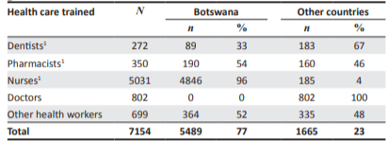 Fig 15. Healthcare workers trained locally and internationally. source; Nkomazana et al. 2014. Human resource for health in Botswana.
Summarised data indicates that the majority of health professionals registered to practise in 2012 were Botswana, Zimbabwe, the Democratic Republic of Congo, Zambia. Most of them are from African countries. The highest number of those from overseas are 110 workers and 70 doctors from the United States of America, followed by 59 workers and 55 doctors from China.
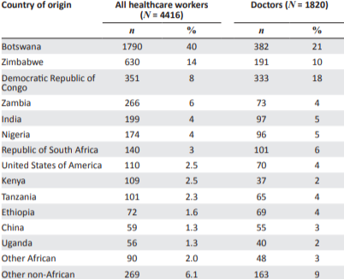 Fig 16. Healthcare workers by country of origin .source; Nkomazana et al. 2014. Human resource for health in Botswana.
This data provided by Nkomazana et al. (2014) proves that Botswana depends on migrant health workers, with only 21 percent of them being Batswana. Most of the migrants are from the DRC, Zimbabwe, as stated above, and these countries are tormented by political and economic hardships. This, therefore, supports the study done by Clemens and Pettersson, 2008. This situation may be viewed as brain gain, but the dependence on the expatriate health workforce is too risky. If the situation improves in their countries, they may consider returning home or migrating to higher-income countries like Botswana doctors.
From a study done by Motlhatlhedi: et al. (2018), a number of factors were identified as factors that push health care workers from Botswana to foreign countries. The leading factor was lack of professional fulfilment, which also has its own issues that cause it. Those were found to be poor quality of patient care, perception of being undervalued and limited career progression opportunities. Quality of patient care includes the availability of resources that are said to be limited or unavailable in Botswana. This compromises service outcomes leaving the professionals highly dissatisfied with the limited service they provided. In terms of career progression, opportunities for further training had been limited in Botswana until 2009; also, even if one got the opportunity for further training, it has not been seen as a reason enough for career progression. These factors are different from pull factors proposed by Clemens and Pettersson (2008). The main pull factor is political stability. Low wages, unbearable working and living conditions can be solved by a politically stable country that also provides safety. Even with threatening push factors, some Batswana finally decide to relocate back home. From a study by Motlhatlhedi: et al. (2018), it is interesting to discover that the main reasons for people returning to work in Botswana had nothing to do with the health system but were rather social. The healthcare workers returned because they were missing home, and some had family challenges.
In conclusion, the government is hoping that local training will reduce the dependence on expatriate health workers through the first medical school in Botswana. The University has partnered with regional and international institutions. Some of them are the University of Stellenbosch that is based in South Africa, the University of Pennsylvania (UPenn), based in the United States of America, and the Children's Hospital of Philadelphia (CHOP). The results so far seem to be positive; according to Children's Hospital of Philadelphia (2020), Botswana school of Medicine had more than 220 medical doctors and over 15 paediatricians graduate in 2020. Approximately 90 percent of the graduates were registered and are practising in Botswana.

4.4.0 SWOT ANALYSIS
Strengths
Abundant natural resources (diamonds, coal)
Low external debt
Substantial foreign exchange reserves
Political stability
Situated close to South Africa, a major African trading hub
High literacy rates
Weaknesses
High-income inequality
High levels of unemployment.
Highly dependent on the diamond sector
Inadequate infrastructure
Underground water pollution
High poverty levels
Prolonged drought
Challenges with energy, water and internet connection,
Poor waste management
High air pollution
Poor water quality
Compromised health services

Opportunities
Potential of increasing market size
Future domination of youth population
expansion on service sector
Potential international business environment

Threats
Strain on infrastructure
Increase in urbanization
Rising slum dwellers and crime
Food insecurity
Even lower precipitation levels
Rise in GHG emissions
Inconsistent supply and high cost of water and electricity

CHAPTER 5

SCENARIOS OF POTENTIAL FUTURE DEVELOPMENT
In this chapter, we will study occurring trends of events in Botswana that are likely to affect labour migration. The aim is to discuss issues that have been identified as contributing factors around human resource flight. We look at population and how it changes the demographic pyramid; urbanization and its potential results; food security and the potential; income inequality and its trend and climate change and its effects, all in the future.

5.0 POPULATION AND DEMOGRAPHY SHIFT
Proven by various studies, Botswana has a long history of low population. In 1950, the Botswana population was reported at 502,745, which was very low compared to other neighbouring countries. However, it kept rising over the years, by 1980, the population doubled to 897,868 and already in 2000, the population reached around 1,700,000. 2 percent of growth shows a good track record of expansion from the beginning, then followed by a constant decline from the 2000s, at an average growth rate of only 1.95 percent.
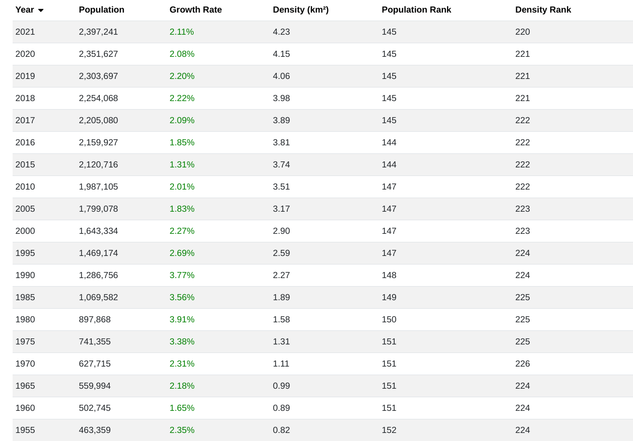 Fig 17. Botswana population by year (historical). Source; world population review, 2021. Botswana population.
According to the world population review (2021), from the year 2017, the population growth rate has started to grow a little over 2 percent and population projection is estimated to rise to over 3 million by the year 2040, and the growth rate is predicted to drop to a rate under 1%, where the following years after will experience stagnant growth. On the contrary, there will be a rise in the aged population. This will have to motivate the government to develop economic systems aimed at providing security for the aged population. New policies should be formulated to promote saving and investment towards sectors like health to improve productivity. Alternatively, the country should keep sustaining strong economic growth.
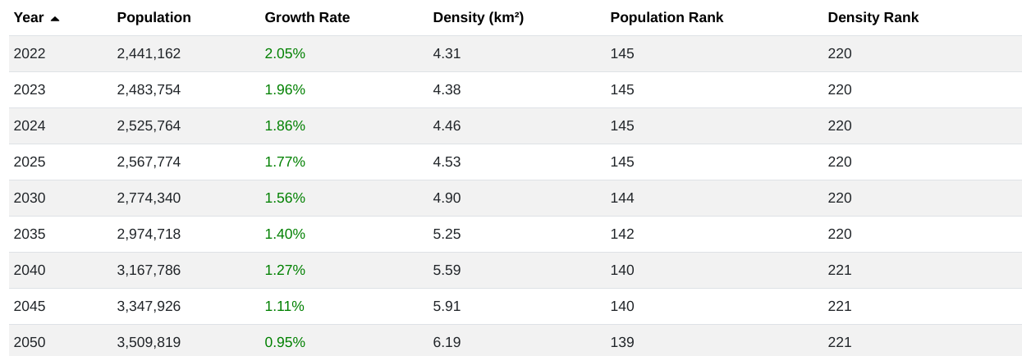 Fig 18. Botswana population by year (projections). Source; world population review, 2021. Botswana population.
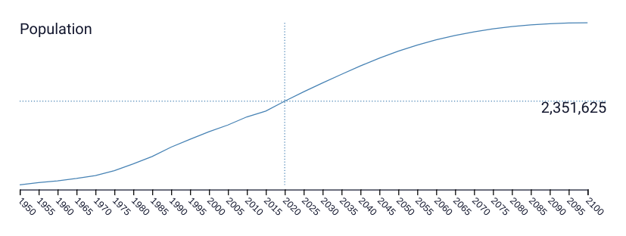
Fig 19. Botswana population by year (projections). Source; world population review, 2021. Botswana population.
The trend is expected to proceed in the SADC region; the population is expected also to continue to grow until the year 2050, but at a lower rate than in the recent past. This region, according to Lipper L and Benton TG. (2020), is expected to be dominated by the youth population during the same period. Rural population is predicted to decline slightly in some of the countries and increase in others in the SADC region, and the major anticipation is the expansion of youth into the labour force in the coming 10 to 20 years within this region (Lipper L and Benton TG.;2020). To summarise, the expected scenarios will include low fertility rates, growth of life expectancy, growth of ageing population, demographic imbalance, growth of labour force.

5.1 URBANIZATION RISE TO CRISIS
Africa's urban population in 2015 was recorded at 360 million and expected to rise to 1,137 million by 2050 (Jayne et al., 2017). Jayne et al. (2017) also stated that most of this growth is from urban population growth, not from Migration; it is also from areas that were previously considered rural being reclassified to urban as the population densities increase. Income and population growth trends from the ongoing migration pressure will also be an influence in driving urbanization. The case also applies in Botswana. Gwebu (2011) stated that "the number of urban places increased by 18 percent and the population classified as residing in urban villages increased by 9.1 percent between 2001 and 2011". The urban settlements can broadly be divided into towns and cities and urban villages; Botswana has two cities, namely Gaborone, which is the capital and Francistown. In 2001, the Census on Population and Housing classified Lobatse, Selibe –Phikwe, Orapa, Jwaneng and Sowa as towns, which previously had been urban villages. Urban Villages have populations of at least 5,000, with a minimum of 75 percent engaged in non-agricultural activities (Gwebu, 2011).
The urbanization crisis in sub-Saharan Africa, according to Lipper and Benton (2020), is that there is growth but no development. African urban areas have a hard time supporting the growing population already, and they depend on foreign direct investment (FDI). The World Bank(2000) stated that they "do not provide the necessary thrust for economic growth and structural transformation." In addition, there is constant failure to provide a conducive urban business environment, water, sewerage and electricity facilities to maintain the urban growth (Gwebu 2011).
Botswana already has a high demand for serviced land and housing units in towns. Research done by Gwebu; 2004 has shown that there is a backlog in serviced urban land and housing units, and this has led to a strain on infrastructure, services as well as overcrowding in existing housing areas. There are yards that still use pit latrines today, and this has caused pollution of groundwater with nitrates and bacteria from the pit latrines. These were found in water samples from the Gaborone Dam and the Notwane River, which are the main source of water in the greater Gaborone region (Gwebu, 2011). These conditions also threaten environmental sustainability. In spite of the remarkable economic growth, Botswana continues to fail in the provision of development. The poverty levels are lower in the city than in rural areas, and research has shown that more of the population moves to urban areas in search of better living standards. However, urban employment is still scarce in Botswana, as perceived by the rates of unemployment at 18.72 percent in 2020. People move to escape rural poverty but end up unemployed as well in the city, hence becoming slum-dwellers (P Granberg; 1998). The spread of social slums, poverty and crime will likely prevail in urbanized areas. To summarise, the expected scenarios will include rising levels of informal employment, and urbanization will continue to rise up to 30 percent in 20 years.

5.2 FOOD SECURITY FAILURE
Maize is the widely grown crop in Southern Africa, and in recent years, maize production has been decreasing in most countries in the region. Extreme droughts and floods are associated with this decline. The table below (fig 20), adapted from Nhamo et al. (2019), shows the deficit levels of maize production from 2011, and Botswana shows the lowest production out of all the countries.
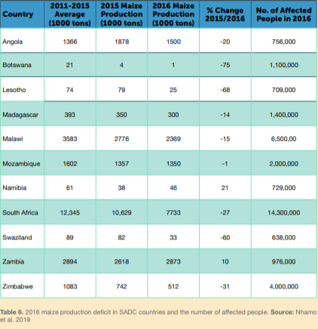 Fig 20 . 2016 maize production deficit in SADC countries and the number of affected people. Source: Nhamo et al. 2019, Cereal Production Trends under Climate Change: Impacts and Adaptation Strategies in Southern Africa.
In order to improve the situation, Botswana has been trying to improve its food security policies which were adopted since the 1970s. The government introduced programmes like The Arable Land Development Programme (ALDEP), which is to assist small-scale farmers in increasing cereal production to promote self-sufficiency; the farmers get subsidies for capital input. There is also The Accelerated Rainfed Arable Program (ARAP)which provides farmers that have short term assistance to encourage recovery from the drought season. Only in 2006, the government reviewed all these policies to track progress and find new ways to increase the level of food production in the country, and one of the problems identified was that there was a discovery that farmers became reluctant after receiving funds from the government (MOA 2006).
The government of Botswana has been making an effort to increase food production and security, but unfavourable climate conditions make it a challenging task, and this is a crisis worldwide, only that Botswana seems to have been hit hard. Climate change has been predicted to get worse; hence the production in Botswana does not stand a chance to improve. In summary, food production will continue to decline, dependence on food imports will grow to almost total dependence in 20 years.

5.3 INCOME INEQUALITY ETERNITY
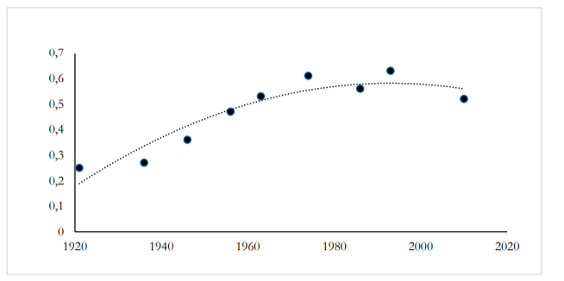 Fig 21. Income Ginis Bechuanaland 1921-2010. Source: J Bolt and E Hillbom (2016). Long-term trends in economic inequality: Lessons from colonial Botswana
In reference to the above graph from J Bolt and E Hillbom (2016), income inequality has always existed in Botswana and was relatively low around the 1920s. The change started to show from the 1940s when inequality rose from around 0.36 in 1946 to around 0.61 in 1974. Diamond incomes started to dominate Botswana's economy in the mid-1970s, and by that time, inequality was already high. The diamond income was serving as a replacement for beef export as the main source of government revenue. In the following two decades, inequality continued to be on the rise, peaking at 0.63 in 1993, to then decline to just above 0.5 in 2016. From a cattle-based economy, inequality continued to rise in the diamond lead economy; the long term trend of rising levels of inequality evenly extended over almost seven decades, from the 1930s to the 1990s, and will likely continue in the following additional seven decades. The cause for concern is that the inequality is combined with high unemployment and continued high poverty rates.
The Southern African region is classified as one of the unequal regions in terms of income indicators. The table below adapted from the 2020 Southern Africa economic outlook report; AfDB 2020 indicates that most countries in the region have only medium to high levels of inequality, and Botswana falling under high Gini. Inequality in Botswana will not decrease but rather remain constant for the next ten years.

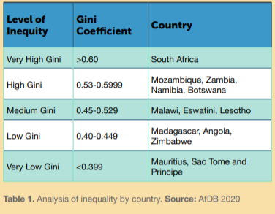 Fig 22. Analysis of inequality by country. Source: Southern Africa economic outlook report, 2020.Mega-trends in the Southern African Region.

5.4 CLIMATE CHANGE AND AGRICULTURE
Greenhouse gas (GHG) emissions keep on rising, leading to an increase in the average surface temperature, which will also cause changes in precipitation and sea levels. As a result, more storms and severe weather events may take place. The Intergovernmental Panel on Climate Change (IPCC) Fifth Assessment Report has anticipated that the impacts of climate change will increase flooding, famine and drought. The predictions were made up to the year 2050 and were based on the RCP of 4.5 and 8.5, which concludes that countries like Botswana will experience high average temperatures, and these serve an extreme disadvantage to the developing countries like Botswana. It is already a semi-arid country with relatively high levels of food insecurity. The country's agriculture is rainfed, and it is concentrated in areas with higher precipitation. The rainfall has been irregular in the country and has been the major cause of agricultural production in the past years. Their primarily produced crops are sorghum and maize, which are grown in rainfed conditions. Sorghum needs 450–600 mm of annual precipitation, and maize requires 500–800 mm of rainfall per annum. According to the figure below adapted from Moseley; 2016, Botswana cannot afford a drop in rainfall amount, but with the acceleration of climate change, the worst is anticipated.
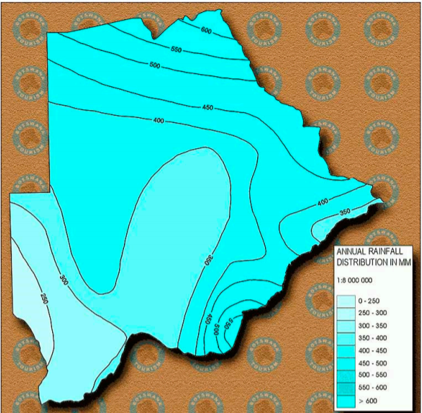 Fig 23. Mean annual rainfall (mm) distribution in Botswana. Source: Kashe 2019. Dryland crop production in Botswana
Coal and petroleum products dominate Botswana's primary energy supply. From the year 2000 records, coal logged 34 percent, petroleum products 32 percent and fuelwood 30 percent of energy supply (EAD 2000). There has also been growth in car ownership across the country, which is known to contribute to greenhouse gas emissions and also depend on petroleum energy. The GHG emissions are therefore increasing, in comparison done by Moseley; 2016, from the year 1994 to 2000, carbon dioxide emissions showed an increase of about 74 percent. The leading greenhouse gas emissions sectors recorded are transport, mining, commercial sector, agriculture and residential sector respectively. Botswana, therefore, needs to work hard on reducing GHG emissions with the rest of the world. With all the events discussed, intense climate changes are expected to continue if GHG emissions are not closely monitored and controlled. Annual temperatures will increase by a minimum of 1.0 by 2050. Hotter temperatures mean increased evaporation. The growing population and rapid urbanization and development put pressure on shared resources, e.g. water. The demand is already increasing, which is a serious problem for a country that is prone to drought.

CHAPTER 6

6.0 RESULTS AND DISCUSSION
This chapter explores results and analysis of the qualitative data compiled from the questionnaire that was shared with random participants. A more detailed research methodology was given in Chapter 1. A semi-structured interview guide was used to understand what motivates participants to migrate; or why they choose to stay in Botswana after completing their studies; and, why they would return to Botswana. The questionnaire was distributed in January 2021. The participants were asked to give their personal details and questions that were formulated are as follows:
-Have you worked abroad?
-Given the chance, would you relocate to work in a foreign country? If yes, please state which. Please give reasons for your answer.
-Would you return home or stay abroad afterwards? What would influence your choice?
-If there were NO differences in job opportunities and quality of life across countries, would you still consider emigrating?
-What are the positive aspects (for you as a professional) of your home country?
-What are the negative aspects (for you as a professional) of your home country?
-What do you admire from the developed countries and regions (US, EU)?
200 participants took part in the questionnaire, the basics of their characteristics is shown on the table below. 93 participants were females, 72 of them had university qualifications and 21 of them had secondary education. The large number of participants were males at 103, 96 had university qualification and only 11 had secondary education. All these participants are literate, therefore Botswana reached their goal of high literacy levels. There is also not a big difference between men and women who have a university degree, so more women are educated and empowered, compared to the post-independence era when a large number of men were educated than women. All the 200 participants have never worked abroad.
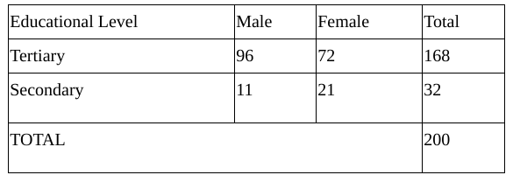
41 percent (82) of the participants are unfortunately unemployed, even though a large number of them have a university qualification. 36 percent (73) have an office job and the remaining 23 percent (45) are self-employed. This supports the report of high unemployment that has been used in this thesis.
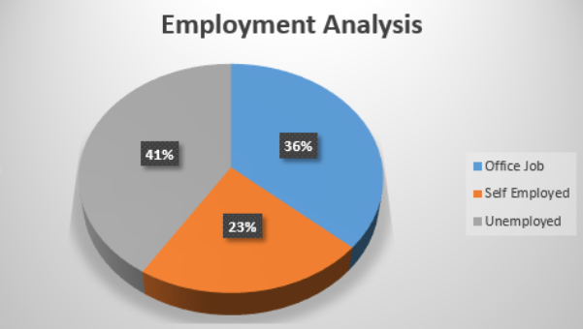

Factors influencing emigration
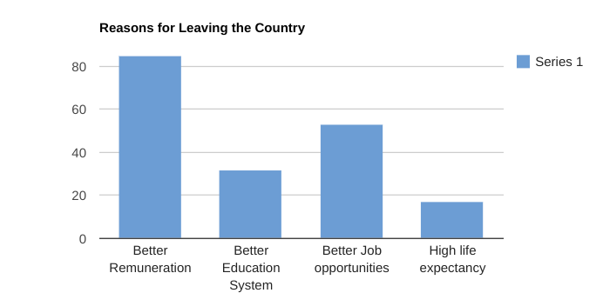
Out of the 200 participants, 93 percent considered emigrating, therefore they are potential emigrants. Only 7 percent of the participants did not want to migrate. There is no significant association between the sex of the participants and considering emigrating The three dominating destination of choice is the United states of America, United Kingdom and China. The United States of America and United Kingdom were expected as they have already been countries of choice according to the data in chapter 3. China is new and a bit of a surprise to find in the top 3 countries. The participants were asked to give reasons for wanting to emigrate, and a number of situations were identified as contributing factors to push citizens of Botswana to foreign countries. Better remuneration was the most dominant reason. 85 participants are willing to relocate to get better pay for the qualification and skills they have. For those who are already employed, this may be influenced by the fact that the government has not increased employee salaries for more than 10 years, yet cost of living has been increasing every year. The second dominating reason is better job opportunities, of which is in line with better remuneration. 53 participants choose to be exposed to better job opportunities which they may not be getting in their home country. The third reason to emigrate is for a better education system. Though most of the participants have university qualifications, they yearn for better education to further improve themself to be more employable. In conclusion of the first objective, Botswana is at risk of brain drain.
For the 7 percent that do not consider emigration, it is good to see people who believe in their country and are willing to stay and work in it. Some of their expressions are as follows:
Participant 1; “As an entrepreneur, Botswana offers a great opportunity to start a business and venture into new opportunities that are still not explored like in other countries. Our country has the best investment climate and a strong currency to support good trade. Our government still offers incentives and tax breaks as per industry that support business growth and entrepreneurship. Ideally it is always a good idea to start in Botswana and grow your business into other neighboring countries.”
Participant 2: “Botswana ranks high on issues of doing business in the world and Africa so I will still prefer to stay in Botswana.”
Participant 3: “I am content in working in Botswana,my family is here and in future I would like to be a farmer. So being home gives me the opportunity to steadily build and get experience in farming. Once I have acquired the knowledge and skill, I can now concentrate only on farming.”

Factors influencing return
Even though most of the participants want to emigrate, a large percentage of them would like to return home. The primary reasons were social, 140 of the participants would come back for their families. 35 would come back to apply the skills they gained abroad in their country, that is confirmation of brain circulation. The third reason motivating the participants to come back is the peace in the country. As already mentioned, most would come back for family reasons, these also include missing home and family values. This shows how much Batswana are family oriented. The prevailing reason was because Botswana is their home and most never intended to remain permanently in the diaspora. The following quotes illustrate this:
Participant 1; “A foreign country remains a foreign country.”
Participant 2: “Home is dear to my heart and also to come and give back my services to my country men and women.”
Participant 3: “Home is home. I will miss my whole family, my extended family.”
The second reason was to gain experience. This means the participants do want to be a part of developing their country if given enough opportunities. Some of their expressions are as follows:
Participant 1: “To share the skills and knowledge I gained by adding value to my beloved country in regard to the world's demand of global village expectations.”
Participant 2 : “My country would use the skills and knowledge acquired abroad for its development”
Participant 3: “I would like to return back to my native country and see where the skills I got outside can be of use.”
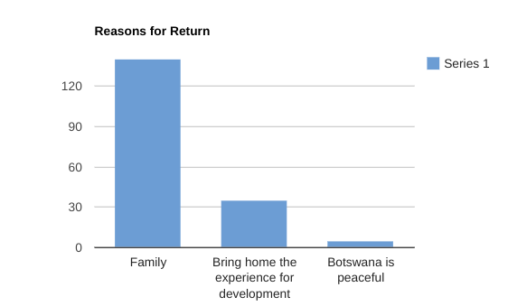
Follow up questions were also included in the questionnaire to evaluate which areas Botswana needs to improve in order to retain its citizens within the country. Even though most of the participants consider emigration, they still admire and believe in their country. When asked the positive aspects of Botswana, some of the responses were:
Participant 1: “The Government is trying to promote Entrepreneurial skills among its citizens to curb employment by coming with programs to finance the Youth to get or start their own business.”
Participant 2: “The fact that education is free. It does help build those students with bright futures but cant afford the feesnesses.”
Participant 3: “Is a middle economy country, which means we are going somewhere as a country.”
The negative aspects the participants noted of the home country and wish for them to be improved include Corruption, low salaries and high unemployment. Corruption was surprising to see as the dominant factor. This is in consideration that various researches indicate that corruption in Botswana is low.

Participant 1: “The market is already monopolized by the big companies and as an emerging firm it is difficult to penetrate, we end up either being forced to close or charge a small fee to get 1 or 2 clients. Even getting a job in the public sector these days is just impossible.”

Participant 2: “Limited opportunities highly influenced by nepotism”

Participant 3: “The educational system where students are not allowed to specialise from an early age. And also an issue of a country focusing much on building women and forgetting men. There should be a balance if at all we want the country to go forward”

Participant 4: “we are just underpaid.”

Participants do admire the developed countries and regions like the US and EU. The dominating factors include availability of job opportunities, high quality of life and accountability of leaders, in that particular order. It is interesting to see the most dominating factor to be availability of jobs in foreign countries, and for this batswana citizens are attracted to emigrate for these job opportunities.

6.1 RECOMMENDATION
Since human resource flight and general migration will continue, the government should consider building strategies that encourage citizens to stay and serve their country or encourage those abroad to return. This may help to turn the potential brain and financial drain to brain gain and circulation. Introduction of fellowship and scholarship programmes should be implemented in the most affected sectors like health. Most health professionals indicated that they would like to advance their studies but experience limitations. Having access to those in the newly established medical university may further reduce the migration of health professionals wishing to further their studies abroad. More research should also be done to get the exact quantities abroad and their reasons. As already mentioned, collecting the compiled data was difficult, and data sources also had certain limitations. The total population's volume and whereabouts is not precisely known, and the few that made estimates vary from one study to another. I believe more numbers are not registered as the government does not seem to keep track of their databases. It will be easier to have concrete, accurate numbers of those who return to assess their impact. Given the massive financial investment by the government in education to develop human capital resources, it is worth adjusting to navigating adverse effects of brain drain.

CHAPTER 7

CONCLUSION
Botswana is faced with all possible human resource flight dynamics. Based on all the information gathered in this thesis, Botswana will face a brain drain in the next ten years. Most of the participants have intentions to leave the country searching for better wages and access to education to advance their skills further and be more competent. The government has shown to try and make adjustments in the health sector that were significantly impacted. However, other factors like climate change, increased urbanization, and food insecurity pushes the citizens to secure themselves before the situation worsens.
As more citizens are anticipated to relocate, the independence of foreign workers will increase as well, which in this case, is brain drain. Brain drain does not solve the problem of a skills shortage as it is unsustainable. Foreign workers are primarily residing on temporary bases until they can accumulate enough to self-sustain back in their countries. As more countries get better, job opportunities grow, and people will choose places that suit them best.
By 2032, more Batswana citizens are anticipated to relocate back home; hence brain circulation will occur. This conclusion is drawn for the survey where 175 participants indicated they are willing to return after some time. Another example can be taken from the case study of health workers when some workers relocated back, even though their reasons were social, not related to human resources. In conclusion, the circle of human resource flight will continue; other countries will lose their labour force and at the same time have it replaced by foreigners until migrants decide to relocate back home for their social reasons. It is likely that by the time they move back home, they will no longer be part of the labour force but rather aged citizens who depend on state welfare.
Even though large numbers want to migrate, it should also be noted that it will always have positive consequences for the migrants. It is possible for their qualifications not to be recognized in countries of destination. Developed countries like Finland have strict policies on qualifications recognition. The migrants may be employed in occupations for which they are overqualified, such as waiters and waitresses, bus drivers, food deliveries, and other low-paying jobs in destination countries. Those who may stand slim chances are health professionals, but preference would still be given to those studied in developed countries. There are also bureaucratic difficulties and requirements to be considered in the process and procedure of migration to be complete. Despite the possible adverse outcomes, positive effects should not be overlooked. The significant impact may be in the large number of remittances sent home by the migrants. This contributes to uplifting the livelihoods of households and the economy.

REFERENCE LIST
-Aaron O’Neil (2021). Botswana: Unemployment rate from 1999 to 2020.statista. https://www.statista.com/statistics/407807/unemployment-rate-in-botswana/
-AFDB. (2009). Botswana country strategy paper 2009-2013 [Online]. http://www.afdb.org
-Beine, M., Docquier, F., and Rapoport, H. (2008). “Brain Drain and Human Capital Formation in Developing Countries: Winners and Losers”. The Economic journal 118: 631-652
-Bolt, Jutta and Ellen Hillbom. (2016). ‘Long-term Trends in Economic Inequality: Lessons from colonial Botswana, 1921-1974’, Economic History Review (pp. 1255-1284).
-Botlhoko,2013. Botswana trains doctors for the world. mmegionline. https://www.mmegi.bw/index.php?sid=1&aid=180&dir=2013/May/Thursday23/
-BOTSWANA CLIMATE CHANGE POLICY. https://info.undp.org/docs/pdc/Documents/BWA/DRAFT%20CLIMATE%20CHANGE%20RESPONSE%20POLICY%20%20version%202%20(2).doc
-Botswana Demographic Survey (2017). Statistics Botswana. https://www.statsbots.org.bw › files › publications
-British council. (2021). Visa requirements to UK. https://www.britishcouncil.co.bw/
-Campbell, E. K. (2001). Preferences for emigration among skilled citizens in Botswana. International Journal of Population Geography, (pp. 151-171).
-Campbell, E and CrUsh, J. (2012). Unfriendly neighboUrs: Contemporary migration from Zimbabwe to botswana. Southern African Research Centre.
-Campbell, A., & Tlou, T. (1984). History of Botswana. Gaborone, Botswana: Macmillan.
-Clemens, M.A., Pettersson, G. (2008). New data on African health professionals abroad. Hum Resour Health. https://doi.org/10.1186/1478-4491-6-1
-Country economy. (2019) . Botswana International emigration stock. https://countryeconomy.com/demography/migration/emigration/botswana
-Children’s Hospital of Philadelphia. (2020). Building a Healthy Future – Medical Education in Botswana. Global health update. https://www.chop.edu/news/building-healthy-future-medical-education-botswana
-Country economy. (2019). migrants from Botswana according to the destination country. https://countryeconomy.com/demography/migration/emigration/botswana
-Crush, J., McDonald, D., Williams, V., Mattes, R., Richmond, W., Rogerson, C. M., & Rogerson, J. M. (2000). Losing our Minds: Migration and the ‘Brain Drain’from South Africa. SAMP Migration Policy Series.
-David Sebudubudu. (2006).Key Challenges for Human Security in Botswana: Mapping a Policy Research and Capacity-Building Agenda. Institute for security studies.
-D Baraedi. (2016). BOTSWANA’S ENVIRONMENTAL PREDICAMENTS. Botswana Society for Human Development (BSHD). http://www.bshdngo.org/?p=454
-dictionary.com. (2021). Drain gain. https://www.dictionary.com/browse/brain-gain#:~:text=an%20increase%20in%20the%20number,where%20greater%20opportunities%20are%20offered.
-Forget J. (2017) Poverty in Botswana. https://borgenproject.org/poverty-in-botswana/
- Gaillard J and Gaillard A M. (1997). Introduction: the international mobility of brains: Exodus or circulation? Science, technology and society (pp. 195-228)
-Granberg P. (1998). A simple formula for forecasting the Botswana urban population total.nBIDPA working paper No.15.
-Gwebu, TD. (2003). ‘Internal Migration in Botswana’, paper presented at the 2001 Population and Housing Census Dissemination Seminar’, held in Gaborone, 8-11 September 2003.
-International Labour Organization (2010). International labour migration A rights-based approach. International Labour Office
-info Botswana. (2021). Botswana's geography. https://www.info-botswana.com/info/botswanas-geography .
-IPCC. (2018). Summary for Policymakers. In IPCC, M. Allen, M. Babiker, Y. Chen, H. Coninck, S. Connors, et al. (Eds.), Global Warming of 1.5°C: An IPCC Special Report on the impacts of global warming of 1.5°C above pre-industrial levels and related global greenhouse gas emission pathways, in the context of strengthening the global response to the threat of climate change, sustainable development, and efforts to eradicate poverty. Geneva: World Meteorological Organization.
-Jayne TS, Yeboah FK, Henry C. (2017). The future of work in African agriculture: Trends and drivers of change. International Labour Office. https://www.canr.msu.edu/fsg/publications/research-papers/wcms_624872.pdf
-Joseph W. (2011). The Effects of Brain Drain on Haiti - UMD. https://drum.lib.umd.edu/bitstream/handle/1903/12464/Joseph.pdf;sequence=1
-Kashe, Keotshephile & Kolawole, Oluwatoyin & Moroke, Thebeetsile & Mogobe, Oarabile. (2019). Dryland crop production in Botswana: Constraints and opportunities for smallholder arable farmers.
-Kate Lefko-Everett. (2004). Botswana's Changing Migration Patterns. Migration Policy Institute. https://www.migrationpolicy.org/article/botswanas-changing-migration-patterns
-Kerven, C. (1979). “Introduction”, in “National Migration Study”, Paper Presented at a Workshop on Migration Research, Gaborone.
- Koboto O, Lesole D, Sisay L, Chambwera M, Gopolang B, Gaokgethelwe N, Molefhe N. (2017). BOTSWANA CLIMATE CHANGE RESPONSE POLICY. UNDP. info.undp.org/docs/pdc/Documents/BWA/DRAFT%20CLIMATE%20CHANGE%20RESPONSE%20POLICY%20%20version%202%20(2).doc
-KPMG. (2014). “Botswana Tax and Budget Summary 2014/2015”
-Kuzniak, Stephen, and John Grable. (2017). “Does Financial Risk Tolerance Change over Time? A Test of the Role Macroeconomic, Biopsychosocial and Environmental, and Social Support Factors Play in Shaping Changes in Risk Attitudes.” Financial Services Review, Academy of Financial Services, (p.p315).
-Lipper L, Benton TG. (2020). Mega-trends in the Southern African Region. SADC Futures: Developing Foresight Capacity for Climate Resilient Agricultural Development Knowledge Series. CCAFS Report. Wageningen, the Netherlands: CGIAR Research Program on Climate Change, Agriculture and Food Security (CCAFS). https://cgspace.cgiar.org/handle/10568/109136
-Macrotrends.net. (2021). Botswana poverty rate 1985-2015. https://www.macrotrends.net/countries/BWA/botswana/poverty-rate
-McGill, B. M., Altchenko, Y., Hamilton, S. K., Kenabatho, P. K., Sylvester, S. R., & Villholth, K. G. (2019). Complex interactions between climate change, sanitation, and groundwater quality: a case study from Ramotswa, Botswana. Hydrogeology Journal, (pp 997-1015).
-McManus. (2021). Immigrate to Australia From Botswana. https://australiamadesimple.com/immigrate-to-australia-from-botswana/
-Mercy T. Magombeyi & Nicholas M. Odhiambo. (2017). Poverty dynamics in Botswana: Policies, trends and challenges, Cogent Social Sciences. DOI: 10.1080/23311886.2017.1329246
-Ministry of Agriculture (MoA) . (2014). Agricultural policy. Ministry of Agriculture, Gaborone, Botswana.
-Mookodi L. (2019). Consumption Inequality in Botswana: The Decomposition of the Gini Coefficient of Consumer Expenditures, Botswana Institute for Development Policy Analysis
-Morapedi, W. (1999). Migrant Labour and the Peasantries of Bechuanaland Protectorate, 1930-1966. Journal of Southern African Studies.
-Motlhatlhedi, Keneilwe & Nkomazana, Oathokwa. (2018). Home is home—Botswana’s return migrant health workers. PLOS ONE. 13. e0206969. 10.1371/journal.pone.0206969.
-MuthuVk. (2020). Dangers of Reverse Osmosis (RO) water. The times of India. https://timesofindia.indiatimes.com/readersblog/ezhil/dangers-of-reverse-osmosis-ro-water-24279/
-Navaneetham, Kannan & Dwivedi, VK. (2014). Patterns and Differentials of Migration in Botswana. Botswana notes and records. (pp. 72-83).
-Nhamo L, Matchaya G, Mabhaudhi T, Nhlengethwa S, Nhemachena C, Mpandeli S. (2019). Cereal Production Trends under Climate Change: Impacts and Adaptation Strategies in Southern Africa.
-Nkomazana, Oathokwa & Peersman, Wim & Willcox, Merlin & Mash, Robert & Phaladze, Nthabiseng. (2014). Human resources for health in Botswana: The results of in-country database and reports analysis. African Journal of Primary Health Care & Family Medicine.
-Ontebetse K. (2019). BOTSWANA’S POTABLE WATER UNHEALTHY – UN REPORT. Sunday Standard Botswana https://www.sundaystandard.info/botswanas-potable-water-unhealthy-un-report/
-Oucho, J. O., & Crush, J. (2001). Contra free movement: South Africa and the SADC migration protocols. Africa today, (pp 139-158).
-Parsons, N. (2021). Botswana. Encyclopedia Britannica. https://www.britannica.com/place/Botswana
- Parsons, N. (2017). Botswana. Encyclopedia Britannica. https://www.britannica.com/place/Botswana
-Rakodi, C, Keiner, M and Koll-Schretzenmayer, M and Schmid. (2005). ‘The Urban Challenge in Africa’, Managing Urban futures-Sustainability and Urban Growth in developing Countries. Hampsire: Ashgate Publishing.
-Schapera, I. (1947). Migrant Labour and Tribal Life: A Study of Conditions in the Bechuanaland Protectorate. Heinemann.
- Statistics Botswana (2013). Population and Housing Census, 2019. Gaborone: Statistics Botswana.
-Statistics Botswana (2015). Population and Housing Census 2015. Statistics Botswana.
-Statistics Botswana (2019). Population and Housing Census, 2019. Gaborone: Statistics Botswana.
-Thando D G. (2011). Policy implications of urbanisation patterns and processes in Botswana. Botswana Notes and Records. (pp 84-98).
-The world bank. (2015). Incomes Growth in Rural Botswana Lifts Thousands out of Poverty and Decreases Inequality. https://www.worldbank.org/en/news/press-release/2015/12/08/incomes-growth-in-rural-botswana-lifts-thousands-out-of-poverty-and-decreases-inequality
-The World bank (2020). The world bank in Botswana. https://www.worldbank.org/en/country/botswana/overview
-Tumkaya, N. (1987). Botswana's population trends: past and future. Botswana Notes and Records, (pp 113-128).
-Trading economics.(2020). Botswana unemployment rate. https://tradingeconomics.com/botswana/unemployment-rate
-UNICEF Botswana. (2018). BOTSWANA BUDGET BRIEF 2018. https://www.unicef.org/esaro/UNICEF-Botswana-2018-Education-Budget-Brief.pdf
-Unicef. (2013) Botswana Migration profiles. https://esa.un.org/miggmgprofiles/indicators/files/Botswana.pdf
-United Nations. (2002). International Migration Report 2002. United Nations publication. https://www.un.org/en/development/desa/population/publications/pdf/migration/migration-wallchart2002.pdf
-United Nations High Commissioner for Refugees. (2016). Universal Periodic Review: 3rd Cycle, 29th Session. Office of the High Commissioner for Human Rights’ Compilation Report.
-UKEssays. (2018). The State Of Food Security In Botswana. https://www.ukessays.com/essays/economics/the-state-of-food-security-in-botswana-economics-essay.php?vref=1
- Watson-Grant, S., Balisi, R., Kaliel, D., Jamu, S., & Thomas, J. (2020). A monitoring and evaluation gap for WHO's community health worker guidelines, Botswana. Bulletin of the World Health Organization, (pp 370–372). https://doi.org/10.2471/BLT.19.243238
-WIDER, U.N.U. (2016) Future climate scenarios for South Africa: The importance of mitigating emissions. WIDER Research Brief 2016/6. Helsinki: UNU-WIDER.
-William G. Moseley. (2016). Agriculture on the Brink: Climate Change, Labor and Smallholder Farming in Botswana. Geography Department, Macalester College.
-Williams, V. (2002). An overview of migration in the SADC region. In Seminar on Regional Integration, Migration and Poverty. Pretoria (Vol. 25).
-World data info. (2019). Asylum applications and refugees from Botswana. https://www.worlddata.info/africa/botswana/asylum.php
-World Fact Book (2014) Population Figures: Botswana. Available on: https://www.cia.gov/library/publications/the-world-factbook/fields/2219.html
-World Population reviews. (2020). Botswana population. https://worldpopulationreview.com/countries/botswana-population
-Vanderpost, C.(1995). Population change and environmental problems in the Mid-Boteti region of Botswana. GeoJournal 35, (pp 521–529) . https://doi.org/10.1007/BF00824368
-Xabier Celaya. (2015). Drought in Botswana, a learning opportunity to achieve water security – UN expert. UN Human Rights. https://www.ohchr.org/SP/NewsEvents/Pages/DisplayNews.aspx?NewsID=16765&LangID=E
-Zanamwe, L., & Devillard, A. (2009). ZIMSTAT_Migration in Zimbabwe: Country Profile_2009.

