# Appendix

Table 1 Distance matrix of the journey

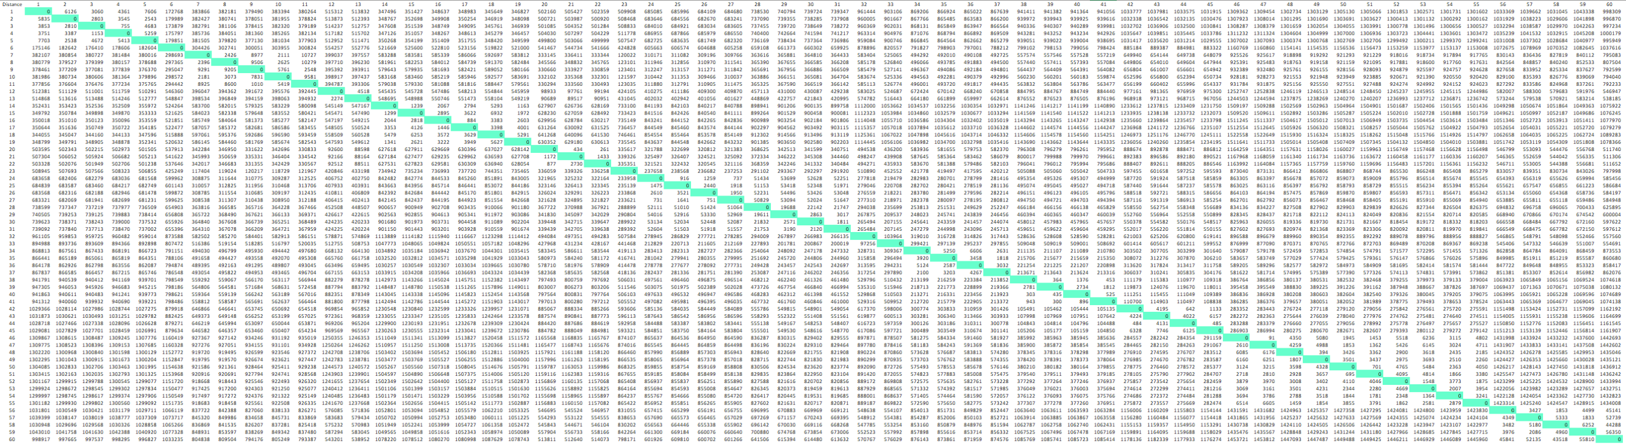

Table 2 is the data in Table 1 are obtained according to the latitude and longitude given by Google Map.

Table 2

|  |  |
| --- | --- |
| **Destinations in Prague (Czech Republic)** | |
| **Number of destinations** | **List of destinations** |
| **1** | 50°04'47.5"N 14°25'47.0"E  **50.079861, 14.429722** |
| **2** | 50°05'27.9"N 14°24'05.8"E50.091083, 14.401611 |
| **3** | 50°05'10.5"N 14°24'49.0"E50.086250, 14.413611 |
| **4** | 50°05'15.3"N 14°25'14.7"E50.087583, 14.420750 |
| **5** | 50°05'01.0"N 14°23'42.1"E50.083611, 14.395028 |
| **6** | 48°48'44.5"N 14°18'56.6"E48.812361, 14.315722 |
| **Destinations in Munich (German)** | |
| **7** | 48°08'14.6"N 11°34'31.5"E48.137389, 11.575417 |
| **8** | 48°08'30.5"N 11°34'46.1"E48.141806, 11.579472 |
| **9** | 48°10'31.5"N 11°33'06.4"E48.175417, 11.551778 |
| **10** | 48°08'18.0"N 11°34'22.5"E48.138333, 11.572917 |
| **11** | 48°10'38.4"N 11°33'26.6"E48.177333, 11.557389 |
| **Destinations in Frankfurt (German)** | |
| **12** | 50°06'57.8"N 8°40'18.8"E50.116056, 8.671889 |
| **13** | 50°06'11.2"N 8°40'28.4"E50.103111, 8.674556 |
| **Destinations in Berlin (German)** | |
| **14** | 52°30'58.6"N 13°22'38.9"E52.516278, 13.377472 |
| **15** | 52°31'07.1"N 13°22'34.3"E52.518639, 13.376194 |
| **16** | 52°31'08.1"N 13°24'02.3"E52.518917, 13.400639 |
| **17** | 52°31'15.0"N 13°24'33.8"E52.520833, 13.409389 |
| **18** | 52°30'18.1"N 13°26'22.9"E52.505028, 13.439694 |
| **19** | 52°30'34.7"N 13°22'33.4"E52.509639, 13.375944 |
| **Destinations in Heidelberg (German)** | |
| **20** | 49°24'40.2"N 8°42'43.3"E49.411167, 8.712028 |
| **21** | 49°24'48.3"N 8°42'34.6"E49.413417, 8.709611 |
| **22** | 49°24'40.8"N 8°42'24.1"E49.411333, 8.706694 |
| **Destinations in Schwangau (German)** | |
| **23** | 47°33'27.4"N 10°44'59.3"E47.557611, 10.749806 |
| **Destinations in Zurich (Switzerland)** | |
| **24** | 47°22'12.9"N 8°32'53.4"E47.370250, 8.548167 |
| **25** | 47°22'11.1"N 8°32'28.9"E47.369750, 8.541361 |
| **26** | 47°22'44.6"N 8°32'26.0"E47.379056, 8.540556 |
| **27** | 47°22'25.3"N 8°32'36.9"E47.373694, 8.543583 |
| **Destinations in Luzern (Switzerland)** | |
| **28** | 47°03'21.6"N 8°29'06.6"E47.056000, 8.485167 |
| **29** | 47°03'10.4"N 8°20'11.1"E47.052889, 8.336417 |
| **30** | 47°03'06.0"N 8°18'27.1"E47.051667, 8.307528 |
| **31** | 47°03'30.3"N 8°18'39.3"E47.058417, 8.310917 |
| **Destinations in Geneva (Switzerland)** | |
| **32** | 46°12'26.6"N 6°09'21.3"E46.207389, 6.155917 |
| **33** | 46°24'51.2"N 6°55'39.0"E46.414222, 6.927500 |
| **Destinations in Milan (Italy)** | |
| **34** | 45°27'50.8"N 9°11'30.9"E45.464111, 9.191917 |
| **35** | 45°28'19.1"N 9°11'16.1"E45.471972, 9.187806 |
| **36** | 45°28'32.7"N 9°10'20.8"E45.475750, 9.172444 |
| **37** | 45°28'15.4"N 9°12'05.0"E45.470944, 9.201389 |
| **Destinations in Bologna (Italy)** | |
| **38** | 44°29'37.6"N 11°20'35.1"E44.493778, 11.343083 |
| **39** | 44°29'39.2"N 11°20'48.2"E44.494222, 11.346722 |
| **40** | 44°29'34.7"N 11°20'35.2"E44.492972, 11.343111 |
| **41** | 44°29'39.5"N 11°20'33.6"E44.494306, 11.342667 |
| **Destinations in Florence (Italy)** | |
| **42** | 43°46'23.3"N 11°15'21.5"E43.773139, 11.255972 |
| **43** | 43°45'46.6"N 11°15'54.2"E43.762944, 11.265056 |
| **44** | 43°46'12.0"N 11°15'21.3"E43.770000, 11.255917 |
| **45** | 43°46'04.1"N 11°15'19.0"E43.767806, 11.255278 |
| **Destinations in Rome (Italy)** | |
| **46** | 41°53'24.8"N 12°29'32.0"E41.890222, 12.492222 |
| **47** | 41°53'23.2"N 12°29'26.2"E41.889778, 12.490611 |
| **48** | 41°54'08.3"N 12°27'29.7"E41.902306, 12.458250 |
| **49** | 41°54'08.0"N 12°27'14.1"E41.902222, 12.453917 |
| **50** | 41°53'33.0"N 12°29'07.2"E41.892500, 12.485333 |
| **51** | 41°53'17.2"N 12°28'53.2"E41.888111, 12.481444 |
| **52** | 41°54'20.5"N 12°28'56.4"E41.905694, 12.482333 |
| **53** | 41°54'03.1"N 12°29'00.1"E41.900861, 12.483361 |
| **54** | 41°53'54.5"N 12°28'37.8"E41.898472, 12.477167 |
| **55** | 41°54'09.5"N 12°27'58.9"E  **41.902639, 12.466361** |
| **Destinations in Paris (France)** | |
| **56** | 48°51'39.7"N 2°20'05.8"E48.861028, 2.334944 |
| **57** | 48°51'31.3"N 2°17'37.4"E48.858694, 2.293722 |
| **58** | 48°51'10.8"N 2°20'59.6"E48.853000, 2.349889 |
| **59** | 48°52'25.4"N 2°17'42.9"E48.873722, 2.295250 |
| **60** | 48°52'15.8"N 2°46'52.3"E48.871056, 2.781194 |