**Czech University of Life Sciences Prague**

**Faculty of Economics and Management**

**Department of Economics**



**Extended Abstract of Diploma Thesis**

**Crude oil Prices Analysis in Kuwait Economy**

**BC. Manal Banana**

**© 2021 CZU Prague**

**Crude oil Prices Analysis in Kuwait Economy**

**Abstract**

This thesis is focused on analyzing how Crude oil has affected Kuwait’s economy. Although we are rapidly moving towards sustainable energy alternatives in the form of solar and wind energy, etc however, most countries still depend on oil as a main source of energy which is evident by the overwhelming presence of internal combustion engines in modern vehicles. It is hard to imagine the countries who their economy mainly depends on oil for their economic growth as it is going to be very challenging. Kuwait is one of these countries that heavily rely on oil as an energy source as not only it is a source of energy for the economy that lets it produce other goods and service, it also generates massive amount of revenue and gives people more opportunities, however, oil also causes economic uncertainty due to many issues, for example, price fluctuation.

The majority of the developing countries depends on crude oil more than developed countries as oil is the major source of energy for their economy’s growth. Though more developed countries have more oil reserve stored in case of any future economic crisis.

This thesis is divided in two parts, theoretical and practical. Theoretical part deals with the history of crude oil, oil as an energy source, production and consumption, world oil reserves, global oil market, OPEC and OPEC policies, demand and supply of the commodity of crude oil, determinants of oil price and, overview of oil export around the world.

The practical part focuses on the overview of Kuwait’s economic development, energy sector and oil imports, the development of linear regression model illustrating the importance of oil prices. Foreign exchange rate on the gross domestic products (GDP) of Kuwait. One of the primary factors is rapid development of alternative sustainable source of energy that can significantly impact the forecasted values.

**Keywords**: oil Market, Regression analysis, economy of Kuwait, energy resources, export, GDP.

**Analýza cen ropy v kuvajtské ekonomice**

**abstrakt**

Tato práce je zaměřena na analýzu toho, jak ropa ovlivnila kuvajtskou ekonomiku. Ačkoli rychle přecházíme k udržitelným alternativám energie ve formě solární a větrné energie atd., Většina zemí je stále závislá na ropě jako hlavním zdroji energie, což je zřejmé z drtivé přítomnosti spalovacích motorů v moderních vozidlech. Je těžké si představit země, jejichž ekonomika je pro svůj ekonomický růst závislá hlavně na ropě, protože to bude velmi náročné. Kuvajt je jednou z těchto zemí, které se do značné míry spoléhají na ropu jako na zdroj energie, protože je nejen zdrojem energie pro ekonomiku, která jí umožňuje vyrábět další zboží a služby, ale také generuje obrovské výnosy a dává lidem více příležitostí , ropa také způsobuje ekonomickou nejistotu kvůli mnoha problémům, například kolísání cen.

Většina rozvojových zemí závisí více na ropě než vyspělé země, protože ropa je hlavním zdrojem energie pro růst jejich ekonomiky. Myšlenky, že vyspělejší země mají více ropných rezerv uložených pro případ jakékoli budoucí hospodářské krize.

Tato práce je rozdělena na dvě části, teoretickou a praktickou. Teoretická část pojednává o historii ropy, ropě jako zdroji energie, výrobě a spotřebě, světových zásobách ropy, globálním trhu s ropou, OPEC a politikách OPEC, poptávce a nabídce komodity ropy, determinantech ceny ropy a přehledu exportu ropy do celého světa.

Praktická část se zaměřuje na přehled ekonomického rozvoje Kuvajtu, energetického sektoru a dovozu ropy, vývoj modelu lineární regrese ilustrující důležitost cen ropy. Směnný kurz hrubého domácího produktu (HDP) Kuvajtu. Jedním z hlavních faktorů je rychlý rozvoj udržitelného alternativního zdroje energie, který může významně ovlivnit předpokládané hodnoty.

**Klíčová slova:** ropný trh, regresní analýza, ekonomika Kuvajtu, energetické zdroje, ekonomický růst, export, hrubý domácí produkt.

**Introduction**

Oil has been and still is one of the most essential commodities over centuries. The second statement depended on innovation in the energy sector which is increasing due to widespread concern over climate and environmental issues. There have been developments in the oil industry recently, for example, The United states of America has increased their abilities to produce oil at becoming self-sustainable in the process and emerging as major a player in the oil energy industry. OPEC policies had to adapt with all these developments as well as the State of Kuwait.

**Objectives and Methodology**

The main aim of the thesis is to research the new dynamics of oil costs and the effects on Kuwait’s financial Development.

The goal is to analysis how oil can play the role of Kuwait’s economic development.

This work is divided in two parts, theoretical and practical. The theoretical part uses an inductive approach where it sees an overview about the energy sector, specifically, the oil sector and a descriptive approach. The second part that is the practical, descriptive and deductive approach were used as well as regression analysis method to analysis the changing of oil prices and exchange rate.

**Literature Review**

**Overview of Oil Export Around the World**

In this present day, our society and industry do rely on the usage of crude oil. The Middle Eastern countries are known for being the important countries for exporting crude oil. Middle Eastern countries considered to have the highest dollar value worth of crude oil exports in the year 2017 with 42.4 % of globally exported crude oil. At the continent level, almost half of crude oil exports comes from the Asian countries which accounted 49.4 %. Europe supplies about 18 % of the overall total, followed by Africa at the rate of 13.4 % Saudi Arabia is known for being the largest country to export crude oil, holding about around 18 % of the world’s proven petroleum reserves.

**Practical Part**

**Overview of Kuwait’s Economic Development**

Kuwait is a model example of an oil-based economy. The oil sector contributes over one-third of GDP and over 90 per cent of exports. Economic diversification for Kuwait means reducing the heavy dependency on the oil sector. It also implicitly includes reducing the direct role of the public sector while increasing private sector activities and hence the private sector’s size and role in the economy.

**Dynamics of Kuwait’s GDP (Nominal)**

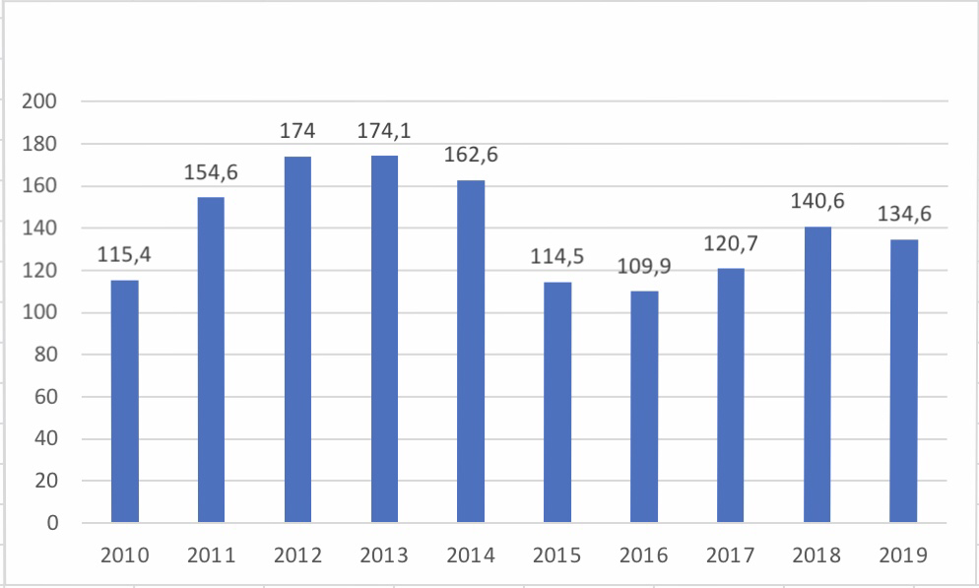

The Figure 1 above, Kuwait total national output has shown negative elements recently, the country's GDP.

.

**References:**

1. A Political Economy of the Middle East. Alan Richards (2007). ISBN-13: 978-0813343488
2. ČESKÁ ZEMĚDĚLSKÁ UNIVERZITA V PRAZE. INSTITUT TROPŮ A SUBTROPŮ, -- JENÍČEK, V. -- KREPL, V. International trade and developing countries. Prague: Czech University of Agriculture, 2006. ISBN 80-213-1464-8.
3. Hilyard, J. The oil & gas Industry; PennWell: Tulsa, Okla., 2012, ISBN-13: 9781593702540