**UNIVERZITA PALACKÉHO V OLOMOUCI**

**PEDAGOGICKÁ FAKULTA**

**Ústav cizích jazyků**

**Bakalářská práce**

Radka Burďáková

Obor: Anglický jazyk se zaměřením na vzdělávání a Výchova ke zdraví se zaměřením na vzdělávání

**Learning English on the Trail**

Application of Experiential Learning in a Digital Environment

Olomouc 2021 vedoucí práce: doc. PhDr. Václav Řeřicha, CSc.

Prohlášení:

Prohlašuji, že jsem bakalářskou práci vypracovala samostatně a použila jen prameny uvedené v seznamu literatury.

V Olomouci …………………… ………………………………………

Radka Burďáková

Acknowledgements:

I would like to thank Doc. PhDr. Václav Řeřicha, CSc. for his support, motivation, and valuable comments on the content and style of my final project.

I would also like to thank all the volunteer students who participated in my small English course and helped me to run my research.

**Contents**

List of figures 6

List of appendices 7

Abstract 8

Introduction 9

THEORETICAL PART 10

1 Definition of Experiential Learning 10

1.1 Communicative Approach 11

2 History and Development of Experiential Learning 12

2.1 Learning Cycles 12

2.2 Kolb’s Learning Cycle 13

2.3 Differences from Traditional Learning 14

2.4 Advantages and Disadvantages of Experiential Learning 14

3 Basic Principles of Experiential Learning 16

3.1 Course Planning 18

3.2 Teacher’s Position 19

3.3 Target Group and Cooperation 19

3.4 Motivation 20

3.5 Comfort Zone 21

3.6 Environment 22

3.7 Topic and Learning Activities 22

3.8 Reflection 23

3.9 Other Aspects 23

4 Transformation of Experiential Learning in a Digital Environment 25

4.1 Using Technology for Experiential Learning 25

4.2 The Characteristics of a Highly Effective Learning Environment 25

4.3 The Advantages of Outdoor Experiential Education 26

PRACTICAL PART 27

5 Introduction to the Research 27

5.1 Course Organization 27

5.2 Approach to the Digital Environment and Guide Approach 31

5.3 Participants 33

5.4 Topic – the Pacific Crest Trail 33

5.5 Online Platforms 35

5.6 Evaluation 36

5.7 Results of the “Knowledge Evaluation Form” 37

5.8 Results of the “PCT Course Evaluation Form” 43

Conclusion 49

Sources 50

Online sources 51

Résumé 65

Anotace 66

# **List of figures**

Figure 1 Kolb’s Learning Cycle

Figure 2 Did you like the topic of the PCT or would you choose another topic? Which one?

Figure 3 Would you like to go to the PCT?

Figure 4 Do you prefer to learn English at school or by playing games in English?

Figure 5 Do you prefer to play games online (on a computer/laptop/tablet/mobile phone) or outside?

Figure 6 Do you think you have learnt more vocabulary in this course than at school?

Figure 7 What activity did you like the most?

Figure 8 What was the most difficult exercise for you?

Figure 9 I had problems with…

Figure 10 Did you read mostly the English or Czech instructions?

# **List of appendices**

Appendix 1: I. day of preparation – basic information

Appendix 2: II. day of preparation – flight ticket and visa

Appendix 3: III. day of preparation – equipment and food

Appendix 4: IV. day of preparation – weather and clothes

# **Abstract**

This thesis focuses on experiential learning and its approach, methods, and the principles used. The research was organized through a small English online course in which, in total, six lower secondary school students participated. The research provides answers to questions concerning whether experiential learning is applicable in digital surroundings and if it can be as effective as in outdoor surroundings.

# **Introduction**

In my bachelor’s project I am going to introduce the topic of experiential learning. When I came to the point of choosing the topic for my project, I was thinking about what approach, as a future teacher, I would like to employ, what would be the best way to introduce the curriculum to my future students so they would not be bored, remembered as much as possible from the lesson, and yet would also be able to use their knowledge in real situations. My personal experience was that the best way I have ever learnt something was through experience.

While studying at university I have found out that these learning methods are generally called experiential learning and I became more interested in finding out more about this approach to learning, e.g. its history and the reasons for its development, the teacher’s approach, examples of applicable activities, and the principles which must be followed for effective learning via experience.

I have been fascinated by the Pacific Crest Trail for a few years now. The first time I heard about it was when the book Wild was published in 2012. More than by the story of the main character itself, I was captured by the beauty of the American landscape, the wilderness and freedom which are hidden in one trail. From that time, I started to gather information about this trail, I read Wild, watched a film and videos about it, and listened to the stories of people who have already experienced hiking there. More often I meet people who share my enthusiasm and dream to hike the PCT at least once in their life.

I could imagine this could be an attractive and sufficiently motivating topic for teenage learners of English. In my opinion the USA is still a very popular country in the eyes of young Czech students and a lot of them admire its greatness and lifestyle.

Because of the current situation caused by Covid-19, when the whole society is forced to follow certain restrictions, the question arose of whether experiential learning would be applicable to the digital environment and if it would be as effective and enjoyable as experiential learning organized outside. In the practical part of this thesis young learners of English are provided with a few activities set in online surroundings and in the end, they are going to evaluate the activity, surroundings, and their knowledge. According to the final questionnaire the hypothesis stated above will be either accepted or rejected.

# **THEORETICAL PART**

# **1 Definition of Experiential Learning**

The aim of this chapter is to provide definitions of experiential learning. Our research has shown that there are many perspectives on how to define the terms experience, learning, and experiential learning. Plenty of theories and definitions of experiential learning have been uncovered; however, they share the same aspects and basic principles.

According to the Oxford Learner’s Dictionary, ‘experience’ is “the knowledge and skill that you have gained through doing something for a period of time” or “the things that have happened to you that influence the way you think and behave” and the third definition is “an event or activity that affects you in some way”. The word ‘learning’ is specified as “knowledge that you get from reading and studying” or “something that you learn, especially from your experience of working on something” (Oxford Learner’s Dictionary). The last definition leads us to the roots of experiential learning, in which experience plays the role of a foundation stone. Kolb (1984, p. 5) states that “It is the work of John Dewey, without doubt the most influential educational theorist of the twentieth century, that best articulates the guiding principles for programs of experiential learning.”

The authors who have been studying experiential learning define it in many different views. Beard and Wilson (2006, p. 2) write that “Experiential learning is the sense-making process of active engagement between the inner world of the person and the outer world of the environment.” They also state that learning from experience is one of the most fundamental and natural means of learning available to everyone (Beard and Wilson, 2006, p. 15). However, this may not be generally valid because each person can experience the same event differently, focus on a different part, or even remember different moments whilst forgetting what another can see as the crucial point. The perception of experience can depend on biological predispositions or on previous experiences. The other thing is that the word “experience”, similarly to “experiential learning”, cannot be so straightforward because not every experience can be transformed into knowledge. Therefore, the basic principles of experiential learning arose. Beard and Wilson also emphasize that experiential learning undoubtedly involves the ‘whole person’, through thought, feelings, and physical activity (2006, p. 2).

Kolb characterizes experiential learning as the process whereby knowledge is created through the transformation of experience (1984, p. 38). According to Dewey, who, as stated above, is considered to be the most influential educational theorist of the twentieth century, a fundamental idea of experiential learning is to maintain close relations between the process of actual experience and education (Kolb, 1984, p. 5).

Even though the definitions differ slightly, the authors of these theories share the opinion that experiential learning is not a matter of memorizing theoretical knowledge and just reading texts, but an enjoyable activity and a set process which leads to gaining knowledge.

## **Communicative Approach**

This subchapter will provide the main reasons why experiential learning originated. Our research has shown that communication is an important tool for experiential learning. It relates to the basic natural human need to understand and express ideas, opinions, feelings, etc. In the earlier traditional concept of education teachers were mostly focused on grammatical correctness. In other words, ‘form’ rather than ‘meaning’ used to dominate teaching (Brumfit and Johnson, 1983, p. 2). However, the general purpose of language learning is to understand the language and to be able to use it for communicative purposes. This is usually the main motivation for language learners. When students realize their ability to use a foreign language in the real world (to understand an original foreign film, to be able to order food on holiday abroad, to make friends outside their home country, to be able to sing a song in English) they became more motivated.

Communication has been described as an exchange between people, of knowledge, of information, of ideas, of opinions, of feelings (Revell, 1979, p. 1). According to Larsen-Freeman (1986, p. 123), we use language to accomplish some function, such as arguing, persuading, or promising.

Communication plays a very important role in experiential learning and it also emphasizes one of its basic principles. According to Littlewood (1994, p. 20), many communicative activities should be implemented in the classroom. These activities provide multi-task practice and natural learning and improve motivation. In the Communicative Approach the learner’s role is very significant. The teacher should only occupy the role of mentor or guide and the learners should take the initiative in fulfilling the tasks given to them.

# **2 History and Development of Experiential Learning**

The origins of experiential learning were inspired by “John Dewey’s progressive pedagogy, Kurt Lewin’s social psychology, Jean Piaget’s work on developmental cognitive psychology, George Kelly’s cognitive theory of personality, and […] humanistic psychology, notably the work of Abraham Maslow and Carl Rogers” (Kohonen et al., 2001, p. 24). According to Kohonen et al., Kelly focused on personal experience. They state that everyone views reality differently, from their unique point of view (2001, p. 25). “Reality is thus a subjective interpretation of the events, based on the individual’s past experiences and history of life” (Kohonen et al., 2001, p. 25). In fact, “simple everyday experience is not sufficient for learning” (Kohonen et al., 2001, p. 29).

Beard and Wilson (2006, p. 30) write that “Dewey drew attention to the limitations of formal education and the fact that much of what we were supposed to learn in school was no longer accessible.”

## **2.1 Learning Cycles**

The significant principles of experiential learning were gathered by researchers and they formed the learning cycles (the models depicting structures of individual steps characteristic for the experiential learning process). The most famous ones are Dewey’s Model of Experiential Learning, Piaget’s Model of Learning and Cognitive Development, Kolb’s Learning Cycle, and Bannon’s Model of Experiential Learning. In the Czech Republic experiential learning was introduced in the form of scouting and camping associations. However, it is not possible to introduce all of them in depth and thus I chose the one I believe is the most common.

When studying the sources, I learnt that the idea of combining these cycles also exists. Beard and Wilson (2006, p. 15) offer a complex diagram representing the process of learning – called the “learning combination lock” (see Fig. 8), which is theoretically grounded in the concept of cognitive processing. Beard and Wilson (2006, p. 15) write that “For the first time ever to our knowledge, all the main ingredients of the learning equation have been brought together in the learning combination lock.”

## **2.2 Kolb’s Learning Cycle**

Of the models mentioned above, I found Kolb’s learning cycle the most useful and my favourite. David A. Kolb described four stages as parts of the experiential learning process and basic principles which should be kept to if the experience is to be transferred into knowledge and experiential learning is to achieve its greatest effectiveness. According to Kolb’s learning cycle theory it is crucial for the learner to go through all four stages (concrete experience, observation and reflection, forming abstract concepts, testing in new situations). The theory of Kolb’s learning cycle was supported by Martin, Franc, and Zounková (2004, p. 12): “just having an experience does not necessarily mean learning will occur” and “it is the reflection process that turns the experience into experiential education”. Even though it is possible to enter the cycle at any stage and follow the logical order from that stage on, the cycle must be gone through completely and carefully. The final knowledge is different, based on the past experience of the participants and their way of receiving and accepting experience. Once the participants have experienced the situation (task), they should test the new knowledge they have gained in similar but new circumstances.

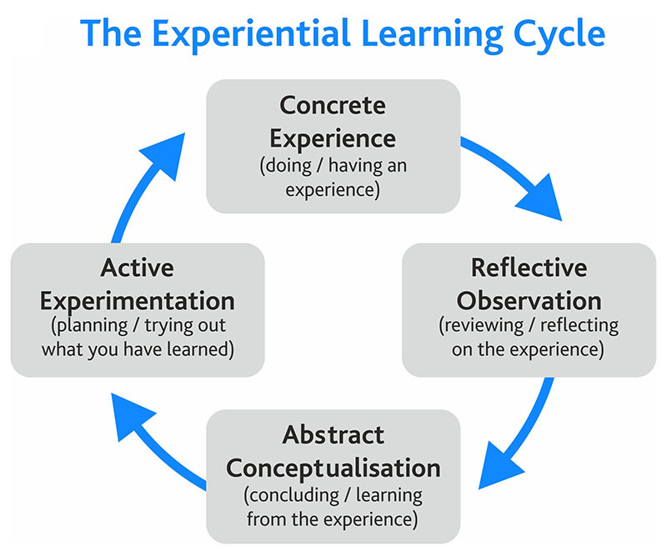

Figure 1: Kolb’s Learning Cycle

## **2.3 Differences from Traditional Learning**

When we look at the topic of experiential learning from a different point of view, we discover the reasons for its origin. As already mentioned, John Dewey found the traditional learning methods ineffective and decided to work on a different style of teaching. He saw only reading, receiving, and memorizing information as insufficient.

Experiential learning concentrates on the present experience and tries to move participants to problem solving and challenging themselves to move away from their comfort zones towards a new educational aim. Dewey pointed out that if learning occurs in isolation and is disconnected from everyday life experience its limitation is that what the children are supposed to learn is no longer accessible (Beard, “Experiential Learning”, 2006, p. 30). Kohonen et al. criticize the traditional methods by saying that ‘experiential learning provides new perspectives for the fundamental process of redesigning foreign language education’ (2001, p. 8).

Beard and Wilson (2006, p. 1) argue that “Traditional learning, with the teacher or trainer spouting facts and figures and with pupils or participants regurgitating the information without deeper involvement, is a very ineffective form of learning.” Beard and Wilson (2006, p. 1) further state that a much more effective and long-lasting form of learning is to involve the learner by creating a meaningful experience.

Informal education is characterized by a non-school environment and its adaptation to the unique needs of the students. Formal and informal education share some important characteristics; both are committed to learning and must follow a carefully planned curriculum. However, they differ in some points: the location, the focus of the learning programme, the qualifications of the teachers and leaders, and the system of evaluation.

## **2.4 Advantages and Disadvantages of Experiential Learning**

One of the main advantages of experiential learning is the fact that it goes hand in hand with the natural flow of life. The fact is that it does not need to be pushed because experiences come as we proceed with our life and most of the time they are unnoticed. “The more energy and effort a person puts into an experience, the more intensive it is and thus the more valuable the experience becomes” (Pelánek, 2008, p. 21).

Despite all the positive evaluations, some critical opinions do exist. The opposing view shows the obstacles and negative consequences which may appear in this kind of educational process. The danger is seen especially in the position of the teacher (losing authority may lead to indiscipline) and in forgetting the aim of learning (the main objective of the activities will be entertainment instead of learning).

# **3 Basic Principles of Experiential Learning**

We have already mentioned that the foundation stone of experiential learning is experience and the basic important principle which is shared by all approaches to experiential learning is the use of real experience for education and training purposes. Some authors also emphasize that if we want the experience to be at its most effective, we must consider personal involvement. A passive attitude can lead to a limited retention of knowledge by students; however, actively lived experience can be an important tool for learning new knowledge and skills.

Most of the authors who deal with experiential learning agree that not every experience is meaningful and leads to learning. If the experience should be effective for learning, we must understand it and reflect on it. Beard and Wilson (2006, p. 20) argue that “we have to engage with the experience and reflect on what happened, how it happened and why”. They also specify that for the achievement of the most effective experience we must also not pay attention to gathering quantities of experiences in a short time period because a space for absorption and reflection must be provided. The learning activity which offers experience must be carefully chosen. The negative impact should be avoided and, on the other hand, it must go along with our personal beliefs. It is important to consider that according to Beard and Wilson (2006, p. 18), the experience should go in hand with our theory. If the experience does not match our theory, then we must revise our theory or revisit the experience.

Our research has shown that not every experience can be used for learning purposes. There are many aspects which the experience should include if it is to be useful in education. If the experience ought to be transferred into knowledge, we must consider certain principles.

Through the research I found the aspects which it is important to consider in experiential learning, such as the environment, learning activities, motivation, senses, emotions, preferences, the comfort zone, and personalization. There are also crucial principles which should be followed to achieve maximum efficiency in the experiential learning process. It is very important to organize the activity in a safe and friendly environment. According to Neuman’s theory (1998, pp. 17-42), group cooperation is also essential. If the new experience that is gained (and transferred into knowledge/skills) is shared with someone who has gone through the same experience (even though it had been seen by others’ eyes) it becomes more remarkable and memorable. The next principle to be mentioned is reflection. Herbert (1995) says that experience alone is not necessarily educative, and it needs to be turned into learning by thought. Reflection distinguishes between the use of games, outdoor and adventurous activities, etc. for the purpose of recreation and education. The teacher’s/instructor’s role is to manage and control the activity, so that it is turned into knowledge. Neuman (1998, p. 39) claims that the debriefing process helps us to see and understand actions and their impacts through individual experiences, as well as to exchange opinions with people who went through the same experiences. Managing reflection is one of the most demanding instructor/teacher skills. The process of learning through experience is student-oriented and therefore the students need to take an active role in the learning process. Therefore, the teacher plays the role of a guide/mentor/instructor. As already mentioned above, not every experience means learning. The level of students’ involvement depends on the effectiveness of the experience. Csikszentmihalyi (1997), the author of the concept of ‘flow’, meaning that people are at their happiest and most productive when fully concentrated on what they are doing and absorbed in it, mentions the main characteristics of experience that are essential for maintaining an optimal experience. These are:

* clear goals – it is important to set clear rules; the participants know what to do and what is expected; they are capable of acting without further questions
* immediate feedback – the students can see their own success or failure during the activity and can adapt their behaviour and take certain steps
* full concentration – there is no space for distracting thoughts, the attention is fully focused on the problem or activity; the focal point of consciousness is narrowed
* total expulsion of self-consciousness – people forget all their problems and pay no attention to irrelevant feelings and circumstances
* time distortion – the perception of time is deformed; for people in a state of flow time usually passes quickly; hours seem like minutes, days like hours
* challenges and skills are in balance – possibly the most important characteristic; if students focus all their skills on overcoming a challenge that is just manageable, flow is likely to occur
* the activity itself is a reward

If we consider the pedagogical and psychological aspects of experiential learning, we notice the theory of Mihaly Csikszentmihalyi, which highlights the sensation that people experience when they are fully immersed in an activity. According to that theory, educators aim their goals at increasing engagement and achievement, restoring creativity, and maximizing learning opportunities for their students. Once the learners’ interests are taken into consideration learners can learn effectively (Beard, 2015).

Harmer states that the application of experiential learning to language learning proved to be effective because of the comprehensible input in a relaxed atmosphere (Harmer, 2007). The projects/tasks should be challenging and meaningful and they should motivate learners to develop their language skills. Harmer (2007) devotes attention to task-based learning (TBL) and explains that this approach is focused on a concrete task in order to resemble real-life situations. After a particular task has been completed, learners reflect on their situations and look at mistakes or think about future improvements.

## **3.1 Course Planning**

Course planning is a process which includes several stages. They ought to be followed if the course is to be organized. There are a few important points which we must know before we start with the course organization. These points are the following:

* the teacher must have a clear vision of what she/he wants to teach; accordingly, she/he must prepare learnable material – create a syllabus
* the next step is planning activities, teaching methods, and the design of the environment – the methodology should reflect the teacher’s beliefs and be associated with language learning ideas – create a daily programme

While planning activities we must consider what kind of programme or course it is and who the course is going to be designed for. According to Graves (2000), teachers should be able to abandon their plans if it is shown that they are not applicable because after that they are better prepared to pay attention to their students. Part of the planning should include discussion about:

* what activities (such as games, discussion sessions, individual work, tests, or quizzes) we are going to use and what rules we are going to set
* connecting them to the main topic (connected to emotions, attractive, motivating, encouraging)
* setting the aims
* how many people will be involved (teachers, assistants, students, team of organizers)
* environment (locality, accommodation, food, etc.)
* budget (decide the price for an individual)
* how to attract participants (various forms of advertisements)
* submit an application, invitation letter to participants

The individual parts the course consists of are listed by Graves (2000):

* processes of defining the content
* organizing the course
* conceptualizing the content, assessment
* formulating the goals and objectives of the course
* developing materials and articulating beliefs

The next step concerns the implementation of the planned activities (prepare the atmosphere of the place, specify the target group and target level, etc.). The last one concerns evaluation. Organizers and students should be provided with questions and give feedback about the planning, organizing, and experiencing of the course (learning methods, activities, environment, etc.). The questions ought to be clear and particular and reflect the specific part of the course.

## **3.2 Teacher’s Position**

Mishan and Chambers (2010, p. 186) specify that experiential learning in language teaching takes place when children do things and learn/find out about something by actually doing it. The position of the teacher in experiential learning has its specific characteristics. If we want to achieve the most effective teaching process the teacher should play the role of a mentor or guide. Hanuš and Chytilová (2009) list three important criteria for the teacher in experiential learning. They should perceive the participants as individuals, they should operate with organizational skills (management, public relations, planning and designing activities), and finally they should have deep knowledge of/be able to arrange the structure and programme.

## **3.3 Target Group and Cooperation**

The next aspect we should consider is the target group. As previously mentioned, the activities should be chosen according to the age of the participants and by using basic knowledge of developmental psychology. When the course or activity is being planned, we should be aware of the children’s age characteristics, their weaknesses, and their general interests. To attract their attention, it is always an advantage for the teacher to adopt a suitable approach and appropriate timing of activities and use various kinds of activities. We must be sure the participants clearly understand the rules and they know exactly what they should do and what the aim is. Children need security and pleasure. The teacher or guide should be sensitive to their moods and adjust the learning process accordingly. They will thus be more capable of cooperating with their classmates. For that reason, pair work and group work are beneficial as the children learn by interacting with their peers as well as with their teacher. Nevertheless, there is still a need for independence and a chance to personalize their learning experience and find their personal learning strategies. As already mentioned, the activities should be carefully chosen, with the right intellectual level, so as to extend the students’ comfort zone. They more enjoyable they are, the more memorable they will be.

Another important aspect is group dynamics. It is crucial that the group atmosphere is positive and that all group members share a common goal and commitment towards membership and interaction with each other. The role of the teacher is significant. She/he should notice the individual disparities in time to be able to adjust the course programme and make everybody feel comfortable (as part of the group).

## **3.4 Motivation**

Motivation is an important and necessary part of every learning process. Students must be involved in the activity in order to achieve the most effective experience which could only then be transformed into new knowledge. There are two main kinds of motivation – extrinsic and intrinsic.

Extrinsic motivation comes from outside (school marks and certificates, salary, etc.). According to Harmer (2007, p. 4), two additional types of extrinsic motivation, integrative and instrumental, can be distinguished:

* integrative motivation – this type is more typical for students in a bilingual society or people living in a different country. They are attracted by the culture of the target country and their desire to learn is increased by the wish to integrate into that culture. In most cases this is not the case for Czech learners;
* instrumental motivation – it is a common type among Czech students. They believe that the knowledge they gain will help to increase their status, or they will be able to get a better job or earn more money. This type of extrinsic motivation is in fact a good start for becoming interested in the subject matter and thus intrinsically motivated.

The second type is intrinsic motivation, which comes from students themselves (inside). This can be subdivided into certain types (Corte and Weinert, 1996, p. 447):

* Curiosity – probably the most typical type of intrinsic motivation to learn; correctly set challenges according to students’ abilities (Corte and Weinert, 1996, p. 447)
* Competence and Efficacy – students are motivated and invest considerable effort when they expect that they can master a task; people like doing things they are good at (Corte and Weinert, 1996, p. 448)
* Control and Self-determination – human beings want to control their environment and the outcomes of their actions (Corte and Weinert, 1996, p. 449); lack of control leads to de-motivation.

According to Harmer (2007, p. 5) there are certain factors that affect intrinsic motivation. These can be divided into four categories:

* physical conditions (room, light, number of participants, etc.)
* method (game, challenge, role plays, journals, drama activities, reflection in cooperative groups, etc.)
* the teacher (role of the teacher – e.g. material provided, motivating students, model of humanity, behaviour, learning strategies, personal values model)
* success (tasks and activities need to be set at the right level so that success is reachable)

Motivation is one of the most important aspects. It is not easy to set the right extrinsic motivation from the teacher’s side for it to be acceptable for most of the students. The activities and topic of the practical implementation must be carefully chosen, because this might be one of the crucial points which can motivate participants in the experiential learning process.

## **3.5 Comfort Zone**

Everyone has their own comfort zone, which means certain information, knowledge, skills, and experience and while doing things we feel safe, known, familiar, secure, comfortable, and predictable. We can only learn new things by overstepping the border of our comfort zone.

One of the aims of experiential learning is to extend an individual’s comfort zone. Students are put into a situation (according to their educational level) in which they feel uncomfortable and while they are on their journey to find a comfortable way of going along with the new circumstances, they will extend their comfort zone.

## **3.6 Environment**

Another important aspect which must be carefully chosen is the topic and place where a certain activity or game will take place. If the participants find the experience boring it will not be as effective as expected or not effective at all.

To achieve the best possible experience, the learners must have a comfortable place for enjoying a particular activity. They must feel physically and mentally safe so they can be fully concentrated on the activity they are doing. The fewer disruptive elements there are around them, the more effective and powerful the experience will be.

A digital environment is valuable because it offers safe, comfortable, and familiar surroundings. The student does not have to face fears of bad weather and they do not have to travel anywhere and waste their time. The learning process is just set in their homes or wherever is most convenient for them, provided the internet connection is adequate. Participants can prepare refreshment for themselves and help themselves when they need to. They may be allowed to be more or less time flexible (this means that they will not have to be in a specific place at a specific time). If we consider the importance of group cooperation, we can see a good example of the transfer of the principles of experiential learning into a digital environment. Students may participate in group conversation via whatever online platform is agreed on. This creates a place for them to share their fresh experiences, get advice, or help others.

## **3.7 Topic and Learning Activities**

The topic must be introduced to students very carefully, so they are aware of what they are doing. The instructions must be clear and appropriate to their age. It is useful to include some obstacles in the activity because overcoming them will be better remembered (deeper experience). It is necessary for the teacher (instructor/supervisor) to motivate the learners. Each individual activity should not take a lot of time and there should be some recommended timeout off the computer because of the health and safety regulations. Additionally, there should not be so many activities in a very short time period, which would mean there was not enough time for absorption of the experience.

All kinds of games, model situations, creative and drama workshops, forums and discussions, physically and mentally demanding and challenging situations, and self-recognizing and team-building activities have been shown to be very useful activities. Some of these recommended activities might be used in a digital environment; however, we already know that some of them are not applicable.

Most of the various interactive practices included in experiential learning techniques, such as portfolios, role plays, personal stories and journals, visualization, and other imaginative activities, are crucial for learning from immediate experience. These activities engage the learners and provide them with the sharing of experience (Kohonen et al., 2001, p. 22).

## **3.8 Reflection**

The next very important principle is reflection. Experience cannot be transformed into knowledge without evaluation and reflection. The newly-gained knowledge becomes useful knowledge only after experiencing a similar situation and having the opportunity to use it again. We should never skip time for reflection on any activity because it is the time when people process the activity, think about it thoroughly, and give themselves the necessary time to absorb every idea and meaning behind the activity. Furthermore, if we rush from one activity to another, Pelánek (2008, p. 24) states that it can lead to a loss of the significance of the activity. The same happens when learners are exposed to too many games and individual experiences start to blend into each other.

## **3.9 Other Aspects**

Apart from the above-mentioned aspects there are other ones that are no less important and which it is also beneficial to consider if we are about to plan experiential activity. These are:

* senses – “the more senses we use in an activity the more memorable the learning experience will become because it increases the neural connections in our brains and therefore will be more accessible” (Beard and Wilson, 2006, p. 7); boredom should not be allowed to appear in the particular activity
* emotions – emotions are very important in both the learning and teaching process as they serve for better understanding
* preferences – the advantage of a digital environment is that the participants can choose their own preferences concerning time. “Some of us learn better in the morning, others in the dark hours of the night.” (Beard and Wilson, 2006, p. 8)
* personalization – everyone should find their own learning style

# **4 Transformation of Experiential Learning in a Digital Environment**

## **4.1 Using Technology for Experiential Learning**

We can use technology in specific spheres by using simulation technologies. Plastic figures, for example, can allow for “real-life” training and practice in a low-risk environment. This is especially used in the Health Science sphere. Other technological equipment might be used in experiential learning in the form of game-based learning. This way is a very motivating and engaging approach to learning. Technology allows students the possibility of sound or video recording, note-taking, or photographing. All this information might be used later for deeper analysis. GPS technology is very useful for fieldwork and Google Street View provides us with the possibility of paying virtual visits to interesting places anywhere in the world (Using Technology for Experiential Learning).

A variety of communication platforms enables us to collaborate. Students are able to share their thoughts/ideas, research findings, or notes via shared online writing spaces. They can also cooperate through video conferences. We consider the mobility of information an advantage.

## **4.2 The Characteristics of a Highly Effective Learning Environment**

If we want to achieve the most effective learning environment, we primarily aim to have an ‘intellectually active’ and progressive learning place. There are some characteristics of a highly effective classroom (Heick, 2018):

* the students ask more questions than the teachers – curiosity plays a crucial role in the whole learning process. Students should be encouraged to ask questions connected to the lessons. This is a very supportive way of enhancing their communicative approach;
* questions are valued over answers;
* ideas come from divergent sources – a variety of sources should be used because this will avoid untrustworthy information;
* a variety of learning models are used;
* classroom learning ‘empties’ into a connected community;
* learning is personalized by a variety of criteria;
* assessment is persistent, authentic, transparent, and never punitive;
* the criteria for success are diverse, transparent, and co-created with students and families;
* learning habits are constantly modeled;
* there are constant and creative opportunities for practice and growth.

(The Characteristics Of A Highly Effective Learning Environment, 2018)

## **4.3 The Advantages of Outdoor Experiential Education**

Experiential learning, also called learning by doing, has many positive impacts on students participating in this kind of outdoor education. Such a course offers them opportunities to get to know themselves and meet new people. Some of the participants face for the first time the state of being alone in an unknown place with unknown people. As a result of this emotional and powerful experience they are forced to learn and develop leadership skills, such as risk management, problem solving, and personal development skills. The free environment allows them to behave spontaneously without their hands being tied by school rules. The attractiveness of the outdoors is motivation for experiencing and learning. The informal attitude limits stress and the relaxed atmosphere encourages students to ask more questions and discuss topics openly.

In the practical part of this thesis we will transfer the outdoors and adventure into a digital environment. I believe this will also be attractive and motivating for the participants. We might take advantage of a peaceful and safe working place, the flexible learning/working time, and using many online platforms as auxiliary tools (translator, maps, etc.). As a result of distance, the participants will probably not be able to establish cooperation through teamwork; however, there will be communicative platforms for sharing ideas, feedback, and results.

# **PRACTICAL PART**

# **5 Introduction to the Research**

In my research part I focused on experiential education in a digital environment. I organized a short English course in which I created a few kinds of activities in the online world, such as portfolios and games. The main aim was to find out if experiential learning is applicable in a digital environment and can be as effective and enjoyable as experiential learning carried out outdoors. The aim is to show whether the students prefer learning a foreign language through conventional methods or prefer learning through experiential methods. They should also clarify if outdoor surroundings and meeting new people are preferable for them or if they would rather pick a digital environment. The next purpose was to check whether the students’ experience gained in the digital surroundings could be transformed into knowledge when they are playing online games or participating in any other online activity. After participating in the whole course, they completed a knowledge evaluation form which tracked their newly-gained knowledge and a course evaluation form which rated the course from the point of view of various aspects. The chosen students participated in a two-week-long online English course in which they followed the instructions received from their tutor and virtually prepared themselves for hiking a trail in the USA.

## **5.1 Course Organization**

The short English course was organized so as to last for two weeks. I asked eight chosen “future participants” in advance through the online platform Messenger whether they would like to participate in a small online English course. Two of them refused to participate.

After their acceptance I set up a joint group conversation in Messenger for the purpose of daily communication and short and fast problem solving and a joint email address for receiving the worksheets – [pctenglishcourse@seznam.cz](mailto:pctenglishcourse@seznam.cz). The participants received basic information about the course conditions and dates via Messenger and also through the first email providing the basic information. These were written in Czech in order to be sure that everybody could clearly understand what they were expected to do. The introductory letter was intended to create a positive and motivating atmosphere.

Translation of the introductory letter:

*Hello again,*

*Please pay attention to the following instructions about the small two-week English course.*

*You will receive worksheets at this email address at regular intervals. This will always be on Monday and Wednesday every week. You will simply log in to this email and download the worksheet (a document in Microsoft Word) and then it is up to your decision when you find the free time to work on it. The deadline is set for every Sunday – this is the latest day on which you can send the completed worksheets to my email address, which is given at the end of every single document.*

*The instructions are written in English, with a Czech translation below. I would appreciate it if the instructions could be read in English. Please try also to use the pictures next to the sentences, which should also be very helpful. If you struggle to understand the instructions, you can follow the Czech translation. Please, try to work independently of the other participants and use your own mind and the internet (useful websites connected to the topic or translation) if needed.*

*If there are any technical issues or you have any other problems, do not hesitate to write to our shared Messenger group or privately to me.*

*I would be glad to see that you worked individually on the tasks and they displayed your own ideas, understanding, thoughts, or knowledge.*

*I am looking forward to your feedback. Enjoy.*

*Thank you.*

*Radka*

1. day of preparation – basic information

The participants will start their preparation for the trip by searching for the basic information.

Every PCT hiker gets a nickname during her/his first few days or weeks. This is what the other hikers call her/him every time they meet. The real names are forgotten and people gain another personality. The nickname usually expresses the hiker’s character, her/his typical appearance or a habit, what she/he like/dislikes, or what she/he is like. The first task of the course will be to choose a nickname for the journey. The students will think about their typical characteristic features, their hobbies, and their habits. According to this, they must create a nickname that they would probably get on the trail.

For the next task the students will need a link for a YouTube video (<https://www.youtube.com/watch?v=styiDn7YKhE>) and a picture of the map. After watching a short video and checking the map they should gather data about the length of the PCT, the geographical surroundings, and its location. These details should be input into the little portfolio attached to the instruction form. The students are free to use their own investigation on the internet if they struggle with searching for information.

The first day of the preparation is over and the participants are asked to send their portfolios to me by email. The first worksheet is presented in Appendix 1.

This part is meant to be easier and shorter to get the participants motivated and inspire them about the topic. The aim of this task is to leave the participants excited as they wait for the next worksheet and curious for the next step and further preparation. They should have learnt some basic information about the trail and how to understand and answer basic questions, such as:

* How long is the PCT?
* Which countries does it connect?
* How many states of the USA will you go through?
* Name them:

1. day of preparation – flight ticket and visa

The aim of the second day is to finalize the budget for two of the biggest expenses – the visa and the flight ticket. Let’s start with the flight ticket. The participants are advised to use the Skyscanner website (<https://www.skyscanner.cz/?locale=en-US&previousCultureSource=GEO_LOCATION&redirectedFrom=www.skyscanner.com>), where they should find a flight ticket to the USA for themselves. On the one hand, they are instructed which field to fill with what information by using coloured points, while on the other hand, they are pushed to be creative and inventive. They must choose a date when they would like to start their trip and by using an attached map find the closest place (in the USA) to the starting point of the trail where they would like to land. Therefore, it will be important to complete the previous day’s portfolio carefully. They will also have to think where they will fly from. The outcomes should again be added to the portfolio.

The next step is to find out which kind of visa is needed for travelling in the USA for the purpose of hiking the trail. The participants are recommended to visit the website of the American embassy in the Czech Republic (<https://cz.usembassy.gov/cs/visas-cs/nonimmigrant-visas-cs/vsechna-viza/>). After clarifying the type of visa they will need, they must check how much it costs. This task is expected to be more difficult and a lot of creativity and searching is needed from the participants.

After completing the portfolio for the second day, the students are requested again to send it to me by email.

1. day of preparation – food and equipment

On the third day of preparation, the participant should become clear about what kind of

food it is appropriate to take on the hiking trip and realize what kind of equipment they will need. They should consider the weight, durability, and energy value.

For the introduction to the topic of food and equipment the participants are invited to play a Kahoot! game. This game consists of six questions. Each of them has a time limit of 60 seconds. There is only one right answer. The faster they reply, the more points they will receive. The students are provided with short basic instructions and a link and a game PIN for the game.

The following task is about food. In the portfolio that is provided there are small pictures of food. They should mark in red what kind of food they would pack and not mark the food which they would definitely not pack.

The aim of this chapter is to put the participants in a situation where it will already be clear what their trip will look like. The game should help them to realize the situation and what they can afford to carry and what would be absolutely useless. This task is meant to be more enjoyable and relaxed. They should just think generally and practically.

1. day of preparation – weather conditions and map

The final step is to check what the weather is like on the entire length of the trail and what kinds of clothes the future hikers should pack accordingly.

The first part of this day is to check the weather by using the “Street View” application (<https://www.google.cz/maps/@49.8602829,18.0027588,9z>). The participants can see a list of a few places and national parks which they will go through while hiking the PCT, such as Southern California – the Mojave Desert, Central California – the Sierra Nevada, Sequoia National Park, Yosemite National Park, Northern California – Lassen Volcanic National Park, Oregon – Crater Lake National Park, Mt. Hood National Forest, Washington – Mount Rainer National Park and North Cascades National Park. Every place that is mentioned should be found on Google Maps and by using the “Street View” application they should look around to see what the weather can be like at different places on the PCT. The participants are provided with brief instructions on how to use the “Street View” application. When they scroll down the worksheet they will find different weather conditions and they will have to match the places visited virtually on the map with the weather conditions according to what they have just seen or what they felt like.

As the second task they are again asked to play a Kahoot! game. This time the topic is the weather and the clothes. The simple rules are introduced to the learners. The game will consist of nine questions with different time limits, depending on the level of the question. Again, the fastest reply gets the most points. There are questions where you must choose one of four answers (only one is the right one) and there are questions to which the reply is only true or false (yes or no).

This final work should also be enjoyable and support the participants’ imagination by seeing the trail in virtual reality. It is also supposed to widen their own thoughts and opinions and express them. It pushes them to be innovative and creative.

## **5.2 Approach to the Digital Environment and Guide Approach**

As already mentioned, the course is set in a digital environment. A dedicated email address was set up for the purposes of this research, to which the participants received a total of four documents with instructions twice a week during two weeks in the term (always on Mondays and Wednesdays). For both tasks in the week the deadline was always set for the following Sunday. With these instructions they were directed to explore the online world and gather basic information that they would need to know to be ready for a hiking trip in the USA.

When organizing this part of the research (the short online English course) a few advantages of the digital environment were uncovered, such as time flexibility and private and comfortable surroundings. None of the people involved needed to be worried about the bad weather conditions which could ruin prepared activities.

On the other hand, some disadvantages were uncovered, too. These are, for example, the possibility of cheating during the completion of the “knowledge evaluation form”, which may cause the evaluation form to be untrustworthy. The home digital surroundings may affect the participants negatively as well. It could be difficult for some of them to meet the deadline because of an unchanging environment where they can find a lot of disturbing elements. The activity might become boring. The experience may not be received in the right form and therefore it will not be transferrable knowledge.

When using online surroundings for learning purposes the tutor should remember the following aspects which it is important to keep in mind:

* find a digital communication tool that everyone can use – only the participants and tutor share a common email address with a shared password; for everyday communication they agreed on using the Messenger platform, where all the course participants share group communication; the tutor ensured that everyone has everyday access to these resources and everyone knows perfectly how to use them
* keep yourself in the loop – check in often – the tutor establishes a friendly and open attitude; the students have the possibility of contacting the tutor every day with any questions either via a group Messenger conversation or privately on Messenger; the tutor contacts the students regularly with short messages to check if all the instructions are clear and well set and ensures that the participants received the learning material and know exactly what it is expected from them; if any delays with deadlines appear the tutor must approach the participant concerned and ask her/him if she/he needs help with her/his difficulties
* be positive – the tutor is not disappointed by the students’ failures but tries to motivate and support them; she/he must expect that students’ feedback will be different than expected

## **5.3 Participants**

The participants in the course are children aged between 13 and 15 years old and attendees of lower secondary schools. I have known some of them since they were little and some of them are students from my home English tutoring. All of them were asked by me a long time in advance and all of them voluntarily agreed to participate in this two-week-long online course. I asked eight candidates in total – five girls in the eighth(4) and ninth (1) grades of lower secondary school and three boys in the ninth grade of lower secondary school. All of them have been studying English as their first foreign language for a minimum of six years. Nevertheless, two of them refused to take part in the course for time reasons and in the end one girl did not send the worksheets back, and neither did she complete the evaluation forms.

In the end there were five active participants – four girls in the eighth grade of lower secondary school (Michaela, Vanessa, Nikola, and Samantha) and one boy in the ninth grade of lower secondary school (Martin).

## **5.4 Topic – the Pacific Crest Trail**

The Pacific Crest Trail is America’s greatest wild scenic trail. It is approximately 4270 km long and it is located all along the western part of the United States of America. It connects Mexico with Canada and it leads through three states of the USA – California, Oregon, and Washington. The idea of building a trail originated in the 1930s, but it was officially finished only in 1993. Since 1977, the Pacific Crest Trail Association has protected, maintained, and advocated for the PCT. The trail crosses 25 national forests and seven national parks. On average it takes five to seven months to hike the PCT. Before entering the trail, all hikers must have a permit which obliges them to agree to abide by all the terms of the permit, and all the laws, rules, and regulations which apply to the areas that the hikers will pass through.

I had two main reasons for choosing this topic for the experiential learning English course. The first reason is the virtual adventure and the second one is that the trail’s location is in the USA. Hiking a trail is an experiential journey. People have various reasons for hiking it. It might be, for example, a spiritual basis, becoming one with the natural world, travelling, pushing our personal limits, or just fulfilling the dream that drives people to the PCT. I personally believe in the attractiveness of the landscape.

The main characteristic feature of experiential learning is crossing the border of our comfort zone and getting ourselves/participants into a state of flow – the moment when we/they enjoy the activity so much that we/they do not even realize we/they are involved in the learning process. The point of learning starts just at the moment when the person who is learning steps out of the zone where she/he knows everything, what to expect, and is hardly ever surprised by anything and therefore there is no space for moving forward. However, when the person is put into a situation in which she/he suddenly must concentrate, search for something, translate, check, find, etc., she/he is ready to receive experience and learn from it. This is called the learning zone. Nevertheless, the person who is in charge of organizing the learning activity must take care and is responsible for creating an appropriate environment. If the requirements are too high and the tasks set cross the border of what the person is able to accept, the participants are moved into a danger zone and they are no longer able to learn. On the contrary, they are more likely to experience frustration and stress.

The Pacific Crest Trail definitely puts us into an uncomfortable zone in many ways. There are situations when we are alone and separated for a long time from familiar people and places. We are forced by ourselves to carry a heavy backpack every day and walk several kilometres just to move forward. It is voluntary hard work and rewarding feelings at the same time. We must plan our food and water consumption and not lose our way. We must be able to help ourselves in the event of injury or sickness.

Our topic of Learning English on the Trail should virtually set down the participants into the surroundings and conditions of the trail. I suppose for most (maybe all) of them it will be the first time they have heard about the PCT. Therefore they will be forced to leave their comfort zone and start to search for the information which should be only their private (and could happen to be useful in the real world) property – their personal nickname, in addition to which each of them will choose a different date and place to start their adventure, and each of them will choose slightly different food, equipment, and clothes. Personal involvement is the one of the main principles of highly effective experiential learning and therefore I believe the topic could be attractive and generate a state of flow in the participants.

## **5.5 Online Platforms**

The activities that are implemented are executed by using online platforms. These serve the purposes of finding information, playing online games, and learning new vocabulary.

- YouTube video

YouTube is an online video-sharing platform. It allows users to upload, view, rate, share, add to playlists, report, comment on videos, and subscribe to other users. There are various kinds of videos available to watch for free, such as video clips, TV show clips, feature films, documentary films, film trailers, live streams, educational videos, etc.

By using a link to a video, the participants are introduced to the PCT in pictures. It should serve as motivation and attract them to ask more questions and therefore find out more about the trail. It shows the American wilderness and the beautiful landscape in all its colours and natural conditions. It tells the stories of people who have been associated with the trail. The basic information is given in this video and so it might be helpful in completing the first portfolio task.

- Kahoot!

It is a free game-based learning platform. People who are registered are allowed to create games and by generating a game code spread the game among learners. The course participants were briefly introduced to the basic rules of:

* how many questions they will have to reply to
* the time limit for answering
* the fact that the faster they reply, the more points they can achieve

The game should serve as an introduction to the topic, for gathering information, learning new vocabulary, and repetition of question formulation. It should also relax the atmosphere.

- Google Maps and Street View

Google Maps and the Street View application provide an insight into the real nature of the PCT. The pictures help to realize what the weather can be like there and make virtual hikers feel more realistic and as if they are a bigger part of the trail. They can actually realize what places they will pass through, what the entire length of the PCT is, and how the weather changes on the way.

- Google Forms

The Google Forms application helps to create the evaluation forms and also helps to test students’ knowledge.

In all the activities that were implemented the guide tried to adhere to the overall strategies and principles of experiential learning.

## **5.6 Evaluation**

At the end of the course, after two weeks, the participants received a total of two kinds of questionnaire/evaluation forms.

The first one is called the “knowledge evaluation form” and the aim of this form was to check the students’ knowledge and to see their feedback. It reflected on what the participants had been able to learn and remember from the course and if the online lived experience is transferrable into knowledge. Until this moment the texts provided to the participants had always been accompanied by a Czech translation in order to achieve the right setting of the comfort zone. However, this was the first time the students had only had a full English text available (except the tasks where translation was required or the vocabulary which was not directly mentioned in the course). The questions were based on the virtual preparation for the trail and all of them had been mentioned in the course. This form consists of 14 questions/items; these are:

* Where is the PCT and which countries does it connect? (write three answers)
* What was the main aim of this course?
* Please translate into English (prosím přeložte do angličtiny) “naplánovat výlet”
* Do you remember what your nickname was?
* What airport will you land at?
* How much does your flight ticket cost? Translate: Moje letenka bude stát …. CZK/USD.
* Please translate into Czech (prosím přeložte do češtiny) “pay”
* What equipment will you need? (write two or three words)
* Please translate into English (prosím přeložte do angličtiny) “doporučuji”
* What food will you pack in your backpack? (write two or three words)
* What clothes will you take with you? (write two or three words)
* What can the weather be like on the PCT? (write two or three words)
* What national park(s) will you go through? (write one or two national parks)
* Please translate into Czech (prosím přeložte do češtiny) “watch this video”

The next form – “the PCT course evaluation form” – served the purpose of gathering the information for the main aim of this research. The main aim was set in the introductory part and it was: “*to find out if experiential learning is applicable in a digital environment and can be as effective and enjoyable as experiential learning outdoors*”. This form was sent to the participants after the whole course. The participants answered general questions about the course such as (to ensure the right understanding of the questions a Czech translation accompanied the questions asked in English):

* Did you like the topic of the PCT or would you choose another topic? Which one?
* Would you like to go to the PCT?
* Do you prefer to learn English at school or by playing games in English?
* Do you prefer to play games online (on a computer/laptop/tablet/mobile phone) or outside?
* Do you think you have learnt more vocabulary in this course than at school?
* What activity did you like the most?
* What was the most difficult exercise for you?
* I had problems with…
* Did you read mostly the English or Czech instructions?

## **5.7 Results of the “Knowledge Evaluation Form”**

The participants were not obliged to answer all the questions. If there were fewer replies than the number of participants (five) the question is considered as unanswered. The total number of points that it is possible to achieve is 70. Every correctly answered reply gets one point. A wrong reply or unanswered question gets zero points. The results of the “knowledge evaluation form” questionnaire are:

* **Where is the PCT and which countries does it connect? (write three answers)**

Information about the trail’s location was mentioned in the first video on the first worksheet the participants received. The task was to find this data first and then write it in the portfolio when the participants had ensured themselves they had found it.

This question was answered by three participants out of five. Only one answer was accepted as completely right; the other one was only partially answered – 1.5 points out of 5.

Participants’ answers:

* + - *It is in USA, it connects Mexico, USA and Canada.*
    - *I don’t know*
    - *Mexico to Canada*
* **What was the main aim of this course?**

The main aim is mentioned in the first worksheet and it is “planning the trip”. This question was answered by four participants out of five. Three answers were accepted. One answer did not match the question – 3 points out of 5.

Participants’ answers:

* + - *The aim of this course is to plan this trip.*
    - *IT IS Very good course*
    - *practice your english*
    - *practice your english, work with text*
* **Please translate into English (prosím přeložte do angličtiny) “naplánovat výlet”**

The participants are asked to translate a simple phrase from Czech to English. This phrase was also mentioned on the first worksheet. This task was answered by all five participants and all can be accepted (even the one which was not mentioned in the worksheet – “schedule a trip”) – 5 points out of 5.

Participants’ answers:

* + - *Plan a trip*
    - *Schedule a trip*
    - *Plan a trip*
    - *Plan a trip*
    - *Plan trip*
* **Do you remember what your nickname was?**

The aim of this question is not to find out if the participants remembered their nickname but to see if they understood the question which was mentioned on the first worksheet. All five participants replied, and all were accepted – 5 points out of 5.

Participants’ answers:

* + - *Yes I do, it was Samantha*
    - *nemluvabuba*
    - *no*
    - *Vanineckabrasko*
    - *Nikibrasko*
* **Which airport will you land at?**

This question was mentioned on the second worksheet and it was up to every participant’s consideration to choose the city they would land at. The condition was set that the city should be located in the USA and logically it should be located close to the beginning of the trail (near the Mexican border). The purpose of this question is that the participants would be able to understand the question, not to remember which airport they wrote in their portfolio. Four answers appeared, all of them accepted – 4 points out of 5.

Participants’ answers:

* + - *At San Diego*
    - *L a airport*
    - *New York airport*
    - *New York airport*
* **How much does your flight ticket cost? Translate: Moje letenka bude stát …. CZK/USD.**

In this question the participants must answer a question. The answer should be written in a full sentence. Therefore, there is a hint in the form of a translation. This question and translation were answered by four participants. Even though one participant seemed not to understand the instruction properly, the answer was partially accepted – 3.5 points out of 4.

Participants’ answers:

* + - *It will cost 12873czk.*
    - *My ticket will cost*
    - *My ticket will cost 8562 CZK.*
    - *My ticket will cost 8562 CZK.*
* **Please translate into Czech (prosím přeložte do češtiny) “pay”**

This is just a simple translation from English to Czech. This word was translated and used on the second worksheet. All five participants replied, and all their answers are accepted – 5 points out of 5.

Participants’ answers:

* + - *Zaplatit*
    - *Platit*
    - *Platit*
    - *Platit*
    - *Platit*
* **What equipment will you need? (write two or three words)**

The aim of this question was to check if the participants understood the question and if they remembered at least two or three pieces of equipment which they were recommended to take with them on the hiking trip. Four participants replied, and all the answers were accepted – 4 points out of 4.

Participants’ answers:

* + - *A tant, backpack, hiking shoes, clothes*
    - *Food, water, raincoat*
    - *Map wather and food*
    - *Ticket, clothes and documents*
* **Please translate into English (prosím přeložte do angličtiny) “doporučuji”**

This is just simple translation of a word from Czech to English. The word was used on the first worksheet. All five participants replied, and all their answers were accepted – 5 points out of 5.

Participants’ answers:

* + - *I recommend*
    - *I recommend*
    - *I recommend*
    - *Recommend*
    - *Recommend*
* **What food will you pack in your backpack? (write two or three words)**

The aim of this question was to check if the participants understood the question and if they remembered at least two or three items of food which they were recommended to take with them on the hiking trip. If there was a food item written in their answers which was not appropriate for such a trip it was not considered a mistake. It is valuable that the participants remembered the vocabulary covered in the lesson. All five participants replied, and all their answers were accepted – 5 points out of 5.

Participants’ answers:

* + - *Instant soup, nuts and muesli bar*
    - *Sausage, cookies, bread*
    - *Canned meat, nuts and candies*
    - *Toast, fruits and chicken cutlets*
    - *Bread, musli, instant soup*
* **What clothes will you take with you? (write two or three words)**

The aim of this question was to check if the participants understood the question and if they remembered at least two or three items of clothing which they were recommended to take with them on the hiking trip. This vocabulary was covered in both Kahoot! games. If there were items of clothing written in their answers which were not appropriate for such a trip it was not considered a mistake. It is valuable that the participants remembered the vocabulary covered in the lesson. All five participants replied, and all their answers were accepted – 5 points out of 5.

Participants’ answers:

* + - *Waterproof and sport clothes*
    - *Raincoat, jacket*
    - *T shirt shorts shoes*
    - *Jeans, t-shirt and shorts*
    - *T-shirt, sports pants, jacket*
* **What can the weather be like on the PCT? (write two or three words)**

The aim of this question was to check if the participants understood the question and if they remembered at least two or three weather conditions which were mentioned on the fourth worksheet and which they might face on the trail. Four participants replied, and all were accepted – 4 points out of 4.

Participants’ answers:

* + - *It will be hot but then in the mountains it will be cold*
    - *Wind, cloudy, warm*
    - *Sunny, rain partly cloudy*
    - *Sunny, windy*
* **What national park(s) will you go through? (write one or two national parks)**

The aim of this question was to check if the participants understood the question and if they remembered at least one or two national parks mentioned on the fourth worksheet and which they would go through while hiking. All five participants replied, but only two answers were accepted. In two replies the participants did not remember the name of the national park and one reply was apparently understood wrongly – 2 points out of 5.

Participants’ answers:

* + - *Seqoia np and Yosemite np*
    - *Sequoida national park*
    - *KRNAP and šumava*
    - *I don’t know*
    - *I don’t know*
* **Please translate into Czech (prosím přeložte do češtiny) “watch this video”**

This is just translation of a simple phrase from English to Czech. The phrase was used on the first worksheet. All five participants replied, and all their answers were accepted – 5 points out of 5.

Participants’ answers:

* + - *Podívat se na video*
    - *Podívat se na video*
    - *Podívej se na tohle video*
    - *Podívej se na tohle video*
    - *Podívej se na toto video*

In total, the participants received 57 points. The percentage of success was 81.43%.

## **5.8 Results of the “PCT Course Evaluation Form”**

The second questionnaire, called the “PCT course evaluation form”, conveys the evaluation of the course organization and participation in a digital environment. The reactions of the participants in the course are:

* **Did you like the topic of the PCT or would you choose another topic? Which one?**

This question was designed to show whether the choice of topic was suitable. There were two options to choose from – I like the topic (to approve the choice of topic) or No, I did not like the topic and recommend another (to disapprove of the attractiveness of the topic). All the participants approved of the choice of topic.

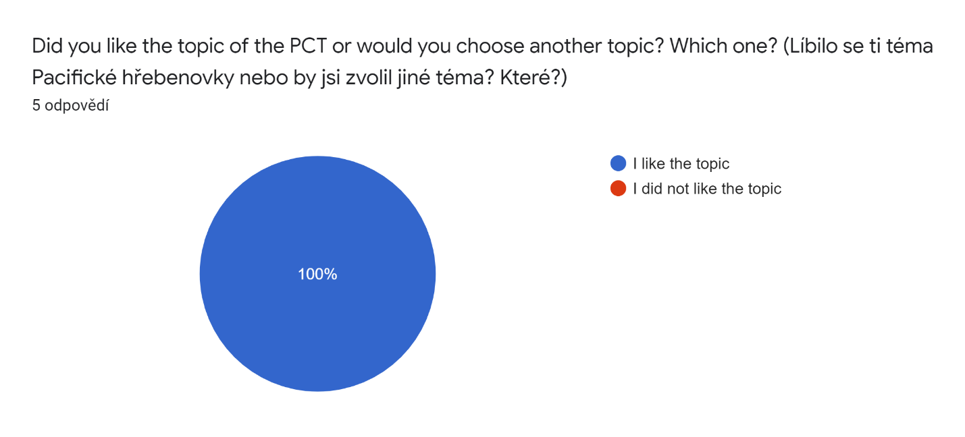

Figure 2

* **Would you like to go to the PCT?**

The previous statement was doubly confirmed by the replies to this question. Four of the participants would like to go to the PCT and only one is not interested in hiking it.

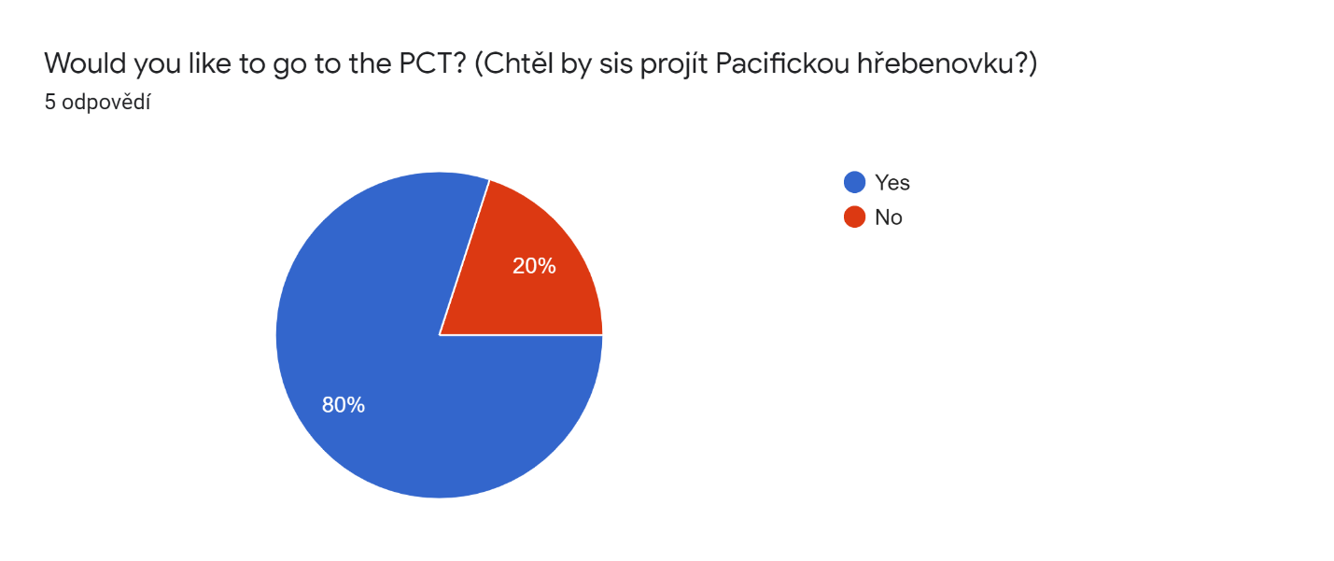

Figure 3

* **Do you prefer to learn English at school or by playing games in English?**

This question was designed to investigate the attractiveness of experiential learning to the students and to find out what type of learning process is preferable for the lower secondary school students. All the participants agreed that their favourite method for learning English is the experiential one (by playing games in English).

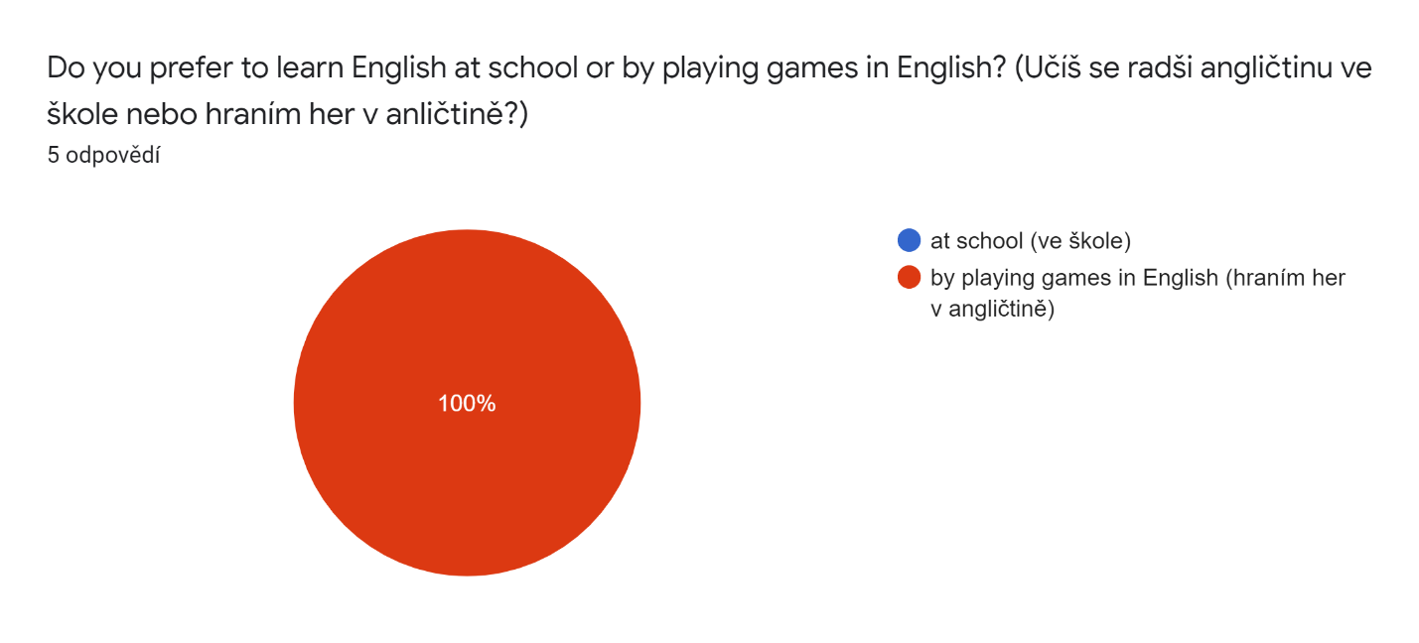

Figure 4

* **Do you prefer to play games online (on a computer/laptop/tablet/mobile phone) or outside?**

This question was designed to confirm the statement about the environment and if the teenagers aged 13-15 years sympathized more with digital or outside surroundings. Four of them preferred to play games outside and one of them preferred the digital environment.

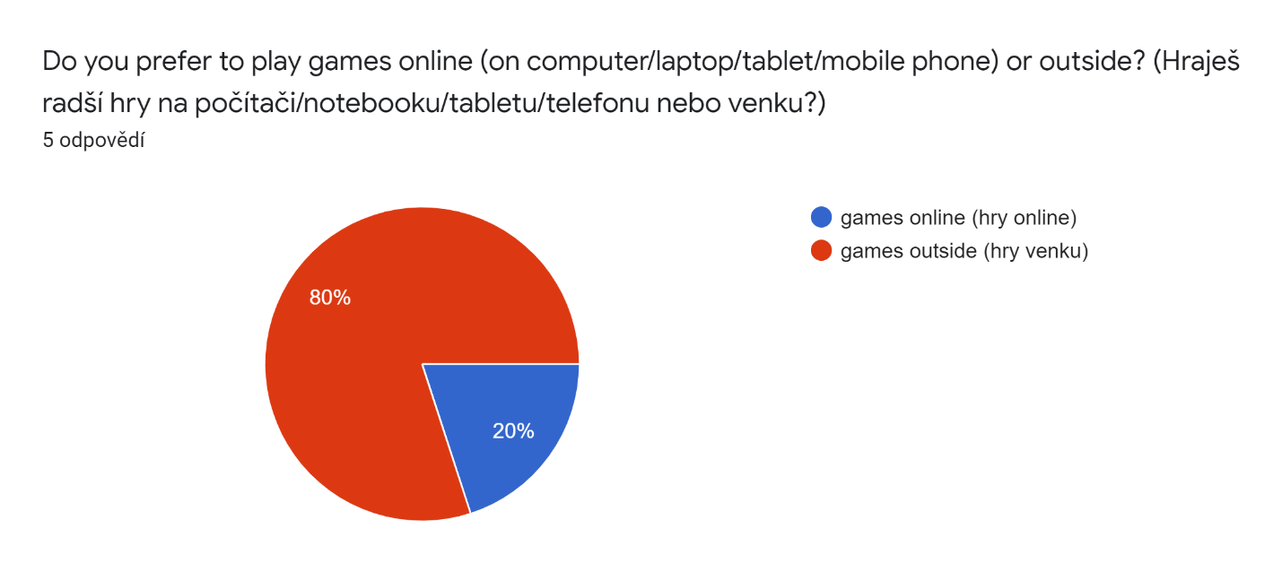

Figure 5

* **Do you think you have learnt more vocabulary in this course than at school?**

This question was designed to investigate the effectiveness of this course. It is based on the participants’ subjective perception. All of them agreed that they learnt more vocabulary by participating in this course then by attending lessons at school.

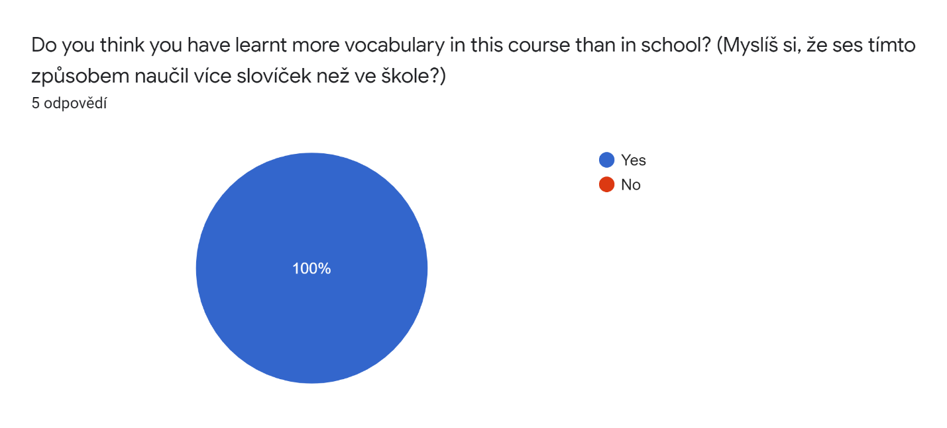

Figure 6

* **What activity did you like the most?**

This question was designed to provide feedback to the mentor about the popularity of the activities. According to the participants, the most popular activity was playing the online Kahoot! games. Three of them chose this option. The other two participants chose the Word document exercises and searching on Google Maps and Street View as the most popular activity.

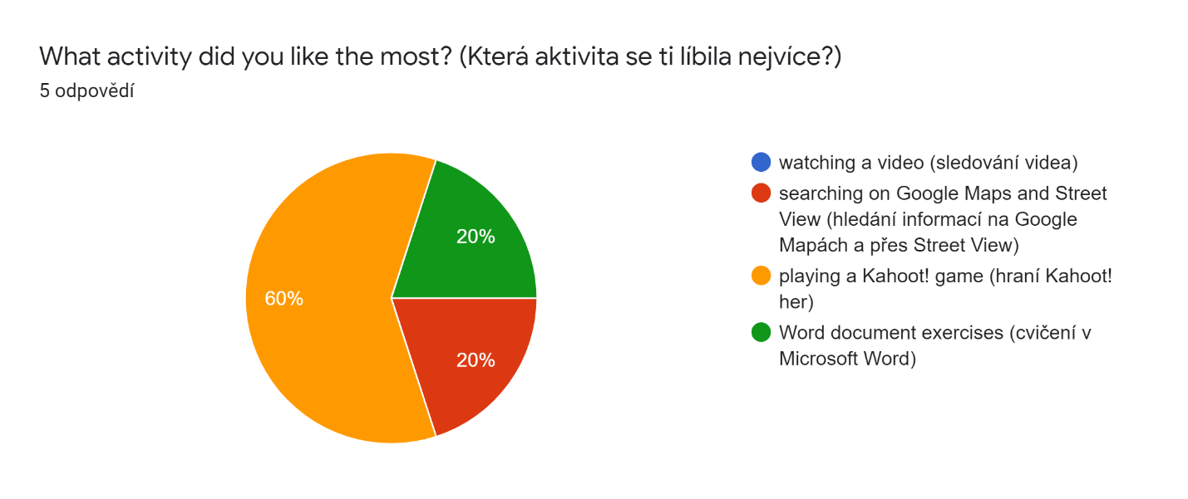

Figure 7

* **What was the most difficult exercise for you?**

This question was also designed to provide feedback to the mentor, this time about the difficulty of the exercises. According to the participants, the most difficult exercises were searching for information about the flight ticket and visa and checking the weather on Google Maps. One of the participants said that completing the portfolio was the most difficult exercise for her/him.

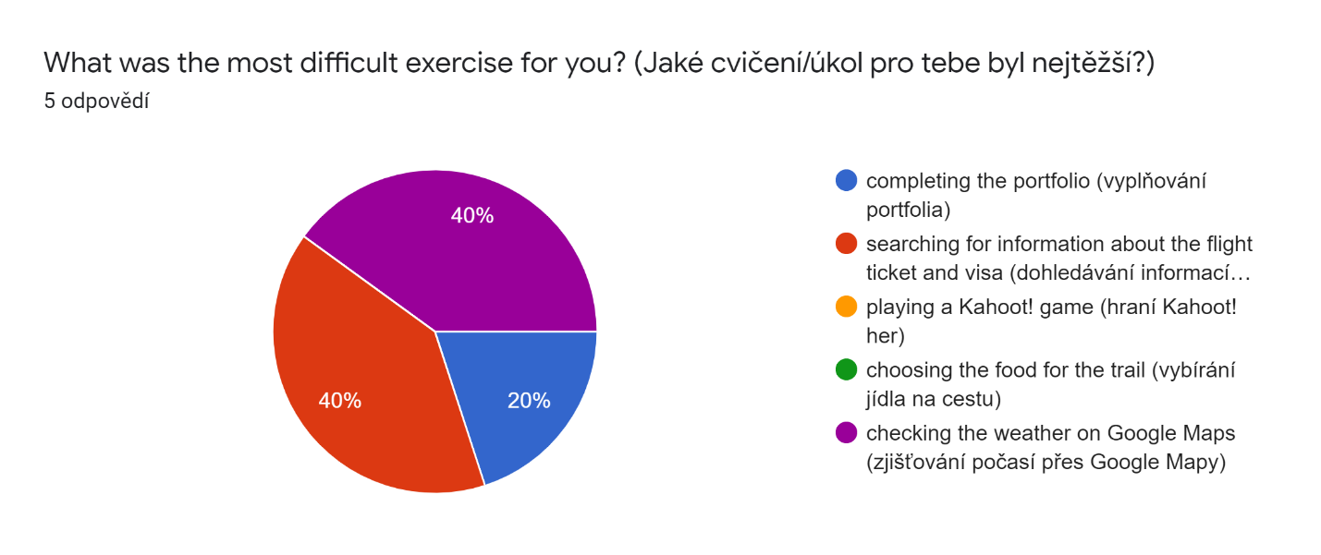

Figure 8

* **I had problems with…**

This task was designed to monitor the digital approach and how the participants dealt with the online environment and online ways of communication. Three of them responded that the biggest problem they had to face was the technical obstacles and two of them responded that the biggest problem they had was understanding the instructions.

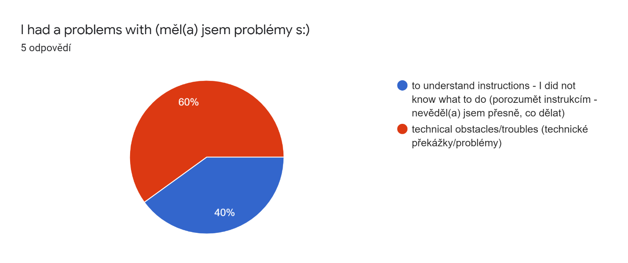

Figure 9

* **Did you read mostly the English or Czech instructions?**

This question was designed to track the purpose of the Czech translation. This was meant to be helpful when the participants struggled with the sentences written in English. However, the participants who skipped these and only followed the Czech translation would probably not gain the maximum benefit from the course.

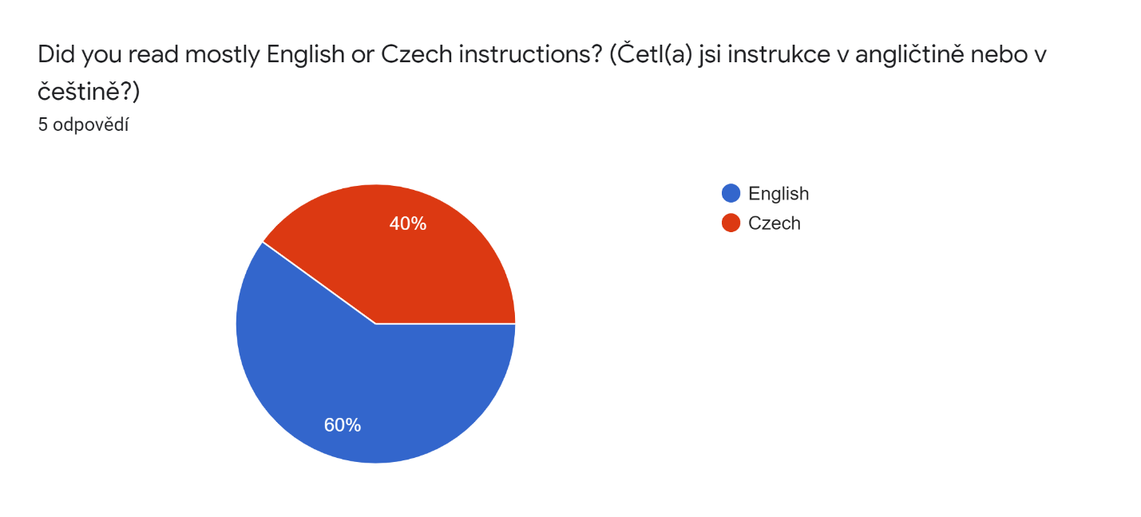

Figure 10

# **Conclusion**

In conclusion, let me summarize the research that was conducted. At the beginning of the research part two hypotheses were set:

* Experiential learning is applicable in a digital environment
* Experiential learning can be as effective and enjoyable in a digital environment as in outdoor surroundings

Although we had a small research group, five people only, it was a very diverse group of participants. There were students of different ages (13-15), both genders, and from different home surroundings (village and city).

According to the “PCT course evaluation form” and the participants’ and my own experience, I can evaluate the course as successful and therefore confirm that experiential learning is applicable in digital surroundings, even though there are certain obstacles which must be dealt with. The first obstacle I was able to notice is in communication. It is hard to express ourselves and to set and understand well the instructions and provide the immediate feedback which is crucial in experiential learning through an online communication platform. However, technology is very highly developed nowadays, and it offers a lot of applications (such as the print screen function or video recording), which might be helpful with dealing with these obstacles. In the end, five of the six worksheets were successfully completed and returned to me. I was not able to persuade the sixth participant to send it back to me, even after sending a few reminders and requests.

If we evaluate the question of enjoyability we understand from the participants’ replies that experiential learning methods are more popular with young adolescent students. They would rather learn English by doing and experiencing some kind of activity but if it comes to their preferences, they like outdoor surroundings more than a digital environment.

If we consider effectiveness, we can see above the results of the “knowledge evaluation form”, which indicates that the participants were 81 per cent successful in remembering and learning new vocabulary and phrases. On the other hand, we can hardly ever check on copying and cheating in a digital environment.

I am very grateful for such a first experience with experiential learning. I have learnt a lot from both the theoretical and research parts. The creation of the course was really enjoyable for me.

# **Sources**

BEARD, Colin, and WILSON, John P., 2006. *Experiential Learning: A Best Practice Handbook for Educators and Trainers*. London: Kogan Page, Print.

BRUMFIT, Christopher J., and JOHNSON, Keith, 1983. eds. *The Communicative Approach to Language Teaching*. Oxford: Oxford University Press, Print.

CSIKSZENTMIHALYI, Mihaly, 1997. *Finding Flow*. New York: Basic Books, Print.

DE CORTE, Eric, and WEINERT, Franz E., 1996. *International Encyclopedia of Developmental and Instructional Psychology.* Bingley: Emerald, Print.

GRAVES, Kathleen, 2000. *Designing language courses: a guide for teachers.* London: Heinle & Heinle. Print

HANUŠ, Radek and CHYTILOVÁ, Lenka, 2009. *Zážitkově pedagogické učení*. Praha: Grada, Print.

HARMER, Jeremy, 2007. *How to teach English.* Harlow: Pearson Education Limited. Print.

KOHONEN, Viljo, et al., 2001. *Experiential Learning in Foreign Language Education*. Harlow: Pearson Education, Print.

KOLB, David A, 1984. *Experiential Learning: Experience as the Source of Learning and Development*. Englewood Cliffs, NJ: Prentice-Hall, Print.

LARSEN-FREEMAN, Diane, 1986. *Techniques and principles in language teaching*. Oxford: Oxford University Press, Print.

LITTLEWOOD, William, 1994. *Communicative Language Teaching.* Cambridge: Cambridge University Press, Print.

MARTIN, Andy, FRANC, Dan, and ZOUNKOVA, Daniela, 2004. *Outdoor and Experiential Learning: A Holistic Approach and Creative Approach to Programme Design*. Boston: Gower Company, Limited, Print.

MISHAN, Freda, and CHAMBERS, Angela, 2010. *Perspectives on Language Learning Materials Development*. Oxford: Peter Lang, Print,

NEUMAN, Jan, 1998. *Dobrodružné hry a cvičení v přírodě*. [Adventure Games and exercise outdoors.] Prague: Portál, Print.

PELÁNEK, Radek, 2008. *Příručka instruktora zážitkových akcí*. Praha: Portál, Print.

REVELL, Jane, 1979. *Teaching Techniques for Communicative English*. London: MacMillan Press, Print.

# **Online sources**

BEARD, Karen Stansberry, 2015. *Theoretically Speaking: An Interview with Mihaly Csikszentmihalyi on Flow Theory Development and Its Usefulness in Addressing Contemporary Challenges in Education.* [online]. [cit. 22.03.2021]. Dostupné z: <https://langleygroupinstitute.com/wp-content/uploads/Interview-with-MC.pdf>

HEICK, Terry, 2018. *The Characteristics Of A Highly Effective Learning Environment* [online]. [cit. 22.03.2021]. Dostupné z: [https://www.teachthought.com/learning/10-characteristics-of-a-highly-effective-learning-environment/https://www.teachthought.com/learning/10-characteristics-of-a-highly-effective-learning-environment/](https://www.teachthought.com/learning/10-characteristics-of-a-highly-effective-learning-environment/https:/www.teachthought.com/learning/10-characteristics-of-a-highly-effective-learning-environment/)

HERBERT, Tom, 1995. *Experiential Learning: A Teacher's Perspective* [online]. [cit. 22.03.2021]. Dostupné z: <https://eric.ed.gov/?id=ED398024>

MOSS, Gwenna, 2017. *Using Technology for Experiential Learning*. [online]. [cit. 22.03.2021]. Dostupné z: https://teaching.usask.ca/articles/using-technology-for-experiential-learning.php

*Oxford Learner's Dictionaries* [online]. [cit. 22.03.2021]. Dostupné z: <https://www.oxfordlearnersdictionaries.com/>

*Pacific Crest Trail Association – Preserving, Protecting and Promoting* [online]. [cit. 22.03.2021]. Dostupné z: <https://www.pcta.org/>

The Scots College. *Ways Boys Can Be Transformed by Outdoor Education* [online]. [cit. 22.03.2021]. Dostupné z: <https://www.tsc.nsw.edu.au/tscnews/ways-boys-can-be-transformed-by-outdoor-education>

Appendix 1: I. day of preparation – basic information

Monday, 8th February 2021

Deadline 14th February 2021 *(termín odevzdání)*

Dear traveller, 

you are going to **visit a track** – you will hike the PCT – **the Pacific Crest Trail**.

*Chystáte se zdolat Pacifickou hřebenovku*

Before you start your journey, you will have to **plan your trip** carefully.

*Než samotná cesta začne, je třeba si výlet pečlivě naplánovat.*

And this will be the main aim of this course .

*A tohle bude hlavním cílem tohoto kurzu.*

Like every participant on the PCT, you should have a nickname. Choose and write your nickname: ………………….

Jako každý účastník na Pacifické hřebenovce bys měl mít přezdívku. Vyber si a napiš svou přezdívku:

For the beginning I recommend watching this video and looking at this map :

*Pro začátek doporučuji, podívat se na video a mapu níže:*

* <https://www.youtube.com/watch?v=styiDn7YKhE>

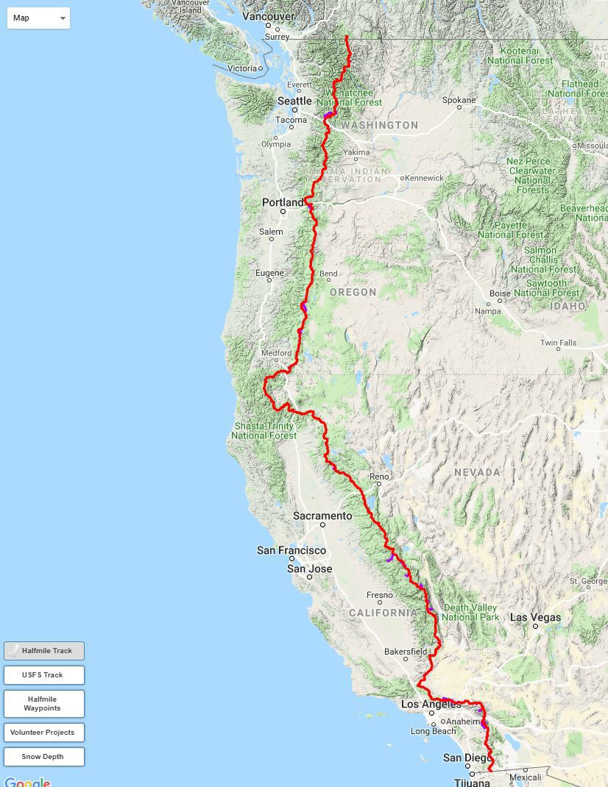

* And now, please fill in the portfolio with the basic answers:

*A nyní, prosím, vyplňte portfolio se základními odpověďmi:*

* **How long is the PCT?**

*Jak dlouhá je Pacifická hřebenovka?*

…………………………………………………………..

* **Which countries does it connect?**

*Které země spojuje?*

……………………………………………………………

* **How many states of the USA will you go through?**

*Kolika státy ze Spojených států amerických budeš procházet?*

…………………………………………………………….

* **Name them:**

*Vyjmenuj je:*

………………………………………………………………….

Please send this Word document with your answers back to my email [burdra@centrum.cz](mailto:burdra@centrum.cz)

*Prosím pošlete mi tento dokument s vašimi odpověďmi zpět na můj email burdra@centrum.cz.*

Thank you.

Appendix 2: II. day of preparation – flight ticket and visa

Wednesday 10th February 2021

Deadline 14th February 2021 *(termín odevzdání)*

Hello again, 

The second task is just in front of you. You must find a **flight ticket** for you and **information about the visa**  you will need.

*Druhý úkol je právě před tebou. Musíš si najít letenku a zjistit, jaké víza budeš potřebovat.*

*Vízum = povolení pro vstup do cizí země*

**FLIGHT TICKET** 

Please use this website:

*Prosím použij tyto webovky:*

* <https://www.skyscanner.cz/?locale=en-US&previousCultureSource=GEO_LOCATION&redirectedFrom=www.skyscanner.com>

and check how much you will have to pay for your flight ticket to the USA.

*Podívej se, kolik budeš muset zaplatit za svou letenku do USA*

Fill in the coloured marked fields:

*Vyplň barevně označená políčka:*

* Choose a city in your country (which airport will you fly from?)

*vyber město ve své zemi, odkud poletíš*

* According to the map below, choose a place in the USA (which airport will you land at?)

*podle mapy níže vyber místo, kam přistaneš*

* Choose a date when would you like to start your trip

*vyber si datum, kdy budeš chtít začít svou cestu*

And click on “search flights” *a klikni na “search flights”*



* And now, please fill in the portfolio:

*a nyní, prosím, vyplň portfolio:*

**My trip will start (when) …………….. at (where) ………………… airport. I will land at (where) …………….. airport on (when) …………… My flight ticket costs …………….. CZK.**



**VISA** 

Please use this website and check what kind of visa you need and how much it will cost you.

*Prosím použij tyto webovky a zjisti, jaká víza budeš potřebovat na svou cestu do USA a kolik budou stát.*

* <https://cz.usembassy.gov/cs/visas-cs/nonimmigrant-visas-cs/vsechna-viza/>

|  |  |
| --- | --- |
| **Popis** | **Typ víza** |
| Diplomaté & Vládní úředníci | [A-1/A-2](https://cz.usembassy.gov/cs/visas-cs/nonimmigrant-visas-cs/viza-a1-a2/) |
| Zaměstnanci v domácnosti držitelů víz A-1/A-2 | [A3](https://cz.usembassy.gov/cs/visas-cs/nonimmigrant-visas-cs/viza-a3/) |
| Služební cesty Domácí zaměstnanci Akademici, vědci a student | [B-1](https://cz.usembassy.gov/cs/viza/turistika-navstevy/) |
| Dovolená, turistika, léčebný pobyt | [B-2](https://cz.usembassy.gov/cs/viza/turistika-navstevy/) |
| Členové posádek letadel a lodí | [C-1/D](https://cz.usembassy.gov/cs/visas-cs/nonimmigrant-visas-cs/viza-pro-posadky-c1-d/) |
| Investoři | [E-1/E-2](https://travel.state.gov/content/travel/en/us-visas/employment/treaty-trader-investor-visa-e.html) |
| Australští profesionální specialist | [E-3](http://www.ustraveldocs.com/au/au-niv-typee3.asp) |
| Studenti: akademické & odborné vzdělávání | [F-1/M-1](https://cz.usembassy.gov/cs/visas-cs/nonimmigrant-visas-cs/studentska-viza-viza-f-1-a-m-1/) |
| Zaměstnanci mezinárodních organizací | [G-1/G-4](https://cz.usembassy.gov/cs/visas-cs/nonimmigrant-visas-cs/viza-g/) |
| Domací zaměstnanci držitelů víz G-1/G-4a | [G-5](https://travel.state.gov/content/travel/en/us-visas/visa-information-resources/temporary-workers.html) |
| Víza založená na zaměstnání včetně H–3 víz pro stážisty | [H](https://cz.usembassy.gov/cs/visas-cs/nonimmigrant-visas-cs/viza-h-pro-docasnou-praci/) |
| Vnitrofiremní přesun zaměstnanců | [L](https://travel.state.gov/content/travel/en/us-visas/employment/temporary-worker-visas.html) |
| Novináři & Pracovníci v médiích | [I](https://cz.usembassy.gov/cs/visas-cs/nonimmigrant-visas-cs/novinari-viza-i/) |
| Výměnné programy a Akademické pobyty Au-pair Stážisté | [J-1](https://cz.usembassy.gov/cs/visas-cs/nonimmigrant-visas-cs/vymenne-programy-au-pair-staziste-viza-j-1/) |
| Zaměstnanci zahraničních armád vyslaní do Spojených států | [NATO](https://travel.state.gov/content/travel/en/us-visas/other-visa-categories/visa-employees-nato.html) |
| Lidé s výjimečnými schopnostmi ve vědě, umění, vzdělávání, obchodě nebo sportovci | [O nebo P](https://cz.usembassy.gov/cs/visas-cs/nonimmigrant-visas-cs/viza-o-p/) |
| Mezinárodní kulturní výměnné program | [Q](https://travel.state.gov/content/travel/en/us-visas/employment/temporary-worker-visas.html) |
| Pracovníci církví | [R](https://travel.state.gov/content/travel/en/us-visas/other-visa-categories/temporary-religious-worker.html) |

* And now, please, fill in the portfolio:

*a nyní, prosím, vyplň portfolio:*

**I will need a ……………. visa. It costs ………………………….. CZK/USD.**

Please send this Word document with your answers back to my email [burdra@centrum.cz](mailto:burdra@centrum.cz). Symbol zvednutého palce

*Prosím, pošlete mi tento dokument s vašimi odpověďmi zpět na můj email burdra@centrum.cz.*

Thank you.

Appendix 3: III. day of preparation – equipment and food

Monday 15th February 2021

Deadline 21st February 2021 (termín odevzdání)

Welcome back to the trail . *(Vítej zpátky na stezce)*

The next thing you should know is what equipment , clothes   and food  you should take with you.

*Další věc, kterou musíš vědět je, co všechno (vybavení, oblečení, jídlo) si vzít s sebou.*

Play a game: *(Zahraj si hru)*

* <https://kahoot.it/challenge/06229652?challenge-id=b6e54797-3bcf-4da5-b3f6-18585500c7c7_1611617598985>
* Game PIN: **06229652**

Pravidla hry: postupně se Vám zobrazí 6 otázek. Na zodpovězení každé budete mít 60 sekund. Čím dříve odpovíte, tím vice získáváte bodů (pokud je Vaše odpověď správná). Vždy je jen jedna odpověď správná. Otázky se týkají pobytu na stezce.

And now choose what food you will probably pack for your trip and mark it in red:

*A nyní vyber, které jídlo si pravděpodobně zabalíš s sebou na cestu, a označ je červeně:*

  

OATMEAL HAMBURGER PIZZA

  

FRIES MUESLI BAR CORN FLAKES

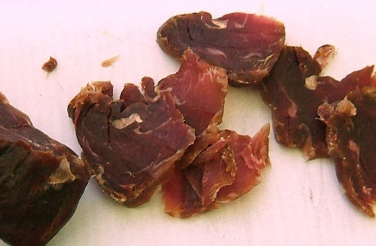  

DRY MEAT INSTANT COFFEE NUTS

  

DARK CHOCOLATE CRISPS SAUSAGES

 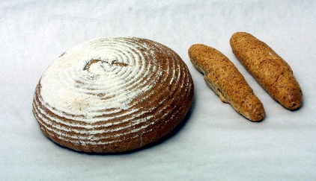 

CRACKERS, BISCUITS, COOKIES BREAD AND ROLLS DRIED FRUIT

  

PEANUT BUTTER CANDY ICE CREAM

  

INSTANT/DRY SOUP CANNED MEAT PANCAKES

Please send this document with your answers back to my email [burdra@centrum.cz](mailto:burdra@centrum.cz). Thanks.

*Prosím pošlete tento dokument s vašimi odpověďmi zpět na můj email. Děkuji.*

Appendix 4: IV. day of preparation – weather and clothes

Wednesday 17th February 2021

Deadline 21st February (termín odevzdání)

What is the weather like on the trail? 

*Jaké je počasí na stezce?*

Find the national parks (below) you will go through on Google Maps and look around using Street View. 

*Najdi národní parky (níže) přes které půjdeš na google maps a použitím street view se rozhlédni kolem.*

* <https://www.google.cz/maps/@49.8602829,18.0027588,9z>

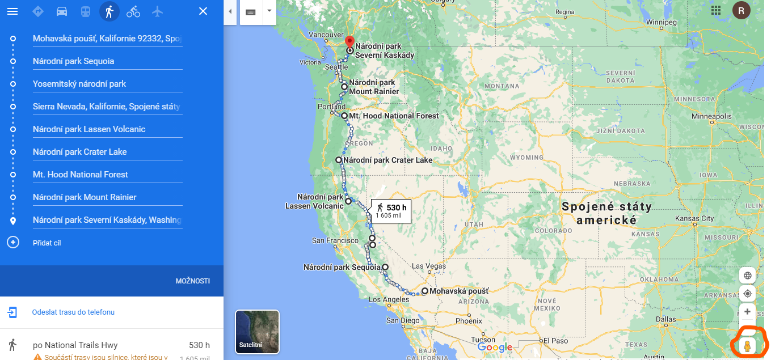

**STREET VIEW** – move the yellow man where you want to look around (potáhni žlutého panáčka tam, kde se chceš podívat)

1. Southern California – Mojave Desert
2. Central California – Sierra Nevada, Sequoia National Park, Yosemite National Park
3. Northern California – Lassen Volcanic National Park
4. Oregon – Crater Lake National Park, Mt. Hood National Forest
5. Washington – Mount Rainier National Park, North Cascades National Park

Please write numbers (1-5) next to the weather according to what you have seen on Street View or what you think the weather can be like there. For example: hot 1 (Southern California)

Prosím napište čísla (1-5) k počasí podle toho, co jste viděli na Street View, nebo podle toho, co si myslíte, jaké kde bude počasí. Například: teplo 1 (jižní Kalifonie)

**Hot - Snow -**

**Warm - Rainy -**

**Dry - Freezing -**

**Sunny - Foggy -**

**Cold - Breeze -**

**Windy - Fresh -**

Please play a game:

* <https://kahoot.it/challenge/04475422?challenge-id=b6e54797-3bcf-4da5-b3f6-18585500c7c7_1611617505073>
* Game PIN: **04475422**

Pravidla hry: postupně se Vám zobrazí 9 otázek. Na zodpovězení každé budete mít jiný časový limit, 20, 30 nebo 60 sekund, při čemž platí, že čím dříve odpovíte, tím vice získáváte bodů (pokud je Vaše odpověď správná). Někdy se nabízí otázky, kde je na výběr více odpovědí. Vždy je jen jedna odpověď správná. Někdy jsou otázky typu ANO/NE. Otázky se týkají pobytu na stezce.

Please send this Word document with your answers back to me at my email [burdra@centrum.cz](mailto:burdra@centrum.cz). Symbol zvednutého palce

*Prosím, pošlete mi tento dokument s vašimi odpověďmi zpět na můj email burdra@centrum.cz.*

Thank you.

# **Résumé**

Tato bakalářská práce se zabývá zážitkovým učením v digitálním prostředí. Praktická část měla za úkol zjistit, zda je zážitkové učení možné aplikovat do digitálního prostředí a zda v této podobě bude stejně efektivní a žáky oblíbené jako v jinak běžném, osobním, spíše venkovním, prostředí.

Krátký kurz angličtiny v digitálním prostředí proběhl, a tím se nám potvrdila první hypotéza, která tvrdí, že zkušenostní učení je možné provádět i v digitálním, online prostředí. Byly však objeveny nedostatky, na které je třeba se zaměřit, a to především správně si nastavit způsob komunikace s příjemci učení. Nepřímý osobní kontakt může způsobit řadu nedorozumění a nedostatečnou zpětnou vazbu, která může narušit proces učení.

Díky dotazníkovému šetření na konci kurzu jsme si mohli také částečně potvrdit druhou hypotézu. Znalostní dotazník byl vyhodnocen s 81procentní úspěšností, na základě čehož jsme schopni říct, že účastníci se v kurzu naučili nebo si zapamatovali v průměru 81 procent informací. Druhý dotazník, který hodnotil samotný kurz, potvrdil hypotézu, že se žáci raději učí anglický jazyk pomocí zážitků a zkušeností než klasickou školní formou, ale také vyvrátil tvrzení, že je digitální prostředí u žáků druhé stupně základních škol stejně oblíbené jako osobní zážitky. Většina účastníků preferovala zážitkové učení v outdoorovém prostředí než v online prostředí.

# **Anotace**

|  |  |
| --- | --- |
| Jméno a Příjmení: | Radka Burďáková |
| Katedra: | Ústav cizích jazyků |
| Vedoucí práce: | doc. PhDr. Václav Řeřicha, CSc. |
| Rok obhajoby: | 2021 |
| Název práce: | Výuka angličtiny na stezce (Aplikace zkušenostního učení do digitálního prostředí) |
| Název práce v angličtině: | Learning English on the Trail: Application of Experiential Learning in a Digital Environment |
| Anotace práce: | Tato bakalářská práce se zabývá zážitkovým učením a jeho aplikací do digitálního prostředí. Cílem práce je zjistit, zda je zážitkové učení možné provozovat v digitálním prostředí a zda bude pro žáky stejně efektivní a zábavné jako v běžné, osobní formě. Práce je rozdělena na teoretickou a praktickou část. První část je zaměřena na obsah a historii zážitkového učení a představuje také základní principy, které je třeba při zážitkovém učení dodržet. Druhá část je krátký kurz anglického jazyka vedený v digitálním prostředí a zahrnuje také výsledky dotazníkového šetření. |
| Klíčová slova: | Zkušenostní učení, zážitek, učení, digitální prostředí, stezka |
| Anotace práce v angličtině: | This Bachelor’s thesis deals with experiential learning and its application in a digital environment. The main objective is to find out if experiential learning is applicable in a digital environment and if it will be as effective and enjoyable as in outdoor surroundings. The thesis is divided into theoretical and practical parts. The first one focuses on the definition and history of experiential learning and it also deals with basic principles which must be followed. The second part describes a small English course organized in a digital environment and also includes the results of its evaluations. |
| Klíčová slova v angličtině: | Experiential learning, experience, learning, digital environment, trail |
| Přílohy vázané v práci: | 4 |
| Rozsah práce: | 41 |
| Jazyk práce: | Angličtina |