UNIVERZITA PALACKÉHO V OLOMOUCI

Filozofická fakulta

Katedra anglistiky a amerikanistiky

SUBJECT-PREDICATE INVERSION IN REPORTING CLAUSES OF DIRECT REPORTED SPEECH

(Bakalářská práce)

2017 Michaela Hetclová

Subject-Predicate Inversion in Reporting Clauses of Direct Reported Speech

(Bakalářská práce)

Autor: Michaela Hetclová

Studijní obor: Anglická filologie

Vedoucí práce: doc. PhDr. Ludmila Veselovská, Ph.D.

Počet normostran: 33

Olomouc 2017

Prohlašuji, že jsem tuto diplomovou práci vypracovala samostatně a uvedla úplný seznam citované a použité literatury.

V Olomouci dne 4. května 2017 …………………………

**Acknowledgements**

I would like to thank doc. PhDr. Ludmila Veselovská, Ph.D., for her time, patience and help throughout the process of writing this thesis, and mgr. Markéta Janebová, Ph.D., for her help with the corpus.

**ABSTRACT**

This bachelor thesis is focused on reporting clauses in the direct reported speech and more specifically on the inversion of the subject, in the form of either pronouns or nouns proper, and the predicate. In the first, theoretical part I will describe the types of reported speech and the differences between them. The second part will be interested in the ratio of the direct reported speech and will also focus on what the percentage of the inversion is, with the help of the InterCorp corpus. It will also describe the position of the reporting clauses and its effect on the subject-predicate inversion.

Keywords: direct reported speech, reporting clauses, reporting verbs, inversion, subject, predicate

**ANOTACE**

Tato práce se zaměřuje na uvozovací věty přímé řeči a zvláště se soustředí na inverzi přísudku a podmětu ve formě zájmen či vlastních jmen. Za pomoci korpusu InterCorp se tato práce zajímá o procentuální poměr přímé řeči a dále konkrétněji o poměr inverze. Také popisuje pozici uvozovacích vět v přímé řeči a její vliv na inverzi.

**Klíčová slova**: přímá řeč, uvozovací věty, uvozovací slovesa, inverze, podmět, přísudek

Obsah

1 Introduction 7

2 Theoretical Part 8

2.1 The Cambridge Grammar of the English Language 8

2.2 A Comprehensive Grammar of the English Language 12

2.3 Mluvnice současné angličtiny na pozadí češtiny 15

3 Subject-Predicate Inversion in Use 17

3.1 The verb added 18

3.2 The verb answered 20

3.3 The verb asked 22

3.4 The verb ordered 24

3.5 The verb promised 26

3.6 The verb said 29

3.7 The verb thought 31

3.8 The verb told 34

3.9 The verb wondered 37

3.10 The verb wrote 40

4 Conclusion 43

5 Resumé 46

6 Works Cited 47

7 Abbreviations of the InterCorp results 48

# Introduction

This thesis will focus on the reported speech, mainly on the phenomenon of the subject and predicate inversion. This phenomenon may occur with the reporting verbs and their subjects in the reporting clauses of the direct reported speech.

The first, theoretical part will describe both types of reported speech and their subtypes. It will focus on the most distinctive points, which appeared in the works of Geoffrey Leech (1985), Libuše Dušková (1988), and Rodney Huddleston and Geoffrey Pullum (2002).

According to Rodney Huddleston and Geoffrey Pullum (2002), there are two main types of reported speech. There is the direct reported speech, which sets to give the original utterance verbatim, while the indirect reported speech gives only the meaning.

Geoffrey Leech (2004) also lists a secondary model of free indirect speech, while mentioning that it is “a very common device of narrative writing” (Leech 2004, 112), and adds that it differs from the two types of reported speech by not using the reporting clauses, “which are the conventional signals of indirect speech.” (Leech 2004, 112)

Geoffrey Quirk adds another subtype of reported speech. Apart from free indirect speech, he also lists free direct speech. He mentions that this form also omits the reporting clauses, because the process of reporting is signalled by the tense shifting (Quirk 1985, 1021).

The practical part will immediately follow with a special interest in the phenomenon of the subject-predicate inversion. According to Huddleston and Pullum, the inversion occurs often in the direct reported speech (H&P 2002, 1027), but all the authors add the conditions that need to be met in order for the inversion to happen. Huddleston and Pullum say that the inversion is not permitted when the verb requires an object (H&P 2002, 1027). Huddleston and Pullum also admitted that the inversion with personal pronouns may occur, but it is regarded as archaic, while Quirk and Dušková say that it does not occur at all when the subject is a pronoun.

The goal of this thesis is to find out which reporting verbs are used most often and how often they are used in the reporting clauses of the direct reported speech. This thesis further aims at finding out how commonly the subject-predicate inversion in reporting clauses of the direct reported speech appears in real use, with the help of the InterCorp corpus.

# Theoretical Part

## *The Cambridge Grammar of the English Language*

Reported speech is a language that is used when a speech or a written text are being reported. According to Huddleston and Pullum (H&P 2002) there are two types of reported speech – direct and indirect.

### Indirect Reported Speech

The indirect reported speech does not aim to give the exact wording, it gives only the content of the original speech and therefore it is used more commonly.

#### Deictic Expressions

Huddleston and Pullum also stated that the most prominent difference between the direct and indirect reported speech is the interpretation of used deictic expressions. Deictic expressions are words which point to, or indicate what they refer to (Leech 2006, 32). Common deictic words, such as demonstrative pronouns, time adverbs, or place adverbs (Leech 2006, 33) and their interpretation is always relative and dependent on the original utterance. Huddleston and Pullum mention two specific cases of deictic expressions that they further analyse.

#### Person

According to the authors of the book, person is the most straightforward case and example of the relative interpretation of the text (H&P 2002, 1025). The interpretation is shown and analysed in example (1a) and (1b).

(1) (a) *I love you.*

(b) You said you loved me. / He said he loved me. / I said I loved her.

Considering that the sentence in (1a) *I love you* was said to Jane by Stephen. Now any of the indirect versions in (1b) can be correct provided that appropriate people are relevantly reporting the message, as the first example is appropriate when Jane is reporting the utterance to Stephen, the second one when Jane is reporting the utterance to someone else and the same situation occurs in the third sentence when Stephen is reporting to someone else. However, there can be a lot of other variants and all of them correct depending on who is reporting the utterance to whom.

#### Tense (backshift)

Another deictic expression used in reported speech is tense. Huddleston and Pullum emphasize that there is nothing remarkable about the change in personal pronouns, but definitely not with the case of tense (H&P 2002, 1025). As can be noted in example (2a) and (2b), reported speech often has a preterite tense whereas the original speech uses a present tense (H&P 2002, 1025). The preterite tense is, however, a special case of a past tense called the backshifted preterite (H&P 2002, 1025).

(2) (a) I love him. (present tense)

(b) Jane said she loved him. (backshifted preterite)

In the original sentence in example (1a) *love* is in the present tense. In example (1b) the backshifted preterite is used. Normally, a past tense would locate the situation of Jane loving Stephen prior to the act and time of speaking, but not in the case of a backshifted preterite (H&P 2002, 1025). However, in (2b) the picture of Jane loving him is not situated prior to the act of speaking, it is in the exact moment when the speech is happening.

Huddleston and Pullum also mention a case of backshifting of what was a preterite in the original clause and explain that a preterite perfect is used in the reported speech.

The backshifting of tense occurs when either of the two following conditions is met:

(3) (a) The **tense** of the matrix clause is past.

(b) The **time** of the matrix clause situation is past.

Usually both of those conditions are satisfied at once, however, meeting either one of them is completely sufficient, as in (4).

(4) Stephen has never said she was incompetent.

In example (4) there is only the first condition of (3a) satisfied. Although the tense is technically present, it has the notion of past and that is enough for the backshifting to occur.

#### Other deictic expressions

Generally, other deictic expressions, such as temporal or space adverbials or demonstrative pronouns, follow the same rules as pronouns and nouns that was described in the section about person. Huddleston and Pullum show this phenomenon on example (5a), which is then analysed in (5b).

(5) (a) The lease expired yesterday.

(b) Stephen told me the lease had expired yesterday / the day before / on 26 May / last Thursday.

The temporal adverbial *yesterday* in (5a) points to the day that preceded the day of the realization of the lease having expired. In the reported speech in (5b) *yesterday* can also make sense but only provided that the original speech is being reported on the same day. The other expressions, such as *26 May* or *last Thursday*, also point to the same day as in (5a).

### Direct Reported Speech

Direct reported speech conveys the actual wording of the original speech, but the conditions for using the direct form are very limited. Huddleston and Pullum give the examples of having an access to a recorded or written version of the speech, being able to remember it or the direct reported speech being a part of a fiction (Huddleston and Pullum, 1023).

#### Embedded vs Non-embedded Reported Speech

Huddleston and Pullum show on a quite simple example the difference between embedded (6a) and non-embedded (6b) constructions. Although they state that there is not a big difference in meaning, there is a difference in the syntactic construction.

(6) (a) She replied, ‘I live alone.’

(b) ‘I live alone,’ she replied.

In embedded constructions, as in (6a), the reported speech functions as a complement of the reporting verb. In other words, in (6a) the clause *She replied* is syntactically superordinate to the complement clause *‘I live alone.’* In (6b) the clause *she replied* is a parenthetical to the reported speech.

#### Position of the Parenthetical

The parenthetical is usually positioned after the reported speech, but can be found medially within it (H&P 2002, 1027). The medial position can be after the first element, as in (7), which may be a vocative, and adjunct or the subject, between the verb and its clausal complement, as in (8), also before an object provided that it is relatively heavy, as in (9), or following the first coordinate in a clause-coordination, as in (10). Coincidentally, these are all positions where an adjunct can be inserted.

(7) “Jane,” Stephen called, “have you talked to Mary?”

(8) “I think,” Jane replied, “that I haven’t seen her today.”

(9) “I have bought,” Stephen insisted, “only the cereal that you eat.”

(10) “It’s already the afternoon,” Stephen complained, “and you haven’t even had breakfast.”

#### Form of the Parenthetical

The parenthetical can appear in two different variants. As Huddleston and Pullum stated, “[t]he subject of a parenthetical reporting frame is often postponed.” (H&P 2002, 1027)

(11) (a) “I love you,” said Stephen.

(b) “I love you,” Stephen said.

This postponing of a subject usually occurs with the direct reported speech, but is definitely not permitted when there is an object. Postponing of a personal pronoun subject can happen, but it is regarded as archaic.

### Reporting verbs

Huddleston and Pullum also give a sample of verbs that can be used to report direct speech and they add that embedded constructions tend to prefer more general verbs (H&P 2002, 1027).

|  |  |  |  |  |  |
| --- | --- | --- | --- | --- | --- |
| add | admit | advise | agree | answer | argue |
| ask | beg | begin | boast | call | comment |
| declare | demand | explain | go | grin | inquire |
| maintain | mumble | observe | order | promise | reason |
| remark | reply | say | smile | state | suggest |
| tell | think | warn | wonder | write | yell |

## *A Comprehensive Grammar of the English Language*

Quirk describes two parts of a sentence in reported speech. There is a reporting clause that refers to the speaker and the act of communication in speech or writing. It can also refer to the people spoken to, the manner of speaking, or the speech act circumstances (Quirk 1985, 1020).

A reported clause, which conveys the utterance itself, can take either the form of direct speech or indirect speech. Indirect reported speech aims to convey only the meaning of the original utterance, unlike direct reported speech that purports to give the exact wording of the original utterance.

There are also two secondary modes related – free indirect speech and free direct speech (Quirk 1985, 1021). The fact that it is reported speech is signalled usually by the shifts in the tense form of verbs.

### Direct Reported Speech

According to Quirk, direct speech is usually signalled by being enclosed in quotation marks (Quirk 1985, 1022).

#### Position of the Reporting Clause

It may occur in the sentence initial or final position, but also medially within the direct speech. In the case of the direct speech extending over more sentences, the reporting clause is usually positioned medially within the first sentence.

Reporting clauses and in some cases also quotation marks can be omitted, such as in fiction writing, where the identity of the speaker is usually obvious, in written plays, formal reports of a meeting, or in headlines.

#### Form of the Reporting Clause

When the reporting clause is within the direct speech, inversion of the subject and the verb may occur, if the verb is either in simple present or simple past, the subject is not a personal pronoun, and the reporting clause is in the medial position. The inversion is most common with the verb *said*, as in (12).

(12) “I’m not sure,” said Jane, “if he loves me.”

The inversion of subject and verb, in the case of the subject being a pronoun usually does not occur, as it is regarded unusual and archaic, even if the verb is said (Quirk 1985, 1022).

### Reporting Verbs

At the end of the Direct Speech chapter, Quirk gives a table of the reporting verbs frequently used with direct speech, and adds that the most common verb is *say*. There are also other reporting verbs that are occasionally used, which refer to the manner of speaking, such as *falter*, *mumble*, *murmur*, *mutter*, *snap*, *sneer*, or *sob* (Quirk 1985, 1024).

|  |  |  |  |
| --- | --- | --- | --- |
| add | comment | object | say |
| admit | conclude | observe | shout (out) |
| announce | confess | order | state |
| answer | cry (out) | promise | tell |
| argue | declare | protest | think |
| assert | exclaim | recall | urge |
| ask | explain | remark | warn |
| beg | insist | repeat | whisper |
| boast | maintain | reply | wonder |
| claim | note | report | write |

### Indirect Reported Speech

Indirect speech is typically used for reporting statements and utterances without putting the emphasis on the exact wording, the reporter can make changes from the original utterance, in

(13a), but those changes do not affect the truth of the report, as in

(13b). This type of reported speech usually takes the form of a nominal that-clause (Quirk 1985, 1025).

(13) (a) “I think I would like to read that book that Jane bought me last year,” said Stephen.

(b) Stephen said he wanted to read the book from Jane.

The report conveyed through the indirect reported speech requires some changes, only because the situation and circumstances of the reporter are different from the situation of the speaker. This change of circumstances affects the use of deictic expressions, those features that refer to the time and place.

There are five different groups of deictic features to discuss: tense forms of the verb, other time references, place references, personal pronouns, and the demonstratives.

#### Backshift

Quirk also describes a phenomenon known as backshift. He states that this is normally optional, but it may result in seemingly anachronistic use of the past tense for present time.

In some cases, the verb in the reporting clause may be in the present tense. This applies to events in recent past, but it is also used for referring to famous works, or works ‘that have present validity,’ (Quirk 1985, 1026), as in (14).

(14) The Bible says love endures all things.

The tense of the verb in the reported clause is therefore dependent on the verb tense in the reporting clause, but as can be observed in (15), the verb *loved* is backshifted, although the reporting verb is in the present simple. This tense shifting signalizes that the situation of Stephen loving her preceded the act of him saying that, unlike in (16) where the act of Stephen loving her is happening at the same time as he is saying that.

(15) Stephen says he loved her.

(16) Stephen says he loves her.

In other words, Quirk says that when the temporal reference of the reported clause is no longer relevant at the time of reporting the utterance, the tense of the verb in the reported clause needs to be changed appropriately and calls this change **backshift**. There are four changes illustrated in a table. If there is a present tense in the reporting clause, it shifts to a past tense in the indirect speech. Accordingly, past tense from the direct speech shifts to a past or past perfective in the reported speech and past or present perfective tenses shift to the past perfective in the indirect speech (Quirk 1985, 1026).

Backshift is optional when the original utterance is still valid at the time of the reporting, as illustrated in (18) where Saint Paul’s quote is still relevant to this day and the backshift is optional unlike in (17) where it is obligatory.

(17) John Laurens said he was sorry.

(18) Paul the Apostle said that hope does/did not disappoint.

#### Other Changes

Other changes that occur in indirect speech are concerning personal pronouns. **Pronoun shift** occurs when the speaker and the addressee are absent in the reported speech and this shifts the 1st and 2nd person pronouns to 3rd person pronouns.

**Time references** are also changed appropriately to the time of the reported utterance.

## *Mluvnice současné angličtiny na pozadí češtiny*

According to Libuše Dušková (1988), reported speech is utterance that is reporting another speech or written text. There are two types of reported speech – direct and indirect.

### Direct Reported Speech

In direct reported speech, the reported sentence functions as a main clause together with the reporting clause. It is usually signalled by quotation marks.

In this case, the reporting clause can be in the sentence initial or sentence final position, but it can also be found medially within. When it is sentence initial, it is followed by a colon and quotation marks, otherwise a comma is used.

An inversion of subject and verb in the reporting clause may occur, only provided that the subject is not a personal pronoun and the clause is not in the sentence initial position.

The reporting verbs most commonly used are usually describing the manner of the utterance, such as *say*, *ask*, *order*, or *shout*, but also verbs describing the mood or the behaviour of the speaker may be used, such as *grin*, or *sigh*.

### Indirect Reported Speech

In the case of indirect reported speech, the reported clause is a subordinate clause, dependent on the reporting clause.

#### Deictic Expressions

Dušková mentions three cases of deictic expressions that need to be shifted appropriately according to the new situation.

**Person**

The shift of personal pronouns occurs when there is a change of speaker. The 1st person pronoun is used when the speaker talks about themselves, the 2nd person pronoun is used to address the hearer and for any other people involved, 3rd person pronouns are used. When neither the speaker nor the hearer are present in the utterance, the pronouns do not shift at all.

**Other Deictic Expressions**

Other deictic expressions, such as demonstrative pronouns, temporal or special adverbs are also subject to the shift in reported speech. Dušková gives three examples, that are shown in (19).

(19) this, that → that, those

here → there

today → that day

**Tense Shift**

According to Dušková, the tense in the reported clause is always relative and its interpretation dependant on the reporting clause. This is shown in examples from (20) to (22). In example (20) the reporting clause shows the act of Stephen saying the utterance and the situation of loving her happening at the same time, therefore the tense in the reported clause needs to be shifted to the past tense. In example (21) the situation of Stephen loving her happened prior to the time of Stephen saying that and Dušková suggests shifting the tense of the verb in the reported clause to the past perfect. Example (22) shows a situation where Stephen saying the utterance was followed by him loving her.

(20) *Stephen said he loved her.*

(21) Stephen said he had loved her.

(22) Stephen said he would have loved her.

In case there is a present tense in the reporting clause, no other tense shift occurs in the reported clause, and also in case the reported clause expresses a situation still valid at the time of the reporting of the utterance. No shifts also occur if there is already a past perfect tense in the original utterance.

# Subject-Predicate Inversion in Use

In this section I will analyse the usage of reported speech, in particular what the ratio of the verb being used in reporting clauses of direct reported speech is and then what the percentage of the subject-predicate inversion is. For this reason, the Intercorp corpus was used.

A list of the examined verbs was created by comparing the lists of reporting verbs that Quirk (1985) and H&P (2002) gave in their books, and choosing those that were listed in both. Then their past tense forms were compared in the corpus and the first ten most frequently used verbs will be discussed in this thesis. The ten verbs are *to say*, *think*, *tell*, *ask*, *write*, *promise*, *wonder*, *add*, *answer*, and *order*, and will be discussed further in this thesis in the alphabetical order.

The parallel corpus Intercorp is a project of the Faculty of Arts of the Charles University in Prague.

The Intercorp corpus uses the Corpus Query Language (CQL). The SketchEngine website describes CQL as “a special code or query language used in SketchEngine to search for complex grammatical or lexical patterns or to use search criteria which cannot be set using the standard user interface.” The Intercorp corpus also uses the Pentree tagset for tagging the part of speech (POS).

In the corpus I created a subcorpus using all of the types of texts, with the supcorpus having around 70 million words.

The query for each verb was composed of comparing two phrases divided by the OR operator ( | ). The query tags for each verb have to be in round brackets as a whole and each part in square brackets. One square bracket included the value of the verb in the past tense and the other square bracket included the tag of the noun proper, in the form of “NP”, or of the personal pronoun, in the form of “PP”.

The Intercorp corpus creates shuffles the results automatically, so they are always random.

With every verb, I searched for 100 examples of reporting clauses of the direct reported speech to determine how common the usage in the reporting clauses is, and then to determine the percentage of the subject-predicate inversion in the sample of 100 examples.

## The verb *added*

### The verb *added* with nouns proper

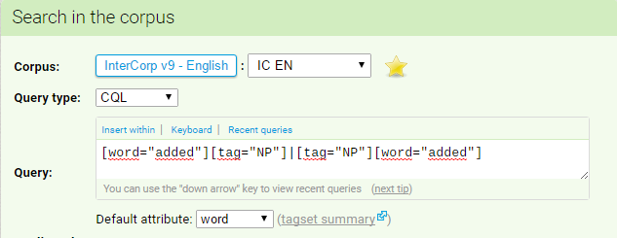

**Figure 1** The query used to find the reporting verb added either preceded or followed by a noun proper

In **Figure *1*** there is a description of the query used to retrieve the results for the verb *added* either preceded or followed by a noun proper. There were 416 hits total, which were manually sorted out to eliminate the irrelevant samples. Then the chronologically first 100 suitable examples were chosen. The 100 examples of the reporting verbs usage in the direct reported speech were found among the first 116 hits. [1]

Out of the 100 examples, there were 39 cases of the subject-verb inversion, three of them are shown in the example (23), specifically the various positions of the parenthetical. It could be found in all places except for the sentence-initial position, which, according to Dušková (1988, 607), does not permit subject-predicate inversion. as is the sentence-final position in (23a) and (23b), and the medial position within the reported clause in (23c).

(23) (a) *“And send it to the King,”****added Pike****.* (JF_NE)

(b) *‘—And make no mistake, we'll hear about it,’****added Lupin*** *pleasantly.* (JR_FR)

(c) *‘Though of course,’****added Doyle****, ‘I do not agree with his analysis.’* (JB_AG)

In the examples with no subject-predicate inversion, the parenthetical could be found in all positions, sentence-initial, (24a), sentence-final, (24b), and medial, (24c).

(24) (a) *In the silence,****Charles added****, ‘It is highly insulting to Miss Freeman.’*(JF_FM)

(b) *"Shove off, Tubby,"****Betty added****.* (JT_SH)

(c) *"That's what I wished,"****Isa added****," when I dropped my pin. Water. Water..."* (VW_MA)

|  |  |  |  |  |
| --- | --- | --- | --- | --- |
| added + NP | direct speech ratio | inversion | non-inversion | S-P inversion percentage |
|  | 86.21% | 39 | 61 | 39% |

### The verb *added* with personal pronouns

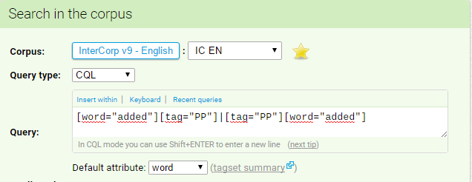

**Figure 2** The query used to find the reporting verb added either preceded or followed by a personal pronoun

In **Figure *2*** there is a description of the query used to retrieve the results for the verb *added* either preceded or followed by personal pronoun. There were 1,202 hits total, which were manually sorted out to get rid of the irrelevant samples Then the chronologically first 100 suitable examples were chosen and were found among the first 117 hits.[2]

Out of the 100 examples, there was only 1 case with the subject-predicate inversion, as is shown in (25), with the parenthetical in the medial position within the reported clause. Dušková argued that the subject-predicate inversion cannot happen when the subject of the reporting clause is a personal pronoun (Dušková 1988, 607), Quirk and Huddleston and Pullum admitted that it can occur, but it is regarded as highly archaic (H&P 2002, 1027).

(25) *“And when you finally quit me, Bartleby,”****added I****, “I shall see that you go not away entirely unprovided. Six days from this hour, remember.”* (HM_BA)

The remaining 99 examples were all cases of no subject-verb inversion, as is shown in the example (26), also with the variable position of the parenthetical. When the parenthetical appeared in the sentence-final position, there was often a description of the tone of the voice, such as in (26d).

(26) (a) ***He added****, "See for yourself if you like."* (AH_KD)

(b) *'Oh, and do you remember' -****she added*** *- 'a conversation we had once about driving a car?'* (FF_VG)

(c) *“And what are you two doing?”****he added****, catching sight of Harry and Ron on the path ahead.* (JR_OP)

(d) *‘Do you think they will?’****she added****, nonchalantly.* (TP_SS)

|  |  |  |  |  |
| --- | --- | --- | --- | --- |
| added + PP | direct speech ratio | inversion | non-inversion | S-P inversion percentage |
|  | 85.47% | 1 | 99 | 1% |

## The verb *answered*

### The verb *answered* with nouns proper

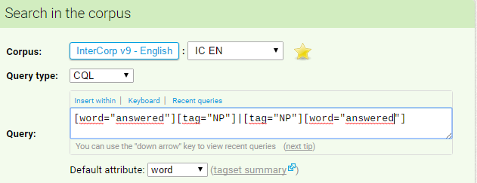

**Figure 3** The query used to find the reporting verb answered either preceded or followed by a noun proper

In **Figure *3*** there is a description of the query used to retrieve the results for the verb *answered* either preceded or followed by a noun proper. There were 757 hits total, which were manually sorted out to get rid of the irrelevant samples[3]. Then the chronologically first 100 suitable examples were chosen. The 100 examples of the reporting verbs usage in the direct reported speech were found among the first 141 hits.

Out of the 100 examples, the subject-predicate inversion was found in 49 cases. In the cases where there was the subject-predicate inversion, the most common position of the parenthetical seemed to be the sentence-final one, as in (27a). There were also examples of the subject-predicate inversion, when the parenthetical was in the medial position within the reported clause, as is shown in (27b).

(27) (a) *'Elrond commanded it,'****answered Gandalf****.* (JT_SP)

(b) *'Go ahead,'****answered Daisy*** *genially, 'and if you want to take down any addresses here 's my little gold pencil.*' (FF_VG)

In the remaining 51 cases when the subject-predicate inversion did not take place, the parenthetical could be found in the sentence-final position, as in (28a), but also in the sentence-initial position, as in (28b).

(28) (a) *"Thank you, Doctor,"****Alexander answered*** *politely.* (AH_KD)

(b) *And****Beleg answered****: ‘I will seek Túrin until I find him, and I will bring him back to Menegroth, if I can; for I love him also.’* (JT_SM)

In (29) there is an example of the reporting clause in the medial position within the reported clause, but the subject-predicate inversion could not take place, as Quirk suggested that it is not permitted when there is an object.

(29) *‘Can you believe it, John,’****Piers answered*** *him, ‘these crazy villains,’ he heard himself use the policeman’s word, ‘wanted to blow up Parliament.’* (AW_CHS)

|  |  |  |  |  |
| --- | --- | --- | --- | --- |
| answered + NP | direct speech ratio | inversion | non-inversion | S-P inversion percentage |
|  | 70.92% | 49 | 51 | 49% |

### The verb *answered* with personal pronouns

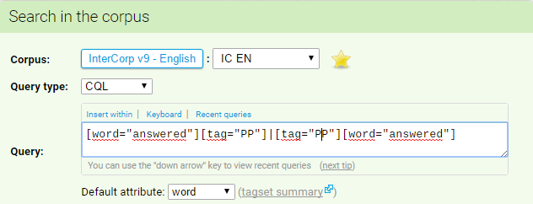

**Figure 4** The query used to find the reporting verb answered either preceded or followed by a personal pronoun

In **Figure *4*** there is a description of the query used to retrieve the results for the verb *answered* either preceded or followed by a personal pronoun. There were 866 hits total, which were manually sorted out to dispose of the irrelevant samples. Then the chronologically first 100 suitable examples were chosen. The 100 examples of the reporting verbs usage in the direct reported speech were found among the first 245 hits.[4]

There was no case of the subject-predicate inversion in the 100 examples. In the cases with no inversion, the parenthetical could be found in the sentence-initial as well as sentence-final position, as in (30a) and (30b) respectively.

(30) (a) ***He answered*** *noncommittally, "I'm not suggesting anything, Reub. Just making some inquiries." (AH_KD)*

(b) *“But I do mind,”****he answered****.* (BS_DR)

|  |  |  |  |  |
| --- | --- | --- | --- | --- |
| answered + PP | direct speech ratio | inversion | non-inversion | S-P inversion percentage |
|  | 40.82% | 0 | 100 | 0% |

## The verb *asked*

### The verb *asked* with nouns proper

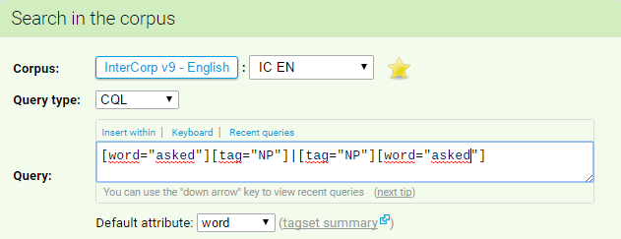

**Figure 5** The query used to find the reporting verb asked either preceded or followed by a noun proper

In **Figure *5*** there is a description of the query used to retrieve the results for the verb *asked* either preceded or followed by a noun proper. There were 7,073 hits total, which were manually sorted out to get rid of the irrelevant samples. Then the chronologically first 100 suitable examples were chosen. The 100 examples of the reporting verbs usage in the direct reported speech were found among the first 132 hits.[5]

Out of the 100 examples, the subject-predicate inversion was found in 49 cases. With the subject-predicate inversion, the parenthetical most often seemed to be found in the sentence-final position, as is shown in (31a) and (31b).

(31) (a)  *‘What do you think?’****asked Dumbledore****.* (JR_PDK)

(b) *'Have they got any weapons?'****asked Merry****.* (JT_NK)

In the remaining 51 cases the subject-predicate inversion did not take place and the parenthetical was found in the sentence-initial as well as sentence-final position, as it is shown in (32a) and (32b).

(32) (a) *"The operas of Wagner?"****Sophie asked****.* (DB_SML)

(b) ***Meg asked****: 'Are you alone?'* (PJ_PT)

|  |  |  |  |  |
| --- | --- | --- | --- | --- |
| asked + NP | direct speech ratio | inversion | non-inversion | S-P inversion percentage |
|  | 75.76% | 49 | 51 | 49% |

### The verb *asked* with personal pronouns

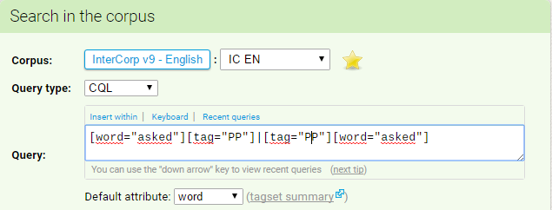

**Figure 6** The query used to find the reporting verb asked either preceded or followed by a personal pronoun

In **Figure *6*** there is a description of the query used to retrieve the results for the verb *asked* either preceded or followed by a personal pronoun. There were 14,851 hits total, which were manually sorted out to get rid of the irrelevant samples. Then the chronologically first 100 suitable examples were chosen. The 100 examples of the reporting verbs usage in the direct reported speech were found among the first 698 hits.[6]

Out of the 100 examples, the subject-predicate inversion was not found in any case.

In all cases where the subject-predicate inversion did not occur, there were different cases of the parenthetical position, as is shown in (33a) and (33b).

(33) (a) *"And what was he thinking, to create a character so fundamentally blind that he does not even understand the true import of his utterances?"****she asked****.* (AS_VP)

(b) ***He asked****: “Wasn't the scientist who killed himself, Dr Toby Gledhill, working on the research side here with you? I thought I read something about that in one of the local papers.”* (PJ_PT)

|  |  |  |  |  |
| --- | --- | --- | --- | --- |
| asked + PP | direct speech ratio | inversion | non-inversion | S-P inversion percentage |
|  | 14.33% | 0 | 100 | 0% |

## The verb *ordered*

### The verb *ordered* with nouns proper

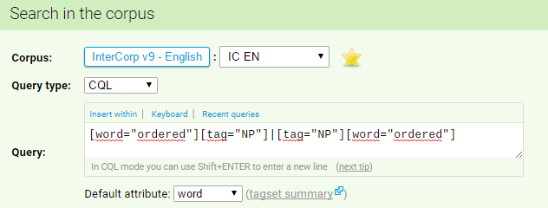

**Figure 7** The query used to find the reporting verb ordered either preceded or followed by a noun proper

In **Figure *7*** there is a description of the query used to retrieve the results for the verb *ordered* either preceded or followed by a noun proper. There were 446 hits total, which were manually sorted out to eliminate the irrelevant samples. Then the chronologically first 100 suitable examples were chosen. The 100 examples of the reporting verbs usage in the direct reported speech were found among the first 329 hits.[7]

Out of the 100 examples, there were 48 cases of the subject verb inversion. The parenthetical with the inversion seemed to appear most likely in the sentence-final position, as in (34a), (34b), and (34c), as it occurred in 33 cases. In 2 cases the parenthetical with the inversion was in the medial position within the reported clause, as is shown in (34d).

(34) (a) *‘Pay him!’****ordered Bourne****, rigid, staring at the Chinese officer.* (RL_BM)

(b) *‘This way,’****ordered Ringo****, sniggering with glee.* (SH_KV)

(c) *‘Shhh!’****ordered Marie****, her index finger at her lips.* (RL_BM)

(d) *‘Master Young,’****ordered R. P. Tyler****, ‘please get your - your mutt away from my Shutzi.’* (TP_DZ)

In most cases, the subject-predicate inversion did not occur and again the parenthetical was most often in the sentence-final position, specifically in 64 cases, as in (35a). In 1 case, it was found in the medial position, as is shown in (35b).

(35) (a) *"Get out the snapshots, doll,"****Betty ordered****.* (JT_SH)

(b) *“Start over,”****Melekhin ordered****, “from the beginning.”* (TC_HP)

|  |  |  |  |  |
| --- | --- | --- | --- | --- |
| ordered + NP | direct speech ratio | inversion | non-inversion | S-P inversion percentage |
|  | 24.27% | 35 | 65 | 35% |

### The verb *ordered* with personal pronouns

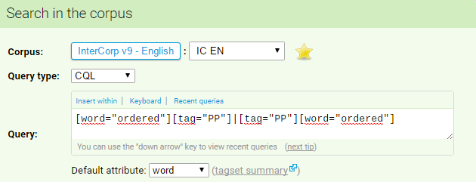

**Figure 8** The query used to find the reporting verb ordered either preceded or followed by a personal pronoun

In **Figure *8*** there is a description of the query used to retrieve the results for the verb *ordered* either preceded or followed by personal pronoun. There were 1,088 hits total, which were manually sorted out to dispose of the irrelevant samples. Among all the results, there were only 50 relevant cases of the verb *ordered* used in reporting clauses of direct reported speech.[8]

In the 50 hits, there was no example of the subject-predicate inversion.

In cases without the inversion, the parenthetical occurred in all possible positions, sentence-initial, in (36a), medial position within the reported clause, in (36b), and sentence-final, in (36c) and (36d).

(36)(a) After an awkward moment **she ordered**, 'Open the shutters, then. Not the window on the left. Just the middle and far windows. And only the lower part of the middle window.' (TC_GP)

(b) *'You must do this,'****he ordered****, 'for they are yours to give, not his or mine. As executor of his will I should not even be here to witness this, but he was my friend, and I would like to see his wish granted.'* (TC_GP)

(c)*‘Take off the rest,’****he ordered****.* (RL_BM)

(d)*"Pray anyway,"****she ordered****.* (JS_HH)

|  |  |  |  |  |
| --- | --- | --- | --- | --- |
| ordered + PP | direct speech ratio | inversion | non-inversion | S-P inversion percentage |
|  | 4.60% | 0 | 50 | 0% |

## The verb *promised*

### The verb *promised* with nouns proper

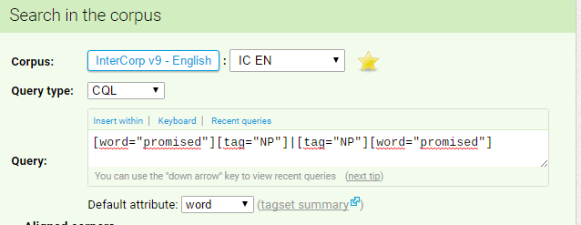

**Figure 9** The query used to find the reporting verb promised either preceded or followed by a noun proper

In **Figure *9*** there is a description of the query used to retrieve the results for the verb *promised* either preceded or followed by a noun proper. There were 436 hits total, which were manually sorted out to eliminate the irrelevant samples. Then the chronologically first 100 suitable examples were chosen. Among all the hits, the examples of the reporting verbs usage in the direct reported speech was found only in 17 cases. [9]

Out of the 17 cases, there were 4 examples of the subject-verb inversion, as is shown in (37a) and (37b), where the position of the parenthetical was always sentence-final.

(37) (a) *‘You'll have him,’* ***promised Sir Nigel****.* (FF_CP)

(b) *‘We’ll make a proper search tomorrow,’****promised Alan****.* (EP_SZ)

The examples in (38) show two cases, where the subject-predicate inversion did not occur, and in (39) there is an example, where the subject-predicate inversion could not occur as there is an object, as was suggested by Huddleston and Pullum (H&P 2002, 1027).

(38) (a) *“I’ll be there,”****Carlos promised****.* (RC_TO)

(b) *'The feet, too,'****Eddie promised****.* (JI_RV)

(39) *'Your scar will be a part of you forever,'****Eddie promised*** *her.* (JI_RV)

|  |  |  |  |  |
| --- | --- | --- | --- | --- |
| promised + NP | direct speech ratio | inversion | non-inversion | S-P inversion percentage |
|  | 3.90% | 4 | 13 | 24% |

### The verb *promised* with personal pronouns

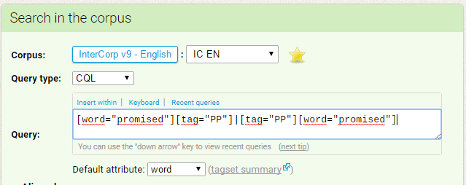

**Figure 10** The query used to find the reporting verb promised either preceded or followed by a personal pronoun

In **Figure *10*** there is a description of the query used to retrieve the results for the verb *promised* either preceded or followed by a personal pronoun. There were 3,300 hits total which were manually sorted out to get rid of the irrelevant samples. Among all the results there were only 23 relevant examples. [10]

Out of the 23 examples none showed the subject-predicate inversion. In the example (40b) the reason could be the object, with which the inversion is not permitted (H&P 2002, 1027). The examples (40a) and (40b), and (40c) show the medial position of the reporting clause, while in (40d) and (40e), there are example sentences where the position of the reporting clause was sentence-final.

(40) (a) *“I’ll treat you like my own boy,”****she promised****, “my own Howard.”* (SB_DO)

(b) *“Some day,”****she promised*** *Rosewater, “I'm going to come in here, and Billy is going to uncover his head, and do you know what he's going to say?”* (KV_JP)

(c) *"I'll try it when I go home,"****she promised****, wondering if that was why she had seen Johnny in the dream, if that had been his message for her.* (DS_SA)

(d) *"I won't melt“****she promised****.* (JK_ZS)

(e)*'I'll come every Sunday,'****I promised****.* (TC_GP)

|  |  |  |  |  |
| --- | --- | --- | --- | --- |
| promised + PP | direct speech ratio | inversion | non-inversion | S-P inversion percentage |
|  | 0.7% | 0 | 23 | 0% |

## The verb *said*

### The verb *said* with nouns proper

**Figure 11** The query used to find the reporting verb said either preceded or followed by a noun proper

In **Figure 11** there is a description of the query used to retrieve the results for the verb *said* either preceded or followed by a noun proper. There were 67,187 hits total, which were manually sorted out to get rid of the irrelevant samples. Then the chronologically first 100 suitable examples were chosen. The 100 examples of the reporting verbs usage in the direct reported speech were found among the first 117 hits.[11]

Out of the 100 examples, the subject-predicate inversion was found in 66 cases, as is shown in (41a), where the parenthesis is found in the medial position within the reported clause. In (41b) there is a case of the subject-predicate inversion in the reporting clause in the sentence-final position.

(41) (a) *‘Do you know,’****said Mr Lyon****, ‘I think I might be able to manage a little breakfast today, Beauty, if you would eat something with me.’* (AC_KK)

(b) *"Put on green branches,"****said Maurice****.* (WG_PM)

In the remaining 34 cases the subject-predicate inversion did not take place, as in (42a). It did not seem to take place especially in the cases of the reporting clause in the sentence-initial position, as is shown in the (42b).

(42) (a) *"Good heavens!"****Ignatius said****.* (JT_SH)

(b) *When I nodded,****Mordecai said****, "That’s them."* (JG_AC)

|  |  |  |  |  |
| --- | --- | --- | --- | --- |
| said + NP | direct speech ratio | inversion | non-inversion | S-P inversion percentage |
|  | 85.47% | 66 | 34 | 66% |

### The verb *said* with personal pronouns

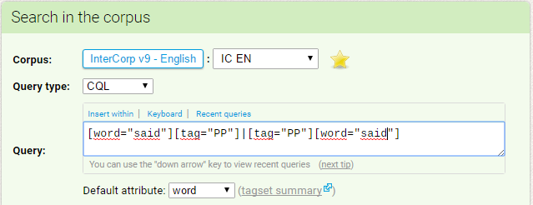

**Figure 12** The query used to find the reporting verb said either preceded or followed by a personal pronoun

In **Figure *12*** there is shown the query used to retrieve the results of the usage of the verb *said* either preceded or followed by a personal pronoun. There were 76,547 hits total, which were manually sorted out to dispose of the irrelevant samples. Then the chronologically first 100 suitable examples were chosen and they were found among the first 286 hits.[12]

Out of the 100 examples, the subject-predicate inversion did not take place in any case.

In all cases, the subject-predicate inversion occurred, and the position of the parenthetical varied; it was found in the sentence-initial position as well as in the sentence-final, as is shown in the examples (43a) and (43b) respectively.

As was suggested by Quirk (1985), the subject-predicate inversion with personal pronouns is regarded as archaic, and it seems to be reflected in the corpus results.

(43) (a) *“I haven't time,”****she said****.* (RB_MK)

(b) ***He said****, “The young fellow, Anthor. Someone with him, too.”* (IA_DN)

|  |  |  |  |  |
| --- | --- | --- | --- | --- |
| said + PP | direct speech ratio | inversion | non-inversion | S-P inversion percentage |
|  | 34.97% | 0 | 100 | 0% |

## The verb *thought*

### The verb *thought* with nouns proper

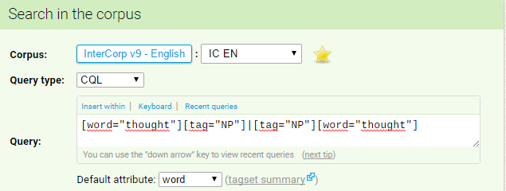

**Figure 13** The query used to find the reporting verb thought either preceded or followed by a noun proper

In **Figure *13*** there is a description of the query used to retrieve the results for the verb *thought* either preceded or followed by a noun proper. There were 4,301 hits total, which were manually sorted out to get rid of the irrelevant samples. Then the chronologically first 100 suitable examples were chosen. The 100 examples of the reporting verbs usage in the direct reported speech were found among the first 690 hits. [13]

Out of the 100 examples, there were 29 cases of the subject-predicate inversion, although only 10 cases were with the quotation marks, as is shown in (44a). The other 19 examples were also cases of reporting the person’s thoughts and remarks, but without the quotation marks, as in (45a) or (45b). And although it could mark a case of indirect reported speech, there was a present tense in the reported clauses, either present simple, continuous or perfect. Because there seemed to be no tense shift, it is assumed that they are still cases of the direct reported speech, especially of its subtype; free direct reported speech.

The remaining 71 cases were examples of no subject-predicate inversion, as is shown in (44b). In these examples, there were also 61 cases of the reported speech without quotation marks, as in (45c), and because of no tense shifting, it is assumed that these were cases of free direct reported speech.

(44) (a) *'What about me of them?'****thought Bilbo****.* (JT_HO)

(b) *‘How fond she is of finding morals in things!’****Alice thought*** *to herself.* (LC_AD)

(45) (a) *I've definitely done more,****Harry thought*** *indignantly.* (JR_FR)

(b) *JESUS,****Langdon thought****, THEY'VE GOT SOMEONE ON THE INSIDE.* (DB_AD)

(c) *THANK GOODNESS,****thought Death****, THAT I AM COMPLETELY UNCHANGED AND EXACTLY THE SAME AS I EVER WAS.* (TP_ZC)

|  |  |  |  |  |
| --- | --- | --- | --- | --- |
| thought + NP | direct speech ratio | inversion | non-inversion | S-P inversion percentage |
|  | 14.49% | 29 | 71 | 29% |

### The verb *thought* with personal pronouns

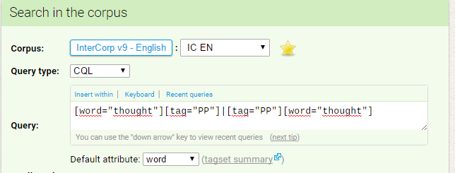

**Figure 14** The query used to find the reporting verb thought either preceded or followed by a personal pronoun

In **Figure *14*** there is a description of the query used to retrieve the results for the verb *told* either preceded or followed by a personal pronoun. There were 52,529 hits total, which were manually sorted out to get rid of the irrelevant samples. Then the chronologically first 100 suitable examples were chosen. The 100 examples of the reporting verbs usage in the direct reported speech were found among the first 3,271 hits. [14]

Among these 100 examples there was no case of the subject-predicate inversion.

(46) (a) *So they went on for a bit, and then, one day,****she thought*** *to herself, “’T is time to clean up my house.”* (AN_AP)

(b) *"Old Smaug is weary and asleep,"****he thought****.* (JT_HO)

(c) *‘This is the retribution of God against the bibulous,’****he thought****, ‘I will never touch another drop.’*(LB_MA)

In the sample of 100 examples, there were 60 cases of the reported speech being used without the quotation marks. With the verb *to think* apparently reporting only the thoughts, and usually not any utterances, and because there was no apparent backshift, these cases were also counted in the statistics, as cases of free direct reported speech.

The reporting clause also appeared in two positions, sentence-final, as in (47a), or medially within the reported clause, as is shown in (47b), (47c), and (47d).

(47) (a) *But I must think,****he thought****.* (EH_SM)

(b) *Serve them right,****he thought****, why can't they give it a rest... bickering all the time... it's enough to drive anyone up the wall...* (JR_FR)

(c) *Those dark Oriental eyes****, he thought****, how full they are of passion, of voluptuous longing!* (JJ_DU)

(d) *Maybe it's another blizzard,****he thought****, and the roads will be closed, and I won't have to go after all.* (JG_PV)

|  |  |  |  |  |
| --- | --- | --- | --- | --- |
| thought + PP | direct speech ratio | inversion | non-inversion | S-P inversion percentage |
|  | 3.1% | 0 | 100 | 0% |

## The verb *told*

### The verb *told* with nouns proper

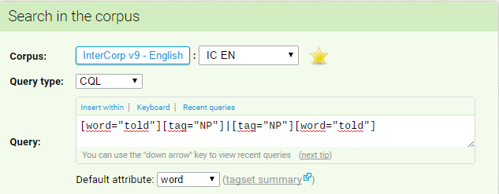

**Figure 15** The query used to find the reporting verb told either preceded or followed by a noun proper

In **Figure *15*** there is a description of the query used to retrieve the results for the verb *told* either preceded or followed by a noun proper. There were 5,725 hits total, which were manually sorted out to eliminate the irrelevant samples. Then the chronologically first 100 suitable examples were chosen. The 100 examples of the reporting verbs usage in the direct reported speech were found among the first 766 hits. [15]

Among the 100 examples, there was no case of the subject-predicate inversion in the reporting clause. This is very likely caused by the verb *tell* being a monotransitive verb and, as Huddleston and Pullum stated, the inversion is not permitted when an object is required (H&P 2002, 1027).

(48) (a) *'That was a darling boy I saw you with,'* ***Rooie told****Ruth.* (JI_RV)

(b) *“We should have taken horses,”* ***Robert Jordan told*** *her.* (EH_KZ)

(c) *“Now wait here,”* ***Hermione told****Harry, who was still under the Invisibility Cloak,“ and we’ll be back with some hairs for you.”* (JR_RS)

(d) *"Tell Chip,"****Alfred told*** *Chip, whom he didn't recognize," there's trouble in the East."* (JF_RO)

In the example (48), there are examples of the cases with no subject-predicate inversion, with the variable position of the parenthetical, as is the sentence-final, in (48a) and (48b), or the medial position within, in (48c) and (48d).

|  |  |  |  |  |
| --- | --- | --- | --- | --- |
| told + NP | direct speech ratio | inversion | non-inversion | S-P inversion percentage |
|  | 13.1% | 0 | 100 | 0% |

### The verb *told* with personal pronouns

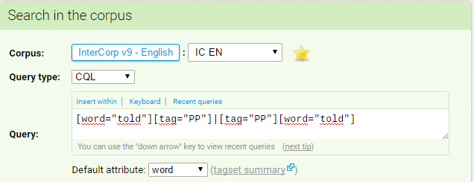

**Figure 16** The query used to find the reporting verb told either preceded or followed by a personal pronoun

In **Figure *16*** there is a description of the query used to retrieve the results for the verb *told* either preceded or followed by a personal pronoun. There were 49,961 hits total, which were manually sorted out to get rid of the irrelevant samples. Then the chronologically first 100 suitable examples were chosen. The 100 examples of the reporting verbs usage in the direct reported speech were found among the first 7,109 hits.[16]

The subject-predicate inversion did not occur in any of the 100 relevant examples, again because the verb *to tell* is a transitive verb and the inversion is not permitted when there is an object, according to Huddleston and Pullum (H&P 2002, 1027). The reporting clause appeared in various positions, such as sentence-initial, as in (49a), medially within the reported clause, as in (49b) or (49c), as well as in the sentence-final position, as in (49d).

(49) (a) ***She told*** *the administrator, "There's a man on the phone who insists on talking to you. A Mr. Bryan."* (AH_KD)

(b) *"Okay, now go play while we eat,"****she told*** *Johnny in a whisper before leaving him in the kitchen, and hurrying into the other room with the turkey.* (DS_SA)

(c) *'I could tell.’****he told*** *me, 'she was leading up to something. Something different.'* (KI_NM)

(d) *“Don’t forget I was practically engaged until New Year’s Day,”****I told*** *him.* (SB_DO)

Among the 100 examples, there was 10 cases of the reported clause without the quotation marks. However, there seemed to be no apparent backshift, in some cases because they were reporting only few words and not whole clauses, as in (50a), or the tense in the reported clause remained present, as in (50b), it was assumed that they were cases of the direct reported speech.

In those 10 examples, there was again no case of the subject-predicate inversion, and the reporting clause appeared in various positions, such as sentence-final, as in (50a), or in the medial position, as in (50b).

(50) (a) *NOT TONIGHT,****he told*** *himself; rumor was THIS conclave would be a “smoke-watch.”* (DB_AD)

(b) *You're young,****they told*** *him, you'll get over it.* (PR_LS)

|  |  |  |  |  |
| --- | --- | --- | --- | --- |
| told + PP | direct speech ratio | inversion | non-inversion | S-P inversion percentage |
|  | 1.5% | 0 | 100 | 0% |

## The verb *wondered*

### The verb *wondered* with nouns proper

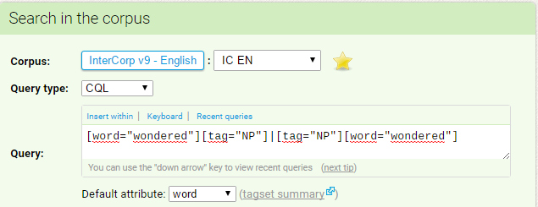

**Figure 17** The query used to find the reporting verb wondered either preceded or followed by a noun proper

In **Figure *17*** there is a description of the query used to retrieve the results for the verb *wondered* either preceded or followed by a noun proper. There were 450 hits total, which were manually sorted out to get rid of the irrelevant samples and among those results there were only 29 cases of direct reported speech. [17]

Among those 29 hits, there were 3 cases of the subject-predicate inversion, 2 cases with quotation marks used, and with the parenthetical in the medial position within the reported clause, as in (51a), or in the sentence-final position, as shown in (51b).

(51) (a) *‘But what,’****wondered Cadfael****, ‘is a minstrel from the heart of Provence doing here in the heart of England? And plainly no mere jongleur, but a genuine troubadour. He’s wandered far from home, surely?’* (EP_SZ)

(b) *'and be so much alike?'****wondered Pip****.* (SUB_IS)

There were 26 cases with no subject-predicate inversion, 13 of them were with used quotation marks, as is shown in (52a) and (52b).

(52) (a) *“Or maybe that he'll say something they don't want us to hear?”****Tait wondered****.*(TC_HP)

(b)  *‘Can we buy all this in London?’****Harry wondered*** *aloud*.  (JR_TK)

There were altogether 14 cases of the reported clause without the quotation marks, as is shown in (53a). The example in (53b) shows the only case of the direct speech usage without the quotation marks, but with the subject-predicate inversion in the reporting clause.

Because there seemed to be no tense shift, it was assumed that these were also cases of free direct reported speech and were counted into the statistics.

(53) (a) *So why,****Gary wondered****, why the rush-rush to get Dad's patent, eh, Curly?*(JF_RO)

(b) *What is he about?****wondered Doyle****.* (MF_LS)

|  |  |  |  |  |
| --- | --- | --- | --- | --- |
| wondered + NP | direct speech ratio | inversion | non-inversion | S-P inversion percentage |
|  | 6.44% | 3 | 26 | 10.34% |

### The verb *wondered* with personal pronouns

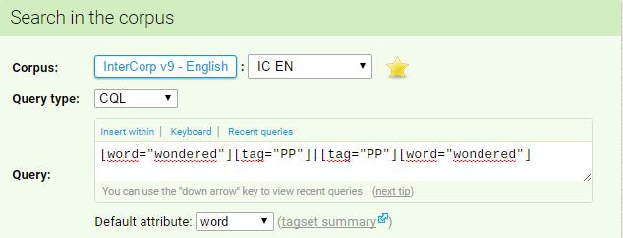

**Figure 18** The query used to find the reporting verb wondered either preceded or followed by a personal pronoun

In **Figure *18*** there is a description of the query used to retrieve the results for the verb *wondered* either preceded or followed by a personal pronoun. There were 1,361 hits total, which were manually sorted out to dispose of the irrelevant samples. Among all the hits, there were only 37 relevant examples of direct reported speech. [18]

The subject-predicate inversion occurred in none of the cases. The position of the reporting clause varied, it was found mostly in the sentence-final position, as in (54a), (54b), or (54c), but it occurred also in the medial position within the reported clause, as in (54d).

(54) (a) *“How could any young woman possibly be interested in that?”****he wondered*** *glumly.* (JF_NE)

(b) *‘I don’t think about death all the time, though I don’t see why one shouldn’t, just as you might expect a man in a condemned cell to think about the drop all the time. Why aren’t I screaming?’* ***he wondered****, referring back to his poem ‘The Old Fools’.*(JB_ZD)

(c) *‘Why do I feel like this?’****I wondered****.* (JW_PO)

(d) *‘Could he be a romoi,’****she wondered****, ‘without even knowing it himself?’* (LB_MA)

In 18 cases, the examples occurred without quotation marks marking the direct speech. However, because there seemed to be no apparent backshift and they were most likely reporting only thoughts of the individuals, it was assumed they were cases of free direct reported speech.

The subject-predicate inversion did not appear in any of these cases, but the reporting clause occurred in the sentence-initial position, as in (55a) and (55b), as well as in the sentence-final, as in (55c).

(55) (a) ***I wondered****: Are sunken tracks a bear's way of marking places of interest?* (BK_MM)

(b) ***She wondered****: should she send for him?* (AH_KD)

(c) *WHERE IS JESUS?****he wondered****.* (DB_AD)

|  |  |  |  |  |
| --- | --- | --- | --- | --- |
| wondered + PP | direct speech ratio | inversion | non-inversion | S-P inversion percentage |
|  | 2.72% | 0 | 37 | 0% |

## The verb *wrote*

### The verb wrote with nouns proper

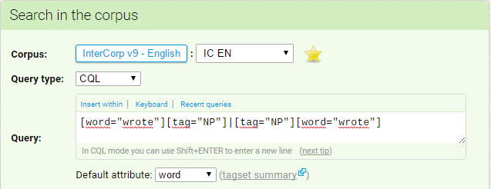

**Figure 19** The query used to find the reporting verb wrote either preceded or followed by a noun proper

In **Figure *19*** there is a description of the query used to retrieve the results for the verb *wrote* either preceded or followed by a noun proper. There were 627 hits total, which were manually sorted out to get rid of the irrelevant samples. Among all the results, there were only 92 examples of the verb *wrote* used in reporting clauses of direct reported speech. [19]

Out of the 92 examples, there were 10 cases of the subject-predicate inversion in the reporting clauses, as is shown in (56). The position of the parenthetical varied, so it could be found in the sentence-final position, as in (56a) and (56b), but in (56c) there is shown a case of the parenthetical in the medial position within the reported clause.

(56) (a) *“EU diplomats exude optimism when asked about China,”****wrote Katinka Barysch*** *of the Centre of European Reform.* (PPC_CE)

(b) *"He is a very handsome man... very grand and majestic,"****wrote Giustiniana****.* (AR_MB)

(c) *"Not one [experiment]",* ***wrote Mendel****, "has been carried out to such an extent and in such a way as to make it possible to determine the number of different forms with certainty according to their separate generations, or definitely to ascertain their statistical relations."* (MR_GE)

The examples in (57) show 3 cases out of the 82 where the subject-predicate inversion did not occur. The parenthetical could be found in all three positions, sentence-initial, (57a), sentence-final, in (57b), or medially within the reported clause, as in (57c).

(57) (a) ***Vita Sackville-West wrote*** *recently, “If we’re not careful soon old roses will be the in thing in the suburban garden.”* (AW_CHS)

(b) *"That's where I am now,"****Harry wrote*** *quickly.* (JR_TK)

(c) *“Inborn errors of metabolism",****Garrod wrote****, "are due to the failure of a step in the metabolic sequence due to loss or malfunction of an enzyme.”*(MR_GE)

|  |  |  |  |  |
| --- | --- | --- | --- | --- |
| wrote + NP | direct speech ratio | inversion | non-inversion | S-P inversion percentage |
|  | 14.67% | 10 | 82 | 11% |

### The verb wrote with personal pronouns

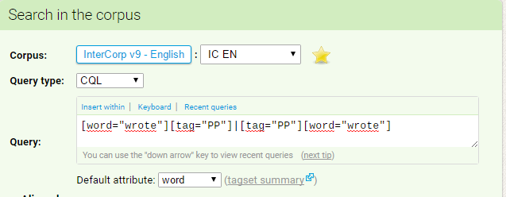

**Figure 20** The query used to find the reporting verb wrote either preceded or followed by a personal pronoun

In **Figure *20*** there is a description of the query used to retrieve the results for the verb *wrote* either preceded or followed by a personal pronoun. There were 3,383 hits total, which were manually sorted out to dispose of the irrelevant samples. Then the chronologically first 100 suitable examples were chosen. The 100 examples of the reporting verbs usage in the direct reported speech were found among the first 1,568 hits. [20]

Out of the 100 examples, there was no case of the subject-predicate inversion. In the sentences with no subject-predicate inversion, the position of the parenthetical varied, so it was in the sentence-final position, as in (58a) or (58b), as well as in the sentence-final position, as in (58b). In (58c) there is shown a case of the parenthetical in the medial position within the reported clause.

(58) (a) *Lifting the eyelids,****he wrote****, "Pupils round, 0.3 cm. diameter."* (AH_KD)

(b) ***I wrote****: “I have a woman friend who gives me whisky and money and big suppers.”* (JK_NC)

(c) *"I am still enchanted by my man,"****she wrote*** *in mid-February.* (AR_MB)

(d) *“Ich habe meine Flugschrift,”****he wrote*** *piteously to Sophie's mother in a smuggled note, the only communication they ever received, “I have my pamphlet. Ich verstehe nicht, warum ... I cannot understand why I am unable to get through to the authorities here and make them see...”*(WS_SV)

|  |  |  |  |  |
| --- | --- | --- | --- | --- |
| wrote + PP | direct speech ratio | inversion | non-inversion | S-P inversion percentage |
|  | 6.38% | 0 | 100 | 0% |

# Conclusion

In this thesis, I focused on the reporting clauses of the direct reported speech. Mainly I was interested in the phenomenon of the subject-predicate inversion, which may occur in the reporting clauses provided that all the requirements are met.

In the first, theoretical part, I described different types of direct speech and summarized what Rodney Huddleston and Geoffrey Pullum, Randolph Quirk, Geoffrey Leech, and Libuše Dušková wrote on the topic of reported speech.

In the second part of the thesis, I looked into the real usage of the subject-verb inversion in English language.

Huddleston & Pullum and Quirk gave in their books lists of verbs used for reporting utterances. I compared both lists and looked for the verb that were listed in both of the lists. I created a subcorpus on the InterCorp corpus and I searched the past tense forms of the verbs in the InterCorp corpus to see which were used more commonly. I made a list of the 10 most often used reporting verbs and focused on their usage and inversion with the subject.

I searched for each verb in its past tense form either preceded or followed by a noun proper or a personal pronoun and then I sorted them out manually to find 100 relevant examples of their usage in the reporting clauses of direct reported speech.

Then I calculated the ratio of the reporting verbs usage in the direct reported speech in the total usage of the verb and the percentage of the subject-predicate inversion in the 100 relevant examples.

All the results are summarized in the **Table 1** below.

|  |  |  |  |  |
| --- | --- | --- | --- | --- |
| verb | direct speech ratio | inversion | non-inversion | S-P inversion percentage |
| added + NP | 86.21% | 39 | 61 | 39% |
| added + PP | 85.47% | 1 | 99 | 1% |
| answered + NP | 70.92% | 49 | 51 | 49% |
| answered + PP | 40.82% | 0 | 100 | 0% |
| asked + NP | 75.76% | 49 | 51 | 49% |
| asked + PP | 14.33% | 0 | 100 | 0% |
| ordered + NP | 24.27% | 35 | 65 | 35% |
| ordered + PP | 4.60% | 0 | 50 | 0% |
| promised + NP | 3.90% | 4 | 13 | 24% |
| promised + PP | 0.7% | 0 | 23 | 0% |
| said + NP | 85.47% | 66 | 34 | 66% |
| said + PP | 34.97% | 0 | 100 | 0% |
| thought + NP | 14.49% | 29 | 71 | 29% |
| thought + PP | 3.1% | 0 | 100 | 0% |
| told + NP | 13.1% | 0 | 100 | 0% |
| told + PP | 1.5% | 0 | 100 | 0% |
| wondered + NP | 6.44% | 3 | 26 | 10.34% |
| wondered + PP | 2.72% | 0 | 37 | 0% |
| wrote + NP | 14.67% | 10 | 82 | 11% |
| wrote + PP | 6.38% | 0 | 100 | 0% |

**Table 1 Results**

The verb *added* had a very similar ratio with both nouns proper and personal pronouns, 86% and 85% respectively. The inversion percentage was 29% with nouns proper and 1% with personal pronouns, as there was only 1 case of the subject-predicate inversion with pronouns.

The verb *answered* was more commonly used with nouns proper than with personal pronouns; the ratio was almost 71% with nouns proper and 41% with personal pronouns. The percentage of the subject-predicate inversion was 49% with nouns proper, and 0% with personal pronouns.

The verb *asked* had also higher ratio of the usage with nouns proper, around 76%, and the same went for the inversion percentage, here the ratio was around 14%. Because there was no case of the subject-predicate inversion with personal pronouns, the subject-predicate inversion appeared in 0% cases, but in 49% with nouns proper.

The verb *ordered* occurred more often with nouns proper, the ratio was 24% with nouns proper and 4,6% with personal pronouns. The percentage of the subject-predicate inversion was also higher with nouns proper, it was 35%, and 0% with personal pronouns.

The verb *promised* appeared more often with nouns proper, in almost 4% of cases, and in nearly 1% of cases with personal pronouns. The inversion percentage was 24% with nouns proper and 0% with personal pronouns.

The verb *said* was more often used with nouns proper in the reporting clauses, the ratio being 85% with nouns proper and almost 35% with personal pronouns, and also the percentage of the subject-predicate usage was considerably higher, so because of the fact that with personal pronouns there was no case of the inversion, the inversion percentage was 0% for personal pronouns, but 66% for nouns proper.

The verb *thought* appeared more commonly with nouns proper, in almost 15% of the cases, than with personal pronouns, in 3%. The subject-predicate inversion occurred in 29% of the cases with nouns proper, and in 0% of the cases with personal pronouns.

The verb *told* was used in reporting clauses in 13% of the cases with nouns proper and in 1.5% with personal pronouns. The percentage of the subject-predicate inversion was 0% in both cases with nouns proper and personal pronouns, as there was no case of the inversion.

The verb *wondered* appeared only slightly more often with nouns proper, in nearly 7%, than with personal pronouns, in almost 3% of the cases. The subject-predicate inversion percentage was around 10% with nouns proper and 0% with personal pronouns.

The verb *wrote* appeared slightly more often with nouns proper than with personal pronouns, in nearly 15% of the cases, rather than 6% with personal pronouns. The subject-predicate inversion percentage was 11% with nouns proper, and 0% with personal pronouns.

# Resumé

Tato práce se soustředila na uvozovací věty přímé řeči, a zvláště na jev inverze podmětu a přísudku, který se v uvozovacích větách za daných podmínek může objevit.

V první, teoretické, části jsem popsala oba jevy, přímou i nepřímou řeč, a shrnula, co o daném tématu napsali Rodney Huddleston a Geoffrey Pullum, Randolph Quirk, Geoffrey Leech a Libuše Dušková.

Ve druhé části své bakalářské práce jsem se soustředila na použití inverze podmětu a přísudku v uvozovacích větách v praxi.

Huddleston & Pullum a Quirk uvedli ve svých knihách seznam sloves, která se používají v uvozovacích větách přímé řeči. Oba seznamy jsem mezi sebou porovnala. Poté jsem vytvořila subkorpus v korpusu InterCorp a ta slovesa, která se objevila v obou případech, jsem v něm vyhledala v jejich tvaru minulého času, abych zjistila, která slovesa se používají častěji. Tímto způsobem jsem vytvořila seznam 10 nejpoužívanějších uvozovacích sloves a na ta se dále zaměřila ve své práci.

Ve vytvořeném subkorpusu jsem vyhledala každé sloveso ve tvaru minulého času spolu buď s vlastním jménem, nebo zájmenem, které danému slovesu buď ihned předcházelo, nebo následovalo těsně za ním. Výsledky jsem poté prošla a vyhledala chronologicky prvních 100 relevantních výsledků sloves užitých v uvozovacích sloves přímé řeči.

Výsledky jsou shrnuty v tabulce **Table 1** výše.

V uvozovacích větách přímé řeči se relativně často v porovnání s ostatními slovesy objevovala slovesa *added*, a to jak s vlastními jmény, tak s osobními zájmeny, a dále slovesa *answered*, *asked* a *said* spolu s vlastními jmény.

Inverze podmětu a přísudku v uvozovacích větách se častěji objevovala, pokud jako podmět sloužilo vlastní jméno. U slovesa *added* se tomu tak stalo v 39 % případů, u sloves *answered* a *asked* ve 49 %, u slovesa *ordered* ve 35 % případů a u slovesa *promised* ve 24 % případů. Sloveso *said* se spolu s vlastními jmény objevovalo v inverzi nejčastěji, a to v 66 % případů, a sloveso thought se s inverzí objevilo ve 29 % případů. U slovesa *told* se ani s vlastními jmény v podmětu inverze neobjevila a slovesa *wondered* a *wrote* se v inverzi objevovala zhruba stejně často, sloveso *wondered* v 10,34 % případů a sloveso *wrote* v 11 %.

Kromě slovesa *add,* které se objevilo v 1 případě v inverzi s osobním zájmenem, se žádné sloveso v inverzi s osobními zájmeny neobjevilo.

# Works Cited

Dušková, Libuše et al. 1988. *Mluvnice současné angličtiny na pozadí češtiny.* Praha: Academia.

Huddleston, Rodney D., and Geoffrey K. Pullum. 2002. *The Cambridge Grammar of the English Language*. Cambridge, UK: Cambridge University Press.

Leech, Geoffrey. 2006. *A Glossary of English Language*. Edinburgh: Edinburgh University Press.

Leech, Geoffrey. 2004. *Meaning and the English Verb.* Edinburgh: Pearson Education Limited.

Quirk, Randolph. 1985. *A Comprehensive Grammar of the English Language.* London: Longman.

SketchEngine. 2017. “CQL – Corpus Query Language.” Accessed April 23, 2017. https://www.sketchengine.co.uk/documentation/corpus-querying/

**Corpus**

Czech National Corpus – InterCorp. Prague: Institute of the Czech National Corpus. Available online at http://www.korpus.cz.

# Abbreviations of the InterCorp results

(AC_KK)

Carter, Angela. 1981. *The Bloody Chamber and Other Stories*. London: Penguin Books.

(AH_KD)

Hailey, Arthur. 1959. *The Final Diagnosis*. New York: Doubleday.

(AN_AP)

Anonymous. 2005. *English Fairy Tales*. Praha: Garamond.

(AR_MB)

Di Robilant, Andrea. 2003. *A Venetian Affair*. New York: Alfred A. Knopf.

(AS_VP)

Shreve, Anita. 2003. *All He Ever Wanted*. Boston:   
Little, Brown, and Company.

(AW_CHS)

Wilson, Angus. 1981. *Setting the World on Fire*. London: Granada Publishing.

(BK_MM)

Kilham, Benjamin, and Ed Gray. 2002. *Among the Bears.* New York: Henry Holt.

(BS_DR)

Stoker, Bram. 1989*. Dracula*. New York: Bantam Books.

(DB_SML)

Brown, Dan. 2003. *The Da Vinci Code.* New York: Doubleday.

(DB_AD)

Brown, Dan. 2000. *Angels and Demons*. New York: Pocket Books.

(DL_HP)

Lodge, David. 1978. *Changing Places: A Tale of Two Campuses.* Harmondsworth: Penguin Books.

(DS_SA)

Steel, Danielle. 2003. *Johnny Angel*. New York: Delacorte Press.

(EH_KZ)

Hemingway, Ernest. 1945. *For Whom the Bell Tolls.* Stockholm: The Continental Book Company.

(EH_SM)

Hemingway, Ernest. 1952. *The Old Man and the Sea.* New York: Charles Scribner’s Sons.

(EP_SZ)

Peters. Ellis. 1993. *The Holy Thief.* London: Headline Book Publishing.

(FF_CP)

Forsyth, Frederick. 1985. *The Fourth Protocol*. London: Corgi Books.

(FF_VG)

Fitzgerald, Francis Scott. 1994. The Great Gatsby. London: Penguin Books.

(HM_BA)

Melville, Herman. 2006. *Bartleby the Scrivener*. Praha: Garamond.

(IA_DN)

Asimov, Isaac. 1982. *Second Foundation*. New York: Doubleday.

(JB_AG)

Barnes, Julian. 2005. *Arthur & George*. London: The Random House Group Limited.

(JB_ZD)

Barnes, Julian. 2009. *Nothing to te Frightened of. London*: Vintage Books.

(JF_FM)

Fowles, John. 1969. *The French Lieutenant’s Woman.* Boston: Little, Brown & Co.

(JF_NE)

Farrell, James Gordon. 2002. *Troubles*. New York: New York Review Books.

(JF_RO)

Franzen, Jonathan. 2001. *The Corrections*. New York: Farrar, Straus and Giroux.

(JG_AC)

Grisham, John. 1998. *The Street Lawyer*. New York: Doubleday.

(JG_PV)

Grisham, John. 1999. *The Testament*. New York: Doubleday.

(JI_RV)

Irving, John. 1998. *A Widow for a Year*. Cambridge: Black Swan.

(JJ_DU)

Joyce, James. 1999. *Dubliners*. Praha: Garamond.

(JR_FR)

Rowling, Joanne K. 2003. *Harry Potter and the Order of the Phoenix*. London: Bloomsbury.

(JK_NC)

Kerouac, Jack. 1976. *On the Road*. New York: Penguin Group.

(JR_OP)

Rowling, Joanne K. 2012. *Harry Potter and the Goblet of Fire*. New York: Pottermore Limited.

(JR_PDK)

Rowling, Joanne K. 2005. *Harry Potter and the Half-Blood Prince*. London: Bloomsbury.

(JR_RS)

Rowling, Joanne K. 2007. *Harry Potter and the Deathly Hallows*. London: Bloomsbury.

(JK_ZS)

Krentz, Jayne Ann. 2004. *Falling Awake*. New York: G. P. Putnam’s Sons

(JR_TK)

Rowling, Joanne K. 1998. *Harry Potter and the Chamber of Secrets*. London: Bloomsbury

(JS_HH)

Steinbeck, John. 1939. *The Grapes of Wrath*. New York: The Viking Press.

(JT_HO)

Tolkien, John Ronald Reuel. 1934. *The Hobbit or There and Back Again*. London: George Allen & Unwin Ltd.

(JT_NK)

Tolkien, John Ronald Reuel. 1955. *The Return of the King*. London: George Allen & Unwin.

(JT_SH)

Toole, John Kennedy. 1980. *A Confederacy of Dunces*. Baton Rouge: Louisiana State University Press.

(JT_SM)

Tolkien, John Ronald Reuel. 1989. *The Silmarillion*. London: Unwin Papers.

(JT_SP)

Tolkien, John Ronald Reuel. 1954. *The Fellowship of the Ring.* London: George Allen & Unwin.

(JW_PO)

Winterson, Jeanette. 2001. *Oranges Are Not the Only Fruit*. London: Vintage.

(KI_NM)

Ishiguro, Kazuo. 2010. *Never Let Me Go*. London: Faber and Faber Ltd.

(LB_MA)

De Bernieres, Louis. 1998. *Captain Corelli’s Mandolin*. London: Vintage.

(LC_AD)

Carroll, Lewis. 2009. *Alice in Wonderland*. Praha: Garamond.

(MF_LS)

Frost, Mark. 1993. *The List of Seven*. New York: William Morrow and Company, Inc.

(MR_GE)

Ridley, Matt. 1999. *Genome: The Autobiography of a Species in 23 Chapters*. New York: Harper Collins.

(PJ_PT)

James, Phyllis Dorothy. 1989. *Devices and Desires*. London: Faber and Faber.

(PPC_CE)

Chaudhuri, Pramit Pal. 2010. *How China Walks Over Europe*. Paris: PressEurop.

(PR_LS)

Roth, Philip. 2000. *The Human Stain*. London: Vintage.

(RB_MK)

Bradbury, Ray. 1979. *The Martian Chronicles*. New York: Bantam Books.

(RC_TO)

Cook, Robin. 1998. *Toxin*. New York: G. P. Putnam's Sons.

(RL_BM)

Ludlum, Robert. 2009. *The Bourne Supremacy*. London: Orion.

(SB_DO)

Bellow, Saul. 1966. *The Adventures of Augie March*. New York: The Viking Press.

(SH_KV)

Hawking, Lucy, and Stephen Hawking. 2007. *George’s Secret Key to the Universe*. New York: Simon & Schuster Books for Young Readers

(SUB_IS):

Subtitles. 2001. *I Am Sam*. OpenSubtitles

(TC_GP)

Chevalier, Tracy. 1999. *Girl with Pearl Earring*. London: Harper Collins Publisher

(TC_HP)

Clancy, Tom. 1984. *The Hunt for Red October*. Annapolis: Naval Institute Press.

(TP_DZ)

Pratchett, Terry, and Neil Gaiman. 2006. *Good Omens*. London: Transworld Publishers.

(TP_SS)

Pratchett, Terry. 1989. *Wyrd Sisters*. London: Corgi Books.

(TP_ZC)

Pratchett, Terry. 2002. *Thief of Time*. London: Corgi Books.

(VW_MA)

Woolf, Virginia. 1947. *Between the Acts*. London: The Hogarth Press.

(WG_PM)

Golding, William. 1954. *The Lord of the Flies*. London: Faber & Faber.

(WS_SV)

Styron, William. 1979. *Sophie’s Choice*. New York: Random House.

1. About 14% of examples had to be eliminated as irrelevant.
2. About 15% of examples had to be eliminated as irrelevant.
3. About 29% of examples had to be eliminated as irrelevant.
4. About 59% of examples had to be eliminated as irrelevant.
5. About 24% of examples had to be eliminated as irrelevant.
6. About 86% of examples had to be eliminated as irrelevant.
7. About 76% of examples had to be eliminated as irrelevant.
8. About 95% of examples had to be eliminated as irrelevant.
9. About 96% of examples had to be eliminated as irrelevant.
10. About 99% of examples had to be eliminated as irrelevant.
11. About 15% of examples had to be eliminated as irrelevant.
12. About 65% of examples had to be eliminated as irrelevant.
13. About 86% of examples had to be eliminated as irrelevant.
14. About 97% of examples had to be eliminated as irrelevant.
15. About 87% of examples had to be eliminated as irrelevant.
16. About 98% of examples had to be eliminated as irrelevant.
17. About 94% of examples had to be eliminated as irrelevant.
18. About 97% of examples had to be eliminated as irrelevant.
19. About 85% of examples had to be eliminated as irrelevant.
20. About 94% of examples had to be eliminated as irrelevant.