UNIVERZITA PALACKÉHO V OLOMOUCI
Pedagogická fakulta
Ústav cizích jazyků

Bc. ANDREA SLAVÍČKOVÁ
II. ročník - distanční studium

Obor: Anglický jazyk se zaměřením na vzdělávání – Německý jazyk se zaměřením na vzdělávání

The Role of the Mother Tongue in Foreign Language Teaching

Diplomová práce

Vedoucí práce: Mgr. Blanka Babická, Ph.D.

OLOMOUC 2017

Prohlašuji, že jsem závěrečnou práci vypracovala samostatně a použila jen uvedených pramenů a literatury.

V Olomouci 22. 6. 2017
....................................................................
vlastnoruční podpis

I would like to thank Mgr. Blanka Babická, Ph.D. for her support and valuable comments on the content and style of my final project.
I would also like to thank my family for their patience and support.

TABLE OF CONTENTS

INTRODUCTION 8
THEORETICAL PART
1 Current Trends in Foreign Language Teaching in the Czech Republic 9
2 The Role of Translation and Mother Tongue in FLT: Changing Views 11
2.1 Communicative Language Teaching as the Current Trend in FLT 12
2.1.1 The Role of Mother Tongue in Communicative Language Teaching 13
2.2 Content and Language Integrated Learning 14
2.2.1 The Role of Mother Tongue in CLIL 15
3 Primary and Lower Secondary School Learners and Foreign Language Learning 16
3.1 Young Learners and Foreign Language Learning 16
3.2 Lower Secondary School Learners 17
4 The Role of Language in Language Learning 19
4.1 Classroom Language 19
4.1.1 The Choice of Language in the Foreign Language Classroom and Reasons for it 20
4.2 Teacher Talk in the Foreign Language Classroom 22
4.2.1 Reasons to Resort to L1 by Teachers 22
4.2.2 Avoiding L1 Use in Foreign Language Classroom 23
4.3 Learner Talk in the Foreign Language Classroom 25
4.3.1 Reasons to Use L1 by Learners 25
4.3.2 Encouraging L2 Use in the Foreign Language Classroom 26
5 The Role of Mother Tongue in Vocabulary Teaching 29
5.1 Positive versus Negative Influence of Mother Tongue on Foreign Language Acquisition 31
5.1.1 Positive Transfer: Cognates and Loan Words 34
5.1.2 Negative Transfer: False Friends 35
5.2 The Use of Bilingual Dictionaries 36
5.3 Vocabulary Records 37
6 The Role of Mother Tongue in Grammar Teaching 39
6.1 Grammar in Communicative Language Teaching 39
6.2 Mother Tongue in Grammar Presentation 39
6.2.1 Explicit Grammar Explanation and its Implications for the Use of Language in Primary and Lower Secondary Schools 40
6.2.2 Some Other Issues 41
7 Translation 43
7.1 Definition of Translation 43
7.2 Translation and the Communicative Language Teaching 44
7.3 Pros and Cons of Translation in Foreign Language Teaching 44
7.4 Aspects to Consider prior to Employing Translation in Foreign Language Teaching 45
7.4.1 Learning Styles and Strategies 46
7.4.2 Age and Level of Learners 47
7.5 Translation Exercises 48
7.5.1 Word cards 49
7.5.2 Word race: translation game 49
7.5.3 Sentence translation 49
7.5.4 Translation game with a bilingual dictionary 50
7.5.5 Correct the sentence: looking for an alien 50
7.5.6 Fill in the missing pronoun: 50
7.5.7 Write dates in English: 50
7.5.8 Fill in the missing expressions: have, haven't, has, hasn't, do, don't, does, doesn't and got. 50
8 Summary of the Theoretical Part 51
PRACTICAL PART
9 Introduction 52
10 Structure of the Survey 52
11 Conditions of the Survey 52
12 Methodology 53
12.1 Types of Questionnaire Items 53
12.1.1 Questionnaire for Teachers 53
12.1.2 Questionnaire for Learners 54
13 Informants 55
13.1 Schools Involved 55
14 Questionnaires 57
14.1 Questionnaires for Teachers 57
14.1.1 Classroom Language 57
14.1.2 Presentation of Vocabulary and Grammar 58
14.1.3 Translation 58
14.2 Questionnaires for Learners 58
15 Analysis of the Questionnaire for Teachers 59
15.1 Specification of Grades Taught 59
15.2 Years of Practice 60
15.3 Classroom Language 60
15.4 Presentation of Vocabulary and Grammar 74
15.5 Translation in the English Language Teaching 76
16 Analysis of the Questionnaires for Learners 82
16.1 Gender 82
16.2 Comprehension of the teacher´s instructions in the ELC 82
16.3 Perception of the Teacher's Choice of Language in the ELC 83
17 Summary of the Practical Part 84
18 Suggestions for Further Research 86
CONCLUSION ………………………………………………………………………………………………………………………………. 87
Bibliography 91
List of Abbreviations . 95
List of Appendices 96
Appendices 97
Resumé
Annotation

Abstract:
Although there are tendencies to eliminate the use of mother tongue from communicative foreign language teaching strategies, it proves to be a difficult task for foreign language teachers. This paper focuses on reasons and situations in which mother tongue is used both by teachers and learners in foreign language classrooms and suggests that a deliberate choice of language by the teacher is one of the keys to the success of language teaching. The results of the study made among the teachers and learners of English confirmed the significance of the role of the mother tongue in foreign language teaching, where it is mainly an important element in ensuring learners´ understanding and a facilitator of language learning.

INTRODUCTION

Using the mother tongue and translation in foreign language teaching do not currently belong to trends in FLT methodology. Although methodologies usually do mention translation as an option in foreign language teaching, the main focus is, naturally, on the communicative competence as this is the primary goal of foreign language usage. In the past we could see a radical shift from using translation and mother tongue in foreign language teaching, leading at times even to their ban. Today´s attitude is not so strict and the mother tongue is not repudiated from foreign language classrooms but still, its use is all but favoured.
Guy Cook, one of the advocates of translation in language teaching, begins his book "Translation in Language Teaching" with describing his own experience, which he calls a communicative disaster, when an inadequate understanding of a foreign language term by him led to an intercultural clash between himself and his counterpart in communication, which could have been avoided if a proper explanation in his mother tongue were provided to him. In connection with this experience of his he raises a question, why students of foreign language classes should be refused a translation if they feel it might be helpful. And this is something language teachers actually come across daily in their classes, whether they do realize it or not, especially with pupils and students (henceforth commonly referred to as "learners") of lower levels who do not always understand either instructions made by the teacher in the foreign language or anything else related to their work in the foreign language classroom.
The aim of this thesis is to explore the different aspects of using the mother tongue in the foreign language classrooms. It is divided into two parts. The theoretical part deals with different views of this issue in different areas of foreign language teaching and that mainly from the perspective of the communicative approach to language teaching. The aim of the practical part is to become familiar with the views of teachers of the Czech primary and lower secondary schools on this topic and find out about the extent and purpose they use mother tongue in their classes. It will provide the learners´ point of view and by trying to find out the attitude of lower secondary school learners towards the teacher's use of language in the foreign language classrooms.
THEORETICAL PART

Current Trends in Foreign Language Teaching in the Czech Republic
General educational trends of teaching and learning in the Czech Republic, and thus also those of foreign language teaching (henceforth "FLT"), are drawn up in the National Education Programme and Framework Education Programmes (henceforth "FEP") on the state level and School Education Programmes on the school level. FEPs define the scope of education for preschool, elementary and secondary education. On the basis of the Framework Education Programme schools create their School Education Programmes reflecting the needs and experience of the individual schools (Framework Education Programme for Elementary Education, 2007, p. 5). The cornerstone of the Czech schooling represents the forming and developing Key Competencies, defined as "a set of knowledge, skills, abilities, attitudes and values which are important for the personal development of an individual and for the individual’s participation in society" (ibid., p. 11). FEP for Basic Education states six key competencies to be developed within the primary and lower secondary school education: learning competency, problem-solving competency, communication competency, social and personal competency, civic competency, professional competency. It goes without saying that the aim of the language teaching should not be restricted to teaching language skills only. Speaking foreign languages opens the door for learners to live and work abroad and to broaden their horizons by speaking with people of other nationalities and cultures and make independent opinions of their own, which is crucial in today's world. FLT should therefore aim at a complex development of learners by taking all these six areas of competencies into account and helping learners find their way in their lives. Numerous language teaching methods, some of them more successful that others, have been developed over a time to promote second language acquisition. But still, in the context of a foreign language perception, language as a communication tool tends to enjoy a privileged position in FLT and as such, the development of the communication competence, in other words "a learner's ability to use language to communicate successfully" (British Council, n.d.), is the key task of language teachers. Communicative Langue Teaching is dominant among language teaching methods and its use in FLT is recommended by the Council of Europe (Choděra, 2006, p. 95).
Translation and communication are two different concepts and it is, of course, not the aim of FLT on primary and lower secondary school level to train future translators but rather successful communicators. This paper deals with the issue of how the use of mother tongue and translation in the foreign language classroom (henceforth "FLC") fit into the communicative concept of FLT and deals with the question whether FLT should be supported by the use of mother tongue at all and if using mother tongue helps with learning languages or if it rather does more harm than good.

The Role of Translation and Mother Tongue in FLT: Changing Views
The perception of the role of translation and mother tongue in FLT has changed over the time. Golden Age of translation in FLT was the 19th century when Grammar Translation Method (henceforth "GTM") became a dominant way of foreign language instruction (Cook, 2010, p. 9). Primary goals of this method included mastery of grammar and accuracy of translation. It employed memorizing and translating sentences from the target language in the mother tongue as main classroom activities with little attention to developing speaking and pronunciation skills. In later stages, tasks involved translation of literary passages. Lists of isolated words were used for vocabulary learning. The language instruction was in the mother tongue only (Richards & Rogers, 1986, p. 5). Although GTM does not apparently focus on the basic role of the language as a means of communication, Richards & Rogers (ibid.) remark that variations on GTM are still in use word wide.
In terms of using mother tongue and translation in FLT, GTM can be considered an extreme variation. A radical shift from these practices came in the form of the Direct Method at the beginning of the 20th century. In respect of using translation in FLT, Cook (2000, p. 3) even uses the term "outlawing". This method strictly avoided both the use of the mother tongue in the FLC and translation as a teaching technique, as well. The translation was replaced with demonstration (Richards & Rogers, 1986, p. 17).
Like all methods employing extreme principles, also Direct Method was overcome and replaced by numerous other ones, allowing more or less for using translation and mother tongue in the FLC again but paving the way toward the Communicative Language Teaching, so often used today. In Appendix 1 is a table with a short overview of some of them, including their teaching goals and attitudes these methods and approaches assume to the use of translation and mother tongue in FLT, or relation between the use of mother tongue and foreign language (henceforth "L2") learning, as the case may be, as stated in Richards & Rogers (1986). It is evident from the scheme that, with the exception of GTM and Cognitive Approach, which put mother tongue to the fore, the aim of the majority of FLT methods and approaches is to eliminate the use of mother tongue as much as possible. In this respect, Beneš et al. (1971, p. 129) writes that it is desirable to evoke a foreign language atmosphere in the classroom. He emphasizes the need of consistent use of L2 in the FLC and, among others, he also warns against frequent alternations between L1 and L2. A similar term is used by Scrivener (2011, p. 63) who talks of creating an "English" atmosphere in the classroom. A teacher should use L2 from the very first contact with learners and resort to L1 to ensure comprehension only.
On the other hand, this may be demanding for those teachers who prefer to rely rather on L1 on their teaching as it makes high demands on their foreign language proficiency.

Communicative Language Teaching as the Current Trend in FLT
Although most of the methods and approaches listed above claim to be more or less "communicative", only some reflect the key objective of today's FLT, which is the ability to communicate in real-life situations.
Cook (2010, p. 135) distinguishes between traditional and communicative focus of FLT and puts them in contrast, although he adds that these terms are not unambiguous since the "traditional" teaching may involve communicative elements and, conversely, some communicative activities may not be communicative at all. The main features pertaining to each of the FLT approaches can be according to Cook (ibid.) distinguished as follows:

Traditional elements of FLT |  | Communicative elements of FLT
Form | vs. | Meaning
Accuracy | vs. | Fluency
Artificiality | vs. | Authenticity
Declarative knowledge | vs. | Procedural knowledge
Authoritarian teaching | vs. | Collaborative learning

As Tarone and Yule (1989, p. 17) note, language should no longer be presented as a set of forms but the emphasis should be laid on language as a functional system used to fulfil a range of communicative purposes. In this respect, Nunan (1989, p. 12) claims that language is now seen as a resource for creation of meaning. The current principles underlying FLT are subordinate to these objectives. Richards & Rogers (1986, p. 187) further note that Communicative Language Teaching (henceforth "CLT") is an approach to language instruction which may be carried out according to a variety of methods, e.g. Content-Based Instruction/CLIL or Task-Based Instruction.

The Role of Mother Tongue in Communicative Language Teaching
The communicative approach follows these principles (adapted from Seznámení s komunikativním způsobem vyučování angličtiny – Příručka pro české učitele, 1998, p. 4):
- learners use L2 in real-life situations,
- learners resolve problem situations in L2,
- learners express their opinions, experience and feeling in L2,
- teacher supports learners' learning awareness,
- learners work in pairs or groups,
- teacher assumes different roles in the class.
From the points above, we can see that mother tongue is actually eliminated from classes in which communicative approach is adopted and, accordingly, in materials concerning CLT little attention is paid to using L1 in communicative language classrooms. Cole (1989) talks about a curious absence of discussion of the use of L1 in the literature on CLT. Typical communicative activities, as proposed by Nunan (1989, p. 66, 68), include information-gap, reasoning-gap and opinion-gap activities, questions and answers, dialogues and role-plays, matching activities, communication strategies, pictures and picture stories, puzzles and problems, discussions and decisions. Goals achieved by communicative activities should, among others, include exchanging information, ideas, opinions, attitudes, feeling and getting things done (ibid., p. 49). Using the mother tongue does not seem to fit in the classes in which the main objective is communication in L2. The same seems to apply for any kind of translation activities which lack any kind of interaction.
Handbook for teachers Seznámení s komunikativním způsobem vyučování angličtiny – Příručka pro české učitele (1998, p. 14) states that foreign language must be the main communication language in the classroom. It is crucial for learners to speak L2 as often as possible. Harmer (2001a, p. 85) puts it that plentiful exposure to language in use and plenty of opportunities to use it is vitally important for learners. The handbook Seznámení s komunikativním způsobem vyučování angličtiny – Příručka pro české učitele (1998, p. 14) advises teachers to use simple language and short phrases and gestures and miming rather than L1. It admits, however, that it is not always possible to use L2 and there are situations in which it is more effective to use L1, such as on explaining new activities, difficult language structures or in connection with difficult vocabulary. Cole (1989) warns against using L2 in CLT by all means as it may lead to a bizarre behaviour when explaining the meaning of a language item where a simple translation would do a better job. He also offers an another point of view of using L1 in the FLC noting that learning a language can be frustrating especially at low levels and a limited use of L1 can have a powerful effect here since, citing Atkinson (1993, p. 13), "for many learners (in particular adults and teenagers), occasional use of the L1 gives them the opportunity to show that they are intelligent, sophisticated people."

Content and Language Integrated Learning
Apart from CLT, another method fitting into communicative approaches has been gaining in popularity, namely Content and Language Integrated Learning (henceforth "CLIL"). In most Czech schools non-language subjects are taught solely in Czech, i.e. in learners' L1. Nevertheless, there are increasing efforts to promote awareness of and employ CLIL in Czech schools, especially in the English language (Šmídová, Tejkalová, Vojtková, 2012, p. 7). CLIL shares principles with CLT as regards its view of a language as a communication tool. CLIL activities, same as CLT activities, involve exchange of information, interaction or problem solving, all with focus on real-life situations (Richards & Rogers, 1986, p. 207). The principle of CLIL is based on the integration of non-language content into an FLT curriculum. Communicative competence in CLIL is to be achieved through the learning of academic subject matter (Richards & Rogers, 1986, p. 203). In other words, non-language subjects, e.g. geography or biology, are instructed in a foreign language so learners learn both the content and the language at the same time. A teacher's lesson plan thus includes two types of objectives: a content and a language one (Šmídová, Tejkalová, Vojtková, 2012, p. 15). An ideal CLIL teacher is qualified for teaching a foreign language, with an excellent command of it, and for teaching a non-language subject (ibid., p. 8).

The Role of Mother Tongue in CLIL
Šmíkalová, Tejkalová and Vojtková (2012, p. 10) claim that by employing CLIL in their curriculum, schools assume a kind of a bilingual approach to teaching. In contrast to bilingual education, which offers an intensive contact with L2 with the aim to acquire a native-like L2 competence, CLIL respects limited language competences of both learners and teachers. It is hence realized both in L1 and L2, while using L2 is a priority. As such, CLIL does not specify the intensity of language exposure. Cameron (2011, p. 11) considers the amount and type of exposure to the foreign language the central characteristics of FLL. In this respect, Šmíkalová, Tejkalová and Vojtková (2012, p. 10) mention the term language immersion which can be divided according to the extent of curriculum delivered in L2. Accordingly, one can speak about total and partial immersion and early immersion, which begins in the kindergarten or in the first years of school, and late immersion, which begins in lower secondary school. Mehisto, Marsch and Frigols (2008, p. 13) further talk about language showers for learners between four and ten, by which young learners should be made aware of the existence of L2 and get prepared for language learning. Language showers include exposure to L2 between 30 minutes and one hour per day. Pinter (2009, p. 40) supports the idea of implementing CLIL in young learners' classes. She has it that integrating a foreign language into the curriculum carries an underlying message that all can be talked about both in L1 and L2.
Despite the fact that there is a clear preference of using L2 in CLIL classes, Šmíkalová, Tejkalová and Vojtková (2012, p. 16) attribute importance to the use of mother tongue, as well. Mother tongue has a supportive function as regards learners' understanding the content. It helps to enhance accuracy in understanding and check understanding. At the same time, however, they warn against translating which neither guarantees nor checks understanding.

Primary and Lower Secondary School Learners and Foreign Language Learning

In the Czech education system, children usually first encounter a foreign language in the third grade, i.e. at the age of eight, although individual schools may introduce a foreign language in lower grades. Some children may start even much earlier, usually from their parents' initiative. FEP for Basic Education states the required level of foreign language proficiency acquired during elementary school education is A2 (or A1 in the field of another foreign language) according to the Common European Framework of Reference for Languages.
It is obvious that teachers need to assume different approaches to children of different age groups and have to respond to their various needs. To define primary and lower secondary school learners for the purpose of this paper, we can divide them into two groups according to their age, although it needs to be mentioned that considerable differences amongst children of a chronological age are to be expected (Clark, 1989, p. 6): primary school learners/young learners up to the age of ten/eleven and lower secondary school learners up to the age of fifteen.

Young Learners and Foreign Language Learning
Young learners are a specific group (not only) in FLT. Clark (1989, p. 7) writes that the system of their L1 is not fully developed, they may still be learning the rules of their own language. They are still developing their communication skills, as well. As he points out, young learners hence do not have the same range of language skills to draw upon on the learning of L2 as secondary school learners. Cameron (2011, p. 13) points that children enter the FLL with differently developed skills and learning abilities in their L1. Nevertheless, Scott and Ytreberg (1990, p. 4) assert that children of eight have a language with all the basic elements in place and are competent users of their mother tongue. They further assert that they have a sort of language awareness which they bring with them into the foreign language classroom. Pinter (2009, p. 7) refers to Piaget's theory of cognitive development noting that children from seven to eleven years of age are in their concrete operational stage, when their ability to apply logical reasoning is restricted to immediate context (Curtain and Pesola, 1988, p. 66). According to Scott and Ytreberg (1990, p. 4) young learners learn best when their L2 learning shadows the process of mother tongue acquisition. They contemplate that as far as children's foreign language learning (henceforth "FLL") is concerned, there are many similarities between learning L1 and L2 although the age and time available differ. The theory that the way young children learn a foreign language is similar to their L1 acquisition and it can be applied in a classroom environment is doubted by Cook (2010, p. 133) who considers this a popular misconception. Cook (ibid.) argues that a classroom exposure to a few lessons a week differs from every-day exposure to a language in which learning can take place without instruction.
Curtain and Pesola (1988, p. 82) lay weight on comprehension rather than speaking at early stages of FLT. Harmer (2001a, p. 38) further mentions that young children up to the ages of nine/ten have a short span of concentration and need to be involved in something active since they can easily get bored. They learn rather indirectly from things around them, focusing on a precise topic is difficult for them. They need a chance to touch and interact. In this respect, Scott and Ytreberg (1990, p. 6) emphasize the need of variety in the young learners' classroom - variety of activity, pace, organization and voice.
Pinter (2009, p. 2) works on the assumption that young learners learn holistically, i.e. they can understand meaning but are not able to analyze the language. For example, although they may not understand every word of song, they may still understand what the song is about (ibid. p. 167). According to Cameron (2011, p. 205), the advantage of young learners is that they do not yet have inhibitions to use L2 and communicate despite their lack of knowledge. However, at the same time, Cameron (ibid. p. 1) warns about such generalisations which may disregard differences among children.

Lower Secondary School Learners
Lower secondary school learners are mostly in their teenage age and their characteristics logically differ from those of young learners. The previous sub-chapter was concluded with Cameron's (2001, p. 205) point about willingness of young children to communicate in L2. The teacher of teenagers must rather count with these learners to be more inhibited about using the L2 and generally less willing to communicate (Cameron, 2001, p. 205). Harmer (2001a, p. 39) says they can be creative and have a great potential to learn but at the same time they may be problematic. Curtain and Pesola (1988, p. 68) talk of transcendent children who undergo dramatic developmental changes.
The positive thing about these learners is that they can think in abstract terms and can learn directly, they can focus on issues being taught (Pinter, 2009, p. 7). Curtain and Pesola (1988, p. 68) claim the major goal of teachers of teenagers is to encourage positive relationships together with positive self-image. Harmer (2001a, p. 39) points out that the teacher's job here is to provoke learners' engagement, intellectual activity and bolster their self-esteem and warns against just answering questions and doing abstract learning activities.

The Role of Language in Language Learning

The general role of language in FLL is described by Pinter's (2009, p. 12) who presents her views of the importance of language for learning, indicating the role of the teacher's talk in the FLC. Pinter (ibid.) says the language used in interactions is a "vehicle through which understanding and learning take place". Language has important implications for teacher talk in the FLC since the teachers' language use is the main source of language input. Listening to the teacher is of crucial importance for understanding new input from context. Pinter (ibid.) refers to the communicative function of language and says learners need to interact with the teacher and with each other. Although Pinter relates her arguments to young learners, this can be applied generally and may have validity when considering the way and extent of L1 integration into the FLC.

Classroom Language
Under classroom language we understand simple instructions and commands teachers use in the FLC. Citing Ellis (2008, p. 45) who says "Just as caretakers modify the way they speak to children learning L1, so do native speakers modify their speech when communicating with learners.", it can be added that also teachers modify the way they communicate with their learners in order to accommodate to learners' age and level.
The classroom language involves classroom management which involves, for example, telling the class what to do, controlling behaviour and explaining activities (Nation, 2003, p. 2).
Curtain and Pesola (1988, p. 64) list some characteristics of the classroom language to ensure it is comprehensible to learners:
- slower rate of speech,
- more distinct pronunciation,
- shorter sentences,
- more rephrasing and repetition,
- meaning checks,
- use of gestures.

The Choice of Language in the Foreign Language Classroom and Reasons for it
It can be said that as regards the question which language should be used in the foreign language classroom, whether L1 or L2, various authors express similar views. Gill and Lenochová (2009, p. 5) believe that with the classroom instructions and commands a natural communication in L2 begins. Hughes (1990, p. 6) considers the classroom situation to be a "genuine social environment which allows the meaningful situational use of the language" and therefore lays emphasis on the use of L2 in the classroom while L1 should be used for necessary explanations only. Many classroom phrases, like Could you open the window; I'm sorry, I didn't catch that can be transferred to common situations and learners learn to use L2 in context (ibid.). Scott and Ytreberg (1990, p. 17) believe that the sooner learners learn simple expressions in L2, the easier communication and cooperation in the classroom will become. Beneš et al. (1971, p. 129) insist that teachers should use L2 from the first contact with learners to a maximum and increasing extent. Underwood (1987, p. 36) expresses the same opinion saying that L2 should be used from the first meeting with a new class and it should become a language of communication. By speaking L2, teachers can give the best example to learners and the teacher's confident use of L2 can have a positive influence of learners' willingness to speak it (ibid., p. 37). Hughes (1990, p. 8) underlines the need for instructions in L2 when pointing out that the teacher may be the only source of L2 for learners and the classroom the only social context for practicing it. Similarly, Nation (2003, p. 2) emphasizes the importance of the maximum use of L2 in those classrooms where learners have minimum opportunity to meet it outside the classroom. Gill and Lenochová (2009, p. 5), however, observe that Czech teachers often use Czech even for basic commands to learners. Although Gill and Lenochová (ibid.) admit that using L1 can sometimes be valuable, they consider this a missed opportunity.
Cole (1980) writes that L1 is most useful at beginning and low levels. According to Pinter (2009, p. 47) this does not apply in young learners' classrooms where teacher often talks in L2 to help children get used to the sounds of the language. Although they do not understand everything, most of them are able to understand the meaning from gestures, visual aids or from context. While teacher gives instructions in L2, children's comments are accepted in L1 (ibid.). On the other hand, Bowen (n.d.) argues that L1 is particularly useful with young learners (and learners at beginner level) to check instructions and for general classroom management. Willis (1991, p. xiv) advices to introduce the classroom language gradually.
Thornbury (2009, p. 123, 124) emphasizes the quality of the communication in the foreign language classroom and the need to create a communicative classroom culture, underlying the fact that a language can be acquired only when it is used. As regards giving instructions, Thornbury (ibid.) advises to minimize what he calls display questions, such as "What is the past of ...?" and make the communication as natural s possible.
Beneš et al. (1971, p. 129) point out that teachers may get the impression they are sometimes losing their time when using L2 in the classroom but this will pay off when learners get used to getting instructions in L2. Gill and Lenochová (2009, p. 37) write in the same tone saying the investment of time will pay in the long run, adding that it is important for instructions to be clear and advise teachers to be patient when giving instructions.
Scrivener (2011, p. 63) finds that using L2 for instructions is necessary in multilingual classes but in monolingual classes teachers can choose between L1, L2 or a mixture of both for instructions. Using L2 can only fail if teacher's instructions are too complex since learners may find them difficult to follow. For classroom language in L2 to succeed Scrivener (ibid.) recommends to pre-plan the instructions to ensure they include only the essential information and are, at the same time, simple and clear, containing no unnecessary language. Scrivener (ibid.) does not omit to mention the importance of gestures and demonstrations in classroom language as a considerable support when giving instructions in L2.
Cameron (2001, p. 200) insists that where the teacher and learners share the L1, it is quite unnatural not to use L1 in the classroom, bringing attention to the fact that even when L2 is appointed as the main communication language in the classroom, the choice of language in the FLC should be done consciously and deliberately. Cameron (ibid.) refers to Pennington (1995) and distinguishes between strategic and compensatory uses of languages in FLT. Strategic uses refer to the teacher's structuring and controlling lessons, while compensatory uses are based on problems either on learners' side, such as their level, ability or discipline, or teacher's side, such as the lack of proficiency or preparation. Unless these factors are taken into consideration, the teacher's choice of the language in FLC may be inappropriate (ibid.).
Although it is obvious from the above that all authors clearly prefer the use of L2 for classroom language, they all agree it is senseless to insist on it by all means and teachers should not hesitate to use L1 whenever they find it appropriate. Nation (2002, p. 2) refers to the communicative effectiveness as a lead to decide which language to use. Hughes (1990, p. 8) suggests a teacher should first try to give instructions in L2, followed by L1 translation. As an alternative Hughes (ibid.) suggests to appoint an interpreter - a learner who would translate unclear instructions. In any case, managing the class in the L2 gives learners opportunity to use the language in interactions (ibid.). As such it is an important step towards gaining communicative competence.

Teacher Talk in the Foreign Language Classroom
The clear preference of the use of L2 over the use of L1 in the communicative classroom has been communicated more times in this paper. Nevertheless, hardly any teacher, whose native language is the same as learners' L1, avoids situations when s/he resorts to L1 for whatever reason. This chapter will disregard any arguments in favour of the use of L1 in the FLC. It will rather concentrate of the ways to avoid it in order to get as close to the foreign language atmosphere in the classroom as possible.

Reasons to Resort to L1 by Teachers
Approaches of teachers as to how much L1 they use in the classroom differ. There are teachers who only use L2 from the very beginning, even with beginners and young learners. Others try to use L2 as much as possible but do not hesitate to resort to L1 for explanation or whenever they find it appropriate (Slattery and Willis, 2001, p. 121). Slattery and Willis (ibid.) also observe that if teachers are good communicators, learners quickly get used to hearing only L2.
Cook (2001, p. 413 - 417) suggests that teachers resort to L1 in the following situations:
- when conveying and checking meaning,
- explaining grammar,
- organizing tasks,
- maintaining discipline,
- making personal remarks to a learner,
- testing.
Some more reasons are given by Cameron (2002, p. 201):
- translating words or sentences,
- giving instructions,
- eliciting language,
- talking about learning,
- giving feedback.

Avoiding L1 Use in Foreign Language Classroom
As was already indicated in Chapter 4.1, one way to expose learners to a considerable amount of L2 is using it for instructions. But the classroom management is one part. A considerable part of the teacher's talk is made up by the presentation of different aspects of L2. Indications have been already made that, in line with the communicative approach, the use of L1 should be kept to a minimum here, too.
Talking of the avoidance of L1 in the FLC does not necessarily imply that L2 explanations are the only alternative. Especially in young learners' classroom there are numerous opportunities to avoid both L1 and explanations in L2 which would quite surely result in incomprehension. Scott and Ytreberg (1990, p. 5) put it that words are not enough in young learners' classrooms and teachers should not rely on spoken word only. Probably the most opportune area in this regard is presenting new vocabulary. As Pinter (2009, p. 88) notes young learners are very good at picking up meaning and meaning can be apparent without the use of L1. It is recommended to introduce things that learners can see, feel, play with, touch or experience. Various aids can be used for this purpose, such as dolls, e.g. to present parts of the body, puppets to act out dialogues, pictures, picture cards, posters, classroom objects, real objects (realia) or games.
As mentioned Chapter 3.1, in the early stages of FLL, emphasis is laid rather on comprehension than production. In this regard, Pinter (2009, p. 88) favours the employment of Total Physical Respond (henceforth "TPR") with young learners, which she finds especially useful in the field of introducing vocabulary. The basis of TPR is the "listen and do it" concept. Learners are exposed to a lot of L2 but do not have to respond verbally, only physically. Typical phrases used in TPR would be, e.g. turn round, sit down, touch ..., etc. Another alternative are TPR listening games like listen and respond, listen and draw a picture or Simon says (ibid. p. 50, 51).
Janíková (2005, p. 100) makes distinction between semantization of vocabulary without translation and through translation (cf. also Cameron, 2002, p. 85; Beneš at al., 1971, p. 114). According to Janíková (ibid.), semantization without translation can be done either verbally or non-verbally. Non-verbal semantization involves demonstration with the help of various aids, like numbers, objects, pictures, gestures, pantomime or sounds. Janíková (ibid.) claims demonstration to be the oldest and most natural manner of explaining the meaning of words. At the same time she advises of drawbacks of demonstration, such as impossibility to use it with abstract terms and possible inaccuracy.
Verbal semantization, according to Janíková (ibid.), involves introducing the meaning of a word within a context. As a help, he teacher can use synonyms, antonyms, word formation or word chains (Monday - Tuesday - ....) or introduce the meaning by means of circumlocution, which involves definitions or paraphrases.
This can be complemented by Thornbury (2002, p. 81) who says that verbal semantization can be done through giving example sentences, giving superordinate terms or by situational presentation.
All these procedures can be complemented with the use of visual aids or miming. Although these procedures take more effort than a simple translation, learners may benefit from getting extra free listening practice (Thornbury, ibid.).
Harmer (2001b, p. 65) concentrates on gestures and miming saying they work best when exaggerated.
Scott and Ytreberg (1990, p. 5) recommend playing with the language, such as making up rhymes or singing songs and claim it is natural at early stages of FLL. Scott and Ytreberg (ibid., p. 18) further advice to make use of clues associated with the meaning, e.g. facial expressions or movements. The meaning can be conveyed by the tone of one's voice and body language (ibid.)
Harmer (2001b, p. 4) points out that the teacher's language should be above the productive level of learners, but still comprehensible for them.
Scrivener (2011, p. 107) gives three basic rules that will help teachers stick to L2. They consist in avoiding words that the learners may not understand, avoiding complex grammar explanations and keeping sentences short.
Curtain and Pesola (1988, p. 64) indicate that apart from the teacher's talk, there is another element of the foreign language atmosphere - the classroom environment in which learners are surrounded by interesting and useful information or messages in L2.
This chapter has shown some reasons for teachers to resort to L1 in the FLC and means to avoid it. Creative teaches may surely find some more. But, at the end of the day, it is again the teachers' decision which language in which situation they pick since they know their learners best.

Learner Talk in the Foreign Language Classroom
So far the main attention has been paid to the teacher's position as regards the use of the language in the FLC. But since the communicative approach is based on the interaction and communication, we should not omit to mention learner's talk, either.
If the use of L2 is preferred on the side of the teacher, it is not otherwise on the side of the learner. It is surely the aim of all language teachers to make their learners speak the L2 in the classes but many of them face the fact that many learners simply tend to stick to their L1. When summarizing the teacher's role in CLT, Littlewood (2002, p. 19) puts it that there may be occasions the teacher may need to discourage learners from resorting to L1. This may result from learners' low confidence or insufficient knowledge of L2 or simply their laziness. It frequently happens during learners' activities which are not fully monitored by the teacher, such as pair or group work or in case of "private" talks outside learning activities. This chapter will deal with this issue closer.

Reasons to Use L1 by Learners
Willis (1991, p. xiii) asserts that L2 should be established as the main language of communication in the FLC. Unfortunately there are numerous reasons this does not always work and learners stick to their L1.
Firstly, learners often cannot say what they want in L2. The lack of proficiency in L2 can cause that they feel shy or even embarrassed to use it or they find it silly, so they simply use L1. (Nation, 2003, p. 6; Scrivener, 2011, p. 296).
According to Harmer (2001a, p. 129) learners use L1 either when they want to communicate something important and use the language they know best or they find it easier to speak in their L1.
Cook (2001, p. 418) gives more reasons saying that learners may be using their L1 wither in explaining the task to each other, negotiating the roles they are to take or in checking their understanding or production of language with peers.
Scrivener (2011, p. 296) notes that learners do not want to speak L2 if the teacher always corrects them when they speak L2 and they are then afraid to get it wrong.
Finally, Nation (2003, p. 6) remarks the reason behind the learners' use of L1 might be the lack of interest in learning the L2.

Encouraging L2 Use in the Foreign Language Classroom
Harmer (2001b, p. 4) insists it is a crucial task for the teacher to make learners use the language they are learning. Harmer (ibid., p. 129, 130) gives some tips to make learners speak L2 in the FLC since, as he adds, they are there to practice L2 and not L1. Harmer (ibid.) believes that the teacher should:
- make clear to learners that overuse of L1 deprives them of the chance to
actually learn and rehearse L2,
- respond to English use only,
- create foreign environment - the usefulness of this has been discussed earlier in
this paper. According to Harmer (ibid.) this consists in constant exposure of learners to L2 through teacher's talk, listening materials and videos,
- constantly remind learners to use L2 and offer help.

Scrivener (2011, p. 297) insists that in encouraging learners to use L2 teachers need to respond positively to any effort by learner to speak it. They need to make sure communication is more important than accuracy and let learners work fluently without correcting them (ibid.)

Slattery and Willis (2001, p. 121-124) claim the most effective technique to make learners speak L2 is responding to all their comments in L2. This shows them the way to say in L2 what they said in their L1 and encourages them to say more in L2. An example of such conversations is shown hereunder (adapted from Slattery and Willis, 2001, ibid.):

1 Learner: Paní učitelko, mohu jít domů?
Teacher: Sorry? ... you want to go home? - Yes, ok.

2 Learner: Já vím! Mohu to říct?
Teacher: Yes, but in English, not Czech.

3 Learner: Paní učitelko! Paní učitelko!
Teacher: What do you want, David?

Similarly, the teacher can recast what learners say in their L1. By repeating in L2 what children said in their L1 the teacher helps them start using L2. Recasting shows learners that the same things they communicate in L1 can be likewise communicated in L2 and is important for learners' language development (ibid.). Here is an example:
Teacher: You need your pencils, paper, and what else?
Learner: Gumu
Teacher: An eraser - yes, you need an eraser.

Slattery and Willis (ibid.) name two more techniques to elicit learners' speaking L2 in the classroom: Rephrasing and Correcting. The former one is a form of indirect correction, which involves teacher's rephrasing what the learner said in L2 without actually saying that s/he was wrong. Willis (1991, p. xiii) emphasizes that direct correction should be used during presentation and practice stages only to help learners do well. In all other cases it might discourage learners from speaking L2 in lessons since they may be afraid of making mistakes. Here the point is, again, the successfulness of communication being superior to accuracy.
Willis (1991, p. xiv) finds it appropriate to allow learners to speak L1 when necessary but only if they are given permission. Such situation can occur when, for example, learners read or listen a text or story. In order to check their understanding the teacher can ask them to summarize it in L1 (Scrivener, 2011, p. 297). At the teacher's command they must then return to L2. Here is another example of such a talk (adapted from Willis, 1991, p. xiv):

Teacher: How do we say that in Czech?
Learner: (answers in Czech)
Learners: (start speaking Czech)
Teacher: Yes, it's ........... . Now back to English, how can we say that in English?

Willis (1991, p. xiv) considers learners' talk in L1 a danger signal which tells the teacher that something is wrong, e.g. they do not understand something or they are bored.
Cameron (2001, p. 207) works on the theory that it is natural to respond in the same language as used by the previous interlocutor. Accordingly, the teacher's use of L2 should provoke the natural tendency in learners to use the same language. Besides, Cameron (ibid.) makes the point that teacher is the authority in the classroom with rights to shift the language and means to invoke them. Such rights imply responsibility to use the language so as to maximize FLL (ibid.).

And last but not least, Willis (1991, p. 2) emphasizes the importance of praising learners for their efforts to speak L2 in the lessons even if they do not say things perfectly well. Such behaviour will increase their motivation to try again.

This chapter has shown that although some learners may for whatever reason tend to persist in using their L1 in the FLC, teachers do have means available to help them switch to L2. Scrivener (2011, p. 297) advices teachers to be patient since the use of L2 will come in steps. Slattery and Willis (ibid.) note that some learners may be slower in L2 production, but the teacher's effort will pay in the end.

FLT can be divided into several areas which can, by no means, be taken as separate learning fields: teaching pronunciation, teaching receptive skills (reading and listening) and teaching productive skills (speaking and writing) (adapted from Harmer, 2001a). For the purpose of this paper, the focus will be made on selected language components which are an integral part of the previously mentioned skills, rather than on the complex skills themselves. Namely, on vocabulary and grammar and the role that mother tongue plays in terms of their teaching and learning.

The Role of Mother Tongue in Vocabulary Teaching

The question of vocabulary teaching was in part a subject matter of Subchapter 4.2.2. This chapter will deal with it a little more in detail.
Taylor (1990, p. 1) implies the importance of vocabulary by quoting Spender (1980, p. 163): "In order to live in the world, we must name it. Names are essential for the construction of reality for without a name it is difficult to accept the existence of an object, an event, a feeling". Teaching vocabulary is an important part of FLT at all levels and especially at primary and lower secondary school level when children learn their first foreign words and gradually build their lexical knowledge in L2. Cameron (2002, p. 72) states that building up a useful vocabulary is a major goal of FLT at this level.

Beneš et al. (1971, p. 114) note the manner of vocabulary teaching depends on the method used. Seznámení s komunikativním způsobem vyučování angličtiny – Příručka pro české učitele (1998, p. 30) outlines the manner learners are taught vocabulary in CLT:
Vocabulary is often presented in the form of lexical sets to ensure that learners encounter new words within a context. It is then practiced in a range of exercises to ensure their remembering. In case of a more complex vocabulary, a number of teaching techniques are recommended. These include guessing from context, drawing on board and demonstrating or using visual aids. Translation into L1 is also taken into account as a possibility. Using L1 is accepted for checking comprehension, as well.

The common introduction to new vocabulary involves present-practice sequence
(Scrivener, 2011, p. 188). There are numerous ways to present new vocabulary to learners. Thornbury (2002, p. 77) asserts translation ranges among the most widely used ones in monolingual classes. Thornbury (ibid.) claims it to be the easiest and most economical way to a word's meaning. Likewise, Nation (2003, p. 4) considers translation the most effective way to the word meaning, since translations are usually short, clear and familiar. The positives are, nevertheless, counterbalanced with negative aspects, such as the over-reliance on translation which may cause that learners will always depend on L1 equivalents (Thornbury, ibid.). Also Cameron (2002, p. 86) warns against the practice when a word is first explained in L2 or with pictures and then immediately translated into the L1. As a consequence, learners will start concentrating on the translation because it is easier for them (ibid.). Thornbury (2002, p. 77) further observes that frequent translations of vocabulary by the teacher may also lead to "no pain, no gain" case on the side of learners, since they do not have to make any effort to find out the meaning and, for this reason, it may not stay in their memory for long (ibid.).
Beneš et al. (1971, p. 114) also write about vocabulary presentation with the help of mother tongue, parallel with the presentation by demonstration and presentation with the use of L2. According to Beneš et al. (ibid.) translation into L1 is suitable for words which have an identical equivalent in L2. This aspect will be dealt with closer in Subchapter 5.1. As already mentioned, Janíková (2005, p. 100) writes about semantization of vocabulary without translation, when the L1 equivalent is not directly disclosed, and through translation. The latter one involves not only L1 equivalent, but pointing out at similarities between L1 and L2, as well.
In the context of young learners vocabulary teaching and learning, Cameron's (2002, p. 85, 86) view of translation into L1 as a technique to present the meaning of new words is rather negative. Cameron (ibid.) distinguishes between presentation by demonstration and pictures (as shortly discussed in Subchapter 4.2) and verbal explanation. The latter includes a definition, putting the new word in a defining context and translation into L1. Unlike translation, explanation by definition and putting the word in a context require certain knowledge of the language from learners and initiates mental activity in learners, while the immediate translation takes away the motivation to think about the word meaning. This affects the time the new word is held in memory. Although translation is an immediate way to a word meaning, its effect may be short (ibid.). This evokes the already mentioned "no pain, no gain" situation referred to by Thornbury (2002, p. 77).
In any case, there are more ways to employ translation in vocabulary presentation. Thornbury (ibid., p. 77, 78) shows these possibilities (adapted):
1 Teacher: V angličtině se košile řekne a shirt. Shirt. Nyní všichni společně ...
Learners: Shirt

2 Teacher: Does anyone know the English for košile? No? Listen, it's a shirt.
Repeat.
Learners: Shirt

3 Teacher: What is this? (pointing to picture of a shirt) Do you know what this is in
English? No? Listen, it's a shirt. Repeat.
Learners: Shirt
Teacher: How do you say shirt in Czech? Jana?
Jana: Košile
Teacher: That's right.

Examples above show that the extent of L1 used by the teacher can significantly differ. The teacher can actually speak the target language most of the time when presenting new vocabulary and reduce L1 to an absolute minimum. In the last example, L1 is used to check comprehension only.

Positive versus Negative Influence of Mother Tongue on Foreign Language Acquisition
The next subchapters will deal with the way mother tongue can either help or hinder vocabulary acquisition. Beneš et al. (1971, p. 137) remark that the fact that we already can speak our mother tongue at the time we learn a foreign language is both an advantage and disadvantage. The advantage lies in the fact that we can apply the rules and structures of our L1 to the L2, which makes our learning easier. This cross-linguistic influence is called positive transfer.
In relation to positive transfer, Gass & Selinker (1994, p. 21) talk of linguistic distance as an important factor which affects the L2 acquisition. The closer the learners' L1 and L2 linguistically are, the more can learners benefit from their L1. Gass & Selinker (ibid., p. 27, 28) use the term borrowing for the process of using L1 items (but also items of any other language the learner knows) in L2 and note that as the knowledge of L2 increases, the tendency to borrowing behaviour decreases.
Reliance on the existence of language universals to provide positive transfer from L1 to L2 is typical for Cognitive Approach which underlines the importance of L1 in language learning (Richards & Rogers, 1986, p. 69) (see also Appendix 1 hereof).

The opposite of positive transfer is negative transfer or so called Interference. Interference errors often occur due to literal translations from L1 to L2 (Beneš et al., p.174). Janíková (2005, p. 80) refers to numerous sources claiming language interference to be a considerable issue on vocabulary acquisition.

Beneš et al. (1971, p. 35) state that the impact of negative transfer is smaller on young learners and becomes stronger with age. This may be an argument for an early start with FLT when it is relatively easy to eliminate the L1 interference. Further the more advanced learners are, the smaller the influence of L1 is (ibid. p. 189). Similarly, Littlewood (1990, p. 25) writes that transfer errors are more frequent with beginners who make more use of their L1 knowledge on L2 learning. Beneš et al. (1971, p. 189) further insist that creating a foreign language atmosphere in the classroom can considerably help to avoid the negative influence of L1 on L2.

Most teachers surely help their learners by pointing out to similarities between learners' L1 and L2. Taylor (1990, p. 68) adds that regardless the fact if teachers do this or not, learners will always make comparisons between the two languages.
Choděra (2006, p. 122) puts it that learners' L1 is permanently present in FLT and FLL and teachers should do their best to eliminate it where it poses a problem and make use of it where it can help.
The principle of language contrasting involving the relation to mother tongue, which can either help or hinder L2 acquisition, belongs, according to Janíková (2005, p. 18), to methodological principles of FLT. Janíková (ibid., p. 48) emphasizes the importance for teachers to be aware of the types of transfers and adapt their methods and lexical exercises accordingly. Lexical exercises can include contrastive exercises which focus of the L1 - L2 relation. Here is an example (adapted from Janíková, p. 145):
1 Can you find any more words that are similar in Czech?
taxi,....
2 Can you replace the underlined word with a Czech equivalent?
We are a good team.
3 Can you guess the meaning of these words?
bus, motorcycle ...

Stern (in House, 2009, p. 98) finds that L2 is learnt on the basis on the previously acquired language. He goes as far to claim the L1-L2 connection to be an indisputable fact of life.
According to Beneš et. al (1971, p. 155) language contrasting is inherent in learners' minds who continuously tend to compare their L2 output with the way it is said in their L1. FLT should aim to eliminate the "inner translating" and teach learners to express content directly in L2 without referring it to their L1.

Although this chapter deals with vocabulary, it is due to be said that transfers do not occur in this area only. According to Fitztumová (2007), interference can affect grammar (e.g. tenses, aspect, prepositions), syntax (e.g. word order), phonology and orthography (e.g. punctuation, capitalizing).

To conclude, it would be right to mention, that L1-related errors make, of course, only a part of the overall errors foreign language learners make. Actually, the amount of errors which do not relate to L1 is considerably higher (Crystal, 2007, p. 433).

Positive Transfer: Cognates and Loan Words
Thornbury (2002, p. 27) deals with the question of difficulty of foreign words for L2 learners. In terms of vocabulary presentation, this may also help us to answer the question of what is more or less suitable for translation in the FLC. According to Thorbury (ibid.), words that are identical in meaning and form to their L1 equivalents are the easiest to learn. These include cognates and loan words (ibid.):
Cognates are words with a common origin. Thornbury (ibid.) gives an example of a French equivalent of the word vocabulary, vocabulaire, or Italian vocabolario. French and Italian learners can thus easily transfer their L1 equivalents to L2.
Loan words have been borrowed and adopted from other languages (Lightbown and Spada, 2013, p. 63) . E.g. robot is the best known English borrowing from the Czech language, software, internet or mobile, to name a few, are Czech borrowings from the English language (Fitztumova, 2007).
Lightbown and Spada (2016, p. 63) note that borrowings are connected with the increasing internationalization of communications. The three above mentioned examples of borrowings can also serve as an example of internationally used words (Fitztumova, 2007). The effect of internationalisms on L2 vocabulary learning is obvious. Lightbown and Spada (2016, p. 63) say: "Students throughout the world may be surprised how many words they already know in the language they are trying to learn". Fitztumova (2007) uses the term "true friends" for words that make it easier for learners to learn L2 and offers a list of the most common ones that can help Czech learners learn some English words, or vice versa, help English learners learn some Czech words. This list is a part of this paper as Appendix 2.
Although cognates and loan words are a great help to L2 learners, Lightbown and Spada (2013, p. 63) point out that teachers should not rely on learners' recognizing a cognate or a loan word in L2. Some words may be identical in meaning but not in form, like e.g. English water and German Wasser, others are more easily recognizable in written form, in spite of the differences in spelling, than in spoken language. Moreover, it is fair to say that there may be a negative side to them and they may not always appear as true friends in every practical sense:
Despite the positive role of cognates and loan words in L2 learning, Nicholls (2002) classifies them as "unreliable friends" and remarks they can be rather tricky. As far as cognates are concerned, the meaning may not overlap completely, there may occur broader, narrower or more specific meanings either in L1 or L2. As regards loan words, some are imported into a language intact but others may change their meaning along the way and prove to be false friends.

Thorbury (2002, p. 35) relates the fact that some words are easier to learn that others based on their similarity with L1 to their learnability. Learnability of words plays a role especially at beginner levels, when it is one of criteria to include words in a syllabus. He observes that words like taxi, cinema or restaurant can often be found in the initial units of English course books. Similarly, Nicholls (2002) writes that teachers and course books often encourage learners by focusing on lexical similarities between learners' L1 and L2 first.

As follows from Chapter 5.1.1, learners' mother tongue can considerably facilitate L2 acquisition. But it can be also the other way round.

Negative Transfer: False Friends
False friends are a source of many errors, the reason being that although they may look or sound similar to learners' L1 words, they do not have the same meaning (Thornbury, 2002, p. 19). It is thus essential for teachers to be aware of them and bring learners' attention to them (Nicholls, 2002). Taylor (1990, p. 3) mentions the usefulness of teachers' using L1 where there are false friends. Fitztumová (2007) notes that there are many false friends connected to one language only, others can affect more languages. She presents typical examples of false friends which may be confusing for Czech learners. The list is attached to this paper as Appendix 3.

In order to fit the issue of interference into the communicative framework, Gass & Selinker (1994, p. 28) offer a different perspective of language interference. They distinguish between "successful" and unsuccessful" borrowings of units from L1 referring to the successfulness of communication as the main consideration. The presence of error, caused by an incorrect transfer from L1, is not to be primarily focused on, with the exception of gross errors which hinder the fluency of communication. Gass & Selinker (ibid.) observe that especially in linguistically close languages, borrowing from L1 can, from this point of view, prove to be a successful communicative strategy. Similarly, Ellis (2008, p. 60) refers to borrowing as an L1-based communication strategy. Littlewood (1990, p. 33) points it is an economical and productive strategy to transfer knowledge of L1 to the new language.
When talking about communication strategies that use L1 as a means to communicate in L2, Thornbury (2009, p. 30) further refers to language switch, or code switching, which is simply using L1 without bothering to translate it.

In respect of L2 vocabulary acquisition, two more issues which have an element of L1 involvement will yet be discussed here: the use of bilingual dictionaries and vocabulary records:

The Use of Bilingual Dictionaries
Consulting a dictionary is a common activity to observe in a foreign language classroom. Basically, we can distinguish between bilingual (e.g. Czech-English) and monolingual dictionaries (e.g. English only). Although teachers often offer learners rather a monolingual dictionary, Thornbury (2002, p. 61) clearly points out that most learners prefer to use bilingual ones. According to Cook (2001, p. 418) up to 85% of learners find them useful as the way to the meanings of L2 words. Many learners, especially at beginner levels, surely find it easier and more convenient to look up a translation equivalent of a foreign word. This fact implies that mother tongue serves as a considerable support in L2 vocabulary learning. Taylor (1990, p. 3), after all, asserts that the knowledge of the L1 equivalent is a precondition of "knowing" a word.
As regards using bilingual dictionaries in FLT, there are arguments both for and against.
Thornbury (2002, p. 60 - 61) summarizes the main arguments against the use of bilingual dictionaries in FLT: firstly, it is the learners' possible over-reliance on translation, which may negatively affect the development of their L2 lexicon, as already discussed in Subchapter 4.2, and, secondly, bilingual dictionaries can be misleading for learners who may select a wrong word for the meaning intended. Duff (1990, p. 15) claims that learners often take the dictionary entry as the final choice without exploring other possibilities.
On the other hand, Thornbury (2002, p. 61) asserts that bilingual dictionaries are especially useful for the production of language, i.e. speaking and writing, when it is much easier to find an L2 equivalent in them (ibid.).
Morgan and Rivnolucri (1991, p. 10) defend the use of bilingual dictionaries claiming they have their place in FLT and demonstrate their attitude towards the use of bilingual dictionaries in the FLC, and translation accordingly, by saying that banning bilingual dictionaries in the FLC is "as absurd as a language teacher trying to mime the meaning of a word like "although" to avoid the cardinal sin of translation back into the students' mother tongue." Scrivener (2011, p. 187) prefers the use of monolingual dictionaries to translation dictionaries saying they include more useful information for learners. Through translation dictionaries we learn the meaning of the word but not how the word functions within the language. Additionally, Scrivener (ibid.) claims the ability to work with monolingual dictionaries to be an essential tool for learners' self-study. Taylor (1990, p. 69) finds bilingual dictionaries useful for beginner levels but with the increasing proficiency teachers should make learners shift to monolingual ones. Thornbury (2002, p. 60) adds that dictionaries should be viewed not as reference aids only, but as learning aids, as well.

Vocabulary Records
It still can be observed in primary and lower secondary schools that some teachers still keep the practice of maintaining vocabulary records in the way of translation lists. Learners just copy words from their textbooks with direct word-to-word translations without any context. The intention of this subsection is not to judge the usefulness of such lists but rather to see opinions of some authors who deal with vocabulary teaching.
The manner learners are required to keep their vocabulary notebooks was subject to criticism already years ago when Beneš et al. (1971, p. 113) made the point that they often contain just translations into L1 and, as such, they function purely as lists of words to be memorized. Scrivener (2011, p. 186) puts it in a similar way claiming that many learners find it difficult to learn vocabulary from long lists of words and their translations. Choděra (2006, p. 69) wonders that the way of vocabulary records in the form of translation lists has not changed for more than a century. He is surprised that neither teachers nor methodologists show any concern about this highly ineffective way.
Thornbury (2002, p. 33) offers a more positive view on bilingual vocabulary lists by claiming the translation equivalents deal with the meaning conveniently and allow learners to test themselves. Thornbury (ibid.) suggests activities to be done with the use of word lists. Here are some examples that involve the use learners' L1:
- learners cover the L1 translation, the teacher gives translations and learners tick the L2 equivalent
- Bingo: learners write down a given number of words from a master list. The teacher reads out this number of words from the list, or their L1 translations. Learners tick off each word, the first one to have ticked off all their words shouts out Bingo! Alternatively, the teacher can use pictures of words.
- To put words from the list in context, Thornbury (ibid.) suggests learners make a story using a given number of words from the list.
The handbook Seznámení s komunikativním způsobem vyučování angličtiny – Příručka pro české učitele (1998, p. 30) proposes an alternative way to keep vocabulary records. Learners are recommended to have notebooks for vocabulary organized around lexical sets. Instead of translations of words into L1, learners are advised to use a dictionary definition in L2, together with the word used in a sentence as an example of its usage. This may be, however, demanding for some learners, especially younger and lower level ones.
Anyway, all sources mentioned above agree on a positive role of vocabulary notebooks as a technique to remember newly acquired vocabulary. The teacher him/herself should then consider the best way for their learners to note down new words while keeping in mind that using words in communicative context involves the knowledge how to use them.

The Role of Mother Tongue in Grammar Teaching

The previous chapter deals with the role of L1 in vocabulary teaching and learning. Since in communication grammar and lexis are closely tied together and interact (Janíková, 2005, p. 74), this chapter will deal with the same in terms of grammar teaching and learning.
The Cambridge International Dictionary of English (1995, p. 617) defines grammar as "the study or the use of the rules about how words change their form and combine with other words to make sentences".

Grammar in Communicative Language Teaching
The role of grammar is viewed differently by different FLT methods. The communicative approach views grammar as a means to achieve communicative goals (Daňová, 2008, p. 10). Harmer (1991, p. 4) claims that the task of grammar teaching within the communicative approach is to concentrate on language functions, like inviting, apologizing, suggesting, etc., rather than explicit grammar teaching. Another issue of communicative grammar teaching is learners' involvement in communicative activities to help them become competent users of L2 (ibid.). The handbook Seznámení s komunikativním způsobem vyučování angličtiny – Příručka pro české učitele (1998, p. 19) points out that when presenting new grammar structures, attention of learners must be brought both to the form and the meaning. Lewis and Mol (2009, p. 5) show two sides of grammar: they refer to grammar as a system with a set of rules which need to be learnt but, at the same time, they see it as a way to improve one's communicative performance. From this perspective, grammar is a system that helps make meaning more precise.

Mother Tongue in Grammar Presentation
The manner of grammar presentation depends on the proficiency and age of learners (ibid.). Thornbury (1999, p. 25) claims that the shorter the presentation of grammar is, the better. In terms of techniques for presenting grammar, i.e. introducing the form, meaning and use of a new language structure (Harmer 1991, p. 17), we can distinguish between overt and covert grammar teaching (ibid., p. 3 - 4). If grammar is presented overtly, grammatical rules are explicitly explained by the teacher. In covert grammar teaching, learners' attention is not drawn to grammar itself. They are expected to acquire new language forms from e.g. reading a text where new grammar is introduced (ibid.). Daňová (2006, p. 21) puts it that presentation of grammar can be done either through grammar rules or without them. The first one refers to inductive and deductive techniques. The inductive technique expects learners to infer the rules themselves, e.g. from context or examples. Deductive way involves the presentation - practice process. She points out teachers must be able to decide which form is suitable for their learners (Daňová, p. 20 - 27).

Explicit Grammar Explanation and its Implications for the Use of Language in Primary and Lower Secondary Schools
If we look at the techniques above, the covert teaching seems an ideal way to avoid the use of L1 in grammar teaching. Harmer (1991, p. 24) presents ways of covert presentation, e.g. using text, dialogues, charts or visuals. Nevertheless, he admits that a frequent strategy used by teachers is grammar explanation (overt way of grammar presentation):
Cameron (2001, p. 105) says that explicit grammar explanation involves using metalinguistic labels, such as "present perfect", to talk about grammar and learners are expected to learn the rules. This method is somewhat in contradiction to CLT but Cameron admits that some learners may favour it. There can be, however, implications for elementary school learners, and other learners, too:
Firstly, if the teacher decides for an explicit explanation of rules, this may be too complex for learners. Scrivener (2011, p. 22) notices the explanation may be more difficult than the thing being explained. The teacher then may need to resort to L1. Harmer (1991, p. 24) advices to be moderate with L1 use on this occasion, too. But as we learn from previous chapters, there are situations where L1 is acceptable, sometimes even desirable. Cook (2001, p. 415) puts it that the efficiency of understanding by learners should be the main argument for using L1 in explaining grammar. Scrivener (2011, p. 297) finds that if the teacher feels it would be more effective to provide an explanation in L1, s/he should do it but this should not become a rule. According to Thornbury (1999, p. 41) grammar instruction in L1 is generally helpful for beginners. This, however, appears to be a rather too broad argument, as follows from the next paragraph, since beginners in primary and lower secondary schooling are young learners.
Secondly, young learners are likely to get lost in such explanations, even if made in their L1 due to the lack of abstract thinking (Cameron, 2001, p. 111). Scott and Ytreberg (1990, p. 6) note that only few ten/eleven-year-old can cope with grammar as such. While lower secondary school children have the ability to talk about grammar concepts and may already show interest in language analysis and ask questions about grammar forms (Pinter 2009, p. 91), this is not the case of young learners. Lewis and Mol (2009, p. 4) warn that young learners are not cognitively ready for explicit grammar explanation. Pinter (2009. p. 86) refers to their holistic way of learning. In terms of grammar it means that it is not taught separately from vocabulary and grammar structures are included in activities like stories, songs or games. Lewis and Mol (2009, p. 4) talk of fun grammar learnt through examples, games and activities.

Some Other Issues
As follows from Chapter 5.1, the issue of interference applies to the area of grammar, too. Harmer (1991, p. 13) writes that difficulties with L2 grammar acquisition can be attributed to differences between learners' L1 and L2. Czech learners may, for example, face difficulties with articles which are not present in their language. Beneš et al. (1971, p. 80) note that the more similar the two languages are, the less intensive the interference is. Similarly, learners may make positive use of similarities in grammar features between two languages.

Pinter (2009, p. 91) brings out another important factor to consider in teaching grammar to children, namely what grammar children learn in their L1. This is well illustrated by the example given by Bilancová, Lorencovičová and Netolička (2009, p. 9, 10). They describe difficulties they had in explaining past progressive to 7th graders, namely the difference between past simple and past progressive. They found the children were not able to translate sentences like "He fell down" vs. "He was falling down" correctly to Czech. When trying to help them by referring to perfective and imperfective aspect in Czech, they found out that this grammatical feature was not yet known to children and this lack of knowledge posed a hindrance in their FLL. As a result, syllabi of L1 and L2 should be consulted to ensure that learners are not exposed to L2 grammar which is not yet familiar to them in their L1.

Translation

All the previous chapters are more or less interwoven with the issue of translation to L1 but the focus is rather on using L1 in the classroom which does not necessarily entail translation. This chapter will deal with translation itself. It is not the aim of it to study the aspects and process of translation itself but to show the place of translation-related activities in the FLC.

Definition of Translation
Crystal (2007, p. 416) defines translation as "all tasks where the meaning of expressions in one language (source language) is turned into the meaning of another (target language), whether the medium is spoken, written or signed" and points out it is a very complex task. House (2009, p. 4) puts it simply: "Translation is a process of replacing a text in one language by a text in another". Beneš et al. (1971, p. 183) note that translating is a special, highly complex ability which requires a special practice and aptitude. Translation itself is usually not the teaching goal of FLT, it is rather used as a means to practice and reinforce mostly lexical and grammatical features. Thornbury (1999, p. 41) observes that translation can be done in monolingual classes only and believes it would be a mistake not to use it, given its efficiency. House (2009, p. 59) mentions two aspects of translation: as a means to facilitate communication between speakers of different languages and a means for teaching and learning a foreign language, the latter being the concern of this chapter.
Basically, it can be distinguished between translation from and to L2. Beneš et al. (1971, p. 183) point out that translating to L2 is more difficult than vice versa and the teacher's requirements for learners' performance must take this fact into account.

Translation and the Communicative Language Teaching
It has been made clear that translation does not belong to favoured activities in CLT and tasks for the communicative classroom hardly ever include anything like translation. This seems logical at first sight. Translation is clearly focused on accuracy, while, as Thornbury (2009, p. 116) points out, the communicative approach prioritizes fluency to accuracy. Thornbury (ibid.) talks of the CLT as of the fluency-driven approach. Cook (2010, p. 88) claims that the detrimental effect of translation on fluency in communication is a typical argument against translation in FLT. At the same time, Cook (ibid., p. 135) objects that both accuracy and fluency are needed for communication to be effective. The same idea is communicated by Bowen (n.d.) who asserts that the clear disproportion between the two concepts is the reason why translating struggles to find its place in CLT. In addition, Pinter (2009, p. 55) asserts that one of the greatest challenges for language learners is to speak fluently and accurately at the same time. Beneš et al. (1971, p. 189) point out that translating is totally different from speaking. It can be said that it is different from the four skills that are a subject matter of CLT.

Pros and Cons of Translation in Foreign Language Teaching
In books by different authors, arguments both in favour of and against translation in FLT can be found. All in all, despite numerous negatives mentioned by the authors, there is no strict rejection as to the employment of translation in language teaching, rather on the contrary. When used in a reasonable extend and a creative way, it can be an alternative to other FLT methods and complement them.
Some of the commonest arguments are summarized hereunder.
Duff (1999, p. 6) names the arguments against translation in FLT, such as there is no oral interaction, it is time consuming and boring. Despite any such arguments he believes that translation can be included in language lessons in an imaginative way.
Cook (2010, p. 88) also observes that the common argument against translation is that it is slow and laborious. Another common argument is that the translation is the cause of interference errors due to learners' tendency to translate word for word or that learners do not learn to use the language automatically (ibid. p. 97).
House (2009, p. 61) adds translation is a highly specialized skill, sometimes seen as a fifth skill which hinders the development of the four skills.
Wilkins (in Lenochová, 1981, p. 54, 55) warns that translating does not take the cultural context, in which language exists, in consideration. Learners may interpret the meaning of L2 items in the same way it exists in their L1, which does not always correspond. Wilkins (ibid.) further warns that translation may disregard polysemy.
Bohle (2012, p. 41) notes that one of reasons to claim that translation is too difficult for learners is that they are not trained for the skill.
Despite any arguments against translation and all efforts to eliminate it from the communicative way of teaching, Cook (2010, p. 3) asserts it persists in FLT and is sometimes even overused. And it can hardly be said that the arguments in favour of translation in FLT are lower in number than those against it. As a rule they say that translation:
- gives insight into how L2 works and how it is similar or different to learners' L1. This knowledge helps fix the new language characteristics in learners' minds (Cook, 2010, p. 55; House, 2009, p. 64),
- explains the meaning unambiguously and makes the knowledge of L2 items more exact (House, 2009, p 64),
- is natural for learners of L2 to relate to the language they already know (ibid. p. 59),
- is useful when checking understanding of grammar concepts. Asking learners to translate complex structures like "If I had worked harder, I would have passed the exam", helps teacher check whether they understand the structure (Bowen, n.d.),
- is a reliable way to check understanding of vocabulary and the whole texts (Bohle, 2012, p. 42),
- trains learners to use both mono- and bilingual dictionaries (ibid.),
- is one of methods to test learners' knowledge (Bilancová, Lorencová, Netolička, 2009, p. 40).
Last but not least, Cook's makes the point that we all are translators sometimes and need to translate things from time to time. Cook (ibid. p. xx) believes that the ability to translate is a major component of bilingual communicative competence. Similarly, Daňová (2008, p. 33) notes that, outside the school reality, learners may face the need to translate different utterances.

Aspects to Consider prior to Employing Translation in Foreign Language Teaching
Like any other types of activities used in FLT, translation may agree with some learners and, at the same time, disagree with others. Cook (2010, p. 129 - 133) gives criteria to be regarded when considering employing translation in FLT: learning styles and strategies, age and the level of proficiency.

Learning Styles and Strategies
Learning Style (also Cognitive Style or Cognitive Strategy), as defined by the Longman Dictionary of Language Teaching and Applied Linguistics (2010, p. 331), is "a particular way of learning preferred by a learner. Differences in learning style are thought to affect how learners approach learning tasks and may affect success on those tasks".
It is a common thing that the teacher is confronted with different types of learners in the classroom and not all activities are suitable for all learners. Morgan and Rinvolucri (1986, p. 5) emphasize that the respect for the learner's own process of learning is a precondition for teaching and learning to be effective. Harmer (2001a, p. 42) notices that being familiar with learner styles in the classroom is vitally important for planning activities in the FLC. Individual learning styles need to be taken into account also when thinking where to put translation in FLT since, given its specific character, we can assume it may agree with a specific type of learners only.
There are different classifications of learning styles by different authors. Lojová and Vlčková (2011, p. 46) name visual, auditive and kinaesthetic types of learners. Lewis and Mol (2009, p. 7) distinguish among physical, aural, spatial and verbal types. Harmer (2001a, p. 43) uses another classification which may be more useful as to understanding the types of learners who may favour translation activities in the FLC:
- Convergers: rather solitary learners, independent, analytic and confident in their own abilities.
- Conformists: prefer to learn about language rather than use it. The communicative approach does not agree with them.
- Concrete learners: they both like to learn about the language and use it for communication, enjoy games and group work.
- Communicative learners: they do not like to analyze the language but rather seek possibilities to use it in social interaction as often as possible.
If we think of translation as a consistent, accurate and analytical work, it can easily be related to three out of four types of learners listed above, with the exclusion of Communicative learners. In general, translation favours those types of learners who prefer to compare L1 and L2. This can be done at the levels of word, sentences, text, collocations or pragmatics (House, 2009, p. 64). As Bowen (n.d.) says, some learners prefer to contrast the two languages and use L1 as a support to their L2 knowledge. They relate L2 lexis and grammar structures to their L1 equivalents.
Language learning is also associated with one's learning strategies. Learning strategy is "the way in which learners attempt to work out the meanings and uses of words, grammatical rules, and other aspects of the language they are learning" (Longman Dictionary of Language Teaching and Applied Linguistics, 2010, p. 331). More classifications of learner strategies are available, for the purpose of this paper the classification by oral skills presented by Lojová and Vlčková (2011, p. 46) seems to be the most appropriate one. Translation strategies fall within this classification which include reverse translation to L1 (or another dominant language) while maintaining the effort to use L2 as much as possible. The aim is to understand or remember given information. Other strategies comprise vocabulary strategies used to learn, remember and recycle new vocabulary, further listening, reading, writing and speaking strategies.

Age and Level of Learners
Beneš et al. (1971, p. 188) remarks that employing translation activities in the FLC depends on the age of learners. The factor of age plays a considerable role when considering the suitability of employing translation in the FLC.
In the light of the facts developed in Chapter 3.1 on the specific features of young learners influencing FLT, translation activities in young learners' classes do not seem to fit, perhaps with the exception of translation of odd words by the teacher when necessary. Although there are various types of translation activities, they all usually require concentration and sitting at desk. As such, they do not match the nature of young children and might be too uninteresting and boring to them on the one hand and also too difficult on the other. The younger the learner is, the fewer translation activities should be used by the teacher. Also Cook (2010, p. 134), although otherwise a strong advocate of translation in language teaching, admits that reasons behind using translation in FLT are of less relevance to young learners and the focus of young learners' classes should be rather communicative, i.e. on learning L2 by using it. Yet, Cook (ibid.) still leaves the door open and is reluctant to give up the idea of using translation and explanation in L1 even in young learners' classes. With young learners, who are usually beginners at the same time, Cook (2010, p. 133) suggests to prefer the communicative approach. Intermediate and advanced learners are usually older and the approach may therefore be adopted accordingly. Intermediate learners can be encouraged to use bilingual dictionaries or watch subtitled films, which will help them essentially on their way to the advanced level. According to Cook (ibid., p. 132), intermediate learners can even be trained in developing translation skills. In the advanced learner classrooms, which obviously is not the case of primary and lower secondary school learners, lessons can proceed without any translation. More likely, the teacher explains the cultural background of the language or deals with problematic issues, unless the primary aim of the lesson is developing translation skill in itself.

What is to be translated plays, of course, an important role. It is important that the material for translation corresponds with the learners' level (Beneš et al., 1971, p. 189). Bowen (n.d.) claims the era of long, uncommunicative texts is over and translating includes rather short, communicative pieces of language which are more relevant and practical. Duff (1990, p. 9) also prefers short and varied materials for translation.

Translation Exercises
Daňová (2008, p. 32, 33) states that translation exercises assume a special position in practicing a foreign language since the FLT is mostly to be conducted in the target language. Translation exercises are used to practice different language features. Daňová (ibid.) claims they should be used to a limited degree so as not to impede spontaneous communication in L2. At the same time, the teacher should bear in mind that translation is a demanding cognitive activity and should accommodate his/her approach accordingly.
In terms of translation in the FLC, Daňová (ibid.) distinguishes between literal translation, free translation and translation of meaning.
Translation exercises may have different forms from simple lexical exercises to translating the whole sentences or chunks of language. Some examples, taken from different authors, which can be used with primary and lower secondary school learners, are shown hereunder:

Word cards
Learners make a set of small cards with L2 words on one side and L1 translation on the other. The cards can be used both for learning and practicing new vocabulary. Once the words are learnt, a new set is made.
Front: Back:
láska |  | love

When learning, learners look at the L2 (or L1) word and check its meaning on the reverse side. They do this with the whole set. They can repeat the sequence and then shuffle the cards and try again (Thornbury, 2002, p. 146-7). Also Nation (2003, p. 4) claims that learning vocabulary with the use of word cards containing L1-L2 word pairs is an effective strategy of language learning.
The cards enable a range of activities besides translation, like peer teaching and testing, guess my word, when learners are to guess words by asking yes/no questions or de-vowelled words, when one partner writes a word from cards without vowels and the other has to work out what the word is (Thornbury, ibid.).

Word race: translation game
The class is divided into teams, each team has their section on the board. The teacher (or an appointed learner) says a word in learners' L1. The first team to write a correct translation equivalent on the board gets the point. The teacher says as many word as s/he finds necessary to recycle (Thornbury, 2002, p. 104).

Sentence translation
Learners are divided into groups. They are given a few sentences to translate into L1. Once they have finished, they exchange papers and translate the other group's translation back into L2 and so on. The game is finished when all groups have done their translations and results, which can be quite amusing, are compared (Bowen, n.d.).

Translation game with a bilingual dictionary
The teacher chooses an L2 word with a set of translations and writes it on the board. Learners are to look up the L1 equivalents in the dictionary and choose one of the dictionary translations and look it up again in L2 and write it down. They continue until they produce a list of words (Morgan and Rinvolucri, 1991, p. 99).

Correct the sentence: looking for an alien
Learners are given a sentence in Czech: Pepa kikuje do míče. They are to find the alien word and put the sentence in Czech. Then they figure out the original English word and use it in sentences.
Examples of words to be used: čekovat, mejkapovat, lajkovat, esemeskovat, míting, branč, etc (Eibenová, Vavrečka, Foltová, Eibenová, 2013).

Belán (2009) provides numerous translation-related exercises focused both on vocabulary and grammar structures:

Fill in the missing pronoun:
1 Kdo je tamta holka? - Who's ______________ girl?
2 Je toto jejich dům? - Is ___________ their house?

Write dates in English:
1 pátého listopadu ___________________________
2 jedenáctého března ___________________________

Fill in the missing expressions: have, haven't, has, hasn't, do, don't, does, doesn't and got.
1 Jak často se koupeš? - How often ___________ you have a bath?
2 Nemá velké uši. - She ___________ got big ears.
3 Kolik má teta Ann koček? - How many cats ___________ aunt Ann got?

Summary of the Theoretical Part
The aim of the theoretical part was to view the role of mother tongue in FLT from the perspectives of different areas of language teaching while the general concept is set within the context of Communicative Language Teaching. The initial chapters are therefore devoted to the role of L1 in CLT. Since the paper focuses on primary and lower secondary school learners, it provides specifics of these learners in respect of their cognitive development and language development.

Special attention is paid to the language adopted in the FLC, both by teachers and learners. It has been stressed that the emphasis is laid on the use of L2 for instructions and commands in the FLC. In terms of learners´ talk in the FLC, some reasons for learners to stick to L1 have been presented and tips for teachers to make learners speak L2 have been provided.

Focus is further put on the issues of using L1 in vocabulary presentation and ways to employ translation in it. Special attention is paid to the topic of positive and negative transfer from L1 to L2 as a facilitation and hindrance to vocabulary acquisition. In this respect, cognates, loan words and false friends are dealt with in more detail.
In terms of the role of L1 in grammar, the focus is put on the explicit grammar explanation and issues arising from it.

Finally, the last chapter is dedicated to translation to possibilities to employ translation in the communicative classroom and arguments in favour of and against the pedagogic use of translation. It suggests what type of learners may benefit from translation activities and gives several examples of such activities, which can be used in a primary and lower secondary school classroom.

PRACTICAL PART

Introduction
The theoretical part has presented opinions of various authors, who focus on different areas of foreign language teaching, regarding the use of L1 and translation respectively in the FLC on the background of the communicative language teaching. The theoretical part served as the basis for the survey carried out by the author. The general purpose of the survey was to ascertain the attitudes of the Czech primary and lower secondary school teachers towards the main issues raised in the theoretical part. The author tried to address some issues also from the opposite perspective, the one of learners, although to a limited extent only. The details of the said survey together with the results analysis are presented in the following chapters of this thesis.

Structure of the Survey
The survey followed the structure of the theoretical part by focusing on the three main areas outlined therein:
a. Classroom language and teacher and learner talk in the English language classroom (henceforth "ELC")
b. Presentation of vocabulary and grammar
c. Translation
It would be too demanding and extensive to embrace all issues arising from these chapters so the questionnaires concentrated on the main issues raised in each of the chapters and aimed to find the informants' attitudes towards these issues.

Conditions of the Survey
For the survey to be relevant, two basic conditions were determined:
a. The teacher's native language is the same as learners' L1
b. The classroom environment, in which the L2 instruction is carried out, is monolingual
Considering the fact that the survey was performed in the Czech schooling environment, no issues were expected to come up in this respect.

Methodology
The research was performed by means of a questionnaire survey. The survey used quantitative research methods and was realized by means of a mixed questionnaire type. The items of the questionnaires were constructed in order to disclose mainly respondent' attitudes and motives and partially also facts related to the selected issues (Chráska, 2016, p. 163).
Altogether, the teachers were asked to complete three questionnaires and there was one questionnaire for learners. The nature of the questionnaires will be described later in this paper.
In order to make the data compilation easier, the teacher questionnaires were created on-line via SurveyMonkey.net website on https://www.surveymonkey.net. The author addressed directors of schools in the Czech Republic via e-mail. The e-mail contained three hyperlinks to the survey in question with a request to pass it on to their English teachers. The teachers completed the questionnaire directly on-line by clicking on the questionnaire link.
Unfortunately, one obvious disadvantage of this method was that the author could not know the exact number of teachers addressed. Assuming that the number of English teachers in some of the schools exceeds one, the assumption was that, in ideal case, the questionnaires reached well over a thousand potential informants.
The learner questionnaire was submitted to learners in their English classes by their teachers and collected after their completion (see Chapter 15.2).

Types of Questionnaire Items
For the purpose of this survey, the questionnaire items can be divided into two categories according to the following criteria: a. the form of the required response and b. the content to be ascertained by the item (Chráska, 2016, p. 160 - 163).

Questionnaire for Teachers
The questionnaire for teachers contained three types of items in respect of the form of the required response:
- multiple-choice questions with one open ended item to select
if no offered response seems appropriate,
- Likert response scale with 4-point bipolar scale to find out the degree respondents agree or disagree with statements presented in the questionnaires,
- 5- point rating scale to find out frequency of occurence.
In terms of the content, the questionnaire contained two types of items:
- fact-focused items,
- items to disclose informants' attitudes and motives.

Questionnaire for Learners
The questionnaire for learners contained two types of items in respect of the form of the required response:
- one multiple-choice question with one open ended item to select
if no offered response seems appropriate
- one 5-point rating scale to find out frequency of occurence
In terms of the content, the questionnaire contained two types of items:
- one fact-focused item,
- one item to disclose informants´ attitudes and motives.

Informants
The informants asked to participate in this survey were divided into two main groups: teachers of primary and lower secondary schools (from the 3rd to the 9th grade) and lower secondary school learners. Because in most of the Czech primary and lower secondary schools the English language (L2) is the first foreign language to be taught, the informants were teachers and learners of English.

The learner group consisted of the 9th graders - learners of the last grade of the lower secondary schooling. These learners are at the age of fourteen / fifteen. It was the intention to choose the oldest children of the lower secondary schooling to ensure that the items of the questionnaire were properly understood and responded.

Schools Involved
The teacher questionnaires were distributed to 650 primary and lower secondary schools around the whole the Czech Republic. The source of email addresses was Seznamskol.cz website on https://www.seznamskol.cz/zakladni-skoly/.

The learner questionnaire was distributed among 9th graders in four schools. These schools are in the author´s location in Zlín Region, so the reason for their choice was obvious.
Valašské Klobouky primary and lower secondary school: the school is located in the town of Valašské Klobouky with aprox. 5,000 inhabitants. The number of pupils in the school year 2016/2017 was 565 pupils. There are 5 English teachers in the school (Source: director of the school).
Vlachovice primary and lower secondary school: the municipality of Vlachovice has aprox. 1,500 inhabitants. The number of pupils in the school year 2015/2016 was 142, there are two English teachers there (Source: Výroční zpráva o činnosti za školní rok 2015/2016).
Luhačovice primary and lower secondary school: the school located in the town of Luhačovice with over 5,000 inhabitants. The number of pupils in the school year 2016/2017 was 576. There are 4 English teachers in the school (Source: Inspection report dated 28/4/2016).
Slavičín primary and lower secondary school: the school is located in the town of Slavičín with over 6,000 inhabitants. The number of pupils in the school year 2015/2016 was 478 (Source: Výroční zpráva o činnosti za školní rok 2015/2016).

The Questionnaires

The Questionnaires form a part of the paper as Appendix 4, 5, 6, 7 and 8.

Questionnaires for Teachers
The questionnaires focused on the three areas outlined in Chapter 10 above. Two items are included for a closer specification of the informants, namely specification of grade taught by the informants and years of practice.

Classroom Language
The questionnaire was based on the fact that the communicative approach, which clearly prefers the use of L2 over L1 in the FLC, is the current trend in FLT in the Czech schooling and the aim of the foreign language classrooms is to create the foreign language atmosphere which, among others, involves active use of L2 both by teachers and learners. Therefore, the hypothetical assumption is that Czech teachers use L2 (English) as the main language in the ELC and speak English most of the time. I intentionally do not use the term all the time since we learn from preceding chapters that there are numerous reasons and motivations for teachers to resort to L1 which may have different grounds both on the teacher´s and learners' side.
In addition, the item of the questionnaire address the observation by Gill and Lenochová (2009, p. 5) that Czech teachers tend to resort to their mother tongue even for basic instructions which indicates that they do not use L2 in their lessons to the biggest possible extent for whatever reason.
The questionnaire aimed to provide an insight into different aspects of the classroom language. These included the general extent of the teachers´ use of English in their lessons, the teachers' perceptions as regards the attitudes of learners towards the teacher´s choice of language in ELT and motivations of teachers to resort to L1. Two items were focused on learners´ talk in the ELC and strategies teachers use to elicit English from their learners.

Presentation of Vocabulary and Grammar
This second area of the survey was dedicated to the field of vocabulary and grammar presentation. It concentrated solely on the role of mother tongue and translation in this field and omitted any other aspects of teaching vocabulary and grammar. It aimed to find out to what extent teachers rely on their mother tongue in vocabulary and grammar presentation.

Translation
The theoretical part has shown the views of the use of translating activities as a means to teach and practice a foreign language to be very ambivalent. The part of the survey related to this area was hence devised with the aim to indicate the prevailing opinion of the Czech English teachers on this matter.
The questionnaire can be divided into two parts:
Part 1 examined the attitudes of teachers towards translation. It consisted of eight hypothetical statements which were based on the main arguments in favour of and against the pedagogic use of translation. This part can be subdivided into two equal parts, one reflecting four approving and the other four disapproving arguments.
Part 2 aimed to find out what types of translation exercises English teachers use (if any) and how often and if they use translation for testing.

Questionnaires for Learners
As already stated above, the target learner group of the survey were learners of the ninth grade of lower secondary schools.
The questionnaire was anonymous. Learners were asked to specify their gender only in order to identify whether there were any differences in perception of the teacher's choice of language between both groups. It was kept short to make sure learners were not distracted when completing it. The language of the questionnaire was Czech to ensure learners understood and responded to it properly.
Item 2 aimed to find out to what extent learners understand their teacher´s instructions in the English language. It was to contrast the teachers' perceptions as regards understanding their instructions in English by learners with responses from learners. Item 3 was to explore learners' attitudes towards the teacher´s use of English in lessons.

Analysis of the Questionnaire for Teachers

As mentioned above, the questionnaires were distributed to 650 schools around the Czech Republic. The number of completed and returned questionnaires was the following:
Questionnaire: | No. of Completions
Classroom English: | 159
Presentation of vocabulary and grammar: | 144
Translation in the English Language Teaching: | 137
Due to the fact that the author did not know the exact number of informants reached by the questionnaires, it was difficult to count the rate of return in percentage but the numbers show that it was very low. In proportion to the number of schools addressed, the rate of return would be 22.5 percent, but the actual rate was even lower, considering the fact that the total number of English teachers teaching in the addressed schools must be considerably higher than the number of schools addressed.

The results were organized in tables showing the frequency of responses. In order to make the results clearer, the frequencies were converted to percentages, too. The percentage figures were rounded to one decimal place. For a clear illustration of the results, the data are presented by means of figures attached to this paper as Appendix 11.

Specification of Grades Taught
2 categories were determined in terms of grades taught by the informants: 3rd - 5th (young learners) and 6th - 9th (lower secondary school learners). The results show that most respondents, namely 57 percent, were teachers of both grades. 20.3 percent of the 3rd - 5th grade and 22.8 percent of the respondents were teachers of the lower secondary school grades.

Years of Practice
Informants were divided into three categories according to years of practice. Most informants fell within the range between 5 and 15 years of practice, namely 44 percent, only one fifth of them reported to have less than 5 years of practice.

For a closer specification of response counts please refer to Appendix 9 and 10 hereto.

Classroom Language

Giving Instructions in the English Language Classroom
It has been emphasized in the theoretical part that the communicative approach to language teaching emphasizes the clear preference of the use of L2 in the FLC. According to observations by Gill and Lenochová (2009, p. 5), Czech teachers rather tend to overuse L1.

The data shown in Table 1 below and Figure 1 show that almost 70 percent of them do use English as a language of instructions in the ELC. Almost 20 percent of them even claimed they always use English for instructions. Besides, 28 percent of respondents claimed they use it often. The number of teachers who stated that they rarely do is absolutely neglectable. These data give a positive view of the teachers' awareness of the fact how important the learners' exposure to L2 in the ELC is. Reasons for teachers to resort to their mother tongue are analyzed in detail later in this paper.
The figures above are closely linked to the fact that, as can be seen from Table 1 and Figure 2, most of the informants avoid using their L1 in the ELC. Almost 80 percent of the respondents state they do either very often or often. But these data can be interpreted also another way round. It follows from them that teachers admit they do not avoid L1 by all means, which can evidence the facilitating and supporting role of L1 in FLT.
The informants were further asked to provide their opinion on whether their learners prefer the use of L1 or L2 by the teacher (see Table 1, Figure 3). The survey has indicated that a high percentage of learners, over 40 percent, would rather prefer teachers to use L1 for instructions as opposed to over 21 percent who, according to teachers, clearly prefer the use of L2 by their teacher. However, the data show that still a relatively high number of learners welcome the use of English at least sometimes.

Answer Options | always | very often | often | rarely | never | Response Count
I use English for instructions in the English language classrooms. | 29  18.5% | 80  51% | 44  28% | 4  2.5% | 0 | 157
I avoid using Czech in the English language classrooms. | 2  1.3% | 60  38.5% | 62  39.7% | 26  16.7% | 6  3.8% | 156
Learners understand my instructions in English. | 13  8.3% | 74  47.1% | 62  39.5% | 8  5.1% | 0 | 157
Learners prefer me to give them instructions in English. | 2  1.3% | 32  20.9% | 57  37.3% | 55  35.9% | 7  4.6% | 153
answered question |  |  |  |  |  | 159
skipped question |  |  |  |  |  | 0
Table 1: Giving instructions in the ELC

In this area, the relevance of the data provided by the teachers can be partially supported by the survey made among the 9th graders who were asked about their perceptions of the choice of language by their English teachers. In order to find out the learners' perspective as to the extent to which English teachers use English in their classes and how such choice is perceived by learners themselves, learners were asked to provide their view to the statements shown in Table 2 and Figure 35 together with the response counts:

How do you feel about the frequency you teacher speaks English in your English language classroom?
Answer Options | Response Percent | Response Count
The teacher speaks English most of the time, I find it ok | 16.5 | 38
The teacher speaks too much English, I am sometimes lost | 11.7 | 27
The teacher´s use of English is adequate | 33.3 | 77
The teacher speaks more Czech than English but I am ok with it | 21.2 | 49
The teacher speaks Czech too often, s/he should use English more | 15.2 | 35
Other (please specify): | 2.2 | 5
answered question |  | 231
skipped question |  | 2
Table 2: Learners´ perception of the teacher´s choice of language in the ELC

The proportion of the responses allocated to each of the statement options indicates a considerable subjectivity in terms of the perception of the teacher´s choice of language in the ELC since no statement shows a considerably more of less responses. It can be said that most learners, approximately 34 percent of the total number of respondents, slightly more girls than boys, perceive their teacher´s choice between L1 and L2 in the ELC as adequate. This means that learners find the teacher's choice between the two languages balanced and convenient for them. A quarter of the respondents indicated that English commands prevail in their ELC. Of this number, one fifth of boys and 13 percent of girls, stated their teacher uses mostly English, which agrees with them. About 12 percent, mostly girls, feel the teacher speaks English too much to follow.
The number of learners who stated their teacher speaks rather Czech in the lessons is relatively high. It makes over 36 percent of all the informants. On the other hand, it corresponds with the number of teachers who stated they either rarely or never avoid using Czech in their classes. A higher number of these learners, almost 28 percent of boys and 15 percent of girls, claimed they find it convenient that the teacher speaks more Czech than English. Over 15 percent of the informants, one fifth of all girls and 10 percent of boys, complained that their teacher does not use English enough.

Other responses contained five statements of which two can be considered relevant: one by a boy complaining about the teacher's approach saying s/he translates his/her utterances to Czech even when it is not necessary and the other by a boy claiming the teacher' choice of language depends on his/her mood. Other responses can be considered irrelevant as they rather show immaturity of the informants. They contain the following statements:
"I do not listen to him/her"
"I sleep, so I do not know"
"Seems to me s/he speaks Spanish, if not even Latin"

Regardless the nature of responses, it can be said that, all in all, over one quarter of the learners show discontent with the frequency their teacher uses whichever language and the rest perceive this as convenient for them.

The survey has further shown there are differences between responses provided by boys and girls, but they are not major, as shown in Table 3 hereunder and Figure 36. In general, more girls expressed their discontent with the teacher's choice of language than boys (26.5 vs. 17.2 percent). A slightly higher percentage of boys indicated the Czech language is overused by the teacher in the ELC but it also appears that boys prefer the teacher's use of Czech more than girls.

Answer Options | Response Percent  Boys | Response Count  Boys | Response Percent  Girls | Response Count  Girls
The teacher speaks English most of the time, I find it ok | 18.8 | 23 | 13.0 | 15
The teacher speaks too much English, I am sometimes lost | 6.9 | 8 | 16.5 | 19
The teacher´s use of English is adequate | 31.0 | 36 | 35.7 | 41
The teacher speaks more Czech than English but I am ok with it | 27.6 | 32 | 14.8 | 17
The teacher speaks Czech too often, s/he should use English more | 10.3 | 12 | 20.0 | 23
Other (please specify): | 4.3 | 5 | 0 | 0
answered question  skipped question | 116 |  | 115
answered question  skipped question | 1 |  | 0
Table 3: Learners´ perception of the teacher´s choice of language in the ELC by gender

As regards the preference of language by learners, it can be said that the data provided by both groups diverge. As can be read from the overview hereunder, while the teachers assume that over 40 percent of learners would prefer them to give them instructions in Czech, the number of learners who expressly said that they either have a problem with understanding English or simply welcome the teacher´s use of the Czech language is lower.
Teachers: | rarely | never
Learners prefer me to give them instructions in English. | 35.9% | 4.6%
vs.
Learners
The teacher speaks too much English, I am sometimes lost | 11.7%
The teacher speaks more Czech than English but I am ok with it | 21.2%

The drawback of this part of the questionnaire was that it was not possible to identify the teacher's language from the statement "The teacher´s use of English is adequate" which was ticked by over a third of learners. The data thus could not be compared with those provided by teachers as one to one.

Further observations were made concerning the learners' understanding the instructions in the ELC.

As can be seen in Table 1 and Figure 4, according to most teachers, learners rather do understand their English instructions, almost a half of them reported they understand very often and almost 40 percent said learners often understand them.
Learners were asked the same question, which was to reflect their point of view, in the Learner Questionnaire. The above stated data can thus be put in a direct contrast with learners' responses, which enabled the author to compare the teachers´ and learners´ points of view, as provided in the following overview (see also Figure 5).
Teachers' responses | always | very often | often | rarely | Never
Learners understand my instructions in English. | 8.3% | 47.1% | 39.5% | 5.1% | 0
vs.
Learners' responses | always | very often | often | rarely | Never
I understand the teacher´s instructions in English | 31.9% | 33.6% | 26.7% | 6.0% | 1.7%

The responses provided by learners and teachers diverge, although not always fundamentally. The most significant variance occurred in the column "always". While more than a third of learners stated they always understand their teacher´s instructions, the teachers´ responses were much less optimistic, assuming only 8 percent of learners fully understand them when speaking English. There may be various reasons for such divergence in responses. Learners may give the impression they do not understand the instructions when they are distracted, unmotivated to work or uninterested to do the task required by the teacher, or in learning English at all.
On the other hand, almost a half of teachers show optimism in believing that learners understand their English instructions very often as compared with over 36 percent of learners who claimed the same. In total, it can be said that well over two thirds of teachers experience that learners do not have problems with understanding the English classroom language and almost two thirds of learners stated the same. Moreover, almost 40 percent of the teachers assume that learners´ understanding is half-way, as opposed to over a quarter of learners stating the same. Items "rarely" and "never" show a neglectable percentage of responses both by the teachers and learners.

These figures indicate that most teachers can handle the language in the ELC in a manner that is acceptable for learners. That implies they accommodate their language to the level of learners, it is simple and clear, their rate of speech is appropriate with distinct pronunciation and they accompany it with non-verbal demonstrations. This all is a great asset for learners. It provides them a kind of scaffolding for future learning of more complex structures of language. It contributes to the learners' self-consciousness in FLL since they get the impression they can understand English well, which may promote also their willingness to speak it.

Since the survey took place in the primary and lower secondary school environment, there were assumptions that there may be differences in between responses by primary and lower secondary school teachers due to the fact that it is desirable to adopt different teaching approaches to either group of learners.
For comparing the responses by the primary and lower secondary school teachers a smaller amount of data was available because most of the respondents were teachers of both grades. The results were therefore drawn from responses by 32 primary school teachers (3rd to 5th grade) and 36 lower secondary school teachers (6th to 9th grade).

The survey has shown the following results in the area of the classroom language:
As regards using English for instructions, it can be said that lower secondary school teachers use English more frequently than teachers of lower grades although the number of lower grade teachers who claimed they do use English is not neglectable either. Nevertheless, majority of the teachers from both groups stated they use English very often in the ELC. Further, a significant percentage of primary school teachers said they use English often. Two findings can be deduced from such results: firstly, teachers are not afraid to use L2 even with young learners and, secondly, as the age and proficiency of learners increases, the amount of L2 they are exposed to increases, too. The comparison of responses by both groups is shown hereunder (see also Figure 6).
3th - 5th grade | always | very often | often | rarely | Never
. | 9.4% | 43.8% | 40.6% | 6.3% | 0
vs.
6th - 9th grade | always | very often | often | rarely | Never
 | 22.2% | 52.8% | 19.6% | 5.6% | 0

A great majority of teachers of young learners, up to 90 per cent, state they try to avoid Czech in the ELC very often or at least often. This fact may not just mean that they use the English language instead, but that they make use of the range of means that a teacher has available to present the foreign language, such as pictures, videos, objects, etc. which often work much better than words with young learners whose language proficiency is low. But also a high percentage of teachers of older learners said they avoid using Czech in the ELC as opposed to 25 per cent who stated the opposite (see also Figure 7).
3th - 5th grade | always | very often | often | rarely | Never
. | 0 | 42.1% | 62.5% | 6.3% | 3.1%
vs.
6th - 9th grade | always | very often | often | rarely | Never
 | 2.8% | 36.1% | 36.1% | 16.7% | 8.3%

Although the data presented above do vary, it cannot be said that the variance is significant. It is obvious that with the increasing proficiency of learners the amount of L2 used by the teacher increases, too. On the other hand, the data do not show any dramatic increase since teachers apparently try to get their learners accustomed to L2 from the beginning. In general, the attitudes towards the choice of language teachers of both grades adopt are fairly similar.

As follow from the schedule below, the differences in the field of the learners' comprehension are not significant, either. More teachers of lower secondary school learners stated that their learners do understand them than those of young learners. The level of proficiency may play its role here. Nevertheless, the percentage of young learners who were claimed to understand is not neglectable (see also Figure 8). This may point at the deliberate choice of the classroom language by the teacher accompanied with suitable teaching aids but also at young learners' ability to work out the meaning without understanding every single word.
3th - 5th grade | always | very often | often | rarely | Never
. | 3.1% | 34.4% | 56.3% | 6.3% | 0
vs.
6th - 9th grade | always | very often | often | rarely | Never
 | 5.6% | 50.0% | 36.1% | 8.3% | 0

The last comparison (see also Figure 9) shows that even the preferences of the teachers' choice of the language are very similar. According to the teachers, a large percentage of young learners prefer to be given instructions in English and again a large percentage would rather prefer them to be in Czech. The same outcome is apparent with older learners. The structure of the primary and secondary school learners is varied and so are their needs and wishes.
3th - 5th grade | always | very often | often | rarely | Never
. | 0 | 18.8% | 37.5% | 43.8% | 0
vs.
6th - 9th grade | always | very often | often | rarely | Never
 | 0 | 13.9% | 44.4% | 36.1% | 5.6%

Situations in which Teachers Resort to L1 in the ELC
The informants were provided with nine situations which may induce the switch from L2 to L1 with an open option to specify any other such situation that comes to their mind. The situations are described in Table 4, together with the response counts (see also Figure 10).
Answer Options | Response Percent | Response Count
as a support to ensure learners´ understanding | 69.6 | 110
checking learners' understanding | 52.5 | 83
organizing tasks | 38.0 | 60
maintaining discipline | 32.9 | 52
making personal remarks to a learner | 32.3 | 51
Testing | 23.4 | 37
giving instructions | 20.9 | 33
eliciting language | 15.8 | 25
giving feedback | 46.2 | 73
Other (please specify): | 10.8 | 17
answered question |  | 158
skipped question |  | 1
Table 4: Situations in which teachers resort to L1 in the ELC

The responses by the respondents have proved the teachers' necessity to resort to L1 in all the given situations to a greater or smaller extent. Most of the time, the informants use L1 to make sure that learners understand them and to check whether they are understood. These numbers are not surprising as the importance of learners' understanding the teacher is crucial for a smooth progress of a lesson. Almost a half of the informants also stated that they provide their learners with feedback in L1. This is another important point since learners need to know, and understand, what they have done wrong or perhaps perfectly well. Apart from this, also all other situations got a relatively high score.
Eleven percent of the informants mentioned also other situations than those offered by the author. Fourteen informants added that they use L1 when explaining grammar. Since respondents usually do not care about open items in such questionnaires, this number can be considered as significant. This part of the FLT aspect is dealt with later in this paper in the chapter Presentation of Vocabulary and Grammar. The rest say the following:
"I tell the pupils lesson plan in English and Czech" (1x)
"to dictate the notes of the presented topic" (1x)
"to compare or contrast English and Czech" (1x)

When analyzing whether there are any differences related to this area between responses of the teachers of young learners and lower secondary school teachers it has again proved that regardless the age of learners, the teachers resort to L1 in all the given situations. The use of L1 in order to ensure or check learners' understanding got again the highest score by both groups. The biggest discrepancy can be seen in "giving feedback" when almost no young learner teachers claimed they use Czech in giving feedback. A higher percentage of primary teachers also stated that they give instruction in L1 in as compared with lower secondary school teachers. The reason behind these figures may be again the need for learners to understand what to do so that the lesson can progress well. Two teachers of older learners stated they resort to Czech when explaining grammar. There is no surprise that no similar response came from primary school teachers who are rather expected to adopt "no grammar" approach when the grammar itself is not the direct subject of the teaching and learning and grammar structures are hidden in e.g. games or songs. While grammar explanations would be far beyond the ability of young learners to understand, for learners of higher grades they may be comprehensible, some may even prefer them. The overview of response counts is provided in Table 5 and Figure 11.

Answer Options | 3rd - 5th  Percent | 6th - 9th  Percent
as a support to ensure learners´ understanding | 68.8 | 83.3
checking learners' understanding | 50.0 | 61.1
organizing tasks | 46.9 | 38.9
maintaining discipline | 15.6 | 30.6
making personal remarks to a learner | 15.6 | 38.9
Testing | 37.5 | 27.8
giving instructions | 37.5 | 22.2
eliciting language | 3.1 | 19.4
giving feedback | 3.1 | 38.9
Other (please specify): | 0 | 5.6
Table 5: Situations in which teachers of young learners and lower secondary school learners resort to L1 in the ELC

Reasons for Teachers to Resort to L1 in the ELC
This part of the survey was focused on reasons for teachers to resort to L1 in the FLC. The informants were given six common reasons to select and an open item to provide any other statement. These statements are provided in Table 6 together with response counts (see also Figure 12).
Answer Options | Response Percent | Response Count
Learners do not understand when I speak English | 40.8 | 64
I find it more convenient to speak Czech | 8.9 | 14
I want to be sure that learners understand what I am saying | 82.2 | 129
Learners respond better to the Czech language than to English | 12.1 | 19
I resort to Czech when I am not well prepared for the lesson | 2.5 | 4
I resort to Czech when I feel my command of English is not sufficient in the given situation | 43.9 | 69
Other (please specify): | 4.5 | 7
answered question |  | 157
skipped question |  | 2
Table 6: Reasons to resort to L1 in the ELC

An absolute majority of the informants stated that they use L1 in order to make sure that learners understand what they are saying. This result confirms the outcome of the previous section, in which a great majority of the respondents said they use L1 to ensure they are understood by learners.

Over a forty per cent of the respondents also admitted that they resort to L1 when they are afraid their command of L2 may not be sufficient. It was indicated in the theoretical part that CLT makes high demands on the level of proficiency of teachers since teachers are supposed to put their mother tongue aside, which may be highly challenging for some of them. The fact that such a high number of teachers admit they help themselves with L1 shows that non-native teachers largely rely on it not only for learners' sake but for their own sake, as well. There is no doubt that the language learners are exposed to in their ELC needs to be correct. Therefore, it the teacher feels s/he would not do well in this respect, the use of L1 by him/her is well justifiable.

A high percentage further claimed they resort to L1 when learners do not understand when they speak English. The theoretical part presented numerous ways for teachers to avoid the need to resort to L1 in their FLC. However, more complex tasks and situations may occur in which sticking to L2 may be rather awkward and may be a cause of misunderstandings. In such cases, the benefit in the form of L1 should be available for both sides.

Fewest informants stated they resort to L1 when not prepared for the lesson.
The informants further provided some other interesting statements listed hereunder:
"I hardly ever use Czech. It is not necessary in my lessons" (1x)
"When the instruction is more complicated and it is uselessly long lasting to explain in English" (1x)
"Learners are not required to learn / understand grammar terms" (1x)
"Sometimes, it is better to give instructions in Czech-especially when the activity is performed for the first time and is too complicated. In this case, it is better to explain the instructions in Czech than to devote so much time on giving instr. in English. Discipline-pupils take it more seriously when I start to speak in Czech-they know something is wrong" (1x)
"If I need everyone to understand" (1x)
"The reality is that the students often don't care about the language at all" (1x)
"Mostly when I am tired" (1x)
These statements more or less reflect what has already been said. The teachers confirmed that it is natural for them to use L1 for more complicated task and situations and thus ensure understanding of all in the classroom. One of the teachers referred to the sad reality faced by many teachers that some learners do not care about learning languages at all and the efforts by teachers may then seem to end up nowhere.

When comparing responses by young learner teachers and lower secondary school teachers, no surprising results have come out. The survey has shown that reasons to resort to L1 in the ELC are the same across all stages of primary and lower secondary school learning. For actual results, please see Figure 13.

Learners´ Willingness to speak English in the English lessons
The teachers were asked to share their experience as regards the learners' language in the ELC. As can be seen from Table 9 (see also Figure 14), it is a reality for a high number of the informants that their learners stick to the mother tongue rather than speak English in the ELC. Only less than a quarter of the informants said they only rarely face this problem.
Answer Options | Always | very often | often | rarely | Never | Response Count
I struggle to make learners speak English in the English lessons. | 19  12.1% | 44  28% | 58  37% | 35  22.3% | 1  0.6% | 157
answered question |  |  |  |  |  | 157
skipped question |  |  |  |  |  | 2
Table 9: Learners´ willingness to speak English in the English lessons

As far as learners' talk in the ELC is concerned, a certain divergence in responses was expected between the teachers of young learners and older learners due to the different nature of either group. Generally, young learners are expected to be more natural in communication and their lack of knowledge should not yet prevent them from being willing to speak L2. The case with teenage learners may be exactly opposite. The lack of English knowledge may be perceived as embarrassing and combined with other characteristics of learners of this age, the teacher may, after all, struggle to elicit any communication from them at all.

The fact is that, as follows from the comparison below, fewer primary school teachers stated they do have problems to make learners speak English than lower secondary school teachers. These figures are also lower than average figures worked out from responses of all the respondents. At the same time more of them said they rarely or never face this issue (see also Figure 15).
3th - 5th grade | always | very often | often | rarely | never
. | 6.3% | 21.9% | 43.8% | 25.0% | 3.1%
vs.
6th - 9th grade | always | very often | often | rarely | never
 | 11.1% | 33.3% | 38.9% | 16.7% | 0

It was expected that the obtained data would support the statement that young learners do not have inhibitions to speak L2 in the ELC. This did not happen since still a high percentage of teachers indicated they often struggle to make them speak L2. At the same time, it needs to be said that such finding is generalizing and a question may still be raised why this happens, if the reasons are related to specific situations or the reluctance to speak L2 is general.
Strategies Used by Teachers to Make Learners speak English in the ELC
It is the foreign language teachers' task to elicit L2 from learners. As follows from the previous section, the success in this area is not always guaranteed. The challenging nature of this task requires teachers to be creative and come with strategies that will help them achieve this primary goal of FLT. The respondents were therefore provided six common strategies to elicit L2 from learners with the request to choose those they employ in their lessons and an open option to provide any other used by them. The overview of these strategies together with response counts can be seen in Table 10 bellow (see also Figure 15).
Answer Options | Response Percent | Response Count
I respond to their comments made in the Czech language in English | 49.1% | 78
I constantly remind learners to use English and offer help | 66.0% | 105
I respond positively to any effort to speak English | 71.7% | 114
I make sure communication is more important than accuracy | 62.9% | 100
I let learners work fluently without correcting them | 32.1% | 51
It is a rule in my lessons to speak English only. Learners can speak Czech only when given permission. | 8.2% | 13
Other (please specify): | 0.6% | 1
answered question |  | 159
skipped question |  | 0
Table 10: Strategies used by teachers to make learners speak English in the ELC

It is obvious from the results that most of the strategies listed in the questionnaire are plentifully adopted by the informants to make learners use English in the ELC. The biggest majority of the respondents stated they respond positively to any efforts to speak English. This fact points at the importance of the positive response to learners' efforts as an essential component of learners' motivation.
It has further turned out that only few of the informants set the rule of speaking English in their classes, which indicates that learners are to a certain extent given a freedom to choose language they want to use.

There was only one response in the category "Other" indicating the teacher uses games in order to elicit L2 from learners. Games seem to be a suitable tool for this purpose. If a game is entertaining for learners, they may easily forget their inhibitions and embarrassments and produce L2 without fear of being ashamed.

Apart from the findings themselves, it can be concluded from this part of the survey that teachers generally lay emphasis on the fluency to the detriment of accuracy. This being one of the keystones of the communicative approach, such finding provides evidence that the CLT is has its fixed place among the methods used by the Czech teachers.

Table 11 hereunder and Figure 16 compare responses by primary and lower secondary school teachers. It shows that all the strategies are used almost equally regardless the grade taught by the teacher. Not as many teachers of lower grades said they respond to learners' Czech language in the ELC in English, which is highly probably given by the fact that young learners may not understand them. The greatest emphasis is, again, laid on the positive feedback to learners. Besides, it can be deduced from the data that although fluency is preferred by the teachers of both grades, accuracy is a bigger issue in lower grades in which foundations of the foreign language are laid.
Answer Options | 3rd - 5th  Percent | 6th - 9th  Percent
I respond to their comments made in the Czech language in English | 28.1 | 55.6
I constantly remind learners to use English and offer help | 56.3 | 61.1
I respond positively to any effort to speak English | 65.6 | 80.6
I make sure communication is more important than accuracy | 56.3 | 69.4
I let learners work fluently without correcting them | 12.5 | 36.1
It is a rule in my lessons to speak English only. Learners can speak Czech only when given permission. | 6.3 | 8.3
Other (please specify): | 0 | 0
Table 11: Strategies used by primary and lower secondary school teachers to make learners
speak English in the ELC

Presentation of Vocabulary and Grammar
This questionnaire was constructed in order to explore the position of mother tongue in the presentation of vocabulary and grammar.

In terms of vocabulary presentation, the communicative approach allows the use of L1 but not as a priority. Although the provision of L1 translation equivalents is considered the easiest way a word meaning, CLT prefers rather less direct methods. Regardless this fact, the survey among the Czech primary and lower secondary school teachers has indicated that it belongs to prevailing methods in vocabulary presentation. It follows from Table 12 that over two thirds of the informants stated they provide learners with Czech translation equivalents either always or very often and only one respondent said s/he never does. Although the reasons for doing so were not explored, it can be said that very probably this way is convenient for teachers thanks to its speed and accuracy. The result may be also put in connection with the fact that there is still a widely used practice of keeping vocabulary records which involve direct translations of vocabulary.

As it follows from Table 12, almost 67 percent of the respondents stated they always or very often use the Czech language to explain new grammar structures. Other 20 percent said they use it often. These high figures imply that the overt approach to teaching grammar prevails among the respondents. Although the difference in approaches between the primary and lower secondary school teachers were not explored in this case, it is assumed that the explicit grammar explanations will less be a case of lower grade teachers due the implications such approach may have for younger learners. On the other hand, some older learners may, thanks to their ability to work with abstract concepts, welcome such direct presentation of grammar forms.

As in the previous two cases, the responses by the informants to the last item of this questionnaire point at the fact that the Czech primary and lower secondary school teachers make a great use of L1 as a considerable support in teaching vocabulary and grammar. It can be seen from Table 12 that almost 60 percent of the teachers put L1 and L2 in contrast whenever it is possible in order to facilitate learners' learning and over one third of them does it often.

Answer Options | always | very often | often | rarely | never | Response Count
In introducing new vocabulary, I provide the Czech translation equivalent | 46  32.6% | 49  34.8% | 32  22.7% | 13  9.2% | 1  0.7% | 141
I use explanations in Czech to present new grammar forms | 54  38% | 41  28.9% | 30  21.1% | 17  12% | 0 | 142
In teaching vocabulary/grammar, I use the Czech language as a support and point at similarities/differences between Czech and English | 29  20.3% | 55  38.5% | 45  31.5% | 14  9.8% | 0 | 143
answered question |  |  |  |  |  | 144
skipped question |  |  |  |  |  | 0
Table 12: The use of L1 in presentation of vocabulary and grammar

Finally, it can be deduced from the presented results, that while the CLT principles seem to prevail in the area of the classroom language, in the area of vocabulary and grammar presentation the teachers seem to employ rather more direct methods. Especially explicit grammar teaching with its focus on grammar as a system of rules is in conflict with the communicative approach.

For a better illustration of the results, please see also Figures 18, 19 and 20 in Appendix 11.

Translation in the English Language Teaching

Attitudes Towards Translation in the ELT
In the last part of the survey, the informants were asked to provide opinions on eight hypothetical statements concerning the use of translation in the ELT, presented in Table 13. These statements stemmed from the fact that opinions on the pedagogic use of translations are divided and the aim of the survey made in this field was to find out whether opinions of the respondents reflect this disharmony, too.
Answer Options | strongly agree | agree | disagree | strongly disagree | Response Count
Translation is a specialized skill and is too difficult for basic school learners. | 7  5.3% | 59  45% | 58  44.3% | 7  5.3% | 131
Translation exercises are slow and time-consuming. | 10  7.5% | 77  57.5% | 45  33.6% | 2  1.5% | 134
Learners often make interference errors (errors due to the influence of mother tongue) when translating, since they tend to translate word for word. | 26  19.7% | 96  72.7% | 10  7.6% | 0 | 132
Translation is accuracy-focused. It is more important to focus on fluency in speech rather than accuracy in FLT. | 16  12% | 91  68.4% | 26  19.6% | 0 | 133
When translating, learners compare structures of foreign language with their mother tongue, which helps them in learning. | 10  7.6% | 85  64.9% | 36  27.5% | 0 | 131
Translation is an effective means of checking learners´ comprehension. | 13  9.9% | 86  65.2% | 31  23.5% | 2  1.5% | 132
Translation is a reliable way to test learners´ knowledge. | 8  6% | 69  51.5% | 54  40.3% | 3  2.2% | 134
Ability to translate is a part of communicative competence. | 11  8.3% | 98  73.7% | 22  16.5% | 2  1.5% | 133
answered question |  |  |  |  | 136
skipped question |  |  |  |  | 1
Table 13: Attitudes towards translation in the ELT

The results of this survey confirmed the ambivalence as regards the views of translation in FLT. The charts clearly show that the response "agree" prevails in most of the statements, regardless the fact whether they reflect a positive or negative view of the pedagogic use of translation.

The only item where the respondents' opinions are almost equally divided between "agree" and "disagree" is the question whether translation is or is not too difficult for primary and lower secondary school learners. Even if no other statements were provided, such a clear conflict of opinions related to this statement would account for the controversy over the use of translation in FLT.

Most teachers agree that translation activities are slow and time-consuming.

A large majority of them also agrees with the fact that when translating, learners tend to over-rely on their mother tongue, which is a source of interference errors. Such overreliance seems natural. Children are at the stage of acquiring the foreign language and developing their knowledge and seek for support which mother tongue apparently offers. Moreover, they are not primarily trained in translating and do not have any experience with it.
The respondents further strongly supported the findings from previous sections that when they are to decide between focusing on fluency or accuracy, they clearly prefer the former and thus follow one of the main principles of CLT.

Since the first four statements were based on negative views of translation in language teaching, it may seem to follow from the results described above that a majority of the respondents reject translation as a teaching method. However, responses to statements based on positives that translation in language teaching offers show that the teachers are aware both of the negatives and positives.

Over 70 percent of the respondents agree that comparing L1 and L2 structures when translating helps FLL. It already follows from the previous Chapter 15.1.1.2.2 that most teachers try to facilitate learners' learning by pointing at similarities between the two languages. Such results support the assumption the teachers are aware of the advantages that the presence of the mother tongue in FLL offers and can utilize it for the benefit of learners.

Three quarters of the informants agreed with the statement that translation is an effective means of checking learners' comprehension. Such outcome can be directly linked with the fact that over a half of the teachers stated they use the Czech language in order to check learners' understanding.

The informants´ opinions were rather divided as to the question if translation is a reliable way to test learners´ knowledge. Over 57 percent believe it is as opposed to almost 43 percent who do not agree with this. Such figures can have more implications. Firstly, the obtained figures confirm the fact that an approximate half of the respondents consider translation to be a too demanding skill for primary and secondary school learners. Secondly, those respondents who provided agreeing opinion in answering this item reflected the frequent tendency of learners to "word-for-wordism", which implies that although a learner may understand a foreign language structure, his/her translation may sound rather awkward or improper. And thirdly, some teachers may not fully realize the actual pitfalls of translation in the ELT.

The last statement reflected the opinion that the ability to translate is a part of the communicative competence and foreign language users sometimes do need to translate for others, whether in writing or orally, although not necessarily on a professional level. It has been proved that a vast majority of teachers realize it, which can serve as an argument that communication and translation may not always be miles away from each other.

The opinions expressed by the informants only confirmed the special position of translation in FLT. Since its use has both clear advantages and disadvantages, it is important for teachers to be aware of them and handle them in a way that makes a maximum use of the advantages and eliminates the negatives at the same time. It follows from the responses by the teachers under scrutiny, that they do realize both the negative and positive sides of translation.

For a better illustration in graphs, please see also Figures 21 to 28 in Appendix 11.

The Use of Translation Exercises in the ELT
Further to the findings related to the attitudes towards translation, the author aimed to find out the extent and type of translation exercises the informants use in their English lessons. It can be seen from Table 14 hereunder (see also Figure 29) that most of the answers are in the middle of the scale. None of the informants stated they never do. It implies that the teachers do not reject translation as a means to teach English but they do not overuse it, either. In the light of the findings from the previous section, this is a logical outcome.
Answer Options | always | very often | often | Rarely | never | Response Count
Do you employ translation exercises in your English lessons? | 5  3.7% | 25  18.4% | 71  52.2% | 35  27.7% | 0 | 136
answered question |  |  |  |  |  | 136
skipped question |  |  |  |  |  | 1
Table 14: The use of translation exercises in the ELT
As far as the types of translation exercises teachers use in their lessons are concerned, it follows from Table 15 (see also Figure 30) that learners are mostly asked to translate vocabulary items and sentences. The fact whether they translate from or to L2 does not seem to play a role.
Still a high percentage of the informants stated that they get learners translated also short texts from English to Czech. Considerably fewer teachers have their learners translate texts from Czech to English. This figure reflects the fact that translation to a foreign language lays high demands on the knowledge and skills of a learner and may be beyond the capabilities of children.
Answer Options | Response Percent | Response Count
Translating single words/ vocabulary items from English to Czech | 52.7% | 69
Translating single words/ vocabulary items from Czech to English | 60.3% | 79
Translating sentences from English to Czech | 71.0% | 93
Translating sentences from Czech to English | 69.5% | 91
Translating the whole paragraphs / short texts from English to Czech | 52.7% | 69
Translating the whole paragraphs / short texts from Czech to English | 16.0% | 21
Other (please specify): | 6.1% | 8
answered question |  | 131
skipped question |  | 6
Table 15: Types of translation exercises used

Besides, some useful tips have been provided by the respondents in the category "Other", for making translation activities more interesting for learners.
Some of the respondents said they translate songs / lyrics with children. Such activity may be attractive even for teenagers if the teacher manages to choose the right song by their favourite singer or allows the learners choose one by themselves.
One informant claimed they translate "Songs, poems, advertising and T-shirt signs".
Another one said s/he translates special phrases with the learners. Under special phrases one can understand phrasal verbs, collocations or idioms which are often untranslatable directly.
One respondent said s/he has learners translate even longer texts. The suitability of such activity at the level of primary and lower secondary school is disputable.
Other statements include:
"I do this only when testing vocabulary" (1x)
"Translating songs / watching movies with later discussion" (1x)
"Chunks of language" (1x)
"I use all kinds of translation exercises although not very frequently" (1x)

The Use of Translation in Testing
The last part of the questionnaire was focused on the frequency the informants use the translation in testing and areas of language tested by it. As it follows from Table 16 (and Figure 31), as regards the use of translation in testing, the opinions are, again, divided. However, it has become apparent that the informants rather prefer practicing the language with use of translation than testing the learners' knowledge with the same. The results are not surprising. While almost 57 percent of the respondents consider translation a reliable way to find out learners' knowledge, one half of them stated they often or very often use this method. The other half stated they rarely or even never do.
Answer Options | always | very often | often | rarely | never | Response Count
Do you use translation in testing? | 3  2.2% | 13  9.6% | 50  36.8% | 54  39.7% | 16  11.8% | 136
answered question |  |  |  |  |  | 136
skipped question |  |  |  |  |  | 1
Table 16: The use of translation in testing

As far as the aspects of knowledge tested by translation are concerned, most informants use this way to test the knowledge of vocabulary and almost a half of them test the knowledge of grammar structures. More than a third of them test the ability itself to translate, which is a surprisingly high number, considering the fact that the informants were solely primary and lower secondary school teachers. On the other hand, such high figure may be attributed to the fact, that a great majority of them believe that translation is a component of the communicative ability and admit that learners may need it in their future lives. The usefulness and success of such activities may be dependent on the nature and practicability of the translated materials.
Two respondents further said they test phrases (a long nose, fetch an onion) and collocations - e.g.těžký =a difficult test, not a heavy test, respectively.
Answer Options | Response Percent | Response Count
Vocabulary | 85.3% | 93
Grammar structures | 49.5% | 54
Ability to translate a text | 33.9% | 37
Other (please specify): | 1.8% | 2
answered question |  | 109
skipped question |  | 28
Table 17: Aspects of language tested by translation

Analysis of the Questionnaires for Learners

The survey was done among the learners of the 9th grades of four primary and lower secondary schools described in 13.1 and concerned the aspects of the English classroom language. The questionnaires reached 233 informants in total. They were distributed by teachers in their classes and collected after their completion. This manner of distribution ensured 100 % return rate and, in respect of the age of the informants, the author found it the only possibility to make sure the questionnaires would be returned. On the other hand, reaching a high number of respondents this way would be more demanding than with on-line questionnaires.

Analysis of the responses by the learners has in part been performed in chapter "Classroom Language". For this reason, the following chapters are only to summarize the obtained findings.
The data were gathered the same way as in the questionnaire for teachers, showing the frequency of responses which were converted to percentages. The percentage figures were rounded to one decimal place. For a clear illustration of the results, the data are presented by means of figures attached to this paper as Appendix 12.

Gender
Out of 233 informants there were 115 girls and 118 boys. The proportion of girls vs. boys was hence 49.4 and 50.6 % respectively.

Comprehension of the teacher´s instructions in the ELC
The aim of this questionnaire item was to find out to what extent learners understand the teacher´s instructions made in the English language and, subsequently, compare the data with responses from teachers.
It follows from the responses that learners usually do not have a problem with the teacher´s instructions being made in English. Well over two thirds of learners claimed they understand always or very often. Only a minor percentage of the respondents stated they understand rarely or never for whatever reason. The difference between the frequency of boys´ and girls´ responses is not significant in this respect, as follows from Table 11.

Answer Options | always | very often | often | rarely | never | Response Count
Responses by boys | 37  31.6% | 37  31.6% | 34  29.1% | 6  5.1% | 3  2.6% | 117
Responses by girls | 33  32.2% | 41  35.7% | 28  22.3% | 8  7.0% | 1  0.9% | 115
answered question |  |  |  |  |  | 232
skipped question |  |  |  |  |  | 1
Table 18: Comprehension of the teacher´s instructions in the ELC by gender

For a more detailed analysis of this issue, please refer to Chapter 15.1.1.2.1 Classroom Language and Figures 33 and 34.

Perception of the Teacher's Choice of Language in the ELC
The responses in this area have shown the varied attitudes of the 9th graders towards the teacher's choice between L1 and L2 in the ELC. The results have been analyzed in Chapter 15.1.1.2.1 Classroom Language. The detailed figures are provided in Tables 2 and 3 and Figures 35 and 36 respectively.

Summary of the Practical Part
The practical part treated the main issues from the area of the classroom language, vocabulary and grammar presentation and translation, raised in the theoretical part of this thesis.

The survey conducted in the field of the classroom language has shown that although most of the informants - English teachers prefer to use English in the ELC and try to avoid using Czech, they admit to a large degree that they face situations when they either decide to or are made to use the Czech language. Czech is mainly an important element in supporting and checking learner´s understanding and is used by teachers for these purposes.
Majority of the teachers reported that they struggle to elicit L2 from learners, although it became obvious they do use a number of strategies to make them speak it. This can undoubtedly be considered as negative.
Comparison between responses of the teachers of the primary and lower secondary school learners have indicated that the approach adopted to classroom language by both groups does not differ significantly.

An insight into the ways of presenting new vocabulary and explaining grammar has shown a large extent of L1 used by the teachers. L1 serves as a teaching aid since by putting L1 and L2 in contrast the teachers often facilitate learners' learning. Many teachers also admitted that they use L1 as a support in situations when they struggle with their own knowledge of English. Generally it can be said, that responses by the informants correspond with this fact that the survey was conducted in monolingual classes, where teachers and learners share their mother tongue and naturally use it.

The survey has further provided an insight into the views of the pedagogic use of translation in the ELT. The responses by the teachers have confirmed that the teachers realize both the negatives and positives of translating in the ELT and it can be said their responses correspond with this fact. It became obvious that they do not overuse translation exercises but they still use them relatively often. The views of translation as a means of testing learners´ knowledge are divided almost in half. One half of teachers use it relatively commonly, the other rather rarely or even never.

The less extensive insight into the learners´ views of the use of language in the ELC has provided a rather positive outcome. A considerably high percentage of learners do not have essential problems with their teacher´s use of L2 in the ELC. The survey has indicated that more learners understand the teacher´s English instructions then the teachers themselves actually think. It has further been shown that a considerably smaller part of learners do not find their teacher´s use of the language in the ELC adequate to their knowledge. A relatively high number of learners stated their teacher speaks rather Czech than English in the ELC. In this regard, the data obtained from learners and those obtained from teachers do not correspond.

Suggestions for Further Research

Although the author tried to cover the issues related the topic of this paper as comprehensively as possible, there are still areas of FLT and FLL where the influence of mother tongue plays its role, which are not covered by this paper and which can still be explored. Some may overlap with findings from this paper, such as teaching speaking, teaching writing or working with texts. On the other hand, teaching pronunciation is a separate area in which the influence of mother tongue enjoys a special role.
When conducting the current research, the author was aware that, although the questionnaires were anonymous, the responses to some of the questionnaire items might tend to be subjective. For this reason it would be suitable to extend the current research by complementing the use of the questionnaire with observations directly in the foreign language classrooms.
In thinking of suggestions for a further research related to the classroom language, the author was inspired by the statement by one of the respondents who claimed s/he hardly ever uses Czech in his/her lessons as it is not necessary. Although the number of the teachers who claimed that learners always or very often understand their English instructions may appear satisfactory, there are still teachers who complain about the opposite. Reasons why some teachers are successful in this area while others fail and optimal ways to start with the foreign language in young learner classes and ensure a gradual progress towards a genuine foreign language atmosphere may deserve a deeper research.
Besides, it was not possible to cover all issues mentioned in the theoretical part by the practical part. This was the case of the learners´ choice of language in the FLC and their reasons and motivations to avoid speaking L2 in the FLC, which the author decided not to include in the survey. This does not mean that the learners´ choice of language is not an interesting and important issue to pay attention to, on the contrary. There were two reasons to omit this topic here. Firstly, there were already a number of issues covered by the survey and the author did not want to make it overly long. And secondly, the author believes there is another potential for a deeper insight into the matter and a more profound survey which might be a subject matter of another thesis, whether by the author or someone else.
CONCLUSION
The aim of this thesis was to provide an overview of the issues related to the role of mother tongue in the foreign language teaching in primary and lower secondary schools. The paper primarily focused on four areas, into which the author tried to provide a complex insight: classroom language, presentation of vocabulary and grammar and translation.

The theoretical part of the thesis aimed to give a comprehensible insight into the issues in question and provide a variety of opinions and points of view. As a lead-in, it outlines the current trends in the Czech primary and lower secondary education and sets the communicative language teaching, currently most employed approach to FLT in the Czech schooling, as the framework of the work. It specifies the role the learners' mother tongue plays in CLT which can be said to be rather marginal. Although CLT does not explicitly ban L1 in FLC, the goals of CLT and methods and activities leading to fulfilment of these goals do not reflect on the possibility to employ L1 in FLT.

The theoretical part has brought attention to the fact that the classroom language is the door to real communication. It pointed at the importance of the conscious choice of language in the foreign language classroom, not only in the field of the classroom management but in the area of vocabulary and grammar teaching, as well. Teachers are strongly recommended to accustom their learners to instructions and commands in L2, although it is admitted that there are reasons for teachers to resort to L1. Some recommendations are provided as to how to minimize the learners' exposure to L1.

Within the focus on the classroom language the learner talk was treated, too. It has been remarked that it is likewise desirable for learners to speak L2 to the biggest possible extent, as it is for the teachers. There are numerous reasons for the learners' reluctance to speak L2 in the FLC, such as the lack of knowledge, shyness or convenience. It is one of the key tasks of the foreign language teachers to encourage learners to speak L2 and numerous strategies are available to them for this purpose.

The use of the mother tongue in vocabulary teaching in line with the communicative approach should be likewise limited. Although the use of L1 is accepted, teachers are encouraged to avoid it where possible and use alternative methods, for example demonstration, guessing from context, visual aids or circumlocution.

A separate chapter was dedicated to the positive and negative impacts the learners' mother tongue may have on their L2 acquisition. It dealt with the issues of positive and negative transfer (interference). The positive transfer was dealt with in terms of cognates and loan words, the negative transfer in terms of false friends. The negative transfer affects especially beginners and becomes stronger with age. The younger the learner is, the smaller the impact of the negative transfer. The issue of interference was put within the communicative framework with the emphasis on successfulness of communication.

The topic of grammar concentrated primarily on explicit explanation of grammar and its implications for the language used. Although explicit grammar teaching does not belong to the principles of CLT, it is frequently used. Such approach may be too demanding for some learners, especially the young ones, even when the teacher uses the mother tongue. For this reason, the covert grammar presentation seems more suitable for primary and lower secondary school learners.

The last chapters treated the issue of translation in the FLT. It has been indicated that translation has a special position within the communicative approach since there are both many positives and negatives to it, none of which seems to prevail. Despite its apparent negatives, translation is still considered the quickest and most accurate way to the meaning.

The theoretical part laid foundations for the practical part. The aim of the practical part was to find out how the issues raised in the theoretical part work in practice. A questionnaire survey was carried out among the teachers of English and learners of the ninth grade.

The research in the area of the classroom language focused on the teacher and learner talk and has brought some positive results. It has evidenced that in the field of the classroom language, most of the teachers follow the principles of CLT by involving L2 in the classroom management to the biggest possible extent. It has shown that the learners are generally satisfied with the teacher' choice of language and although most of them would rather welcome to get instructions in Czech, they do not have issues when their teacher speaks English with them.
In terms of the classroom language, differences in approach between the teachers of young learners and older learners were studied. No dramatic differences have been identified. The teachers obviously try to employ English from the beginning and try to avoid overuse of the Czech language.
Despite the above mentioned results, the survey has also confirmed that in numerous situations teaches are made to resort to L1 and, similarly, they face the reality that the learners are not willing to use L2, although they vastly use strategies to prevent it.

The research in the area of vocabulary and grammar has proved that translation is still alive in the ELT since a majority of the Czech teachers provide translation equivalents in presenting new vocabulary. What seems rather negative is that it has turned out that the teachers stick to the explicit grammar teaching with the use of L1 instead using more creative and less direct methods.
Nevertheless, the Czech language has proved to have a supportive function in vocabulary and grammar teaching since most teachers make use of the issues of the positive and negative transfer to facilitate the learners' learning.

The issue of the use of translation in language teaching continues to have a touch of controversy. The survey has brought so ambivalent results that the question, whether translation is beneficial or detrimental to language learning, remains to be open. The relatively moderate use of translation exercises and translation in testing corresponds with this finding.

To conclude, the results of the research have confirmed what has been said in the theoretical part. That is that in monolingual classes where the teacher and learners share their mother tongue, it would require a big effort to avoid the use of the mother tongue and it might be even unnatural to avoid it by all means. Moreover, it would be senseless to refuse the benefits one's mother tongue offers in terms of facilitation of FLL. On the other hand, the fact that it is the foreign language that the learners learn, should always be in the centre of the teacher's deliberate choice of his/her language in the FLC.

Bibliography:
Belán, J. Průvodce anglickým jazykem aneb co byste měli znát z anglické gramatiky. Brno: Didaktis, 2009, ISBN 978-80-7358-147-3.

Bohle, F. Sprachmittlung im Fremsprachenunterricht. Hamburg: Diplomica Verlag GmbH, 2012, ISBN 978-3-8428-8636-0.

Cambridge International Dictionary of English. Cambridge: Cambridge University Press, 1995, ISBN 0-521-58468-5.

Cameron, L. Teaching Languages to Young Learners. Cambridge: Cambridge University Press, 2002, ISBN 0-521-77434-9.

Cook, G. Translation in Language Teaching: An Argument for Reassessment. Oxford: Oxford University Press, 2010, ISBN 978 0 19 44247 2.

Clark, J. Mental Age and Language Learning. In IATEFL Young Learners Group Newsletter No. 6, 1989.

Crystal, D. How Language Works. London: Penguin Books, 2006, ISBN 978-0-141-01552-1.

Curtain, H. A., Pesola, C. A. Languages and Children - Making the Match. Foreign Language Instruction in the Elementary School. Addison-Wesley Publishing Co., 1988, ISBN 0-201-12290-1

Daňová, M. Vybrané aspekty práce s gramatikou vo výučbe cudzích jazykov. Banská Bystrica: Univerzita Mateja Bela, 2008, ISBN 978-80-8083-630-6.

Duff, A. Translation. Oxford: OUP, 1990, ISBN 0-19-437104-2.

Eibenová, K., Vavrečka, M., Foltová, H., Eibenová, I. Hry ve výuce angličtiny. Praha: Albatros Media a.s., 2013, ISBN 978-80-266-0208-8.
Gass, S., Selinker, L. Language Transfer in Language Lerning. Revised Edition. Amsterdam: John Benjamis Publishing Co., 1994, ISBN 90-272-2476-5

Gill, S., Lenochová, A. Classroom English. Olomouc: Univerzita Palackého v Olomouci, 2009, ISBN 978-80-244-2291-6.

Harmer, J. The Practice of Language Teaching. Third edition. Harlow: Pearson Education
Limited, 2001a, ISBN 0-582-40385-7.

Harmer, J. How to Teach English. An Introuction to the Practice of English Language Teaching. London: Longman, 2001b, ISBN 0-582-29796-6.
Harmer, J. Teaching and learning grammar. London: Longman, 1991, ISBN 0-582-74623-X.
House, J. Translation. Oxford, Oxford University Press, 2009, ISBN 978-0-19438922-8.

Hughes, G. S. A Handbook of Classroom English. Oxford, Oxford University Press, 1990, ISBN 0-19-431633-5.

Choděra, R. Didaktika cizích jazyků. Úvod do vědního oboru. Praha, Academia, 2006, ISBN 80-200-1213-3.

Chráska, M. Metody pedagogického výzkumu. Základy kvantitativního výzkumu. 2. vydání. Praha, Grada Publishing, 2016, ISBN 978-80-247-5326-3.

Janíková, V. Osvojování cizojazyčné slovní zásoby. Brno, Masarykova univerzita v Brně, 2005, ISBN 80-210-3877-2.
Lewis, G., Mol, H. Grammar for young learners. Oxford: Oxford University Press, 2009. ISBN 978-0-19442589-6.
Lightbown, P., Spada, N. How languages are learned. Fourth edition. Oxford: Oxford University Press, 2015, ISBN 978-0-19-454126-8.
Littlewood, W. Communicative Language Teaching: An Introduction. Cambridge: Cambridge University Press, 2002, ISBN 0-521-28154-7
Littlewood, W. Foreign and Second Language Learning. Language Acquisition Research and Its Implications for the Classroom. Cambridge: Cambridge University Press, 1990, ISBN 0-521-2786-9.
Lojová, G., Vlčková, K. Styly a strategie učení ve výuce cizích jazyků. Praha: Nakladatelství Portál, 2011, ISBN 978-80-7367-876-0

Mehisto, P., Marsch, D., Frigols, M. J. Uncovering CLIL. Oxford, Macmillan, 2008. ISBN 978-0-230-02719-0.

Morgan, J., Rinvolucri, M. Vocabulary. Oxford: Oxford University Press, 1991. Resource books for teachers. ISBN 0-19-437091-7.

Nunan, D. Designing Tasks for the Communicative Classroom. Cambridge: Cambridge University Press, 1989, ISBN 0-521-37915-6.

Pennington, M. Pattern and Variation in Use of Two Languages in the Hong Kong Secondary English Class. RELC Journal, 26, 2, 80-105. In Cameron, L. Teaching Languages to Young Learners. Cambridge: Cambridge University Press, 2002, ISBN 0-521-77434-9.

Pinter, A. Teaching Young Language Learners. Oxford: Oxford University Press, 2009, ISBN 0-19-442207-0.

Richards, J. C., Schmidt, R. Longman Dictionary of Language Teaching and Applied Linguistics. Harlow: Longman, 2010, ISBN 978-1-4082-0460-3.

Richards, J. C., Rodgers, T. S. Approaches and Methods in Language Teaching. Cambridge: Cambridge University Press, 1986, ISBN 0-521-31255-8.

Scrivener, J. Learning Teaching. The Essential Guide to English LanguageTeaching. Oxford: Macmillan, 2011, ISBN 978-0-230-72982-7.

Scott, W. A., Ytreberg, L. H. Teaching English to Chidren. New York: Longman, 1990, ISBN 0-582-74606-X.

Seznámení s komunikativním způsobem vyučování angličtiny – Příručka pro české učitele. Oxford: OUP, 1998.

Slatery, M., Willis, J. English for Primary Teachers: A Handbook of Activities and Classroom Language. Oxford: Oxford University Press, 2001, ISBN 0-19-437563-3.

Spender D. Man Made Language. Routledge & Kegan Paul, 1980. In Taylor, L. Teaching and Learning Vocabulary. Hemel Hempstead: Prentice Hall International (UK) Ltd, 1990, ISBN 0-13-895301-5.

Stern, H. H. Issues and Options in Language Teaching. Oxford, Oxford University Press, 1992, p. 282-3. In House, J. Translation. Oxford, Oxford University Press, 2009, ISBN 978-0-19438922-8.

Tarone, E., Yule, G. Focus on the Language Learner. Oxford: Oxford University Press, 1989, ISBN 0-19-437061-5.

Taylor, L. Teaching and Learning Vocabulary. Hemel Hempstead: Prentice Hall International (UK) Ltd, 1990, ISBN 0-13-895301-5.

Thornbury, S. How Teach Speaking. Harlow: Pearson Education Limited, 2009, ISBN 978-0-582-85359-1.
Thornbury, S. How to Teach Vocabulary. Harlow: Pearson Education Limited, 2002. ISBN 0-582-42966-8.
Thornbury, S. How to teach grammar. Harlow: Longman, 1999. ISBN 0-582-33932-4.
Underwood, M. Effective Class Management. A Practical Approach. Harlow: Longman Group UK Limited, 1987, ISBN 0-582-74622-1.

Wilkins, D. A. The Significance of Meaning and the Role of Mother Tongue. In Lenochová, A. Teaching English as a Foreign Language. Olomouc: Univerzita Palackého v Olomouci, 1981, s. 52-57.

Willis, J. Teachnig English Through English. Harlow: Longman Group UK Limited, 1991, ISBN 0-582-74608-6.

Online sources:

Atkinson, D. Teaching monolingual classes. London: Longman, 1993. In Cole, S. The Use of L1 in Communicative English Classrooms. 1998. [online]. [accessed 2017-04-05]. Available from ˂ http://jalt-publications.org/old_tlt/files/98/dec/cole.html˃.

Bilancová, M, Lorencovičová, E., Netolička, J. Metodika výuky anglického jazyka na 2. stupni základních škol a středních školách z pohledu pedagogické praxe – náměty pro začínajícího učitele. Ostrava: Ostravská univerzita, 2009, ISBN 978-80-7368-881-3. [online]. [accessed 2017-05-01]. Available from ˂http:// http://projekty.osu.cz/synergie/dok/opory/bilanova-metodika-vyuky-anglickeho-jazyka-na-2-stupni-zs-a-ss.pdf˃.

Bowen, T. Teaching Approaches: Translation as a Language Learning Tool. [online]. [accessed 2017-04-21]. Available from ˂http://www.onestopenglish.com/methodology/methodology/teaching-approaches/teaching-approaches-translation-as-a-language-learning-tool/146504.article˃.

Cole, S. The Use of L1 in Communicative English Classrooms. 1998. [online]. [accessed 2017-04-05]. Available from ˂ http://jalt-publications.org/old_tlt/files/98/dec/cole.html˃.

Common European Framework of Reference for Languages. [online]. [accessed 2017-04-17]. Available from ˂ https://www.coe.int/t/dg4/linguistic/Source/Framework_EN.pdf˃.
Communicative Competence. [online]. [accessed 2017-04-17]. Available from ˂https://www.teachingenglish.org.uk/article/communicative-competence˃.
Cook, V. Using the First Language in the Classroom. Canadian Modern Language Review, 57(3), 2001. [online]. [accessed 2017-05-03]. Available from ˂ http:// http://www.est-translationstudies.org/research/2012_DGT/documents/2001_cook.pdf˃.

Fitztumová, J. From robots to soap operas:100 years of Czech-English borrowings. MED Magazine, issue 47, 2007. [online]. [accessed 2017-04-25]. Available from ˂ http://www.macmillandictionaries.com/MED-Magazine/October2007/47-LI-Czech-print.htm ˃.

Ministerstvo šklolství mládeže a tělovýchovy. Rámcové vzdělávací programy [online]. [accessed 2017-03-27]. Available from ˂ http://www.msmt.cz/vzdelavani/skolstvi-v-cr/skolskareforma/ramcove-vzdelavaci-programy˃.

Nation, P. The Role of the First Language in the Foreign Language Learning. Asian EFL Journal, 2003, June. [online]. [accessed 2017-03-28]. Available from ˂ http://www.asian-efl-journal.com/june_2003_pn.pdf˃.

Nicholls, D. Friend or Foe? False Friends and the Language Learner. MED Magazine, issue 3, 2002. [online]. [accessed 2017-04-25]. Available from ˂ http:// http://www.macmillandictionaries.com/MED-Magazine/December2002/03-language-interference-false-friends.htm˃.

Šmídová, T., Tejkalová, L., Vojtková, N. CLIL ve výuce: Jak zapojit cizí jazyky do vyučování. [online]. Praha: Narodni ustav pro vzdělavani, školske poradenske zařizeni a zařizeni pro dalši vzdělavani pedagogickych pracovniků, 2012, ISBN 978-80-87652-57-2. [accessed 2017-04-02]. Available from ˂http://www.nuv.cz/uploads/Publikace/CLIL_ve_vyuce.pdf˃.

List of Abbreviations:

ELC English Language Classroom
ELT English Language Teaching
FLC Foreign Language Classroom
FLT Foreign Language Teaching
FLL Foreign Language Learning
FEP Framework Educational Programme
GTM Grammar Translation Method
L1 First language (mother tongue)
L2 Second language (foreign language)
CLT Communicative Language Teaching
CLIL Content and Language Integrated Learning
List of Appendices:

Appendix 1: Selected FLT methods with regard to the use of translation and mother tongue
Appendix 2: List of international words in Czech
Appendix 3: Czech-English false friends
Appendix 4: Questionnaire for teachers: Classroom Language
Appendix 5: Questionnaire for teachers: Presentation of vocabulary and grammar
Appendix 6: Questionnaire for teachers: Translation
Appendix 7: Questionnaire for learners in English
Appendix 8: Questionnaire for learners in Czech
Appendix 9: Specification of grades taught
Appendix 10: Years of practice
Appendix 11: Overview of figures based on the data from the Teacher Questionnaire
Appendix 12: Overview of figures based on the data from the Teacher Questionnaire

Appendix 1: Selected FLT methods with regard to the use of translation and mother tongue
Method/Approach | Goals | Translation and use of mother tongue
Audio-lingual method (1940s) | Creating communicative competence | All instructions and strategies used in the classes must be in the target language. Phonology, morphology and syntax of the target language are learned through contrastive analysis of the differences between the native tongue and the target language.
Cognitive Approach (1960s) | Learner´s understanding of FL structure | Mother tongue to be the basis of studying foreign language, although its role should not be over-emphasized. It builds on the positive transfer between the first language (henceforth "L1") and L2. Rules are explained in learner´s.
Total Physical Response (1970s) | Communication in the target language | L2 learning is a parallel process to L1 acquisition. In other words, learners learn L2 the same way as infant acquire their L1.
Natural Approach (late 1970s) | Developing basic communication skill, both written and oral | Target language is used as much as possible, L1 is used for necessary clarifications only. Learners are encouraged to respond in L1, L2 or a mixture of the two.
Suggestopedia (late 1970s) | Communicative proficiency | Minimal use of the native language. The use of L1 is decreased as learners´ comprehension develops
Content Based Instruction /Content and Language Integrated Learning (1980s) | Developing content knowledge and linguistic proficiency | Native language is used only when teacher finds it necessary
Communicative Language Teaching (1980s) | Ability to use languages as a means of communication | The use of mother tongue is kept to minimum. L1 is used to ensure comprehension only

Appendix 2: List of international words in Czech (as listed in Fitztumová, 2007)
Nouns
English word | Czech word
address | adresa, f
anatomy | anatomie, f
civilisation | civilizace, f
concert | koncert, m
football | fotbal, m
ketchup | kečup, m
Plan | plán, m
problem | problém, m
Radio | rádio, n
restaurant | restaurace, f
student | student, studentka, m, f
television | televize, f
university | univerzita, f
video | video, n
wine | víno, n
Adjectives
analytic, analytical | anylytický
capitalist | kapitalistický
communist | komunistický
dietary, dietetic | dietní
ecological | ekologický
hygienic | hygienický
individualistic | individualistický
neurotic | neurotický
political | politický
psychological | psychologický
Racial | rasový
strategic | strategický
systematic | systematický
telephonic, telephone | telefonický, telefonní
utopian | utopický
Verbs
characterise | charakterizovat
improvise | improvizovat
modernise | (z)modernizovat
play sports / do sports | sportovat
register | registrovat (se)
rehabilitate | rehabilitovat
risk | riskovat
symbolise | symbolizovat
Train | (za)trénovat (si)

Appendix 3: List of Czech-English false friends (as listed in Fitztumová, 2007)
English word | Czech false friend | Meaning of false friend
camera | kamera | only a film/video camera (i.e. not stills)
closet | klozet | toilet
concurrence | konkurence | competition
correct | korektní | proper, decorous (also right)
curve | kurva | whore, prostitute
exactly | exaktně | scientifically, accurately
mixer | mixér | blender (not cement mixer)
pathetic | patetický | impassioned, fervent
pollution | poluce | emission of semen in sleep
pregnant | pregnantní | pithy, condensed
preservative | prezervativ | Condom
protection | protekce | Favouritism
solid | solidní | reliable, earnest, fair
stop | stopovat | Hitchhike
visit | vizita | doctor’s rounds
Examples of Czech-English homographs
Word | Meaning in Czech
host | Guest
list | leaf
lump | villain
past | trap
pasta | tooth(paste)
plot | fence, hedge
police | shelf

Appendix 4: Questionnaire for teachers: Classroom Language
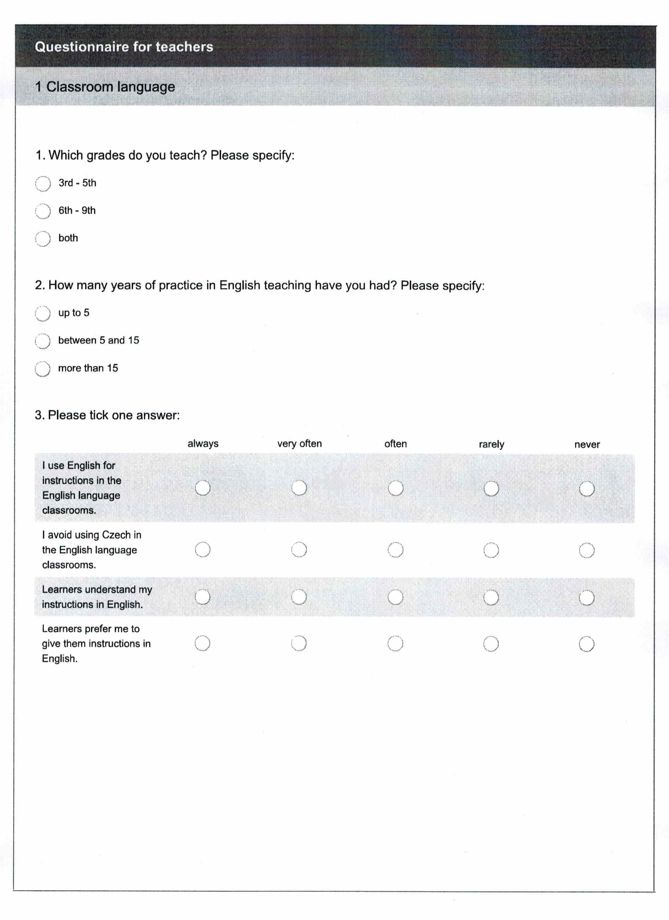

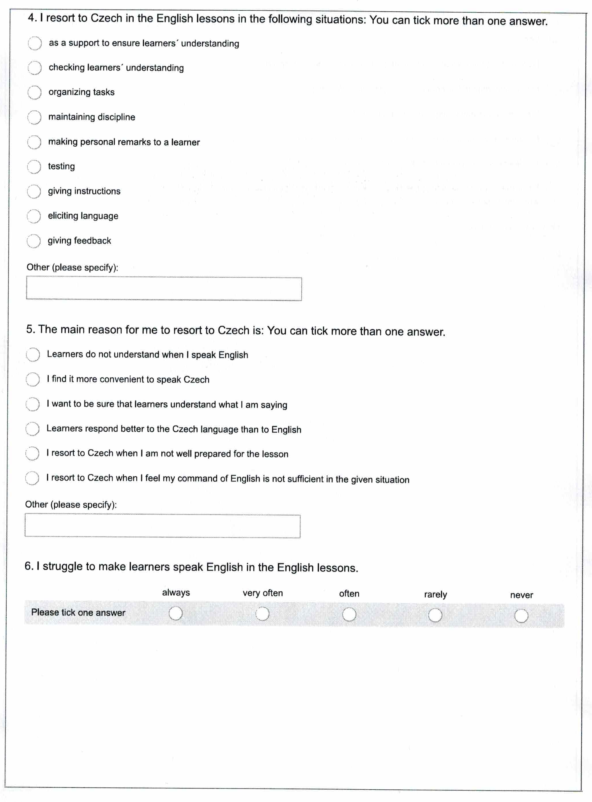

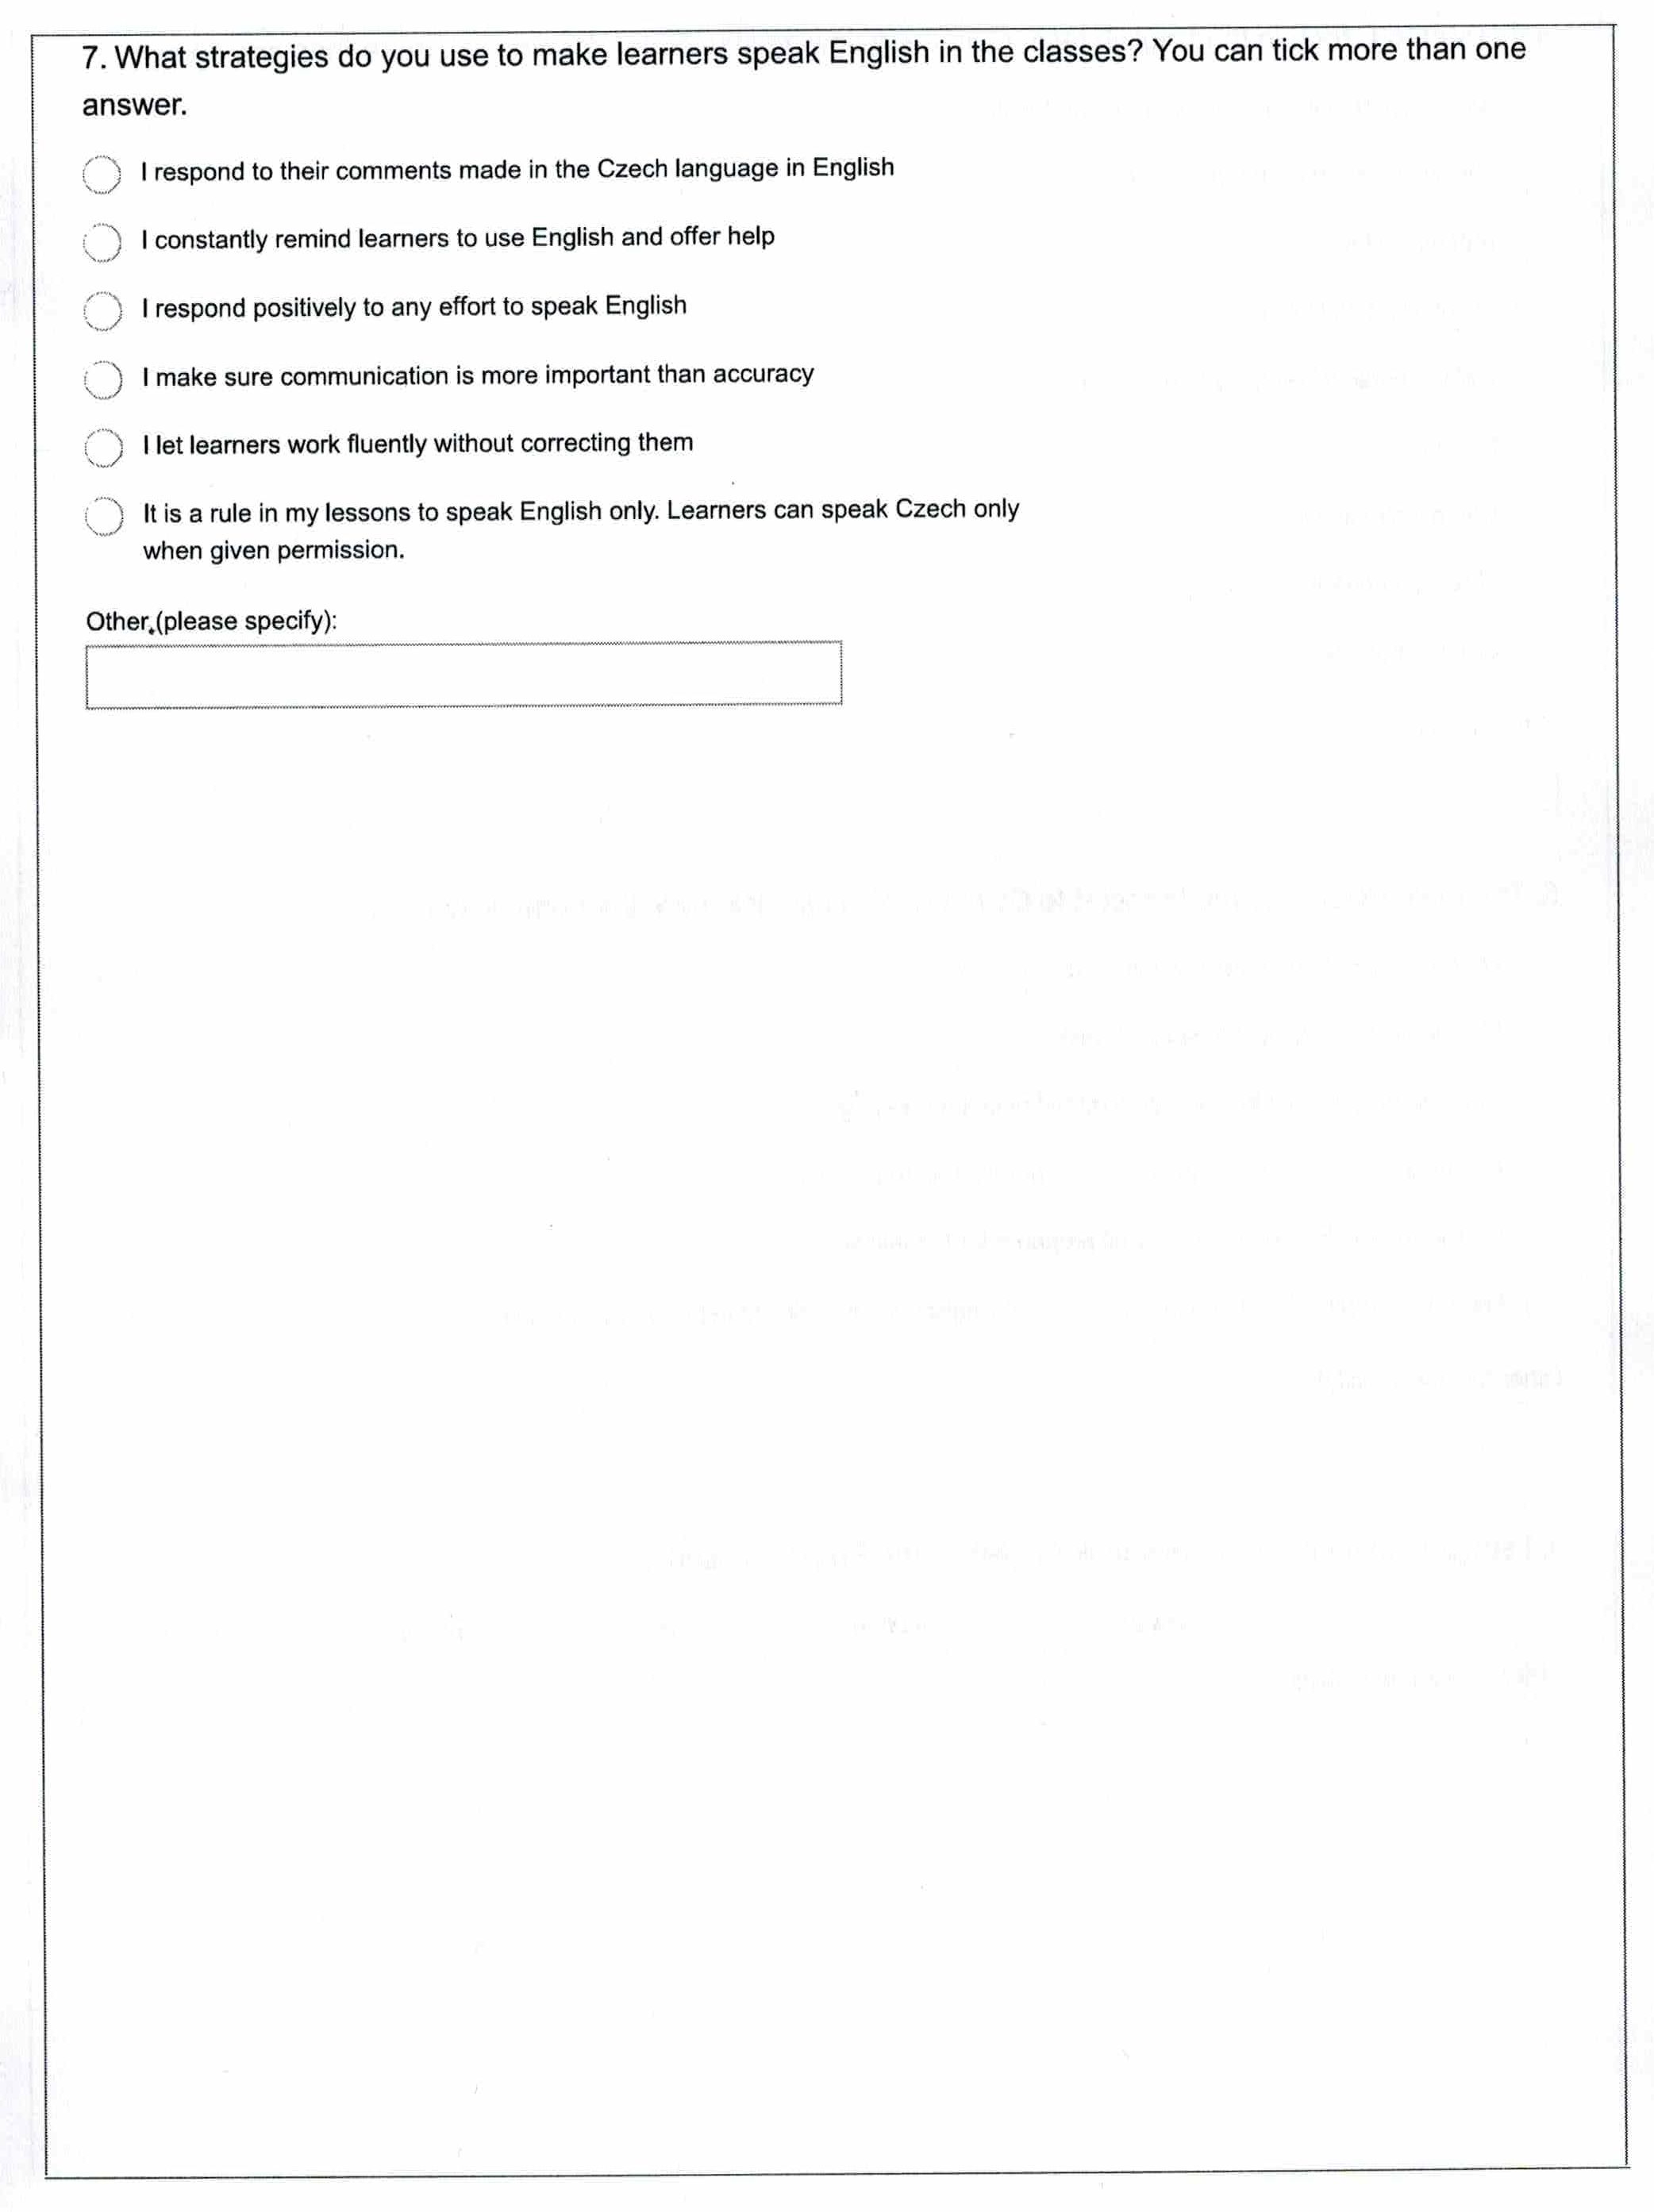

Appendix 5: Questionnaire for teachers: Presentation of vocabulary and grammar
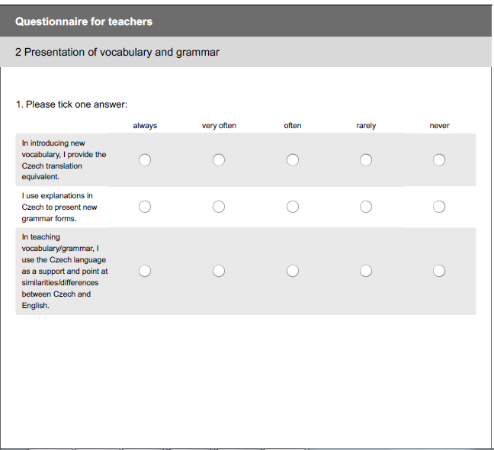

Appendix 6: Questionnaire for teachers: Translation
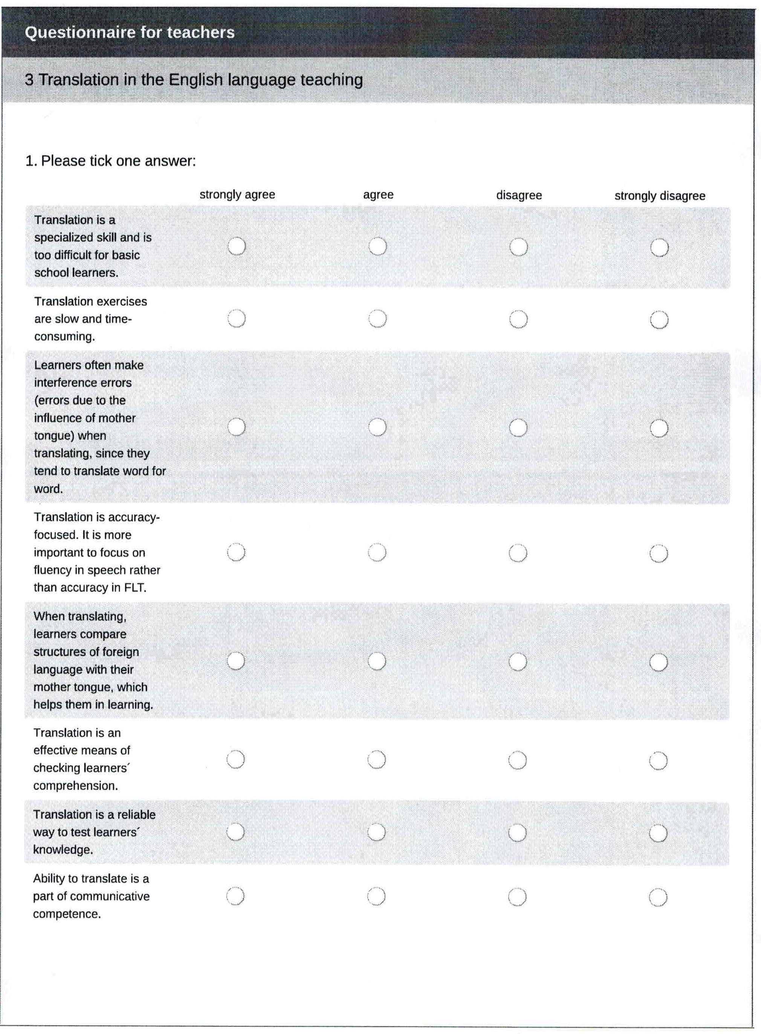

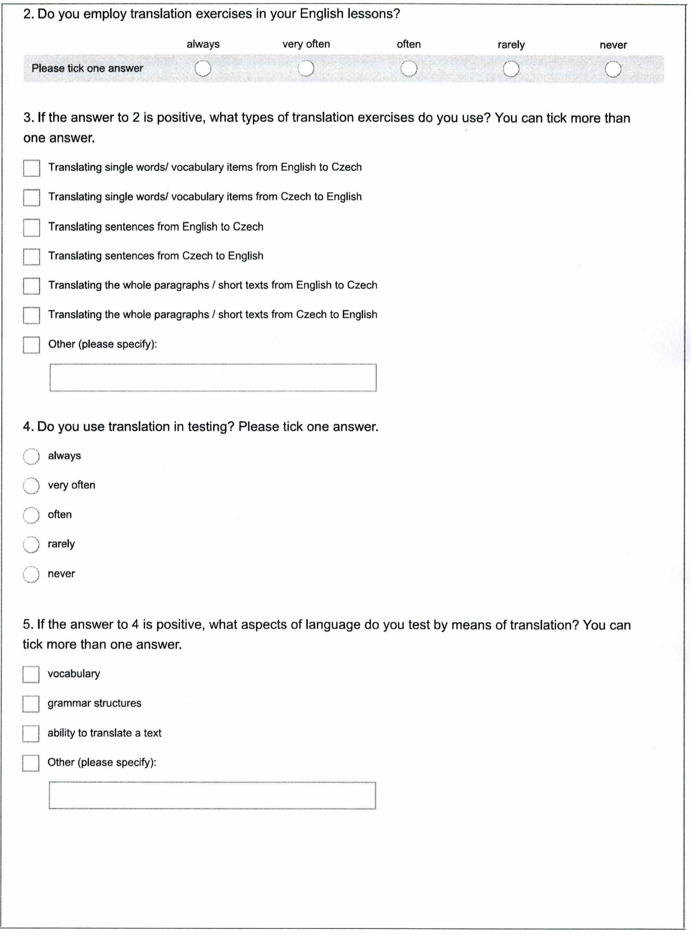

Appendix 7: Questionnaire for learners in English
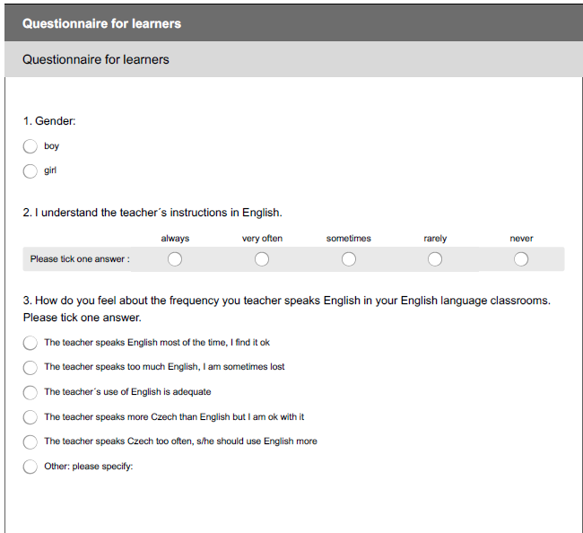

Appendix 8: Questionnaire for learners in Czech
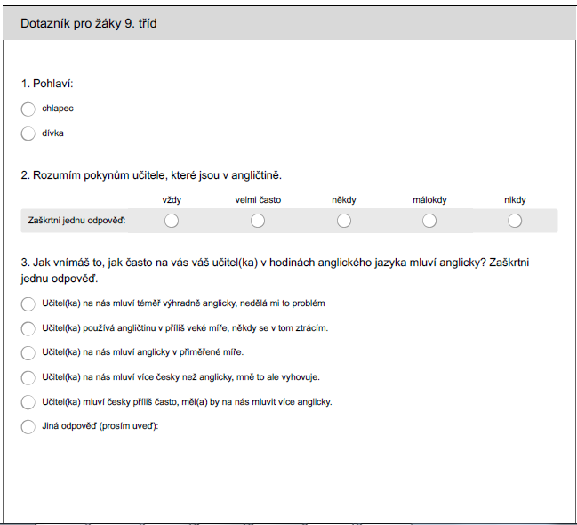

Appendix 9: Specification of grades taught
Which grades do you teach? Please specify:
Answer Options | Response Percent | Response Count
3rd - 5th | 20.3% | 32
6th - 9th | 22.8% | 36
Both | 57.0% | 90
answered question |  | 158
skipped question |  | 1

Appendix 10: Years of practice
How many years of practice in English language teaching have you had? Please specify:
Answer Options | Response Percent | Response Count
up to 5 | 20.8% | 33
between 5 and 15 | 44.0% | 70
more than 15 | 35.2% | 56
answered question |  | 159
skipped question |  | 0

Appendix 11: Overview of figures based on the data from the Teacher Questionnaire
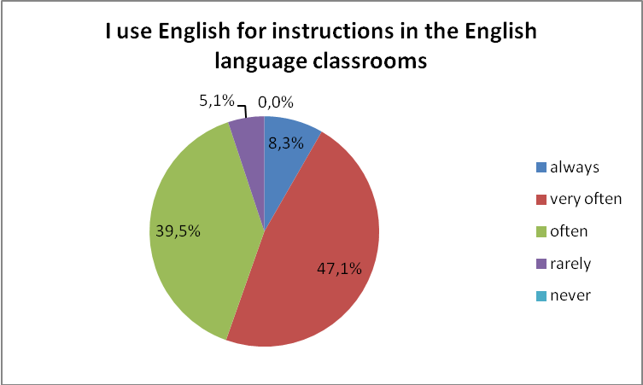
Figure 1: English as language for instructions in the ELC
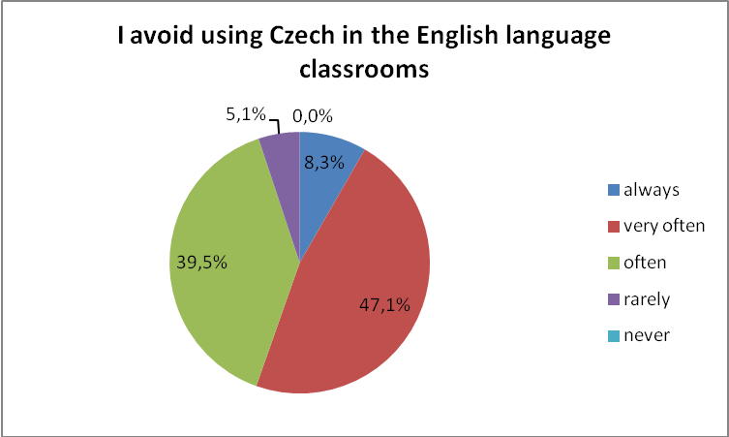
Figure 2: The use of Czech in the ELC

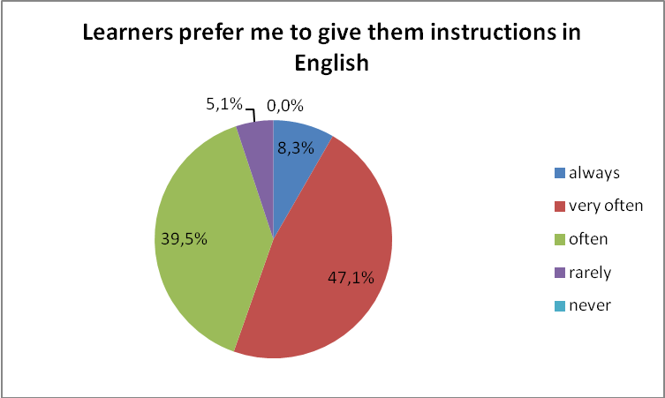
Figure 3: Learners´ preferences of the teacher´s choice of language

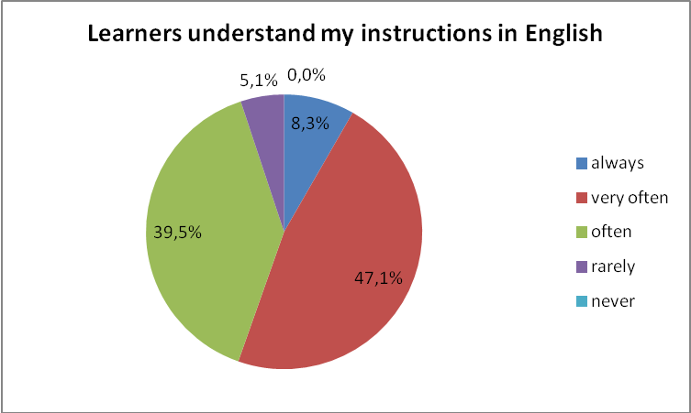
Figure 4: Comprehension of English instructions by learners

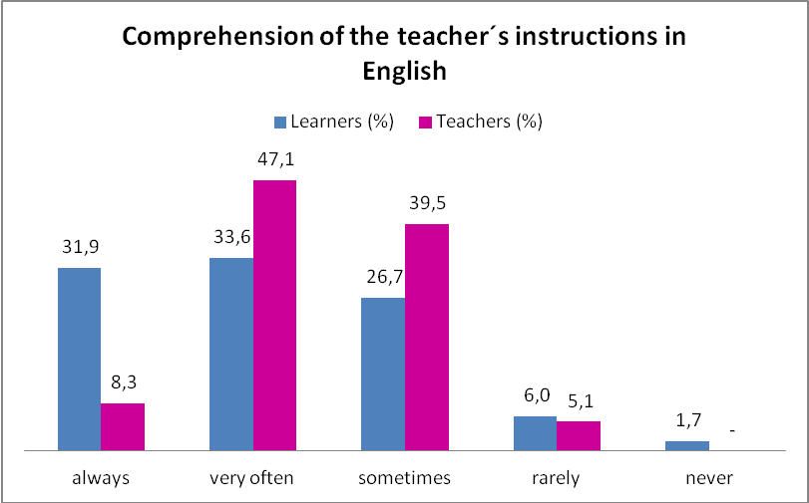
Figure 5: Comprehension of the teacher´s instructions in English: comparison of learners´ and teachers´ responses
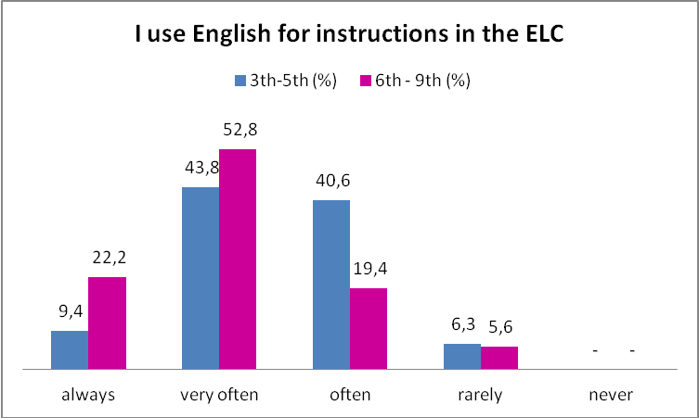
Figure 6: Difference in the use of English as language for instructions in the ELC between primary and lower secondary school teachers

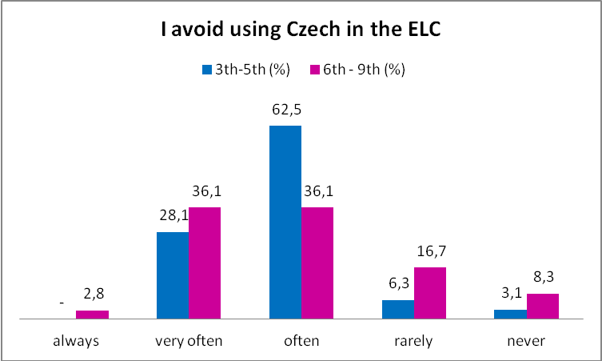
Figure 7: Difference in the use of Czech in the ELC between primary and lower secondary school teachers
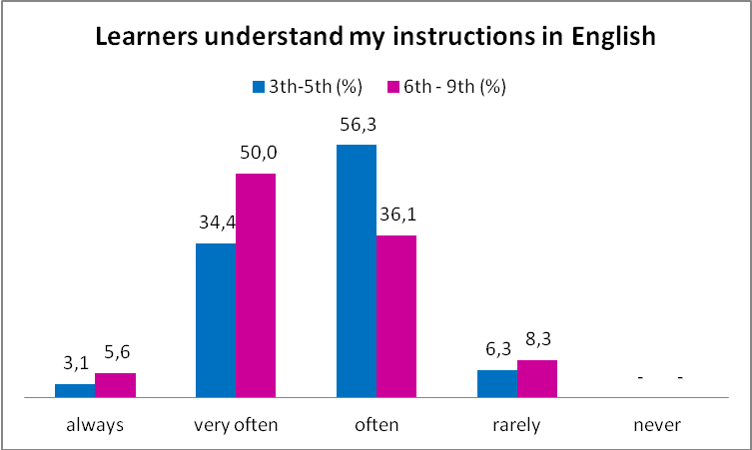
Figure 8: Comprehension of English instructions by learners of primary and lower secondary schools

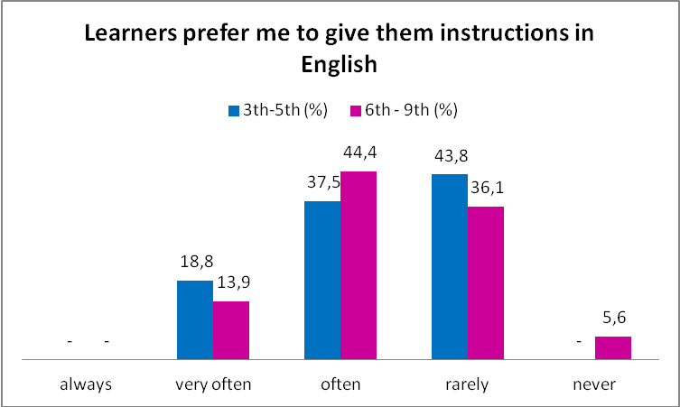
Figure 9: Preferences of the teacher´s choice of language by learners of primary and lower secondary schools

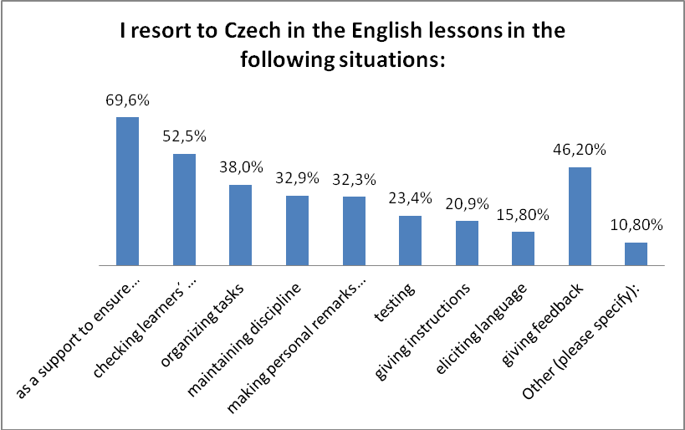
Figure 10: Situations in which teachers resort to L1 in the ELC

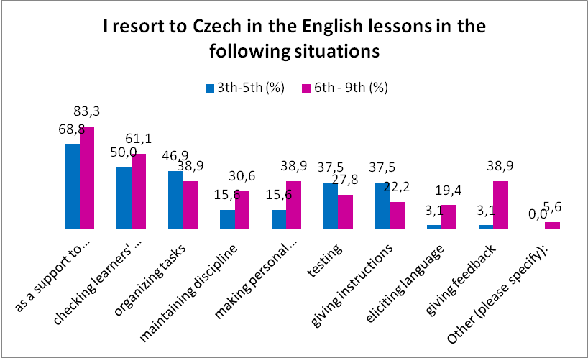
Figure 11: Situations in which teachers of primary and lower secondary school learners resort to L1 in the ELC
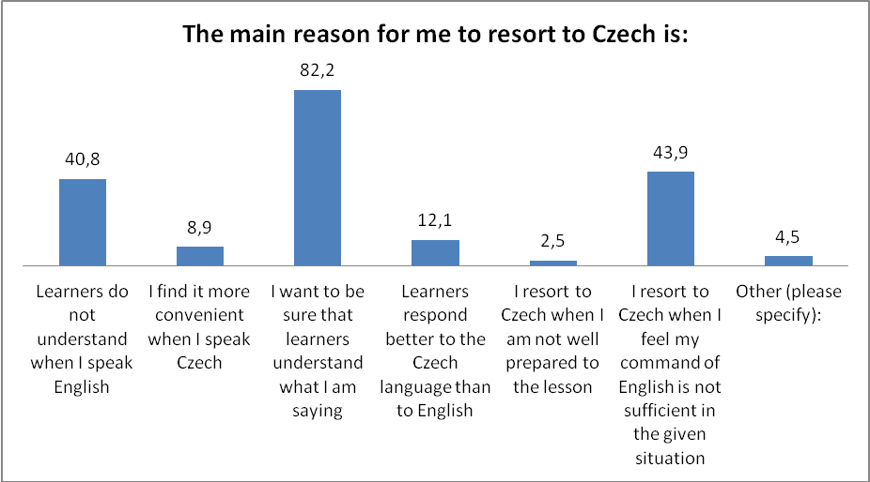
Figure 12: Reasons to resort to L1 in the ELC

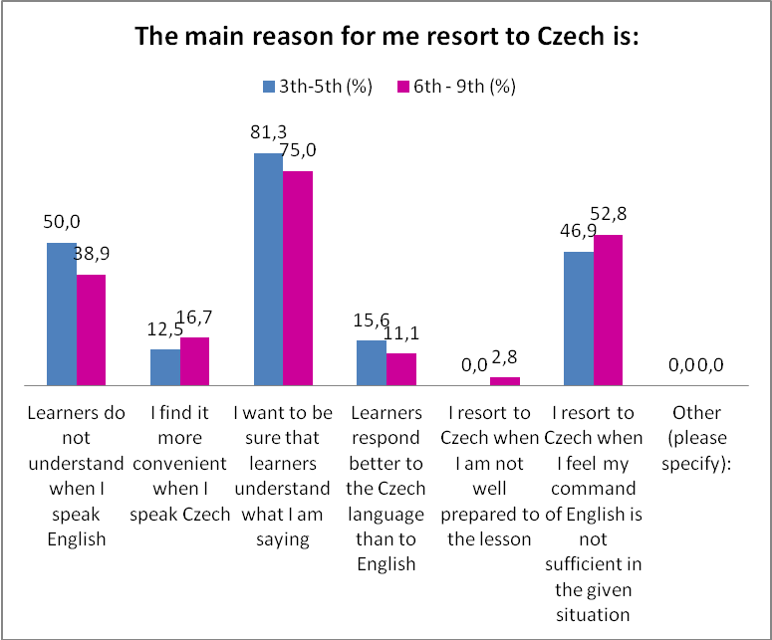
Figure 13: Reasons for teachers of primary and lower secondary school learners to resort to L1 in the ELC
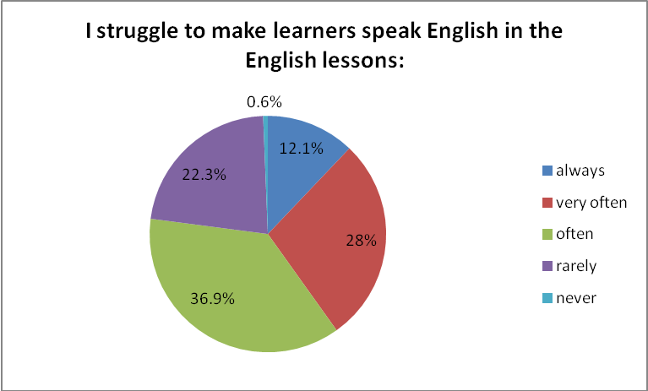
Figure 14: Learners´ willingness to speak English in the English lessons

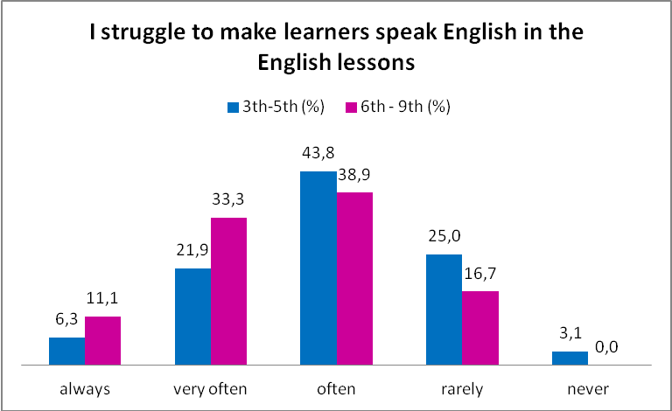
Figure 15: Young learner' and lower secondary school learners´ willingness to speak English in the English lessons

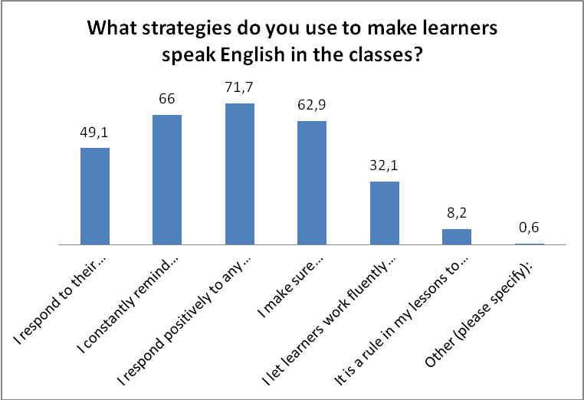
Figure 16: Strategies used by teachers to make learners speak English in the ELC

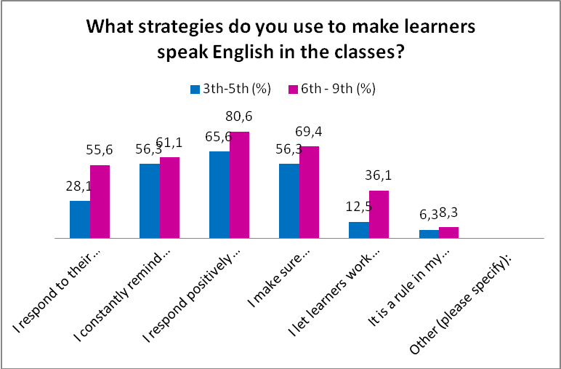
Figure 17: Strategies used by primary and lower secondary school teachers to make learners speak English in the ELC

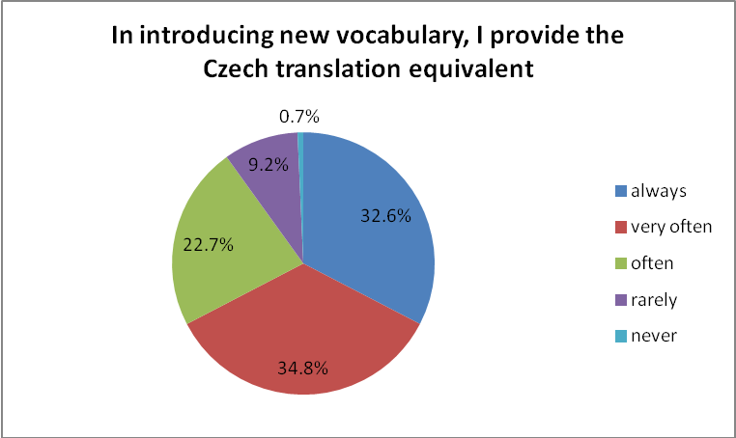
Figure 18: Providing the Czech translation equivalent in introducing new vocabulary

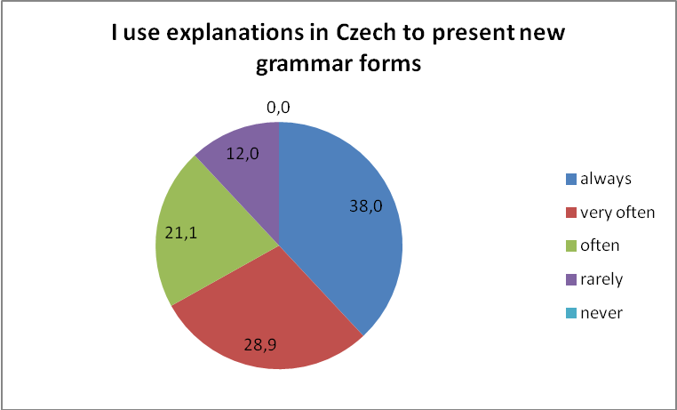
Figure 19: Providing explanations in Czech to present new grammar forms

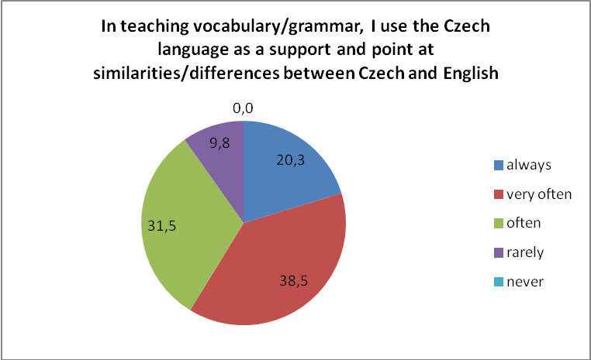
Figure 20: Making comparisons between L1 and L2 in the ELC

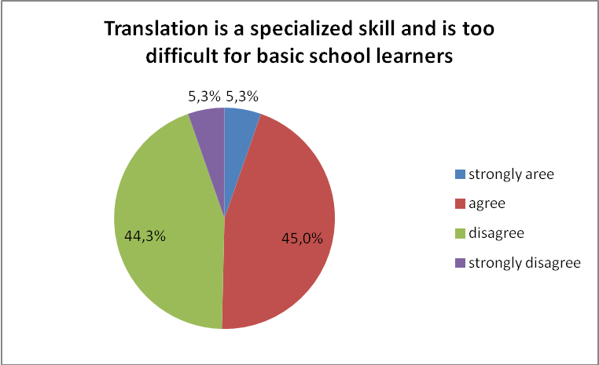
Figure 21: Translation as a specialized skill

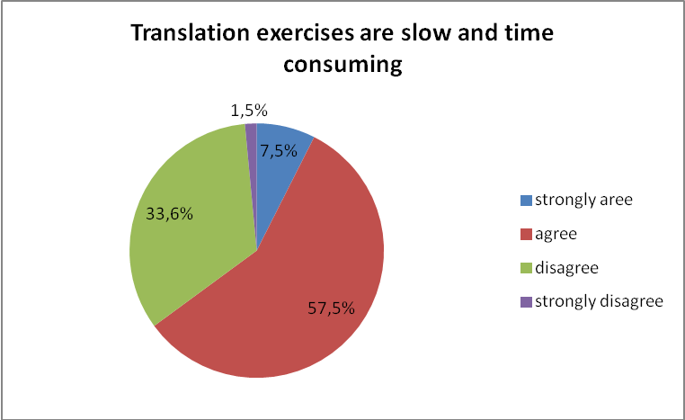
Figure 22: Effectiveness of translation exercises

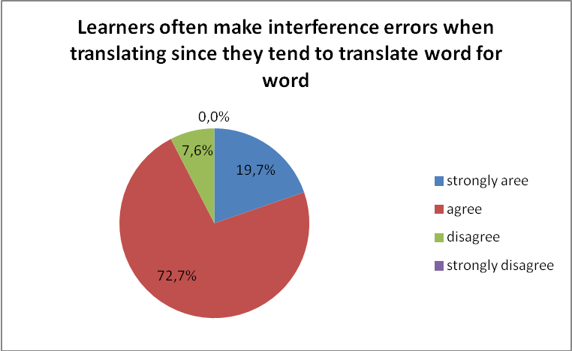
Figure 23: Interference errors in translating

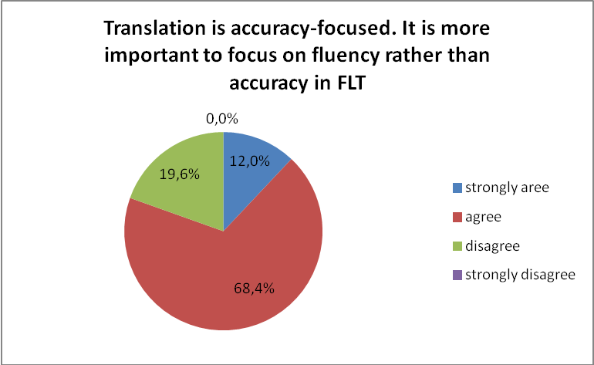
Figure 24: Accuracy vs. fluency approach in FLT

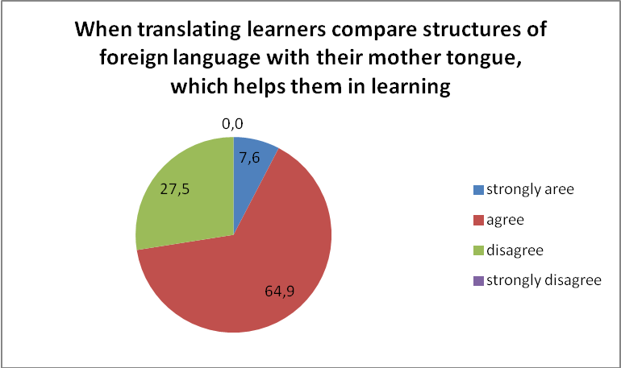
Figure 25: Translation as a help in learning

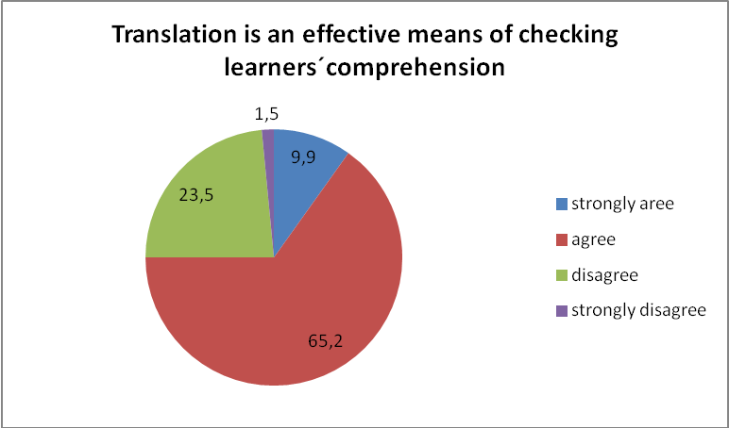
Figure 26: Translation as a means of checking comprehension

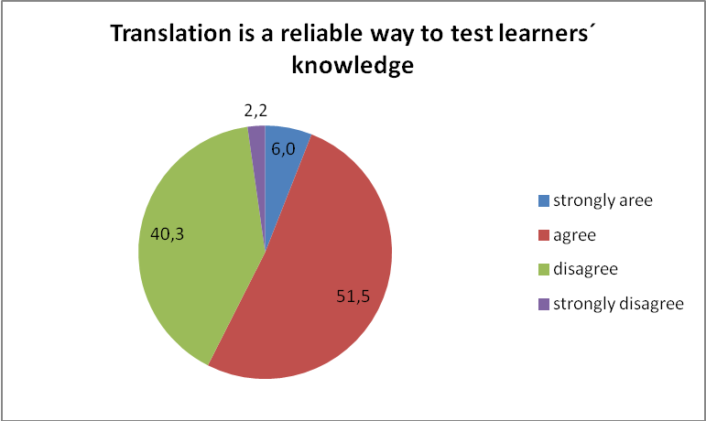
Figure 27: Translation as a means to test learners´ knowledge

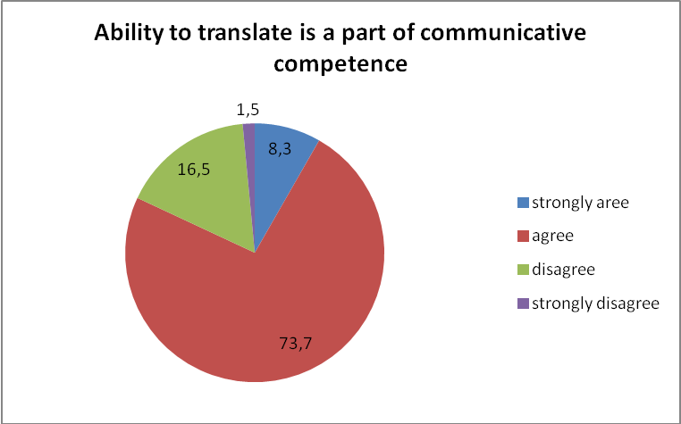
Figure 28: Translation as a part of communicative competence

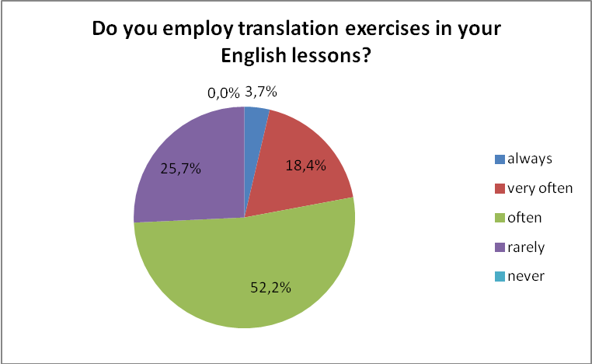
Figure 29: The use of translation exercises in the ELT

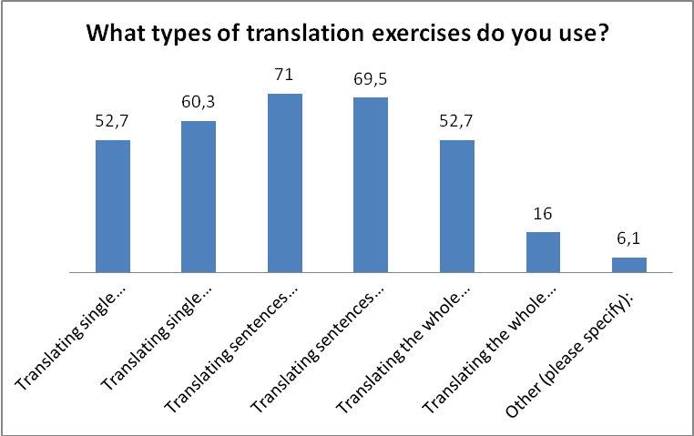
Figure 30: Types of translation exercises used by the respondents

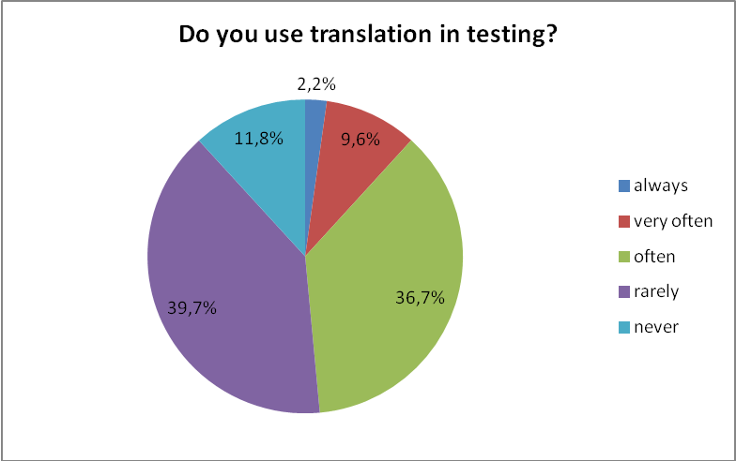
Figure 31: The use of translation in testing

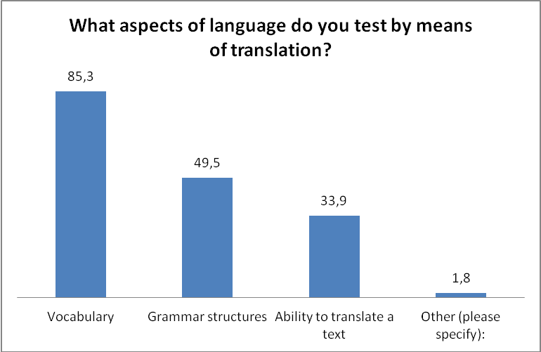
Figure 32: Aspects of language tested by translation

Appendix 12: Overview of figures based on the data from the Learner Questionnaire

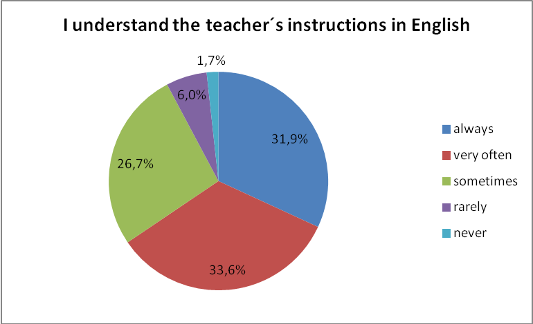
Figure 33: Comprehension of the teacher´s instructions in the ELC

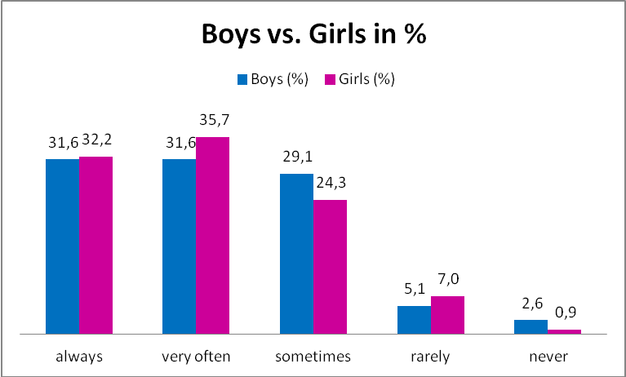
Figure 34: Comprehension of the teacher´s instructions in the ELC by gender

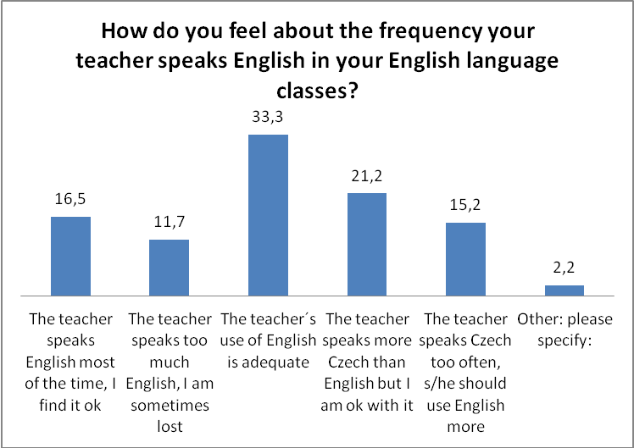
Figure 35: Learners´ perception of the teacher´s choice of language in the ELC

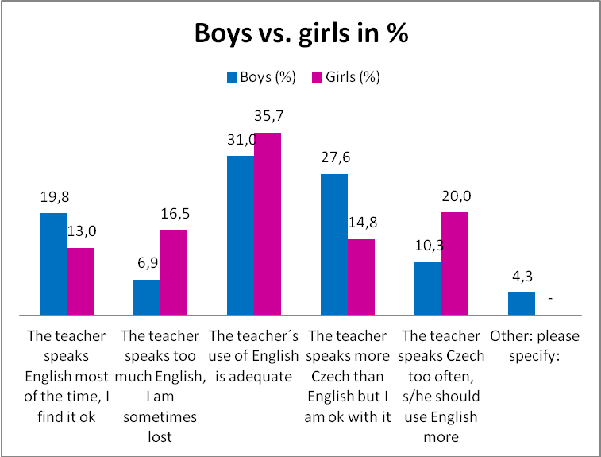
Figure 36: Learners´ perception of the teacher´s choice of language in the ELC by gender

Résumé
Diplomová práce se zabývá úlohou a postavením mateřského jazyka v cizojazyčné výuce na základních školách, přičemž je zasazena do rámce komunikativního přístupu k cizojazyčné výuce. V teoretické části jsou rozpracovány aspekty volby jazyka používaného v různých oblastech cizojazyčné výuky. Praktická část je zaměřena na výuku anglického jazyka s cílem zjistit rozsah a účel používání mateřského jazyka učiteli angličtiny a míru porozumění anglickým pokynům ze strany žáků. Zabývá se také zařazením metody překladu do výuky angličtiny.

ANNOTACE
Jméno a příjmení: | Andrea Slavíčková
Katedra nebo ústav: | Ústav cizích jazyků
Vedoucí práce: | Mgr. Blanka Babická, Ph.D
Rok obhajoby: | 2017
Název práce: | Role mateřského jazyka ve výuce cizích jazyků
Název v angličtině: | The Role of the Mother Tongue in the Foreign Language Teaching
Anotace práce: | Diplomová práce pojednává o roli mateřského jazyka v různých aspektech cizojazyčné výuky. Teoretická část poskytuje rozličné úhly pohledu na jazyk používaný učitelem i žákem v rámci komunikativního přístupu k výuce cizího jazyka. Praktická část vyhodnocuje na základě dotazníkového šetření míru a účel používání mateřského jazyka v hodinách angličtiny.
Klíčová slova: | mateřský jazyk, cizí jazyk, komunikativní výuka, výuka angličtiny, překlad, slovní zásoba, gramatika
Anotace v angličtině: | This diploma thesis deals with the role of mother tongue in different aspects of foreign language teaching. The theoretical part provides various points of view on the language used both by the teacher and the learner in communicative foreign language teaching. The practical part is conducted by means of a questionnaire survey. It provides evaluation of the extent and purpose of the use of the mother tongue in English lessons.
Klíčová slova v angličtině: | mother tongue, foreign language, communicative language teaching, English language teaching, translation, vocabulary, grammar
Přílohy vázané v práci: | Příloha 1: Metody cizojazyčné výuky z pohledu používání mateřského jazyka a překladu  Příloha 2: Internacionalismy v češtině  Příloha 3: Zrádná slova v češtině a angličtině  Příloha 4: Dotazník pro učitele: Zprostředkovací jazyk  Příloha 5: Dotazník pro učitele: Prezentace slovní zásoby a gramatiky  Příloha 6: Dotazník pro učitele: Překlad  Příloha 7: Dotazník pro žáky v angličtině  Příloha 8: Dotazník pro žáky v češtině  Příloha 9: Specifikace respondentů podle stupně, na kterém učí  Příloha 10: Specifikace respondentů podle let praxe  Příloha 11: Přehled grafů na základě dat z dotazníků pro učitele  Příloha 12: : Přehled grafů na základě dat z dotazníků pro žáky
Rozsah práce: | 90, 32 stran příloh
Jazyk práce: | Angličtina

The full text is available in Cook (2010, p. xi-xii).
All others being omitted as they are not relevant for the purpose of this paper
Level A2 is described as follows: "Can understand sentences and frequently used expressions related to areas of most immediate relevance (e.g. very basic personal and family information, shopping, local geography, employment). Can communicate in simple and routine tasks requiring a simple and direct exchange of information on familiar and routine matters. Can describe in simple terms aspects of his/her background, immediate environment and matters in areas of immediate need." (Common European Framework of Reference for Languages)
All skills are combined in everyday communication and hence in FLT. For this reason we can talk of integrated skills (Seznámení s komunikativním způsobem vyučování angličtiny – Příručka pro české učitele, 1998, p. 23)
Scrivener (2011, p. 185) distinguishes the terms vocabulary and lexis: He refers Vocabulary to single words and tightly linked combinations of words, while lexis refers to our internal database comprising single words, collocations and multiword items (combination of words typically used together).
Apart from translation, other means of vocabulary presentation Thorbnury (2002, p. 77) mentions are real things, pictures, actions/gestures, definitions and situations.
According to Fitztumová (2007, on-line), about 70% of English words have their origin in other languages.
Other criteria for the choice of words to be included in a syllabus, as stated by Thornbury (2002, p. 34), are usefulness, frequency and teachability.
Dominant language is the language that one uses most often and is most competent in (Longman Dictionary of Language Teaching and Applied Linguistics (2010, p. 183).
Available on-line from http://zs.vlachovice.cz/e_download.php?file=data/editor/45cs_4.pdf&original=V%C3%BDro%C4%8Dn%C3%AD+zpr%C3%A1va+2015-16.pdf
Available on-line from https://portal.csicr.cz/School/600114031
Available on-line from http://www.zsslavicin.cz/cs/files/contents/VZ%202015_2016.pdf

