**APPENDIX**

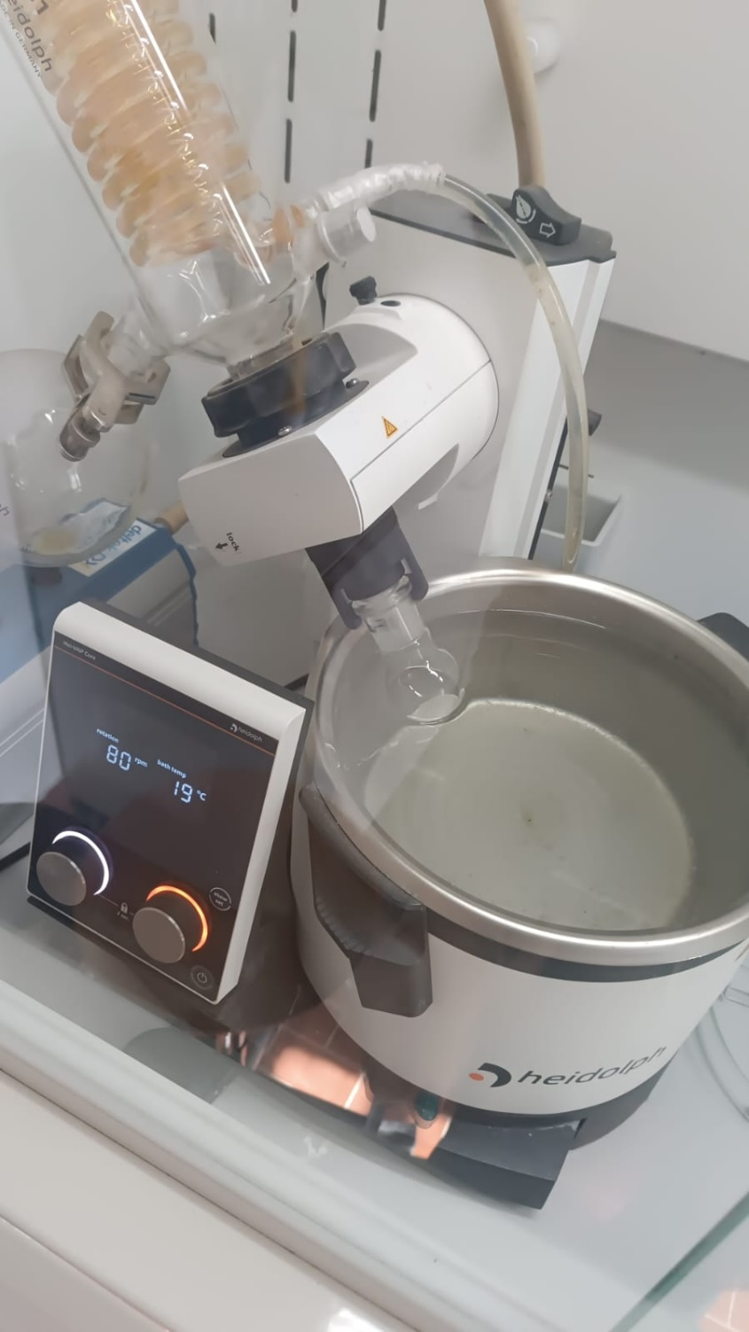

Figure 2: Rotovap.

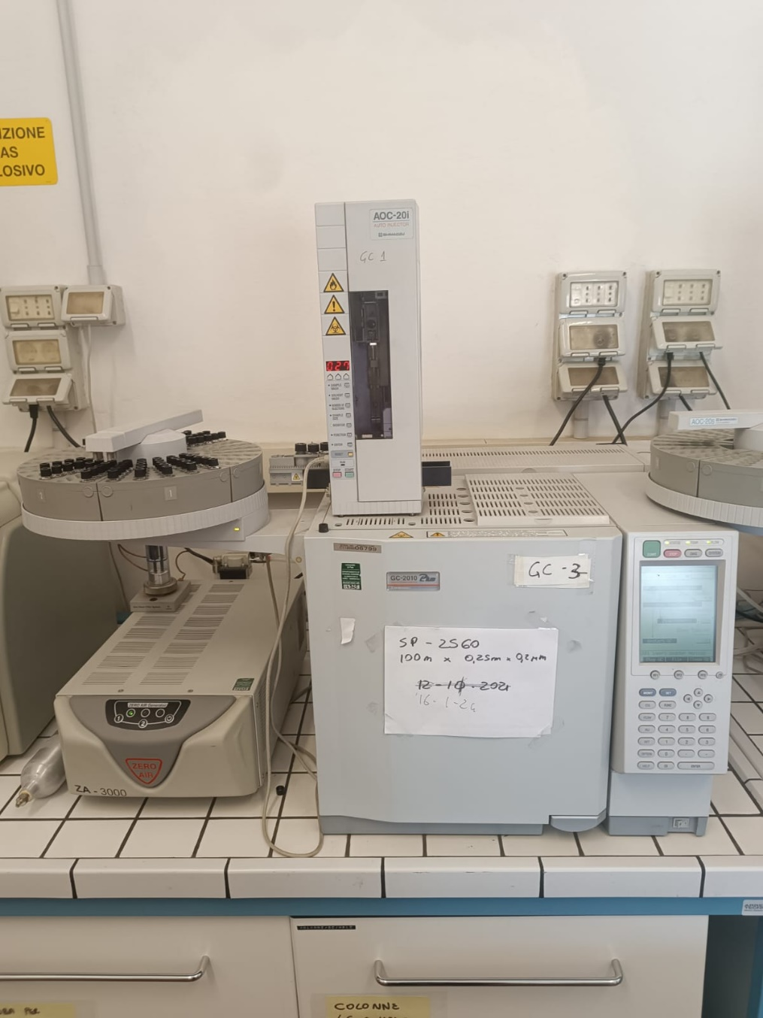

Figure 3: Gas chromatography.



Figure 2: Rotovap.

Figure 3: Gas chromatography.