Appendix

Appendix 1, Consolidated Statement of Financial Position X5 Group (2018-2019 years) Assets
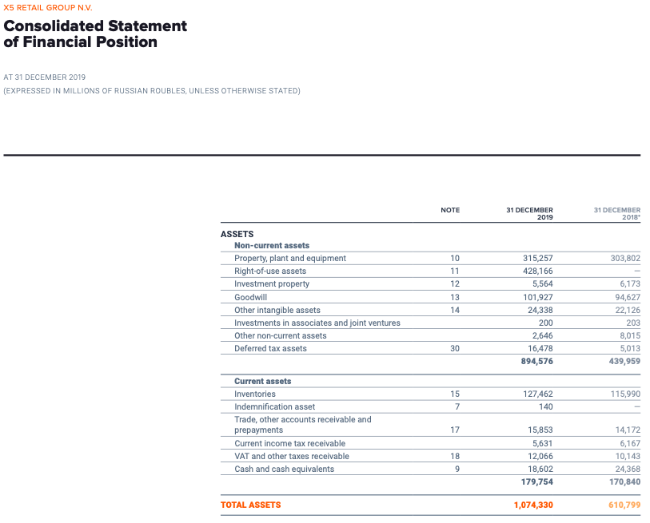
Source: Official annual report. Retrieved from https://www.x5.ru/en/investors/annual-reports/
Appendix 2, Consolidated Statement of Financial Position X5 Group (2018-2019 years) Liabilities and Equity
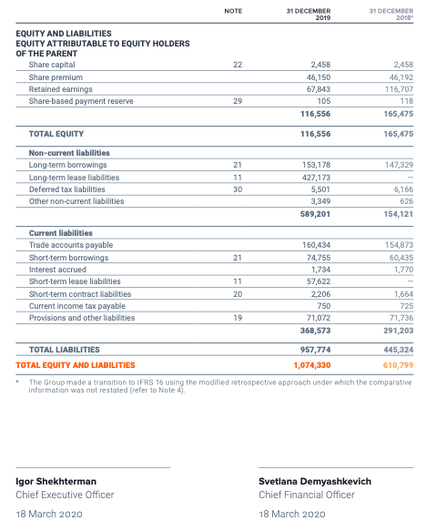
Source: Official annual report. Retrieved from https://www.x5.ru/en/investors/annual-reports/

Appendix 3, Consolidated Statement of Financial Position X5 Group (2020-2021 years)
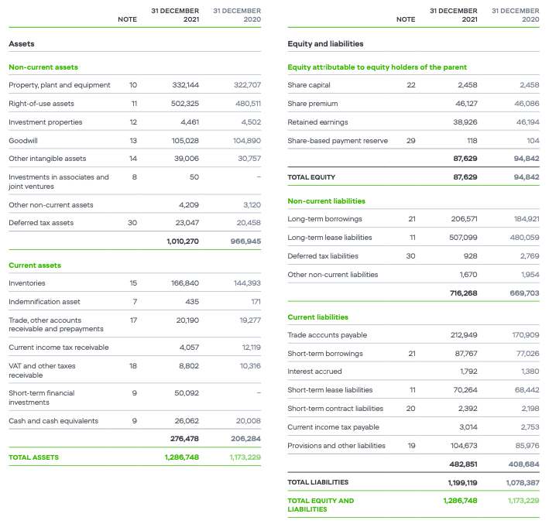
Source: Official annual report. Retrieved from https://www.x5.ru/en/investors/annual-reports/

Appendix 4, Consolidated Statement of Financial Position X5 Group (2022 year)
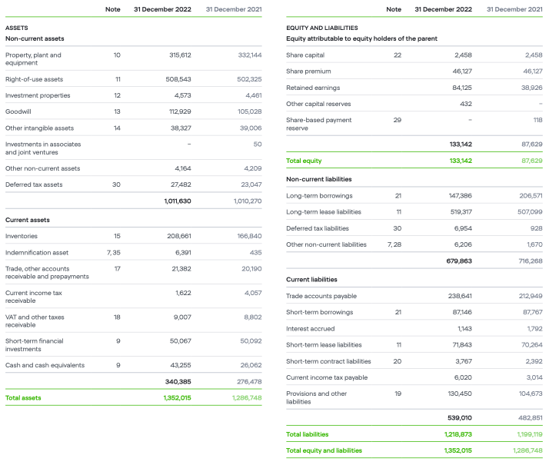
Source: Official annual report. Retrieved from https://www.x5.ru/en/investors/annual-reports/

Appendix 5, Consolidated Statement of Profit or Loss X5 Group (2018-2019 years)
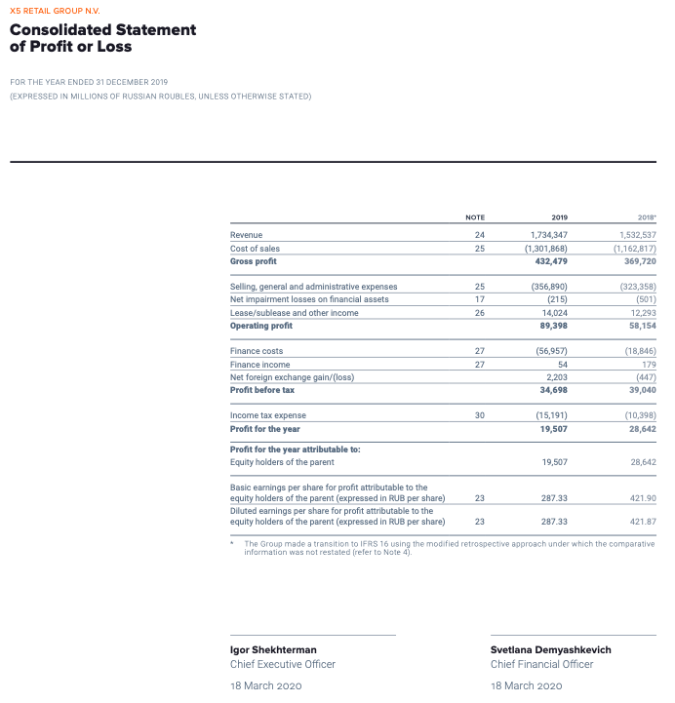
Source: Official annual report. Retrieved from https://www.x5.ru/en/investors/annual-reports/
Appendix 6, Consolidated Statement of Profit or Loss X5 Group (2020-2021 years)
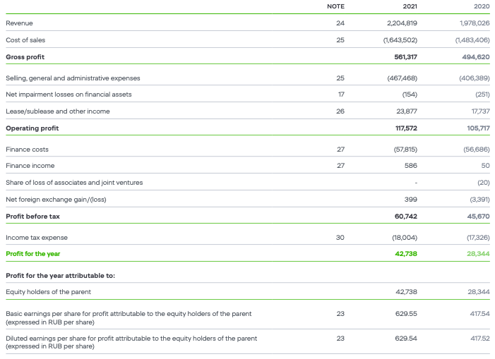
Source: Official annual report. Retrieved from https://www.x5.ru/en/investors/annual-reports/

Appendix 7, Consolidated Statement of Profit or Loss X5 Group (2022 year)
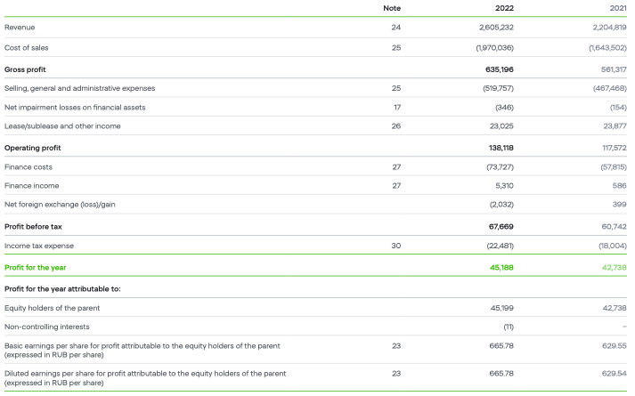
Source: Official annual report. Retrieved from https://www.x5.ru/en/investors/annual-reports/

Appendix 8, Consolidated Statement of Cash-Flow X5 Group (2018-2019 years)
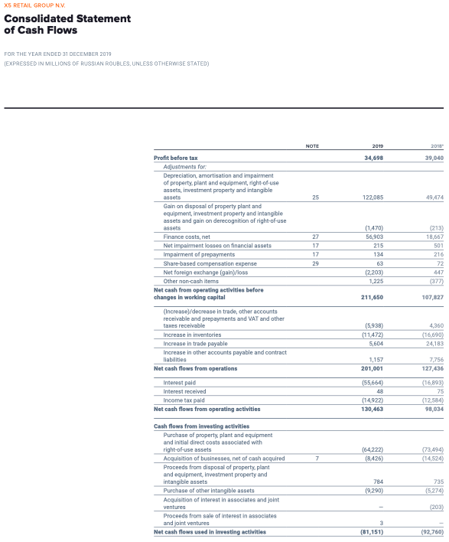
Source: Official annual report. Retrieved from https://www.x5.ru/en/investors/annual-reports/
Appendix 9, Consolidated Statement of Cash-Flow X5 Group (2018-2019 years)
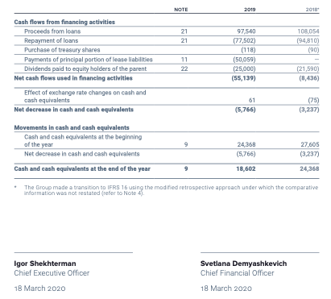
Source: Official annual report. Retrieved from https://www.x5.ru/en/investors/annual-reports/
Appendix 10, Consolidated Statement of Cash-Flow X5 Group (2020-2021 years)
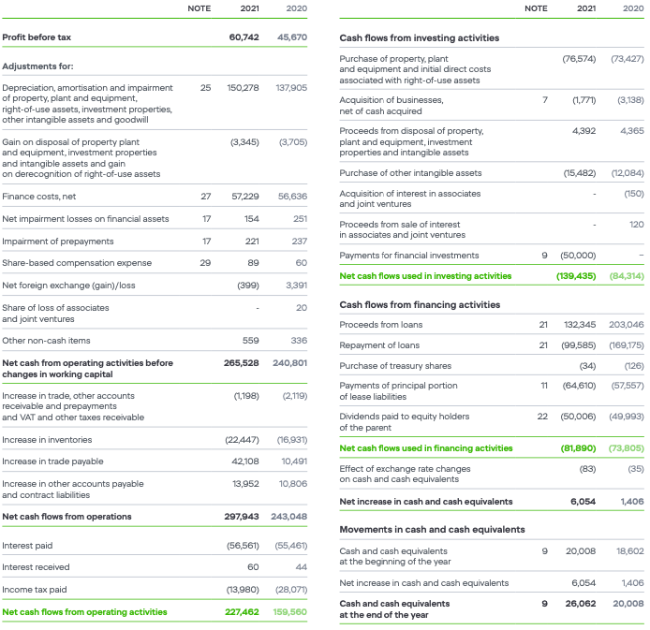
Source: Official annual report. Retrieved from https://www.x5.ru/en/investors/annual-reports/

Appendix 11, Consolidated Statement of Cash-Flow X5 Group (2022 year)
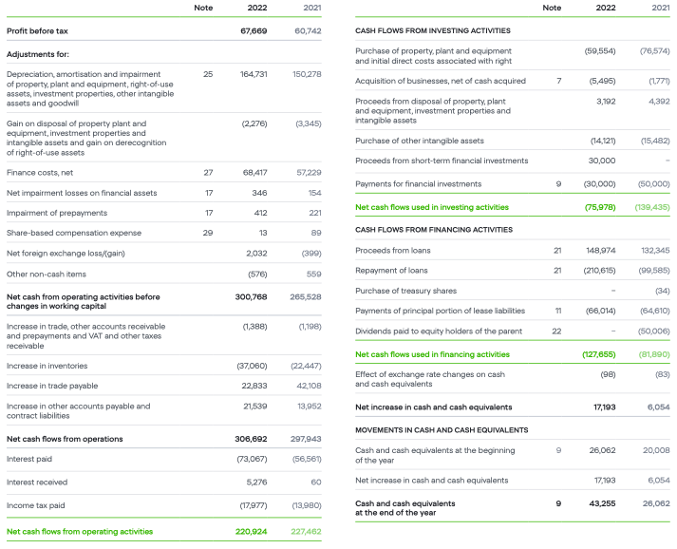
Source: Official annual report. Retrieved from https://www.x5.ru/en/investors/annual-reports/
Appendix 12, Consolidated Balance Sheet Ahold Delhaize Group (2018-2019 years)
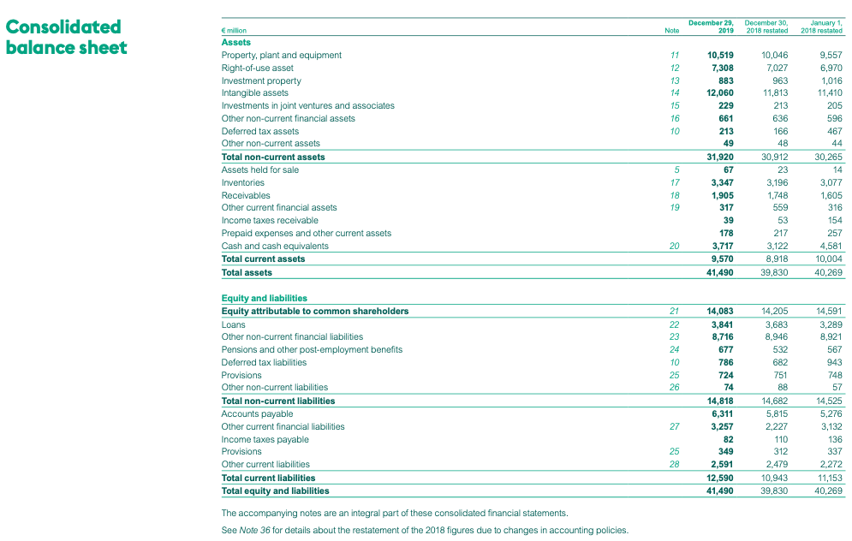
Source: Official annual report. Retrieved from https://media.aholddelhaize.com/media/1xbnvzzk/ahold-delhaize-annual-report-2019.pdf?t=637526941720330000

Appendix 13, Consolidated Balance Sheet Ahold Delhaize Group (2020-2021 years)
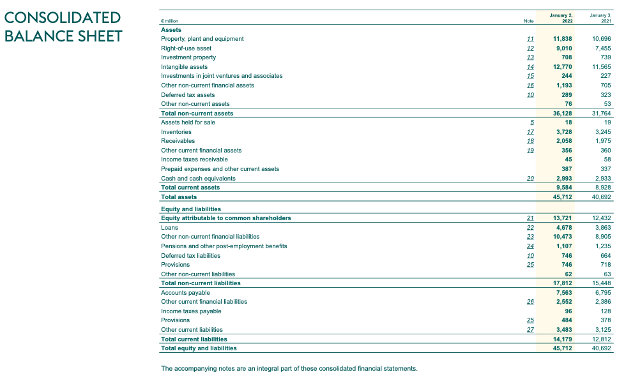
Source: Official annual report. Retrieved from https://media.aholddelhaize.com/media/1l5iqhvt/full-annual-report-2021.pdf?t=637818238680370000

Appendix 14, Consolidated Balance Sheet Ahold Delhaize Group (2022 year)
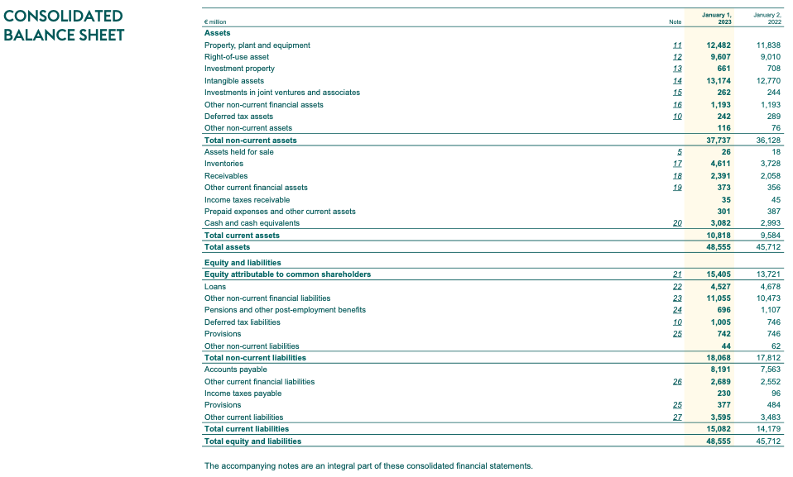
Source: Official annual report. Retrieved from https://media.aholddelhaize.com/media/vy4neu1n/ar-2022-ahold-delhaize-interactive-final.pdf?t=638143108570530000

Appendix 15, Consolidated Income Statement Ahold Delhaize Group (2018-2019 years)
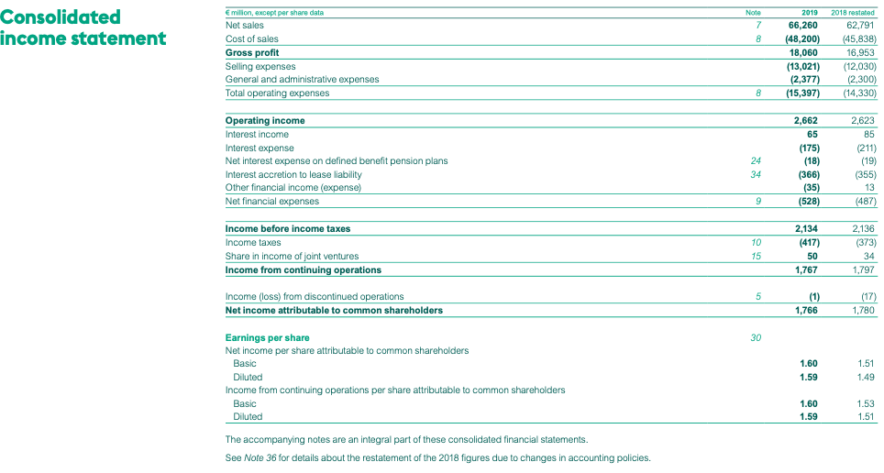
Source: Official annual report. Retrieved from https://media.aholddelhaize.com/media/1xbnvzzk/ahold-delhaize-annual-report-2019.pdf?t=637526941720330000

Appendix 16, Consolidated Income Statement Ahold Delhaize Group (2020-2021 years)
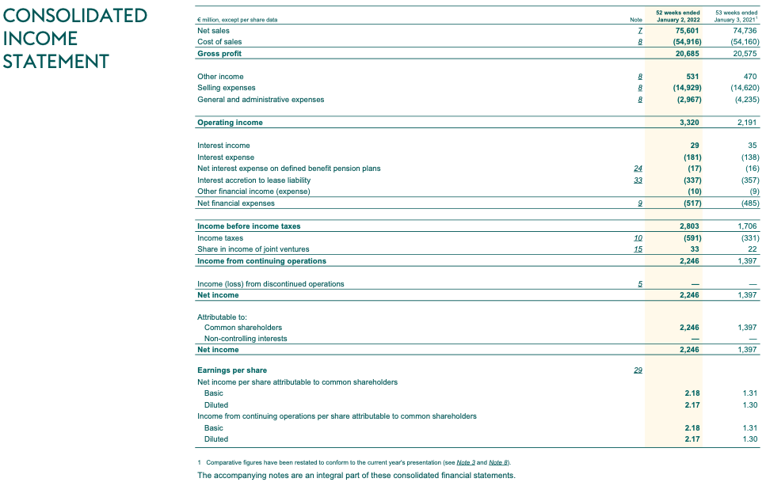
Source: Official annual report. Retrieved from https://media.aholddelhaize.com/media/1l5iqhvt/full-annual-report-2021.pdf?t=637818238680370000

Appendix 17, Consolidated Income Statement Ahold Delhaize Group (2022 year)
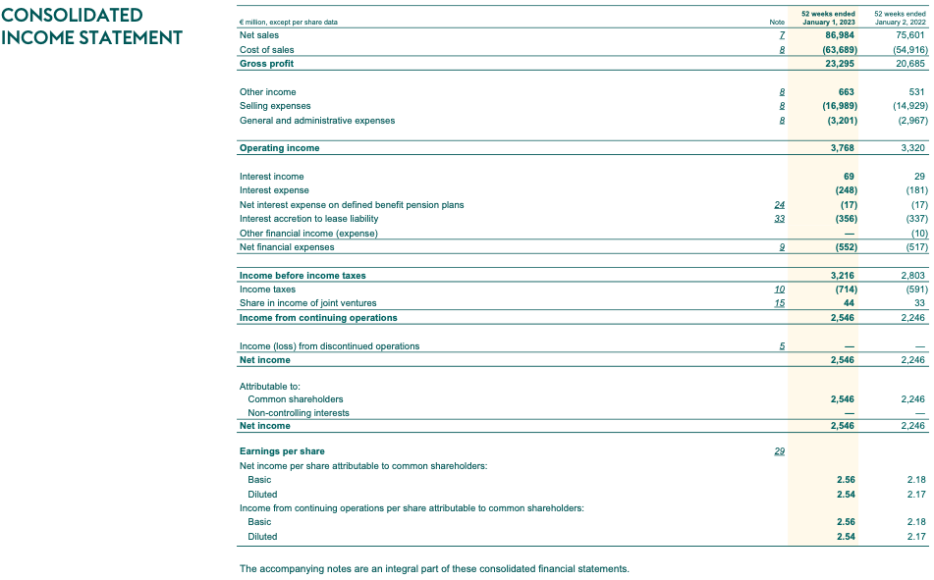
Source: Official annual report. Retrieved from https://media.aholddelhaize.com/media/vy4neu1n/ar-2022-ahold-delhaize-interactive-final.pdf?t=638143108570530000

Appendix 18, Consolidated Statement of Cash-Flows Ahold Delhaize Group (2018-2019 years)
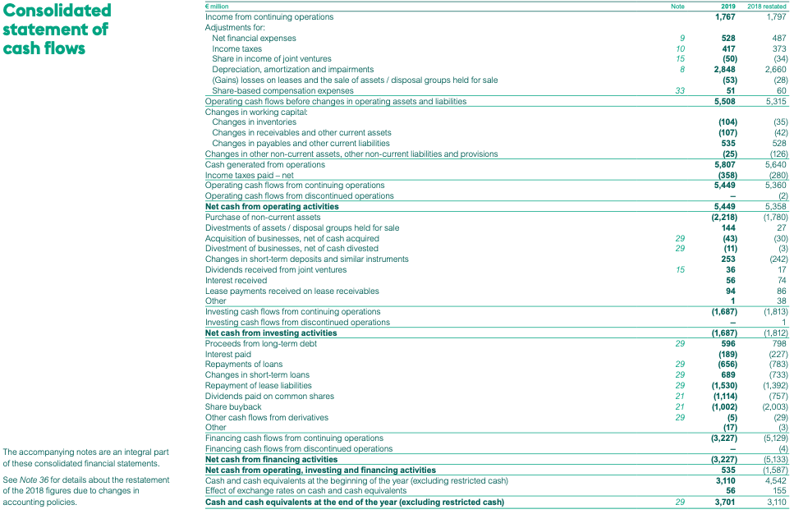
Source: Official annual report. Retrieved from https://media.aholddelhaize.com/media/1xbnvzzk/ahold-delhaize-annual-report-2019.pdf?t=637526941720330000

Appendix 19, Consolidated Statement of Cash-Flows Ahold Delhaize Group (2020-2021 years)
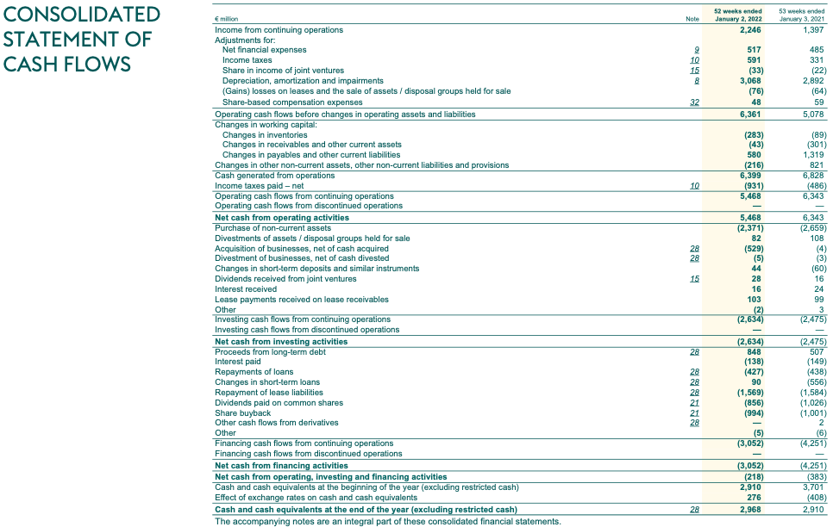
Source: Official annual report. Retrieved from https://media.aholddelhaize.com/media/1l5iqhvt/full-annual-report-2021.pdf?t=637818238680370000

Appendix 20, Consolidated Statement of Cash-Flows Ahold Delhaize Group (2022 year)
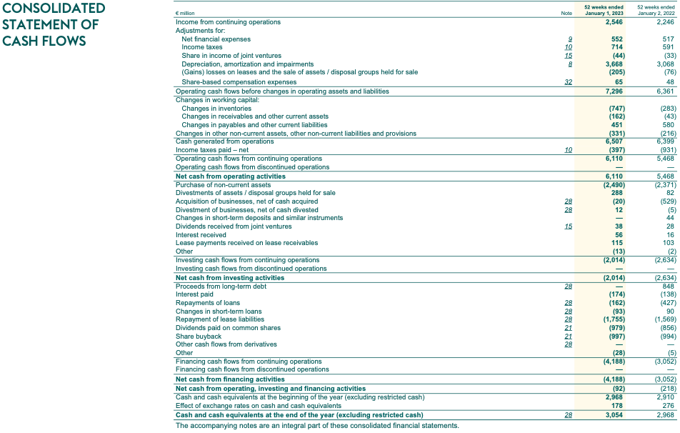
Source: Official annual report. Retrieved from https://media.aholddelhaize.com/media/vy4neu1n/ar-2022-ahold-delhaize-interactive-final.pdf?t=638143108570530000

Appendix 21, Consolidated Balance Sheet Walmart (2018-2019 years)
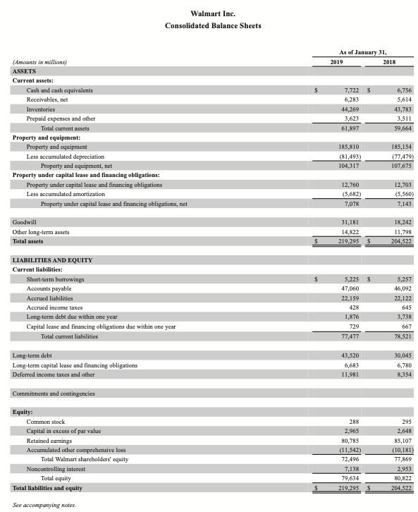
Source: Official annual report. Retrieved from https://s201.q4cdn.com/262069030/files/doc_financials/2019/ar/Walmart-2019-AR-Final.pdf
Appendix 22, Consolidated Balance Sheet Walmart (2020-2021 years)
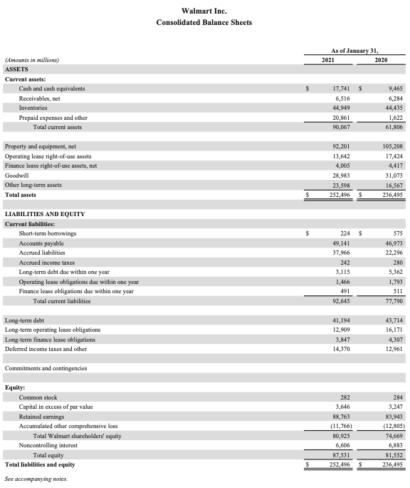
Source: Official annual report. Retrieved from https://s201.q4cdn.com/262069030/files/doc_financials/2021/ar/WMT_2021_AnnualReport.pdf
Appendix 23, Consolidated Balance Sheet Walmart (2022 year)
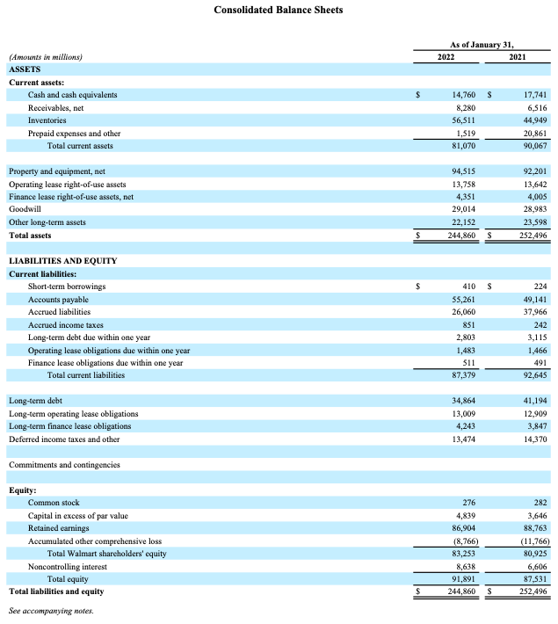
Source: Official annual report. Retrieved from https://s201.q4cdn.com/262069030/files/doc_financials/2022/ar/WMT-FY2022-Annual-Report.pdf

Appendix 24, Consolidated Statement of Income Walmart (2018-2019 years)
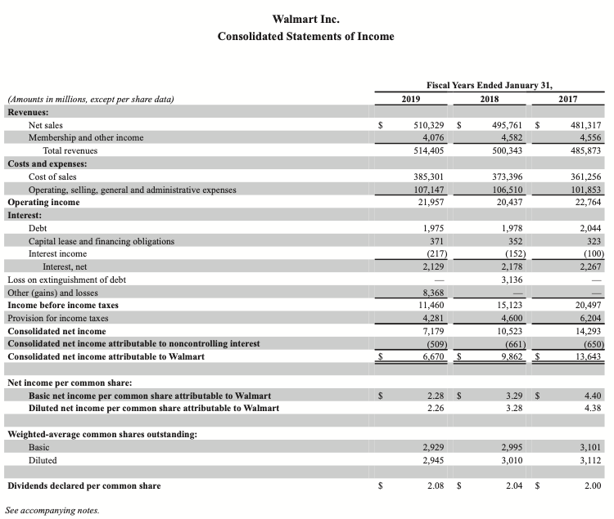
Source: Official annual report. Retrieved from https://s201.q4cdn.com/262069030/files/doc_financials/2019/ar/Walmart-2019-AR-Final.pdf

Appendix 25, Consolidated Statement of Income Walmart (2020-2021 years)
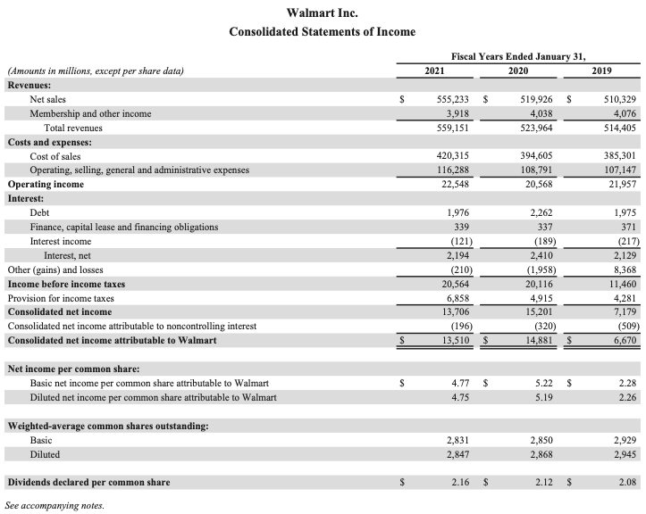
Source: Official annual report. Retrieved from https://s201.q4cdn.com/262069030/files/doc_financials/2021/ar/WMT_2021_AnnualReport.pdf

Appendix 26, Consolidated Statement of Income Walmart (2022 year)
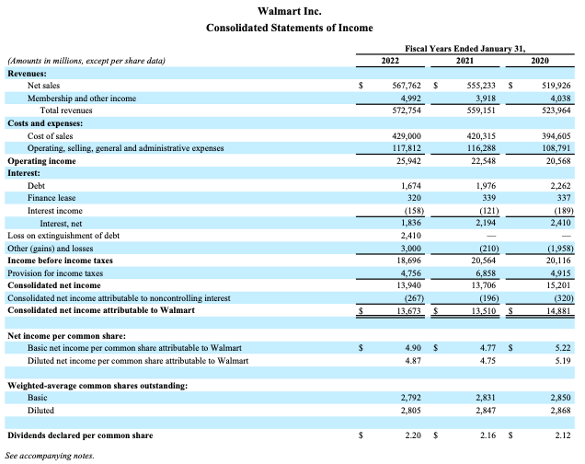
Source: Official annual report. Retrieved from https://s201.q4cdn.com/262069030/files/doc_financials/2022/ar/WMT-FY2022-Annual-Report.pdf

Appendix 27, Consolidated Statement of Cash-Flows Walmart (2018-2019 years)
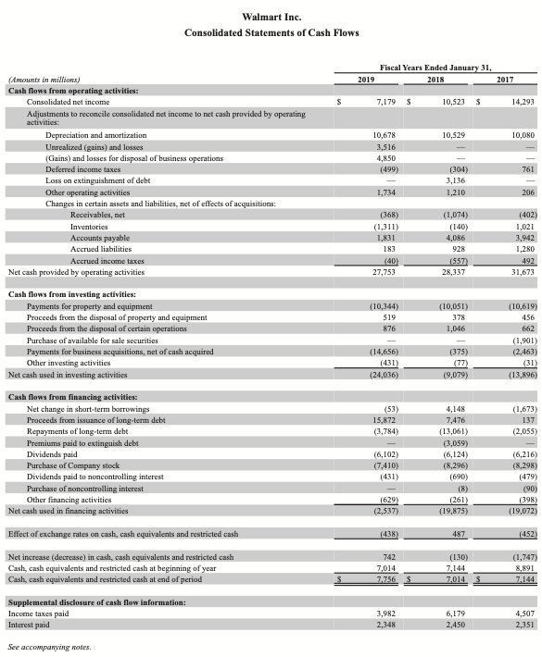
Source: Official annual report. Retrieved from https://s201.q4cdn.com/262069030/files/doc_financials/2019/ar/Walmart-2019-AR-Final.pdf

Appendix 28, Consolidated Statement of Cash-Flows Walmart (2020-2021 years)
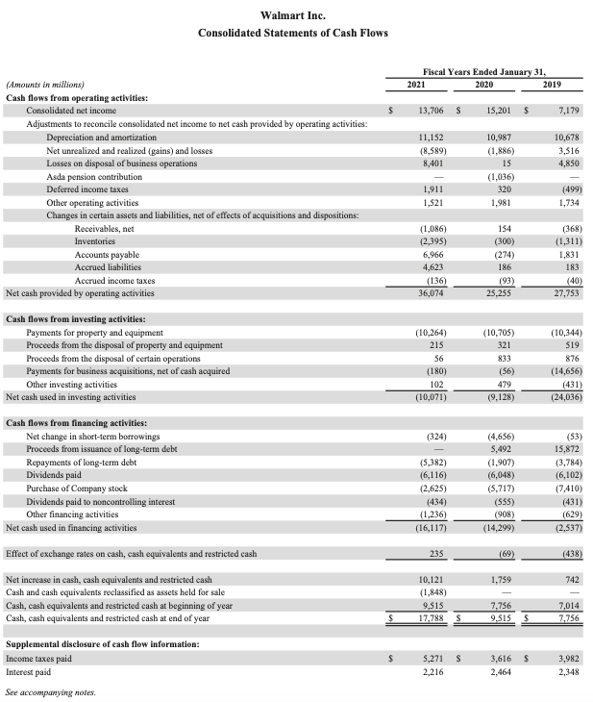
Source: Official annual report. Retrieved from https://s201.q4cdn.com/262069030/files/doc_financials/2021/ar/WMT_2021_AnnualReport.pdf
Appendix 29, Consolidated Statement of Cash-Flows Walmart (2022 year)
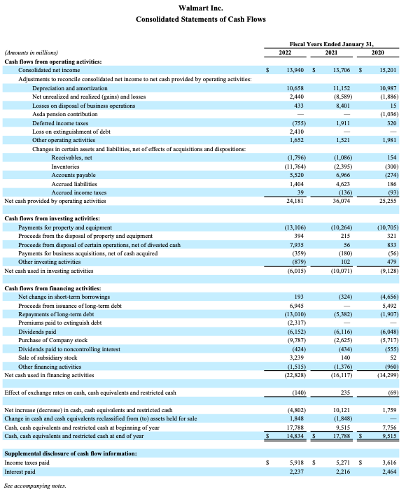
Source: Official annual report. Retrieved from https://s201.q4cdn.com/262069030/files/doc_financials/2022/ar/WMT-FY2022-Annual-Report.pdf

