UNIVERZITA PALACKÉHO V OLOMOUCI

PEDAGOGICKÁ FAKULTA

**Diplomová práce**

2024 Bc. Marcela Kingová

UNIVERZITA PALACKÉHO V OLOMOUCI

PEDAGOGICKÁ FAKULTA

Ústav cizích jazyků

Diplomová práce

Bc. Marcela Kingová

Gender in learning English language at primary school

Olomouc 2024 Vedoucí práce: Mgr. Ondřej Duda

**ACKNOWLEDGEMENT**

Ráda bych poděkovala Mgr. Ondřeji Dudovi za odborné vedení, cenné rady a připomínky, které mi poskytoval při psaní této práce

CONTENT

[INTRODUCTION 8](#_Toc164272152)

[I. THEORETICAL PART 9](#_Toc164272153)

[1 Gender in society 9](#_Toc164272154)

[1.1 Gender 10](#_Toc164272155)

[1.2 How gender relates to sex 11](#_Toc164272156)

[1.2.1 Gender categories 12](#_Toc164272157)

[1.3 Gender Stereotypes 14](#_Toc164272158)

[1.3.1 Social Category 16](#_Toc164272159)

[1.4 Gender Stereotypes and Society 17](#_Toc164272160)

[1.5 Masculinity and Femininity in a Mutual Connection 18](#_Toc164272161)

[1.6 Gender socialization 19](#_Toc164272162)

[1.7 Framework of Gender Socialization 21](#_Toc164272163)

[2 Gender in school environment 23](#_Toc164272164)

[2.1 History of Gender approach in Educational Systems 23](#_Toc164272165)

[2.2 Gender and Curriculum 25](#_Toc164272166)

[2.3 Schools and Gender Segregation 26](#_Toc164272167)

[3 Textbooks and ILLUSTRATIONS 34](#_Toc164272168)

[3.1 Textbooks’ approval 36](#_Toc164272169)

[II. Practical part 38](#_Toc164272170)

[4 RESEARCH 38](#_Toc164272171)

[4.1 Research Design 39](#_Toc164272172)

[4.2 Research Method 39](#_Toc164272173)

[4.3 Description of ELT Textbooks Samples 40](#_Toc164272174)

[4.4 ELT Textbooks Analyses 45](#_Toc164272175)

[4.5 Sample Pictures Analyses 48](#_Toc164272176)

[4.6 Questionnaire 50](#_Toc164272177)

[4.7 The Questionnaire Data Analyses 51](#_Toc164272178)

[4.7.1 Findings 51](#_Toc164272179)

[5 RESUlTS 65](#_Toc164272180)

[5.1 Questionnaire results 65](#_Toc164272181)

[6 DISCUSSION 66](#_Toc164272182)

[7 Conclusion 69](#_Toc164272183)

[LIST OF ABBREVIATIONs 70](#_Toc164272184)

[List of tables 70](#_Toc164272185)

[List of Charts 70](#_Toc164272186)

[List of pictures 71](#_Toc164272187)

[BIBLIOGRAPhy 72](#_Toc164272188)

[Attachment 80](#_Toc164272189)

**Abstract**

This work is focused on evaluating pictures and visual components of textbooks designed for teaching English language in primary level of education. The research deals with gender, gender stereotypes and gender varieties. The main interest of the research is to find out whether there have been taken any steps and measures towards safeguarding of gender equality of male and female population in ELT textbooks because illustrations and visual components play a big role in shaping young learners’ gender responsive values and help them form attitudes towards social roles. A questionnaire related to gender was designed, as a part of this work, in order to find out whether young learners and adults are aware of the term gender and if they take an interest in the question of gender and gender equality.

**Anotace**

Tato práce je zaměřena na hodnocení ilustrací a obrazové složky učebnic anglického jazyka na základním stupni vzdělávání z pohledu zastoupení genderových stereotypů a genderové rozlišnosti. Podstatou je zjištění, jestli byly učiněny nějaké kroky a opatření směrem k zajištění genderové rovnosti mužské a ženské populace v učebnicích anglického jazyka, protože ilustrace a vizuální složky hrají velkou roli ve vytváření genderově citlivých hodnot žáků a pomáhají jim utvářet postoj k sociálním rolím. Následně, je vypracován dotazník jako součást této práce za účelem zjistit, jestli žáci a dospělí mají podvědomí o termínu ‘gender’ a jestli se zajímají o otázku genderu a genderové rovnosti.

**Key Words**

gender, social roles, gender in school environment, gender stereotypes, variability, equality and segregation, gender in textbooks, gender in primary schools, visual components, approval clause, graphic elements, unisex, ELT textbooks, Gender Transformative Education (GTE),

**Klíčová slova**

gender, sociální role, gender ve školním prostředí, genderové stereotypy, variabilita, rovnost a segregace, gender v učebnicích, gender na základních školách, obrazová složka, schvalovací doložka, grafické prvky, unisex, genderově transformativní vzdělávání

Počet stran práce: 81

Počet příloh: 1

Prohlašuji, že

- diplomovou práci včetně příloh, jsem vypracovala samostatně a uvedla jsem všechny použité podklady a literaturu*.*

- jsem si vědoma, že na moji diplomovou práci se plně vztahuje zákon č.121/2000 Sb. - autorský zákon, zejména § 35 – využití díla v rámci občanských a náboženských obřadů, v rámci školních představení a využití díla školního a § 60 – školní dílo,

- beru na vědomí, že Univerzita Palackého v Olomouci (dále UP Olomouc) má právo nevýdělečně, ke své vnitřní potřebě, diplomovou práci užívat (§ 35 odst. 3),

- souhlasím, aby jeden výtisk diplomové práce byl uložen v Knihovně UP k prezenčnímu nahlédnutí,

- souhlasím, že údaje o mé diplomové práci budou zveřejněny ve Studijním informačním systému UP,

- v případě zájmu UP Olomouc uzavřu licenční smlouvu s oprávněním užít výsledky a výstupy mé diplomové práce v rozsahu § 12 odst. 4 autorského zákona,

- použít výsledky a výstupy mé diplomové práce nebo poskytnout licenci k jejímu využití mohu jen se souhlasem UP Olomouc, která je oprávněna v takovém případě ode mne požadovat přiměřený příspěvek na úhradu nákladů, které byly UP Olomouc na vytvoření díla vynaloženy (až do jejich skutečné výše).

V Olomouci dne 17.4. 2024 Bc. Marcela Kingová

# INTRODUCTION

The topic of gender is frequently discussed by experts, by general public and by the media. The topic brings some controversial questions and subsequent reactions because people always have had different understanding of gender. Progress, social and economic development of a society strive for equality have brought some freedom of gender expression and individuality. However the question of gender is very complex. On one hand, there are people who support the idea of well embedded gender stereotypes and expect that everybody should fulfil standardised social roles. On the other hand, there are many people who support gender variation and believe in gender equality. They believe that everybody should have an opportunity to express themselves and to decide what gender they wish to represent without being concern about their social roles and looks connected with a specific gender. There have been introduced measures by governing bodies in many countries to improve gender equality and to provide the same fare conditions for male and female genders and gender variations. These measures influence education, school environment, teaching material and textbooks.

This work is divided into two main parts. The first part is theoretical and deals with general terminology related to gender. There is discussed a development and perception of the term gender from the point of its meaning and understanding by societies and various experts. Further, the gender is discussed in a connection with educational systems and teaching materials.

The second part is a practical research dealing with two areas. One area concerns textbooks. The research is based on analyses of graphic elements and illustrations used in ELT textbooks in primary schools. Here is used an explanatory research design. The analyses try to find out to what extend pictures and photographs reflect perception of gender, whether they support gender stereotypes and if there are evident changes towards gender equality. The second area contains a self-constructed questionnaire. Collected data from the questioner is to provide information about the respondents’ awareness of gender, gender terminology and gender equality.

The research goal is to find out whether the graphic edits of textbooks and educational material used in ELT classes in primary level of education fulfil requirements for gender equality. There are two hypotheses to be confirmed or declined. ELT textbooks illustrations portray equal gender roles between men and women and the second hypothesis is that illustrations portray typical gender stereotypes.

# I. THEORETICAL PART

# Gender in society

At the beginning, it is essential to define basic concepts and phenomena related to gender in general, because gender, society and education make one close unit which is reflected in the system of education. All individual parts of the unit depend and influence each other. With the growing emphasis on political correctness, there is a great effort to establish gender neutrality in language, education, work and in other areas of human lives. The issue of gender is becoming more and more widely discussed by the public and the media, mainly in a connection with various controversial cases which cause resistance and disapproval, especially among conservative people. One example includes the introduction of gender-neutral addressing. British Airways currently address people as guests and passengers instead of the previously used "*ladies and gentlemen*" (Švarc, 2021).

A lot of people do not know what gender means and in sometimes people confuse gender with sex. A great problem is that general public accepts standardised images of people with specific qualities fulfilling specific social roles. Anything that seems to be strange to them becomes a problem and a controversial issue. The idea of gender neutrality is to prevent any disputes and unpleasant situations. It is evident that there exists more modifications to humans and their choice of individual approach to gender and activities and their adaptation of social roles (Smetáčková, 2016).

Amy M. Blackstone states in her work Gender and Society that gender roles are based on different expectations that individuals, groups and societies have of people based on their sex and based on each society's values and beliefs about gender. Gender roles are a result of interactions between individuals and their surrounding environments. Societies give individuals characteristics about what sort of behaviour is understood to be appropriate for a specific gender. Appropriate gender roles are defined according to a society's beliefs about differences between male and female sexes. A formation of a gender equal society depends on the establishment of a social framework that allows individuals to choose various lifestyles regardless of their gender, and without being bound by expected stereotyped gender roles (Amy M. Blackstone, 2003). Genders and gender roles are not strictly determined and clear cut categories that can be assign to everyone in a society. Gender roles are influenced by social beliefs, ideology and generalization that have been in use for centuries (Joy Nash, 2016).

## Gender

According to Irena Smetáčková, the term gender refers to socially and culturally constructed differences between femininity and masculinity. A gender is understood as a social construct which is different from the concept of sex. The term sex carries the meaning of a biological determination of a female and male body in relation to reproductive abilities. Moreover, gender represents culturally determined mental processes reflecting social arrangements and male and female roles (Smetáčková, 2016).

She further states that gender can be defined into three levels. The first level can be defined based on a perspective where it represents a set of characteristics connected with looks, abilities, behaviour and interests. This system is tied up to a specific society in a certain historical era and it is reflected by a typical image of male and female of that time. It means that male and female characteristics are culturally and historically variable and conditioned by these two aspects. In the second level, gender represents organizational principles of society. It is an arrangement of social institutions which assume differentiation between male and female gender, femininity and masculinity. In the last level, gender represents masculine and feminine characteristics of each person which are formed being influence by socio-cultural conditions (Smetáčková, 2016).

Similar ideas about gender has an American sociologist M. Kimmel. He described the multilevel existence of gender in his theory about gender order. He points out that complexity and stability of gender order is determined by how much the three levels are interconnected. The first level is made by social institutions. They represent established social structures and specific ideas of culturally acceptable models of femininity and masculinity. Social institutions aim to legitimize and reproduce mutual understanding between genders. They use practical and symbolic means to achieve mutual understanding. A family is generally considered to be the basic institution of a society thus a concept of a family changes with the change of cultural and historical conditions.

The second level in Kimmel’s theory of gender order is represented by interaction. This is an area of relationships and communication between specific people. When a man or a woman enters an interaction, he or she is aware of their own gender and the gender of other people being present. They communicate their own gender identity. Gender is one of the factors which determines the course of interactions among people. If the gender as an organizational principle is completely absent such a situation becomes, for most people, incomprehensible or even unpleasant and causes an uneasiness among the participants. For a gender "unreadable" person such an experience can be a confirmation of the importance of profiling one's gender through clothing, hairstyle, movements, speech and a general appearance. A reality in which gender clarity is not present increases the risk of social isolation.

The third level of gender order is made by identity that represents awareness of oneself as a man or a woman, respectively male or female. High percentage of people perceive themselves as a gender defined human being and in accordance with their gender affiliation they make decisions about activities, hobbies and goals they pursue, about their friends and values. Identity includes awareness of one’s own body (Smetáčková, 2016).

## How gender relates to sex

Even though they are two individual words, gender and sex are very close to each other and in many cases the two terms are used as synonyms. Gender can be understood as a social construct denoting a personal identity and a social role of an individual in relation to masculinity and femininity and a biological sexual gear we are born with. Sex means that humans are divided on the basis of their reproductive functions (Vrhel in Weiss, 2010). Historically, in our socio-cultural conditions, people did not perceive men and women as two different bodies, but as one body that had only two forms until the 18th century (Pavlík in Smetáčková, 2016). However, nowadays, sex is still mostly viewed from the perspectives of theory of biological determinism as something genetically predetermined. Gender, on the other hand, is a social construct, something created by a society. It is also necessary to mention that gender is based on a concept of a relationship with the opposite sex. Masculinity works in contrast to femininity (Smetáčková, 2016).

From an etymological point of view, the word gender was adapted into Czech language from English language and it was originally used to express a linguistic category of gender. In Czech language, the word gender started to be used from the 1950s. An increase of use of this term came with the rise of the feminist movement in the 1970s and 1980s. Here, gender refers to a female or to a male (Haig, 2004).

Nevertheless, there exists more interpretations of the meaning related to gender. The feminist movement uses the meaning of the word from the point of sociology. Biologists use gender for animal species (De Loof, 2018). Boundieu emphasises the significance of the anatomical differences between men and women. Men are associated with physical strength and logical strategic reasoning, whilst women are connected with gentleness and creative feeling. Regarding the gender, there is a strong connection with nature and naturalness. Sexual biological differences between men and women are defined on biological basis and the more natural they are, the stronger they are (Boundieu, 2000).

One of the most straight forward definition from the biological point of view about gender says that gender is a person’s genetic inheritance, the person’s biological sex. It is an immutable characteristic and it is determined at fertilization and during embryonic development. It is possible to change a person’s outward appearance, including bodily features but not genetic inheritance (Clinical Advisory Network on Sex and Gender, 2023).

### Gender categories

In the 21st century and mainly in western societies, we are taught that there are more than two genders and there are no longer just male and female categories. Dr. Chris Drew claims that there are at least eighty ways to describe genders and there are eighty ways to describe gender constructs and that people’s identities may change over the time. Below there are some examples of gender varieties:

* **AFAB** - stands for ‘assigned female at birth’. It is a gender identity often assigned to people if there is for any reason a need to know a person’s birth gender, especially if that person no longer associates with that gender. It acknowledges that birth genders are assigned through cultural inscriptions.
* **A gendered** - people do not have a gender. They are considered genderless or gender free and do not fit on a masculine-feminine spectrum. They refer to as A gender.
* **Aliagendered -** people are neither male, female, nor A gendered. They are people who experience a gender identity that does not fit on the masculine-feminine spectrum but nonetheless feel a gendered identity.
* **An androgynous** - person is neither male nor female. This person’s identity is considered ambiguous. Often, androgynies express elements of both [masculine](https://helpfulprofessor.com/masculinity-examples/) and [feminine identities](https://helpfulprofessor.com/femininity-examples/) at different times.
* **A poragender** - people are those who do not identify with any specific gender. They may feel that they have no gender, or that their gender is undefined. This can be due to a variety of reasons, such as feeling like one does not fit into any existing gender categories, or feeling like all existing gender categories are equally valid and none stands out as feeling more ‘right’ than the others.
* **Bi gender** - people experience two genders, either simultaneously or at different times. These genders can be any combination of male A gender.
* **A cisgendered** - person is a person who identifies with the same gender as the gender with which they were assigned at birth. These relates to male and female genders.
* **Demi gender** - people are those who identify as partially male or female. They may feel that they are neither fully male nor fully female, or that they are a mix of both genders.
* **FTM** - is a term used to describe a person who was assigned the female gender at birth but identifies as a man. This acronym stands for ‘female-to-male.’
* **Gender queer** - is a term that describes people with non-binary gender identities. Gender queer people may identify as neither male nor female, or they may identify as a mix of both genders. They may also use gender-neutral pronouns such as them/they, ze/hir, or xe/xem.
* **Inter gender** - is a term used to describe people who have both, male and female characteristics, or who fall somewhere in between the two genders. Inter gender people may identify as neither male nor female, or they may identify as a mix of both genders
* **Intersex** - describes people who are born with genitals or other sex characteristics that do not conform to normative definitions of ‘male’ or ‘female.’ Intersex people may choose to identify as male, female, or non-binary.
* **Non-binary** - is a term used to describe people who do not identify as exclusively male or female. They may identify themselves as being of multiple genders, no gender, or a third gender and they can use gender-neutral pronouns such as they/them/their (Chris Drew, 2023).

## Gender Stereotypes

Stereotypes are generally considered as sets of ideas that an individual frequently learns from people around him. Not only, a person accepts these ideas, but subsequently he shares them with other people in mutual communication. The term stereotype is used in a social science as a set of stable preconceptions about a certain object and the way it is perceived and determined (Smetáčková, 2016).

Smetáčková adds that one aspect of stereotypes is their negative connotation. By marking something as a stereotype an attention is drawn to its correctness and simplification. People create stereotypes themselves because they generally assume that a certain social category shares a certain set of characteristics. If their assumption or generalisation of certain characteristics of social groups is incorrect or false, then they distort social reality. She further says that people usually do not verify whether there is a link between social category and some specific characteristics. Characteristic features are mostly represented by age, gender or skin, ethnic origin or cultural background, for example. Ideas associated with a particular social category are generalized and valid for all its members. For this reason, individual specifics of individuals may be overlooked (Smetáčková, 2016).

Mr Výrost claims that stereotypes play a key role in people's lives because they help them to find a place and orientation in the social world. Based on stereotypes, people create cognitive schemas and therefore they reduce the quantity of information they need to process when interacting with other people, especially with strangers (Výrost, 2019). Stereotypes can be divided into auto stereotypes, concerning ourselves, and hetero stereotypes, which we take towards other people. We use stereotypes as a platform to adjust our own opinions, attitudes and behaviour. The strength of stereotypes increases if they include natural scale.

Gender stereotypes are therefore associated with ideas and norms which a society approaches towards men and women, respectively towards masculinity and femininity. These stereotypes are one of the oldest and at the same time one of the strongest differentiation between men and women. They are not based on our personal experience but are acquired indirectly. The acquisition takes place primarily in a family, in a peer group, from the media, but also in school, sport and free time organizations. The only problem with stereotypes is that some people only see their negative aspects and create hostility and prejudice (Janošová, 2008).

In contrast to Mr Výrost, some experts believe that gender stereotypes can reduce natural variabilities among people. If the innate dispositions and potentials of people were compared without socio-cultural influence and established stereotypes and only their abilities, skills and knowledge were taken into consideration, then variability and established gender stereotypes would be reduced (Janet S. Hyde, 2005).

Joy Nash wrote that a lot of people keep to traditional ideas that men and women should behave in a way that falls into a specific category being determined by male or female gender. Nevertheless, male or female gender-specific identity is irrelevant in a modern and civilized society. Gender roles as social constructs are not based on natural human behaviour and have developed over times and eras. This is because gender roles have been created to serve specific purpose and were dictated by environments and the needs of a society. Some people may say that traditional gender roles should not be changed because they are a key element in human development. However, in many modern societies nowadays, traditional gender roles are no longer needed, because men and women carry out the same task and fulfil the same social roles. For this reason, holding to stereotypes can be harmful because they encourage people to condemn and oppress those ones who do not fit the traditional social roles. As a result of this oppression, a lot of people struggle to fully develop and use their potential.

Joy Nash summed his thoughts by saying that people should be encouraged to follow and express their own truth and feelings. He added that media should portrait people who do not follow traditional gender roles in more positive way and schools should provide more comprehensive lessons that explain the difference between sex and gender to help teenagers to better understand themselves, their feelings and their bodies as they go through puberty and begin to develop and change (Joy Nash, 2016).

### Social Category

A social category is a result of cognitive categorization, it is a kind of mental process. Through the categorization, a person gains orientation in social reality by matching individual elements to superior categories with common features that he or she connects to reality. Aronson and his team defined a stereotype as generalization of a group of people where "certain characteristics are attributed to all members of the group absolutely, regardless of the actual diversity that exists among them" (Aronson, Wilson, Ahert and Fehr, 2012).

Other experts claim that individuals in specific social categories influence the group identity based on stereotypes. This helps identify and define the boundaries of one's own group. A certain social category exhibits a certain set of characteristics and it is projected as a stereotype (Smetáčková, 2016).

April Hess says that ‘a social category is a group of people who share common traits or characteristics, but do not interact with one another.’ Commonly shared features may range from age, gender, race, religion, leisure activities, income, educational level and interests. It is important to keep in mind that in a social category people share common traits and do not interact compared with a social group where people share the same traits or characteristics but do interact. For example, people who play football versus a university football team (Hess, 2022).

Krueger wrote that creating categories simplifies perception and apprehension related to the social world by creating relationships and finding mutual similarities. Social categorisation is a process in which people categorise themselves, and others, into specific social groups. The main function of social categorisation is to bring a kind of order into chaotic interference. People transfer group features to individual members and this way they create a generalized feature of such a group. They rely on a pattern of similar features. However, some social categories have weak boundaries since they are based on a socially constructed label

(J. Krueger, 2001).

Categorization leads to emphasizing of differences among individuals in different categories and to emphasizing of similarities of individuals within a specific category. If social categorisations of similar features are significantly strong they result in stereotypical perception of both categories. When people categorise one another they generally include themselves into one of the categories (D. Abrams, 2001).

## Gender Stereotypes and Society

In her research, Irena Smetáčková wrote that gender stereotypes are general ideas of a society of how men and women should behave, look, represent themselves and what they are expected to do. These ideas are generalized for specific social groups and individual members belong to such a group. Gender stereotypes present femininity and masculinity as opposites to each other. She, as well as the previous experts, commented that a gender is frequently connected with biological differences between male and female body. For example, a handsome strong prince and a gentle princess (Smetáčková, 2016).

Other sources state that in countries of European-American province, men are mainly associated with a physical strength, rationality, dominance and an orientation in technical areas, whilst women are associated with physical beauty, affection, submissiveness and a social orientation (Diekman Eagly, 2000), (Prentice; Carranza, 2002).

So, we already know that in a society gender stereotypes represent widely shared and generalized ideas about typical characteristics of men and women and their behaviour pattern. Based on these generalised ideas, women and men are expected to bare certain expected psychological characteristics, abilities and attitudes. They are assumed to take on specific social roles and have specific interests. A social role is understood as an expected behaviour of a person in a certain social position. It is always complementary and reciprocal (Smetáčková, 2016). Female and masculine roles are typical social roles of a man and a woman. Since gender stereotypes are culturally conditional constructs, they change their content and expectations across different societies. In the real world and over times, men and women become very similar in their looks and behaviour patterns. In a modern society men and women take on similar social roles, have similar goals, interests and hobbies. They use similar vocabulary and gestures. Many women have abandoned the symbol of femininity and prefer to choose comfortable hairstyles, shoes and clothes like men. Women stand out for themselves and try to even out to men or succeed them in the field of professional jobs, politics and education. This can be seen as a process of homogenization of masculinity and femininity. In other words, gender stereotypes lead to a homogenization within a category that obscures the true variability among people. This means, that the way we perceive stereotypes leads us to such a view of a reality that confirms the existence of stereotypes. Expanding this thought, we can see what we think that we should see or what we want to see (Sabini, 1995).

## Masculinity and Femininity in a Mutual Connection

Individual characteristics of femininity and masculinity form imaginary dichotomous pairs in a relationship in which they are mutually exclusive and opposite of each other. American cognitive psychologist Carol Martin and her team concluded that (in the case of gender) there are only two mutually exclusive groups, the assumption of group differences is extreme. "People think that if women have certain characteristics, then men probably do not have those characteristics, and vice versa." (Martin, 1995)

Shanshan Du classified mutual connection between male and female gender. She established a classification of four frameworks that promote gender equality. The first framework is called ‘maternal centrality’ and it relates to the interdependence of male and female gender in layers of cross-sex bonding, close family relations and the importance of parental role. In this mother centred network of relationships, men and women are identified primarily as partners who share interests and benefit from harmony and mutual interdependence in socio-cultural environment across cultures. ‘Gender complementary’ the second established model, generates equality between men and women by promoting symmetrical reciprocity of male and female sexes. Both sexes are seen as being different as well as being equal. The framework of gender complementarity generates equality between men and women based on symmetrical reciprocity of the two sexes. Men and women are identified as reciprocal partners with shared interests. They benefit from their cooperation, harmony and mutual balance between the sexes. Nevertheless, there exists institutionalised gender separation in social and economic domain. Similarly, as the maternal centrality, the gender complementary stresses equal values to men and women and their roles they accept by highlighting their differences. The next framework, ‘gender triviality’ is on the other hand, designed to foster gender equality by minimising the socio-cultural significance of sexual differences. Within this framework, sex differences are socially and culturally insignificant because men and women are primarily considered as individual members of a community regardless of their different sex. Gender equality is, in this case, achieved by total ignorance of the gender itself. In the socio-cultural framework men and women are equal due to ignorant, Shanshan Du own words: "gender blind attitudes towards ideologies and institutions." The last type of gender equality is represented as ‘gender unity.’ It is a unity of male and female genders which are defined as being essentially similar and are bound to each other in the sense of interests, values, obligations, authority, social roles and status. She further claims that by recognising the existence of more distinct frameworks, gender equality may be achieved (Shanshan Du, 2011).

## Gender socialization

Gender socialization is closely connected with social norms. There are many definitions explaining the word. For example, Jaroslav Řezáč wrote that socialization is a way from global self-awareness of own difference to integration among other people whilst creating real autonomy and authenticity among them (Řezáč, 1998).

Watson believes that, socialisation is a process which allows children to become functional and capable members of a society through learning norms of children’s society and general norms of behaviour which they are expected to follow (Watson, 1965).

Socialisation is, as H.P. Frey said, is a preparation of an individual to fulfil her or his social roles, integration of the individual into activities and tasks that he or she must fulfil in order to maintain working functional existence of a society (H.P. Frey 1974). It is a transformation of a biological individual into a cultural being (Smetáčková, 2016). Socialization can be considered as a type of learning in which a person acquires values, norms and behaviour patterns that are standard for a specific society. The result of socialization is internalisation. Children try to fulfil gender expectations of the society in which they are being brought up. If children differ from general standards of a specific social group, they can be disadvantaged (Matonoha, 2017).

For this reason, both children and adults try not to stand out and rather they adapt their physical body and their appearance to the environment around them. Because people are subjected to cultural values and social norms that shape the idea of how women and men should look and how they should express themselves, this results in a natural differentiation between men and women (Smetáčková, 2016).

Based on findings from various studies, gender socialisation begins with a birth of a child, then it intensifies during adolescence to the young adult age. It is a process in which individuals develop, refine and learn to do what is expected from them based on social norms. Gender socialization means an influence on individuals by surrounding circumstances, cultural background, social networks, families, social institutions and general attitude towards gender. People accept expected social roles and follow internalized gender norms. As Nicola Balvin wrote in her article, this leads to gender inequalities in education, employment, income, empowerment, and other significant outcomes of well-being during adolescence and in adult life (Balvin, 2017).

Moreover, Andrew Mason believes that people have equal access to their autonomous choice and decisions and should not suffer from disadvantage or have advantage because of who they are. Roemer in his discussion paper ‘*Egalitarion Perspections*’ says that a person is morally responsible for his or her actions regardless the median behaviour for her or his median gender type. He proposes that people have the same capacity to exercise equal share of responsibilities for their actions. They have the same abilities and do not represent any specific kind of behaviour. People consequently bear the cost of their actions and decision-making regardless their gender (Mason, 2004).

The level of socialisation also depends on a person’s free will and determination. Ronald Dworkin believes that human desire is fully authentic if he or she has an adequate opportunity to fulfil one’s desire without being affected by surrounding circumstances, manipulation, brainstorming or evident criticism. Further, he states that a person’s desire is influenced by a variety of socialisation processes, especially, in the case of gender socialisation. Gender socialisation often happens unintentionally, in a natural subtle way by the clout of family’s members and close friends. People, in general, accept society’s conventions and social practices. He adds, that process of socialisation shapes a person’s identity, his or her needs and aspirations which are elaborated into accepted social roles. Gender socialization and the formation of gender stereotypes start in families where children subconsciously start to accept social roles. For instance, even before a baby is born members of the family are curious about the gender. The main reason is to decide about the kind of colours which will represent the child. It is commonly expected that for a girl a pink colour schemes will be used for almost all objects and items connected with her. A boy will be surrounded with things of blue or darker colours. The same goes for clothes. The second step in a child’s gender socialization is the choice of toys. Girls are automatically expected to play with dolls, ponies and toys resembling household items. Boys, on the other hand, receive toys such as cars, weapons, tools and various building kits. The third step in children’s socialization process in families is the parents’ choice of sport, hobbies and free time activities for their offspring. Again, there are typical categories of activities for boys and girls. It seems, that parents follow gender established patterns they have experienced themselves and which are passed from a generation to a generation. Another big impact on children’s socialisation process have school institutions that follow standardised social and cultural norms (Mason, 2004).

## Framework of Gender Socialization

The framework concept is an outcome from a study carried out and recently published in a discussion paper by UNICEF Office of Research - "Innocenti" and the International Centre for Research on Women. The paper enhances understanding of gender socialisation by combining theories from sociology, psychology and biology and provides more holistic picture of how gender socialisation happens and who are the major agents. The agents of socialization are themselves influenced by factors such as the socio-economic conditions of a country, gender, political structures, social and cultural norms, global media and their own communities and networks. Nikola Balvin points out that gender socialisation during adolescence is particularly important as today’s teenage boys and girls are pivotal to the achievement of the Sustainable Development Goals and their gender attitudes and outcomes will influence future generations (Balvin, 2017).

The following schema shows how gender socialization process of young teenage people is affected by different agents. Adolescence is a critical period in which gender attitudes and behaviour intensify and new gender roles emerge. It is also a period during which the negative outcomes of some gender norms begin to manifest. (UNICEF, 2014; WHO, 2016; UNESCO, 2015; UNAIDS, 2014).

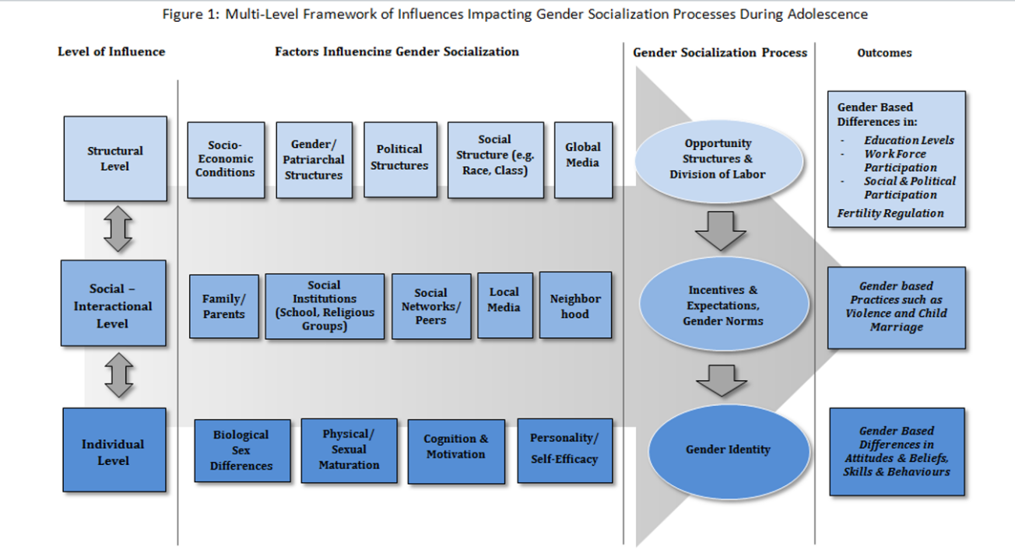

Picture 1 - Gender Socialisation (UNICEF, 2014)

The framework was designed to help develop policies and programmes focused on increasing gender equality. It helps decision-makers to understand key areas influencing gender socialisation. It helps to produce effective changes toward gender stereotypes, and therefore allow young adults to succeed in their carriers and personal development. One of the definitions says that equality between men and women means equal status, visibility and a participation of both genders in all spheres of public and private lives on all levels, including decision-making processes and leadership positions. Gender equality aims to promote the full participation of men and women in a society (Jon Kvist, 2014).

Since 2013, European Union have been promoting social investments as a national reform strategy to escalate person’s capacities and national economic growth. To have a complete advantage of social investments, the strategy requires a coherent framework that considers the multidimensional and dynamic nature of social investments and social issues. The framework consists of three parts. Generational, life course and gender perspectives on social investments. Experts believe that social investments can improve economic and social returns when gender and ageing over the course of life are taken into consideration. Cross-national patterns indicate a positive relation between social investment policies and returns.’ Social investment policies help to improve people’s lives. Gender equality in sharing of care helps increase fathers’ investment in children, reduces discrimination of women in the labour market and allows women to have full time jobs. It also leads to a reduction of gender gaps in salaries and pensions and better health for both genders. The social investment strategy has to deal with many societal challenges. Because social investments can address the increased skill demand, less uniform work markets and family types, labour supply and health, there is little doubt that all EU countries will accept social investment to guide their welfare reforms (Jon Kvist, 2014).

Global Partnership for Education (GPE), consisting of UNESCO, Plan International, Transform Education, UNGEI and UNICEF Education have led national and regional Gender-responsive education sector planning (GRESP) workshops to implement gender equality into a country’s education plan. GRESP guides Ministries of Education and partners to identify gender barriers within education systems and apply strategies and policies in all areas connected to educational process. These areas concern schools, classrooms, teachers, teaching methodology and practice, curriculum and materials, development, leadership and administration (Gender Transformative Education, UNICEF, 2021).

# Gender in school environment

Irena Smetáčková dealt with the issue of an impact of the school environment on a social development of children. In her research, she found out that schools plays key roles in a gender development of students. By taking a part in the lessons, pupils encounter gender-charged content in teaching materials, textbooks and procedures that foreground an experience imposing that they are divided into girls and boys. Thus experience results in expected gender roles associated with female and male sexes. According to Irena Smetáčková, gender stereotypes can have negative effects on pupils. Girls and boys form a certain idea about roles of men and women due to perception of gender perspectives. They subsequently project this perception to their mutual relationships with other people (Smetáčková, 2016).

Adolescence is a critical period in which gender attitudes and behaviour intensify and new gender roles emerge. It is also a period during which negative outcomes of some gender norms begin to manifest (Balvin, 2017)

Vladimír Hrabal wrote that school, as a central social educational institution, influences a personal development of individuals. Their perception of people and the world is influenced by a school environment, teachers and peers, intentionally or non-intentionally. In schools, learners build socio psychological dispositions which are the goal and the result of learning. Formation of socially required dispositions is a specific task of education. (Hrabal, 2004)

## History of Gender approach in Educational Systems

First differences in the approach to education were visible in primitive societies. People lived in groups and shared work and daily tasks. This system of shared work gave a basic character to education and upbringing. Boys and young men were prepared to become hunters, fighters and builders whilst girls and young women were brought up to look after children and were prepared for basic household activities. After the disintegration of primitive societies, social differentiation in approach to educational started to begin. Knowledge and physical fitness became essential tools of dominance and power. Young people, mainly young men, from ruling classes were trained and educated in writing, speaking, general knowledge, medicine, civil building, arithmetic and military. The subjugated population, on the other hand was prepared to work and to be obedient. First, schools appeared in Mesopotania and Persia 4 000 thousand years before Christ. They were established as a part of temples at the courts of rulers. In European countries, origins of education were connected with ancient Greece. Greek Polis, especially Athens were homes of famous philosophers such as Socrates, Plato and Aristotle. Plato established a gymnasium, the Academy in 355 BC, Aristotle established a gymnasium the Lykeion, where physical, moral and intellectual education prevailed for men. Girls were excluded. The situation regarding educating girls stayed unchanged even in the ancient Rome (Jůva, 1997).

Almost the same situation remained during the middle ages. Monastic schools were established from the sixth century and education was connected primarily with Christianity, religion and the Church. Again, schools were designed to educate men only. In the eleventh and twelfth centuries, first European universities appeared. However, they were also attended exclusively by male students. Girls from aristocratic families received limited education at home by hired private tutors or in monasteries. In Czech lands, the role of women began to change under the rule of Austro-Hungarian Empress Maria Theresa during the Enlightenment in 1774. She issued the so-called General School Regulations. This document enacted general education obligation for boys and girls. Although school attendance was not mandatory yet, this law was ground breaking, mainly from the gender perspective as it concerned educating girls as well (Somr, 1987).

Nevertheless, girls were still predominantly educated at home by tutors until the half of the nineteenth century. The Imperial Education Act (the so-called Hasner Act) from 1869, ordered compulsory school attendance for both sexes. Fortunately, even this law did not bring equal status for men and women in the educational process. Schools were divided into boys' and girls', not only formally, but also in terms of educational content. Schools for girls were mainly focused on general education and on handicrafts in order to prepare the girls for their future employment in a female industry. Schools for boys, on the other hand, had more diverse educational content and a system of higher education. For girls, higher education was considered as unnecessary because of their female roles. For example, at the Charles University, women did not study until the 1902. Finally, due to efforts of the feminist movement during the First Czechoslovak Republic, a system of co-education was introduced. It was a mixed system of education for boys and girls in all types of schools (Tužilová, 2016).

A very similar development took place concerning teachers. Originally, the teachers and tutors were exclusively of male gender since the beginning of educational systems in a society. In Czech lands, the situation started to change with the Teresian school reforms, however, male teachers had superiority until the end of the 19th century. Women teachers begin to appear in schools after the First World War when gradual feminization of this profession started. Women were able to combine their work as female teachers with their roles of mothers at home. In the fifties’ of the twentieth century, the share of both genders in the system of education was already balanced, and at the beginning of the 21st century eighty-four per cent of teaching staff were women (Bendl, 2002).

It is necessary to mention that a specific type of school usually determines the amount of male or female teachers present. In general, the higher the level of education, the greater the proportion of men. Therefore, in nursery schools mainly work women, while there is a slight predominance of men in higher education (czso.cz, 2021).

## Gender and Curriculum

The curriculum reflects cultural values, femininity and masculinity and a labour market. Young people gain knowledge, skills and competencies that prepare them for their future professions. Learners build attitudes towards their future social roles and learn responsibilities. The curriculum is a dynamic entity influenced by changes in economy, current political situation and interests of individual countries and by international business. The curriculum is also connected with school teachers, students, families, gender and the school system. All these factors have a specific role. Sheila I. Riddell wrote that there is a relationship between curriculum choice and the formation of gender identity. This appears as a two-way process in which learners struggle to establish a correct gender identity formation in a particular area of the national curriculum. The choice that learners make significantly alter the shape of their future working lives. Arnot uses a term ‘gender code’ to refer to massages concerning appropriate models of masculinity or femininity which learners receive and transmit (Riddle, 2012). The gender code represents behaviour, attitudes and emotional learners’ responses to their choice of subjects and future social roles. There seems to be evident ‘sex-role’ socialization, possible discrimination and the girls’ relative absence from science and technical classes (Kelly 1987). More recent studies paid greater attention to the role of teachers, schools and educational policies in general (Acker, 1987). Various research proved that it is the teacher’s initiatives to provide and facilitate equal opportunities for pupils of both genders. (Whyte, 1986)

## Schools and Gender Segregation

There are mixed reactions regarding the question of single-gender education. While many supporters say that it is an opportunity to increase confidence, strengthen community involvement and customise educational process, the opponents to single-gender education claim that it limits vital social interaction. Being used to interact only with students of the same gender it may cause problems when the students have to interact with the opposite sex. For example, separating boys and girls in schools may cause a lack of social skills outside the school in a real world. They may find difficult to interact and communicate with the opposite sex and to assimilate into gender mixed society. This can affect their future partnerships and relationships in workplaces. Ms. Purdy, a psychology teacher, believes that gender separated schools may negatively influence children’s socialisation skills. She thinks that it will make more difficult for children to interact with the opposite sex and to create one unified environment. Furthermore, a research done by the University of Wisconsin and Whitman College in 2014 found a little evidence of benefits of single-gender schools. Psychology professor Janet Hyde one of the members of a research team, added that many studies on the benefits of single-gender education fail to account other factors that might influence success (Borst, 2022).

Single-gender schools for girls

It has been proved in various studies that girls feel more motivated when attending gender-segregated schools because they do not feel any pressure from boys to prove themselves. Heidi Borst claims that girls can be very supportive in a single gender setting. Not having to prove anything to challenging boys, or being criticised by them, it motivates girls to create more positive, supportive a cooperative environment. Mat Albert, executive director of the Centre for Reflective Communities in Los Angeles, says that single-gender schools can establish more relaxed environment, reduce stereotyping and courses can be better tailored to students’ needs and interests. The same ideas shares Vanesa Garza. She points out that girl’s school learning environment benefits girls by increasing their confidence which in turns helps build leadership capabilities. Furthermore, the results from a research carried out by the National Coalition of Girls’ Schools in the USA show that graduates in only female gender schools perform better academically, have higher aspiration, greater motivation and are more supportive to each other (Borst, 2022).

Single-gender schools for boys

Male gender-segregated schools help reduce problems with bad behaviour. Matt Albert, states that single-gender school setting increases positive mind set for boys because they become more willing to take risks. The same reason as for the girls, they do not feel the fear of failing in front of the opposite sex. Another benefit of separate school environment is that girls mature faster than boys and boys need different learning techniques. This mostly affects the position of teachers (Niche, 2016).

Mixed-gender schools

Most schools are mixed gender schools and they are expected to provide the same opportunities and treatment for pupils regardless their gender. Department for Education in Great Britain published a non-statutory guidance for schools, school leaders, teachers, school employs and governing bodies in all types of mixed schools and academies. This document provides support for schools and academies when it concerns separation by sex. Department for Education in Great Britain established key measures preventing segregation in schools and guarantying gender equality and the same chances for everyone in an educational process:

* Schools should not generally separate pupils by protected characteristics such as gender,

race or faith while being at school.

* In a mixed school, if pupils are separated and denied the choice of a social interaction

or to interact in an educational setting with pupils of other sex, this will be direct

discrimination and will be unlawful based on the Equality Act.

* If pupils are separated by sex in specific classes (based on protected characteristic),

assemblies or for any extra-curricular activities, school leaders and governors would be

expected to justify this action.

* Schools should check that there are no practices discriminating a boy or a girl because

of his or her gender.

* It would be unlawful for a school not to allow girls to learn the same subjects as boys.

Girls should not be denied to learn the same skills as boys. The same applies to boys.

Boys should not be denied to learn the same subjects and gain the same skills as girls.

In both cases it could be considered as sex discrimination.

* In certain circumstances school can provide lessons or activities which are designed for

just one sex, boys or girls based on a positive action.

* Positive action is a general exception to discrimination under the Equality Act 2010.

Reasonable separation of pupils by sex are as follows:

a) Girls or boys suffer a disadvantage connected to their gender.

b) Girls or boys have needs that fifer from the needs of the other gender.

c) Participation in an activity by girls or boys is disproportionately low.

* Schools may take actions designed to achieve the aim of enabling or encouraging girls

or boys to overcome or minimise the disadvantage to meet the sex - specific needs or to

increase participation.

* If a positive action initiative in the curriculum is designed specifically to help one sex it

is not necessarily unlawful act.

* Permission for ‘single-sex sport’. A ‘gender-affected activity’ is sport, game or other

activity of a competitive nature in circumstances where the physical strength, stamina

or physique put either gender (boys or girls) at a disadvantage in competition. However,

a school may still have to allow boys or girls equal opportunities to participate in

comparable sporting activities. In such case, the school has to consider the age and stage

of development of children competing in gender-affected activity.

* Where separate teams exist for different genders, it would be unlawful discrimination

for a school to treat one group less favourably.

* There can be situations where a mixed school may lawfully separate girls and boys if

the separation can be considered negligible in its effect on the ability of pupils of both

genders to mix, learn from or socialise with each other

(Department for Education, 2018).

Gender segregation in schools used to be very typical phenomenon in previous centuries, but even nowadays, there are some parents who prefer to enrol their children to gender-segregated schools. One of the reasons for sending children to a single-sex school is that some parents believe that boys and girls have different intellectual abilities and learning approach and that their off-springs will excel more as well as gain higher academic results.

In the end, parents choose the right school for their children. They make decisions based on their values, believes, financial possibilities, status and prestige. (Borst, 2022).

In the Czech Republic, there were taken certain steps into gender equality as well. For instance, the Ministry of Education, Youth and Physical Education in cooperation with the European Union, issued a plan for supporting equality of women and men for the years 2021–

1. They together introduced measures improving gender equality that should be visible in teaching materials and textbooks. The main strategic goal is to guarantee that the content of textbooks is in accordance with principles of gender equality. There were created measures in order to update the existing system of expert assessment of textbooks for primary education from the point of gender equality and for the purposes of granting textbooks an approval clause. Gender equality is included in the formal curriculum (MŠMT, 2013).

In the tables below, there are listed strategic goals and measures introduced by the Ministry of Education issued in their publication (See pages from 23 – 24 of the document). The first table (part F) defines a strategic goal to include gender equality in the formal curriculum of the Frame Educational Programme. There are set two specific goals, measures, performance criteria and deadlines towards achieving the set goals. The aim of the first strategic goal is to design Frame Educational Programme and School Educational Programme that guarantee equality between men and women, maximizes their potentials and promotes equal opportunities, tolerance and respect. The measures for assuring these steps are regular evaluations of gender related topics and proposed specific changes in the Framework Educational Programme. Second strategic goal determines that the content of textbooks is in accordance with principles of gender equality. For the measures, there is designed and updated methodology that assesses gender correctness of textbooks. There are used manuals as an integral part of the process of assessing the quality of textbooks. If textbooks pass the assessment they are granted an approval clause by the Ministry of Education. Both specific strategic goals have set deadlines for their completion and performance criteria.

|  |  |  |  |  |
| --- | --- | --- | --- | --- |
| **Strategic goal** | 1. **Gender equality is included in the formal curriculum** | | | |
| **Specific goal** | **Measures** | **Description of measures** | **Deadline** | **Performance criteria** |
| 1.  Frame Educational Programme and School Educational Programme are based on principles of equality women and men | 1.1  Regularly evaluate the topic of equality between men and women in the FEP | in addition to mutual tolerance and respect, the target value is the maximization of the individual's potential and the promotion of equal opportunities | 31. 12. 2024 | In the event of proven significant discrepancy, a proposal for specific changes in FEP  Round table on report results  Seminar on report results |
| 1.2.  in the event that a significant non-compliance with the declared principles is shown, the FEP will be modified and a methodology will be created for adjusting the School EP | FEP, in which the evaluation above shows a discrepancy, will be revised in terms of securing the topic in the content.  In accordance with this, the gender equality methodology for School Education Programme will be developed | 31. 12. 2024 | Revised Frame Educational Programme  Methodology of gender equality for School Educational Programme |
| **Specific goal** | **Measures** | **Description of measures** | **Deadline** | **Performance criteria** |
| 2.  The content of the textbooks is in accordance with the principles of gender equality | Update the existing system of expert assessment of textbooks for primary schools from the point of view of gender equality for the purposes of granting an approval clause | revise the existing and set up a new system of expert assessment of textbooks for primary schools from the point of view of gender equality for the purposes of granting an approval clause | 31. 12. 2023  and then  perpetually | Updated assessment system |
|  | 2.2  Update the methodology for assessing the gender  correctness of textbooks | Update the methodology for assessing gender correctness of textbooks. Continue to systematically use the manual as an integral part of the process of assessing the quality of textbooks, see measure 2.1. | 31. 12. 2023  Then  perpetually | The existence of an updated methodology for assessing correctness of textbooks. |

Table 1 - Gender equality in curriculum (MŠMT, 2013)

Table two (part G) specifies a strategic goal related to healthy educational environment that will create equal opportunities for professional growth of male and female students. The strategic goal contains three specific goals. First specific goal is to have an educational and career guidance in primary and secondary schools with the intention to reduce gender stereotypes and to provide equal opportunities for male and female genders. The proposed measures include creating and publishing gender non-stereotypical methodological and other materials and school prevention methodologies. Textbooks for primary schools are revised and assessed from the point of gender equality. The purpose of these measures is to prevent risky behaviour of children and youth. Groups of experts appointed by the Ministry of Education assess textbooks for primary education, update methodological recommendation and grant an approval clause. The approval clause is guaranteed for a specific period of time and it can be removed. Second specific goal is to reduce differences in skills and knowledge of male and female students. The curriculum content, methods and work with students will be adapted and incorporated into educational process in a way that gender stereotypes are avoided during lessons. There will be organised courses and a system of lifelong support and training for male and female teachers focused on differentiation of teaching. The third specific goal is aimed at gender-balanced approach. It deals with creating and revising professional qualifications in the National System of Qualifications based on gender balance. For more details, see the table below (MŠMT, 2013).

|  |  |  |  |  |
| --- | --- | --- | --- | --- |
| **Strategic goal** | 1. **Healthy educational environment, free life and professional options, sensitive assessment and more permeable educational trajectories are supported in education** | | | |
| Specific goal | Measures | Description of measures | Deadline | Performance criteria |
| G.1.  Educational and career guidance in primary and secondary schools reduces gender stereotypes | G.1.1.  Issue and publish methodological and other materials for educational counselling and school prevention methodologies that are gender non-stereotypical | revise the existing and set up a new system of expert assessment of textbooks for primary schools from the point of view of gender equality for the purposes of granting an approval clause | 31. 12. 2023  and then  perpetually | updated methodological recommendations for the primary prevention of risky behaviour of children and youth |
| Specific goal | Measures | Description of measures | Deadline | Performance criteria |
| G.2  Reduction of differences in the knowledge and skills of male and female students | G.2.1  To support internal differentiation of teaching and non-stereotypical assessment of male and female students in key subjects | Iincorporate the adaptation of curriculum content, methods and forms of work with pupils, aiming not to project gender-based stereotypes in lessons and in assessing of female and male pupils, especially in key subjects | 31. 12. 2022 | There are courses within the systems of lifelong support and education for male and female teachers, focused on the differentiation of teaching |
| Specific goal | Measures | Description of measures | Deadline | Performance criteria |
| G.3.  Gender-balanced approach in the creation and revision of professional qualifications in the National System of Qualifications | G.3.1.  To take into account the aspect of gender balance when creating and revising professional qualifications | To take into account the aspect of gender balance in the revisions and creation of professional qualifications | 31. 12. 2020  and then  perpetually | National System of Qualifications takes into account the principles of gender balance to the maximum extent |

Table 2 - Healthy educational environment (MŠMT, 2013)

Strategic goal in the table three (part H) focuses on gender equality in undergraduate teachers’ training at the faculties of education in Czech universities. The Association of Deans of Pedagogical Faculties sets measures to guarantee gender equality content of educational process at pedagogical faculties. The measures implements activities to increase prestige of the teaching profession. The plan is to attract and motivate men to become teachers and to guarantee that there is equal amount of male and female teachers in the system of education. The Ministry of Education supports male teachers as role models for motivating boys to become future teachers. Regular internet publication of interviews is upload on websites and social networks of Ministry of Education of the Czech Republic (MŠMT, 2013). See table three below.

|  |  |  |  |  |
| --- | --- | --- | --- | --- |
| **Strategic goal** | 1. **Educating teachers includes the topic of gender equality** | | | |
| **Specific goal** | **Measures** | **Description of measures** | **Deadline** | **Performance criteria** |
| H.1  Undergraduate teachers´ training includes the topic of equality between men and women | H.1.1.  To support the introduction of a gender perspective into the content of teaching at the faculties of education | Supporting the introduction of a gender perspective into the content of teaching at the faculties of education in the Czech Republic through a dialogue with the Association of Deans of the Faculties of Education | 31. 12. 2022 | To transfer this topic to the soil of the Pedagogical Faculties  through a dialogue with the Association of Deans of Pedagogical Faculties, |
| **Specific goal** | **Measures** | **Description of measures** | **Deadline** | **Performance criteria** |
| H.2.  The representation of men and women in the teaching profession is more equal | H.2.1.  Implement activities to increase the prestige of the teaching profession | Implement thematic activities of the Ministry of Education to support male teachers as role models for motivating boys to become teachers | 31. 12. 2020  and then  perpetually | Regular internet publication of interviews on websites and social networks of Ministry of Education CR |

Table 3 - Educating teachers (MŠMT, 2013)

UNICEF (United Nations International Children's Emergency Fund) is as well highly involved in making strategies to guarantee equality in education and gender justice. They say that there has been made a great progress in improving educational systems to achieve gender equality around the world. Their programme ‘Gender Transformative Education (GTE) System’ tries to bring quality education for everybody, not matter what gender a person is. They add that gender should not determine how people are treated or what services they are allowed to use. For the Gender Transformative Education system to work efficiently, it has to start from an early childhood when gender identity and personal expression begins to form. The GTE system helps to improve access to education for girls and women by equipping and empowering stakeholders. Students, teachers, communities and policy makers examine, challenge, and change harmful gender norms. It requires strategies and programmes that intentionally challenge inequalities in gender roles. ‘Gender Transformative Education seeks to utilize all parts of an educational system to transform stereotypes, attitudes, norms and practices by challenging power relations, rethinking gender norms and binaries, and raising critical consciousness about the core causes of inequality and systems of oppression’(UNICEF org., 2021).

# Textbooks and ILLUSTRATIONS

This chapter focuses on illustrations, photographs and graphic components since these represent an essential visual part of ELT textbooks and have undoubtedly the power to directly transmit their content onto learners. They are the first thing that learner encounter when they open their textbooks. Different terminology is used to describe graphic components of textbooks. Some examples are: graphic information, non-verbal geographic information, non-verbal elements, visual means or didactics images (Bačáková, 2017). Didactic images help people and learners understand key facts and phenomena. The ability to understand and use visual messages, think and learn through images is referred as visual literacy (Čáp; Mareš, 2001).

Janko says that artistic and aesthetic aspects of graphic elements are important especially for younger learners because they have an effect on them no matter if the learners pay attention to a certain image or just pass it without noticing it. Graphic images also help learners to develop their aesthetic sense and imagination. These aspects not only have an influence on learners’ preferences, but can also be one of the criteria for selecting textbooks by teachers for school use and by parents for home tuition. Non-verbal elements and illustrations play a vital role due their qualitative characteristics. They define what didactic functions a certain image, element and picture can fulfil in relation to the interpretation of educational content (Janko, 2012).

To assess the quality of graphic components of textbooks, all graphic features must be analysed from the point of syntactic, semantic and pragmatic meaning. The syntactic level expresses to what extent certain components of illustrations and graphic elements are linked to convey didactic information. The semantic level reflects the credibility and recognition of non-verbal elements. Pragmatic level, on the other hand, takes into consideration the relationship between graphic elements and learners as their users. The way of how graphic elements are perceived can be influenced by age, gender, education, interests, or cultural background. The degree of connection of the non-verbal elements and the written text indicates important characteristics that can influence the function of graphic elements as didactic resources significantly. It is essential that visual elements are relevant to a text in a textbook at least partially. This enables to communicate the curriculum content using two different communication codes being verbal and non-verbal (Janko, 2012).

The same opinion as Janko shares another two experts. They say that illustrations and graphic elements not only help children to learn and develop their understanding, they also shape their point of view and perspectives. One of these perspectives is gender. In children’s books and textbooks for young learners, gender perspective is essential because books influence shaping of children’s view about gender responsive values, such as free of stereotypes and gender bias, as well as supporting gender equality. Design and illustrations play a big role in gender responsive values (Cintantya Sotya Ratri; Riama Maslan Sihombing, 2021).

Textbook Committee Education Bureau, in 2016, suggested a guidance to serve to direct instructional focus regarding illustrations in a printed version of textbooks. Illustrations such as photographs, pictures, charts and graphs are accurate, appropriate, effective and suitably annotated to stimulate, motivate and facilitate learning. A number of factors is considered when making graphics in textbooks aimed for learning. They are:

* graphics are relevant to the text. Photographs and illustrations are not just added to lighten up the presentation and the text, heir reference to the text is obvious, either through direct connection or by proximity to the relevant text segment;
* sequencing of the graphics is appropriate to show a gradual process
* balance is kept between text and graphics

However, the contextual meaning of graphics and illustrations has to be taken to consideration, too because "In some countries, textbooks deliberately entrench gender norms, depicting women in the kitchen or girls carrying water on their heads and men in the office or as doctors in hospitals." Being quoted from the article: Gender Transformative Education (UNICEF.org, 2023).

It can be said that pictures and graphic elements used in ELT textbooks catch learners’ attention, provide basic information, shape their perspective of the world and society and direct them into a specific course of thinking. Apart of explicit reason for using pictures, there are as well, contextual messages within the pictures. Learners and readers of books and textbooks perceive the messages most of the time subconsciously. Perception of gender and gender roles is one of the messages that learners perceive subconsciously.

## Textbooks’ approval

Taktik publisher explained on their website that the approval clause is granted by the Ministry of Education, Youth and Physical Education of the Czech Republic (hereinafter referred as MŠMT) based on an assessment of submitted textbooks and teaching texts. These have to be in accordance with educational goals set by the Education Act, Framework Educational Programme and legal regulations. The purpose of the approval clause is primarily to inform users that these textbooks or teaching texts meet the previously mentioned conditions required by MŠMT. Nevertheless, schools may also use other supplementary textbooks and teaching texts as long as they do not conflict with educational goals set by this law, educational programmes or legal regulations and if their structure and content comply with pedagogical and didactic principles of education (Taktik International, s.r.o., 2023). This means that schools can purchase textbooks without the approval clause, but the Ministry of Education will not provide any financial help for their purchase (Pořízková, 2014).

Lenka Pořízková further explains that the approval of textbooks is a centralised and controlled process by a state. The state guarantees the content of educational materials to be unobjectionable. The most regulatory intention is to remove social stereotypes and to prevent their emergence if possible in textbooks. This regards not only content of texts but also illustrations. Pořízková concluded that many illustrations have been removed due to gender correctness problems. An instrument for regulating the content of textbooks is an approval clause, usually granted for the period of six years, however, this period can be extended if the publisher applies for the assessment again and passes a new procedure. An approval clause can be removed from a textbook in a shorter period of time if an appropriate authority decides to do so (Pořízková, 2014).

MŠMT stipulated that they can grant an approval clause only to those textbooks and teaching material intended for the use of educating learners in schools which provide primary and secondary education and are designed in such didactic way that enables to achieve expected outputs which are defined by Framework Educational Programmes in the field of education and which lead towards shaping learners’ key competences. An approval clause may be granted by the director of a relevant department to such textbooks which respect the constitutional order and legal regulations applicable in the territory of the Czech Republic and at the same time contribute to introduction and understanding of principles of gender equality in a society. Approved textbooks respects basic rights and freedom guaranteed to all people without discrimination of race, colour, language, faith, religion and being a part of national or ethnic minority. A list of textbooks intended to be used for teaching children in primary schools and preparatory classes is published in bulletin of the Ministry of Education, called Věštník MŠMT twice a year. This list including a list of textbooks intended for educating students in secondary schools are published on the Ministry’s website [www.msmt.cz](http://www.msmt.cz) (Ministerstvo školství, mládeže a tělovýchovy Č. j.: MŠMT-12194/2023-3 2023).

In this work, it is dealt with a content of graphic elements and illustrations used in ELT textbooks for primary education in the connection with gender and gender equality. All selected textbooks have been granted the approval clause which means they have met criteria specified by the Ministry of Education and have been approved as non-gender stereotyped teaching material ((MŠMT, 2023).

# II. Practical part

# RESEARCH

The research goal is to find out whether the graphic edits of textbooks and educational material used in ELT classes in primary level of education fulfil requirements for gender equality established by Ministry of Education, Youth and Physical Education in the field of education (MŠMT, 2013) or whether the ELT textbooks still portray gender stereotypes and typical social roles mainly. The aim is to verify if used pictures, illustrations and graphics in ELT textbooks offer variety of gender free social roles and to what scope the textbooks communicate that a modern person can do any kind of jobs, can have any hobbies and fulfil not generally expected social roles. Another part of the research is to get feedback from respondents to detect what their opinion on gender stereotypes and typical social roles is.

The key research question is as follows. Do illustrations in ELT textbooks for primary schools support gender equality?

Second question relates to gender awareness. Do children and adult people take interest in gender issues and are concern about gender equality?

Hypotheses

H0 hypothesis: ELT textbooks illustrations portray equal gender roles between men and women

H1 hypothesis: Illustrations portray typical gender stereotypes

## Research Design

For the research, it is used an explanatory design which makes allows to explore, recognize and explain theories through literature analysis and through responses of targeted group of respondents in a questionnaire. First step is to design research questions and to state hypotheses. Secondly, sample ELT textbooks are selected. All the sample books have to contain an approval clause. Next are chosen research methods and individual steps. The illustrations and graphics of the research material are analysed, compared and data is collected. Finally, the data is sort out, findings are summed up and the research questions are answered and the stated hypotheses are verified.

## Research Method

A qualitative method is used for analysing illustrations and pictures in ELT textbooks for primary education. The purpose of this method is to provide an overall and comprehensive evidence of development towards gender equality in teaching materials. Four sample ELT textbooks are selected as the means for data collection with the aim to find out to what extend these textbooks guarantee gender equality and reduce gender stereotype.

Empiric mixed-methods for data collection is used in the case of a questionnaire. ‘Semi-structural focus groups’ (SciRes, 2013) has been created to allow individual respondents to provide their own opinion in the question of gender, gender related social roles and gender equality. There are two main age groups of respondents, adults and young learners under the age of fifteen. For respondents who cannot be present in a school building, an electronic form of the questionnaire is created and published on the survio.com internet provider. Trustworthiness and confidence in the data is guaranteed by filing the respondents’ hard copies of the questionnaire and by including of print screens of the results in the electronic form of the questionnaire. A blank sample the questionnaire is an attachments of this work. Generated summaries and the print screens ensure accuracy of the data and completeness of participants’ response (Creswell, 2012).

Findings from both forms of the questionnaire are put together to get the overall results. The data shall be collected from May 2023 to June 2023. People’s responses are going to be translated into English language. For data analyses, it is used descriptive and inductive statistics of the collected data based on the explanatory research design.

## Description of ELT Textbooks Samples

The ELT abbreviation stands for English Language Teaching and relates to people who learn English as a second language. This part of the work is focused on general description of textbooks used for teaching English language in primary schools.

There were chosen four sample textbooks often used by primary schools. These textbooks provide comprehensive series of books from the third to the ninth grade of primary education and lower secondary schools. The textbooks guarantee gradual development of skills in all areas of English language. They represent a complex course teaching speaking, listening, writing and reading skills. Pupils and students gain language proficiency level A1-A2 based on the scaling system designed by the Common European Framework of Reference for Languages, International language standards (Council of Europe, 2023).

The sample textbooks contain vast range of topics on cultural events around the world, well known people, sport and environmental issues and they provide insight to life in English speaking countries. The books are modern, user friendly, colourful and enjoyable. There is used modern vocabulary, updated articles about current issues and contemporary graphic elements suitable for specific age groups. All four sample textbooks fulfil curricular criteria and curricular content required by the Framework Educational Programme for primary education in the Czech Republic and they have been approved by the Ministry of Education, Youth and Physical Education (MŠMT, schvalovací doložka, 2023). The four selected sample textbooks are popular among teachers for their methodological support and extra educational downloadable material from the Internet. Oxford publisher also provides an internet platform for using textbooks, recordings and videos on-line. The sample textbooks used in this work are:

**A.**  **Bloggers,**

**B. Explore Together,**

**C. Access,**

**D. Project 4th Edition**

1. **Bloggers**

The Bloggers English language set of textbooks is designed for learners from the fifth to ninth grades of primary schools. The sample textbook was written by a group of authors, namely by Mgr. Pavlína Hrabětová, Mgr. Michaela Mikulková a Karen Cryer. The book was approved by Ministry of Education, Youth and Physical Education in 2018 and was granted the approval clause. It was published in the same year by Klett publisher. The textbook is designed in accordance with the Framework Educational Programme for primary education for learning English as the first foreign language. Language levels range from A1 to A2 of the Common European Framework of Reference for Languages scale. The main advantages of the set is mainly gradual progression, internal differentiation and exercises adapted to the needs of students with all needs and learning difficulties (FEP EE, 2007).

To engage and motivate learners, the textbook contain a lot of features such as attractive mind maps, projects using modern technology, interesting videos and games, pictures and audio dictionaries. All instructions and key information is written in Czech language to help learners comprehend them easier. The textbook is supplemented by two interactive workbooks that provide various exercises to practice grammar and vocabulary which assist to build comprehension, reading and listening skills. The workbooks include a code to access the Bloggers’ internet website that allows pupils to get interactive on-line support. The Bloggers textbooks set is complemented by DVDs with videos, audio recordings and other downloadable materials. Teaches are able to purchase a book of tests and quarterly test for lower secondary schools and for lower grammar schools. All episodes of Bloggers are accompanied by main heroes who introduce learners to the topics of everyday life (Klett, 2023).

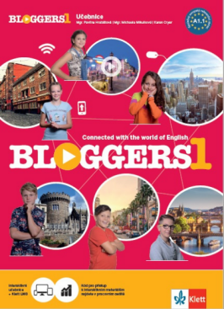

Picture 2 - Textbook - Bloggers (Klett, 2023)

1. **Explore Together**

Explore Together is a series of textbooks designed for learning English language in primary schools. The textbooks are designed for learners from the first to the ninth grade. The authors of the course books are Nina Lauder, Paul Shipton, Shona Evans and Suzane Torres and the first edition was published by Oxford University Press in 2019. The textbooks provide an appropriate level of difficulty of used language and tasks and support each stage of primary education. One of the key features of the textbooks is for children to learn language through discovering and exploring language and various topics. Children become explorers, and they are on their quest. The textbooks also put great emphasis on teaching language through stories, songs and chants. Pupils combine a fantasy world with the real world. The language is taught in a friendly way by six cartoon friends and Lucky the dog.

The vocabulary and knowledge of grammar are built through dialogues, games and cross-curricular relations. Each Pupil’s book contains five modules which are divided into seven lessons. The same structure and layout of a textbook is preserved for all the levels. This makes it easy for teachers to prepare lessons and for pupils to orientate themselves in the textbook or the workbook in the following year. At the end of each unit there is an explorer’s review with my effort self-assessment scale. The workbook uses English and a native language for instructions. Flash cards created for each module are as well part of the course material. The cards contain pictures representing vocabulary and grammar elements. Flesh cards help engage pupils’ attention, build their concentration, speaking skills and activate their imagination. Another essential part of the Explore Together textbooks are short cartoons stories and short videos from real British environment. (Ajshop, 2023)



Picture 3 - Explore Together (AJSHOP,2023)

1. **Access**

A series of Access textbooks was written by Virginia Evans and Jenny Dooley. The textbooks are meant for primary school and lower secondary school learners of English language as their second language and they cover levels of English A1- 1/2B1 based on the Common European Framework of Reference for Languages. The books are published by Express Publishing.

The course includes thematic lessons, several reading texts including exercises, dialogues, grammar, pronunciation, and intonation sections, wide range of speaking exercises, working in pair activities and a cultural corner. Access textbooks feature people in everyday life activities of contemporary era. Recorded dialogues among speakers are very realistic. Reading texts in the books encourage learners to read intensively as well as extensively. The texts contain modern vocabulary and topics that learners can relate to. The books offer learners with tips and hints which help them become autonomous users of the language. At the end of each module, there is a self-check section available for learners to assess their knowledge and to see what areas they should improve in. An essential part of the set of the textbooks is a Grammar book. This provides a comprehensive explanation of grammar rules for better understanding and varies exercises which help learners to improve their grammar skills. Each unit in the grammar book contains a revision page. There is also an internet support available with interactive exercises and extra downloadable material. Access textbooks were granted the approval clause (Ajshop, 2023).

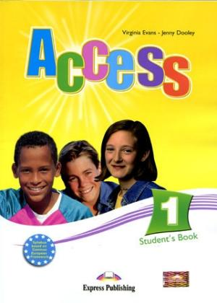

Picture 4 - Textbook - Access (Infoa, 2023)

1. **Project 4th Edition**

The 4th edition of the Project textbooks are designed for primary school pupils aged from ten to fifteen years and levels of English A1- 1/2B1 based on the Common European Framework of Reference for Languages. Publisher of the series of the Project textbooks and all additional teaching material is Oxford University Press. The authors are Tom Hutchinson and Rezmuves Zoltan. The Project 4th edition textbooks were published in 2014 and they come with workbooks and audio CDs. Learners can find attached codes in the textbooks which allow them to register on the publisher’s web site for on-line practice and extra material. Projects series of textbooks also provides methodical manual for teachers with multi-ROM, audio recordings, iTools, printable worksheets and a test builder (SEVT, 2023).

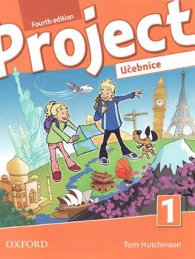The 4th edition of the Project textbooks build on a proven methodology and popular formats that are complemented by special pages with preparation for testing and extended digital support. The textbooks offer more communicative exercises and multi-skill exercises to practise language abilities that draw learners into the classroom and prepare them to use English in the real world. There are also included short videos in each unit featuring real life situations and real people. The Extensive Reading Bank contains typical simplified reading task with additional exercises to assess reading comprehension. Part of each story is adapted into a dialogue that pupils can practice during a lesson. Pronunciation Bank focuses on building vocabulary and learning correct pronunciation skills. Modern graphic design and the contemporary content make the use of the textbooks more interesting and entertaining. Throughout the first books pupils are accompanied by cartoon characters Mickey, Millie and Mut, detectives Sweet Sue and Smart Alex, which are gradually replaced by dramatized episodes and photo stories from teenage children's lives. There are six modules which are further divided into four units. Each module deals with a specific topic. Each module also contains a unit related to culture of English-speaking countries, science and school subjects (Ajshop, 2023).

Picture 5 - Project 1, fourth edition (Sevt, 2023)

## ELT Textbooks Analyses

The research strategy is to analyse gender related content of photographs and illustrations in the sample ELT textbooks. Eight illustrations from the sample books were depicted to demonstrate the current situation of gender representation in illustrations. For the analyses, there were used four selected sample ELT textbooks used in primary education. To compare the textbooks a categorical system was used. There were created two main categories and eight subcategories. Six of the subcategories representing male and female genders in social roles and activities and the other two subcategories were designed to investigate people’s appearance in the pictures of the textbooks. The findings for each category were represented by ‘yes’ or ‘no’ answers and an additional information for a positive respond was added. In this case, there was used a qualitative method for collecting the data. By analysing the pictures of each sample textbook, an inventory was obtained for further possible evaluation. Here are the categories:

**Graphic elements presenting gender stereotypes**:

Male doing a typical activity for men, Female doing housework, Female doing a typical female activity

**Graphic elements presenting gender variety:**

Male doing feminine activity or sport, female having a job typical for men,

Male with feminine looks, Female with masculine looks, Males doing housework,

Female doing masculine activity or sport

An inductive approach was used for qualitative content analysis. This allowed to collect and to analyse data without prejudicial and biased theories and to identify emerging patterns and concepts. A mathematical sing test was used for data analyses. The test is a simple static method of meta-analyses, a method of counting votes. Values for the measured object always form a statistically significant pair. The research result is positive or the research result is negative (Chráska, 2016). In this case: ‘Yes’ for + sign and ‘No’ for – sign. In this sign test, the + and the - signs are used to indicate whether the individual categories show an equal representation of gender roles that is social roles between men and women.

The table below (Table 4 - Gender in graphics in ELT textbooks for primary education own table, 2023) shows a comparison of the four sample ELT textbooks. The textbooks were compared on gender stereotypes criteria listed above the table. The following chart provides a visual picture of the total findings. Only the textbook ‘Bloggers’ has one picture of a person who looks like a boy with pink hair. This could be considered as the only example of gender diversity regarding the appearance. The other sample textbooks present typical stereotypes and typical features of men and women’s appearances. The same results apply to professions. There are not any examples of job equality. What is more, in all sample textbooks, women were pictured doing typical female activities such as cooking and baking. However, all four textbooks illustrate females doing males’ sport which can be seen as a step towards breaking stereotypes about women doing only female activities. Please note, that from the 10 categories and the 4 sample textbooks a majority of negative results was indicated.

10 x 4 = 40 total Out of the total: 25 negative results and 15 positive results

100 % = 62.5 % negative v 37% positive results

Substantive hypothesis H0: ELT textbooks illustrations portrait equal gender roles between men and women cannot be agreed.

H1 hypothesis: Illustrations portray typical gender stereotypes can be agreed

See the table below.

|  |  |  |  |  |
| --- | --- | --- | --- | --- |
| **Gender in Illustrations and photographs in ELT Textbooks for Primary Education** | | | | |
|  | **A Bloggers** | **B Explore Together** | **C Access** | **D Project** |
| Male doing housework | No - | Yes +  (washing up) | No - | No - |
| Male having job typical for women | No - | No - | No - | No - |
| Male with feminine looks | No - | No - | No - | No - |
| Male doing feminine activity or sport | Yes +  (cooking, yoga) | No - | No - | No - |
| Male doing typical activity for men | No - | Yes +  (car repair) | Yes +  (fishing) | Yes + |
| Females doing housework | No - | Yes +  (washing up) | No - | Yes + |
| Female having job typical for men | No - | No - | No - | No - |
| Female with masculine looks | No - | No - | No - | No - |
| Female doing male activity or sport | Yes +  (football, basketball) | Yes +  (football, lacrosse) | Yes +  (football) | Yes +  (football) |
| Female doing typical female activity | Yes +  (baking) | Yes +  (cooking, shopping) | Yes +  (baking) | Yes +  (baking) |

Table 5 - Gender in graphics in ELT textbooks for primary education (Own table, 2023)

For a better clarity, the same results are shown in the chart Gender in graphics in ELT textbooks for primary education (Graph 1). The chart contains the same data as the table above but it is more visual. Each textbook is represented by its own colour. All selected textbooks portray women doing typical female activities such as household work, cooking and baking and only the textbook ‘Project’ contains a picture of a man doing housework. Fortunately for women, all textbooks depict them doing sport that only men used to do in the past, so there is evident some progress towards gender equality. This, however, cannot be said about professional carrier because all women are portrayed doing typical female jobs. The same applies to men. Men did not do female jobs in any of the sample textbooks. Regarding the appearance, all textbooks show people with their typical European looks in typical gender related clothes. Men have masculine looks and women feminine looks. Unfortunately, except of one picture, there is very little evidence in the textbooks towards gender diversity or equality, in the matter of facts. See the chart below.

Chart 1- Gender in graphics in ELT textbooks for primary eduation (own chart, 2023)

The four sample ELT textbooks have been granted the approval clause. They all fulfil the conditions required by the Ministry of Education (MŠMT) for guaranteeing gender equality in teaching materials used in primary level of education.

## Sample Pictures Analyses

The following tables (Table 5 and Table 6), contains illustrations and a short descriptions based on a gender categorisation. All graphic elements come from the sample textbooks used in this work. The same illustrations were used in a questionnaire designed for this research. The illustrations represent male and female genders in their social roles and activities. The graphic elements are either drawings or actual photographs of people. For this part of the research it was used qualitative method of data analyses as well. This is a gender inquiry of illustrations. A non-parametric test was used, the variables were randomly selected. The variables are the illustrations.

|  |  |  |
| --- | --- | --- |
| **No.** | **Image** | **Description** |
| 1 | Obrázek1genderstereotypes  Picture 6 – Textbook Bloggers 1 (Klett, 2017) | **Gender stereotype**  Complete family in expected social roles, with typical looks and gender determination.  Pictures of a typical complete family are used in all selected course books. |
| 2 | Father And Son Washing Up Together Flat RGB Color Vector Illustration. Male  Parent And Child Washing Dishes, Smiling Family Members Near Kitchen Sink  Isolated Cartoon Characters On Blue Background Royalty Free SVG,  Picture 7 - Textbook Explore Together 2 (OUP, 2020) | **Gender equality**  Male takes on a typical female social role. This is a great example for children to learn about sharing household chores and tasks. |
| 3 | basketbal  Picture 8 - Workbook 1 Bloggers 1 (Klett, 2017) | **Gender equality**  In all four course books, women were captured doing female sport as well as male sport.  There was only one photograph in the samples, where a man was doing yoga. |
| 4 | nonbinary  Picture 9 - Textbook Bloggers 1 (Klett, 2017) | **Gender variety**  This is the only picture from the four course books picturing a person with no gender stereotyped looks. It passes a message that you can look as you wish, freedom of gender. |

Table 6 - Graphic elements and pictures 1 (own table, 2023)

|  |  |  |
| --- | --- | --- |
| **No.** | **Image** | **Description** |
| 5 | 20230622_072342  Picture 10 - Textbook Explore Together 2 (OUP, 2020) | **Gender stereotype**  Male, father in expected social role, with typical looks and gender determination.  Female, daughter wearing expected pink colour clothes and long hair. |
| 6 | 20230622_072329  Picture 11 - Textbook Explore Together 2 (OUP, 2020) | **Gender stereotype**  Female, mother takes on an expected female social role. This is a typical example of a woman doing household chores and tasks. |
| 7 | 20230622_072401  Picture 12 - Workbook 1 Bloggers 1 ( Klett, 2017) | **Gender equality**  Another example of a father helping at home with the chores. Male doing the same work as female. This image could be seen in two books. |
| 8 | 20230622_072519    Picture 13 - Textbook Explore Together 2 (OUP, 2020) | **Gender equality**  This is the only picture from the four textbooks picturing a person with no gender stereotyped looks. |

Table 7 - Second part of table 5

It can be concluded, from the illustrations in the four sample textbooks, that there is some approach to gender equality regarding social roles. However, the textbooks offer very limited range of people doing various jobs and activities. Children can see that both parents do the washing up, women cook and bake and girls can do boys’ sport. There are not any illustrations of boys doing sport and activities with girls or the same as the girls, nor women doing something else than expected. None of the illustrations reflect modern society and gender differentiation. All textbooks have received the approval clause, therefore fulfil the criteria established by the Ministry of Education, Youth and Physical Education based on principles of equality of women and men and the content of the textbooks is in accordance with the principles of gender equality (Table 8 - Gender equality in curriculum (MŠMT, 2013).

## Questionnaire

There was designed a specific pedagogical research questionnaire for this work with the aim to find out whether pupils in primary level of education and adult people representing general public are interested in the question of gender and have an understanding about gender issues. For the data collection it is used a quantitative method. Quantitative methods refer to the use of mathematical and statistical techniques to analyse and interpret data. These methods are commonly used in various fields, including social science, business, finance, engineering and health. They involve gathering data, manipulation, and interpretation of numerical data to draw conclusions and make informed decisions. When using a questionnaire for research, it is important to follow certain rules and guidelines to ensure the reliability and validity of the data collected (Chráska, 2016).

The purpose of the questionnaire in this research is to gather feedback on how illustrations in ELT textbooks influence young learners and whether the learners take an interest in gender issues in such an early age. The questionnaire is created on the website survio.com and then printed out in Czech language. The on-line format makes an easier way of data collection and better evaluation. The on-line questionnaire is identical to the paper format. The questionnaire contains opened and closed questions and there is also used Likert’s system of five answers from the most positive to the least positive options.

In the research, a sample refers to a subset of individuals or persons selected from a larger group of population. The sample is used to gather data and make inferences about the population as a whole unit. Selecting an appropriate sample is crucial for ensuring the representativeness and generalizability of research findings (Chráska, 2016). In this research, it is used a sample of pupils in a primary level of education in grades from four to seven. The age ranges from ten to fifteen years. Regarding the adult respondents, they are on average in the age group between twenty to fifty years. There are sixteen questions in total in the questionnaire. The questions (control items) are related to gender, gender stereotypes and gender in English language textbooks for primary schools. The purpose of the control items is to check the reliability of the collected data. The control items are divided into knowledge gathering items, item gathering respondent’s opinions and attitudes (Chráska, 2016). There are opened and closed questions. Some questions are complemented with a picture. Respondents received the questionnaire either in paper format in person or the questionnaire was submitted electronically via a URL link and through social media.

## The Questionnaire Data Analyses

The questions in the questionnaire covered two thematic areas. First area was connected with gender and gender related questions in general. The second area was connected with illustrations representing gender in ELT textbooks. The integration of data from both the physical and the electronic formats of the questionnaires allowed to provide total summary of the respondents’ interest in gender related issues.

The following data was collected from both types of the questionnaire, the paper format and the on-line format. Each question was analysed separately. On the left, there are listed results in numbers and on the right, there is a pie chart of cumulative properties for visual illustrations. For the data analyses was used a research method. Data on the depended variable was collected (Chráska, 2016).

### Findings

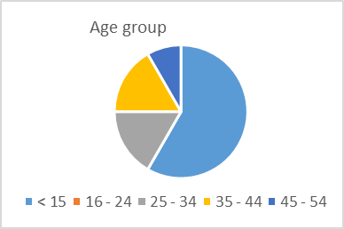**A. Questionnaire: a paper form**

Chart 2 - Age group (own chart 2023)

**Age category Number**

10 - 15 14

16 - 24 0

25 - 34 4

35 - 44 4

45 - 54 2

55 - 70 2

Number of respondents was 26. The biggest age group of the respondents was represented by pupils in the fifth grade at primary school and made a half of the respondents. Adult respondents were members of the teachers’ staff and parents.

1. **Gender**

Male 11

Female 14

Not specified 1

Women made up to about 54 % and men 42 %. There was one respondent who did not specify his or her gender.

1. 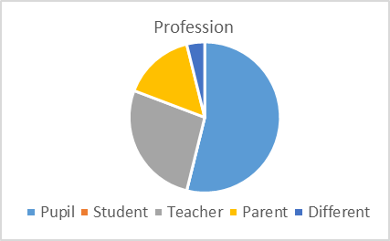**Profession**

Pupil 14

Student 0

Teacher 7

Parent 4

Chart 3- Profession (own chart, 2023)

Different (specify) 1

The biggest group was again represented by pupils under the age of fifteen.

1. **Do you know what gender is?**

Yes 12

No 12

N/A 2

46 % of the respondents had some ideas about gender, however 46 % of the respondents did not know. From the people who gave a negative answer was just one adult in the age category 25 - 34. One person did not answer at all. Respondents also wrote a short description of what a gender is. Their responses: Male and female sex (gender), sexual orientation, gender equality, gender, being part of a social group, a person knows which community belongs to.

1. **Statements about gender**

There are only two genders (male and female) 5

We are born with a gender and we cannot change it 11

Gender is determined by society and we learn it during our lives 4

Gender is the same in all eras and societies 4

One responded did not answer at all 2

This was a controversial question and some respondents believed that there should be more than one answer possible and some believed that the options were misleading. Almost 42 % of them stated that we are born with a gender and we cannot change it. This was the biggest group.

1. **Gender stereotype**

Here was an open question and respondent wrote their own ideas:

* Attributing some characteristic, behaviour to a certain gender
* Family - husband, wife, daughter, son
* That only man and woman exists, a man and a woman in a marriage
* Woman- long hair, dress, kitchen, household. Man a head of a family
* Woman looks like a woman and fulfils the expected roles of a woman
* Complete family

13 pupils and 1 adult did not answer or said that they did not know. This makes 54 % of people who have little or no knowledge about gender. Moreover, it is 86 % of pupils under the age of 15.

1. **Being dressed and to behave as expected for my gender?**

Yes 10

No 14

Different answer (specify) 2 none

54 % of the respondents said that they did not have to dress and behave in accordance with their gender. Two pupils did not answer at all. However, the teachers and the parents gave a positive answer. This could mean, that they accepted their social roles and follow standardised dress code and behaviour pattern.

1. **Gender stereotype of a picture representing a complete family**

Yes 18

No 8

69 % of the respondents believe that a complete family with one male and one female parents and grandparents and with couple of children represent a gender stereotype. 31% of respondents believe that not. Two respondents with the ‘no’ answer were pupils and one was an adult in the age group from 35 - 44 years.

1. **Meaning of the symbol.**

Picture 14 - Unisex (symbol.svg., 2023)

Male and female 4

Toilet symbol for men and women 4

Unisex 6

WC 1

Gender 4 age 15

Do not know 7 age 15

This was an open question and everybody was asked to write their own opinion about the pictogram in the question. The people who wrote unisex gave the most correct answer because the symbol means gender neutrality or not-sex specified. This symbol is often connected with toilets in public places, as one person noted. On average, the results could be seen as not satisfactory, because only 23 % of the answers were correct.

1. 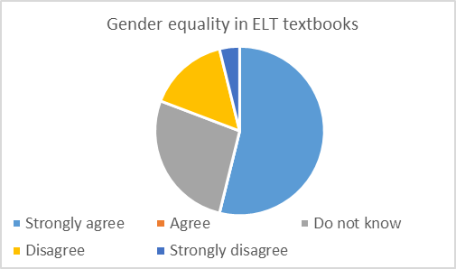**Pictures in ELT textbooks represent gender equality.**

Strongly agree 0

Agree 10

Do not know 16

Disagree 0

Strongly disagree 1

Chart 4 - Gender equality in ELT textbooks (own chart)

This question was designed specifically to gather respondents’ own opinion about this issue because the core of the research is about gender in illustrations in ELT textbooks. 62 % of respondents answered that they did not know whilst 38 % agreed. This could mean that people do not take interest in the pictures’ content, see illustrations only just a break from the text or that pictures really represent gender equality into some level.

1. **Gender stereotype of a boy with pink hair**

Yes 3 age 15

No 9

Specify 1 age 15

69 % of the respondents did not consider a boy with pink hair as a gender stereotype which is an expected answer. However, three pupils agreed, which could mean that they did not understand the question or agreed on purpose to make their own statement

1. **ELT textbooks avoid gender stereotype and portrait life of famous women and men**

Strongly agree 0

Agree 10 (4 teachers, 6 pupils)

Do not know 14

Disagree 2

Strongly disagree 0

This question was badly worded and confusing. Nevertheless, 38 % of respondent agreed that ELT textbooks avoid gender stereotype and portrait life of famous women and men. Famous people were mentioned only in one of the analysed books and very briefly. This part of the question should have been avoided. 54 % of respondents stated that they did not know.

1. 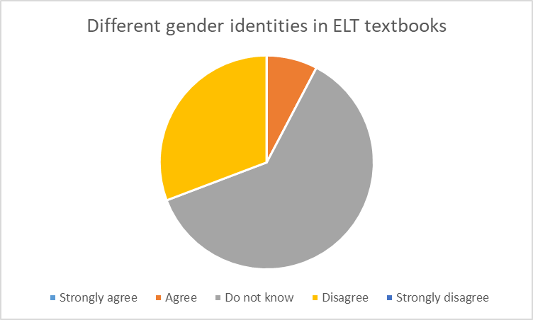**ELT textbooks contain information about different gender identities**

Strongly agree 0

Agree 2

Do not know 16

Disagree 8

Strongly disagree

Chart 5 - Different gender identities (own chart, 2023)

62 % of the respondents could not answer the question and 31 % gave a negative answer. This could mean that illustrations in textbooks really do not contain images of different gender identities or users of textbooks do not pay much attentions to pictures. However, there are 8 % of readers who agree with the statement.

1. 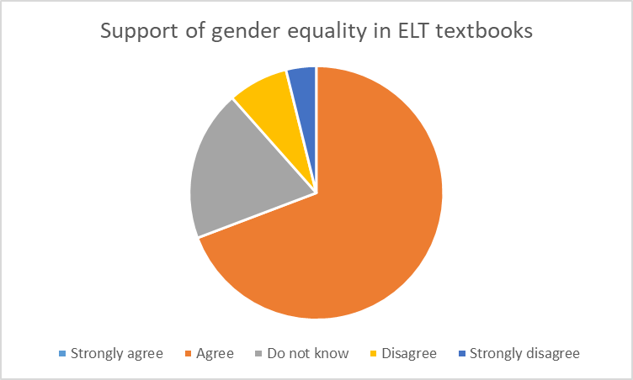**ELT textbooks should support gender equality**

Strongly agree 0

Agree 18

Do not know 5

Disagree 2 (pupil)

Strongly disagree 1 (teacher)

Chart 6 - Support of gender equality (own chart, 2023)

69 % of respondents agreed that ELT textbooks should support gender equality and 19 % did not know. However, two pupils (8 %) disagreed and one male teacher, representing 4 %, strongly disagreed.

1. 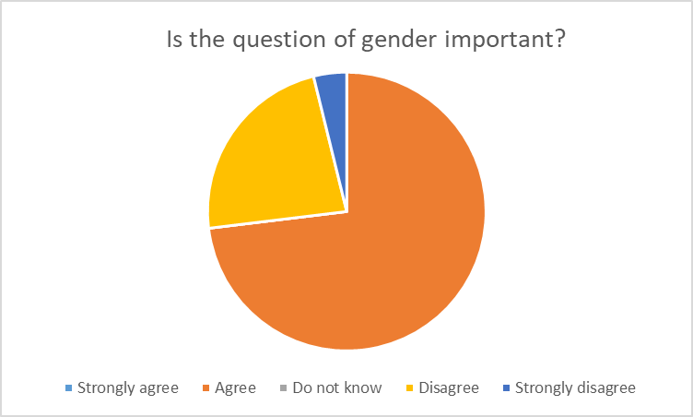**Gender is an important issue**

Strongly agree 0

Agree 19

Do not know 0

Disagree 6 (pupils)

Chart 7 - Question of gender (own chart, 2023)

Strongly disagree 1 (pupil)

Majority of the respondents, 73 %, believe that questions about gender are important and should be discussed. Six pupils disagree and one pupil disagrees strongly. This make 27 % of young learners under the age of 15 who do not wish to talk about gender related issues at all.

1. **New ideas for pictures in ELT textbooks**

The question was an open one and it allowed respondents to formulate their own ideas regarding textbook’s illustrations. The question did not specify that there was meant an approach into gender equality. The most common suggestions made by the respondents were as listed below:

* 14 respondents answered: I do not know
* 6 respondents did not write any answers
* Two men taking care of a child, for example
* They should capture the true form of the world, male in female roles,

women doing men’s jobs, different looks reflecting modern society

* Practically, what we see around us. Not in order to support the diversity of different

identities, but for children and pupils not to be shocked by a reality

* More pictures of animals, cats and dogs, for example.

26 respondents physically present at the school were handed the paper questionnaire. Young learners found gender related questions difficult. In general, they were not very interested in gender issues and did not care about the illustrations in textbooks nor thought about the content of pictures. They did not have any suggestions for pictures and illustrations since the question did not specify that the possible changes related to gender and new approach to gender equality. Among the adult respondents, there on the other hand, were a few people who suggested pictures reflecting modern society and equal gender roles.

**B. Questionnaire: an electronic form**

The respondents were either teachers, trainee teachers from a pedagogy faculty or people from general public. The electronic questionnaire was created and uploaded on 18th June 2023 on the survio.com and the results were collected on 17th July 2023.

The questions and the respondents’ answers are in this case left in the original Czech language because the charts are actual copies taken from the questionnaire created on line via survio.cz webpage. The link: <https://my.survio.com/V8U3H5W1J6W1A7S3V2V1/results> and they are authentic. The questionnaire is translated into English language and it is in the attachment of this work. It also contains illustrations used in questions 8, 9, 11 and 12 in the paper and electronic forms. Print shots are included. Frequency histogram was used as a method for displaying data (Chráska, 2016).

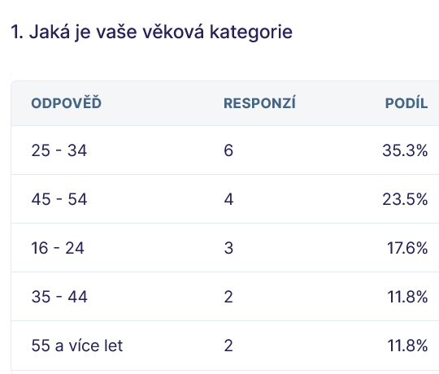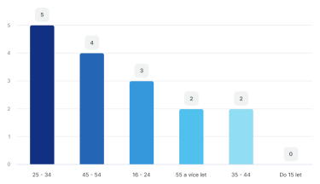**1** **Question:** **Age group**

Chart 8 - Age group (Survio.com, 2023)

Regarding the on-line questionnaire, there were not any young people under the age of fifteen. The biggest group was represented by adult people at the age of between 25 – 34 years, they made up to 31 %. The second biggest group were people in the age group 45 – 54. 25 %.

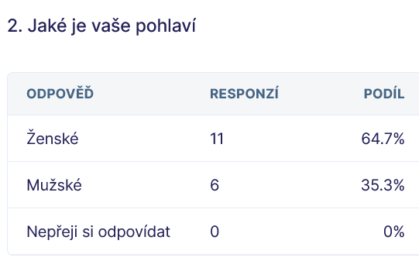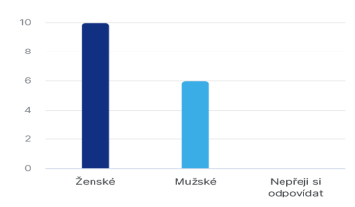**2** **Gender of respondents**

Chart 9 - Gender (Survio.com, 2023)

Female gender was represented by 62. 5 % and male gender by 37. 5 % of the respondents.

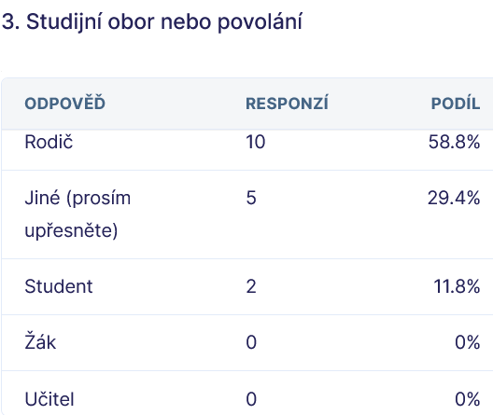**3** **Profession of respondents**

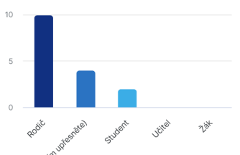

Chart 10 - Proffesion (Survio.com, 2023)

Regarding respondents’ profession, there were not any pupils or teacher involved. Parents made 62, 5 %, students 12, 5 % and 25 % of people chose a category for different profession without any further specification.

**4 What is a gender, do you know? Describe briefly**

Respondents

Yes 7 56.2 %

Sex 2 12.5 %

Social family 1 6.3 %

Social gender 1 6.3 %

What a person likes to be 1 6.3 %

It is a mental and physical identity

of a man or a woman or other 1 6.3 %

Nothing 1 6.3 %

Gender socialisation 1 6.3 %

Respondents gave their own ideas on a gender in an open question. From the qualitative point of view, 94.7 % of respondents have an understanding in the question of a gender. Only one person did not respond at all. Despite it was an open question, many respondents decided not to write any description.

**5 Which statement about gender is correct?** Please choose one answer

□there are only two □we are born with a gender □gender is determined by □gender is the genders (male and female) and we cannot change it society and we learn it same in all eras

during our lives and societies

50% of the respondents chose the option saying that there are only two genders (male and female). 43.8% of respondents selected that gender is determined by a society and we learn it during our lives. 12.5% chose that gender is the same in all eras and societies. Only one person selected option claiming that we are born with a gender and we cannot change it. This is a correct answer based on the article by Clinical Advisory Network on Sex and Gender (2023) gender was determined at fertilization and during embryonic development.

**6 What tod you think a stereotype is?**

Here are examples of the respondents’ answers:

That a woman is a woman and a man is a man

Perception of gender at the sex level

What it is determined by a society

Social expectations associated with gender

Concept that should evoke a reflection whether gender is not a stereotype

Typical division into male and female categories

It should not be always so strict

It is not a stereotype, it is determined by nature.

A man has to be strong, a leader and a head of the family. A woman has to look after the household and children.

An unsubstantiated rule that we believe ‘must’ apply to every individual of a given gender (e.g. girls mainly like the colour pink, boys like blue)

There are men's and women's jobs and that only a man can do certain things and only a woman can do others

Certain ideas of society on how each group of people behaves

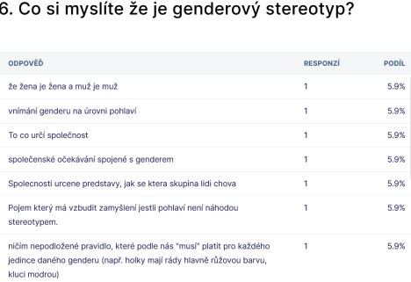

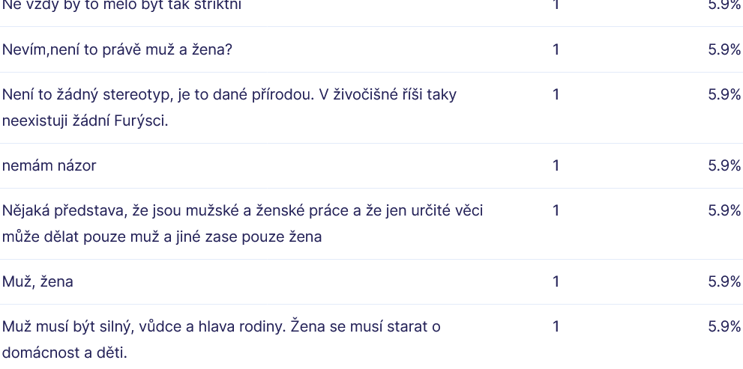

Some respondents wrote that there are two main categories of gender, male and female. They also agreed, that women and men follow general unwritten rules determined by a society and fulfil expected standardised behaviour patterns. There was also mentioned in the response that we should reflect on the concept of gender as a stereotype and not to be so strict with gender division into just male and female categories. As one respondent mentioned, we are born with a gender and it is determined by nature not by a society (survio.com, 2023).

**7 Do I have to dress and behave as expected for my gender?**

□yes □ no □ different answer (specify)

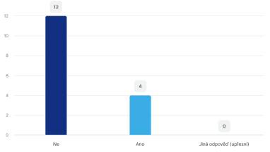

Chart 11 - Dressed and behaved as my gender (Survio.com, 2023)

Being dressed and behaved as my gender. Respondents had two closed ‘yes’ and ‘no’ questions and one open question. 75 %, that is three quarters of people, answered that they have to dress and behave as their gender, whilst only 25 % said no. This information could be considered as prove that there exists a dress code stereotype and expected behaviour pattern connected to a gender (survio.com, 2023).

**8 Do you think that this picture represents a gender stereotype?**

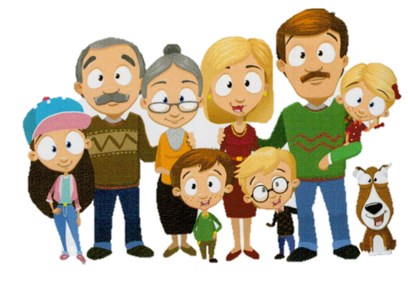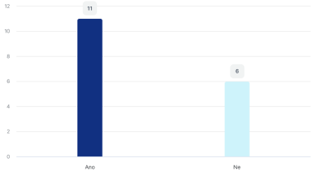

Chart 12 - Gender stereotype (Survio.com, 2023)

The picture was taken from a textbook and it represents a complete family. 61.7% of respondents saw the picture as a gender stereotype, however 41.2 % shared opposite opinion.

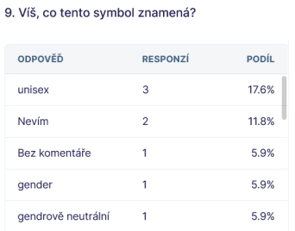**9** **Do you know what this symbol means?**

****

There were not all answers copied to this paper because there were problems with taking the screen shots. The tables with answers were too big. Nevertheless, from all results being uploaded on the website, 50 % of respondents knew that the pictogram represents gender neutrality usually used in public places and restrooms. 6.3 % of respondents did not comment, 12.5 % did not know and the 31.2% of respondents provided incorrect answer (survio.com, 2023).

**10 Do pictures in ELT textbooks represent gender equality?** All people, regardless of their gender, have the same opportunities and rights.

□ strongly agree □ agree □ do not know □ disagree □ strongly disagree

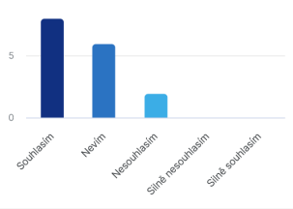

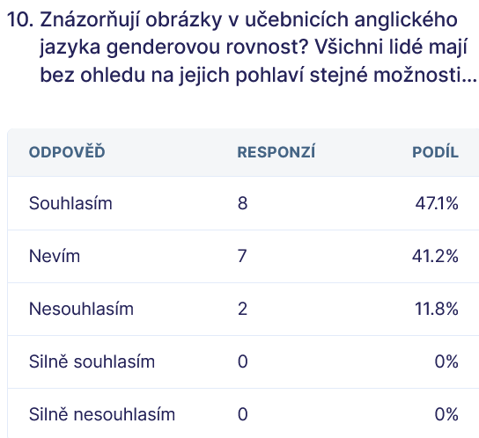

Chart 13 - Gender equality in ELT textbooks (Survio.com, 2023)

There was used the Likert’s system (Batterton, 2017) of five answers from the most positive to the least positive options. Almost half, 47.1 % of respondents agree that textbooks teaching English language depicts gender equality, unfortunately nearly the same number of respondents, 41.2 %, do not know, so the question cannot be correctly answered. 11.8 % of respondents disagree that textbooks show gender equality (survio.com, 2023).

**11 Does the person in the picture shows a gender stereotype?**

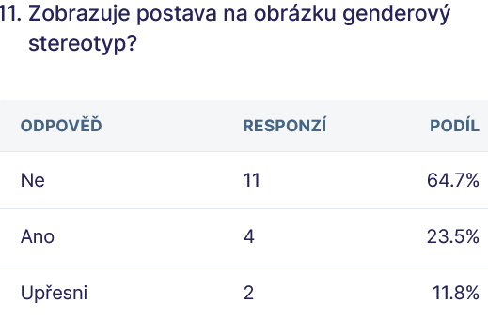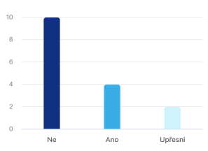

Chart 14 - A boy with pink hair (Survio.com, 2023)

Possible answers were ‘yes’, ‘no’ or ‘specify’. Illustration of a person with pink short hair at school. 64.7 % of people stated that it is not a gender stereotype compared with 23.5 % of people saying yes, meaning that it is. Here it would be more useful method to visit pupils in real schools. See Picture 15 - Textbook Bloggers 1 (Klett 2017).

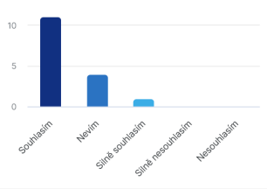**12 ELT textbooks avoid gender stereotype and portrait well-known women and men**

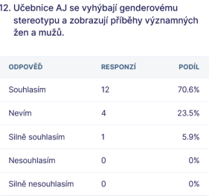

Chart 15 - Avoidance of gender stereotype (Survio.com, 2023)

Based on the Likert’s scale with possible answers: strongly agree, agree, do not know, disagree and strongly disagree, 70.6 % of respondents agree that ELT textbooks avoid gender stereotype and present life stories of well-known women and men. 23 % of respondents do not know and 5.9 % strongly disagree (author’s own questionnaire on survio.com, 2023).

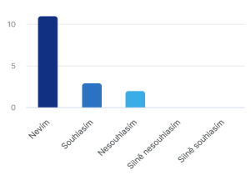**13 ELT textbooks contain information about various gender identities**

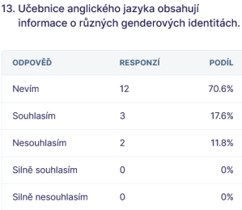

Chart 16 - Various gender identities (Survio.com, 2023)

Question thirteen also contained five possible answers based on the Likert’s scale. 70.6 % of respondents do not know whether ELT textbooks contain information about various gender identities. Nevertheless, 17.6 % of respondents agree with the statement and 11.8 % disagree.

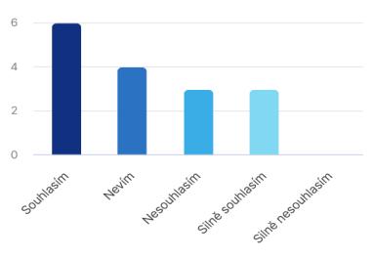**14 Do you think that it is important for ELT textbooks to support gender equality?**

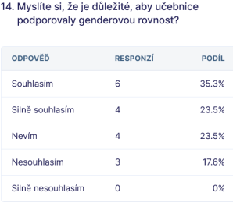

Chart 17 - Support of gender equality (Survio.com, 2023)

The responses were all in all quite positive. 35.3 % of respondents agree that it is important for textbooks support gender equality and 23.5 % of respondents even strongly agree. This makes 58.8 % in total. With the idea of supporting gender equality 17.6 % of respondents disagree and 23.5 % do not know.

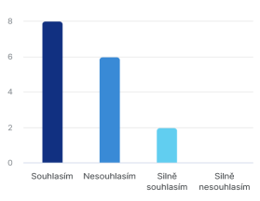**15 Do you think that gender is an important issue?**

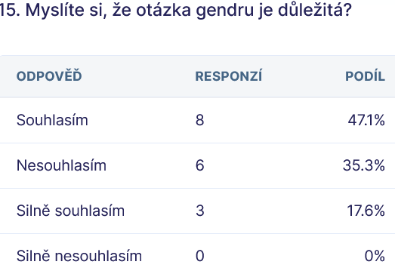

Chart 18 - Gender is an important issue (Survio.com, 2023)

There were only four possible answers in this question of gender importance. I agree, disagree, strongly agree and strongly disagree. 50 % of people believe that a question of gender is important, on the other hand, another 37.5 % of respondents disagree and what is more, 12.5 % strongly disagree. Total of negative responds is also 50 %. It is an even point of view.

**16 What kind of pictures would you choose into your ELT textbooks? What should they capture?**

The respondents provided their own answers in this question. They had to be translated into English language.

- It depends on the content of the curriculum not the picture 1 5.9 %

**-** Traditional so children are not confused2 11.8 %

**-** Pictures representing culture of Anglophone countries 1 5.9 %

- Related to text 1 5.9 %

- Similar to the picture in the question 11 1 5.9 %

- Colourful, depending on the targeted group 1 5.9 %

- People, things, animals, food ad similar 1 5.9 %

- Pictures of women and men in all roles regardless

gender stereotypes 1 5.9 %

- They should capture men and women in the same 1 5.9 %

social roles

- The whole society, teach that also a man can cook and 1 5.9 %

clean and a woman can repair a light

- I do not know or no comment 4 23.6 %

# RESUlTS

The system designed to compare ELT textbooks that was used in this work provides evidence that the content of illustrations and photographs presented in the four sample textbooks is based on typical gender stereotypes. It also give little evidence towards gender equality. The results, however cannot be used as a proof because of the small quantity of four samples textbooks (chart1, subchapter 5.2.).

The results from the questionnaire on the question of gender stereotype and gender equality collected from the respondents answers show that in total 66.6% do not know, 23% disagree and 12% agree.

## Questionnaire results

A total of 42 respondents took part in the survey including 14 young learners from a primary school. Among the adult respondents, there were 7 teachers, 2 students and 14 parents. 6 people did not specify their occupation. The age range of the respondents was between 10 to 70 years. Young learners made for the biggest age group and individuals between the 25 – 34 years represented the second biggest age group.

There were only fourteen pupils in the age group between ten to eleven years taking part in the research. (Chart 2, sub chapter 5.2) and looking at their responses from all 16 questions in the questionnaire they had a very little understanding of the term gender and gender related questions. Most of their answers was ‘do not know’ or nothing. (Data collected from paper form of a questionnaire in questions 4 – 16).

Adult respondents had better understanding of gender and were aware of gender related issues (data collected from electronic form of a questionnaire in questions 4 – 16).

Due to the small percentage of population taking a part in the research the research question whether children and adult people take interest in gender issues cannot be objectively answered.

# DISCUSSION

To answer the research question, it is necessary to think about the comparison of the theoretical information and the actual empiricism. A lot of research works deal with the question of gender and gender equality. The subject of interest is to analyse gender as a social construct representing social arrangements and male and female roles (Smetáčková, 2016). Gender not only influences male and female social roles, but it also determines the course of interaction among people. When a man or a woman enters an interaction they communicate their own gender identity. Gender can also be understood as a social construct denoting a personal identity (Kimmel). Sex, on the other hand, means that humans are divided on the basis of their reproductive functions to a male and female sex (Vrhel in Weiss, 2010). However, modern studies show that there are more than two genders. In fact, there exists eighty two ways to describe gender constructs people identify themselves with (Chris Drew, 2023). With social roles come social stereotypes because they help people to find a place and orientation in a social world. Based on stereotypes, people create cognitive schemas and therefore reduce a quantity of information they need to process when they interact with other people. (Výrost, 2019). Gender stereotypes are therefore associated with ideas and norms of a society towards men and women (Jánošová, 2018).

Nevertheless, stereotypes can have negative connotation as well. By marking something as a stereotype, an attention is drawn to its correctness. People create stereotypes themselves because they generally assume that a certain social category shares a certain set of characteristics. If their assumption or generalisation of certain characteristics of social groups is incorrect or false, then they distort social reality (Smetáčková, 2016). Joy Nash says that holding to stereotypes can be harmful because they encourage people to condemn and oppress those ones who do not fit the traditional social roles. As a result of the oppression, a lot of people struggle to fully develop and use their potentials. Therefore people should be encouraged to follow and express their own truth and feelings. She further comments that media should portrait people who do not follow traditional gender roles in more positive way and schools should provide more comprehensive lessons about gender (Joy Nash, 2016).

Before people accept social roles they go through gender socialization process. This starts in early childhood. Watson believes that, socialization is a process which allows children to become functional and capable members of a society through learning norms of children’s society and general norms which they are expected to follow (Watson, 1965). Gender socialization also is, as H.P. Frey said, a preparation of an individual to fulfil her or his social roles, integration of the individual into activities and tasks that he or she must fulfil in order to maintain a working functional existence of a society (H.P. Frey 1974). Nikola Balvin points out that gender socialization during adolescence is particularly important as today’s teenage boys and girls are pivotal to the achievement of the Sustainable Development Goals. Their gender attitudes and outcomes will influence future generations (Balvin, 2017). As it has been mentioned, gender socialization and consequent attitude towards gender and social roles starts in early childhood. Irena Smetáčková wrote that school plays a key role in the gender development of students. Taking a part in lessons, learners encounter gender-charged content of teaching materials and procedures. What students experience results in shaping their social roles associated with female and male genders. She further states that gender stereotypes can have a negative effect on the learners. Girls and boys form a certain idea about roles of men and women due to perception of gender perspectives and they project this perception to their mutual relationships with other people (Smetáčková, 2016). The same view shares Vladimír Hrabal. He wrote that school, as a central social educational institution, influences the development of individuals. In schools, learners build socio psychological dispositions which are the target and the result of learning. Formation of socially required dispositions is a specific task of education. (Hrabal, 2004)

From the above studies can be seen that the question of gender is very important since it shapes each individual and his or her attitude towards social roles and other people. Modern global approach is to guarantee gender equality among men and women and to promote gender variation. There have been made many steps to produce effective changes reducing gender stereotypes and increasing gender equality. UNICEF designed framework to help develop policies and programmes focused at increasing gender equality. It helps decision makers to understand key areas influencing gender socialisation. The framework helps to produce effective changes related gender stereotypes, and therefore it allows young adults to succeed in their carriers and a personal development as well as their full participation in a society (UNICEF, 2014). Since 2013 European Union have been promoting social investments as a national reform strategy to escalate person’s capacities and national economic growth. Gender equality in care sharing helps increase fathers’ investment in children, reduces discrimination of women in the labour market and allows them to have full time jobs. It also leads to a reduction of gender gaps in salaries and pensions and to better health for both genders (Jon Kvist, 2014).

In the Czech Republic, there have been taken certain steps into improving gender equality, as well. For instance, the Ministry of Education, Youth and Physical Education in cooperation with the European Union, issued a plan for supporting equality of women and men for the years 2021 – 2024. Together, they established measures improving gender equality that should be visible in teaching materials and textbooks in primary level of education and lower secondary schools. There have been set two strategic goals. The aim of the first strategic goal is to design Frame Educational Programme and School Educational Programme that guarantee equality between men and women, maximizes their potentials and promotes equal opportunities, tolerance and respect. The next strategic goal is to guarantee that the content of textbooks is in accordance with the principles of gender equality. The measures are in place to update the existing system of expert assessment of textbooks for primary education. The gender equality is included in the formal curriculum (MŠMT, 2013). To guarantee gender equality in ELT textbooks, the Ministry of Education, Youth and Sports of the Czech Republic grants an approval clause to textbooks and teaching texts based on an assessment. The textbooks have to be in accordance with educational goals set by the Education Act, Framework Educational Programmes and legal regulations (MŠMT, 2013).

It emerges from the presented case study that ELT textbooks should contain illustrations with gender equal content because illustrations and graphic elements not only help children to learn and develop their understanding, they also shape their point of view and perspectives. Books influence children’s opinion about gender and their responsive values, such as free of stereotypes and gender bias, as well as supporting gender equality. Illustrations play a big role in presenting gender responsive values. (Cintantya Sotya Ratri; Riama Maslan Sihombing, 2021)

The answer to a research question: Do illustrations in ELT textbooks for primary schools support gender equality? is that there is evident a small progress into gender equality, based on the research actual findings. The ELT textbooks currently sold in the market follow similar structure and safe approach to standardised social roles. The ELT textbooks mostly portray people in expected social roles and promote well embedded gender stereotypes

The secondary research question: Do children and adult people take an interest in gender issues? Adult people have deeper insight knowledge into gender related issues in general and can make their own opinion about this topic. However, they cannot provide more specific opinion about illustrations in ELT textbooks.

Regarding the hypotheses that were specified for this thesis, H0 hypothesis: ELT textbooks illustrations portray equal gender roles between men and women and H1 hypothesis: Illustrations portray typical gender stereotypes can be verified to be true based on the actual findings.

# Conclusion

This work was focused on a question of gender, gender stereotypes and gender equality in illustrations and graphics in English language textbooks in primary level of education. The reason for discussion gender in teaching materials was the fact that illustrations and pictures in textbooks influence young learners’ perception of gender, their attitude towards genders and gender related roles. The Czech Ministry of Education introduced measures to assure a gender equality in teaching materials in accordance with the educational goals set by the Educational Act. Gender equality is implemented into the Framework Educational Programme, school educational programmes as well as the school curriculum. The Ministry of Education, Youth and Physical Education guarantees gender equality of ELT textbooks by granting them an approval clause, usually for the period of six years.

There were used four sample ELT textbooks in this work commonly used by primary schools in the South Moravian region. From the analyses of the illustrations and pictures it is visible that there is some progress in portraying both male and female genders in different social roles. Nevertheless, most illustrations and pictures depict people with expected looks, careers and hobbies. Most housework is still done by women. There is very little evidence towards gender variety and gender equality despite all the sample textbooks were granted an approval clause. Due to a small amount of samples it can be only assumed that ELT textbooks do not prepare young learners for the fact that in a real world there exist various genders, homosexual couples and that people fulfil different socials roles regardless if they are men, women or other genders. To change this situation, writers and publishers of English language textbooks would have to cooperate with governing bodies and alter illustrations in accordance with an international strive towards gender equality in general and in educational systems.

To broaden the question of a gender there was created a questionnaire to provide a feedback on gender awareness of young learners in primary level of education and a general public represented by adults. The results from the questionnaire shows that young people do not take much interest in gender related issues and adult population is split. Some people are for changes related to gender equality development whilst some prefer to keep gender stereotypes since they are well embedded in the society’s culture.

If society is to change their perception of gender and governments wish to fulfil their measures guarantying gender equality, then textbooks is one of the means. If publishers design textbooks that reflect equality between male and female roles and genders then the learners will accept them naturally without prejudice.

# LIST OF ABBREVIATIONs

**ELT:** English language teaching

**FEP EE:** Framework Education Programme for Elementary Education

**GPE**: Global Partnership for Education

**GRESP:** Gender Responsive Education Sector Planning

**GTE:**  Gender Transformative Education

**MŠMT:** Ministry of Education, Youth and Physical Education

**UNGEI:** United Nation Girls’ Education Initiative

**UNAIDS**: United Nations Programme on HIV/AIDS

**WHO:** World Health Organisation

# List of tables

[Table 1 - Gender equality in curriculum (MŠMT, 2013) 30](#_Toc160363149)

[Table 2 - Healthy educational environment (MŠMT, 2013) 31](#_Toc160363150)

[Table 3 - Educating teachers (MŠMT, 2013) 32](#_Toc160363151)

[Table 4 - Gender in graphics in ELT textbooks for primary education (own table, 2023) 46](#_Toc160363153)

[Table 5 - Graphic elements and pictures 1 (own table, 2023) 48](#_Toc160363154)

[Table 6 - Second part of table 5 49](#_Toc160363155)

[Table 7 - Gender equality in curriculum (MŠMT, 2013). 49](#_Toc160363156)

# List of Charts

[Chart 1- Gender in graphics in ELT textbooks for primary eduation (own chart, 2023) 47](#_Toc160549372)

[Chart 2 - Age group (own chart 2023) 51](file:///C:\Users\Marcela%20King\Desktop\diplomka7.docx#_Toc160549373)

[Chart 3- Profession (own chart, 2023) 52](file:///C:\Users\Marcela%20King\Desktop\diplomka7.docx#_Toc160549374)

[Chart 4 - Gender equality in ELT textbooks (own chart) 54](file:///C:\Users\Marcela%20King\Desktop\diplomka7.docx#_Toc160549375)

[Chart 5 - Different gender identities (own chart, 2023) 55](file:///C:\Users\Marcela%20King\Desktop\diplomka7.docx#_Toc160549376)

[Chart 6 - Support of gender equality (own chart, 2023) 55](file:///C:\Users\Marcela%20King\Desktop\diplomka7.docx#_Toc160549377)

[Chart 7 - Question of gender (own chart, 2023) 56](file:///C:\Users\Marcela%20King\Desktop\diplomka7.docx#_Toc160549378)

[Chart 8 - Age group (Survio.com, 2023) 57](file:///C:\Users\Marcela%20King\Desktop\diplomka7.docx#_Toc160549379)

[Chart 9 - Gender (Survio.com, 2023) 57](file:///C:\Users\Marcela%20King\Desktop\diplomka7.docx#_Toc160549380)

[Chart 10 - Proffesion (Survio.com, 2023) 58](file:///C:\Users\Marcela%20King\Desktop\diplomka7.docx#_Toc160549381)

[Chart 11 - Dressed and behaved as my gender (Survio.com, 2023) 60](#_Toc160549382)

[Chart 12 - Gender stereotype (Survio.com, 2023) 60](#_Toc160549383)

[Chart 13 - Gender equality in ELT textbooks (Survio.com, 2023) 61](file:///C:\Users\Marcela%20King\Desktop\diplomka7.docx#_Toc160549384)

[Chart 14 - A boy with pink hair (Survio.com, 2023) 62](file:///C:\Users\Marcela%20King\Desktop\diplomka7.docx#_Toc160549385)

[Chart 15 - Avoidance of gender stereotype (Survio.com, 2023) 62](file:///C:\Users\Marcela%20King\Desktop\diplomka7.docx#_Toc160549386)

[Chart 16 - Various gender identities (Survio.com, 2023) 62](file:///C:\Users\Marcela%20King\Desktop\diplomka7.docx#_Toc160549387)

[Chart 17 - Support of gender equality (Survio.com, 2023) 63](file:///C:\Users\Marcela%20King\Desktop\diplomka7.docx#_Toc160549388)

[Chart 18 - Gender is an important issue (Survio.com, 2023) 63](file:///C:\Users\Marcela%20King\Desktop\diplomka7.docx#_Toc160549389)

# List of pictures

[Picture 1 - Gender Socialisation (UNICEF, 2014) 21](file:///C:\Users\Marcela%20King\Desktop\diplomka7.docx#_Toc160555427)

[Picture 2 - Textbook - Bloggers (Klett, 2023) 41](file:///C:\Users\Marcela%20King\Desktop\diplomka7.docx#_Toc160555428)

[Picture 3 - Explore Together (AJSHOP,2023) 42](file:///C:\Users\Marcela%20King\Desktop\diplomka7.docx#_Toc160555429)

[Picture 4 - Textbook - Access (Infoa, 2023) 43](file:///C:\Users\Marcela%20King\Desktop\diplomka7.docx#_Toc160555430)

[Picture 5 - Project 1, fourth edition (Sevt, 2023) 44](file:///C:\Users\Marcela%20King\Desktop\diplomka7.docx#_Toc160555431)

[Picture 6 – Textbook Bloggers 1 (Klett, 2017) 48](file:///C:\Users\Marcela%20King\Desktop\diplomka7.docx#_Toc160555432)

[Picture 7 - Textbook Explore Together 2 (OUP, 2020) 48](file:///C:\Users\Marcela%20King\Desktop\diplomka7.docx#_Toc160555433)

[Picture 8 - Workbook 1 Bloggers 1 (Klett, 2017) 48](file:///C:\Users\Marcela%20King\Desktop\diplomka7.docx#_Toc160555434)

[Picture 9 - Textbook Bloggers 1 (Klett, 2017) 48](file:///C:\Users\Marcela%20King\Desktop\diplomka7.docx#_Toc160555435)

[Picture 10 - Textbook Explore Together 2 (OUP, 2020) 49](file:///C:\Users\Marcela%20King\Desktop\diplomka7.docx#_Toc160555436)

[Picture 11 - Textbook Explore Together 2 (OUP, 2020) 49](file:///C:\Users\Marcela%20King\Desktop\diplomka7.docx#_Toc160555437)

[Picture 12 - Workbook 1 Bloggers 1 ( Klett, 2017) 49](file:///C:\Users\Marcela%20King\Desktop\diplomka7.docx#_Toc160555438)

[Picture 13 - Textbook Explore Together 2 (OUP, 2020) 49](file:///C:\Users\Marcela%20King\Desktop\diplomka7.docx#_Toc160555439)

[Picture 14 - Unisex (symbol.svg., 2023) 54](file:///C:\Users\Marcela%20King\Desktop\diplomka7.docx#_Toc160555440)

# BIBLIOGRAPhy

BEAL, Carole R. *Boys and girls: the development of gender roles*. New York: McGraw-Hill, 1994. ISBN 0-07-004533-X

CVIKOVÁ, Jana. *Ružový a modrý svet: rodové stereotypy a ich dosledky*. Bratislava: Aspekt, 2003. ISBN 80-89140-02-5

ČÁP, J. MAREŠ, J. *Psychologie pro učitele*. Praha: Portál, 2001. ISBN: 80-7178-463-X

DU, Shanshan a Ya-chen CHEN. *Women and gender in contemporary Chinese societies: beyond Han patriarchy*. Lexington: Lexington Books, 2011. ISBN 0739145800.

DVORKIN, Gerald. *The Theory and Practice of Autonomy*. Cambridge: Cambridge University Press, 1988. Published online by Cambridge University Press: **16 January 2009.**

HRABĚTOVÁ, Pavlína; MIKULKOVÁ Michaela a CRYER, Caren. *Bloggers 1. Connected with the world of English.* Učebnice. Praha 3 - Vinohrady: Klett nakladadelství. s.r.o., 2018. ISBN 978-80-7397-264-6

HUTCHINSON, Tom; REZMUVES. *Project 1, 2 - Fourth Edition.* Učebnice. Oxford: Oxford University Press, 2014. ISBN: 9780194764667

CHRÁSKA, Miroslav. *Metody pedagogického výzkumu: základy kvantitativního*

*výzkumu*. 2. aktualizované vydání. Praha: Grada, 2016. Pedagogika (Grada).

ISBN 978-80-247-5326-3.

JAMES, Sharon. *Genderová ideologie. Co všichni potřebují větet.* Praha: Poutníkova četba, 2022. ISBN 978-80-87606-51-3.

JANKO, T. *Nonverbální prvky v učebnicích zeměpisu jako nástroj didaktické*

*transformace*. Brno: Masarykova univerzita, 2012. ISBN978-80-210-6400-3

Dostupné také z www. https://munishop.muni.cz/obchod/e-knihy-zdarma/nonverbalni-prvky-v-ucebnicich-zemepisu-jako-nastroj-didakticke-transformace-munispace\_16.

JANOŠOVÁ, Pavlína. *Dívčí a chlapecká identita: vývoj a úskalí*. Praha: Grada, 2008. Psyché (Grada). ISBN 978-80-247-2284-9.

JARKOVSKÁ, Lucie. *Gender před tabulí: etnografický výzkum genderové reprodukce v každodennosti školní třídy*. Praha: Sociologické nakladatelství (SLON), 2014. Studie (Sociologické nakladatelství). ISBN 978-80-7419-119-0.

JARKOVSKÁ, Lucie. *Rovné příležitosti dívek a chlapců ve vzdělání*. 2. aktualiz. vyd. Brno: Nesehnutí, 2005. ISBN 80-903228-6-7.

LAUDER, Nina; PALIN, Cheryl a SHIPTON, Paul. *Explore Together 2*. Student´s Book. Oxford: Oxford University Press. 2019. ISBN 978-01-940516-06

LIPPA, Richard A. *Pohlaví: příroda a výchova*. Praha: Academia, 2009. Galileo. ISBN 978-80-200-1719-2.

MATONOHA, Jan a kol. *Za (de)konstruktivismem, Kritické koncepty  
(post)poststrukturální literární a kulturní teorie.* Literární řada. Praha: Academia, 2018, ISBN 978-80-200-2805-1

MURPHY, Bróna. *Corpus and sociolinguistics: Investigating age and gender in female talk*. Amsterdam: John Benjamins Publishing Company, 2010. ISBN 978-90-272-2312-8.

OAKLEY, Ann. *Pohlaví, gender a společnost*. Přeložil Martin POLÁČEK,

přeložila Milena POLÁČKOVÁ. Praha: Portál, 2000. ISBN 80-7178-403-6.

ŘEZÁČ, Jaroslav. Sociální psychologie. Brno: Paido, edice pedagogické literatury, 1998. ISBN 80-85931-48-6

SALISBURY, M a STYLES, M. The Art of Storytelling. Children’s

Picturebooks: Second Edition, London, Laurance King Publishing, 2012. ISBN 978-185-669-738-5

SMETÁČKOVÁ, Irena. *Genderové představy a vztahy: Sociální a kognitivní aspekty vývoje maskulinity a feminity v průběhu základní školy*. Praha: Sociologické nakladatelství (SLON), 2016. ISBN 978-80-7419-229-6

SMETÁČKOVÁ, Irena a Lucie JARKOVSKÁ. Gender ve škole: příručka pro budoucí i současné učitelky a učitele. Praha: Otevřená společnost. 2006. ISBN 80-903331-5-X.

SOMR, Miroslav. Dějiny školství a pedagogiky. vysokoškol učeb. pro stud. skupiny stud. oborů 76 Učitelství na fak. připr. učitele v ČSR. Praha: SPN. 1987. 215182

RATRIL, S. Cintantya a SIHOMBING M. Riama. Gender Perspective in Design and Illustration of Children’s Books. (Case Study in Biographical Children’s Books of Influential Female Figures in Indonesia). Advances in Social Science, Education and Humanities Research, volume 625. ICON ARCCADE 2021: The 2nd International Conference on Art, Craft, Culture and. Design (ICON-ARCCADE 2021). [online]. 2021.

RIDDELL I. Sheila. *Gender and the Politics of the Curruculum.* Svazek 74. Routledge library edition. Education*.* Routledge2012. ISBN 0415683629, 9780415683623

**Internet resources**

ABRAMS, D**.** Categorisation**.** [online]. 2023. Social Identity, Psychology of. International Encyclopedia of the Social&Behaviour Science, 2001. ScienceDirect. [cit. 2023-07-21]. Dostupné z: <https://www.sciencedirect.com/topics/social-sciences/social-categorization> >.

AIGA, MossAnon. *Unisex-symbol.svg.* [online]. 2013. [cit. 2023-06-24]. Wikimedia Commons. Dostupné z: < <https://commons.wikimedia.org/wiki/File:Unisex-symbol.svg>>.

BABANOVÁ, Anna; MIŠKOLCI, Jozef. *Genderově citlivá výchova. Kde začít?* [online]. *2007*. [cit. 2023 - 01-15]. *Příručka pro vyučující základních a středních škol,  
vydaná v rámci projektu Rovné příležitosti v pedagogické praxi.* Dostupné z: <<https://is.muni.cz/el/ped/podzim2020/SO533/um/Genderove_citliva_vychova_Kde_zacit.pdf?lang=en>>.

BAČÁKOVÁ, Lucie. Bakalářská práce: Lucie Bačáková [online]. 2017 [cit. 2023-05-24]. *Hodnocení obrazové složky vybraných učebnic přírodopisu*. Dostupné z: <

<https://theses.cz/id/rojed8/BP_viz_prvky.pdf> >.

BALVIN, Nikola. *What is gender socialization and why does it matter?* [online]. 2017. [cit. 2023 - 04- 25]. Unicef for every child. Office of research - Innocenti.

Dostupné z: <<https://www.unicef-irc.org/evidence-for-action/what-is-gender-socialization-and-why-does-it-matter/> >.BLACKSTONE, M. Amy. *Gender Roles and Society*. [online]. [cit. 2023-05-04]. University of Maine. Santa Barbara. Dostupné z: <https://digitalcommons.library.umaine.edu/soc\_facpub/1/ >.

BATTERTON A. Katherine a HALE N. Kimberly. *The Likert Scale What It Is and How To Use It*.[online]. 2017 [cit. 2023-08-24]. JSTOR.

Dostupné z: < <https://www.jstor.org/stable/26296382>>.

BORST, Heidi*. The Pros and Cons of Single-Gender Schools.* [online]. 2022. [cit. 2023-05-25]. U.S. News. Dostupné z: < <https://www.usnews.com/education/k12/articles/the-pros-and-cons-of-single-gender-schools> >.

ČASTULÍKOVÁ, Žaneta. *Diplomová práce: Žaneta Častulíková* [online]. 2014. [cit. 2023-01-14]. Genderová koretnost vybraných učebnic pro základní a střední školy. Dostupné z: <<https://is.muni.cz/th/gp9ol/Diplomova_prace.pdf> >.

DOSKOČILOVÁ, Marie. *Dizertační práce:* Marie Doskočilová [online]. 2016 [cit. 2022-01-28]. Reprodukce genderových stereotypů ve výuce angličtiny na 2. stupni ZŠ. Dostupné z: < <https://is.muni.cz/th/uw97b/Dizertace_TISK.pdf> >.

DREW, Christ (PhD). *81 Types of Genders & Gender Identities (A to Z List).* [online]. 2023 [cit. 2023-07-12]. HelpfulProfessor.com. Dostupné z: < <https://helpfulprofessor.com/types-of-genders-list/>>.

EVANS, Virginia; DOOLEY, Jenny. *Access 1 Student’s Book*. Angličtina / Učebnice pro 2. stupeň ZŠ a SŠ. Newbury. Express Publishing. 2007. ISBN 978-1-84679-470-4

[online]. 2023 [cit. 2023-06-04]. Infoa. Dostupné z: < <https://www.infoa.cz/zbozi/access-1-student-s-book> >.

FAZIL, Wardah. *Pros and Cons of Gender Segregated Schools.* [online]. 2022. [cit. 2023-04-29]. The Independent. The Student News Site of Glenbard South High School. Dostupné z: < <https://gbsindependent.org/10357/opinions/pros-and-cons-of-gender-segregated-schools/> >.

FLOYA, Anthias. *The Sociological Review*, Volume 46, issue 3. [online]. 1998. [cit. 2023-08-07]. Wiley on Line Library. Dostupné z: <

<https://onlinelibrary.wiley.com/doi/epdf/10.1111/1467-954X.00129?saml_referrer> >.

HÁDKOVÁ, Matylda. *Diplomová práce*: *Matylda Hádková* [online]. 2020. [cit. 2022-12-29]. *Kyselá jablka*. *Gender ve škole a ve výtvarné výchově*. Katedra výtvarného umění. Dostupné z: <<https://is.muni.cz/th/mei29/Kysela_jablka> >.

HESS, April. *Social Category Overview, Examples ＆Robbers Cave Experiment.*[online]. 2022[cit. 2023 - 05- 28]. Study.com. Dostupné z:

< <https://study.com/learn/lesson/social-category-overview-examples.html> >.

HRABĚTOVÁ, Pavlína; MIKULKOVÁ, Michaela; CRYER, Caren. *Bloggers 1, 2. Connected with the world of English.* Učebnice [online]. 2023. [cit. 2023 - 06- 03]. Dostupné z: < <https://www.ajshop.cz/p/bloggers-2-a1-2-ucebnice?gclid=Cj0KCQjwtO-kBhDIARIsAL6LorfBNHzA9TM-v3Nj1RhGLPBYRQWmHjqAJM4jMXLZ45HLOq1P9tY1SRcaAgbxEALw_wcB> >.

HUTCHINSON, Tom; REZMUVES. *Project 1, 2 - Fourth Edition.* Učebnice [online]. 2023. [cit. 2023 - 06- 03]. Dostupné z: < <https://www.ajshop.cz/p/project-fourth-edition-2-ucebnice> >.

KRUEGER, J. *Social Categorization*[online]. 2023. [cit. 2023-07-21]. Social Identity, Psychology of. International Encyclopedia of the Social&Behaviour Science, 2001. ScienceDirect. Dostupné z: < <https://www.sciencedirect.com/topics/social-sciences/social-categorization> >.

KVIST, Jon*. A framework for social investment strategies: Integrating generational, life course and gender perspectives in the EU social investment strategy, Comparative European Politics* [online]. 2014. [cit. 2023-07-12]. Dostupné z: <https://www.academia.edu/8954076/Kvist_Jon_2014_A_framework_for_social_investment_strategies_Integrating_generational_life_course_and_gender_perspectives_in_the_EU_social_investment_strategy_Comparative_European_Politics>>.

LAUDER, Nina; PALIN, Cheryl; SHIPTON, Paul. *Explore Together 1*. Student´s Book

[online]. 2019 [cit. 2023-06-03]. AJSHOP. Dostupné z: < [https://www.ajshop.cz/p/explore-together-1 -student-s-book-cz](https://www.ajshop.cz/p/explore-together-1%20-student-s-book-cz) >.

MASON, Andrew. 2004, *Equality, Personal Responsibility and Gender Socialisation* [online]. 2004 [cit. 2023-04-28]. Wiley Online Library. AS. Dostupné z: <https://onlinelibrary.wiley.com/doi/abs/10.1111/j.0066-7372.2003.00014.x >.

NASH, Joy. *Gender roles in modern society*. *Gender Equality*. [online]. 2016. [cit. 2023-06-29]. One World Educaion. Dostupné z: < <https://www.oneworldeducation.org/our-students-writing/gender-roles-in-modern-society/> >.

ONDRA, Lukáš. *Diplomová práce: Lukáš Ondra* [online]. 2007 [cit. 2023-01-14]. Gender ve výuce na střední škole. Dostupné z: < <https://is.muni.cz/th/m0fda/diplomka_gender2007.pdf> >.

PEI Jackqueline; JOB M. Jenelle; POTJ Cheryl; ATKONSON Erin. *Assessment for Intervention of Children with Fetal Alcohol Spectrum Disorders: Perspectives of*

*Classroom Teachers, Administrators, Caregivers, and Allied Professionals.* [online]. 2013 [cit. 2023-10-14]. Department of Educational Psychology, University of Alberta, Edmonton, Canada. Dostupné z: < <http://www.scirp.org/journal/psych> >.

POHOŘEL, Svatopluk*. Sdělení Ministerstva školství, mládeže a tělovýchovy k postupu a stanoveným podmínkám pro udělování a odnímání schvalovacích doložek učebnicím a učebním textům a k zařazování učebnic a učebních textů do seznamu učebnic.* [online]. 2023. [cit. 2023-07-28]. Ministerstvo školství, mládeže a tělovýchovy Č. j.: MSMT-12194/2023-3. Dostupné z: < <https://www.msmt.cz/file/60603/> >.

POŘÍZKOVÁ, Lenka. *Učebnice jako res publica*. [online]. 2014 [cit. 2023-06-14]. Lektorské posudky prostředkem vyjednávání konzenzu. Dostupné z: <

<https://service.ucl.cas.cz/edicee/images/data/dejiny/Cenzura/Svazek%20II/II._1938-2014_1509_%C4%8C%C3%A1st-osm%C3%A1_1989-2014_PS_Po%C5%99%C3%ADzkov%C3%A1.pdf> >.

ROEMER, John E. *Equality and Responsibility.* [online]. 2023 [cit. 2023 - 04- 25]. Boston Review Vol. 20, AprilMay1995. SCRIBD. Dostupné z: < <https://www.scribd.com/document/211331909/Boston-Review-Equality-and-Responsibility-by-John-E-Roemer> >.

SMETÁČKOVÁ, Irena.*Gender ve škole.* [online]. 2006 [cit. 2023 - 01- 25]. *Příručka pro budoucí i současné učitelky a učitele.* Dostupné z: <<https://www.otevrenaspolecnost.cz/knihovna/otevrenka/prosazovani-genderove-rovnosti/gender-ve-skole-ucitele.pdf> >.

VALDROVÁ, Jana; KNOTKOVÁ-ĆAPKOVÁ, Blanka a PACLÍKIVÁ, Pavla. *Kultura genderově vyváženého vyjadřování. Jak koncipovat promluvy a texty? Na co dbát v češtině a v cizím jazyce? Jak lépe zviditelnit odborný přínos žen?* [online].[cit. 2023 - 01- 12]. Ministerstvo školství, mládeže a tělovýchovy. Dostupné z: <<https://data.idnes.cz/soubory/studium/a100125_bar_gender_prirucka.pdf> >.

ACLU*. Sex Segregated Schools: Just the Facts.* Document. [online]. 2008. [cit. 2023-05-25]. Dostupné z: < <https://www.aclu.org/other/sex-segregated-schools-just-facts-0> >.

CAN-AG. *Can humans change sex?* [online]. 2023. [cit. 2023-10-07]. Clinical Advisory Network on Sex and Gender. Dostupné z: < <https://can-sg.org/frequently-asked-questions/can-humans-change-sex/#site-header> >.

Council of Europe. *Common European Framework Reference for Languages.* [online]. 2023 [cit. 2023-10-14]. Dostupné z: <<https://www.coe.int/en/web/common-european-framework-reference-languages/level-descriptions> >.

Council of Europe*. Common European Framework Reference for Languages*. [online]. 2018 [cit. 2023-05-03]. Dostupné z: <<https://www.coe.int/en/web/common-european-framework-reference-languages/level-descriptions> >.

Educational Bureau*. Guiding Principles for Quality Textbooks*. (Revised June 2016). [online]. 2023. [cit. 2023-05-29]. Dostupné z: < <https://www.edb.gov.hk/en/curriculum-development/resource-support/textbook-info/Guiding>Principles/index.html >.

GOVERNMENT UK. *Gender separation in mixed schools. Non-statutory guidance*. [online]. 2018 [cit. 2023-05-03] Department for Education. Dostupné z: < <https://assets.publishing.service.gov.uk/government/uploads/system/uploads/attachment_data/file/719398/Gender-separation-guidance.pdf>. >.

ICGS. *Quick Facts*. [online]. 2023. [cit. 2023-06-12]. International Coalition of Girl’s Schools. Dostupné z: < <http://girlsschools.org/research/quick-facts/> >.

KLETT*. Ukázky z výukové sady Bloggers 1*. Bloggers. [online]. 2023. [cit. 2023 – 06-04] Dostupné z: < <https://klett.cz/bloggers/ukazky-z-vyukove-sady-bloggers-1/> >.

#### MŠMT *Pomůcka při posuzování genderové korektnosti učebnic* [online]. 2013 - 2023 [cit. 2023-01-18]. Ministerstvo školství, mládeže a tělovýchovy. Dostupné z: <<https://www.msmt.cz/vzdelavani/zakladni-vzdelavani/pomucka-pri-posuzovani-genderove-korektnosti-ucebnic> >.

NICHE resources *Pros and Cons of Single-Sex Education.* [online]. 2016. Updated 2023 [cit. 2023-05-24]. Dostupné z: <<https://www.niche.com/blog/pros-and-cons-of-single-sex-education/> >.

SURVIO*. Gender v učebnicích pro základní školy*. [online]. 2023. [cit. 2023-07-29]. Moje dotazníky. Výsledky. Analýza výsledků. Survio 2023. Dostupné z: < <https://my.survio.com/V8U3H5W1J6W1A7S3V2V1/results> >.

UP. Knihovna Univerzity Palackého. Praktické tipy pro citování podle ČSN ISO 690:2011. Dostupné z: https://ezdroje.upol.cz/files/Citovani-CSN\_ISO690.pdf

VÚP*. Framework Education Programme for Elementary Education. FEP EE.* [online]. 2007[cit. 2023 - 05- 25]. Translated ČECHOVÁ, Hana. Praha. Dostupné z: <

<http://www.vuppraha.rvp.cz/wp-content/uploads/2009/12/RVP_ZV_EN_final.pdf> >.

TAKTIK. *Schvalovací doložky* [online]. 2023. [cit.2023-06-25]. Vydavatelství Taktik. Dostupné z: < <https://www.etaktik.cz/casto-kladene-dotazy/schvalovaci-dolozky/> >.

# Attachment

**Questionnaire:** **Gender in textbooks for primary schools**

Hello

Please take a few minutes of your time to fill out the following questionnaire. We are interested in your opinion on how gender issues are included in the English language textbook for primary education and how they are perceived by pupils and adults. Your answers will help us to better understand how gender equality is known and how textbooks can be adapted to modern times to avoid gender stereotypes. All responses will be anonymous.

Thank you for your time

1. **What is your age category?** Please choose one answer

□ up to 15 □ 16 - 24 □ 25 - 34 □ 35 - 44 □ 45 - 54 □ 55 +

1. **What is your sex?** Please choose one answer

□ male □ female □ I do not wish to answer

1. **Field of study or profession.** Please choose one answer

□ pupil □ student □ teacher □ parent □ different (specify)

1. **Do you know what gender is?** Please, describe briefly.
2. **Which statement about gender is correct?** Please choose one answer

□there are only two □we are born with a gender □gender is determined by □gender is the genders (male and female) and we cannot change it society and we learn it same in all eras

during our lives and societies

1. **What do you think a gender stereotype is?**
2. **Do I have to dress and behave as expected for my gender?**

□ yes □ no □ different answer (specify)

1. **Do you think that this picture represents a gender stereotype?**

□ yes □ no

1. **Do you know what this symbol means?**  Please, describe briefly.



1. **Do pictures in ELT textbooks represent gender equality?** All people, regardless of their gender, have the same opportunities and rights.

□ strongly agree □ agree □ do not know □ disagree □ strongly disagree

1. **Does the person in the picture shows a gender stereotype?**

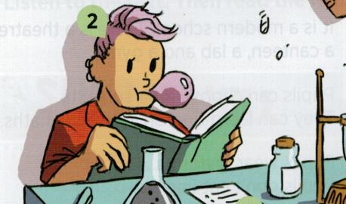

□ yes □ no □ specify

1. **ELT textbooks avoid gender stereotype and portrait life of famous women and men**

□ strongly agree □ agree □ do not know □ disagree □ strongly disagree

1. **ELT textbooks contain information about different gender identities**

□ strongly agree □ agree □ do not know □ disagree □ strongly disagree

1. **Do you think that it is important for ELT textbooks to support gender equality?**

□ strongly agree □ agree □ do not know □ disagree □ strongly disagree

1. **Do you think that gender is an important issue?**

□ strongly agree □ agree □ do not know □ disagree □ strongly disagree

1. **What kind of pictures would you choose into your ELT textbooks? What should they capture?**

Picture 16 - Course book - Bloggers (Klett, 2023)

Picture 17 - Course book - Bloggers (Klett, 2023)

Picture 18 - Course book - Explore Together (AJSHOP, 2023)Picture 19 - Course book - Bloggers (Klett, 2023)

Picture 20 - Course book - Bloggers (Klett, 2023)

Picture 21 - Course book - Bloggers (Klett, 2023)

PictuPicture 22 - Course book - Explore Together (AJSHOP, 2023)

Picture 23 - Course book - Access (Infoa, 2023)Picture 24 - Course book - Explore Together (AJSHOP, 2023)

Picture 25 - Course book - Access (Infoa, 2023)

Picture 26 - Textbook - Project fourth edition - 1 (Sevt, 2023)Picture 27 - Course book - Access (Infoa, 2023)Picture 28 - Course book - Explore Together (AJSHOP, 2023)

Picture 29 - Course book - Access (Infoa, 2023)Picture 30 - Course book - Explore Together (AJSHOP, 2023)re 31 - Course book - Bloggers (Klett, 2023)

Picture 32 - Course book - Explore Together (AJSHOP, 2023)Picture 33 - Course book - Bloggers (Klett, 2023)

Picture 34 - Course book - Bloggers (Klett, 2023)

The questionnaire was translated into English language for this work by the author. Respondents received the questionnaire in Czech language.