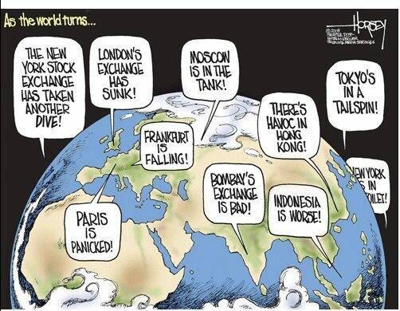

Source: <http://www.conservapedia.com/File:CRASH08.JPG>

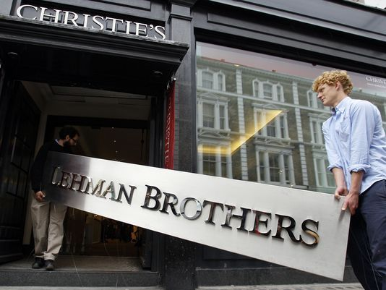

‘’Sept. 15, 2008 -- Lehman Brothers’ bankruptcy escalated the USA’s worst financial crisis since the Great Depression’’

Source: <http://www.usatoday.com/story/money/business/2013/09/08/legacy-2008-financial-crisis-lehman/2723733/>

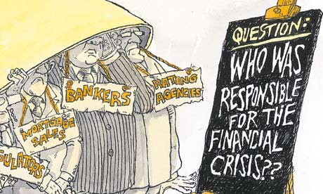

‘’Who was responsible for the financial crisis?’’

Source:<https://livinglogically.me/2016/04/24/us-housing-financial-credit-and-sub-prime-crises-2008/>

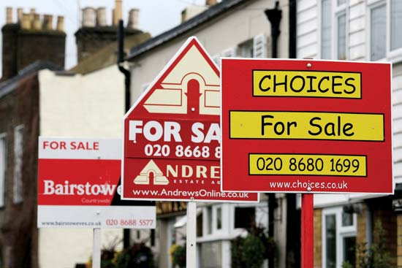

‘’Signs advertising residential property for sale line a street in south London in April 2008’’

Source: <https://www.britannica.com/topic/Financial-Crisis-of-2008-The-1484264>

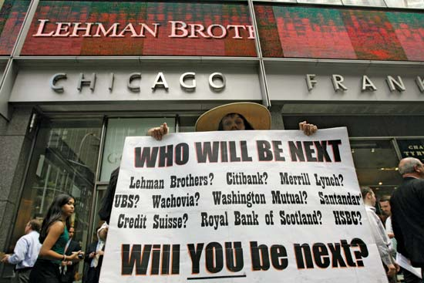

‘’ A demonstrator holds up an ominous placard outside the headquarters of Lehman Brothers in New York’’

Source: <https://www.britannica.com/topic/Financial-Crisis-of-2008-The-1484264>

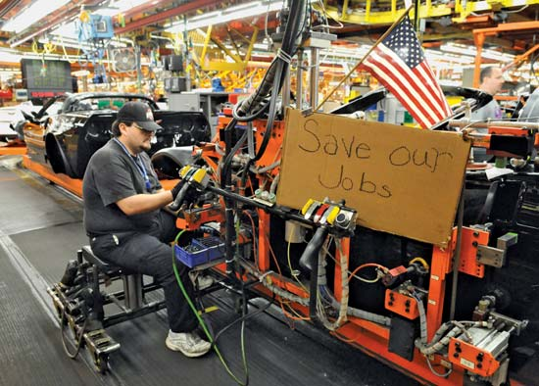

Source: <https://www.britannica.com/topic/Financial-Crisis-of-2008-The-1484264>

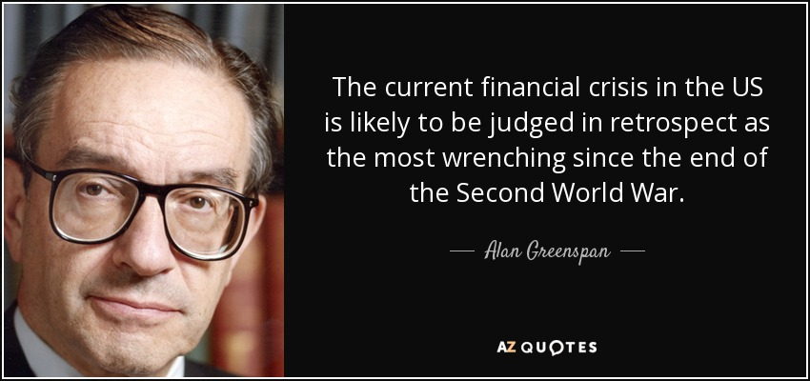

Source: <http://www.azquotes.com/quote/1369534>

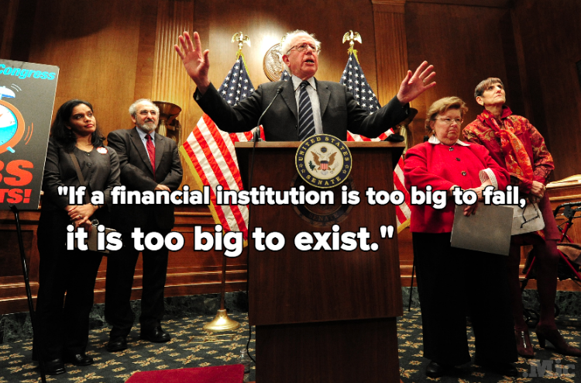

Source: <https://mic.com/articles/117510/11-powerful-quotes-from-bernie-sanders-show-why-he-s-a-progressive-icon#.v8rV4XH9P>

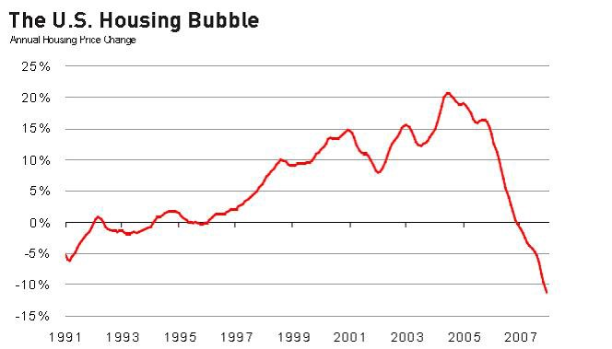

Source: <https://medium.com/@eselskind/the-great-recession-was-an-oil-crisis-4b0aafbd27f4#.c4izc0nq2>

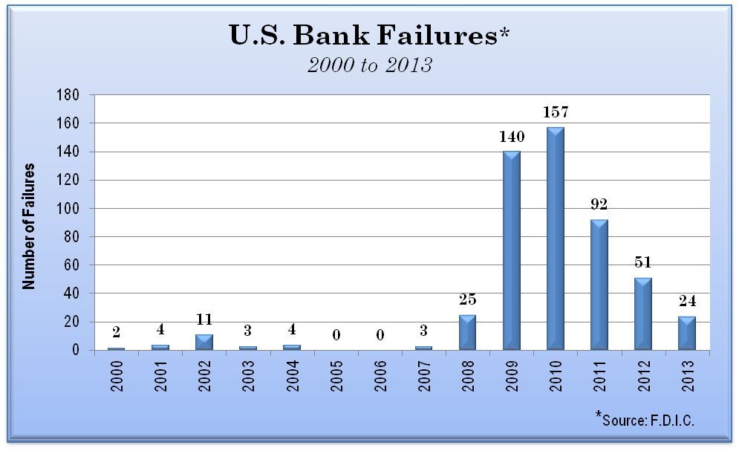

Source: http://keywordsuggest.org/gallery/446865.html