Chart 1. Balance Sheet of AMD Inc. FY2019-2022.

|  |  |  |  |  |
| --- | --- | --- | --- | --- |
|  | **2022** | **2021** | **2020** | **2019** |
| **Assets** |  |  |  |  |
| *Current assets* |  |  |  |  |
| *Cash and short-term investments | 5,855 | 3,608 | 2,29 | 1,507 |
| Cash and cash equivalents | 4,676 | 2,535 | 1,595 | 1,47 |
| Short-term marketable securities | 1,179 | 1,073 | 0,695 | 0,037 |
| Total Accounts Receivable | 4,128 | 2,708 | 2,076 | 1,859 |
| *Inventories | 3,771 | 1,955 | 1,399 | 982 |
| Other current assets | 1,265 | 312 | 378 | 249 |
| *Total current assets | 15,019 | 8,583 | 6,143 | 4,597 |
| *Non-current assets* |  |  |  |  |
| Net Property, Plant & Equipment | 1,973 | 1,069 | 849 | 705 |
| Total Investments and Advances | 83 | 135 | 109 | 88 |
| *Intangible assets | 24,539 | 617 | 518 | 499 |
| Net Goodwill | 24,177 | 289 | 289 | 289 |
| *Other long-term assets | 25,908 | 1,084 | 98 | 117 |
| *Total assets | 67,58 | 12,419 | 8,962 | 6,028 |
|  |  |  |  |  |
| Liabilities and Shareholders’ Equity |  |  |  |  |
| ST Debt & Current Portion LT Debt | - | 383 | 41 | 43 |
| Accounts payable | 2,956 | 1,406 | 546 | 1,201 |
| Other Current Liabilities | 3,413 | 2,451 | 1,83 | 1,115 |
| Total Current Liabilities | 6,369 | 4,24 | 2,417 | 2,359 |
| Long-Term Debt | 2,863 | 349 | 531 | 685 |
| Deferred Taxes | 1,876 | -919 | -1,234 | -11 |
| Other Liabilities | 1,664 | 321 | 166 | 146 |
| Total Liabilities | 12,83 | 4,922 | 3,125 | 3,201 |
| Total Shareholders' Equity | 54,75 | 7,497 | 5,837 | 2,827 |
| Total Equity | 54,75 | 7,497 | 5,837 | 2,827 |
| Liabilities & Shareholders' Equity | 67,58 | 12,419 | 8,962 | 6,028 |

Source: Based on data from annual reports (all numbers are in millions USD)

Chart 2. Balance Sheet of INTEL Company FY2019-2022

|  |  |  |  |  |
| --- | --- | --- | --- | --- |
|  | **2022** | **2021** | **2020** | **2019** |
| **Assets** |  |  |  |  |
| *Current assets* |  |  |  |  |
| *Cash and short-term investments | 28,338 | 28,413 | 23,895 | 13,123 |
| Cash and cash equivalents | 11,144 | 4,827 | 5,865 | 4,194 |
| Short-term marketable securities | 17,194 | 23,586 | 18,03 | 8,929 |
| Total Accounts Receivable | 4,457 | 9,632 | 7,352 | 7,735 |
| *Inventories | 13,224 | 10,776 | 8,427 | 8,744 |
| Other current assets | 4,388 | 8,897 | 7,575 | 1,637 |
| *Total current assets | 50,407 | 57,718 | 47,249 | 31,239 |
| *Non-current assets* |  |  |  |  |
| Net Property, Plant & Equipment | 81,347 | 63,794 | 58,69 | 57,655 |
| Total Investments and Advances | 5,922 | 7,917 | 8,894 | 7,243 |
| *Intangible assets | 33,609 | 34,233 | 35,997 | 37,103 |
| Net Goodwill | 27,591 | 26,963 | 26,971 | 26,276 |
| *Other long-term assets | 5,468 | 3,813 | 872 | 1,521 |
| *Total assets | 182,103 | 168,406 | 153,091 | 136,524 |
|  |  |  |  |  |
| Liabilities and Shareholders’ Equity |  |  |  |  |
| ST Debt & Current Portion LT Debt | 4,54 | 4,771 | 2,677 | 3,868 |
| Accounts payable | 9,595 | 5,747 | 5,581 | 4,128 |
| Other Current Liabilities | 15,769 | 15,844 | 15,74 | 13,739 |
| Total Current Liabilities | 32,155 | 27,462 | 24,754 | 22,31 |
| Long-Term Debt | 37,92 | 33,805 | 34,251 | 25,838 |
| Deferred Taxes | -3,248 | 1,793 | 2,611 | 835 |
| Other Liabilities | 7,891 | 7,442 | 7,154 | 7,198 |
| Total Liabilities | 78,817 | 73,015 | 72,053 | 59,02 |
| Total Shareholders' Equity | 101,423 | 95,391 | 81,038 | 77,504 |
| Total Equity | 103,286 | 95,391 | 81,038 | 77,504 |
| Liabilities & Shareholders' Equity | 182,103 | 168,406 | 153,091 | 136,524 |

Source: Based on data from annual reports (all numbers are in millions USD)

Chart 3. Balance Sheet of NVIDIA Company FY2019-2022

|  |  |  |  |  |
| --- | --- | --- | --- | --- |
|  | **2022** | **2021** | **2020** | **2019** |
| **Assets** |  |  |  |  |
| *Current assets* |  |  |  |  |
| *Cash and short-term investments | 13,296 | 21,208 | 11,561 | 10,897 |
| Cash and cash equivalents | 3,389 | 1,99 | 0,847 | 10,896 |
| Short-term marketable securities | 9,907 | 19,218 | 10,714 | 0,001 |
| Total Accounts Receivable | 3,827 | 4,65 | 2,429 | 1,657 |
| *Inventories | 5,159 | 2,605 | 1,826 | 979 |
| Other current assets | 791 | 366 | 239 | 157 |
| *Total current assets | 23,073 | 28,829 | 16,055 | 13,69 |
| *Non-current assets* |  |  |  |  |
| Net Property, Plant & Equipment | 4,845 | 3,607 | 2,856 | 2,292 |
| Total Investments and Advances | 299 | 266 | - | - |
| *Intangible assets | 6,048 | 6,688 | 6,93 | 667 |
| Net Goodwill | 4,372 | 4,349 | 4,193 | 618 |
| *Other long-term assets | 3,521 | 3,575 | 2,144 | 118 |
| *Total assets | 41,182 | 44,187 | 28,791 | 17,315 |
|  |  |  |  |  |
| Liabilities and Shareholders’ Equity |  |  |  |  |
| ST Debt & Current Portion LT Debt | 1,426 | - | 1,12 | 91 |
| Accounts payable | 1,193 | 1,783 | 1,201 | 687 |
| Other Current Liabilities | 3,477 | 2,552 | 1,543 | 945 |
| Total Current Liabilities | 6,563 | 4,335 | 3,925 | 1,784 |
| Long-Term Debt | 10,605 | 11,687 | 6,598 | 2,552 |
| Deferred Taxes | -3,149 | -977 | -565 | -519 |
| Other Liabilities | 1,666 | 1,308 | 1,101 | 724 |
| Total Liabilities | 19,081 | 17,575 | 11,898 | 5,111 |
| Total Shareholders' Equity | 22,101 | 26,612 | 16,893 | 12,204 |
| Total Equity | 22,101 | 26,612 | 16,893 | 12,204 |
| Liabilities & Shareholders' Equity | 41,182 | 44,187 | 28,791 | 17,315 |

Chart 4. Vertical Common-size Balance Sheet 2022

|  |  |  |  |
| --- | --- | --- | --- |
| **2022** | **AMD** | **INTEL** | **NVIDIA** |
| Current assets |  |  |  |
| Cash and short-term investments | 8.65% | 15.57% | 32.24% |
| Cash and cash equivalents | 6.93% | 6.12% | 8.22% |
| Short-term marketable securities | 1.73% | 9.45% | 24.02% |
| Total Accounts Receivable | 6.10% | 2.45% | 9.28% |
| Inventories | 5.58% | 7.26% | 12.51% |
| Other current assets | 1.87% | 2.41% | 1.91% |
| Total current assets | 22.86% | 42.26% | 88.19% |
| Non-current assets |  |  |  |
| Net Property, Plant & Equipment | 2.92% | 44.67% | 11.74% |
| Total Investments and Advances | 0.12% | 3.25% | 0.72% |
| Intangible assets | 36.27% | 18.44% | 14.67% |
| Net Goodwill | 35.73% | 15.16% | 10.60% |
| Other long-term assets | 38.33% | 3.00% | 8.53% |
| Total assets | 100.00% | 100.00% | 100.00% |
| Liabilities and Shareholders’ Equity |  |  |  |
| ST Debt & Current Portion LT Debt | 0.00% | 2.50% | 3.46% |
| Accounts payable | 2.86% | 5.28% | 2.89% |
| Other Current Liabilities | 5.05% | 8.66% | 8.42% |
| Total Current Liabilities | 9.42% | 17.68% | 15.89% |
| Long-Term Debt | 4.23% | 20.81% | 25.74% |
| Deferred Taxes | 2.78% | -1.78% | -7.64% |
| Other Liabilities | 2.46% | 4.33% | 4.04% |
| Total Liabilities | 19.90% | 41.04% | 37.03% |
| Total Shareholders' Equity | 80.10% | 55.96% | 53.52% |
| Total Equity | 80.10% | 44.04% | 53.52% |
| Liabilities & Shareholders' Equity | 100.00% | 100.00% | 100.00% |

Chart 5. Horizontal Common-size Balance Sheet 2022

|  |  |  |  |  |  |  |  |  |
| --- | --- | --- | --- | --- | --- | --- | --- | --- |
|  | | | AMD | | **INTEL** | | | NVIDIA |
|  | | | 22-21v% | | 22-21v% | | | 22-21v% |
| **Assets** | | |  | |  | | |  |
| *Current assets* | | |  | |  | | |  |
| *Cash and short-term investments | | | 62,28% | | -0,26% | | | -37,31% |
| Cash and cash equivalents | | | 84,46% | | 130,87% | | | 70,30% |
| Short-term marketable securities | | | 9,88% | | -27,10% | | | -48,45% |
| Total Accounts Receivable | | | 52,44% | | -53,73% | | | -17,70% |
| *Inventories | | | 92,89% | | 22,72% | | | 98,04% |
| Other current assets | | | -99,59% | | -50,68% | | | 116,12% |
| *Total current assets | | | 74,99% | | -12,67% | | | -19,97% |
| *Non-current assets* | | |  | |  | | |  |
| Net Property, Plant & Equipment | | | 84,57% | | 27,52% | | | 34,32% |
| Total Investments and Advances | | | -38,52% | | -25,20% | | | 12,41% |
| *Intangible assets | | | -96,02% | | -1,82% | | | -9,57% |
| Net Goodwill | | | -91,63% | | 2,33% | | | 0,53% |
| *Other long-term assets | | | 2290,04% | | 43,40% | | | -1,51% |
| *Total assets | | | 444,17% | | 8,13% | | | -6,80% |
|  | | |  | |  | | |  |
| Liabilities and Shareholders’ Equity | | |  | |  | | |  |
| ST Debt & Current Portion LT Debt | | | - | | -4,84% | | | - |
| Accounts payable | | | 110,24% | | 66,96% | | | -33,09% |
| Other Current Liabilities | | | 39,25% | | -0,47% | | | 36,25% |
| Total Current Liabilities | | | 50,21% | | 17,09% | | | 51,40% |
| Long-Term Debt | | | -99,18% | | 12,17% | | | -9,26% |
| Deferred Taxes | | | -100,20% | | -281,15% | | | -99,68% |
| Other Liabilities | | | -99,48% | | 6,03% | | | 27,37% |
| Total Liabilities | | | 160,67% | | 7,95% | | | 8,57% |
| Total Shareholders' Equity | | | 630,29% | | 6,32% | | | -16,95% |
| Total Equity | | | 630,29% | | 8,28% | | | -16,95% |
| Liabilities & Shareholders' Equity | | | 444,17% | | 8,13% | | | -6,80% |
| AMD | **2022** | **2021** | | **2020** | | **2019** |
| Sales/Revenue | 23,601 | 16,434 | | 9,763 | | 6,731 |
| Cost of Goods Sold (COGS) incl. D&A | 15,098 | 8,505 | | 5,416 | | 3,862 |
| Gross Income | 8,503 | 7,929 | | 4,347 | | 2,869 |
| SG&A Expense | 6,889 | 4,251 | | 2,964 | | 2,28 |
| Unusual Expense | 514 | -7 | | 68 | | 189 |
| Interest Expense | 88 | 34 | | 47 | | 94 |
| Pretax Income | 1,184 | 3,669 | | 1,275 | | 372 |
| Income Tax | -122 | 513 | | -1,21 | | 31 |
| Net Income | 1,32 | 3,162 | | 2,49 | | 341 |
| EPS (Basic) | 0.84 | 2,57 | | 2,06 | | 0.30 |
| Basic Shares Outstanding | 1,561 | 1,213 | | 1,184 | | 1,091 |
| EPS (Diluted) | 0.84 | 2,57 | | 2,06 | | 0.30 |
| Diluted Shares Outstanding | 1,571 | 1,229 | | 1,207 | | 1,12 |
| EBITDA | 5,876 | 4,141 | | 1,737 | | 847 |

Chart 7. Income Statements INTEL 2019-2022

|  |  |  |  |  |
| --- | --- | --- | --- | --- |
| Intel | **2022** | **2021** | **2020** | **2019** |
| Sales/Revenue | 63,054 | 79,024 | 77,867 | 71,965 |
| Cost of Goods Sold (COGS) incl. D&A | 36,373 | 35,418 | 34,46 | 30,025 |
| Gross Income | 26,681 | 43,606 | 43,407 | 41,94 |
| SG&A Expense | 24,345 | 21,733 | 19,736 | 19,512 |
| Unusual Expense | -1,121 | 1,452 | 1,12 | -227 |
| Interest Expense | 496 | 597 | 629 | 489 |
| Pretax Income | 7,768 | 21,703 | 25,078 | 24,058 |
| Income Tax | -249 | 1,835 | 4,179 | 3,01 |
| Net Income | 8,014 | 19,868 | 20,899 | 21,048 |
| EPS (Basic) | 1,94 | 4,86 | 4,94 | 4,71 |
| Basic Shares Outstanding | 4,108 | 4,059 | 4,199 | 4,417 |
| EPS (Diluted) | 1,94 | 4,86 | 4,94 | 4,71 |
| Diluted Shares Outstanding | 4,123 | 4,09 | 4,232 | 4,473 |
| EBITDA | 15,371 | 33,665 | 35,91 | 33,254 |

Chart 8. Income Statements NVIDIA 2019-2022

|  |  |  |  |  |
| --- | --- | --- | --- | --- |
| NVIDIA | **2022** | **2021** | **2020** | **2019** |
| Sales/Revenue | 26,974 | 26,914 | 16,675 | 10,918 |
| Cost of Goods Sold (COGS) incl. D&A | 11,618 | 9,439 | 6,279 | 4,135 |
| Gross Income | 15,356 | 17,475 | 10,396 | 6,783 |
| SG&A Expense | 9,779 | 7,434 | 5,78 | 3,892 |
| Unusual Expense | 1,414 | -100 | 84 | 45 |
| Interest Expense | 262 | 236 | 184 | 52 |
| Pretax Income | 4,181 | 9,941 | 4,409 | 2,97 |
| Income Tax | -187 | 189 | 77 | 174 |
| Net Income | 4,368 | 9,752 | 4,332 | 2,796 |
| EPS (Basic) | 1,74 | 3,85 | 1,72 | 1,13 |
| Basic Shares Outstanding | 2,487 | 2,496 | 2,468 | 2,436 |
| EPS (Diluted) | 1,74 | 3,85 | 1,72 | 1,13 |
| Diluted Shares Outstanding | 2,507 | 2,535 | 2,512 | 2,472 |
| EBITDA | 7,121 | 11,215 | 5,714 | 3,272 |

Chart 9. Vertical Common-size Income Statement Analysis 2022

|  |  |  |  |
| --- | --- | --- | --- |
|  | **AMD** | **Intel** | **NVIDIA** |
| Sales/Revenue | 100.0% | 100.0% | 100.0% |
| Cost of Goods Sold (COGS) incl. D&A | 63.9% | 57.7% | 43.0% |
| Gross Income | 36.1% | 42.3% | 57.0% |
| SG&A Expense | 29.2% | 38.6% | 36.2% |
| Unusual Expense | 2.2% | -1.8% | 5.2% |
| Interest Expense | 0.4% | 0.8% | 1.0% |
| Pretax Income | 5.0% | 12.3% | 15.5% |
| Income Tax | -0.5% | -0.4% | -0.7% |
| Net Income | 5.6% | 12.7% | 16.2% |
| EPS (Basic) | 0.84 | 1.94 | 1.74 |
| Basic Shares Outstanding | 1,561 | 4,108 | 2,487 |
| EPS (Diluted) | 0.84 | 1.94 | 1.74 |
| Diluted Shares Outstanding | 1,571 | 4,123 | 2,507 |
| EBITDA | 24.9% | 24.4% | 26.4% |

Chart 10. 2021- 2022% Change of Income Statement Entries

|  |  |  |  |
| --- | --- | --- | --- |
|  | **AMD** | **Intel** | **NVIDIA** |
| 22/21v% | | |
| Sales/Revenue | 43,61% | -20,21% | 0,22% |
| Cost of Goods Sold (COGS) incl. D&A | 77,52% | 2,70% | 23,09% |
| Gross Income | 7,24% | -38,81% | -12,13% |
| SG&A Expense | 62,06% | 12,02% | 31,54% |
| Unusual Expense | -7442,86% | -177,20% | -101,41% |
| Interest Expense | 158,82% | -16,92% | 11,02% |
| Pretax Income | -67,73% | -64,21% | -57,94% |
| Income Tax | -123,78% | -13669,48% | -198,94% |
| Net Income | -58,25% | -59,66% | -55,21% |
| EPS (Basic) | -67,32% | -60,08% | -54,81% |
| Basic Shares Outstanding | 28,69% | 1,21% | -0,36% |
| EPS (Diluted) | -67,32% | -60,08% | -54,81% |
| Diluted Shares Outstanding | 27,83% | 0,81% | -1,10% |
| EBITDA | 41,90% | -54,34% | -36,50% |

Chart 11. Simplified Cash Flow Statements for AMD Inc.

|  |  |  |  |  |
| --- | --- | --- | --- | --- |
|  | **2022** | **2021** | **2020** | **2019** |
| Operating Activities |  | | | |
| Depreciation, Depletion & Amortization | 4,262 | 463 | 354 | 258 |
| Changes in Working Capital | -1,846 | -774 | -931 | -542 |
| Net Operating Cash Flow | 3,565 | 3,521 | 1,071 | 493 |
| Investing Activities |  |  |  |  |
| Capital Expenditures | -450 | -301 | -294 | -217 |
| Net Assets from Acquisitions | -1,544 | - | - | - |
| Sale of Fixed Assets & Businesses | 2,366 | - | - | - |
| Purchase/Sale of Investments | 1,643 | -378 | -658 | 41 |
| Net Investing Cash Flow | 1,999 | -686 | -952 | -149 |
| Financing Activities |  |  |  |  |
| Cash Dividends Paid - Total | - | - | - | - |
| Change in Capital Stock | -3,535 | -1,895 | 85 | 523 |
| Issuance/Reduction of Debt, Net | 679 | - | - | -473 |
| Net Change in Cash | 2,3 | 940 | 125 | 387 |
| Free Cash Flow | 3,115 | 3,22 | 777 | 276 |
| Net Financing Cash Flow | -3,264 | -1,895 | 6 | 43 |

Chart 11. Simplified Cash Flow Statements for INTEL.

|  |  |  |  |  |
| --- | --- | --- | --- | --- |
|  | **2022** | **2021** | **2020** | **2019** |
| Operating Activities |  | | | |
| Depreciation, Depletion & Amortization | 13,035 | 11,792 | 12,239 | 10,826 |
| Changes in Working Capital | -4,508 | -4,873 | 2,179 | 1,148 |
| Net Operating Cash Flow | 15,433 | 29,991 | 35,384 | 33,145 |
| Investing Activities |  |  |  |  |
| Capital Expenditures | -25,05 | -20,329 | -14,259 | -16,213 |
| Net Assets from Acquisitions | - | -209 | -837 | -1,958 |
| Sale of Fixed Assets & Businesses | 6,579 | - | 317 | 911 |
| Purchase/Sale of Investments | 9,534 | -5,287 | -7,801 | 2,14 |
| Net Investing Cash Flow | -10,477 | -25,167 | -20,796 | -14,405 |
| Financing Activities |  |  |  |  |
| Cash Dividends Paid - Total | -5,997 | -5,644 | -5,568 | -5,576 |
| Change in Capital Stock | 2,009 | -1,395 | -13,332 | -12,826 |
| Issuance/Reduction of Debt, Net | 5,164 | 2,474 | 5,722 | 765 |
| Net Change in Cash | 6,317 | -1,038 | 1,671 | 1,175 |
| Free Cash Flow | -9,617 | 9,662 | 21,125 | 16,932 |
| Net Financing Cash Flow | 1,361 | -5,862 | -12,917 | -17,565 |

Chart 12. Simplified Cash Flow Statements for NVIDIA.

|  |  |  |  |  |
| --- | --- | --- | --- | --- |
|  | **2022** | **2021** | **2020** | **2019** |
| Operating Activities |  | | | |
| Depreciation, Depletion & Amortization | 1,544 | 1,174 | 1,098 | 381 |
| Changes in Working Capital | -2,207 | -3,363 | -703 | 717 |
| Net Operating Cash Flow | 5,641 | 9,108 | 5,822 | 4,761 |
| Investing Activities |  |  |  |  |
| Capital Expenditures | -1,833 | -976 | -1,128 | -489 |
| Net Assets from Acquisitions | -49 | -263 | -8,524 | - |
| Sale of Fixed Assets & Businesses | - | - | - | - |
| Purchase/Sale of Investments | 9,334 | -8,567 | -9,989 | 6,634 |
| Net Investing Cash Flow | 7,375 | -9,83 | -19,675 | 6,145 |
| Financing Activities |  |  |  |  |
| Cash Dividends Paid - Total | -398 | -399 | -395 | -390 |
| Change in Capital Stock | -9,684 | 281 | 194 | 149 |
| Issuance/Reduction of Debt, Net | - | 3,977 | 4,968 | - |
| Net Change in Cash | 1,399 | 1,143 | -10,049 | 10,114 |
| Free Cash Flow | 3,808 | 8,132 | 4,694 | 4,272 |
| Net Financing Cash Flow | -11,617 | 1,865 | 3,804 | -792 |

Chart 13. Vertical Common-Size Cash Flow Statements 2022

|  |  |  |  |
| --- | --- | --- | --- |
|  | **AMD** | **INTEL** | **NVIDIA** |
| **Operating Activities** |  | | |
| Depreciation, Depletion & Amortization | 23.0% | 52.9% | 7.6% |
| Changes in Working Capital | -9.9% | -29.2% | -18.6% |
| Net Operating Cash Flow | 13.1% | 71.2% | 32.3% |
| **Investing Activities** |  | | |
| Capital Expenditures | -1.4% | -161.4% | -32.5% |
| Net Assets from Acquisitions | -4.9% | - | -0.7% |
| Sale of Fixed Assets & Businesses | 7.4% | 42.6% | - |
| Purchase/Sale of Investments | 5.1% | 61.9% | 165.5% |
| Net Investing Cash Flow | 3.8% | -67.8% | 131.3% |
| **Financing Activities** |  | | |
| Cash Dividends Paid - Total | - | -38.8% | -3.4% |
| Change in Capital Stock | -18.9% | 13.0% | -137.1% |
| Issuance/Reduction of Debt, Net | 4.6% | 33.4% | - |
| Net Change in Cash | 2.2% | 14.7% | 3.3% |
| Free Cash Flow | 3.0% | -62.3% | 67.5% |
| Net Financing Cash Flow | -3.2% | 8.8% | -205.8% |

Chart 14. Revenues Structure for AMD

|  |  |  |  |  |  |
| --- | --- | --- | --- | --- | --- |
| Operating segment revenue: | 2021-2022v% | 2022 % of revenues | 2022 | 2021 % of revenues | 2021 |
| Data Center revenue | 63,59% | 25,60% | 6,043 | 22,48% | 3,694 |
| Client revenue | -9,96% | 26,27% | 6,201 | 41,91% | 6,887 |
| Gaming revenue | 21,37% | 28,83% | 6,805 | 34,12% | 5,607 |
| Embedded revenue | 1750,41% | 19,29% | 4,552 | 1,50% | 0,246 |
| Total revenue | 43,61% | 100,00% | 23,601 | 100,00% | 16,434 |

Chart 15. Revenues Forecast for AMD

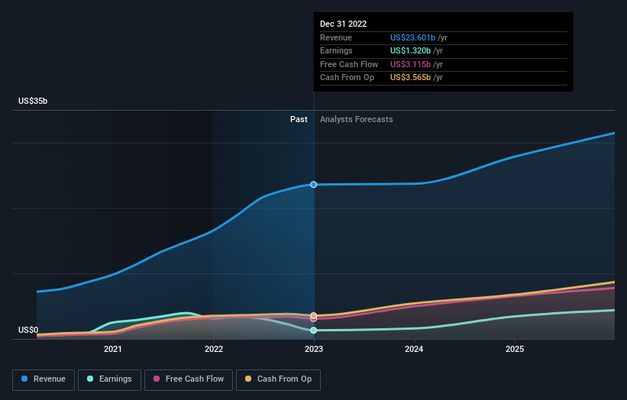

Chart 16. Revenues Structure for INTEL

|  |  |  |  |  |  |
| --- | --- | --- | --- | --- | --- |
| Operating segment revenue: | 2021-22v% | 2022% | 2022 | 2021% | 2021 |
| Desktop | -14,28% | 16,77% | 10,661 | 15,60% | 12,437 |
| Notebook | -26,18% | 29,55% | 18,783 | 31,92% | 25,443 |
| Other | -28,96% | 3,56% | 2,264 | 4,00% | 3,187 |
| Total client computing revenue | -22,79% | 49,88% | 31,708 | 51,53% | 41,067 |
| Data Center and AI | -15,40% | 30,19% | 19,196 | 28,47% | 22,691 |
| Network and Edge | 11,25% | 13,96% | 8,873 | 10,01% | 7,976 |
| Mobileye | 34,85% | 2,94% | 1,869 | 1,74% | 1,386 |
| Accelerated Computing Systems and Graphics | 8,14% | 1,32% | 0,837 | 0,97% | 0,774 |
| Intel Foundry Services | 13,87% | 1,41% | 0,895 | 0,99% | 0,786 |
| All other | -96,09% | 0,31% | 0,196 | 6,30% | 5,019 |
| Total operating segment revenue | -20,23% | 100,00% | 63,574 | 100,00% | 79,699 |

Chart 17. Revenues Forecast for INTEL

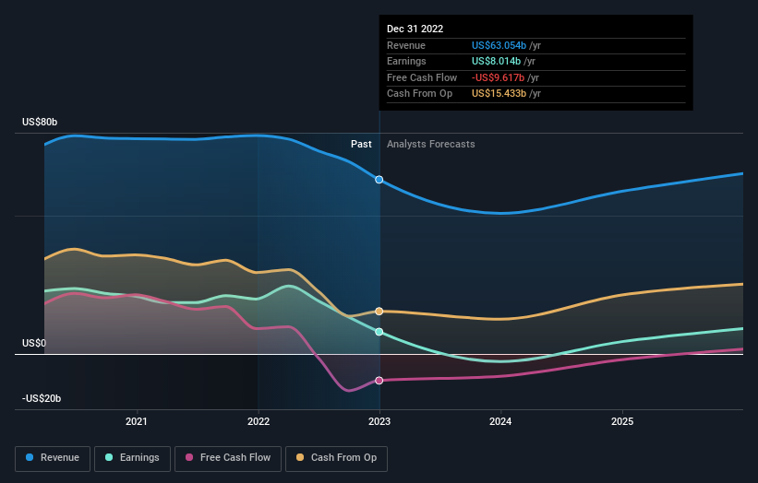

<https://simplywall.st/stocks/us/semiconductors/nasdaq-nvda/nvidia/future>

Chart 18. Revenues Structure for NVIDIA

|  |  |  |  |  |  |
| --- | --- | --- | --- | --- | --- |
| Operating segment revenue: | 2021-22v% | 2022% | 2022 | 2021% | 2021 |
| **Graphics** | -5,22% | 55,42% | $ 15,04 | 58,96% | $ 15,87 |
| **Compute and networking** | 9,54% | 44,58% | $ 12,10 | 41,04% | $ 11,05 |
| **Total** | 0,84% | 100,00% | $ 27,14 | 100,00% | $ 26,91 |

Chart 19. Revenues Forecast for NVIDIA

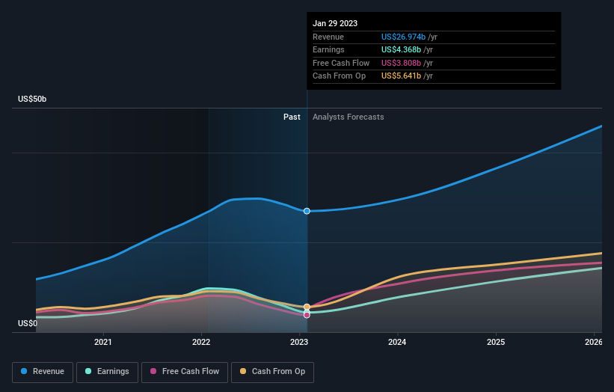

Chart 33. Liquidity Ratios

|  |  |  |  |
| --- | --- | --- | --- |
|  | AMD | Intel | NVIDIA |
| Current ratio | 2,36 | 1,57 | 3,52 |
| Quick ratio | 1,77 | 1,16 | 2,73 |
| Cash ratio | 1,05 | 0.346 | 2,03 |
| Defensive interval ratio | 298.03 | 84.11 | 51.93 |

Chart 34. Solvency Ratios

|  |  |  |  |
| --- | --- | --- | --- |
|  | AMD | Intel | NVIDIA |
| Debt-to-assets | 0.195 | 0.255 | 0.194 |
| Debt-to-capital | 0.242 | 0.324 | 0.279 |
| Debt-to-equity | 0.23 | 0.76 | 0.44 |
| Financial leverage | 1,2 | 1,8 | 1,9 |

Chart 35. Profitability Ratios

|  |  |  |  |
| --- | --- | --- | --- |
|  | AMD | Intel | NVIDIA |
| Return on Sales |  |  |  |
| Gross profit margin | 43% | 42.6% | **63.34%** |
| Operating profit margin | **19.84%** | **12.04%** | **23.09%** |
| Pre-tax margin | 5.02% | 12.32% | 15.50% |
| Net profit margin | *5.59*% | 12.71% | *16.19*% |
| Return on Investment |  |  |  |
| Operating ROA | 18.7% | 12.79% | 10.25% |
| ROA | 1.96% | 4.56% | 10.26% |
| ROIC | **3.4%** | -1.62% | **26.35%** |
| ROE | 2.40% | 7.87% | 18.66% |

tool for investors.

Chart 36. Valuation Ratios

|  |  |  |  |
| --- | --- | --- | --- |
|  | AMD | Intel | NVIDIA |
| Price to earnings ratio | 31.42 | 16.57 | 154.59 |
| Price to cash flow ratio | 48.93 | 8,6 | 119.71 |
| Price to sales ratio | 6,79 | 2,06 | 25,03 |
| Price to book value ratio | 2,78 | 1,17 | 30.55 |

Rates of Return and supporting data

|  |  |  |  |
| --- | --- | --- | --- |
|  | AMD | Intel | NVIDIA |
| Beta(1-Year) | 1,58 | 0,9 | 1,68 |
| RRR | - | 2.60% | 32.34% |
| ERR1 | - | 4.2% | 25.93% |
| ERR2 | - | 69.41% | 22.86% |
| Km= | 10,24 |  |  |
| Krf= | **0,049** |  |  |