**Appendices**

**List of the Appendices:**

1. Schedule of Master Thesis ………………………………………………II
2. Daily readings of pH, ORP and Biogas Production from the

Sugarcane bagasse and cow manure batch assay……………………..……..III

1. Daily readings of pH, ORP and Biogas Production from the

Sugarcane bagasse and cow manure batch assay…………………….……..IV

1. Means Plot of the two batch tests…………………………………………..IV
2. Taking samples for pH and ORP test……………………………..……….V
3. A picture with some of the farmers in the study area………………….…..VI
4. A picture with the head of farmers in study area on his Sugarcane farm......VII

**Appendix 1: Schedule of Master Thesis**

|  |  |
| --- | --- |
| Activity | Time Frame |
| Writing and Approval of Proposal |  |
| Further Literature Review |  |
| Design of Methodology and Approval | 1 week |
| Questionnaire Design and Approval | 2 weeks |
| Data Collection and Collation | August 1st – December 3rd |
| Data entry and Analysis | December 19th – January 30th |
| Interpretation of Results | February 3rd – March 20th |
| Conclusion and Recommendation | April 11th – 18th |
| Review of Thesis | April |
| Final Submission | April |

**Appendix 2: Daily readings of pH, ORP and Biogas Production from the Sugarcane bagasse and cow manure batch assay.**

|  |  |  |  |  |
| --- | --- | --- | --- | --- |
| **Day** | **Date / time** | **ph** | **ORP [mV]** | **Gas volume [ml]** |
| 0 | 3/25/23 17:00 | 7.61 | -339.4 | 0 |
| 2 | 3/27/23 17:00 | 7.09 | -344.1 | 495 |
| 4 | 3/29/23 17:00 | 7.4 | -378.5 | 505 |
| 6 | 3/31/23 17:00 | 7.48 | -381.6 | 1025 |
| 8 | 4/2/23 17:00 | 7.56 | -377.8 | 1335 |
| 10 | 4/4/23 17:00 | 7.79 | -379.8 | 325 |
| 12 | 4/6/23 17:00 | 7.6 | -344.6 | 935 |
| 14 | 4/8/23 17:00 | 7.65 | -325.7 | 600 |
| 16 | 4/10/23 17:00 | 7.74 | -332 | 650 |
| 18 | 4/12/23 17:00 | 7.35 | -341.5 | 255 |
| 20 | 4/14/23 17:00 | 7.32 | -335.6 | 125 |
| 22 | 4/16/23 17:00 | 7.16 | -332.4 | 75 |
| 24 | 4/18/23 17:00 | 6.98 | -328.8 | 35 |

**Appendix 3: Daily readings of pH, ORP and Biogas Production from the Sugarcane bagasse batch assay.**

|  |  |  |  |  |
| --- | --- | --- | --- | --- |
| **Day** | **Date / time** | **Ph** | **ORP [mV]** | **Gas volume [ml]** |
| 0 | 3/25/23 17:00 | 7.61 | -324.8 | 0 |
| 2 | 3/27/23 17:00 | 7.25 | -408.2 | 935 |
| 4 | 3/29/23 17:00 | 7.43 | -364.8 | 765 |
| 6 | 3/31/23 17:00 | 7.56 | -375 | 652 |
| 8 | 4/2/23 17:00 | 7.6 | -412.2 | 870 |
| 10 | 4/4/23 17:00 | 7.59 | -458 | 210 |
| 12 | 4/6/23 17:00 | 7.55 | -360.8 | 1130 |
| 14 | 4/8/23 17:00 | 7.59 | -351.3 | 810 |
| 16 | 4/10/23 17:00 | 7.53 | -351.3 | 550 |
| 18 | 4/12/23 17:00 | 7.44 | -340 | 235 |
| 20 | 4/14/23 17:00 | 7.45 | -332 | 110 |
| 22 | 4/16/23 17:00 | 7.36 | -366.1 | 60 |
| 24 | 4/18/23 17:00 | 7.37 | -353.6 | 25 |

**Appendix 4: Means Plot of the two batch tests.**

**Appendix 5: Taking samples for pH and ORP test.**

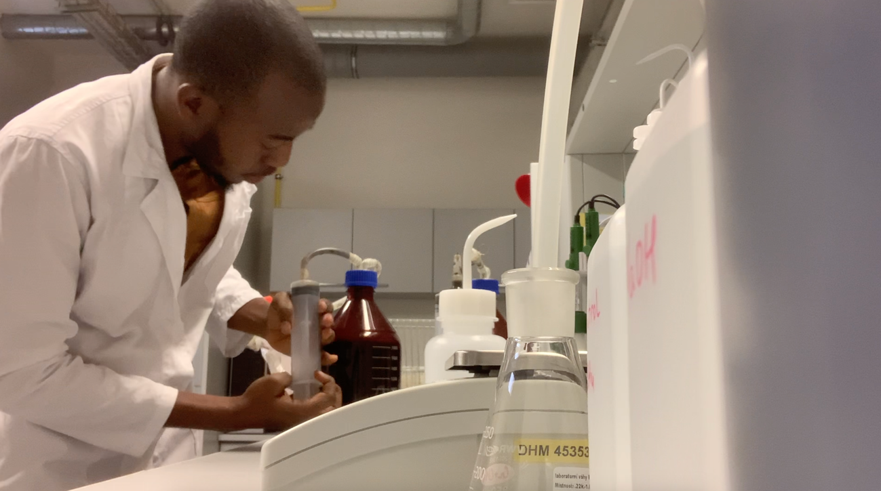

**Appendix 6: A picture with some of the farmers in the study area**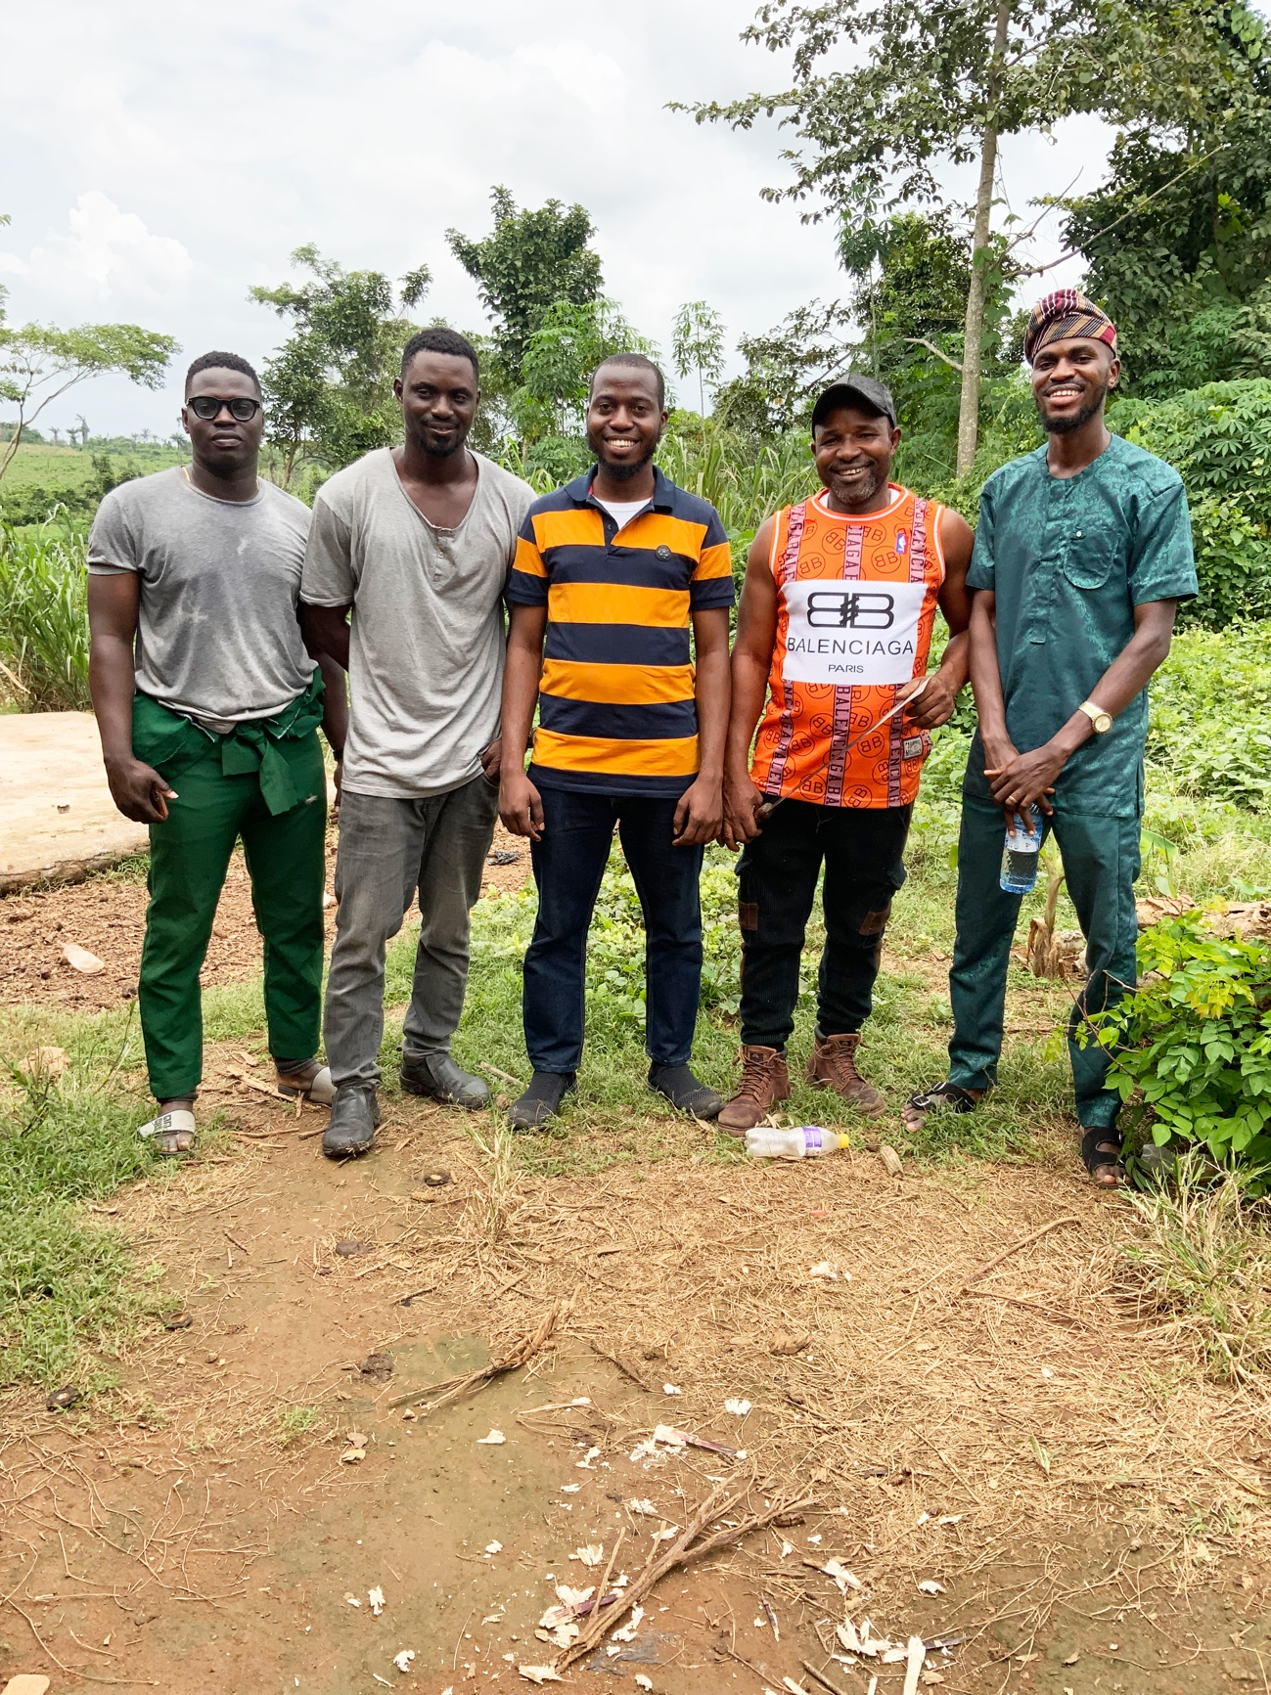

**Appendix 7: A picture with the head of farmers in study area on his sugarcane farm.**