**Czech University of Life Science Prague**

**Faculty Economics and Management**

**Department of Agriculture**



**Diploma Thesis**

**Appendices**

**Evaluation of Marketing Communication in Sport Industry on example of FC “Zenit Saint-Petersburg”.**

**Bc. Uladzimir Ananich**

© 2017 CULS Prague

# Appendices

*Figure 2: Peterborough Utd. Season ticket.*

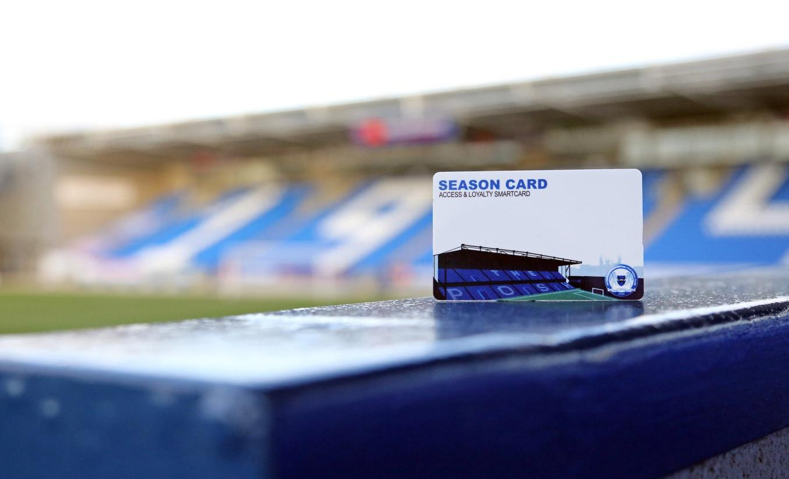

*Source: Peterborough Utd. official web-page.*

*Figure 3.*

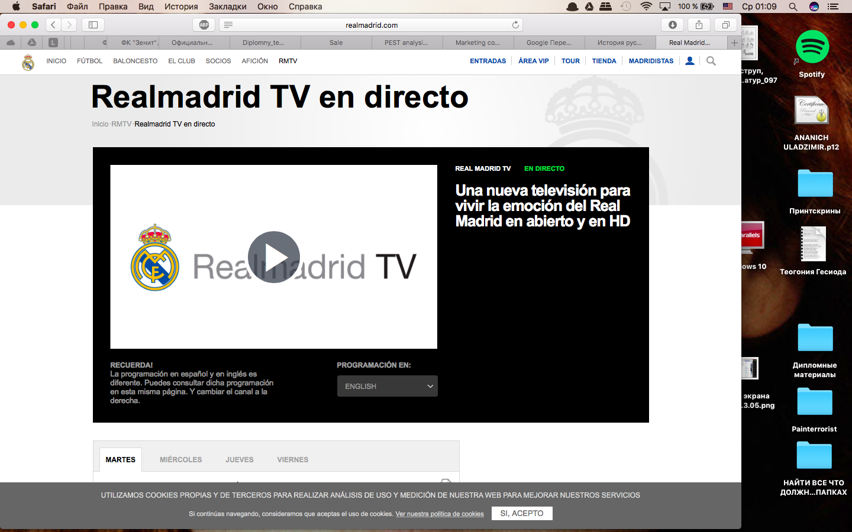

*Source:*<http://www.realmadrid.com/real-madrid-tv>

*Figure 7.* Supporters.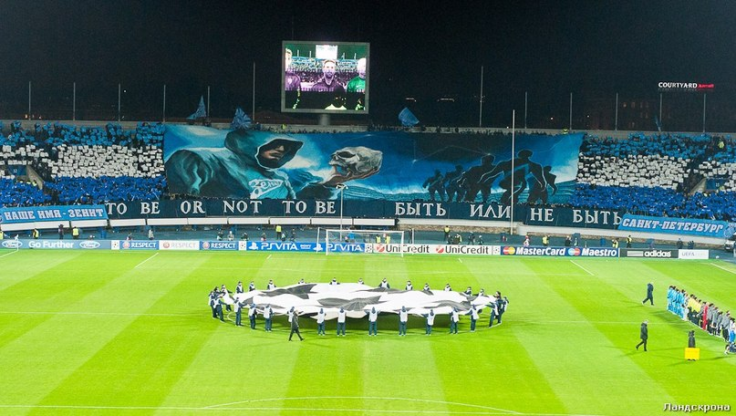

*Source:* <https://www.sports.ru/tribuna/blogs/loftyvillage/754522.html>

*Figure 11.* “Nash Zenit” magazine.

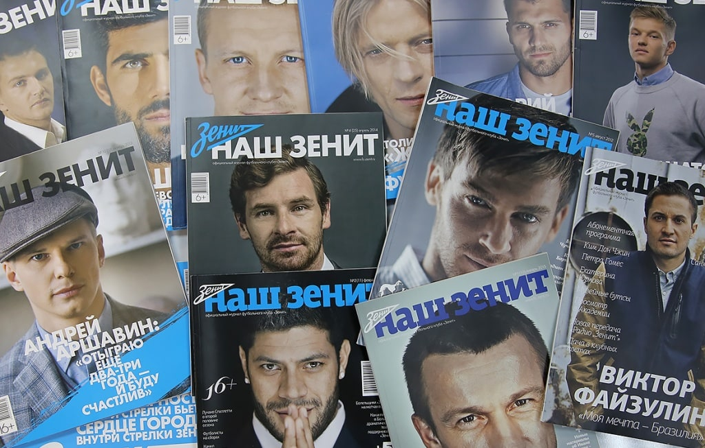

*Source:*<http://fc-zenit.ru>

*Figure 12.* Online museum.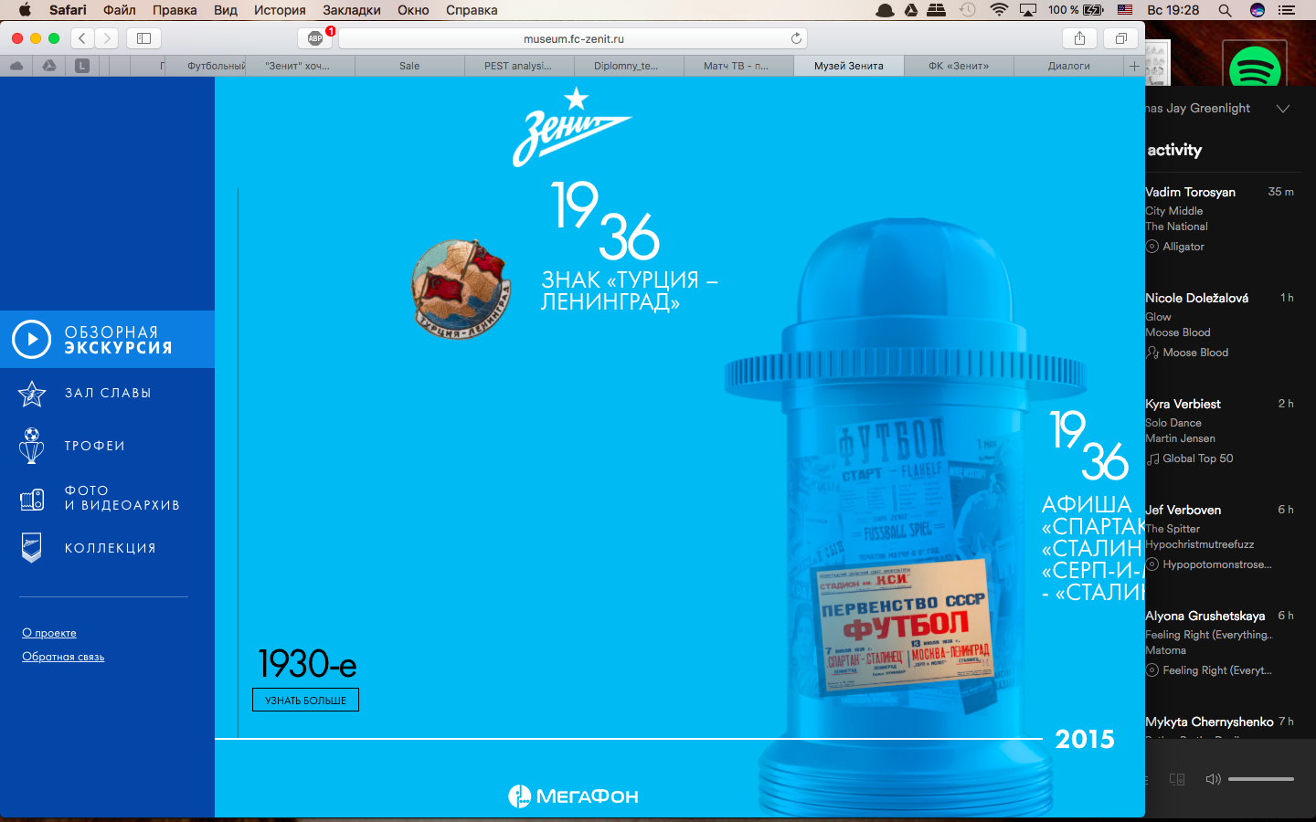

*Source:* <http://museum.fc-zenit.ru>

*Figure 13. EA Sports FIFA special face-modelling technology application.*

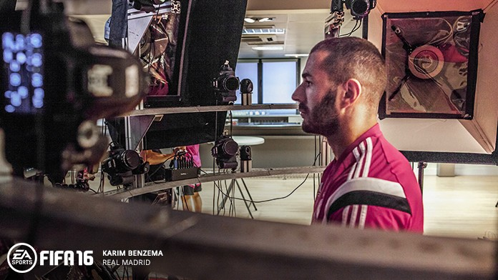

*Source:* <https://www.easports.com/uk/fifa/real-madrid>

*Figure 16. “Zenit” online shop.*

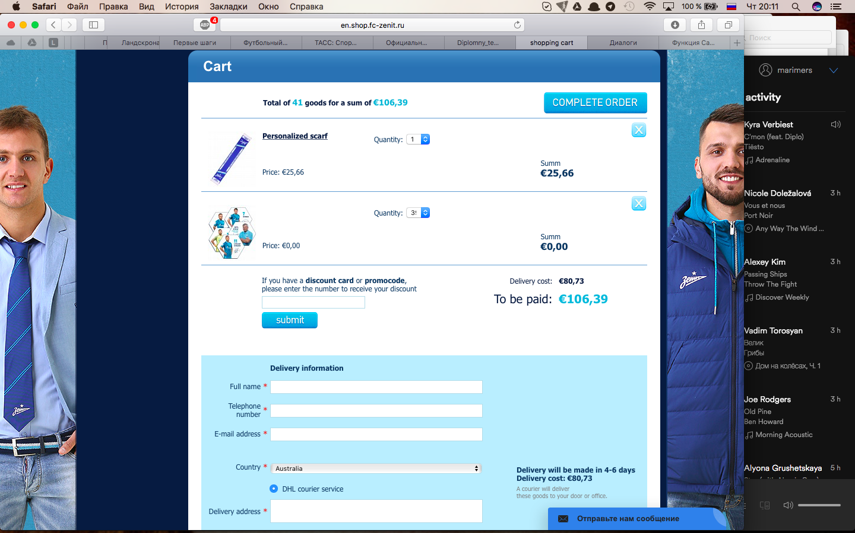

*Source:*<http://en.shop.fc-zenit.ru/>

*Figure 17. Sony PS4 console, “Zenit” special edition.*

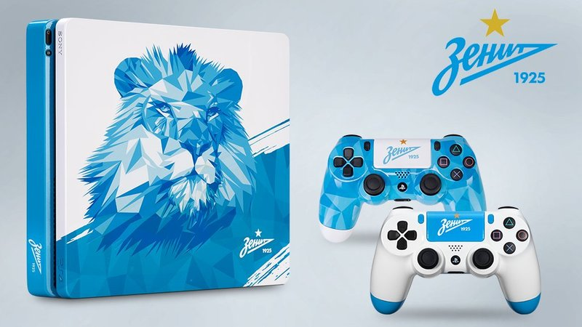

*Source:*<https://geek-tv.ru/games/20170310/sony_vipustila_ps4_v_cvetah_zenit_csk_spartak>

*Figure 18. “Davai Davai!” project 1.*



*Source:*<http://fc-zenit.ru/club/inits/davai/>

*Figure 21. BC “Zenit”.*

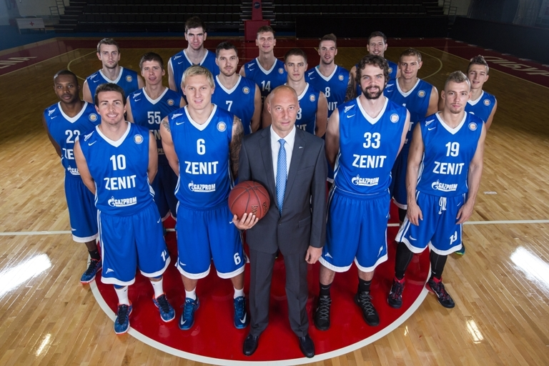

*Source:*<http://ianews.ru/articles/68615/>

*Figure 24.*

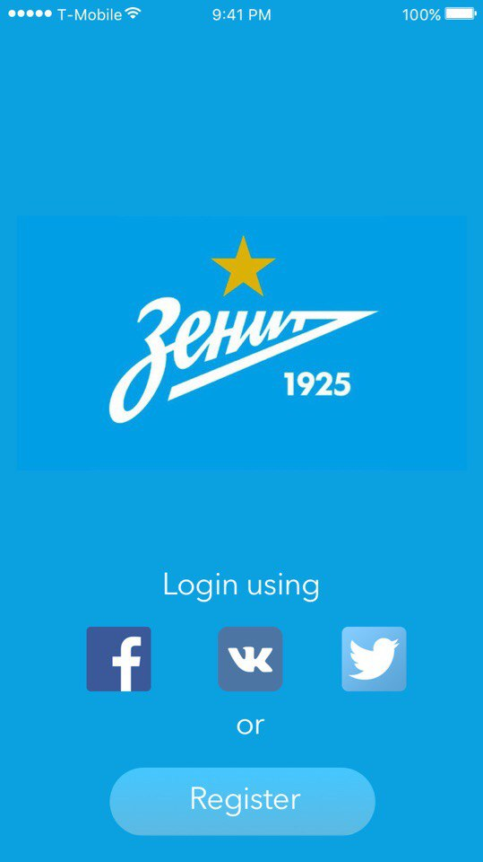

*Figure 25.*



*Figure 26.*

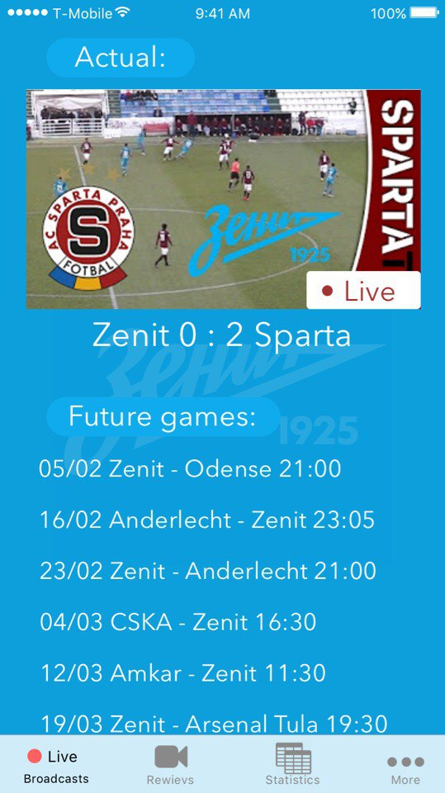

*Figure 27.*

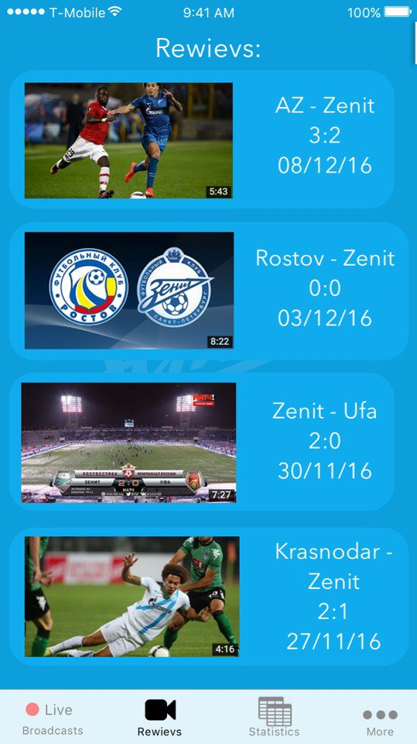

*Figure 28.*

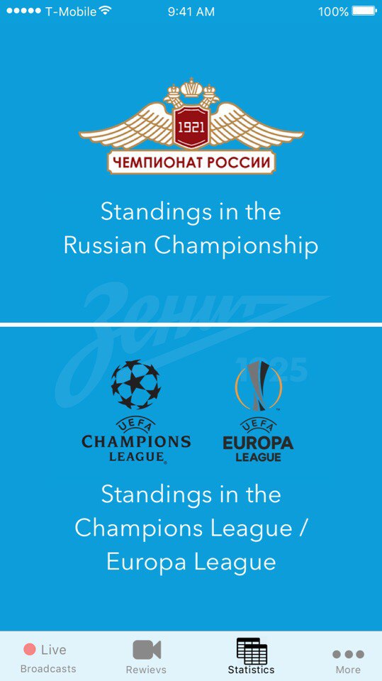

*Figure 29*.

