***Czech University of Life Sciences Prague***

**Faculty of Economics and Management**

**Department of Information Technologies**



DIPLOMA THESIS

Abstract

**Analysis and Design of an Application based on**

**Open Data**

**Author: Dehbi Sahbi**

**Supervisor:** [**Ing. Miloš Ulman, Ph.D.**](https://is.czu.cz/auth/lide/clovek.pl?id=71882)

**© CULS 2015 Prague**

# *Summary*

The goal of this research is to present a study of mobile applications and technical development tools and to build a real application based on process using technology and corresponding tools. For this purpose, this research mainly focused on using visual studio, connect databases to our application and creating page which will be used to display the search results after sorting this database.

This is an application focused on locating “Farmer Markets” in USA based on open data. In this research, www.data.gov has been chosen as the main source.

The implementation of this application was connected to our data using SQL server database.

**Keywords:** Mobiles, IOS, Android, Open data, database, visual studio, ASP.NET, SQL, UML, class diagram.

# *Introduction and Methodology*

Over the years mobile has evolved from an over driven toy to hyper operative tool. Mobile devices have now become the focal point in IT business. Technology is advancing day by day and people are more inclined towards smart phones, tablets or any other mobile devices (1).

Many cell phones today have the capability of performing many tasks that your computer can. You can access the Internet, write emails and send documents from wherever you might find yourself. This, in turn, allows you to be on top of time-sensitive issues (2).

With the widespread use of mobile phones to touch screens as well as large software development and networks, mobile applications are capable of satisfy a wide range of needs, not to mention a technological development continuously making it an even more essential tool.

Despite the increase in the power of these devices, their capacity is limited face how laptops and PCs. We must therefore take into account these limitations depending on their size (screen) of the processing power and the ability to memorization. Technologically there are several aspects that vary function scales and equipment versions:

* Interfaces are multiple connectivity: Bluetooth, WI-Fi, GSM,
* Development platforms are heterogeneous: Apple, J2ME, Android, Symbian and windows phone.

The goal of this thesis is to present a study of mobile applications, technical and development tools and to build a real web application based on process using technology and corresponding tools.

This is an application that allows us to locate “Farmer Markets” in USA based on open data

The aim of the thesis is to analyze and design web application for mobile devices for farmers’ markets. The thesis describes technical aspects of the solution, development tools and methods in order to build a real application based on open data. The thesis also presents evaluation of the application and proposes its economic sustainability.

For the thesis purpose, we have chosen Farmers’ Markets web application for mobile devices to implement it as an example. It is a kind of application where users can get to know location, address and all details about farmer markets in USA. ASP.NET is a good choice for design this application, because is the most useful code for creating mobile applications. The code is generally a part of a web site.

During doing this thesis and development of the application, we have tried to follow agile methodology principles which focuses on keeping code simple, testing often, and delivering functional bits of the application as soon as they're ready. For build upon small client-approved parts as the project progresses, as opposed to delivering one large application at the end of the project and also we have used the following methods:

UML Class diagram is used for modeling of the application. It helped us to overview object classes. SQL server is used for accessing database and managing it. Software engineering techniques of software quality and complexity estimation are used for evaluation of database performance and workload of developers.

Especially when users of this application come from different societies or areas in the same country, SWOT analysis can reveal hidden obstacles to develop this application. In the same way, SWOT can identify positive elements that may not be readily evident.

# *Practical and results*

In this phase will present the final part of this thesis and how does Application work?

There are two main tasks: the programming search part where user uses direct application; and programming result part when application connects the server for data access.

First, we start with the presentation of the software environment and technology unused.

Our application can be specified by the following diagram

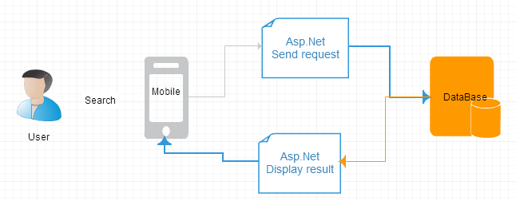

Figure : General System Architecture

**Source: Author**

**Search Part:**

The first page will be used for entering data (city) the search box and making a database search. We will name it as search

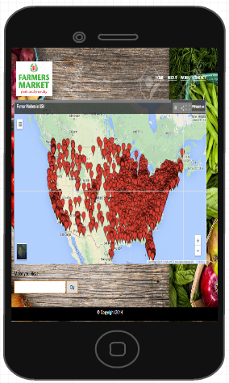

Figure : default model

**Source: Author**

**Result Part:**

The second webpage which will be used to display the search results after connecting the database. Hence we will name the web page as results

|  |  |  |  |  |  |  |  |  |  |
| --- | --- | --- | --- | --- | --- | --- | --- | --- | --- |
| **FMID** | **ID** | **Market**  **Name** | **Other**  **Media** | **street** | **city** | **County** | **State** | **zip** | **Season1Date** |
| 1000263 | 1671 | Crescent City Farmers Market |  | 200 Broadway | New Orleans | Orleans | Louisiana | 70118 | 01/01/2014 to 12/31/2014 |
| 1000264 | 1672 | Crescent City Farmers Market |  | 3700 Orleans Ave | New Orleans | Orleans | Louisiana | 70119 | 01/01/2014 to 12/31/2014 |
| 1000265 | 1673 | Crescent City Farmers Market | nstagram: @crescentcityfarmersmkt | 700 Magazine Street | New Orleans | Orleans | Louisiana | 70130 | 01/01/2013 to 12/31/2013 |
| 1000266 | 1674 | Marketplace at Armstrong Park | Rampart St. and Basin St. | New Orleans | Orleans | Louisiana | 70116 |  | Rampart St. and Basin St. |
| 1000267 | 1675 | Michoud Farmers Market – Summer |  | 13800 Old Gentilly Road | New Orleans | Orleans | Louisiana | 70129 | 08/06/2014 to 08/05/2015 |
| 1000268 | 1676 | Michoud Farmers Market – Summer |  | 3800 Old Gentilly Rd | New Orleans | Orleans | Louisiana | 70129 | 03/19/2014 to 12/17/2014 |

Table : result example “New Orleans City farmer market”

**Source: Author**

# *References*

*.NET Compact Framework Architecture*. (n.d.). Retrieved from https://msdn.microsoft.com: https://msdn.microsoft.com/en-us/library/9s7k7ce5(v=vs.90).aspx

Aaron, S. (2014, November 13). *marketing land*. Retrieved December 2014, from http://marketingland.com: http://marketingland.com/killer-app-just-kill-app-106224

Admin. (2015, April 14). *Best Apps for Android Phones*. Retrieved from http://computersandphotography.com: http://computersandphotography.com/best-apps-for-android-phones-2/

Ali, S. N. (2013, October 8). *Types of Apps - Develop Application for Buisiness*. Retrieved from http://www.socialhunt.net: http://www.socialhunt.net/blog/types-of-mobile-app/

*ASP.NET Overview*. (n.d.). Retrieved from https://microsoft.com: https://msdn.microsoft.com/en-us/library/4w3ex9c2.aspx

Beal, V. (2015). *Apple iOS*. Retrieved from http://www.webopedia.com: http://www.webopedia.com/TERM/A/apple_ios.html

Bednar, P. (2011). Knowledge Management: an Open Systems Approach. *Proceedings of 8th Conference of the Italian Chapter of AIS.* Rome, Italy: ItAIS 2011.

Booch, G. ( 2005). *Unified Modeling Language User Guide.* Addison-Wesley Professional.

Budiu, R. (2013, September 14). *Mobile: Native Apps, Web Apps, and Hybrid Apps*. Retrieved from http://www.nngroup.com: http://www.nngroup.com/articles/mobile-native-apps/

Cassavoy, L. (n.d.). *What is Google Android?* Retrieved from http://cellphones.com: http://cellphones.about.com/od/glossary/g/define_android.htm

David, M. (2015, September). *Visual Studio IDE offers many advantages for developers*. Retrieved from http://www.techtarget.com: <http://searchsoftwarequality.techtarget.com/feature/Visual-Studio-IDE-offers-many-advantages-for-developers>

Figures

Figure 1: General System Architecture 5

Figure 2: default model 6

Table 1: result example “New Orleans City farmer market” 6