Appendices

- Top 20 China's export industries 2009-2019
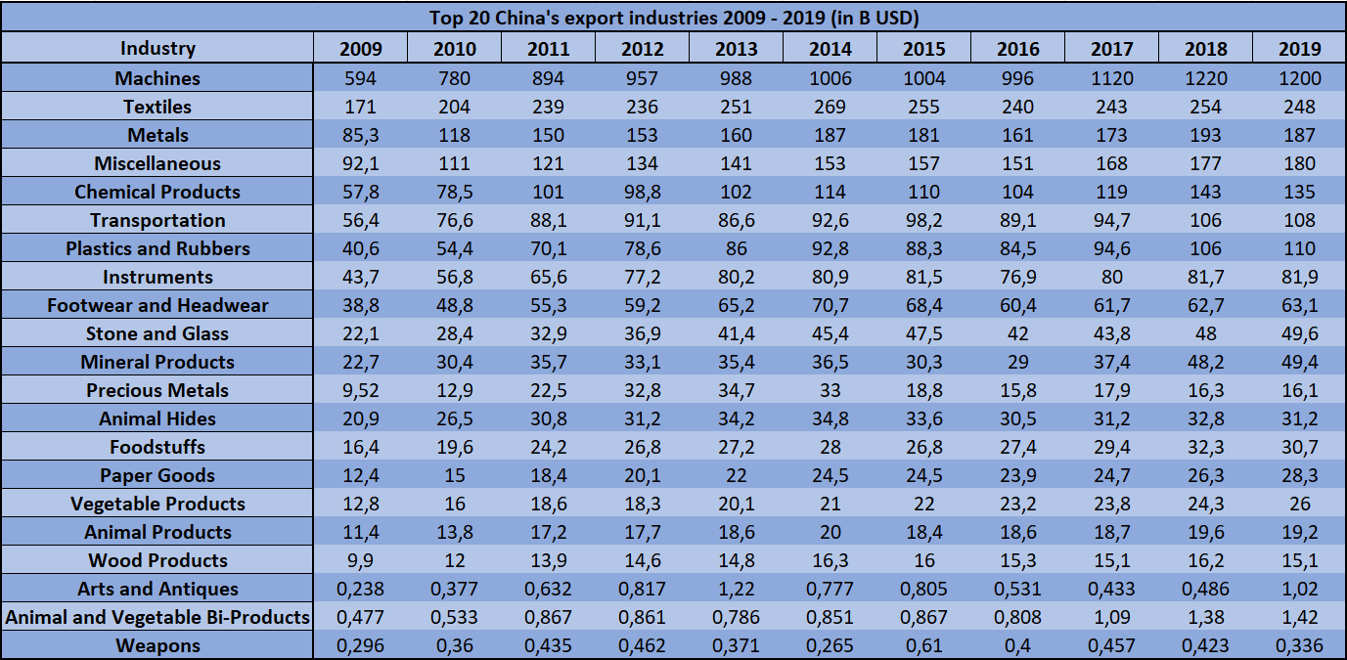

- Top 20 China's export industries 2009-2019
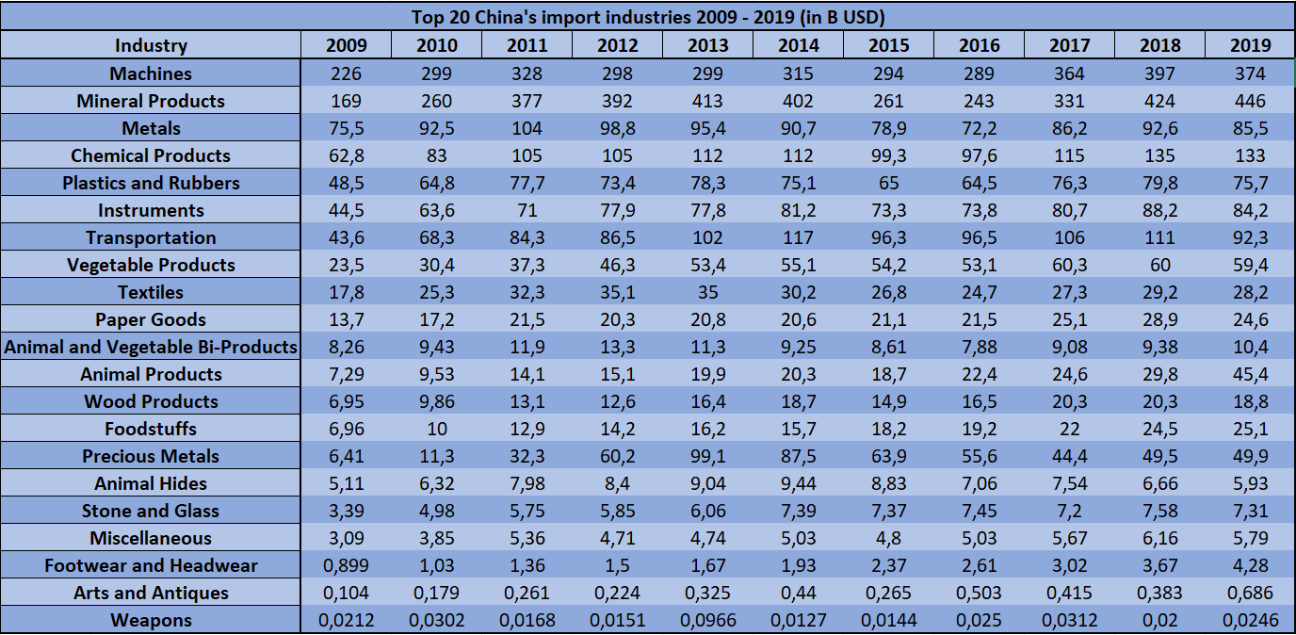

- China’s leading export partners in 2021 in Billion Yuan

