Palacký University Olomouc
Faculty of Science
Department of Geology



Curing Lost Circulation in KRG Wells

Bachelor thesis

Zana Azez Abdullah

Petroleum Engineering (B0724A330002)
Fulltime Study

Supervisor: Prof. Howri Mansurbeg, Ph.D.
Advisor: Rebar Mahmmud M.Sc.

Olomouc 2023
Curing Lost Circulation in KRG Wells
Anotace:
Techniky pro snížení ztrát při vytvrzování se uplatňují při výrobě různých materiálů, včetně kompozitů, lepidel a povlaků, s cílem snížit ztráty, které nastávají během procesu vytvrzování. Ztráty při vytvrzování mohou vést k vadám, jako je nedostatečné vytvrzení, deformace, praskliny a delaminace, což snižuje výkonnost výrobku a zvyšuje výrobní náklady. K řešení těchto problémů lze použít několik metod ke zlepšení procesu vytvrzování.

Jednou z metod snižování ztrát při vytvrzování je optimalizace procesu. Pro zajištění důkladného a konzistentního vytvrzování se modifikují podmínky vytvrzování, jako je teplota, čas a tlak. Pro optimalizaci procesu je nezbytné porozumět mechanismu vytvrzování a vlastnostem materiálu, který se vytvrzuje. Pro dosažení zamýšleného výkonu výrobku také zahrnuje identifikaci klíčových proměnných procesu, které ovlivňují kvalitu vytvrzeného materiálu, a jejich optimalizaci.

Další metodou snižování ztrát při vytvrzování je použití nejmodernějších metod a zařízení pro vytvrzování. Pro dosažení nejlepších podmínek vytvrzování se používají vysokovýkonné pece, autoklávy a infračervené ohřívače, které nabízejí přesnou kontrolu teploty a tlaku.

Další klíčovou strategií pro snižování ztrát při vytvrzování je volba materiálu. Pro snížení rozdílů v procesu vytvrzování je nezbytné vybrat materiály s příznivými vlastnostmi vytvrzování a spolehlivou kvalitou. Při výběru materiálu je třeba zohlednit podrobnosti, jako je proces vytvrzování, rozsah teploty a doba potřebná k vytvrzení.

Závěrem lze konstatovat, že v této studii bylo ukázáno, že několik postupů pro snižování ztrát při vytvrzování je nezbytných pro výrobu vysokokvalitních výrobků za co nejnižší náklady. Mezi metody používané ktion in Czech Anotation in Czech Anotation in Czech Anotation in Czech Anotation in Czech
Annotation:
Techniques for reducing curing losses are employed in the production of a variety of materials, including composites, adhesives, and coatings, to reduce losses that occur during the curing process. Curing losses can produce flaws such insufficient curing, warpage, fractures, and delamination, which lowers product performance and raises manufacturing costs. Several methods may be used to improve the curing process in order to deal with these problems.
Process optimization is one method for lowering curing losses. To guarantee thorough and consistent curing, this entails modifying the curing conditions, such as temperature, time, and pressure. Understanding the curing mechanism and the characteristics of the material being cured is essential for process optimization. In order to achieve the intended product performance, it also entails identifying the crucial process variables that have an impact on the cured material's quality and optimizing them.
The application of cutting-edge curing methods and apparatus is another method for reducing curing losses. In order to obtain the best curing conditions, this entails using high-performance ovens, autoclaves, and infrared heaters that offer exact temperature and pressure control.
Another key strategy for reducing curing losses is material choice. To reduce variances in the curing process, it entails choosing materials with favorable curing qualities and reliable quality. When choosing a material, one should take into account details like the curing process, the temperature range, and the amount of time needed.
In conclusion, in this research showed several curing losses procedures are essential for producing high-quality goods at the lowest possible cost. Among the methods used to reduce curing losses and enhance product performance are process optimization, cutting-edge curing technologies and apparatus, and material selection. A detailed grasp of the curing process, the qualities of the material, and the particular needs of the application are necessary for the successful use of these procedures.

Keywords: Lost Circulation, Loss Circulation Materials, Fracture, Carbonate Formation

I declare that I have prepared the bachelor's thesis myself and that I have stated all the used information resources in the thesis.

In Olomouc, May 08, 2023 …………………………………………
Zana Azez Abdullah

Acknowledgement

I would like to express my deepest gratitude and appreciation to all those who have contributed to the successful completion of my bachelor thesis.
First and foremost, I would like to extend my heartfelt thanks to Professor Howri Mansuebeg, my supervisor, for his invaluable guidance, support, and mentorship throughout the entire research process. His profound knowledge, insightful suggestions, and unwavering commitment to excellence have been instrumental in shaping this thesis. I am truly grateful for his continuous encouragement and belief in my abilities.
I would also like to extend my sincere appreciation to Mr. Rebar Mahmmud, my advisor, for his valuable insights, expertise, and constructive feedback. His guidance and input were crucial in refining my research methodology and enhancing the overall quality of this work. I am grateful for his dedication and patience in providing me with the necessary resources and guidance to navigate through the challenges encountered during this study.
I would like to express my gratitude to the faculty members of the Petroleum Engineering Department at Placky University for their valuable teachings and the knowledge imparted during my academic journey. Their passion for their respective fields has inspired and motivated me to pursue excellence in my studies.
Furthermore, I would like to thank my friends and family for their unwavering support and understanding throughout this endeavor. Their encouragement and belief in me have been a constant source of strength and motivation, pushing me to surpass my limitations and strive for greatness.
Lastly, I would like to express my gratitude to all the individuals who participated in my research and provided their time and valuable insights. Without their cooperation and contribution, this thesis would not have been possible.

Contents

List of graphics 7
List of tables 7
List of annexes 8
1 Chapter I Introduction 9
2 Chapter Theoretical Background 12
2.1 Drilling 12
2.2. Drilling Fluid 15
2.3. Drilling Fluid Problems. 18
2.4. Diagnosis Losses circulation. 21
2.5 Establish the Loss Rate 25
2.6. Loss circulation materials 27
2.7 Formation Damage Considerations 30
2.8. Locate the Loss Zone 32
2.9. Preventive Measures 34
2.10. Natural fractured carbonate reservoir of Iraq 37
3 CHAPTER III METHODOLOGY 40
3.1 Geological setting 40
3.2 Data Analysis 41
3.2.1 International Company Techniques 41
3.2.2 Oil Industry in Kurdistan 51
3.2.3 KRG Case Studies 52
4 CHAPTER IV RESULT AND DISCUSSION 59
4.1 International Company Experiences 59
4.2 KRG Case Studies 60
5 CHAPTER V CONCLUSION 66
6 Reference 67

List of graphics
Figure 2. 1 Average annual number of operative oil rigs worldwide from 1975 to 2021 (Sönnichsen, 2022)
Figure 2. 2 Number of oil and gas rigs worldwide as of October 2021, by region and type (Sönnichsen, 2021)
Figure 2. 3 Typical casing program with different sizes and depths (Islam, 2020)
Figure 2. 4 Drilling fluid system on a conventional drilling unit (Windsland, 2017)
Figure 2. 5 Types of Drilling Fluid (Iversen and Geehan, 2015).
Figure 2.6 Lost-circulation sections: a: High-permeability unconsolidated sands and gravel. b: Cavernous or vugular zones in carbonates (limestone or dolomite). c: Natural fractures, faults and transition zones in carbonates or hard shales. d: Induced fractures from excessive pressure.
Figure 2.7 Depleted sand.
Figure 2.8 Pit Level Indicator
Figure 2.9 Bottom-hole pressure for normal drilling cycle (after Clark).
Figure 3.1 Geological Setting of studied Area
Figure 3.2 Avanah Formation Master Log
Figure 3.3 WI-01 Losses per Depth Graph
Figure 3.4 Completion design before Workover Operation
Figure 3.5 Proposed Completion Design
Figure 4.1 Losses rate with days of curing period

List of tables
Table 2.1 The definitions for loss rates are as follows:
Table 2.2 size definitions for LCM
Table 2.3 Selecting LCM Size to Match the Loss Rate:
Table 2.4 The following table shows the conversion from microns to screen mesh size:
Table 2.5 Particle size recommendations before using a product.
Table 3.1 Curing losses techniques in Generic system:
Table 3.2 Curing losses techniques in Halliburton system:
Table 3.3 Curing losses techniques in Schlumberger system:
Table 3.4 Local Case Studies
Table 3.5 WI-01 LCM Pill Concentration
Table 4.1 Reverse Gunks (OBM) Concentration
Table 4.2 Well Losses Profiles
Table 4.3 LCM Pills Concentrations in Production Well
Table 4.4 LCM Pills Concentrations in Water Injection Well

List of abbreviations
LCM Lost Circulation Materials
ECD Equivalent Circulation Density
PWD Pressure While Drilling
BHA Bottom Hole Assembly
SC Slow Circulation
KRG Kurdistan Region
UK United Kingdom

Chapter 1: Introduction
1 Introduction
Lost circulation is one of the most expensive and troublesome problems in drilling operations occurred where less fluid returned from the wellbore that is pumped into well. It is a significant and continuing loss of total mud or cement slurry into the formation. Lost circulation may occur under one or more of the following conditions: highly porous and permeable formations also faulted formations, excessive high cement columns and high mud weights and excessive penetration rates while drilling can break down weak formations and cause losses.
The classification of lost circulation events is based on the total volume of fluid lost throughout the event and there are three degrees or levels of lost circulation which are seepage, partial and total losses. Seepage losses will have no or little effect for drilling operation because it happens when the mud volume losses into the formation are very minimal. Partial loss happens when some volume of mud loses into the formation and some of it back to surface and will not lead to well control situation because the total hydrostatic pressure does not reduce. The worst situation is the total loss because there is no mud returning back to the surface losing a lot of fluid into the formation will directly effect on the hydrostatic pressure at the bottom the hydrostatic pressure is less than reservoir pressure a good control situation will happen and wells commonly get ignored because they can't get their hole condition in stable form (Robert F. Mitchell. 2007).
There are presently no quick and simple means to keep track of lost circulation zone states and take effective emergency actions, and the properties of the formation, the features of the drilling fluid, and the formation collapse pressure all have an impact on the quantity of mud loss. Therefore, preventing lost circulation completely is impossible because the formations could be cavernous inherently fractured or high-permeability zones and it is can not be one face formation (Nediljka G. M. and Borivoje P. 2014).
A lost-circulation situation imposes a high cost that extends well beyond the cost of the items needed to treat it and results in lost productivity, which includes the cost of the rig's manpower and each of the services that assist the drilling operation. Since lost circulation is so frequent, effective remediation techniques are also a top priority. When lost circulation occurs, sealing the zone is required. Losing mud into the oil or gas reservoir can significantly reduce the operator's ability to produce the zone, so prevention is crucial. Typically, mud and common lost circulation materials (LCMs) are used to seal loss zones. The effects of different LCMs on the curing losses properties of drilling fluids have been the subject of several research and investigations in the past, like accornding to Yingrui Bai with his colloges, 2022 assumed that pores and fractures that form in formations frequently result in significant loss of circulation of oil-based drilling fluid, which can significantly raise drilling costs, researchers looked into the effects of synthesis conditions on the oil-absorption properties of a ternary composite self-swelling oil-absorbing resin. The resin shown good toughness and oil-swelling performance when the ratio of butyl acrylate and stearyl methacrylate was 2:1, the sodium-p-styrenesulfonate content was 1%, the initiator content was 0.3%, and the cross-linker dose was 0.16%. The copolymer's unsaturated groups were grafted together to create a three-dimensional network structure. The pressure bearing capability of composite resin particles employed to seal cracks with a width of 1-3 mm reached 4.7 MPa at 120 °C. Deformation, compaction, and filling were used to compact and close the crack. According to studies by Alsaba et al. 2014, LCMs can be categorized according to their physical characteristics, chemical characteristics, and intended uses. The appearance and particle size are examples of physical qualities. Acid solubility, swelling, and reactivity or activation with other chemicals are examples of chemical qualities. M. T. Chapmanin, 1890 first proposed the idea of stopping or reducing drilling fluid fluid losses into the formation by adding granular materials to the drilling fluid. Since then, lost circulation materials have been frequently employed.
The goal of this article is to evaluate and expand on current understanding, as well as to suggest the implementation of such strategies that enable managing curing losses issues in Kurdistan Region and Avanah formation as referece. In this thesis reviews the techniques for preventing this issue and set guidelines and measures to address the issue if it arises by the conclusion.

  - Research objectives
The major goal of this study is to provide the best techniques and environmentally friendly loss circulation materials to address the problem of losses in the Kurdistan area. Case studies involving the issue of previous losses in the Kurdistan area will be reviewed. To avoid problems with losses, the influence on rheology and filtration are also investigated.

  - Report outline
There are five sections in this bachelor's thesis. The following succinctly summarizes each section's focus and purpose:
Chapter 1: is the Introduction part. It provides a brief introduction and the primary objectives of the research are stated.
Chapter 2: is the Theoretical Background. This chapter provides background information about the oil industry, drilling, and drilling fluids and the types. Previous works on the applications of losses circulation materials in drilling fluids are also expounded.
Chapter 3: is the Materials and Methodology part. The materials that are used in the experiments are demonstrated. The methods that are used for the drilling fluid samples preparation, are shed light on and elucidated clearly.
Chapter 4: is the Results and Discussion part. The experimental results are tabulated in tables and illustrated as graphs and bar charts. Discussion and critical explanations are provided for the results.
Chapter 5: is the Conclusion part which concludes and summarizes the whole projec t and draws the conclusions.

Chapter 2: THEORETICAL BACKGROUND

2.1 Drilling
Oil and gas have long been considered to be crucial resources for the benefit of humanity, and they are now essential parts of the global energy system (Vezirolu, T.N., and Sahi, 2008). The oil and gas sector is regarded as one of the largest, most diverse, and important global industries (Inkpen, et al., 2011). According to the American Petroleum Institute, using fossil fuels helps civilization advance and secures sustainable development for the future. The production of oil and gas also has a significant impact on global demand; as the world's population rises, so does the need for these fuels (Holditch, S.A. and Chianelli, R.R., 2008). The prediction tends to raise the demand for energy globally by 40% by 2030, as Inkpen, et al., (2011) noted. Additionally, the demand is rising by roughly 60% in 2030 compared to 2000. This suggests that the oil and gas sector play a significant role and has a significant impact on the global economy.
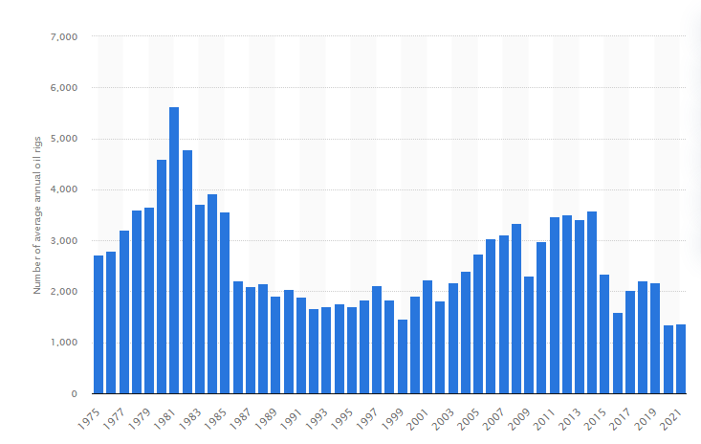
Figure 2. 1 Average annual number of operative oil rigs worldwide from 1975 to 2021 (Sönnichsen, 2022)

One of the key areas of petroleum engineering is drilling, which is responsible for wells that generate hydrocarbons. Drilling is the process of penetrating a target reservoir that contains hydrocarbons while also involving good design, drilling regime, and completion (Jahn, et al., 2008). As shown in figure 2. 1, the number of operative oil rigs worldwide from 1975 to 2021 and figure 2. 2 Number of oil and gas rigs worldwide as of October 2021, by region and type, thus they show the importance of drilling in worldwide.
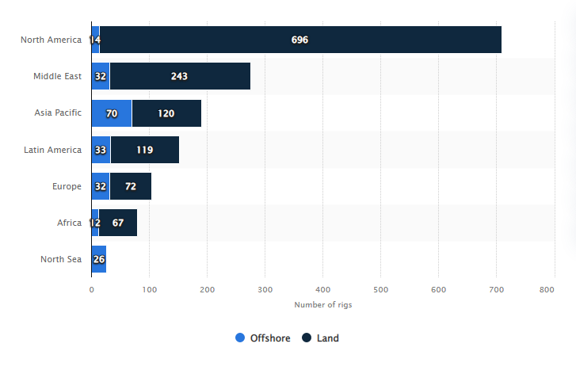
Figure 2.2 Number of oil and gas rigs worldwide as of October 2021, by region and type (Sönnichsen, 2021)
There are many different types of drilling wells, each used for a different purpose, such as exploration wells, appraisal wells, and development wells. Exploration wells are drilled to identify hydrocarbons in the subsurface. Since it has been established that a location is appropriate for producing hydrocarbons, production wells are dug for their extraction, and the wells are abandoned if no hydrocarbons are discovered underground.
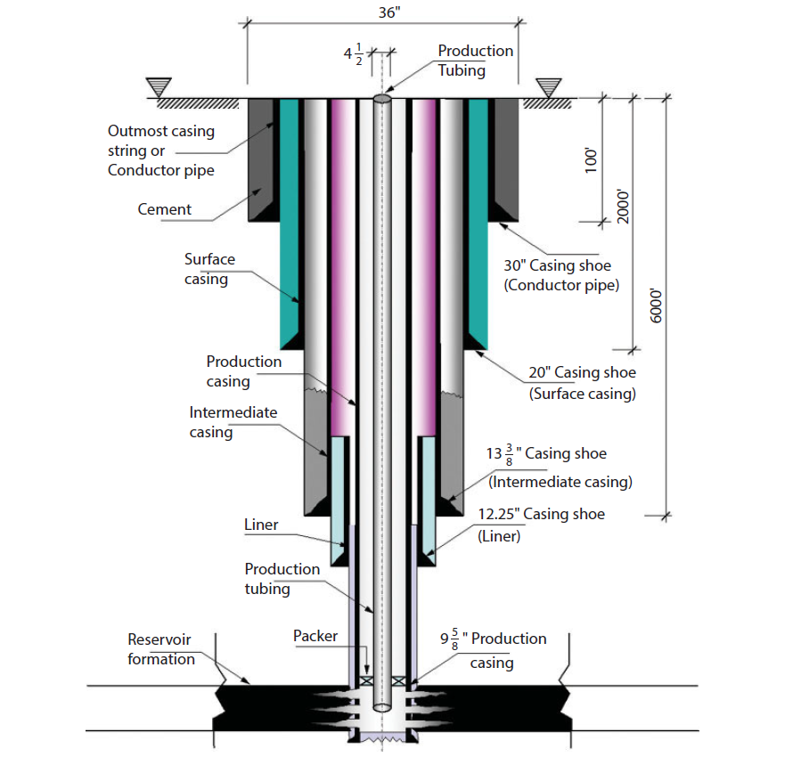
Figure 2. 3 Typical casing program with different sizes and depths (Islam, 2020)
Casing activities are the next step after the initial well drilling, followed by completion. Figure 2. 3 shows various diameters and depths for the casing program. The Power system, hoisting system, Pressure control system, rotating system, and Circulating system are the primary core components of drilling process.
2.2. Drilling Fluid
Drilling fluid is an essential and crucial component of the drilling process. The term "mud" refers to a fluid that circulates continuously during the drilling operation in order to bring the cuttings back to the surface (Skalle, P., 2011). The simplest drilling fluid, according to Khodja, M., et al., (2010), is made up of a mixture of fluid (water) and clay. Drilling mud travels from steel tanks to mud pumps, then through the standpipe, rotary hose, Kelly, and drill string. The mud then moves to the bit at the bottom of the borehole, then moves up to the outside of the well through the annulus (Austin, E.H., 2012).
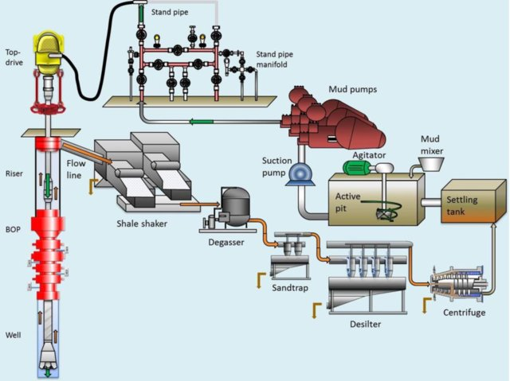
Figure 2.4 Drilling fluid system on a conventional drilling unit (Windsland, 2017)

The returned mud and the transported cuttings are processed using degassers, desanders, shale shakers, desilters, and centrifuges near the surface to remove contaminants. The mud is then sent to the active pit once the cuttings have been removed (Pool, J.R., Pool James R, 1986). Figure 2. 4 shows the drilling mud circulation system.
The major criteria for choosing the drilling fluid types are the sorts of fluids that the formation exhibits, also the cost of the drilling fluid contributes significantly to the overall cost of drilling a well (Bloys, B., et al., 1994). Therefore, Water-based drilling fluids are the most commonly utilized drilling fluid amongst the three major drilling fluid types in the drilling process. These types include water-based, oil-based, and air-based drilling fluids (Mahto, V. and Sharma, V.P., 2004). Figure 3. 7 depicts the three main types of drilling fluids.
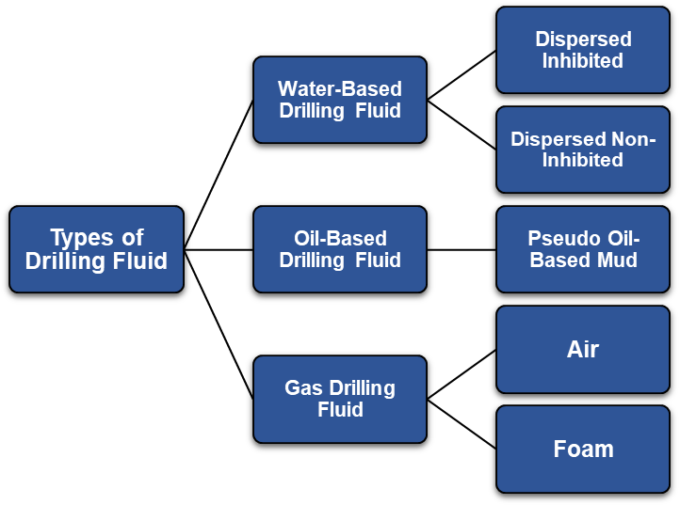
Figure 2. 5 Types of Drilling Fluid (Iversen and Geehan, 2015).

For a successful drilling fluid, which must be able to fulfil all of the drilling fluid's functions, density and viscosity are two of the most important factors and attributes. The following are the most crucial duties performed by drilling fluids (ASME, 2011):
- Get cuttings out of the well and manage the cutting on the surface.
- Manage the pressures during drilling.
- Cover porous structures and keep the wellbore stable.
- Reduce reservoir deterioration.
- Cool, lubricate, support the bit and drilling assembly.
- Deliver hydraulic energy to the bit and tools.
- Ensure proper evaluation of the formation.
- Reduce your environmental impact.
Throughout the drilling program, several additives and chemicals are routinely applied to retain the properties of mud. And most critical additives are:
- Alkalinity Control: aid in fluid stability, enhance polymer hydration and performance, and remove impurities such as cement, carbon dioxide, hardness, and H₂S found in drilling fluids or mix waters. The most common Alkalinity Control Materials are Lime, Caustic Soda, Citric Acid and Soda Ash.
- Corrosion Inhibitors: aid in handling surface and downhole corrosive gases. Several corrosion control additives are used in water-based drilling fluid systems to prevent failure of drilling equipment and drillstring tubulars.
- Filtration Reducers: are used to drill permeable formations while reducing drilling fluid filtration and improving filter cake quality. The most common Filtration Reducer Additives are Starch, PAC R and PAC LV.
- Loss Control Material (LCM): is a chemical pill used as a bridging agent to seal expensive loss zones. LCMs include flakes, fibres, and crosslinking polymer families that have been carefully created to fill massive cracks or vuggy zones.
- Shale Inhibitor: Shale may swell when encountered with water in the drilling fluid during drilling operations. This may cause the wellbore to become unstable and cause shale to slough into the drilling fluid, eventually causing hole washout. A variety of shale inhibitors with various molecular weights, levels of ionicity, and product forms to meet a variety of circumstances and fluid systems. Hydration inhibitors and multifunctional polymers that contribute additional viscosity and carrying capacity are among the available goods.
- Viscosifiers: used to make, oil-based, and water-based drilling fluids more viscous. Give drilling fluids access to a variety of clay, polymer, and biopolymer viscosifiers to enhance their ability to clean holes and suspend particles.
- Weighting Agent: all water-based and invert-emulsion drilling fluids will gain density from the addition of barite and hematite components.

2.3. Drilling Fluid Problems
2.3.1. Hole Cleaning
Normally, for operations when there is a narrow window between the pore pressure and the fracture gradient, inversion emulsion drilling fluids (OBFs and SBFs) are the best option; however, their use is becoming more constrained due to environmental concerns, hence a number of inhibitive WBM systems have been developed as alternatives. The effectiveness of a high-angle or horizontal extended-reach drilling (ERD) operation depends on good drilling-fluid selection and control. Hole cleaning concerns can be avoided with careful control of annulus velocities, drilling fluid viscosity, pipe rotation speed, and pipe eccentricity. The most significant ERD challenges, in addition to formation preservation, involve managing the ECD, cleaning the hole adequately, reducing torque and drag, wellbore stability, barite sag, and circulation loss. (Cameron, C., 2001)

2.3.2. Lost-Circulation
A lost-circulation is a mud loss into formation which can significantly lower or perhaps completely eliminate the ability to produce the zone in an oil or gas reservoir. Although prevention is essential, there is also a significant priority placed on effective repair strategies given how frequently lost circulation occurs. (Whitfill, D.L. and Hemphill, T., 2003).
According to Lake, L.W. ed., (2007) it is simpler to stop a crack from spreading than it is to block it later to stop fluid from re-entering. Because most weighted, treated drilling-fluid systems are expensive, LCM is frequently carried in the active system on many operations where likely lost-circulation zones exist. Natural and man-made cracks, formations with significant porosity and/or permeability, and vugular formations are other factors that might lead to loss of circulation. To prevent the hydrostatic pressure from dropping below formation pressure and triggering a kick when a loss zone is encountered, it is crucial to keep the hole full. As long as there is enough density to avoid well-control issues, the hydrostatic pressure can be intentionally decreased to stop the loss. Differential sticking is also quite likely to occur in loss zones. For treatment purposes, it is usual practice to combine several types and particle sizes of LCM. The development of unique materials that conform to the fracture to seal up pores, regardless of changes in annular pressure, was encouraged as lost circulation has always been one of the most expensive issues facing the industry. Common and fairly priced materials include sized calcium carbonate, paper, cottonseed hulls, nutshells, mica, and cellophane. An emphasis on repairing the loss zone quickly and safely also encouraged this development. (Sweatman, et al., 2004).

2.3.3. Shale Instability
The majority of drilled formations are composed of shale, a fine-grained sedimentary rock composed of clay, silt, and, occasionally, fine sand. Shales are the main cause of wellbore instability problems, which can range from washout to full hole collapse. (Lake, L.W. ed., 2007). Drilling-fluid pressure can enter the shale formation when it is overbalanced through with a WBM and due to the saturation and low permeability of the shale formation. As a result, the mud filtrate that enters the formation raises the pore-fluid pressure significantly near to the wellbore wall. Instability may happen as a result of the increase in pore-fluid pressure because it reduces the effective mud support. by using strong inhibitors and encapsulations to stop shale from becoming wet and spreading out.
According to Ewy, R. T., Patel, A., et al., (2007), the novel water-based mud has a polymeric amine shale intercalator that is utilized to inhabit shale and is compared to an oil-based mud. The results show a significant shift of the WBM features connected with prior trials, demonstrating that WBM perform like OBM. Shale instability results in sloughing, pipe stacking, and shale collapse, all of which set the stage for fines to accumulate and influence the ROP when WBM is employed with unrelated materials. RC Jung et al., (2013) the drilling mud design, which is one of the factors that can be taken into consideration, has the most significant impact on avoiding these problems once the general shale unsteadiness issues have been eliminated.

2.3.4. Stuck Pipe
Drill strings may be dragged against walls and become stuck in filter cakes while drilling through depleted zones, where annular pressure is higher than formation pressure. The drill pipe is kept against the wall by differential pressure as the internal cake pressure drops where it comes into contact with the filter cake. Gravitational force helps the drill string and formation make prolonged contact in high-angle and horizontal wells. (Ottesen, et al., 1999). Stuck pipe incidents can be decreased by effectively controlling the drilling fluid's lubricity and the filter cake's quality throughout the permeable formation. Key seating, pack off from inadequate hole cleaning, shale swelling, wellbore collapse, plastic-flowing formation and bridging are examples of mechanical causes for stopped pipe.
It may be necessary to keep a close eye out for early warning signals of stuck pipe, like increases in torque and drag, evidence of an excessive cuttings load, tight areas when tripping, and loss of circulation while drilling. The drilling-fluid density may need to be increased to stabilize a swelling shale or decreased to safeguard the depletion zone and prevent differential sticking, depending on what the suspected source of sticking. (Lake, L.W. ed., 2007). The most lubricious materials are OBFs and SBFs; inhibitive WBMs can be treated with a lubricant and designed to create a thin, impermeable filter cake that provides more resistance to sticking. High-performance-polymer WBMs that are intended to replace OBFs and SBFs naturally lubricate well and may not need to be lubricated at all.

2.3.5. Kick and Blowout
When drilling, it is necessary to manage and keep under control the formation pressures. Traditionally, this has been done by adjusting the density of the drilling fluids employed, ensuring that the hydrostatic pressure applied by drilling fluid is high enough to overcome the formation pressure and prevent an invasion of formation fluids into the well. In the event that this is not accomplished, fluids may voluntarily enter the well. Kicks are most frequently caused by the rig personnel failing to manage the well pressures properly, which is their responsibility. The necessity for secondary well control, more particularly "kick recognition, control, and displacement from a well," follows the occurrence of a kick. Failure to manage the kick effectively could result in a blowout, which is a very dangerous circumstance that puts the lives of rig workers in jeopardy and is one that businesses aim to avoid at all costs. Aside from the possibility of human pain or death, this uncontrolled flow of creation could also cause significant economic losses and environmental harm. (Grace, R.D, 1994)

2.4. Diagnosis Losses circulation
Besides the obvious benefits of maintaining circulation, preventing or curing mud losses is important to other drilling objectives such as obtaining good quality formation evaluation and achieving an effective primary cement bond on casing. (Al-Ali, et, al. 2017).
Lost circulation occurs in one of two basic ways:
2.4.1 Invasion.
In many cases, lost circulation cannot be prevented in formations that are cavernous, vugular, fractured or unconsolidated. Depleted low-pressure formations (usually sands) are similar relative to lost-circulation potential.
- Coarse, unconsolidated formations can have sufficiently high permeability for whole mud to invade the formation matrix, resulting in lost circulation. This high permeability is often present in shallow sands and gravel beds. Formations that were once reefs and oyster beds also have similar tendencies. One important reason for preventing mud loss in shallow intervals is that it may cause these unconsolidated formations to wash out, forming a large cavity that is less stable which could cave in more easily from overburden and rig weight. (Al-Ali, et, al. 2017).
- Another potential loss zone is in depleted formations (usually sands). Producing formations in the same field, or general vicinity, may cause subnormal (depleted) formation pressure due to the extraction of the formation fluids. In such a case, mud weights required to control other exposed formation pressures may be too high for the depleted formation, forcing mud to invade the low-pressure depleted formation (see Figure 1). If this situation exists, plans should be formulated to prevent lost circulation or stuck pipe from occurring in the depleted zone. Special bridging agents and sealing materials should be used to form a good seal and filter cake on the depleted zone. (Gong, et, al. 2020)
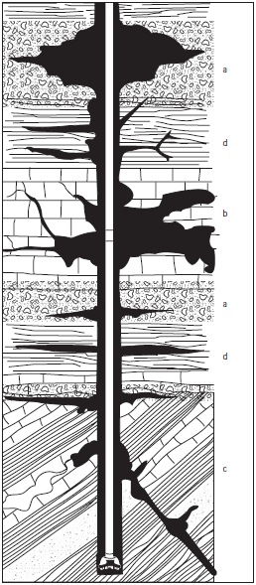
Figure 2.6 Lost-circulation sections: a: High-permeability unconsolidated sands and gravel. b: Cavernous or vugular zones in carbonates (limestone or dolomite). c: Natural fractures, faults and transition zones in carbonates or hard shales. d: Induced fractures from excessive pressure. (Gong, et, al. 2020)
- Cavernous or vugular zones are usually associated with low-pressure carbonate (limestone and dolomite) or volcanic formations. In limestone, vugs are created by the previous continuous flow of water that dissolved part of the rock matrix (leaching), creating a void space often later filled with oil. When these vugular formations are drilled, the drillstring may fall freely through the void zone and a rapid loss of mud is usually experienced. The volume and persistence of this kind of loss depends on the degree to which the vugs are interconnected. Similar vugs and caverns can develop during the cooling of volcanic magma or ash. Cavernous and vugular formations are often easily traceable from offset wells and predictable from mud logs and lithology. (Zhang, et, al. 2016).
- Mud loss also occurs to fissures or fractures in wells where no coarsely permeable or cavernous formations exist. These fissures or fractures may occur naturally, or may be initiated or extended by hydraulically imposed pressures. Natural fractures exist in many cases, which may be impermeable under balanced pressure conditions. Losses may also occur at unsealed fault boundaries. (Chen, et, al. 2020).
2.4.2 Fracturing.
Hydraulic fracturing is initiated and lost circulation occurs when some critical fracture pressure is reached or exceeded. Once a fracture is created or opened by an imposed pressure, it may be difficult to repair (heal) and it may never regain the original formation strength, as shown later in Figure 5. (Chenevert, et, al. 1995). Lost circulation may persist even though the pressure is later reduced. This is one reason why it is better to pretreat for, and prevent, lost circulation than to permit it to occur. Lost circulation resulting from induced pressure is usually caused by one of two situations:
- Setting intermediate casing in the wrong place. If casing is set above the transition zone crossing from normal to abnormal pressures, the pressures exerted by the heavier mud (required to balance the increasing pressures) will often induce fracturing at the weak casing seat. Losses due to fracturing are most commonly near the previous casing seat, not at bit depth, even if casing is properly set. (Li, X.,et, al. 2019).
- Excessive downhole pressures are the result of many conditions including:
i. Mechanical forces.
- Improper hydraulics. Excessive pump rates and velocities causing high Equivalent Circulating Density (ECD) pressures.
- Drilling practices.
- Spudding bridges.
- Excessive Rate of Penetration (ROP) for a given flow rate will result in high cuttings concentration in the annular fluid causing a high ECD.
- Pipe whipping.
ii. Hole conditions.
- Sloughing shale or increased solids loading in the annulus and high equivalent circulating density.
- Accumulation of cuttings in a washed-out portion of the hole or in the mud.
- Cuttings beds or barite sag forming on the low side of a directional well, or possible slumping.
- Bridges.
- Kicks and well-control procedures.
iii. Mud properties.
- Excessive viscosities and gel strengths.
- Buildup of drilled solids.
- Thick filter cakes that reduce the hydraulic diameter of the wellbore.
- Excessive mud density or increasing mud density too fast.
- Unbalanced mud columns.
- Barite sag.
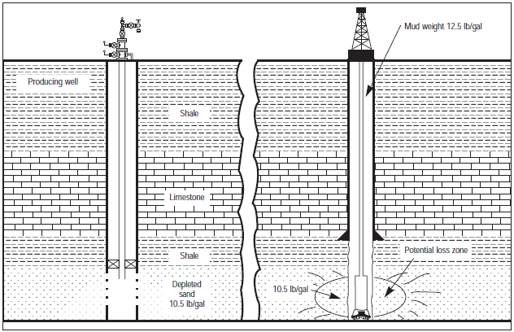
Figure 2.7 Depleted sand.

2.5 Establish the Loss Rate
As a matter of routine, the monitoring of pit levels and returns should give early indications of losses. Once losses are observed, the loss rate should be carefully monitored as it could change rapidly. (Guo, et, al. 2017).
Loss rates are expressed in barrels per hour (bbl/hr) or sometimes in cubic metres per hour (m³/hr).
Table 2.1 The definitions for loss rates are as follows:
Loss Severity | Loss Rate (bbl/hr) | Loss Rate (m³/hr)
Seepage  Partial  Severe  Total | <10  10 - 30  30 – 100  >100 | <1.6  1.6 – 4.8  4.8 – 16  >16
It is important to confirm that the losses are occurring down hole and not at the surface. The following procedure is recommended:
- Check the solids control equipment to ensure that no new equipment has been placed online and that the discharge rates are normal.
- Check to ensure that no mud has been dumped, transferred or otherwise removed from the system.
- Check all pipe joints; connections, and valves for leaks.
If it is established that the losses are occurring downhole, decide if the loss rate is sustainable. If inexpensive mud is being used or the losses occur near TD of the section, it may be deemed acceptable to ‘live with the losses’ even if loss rates are fairly high. There are special cases where drilling with high losses is done such as losses in massive carbonates. The option to drill ahead with losses should always be considered, but it is a decision which has to be carefully made. Consider well control and implications for cementing once the liner/casing has been run. (Zhang, G., & Liu, Y. 2019).
The following checks can be carried out to characterise the type of loss.
- Check the drilling programme and check with personnel - is this a potential zone for natural losses (e.g. natural fractures, vuggy formations)? If so, LCM treatments will be needed to cure the loss.
- Check for induced losses by considering the following options:
- back off drill rate (ROP)
- reduce pump rate
- stop drilling and stop mud pumps for a short time
- thin the mud
Consult with mud logging service providers and discuss the trends seen in the last few hours; consider pit level indicators to establish the type of loss zone:
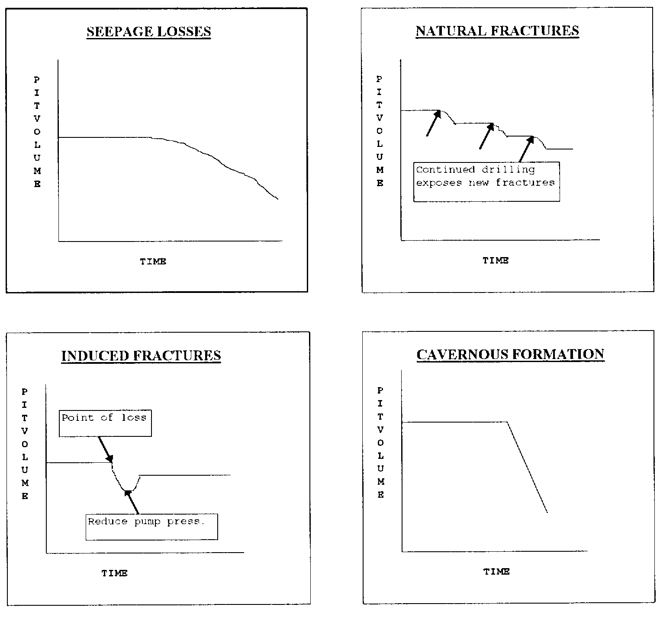
Figure 2.8 Pit Level Indicator
Pores/matrix: In this case the pit volume decreases gradually with time. The loss rate may increase during drilling as more formation is exposed. The loss rate can be low or high depending on the formation permeability.
Natural Fractures: A sudden decrease in pit volume occurs. The loss rate depends on the width and extent of the fracture and can be low or catastrophic. If there are small multiple fractures a stepwise decrease may be seen as new fracture surfaces are exposed.
Induced: Losses caused by increased annular pressure. Reducing pump rate, stopping pumps or reducing ROP can cure the problem. Dynamic losses high but static losses low.
Cavernous/Vuggy: A sudden decrease in pit volume and high loss rate. Will be hard to distinguish from a large natural fracture, but geological information should help (Wang, Z., et, al. 2019).

2.6. Loss circulation materials
There are many conventional lost circulation products on the market, ranging from simple granular materials such as ground marble, to nut shells, cellulosic fibres, and plate-like systems like micas, flaked calcium carbonate, or shredded plastics. There has not been a definitive study to prove that one particular type of product is more effective than another. It is not too surprising, therefore, that in most applications a mixture of different products is used in the hope that at least one of the components will do the job. To some extent, selection is based on local experiences, cost, availability and personal preferences. This does not matter provided some important general rules are applied. By simply applying the basic principles correctly it is possible to bring more certainty to the treatment of losses.
(Song, S., Li, X., & Wei, B. 2020).

The following rules should be followed:

- Use an LCM mix with sufficient particle size for the loss rate encountered
- Consider formation damage issues when selecting product type
- Use a good engineering approach
- sufficient pill size
- sufficient concentration
- check the LCM won’t block nozzles
- Use correct placement techniques

Traditionally, LCM treatments are formulated based on particle size. The terms ‘fine’, ‘medium’, ‘coarse’ and ‘extra coarse’ are usually used to describe the components of an LCM pill, eg ‘15ppb medium carbonate’ or ‘10ppb fine fibre’. However, these terms are misleading because the size ranges have not been defined and can be very different for different types of product. For example, an extra-coarse grade carbonate could be of similar size to a fine grade fibre. (Yang, J., et, al. 2021). This makes it difficult to standardise on pill formulations, and could explain why performance is so variable from job-to-job. In order to address the variances in size definitions used by the industry have adopted the following standards:

Table 2.2 size definitions for LCM
LCM Grade | Microns | Mesh Size
Fine | d90 < 75 | At least 90% passes 200 mesh
Medium | d90 = 75 -250 | 90% passes 60-200 mesh
Coarse | d90 = 250 -1000 | 90% passes 18–60 mesh
Extra Coarse | d90 > 1000 | At least 90% passes 18 mesh

* Note that particle sizes are best measured using sieve analysis, especially for the larger particles. This will better reflect their plugging ability and allow to some extent for different particle shapes (aspect ratio). Laser sizers tend to give an average spherical diameter even for needle-shaped particles, which may not accurately reflect their sealing ability.
The d90 is a measure of the large particles present. It is defined as follows:
d90 value = 90% of the particles are less than this size
For example, a material with a d90 of 100 microns would be classified as ‘medium grade’ in the above table. The d90 is a good parameter to use when referring to pore and fracture sealing as it tells us that there is a reasonable concentration (10% of the particles) which are large enough to form an initial bridge.
However, in most cases the fracture/pore size is not known. When this happens, the LCM size selection must be based on the loss rate. The following table is a useful guide in selecting the size to match the loss rate:

Table 2.3 Selecting LCM Size to Match the Loss Rate:
Loss Severity | Loss Rate (bbl/hr) | Loss Rate (m³/hr) | LCM Grade Required
Seepage  Partial  Severe  Total | <10  10 - 30  30 - 100  >100 | < 1.6  1.6 – 4.8  4.8 - 16  >16 | Fine/Medium  Medium/Coarse  Coarse/Extra Coarse  Extra Coarse
LCM formulations should contain a blend of products such as mixtures of coarse and medium grades. This gives a range of smaller particles to fill the gaps between the larger ones. Most importantly though the largest size must be sufficient for the pore/fracture width and loss rate encountered. (Li, X., Li, Q., Li, L., & Wang, X. 2018).
Table 2.4 The following table shows the conversion from microns to screen mesh size:
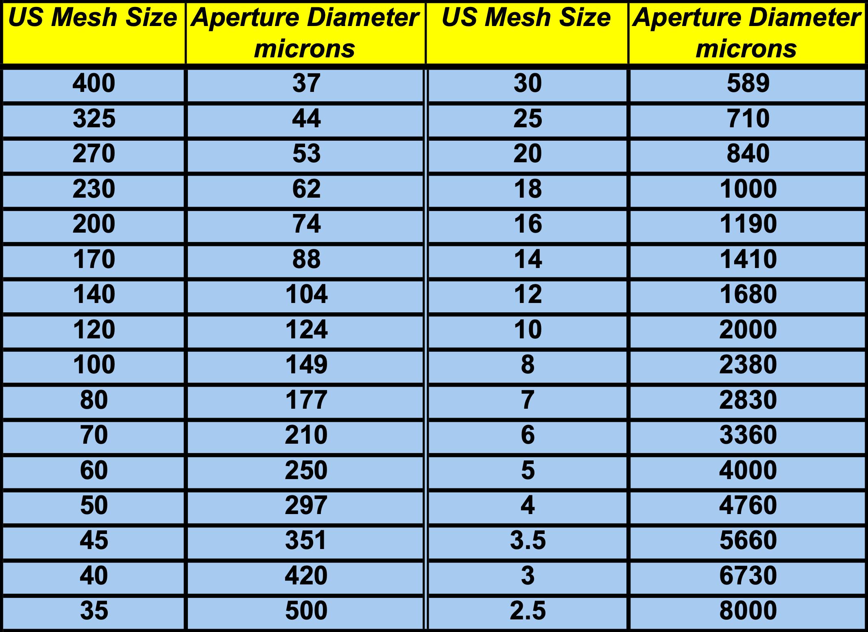

2.7 Formation Damage Considerations
When the loss zone is in or close to a potential production horizon, the use and subsequent removal of LCM could result in formation damage. Therefore, the selection of suitable LCM is critical, particularly if open hole completions are planned, perhaps involving OHGP placements or sand control screens. In these cases it is
best to incorporate LCMs that have a proven history and can be removed by downhole treatments such as acid and hypochlorite treatments. (Guo, J.,et, al. 2016).

- Calcium carbonate can be subsequently removed using acid (typically 15% HCl).
- Cellulose fibres can also be used, with caution. While only about 40% soluble in acid, the fibres can usually be oxidised and removed by a 2% to 5% hypochlorite solution at high pH.
- Sized salt particles (e.g. NaCl) can be used in saturated salt fluids. The salt can be dissolved later using water or dilute brine.
- Oil-soluble resins. Crude oil or condensate can in theory dissolve the resin when the well is brought on production, or treatments with diesel can be applied. This sort of treatment requires some careful pre-planning and laboratory testing to judge the suitability.

Note: Productive formations or injection zones usually use a drilling fluid specifically designed to prevent formation damage, often referred to as a “Drill-In Fluid”. These fluids may already incorporate one or more of the aforementioned materials to minimise fluid invasion and hence formation damage.
2.7.1 LCM Listings
The table below lists size data and formation damage information for various LCMs. The products are categorised in terms of the above size definitions, which should help in selecting equivalent materials and finding substitutes when needed. The data are based on sieve analyses where available. Quality control can be an issue, especially from region-to-region where products are locally manufactured. Therefore, there is no guarantee that the sizes will be exactly as given in the table. (Wang, Q., et, al 2020).

Table 2.5 Particle size recommendations before using a product.
Procedures and generic pill formulations for different loss rates will be given in section
2.8. Locate the Loss Zone
The accurate location of the loss zone is critical to enable the effective deployment of LCM treatments. Loss circulation pills will fail if they are not applied to the right zone. However, locating the loss zone is not always easy.
It is important to examine the type of formations being drilled and the drilling circumstances leading to the point of loss. Drilling breaks such as the drill bit dropping into a cavern are obvious. Drilling a highly fractured zone where bit torque varies abnormally can be another indicator of the zone of loss. A sudden change in rate of penetration can indicate the bit is penetrating a formation with high porosity and high permeability where losses could occur.
Note that losses are usually "On Bottom" if….
- They first occur while drilling ahead.
- The loss is accompanied by a notable change in torque or drilling roughness.
- The loss is due to natural fractures, caverns, or pores.
Losses are usually “Off Bottom” if…
- They first occur while tripping, wiping or increasing mud weight.
- They are the result of an induced fracture
If losses are off bottom it can be difficult to locate the exact zone. The most likely place is at the base of the previous shoe where the formation is normally weakest. Check to see if the mud weight has been raised close to, or above, the fracture gradient
If the loss zone cannot be located by the above steps it is probably best to attempt a cure anyway by pumping LCM pills. Try spotting pills near the bottom, and near the top of the hole, or in other suspected zones. (Hu, J., et, al. 2019).
If this fails, there is the option to run surveys:
- Surveys
There are many survey methods available to assist in the identification of loss zones. While of great utility, all of the survey methods have the same limitations:
- A lot of time is required to run the survey and accurately locate the loss zone
- The tools are not always readily available
- A considerable amount of drilling fluid is lost doing the survey.
- The results are often difficult to interpret.
- The tool could be lost in the hole.
The following paragraphs describe a number of survey types:
- PWD/LWD
If a PWD or LWD tool is being run consider using it to help to locate the loss zone. With PWD, a discontinuity in pressure would be expected when comparing above and below the loss zone. If a LWD tool is being run, trip data from LWD-resistivity can sometimes identify loss zones and show healing on subsequent trips. Invasion of oil mud is easily picked up by resistivity.
- Temperature Survey
A zone of loss can be determined by temperature discontinuity. Taking this approach requires the well to remain static for a period of time, usually about four hours, so temperature equilibrium can become established. A temperature survey is then run. A volume of fluid, usually 100 barrels, is pumped into the annulus through the fill up line and the temperature survey is run again. The zone of loss is located by the distinct temperature change in the second temperature survey.
- Spinner Survey
Flow into the zone of loss can be detected by a spinner survey, where an instrument containing a rotor is lowered in to the hole. The speed of the rotor is affected by fluid movement perpendicular to the wellbore and is continuously monitored as the spinner is lowered. The highest observed rotor speed, while pumping into the annulus to keep the hole full, indicates the depth of the lost zone.
- Tracer Survey
A gamma-ray log and radioactive material can establish the zone of loss. The procedure requires spiking a portion of the fluid with a radioactive material. A base log is run before the introduction of the radioactive material. A pill containing the radioactive material is then pumped into the hole and the survey run again. A high concentration of radioactive material will be located at the point of loss. The drill pipe should be rotated and reciprocated during this process in order to minimise the potential of differential sticking.
Pressure Transducer
A pressure sensor containing a diaphragm is lowered in to the hole. The pressure differential across the diaphragm as a function of depth is monitored. A large pressure change indicates the loss zone.

- Acoustic Log
The acoustic log is run as in a production environment. The tool monitors the “noise” of the fluid leaving the hole as a function of depth. It is more applicable to large loss scenarios.
- Hot Wire Survey
The survey makes use of an instrument that monitors the resistance of a wire through which an electric current is passing. The wire is sensitive to temperature changes. The tool is run into the hole and the resistance is noted. Mud is then pumped into the hole. If the tool is above the point of loss, mud will flow by it, changing the resistance. If the resistance does not change, the tool is below the point of loss.
2.9. Preventive Measures
Good planning and proper drilling practices are the keys to preventing lost circulation by minimizing excessive pressures on the formation. (Wang, Z., et, al. 2019).
Several measures can be taken to prevent or minimize lost circulation:
1. Set the casing in the appropriate zone so the fracture gradient of the formation at the casing shoe will be sufficient to support the hydrostatic head of heavier muds required to balance pressures in the formations below.
2. Minimize downhole pressures.
a. Pipe movement should not exceed critical speeds when tripping. When the drill-string is run in the hole, there is a surging pressure from the piston effect of the bit and collars increasing the pressure exerted on the bottom of the hole. Good drilling practices will keep these pressure surges within the fracture and formation pressure, as shown in Figure 3.
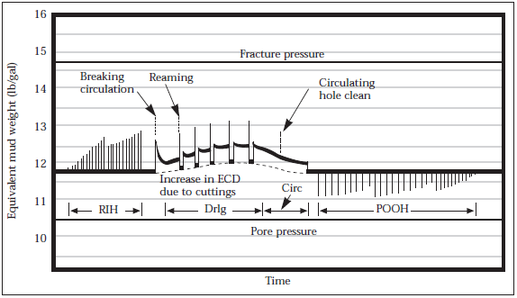
Figure 2.9 Bottom-hole pressure for normal drilling cycle (after Clark).
Many wells experience lost circulation while running pipe or casing into the hole. The length of pipe in the hole affects the magnitude of the surge. Tests show that the flow of mud along the pipe creates most of the pressure surge. The longer the pipe, the greater the surge. Therefore, the deeper the well, the slower the pipe should be run into the hole as the depth of the bit increases. Smaller annular clearances also increase surge pressures much in the same way annular pressure losses are increased as annular clearances decrease.
b. Rapid movement of pipe while circulating also causes even greater pressure surges. Rapid “spudding” of the pipe or fast reaming while circulating can create large surges.
c. Very high ROP loads the annulus with cuttings, thus increases the ECD, making any further surging on connections more likely to cause fracturing as shown in Figure 3. It is important to control the ROP and circulate prior to making connections when the ECD is near the fracture pressure. Maintain the cuttings concentration in the annulus below 4% to minimize the effect of cuttings on ECD.
d. Rapid starting or stopping of the mud pumps can cause pressure surges. Starting the pumps too rapidly will create a pressure that can cause lost circulation, especially when breaking circulation on bottom after a trip. Part of the surge is caused by pressure required to break the gel structure of the mud. Rotating the pipe when starting circulation will aid breaking the gel strengths and greatly reduce the surge pressure. The other part of the surge is the pressure required to accelerate the mud column to the normal circulating rate. Maintaining low gel structure and gradually increasing the pump rate will reduce this type of surge pressure. Breaking circulation at several intervals when tripping in hole is another way to minimize these pressures.
e. Use enough drill collars to keep the neutral point in the Bottom-Hole Assembly (BHA) to minimize drillstring whipping.
f. During the planning phase of the well, casings and drillstring design should be engineered for proper and safe operation, and also to optimize hydraulics for good hole cleaning and minimum ECD, especially in sensitive areas.
g. Wash and ream cautiously through bridges.
h. Avoid kicks if possible. Shut-in pressure at the surface is transmitted down the wellbore, often breaking the formation down at the weakest point. This not only results in loss of circulation, but losing control of the well. Proper research, well planning and execution will minimize the possibility and severity of a kick. Those responsible for the operation at the wellsite should always be aware of the maximum shut-in casing pressure and volume. The volume of the intruding fluid is directly related to the shut-in pressures and should be minimized. If a well has to be shut-in, proper kill procedures should be used to maintain the right constant bottom-hole pressure required to kill the well. (Li, X., et, al. 2018).
i. Control mud properties in the proper ranges.
i. High viscosity and gel strengths increase surge pressures each time circulation is interrupted and restored (see Figure 3). They also increase the ECD while drilling. These values should be optimized to ensure good hole cleaning and solids suspension, and minimize ECD, surge and swab pressures. Many times mud properties can not be kept at a level which will provide adequate hole cleaning due to other operational considerations. Higher flow rates and aggressive drill pipe rotation are the best methods to improve hole cleaning. High viscosity sweeps are recommended in such cases where good hole cleaning is questionable. These sweeps are usually made of mud from the active system that has been viscosified by additions of bentonite, polymers or Lost-Circulation Material (LCM). The use of LCM in these sweeps is preferable in many cases since they are screened out at the surface and have no permanent effect on the viscosity of the mud. Controlling the ROP may be necessary if efficient hole cleaning can not be achieved. Although this may lengthen the rotating hours, it will generally be less expensive than the costs incurred by losing returns.
ii. Control drill solids at the minimum practical level and add proper treatment to minimize filter-cake build-up. Anything that reduces the annular clearance causes a pressure increase. Balling of the bit, collars, stabilizers or tool joints decreases the annular clearance. In the case of extensive bit and/or stabilizer balling, a significant pressure will be exerted on the formation. An increase in drag or swabbing on connections are possible indicators of balling. Sometimes a ball can be pumped off a bit, but if that fails, the common practice of spudding the bit should be avoided. The combination of the reduced annular clearance and the pipe surge can cause the pressure to exceed the fracture pressure.
iii. High fluid-loss muds deposit a thick filter cake that can reduce the annular clearance. The smaller annular space increases the ECD. Therefore, fluid loss and filter-cake thickness should always be controlled in the proper range. Mud that develops a thin, strong filter cake is more effective in preventing lost circulation to small fractures or pores.
iv. Drill with minimum mud density. This not only enhances the ROP but also diminishes other mud-related effects.
v. A good selection of the proper size of bridging materials helps reduce and eliminate whole mud losses into porous formations. The choice of such bridging agents will depend on the formation characteristics. Generally, particles that are one-third to one-half the square root of the permeability in millidarcies (md) should be able to bridge such formations.

2.10. Natural fractured carbonate reservoir of Iraq
The majority of geological formations in the upper section of the earth's crust have some degree of fractureing because fractures are displacement discontinuities in rocks that show as local interruptions in the normal sequence of the rock's characteristics. As a result of natural geological stresses like tectonic movement, lithostatic pressure changes, thermal stresses, high fluid pressure, drilling activity, and even fluid withdrawal since fluid also helps to support some of the weight of the overburden rock the rock has fractured. This mechanical failure of the rock is indicative of natural geological stresses. Although petroleum reservoir rocks can be found at any depth, the overburden pressure at deeper depths is enough to cause plastic deformation in the majority of sedimentary rocks. As a result, these rocks are unable to withstand shear stresses for an extended period of time and flow toward an equilibrium condition. Fractures can take the shape of microfissures that extend a few micrometers or continental fractures that extend a few thousand kilometers; they can also be restricted to a single rock formation or layer or they can spread over a number of rock formations or layers. Planes of weakness in rock react to shifting stresses in the earth's crust by breaking in one or more distinct ways, depending on the direction of the highest stress and the kind of rock. In geological words, a fracture is any planar or curvi-planar discontinuity that emerges from the process of brittle deformation in the earth's crust. Two irregularly shaped rock surfaces that are somewhat in contact with one another might form a fracture. The fracture void is the space between the surfaces.Three basic types of spontaneously fractured rocks may be distinguished geologically according to their porosity systems:
Intercrystalline-intergranular structure, matrix-fracture, and vugular solution. Carbonate reservoirs are often easily fractured because they are relatively weak and brittle compared to other types of rock formations. This is due to several factors, including the nature of the carbonate minerals themselves and the way they are cemented together. Carbonate rocks, such as limestone and dolomite, are composed of calcite (CaCO3) or dolomite (CaMg(CO3)2) minerals. These minerals are relatively soft and brittle, which makes the rocks susceptible to fracture. Additionally, carbonate rocks often contain cracks and fractures that are created during the process of formation, and these pre-existing fractures can provide pathways for fluid flow. Another factor that contributes to the brittleness of carbonate reservoirs is the way they are cemented together. In some carbonate formations, the calcite or dolomite crystals are held together by a matrix of clay minerals or micrite, which is also brittle and easily broken. In other formations, the carbonate minerals are cemented together by a more durable mineral, such as calcite, but these cements can also be brittle and susceptible to fracture. Some carbonate formations are subjected to tectonic forces that cause them to become faulted and fractured. These fractures can provide conduits for fluid flow, and they can also create permeability barriers that can trap hydrocarbons. The relatively soft and brittle nature of carbonate minerals, combined with the way they are cemented together and the potential for tectonic forces to cause fracture, makes carbonate reservoirs prone to fracture and easily damaged. The carbonate formations of Iraq are a significant aspect of the country's geology and petroleum industry. The formation of these carbonates is largely the result of sedimentation and diagenesis of ancient shallow-marine platforms, influenced by various tectonic, eustatic, and climatic factors.
In Iraq, carbonate formations are widespread and can be found in the northern and central regions of the country, such as the Zagros Mountains and the Arabian Plate. They range in age from the Jurassic to the Cenozoic and are comprised of limestone, dolomite, and chalk. One of the most well-known carbonate formations in Iraq is the Kurdistan Region's Avanah Formation, which is a high-quality reservoirs and has significant hydrocarbon resources, including both oil and natural gas and widely distributed in the country and is a significant reservoir for petroleum. It is also notable for its abundant fossils, including those of marine reptiles, such as plesiosaurs and mosasaurs, and ammonites. These formations provide important insights into the depositional environment and diagenetic processes that took place in the region millions of years ago and are essential for the exploration and development of the country's hydrocarbon resources.
The Avanah Formation was initially identified by Mc Ginty in 1953 (Bellen et al., 1959) from well Kirkuk 116 on the Avanah dome of the Kirkuk anticline in the low folded Zone. The Avanah Formation is made up of 210 m of dolomitized and recrystallized limestones of shoal lithologies with sporadic beds of lagoonal dolomitized limestone, and its thicknesses in subsurface sections in northern Iraq are as follows: Kirkuk-117 (159 m), Butmah-I (503 m), Alan-l (154 m), Atshan-1 (138 m), and Mushorah-l (550 m). In the wells Sufaya-A2 and Najmah-30, the Avanah Formation interfingers with the Jaddala Formation laterally (Jassim & Buday, 2006). The Avanah Formation, which dates to the late Lower Eocene-Upper Eocene cycle, is thick in the Foothill Zone of iraqi Kurdistan as an isolated carbonate shoal connected to a palaeoridge along the northeastern border of the basin throughout a high stand of sea level (Jassim & Buday, 2006). The Avanah Formation, on the other hand, is distinguished by a high permeability and porosity rate, a predominance of macro- and microfossils, and other characteristics that make its lower and middle portions an excellent hydrocarbon resource (Al-Hamdany & Sulaiman, 2014).

CHAPTER 3: METHODOLOGY
3.1 Geological setting
The research area is situated 36° 16' 48" north and 44° 20' 07" east, northeast of Erbil city in northern Iraq's Kurdistan Region. The Avanah Formation is visible in various parts of the High Folded Zone as a belt that is near to the Low Folded Zone's border. There are several folds and faults in the High Folded Zone, with the majority flowing northwest to southeast. The tectonostratigraphic AP 10 mega series includes the Avanah Formation in its middle section. The Paleocene-Early Eocene sequence and the Middle to Late Eocene sequence were created from this mega sequence. The Middle-Late Eocene subsequence that the Avanah Formation belongs to was closing the Neo-Tethys Ocean and the final stage of subduction when it was deposited in the SW of the emergent uplift. The Avanah Formation often occurs as a tongue inside the Gercus Formation in eastern Erbil, from Koya in the east to Shaqlawa in the northeast, and is characterized by lateral variable thickness. The Gomaspan section's Avanah Formation emerges at the southwest limb of the Bina Bawi anticline, which has a NW-SE trending and verges to the SW is connected to the northwest by the Pirmam anticline, which Omer (2005) proposed as the northwest continuation of the Bina Bawi anticline, and which together may form a massive anticline that is more than 75 km long. The study area's geologic successions include the Tertiary units of Kolosh, Khurmala, Gercus, Avanah, Pilaspi, Fatha (Lower Fars), and Injana, which are overlain by the latter (Upper Fars). Within the red mudstone examined the Avanah Formation, which is gathered while drilling well from different points. Below represents

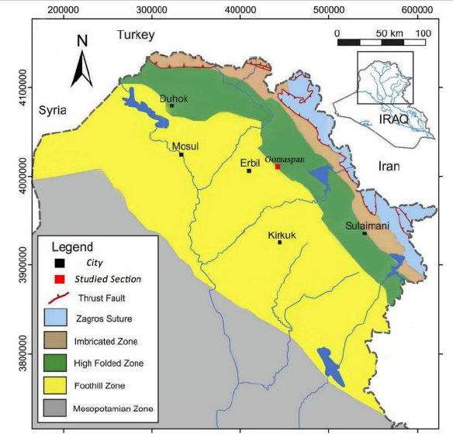
Figure 3.1 Geological Setting of studied Area

3.2 Data Analysis
The information was evaluated and gathered using two main forms of data: local wells drilled in the avanah formation and from international companies experience and for each situation suitable pill must be selected.

3.2.1 International Company Techniques
There are many available options so that selection is difficult. Conventional LCMs are not effective for very high loss rate situations (>100bbls/hr) as situation of avanah formation. They work by bridging, and at >100bbls/hr losses the fractures/voids are generally too large for the materials to function. The alternative is to use chemical systems which set and seal the loss zone. There are several types of system available:
- Generic Systems
1. Cement Slurries
Cement slurries can be used as an effective lost circulation remedy for some situations and can be used in combination with other techniques as modified cements. Since, its well-established technology, procedures well-known, high density slurries easy to formulate if required and when correctly placed, forms very effective/permanent seal especially for fractures. However, it is not usually the first course of action as there are several risks and drawbacks like Will tend to screen out on pores so may be difficult to inject and seal rock matrix, Set time is very sensitive to temperature; it is crucial to check thickening times. Forms a hard set which can lead to accidental sidetracks when drilling out the cement following treatment. Re-entering the zone before the pill gains full strength can help prevent sidetracking, but at some risk of getting stuck or washing away too much of the pill.
2. Modified Cements
There are modifications that can be made to the basic cement slurry to try to improve its suitability for loss control. The cement must stay in place long enough to solidify and seal off the loss path, so there is a benefit in trying to avoid excessive flow of cement into the formation. The penetration of the slurry must be at least some minimum distance into the formation, otherwise losses will return when the wellbore is drilled out. The tools available to control these processes are bridging additives, initial gel strength, and the rate of compressive strength development of the cement. Compared with muds, cement slurries will form solid bridges more quickly since they have a higher solids content and inherently less fluid loss control. But bridging of the loss zone will be enhanced by adding bridging additives. Suitable products are Gilsonites, crushed coal, calcium carbonates, or other LCMs like fibres or flakes. The materials must be non-reactive in the cement, suspend easily, and encompass a broad particle distribution range. The cement contractor can advise on suitable concentrations. Some of these modified systems form softer cements which can be more easily drilled out with less risk of sidetracking. However it has many drawworks like Systems containing bridging solids will not be suitable for pumping through the BHA due to the risk of plugging. The setting time of cement treatments tends to be very temperature sensitive.

3. Gunks (WBM)
DOB2C is a gel cement slurry that is mixed in diesel oil. It is typically used to cure severe loss circulation situations. DOB2C when contacted by water or a water base mud, will react, releasing the diesel and hydrating the cement. This reaction begins ~ 1 min after mixing. The degree and rate of reaction depends on how much water mixes with the DOB2C. For DOB2C temperature is not very important, soft set avoids sidetracking problems and slurry will pass through most BHAs. And it has some drawworks like placement – need to generate gunk in the right place, flow rate and mix is important to achieve suitable consistency and avoid premature mud contamination.
4 Reverse Gunks (OBM)
This is the reverse procedure compared with ordinary Gunks. Typically, organophilic clay is mixed into an aqueous suspension and pumped down the drill pipe. The oil mud is pumped simultaneously down the annulus and gelation occurs when the two fluids meet. The gunk is squeezed into the formation. Note that it is not possible to add cement to strengthen the pill (unlike DOB2C used for WBM applications). For Reverse Gunks temperature is not very important, procedures are well established and suitable for large fractures/voids. However, it has some limitations like avoiding premature mud contamination, mixing time/placement often greater than 6hrs and effect can be short-lived due to soft plug formed.
5 Dilatant Slurries
Dilatant slurries exhibit the characteristic that the more force that is applied to move them, the harder they become to move or deform. A dilatant fluid’s characteristic of shear thickening. That is, the higher the amount of shear, the thicker the system becomes. In general, dilatant slurries are prepared by mixing very high concentrations of fine solids into a minimum amount of liquid. As the fluid flows into higher shear rate regimes, the resistance to flow increases dramatically. This mechanism can be applied to high-solid slurries such as barite plugs. A pumpable mixture of a solid and liquid can be prepared. This mixture generally consists of slightly less than 50% solids. It can be pumped into place and, as it de-waters itself by the liquid fraction leaking off into the formation, it causes the solids to increase in concentration. A dilatant condition occurs when the remaining slurry “sets up” as pressure tries to force it to move.
Table 3.1 Curing losses techniques in Generic system:
 | Generic Systems
Selection Criteria | Cements | Modified Cements | Gunks and DOB2C | Reverse Gunks | Dilatant Slurries
Product type | cement | cement | gunk | gunk | dilatant slurry
Supplier | various | various | various | various | various
Works with WBM/OBM | wbm/obm | wbm/obm | wbm | obm | wbm/obm
HSE friendly | ✹✹✹ | ✹✹ | ✹✹✹ | ✹✹✹ | ✹✹✹✹
Has good track record | ✹✹ | ✹✹✹ | ✹✹✹ | ✹✹ | ✹✹✹
Quick | ✹✹ | ✹✹ | ✹✹✹✹ | ✹✹✹✹ | ✹✹✹
Suitable for extreme losses | ✹ | ✹✹✹✹ | ✹✹✹✹✹ | ✹✹✹✹✹ | ✹✹✹✹
Can be pumped through BHA | ✹✹ | ✹ | ✹✹✹✹ | ✹✹✹✹ | ✹✹✹
Uses normal rig equipment | ✹✹✹✹ | ✹✹✹ | ✹✹✹✹ | ✹✹✹✹ | ✹✹✹
Normal skills sufficient | ✹✹✹✹ | ✹✹✹ | ✹✹✹ | ✹✹ | ✹✹✹
Can be easily drilled out | ✹ | ✹✹ | ✹✹✹✹✹ | ✹✹✹✹✹ | ✹✹✹✹✹
Does not need accurate downhole temperature | ✹ | ✹ | ✹✹✹✹✹ | ✹✹✹✹✹ | ✹✹✹✹✹
Works at low shear, eg through open ended pipe | ✹✹✹✹✹ | ✹✹✹✹✹ | ✹✹✹✹✹ | ✹✹✹✹✹ | ✹✹✹✹✹
Tolerant to contaminations | ✹✹✹ | ✹✹✹ | ✹ | ✹ | ✹✹
Can be used in open hole completions |  |  | ✹ | ✹

- Haliburton Systems
1 Flex plug WBM
This treatment, also known as ‘Flex plug W’, reacts with drilling mud to create a barrier at the face of the lost circulation zone. It does not penetrate the matrix but bridges at the mouth of the fracture - or at the mouth of the pores in high permeability zones. The treatment is a variation on the standard gunk system. A typical recipe involves mixing 220lb of Flex plug W dry blend with 31 gal of base oil or diesel to produce 1 barrel of slurry. An approximate density of the slurry is 10 ppg, but multiple density options are available. To avoid premature gelation, the slurry must be prepared shortly before and it is critical that the equipment is free from water during mixing after mixing it must be kept stirred at a low rate. An oil based spacer is needed (diesel): at least 1000 ft of spacer ahead of treatment and 500ft behind. Treatment volumes should be suited to the loss rate encountered and may vary from 10 – 100bbl. Flex plug W can be formulated with cement to provide compressive strength. Substitute 30% of the dry blend mix with cement. Conventional LCMs can be added but the treatment is probably then not suitable for pumping through the bit.
2 Flex plug OBM
This treatment reacts with drilling mud to create a barrier at the face of the lost circulation zone. It does not penetrate the matrix but bridges at the mouth of the fracture - or at the mouth of the pores in high permeability zones. The treatment is a variation on the standard reverse gunk system. A typical recipe involves mixing 80lb of Flex plug OBM dry blend with 16 gal of fresh water and 20 gal latex 2000, to make I bbl of slurry. Approximate slurry weight is 9.2ppg, although multiple density ranges are available. The slurry must not be mixed until ready for use as it will gradually set. A water based spacer is needed: at least 1500 ft of spacer ahead of treatment and 1000ft behind. Treatment volume 10 – 100bbl.
3 Flo-Chek
Flo-Chek is a silicate based system. The fluid is injected and combines with divalent metal ions in brine (pumped ahead of the fluid or in the formation) to form a gel plug. Often a cement squeeze is performed directly behind the Flo-Chek. The cement flash-sets when it contacts the silicate gel. Flo-Chek can be used with wbm or obm and only about 2 hrs to prepare job. However, it has some limitations like silicate systems have high pH and need careful handling, contaminations can cause premature gelation and cannot be mixed in mud pits.
4 K-Max
This is a cross-linked solids-free polymer system based on HEC. It designed for use in production zones. It helps prevent costly completion fluids from leaking off into adjacent formations during well completions and re-completions. The material is supplied as a gel concentrate which is hydrated in standard completion brines up to densities of 14lb/gal. The formulated system can be prepared containing stabilisers to increase high temperature stability, or containing breakers to cause the gel to break after a pre-set period (e.g. several days). It is claimed the pill does not penetrate into the rock matrix and so should avoid damage within the rock. It is claimed the system can be circulated out of the loss zone and reversed through a gravel-pack screen. An external acid breaker fluid can be spotted to reverse the cross-linking and return the gel to a brine consistency therefore can be used in production zones.
5 N-Squeeze
This is a cross-linked polymer combination which is claimed to be suitable for all loss zone situations. Typical pill volume is 25-60 bbls. A success rate of 90% is claimed. The system is tolerant to mud and cement contamination and is compatible with all mud types (although spacers are needed). Mixing time is 1-2hrs and the set time is also 1-2hrs. It functions over the temperature range 250°F (121°C) to 350°F (177°C). Forms soft plug easy to drill out and uses rig pits so can be pumped through the BHA and environmentally acceptable in most areas.

Table 3.2 Curing losses techniques in Halliburton system:
 | Halliburton Systems
Selection Criteria | Flexplug WBM | Flexplug OBM | Flo Chek | Kmax | N-Squeeze
Type | modified gunk | modified gunk | silicate | polymer | polymer
Supplier | Halliburton | Halliburton | Halliburton | Halliburton | Halliburton
Works with WBM/OBM | wbm | obm | wbm/obm | completion brines | wbm/obm
HSE friendly | ✹✹✹ | ✹✹✹ | ✹✹ | ✹✹✹ | ✹✹✹✹
Has good track record | ✹✹✹✹ | ✹✹✹✹ | ✹✹ | ✹✹✹ | ✹✹✹
Quick | ✹✹✹✹ | ✹✹✹✹ | ✹✹✹✹ | ✹✹✹✹ | ✹✹✹
Suitable for extreme losses | ✹✹✹✹✹ | ✹✹✹✹✹ | ✹✹ | ✹✹✹ | ✹✹✹
Can be pumped through BHA | ✹✹✹✹ | ✹✹✹✹ | ✹✹✹✹ | ✹✹✹✹✹ | ✹✹✹✹
Uses normal rig equipment | ✹✹ | ✹✹ | ✹✹✹✹ | ✹ | ✹✹✹✹
Normal skills sufficient | ✹ | ✹ | ✹ | ✹ | ✹✹✹
Can be easily drilled out | ✹✹✹✹✹ | ✹✹✹✹✹ | ✹✹✹✹✹ | ✹✹✹✹✹ | ✹✹✹✹✹
Does not need accurate downhole temperature | ✹✹✹✹✹ | ✹✹✹✹✹ | ✹✹✹✹ | ✹✹ | ✹✹
Works at low shear, eg through open ended pipe | ✹✹✹✹✹ | ✹✹✹✹✹ | ✹✹✹✹✹ | ✹✹✹✹✹ | ✹✹✹✹✹
Tolerant to contaminations | ✹ | ✹ | ✹ | ✹ | ✹✹✹
Can be used in open hole completions |  |  |  | ✹✹✹

- Schlumbergur Systems
1 Instanseal
This is a polymer-in-emulsion system. It is designed for sealing fractures or fissures not effected by temperature. The material thickens by the action of shear through the drill bit and can be pumped through BHA, also it is easily drilled out. Spacers are required to isolate the treatment from mud and needs special mixing tank and has some enviromental issues due to containing oil and not very effective in very large fractures. Density range: 1 – 1.3sg and preparation time is about 2 hours. Thickening is virtually instant once it is sheared through the bit. A pressure drop of around 400psi is required.
2 Maraseal
Maraseal is a polymer system designed for sealing pores rather than fractures/vugs and can be pumped through BHA and forms soft plug so can be easily drilled out. Typically a 15bbl pill would be pumped although this depends on the height of the loss zone and can be mixed in mud pits if they are clean (no special equipment needed). However, only suitable for WBM.and not compatible with cement
3 Permablok
This is a silicate based lost circulation treatment can be pumped through BHA and forms soft plug, easy to drill out. Like Halliburton’s Flo Chek or Schlumberger’s Zonelok SC, it can be used with a spacer ahead of cement so that when the cement contacts the silicate in the formation it flash-sets and can be mixed in clean mud pits without special equipment. However, it is designed for pores (matrix) and WBM use only, and not compatible with cement or calcium salts.
4 Protectozone
Protectozone is a cross-linked polymer system designed for sealing porous formations particularly in production zones, forms soft plug which can easily be drilled out and can be used for WBM and OBM systems. However, cannot be pumped through BHA and not compatible with cement.

5 Zonelock S and SC
ZONELOCK S (D813) and ZONELOCK SC (D814) utilise specialized silicate solutions prepared with Liquid Extender D075. They can be used to effectively seal problem zones of brine production or lost circulation. Similar systems are Halliburton’s Flo-Chek and Schlumberger’s Permablok. For the ZONELOCK S System, a solution of D075 and water forms a rigid semi-permanent gel when in contact with a heavy-calcium or sodium brine. The ZONELOCK SC System utilizes the ZONELOCK S System followed by a spacer and then cement. When the cement contacts the gel resulting from the D075/calcium chloride solution, the cement will set very rapidly. The ZONELOCK SC System forms a permanent seal that can only be drilled out.

Table 3.3 Curing losses techniques in Schlumberger system:
 | Schlumberger Systems
Selection Criteria | Instanseal | Maraseal | Permablok | Protectozone | Zonelock S and SC
Type | polymer | polymer | silicate | polymer | silicate, silicate/cement
Supplier | Schlumb. | Schlum. | Schlumb. | Schlumb. | Schlumb.
Works with WBM/OBM | wbm/obm | wbm | wbm | wbm/obm | wbm/obm
HSE friendly | ✹✹ | ? | ✹✹✹✹ | ? | ✹✹✹✹
Has good track record | ✹✹ | ✹✹ | ✹✹ | ✹✹ | ✹✹✹
Quick | ✹✹✹✹ | ✹✹✹✹ | ✹✹✹✹ | ✹✹✹✹ | ✹✹✹✹
Suitable for extreme losses | ✹ | ✹ | ✹ | ✹ | ✹✹ (s)  ✹✹✹✹✹ (sc)
Can be pumped through BHA | ✹✹✹✹✹ | ✹✹✹✹✹ | ✹✹✹✹✹ | no | ✹✹✹✹✹ (s)  ✹ (sc)
Uses normal rig equipment | ✹✹ | ✹✹✹✹ | ✹✹✹✹ | ✹✹✹✹ | ✹✹✹✹
Normal skills sufficient | ✹ | ✹ | ✹✹ | ✹ | ✹✹
Can be easily drilled out | ✹✹✹✹✹ | ✹✹✹✹✹ | ✹✹✹✹✹ | ✹✹✹✹✹ | ✹✹✹✹✹(s)  ✹✹✹ (sc)
Does not need accurate downhole temperature | ✹✹✹ | ✹✹✹ | ✹✹✹✹ | ✹✹ | ✹✹✹✹(s)  ✹ (sc)
Works at low shear, eg through open ended pipe | No | ✹✹✹✹✹ | ✹✹✹✹✹ | ✹✹✹✹✹ | ✹✹✹✹✹
Tolerant to contaminations | ✹ | ✹✹ | ✹✹ | ✹ | ✹

3.2.2 Oil Industry in Kurdistan
The Middle East's Kurdistan is renowned for having enormous oil reserves. Early in the 20th century, Kurdistan started producing oil, and since then, it has grown to be one of the world's major oil-producing areas. The Kurdistan region includes sections of Iraq, Turkey, Iran, and Syria, with the majority of the oil production centered in Iraq's north. We have several examples as D. Zou at 2015 mentioned about the Kurdish Oilfield, problems with lost circulation borehole collapse and pipe sticking led to extended drilling times and expensive drilling costs. To address the aforementioned issues, the Well SN-2 was drilled using drilling fluid that was specifically tailored for each interval. The drilling fluid for the salt and gypsum formations, as well as for dealing with hydrogen sulfide, was 2.2 g/cm3 undersaturated saltwater. The Well SN-2 took 65 fewer days to drill than the nearby wells. Additionally, the most recent exploration wells have been sunk in Kurdistan, and DNO ASA has demonstrated three distinct Triassic reservoirs there using data from the Baeshiqa-2 exploratory well. During the initial testing phase, the top portion of Triassic Kurra Chine B served as the reserve. The reservoir produced 8.5 to 15 MMscfd of sour gas and 900–3,500 bo/d of oil with a specific gravity of 40–52° API. Additionally, 950-3,100 bo/d of 30-34° API and 1.8-3.6 MMcfd of sour gas from a 70 m interval flowed through Kurra Chine A. Kurra Chine C, which covers 34 m of what is anticipated to be a thicker 200 m reservoir, was the deepest location found. The reservoir generated sour gas at a rate of 3.8–6 MMcfd and 200–1,200 bo/d of 52° API gravity.
3.2.3 KRG Case Studies
In the Kurdistan Regional Government, north of Erbil, there exists numerous types of formations, more often, during the drilling operation, formation losses are faced, these losses mainly occur in the Avanah formation. Figure 3.2 illustrates the master log of Avanah formation, the primary zone of formation losses in the north of Erbil. In this section several case studies will be presented to provide a detailed examination of the LCMs and techniques used to cure losses in the KRG, especially the north of Erbil, more details and data will be presented in the data analysis of this thesis. These local cases will provide valuable real-world application of the ideas explored in the thesis and add depth to the overall argument. Table 3.4 showcases the local wells which will be studied.

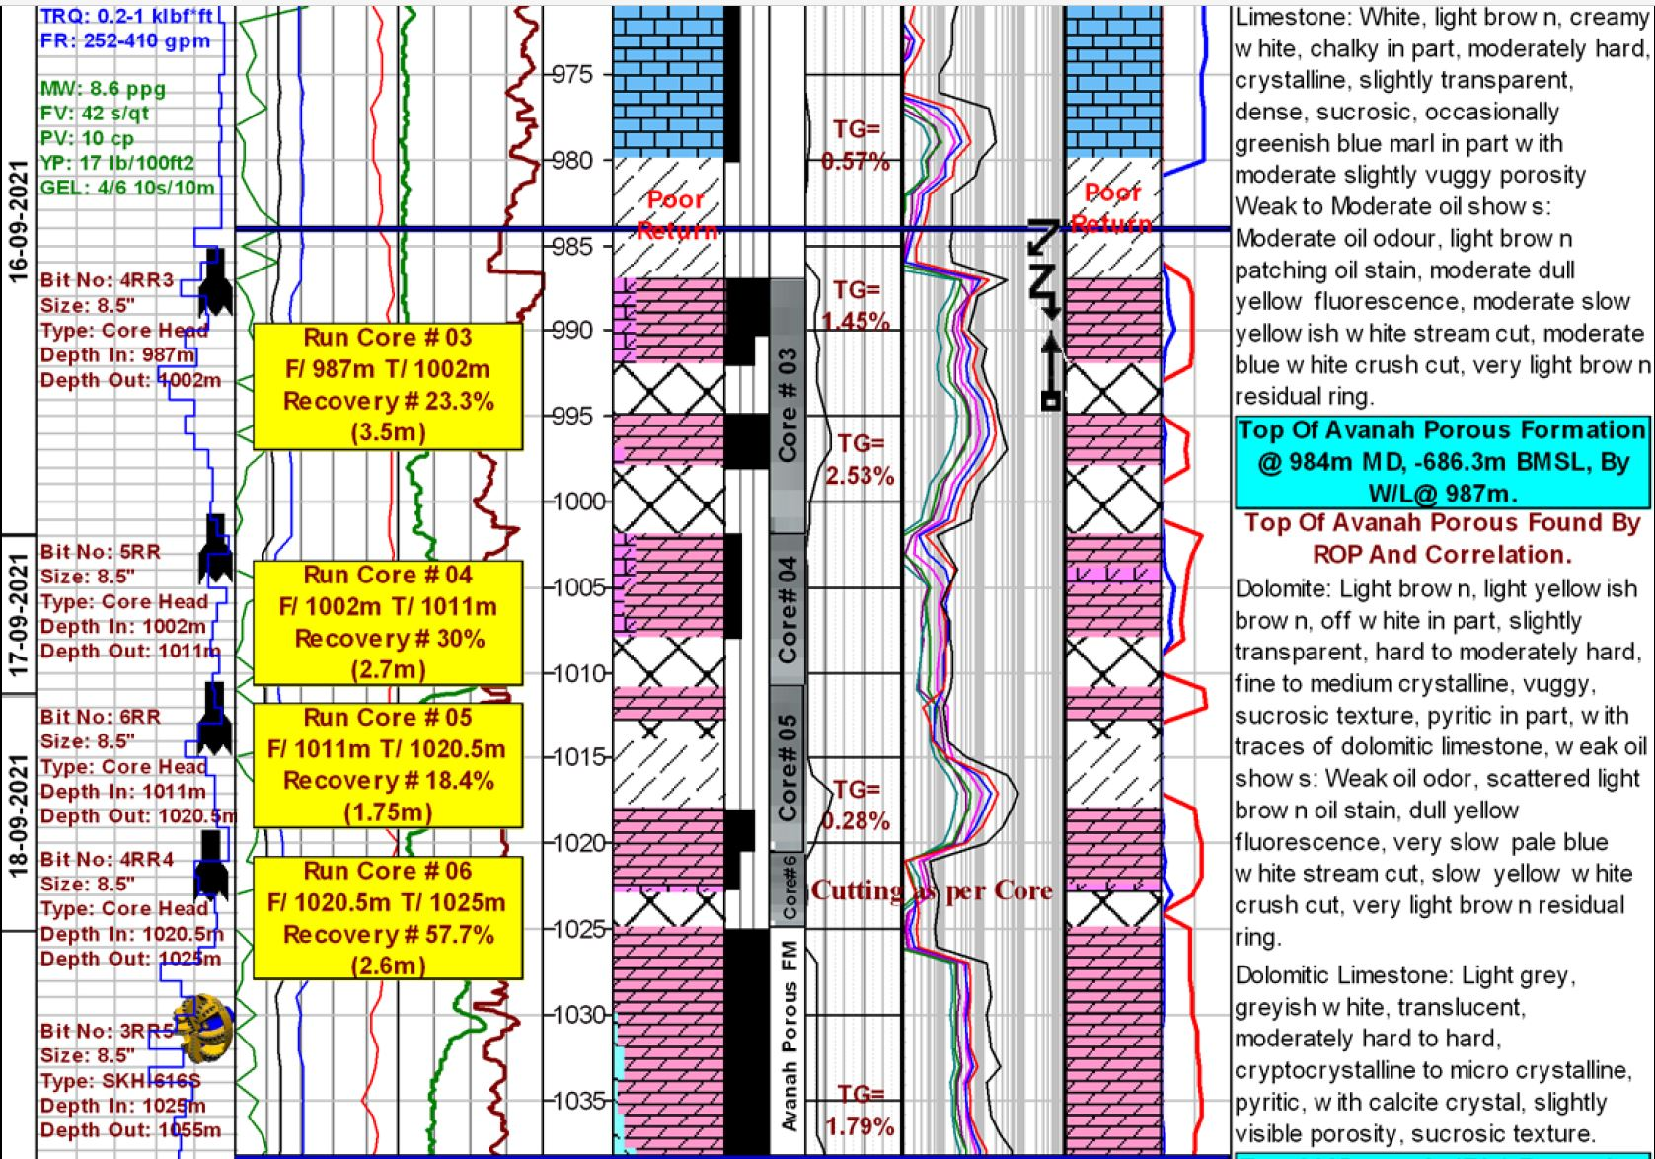
Figure 3.2 Avanah Formation Master Log

Table 3.4 Local Case Studies
Wells | Type of Wells | Type of Losses | Solution
PW-01 | Production Well | Total Losses | LCM with Cement Plug
WI-01 | Water Injection Well | Partial Losses | LCM
WO-01 | Workover Well | Total Losses | Composite Plug

1. PW-01
During the drilling operation of the last sections of this production well, especially Avanah formation, total losses were faced. Before commencing cementing completion operations, it was decided to prepare LCM and attempt to cure the existing losses. After several unsuccessful LCM pills, the usage of cement plug alongside LCM was suggested. In conclusion, the final LCM pill aided with cement plug was able to solve the issue. This case is especially beneficial to study, as it demonstrates that the usage of LCM alone is not always the answer.
2. WI-01
Similar to the formation presented during the drilling operation of well PW-01, this well started to loss drilling fluid near the top of Avanah formation near 1000-meter mark. Started with a high amount of losses, around 200 bbl/hr and this amount changed as more depths were drilled, refer to figure 3.3 for more details. Similar to PW-01, upon reaching the target depth 5 LCM pills with various concentrations, refer to table 3.5, were pumped to cure the available 100 bbl/hr losses. Ultimately, the formation was successfully cured and cementing operation commenced with no losses.

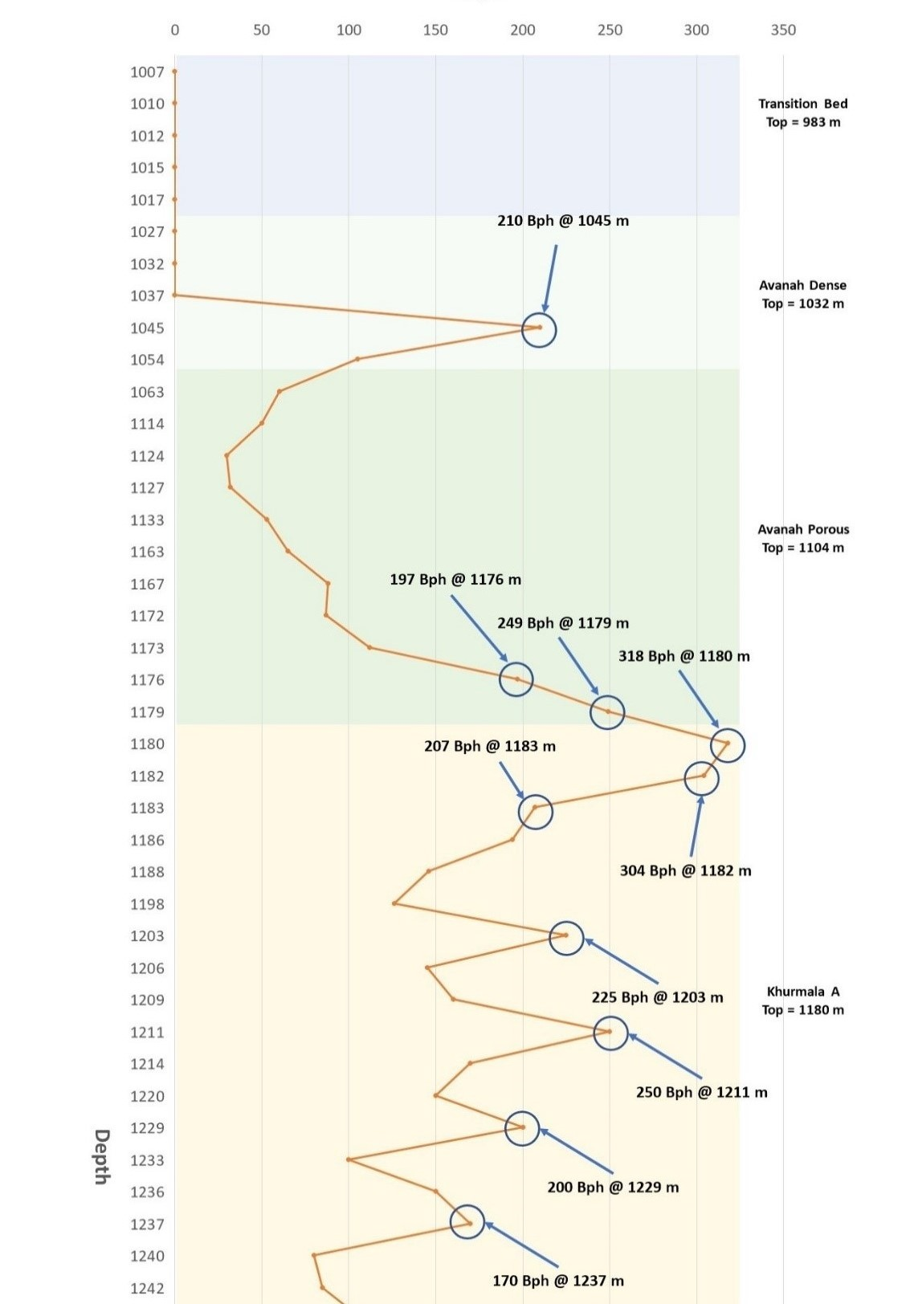

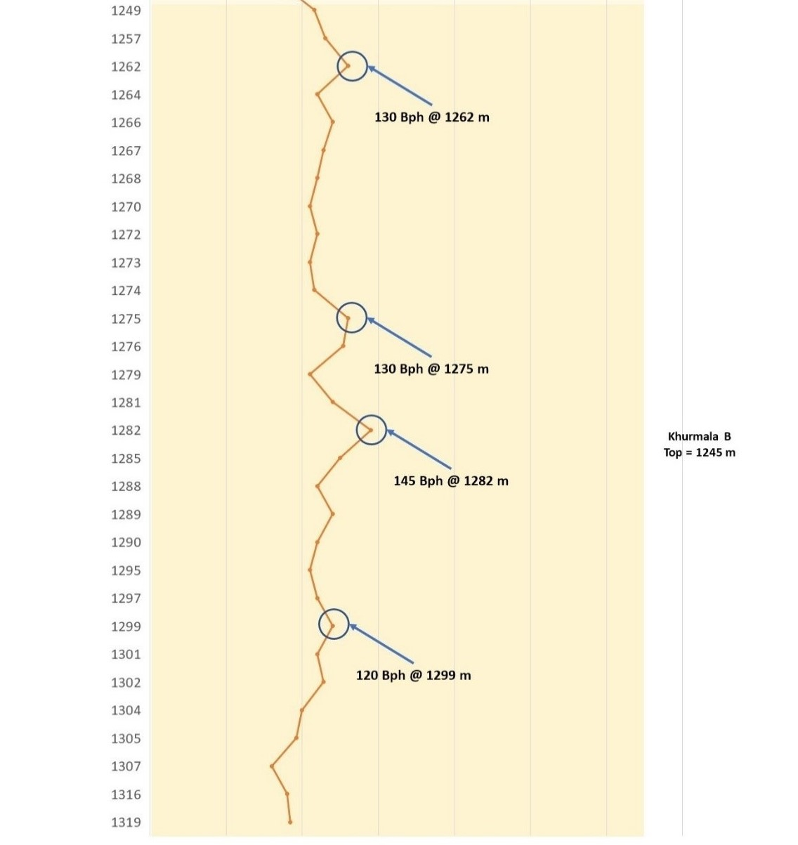
Figure 3. 3 WI-01 Losses per Depth Graph

Table 3.5 WI-01 LCM Pill Concentration
LCM Pills | Concentration | Type of Losses | Concentration
LCM #1 | P-XCD = 2 lb/bbl  P-Carb F = 22 lb/bbl  P-Carb C = 22 lb/bbl  P-Lock F = 4 lb/bbl  P-Lock M = 3 lb/bbl  P-Lock C = 3 lb/bbl  P-Carb UC = 11 lb/bbl  P-Shell F = 13 lb/bbl  P-Shell M = 12 lb/bbl  P-Shell C = 12 lb/bbl | LCM #3 | P-XCD = 3 lb/bbl  P-Carb F = 22 lb/bbl  P-Carb M = 22 lb/bbl  P-Lock F = 4 lb/bbl  P-Lock M = 3 lb/bbl  P-Lock C = 3 lb/bbl  P-Carb UC = 22 lb/bbl  P-Shell F = 14 lb/bbl  P-Shell M = 13 lb/bbl  P-Shell C = 13 lb/bbl
LCM #2 | P-XCD = 3 lb/bbl  P-Carb F = 22 lb/bbl  P-Carb C = 22 lb/bbl  P-Lock F = 4 lb/bbl  P-Lock M = 3 lb/bbl  P-Lock C = 3 lb/bbl  P-Carb UC = 11 lb/bbl  P-Shell F = 14 lb/bbl  P-Shell M = 13 lb/bbl  P-Shell C = 13 lb/bbl | LCM #4 | P-XCD = 3 lb/bbl  P-Carb M = 22 lb/bbl  P-Lock F = 7 lb/bbl  P-Lock M = 8 lb/bbl  P-Shell F = 6 lb/bbl  P-Shell M = 4 lb/bbl
LCM #2 |  | LCM #5 | P-XCD = 3 lb/bbl  P-Lock F = 6 lb/bbl  P-Lock M = 4 lb/bbl  P-Carb UC = 22 lb/bbl  P-Shell F = 15 lb/bbl  P-Shell M = 15 lb/bbl
3. WO-01
This well was Workover well which designed and drilled from surface to 1121 m. Workover plan was done to evaluate, test, and complete the well as an oil producer which was facing water cone therefore starting producing from a tertiary (Main-Limestone) reservoir with a completion interval from 1121 to ±965 meters, and ensure to have high-productivity index, and target sustained initial production rate of 2-4 KBOPD with no initial water Cut and gas coning predicted. This section will go through Avanah formations which are mostly consisted of Limestone and Dolomite. This interval includes Reservoir and TD will be changed from 1121 to 965 m. The workover operation was done for 8 ½” hole section, in this section loss of circulation is possible to happen. In case of downhole losses, acid soluble LCMs with different grain sizes, was planned to be premixed and pumped in order to cure losses. And below figures shows initial phase of completion design and final proposed plan.
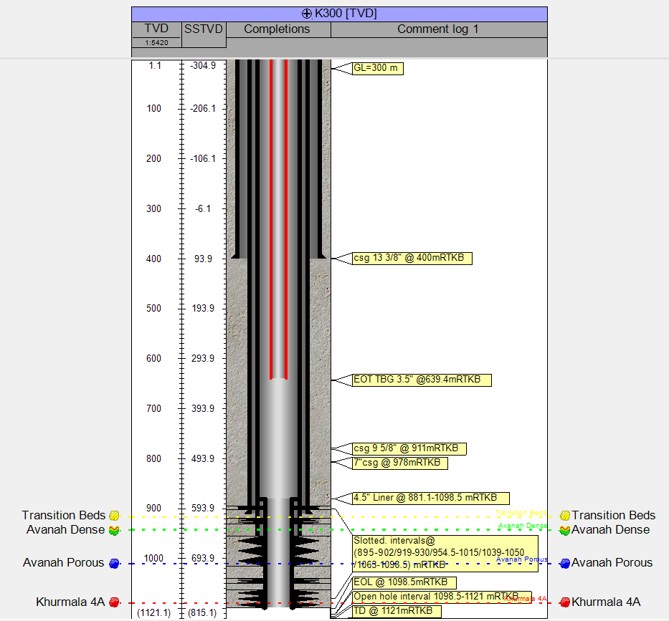
Figure 3.4 Completion design before Workover Operation
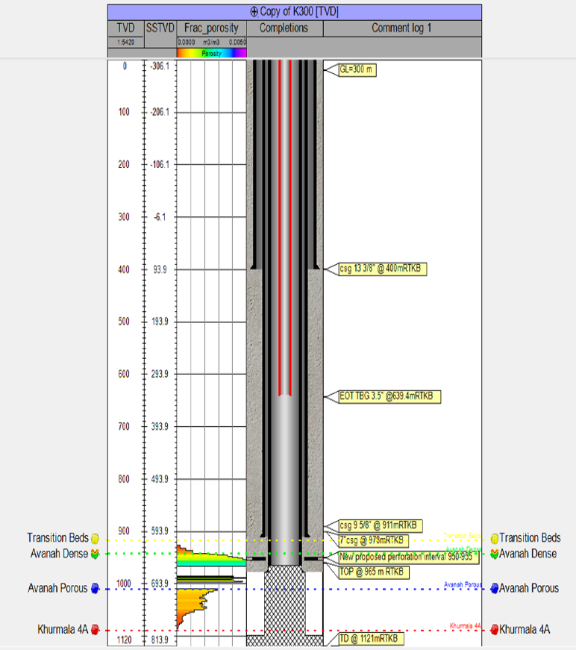
Figure 3.5 Proposed Completion Design

CHAPTER 4: RESULT AND DISCUSSION
4.1 International Company Experiences
Curing lost circulation in drilling operations involves addressing the problem of fluid loss into formations, voids, or fractures within the wellbore. This can result in reduced well productivity and stability, and even the complete loss of the well. To cure lost circulation, common methods include plugging and squeezing, where materials such as clay or cement are injected into the formation to close off voids or fractures, and increasing the density of the drilling fluid to increase the hydraulic pressure and control the well. Other methods include drilling fluid additives to repair the damaged formations, and switching to different drilling fluid systems that are better suited to the specific formation being drilled. The choice of method will depend on the specific circumstances and the cause of the lost circulation. Therefore, below most common techniques have been mentioned:

4.1.1 Generic system
Reverse Gunks (OBM) technique has been used by BP Azerbaijan and BP Wytch Farm experiences and they have used based on below concentration
Table 4.1 Reverse Gunks (OBM) Concentration:
Formulation for “Unweighted Reverse” Gunk Pill
Water | 0.72 bbl
Caustic Soda | 1.5 lb
Dispersant (CFL) | 3.5 lb
Organophilic clay (B128) | 250 lb

The slurry density can be increased to that of the active mud weight by viscosifying the water/clay slurry with XC polymer and adding barite which they are using it in OBM.
The pill was prepare in the cement batch tank and add the ingredients in the order shown utilising as much shear as possible to disperse the organophilic clay (Bentone 128). A pill of approximately 20bbl is recommended. The resultant slurry is preferably pumped through open ended pipe but may be pumped through the bit if it is not practicable to POOH. This technique was used main Pass Block 264 in Amberjack A11 ST#1, 2001 (deepwater). Losses were reduced from 40bbl/hr to a few bbls/hr. And Amberjack A24 ST#1, 1999. After Frac Attack treatment, low ROPs and pack-offs were observed. A cement plug was set and the well sidetracked.

4.1.2 Halliburton System
There have been mixed results with K-Max treatment. Failures have occurred, perhaps mainly due to the lack of bridging solids in the system or incorrect application. Kmax was used on BP Forties Charlie in 2001, well 21/10-C25. An internal breaker was used which was designed to break the gel after 14 days. The aim was to cure losses of around 100 bbls/hr by pumping the treatment down the annulus past a retrievable packer. It proved ineffective although there may have been caverns present leading to failure. A post analysis suggested insufficient material may have been pumped. Losses were eventually cured after 500bl of conventional LCM pills were pumped.

4.1.3 Schlumberger System
Zonelock S was used on Everest (North Sea) in December 2000. Conventional LCMs reduced dynamic losses down from 200bbl/hr and Zonelock S was then used successfully to form a more permanent cure before running casing. Has been used successfully by various Operators in UK, Norway, manland Europe, Algeria, Alaska, and the Middle East

4.2 KRG Case Studies
Cased study experiences and knowledges of working with 3 different wells that had formation loss in Avanah formations. Table 4.2 demonstrates the well profile of these wells curing process. The approached curing process for each well with almost similar steps and depending on LCM decision tree was followed first by estimating highest losses intervals and preparing the most suitable LCMs. Then pumping LCM pills at the desired depths with open-end drill pipes. After that Pulling out of hole to designated depth and allowing soaking time for the LCM for some hours. Finally run in hole and sweep the settled LCM in the well with Hi-Vis. While performing these steps, tank levels were constantly checked to account for any alteration in the losses rate in case it did not succeeded moving to next plans.
Table 4.2 Well Losses Profiles
Well Name | Total Depth (m) | Losses Start Depth (m) | Highest Loss Rate (bbl/hr) | No. of LCM Pill Used | Loss Rate After Curing (bbl/hr)
PO-01 | 1200 | 1080 | Total Loss | 7 | 0
WI-01 | 1350 | 1037 | 318 | 5 | 3
WO-01 | 1100 | 940 | Total Loss | 4 | 0

1. PW-01
Before beginning cementing completion operations, it was decided to prepare LCM and try to cure the existing losses. Near the top of Avanah, this well stated having formation loss up to 130 bbl/hr, as shown in the graph 4.1 then total losses were encountered during the drilling operation of the last sections of this production well, especially the Avanah formation. For PW-01, the curing process proved to be more effective and efficient, but they wanted to test formation and after cured four times then they did pressure test on formation and break it. Curing of PW-01 took 7 LCM pills to achieve borehole stability and after the use of cement plug in conjunction with LCM was suggested to get better formation strength. The concentration of each pill is listed in table 4.3. The problem was finally resolved by the last LCM tablet combined with the cement plug.

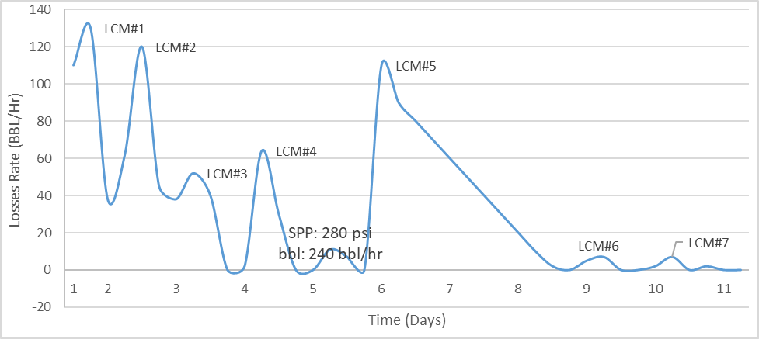
Figure 4.1 Losses rate with days of curing period

Table 4.3 LCM Pills Concentrations in Production Well
LCM Pills | Material Concentration | Pumping Procedure | Effect
LCM #1 | P- Lock F= 5.5 lb/bbl  P- Lock M= 5.5 lb/bbl  Xanthan Gum=2 lb/bbl  P-Carb F= 22 lb/bbl  P-Carb M = 22 lb/bbl  P-Carb C= 22 lb/bbl  P-Carb UC= 22 lb/bbl | Pumped 100 BBL of LCM at 1150 m. POOH to 700 m and 12 hrs of soaking. | During soaking time losses decreased to 38 BBL/hr from 130 BBL/hr.
LCM #2 | P- Lock F= 8.25 lb/bbl  P- Lock M= 8.25 lb/bbl  P- Lock C= 8.25 lb/bbl  Xanthan Gum= 2 lb/bbl  P-Carb C= 44 lb/bbl  P-Carb UC= 44 lb/bbl | Pumped 100 BBL of LCM at 1161 m. POOH to 725m and 13 hrs of soaking. | During soaking time losses = decreased to 35 BBL/hr from 120 BBL/hr.
LCM #3 | Fiber Lock F= 5.5 lb/bbl  P-Lock M= 8.25 lb/bbl  P- Lock C= 8.25 lb/bbl  Xanthan Gum= 2 lb/bbl  P-Carb M= 22 lb/bbl  P-Carb C= 44 lb/bbl  P-Carb UC= 22 lb/bbl | Pumped 50 BBL of LCM at 1190 m POOH to 806m and 3 hrs of soaking then RIH to 1180 m and Pumped 50 BBL of LCM. | During soaking time Losses = decreased to 0 BBL/hr from 52 BBL/hr. Later went back up to 64 BBL/hr after they did formation pressure.
LCM #4 | P- Lock F= 8.25 lb/bbl  P- Lock M= 8.25 lb/bbl  P- Lock C= 8.25 lb/bbl  Xanthan Gum= 2 lb/bbl  P-Carb M= 22 lb/bbl  P-Carb C= 44 lb/bbl  P-Carb UC= 22 lb/bbl | Pumped 100 BBL of LCM at 1100 m. POOH to 769m and 6 hrs of soaking. | During soaking time Losses = decreased to 0 BBL/hr from 64 BBL/hr.
LCM #5 | 8.25 lb/bbl P- Lock M  8.25 lb/bbl P- Lock C  1.65 lb/bbl Xanthan Gum  66 lb/bbl P-Carb C  22 lb/bbl P-Carb UC | Pumped 100 BBL of LCM at 1020 m. POOH to 600m and 4 hrs of soaking. | During soaking time Losses decreased to 0 BBL/hr from 11 BBL/hr. Later went back up to 110 BBL/hr after they did formation pressure.
LCM #6 | P- Lock M= 8.25 lb/bbl  P- Lock C= 8.25 lb/bbl  Xanthan Gum= 3.3 lb/bbl  P-Carb M= 66 lb/bbl  P-Carb C= 22 lb/bbl | Pumped 100 BBL of LCM at 1161 m. POOH to 725m and 13 hrs of soaking. | During soaking time losses = decreased to 0 BBL/hr from 7 BBL/hr.
LCM #7 | P- Lock M= 8.25 lb/bbl  P-Lock C= 8.25 lb/bbl  Xanthan Gum= 2.2 lb/bbl  P-Carb M= 44 lb/bbl  P-Carb C= 44 lb/bbl  P-Carb UC= 22 lb/bbl | Pumped 100 BBL of LCM at 1160 m. POOH to 600 m and 6 hrs of soaking. | During soaking time Losses = decreased to 0 BBL/hr from 52 BBL/hr. Later went back up to 64 BBL/hr after they did formation pressure.

- WI-01
The conditions at the time of Mud loss was accurately recorded and studied. Therefore, WI-01 all information was recorded, and the figure XXX was prepared. Formation in this interval consisted of Limestone and Dolomite in Avanah formation since the well was drilled in the boundary of formation and rocks were more compacted this resulted in curing losses with only conventional materials. This section went through the Avanah formation at 1034m, encountered 210 bbl/hr formation loss and resumed drilling with water as the drilling fluid to section TD (1357m). For the curing process in the WI-01, they prepared 5 batches of LCM Pills, each with a different composition, and pumped them at the designated intervals. These pills were able to completely stop mud loss and decrease it from up to 114 BBL/hr to zero. The pills were as follows:
Table 4.4 LCM Pills Concentrations in Water Injection Well
LCM Pills | Material Concentration | Pumping Procedure | Effect
LCM #1 | Xanthan Gum = 2 lb//BBL  P-Carb F = 22 lb//BBL  P-Carb C = 22 lb//BBL  P-Lock F = 4 lb//BBL  P-Lock M = 3 lb//BBL  P-Lock C = 3 lb/BBL  P-Carb UC = 11 lb//BBL  P-Shell F = 13 lb//BBL  P-Shell M = 12 lb//BBL  P-Shell C = 12 lb//BBL | Pumped 40 BBL of LCM followed by 20 BBL of Hi-Vis at 1355 m.  POOH to 995m and 4 hrs of soaking. | During soaking time losses decreased to 60 BBL/hr from 114 BBL/hr.
LCM #2 | Xanthan Gum = 3 lb//BBL  P-Carb F = 22 lb//BBL  P-Carb C = 22 lb//BBL  P-Lock F = 4 lb//BBL  P-Lock M = 3 lb//BBL  P-Lock C = 3 lb//BBL  P-Carb UC = 11 lb//BBL  P-Shell F = 14 lb//BBL  P-Shell M = 13 lb//BBL  P-Shell C = 13 lb//BBL | Pumped 50 BBL of LCM followed by 30 BBL of Hi-Vis at 1261 m.  POOH to 902m and 3 hrs of soaking. | During soaking time losses = decreased to 35 BBL/hr from 72 BBL/hr.
LCM #3 | Xanthan Gum = 3 lb//BBL  P-Carb F = 22 lb//BBL  P-Carb M = 22 lb//BBL  P-Lock F = 4 lb//BBL  P-Lock M = 3 lb//BBL  P-Lock C = 3 lb//BBL  P-Carb UC = 22 lb//BBL  P-Shell F = 14 lb//BBL  P-Shell M = 13 lb//BBL  P-Shell C = 13 lb//BBL | Pumped 50 BBL of LCM followed by 20 BBL of Hi-Vis at 1180 m.  POOH to 806m and 3 hrs of soaking. | During soaking time Losses = decreased to 4 BBL/hr from 30 BBL/hr. Later went back up to 17 BBL/hr after circulation.
LCM #4 | Xanthan Gum = 3 lb//BBL  P-Carb M = 22 lb//BBL  P-Lock F = 7 lb//BBL  P-Lock M = 8 lb//BBL  P-Shell F = 6 lb//BBL  P-Shell M = 4 lb//BBL | Pumped 50 BBL of LCM followed by 10 BBL of Hi-Vis at 1309 m.  POOH to 989m and 3 hrs of soaking. | During soaking time Losses = decreased to 15 BBL/hr from 17 BBL/hr. LCM mainly ineffective due to incorrect location of pumping, below the fracture.
LCM #5 | Xanthan Gum = 3 lb//BBL  P-Lock F = 6 lb//BBL  P-Lock M = 4 lb//BBL  P-Carb UC = 22 lb//BBL  P-Shell F = 15 lb//BBL  P-Shell M = 15 lb//BBL | Pumped 50 BBL of LCM followed by 20 BBL of Hi-Vis at 1017 m.  POOH to 873m and 3 hrs of soaking. | During soaking time Losses decreased to 3 BBL/hr from 15 BBL/hr.

- WO-01
In the case of this workover well, after the completion string was retreated and circulation commenced, total losses occurred, due to the age of the well and improper perforation. LCM pills were prepared and pumped with various concentrations and at different rates, with no success and continues total losses. Eventually, it was decided to set a composite plug at the top of the losses interval to block it off and later seal it completely by cementing the top of the plug and they perforated the upper section and started producing from there. This technique proved to be successful and this case confirms that LCM pills, no matter the concentration, are not always able to cure losses and instead in some situations it is necessary to use more extreme methods.

CHAPTER 5: CONLUSION
Curing losses may have a substantial influence on the production process, product quality, and profitability in any business that uses curing procedures, such as the oil and gas industry. As a result, employing strategies to reduce curing losses is essential to ensuring the best possible product performance and production efficiency.

Like any other oil-producing area, Kurdistan confronts difficulties with the curing process, including inadequate curing, warpage, and delamination. Implementing strategies like process optimization, cutting-edge curing technologies and equipment, and material selection might be useful for overcoming these difficulties.

However, putting these strategies into practice takes large investments in technology, equipment, and research, which may not be possible for all of the businesses in the area. Additionally, political unrest and financial issues can make it difficult to put these strategies into practice.

In conclusion, reducing cure losses is crucial for the success of the oil and gas business, notably in the Kurdistan area. Utilizing strategies to reduce curing losses might have a positive impact on production efficiency and product quality. However, putting these strategies into practice entails overcoming a number of obstacles, including political and economic ones.

6 References

Abdo, J. and Haneef, M. (2012). Nano-Enhanced Drilling Fluids: Pioneering Approach to Overcome Uncompromising Drilling Problems. J. Energy Resour. Technol., 134(1),p.014501.
Abdo, J. and Haneef, M.D., 2010, August. Nanoparticles: Promising solution to overcome stern drilling problems. In Nanotech Conference and Exhibition, Anaheim, California (pp. 6-8).
Ahmadi, M.A. and Shadizadeh, S.R., 2013. Induced effect of adding nano silica on adsorption of a natural surfactant onto sandstone rock: experimental and theoretical study. Journal of Petroleum Science and Engineering, 112, pp.239-247.
Al-Ali, M. H., & Bai, B. (2017). Lost circulation management: Current practices and future perspectives. Journal of Natural Gas Science and Engineering, 47, 152-165.
Alsaba, Mortadha, Runar Nygaard, Arild Saasen, and Olav-Magnar Nes. "Lost circulation materials capability of sealing wide fractures." In SPE Deepwater Drilling and Completions Conference. OnePetro, 2014.
AM Sulaiman, Mohammed, and Abdalaziz M AL-Hamdany. (2014) "Porosity of Avanah Formation and its stratigraphical distribution in selected wells of Kirkuk Oil Field." Iraqi National Journal of Earth Science 14, no. 1: 49-66.
ASME, S. S. c., 2011. Drilling fluids processing handbook.. s.l.:Elsevier.
Austin, E.H., 2012. Drilling engineering handbook. Springer Science & Business Media.
Bellen, RC Van, H. V. Dunnington, R. Wetzel, and D. M. Morton. (1959) "Lexique stratigraphique international Asie." Iraq. Intern. Geol. Conger. Comm. Stratigr 3: 333.
Bloys, B., Davis, N., Smolen, B., Bailey, L., Houwen, O., Reid, P., Sherwood, J., Fraser, L. and Hodder, M., 1994. Designing and managing drilling fluid. Oilfield Review, 6(2), pp.33-43.
Cameron, C., 2001, October. Drilling fluids design and management for extended reach drilling. In SPE/IADC Middle East Drilling Technology Conference. OnePetro.
Chen, L., Li, X., Liu, C., & Zhang, J. (2020). Multi-factor coupling model for lost circulation in directional drilling through weak zones. Journal of Petroleum Science and Engineering, 193, 107315.
Chenevert, M. E., & Sharma, M. M. (1995). Drilling fluid loss prevention: An overview. SPE Drilling & Completion, 10(1), 51-58.
Collins, A. Gene. "DRILLING AND COMPLETION OPERATIONS." In Environmental Aspects of Chemical Use in Well-drilling Operations: Conference Proceedings: May 1975, Houston, Texas, vol. 1, p. 231. Office of Toxic Substances, Environmental Protection Agency, 1975.
Ewy, R.T. and Morton, E.K., 2009. Wellbore-stability performance of water-based mud additives. SPE Drilling & Completion, 24(03), pp.390-397.
Fionn Iversen and Thomas Geehan, 2015. Drilling Fluid Processing:Preparation, Maintenance and Continuous Conditioning, s.l.: IEEE Instrumentation & Measurement Magazine.
Gaurina-Medjimurec, Nediljka, and Borivoje Pasic. (2014) "Risk due to pipe sticking." In Risk Analysis for Prevention of Hazardous Situations in Petroleum and Natural Gas Engineering, pp. 47-72. IGI Global, 2014
Gazaniol, D., Forsans, T., Boisson, M.J.F. and Piau, J.M., 1995. Wellbore failure mechanisms in shales: prediction and prevention. Journal of petroleum technology, 47(07), pp.589-595.
Gong, H., Liu, J., Lin, M., & Zhang, G. (2020). An experimental investigation of lost circulation in fractured formation during drilling. Journal of Petroleum Science and Engineering, 194, 107381.
Grace, Robert D. 1994, Advanced blowout & well control. Gulf Professional Publishing,
Guo, J., Shi, Y., & Zhang, H. (2017). Experimental study of lost circulation in directional drilling through shallow fractured formations. Journal of Petroleum Science and Engineering, 158, 514-525.
Guo, J., Zhang, H., Huang, D., Zhang, B., & Feng, J. (2016). A study of lost circulation in fractured formations during drilling. Journal of Natural Gas Science and Engineering, 33, 1239-1250.
Holditch, S.A. and Chianelli, R.R., 2008. Factors that will influence oil and gas supply and demand in the 21st century. MRS bulletin, 33(4), pp.317-323
Hu, J., Zhang, J., Li, X., & Liu, Y. (2019). Investigation of the effect of mud properties on lost circulation in weak zones using a new coupling model. Journal
Inkpen, A.C. and Moffett, M.H., 2011. The global oil & gas industry: management, strategy & finance. PennWell Books.
Islam, M. a. H. M., 2020. Drilling Engineering: Towards Achieving Total Sustainability. s.l.:Gulf Professional Publishing.
Jahn, F., Cook, M. and Graham, M., 2008. Hydrocarbon exploration and production (Vol. 55). Elsevier.
Jassim, Saad Z., and Jeremy C. Goff, eds. (2006) Geology of Iraq. DOLIN, sro, distributed by Geological Society of London,
Jiang, Zaixing, Zhang, Wenzhao, Liang, Chao, Wang, Yongshi Liu, Huimin and Chen, Xiang , 2016. Basic characteristics and evaluation of shale oil resrvoirs. Petroleum Research, Volume 2, pp. 149-163.
Khodja, M., Canselier, J.P., Bergaya, F., Fourar, K., Khodja, M., Cohaut, N. and Benmounah, A., 2010. Shale problems and water-based drilling fluid optimisation in the Hassi Messaoud Algerian oil field. Applied Clay Science, 49(4), pp.383-393.
Khodja, M., Khodja-Saber, M., Canselier, J.P., Cohaut, N. and Bergaya, F., 2010. Drilling fluid technology: performances and environmental considerations. In Products and services; from R&D to final solutions. IntechOpen.
Li, L., Sun, J.S., Xu, X.G., Ma, C., Yang, Y.P. and Yuan, X.B., 2012. Study and application of nanomaterials in drilling fluids. In Advanced Materials Research (Vol. 535, pp. 323-328). Trans Tech Publications
Li, X., Li, Q., Li, H., & Li, L. (2019). Study on lost circulation mechanism and control technology in deep drilling. Petroleum Science and Technology, 37(21), 2528-2535.
Li, X., Li, Q., Li, L., & Wang, X. (2018). Experimental investigation of lost circulation in directional drilling through weak formations. Journal of Natural Gas Science and Engineering, 58, 244-253.
Mahto, V. and Sharma, V.P., 2004. Rheological study of a water based oil well drilling fluid. Journal of Petroleum Science and Engineering, 45(1-2), pp.123-128.
Mitchell, Robert F. (2007) "The effect of friction on initial buckling of tubing and flowlines." SPE Drilling & Completion 22, no. 02 112-118.
Nazhat, D.H. and Preining, P., 2013, October. Advantages and Achievements of Multiphase Managed Pressure Drilling on Exploratory Well in Sarsang Block in the Kurdistan Region of Iraq. In SPE/IADC Middle East Drilling Technology Conference & Exhibition. Society of Petroleum Engineers.
Noah, A., El-Khadragy, A., Ramadan, F. & and Mohamed, M., 2019. The Effect of Nano Drilling Fluids on Reduction of Clay Swelling.. Int J Nanoparticles Nanotech,, Volume 5, p. 24.
Ottesen, S., Benaissa, S. and Marti, J., 1999, March. Down-hole simulation cell for measurement of lubricity and differential pressure sticking. In SPE/IADC drilling conference. OnePetro.
Pool, J.R., Pool James R, 1986. Self-cleaning mud pit. U.S. Patent 4,563,280. Professional Publishing; 2012.
Rana, A., Arfaj, M. K. & Saleh, T. A., 2019. Advanced Developments in Shale Inhibitors for Oil Production with Low Environment Footprints. Fuel, p. 247.
Roco, M.C., 2001. International strategy for nanotechnology research. Journal of Nanoparticle Research, 3(5-6), pp.353-360.
Saboori, R., Sabbaghi, S. and Kalantariasl, A., 2019. Improvement of rheological, filtration and thermal conductivity of bentonite drilling fluid using copper oxide/polyacrylamide nanocomposite. Powder Technology, 353, pp.257-266.
Song, S., Li, X., & Wei, B. (2020). Numerical simulation of lost circulation in fractured formations during drilling. Journal of Natural Gas Science and Engineering, 84, 103471.
Sönnichsen, N., 2021. Statista. [Online] Available at: https://www.statista.com/statistics/326727/global-gas-and-oil-rig-numbers-by-region/
Sönnichsen, N., 2022. statista. [Online] Available at: https://www.statista.com/statistics/463369/number-of-global-oil-rigs/ Windsland, Y., 2017. Design of an Offshore Drilling Fluid Maintenance Vessel. NTNU.
Sweatman, R., Wang, H. and Xenakis, H., 2004, October. Wellbore stabilization increases fracture gradients and controls losses/flows during drilling. In Abu Dhabi International Conference and Exhibition. OnePetro.
Vipulanandan, C. and Mohammed, A., 2015. Effect of nanoclay on the electrical resistivity and rheological properties of smart and sensing bentonite drilling muds. Journal of Petroleum Science and Engineering, 130, pp.86-95.
Vipulanandan, C. and Mohammed, A., 2016. Nanoclay Modified Drilling Muds for HPHT Applications (p. 11). AADE-16-FTCE-85.
Wang, Q., Liu, W., Tang, J., Song, W., & Zhang, X. (2020). A new approach to predicting the lost circulation zone in shale formations. Journal of Petroleum Science and Engineering, 187, 106714.
Wang, Z., Guo, J., Liu, Y., Liu, G., & Zhang, H. (2019). Mechanisms of lost circulation in deep and ultra-deep drilling: A review. Journal of Petroleum Science and Engineering, 173, 752-760.
Whitfill, D.L. and Hemphill, T., 2003, October. All lost-circulation materials and systems are not created equal. In SPE annual technical conference and exhibition. OnePetro.
Windsland, Y., 2017. Design of an Offshore Drilling Fluid Maintenance Vessel. NTNU.
Xu, Chengyuan, Honglin Zhang, Yili Kang, Jingyi Zhang, Yingrui Bai, Juan Zhang, and Zhenjiang You. 2022 "Physical plugging of lost circulation fractures at microscopic level." Fuel 317 (123477.
Yang, J., Li, X., Li, Y., & Zhang, J. (2021). A field study on lost circulation mechanism and control technology in the Changning shale gas field. Journal of Petroleum Science and Engineering, 197, 108151.
Yunita, P., Irawan, S. and Kania, D., 2016. Optimization of water-based drilling fluid using non-ionic and anionic surfactant additives. Procedia engineering, 148, pp.1184-1190.
Zhang, G., & Liu, Y. (2019). Numerical investigation of the impact of mud weight and wellbore pressure on lost circulation in naturally fractured formations. Journal of Natural Gas Science and Engineering, 64, 174-183.
Zhang, G., Zhu, W., & Ma, J. (2016). A review of lost circulation mechanisms and treatment strategies. Journal of Natural Gas Science and Engineering, 34, 198-206.
Zhang, J. Lang, and W. Standifird, “Stress, porosity, and failure-dependent compressional and shear velocity ratio and its application to wellbore stability, ”Journal of Petroleum Science and Engineering,vol.69,no.3-4,pp.193–202,2009

