# The development of sociolinguistic competence in the EFL classroom

Diplomová práce

Zuzana Otevřelová

Prohlášení

Prohlašuji, že jsem diplomovou práci vypracovala samostatně s využitím uvedených pramenů a literatury a souhlasím s uveřejněním této práce.

V Olomouci dne 11.6.2022

……………………………………...

vlastnoruční podpis

Acknowledgement

This project was written as a part of the student project IGA_Pdf_2021_021 *The phenomenon of informal learning with a focus on online technologies for future English language teachers* at Palacký University in Olomouc.

**Abstract**

The thesis focus is on the development of sociolinguistic competence in the EFL classroom. The thesis is aimed at secondary schools. It examined the development of sociolinguistic competence and its relationship with culture. It examined how various factors such as age, social group, geographical location and so on that have an influence on the language. This thesis gives reasons why sociolinguistic competence is important in teaching and how its teaching can be reflected in schools. It describes an approach suitable for teaching sociolinguistic competence, together with appropriate materials and their use. It examines how much school coursebooks focus on sociolinguistic competence and whether they need to be adapted in any way. The thesis explores teachers' views and their teaching of sociolinguistic competence and investigates how teachers work with teaching materials. It provides suggestions on how to implement sociolinguistic competence in the classroom and offers activities that create this competence.

Contents

Introduction 4

THEORETICAL PART 6

1. Sociolinguistic competence 6

1.1 Markers of social relations 10

1.2 Politeness conventions 13

1.3 Expressions of folk-wisdom 16

1.4 Register differences 17

1.5 Dialect and accent 19

1.5.1 Dialects 19

1.5.2 Accents 21

2. Sociolinguistic competence in education 23

2.1 Communicative activities 24

2.1.1 Communicative Language Teaching (CLT) 26

2.2 Intercultural education 27

2.3 The role of the teacher 29

3. Teaching materials 32

3.1 Coursebooks 36

3.2 Authentic materials 39

4. Summary of theoretical part 43

PRACTICAL PART 44

5. Coursebooks analysis 46

5.1 Project 3 (4th edition) 47

5.2 Project Explore 2 49

5.3 Focus 2 51

5.4 Way to Win 53

5.5 Coursebook analysis conclusion 56

6*.* Teacher’s questionnaire 57

7. Activities aiming at developing sociolinguistic competence 62

7.1 Difficult situations 62

7.2 Mood Swing Script 64

7.3 Offers and Promises 66

8. Summary of the practical part 68

Conclusion 70

Bibliography 73

List if appendixes 79

Anotace 94

Resumé 96

Introduction

The thesis is dedicated to the development of sociolinguistic competence in the EFL classroom. It focuses on the theory behind sociolinguistic competence and presents several linguists who have dealt with this subject and contributed to its development.

The thesis is divided into two parts, the theoretical part and the practical part. The theoretical part is divided into three main chapters and they are sociolinguistic competence, sociolinguistic competence in education and teaching materials.

The first chapter focuses on the definition of sociolinguistic competence and what it has to do with linguistics and pragmatics. It deals with various parts of sociolinguistic competence which are markers of social relations, politeness conventions, expressions of folk wisdom, register differences and dialects and accents. It examines how different aspects of sociolinguistic competence influence language use.

The second chapter is devoted to sociolinguistic competence in education. It deals with how sociolinguistics competence became a part of teaching and what approach is appropriate for teaching sociolinguist competence as well as examines how cultural awareness is an integral part of teaching those competences and what teachers have to be like in order to present them with sociolinguistic competence in an understandable way.

Lastly, the thesis investigates what is the role of teaching materials and coursebooks in schools. Because the practical part consists of an analysis of the coursebook and the creation of authentic materials there is a description that is more detailed in the theoretical part.

The practical part is broken down into three parts. The first one is the coursebook analysis, where according to the criteria by CEFR the coursebooks are evaluated. The goal is to find out how much coursebooks deal with sociolinguistic competences and what adaptions might be needed. The following part is small scale research for secondary school teachers which examines the teachers' views on sociolinguistic competence. This part’s aim is to figure out how satisfied are teachers with the presentation of sociolinguistic competence in the coursebooks they use, what materials teachers use to teach sociolinguistics and how they teach sociolinguistic competence. The third section of the practical part is devoted to the three activities that are focusing on developing sociolinguistic competence. The goal of this part is to create activities suitable for teaching sociolinguistic competence.

# THEORETICAL PART

1. Sociolinguistic competence

This section is focused on the definition of sociolinguistic competence and its connections with pragmatic and linguistic competences. Followed by a chapter dedicated to the markers and of social relations that explains the use of different variations of greetings and addressee forms. The next chapter is describing politeness conventions. This chapter is concerned with how language is used in social interactions. The following chapter focuses on folk wisdom expressions that describe idioms and proverbs. The next chapter is called register differences and describes various degrees of formality. The last chapter of this part is dialect and accent which is concerned with different types of dialects and the meaning of accent.

Sociolinguistic competence encompasses the ability to use and understand a broad set of social words, phrases, and idioms. This includes being able to understand and use the basic terms and phrases common to a particular field or subfield, being able to use the appropriate terms for a specific situation and being able to use the right word at the right time. It also includes being able to use more advanced social words and phrases as needed, such as being able to describe what a subfield is in one field using the same terms used in a different field. It also includes being able to use the right words when talking about social topics with other professionals in the same field, such as the terms and phrases used in job interviews, conferences, and professional social gatherings. Sociolinguistics is the study of the relationship between language and culture. It is a field of study that claims human society is made up of a variety of interconnected patterns and behaviours. (Wardhaugh, 2015: 1)

Sociolinguistic competence is a part of communicative language competences. These competences are important for our everyday communication and understanding. They allow us to combine words into single utterances and to understand the communication of others. In the context of education, they serve as an important tool for language development and learning. Communicative language competences are essential for developing knowledge of the world and for contributing to society. To gain communicative competence, the child must be able to understand the meaning of words and how language works. It is not enough to simply learn to speak; the child must also learn to understand what is being said to him or her. Communicative competence also involves the ability to contribute appropriately to the process of creating and exchanging knowledge. When children are at this stage of their development, they are able to understand what is being said to them and to contribute appropriate responses. (Wardhaugh, 2015: 231) There are three types of communicative competence: linguistic, sociolinguistic, and pragmatic (CEFR,2001: 131).

Linguistic competence refers to the knowledge and skills necessary to understand and use language. Knowledge of vocabulary, grammar, pronunciation, word order, and the meanings of words are all aspects of linguistic competence. The ability to use language, either orally or in writing, also constitutes linguistic competence. Linguistics varies from sociolinguistics in that it primarily focuses on language structure, ignoring the social settings in which it is acquired and used. According to this perspective, the goal of linguistics is to figure out "*the rules of language*." (Hudson, 1996: 3). In contrast to sociolinguistics, the primary interest of which is in how language is used and understood in social interaction, the primary interest of linguistics is in the rules that govern the structure of languages. The rules of language can be described by linguists as the principles that govern the formation of sentences, including the principles of the case, tense, agreement, and concord, which regulate the relationships between words in a sentence.

Pragmatic competence is the ability to communicate effectively in an appropriate environment. This includes managing uncertainty, persuading others, and being accepted. It also includes being able to make decisions when the context requires it. Pragmatic competence is the ability to understand what is needed in a particular situation and to be able to respond appropriately. Pragmatics is the systematic study of the relationships between linguistic features of sentences and their aspects as social action. According to the concept of social action, individuals engage in social activities when they are speaking. From the perspective of sociological theory, which is a known theoretical perspective on language in use, asking someone to lock the door, getting a latte at the local coffee shop, and narrating a story about one's parents are all acts. (LoCastro, 2012: 5) Pragmatics is the study of how language is used in such social action and different situations. The study of pragmatics is often considered part of the larger, more general field of discourse theory, which is the study of how language is used in social action. (Brown, 2005: 207)

Sociolinguistic competence refers to the knowledge and skills necessary to understand and use language in social contexts. Knowledge of how language functions in different social situations, such as in business or with teachers, in the media, or with strangers, also constitutes sociolinguistic competence. The ability to use language in situations where you have to make others understand you and where you have to get your message across also constitutes sociolinguistic competence. An example of sociolinguistic competence is the ability to understand and contribute to a conversation with a group of people. An example of sociolinguistic incompetence is the inability to understand what is being said to you even though you speak and understand the language well. (Spolsky, 1993: 3)

There are different definitions of sociolinguistic competence. One of them is “Sociolinguistics is the study of our everyday lives – how language works in our casual conversations and the media we are exposed to, and the presence of societal norms, policies, and laws which address language” (Wardhaugh, 2015: 21) by Canadian professor of linguistics. Sociolinguistics is the study of beliefs on how cultural standards relate to human language use. The environment we are accompanied by influences our behaviour and the actions we make. Sociolinguistics is defined as the study of language "in society" or "in its social environment," according to the more common definitions. Other definitions concentrate on the study of linguistic diversity or variation. These simple definitions have one thing in common: they prioritize language and then add a brief understanding of what feature of language should be prioritized or what type of data should be prioritized. (Coupland, 2007: 4)

As for the word competence, one of the influential figures in sociolinguistics is linguist Chomsky who came up with a theory of competence. According to Chomsky the word competence is described as the knowledge of the abstract rules of the language while performance is referred to as the actual use of language in specific settings. Basically, competence is a set of rules that he or she understands, whereas their performance is what they do (Chomsky, 1970: 4). The fundamental goal of Chomsky's linguist theory was to define the abstract abilities that allow speakers to construct grammatically accurate sentences in a language. It was founded on a cognitive understanding of language. Linguist Hymes held a different view on the linguist theory. Linguistic theory, according to Hymes, should be viewed as part of a larger framework that includes communication and culture. Hymes' communicative competence theory defines what a speaker needs to know in order to communicate effectively in a speech community. A person who gains communicative competence, according to Hymes, gains both knowledge and skill to utilize language (Richards, 2014: 88).

This chapter defined sociolinguistic as an ability to understand why language is used in a way it is in a certain social context and how culture influences the word choice people make as well as described the word competence that has been defined by Chomsky as an abstract set of rules. Pragmatics and linguistics were defined, as they are part of the communicative competences. Linguistics is an ability to use language and to understand sentence structure and pragmatics is an ability to use language properly in social situations.

* 1. Markers of social relations

This chapter describes how different cultures have different customs when it comes to meeting people. It focuses on the different ways of greetings and addressee forms in various situations as well as formal and informal differences.

These vary greatly between languages and cultures, depending on criteria such as relationship, the closeness of the relationship, and speech style. The English expressions may or may not be equivalent in other languages. For people unfamiliar with foreign customs, the use and selection of greetings and goodbyes may be difficult to comprehend. In the United States, people are commonly addressed by their first names or by their title and surname (eg. Dr Smith) (Brown, 2005: 83). The words we use are also influenced by the situation. When we arrive, when we begin a conversation, and when we leave a conversation, we employ various terms. Some people use their names while others use their titles. Some may address people by their title only. The words we use also reflect our culture. One culture's terms for good morning, good afternoon, or good evening may sound different from another. Another culture may have different terminology for these situations altogether. For example, the Japanese refer to these situations as “Arigatō gozaimasu”, which translates to, “Thank you for your hard work,” whereas Americans might say “Hola”, which means, “Hello”. The words we use reflect our culture and may even reflect our profession (Kartika, 2018: 230).

The greeting is a term that is used to describe someone who is meeting someone. “Hello there, visitor! What's up?; I'm sorry, but I'm not sure how I can assist you?” and many more. For specific people in specific situations, each of these greetings has its own time and place. A wide range of greeting terms is available in English. It includes a list of frequent singular and plural identifiers, as well as their relationship. Thousands of forms of gestures and references for those in titled social positions continue to be listed in books of diplomacy etiquette (Mesthrie, 2011: 53).

Another mark of social relationships is addressee forms. A language's address forms are the way people are referred to in a language, such as pronouns, article forms, and possessive forms. These forms identify the speaker's relationship to the person they are addressing, such as whether they are addressing a person, a group of people, or an idea. The usage of diverse types of addresses is sociolinguistically bound. People's introductions are usually determined by their age, gender, social group, and personal relationship. There are various types of addressing forms, some of them are more formal and some are more used in informal English. Titles, for example, are often used in a formal context and are replaced by Mr., Mrs., Ms., or some other title that is considered more formal, and casual titles are used in an informal context and are replaced by nicknames. Recognizing and using someone's first name indicates closeness or a wish for it. Applying a pet name or a nickname expresses even more intimacy. When somebody addresses someone by his/her first name only, you may get the impression that they are assuming an intimacy with you that you are unaware of, or that they are seeking to impose control over you. (Wardhaugh, 2015: 268). As mentioned above pronouns are used as a reference for someone.

As mentioned above pronouns are used as a reference for someone. For a foreigner the use of the English pronoun you might be a bit confusing. The pronoun you is used as the first person plural pronoun. The pronoun “you” is a formal or informal way to address a person or a group of people. It can be used when you want to be polite or when you want to be respectful. As mentioned, there is only one version of you in English nowadays, however, there is a formal and informal you in Czech, French, German, Italian, and many other languages (Brown, 2005: 85). That is why foreigners might informally use you and it can be misunderstood.

The use of formal and informal you is similar to the use of first names and titles and surnames. A formal address expresses power and authority. It is used by important people (e.g. teachers, parents). The informal address is used between familiar people (e.g. friends, co-workers). In the business area, the boss uses the formal you or Mr/Mrs whereas his/her employees use the informal you or he/she calls them by their first names. The same situation is with titles. Formal English is also used when younger people talk to the older ones. It expresses respect for the older generations and is more polite as far as it is a foreigner. The application of informal English, in this case, might be suitable on some occasions. For example when speaking with relatives or friends.

This chapter reviewed the usage of markers and addressee forms. How the usage of different addressee forms depend on the situations, relationships between the communicators, the age and the culture.

* 1. Politeness conventions

This chapter defines politeness and also, describes types of politeness and how they differ.

Politeness conventions are a common and significant aspect of language, and most often involve rules relating to conversational interaction. For example, in English, it is considered more polite to wait for someone to begin a conversation before starting a sentence with yourself. This is an example of a politeness convention, which is a set of rules governing how people should or should not behave in a social setting. The rules of politeness are an important area of study in linguistics, as they can often reveal something about the society in which a language is spoken. However, sociolinguists tend to be more concerned with how language is used and understood in social interaction, while linguists tend to be more concerned with the rules that govern the structure of languages.

The recognition of the listener and his or her privileges in the situation is what determines politeness. Most of the time, when we speak, we assume that our listener understands our words the way we intend them. However, when we speak to a person who is either unfamiliar with the language or who does not share our cultural background, we are more likely to use language that is formal and polite. This is because we are seeking to ensure that our listener understands our words the way we intend them, and that involves a greater degree of emphasis and formality. (Spolsky: 1998:19)

There are complex sets of politeness formulations in various languages, such as in Arabic saying “*mabruk*” to someone who has just purchased something new, or *no?iman* to somebody who has just been to a hairdresser, bath, or a quick nap. In some languages, these politeness formulations are so common that we do not even notice them. The reason for this is that as people, we already have a mental catalogue of the words we say to people in different situations, and we use those words automatically without even thinking about it. (Spolsky: 1998: 20)

Greetings involve the most frequent types of politeness formulations. Greetings are the essential component of social interactions. Failure to welcome someone who expects to be greeted indicates either a lack of attention or a desire to offend the individual. Each social group has its own set of rules about who should be greeted, who should greet first, and what type of greeting is appropriate. (Brown, 2005: 19-20)

Despite the need to send negative messages, politeness' goal is to maintain peaceful and pleasant social relations. Cruse introduces two types of politeness. Positive politeness s emphasizes the hearer's positive status “Thank you, that was extremely helpful.” Things that are likely to bring joy to the listener are referred to as positive politeness (Cruse, 2000: 362-363).

**Positive politeness** techniques include claiming a common ground, giving/asking reasons, including the speaker and hearer in the activity, amplifying the hearer's interest, giving hearer gifts, being positive, using in-group identity markers, joking, seeking agreements, offering/promise, notice and attend to hearer's interests and needs and presuppose (Njuki, 2020: 4).

The second type is **negative politeness**. Negative politeness is an avoidance technique that assumes the speaker will impose on the listener. Techniques include being indirect, hedging, reducing pressure, being sympathetic, conveying respect, impersonalizing, and using a broad norm (Njuki, 2020: 13). The appropriate use of ‘please’, ‘thank you, etc. is an important part of being polite. When a person uses the ‘please’ and ‘thank you’ forms correctly, it shows that they respect you and are willing to show that they value your opinion. Incorrect use of these forms might seem disrespectful and has a negative impact on your language learning experience.

In conclusion, this chapter has provided readers with how being polite is one of the major elements of successful communication. How it is the foundation of relationships, personal and business, and how it is vital for any individual to be able to maintain and build good relationships. It has stated that politeness conventions differ in various cultures and that is why it is needed to learn how to show respect to others.

* 1. Expressions of folk-wisdom

This chapter focuses on idioms and adverbs and their differences as well as on why they need to be understood in different societies.

An integral part of the figurative language is aphorisms, winged words, slogans, quotations and riddles. They are used to provoke, inspire and provide illumination. TV catchphrases, posters, graffiti and prints are all part of the figurative language as well (CEFR, 2001: 120). The use of them reflects the society we live in. The part of English which is focused on the folk-wisdom is called figurative language. Figurative language is a language that uses resemblance to express meaning, rather than words that mean one thing. The best examples of figurative language in English are proverbs and idioms (Dobrovol’ski, 2020: 35)

Idioms are combinations of words that have a meaning that cannot be deduced from the meanings of the individual words. They are for the most part culturally defined and limited to the language in which they are used. Exposure and practice in using idioms with members of the target language group should help students increase their communicative competence in the target language. For example, the idiom, as old as the hills, means very old. The idiom, a drop in the bucket, means not much at all. (Dobrovol’ski, 2020: 54)

As well as idioms, proverbs vary in every culture, and some are understood more widely than others. Proverbs are short, well-known expressions that contain truth or a strongly shared view about life and should be understood metaphorically. For example, "Actions speak louder than words" means that the behaviour of someone is more important than what they say (Lazar, 2003: 1). Someone from Czechia might not understand phrases like *“It’s raining cats and dogs*” and the other way round. Americans would not understand the proverb “*Leje jako z konve*.” (English translation “*It pours like from a can”)*.

This chapter focused on how in any society, the culture around us has a big influence on the choice of language as well as on the use of proverbs, idioms, slogan and so on. In other words, how it is understood only when we acquire the culture of the environment we are in.

* 1. Register differences

This part of the thesis describes different types of styles and when they are used.

The degree of formality with which you communicate is referred to as the language register. The concept of the register is typically concerned with variation in language conditioned by uses rather than users and involves consideration of the situation or context of use, the purpose, subject matter, content of the message, and the relationship between participants (Romaine, 2000: 21).

Different scenarios and individuals require various registers. People acquire several registers as a result of their socialization in various cultural groupings within their culture. When it comes to distinguishing between registers, there are differences in vocabulary or unique meanings for common terms. A single individual may be in charge of several different registers (Wardhaugh, 2015, 53). For example, lawyers use a different register when they are in court than they do when dealing with their friends. The way people use their registers is often connected to their roles and the people they are with (Coupland, 2007:57).

The concept of style is an essential part of the register. Depending on the social setting, participant relationships, social class, sex, age, physical environment, and content, language style can range from formal to informal. Martin Joos offered division of style in his book The Five Clock (1962). The 'clocks' were several levels of formality in spoken and written English that Joos labelled as frozen, formal, consultative, casual and intimate. It was based on an instinct regarding people's levels of familiarity and intimacy. The frozen style is traditional and does not change. Examples of frozen style are found in biblical texts, prayers and legal documents. The formal style of a language is impersonal and used on formal occasions. Academic and scientific writings are also written in a formal style. Conversations between professionals are part of the consultative style. Casual is the style of language used between friends and in everyday communication. The language of family members and lovers is intimate style. It involves “inside jokes and slang. (Brown, 2005: 117-118)

This chapter reviewed how registers are a part of each conversation. That they may change according to the situations and according to the participants in various conversations. It has introduced different styles of registers some of which are more formal and others are used in informal language.

* 1. Dialect and accent

This chapter is divided into two sections. One of them being dialects and the second one being accents. The part dedicated to dialects defines dialects and describes their types. The part dedicated to the accent defines the accent and its characteristics.

* + 1. Dialects

The regional dialect indicates our origins, whereas the social dialect reveals our social standing (Romaine, 2000: 21). The usage of the term dialect to distinguish between regional variations can be astonished by what is known as a dialect continuum, for which the language changes over time (Wardhaugh, 2015: 39).

**Regional dialects** are often associated with a particular region and can be differentiated in various ways, such as pronunciation, grammar, vocabulary, sentence structure and word order. For example, the dialect of the north of England is different from the dialect of the south, which in turn is different from the standard British accent. The same is true when it comes to regional dialects. Cockney is a form of English used by people who live in London. People move from one place to another, bringing their dialects with them, however, they change them over time to fit their new surroundings (Hudson, 1996: 38). Regional dialects are often perceived as markers of belonging and identity. In the past and present, the use of regional dialects has been a major focus of regionalism. The dialects that have historically been dominant across the region have been identified as regional dialects. However, there is no consensus on how these dialects should be identified. Two criteria are most often used to differentiate between dialects. The first of these criteria is that the dialects should differ from the standard.

In the United Kingdom, standard English is known as RP, or received pronunciation. There are presently two types of RP: a marked form used by the royal family and aristocracy, and an unmarked form used by reporters, teachers, accountants, and educated people in general. (Brown, 2005: 104)

The second is that dialects should be widely used. If the dialect of a region is more widely used than the standard, it is known as a regional dialect. (Hudson, 1996:38)

The term **social dialects** refer to non-regional distinctions. A social dialect is a type of language that a group of people uses to communicate and express their social status. Non-regional differences are referred to as social dialects. A speaker's language may be more common among people within the same social circle in a different location than among persons from various social groups in the same area due to these other considerations. A social dialect is a mode of language used by a group of people, and it is the way they communicate with each other (Hudson, 1996: 42). With social dialects, people can express their identity, and create and define themselves. The issue is when defining a social group or social class, as well as assigning appropriate weight to various factors that can be used to determine social position, such as occupation, place of residence, education, income, racial or ethnic classification, cultural background, social position, religion, and so on. Such factors appear to have a direct relationship with how people communicate. (Romaine, 2000, 21)

* + 1. Accents

Accents refer to pronunciation (Hudson, 1996: 42). Some accents are more frequent and distinctive than others. For example, the southern Scottish accent, which has been adopted by people in the South of England and the English Midlands, is characterised by the absence of the trill in some words and by the use of /r/ for /l/ in certain words. This is not to say that accents are restricted to these regions since accents can vary from region to region. For example, the Irish accent is characterised by dropping "g" from the words like morning, talking and so on. People in the United Kingdom assessed the speech of urban places such as Birmingham, Liverpool, and Glasgow far less positively than accents from rural areas such as Devon and Cornwall, according to accent studies. In the United Kingdom, one kind known as RP (received pronunciation) has a high reputation. RP is a speech variety that is used by students in public (private) schools and is not specific to any one location (Romaine, 2000: 20,).

The people living in London have always been known to have a unique accent. It is called cockney. This accent is used by the working-class people of London. Examples of cockney accents are the words “goin” (going), “gorn” (gone), and “doin’” (doing). These are just a few words that demonstrate the unique accent of the people of London. Judging someone based on the way they talk rather than the content of their words is socially unacceptable. For example, if I speak with an upper-class accent, you may believe I am smarter than I am, and vice versa if I speak with a lower-class accent. (Hudson, 1996: 206) Accents derive from pronunciation that involves a variation in the sounds of particular words or phrases.

This chapter has defined dialect and accent and pointed out the differences between them. The dialect has been divided into social dialect and regional dialect. Social dialect is connected to the social setting in which people are surrounded and regional dialect is connected to the people’s origin or place they are in.

1. Sociolinguistic competence in education

This chapter’s focus is on how sociolinguistic competences are presented at schools. What role do communicative activities have in teaching sociolinguistic competences? What does have sociolinguistic competence and intercultural education in common? What are the roles of a teacher who is teaching sociolinguistic competence and what role have authentic materials in teaching sociolinguistic competence?

As mentioned in chapter 1.1 sociolinguistic competence refers to the knowledge and skills that are necessary to participate in the social aspect of language that and that is the reason why it is necessary to teach learners these competences.

A typical learner of English learns grammar, vocabulary and so on but also how suitable is the sentence for various situations. He or she learns when to speak and when not to speak, as well as what to talk about with whom, where, when, and how. In short, a child learns to perform a range of speech actions, participate in speech events and have others judge their performance. A child who learns this way will learn to speak not only when appropriate but also in a socially appropriate manner. The acquisition of sociolinguistic competence is fueled by social experience, needs, and motives, as well as issues in action, which are in turn fueled by motives, needs, and experience (Holmes, 1972: 277-278)

In Europe, one of the important documents concerning sociolinguistics competences in education is the European Framework of Reference for Languages (CEFR, 2001) which was developed by the Council of Europe between the years 1989 and 1996. This document is divided into several chapters one of which is communicative language competences. Communicative competence’ is described by Saville-Troike as ‘what a speaker needs to know to communicate appropriately within a particular language community’ (Regan, 2009: 6). This chapter dedicated to the communicative language competences deals with linguistics, pragmatics and sociolinguistics competences (CEFR, 2001: 129).

According to the CEFR, the requirements for mastering sociolinguistics competence are met by learners who can perform and respond to a wide range of language functions by employing their most common expressions in a neutral register. Learners who are aware of the most important politeness rules follow them. Competent learners are aware of the most significant variations between the customs, usages, attitudes, values, and beliefs prevalent in the community in question and their own. (CEFR, 2001:153) For a more detailed description of the standards for sociolinguistic competence according to the CEFR see appendix 1.

This chapter included reasoning why sociolinguistics needs to be taught to learners and introduces the European Framework of Reference for Languages which is a major European document that describes the standards for English ability.

* 1. Communicative activities

This chapter defines communicative activities and describes the main characteristics of communicative language teaching.

The context in which communication takes place is called the communicative situation. For descriptive purposes, the communicative event is the fundamental unit. A unified set of components defines a single event throughout, beginning with the same general communication purpose, the same general topic, and the same people involved, generally using the same dialect, maintaining the same tone, and using the same rules for interaction, in the same setting. In ESL classrooms these events refer to for example opening and closing routines. (Mckay, 1996: 370)

In communication, some rules have to be followed. There is a difference when talking with a teacher and when talking to a friend otherwise it would be inappropriate. Even though the sentence might be grammatically correct, the context is crucial for its appropriateness. Each communicative event has a purpose. The purpose can be to request, apologize, complaints and so on (Shastri, 2010, 4). The main areas of linguistics that are focused on these purposes are sociolinguistics and pragmatics. Communication entails more than just asking and answering questions; it also entails the expression, interpretation, and negotiation of meaning. Meaning negotiation becomes a crucial aspect, involving encounters in which learners must solve difficulties, come to an agreement, or settle an issue. (Benati, 2020: 152)

Most of the coursebooks nowadays consist of activities that are so-called communicative. In other words, they are designed to make you communicate in a language as much as possible. For example, a task where learners are supposed to describe a picture or talk to their classmates about a certain topic (Mishan, 2015: 51)

* + 1. Communicative Language Teaching (CLT)

The main approach, which is concerned with communicative tasks, is Communicative Language Teaching (CLT). In CLT students engage in actual or realistic communication in communicative activities, where the effective accomplishment of the communicative task is equally as great as the accuracy of their language use. As a result, role-playing and simulation have grown in popularity in CLT. For these activities to be truly communicative, students need to have a desire to express something. These tasks should have a purpose and be meaningful for the learners. The content of the communications should have a purpose. The teacher is supposed to change the task to let learners use different variations of the language. Formal, informal language and different situations make learning more realistic. Also, the teaching is learners centred and the teacher is more of a resource, and he will not dictate the specific language they are supposed to use. (Harmer, 2015: 58)

The development of fluency, correctness, and appropriateness in language use is one of the aims of second language learning. Fluency in language use occurs when a speaker participates in meaningful interaction and sustains understandable and continuous communication despite communicative competence limitations (Richards, 2016: 13). Fluency is addressed in CLT through classroom activities that required students to clarify errors and work to prevent communication difficulties. In contrast to fluency practice, accuracy practice focuses on providing accurate instances of language use. In CLT teachers are encouraged to make use of group work, often involving information gap activities and pair work. CLT activities often include jig-saw activities, task-completion activities such as puzzles and map reading, information-gathering activities such as surveys and interviews, opinion sharing activities, information-transfer activities, reasoning gap activities and role-plays (Richards, 2014: 97).

This chapter has defined the characteristics of communicative activities. Also, it includes a description of the communicative language teaching approach as it is highly concerning with communicative tasks.

* 1. Intercultural education

This chapter focuses on intercultural education and the reason why it is important to teach culture. It describes the benefits of raising cultural awareness among learners.

Intercultural education can provide students with opportunities to develop the skills of self-awareness, self-reflection, cultural awareness, empathy, and communication. Intercultural education provides opportunities for students to study and learn about cultures that are different from their own. Intercultural education has been called "the process of responding to the adaptive demands that result from interacting with a new cultural environment" (Shaules, 2007: 20) and has been dubbed "a major theme which needs to inform the teaching and learning of all subjects" (Coulby, 2016: 246). Culture in teaching is connected to the expressions of folk wisdom, politeness conventions, dialect, and accent that are in detail described in the first section of this thesis.

When it comes to culture learning objectives, teachers associate the concept of culture teaching and learning mainly with the teaching of civilisation, or expanding learners' understanding of the target culture's facts and events. One of the possible teaching objectives is to provide insight into the history, geography, and political situation of foreign cultures, as well as insight into the daily life and routines, beliefs, and examples of cultural expressions through literature, music, films, and other forms of media. One of the goals could also be to develop an attitude toward people from other cultures, as well as a better awareness of diverse traditions and how to respond in such situations. (Sercu, 2005: 21-26)

This will help students to become more culturally sensitive and to be able to interact with people from other cultures in a more positive manner. A sufficient level of intercultural knowledge is required for a teacher to be successful in teaching intercultural competence. They should make extensive use of teaching materials as well as authentic materials to teach cultures and encourage students to be interested in cultural concerns. An example of authenticity can be a film about a family from different cultures, the teacher can ask questions about how the family behaves in a specific place in the film. Authentic materials in cultural education that should be used by teachers are media products, websites, magazines, books, newspapers, etc. (Zhang, 2017: 230)

The teacher's involvement includes gathering information on how native speakers do essential speech actions like requesting, complaining and apologizing. On the other hand, the learners' job is to detect the similarities and contrasts between native speakers and their performance of such speech acts. (Mckay, 1996: 412)

The assumption behind the educational goals of intercultural education is that it can help learners achieve attributes like intercultural awareness in addition to having pleasant intercultural experiences. Pedagogical goals are frequently focused on supporting learners in gaining an insight into the nature of culture, how cultural differences affect communication and social interactions, and the impact of culture and cultural differences in particular areas such as business and language learning. (Shaules: 2007, 85). Sociolinguistic competence is part of any cultural topic in teaching because topics involving cultural awareness are often connected to different customs in language use and help to understand why is the language used in the way it is. Also, introducing a different culture to the learners while using authentic materials helps them to understand the language in its natural setting.

This chapter has aimed to provide a reason why culture is being taught. It has described the benefit of cultural education such as understanding different customs, facts and differences which are part of sociolinguistics.

* 1. The role of the teacher

This chapter is dedicated to the definitions of different roles that teachers take and the characteristics of a good teacher according to Harmer (2007). This chapter discusses what role teacher teaching sociolinguistic competence has.

Teacher roles refer to the various methods of behaving in and managing the classroom. Every class requires teachers to take on a variety of roles. To properly manage the classroom and assist learners through the lesson, teachers must use different ways at different stages of the class.

Teachers have a variety of roles, including planner, who prepares and analyse the lesson before teaching, predicts challenges, and selects, design, and adjusts resources. Another position is that of a manager. The manager organizes the learning environment, ensures that everything in the classroom runs well, and sets behaviour and interaction rules and routines. The observer is a teacher who walks around the room throughout individual, pair, and group work activities, checking for understanding and offering assistance as needed. A facilitator is a teacher who gives learning opportunities, assists learners in accessing, and develops learner autonomy. The diagnostician defines what is causing the students' difficulties. Another function is that of a language resourcer, who is a teacher who may be accessed by students for language support and advice. An assessor is a teacher who examines the language level and attitudes of students using a variety of informal and formal assessment methods, and finally, a rapport builder is someone who helps students make positive relationships with and among themselves. (Spratt, 2011: 204)

As for sociolinguistic competence, the teacher’s main role is a facilitator and planner because the teacher provides learners with materials focusing on different variations of registers, politeness conventions, accents, and dialects and introduces them to cultural differences. The teacher provides learners with authentic materials and rises cultural awareness among the learners.

Effective teachers are well-prepared. Part of this education is based on their subject understanding as well as their ability to teach. Another aspect of being well-prepared is having a planned time for what the teacher will do in his or her lessons. The teacher should have a notion of what the students will learn in the class as well as the lesson's goals. The teacher's job is to keep track of how well things are going. After that, the teacher starts to draw conclusions about what works. It is crucial for teachers to measure the efficiency of an activity in terms of student involvement and learning outcomes. (Harmer, 2007: 28)

This chapter has introduced the roles of teachers defined by Spratt (2011) as a planner, manager observer, facilitator, diagnostician, resource, assessor and rapport builder. From those roles, the facilitator and planner have been pointed out, as they are the roles whose goals are to prepare materials and pieces of information about other cultures. This chapter also includes a description of a successful teacher.

1. Teaching materials

This section defines teaching materials. It describes the purpose of teaching materials in schools and different types of teaching materials. Also, the focus is on the characteristics of successful materials. Then in more detail are described coursebooks and how they are used in teaching authentic material and their usage and their connection to sociolinguistic competence. This thesis concerns more detail on the coursebooks and authentic materials as they are in the practical part of this thesis.

The definition of what language learning materials are is defined by Tomlinson (2013) as anything which is used by teachers and learners to facilitate the learning of a language. Materials could be videos, DVDs, emails, YouTube, dictionaries, grammar books, readers, workbooks, or photocopied exercises. They could also be newspapers, food packages, photographs, live talks given by invited native speakers, instructions given by a teacher, tasks written on cards or discussions. To begin, it emphasises the use of electronic media. Then it refers to the more traditional area of paper-based materials, and third, it considers realia. The incorporation of a pedagogic purpose by the materials creator is a unique characteristic of materials. (Tomlinson, 2013: 2).

There is no 'theory' of materials development in and of itself. This is because materials development is based on or should be based on what the teachers know about how second language learners learn. Teachers make assumptions about how students learn each time they make pedagogic decisions concerning a topic or practice. A group of British Council teachers working in Southeast Asia were asked what they wanted materials for during a brief materials development course in Bangkok in 2011. There are some of their answers:

1. *“ arouse our learners’ interest*
2. *be challenging enough*
3. *make the students feel that they are having a properly planned class*
4. *support and guide both the students and the teacher, and provide structure and progression (even if this is not explicit)*
5. *provide a variety of experiences in terms of texts*
6. *be a resource that introduces and/or reinforces areas of lexis or grammar.*
7. *teach new skills and strategies that our learners really need*
8. *provide knowledge about other cultures*
9. *be a ‘springboard’ that stimulates students to engage with the language and use it*
10. *stimulate interest in non-linguistic issues*
11. *guide learners to be more autonomous*
12. *be flexible for other teachers to use or for teachers to personalise*
13. *provide teachers with sound teaching principles”* (Mishan, 2015: 5)

As Mishan (2015: 6) states materials can give motivation to the learner through texts, themes, assignments, and pictures, which is difficult for the teacher alone to maintain. Second, in the case of a set of course materials, they provide at least a sense of ordered progression to learners and teachers, as well as meeting their assumption that learning involves resources.

The materials expose students to the language. Teachers are significant sources of exposure to the target language, but they cannot give the variety of exposure, diverse spoken and written genres and styles, different accents, and so on – that may be achieved through carefully selected reading and listening texts and visuals. Materials can provide more accurate and extensive knowledge about grammar and vocabulary, as well as about the culture and other cultures, than the teachers alone. They can also educate students on a variety of techniques and practices. Learners can respond orally or in writing to materials. This could take the form of a quick response to a text or a longer discussion, debate, or project. (Mishan, 2015: 73)

Materials can have a broader educational benefit by exposing students to issues outside of their own experiences and encouraging more autonomous learning. They can also inspire teachers to come up with their ideas on how to best use them. Materials, especially those that come with a teacher's book, can serve as useful examples of practice for teachers, especially if the teacher's book explains the method clearly. (Mishan, 2015: 6)

To be successful with teaching materials, there are a few guidelines to follow. Materials should have an influence on learners that happens when learners' curiosity, interest, and attention are piqued. If this is accomplished, there is a larger likelihood that some of the materials' language will be processed. It might be the topics, the visuals, various activities and so on. Materials should not be overwhelming. The structure should be simple, with some illustrations and learners should feel comfortable during the task. Materials should develop learners' confidence. This can be accomplished through activities that aim to 'push' learners beyond their current level of competence by involving them in intriguing, challenging, but doable tasks. (Mishan:2015: 22)

Another idea is that what is taught should be viewed as relevant and valuable by the students. Those tasks are useful because they are linked to learner interests and 'real-life' tasks that learners need or may need to complete in the target language. Learners benefit the best when they engage in the learning activity with enthusiasm, effort, and focus. Materials can assist children in accomplishing this by allowing them to choose their focus and activity, giving them subject control, and involving them in learner-centred exploration activities. Also, learners must be prepared to comprehend the curriculums that are being taught. Learners should be exposed to language in its natural setting. It is required because learners must have prior knowledge of how the language is generally used. Style, manner and purpose should all be varied, and the input should be rich in aspects that are typical of authentic discourse in the chosen language. Learners should be given opportunities to utilize the target language for communicative purposes in the materials. Interaction can be achieved through a variety of activities, including information or opinion gap exercises, post-listening, and post-reading activities, as well as creative writing and creative speaking. (Tomlinson, 2013: 29)

Materials should accommodate for the fact that different learners have different learning styles (auditory, kinesthetic, visual). There should be opportunities for outcomes feedback in the materials. When feedback is centred on the efficacy of the outcome rather than the accuracy of the output, the output can become a profitable source of input (Tomlinson, 2011: 8-23).

Teaching materials have several forms. For example, for presenting and manipulating words, as well as integrating pupils in various activities, a variety of objects, photographs, cards, and other items, such as menus or maps, can be employed. Real items can be used to teach students the meanings of words or to encourage them to participate in activities. To make learning more fun, some teachers utilize a softball. Teachers have used pictures or graphics to help children understand, whether they were drawn, copied from books, newspapers, or magazines, or photographed. Flashcards, posters, cue cards, photographs, and illustrations are all examples of pictures. Technology has revolutionized how teachers and students are able to show one other thing throughout time. The board is the most versatile part of educational teaching equipment, whether it is the more conventional chalk-dust kind, which is not used as much these days, or a whiteboard with marker pens. The next piece of technology is usually a projector, tablet, or notebook, which can be used for a variety of tasks (Harmer, 2015:193-194).

This chapter defined teaching materials as anything that is used by teachers for a teaching purpose. There are mentioned several functions such as support for teacher and learner or that they provide knowledge about other cultures, which is connected to sociolinguistics. This chapter has also, proposed some guidelines on how to make good-quality teaching materials and they should focus. One of the pieces of advice is to be aware of different learning styles learners might have. Also, in this chapter, there are mentioned different teaching materials from real objects like photographs or books to different technologies such as notebooks or tablets.

* 1. Coursebooks

This chapter aims to introduce the history behind coursebooks. Also, it describes the role of coursebooks in teaching and their purpose and suggests how a teacher should choose a coursebook. The thesis focuses on the coursebooks as they are part of the practical part.

The 'boom' in ELT materials was triggered by a combination of events back in the early 1960s. One was the nascent 'Common Market's interest in language teaching, as well as the Council of Europe's following work on the subject. Another was the realization in the United Kingdom and the United States that ELT was a very marketable and exportable product, both regarding native-speaking teachers and learning resources. In the United Kingdom, respected academic publishers located in Oxford and Cambridge were the centre of the new publishing business, while in the United States, firms like Longman, Macmillan, and Cambridge University Press's American subsidiary were the focus (Mishan, 2015: 44).

The most common teaching materials are coursebooks. Coursebooks contain information about the language, its grammar, and the language rules. They provide examples of correct and incorrect language use and explanations of those examples. They also provide practice exercises and tests. Nowadays coursebooks include the student book, teacher's books, workbooks, CDs, DVDs, a supporting website or e-learning portal, and mobile apps which are getting popular. Today's typical coursebook includes the communication functions that are taught. Textbooks typically incorporate a wide range of interactive group work, grammar, vocabulary, and pronunciation focused exercises, listening activities, and writing practice throughout their units (Brown, 2014: 215). Activities are provided to assist in the learning of various types of language to complete various tasks. Several textbooks for teachers and teacher educators discuss the nature of communicative approaches and provide techniques for students of various ages and purposes (Brown, 2014: 235).

Coursebooks provide a lot of benefits for teachers, especially for first-year teachers. One of them is a framework for the teachers which means that they have a structure of what is coming in next in lessons. Another advantage of using a coursebook is that they suggest a syllabus and teachers can adapt their teaching according to the coursebook while making sure that the content will be balanced. Coursebooks save time as they offer premade text and tasks. As mentioned above coursebook usually comes with other supplementary materials that correspond with the coursebook. But coursebooks are not only for teachers but learners can benefit from them as well. As they can revise or monitor their progress and knowledge. (Ur, 1991: 184)

Teachers must make decisions on which books to use at various points throughout their careers. The first step for teachers is to evaluate the books in consideration and evaluate how they compare to one another. Making a checklist is a good idea. Methodology, curriculum, layout and design, price and availability, add-ons and extras, instruction, language skills, topics, culture appropriacy, and teachers' guide may all be on the checklist (Harmer, 2007:154).

Some coursebooks are focused on quick tests to see if the learners understand the taught material and other ones are more engaging repetitions of various parts of the language. Coursebooks can be easily adapted. If the tasks seem too short or too easy, they can be extended and adapted to the learner's needs. It is suggested to use more materials to give more diverse or interesting assignments for the learners or to deliver topics that are more meaningful for the individuals or group needs (Ur, 1991: 188).

This chapter reviews the coursebook development as it mentions the history behind it. It explains that what led to the expansion of the coursebook development was held in the 1960s when the interest in language teaching aroused. There are mentioned the benefits of using coursebooks. Some of the benefits for teachers are that they save time, suggest a syllabus or usually come with supplementary materials and so on. This chapter has included tips on what should be taken into account when choosing a coursebook. Also, this chapter mentions that coursebooks differ and adaptations are possible.

* 1. Authentic materials

This chapter’s focus is on the characteristics of authentic materials, the benefits of the authentic materials and different definitions. Also, it describes why are authentic materials for teaching sociolinguistic competence.

Authentic material is not written or delivered for the purpose of language teaching. Authentic texts include things like a newspaper article, a song, a novel, a radio interview, instructions, and a classic fairy tale. Authentic texts would not include a story written to illustrate the use of reported speech or a linguistically shortened version of a novel. When learners learn the exact structures from coursebooks and so on, the materials are as beneficial as authentic texts. It is pointless for learners to study a language that is not natural and unusual to the language they will encounter in real life (Tomlinson, 2011: 54). For example, teachers might lead students to integrate textual or grammatical analysis with an inquiry into associated social and cultural aspects while examining authentic readings or recordings. (Mckay, 1996: 376)

Given the importance of authenticity in the ELT research literature, as well as the wide usage of authentic materials in language coursebooks and classrooms, this is an area that should be addressed in both teacher training as well as in courses. An analysis of what authenticity in language teaching means, what kinds of authenticity teachers most benefit from in the classroom, choosing authentic materials for the classroom, and methods to useful techniques the rich potential of authentic materials are all important topics to consider. Authenticity is a multi-faceted concept, and its different forms have significant consequences for designing L2 resources and language courses. Authenticity is described by several figures as:

1. language produced by native speakers for native speakers (e.g. Porter & Roberts,1981). In a world that recognizes the importance of English as an International Language and values variants of English like Kachru's, this viewpoint may appear outdated. However, in internationally promoted textbooks, 'native speaker' (i.e. British, American, or Australian) variants of English remain to dominate, and language teachers and their learners around the world continue to show a tendency for inner circle,' standard' forms.

2. language produced by a real speaker/writer for a real audience, conveying a real message (e.g. Morrow, 1977). This definition emphasizes the importance of language models originating from a true communicative occurrence rather than being something produced specifically for the aim of language teaching.

3. the ability to think or behave like a target language group in order to be recognized or validated by them (e.g. Kramsch, 1993). The notion of communicative competence, or a speaker's ability to express effectively in a range of social situations, is the subject of this definition.

4. the types of task chosen (e.g. Guariento & Morley, 2001; Mishan, 2010). The authenticity of the tasks, rather than the texts, is the focus of this definition, as is the amount to which they reflect learners' authentic needs.

5. language assessment (e.g. Bachman & Palmer, 1996; Lewkowicz, 2000). This definition connects the concept of authenticity to L2 evaluation. It usually relates to situational authenticity,' or how closely test tasks resemble target language usage activities, but it can also refer to 'interactional authenticity,' or how engaged test participants are with the task.

6. the qualities bestowed on a text by a reader/listener in a process of ‘authentication’ (e.g. Widdowson, 1978; Breen, 1985). The contrast between 'genuine' and 'authentic' texts is directly related to this definition: 'Genuineness is a distinguishing feature of the passage and absolute quality. Authenticity is a feature of the passage's interaction with the reader, and it has to do with the reader's appropriate response.' In this sense, any text that learners may connect with and learn from, whether genuine or fabricated, can be considered as fulfilling an actual educational purpose.

7. a personal process of engagement between teachers and students in the classroom (e.g. van Lier, 1996). This term includes a social constructivist approach to language acquisition, in which information and meaning are socially placed and cooperatively formed through classroom interaction. (Walsch, 2019: 300-305)

The majority of authentic materials have the same purpose of presenting some information to learners of the second language community. Authentic materials can be used as cultural resources as well as a foundation for speaking and writing activities. It makes sense to use video materials to teach a second language and to educate learners about the cultures of the people who speak such language at a time when videos are so popular because people seem to be so visual. Because visually rich settings are supplied along with a variety of nonverbal cues such as gestures and facial expressions, videos provide more clues for understanding learners than other materials. Audiotaped materials such as songs or radio interviews differ from videos in that they omit the visual dimension as well as the textual assistance. As a result, students' ability to infer meaning from the spoken message and nonverbal clues offered by sound effects is nearly completely dependent on their ability to comprehend these materials (Walsch, 2019: 468-469).

This chapter has defined authentic materials by several figures. It has given a number of ideas of things that can be used in teaching. This chapter mentioned why authentic materials good choice in teaching, one of them being for example authentic videos because people seem more visually orientated. Also, this chapter mentioned the use of authentic materials in raising cultural awareness which is part of sociolinguistics.

1. Summary of thetheoretical part

The theoretical part of this thesis started by introducing the term sociolinguistic and placed it among communicative competences. Pragmatics and linguistics were also defined, as they are part of communicative competences according to the CEFR (2001) as well. Linguistics Hymes and Chomsky defined the word competence. In more detail markers of social relations, politeness conventions, expressions of folk wisdom, register differences, dialects and accents were explored as they are part sociolinguistic. This section’s aim was to introduce the theory behind sociolinguistics the connections to the culture.

The following section discussed sociolinguistic competence in education. It mentioned the major European document CEFR which presents standards for English teaching concerning several sections and one being sociolinguistic competence. Then communicative activities are presented and there is more detail was dedicated to the communicative language teaching approach. The next chapter introduced intercultural education and defined the role of the teacher. The goal of this part of the thesis was to explain why sociolinguistics is part of education, what are its benefits and how to introduce sociolinguistics to the learners.

The last section has reviewed English teaching materials. It explained the benefits and purposes of materials. More detail was held on the coursebooks as they were part of the practical part and authentic materials as they were connected to the activities in the practical part. The aim of this section was to give an idea of what teaching materials are and how sociolinguistic materials create good quality teaching materials.

PRACTICAL PART

The aims of this diploma thesis are: To suggest and provide an efficient way of teaching and developing sociolinguistic competences. To check and measure how much English Coursebooks are concerned with sociolinguistic competences and what sociolinguistics competences if any are learned in Czech schools and what are the Czech teachers’ strategies for teaching sociolinguistic competences.

Research questions:

1. What methods are used by teachers in lower secondary schools to teach sociolinguistics competence?
2. How much are EFL teachers are aware of the importance of teaching sociolinguistics competence?
3. How much are English coursebooks dealing with sociolinguistics competence?
4. What tasks develop sociolinguistics competence in the EFL classroom?

The first part of the practical part is dedicated to the analysis of 4 English coursebooks: Project 3, Project Explore 2 from and British publishing company Oxford University Press, Focus 2 from another British company Pearson Education and the last coursebook analysed is from Czech company Fraus Way to Win. Those coursebooks were chosen because I wanted to see if there are any differences between the English publishers and Czech publishers.

The next part describes the results of a teacher questionnaire where I explored teachers’ perception of sociolinguistic competence. The questionnaire aims at finding answers to:

How important is it for a teacher to learn sociolinguistic competence? If teachers teach students these competences and how.

The last part of the practical part includes activities suitable for developing sociolinguistic competence.

1. Coursebooks analysis

The goal of this section is to see if, how, and to what extent, selected textbooks reflect sociolinguistic competence. The study is concentrated on the A2 level, which relates to the level of lower secondary school students in the Czech Republic, meaning grades 6 to 9. According to the CEFR (2001), learners who can perform and respond to basic language functions, such as information exchange and requests, and express opinions and attitudes in a simple manner fulfil one of the requests. Other requests are that the learner can socialize simply but effectively using the simplest common expressions and following basic routines, and learners who can handle short social exchanges, using everyday polite forms of greeting and address. Lastly, learners who can make and respond to invitations, suggestions, apologies, and so on are at the A2 level (CEFR, 2001: 137). For the concrete table see appendix 2.

I selected 4 coursebooks from 3 different publishers such as Oxford University Press from Great Britain: *Project 3 (4th edition), Project Explore 2*, Pearson Education publishers from Great Britain: *Focus 2* and Czech publishing company Fraus:  *Way to Win*. I choose two books from Oxford University Press because they are the most used in the Czech Republic and to see whether there is progress from an older to newer coursebook. And I choose Way to Win to see if there are any differences between Czech and British publishers.

The criteria for my coursebook analyses are taken from the Common European Framework of References for languages (CEFR). The chosen criteria correspond with requests for A2 level learners. The criteria chosen for coursebooks analyses are:

* different types of greetings and address forms
* the language chosen for requests
* the language chosen to express opinions and attitudes
* phrases for responses, invitations, suggestions, and offers
* apologies
  1. Project 3 (4th edition)

Project 3 (4th edition) is from the year 2014 but it is still used in some schools in the Czech Republic and that is the reason why I selected this book. The coursebook offers 6 units and each unit consists of several pages of grammar, listening, reading, writing, and speaking tasks. Each unit ends with a page dedicated to revision, culture, across the curriculum, a project, and a song. The layout of the coursebook is explained in the first pages of the book where sociolinguistic competence is expressed under the term Everyday English.

 As mentioned this coursebook consists of tasks specially dedicated to sociolinguistic competence and it is called Everyday English. Each unit serves one type of functional language and offers useful phrases such as “*you are kidding!*” (Hutchinson, 27). The authors of the coursebook do not title these phrases. They call them just useful expressions. The expressions have a similar purpose in all the 6 units. There are phrases for expressing attitudes towards something, expressing excitement, apologies, request phrases and different types of responses such as “*tell me all about it! Or Guess what!” (Hutchinson,51-63)*.The first unit is dedicated to invitations, likes, and dislikes. It consists of two tasks one of them being fill in the gap type of task and the second one is a pair work activity where learners take turns, invite each other, and refuse visits to a certain place that is listed in the coursebook. These tasks are even more practised in the workbook. The next unit concerns tasks dedicated to offering help and stating intentions. The tasks are communicative as they are often done in pairs or groups. The third unit deals with responses to a friend. The responses are only in informal English such as “*That sounds exciting*” (Hutchinson, 39).

Unit 4 deals with making arrangements and the coursebook continues with tasks dedicated to the phrases for turning down a suggestion. As I mentioned above the language is more practised in the workbook. The tasks in Everyday English are similarly structured in each unit. There are always tasks for useful expression, then on the types of functional language: invitations, likes and dislikes, offering help, stating intentions, responses, making arrangements and turning down a suggestion. The expressions are presented and then there is usually a matching type of activity or fill in the gap type of activity. The tasks are often communicative, there are pair work and group tasks such as acting out the dialogue from the coursebook. Of the whole six units, only two of them were listening tasks that were dedicated to the topic of stating intentions in unit 2 and unit 6. As for the different types of greetings and addressee forms the coursebook presents formal as well as informal addressee forms. The dialogues are mostly in informal English, so the addressee forms are typically only the characters' first names. In the comics, there are some cases of formal addressee forms like Mrs or Mr, peremptory meaning using only a surname such as Wilson and informal English. The coursebook also offers an example of a familiar addressee from *dear Marta, dear Sweet sue*(Hutchinson 7-10). The greetings are always in informal English. There are typical phrases such as *Hi, hello, and How are you?* Etc.

Tasks concentrated on the sociolinguistic competences are clearly separated as one part of the unit but sociolinguistic competence is also part of other tasks such as listening and reading where it is a part of dialogues. For example in the listening:

*A: Hi. Sorry, I’m late.*

*B: That’s ok. I’ve just arrived, too.*

*A: Have you ever played ice hockey?*

*B: No, I haven’t, no I haven’t but I watched it on TV.*

*A: Shall we go to the sports centre to play table tennis?*

*B: Can we go a bit later? I’ve just had lunch.*(Hutchinson, 66)

That is an example of a greeting to a friend and an apology followed by a question that suggests a visit to a sports centre with a polite way of turning down. Another example is on page 23 where learners are supposed to make sentences using a will.

*Hello, Could I speak to Mark, please?*

*I’m sorry. He isn’t in at the moment.*

*Ok.*  (Hutchinson, 23)

In the coursebook, there is a great variety of phrases that meet the criteria that I made and that are required by CEFR for sociolinguistic competence. Unfortunately, there is not a big variety of phrases and most of them are in informal language.

* 1. Project Explore 2

Project Explore 2 is from the same publisher as Project 3 the Oxford University Press which was analysed previously. I choose this coursebook to see whether there are any changes connected to sociolinguistic competence. This coursebook comes from the year 2019 being one of the most recent coursebooks that are used nowadays in Czech schools. The structure is very similar to the older version. The first two pages explain the layout of the coursebook and what will be taught. The sociolinguistics competences are again part of the speaking column where is the term Everyday English introduced.

The coursebook consists of 6 units and in each unit is a part called Everyday English that is dedicated to sociolinguistic competence. At the end of each unit is a page dedicated to revision, project, and culture and a page called Learn Trough English is an extra reading focused on other school subjects. As mentioned the structure is the same as the coursebook Project 3. Everyday English starts with asking and giving permission, followed by expressing sympathy and regrets then giving instructions and polite requests, offering help, asking for giving directions and followed by persuading and encouraging.

The first unit presents the language used for asking and giving permission. The coursebooks present the formal as well as informal ways of these phrases. There are three tasks of which two of them have a listening part the rest are mostly speaking activities. There is an activity where learners choose one of the phrases according to the situation and they decide whether it is suitable to use formal or informal English. The language is practised also in the workbooks and in the revision part of each unit which is different in comparison with the older version of Project 3. All the other units have a similar way of presenting the phrases. The tasks are aimed to be communicative. There is always a task for pair work and extra activity. In each unit in the part for Everyday English, there are 5-6 tasks focused on speaking activities. As for the greetings, it is a mixture of using formal and informal English. Dialogues are mostly in informal English among friends such as dialogue between a group of friends on page 52 where they discuss making a vlog. There is a request for Elsa

“JED: Elsa, can you do some editing?

ELSA: Sure I’ll help you with that.

JED: Thanks, guys that’s really nice of you.” (Wheeldon, 2019: 552)

One of the examples of formal English is on page 35. There is a dialogue between a waiter and a customer where learners fill in the gaps according to what they have heard the listening. There are phrases such as *Can I help you? Yes, please, … Is that everything? Yes, thanks.* Sociolinguistic competence is practised throughout the coursebook.

This coursebook offers a wide range of phrases that fulfil my requirement for the analysis. There are tasks with formal as well as informal language. There is enough recycling, and the phrases seem like a natural part of each text. Project Explore is more focused on communicative activities whereas its older version Project 3 has more fill in gap activities. Another difference is that in Project explore there is an extra role play in every part of everyday English. Also in the revision, there is an exercise to revise the Everyday English phrases.

* 1. Focus 2

The coursebook Focus 2 is from a British publishing company Pearson Education. It is from the year 2016. That makes this coursebook one of the more updated. I choose this coursebooks to see is different publishing company has a different view on the sociolinguistic competences. The structure of the coursebook is explained in the first two pages where all the language skills and grammar topics are introduced. In the speaking part, there is a topic devoted to one of the sociolinguistic competences required for this analysis. This coursebook consists of 8 units. In each unit, there are pages focused on vocabulary, grammar, listening, reading, speaking, and writing. In the end, if a unit there is a two-page long revision. There are not any extra pages for culture, clil lesson or anything like that.

The sociolinguistic competence is mainly presented on the page related to the speaking. Each speaking part has a specific purpose. In the first unit, it starts with the phrases for showing interest, then in the fourth unit, the main focus is making suggestions, followed by giving an opinion, disagreeing and agreeing in the fifth unit, continuing with the asking for and giving advice in the sixth unit. The 7th unit is focused on shopping and making complaints and the last unit is about expressing and justifying an opinion.

The speaking part of each unit starts with a speaking focus. The main phrases are introduced there. In some cases the whole sentences or phrases are listed in other cases there is a listening activity, for example, in the first unit. Learners are supposed to listen to a dialogue between friends and decide what belongs to the missing place. There are 8 tasks about showing interest. There are two pair type activities, listenings and matching activities. In those speaking sections, there are from 5 up to 8 tasks in each unit. There are examples of both formal as well as informal English. Unit 1 is an interview about teenage dreams; in-unit 7 there is a dialogue between a sales assistant and a customer. There are phrases for offering help such as “*What can I do for you?”*As well as for complaints such as “*what’s wrong with it? I’d like a refund, …”*.

Greetings and addressee forms are presented naturally as part of the text similar to the previously analysed books. The sections focused on writing are a polite version of greetings presented such as “*Dear sir or madam, yours faithfully”*in the letter of complaint or formal emails and letters. In the writing part there are also phrases such as “*See you soon, how are you, best wishes, I’m sorry to hear about”.*Greetings such as *Hi, and Hello*are part of dialogues and listenings.

In this coursebook, I miss more dialogues. A lot of phrases that are useful for developing sociolinguistic competence such as response phrases and language to express opinions are mainly listed and not used in authentic dialogues. They are listed in the part called speaking focus and in the writing parts where useful language is listed. Overall I miss more tasks including apologies, variations for expressing attitudes and as mentioned more authentic language.

* 1. Way to Win

Way to Win is a coursebook from a Czech publishing company Fraus. It was published in the year of 2012. I choose this coursebooks to see how Czech publishers deal with sociolinguistic competences. The coursebook consists of 10 units. There are no specific pages for revision as in previous coursebooks that were analysed. Also, there is not a page dedicated to culture or other extra tasks such as projects or clil inspired pages but at the end of the book, there are some extra readings. This coursebook has a different layout than the ones before. The structure of this coursebook is only one page long. There are not described any specific skills for each unit. There is only the main topic and the grammar topic.

As mentioned, sociolinguist competence acts more as a natural part of the text and it is not presented directly. In the coursebook, there are several types of requests. There are direct requests such as: “*You mustn’t be late*(Betáková17)*or Come on everyone “(*Betáková 91) as well as indirect requests such as “*Can you make a cake for us, mum?”*(Betáková, 20) or “*Can you wash the dishes, please?”*(Betáková 25) that are more polite. Those phrases are part of dialogues and tasks. This coursebook offers many dialogues that offer a wide range of sentences. Throughout the book, there are several cases of opinion related phrases. In unit 7 in a task called *What do you think?*  there are phrases such as *Well, I think …, I think … too., What about you?*and *I agree*(Betáková, 60). With those phrases, learners are supposed to discuss them in groups listed topics. This task is specifically designed to practise the language. In some other cases, they are part of other tasks like in unit 10 on page 80 where is a conversation between three friends talking about their geography project.

*BEN: But I don’t want to write about boring old tourists.*

*JENNY: No, I don’t want to do that either. …*

…

*JENNY: I think this song is the best “What shall we do with the drunken sailor?*

*NICK: I agree. Everyone knows that song.* (Betáková, 2012: 80)

A part of the 3rd unit is dedicated to the apologies. In the conversation between friends about the future party one of the characters cannot come and uses the phrase “*I’m really sorry, Jenny but I can’t.*or *I’m sorry I didn’t do it”*(Betáková, 24).As sociolinguistic competences are a natural part of the text in one reading or dialogue there are mixed competences. In the 4th unit, there is an offer followed by an apology. It is a dialogue between a customer and shop assistant. This task is supposed to be a role play. Example sentences are starting with an offer and end with a polite apology.

A:*How can I help, you?*

*B: One kilo of oranges, please.*

*A: Here you are.*

*B: And two jars of peanut butter, please.*

*A: I’m sorry I haven’t got any today.*

*B: Oh, well …* (Betáková, 2012: 36)

In the coursebook, the greetings and addressee forms are presented as a natural part of the text as in the other analysed coursebooks. In the first unit, there are common uses phrases such as *hello, hi, nice to meet you, see you after*and so on. In the texts, there are the formal version of Mr Mrs as well as the informal usage of people’s first names. The formal and informal addressee forms are well presented in letters. There can be found address form “*Dear mum and dad, dear Mr White, dear Colin”*and endings like “*yours sincerely, love Helen, yours Alan, lots of love.”*There are different variations of formal as well as informal language.

This coursebook is not focused on sociolinguistic competence as it is not presented separately. This coursebook offers phrases indirectly through different readings. Most of the readings are informal. I miss more specific phrases to practise the invitations, giving permission, making arrangements and more offering phrases. To practise sociolinguistic competence the teacher should adapt the coursebook or bring some additional materials.

* 1. Coursebook analysis conclusion

All the coursebooks were provided with some sociolinguistic competences. The one coursebook that stand out was the Project Explore 2. The main reason for that is that it covered all requirements. The competences are separately presented, and it is easy to orient them. The other thing is that there were many speaking activities focusing on these phrases. What I would add to the Project Explore 2 are formal writings to introduce formal ways of addressee forms. In Project 3, there is a similar layout but fewer speaking activities and as well as in the Project Explore 2, there are no formal writings to present the polite versions of address forms. In the coursebook Focus 2, the requirements are also fulfilled but there is not enough authentic language where would be the phrases used and practised. In this coursebook, the sociolinguistic competences such as giving opinions, making suggestions and so on are also, separately introduced which is good for the teacher to be sure that the learners are taught the competences. On the other hand, there are examples of formal addressee forms in writings that are not in the coursebooks from Oxford University Press. The last coursebook Way to Win I would not recommend it, as it is not as clear as the other coursebooks. The phrases focused on sociolinguistic competence are not presented separately which makes it harder for the teacher. The phrases are always indirectly presented as part of some readings or tasks that are not dedicated to teaching sociolinguistic competence. Of all the coursebooks the newest is the most focused one on the competences which is the Project Explore 2 and the oldest Way to Win is the least suitable for teaching sociolinguistic competences.

1. Teacher’s questionnaire

The purpose of this chapter is to determine the level of teachers' knowledge of the importance of sociolinguistic competence and their view on the competences.

My small-scale research had 17 questions and had 36 respondents. The respondents were only teachers of English in secondary schools. The questionnaire concerns how teachers deal with sociolinguistic competence, how satisfied are they with presentations of sociolinguistic competence in the coursebooks and how available are for teachers materials focused on sociolinguistic competence.

The respondents were 97% women there was only one male teacher. I had a question asking how long they have been teaching, 53% of teachers were teaching for more than 11 years, and the second most frequent category was teachers that were teaching for 0-2 years, which was 22%. The next category was 3-5 years with 14% of respondents and finally 6-10 years with 11%.

The first part of the questionnaire has focused on the presentation of sociolinguistic competence in the coursebooks. Another part was devoted to how teachers themselves teach sociolinguistic competence. The last part of the questionnaire was dedicated to teaching materials.

The first question concerning sociolinguistic competence was related to the coursebooks they use. In total, there were 44 coursebooks mentioned see Appendix 7 for the full list). The coursebooks from the British publishing company The Oxford University Press were often mentioned, as it was 38% of the coursebooks were from The Oxford University Press, 27% of those were Project and 11.35% were Project Explore. Similarly, to Project Explore, the coursebook Solution was mentioned and was used by 11.35% of the respondents. Less often were used the coursebooks English Plus and English File were used by 6.81% of respondents.

The second question’s aim was to figure out if teachers consider the number of tasks focusing on sociolinguistic competence to be sufficient in the coursebook they use. 58.3% of the respondents were satisfied.

The next questions were focused on specific sociolinguistic competence. I asked how satisfied they were with the presentation of greetings, address forms, requests, apologies, expressing opinions, suggestions and offers in the coursebook. Overall, the teachers were rather satisfied. The respondents were 75% and more always positive about the topic. The answers were yes or rather yes. Only up to 5.6% of respondents were not satisfied which matched to two teachers. The respondents were least satisfied with the representation of the address forms, which were in 22.3% of the teachers whose answers were rather no and no.

The following question was “*Do you consider it important to teach sociolinguistic competence?*” and the answer was 100% yes. That agrees with what has been said in chapter 2 where the importance of sociolinguistics was mentioned.

The next question’s aim was to find out how often teachers teach sociolinguistic competence. 41.7% of respondents answered once in two weeks and 36.1% of respondents were teaching sociolinguistic competence once a week. 19.1% of teacher teaches sociolinguistics only once a month. Only one teacher answered once in two months and not at all was not an option for anyone.

The questionnaire continued with a question asking about the type of activities they use to teach sociolinguistics. The teachers were able to choose more than one option. The options were dialogues, role-plays, listening from the coursebook, readings from the coursebook, discussions, authentic listening and authentic readings. There were 145 responses. The most used activity used to teach sociolinguistic competence was dialogues which were answered by 83.3% of the teachers. Role plays, listenings and readings from the coursebook and discussions were answered by 55.5% to 66.7% of the respondents. The least used choices were related to the authentic materials and were answered by 36.1% to 38.9% of the respondents.

The following question examined what activity teachers find the most successful in teaching sociolinguistic competence. The options were the same as in the previous question. The first place took role-plays which were answered by 38.9% of the respondents followed by dialogues 27.8% and authentic listenings which were answered by 22.2% of the respondents. The rest of the options were under 5.6%.

The next question, I asked was if they consider it important to use authentic materials to teach sociolinguistic competence. The answers were all positive. 69.4% of respondents answered yes and 27.8% answered rather yes. Only one answer was negative.

The following question was “*Do you consider the amount of materials focused on sociolinguistic competences available to you sufficient?”.* The answers were mostly positive. 38.9 % answered yes and 36.1% answered rather yes. Only 19.4% of teachers were not completely satisfied.

The next question focused on the teacher’s own materials. I asked them “*How often do you use your own materials?* The most common answer was sometimes which was chosen by 66.7% of the teachers. 19.4% of teachers always use their own materials.

The last question I examined was if teachers would like to see more materials focusing on sociolinguistic competences and their answer was 97.2% yes. Only one teacher did not think that it is necessary.

In conclusion, in my small-scale research were participated 36 secondary school teachers. The first part of the questionnaire was related coursebooks they use. 38.3% of the teachers were using coursebooks from the British publishing company *The Oxford University Press.* Most of the teachers were satisfied with how greeting, address forms, requests apologies, expressing opinions, suggestions and offers are presented but 41.7% of respondents consider the number of exercises focusing on sociolinguistic competence to be insufficient.

The next part of the questionnaire examined how teachers themselves taught sociolinguistic competences. Most teachers find sociolinguistic competence important and teach it at least once in two weeks. The way teachers teach sociolinguistic competence is for the most part dialogues, followed by role-plays, listenings and readings from books and discussions. What they find most successful are role-plays, dialogues and authentic listenings, which were surprisingly not chosen as one of the activities they would use often to teach sociolinguistic competence.

In the last part of the questionnaire, I focused on the use of teaching materials. 97.2% of the teachers considered the use of authentic materials important. I found this answer the most surprising as most of the teachers mentioned that they do not use them very often as my previous question has shown. Teachers usually do not use their materials, as they are mostly satisfied with the number of materials that are available but they would like to see even more of them.

1. Activities aiming at developing sociolinguistic competence

The purpose of this chapter is to offer some activities for increasing sociolinguistic competence in ESL lessons. The activities are aimed at secondary school learners and promote the development of various sociolinguistic competence. The activities follow the criteria that were set up for the A2 level by CEFR (2001).

Unfortunately, these activities were not practised in schools because of the pandemic restriction. This diploma thesis took place from the spring of 2021 till the autumn of 2022.

* 1. Difficult situations

This activity is aimed at practising phrases suitable for giving advice. Learners will practise critical thinking skills accompanied by real-life situations. This activity follows the criteria for CLT (see chapter 2.1) and is suitable for 6-9 grades. This activity can take up to 10 to 15 minutes.

I would recommend a teacher who will play this activity to revise some of the phrases suitable for advising so the learners would not have a problem writing down the sentences or even have them written on a poster or the board if needed. These are some useful phrases for this activity.

*You ought ...*

*I would advise that ...*

*You could try ...*

*If I were you I would ...*

*My advice is ...*

*You’d better ...*

The only thing teacher needs is to think of the number of learners in a group and the sentences. There are a few possible sentences below. The only material that the teacher needs is a board where the sentence will be written and a timer. Learners will need only a piece of paper and a pen.

The main point of this activity is to let learners figure out as many possible pieces of advice as possible in 2 minutes but if learners need more time, it can be modified. The game can be played in pairs or small groups. The number of learners in a group can be changed according to the teacher’s needs. For example, slower learners can be in groups of four whereas faster learners can work in groups of three. In each group, one learner will be writing. It is up to the learners who will they pick to write. Also, they will pick who will be reading the answers. When learners get in pairs or groups teacher then writes on a board a sentence that describes a difficult situation such as “*I just lost my mobile phone”.*Then learners write on a piece of paper as many pieces of advice for a certain situation as they can. After 2 (or more) minutes learners will read their answers. The group with the most suitable answers will get a point. If the number of suitable sentences is the same in more teams they all get a point. Then teacher writes another sentence. There is a list of possible sentences:

*My dog runs away.*

*I just had a car accident.*

*I got fired from my job.*

*I don’t have any groceries and shops are closed.*

*It’s my friend's birthday and it's too late to buy a present.*

*Somebody broke into my house*.

The teacher can create more sentences according to his/her needs. After this activity learners should know how to give a piece of advice for various real-life situations. Learners should be able to communicate with each other.

* 1. Mood Swing Script

This activity is aimed at practising phrases for requests, offers, suggestions and responses. This game is an example of how authentic materials can be used for teaching sociolinguistic competence. In this activity, learners will work with parts of a movie script (see appendix 3). It is another activity based on the CLT method. Learners will work in pairs (groups) and perform a dialogue. I would recommend trying this game with 8-9 graders. This activity can take up to 20 minutes.

The principle of this game is very easy, and the teacher does not need a lot of preparation. The only thing the teacher needs is a copy of the movie scripts. In each script, there are some instructions on how the concrete script is supposed to be changed. For example, in the dialogue between Belle and Gaston, Gaston takes Belle’s book and she wants it back. Gaston does not understand how Belle can read books without a picture in them and says it is inappropriate for a woman to read so much the instruction for the change is that Belle offers Gaston her book and he is happy about that. Each movie script is different, there are 13 movie scripts of which 5 are for more than 2 learners.

Learners will need a piece of paper and a pen. Before this activity learners will get in pairs. The teacher will have the learners draw one of the movie scripts. In some scripts as mentioned, there are more than two roles. The solution for those movie scripts is that one of the learners will have two roles or there will be a group of three or more learners. After they choose a movie script, learners will rewrite the dialogue according to the instructions in the right corner. Also, they can rewrite the dialogue according to their needs but they need to use one of the phrases for giving permission and making suggestions or offers. For example, the dialogue from Beaty and the Beast between Gaston and Belle. The instruction is “Belle offers Gaston her book and he is happy about that”.

The original sentences:

*Gaston: Hello, Bell.*

*Belle: Bonjour, Gaston. Gaston, may I have my book, please?*

*Gaston: How can you read this? There are no pictures!*

*Belle: Well, some people use their imagination.*

*Gaston: Belle, it's about time you got your head out of those books and paid attention to more important things...like me! The whole town's talking about it. It's not right for a woman to read--soon she starts getting ideas... and thinking.*

The modified sentences:

*Gaston: Hey, Bell.*

*Belle: Bonjour, Gaston. I’d be happy to give you the book.*

*Gaston: I’d love to. It doesn’t matter that there aren’t any pictures.*

*Belle: Yes! We can use our imagination.*

*Gaston: It’s great to read books they are full of wonderful ideas and it’s my favourite thing to do! People in this town don’t like that but I do.*

After they will finish rewriting the movie script, they will read aloud the original version and then their version. If the activity seems too hard, I have created a list of useful phrases for requests, offers and suggestions that learners might use (see appendix 4).

This activity supports creativity and communication skills. I believe it might be fun to listen to learners’ versions and see how they would cope with it. In some of the movie scripts there even might be some unknown words so they could need a vocabulary.

* 1. Offers and Promises

This activity aim is to practise making promises and offers. This activity is for pair work activity and it is suitable for 6-9 grades. Again this activity is a CLT activity as they work in pairs with examples from real situations. It might up to 10 minutes or more depending on the level of English learners.

For this activity teacher will need a copy of the sheet for each pair and create cards from it (see appendix 5). There are 16 cards, of which 8 are dedicated to promises and 8 to the offers. Each card has a description of a situation such as “*Your friend told you that she can’t find her car keys*” and underneath the sentence, there is written make an offer or situation such as “*You want to watch a different movie than your friend”*and underneath is written make a promise. Learners will not need anything. In the situation when there is an odd number of learners, they can be in a group of three.

When learners are in pairs, a teacher will give them a deck of cards, that will be mixed up, the described side down. Then learners take a turns creating a sentence for various situations using phrases suitable for making promises or offers. For example, when a learner has a card saying “*Your friend told you that she can’t find her car keys”*the learner will say “*I’d be happy to help you look for the keys”.*

My recommendation is to tell learners to use different ways of saying promises or offers so they practise different variations.

1. Summary of the practical part

The first part of the practical part has reviewed 4 coursebooks. Two from British publishing company *The Oxford University Press* and it was coursebook *Project 3 (4rd edition*) and *Project Explore 2*. *Project Explore* is the most recent. Other British company was *Pearson Education,* the coursebook chosen for the analysis was *Focus 2*  and the last coursebook was from Czech publishing company Fraus. The coursebook is called Way to Win.

The coursebooks from *The Oxford University Press* are presenting the sociolinguistic competences in way that is easy to comprehend and according to the questionnaire I made, they are the most used. I would suggest using *Project Explore* as there is a higher number of communicative tasks and the coursebook stresses sociolinguistics more as they are part of the revision. I would suggest adding more materials focusing on the formal phrases and adding more writing tasks that would develop sociolinguistic competence similar to the writing tasks in the coursebook *Focus 2* where those phrases are listed.

*Focus 2* is good as well, only I would suggest adding more authentic language such as dialogues, but overall the way sociolinguistic competence is presented is clear and understandable.

The coursebook *Way to Win* was not even mentioned by teachers when I asked them for the name of the coursebook they use. The reason why I choose coursebooks which was not even mentioned is that I expected that schools use this coursebook and the questionnaire was completed after the coursebooks analysis. I agree that this coursebook seems not well organized. It does not seem like it considers sociolinguistic competence as important. If teachers use this coursebook, they need to provide learners with some additional materials concerning sociolinguistic competence.

As was examined, teachers consider sociolinguistics important and the coursebooks are an integral part of teaching. As was found out most teachers are quite satisfied with the coursebooks they use. From the questionnaire, I figure out that teachers use coursebooks as the main source for teaching sociolinguistic competence. It was mentioned by many teachers that they found role-plays, dialogues and authentic materials as one of the most successful activities in teaching sociolinguistic competences. On the other hand from my research, it is clear that they do not use authentic materials very often. That is something that should be improved.

The activities that were created to develop sociolinguistic competence are communicative and always a group or a pair work. The activities aim is to practise giving advice, phrases for requests, offers, suggestions, responses and promises. I intentionally used movie scripts in the second activity called *Movie Swing Script* because authentic materials were considered useful by teachers. Also, I used real situations that might happen in real-life situations as it was mentioned in chapter 2.1.1 that those activities are more meaningful for learners.

Conclusion

In conclusion, this thesis focuses on the development of sociolinguistic competence in the EFL classroom. The purpose of the thesis was to examine how sociolinguistic competence is taught in secondary schools.

The first research questions was “What methods are used by teachers in lower secondary schools to teach sociolinguistics competence?” According to the questionnaire, teachers teach sociolinguistic competence most often through dialogues and less often through the exercises focused on reading and listening from the coursebook and discussions. My suggestion is to incorporate more authentic materials because teachers mentioned them as one of the most successful ways to teach sociolinguistic competence.

The next research question was “How much are EFL teachers aware of the importance of teaching sociolinguistics competence?” The answer is all the teachers agree sociolinguistic competence is an important aspect of language and deserves to be treated in ELT lessons. Most of the teachers admit to teaching sociolinguistic competence at least once in two weeks.

The following research question was “How much are English coursebooks dealing with sociolinguistics competence?” According to the questionnaire, teachers are mostly satisfied with the presentation of sociolinguistic competence and the coursebooks they use according to them have a sufficient number of tasks focused on different aspects of sociolinguistic competence. According to my analysis of the four coursebooks, three of them were suitable for teaching sociolinguistic competence and the one which was not (*Way to Win*)I would not recommend. None of the teachers who participated in the questionnaire mentioned this coursebook.

The last research question was “What tasks develop sociolinguistics competence in the EFL classroom?” According to the teachers, the most successful way of teaching sociolinguistic competence is through role-plays, dialogues and authentic listening.

This study is expected to have some limitations as there were only four coursebooks analysed and there is a number of coursebooks used in the Czech Republic. In addition, 36 respondents had answered the questionnaire and the results might differ if more people answered the questionnaire. Lastly, the activities were not practised in schools and therefore their suitability for teaching and potential problems could not be verified.

The result of this study confirms that sociolinguistic competence is an integral part of teaching. The recommendations for teachers of English in the secondary schools derived from this study are to incorporate more authentic materials and teachers should encourage learners to watch English movies or other sources of authentic language such as music. Teachers should incorporate more role-plays and dialogues to practise different aspects of sociolinguistic competence. Another recommendation for teachers or publishers of teaching materials on how to improve the teaching of sociolinguistic competences would be to create more teaching materials focusing on these competences that would be available because the number of sources other than coursebooks is limited.

Recommendations for further study include creating a test or asking students questions to test their knowledge focused on sociolinguistic competence. In addition, it would be interesting to verify which activity is the most useful by doing different activities such as role-plays, dialogues and authentic listening by different learners and after a while testing them on the sociolinguistic competence to see which activity is the most successful.

Bibliography

BROWN, H. Douglas. *Principles of language learning and teaching: a course in second language acquisition*. Sixth Edition. White Plains, NY: Pearson Education, [2014]. ISBN 978-0-13-304194-1.

WARDHAUGH, Ronald a Janet M. FULLER. *An introduction to sociolinguistics*. Seventh edition. London: Wiley-Blackwell, 2015. Learning about language. ISBN 978-1-118-73229-8.

SPOLSKY, Bernard. *Sociolinguistics*. New York: Oxford University Press, 1998. ISBN 0193472111.

COMPANION, Volume. Common European framework of reference for languages: learning, teaching, assessment. Strasbourg: Council of Europe, 2020. ISBN 978-92-871-8621-8.

BENATI, Alessandro G. *Key questions in language teaching*. Cambridge: Cambridge University Press, 2020. ISBN 978-1-108-44140-7.

CHOMSKY, Noam. *Aspects of the theory of syntax*. 3.rd. Cambridge: Press, 1970. ISBN 9780262530071.

SERCU, Lies. Foreign Language, Teachers and Intercultural Competence. New York: Multilingual Matters, 2005. ISBN 1-85359-844-5.

MISHAN, Freda a Ivor TIMMIS. Materials development for TESOL. Edinburgh: Edinburgh University Press, 2015. ISBN 9780748691357.

DOBROVOL’SKI, Dmitrij a Elisabeth PIIRAINEN. Figurative Language: Trends in Linguistics Studies and Monographs. 2st. Berlin: De Gruyter Mourton, 2022. ISBN 978-3-11-061691-0.

TOMLINSON, Brian. Developing Materials for Language Teaching. 2st. New York: Bloomsbury Academic, 2013. ISBN 978-1-4411-5311-1.

TOMLINSON, Brian. Materials development in language teaching. 2nd ed. Cambridge, N.Y.: Cambridge University Press, 2011. ISBN 978-052-1157-049.

RICHARDS, Jack C. a Theodore S. RODGERS. Approaches and methods in language teaching. Third edition. Cambridge: Cambridge University Press, 2014. ISBN 978-1-107-67596-4.

COUPLAND, Nikolas. *Style: Language Variation and Identity*. New York: Cambridge University Press, 2007. ISBN 0-511-35005-8.

HUDSON, R.A. *Sociolinguistics*. 2.st. New York: Cambridge University Press, 1996. ISBN 978-0-521-56349-9.

LOCASTRO, Virginia. *978–0–415–80115–7*. New York: Routledge, 2012. ISBN Pragmatics for language educators.

MCKAY, Sandra a Nancy H. HORNBERGER. *Sociolinguistics and language teaching*. New York: Cambridge University Press, 1996. ISBN 978-0-521-48205-9.

SHASTRI, Pratima D. Communicative Approach to the Teaching of English as a Second Language. Mumbai: Himalaya Publishing House, 2010. ISBN 978-93-5024-543-9.

REGAN, Vera Regan, Martin HOWARD a Isabelle LEMÉE. The Acquisition of Sociolinguistic Competence in a Study Abroad Context. Bristol: Multilingual Matters, 2009. ISBN 978-1-84769-156-9.

MESTHRIE, Rajend. *The Cambridge handbook of sociolinguistics*. New York: Cambridge University Press, 2011. ISBN 978-110-8456-081.

BROWN, Steven a Salavatore ATTARDO. *Understanding language structures,* interaction *and variation*. Michigan: The University of Michigan, 2005. ISBN 978-0472-03038-5.

CRUSE, Alan. *Meaning in Language*. New York: Oxford University Press, 2000. ISBN 0-19-870010-5.

LAZAR, Gillian. *Meanings and metaphors: activities to practise figurative language*. Cambridge: Cambridge University Press, 2003. Cambridge copy collection. ISBN 05-217-7436-5.

ROMAINE, Suzanna. *Language in Society*. 2st. New York: Cambridge University Press, 2000. ISBN 0-19-873192-2.

KORAN, Elvira. Assessment of EFL learners’ Sociolinguistic and Pragmatic Competence and Performance. Journal of Education in Black Sea Region. 2015, 1(1), 9. ISSN 2346-8246.

HOLMES, Janet. “On Communicative Competence”, Sociolinguistics. Selected Readings. Harmondsworth: Penguin Books, 1972. ISBN 978-0140226584.

WALSCH, Steve a Steve MANN. The Routledge handbook of English language teacher education. New York: Routledge, 2019. ISBN 978-1-138-96137-1.

SPRATT, Mary, Alan PULVERNESS a Melanie WILLIAMS. The TKT course: Teaching Knowledge Test. Cambridge: Cambridge University Press, 2011. ISBN 978-0-521-12565-9.

SHAULES, Joseph. Deep Culture: The Hidden Challenges of Global Living. New York: Multilingual Matters, 2007. ISBN 978-1847690173.

HARMER, Jeremy. *How to teach English*. Harlow: Longman, 2007. ISBN 978-1-4058-4774-2.

UR, Penny. A course in English language teaching. Cambridge: Cambridge University Press, 1991. ISBN 978-0-521-44994-6.

HARMER, Jeremy. The practice of English language teaching. 5.th. Harlow: Pearson, 2015. ISBN 978-1-4479-8025-4.

RICAHRDS, Jack C. Communicative Language Teaching Today. New York: Cambridge University Press, 2016. ISBN 978-0-521-92512-9.

**Online sources:**

KARTIKA, D. Analysis of Politeness Speech Acts Thanking in Japanese By Indonesian Students: Study Case By Students Majoring in Japanese Literature at Bung Hatta University. *KnE Social Sciences*.+ 2018, **3**(9), 226-235. ISSN 2518-668X. Dostupné z: doi:10.18502/kss.v3i9.2631

ROGERS, Carmen Villegas a Frank W. MEDLEY. Language With A Purpose: Using Authentic Materials in the Foreign Language Classroom. *Foreign Language Annals* [online]. 1988, **21**(5), 467-478 [cit. 2022-03-30]. ISSN 0015718X. Dostupné z: doi:10.1111/j.1944-9720.1988.tb01098.x

NJUKI, Emmanuel a Humphrey Kirimi IRERI. Positive and Negative Politeness Strategies. *Open Access Library Journal*. 2021, **2021**(8), 20. ISSN 2333-9721. Dostupné z: doi:10.4236/oalib.1107690 A

COUNCIL OF EUROPE. Common European Framework of Reference for Languages. Cambridge: CUP, 2001. Web. 20 August 2010.

COULBY, David. Intercultural education: theory and practice. *Intercultural Education* [online]. 2006, **17**(3), 245-257 [cit. 2022-03-16]. ISSN 1467-5986. Dostupné z: doi:10.1080/14675980600840274

ZHANG, Yechun. A Study on ESL Teachers’ Intercultural Communication Competence. English Language Teaching [online]. 2017, 10(11) [cit. 2022-03-16]. ISSN 1916-4750. Dostupné z: doi:10.5539/elt.v10n11p229

**Coursebooks:**

HUTCHINSON, Tom, Michaela TRNOVÁ, Diana PYE, Zoltán RÉZMŰVES, Jackie WALKDEN a Usoa SOL. Project 3. Fourth edition. Oxford: Oxford University Press, 2014-. ISBN 978-0-19-476467-4.

HUTCHINSON, Tom a James GAULT. Project: teacher's book 3. 4th ed. Oxford: Oxford University Press, 2008. Oxford English. ISBN 9780194763127.

VAUGHAN, Jones. *Focus 2*. New York: Pearson Education, 2016. ISBN 978-1-4479-9788-7.-8.

BETÁKOVÁ, Lucie a Kateřina DVOŘÁKOVÁ. *Angličtina 7: way to win : pro základní školy a víceletá gymnázia*. Plzeň: Fraus, 2006. ISBN 80-7238-389-2.

List if appendixes

Appendix 1: Sociolinguistic competence retrieved from CEFR (2021)

Appendix 2: Sociolinguistic appropriateness for A2 level of English

Appendix 3: Teacher’s questionnaire

Appendix 4: List of the coursebooks mentioned by teachers

Appendix 5: Worksheets for the activity Mood Swing Script

Appendix 6: Phrases for the activity Mood Swing Script

Appendix 7: Worksheet for the activity Offers and promises

Appendix 1: Sociolinguistic competence retrieved from CEFR (2021)

|  |  |  |
| --- | --- | --- |
| Linguistic markers of social relations | Use and choice of greetings: | on arrival, e.g., Hello! Good m20orning!  introductions, e.g. How do you do?  leave-taking, e.g., Good-bye . . . See you later |
| Use and choice of address forms: | frozen, e.g. My Lord, Your Grace  formal, e.g., Sir, Miss, Dr, Professor (+ surname)  informal, e.g., first name only, such as John! Susan!  e.g., no address forms  familiar, e.g., dear, darling; (popular) mate, love  peremptory, e.g., surname only, such as Smith!  ritual insult, e.g., you stupid idiot! |
| Conventions for turntaking |  |
| Use and choice of expletives | e.g., Dear, dear! My God!, Bloody Hell!, etc. |
| Politeness conventions | ‘Positive’ politeness, e.g.: | showing interest in a person’s well being  sharing experiences and concerns, ‘troubles talk’  expressing admiration, affection, gratitude  offering gifts, promising future favours, hospitality; |
| ‘Negative’ politeness, e.g.: | avoiding face-threatening behaviour (dogmatism, direct orders, etc.)  expressing regret, apologising for face-threatening behaviour (correction, contradiction, prohibitions, etc.)  using hedges, etc. (e.g. ‘ I think’, tag questions, etc.); |
| Appropriate use of ‘please’, ‘thank you’, etc.; |  |
| Impoliteness | bluntness, frankness, expressing contempt, dislike |
| Expressions of folk wisdom | Proverbs, | e.g., a stitch in time saves nine |
| Idioms, | e.g., a sprat to catch a mackerel |
| Familiar quotations, | e.g., a man’s a man for a’ that |
| Expressions of | belief, such as – weathersaws, e.g., Fine before seven, rain by eleven  attitudes, such as – clichés, e.g. It takes all sorts to make a world  values, e.g. It’s not cricket. |
| Register differences | Frozen, | e.g. Pray silence for His Worship the Mayor! |
| Formal | e.g., May we now come to order, please. |
| Neutral, | e.g., Shall we begin? |
| Informal, | e.g., Right. What about making a start? |
| Familiar | e.g., O.K. Let’s get going. |
| Intimate | e.g., Ready dear? |
| Dialect and accent | The ability to recognize linguistic identifiers for example:  Social class, regional, provenance, national origin, ethnicity, occupational group | lexicon, e.g., Scottish wee for ‘small’ grammar, e.g., Cockney I ain’t seen nothing for ‘I haven’t seen anything’  phonology, e.g., New York boid for ‘bird’  vocal characteristics (rhythm, loudness, etc.)  paralinguistics  body language |

Appendix 2: Sociolinguistic appropriateness for A2 level of English

|  |  |
| --- | --- |
| A2 | Can perform and respond to a wide range of language functions, using their most common exponents in a neutral register. |
| Can socialise simply but effectively using the simplest common expressions and following basic routines. |
| Can handle very short social exchanges, using everyday polite forms of greeting and address. |
| Can make and respond to invitations, suggestions, apologies, etc. |

Appendix 3: Teacher’s questionnaire

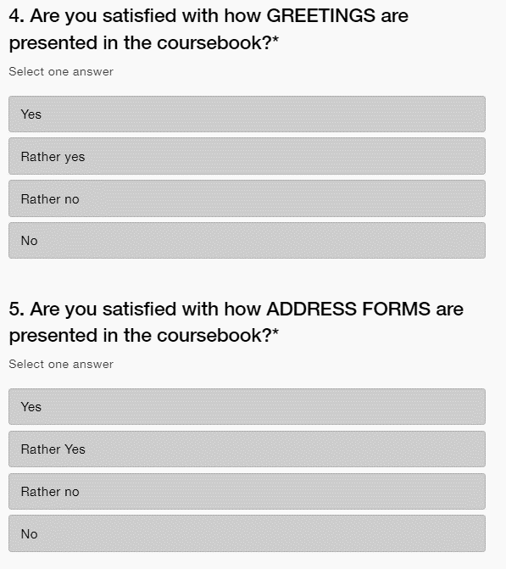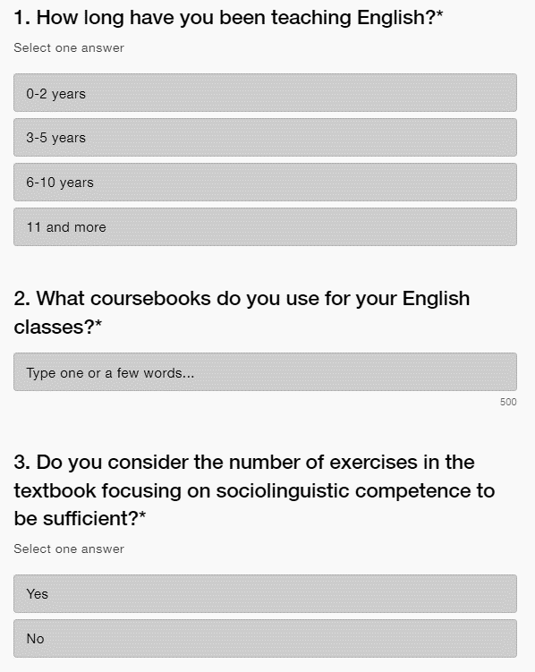

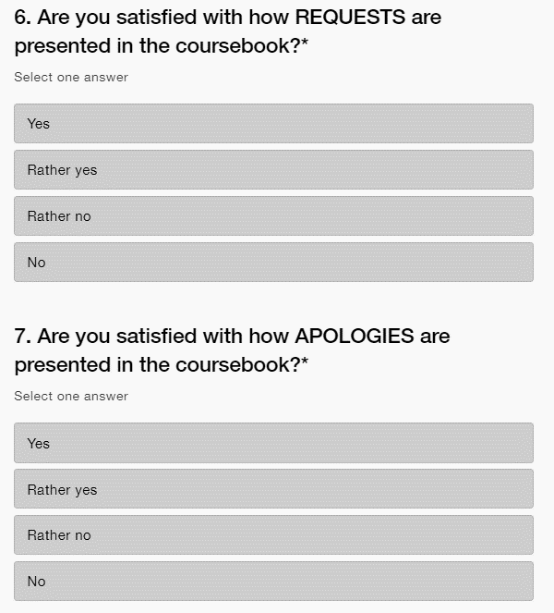

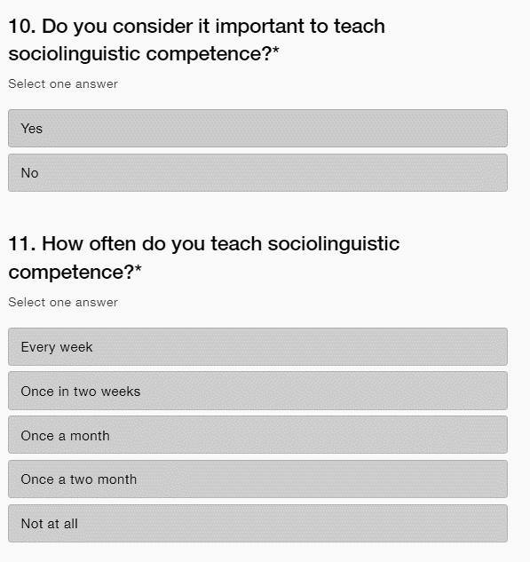 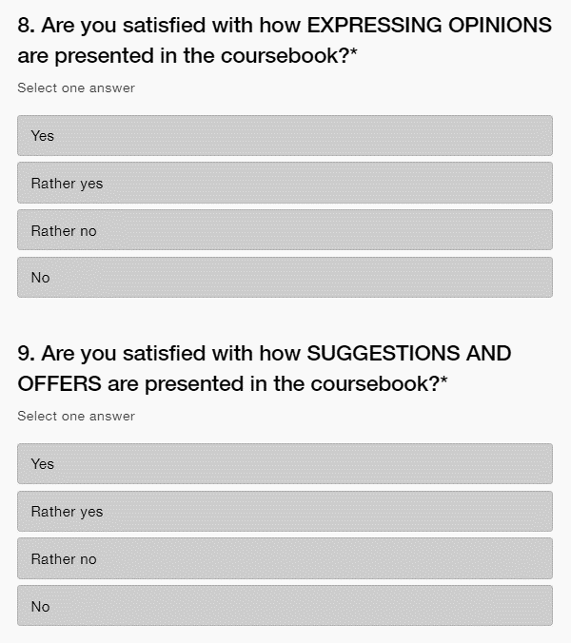 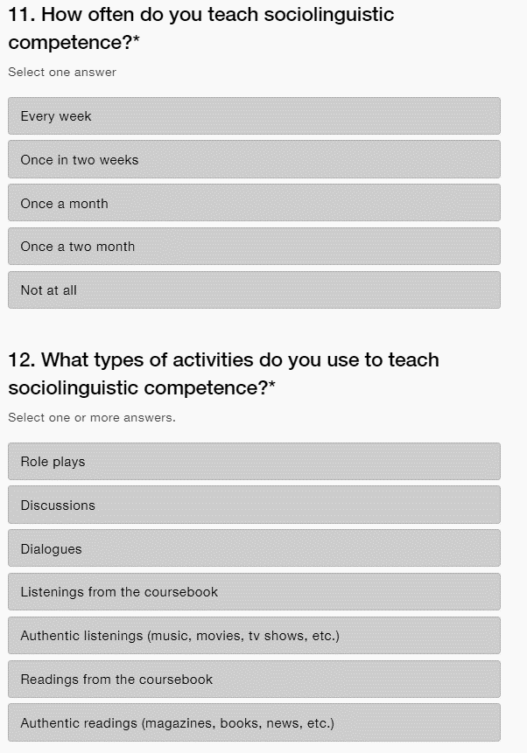

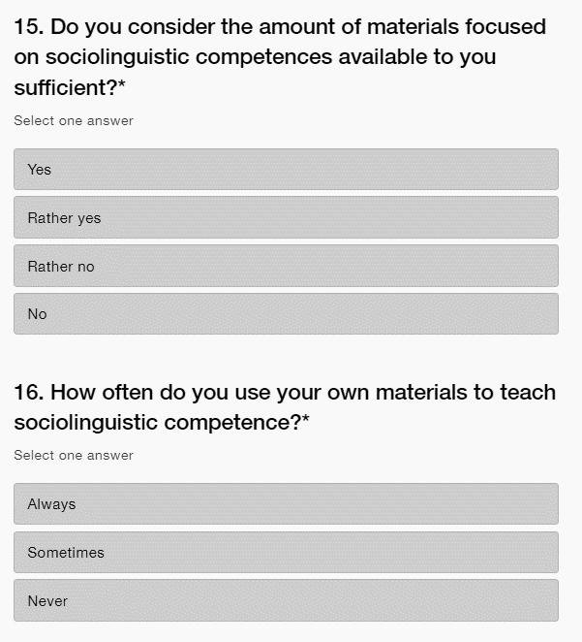 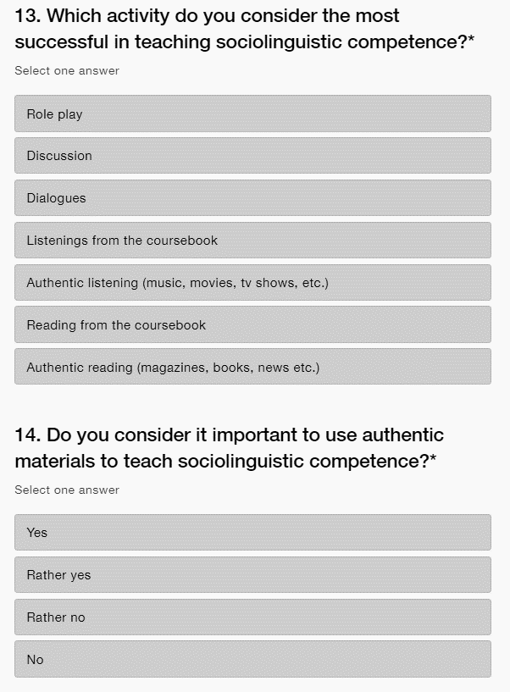



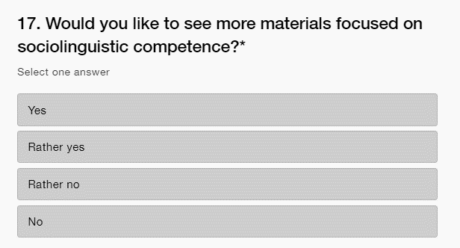

Appendix 4: List of the coursebooks mentioned by teachers

|  |  |
| --- | --- |
| Coursebooks mentioned by questionnaire respondents | |
| Coursebooks | How many times they were mentioned |
| Project | 12 |
| Solutions | 5 |
| Project Explore | 5 |
| English File | 3 |
| English Plus | 3 |
| New Headway | 2 |
| Gateway | 2 |
| Oxford Trainer | 2 |
| More! | 2 |
| I don’t use any coursebook | 2 |
| International English | 1 |
| Maturita Focus | 1 |
| Insight | 1 |
| Perspectives | 1 |
| Focus | 1 |
| Kids Box | 1 |

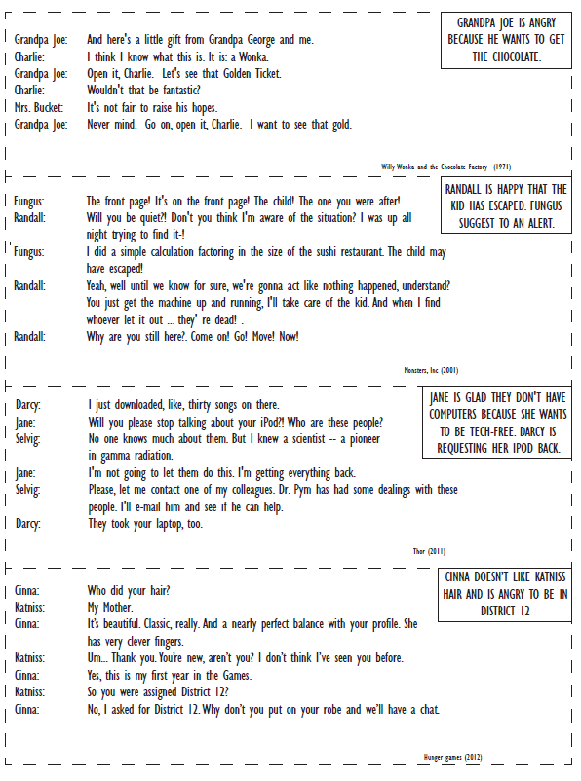Appendix 5: Worksheets for the activity Mood Swing Script

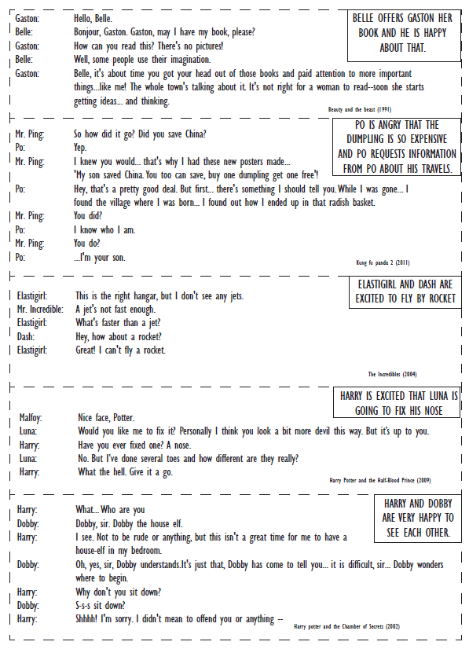

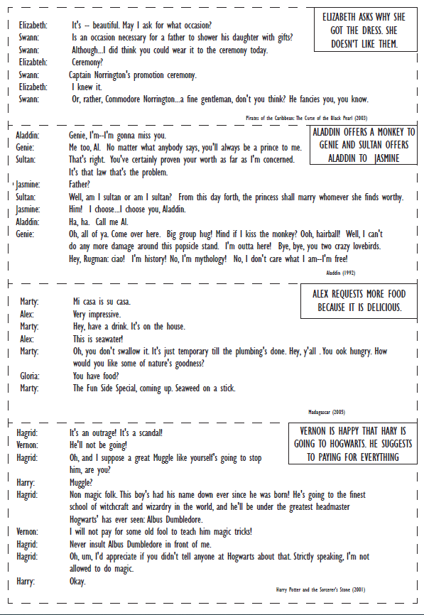

Appendix 6: Phrases for the activity Mood Swing Script

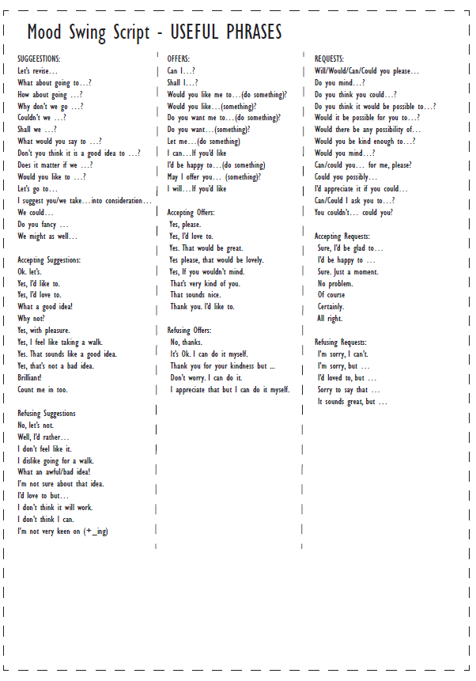

Appendix 7: Worksheet fot the activity Offers and promises



Anotace

|  |  |
| --- | --- |
| **Jméno a příjmení:** | Zuzana Otevřelová |
| **Katedra:** | Ústav cizích jazyků PdF UP Olomouc |
| **Vedoucí práce:** | Mgr. Josef Nevařil , Ph.D. |
| **Rok obhajoby:** | 2022 |
| **Název Práce:** | Výuka sociolingvistické kompetence ve výuce anglického jazyka. |
| **Název v angličtině:** | The development of sociolinguistic competence in the EFL classroom. |
| **Anotace práce:** | Magisterská práce se zaměřuje na rozvoj sociolingvistické kompetence ve výuce anglického jazyka. Teoretická část shrnuje definice spojené se sociolingvistikou a vysvětluje jak souvislostí se vzděláváním. Praktická část je rozdělena do tří částí. První z nich je analýza učebnic angličtiny. Další je dotazník pro učitele a poslední jsou aktivity podporující sociolingvistickou kompetenci. |
| **Klíčová slova:** | Sociolingvistická kompetence, autentické materiály, 2. stupeň základní školy, komunikativní kompetence |
| **Anotace v angličtině:** | The master thesis focuses on the development of sociolinguistic competence in the EFL classroom. The theoretical part summarizes definitions connected to sociolinguistics and explains the connections to EFL education. The practical part is divided into three sections. The first one is an analysis of English coursebooks. The next one is a questionnaire for teachers and the last are activities promoting sociolinguistic competence. |
| **Klíčová slova v angličtině:** | Sociolinguistic competence, authentic materials, secondary schools, communicative competences |
| **Přílohy vázané v práci:** | Appendix 1: Sociolinguistic competence retrieved from CEFR (2021)  Appendix 2: Sociolinguistic appropriateness for A2 level of English  Appendix 3: Teacher’s questionnaire  Appendix 4: List of the coursebooks mentioned by teachers  Appendix 5: Worksheets for the activity Mood Swing Script  Appendix 6: Phrases for the activity Mood Swing Script  Appendix 7: Worksheet for the activity Offers and promises |
| **Rozsah práce:** | 97 |
| **Jazyk práce:** | Anglický jazyk |

Resumé

Diplomová práce se zaměřena na rozvoj sociolingvistických kompetencí ve výuce anglického jazyka na 2. stupni základních škol. Zkoumá do jaké míry je jazyk ovlivněn socioklutrurními vlivy, jako je geografické umístění, zdvořilostní konvence, dialekt a akcent atd. Práce představuje několik lingvistů, kteří se tímto tématem zabývali a přispěli k jeho vývoji.

Dále se práce zabývá tím jaké postavení mají sociolingvistické kompetence ve výuce anglického jazyka v českých školách. Práce představuje Referenční rámec pro jazyky, který sociolingvistické kompetence řadí mezi jednu z komunikativní kompetencí. Zkoumá jaký přístup je vhodný pro výuku sociolingvistické kompetence, a také jak kulturní povědomí přispívá k výuce. Práce popise jakým způsobem sociolingvistické kompetence vyučovat a vysvětluje proč je ve výuce důležitá.

V diplomové práci se objevuje sekce zaměřená na učební materiály, která popisuje jakou mají roli ve výuce. Vice prostoru je věnováno učebnicím a autentickým materiálům, jelikož jsou součástí praktické části.

Hlavní část práce se věnuje zaprvé analýze učebnic a zkoumá zda jsou požadavky Referenčního rámce pro jazyky pro 2 stupeň naplněny. Dále práce zkoumá názory učitelů týkajících se rozvoje sociolingvistických kompetencí. Analyzuje zda jsou učitelé spokojeni s prezentací sociolingvistických kompetencí v učebnici a jakým způsobem oni sami sociolingvistické kompetence vyučují. Výzkum se dále zabývá materiály, které učitelé k výuce socilingvistyckých kompetencí používají a jak spokojeni jsou s množstvím dostupných materiálů. Poslední sekcí práce jsou aktivity zaměřené na rozvoj sociolingvistockých kompetencí. Jedná se o aktivity, které jsou skupinové a podporují komunikativní přístup ve výuce. Jedna z aktivit je vytvořena s použitím autentických materiálů.

Práce navrhuje řešení problémů v oblasti učebnic a materiálů. Navrhuje vhodné způsoby jak tyto problémy řešit a přispět tak k rozvoji sociolingvistických kompetencí.