UNIVERZITA PALACKÉHO V OLOMOUCI
PEDAGOGICKÁ FAKULTA
Ústav cizích jazyků

DIPLOMOVÁ PRÁCE
Bc. Zuzana Hálová

Teaching English Through Literature Using The Borders of Fantastic Space in Neil Gaiman’s Work

Olomouc 2024 Vedoucí práce: doc. Mgr. Janka Kaščáková, PhD.

Čestné prohlášení
Prohlašuji, že jsem závěrečnou práci vypracovala samostatně a použila jen uvedené pramenů a literatury.
V Olomouci den .............…………………………..
vlastnoruční podpis

Acknowledgements
I would like to thank doc. Mgr. Janka Kaščáková, PhD. for her support and valuable comments on the content and style of my diploma thesis. A special thanks goes to my mother and my partner for ongoing support.

Table of Content
List of Abbreviations 6
Abstract 7
1 Introduction 9
2 THEORETICAL PART 11
2.1 Using Literature in English Language Teaching 11
2.2 Benefits of Using Literature in ELT 11
2.2 Literature in Czech Curriculum 14
3 Learner in the Classroom 18
3. 1 The Age Groups 19
3. 2 Learning Styles 20
3.3 Motivation 22
4 Selecting Text for ELT Lessons 24
4.1 Planning English Language Lessons 26
5 About the Author and Books 29
5.1 The Author’s Life and Literary Work 30
5.2 Selected books 31
5. 3 Coraline 31
5. 4 Stardust 33
5.5 Reasons for Selecting the Books 34
6 Practical Part 35
7 Lesson Plans 36
7.1 Lesson plans – Coraline 36
7.1.1 Lesson Plan: The Cat 37
7.1.2 Lesson Plan: The Hallway 39
7.2 Lesson Plans – Stardust 40
7.2.1. Lesson Plan: The Wall 41
7.2.2 Lesson Plan: the Star 42
8 Analysis and Observations 44
8.1 The cat – analysis 44
8.1.1 The cat – observation 1 45
8.1.2 The cat – observation 2 46
8.2 The hallway – analysis 46
8.2.1 The hallway – observation 47
8.3 The wall – analysis 48
8.3.1 The wall – observation 1 49
8.3.2 The wall – observation 2 50
8.4 The star – analysis 51
8.4.1 The star – observation 1 52
8.4.2 The star – observation 2 52
9 RESULTS 53
10 DISCUSSION 54
11 CONCLUSION 56
Bibliography: 58
Appendices: 63

List of Abbreviations

ELT – English language teaching
FEP BE – Framework Educational Programme for Basic Education
LC – Learning competencies
PSC – Problem-solving competencies
CoC – Communication competencies
SPC – Social and Personal competencies
CiC – Civil competencies
WC – Working competencies
DC – Digital competencies
L – Learner
T – Teacher

List of Tables and Figures
Table 1: The Cat
Table 2: The Hallway
Table 3: The Wall
Table 4: The Star

Abstract

This diploma thesis is concerned with the usage of literature within the field of English Language Teaching. In total four worksheets and four lesson plans were constructed based on two books written by Neil Gaiman (Coraline and Stardust) and used in an English lesson in the lower secondary school and the first year of the secondary school. After the analysis of the data gathered during the lessons, it was discovered that in general, the learners’ response to the texts was positive. Furthermore, it is possible to use them in all grades of lower secondary school and in mixed level classes. The worksheet and lesson plans have the potential to develop key competencies stated by the FEB BE and they help to fulfil expected outcomes stated by the FEP BE, although further research would be necessary to fully prove the long-term effects of which they have.

“Fairy tales are more than true: not because they tell us that dragons exist, but because they tell us that dragons can be beaten.”
― Neil Gaiman, Coraline

1 Introduction

Fantasy literature has been a favourite genre amongst generations of readers. Books like The Hobbit and the Lord of the Rings by J.R.R. Tolkien, the Chronicles of Narnia by C. S. Lewis, Harry Potter by J.K. Rowling, Discworld by Terry Pratchett, Alice’s Adventures in Wonderland by Lewis Carol and many, many more have been read by people, young and old, and also found their way into different media of entertainment. Therefore, they have an incredible potential to spark the interest of learners. The books can be used to broaden the learners' sense of imagination, fantasy and creativity. They also allow learners to study the language in a way that they find interesting.

However, it is not frequently used in foreign language lessons at lower-secondary schools. The educational system of the Czech Republic provides guidelines in the form of a Framework Educational Program for Basic Education, it defines expected outcomes which must be met by the end of basic education. Due to the increased use of mobile phones, social media and the consumption of short-form content, books are losing their place in our everyday lives. So now more than ever, works of literature should be part of language lessons. Mohammad (2019, p.1) states that literature is “a great medium for teaching and learning language since the language of literature is very rich in vocabulary, well-organised and consistent. Literary classes not only enhance language abilities but also foster the progress of better reading and writing skills. Moreover, there are myriads of grammatical structures and lexicons wittily demonstrated and used in the literary texts, which indubitably influence students to better understand the grammar and enrich their resources of the language, particularly English language.” However, the Framework Educational Program for Basic Education only mentions short simple texts and does not recommend any literature, which leads teachers to rely on textbook texts, instead of taking advantage of the vast possibilities, books could give them.

The sections of text chosen for this thesis consist of the borders between our world and the world of magic or where they intertwine. These crossings hold a certain aura of the unknown and all you have to do is to cross them. They also provide some sort of mystery which makes the reading more engaging. As a result, it has great potential to grasp learners’ interests, be entertaining during the lessons and serve as motivation for further reading. Therefore, this diploma thesis aims to analyse the usage of borders of fantastic spaces in Neil Gaiman’s work and identify possible benefits of using fantasy literature in English language teaching.

This thesis consists of two parts, a theoretical and a practical part. The theoretical part consists of three chapters. The first chapter presents the concept of literature in the context of English language teaching, the main benefits of using literature in English language teaching and discusses the role of motivation. The second chapter looks into a set of criteria that should be useful to foreign language teachers when choosing the right literary texts. The last chapter introduces the author Neil Gaiman as well as two of his books that are later used while creating the worksheet accompanied by lesson plans - Coralina and Stardust. Specifically, the borders of fantastic spaces, which will be the specific part of the books where two worlds meet and intertwine.

The empirical part of this thesis presents created worksheets and lesson plans which use text from the novels Stardust and Coraline. To show in what ways fantasy literature can be incorporated into English language lessons, while analysing their didactic potential. Based on the aims of the diploma project three research questions were compiled:

- How can borders of fantastic spaces be incorporated into English teaching?
- Does using literary text develop language skills needed to fulfil expected outcomes and key competencies stated in the FEP BE?
- Does using literary text have a positive effect on learner’s motivation to read?

The data for the analysis are gathered through the method of observation - the individual worksheets are used at the lower secondary school and first year of secondary school where the pupils are carefully observed. Additionally, the lesson plans are analysed based on the criteria set in the theoretical part of this thesis – expected outcomes, learning objectives, learning competencies and learners’ engagement.

2 THEORETICAL PART
2.1 Using Literature in English Language Teaching

In the following paragraph, we go over common objections against using literature and summarise why incorporating literature into English language lessons is beneficial. Although there are some downsides to doing this, such as a lack of time and the fact that there is no specific requirement for using literary text in the Czech curriculum, there are considerably more benefits, authors such as Vraštilová (2007), Collie (2007) or Shuza (2014) all emphasize its effectiveness. Therefore, the main aim of this chapter is to introduce some benefits of using literature in ELT lessons and analyze the requirements set by the Czech curriculum for using literature in ELT.

2.2 Benefits of Using Literature in ELT

Firstly a few of the common objections to using books first. The following are the most typical. Although teaching grammar is one of our main goals as ELT teachers, literature doesn’t do much to further accomplish this goal because of its complicated grammatical structure and distinctive use of language. Secondly, the study of literature is unlikely to help our learners in achieving their academic or professional goals. Finally, since literature frequently expresses a particular viewpoint, it may be challenging for learners to understand on a conceptual level. If we are to decide whether or not to use literature, these reasons must undoubtedly be taken into consideration. (McKay, 1982, 526)

It is believed that literature is a valuable tool for learning languages. There are many significant instances in literary writings where linguistic elements like lexical items and grammatical structures are used naturally. This means that the learners will have the opportunity to encounter a wide range of unexpected linguistic expressions and uses. They then gradually become accustomed to various linguistic functions, common writing styles, and the development of their communicative abilities. This feature of literature gives readers a chance to process and analyse new vocabulary in a particular setting. The literature will broaden one’s understanding of language by demonstrating the use of a rich vocabulary and intricate grammar. (Shazu, 2014, p.62) These ideas are supported by (Collie and Slater, 2007, p.7) who state that literature provides a rich environment for particular lexical or syntactical items to become more recognisable. Learners gain engagement with many characteristics of the written language - the formation and function of sentences, the range of possible structures, and the various ways of connecting ideas - by reading an extensive and contextualised body of text, which broadens and improves their writing skills. Lastly, they also mentioned that “the extensive reading required in tackling a novel or long play develops the student’s ability to make inferences from linguistic clues, and to deduce weaning from context, both useful tools in reading other sorts of material as well.” (Collie and Slater, 2007, p.7)

According to Collie one of the reasons why literature should be used in foreign language lessons, especially when there is no curricular requirement and very little extra time, (Collie and Slater, 2007, p.5) is because literature is an authentic material. By that, we mean that the majority of literary works aren’t created with foreign language teaching in mind. More up-to-date course materials have included numerous real-life pieces of language, such as transport timetables, city plans, forms, cartoons, advertisements, newspaper or magazine articles, and more. Thus, learners are exposed to language that is as authentic and unaltered as is possible in a classroom setting. Students learn additional linguistic uses, forms, and norms of the written mode while they study works of fiction since they must also deal with language meant for native speakers, such as irony, exposition, argument, narrative, and so on. (Collie and Slater, 2007, p.6) Vraštilová also states that the context of the book can not only speak to a native reader but also to someone in a different country and different time. While reading, learners must deal with language intended for native readers, therefore getting familiar with a wider range of language use. In other words, literature provides learners with both the linguistic and cultural context. (Vraštilová, 2014, p.51)

Another reason to incorporate literature into English language lessons is that, although the story of a piece of literature is frequently made up, it still provides a rich and vivid backdrop in which persons from diverse socioeconomic backgrounds can be portrayed. A person’s views, sentiments, costumes, assets, what they believe in, what they fear, what they love, and how they speak and act in private can all be revealed to the reader. Because of this imaginary setting, a reader from another country can easily grasp the customs and concerns that form a real civilization. (Collie and Slater, 2007, p.6) English literary works represent the world's wide and fascinating differences. Because of the historical and colonial origins of the British Empire, they were written by authors from a wide range of cultural backgrounds and locations. (Lazar, 2009, p.16) Collie adds that literature is utilized in addition to other materials to give foreign language learners a better understanding of the country whose language they are learning. (Collie and Slater, 2007, p.6) Vraštilová agrees that incorporating literary works in foreign language education helps learners understand the social and cultural environment, in our case, of English-speaking countries. (2014, p.51)

Hall (2015, p.47) argues using literature in ways that do not coordinate the literary and linguistic aspects, communicative language teaching and the teaching of foreign languages have frequently missed (different) learning opportunities. In university, literature is generally used in more conventional ways, with an emphasis on theoretical concepts of literature and a minimizing of linguistic components. In second language teaching, literature is more likely to be used in a curriculum, where the focus is on language items, the difficulty of the text and where the features of literature are minimized. As a result, different integration of literature may have great potential. In fact, literature can be beneficial in second language learning hence it develops personal engagement in readers. Creatively engaging with literature allows students to shift their focus away from the more technical aspects of the foreign language. While reading, the reader is drawn to find out how the story progresses, and finding out what individual word meanings becomes less important in favour of the storyline itself. This may improve the whole learning process, as long as, the learner is motivated to do so, and the process of reading is acceptably engaging. (Collie and Slater, 2007, p.7)

As was already mentioned, the primary reasons why foreign language teachers should try to incorporate English literature into their lessons are the growth of linguistic knowledge, the authenticity of the text, comprehension of other cultures, and personal development. We often only utilize coursebooks to demonstrate certain grammatical rules because they frequently contain unauthentic sources. These rules gain more depth and context when applied to literature because of the length of the work. Reading may teach students more than just grammar and vocabulary; it can also teach them about other cultures and how to respect them. Finally, when students feel connected with the material, it has a beneficial effect on their personalities and encourages them to read more outside of English language classes.

2.2 Literature in Czech Curriculum

The worksheets offered in the practical portion are designed to be used in foreign language lessons, in this case, English, in the Czech Republic. We have two documents in the Czech Republic that outline education on a national level. The National Educational Programs (561/2004 Sb. ZÁKON o předškolním, základním, středním, vyšším odborném a jiném vzdělávání (školský zákon)) define education at all levels, whereas the Framework Educational Programs (RVP, 2021) focus on individual levels of the educational system. Because of the topic of this thesis and the author's study program, we shall concentrate on the Framework Educational Programme for Basic Education, specifically the lower secondary level.

The FEP BE is a document that states what educational goals must be met, and hence what subjects learners should study, as well as what information, skills, and habits they should acquire while attending basic education. (RVP, 2021, p.6) The document additionally defines certain areas of education for children, such as Human and Society, Art and Culture, Language and Communication, and Other Educational Fields. It also outlines the minimum number of lessons to be taught and the goals that learners should attain by a given grade level. Finally, it specifies the essential tools and materials, as well as the conditions under which education takes place.

Language and Language Communication is one of the areas of FEP BE, since this thesis is focused on using literature in teaching English as a second language from now on we shall mainly focus on this particular area since it is the only one relevant to us. Language and Language Communication consist of three parts, the Czech language and literature, the Foreign language and the Second foreign language. The Czech language and literature section goes more in-depth regarding literature, its genres, the intent of an author, reading habits and so on. On the other hand, there is no specific division or requirements regarding Foreign languages. (RVP, 2021, p.16) The area of Foreign language focuses on the expected outcomes at the end of basic education, which are split into listening, speaking, writing, reading and comprehension skills, later go more in-depth regarding skills and topics that must be taught and practised during foreign language lessons. The empiric part of this thesis uses literature in English language lessons therefore expected outcomes defined by FEP BE are to be met in worksheets and lesson plans. Therefore, an overview of expected outcomes is provided. (RVP, 2021, p.16-17)

Expected outcomes: -.------ learner will (RVP 27)
Listening -
CJ-9-1-01: understand the information in an easy listening recording, if they are pronounced slowly and clearly
CJ-9-1-02: understand the content of simple, clearly pronounced speech or conversation, that relates to covered topics

The minimal recommended level for outcome adjustments in support measures:
CJ-9-1–01p: understand basic information in an easy listening recording about covered topics
CJ-9-1–02p: understand simple questions about themselves

Speaking -
CJ-9-2-01: ask for basic information and react adequately during formal and informal situations
CJ-9-2-02: speak about their family, friends, school, free time and other covered topics
CJ-9-2-03: narrate simple stories or events: and describes people. places and items from their everyday life

The minimal recommended level for outcome adjustments in support measures:
CJ-9-2-01p: answer basic questions about themselves

Reading -
CJ-9-3-01: search for the required information in simple everyday authentic texts
CJ-9-3-02: understand short and simple texts, search for required information

The minimal recommended level for outcome adjustments in support measures:
CJ-9-3-01p: understand words and individual sentences about covered topics (especially if visual aids are provided)

Writing -
CJ-9-4-01: fill in basic information about themselves in a form
CJ-9-4-02: write a simple text about themselves, their family, school, free time and other covered topics
CJ-9-4-03: responds to a simply written announcement

The minimal recommended level for outcome adjustments in support measures:
CJ-9-4-03p: react to a basic written announcement about themselves
(RVP, 2021, p.27)

Another topic The FEP BE also covers is the topic of key competencies. In FEP BE they “represent a collection of knowledge, skills, abilities, concepts and values considered to be important for the personal development of each member of the society”. The competencies were picked based on the general values of the society which lead to a satisfying and successful life. The document highlights that their development must be one of the main priorities of the Czech educational system. (RVP, 2021, p.10) There are seven key competencies - learning competencies, problem-solving competencies, communication competencies, social and personal competencies, civil competencies, working competencies and quite recently added digital competencies. Cultivation of them is a lengthy process which starts in preschool education and doesn't end with finishing former education. Finally, key competencies do not stand on their own but intervene with each other, therefore, it is needed to include them in various ways during the teaching process. (RVP, 2021, p.10)

The FEP BE (2021, 10-13) describes each competence that learners should achieve by the end of their time in lower secondary school, they include knowledge, skills, abilities, attitudes and values that are important for a person’s development and role in society. The lesson plan in the following empirical part of this work will include activities developing key competencies summarised below.

Learning competencies
- Learners should be able to look for and sort information in learning, creative processes, and real life.
- Learners should be able to have a positive attitude toward learning, assess their own progress, identify difficulties, and create strategies to overcome them.

Problem-solving competencies
- learners should be able to search for information that they can subsequently use to solve problems, and they should be able to use their newly acquired knowledge and abilities to solve problems effectively.
- uses reliable problem-solving approaches and employs critical thinking to make decisions

Communication competencies
- Learners should be able to express their thoughts and opinions in written and spoken utterances in a fluent, logical structure.
- listens to and understands others, is an active participant in a discussion
- comprehends many types of text, visual materials, and nonverbal communication, applies such abilities to one's development and involvement in social events

Social and personal competencies
- learners should be able to cooperate in a group setting
- participate in a discussion and work successfully with a small group of learners

Civil competencies
- learners should be able to respect and empathize with others' opinions and personal values.
- recognizes fundamental environmental issues in a global setting

Working competencies
- Learners should be able to use materials, tools, and equipment successfully, as well as adapt to changing or new working environments.
- applies newly acquired knowledge and abilities in subsequent schooling, personal and professional life

Digital competencies
- be able to use digital devices, applications and programs in the learning process.
- obtaining, searching for, connecting, and sharing information and digital content
- develops and edits digital content; expresses themselves through digital technologies

According to what was just said, the FEP BE only defines the specific skills that students must possess by the time they complete their education; it makes no mention of the genre of literature that should be used, other than “short simple authentic text,” which is quite vague and leaves us with no idea as to what precisely we should use when teaching reading comprehension. Therefore, it is up to the teachers to select the suitable material. Although short texts, articles and advertising are regularly included in the coursebooks used in Czech schools to teach second languages, students have little opportunity to read real literary works. According to Vraštilová (2014, p.63), skilled teachers are those who not only have the background knowledge that can help them in searching, selecting, and utilizing appropriate works of literature but are also those who are interested in further education. Recent graduates, according to Skopečková (2011, p.2), are well prepared for teaching literature in their classes because of the study modules they completed. Finally, Vraštilová and Skopečková agree that working with literature will assist teachers in meeting the FEP BE requirements if well chosen.

3 Learner in the Classroom

We discuss the learner's part in the teaching process in this chapter. With a focus on learners in lower secondary school (sixth, seventh, eighth and ninth grade of the Czech education system), age categories are defined. It also highlights additional topics like learning methods and motivation. These elements are taken into consideration while deciding on an approach and how to create the tone for the lesson.

3. 1 The Age Groups

The age of our students plays a significant role in how and what we decide to teach. People of different ages have diverse needs, dispositions, and cognitive abilities. For instance, we would anticipate that young children will learn a lot of a foreign language through play, while adults can be expected to employ abstract thought more frequently. (Harmer, 2015, p.81) The majority of authors like Harmer (2015), Ur (2012), and Lightbow and Spada (2006), divide students into three categories: young learners, adolescents, and adult learners. We discuss how to approach each group in this subsection, with a focus on learners in lower secondary education.

We must keep in mind that children (up to the age of eleven) are still in the intellectual stage of what Piaget (1972) called “concrete operations.” Therefore, it is important to approach language-related rules, explanations, and other rather abstract concepts with caution. At this age, children are naturally curious and very driven to study. (Bastable 2017, p.183)

Cozma (2015, p.1210) defines adults as those who choose to pursue a particular form of education to meet a professional, social, or personal need or interest and are older than the typical age for traditional schooling, which is between 23 and 25 years. They can use their imaginations a little more when they require secondary input. Although adults often have developed a level of self-confidence not present in children, their level of shyness might be equal to or greater than that of children. Additionally, “adults” can at least occasionally deal with language that is not predetermined here and now thanks to their cognitive abilities. (Brown, 2015, p.90)
Additionally, there are people between the previous age categories who are between the ages of twelve and eighteen. The age of doubt, perplexity, self-consciousness, development, and change. Teenagers or adolescents fall somewhere between youth and adulthood, thus teaching them requires a very particular set of concerns. (Brown, 2015, p.92) They have a higher learning potential than young children, and they are starting to employ more deliberate, explicit language learning tactics. However, the majority of them continue to learn out of necessity rather than want, so they could be hesitant to put out the effort. They are capable of abstract thought within the learning process. (Bastable, 2017, p.170) Adolescent-specific issues with identity, relationships, physical change, and other issues make it more challenging for them to pay attention. (Ur, 2012, p.264) Adolescents may therefore be harder to manage and motivate, and it takes longer to establish a trustworthy connection. Questioners can be used to elicit their opinions. (Ur, 2012, p.265) “It is strange that despite their relative success as language learners, Adolescents are often seen as problem students. Yet with their great ability for abstract thought and their passionate commitment to what they are doing once they are engaged, Adolescents may well be the most exciting students of all ” (Harmer, 2015, p.83)

Educating different age groups call for entirely different strategies, resources, and instructional approaches. Since this thesis focuses on lower secondary school learners, their ages roughly range from 11 to 15 years old, at which age children become adolescents. Such learners have different stages of development, thus it is critical to address them according to their requirements. Any learning difficulties also need to be taken into consideration. As we stated, as previously mentioned, it is possible to solicit their feedback and include their feedback in the lessons.

3. 2 Learning Styles

Now that we are more familiar with the age group we will be teaching. It is important to pick the correct teaching method since individuals in a small group who are of a similar age may have various approaches to the learning process. Each person has their “preferred way of absorbing, processing, and retaining new information and skills.” (Lightbow, 2006, p.59) There are many various approaches for dealing with learning styles. But authors Lojová and Vlčková (2011), Harmer (2015), and Pinter (2017) bring up variations in perception, personality traits, and the theory of multiple intelligences. In the next section, we focus on how variances in perception lead to three distinct teaching styles: the kinaesthetic style (learning through movement), the auditory style (learning through hearing), and the visual style (learning through sight). (Harmer, 2015, p.87)

First, there are those whose dominant sense of sight serves as their primary method of information intake. When learning, a person must connect verbal knowledge with additional pictures or charts or learn information by sight. These students would rather read about the subject than listen to it while being taught to them. They employ textbooks, digital materials, or written texts that are enhanced with a variety of font styles, vibrant highlights, and graphics. To better understand words and phrases, learners should read as many foreign-language texts, books, and periodicals as they can. (Harmer, 2015, p.48) While it is possible to teach speaking through images, movies, or videos, students should also be able to express their thoughts and opinions. Working with text completion, filling in missing words, or using comics can be effective when teaching writing. (Harmer, 2015, p.49) Visual aids or text can be used to accompany listening exercises. It is beneficial to choose a listening exercise that simulates a real-world scenario. As has already been mentioned, adding images to the text makes reading easier. Reading comic books, watching movies, or engaging with a video could be enjoyable activities for visual learners. (Harmer, 2015, p.50)

Second, some people learn best by hearing or speaking; for these individuals, it is crucial to hear rather than read about a topic from a book, even if it is not a difficult one. They pick up on verbal instructions quickly and readily. During group work, it is also beneficial for learners to listen to their classmates’ comments or to engage in conversation. While “talking to themselves” or reading aloud text is an effective way of memorization for them. (Harmer, 2015, p.50) The auditory learners adopt pronunciation and other phonological and phonetic features of a foreign language rather quickly. (Harmer, 2015, p.51) During the class, auditory learners perform exceptionally well in discussions, dialogues, and any type of drill exercise or activity that involves asking questions and providing answers. While writing text using verbal information, dictation, as well as other activities like writing conversation and completing song lyrics, are beneficial for auditory learners. These learners are without a doubt excellent listeners, thus songs, readings of stories, books, and poetry are appropriate. Last but not least, it might be beneficial to read aloud, record one's reading, or pair a book with an audio version while practising reading. (Harmer, 2015, p.52)

People who prefer to learn by movement, touch, or handling objects make up the third group of learners. Experiments, practice, and other hands-on activities are the most productive types of learning for learners of this group. (Harmer, 2015, p.53) Teaching aids including cards, 3D models, and actual items are important in foreign language classrooms. When dealing with kinaesthetic learners, games, role-playing, project work, or presentations are all highly recommended activities. Any verbal activity is appropriate when paired with movement while practising speaking. They can also act out scenarios or present their work. Creating a magazine, or poster or incorporating writing into maps, graphs, or graphics are all creative writing exercises that can be helpful while writing. (Harmer, 2015, p.54) For kinaesthetic learners, the Total Physical Response exercises, executing movement based on instructions, finding and moving classroom items in line with directions, and drawing based on instructions are all very beneficial tasks. The teacher can incorporate activities like reading, followed by a dramatization of the book, or reading dialogues along with role-playing when the students are practising reading. (Harmer, 2015, p.55)

Each teacher must be aware that every classroom will always contain a range of students. It is never possible for a single approach or textbook to meet the needs of all learners (Lightbown 2006, p.59). In this subchapter, we have introduced various kinds of exercises that are helpful for specific groups of learners. Pinter (2017, p.16) suggests that teachers should include various activities in their classes to ensure that everyone's needs are met, at least most of the time.

3.3 Motivation

Motivation is “the extent to which you make choices about the goals to pursue and the effort you will devote to that pursuit,” according to Brown (2001, p. 72). “Goals to pursue” in the context of English language teaching might be tasks assigned by the teacher or overall language acquisition. The previous subchapter discussed several important advantages of incorporating literary texts in ELT. However, it is important to recognize that English language learners cannot clearly understand these advantages. As read more frequently tend to have better reading comprehension and language skills (Protacio, 2012, p. 69). Being motivated, or putting in the most effort possible to learn, is essential for success when learning a foreign language. Therefore, the teacher's primary responsibility should be to maintain high levels of learner motivation.
Different types of motivation exist. The majority of scientists make a distinction between intrinsic and extrinsic motivation. Extrinsic motivation is linked to a certain subject, interest, and enjoyment of completing a particular task while learning. (Obst, 2017, p. 138) The term “intrinsic motivation” refers to motivation that originates from sources other than the learners themselves (Harmer 2015, p. 90). It depends on the concepts of the rewards of learning achievement and the costs of failure (Ur 2012, p. 10). By these criteria, a driven student would feel pressure to do well on a test or be able to speak while travelling abroad. And the learner is motivated by these ideas (Harmer 2015, p. 90). Intrinsic motivation, on the other hand, originates from the learners themselves. According to Ur (2012, p. 10–11), language learning itself is associated with this type of motivation. In this situation, students who are motivated are those who want to do well in class and who are affected by what happens in the lesson (Harmer 2015, p. 90). We can also distinguish between integrative and instrumental motivation, two other categories of motivation. Integrative motivation is the desire to acquire a language to integrate into the group that speaks it, according to Ur (2012, p. 10) and Harmer (2015, p. 90). The need to acquire a language for a specific purpose, on the other hand, is known as instrumental motivation (Harmer 2015, p. 90). According to Ur (2012, p. 10), such benefits can be both educational and material, which means that learners may be motivated by a better career or academic advancement.
The learners themselves should be the main source of motivation for realizing something, in this example, the advantages of reading in a foreign language. When asked what factors have the most impact on their academic performance, students frequently respond that either their abilities or their level of effort matter the most (Kalhous & Obst, 2009, p. 368). Additionally, a study conducted by Maria Protacio identifies five important elements that encourage English language learners in elementary and lower secondary levels to read. The first one is the learner's sociocultural environment, which shows the influence of their friends and family who support reading. On the other hand, Wallace (1992, p. 6-7) adds that learners will struggle to read in a foreign language if they don't enjoy doing it in their language. This affects students’ reading ability, which affects students' desire to read. Second, it appears that students are inspired to read English-language novels because doing so allows them to get insight into the daily lives of English speakers and helps them better comprehend their cultural background.
Because student growth is greatly influenced by their level of motivation, the teacher must keep the class motivated to achieve the most significant results. The target audience for this thesis is lower secondary school students between the ages of 11 and 15. This age, as was said in the previous subchapter, is when childhood ends and adolescence begins. A study has been introduced by professor Jelena Mihaljevi Djigunovi as described by Pinter (2017, p. 45). From the ages of 9 to 13, she studied young learners’ motivation across four years. She claims that the student’s motivation noticeably decreases after the age of eleven. When they turn 13 years old, though, the level begins to rise. When they first start learning, Djigunovi claims, their enthusiasm wears off. However, with time, “they became more aware of the practical usefulness of English for their future, and this gave them a new boost of motivation.” (Pinter, 2017, p. 45)
The study stated earlier shows that encouraging kids at this age is crucial. According to Ur (2012, p. 11), teachers “have a crucial role to play in increasing motivation to learn” with learners of this age. The author offers three key strategies for impacting students’ motivation. First and foremost, educators must frequently emphasize to students the value of knowing English. It is possible to work on self-motivating techniques with older learners so they are prepared to handle a loss of motivation. Second, it emphasizes how important it is for teachers to help students develop positive self-images. By providing engaging tasks, Pinter (2017, p.46) proposes promoting learners’ self-esteem as well as their self-confidence and cooperation. Last but not least, the teacher should make sure the activities in the classroom are engaging. Each age group has unique characteristics, as we discussed in the previous subchapter. As a result, the teacher must take into account the types of activities that are typical for each age group. The only way a teacher can inspire learners is through such activities. It is crucial to note that the teacher is mostly responsible for knowing how to do this since they are the ones who should draw students' attention to a particular subject.

4 Selecting Text for ELT Lessons

As previously stated, due to the structure of the Czech curriculum, it is up to the teacher to select literary resources for their English language lesson. Therefore, some of the most important aspects to consider while selecting literary works for ELT will be mentioned. There is no predetermined number of criteria, in the Czech curriculum, that would specify which texts to select and how to select them. Hausenblas provides four categories for the text we plan on using. First, the Purpose of the text and intentions of the author: themes and key ideas of the text, the importance of the text. Second, Reader and the text: aspects of the text which are relatable to the reader's life, in what way does the text align with the learner's personal and educational maturity? Third, the Genre of the text and the way the author presents it: in what way is the text structured, type of language used and genre. Finally, Form and linguistic devices in connection with understanding: what concept does the learner have to be familiar with to understand the text as a whole, what part of the text can be confusing for the learner and why (Hausenblas, 2012, p. 81-82).

Bučková (2012, p. 10-11) The author, garnered, literary work, and the theme is the most prevalent criteria for selecting the correct literary literature. Other criteria include the appropriateness of the text that we intend to use. The teacher also makes decisions depending on their students’ interests, so that the material can capture their attention and increase motivation. Finally, content that covers a similar topic to the one we intend to discuss in our lessons. According to Colie (8), the criteria ultimately depend on each group of students, their needs, hobbies, cultural backgrounds, and language skills.

Vraštilová (2014, p. 60) emphasizes the need to remember the text’s proprieties so that the text corresponds with the demands of the learners and our plans for the next classes. Of course, linguistic proficiency must also be considered. Foreign learners may be unable to relate to or enjoy literature that they consider to be laced with difficulty every step of the way because they must overcome linguistic and cultural obstacles. “In the absence of curriculum or exam constraints, it is much better to choose a work that is not too much above the students’ normal reading proficiency.” (Collie, 2017, p. 8) Books and fairytales are examples of possible resources because learners are familiar with the story and characters from their native language. This might help us in foreign language classes, particularly in the early years of education or with students who have learning difficulties. (Vašrtilová, 2014, p. 60)

A common issue when working with literature intended for native readers is that they may not always be appropriate for use in foreign language classrooms. According to Lazar, teachers should consider the length of a text concerning the limited amount of time they have in class. (Lazar, 2009, p.17) Because of these factors, teachers regularly change the literary texts they want to use in their classes. These changes or simplifications may result in the author's fundamental aims, cultural context, and theme being lost. As previously said, this is one of the primary reasons why we choose the content from the very beginning. (Kyloušová, 2010, p. 87) Bučková adds that during the modifying process, the teacher becomes a secondary author, emphasizing the importance of teachers in the language learning process. (Bučková, 2011, p. 12) Vraštilová emphasizes the importance of text modification, particularly when working with less skilled students. She explains that using unedited authentic texts is feasible when the level of learners’ proficiency does not result in learners being demotivated while working with text that is too difficult for them to read and understand. (Vraštilová, 2014, p. 62)

Overall, the key themes emphasize the significance of selecting acceptable literary texts for ELT while taking into account elements such as learner needs, language proficiency, and cultural relevance. Typically, these works must be altered to fulfil our requirements for difficulty and length. We can begin lesson planning after we have chosen a suitable literary work.

4.1 Planning English Language Lessons

In the previous chapter, we discussed how to choose a text for our English language lessons. This chapter will discuss how we can incorporate literature into English language lessons. We are going to focus on various parts of the lessons. When using literary texts, we must consider a variety of factors and stages, which we mentioned in previous chapters (See Chapter 3).

Planning also involves taking into consideration:
1. What is to be taught.
2. How should it be taught.
3. What material should we use.
4. How much time is required for each task.
5. How to evaluate learners at the start and end of a school term.
(Aebersold, 2010, p. 184)

As a result, it is critical to initially establish the objectives and goals for upcoming lessons. (Vraštilová, 2014, p. 69) Maintaining learners’ interest and involvement can be accomplished through a range of activities such as role play improvisation, creative writing, dialogues, questioners, and more. These have proven to be an excellent way to maintain variation when using literature in English language lessons. (Collie, 2017, p. 9) When teaching literary works, group collaboration proved to be beneficial. It encourages learners to open up when working on a group project. Selected exercises can improve individual interpretation of the material by providing learners with a safe space to express and share their views. Finally, on a more practical level, working in a group helps reduce the difficulties that learners might encounter while working. “Very often someone else in a group will be able to supply the missing link or fill in an appropriate meaning of a crucial word, the task of doing so will become a shared one.” (Collie, 2017, p. 10) Activities can be classified in a variety of ways. Collie categorizes them as follows: first encounter, momentum, exploiting highlights, and endings. This method is better suited for working with a book's full text. Activities such as missing information guessing, True or False, and creative conversation writing are listed.

Lazar (2009, p. 84) and Vraštilová (2014, p. 65) classify activities applied during lessons as follows: 1. Pre-reading, 2. While-reading, 3. Post-reading. The benefit of applying this categorisation is that we are not constrained by the length of the text. Because the type of literature is something we must consider when designing our lessons. The Lazar classification is used in the Empiric section of this thesis. (Lazar, 2009, 84-86) (See below) This chart focuses on prosaic writing forms like short stories and novels. The author of this thesis will use this classification during the lesson planning process.

PRE-READING ACTIVITIES
- Helping students with cultural background

- Reading or listening comprehension about the author’s life or the historical and cultural background to the story
- Predictions about the genre of the short story
- Discussion about events student’s own country during the period of the story

- Creating student interest in the story

- Students make general predictions about the story, using pictures or the dustjacket on the cover of the book
- Discussion about what the title suggests
- Prediction about the story based on reading the first paragraph only or based on three or four words or on phrases which the teacher selected from the story
- Discussion questions about some of the themes which occur in the story

- Pre-teaching vocabulary

- Brainstorming a lexical set which is important in the story
- Matching important words in the story with their dictionary definitions

WHILE-READING ACTIVITIES
- Helping students to understand the plot

- Overall questions to check the gist of the story
- Students writing a brief summary of the plot
- Students provide titles for each paragraph
- Students reorder sentences which summarise the plot
- Sentence completion activities
- Selecting the right summary of the text

- Helping students to understand the characters

- Matching provided adjectives to the characters
- Ranking the characters from the story

- Helping students with difficult vocabulary

- Multiple choice questions to encourage the guessing of meaning from context
- Matching words to their definitions

- Helping students with language and style

- Close textual analysis of a section of the text
- Focusing on a particular grammatical problem

POST-READING ACTIVITIES
- Interpretation of the main themes of the story

- Discussing interpretations of the story
- Providing general questions to debate
- Speculating about possible symbolic associations

- Understanding narrative point of view

- Writing short text from the point of view of one of the characters
- Writing a description of the narrator based on the evidence in the text

- Follow-up writing activities

- Writing paragraphs using certain stylistic features of the story
- Writing a review of the story

- Follow-up Discussion

- Reading critical writing about the author of the story
- Roleplay or acting out of a scene from the story
- Discussion or debate about the worldview of values depicted in the text
To sum up, there are various approaches to categorize activities in foreign language education, in our instance English. We are going to implement Lazar and Vratšilová’ s classification of pre-reading, while-reading, and post-reading. The above categorisation will be applied to create lesson plans for the Empiric section of this thesis.

5 About the Author and Books

In earlier chapters, we discussed the role of literature in foreign language teaching, why it is beneficial to utilize works of literature during English lessons, specifications given by the Czech Curricular system, The Learner in the teaching process, how to select literary text for a foreign language lesson, how to plan one and different types of reading style which can be applied during the teaching process. However, for the needs of the practical part of this thesis, a specific piece of literature must be selected. For this thesis, the author selected two works by well-established contemporary author Neil Gaiman. It covers his life as well as his work. Lastly, some background information and analysis of his work will be presented.

5.1 The Author’s Life and Literary Work

The following chapter delves into the life of Neil Gaiman. However, the work does not provide a complete biography; rather, this thesis concentrates on aspects of his life that are relevant to his writing. As an adult, Gaiman would draw from his family history for inspiration in his fiction, recalling fragments and sometimes distorting details in his memory. However, before being filtered through Gaiman’s creative lens, the original facts or stories go like this. (Campell, 2014, p. 22)

Neil Richard Gaiman was born on November 10, 1960, in a small town in Hampshire, where his father owned a grocery store above which they lived and his mother worked as a pharmacist. When he was eight years old, his family moved and he started school at Aston House School in Sussex. (Campell, 2014, p. 22) Around this time, Gaiman began writing his first short stories, which grew into a series about a space frog and his time-travelling professor partner. (Campell, 2014, p. 23) He spent a lot of his childhood reading comic novels like Fantastic Four, Batman, and Spider-Man, as well as browsing the school library shelves. (Campell, 2014, p. 26)

Gaiman began working as a freelance journalist after graduating, producing articles for British newspapers and publications such as the Sunday Times, the Observer, and Time Out, among others. (EWB, online) In 1984, he earned authorship for a biography of the English rock band Duran Duran; due to the band's fame, the first round of print sold out in days. Gaiman met illustrator Dave McKean in the late 1980s, and the two collaborated on Violent Cases (1987). The graphic novel, designed for adult readers, achieved popularity not only in the United Kingdom but also on the other side of the Atlantic. They pitched the story to DC Comics, which resulted in years of collaboration. (Britannica) The Sandman, DC’s best-selling comic at the time, was published in instalments over eight years, resulting in seventy-five issues later issued as graphic novels, the first of which was Sandman: Preludes and Nocturnes (1989). In the early 1990s, he moved to America with his American wife and children, buying a large Addams family-style mansion that could not be found in England. Gaiman was inspired to write American Gods after experiencing America as an outsider. Gaiman's other best-sellers include Good Omens (co-written with Terry Pratchett in 1990), Neverwhere (1996), Stardust (1999), The Graveyard Book (2008), and The Ocean at the End of the Lane (2013). (Campell, 2014, p. 14) Gaiman avoids sticking to a single genre in his creative endeavours. Instead, he tells the stories he wants to tell, then incorporates genre aspects as if they were different spices in a recipe. To suit his taste and vision, he might add a dash of horror, a hefty chunk of fantasy, or a sprinkling of science fiction. (Campell, 2014, p. 12)

5.2 Selected books

Gaiman writes books for people of all ages, in his repertoire even picture books for children can be found, for example: The Day I Swapped My Dad for Two Goldfish (1997) or M is for Magic (2007). (NGW, online) According to Campbell Neil Gaiman describes his job “as making stuff up and writing it down” (Campell, 2014, p. 10) Books used in the empirical part were chosen based on the criteria covered in the literature review of this thesis. After a great deal of thought two books were selected, Coralina and Stardust. Every book belongs to a somewhat different category. Showcasing Gaiman’s wit in his creation of unique, entertaining stories for people of all ages, gives us enough material to develop English language lessons. As the title suggests the sections of the piece of writing where the real world and the realm of imagination meet, where they intertwine, or where a human encounters an extraordinary being were used by the author. For instance, when Coraline enters the other world through the door, when she first sees the cat in both homes, when Tristan crosses the wall, or when he first meets the star. The specific parts of the text offer enjoyable and engaging contexts that can help and encourage learners’ motivation while serving as a teaching aid for acquiring language skills and key competencies.

3 Coraline

Coraline, one of Neil Gaiman’s best-known middle-grade novels, is a dark horror fantasy novel. Gaiman began writing the novel in the early 1990s, and it was released in 2002 by the Bloomsbury Publishing business in the United Kingdom and HarperCollins in the United States. The novel received numerous literary honours and made it on lists such as the New York Public Library's “One Hundred Titles for Reading and Sharing” and others. (MC, online) The book was turned into a film by the Laika stop motion animation studio in 2009.

During the summer school break, Coraline moves to a new house separated into many flats with her busy parents. As a curious child, she proceeds to investigate every corner of the house and its surroundings. She meets her downstairs neighbours, Miss Spink and Miss Forcible, as well as Mr Bobo, who claims to be training a mouse circus in his upstairs flat. But, with no new places to explore and no new people to meet, Coraline grows suspicious of a door in the drawing room. Coraline's mother unlocks the door with an antique black key to show her that behind the door is a brick wall that was built to split the house into flats. Because no one has moved in yet, the flat behind the wall remains vacant. Coraline hears noises coming from the drawing room that night. She follows a shadow into the drawing room, only to discover that the door is open, even though her mother has locked it. She shuts the door and falls asleep, dreaming of small black singing shadows with little red eyes and yellow teeth. When Coraline returns home alone the next day, she unlocks the door, the brick wall is gone, and she travels through a corridor only to find herself in a house identical to hers. Coraline meets a woman who claims to be Coraline’s other mother there. She resembles her mother, but she has a pale complexion, long sharp fingers, and button-like black eyes. The other parents pay attention to her, the food is far better than at home, and even her neighbours are more interesting than those at her real home. Coraline resolves to return home only to discover that her parents have gone missing. She chooses to return to look for them after a day alone. Coraline experiences various adventures and obstacles in the other world as she battles her other evil mother to save her parents and the souls of lost children. (CS, online)

When Gaiman began writing the book for his daughter Holly, he modelled it heavily on a house in a tiny Sussex town they moved to in 1987. (Coraline, 2013, p. 11) He worked on the book on and off for several years before finishing it for his youngest daughter Maddy. According to Gaiman, he intended to write a narrative that would teach young people something he wished he had known as a child: “Being brave does not mean you are not scared. Being brave means being scared badly scared, and you do the right thing anyway.” (Coraline, 2013, p. 15)

4 Stardust

This book is targeted towards young teenagers, thus the level of English is slightly higher in this book. Therefore, it is important to make thoughtful decisions about how much of the text should be changed or which parts can be used for English language lessons.
Dunstan Thorn, a young man who lives in the English village of Wall, which is divided from the world of Faerie by a stone wall, had an accidental encounter with a young enslaved woman owned by a witch at the yearly market fair held between the worlds. They spend the night together and conceive a son named Tristran, who is sent to live with his father. Tristran falls in love with a local girl named Victoria Forester as a teenager, and when they see a falling star, Victoria pledges to marry Tristran if he retrieves it for her. Meanwhile, the Lord of Srormhold is dying, and his three remaining sons, Primus, Tertius, and Septimus, are competing for the throne in Faerie. The Lord tosses his royal topaz necklace out the window and declares that whoever finds it will become ruler. The necklace collides with the fallen star, a young woman called Yvaine, knocking her to the ground. Tristran discovers and captures the star, figuring out she is more than just a rock. He wants to take her to Victoria while chained to himself. However, three witches known as the Lilim want to use Yvaine’s bright heart to restore their youth. They arrive at an inn that the witch queen has magically transformed into a trap for Yvaine. Tristran and Yvaine use a magic candle to escape and are rescued by a passing lightning ship. They spend time as members of the ship’s crew before making their way to Wall. Tristran and Yvaine travel with a witch and her caged bird, who turns out to be Tristran’s mother, Una, and the market enslaved woman. Due to a spell, the witch transforms Tristran into a dormouse for the journey and is unable to perceive Yvaine. Tristran returns home after visiting the market to reunite with Victoria. Tristran, on the other hand, recognizes he has fallen in love with Yvaine. Meanwhile, Yvaine awaits the return of Tristran. The woman who was previously enslaved was discovered to be Tristran’s mother Una and Lord Stormhold’s solitary daughter is eventually set free. As a result, Tristran is the only remaining male successor to the kingdom. Tristran accepts taking on his place on the throne beside Yvaine, but he expresses a wish to travel the world with her first. Meanwhile, Una acts as a regent until they return. (SS, online)

5.5 Reasons for Selecting the Books

There are a variety of Neil Gaiman’s writings from which teachers might select. Several statements regarding the role of literature in the classroom were made during this literature review, and we will now demonstrate how they relate to the selected work. This subchapter will deal with several reasons why Coraline and Stardust, which depict the borders of fantastic spaces, are easy materials to employ for foreign language teaching. The website Mousecircus.com (NG official website with a focus on children’s books) classifies Coraline as a middle-grade book and Stardust as a teen book, both of which are ideal for our intended demographic of kids between the ages of 11 and 15. Because of the themes of growing up and childhood, the fact that our learners can identify with the major characters of the stories and the element of adventure and magic, it is a suitable choice for the demands of our ELT classes. Supporting student enthusiasm and personal engagement with the story will result in a successful reading activity. The fact that the stories are intended for children makes the words used in them, less difficult and the plot easier to follow, making minor adjustments less necessary. This is another reason why the stories may be appropriate for ELT. The book Stardust may be deemed unsuitable since it uses words like “flank” and “solitary rambler ” that are difficult to understand, but as was already said (See Subchapter 4.2), most texts we utilize in foreign language lessons will require some alterations. Therefore, we can prepare learners for literature that contains unfamiliar words by adjusting the content or teaching vocabulary beforehand, preventing learners from losing interest or motivation while working. Additionally, both books have been made into movies and audio versions are available, which the learners may already be familiar with. We may use these resources when coming up with activities for subsequent classes. Although the novel has some challenging language in some places, both the stories themselves and the subject matter make for good reading material, and when utilized with the correct audience of learners, the story and its language will not impede learning. After all, the practical part of this thesis will assess the story’s application to back up these claims. Based on the criteria listed in subchapter 4.2, sections of text that represent borders of fantastic spaces were selected for this thesis. To spark the curiosity of learners and increase their motivation. These particular passages in the text can also be easily turned into a variety of assignments and exercises. Hence raising the likelihood that our teaching methods will be inclusive of all of our learners. And assist us in achieving learning objectives by the end of the academic year.

6 Practical Part

As previously mentioned, this diploma thesis applies the borders of fantastic spaces in Neil Gaiman’s work in English language teaching. The aim is to offer helpful teaching resources for teachers of English based on Gaiman’s books. To answer the research questions the author has selected two books and created four worksheets and four lesson plans.

The following chapter presents the practical part of this thesis. The main aim is to show different and approaches for incorporating borders of fantastic spaces into ELT and also to demonstrate how literature can be a useful tool for developing language proficiency, key competencies according to the Framework Educational Program for Basic education and enhancing learner’s motivation to read.

The research questions for the Empirical part are:

- How can borders of fantastic spaces be incorporated into English teaching?
- Does using literary text develop language skills needed to fulfil expected outcomes and key competencies stated in the FEP BE?
- Does using literary text have a positive effect on learner’s motivation to read?

To answer these questions, the author has selected two books by Neil Gaiman (Coraline and Stardust) and created four worksheets accompanied by lesson plans. These were later used in English Language lessons at a lower secondary school and first year of secondary school. The data were gathered utilizing observation during the lessons where the worksheets were used.

The empirical part presents the observations, the overview of the lesson plans and their analysis. The analysis is concerned with the aspects of Learning engagement: during the observations, the author focused on whether the learners are enjoying the lesson and if they are cooperating. At the end, learners were asked to mark the lesson on a scale from one to five using Linkert’s scale. Based on their response and the author's observation average answer was selected from a scale of Very poor – Poor – Average – Good – Very good. Learning objectives: for a successful lesson learning objectives must consist of Cognitive, Affective and Psychosomatic parts. Expected outcomes: FEP BE presents expected outcomes that learners should reach by the end of their education. Therefore, the following chapter presents which skills are being developed by the lesson exercises. Lastly, we analyse what key competencies are being implemented within the lesson plans. Finally, an overview of the analysis is presented, followed by a discussion of the findings.

7 Lesson Plans

The following chapter presents lesson plans with a step-by-step procedure and aims of the lessons. Worksheets used during the lessons can be found in the Appendices. The worksheets serve as a guide throughout the lessons, they can be used on paper or in a digital form. The teacher can also add video or audio to the lessons. Illustrations and pictures are included in the worksheets, they were taken from free online sources and, therefore can also be used in print or digital form.

7.1 Lesson plans – Coraline

Based on the criteria by Hausenblas presented in Chapter Three, two books were selected. The first book chosen is Coraline. The Purpose of the text and the author is to face one’s fears and how looks can be deceiving. Read and the text, for learners between twelve and fifteen years the book offers many themes that can be implemented into lessons, such as self-sufficiency, good and evil, family and contentment. Genera of the Text is a children’s fantasy novel which follows a young girl Coraline who sets off on a series of adventures. Lastly, the form and linguistic devices directly connect to the learner as it is crucial for understanding the text as a whole. Apart from some exceptions the language is simple and easy to follow and is suitable for learners of the lower secondary school and first year of secondary school.

7.1.1 Lesson Plan: The Cat

Lesson plan: the cat

Class: 1.D, first year of lyceum
time: 45 minutes
level: pre-intermediate (A1-B2)
Aim:
Learning objective: at the end of the class …
- learners will be able to make predictions about the text based on a picture and guideline question
- learners will be able to answer questions about the provided text
- learners will be able to determine whether the statements are true or false based on the provided text
- learners will be able to write a list of items based on previous reading

Materials: Worksheet number one (Appendix 1), writing accessories

Procedure:
Organisational part
Teacher (T) welcomes learners (L) introduces the topic and aims of the lesson and hands out worksheets to the Ls.

Pre-reading activities
- discussion: T shares the front cover of the book with L, then asks them what the story could be about. Ask them to justify their responses. The focus is on predicting and drawing connections between the cover and the potential storyline of the book. Ls mark down their predictions on the worksheet for future reference.
T asks questions:
- Who do you think this character is? what kind of character they might be? What is she holding?
- What does the title suggest?
- What do you think of the building behind her, and the setting in general?
- What impression does the old building, black cat and figure at the window give you? Does this setting remind you of any other story? What do you think the genre of the book is?

While-reading activities
Ls read the text out loud, and T explains any words that might be difficult for the Ls. Optionally they can use the dictionary to find out about their oven.

- comprehension questions
After reading Ls skim the text and answer the following questions:
Where does the conversation between Coraline and the Cat take place?
What colour are the cat's eyes?
How many cats are there?
What is the cat's name?
Why do people have names?

- True or False questions
Ls read the second extract from the book, then they read sentences and based on the text they decide whether the sentences are true or false. T asks Ls to justify their answers.

Post-reading activities

- Making a list
Ls are asked to write a list of things which might be useful in a situation where they would find themselves in a place they don't know and might be potentially dangerous. Then they share their list with the rest of the class.

- Time filler
In case of a spare time T can play part of the film which corresponds with the text Ls read during the class. Ls compare the text to the film.
End of the lesson
T assesses the lesson and invites Ss to give feedback.

7.1.2 Lesson Plan: The Hallway

Lesson plan: the hallway
Class: 1. prima, eighth grade of lower secondary school
time: 45 minutes
level: pre-intermediate (A1-B2)
Learning objective: at the end of the class …

- learners will be able to match the short description of the characters with corresponding illustrations based on previous knowledge
- learners will be able to arrange the text based on the previous reading and knowledge of the storyline
- learners will be able to create an illustration based on the provided description of a character - and will be able to describe and discuss their illustration

Materials: Worksheet number two (Appendix 2), writing accessories

Procedure:
Organisational part
Teacher (T) welcomes learners (L) introduces the topic and aims of the lesson and hands out worksheets to the Ls.

Pre-reading activities

- Matching
T asks Ls if they know the book, Coraline, T elicits their answers and summarises the text for those who are not familiar with the story. Ls look at the individual descriptions of the characters and match them to the illustrations.

While-reading activities

- Reading the text
Each L reads and translates a section of the text, and T helps them with any words they are not familiar with.

- What happens before and after
Ls are provided with six options, three for what might have happened before the extract and three after it. Based on previous reading Ls choose one for before and one for after and explain why they made that choice.
After that T initiates a discussion about how is the story going to continue.

Post-reading activities

- Illustration
In the last part of the worksheets, Ls are given a blank page and a character description. Their task is to draw an illustration of the character described in the provided extract. After the L are finished the whole class compares their illustrations with the illustrations made by Chris Riddell and the character from the film.
Exercise variation: exercise can be flipped, in that case, L are provided with an illustration of a character from the book and their task is to write a description of the given character
Time filler: L additionally compare illustrations with the description of Miss Spink and Forcible from the other place and vice versa.
End of the lesson
T assesses the lesson and invites Ss to give feedback.

7.2 Lesson Plans – Stardust

The second book selected based on the criteria from Chapter Three is Stardust. The purpose of the text and the intentions of the author are magic, romance and coming of age. Reader and the text, for readers between the ages of thirteen to fifteen the book offers themes which can be incorporated into lessons, the story suggests that the search for true love requires determination and persistence. The genre of the text is a fantasy novel set in nineteenth-century England, which follows a young man going on an adventure in search of a fallen star. The author offers a look into British culture and Scottish folklore Lastly, the form and linguistic devices connected to understanding the text, the novel offers language suitable for learners of the age group this thesis focuses on. It involves some archaic expressions. However, those that can easily be adapted or simplified are also followed by illustrations which can further improve the understanding of the story. Finally, the book has also been published in a graphic novel edition which can bring a great variety to the lessons.

7.2.1. Lesson Plan: The Wall

Lesson plan: the wall
Class: 3. tercie
time: 45 minutes
level: intermediate (A1-B2)
Learning objective: at the end of the class learners…
- will gain a basic understanding of the plot and the cultural background of the book
- will be able to search for terms using the dictionary
- will be able to identify and form a comparative and superlative form of adjectives based on previous reading
- will be able to summarise a text by selecting one of three possibilities
- will be able to match text with corresponding screenshots from the film adaptation of the book and speculate and talk about the plot

Materials: Worksheet number three (Appendix 3), writing accessories

Procedure:
Organisational part: Teacher (T) welcomes learners (L) and introduces the topic and aims of the lesson
Pre-reading activities

- Mind map
T writes “fairy” on the white beard puts it in a circle and asks Ls what the word means. Then T asks Ls to create a mind map by writing as many words as possible that come to their mind when they hear the word fairy.
After they have finished T and the Ls together go over what they have written. T explains to Ls the role of fairies in English folklore.

While-reading activities
- working with a dictionary

T explains to the Ls that some words are more difficult. Ls read the extract from the book, and by using a dictionary they look for the meaning of the highlighted words. They can work in pairs.

- Search for adjectives
Ls read the text and write out or underline all the adjectives. T checks with them and points out any they might have missed.

- Practising comparative and superlative adjectives
The class is asked to say the correct way of grading adjectives. After that, Ls complete the table in the fourth exercise. Next T checks if their answers are correct.

- Summary
Ls read three sentences and based on previous reading they choose one which summarises the text they have read the best.

Post-reading activities

- Ls are presented with four paragraphs of text and four screenshots from the film adaptation of the book. They are instructed to match the text with its corresponding scene. They can work in pairs. Next T checks if their answers are correct.
Exercise variation/time filler: instead of providing the screenshots T can play the portion of the film.
End of the lesson
T assesses the lesson and invites Ss to give feedback.

7.2.2 Lesson Plan: the Star

Lesson plan: the star
time: 45 minutes
level: intermediate (A1-B2)
Learning objective: at the end of the class learners …
- will be able to identify verbs in a text
- will be able to use regular and irregular verbs in the past simple form
- will be able to tell a story using the correct language and discuss their writing

Materials: Worksheet number four (Appendix 4), writing accessories
Procedure:
Organisational part: Teacher (T) welcomes learners (L) and introduces the topic and aims of the lesson

Pre-reading activities
- Wordsearch
T hands out worksheets to the Ls. Ls search for twelve words from the previous reading. When they are finished T shows them the key to the word search so they can check they have found everything.

While-reading activities
- Verbs from the text
Ls read the text. T makes sure Ls understands all the words from the extract. Then their task is to underline verbs in past simple form. T checks with them and writes them out onto the whiteboard.

- Regular and irregular verbs
Ls uses selected verbs and divides them into two groups. First group of regular verbs then a group of irregular verbs. T instructs Ls to also add all three forms of the irregular verbs. Next T checks if their answers are correct.

- Filling the gaps
Ls look at the given verbs and use their correct form to complete the sentences from the book.

Post-reading activities
- Writing a story
Based on previous reading Ls write a short text. They are given prompts that can help them when dividing what to write about:
How does the story continue?
What Tristan and the Star talk about later?
After they are finished Ls can read their story aloud or T can pick someone to do so.
End of the lesson
T assesses the lesson and invites Ss to give feedback.

8 Analysis and Observations

8.1 The cat – analysis

Table 1: The Cat
Learners’ engagement | Quality learner’s engagement and cooperation within the first lesson - Good.  Quality learner’s engagement and cooperation within the second lesson – Average.
Learning objectives | Cognitive: learners will be able to answer questions about the provided text  Affective: learners will be able to determine whether the statements are true or false based on the provided text  Psychosomatic: learners will be able to make predictions about the text based on a picture and guideline question
Expected outcomes | CJ-9-2-03: 1. talking about the cover of the book  CJ-9-3-02: 2. comprehension questions, 3. True or false  CJ-9-4-02: 4. write a list of things based on a text
Key competencies | PSC and CoC: At the beginning of the lesson learners cooperate with their classmates and contribute to discussion about the plot of the book. While reading provided text Ls comprehend certain types of text.  LC: Ls search for information which will be used later in the lesson.  PSC: During the fifth activity they have to determine if the statement is true or false, they have to defend their decisions and correct statements which are false.  SPC: During the whole lesson as well as the last activity Ls contribute to a discussion about the text.

8.1.1 The cat – observation 1

The lesson was taught in a class of 14 learners from the first year of lyceum during the second period. Therefore, the learners were mostly fully engaged in the lessons, they cooperated well and were not afraid to share their opinions during the lesson. The class consist of learner with various levels of English. Nevertheless, all the activities were fulfilled according to the lesson plans, and none of them were skipped or needed adjusting for the learners. During the first activity learners did not have a problem with talking aloud in front of the class, they bounced ideas of off each other. The pre-reading activity worked well as an introduction to the book. Some were familiar with the film adaptation of Coraline, so the text was less intimidating to them. The learners had no problem tackling the text, there were a few words they did not know but they did not hesitate to ask for clarification. They managed to answer all questions correctly, the same follows with the true or false activity. Learners were also allowed to work in pairs if they wanted which was beneficial for learners who are not as proficient in English as some of their classmates. The least successful was the after-reading activity as the end of the lesson approached, they were losing motivation and struggled with creativity-based tasks. At the end of the lesson, learners deemed the lesson enjoyable and easy to follow. The text was clear enough for them and they liked the activities. Learners who had already seen the film were interested in reading the actual book. On the other hand, learners who already didn’t enjoy reading books said it is not very likely that they will read the book in the future. Therefore, I believe it would take more classes where literary text is used to get them sufficiently motivated to get into reading. After all, it takes more effort with a class of fifteen-year-old learners who lack the habit of reading.

8.1.2 The cat – observation 2

The lesson was taught in the second year of gymnasium (circa 14 years old learners) and there were 15 learners. This lesson was the last lesson of the day which reflected in the participation and motivation of the learners. In addition, this group is extremely difficult to manage in terms of behaviour. Throughout the process, they were not very communicative. Throughout the reading process, they had no difficulties and were quite cooperative. Here and there they would ask about the meaning of certain words. All the comprehension questions and true or false answers were mostly answered correctly. By the time we checked the correct answers they lost all the interest they initially had. During the last activity, only a couple of learners were interested in it, the rest would not participate. Because the class had to be disciplined repeatedly during class there was not a lot of time for the final activity. During the final evaluation, learners deemed the text as easy to follow and not difficult to understand for them. They did not have much else to say about the class overall. After teaching this group a couple more times I found out that they work the best when they have to do work on their own. So next time I would shift the dynamics of the lesson more towards that.

8.2 The hallway – analysis

Table 2: The Hallway
Learners’ engagement | Quality learner’s engagement and cooperation within the lesson - Good.
Learning objectives | Cognitive: match the short description of the characters with corresponding illustrations based on previous knowledge  Affective: create an illustration based on the provided description of a character - and will be able to describe and discuss their illustration  Psychosomatic: arrange the text based on the previous reading and knowledge of the storyline
Expected outcomes | CJ-9-3-02: 1. identify the characters 2. Determine what happened before and after the text  CJ-9-3-01: 5. draw the character  CJ-9-2-03: 5. talk about your finished illustration
Key competencies | PSC: When identifying characters Ls make a statement, they can defend.  LC: During the While reading activities Ls search for information and continue to use them in while-reading activities as well as in further learning process.  CoC: In the After reading activity Ls visually express their ideas.  SPC: Ls participate in a discussion about their illustration in comparison with the ones from the book.

8.2.1 The hallway – observation

The lesson was taught in the first year of the gymnasium (circa 13-year-old learners) and there were 17 learners which was not ideal but the lesson was quite successful. Because the learners are younger they tend to be quite talkative therefore they had to be calmed down, from time to time, otherwise they cooperated very well. Also, they require more assistance than the older learners. Some of them were familiar with the film or the book which made the teaching process much easier. Despite losing a little bit of time at the beginning of the lesson due to some class affairs, all activities were fulfilled.
The first activity was interesting for the learners, they had no problem matching the descriptions to the illustrations of the characters. The activity served as a simple and quick warm-up activity. Next time I would not be afraid to make the activity a little more complicated. Due to the younger age of the learners, I made sure they understood the text during the reading and translating process. Learners were also asked comprehension questions throughout the process and I wrote out words they did not understand and their translations on the whiteboard. The third and fourth activities were done simultaneously, learners were allowed to work in pairs which made the task easier for them. Considering the amount of text they had to go through and the level of English, the task took them more time than I would like to. Nevertheless, everyone managed to finish it after all. Upon assessing I found out that besides some exceptions they managed to finish it with success. The lesson time was only forty-five minutes, therefore, the last activity had to be shortened. However, they enjoyed the creative process and were not afraid to share their final creations with the class. Another notable aspect of the activity is that they worked completely on their own without any visual references.

At the end of the lesson, the learner said that the lesson was enjoyable and easy to follow. The text was clear enough for them and they liked the activities. With this class, I would use some form of short anonymous questionnaire to get feedback because I was not sure if all of them were fully honest. Lastly, from the perspective of a teacher, I would prefer if the lesson had more than forty-five minutes so there is more time for individual activities and creative work.

8.3 The wall – analysis

Table 3: The Wall
Learners’ engagement | Quality learner’s engagement and cooperation within the lesson – Very good.  Quality learner’s engagement and cooperation within the lesson – Very good.
Learning objectives | Cognitive: basic understanding of the plot and the cultural background of the book  Affective: match text with corresponding screenshot from the film adaptation of the book and speculate and talk about the plot  Psychosomatic: to search for terms using the dictionary
Expected outcomes | CJ-9-2-03: 1. discussion about a given topic  CJ-9-3-01: 2. Searching for the meaning of words from the text  CJ-9-3-02: 2. Searching for the meaning of words from the text 3. Finding adjectives in the text 5. Summary  CJ-9-1-02: 6. Matching the text to the corresponding scene from the film adaptation
Key competencies | CoC: Learners organise and communicate their ideas. While reading provided text Ls comprehend certain types of text.  PSC: In the second activity Ls search for the meaning of words in the dictionary.  SPC: If they decide to work in pairs, they practice communication and cooperation.  LC: While reading the provided text they search for information which they will need to complete the while-reading exercises.  SPC: In post-reading tasks, they contribute to a discussion about the text and scenes from the film.

8.3.1 The wall – observation 1

The lesson was taught in the third year of gymnasium (circa 15 years old learners) and there were 13 learners. I was substituting for a teacher who was missing that day, so the class took place in the computer room which in the end was more useful than I expected. Despite this being their last period that day they were active and cooperated very well even while being visibly tired.

The first activity they enjoyed was most likely because it revolved around concepts they were familiar with, and they did not need any complex vocabulary. During the process of talking about the cultural context of fairies and faerie tales, they were attentive. During the second activity, we took advantage of being in the computer room so the learners could use online resources to find out the meaning and translation of the words from the text. I mentioned some useful and reliable sources they can use. Some worked in pairs. Completing tasks which concerned adjectives was mostly revision for them so they had no trouble completing it. As I already mentioned I was substituting the lesson and did not look up where the classroom was. This affected the time management of the lesson and instead of the usual forty-five minutes, we had only forty. Therefore, the last activity was not as complex or long as I would like it to be.

Overall, the lesson was successful at the end of the lesson, they said that they enjoyed the lesson especially the activity where they searched for meanings of words. They appreciated the variety of activities and the classroom environment.

8.3.2 The wall – observation 2

The lesson was taught in the first year of the four-year gymnasium (circa fifteen years old) there were thirteen learners. I was substituting therefore I was not familiar with the dynamics of the group. The lesson took place during the first period, however, they were active and cooperated very well during the whole class. Their level of English is quite good therefore, during the first activity, which does not involve complex vocabulary, they were active and talkative.

During the second activity, they were provided with dictionaries to look for the meaning of words. Additionally, they were also allowed to use their phones for additional research. I mentioned some useful resources they might use. Some of them worked in pairs which made the activity go smoothly. The rest of the While-reading activities was a revision for them and they had no problem completing the task. The final, activity also went smoothly and there was some time at the end of the lesson. We discussed how the text compares to the videos from the film. Next time I would take advantage of the extra time and have actual clips from the film prepared so we can watch them for comparison. Overall, the lesson was successful, the learners cooperated and enjoyed the lesson. Unlike in the previous class this time the time management worked out well. There was enough to finish all the activities and a discussion at the very end of it.

8.4 The star – analysis

Table 4: The Star
Learners’ engagement | Quality learner’s engagement and cooperation within the lesson – Very good.  Quality learner’s engagement and cooperation within the lesson – Good.
Learning objectives | Cognitive: identify verbs in a text  Affective: to use regular and irregular verbs in the past simple form  Psychosomatic: to tell a story using the correct language and discuss their writing
Expected outcomes | CJ-9-3-01: 2. Finding verbs in the text  CJ-9-3-02: 3. Irregular verbs 4. Filling the gaps  CJ-9-4-02: 5. Finishing the story  CJ-9-2-03: 5. Talking about their writing
Key competencies | PSC: Ls search for information to solve the word search.  LC: While reading the text they search for information and use it within the learning process and while reading activities.  CoC: Based on reading a certain type of text Ls write their own as a continuation of the story. During writing, they express their ideas.  CoC and CiC: After the activity Ls read and express their opinions about their writing as well as the writing of their classmates.

8.4.1 The star – observation 1

The lesson was taught in the third year of gymnasium (circa 15 years old learners) and there were 9 learners a lot of them were sick that day. It is the same group of learners in which I used the previous lesson. So, the class was already familiar with the plot of the book and the procedure we were about to go through as in the last lesson they were active and participated well. The time management had to be adjusted because they had a lecture in the second building of the school.

In the first activity, they were able to use their previous knowledge of the vocabulary. Some of the words were difficult to find but in the end, most of the learners managed to find them. Next time I would set a timer for it so it be a bit of a competition. During the while-reading activities, they needed little to no assistance. They finished the activities successfully with only a couple of spelling mistakes. Creative writing was not for everyone some of the learners said they liked it a lot on the other hand some said it was not their cup of tea. Because our time was cut short there was no time for further discussion about the stories learners had written.

Due to the limited time we had there was no time for a reflection with the learners. Nevertheless, from my perspective, they seemed to enjoy the lesson. Lastly, knowing the group of learners, I would not be afraid to make the exercises more difficult.

8.4.2 The star – observation 2

The lesson was taught in the first year of the four-year gymnasium (circa fifteen years old) there were fourteen learners. I was substituting the second half of this class a couple of days before this one, so I had some idea about the learners' level and the dynamics of the class. This class took place during the last period of the day which had an impact on learners' performance and the flow of the lesson. We started with a quick overview of the plot of the book and continued on the first activity. While reading they seemed engaged and did not have any major problem tackling the text. The following activities were also a revision for them therefore they went according to plan. There was just enough time to finish the last activity but there was much left to discuss learners writing. They were also quite hesitant to do so.
Overall, the learners cooperated well. There was not much time for discussion or evaluation at the end of the lesson. Nevertheless, they found the text interesting. Text time I would leave this lesson plan for a class which takes place during an earlier time of the day.

9 RESULTS

In this subchapter summarization of results is presented. The results are divided into four sections: learners’ engagement, learning objectives, expected outcomes and key competencies.

The first section was Learners’ engagement. To collect data, we designed a five-point scale based on Linkets’ scale from which one was selected based on feedback from the learners and observation done during the lessons. In 45% of the lesson, the Learner’s engagement and cooperation within the lesson was rated as Very good. In 45% of the lesson was rated as Good. The remaining 10% of the lesson was rated as Average. None of the lessons were rated as Poor or Very poor.

The Second section was about Learning objectives. The goal was to assess whether objectives in all lesson plans had all three essential components. The lesson plans presented fifteen objectives in total. All fifteen objectives contain Cognitive, Affective and Psychosomatic components. Knowledge-focused Cognitive components appeared in the form of understanding text, searching for information, and matching and answering comprehension questions. Ability-focused Affective component manifested in activities focused on the use of language, creating text and illustrations, and determining conclusions. Lastly, the Psychosomatic component appeared in objectives focused on making predictions and completing tasks based on previous knowledge.

The third section concerns Expected outcomes. The FEP EB states 15 expected outcomes to which all the foreign language classes in the Czech Republic must lead. They are divided into four groups each focusing on one of the language skills, that is listening, speaking, reading and writing. All the lesson plans train reading skills, specifically: CJ-9-3-01, and CJ-9-3-02. All of them also train speaking skills, specifically: CJ-9-2-03. Two of the lesson plans include CJ-9-4-02 to practice writing skills. Lastly, only one of the lesson plans practises listening skills: CJ-9-1-02.

The last section concerns Key competencies. Due to the nature of key competencies which take place during the whole duration of the learning process. The results presented only foreshadow the potential impact they might have on a learner in the long run. All the lesson plans develop learning competencies, problem-solving competencies and communication competencies. Three out of four lesson plans developed social and personal competencies. One lesson plan developed civil competencies. None of the lesson plans developed working and digital competencies.

10 DISCUSSION

The main output of this thesis were the worksheets alongside the lesson plans, created with the help of the book by Neil Gaiman. The books and specifically the borders of fantastic spaces were selected based on the four didactic categories outlined by Housenblas (See Chapter 3). The worksheets resonate with the parts of the theoretical part that concerns using literature in English language teaching. Authors such as McKay, Collie and Hall focus on the use of literary texts in ELT. Vraštilová (2014) and Skopečková (2012) cover the practice of using literature in the Czech educational system. The analysis is based on literature from the same field, namely Housenblas, Harmer, Ur, Brown and Protacio. It helped to establish the success of the worksheets not only from the perspective of the Framework Educational Program for Basic Education which builds the structure for the Czech educational system but also the success with the learners of secondary school and first year of secondary school.

First, it was important to pick books which would fulfil the criteria mentioned in chapter three as well as contain the borders in which magical realms meet the human worlds. For the lessons to be successful explicit learning objectives had to be established. All fifteen objectives included all three essential parts that are: Cognitive, Affective and Psychosomatic parts.

One of the main aims was to construct lesson plans which aligned with the requirements stated by the FEP BE. The document lists language skills (reading, speaking, writing and listening) alongside key competencies. All these have to be practised to fulfil the expected outcomes by the end of a person's education. As presented in the chapter above, the lesson plans presented in this thesis develop reading, speaking and writing skills by including as well as expected outcomes with the help of literary texts. Due to the nature of the lesson plans focusing on implementing literary texts into the lessons, the listening skill was the least practised. To implement the listening skills fully the class would need to be longer than forty-five minutes which would make more space for an even wider variety of exercises. Nevertheless, the presented worksheets and lesson plans prove that it is possible to use fantasy literature text to develop language skills outlined by FEP BE.

Expected outcomes and key competencies are clearly defined by FEP BE (See Chapter 1.2.). They focus on learners' individual development as their role in the society. It is clear that this concept is very complex and any relevant result would show after a longer time. Therefore, it is impossible to determine, if, implementing certain tasks had a positive effect on the learner, by observing one lesson. However, when constructing the lesson plans the author tried to incorporate them as effectively as possible so the potential of developing them would be as high as possible. With the help of the worksheet fine out of seven competencies were developed. Nevertheless, much longer and more tedious research would have to be conducted in a way that would map the true effectiveness of the tasks on the learners. Lastly, with certainty, we can say that the incorporation of the key competencies into the literature-focused lesson plans was successful.

The lessons were intended to be beneficial for the learners. Based on the works of Ur, Brown and Harmer (See Chapter 2.1.) the lesson plans were adapted so they were suitable for learners between the ages of thirteen and fifteen. The practical use of them in a classroom has proven that all of them were suitable for the age group of lower secondary school and first year of secondary school. Different learning styles of the learners were also considered (See Chapter 2.2.). Thus the lesson plans provide a wide variety of exercises, each focusing on different learning skills. The last aspect connected to the learners was motivation. Which was also greatly considerate when assembling the lesson plans. Except for one lesson plan where the learners had an average participation level, the majority of learners enjoyed the lessons that incorporated the borders of fantastic spaces from books by Neil Gaiman. This concludes that the sections of books describing the borders of fantastic spaces were well received by learners of different language levels and ages and they responded to the text and activities enthusiastically.

Lastly, it is important to mention that the worksheets and lesson plans were used only once each in one group of learners. Therefore, there are quantitative limitations to the results. The category of learner's engagement would gain a whole new perspective if the lesson plans were used with more learners from different types of schools. Nevertheless. The result presented in the previous chapter answers all three research questions. The practical part presents functional lessons that were enjoyed by the children and were able to fulfil a great number of learning requirements stated by the Framework Educational Program for Basic Education.

11 CONCLUSION

This diploma thesis examines whether the use of borders of fantastic spaces in Neil Gaiman's books has curricular potential. Because there are multiple benefits when literary texts are used in language teaching and the lack of use of literary texts in lessons, this thesis aimed to analyse the usage of borders of fantastic spaces in Neil Gaiman's work and identify possible benefits of using fantasy literature in English language teaching.

This project is divided into two parts. The theoretical part presents previous research findings conducted within the field of language teaching. It provides a background for conducting the practical part. The first chapter presents the benefits of using literature in foreign language teaching, in our case English. The second half of this chapter focuses on the Czech educational system, specifically the Framework Educational Program for Basic Education which builds the structure of the educational system. Expected outcomes and key competencies are also discussed. The second chapter focuses on the role of learners within the classroom, their age, learning style and the children's motivation. The third chapter focuses on criteria which should be used when choosing a literary text for English language teaching. How to plan and structure lessons is discussed in the second half of this chapter. The fourth and final chapter of the theoretical part focuses on the author Neil Gaiman, his life and work as well as the background information about the books chosen for the Practical part of this thesis Coraline and Stardust. Lastly, the author states why these books were chosen and why they might be useful within English language teaching.

The first chapter of the practical part of this thesis presents detailed aspects of why the books Coraline and Stardust were chosen, what makes them suitable for use in Lessons for lower secondary school and the lesson plans which were used during the in-person classes. The second chapter presents the observations from the lessons and an analysis based on criteria by Housenblas (2012). These data were then used to answer the research questions stated in the introduction of this thesis.

The first research question was How can borders of fantastic spaces be incorporated into English language teaching? This question can be answered by the analysis of the lesson plans which covers all the essential parts which should every lesson plan has. Therefore, we can conclude that the borders of fantastic spaces from Neil Gaiman's books can be used in English language lessons to teach learners certain grammar structures, language skills and vocabulary as well as cultural background and topics which are relevant to the learners.

The second research question was Does using literary text develop language skills needed to fulfill expected outcomes and key competencies stated in the FEP BE? The presented results showed that the lesson plans practice all language skills, that being speaking, reading, writing and listening. As well as five expected outcomes stated by FEP BE. Key competencies were hard to research because they represent a set of skills, abilities, knowledge, attitudes and values which the learners should be able to do at the end of their education. However, due to the clear descriptions of key competencies described by FEP BE we were able to analyse the potential of the lesson plans. The results competencies could develop over a longer time.

The third and final research question was Does using literary text have a positive effect on learners' motivation to read? Mainly the author's observation found that the general interest of the learners had a huge impact on their involvement with the lesson and their motivation during the lesson. And in the same case the motivation for further reading. Additionally, learning objectives were analysed to ensure that the lessons had adequate objectives that would set the aims for each lesson plan.

In conclusion, the research presented in the practical part of this thesis proved that the borders of fantastic spaces in Neil Gaiman's work are suitable for usage in English language teaching with a focus on the lower secondary school level. They were enjoyed by the learners, had appropriate learning objectives, and fulfilled most expected outcomes and key competencies stated by the Framework Educational Program for Basic Education. Additionally, further research with a higher number of participants from different schools could be conducted to get a more adequate outcome.

Bibliography:

AEBERSOLD, J. A., FIELD, M. L. From Reader to Reading Teacher. Issues and strategies for second language classrooms. New York: CUP, 2010. ISBN 05-214-9785-X.
BASTABLE, Susan B. a Gina M. MYERS, 2017. Developmental Stages of the Learner. Nurse as Educator: Principles of Teaching and Learning for Nursing Practice. 5th edition. Burlington: Jones & Bartlett Learning, s. 169-218. ISBN 9781284127201.
BASTABLE, Susan B. a Gina M. MYERS, 2017. Developmental Stages of the Learner. Nurse as Educator: Principles of Teaching and Learning for Nursing Practice. 5th edition. Burlington: Jones & Bartlett Learning, s. 169-218. ISBN 9781284127201.
BROWN, Henry Douglas, 2001. Teaching by Principles: An Interactive Approach to Language Pedagogy. 2 nd edition. New York: Addison Wesley Longman, Inc. ISBN 978-0130282835.
BUČKOVÁ, Tamara, 2012. K interkulturním aspektům literatury pro děti a mládež – III. část. Cizí jazyky. 55(5), 7-14. ISSN 1210-0811.
CAMPELL, Hayley a Neil GAIMAN. The art of Neil Gaiman. B.m.: Thames & Hudson Ltd., 2014. eISBN: 978-1-78157-517-8.
COLLIE, Joanne et SLATER, Stephen. Literature in the language classroom: A resource book of ideas and activities. Cambridge : Cambridge University Press, 2017
GAIMAN, Neil. Coraline. London, UK: Bloomsbury, 2013. ISBN: 978-1-4088-4175-4.
GAIMAN, Niel. Sturdust. London, UK: Headline Publishing group, 2013. ISBN: 978-0-7472-6369-2.
HALL, Geoff. Literature in language education. Basingstoke : Palgrave Macmillan, 2015
HARMER, Jeremy, 2015. The practice of English language teaching. Fifth edition. Harlow: Pearson. ISBN 978-1447980254.
HAUSENBLAS, Ondřej, 2012. Didaktický potenciál textu. ŠLAPAL, Miloš, Hana KOŠŤÁLOVÁ a Ondřej HAUSENBLAS. Metodika rozvoje čtenářství a čtenářské gramotnosti [online]. Nový Jičín: Krajské zařízení pro další vzdělávání pedagogických pracovníků a informační centrum Nový Jičín, s. 81-90. ISBN 978-80-905036- 8-7.
KALHOUS, Zdeněk and Otto OBST, 2009. Školní didaktika. Praha: Portál, 2nd edition. ISBN 978-80-7367-571-4
KYLOUŠKOVÁ, H. Literární komunikace ve výuce cizích jazyků. Cizí jazyky. 2009/2010, roč. 53, č. 3, s. 85-88. ISSN 1210-0811.
LAZAR, Gillian, 2009. Literature and Language Teaching: A guide for teachers and trainers. 19th printing. Cambridge: Cambridge University Press. ISBN 978-0-521-40651-2.
LIGHTBOWN, Patsy a Nina SPADA, 2006. How languages are learned. 3rd edition. Oxford: Oxford University Press. Oxford handbooks for language teachers. ISBN 978-019-4422-246
LOJOVÁ, Gabriela a Kateřina VLČKOVÁ, 2011. Styly a strategie učení ve výuce cizích jazyků. Praha: Portál. ISBN 978-80-7367-876-0.
MCKAY, Sandra, 1982. Literature in the ESL Classroom. TESOL Quarterly, 16 (4), p. 526. ISSN 00398322.
OBST, Otto. Obecná didaktika. Olomouc: Univerzita Palackého, Pedagogická fakulta, 2017.,s. 138 ISBN 978-80-244-5141-1.
PINTER, Annamaria, 2017. Teaching English to young learners: critical issues in language teaching with 3-12 year olds. Second edition. London: Bloomsbury. Oxford handbooks for language teachers. ISBN 978-1-4725-8856-2.
UR, Penny. A course in English language teaching. Second edition. Cambridge : Cambridge University Press, 2012
VRAŠTILOVÁ, Olga, 2014. Dětská literatura a čtenářská gramotnost v cizím jazyce. 1. Hradec Králové: Gaudeamus. Recenzované monografie. ISBN 978-80-7435-529-5.
WALLACE, C. Reading. Oxford: OUP 1992. ISBN 01-943-7130-1.

Online Sources:

1. MUHAMMAD, Ali Baram. The advantages of using literature in the language learning classes. Reasearchgate [online]. November 2019. [Accessed 10 August 2023]. Available from: https://www.researchgate.net/publication/336973082_The_advantages_of_using_literature_in_the_language_learning_classes
/1 Coraline summary and Study Guide. SuperSummary [online]. [vid. 11. červen 2023]. Získáno z: https://www.supersummary.com/coraline/summary/
Biography. Neil Gaiman | About Neil | Biography [online]. [vid. 11. červen 2023]. Získáno z: https://www.neilgaiman.com/About_Neil/Biography
Coraline. MouseCircus.com - The Official Neil Gaiman Website for Young Readers [online]. [vid. 11. červen 2023]. Získáno z: https://www.mousecircus.com/books/9780060575915/coraline
COZMA, Mihaela, 2015. The Challenge of Teaching English to Adult Learners in Today's World. Procedia - Social and Behavioral Sciences [online]. 197(1), 1209-1214 [cit. 2023-06- 10]. ISSN 18770428. Dostupné z: doi:10.1016/j.sbspro.2015.07.380
MŠMT. Edu.cz. Přejít na edu.cz. [online]. 2021 [vid. 10. červen 2023]. Získáno z: https://www.edu.cz/rvp-ramcove-vzdelavaci-programy/ramcovy-vzdelavacici-program-pro-zakladni-vzdelavani-rvp-zv/
Neil Gaiman Biography. Encyclopedia of World Biography [online]. [vid. 11. červen 2023]. Získáno z: https://www.notablebiographies.com/news/Ca-Ge/Gaiman-Neil.html
Neil Gaiman. Encyclopædia Britannica [online]. [vid. 11. červen 2023]. Získáno z: https://www.britannica.com/biography/Neil-Gaiman
PROTACIO, Maria Selena. Reading motivation: A focus on English learners. The Reading Teacher [online]. 4. listopad 2015 [vid. 10. červen 2023]. Získáno z: https://www.academia.edu/17731292/Reading_Motivation_A_Focus_on_English_Learners
SHUZA, Rafiul Islam. Use of literature in language teaching and Learning: A critical assessment [online]. 2014 [vid. 10. červen 2023]. Získáno z: https://www.iiste.org/Journals/index.php/JAAS/article/viewFile/12079/12419
SKOPEČKOVÁ. Literární text ve VÝUCE Anglického jazyka : Specifické Aspekty ... [online]. 2010 [vid. 10. červen 2023]. Získáno z: https://www.researchgate.net/publication/49297605_Literarni_text_ve_vyuce_anglickeho_jazyka_specificke_aspekty_didaktiky_anglicky_psane_literatury_ve_vyuce_anglickeho_jazyka_v_kontextu_soucasnych_promen_ceske_vzdelavaci_soustavy
Stardust summary and Study Guide. SuperSummary [online]. [vid. 11. červen 2023]. Získáno z: https://www.supersummary.com/stardust/summary/

Appendices:
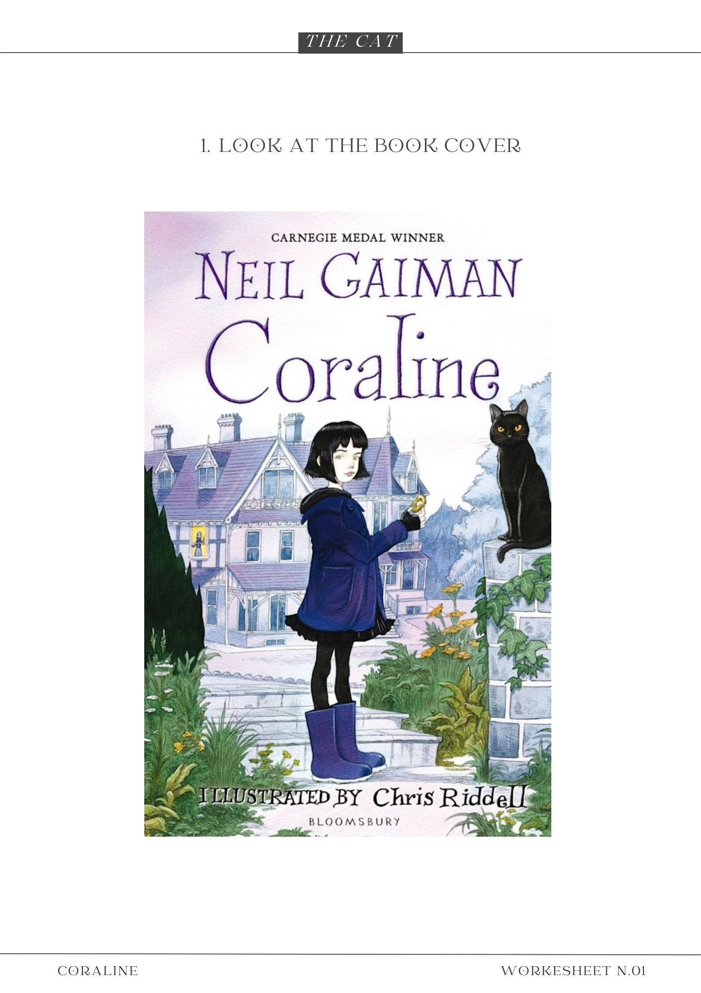

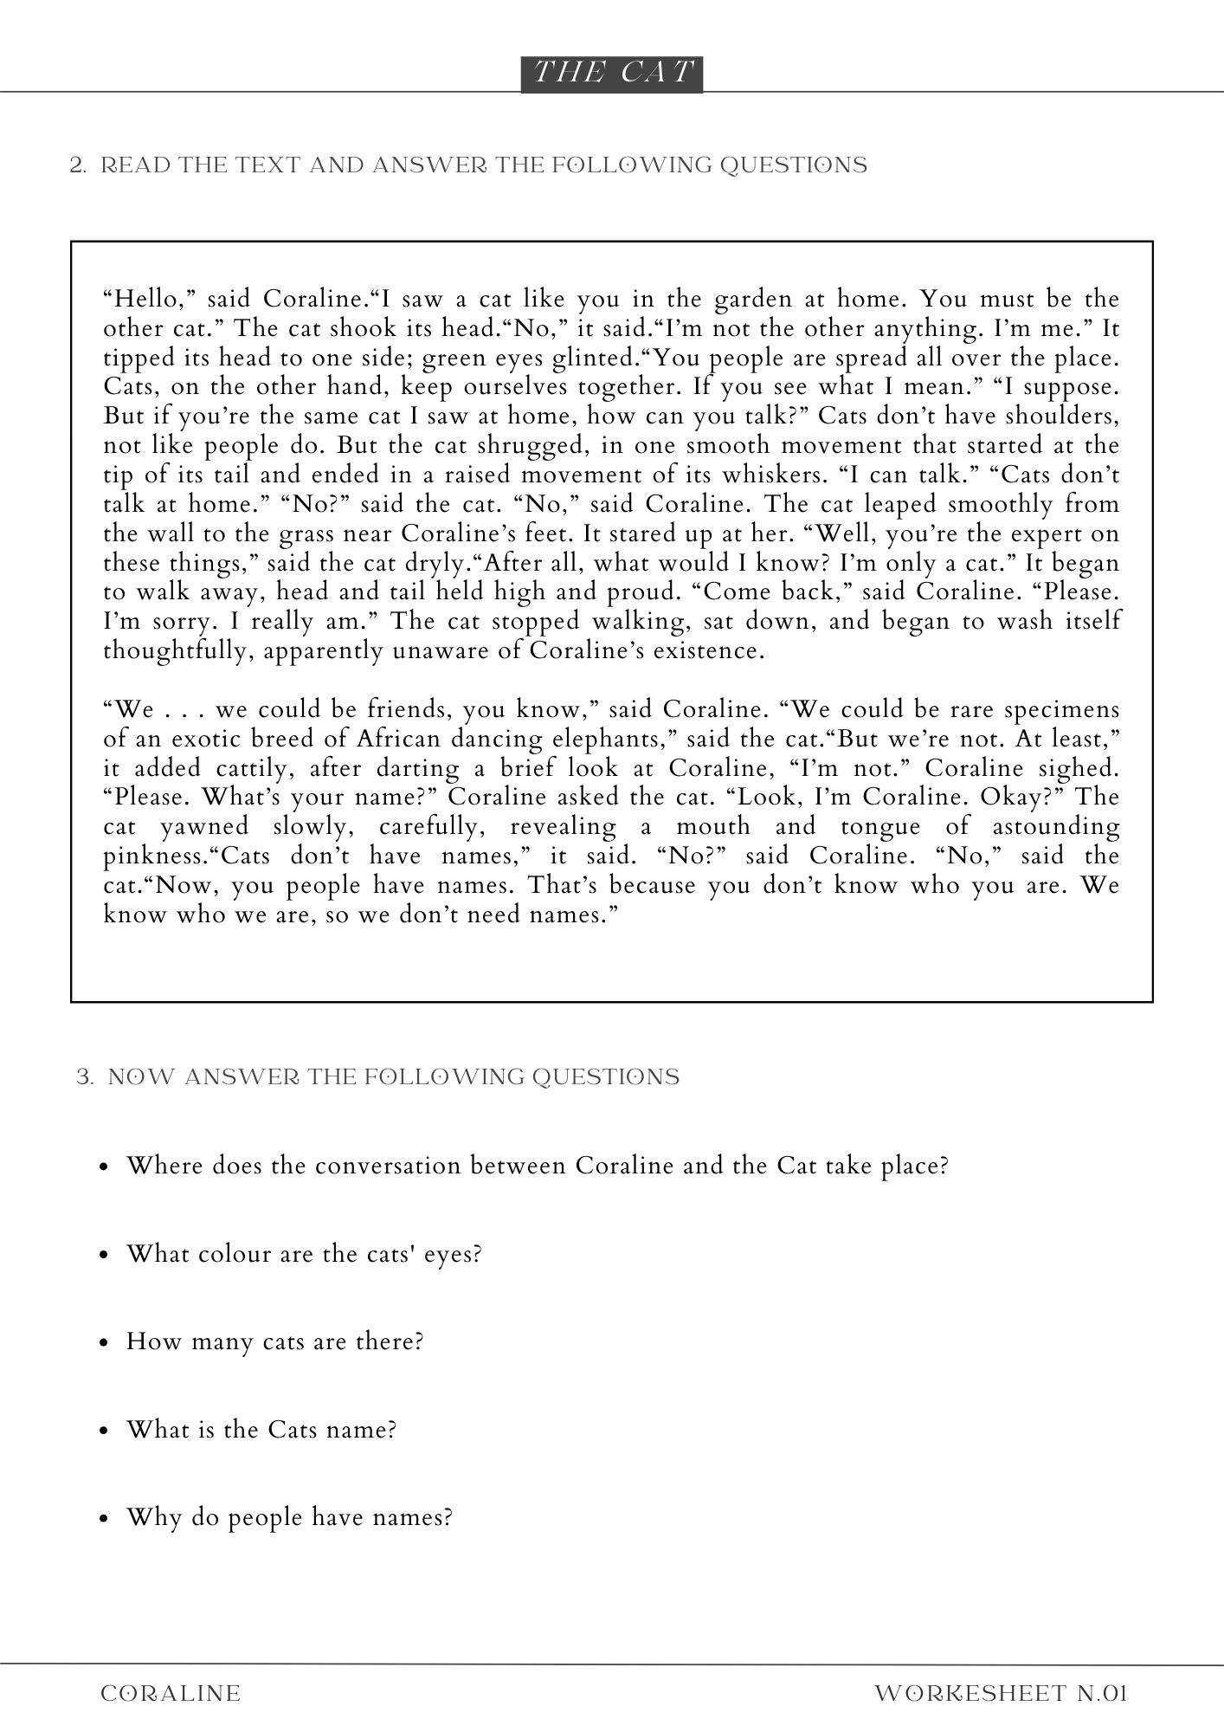

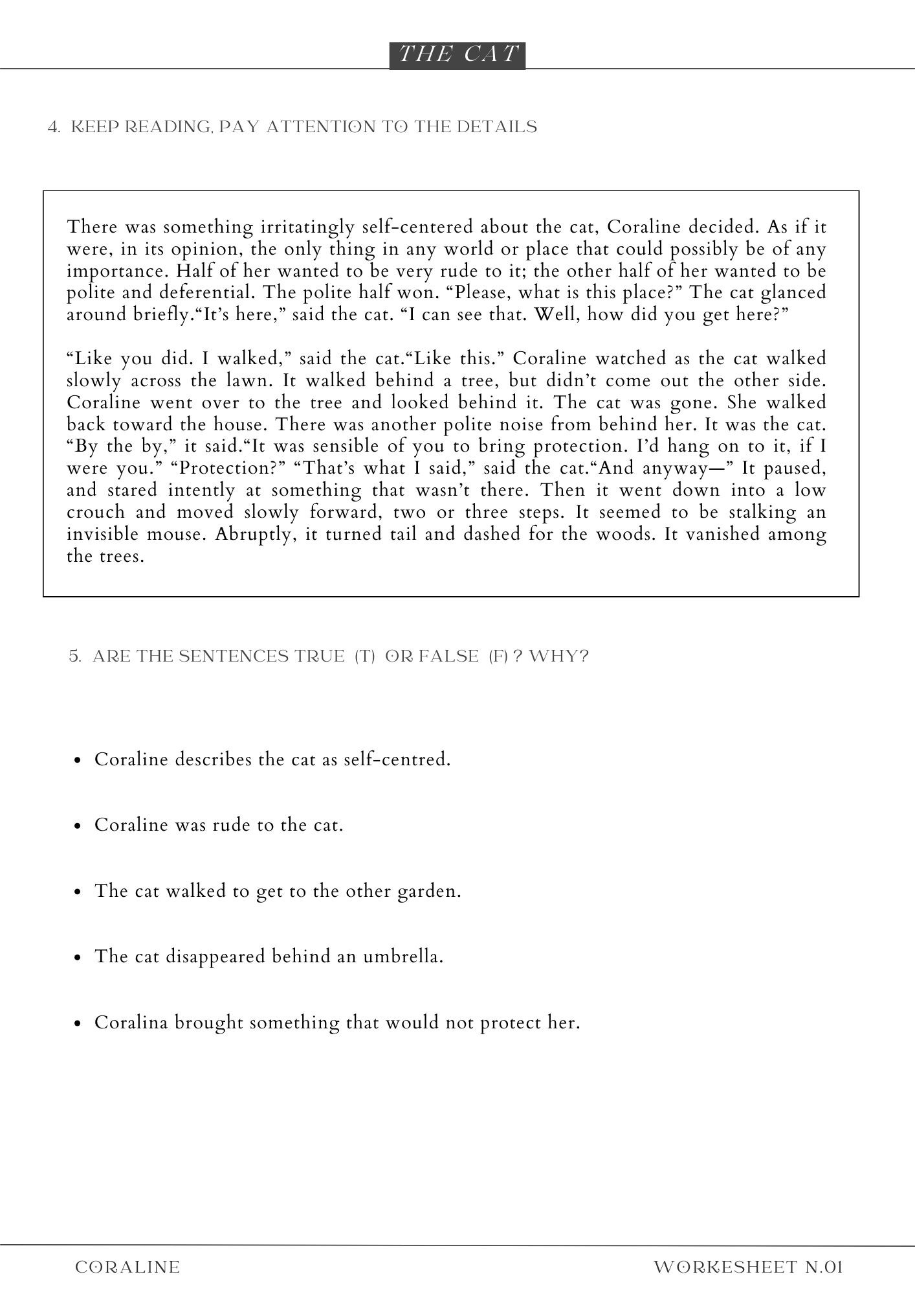

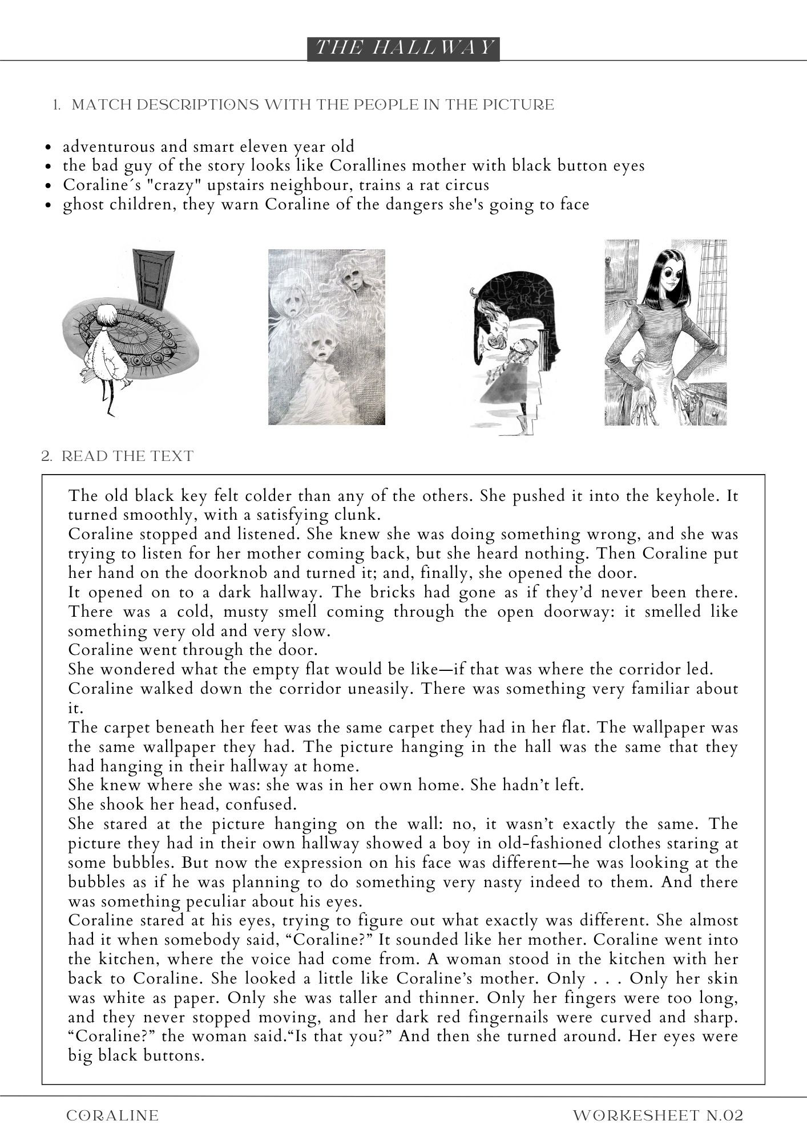

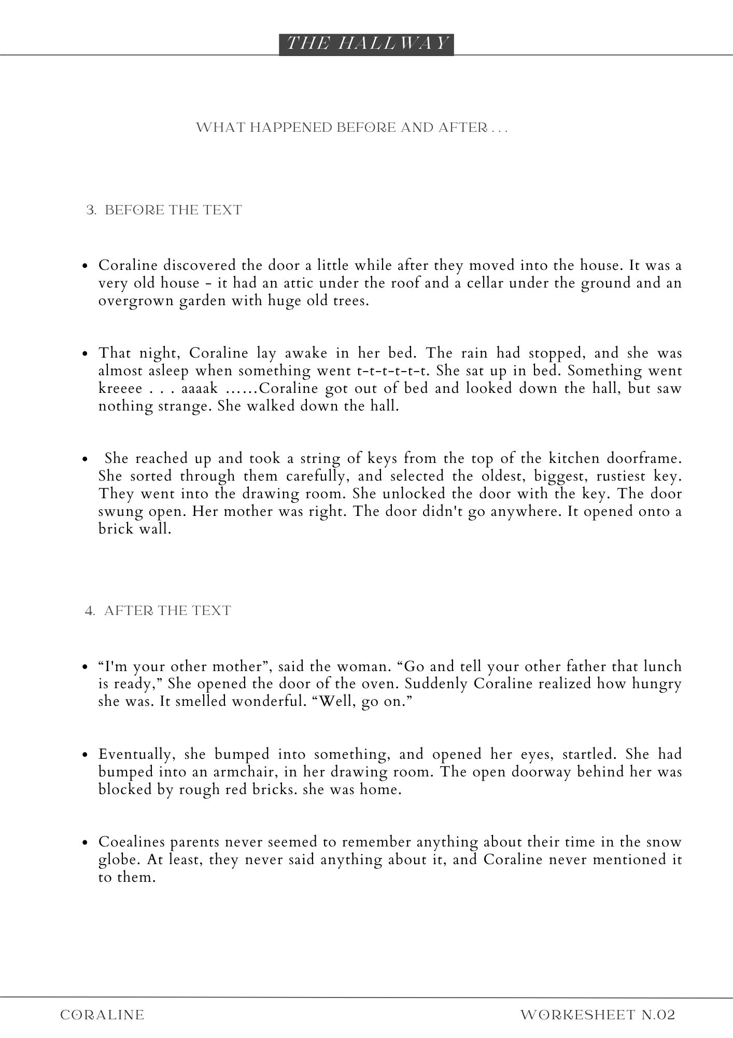

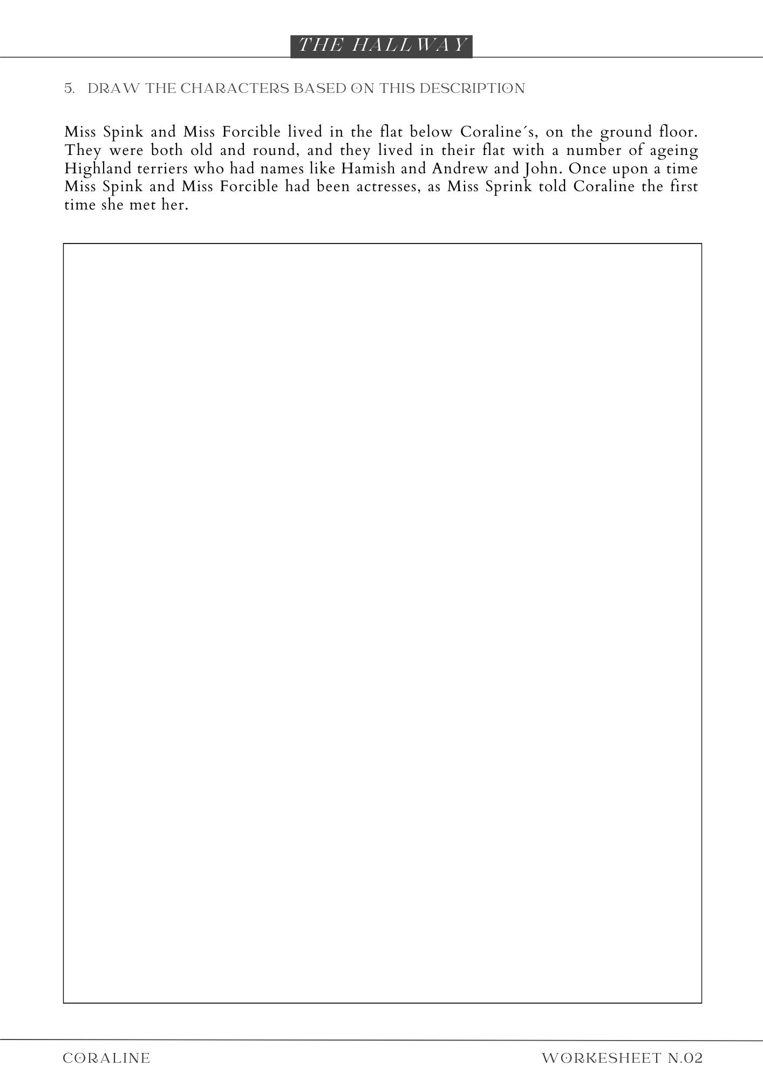

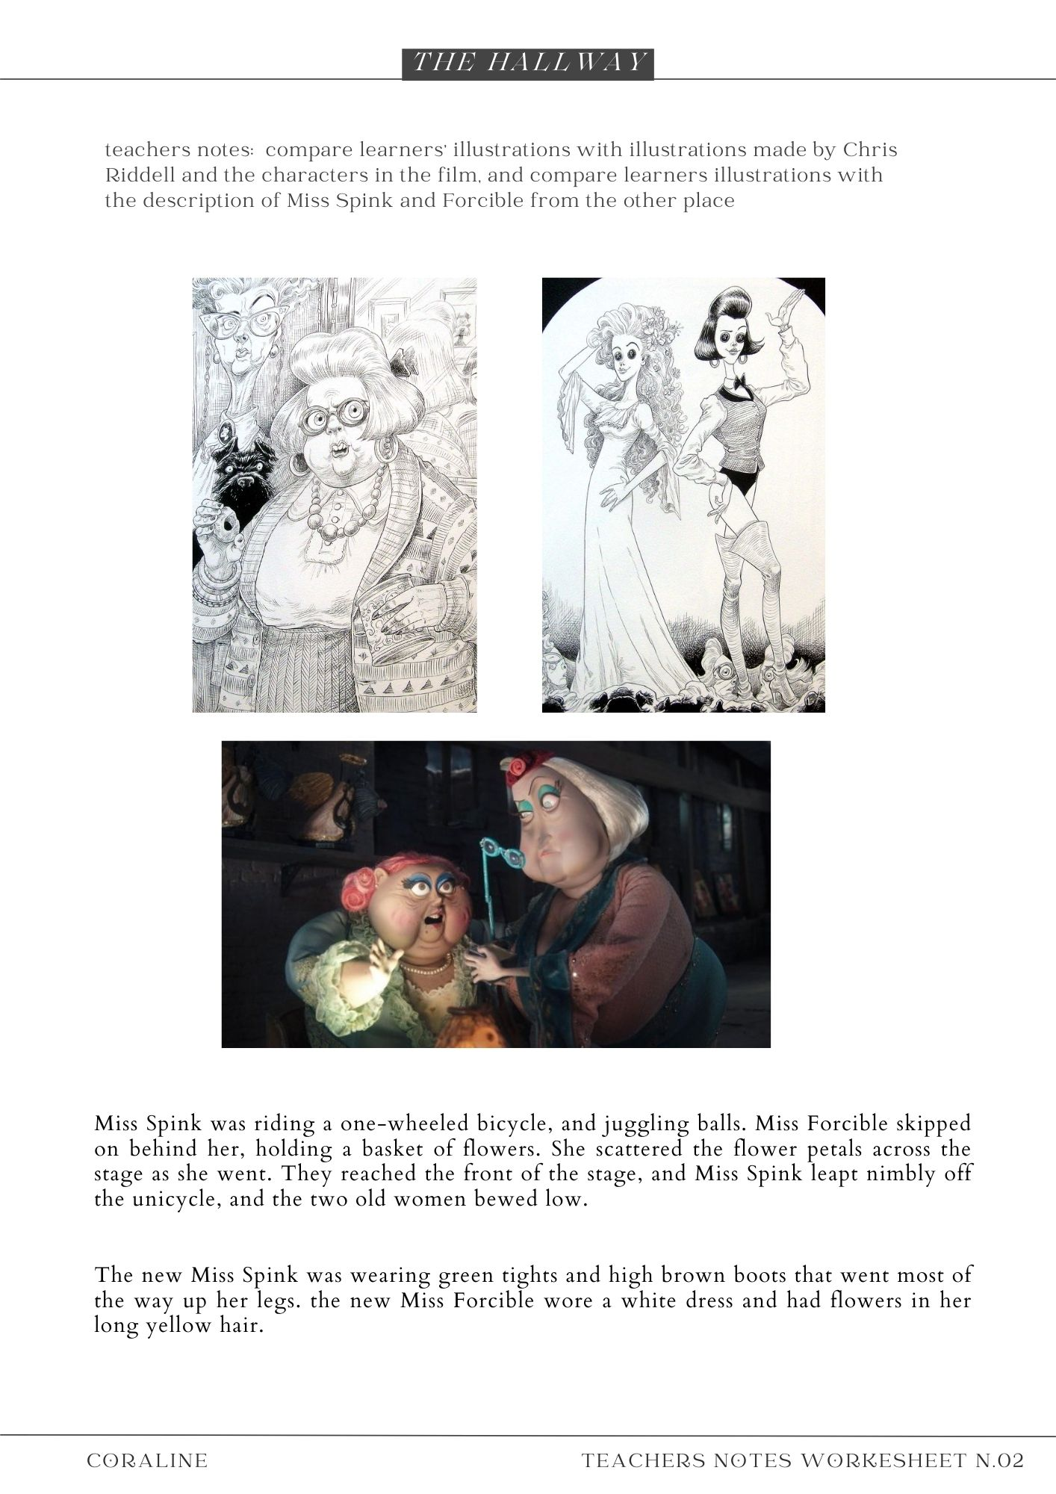

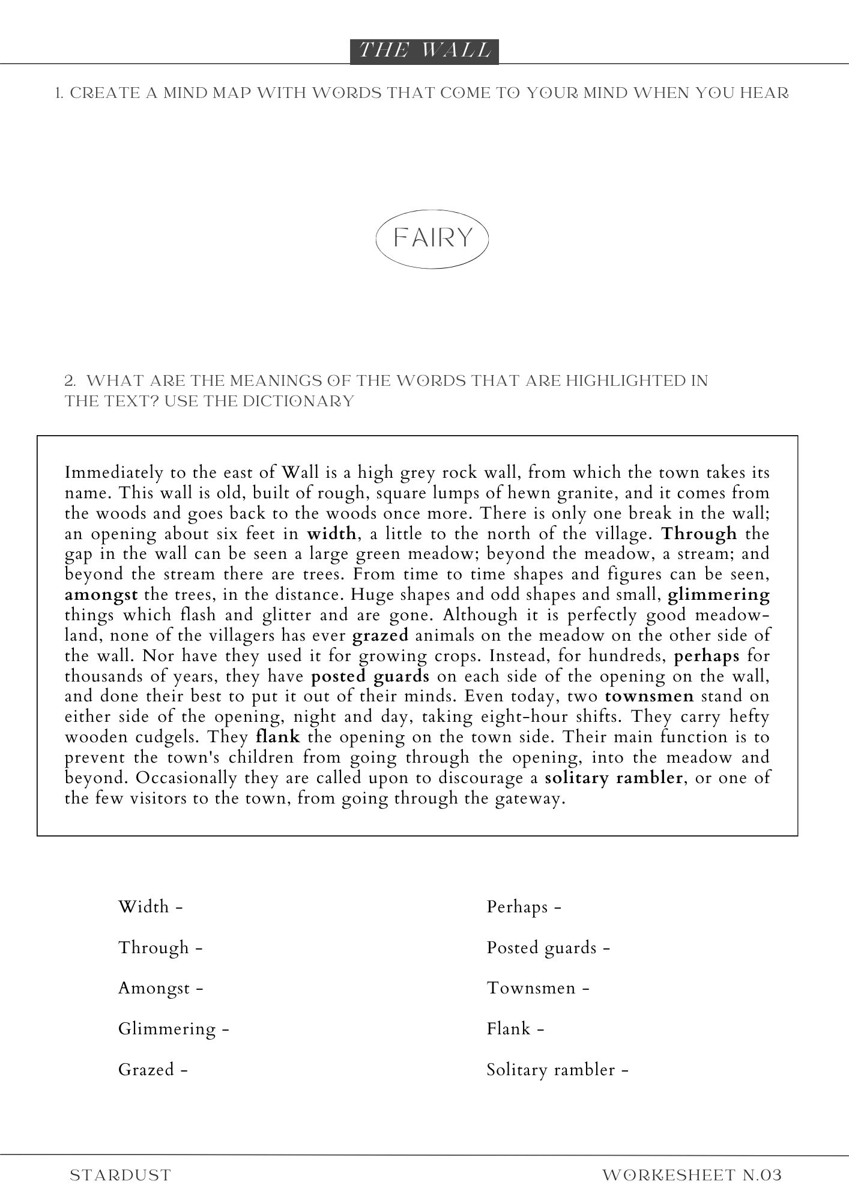

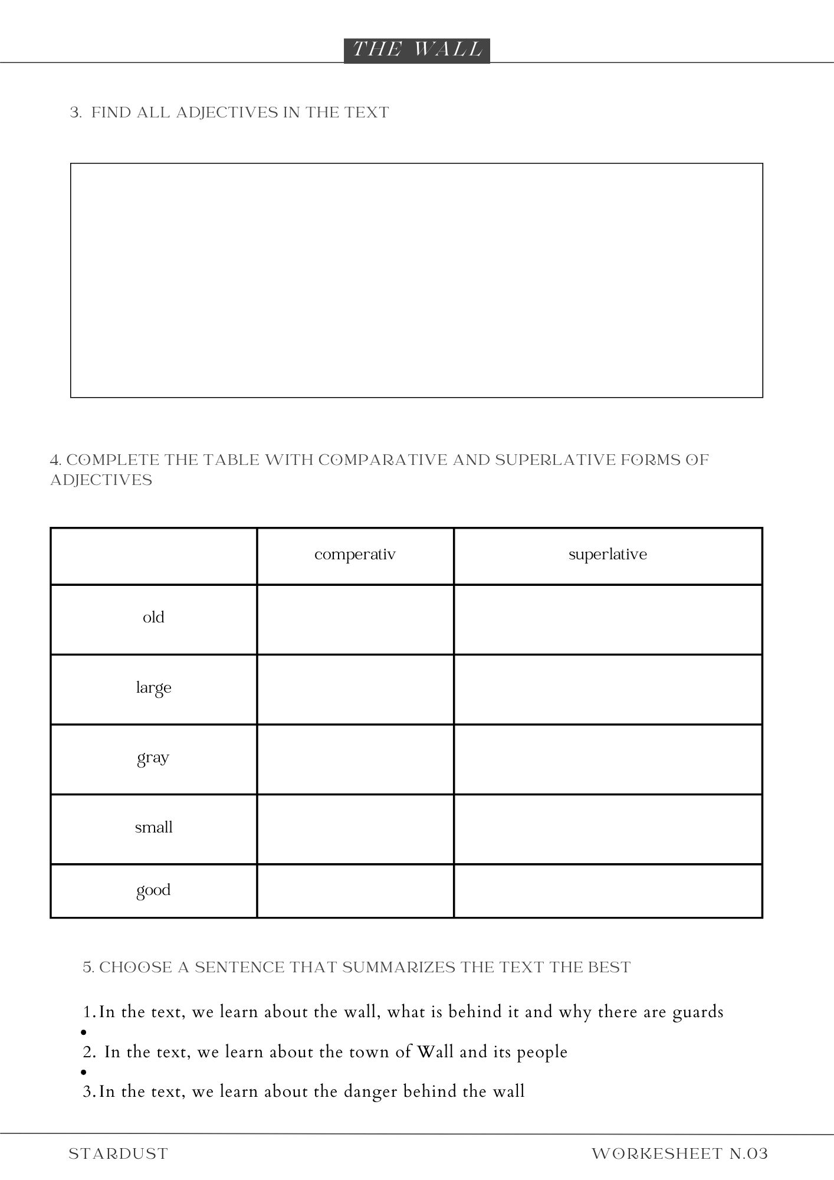

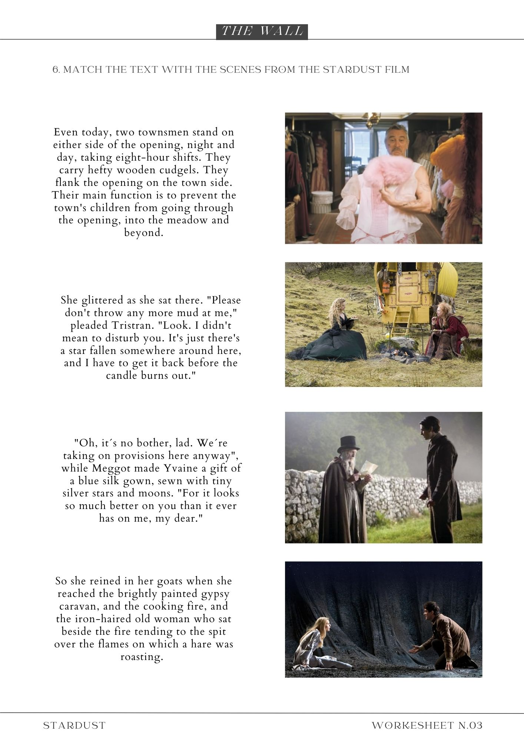

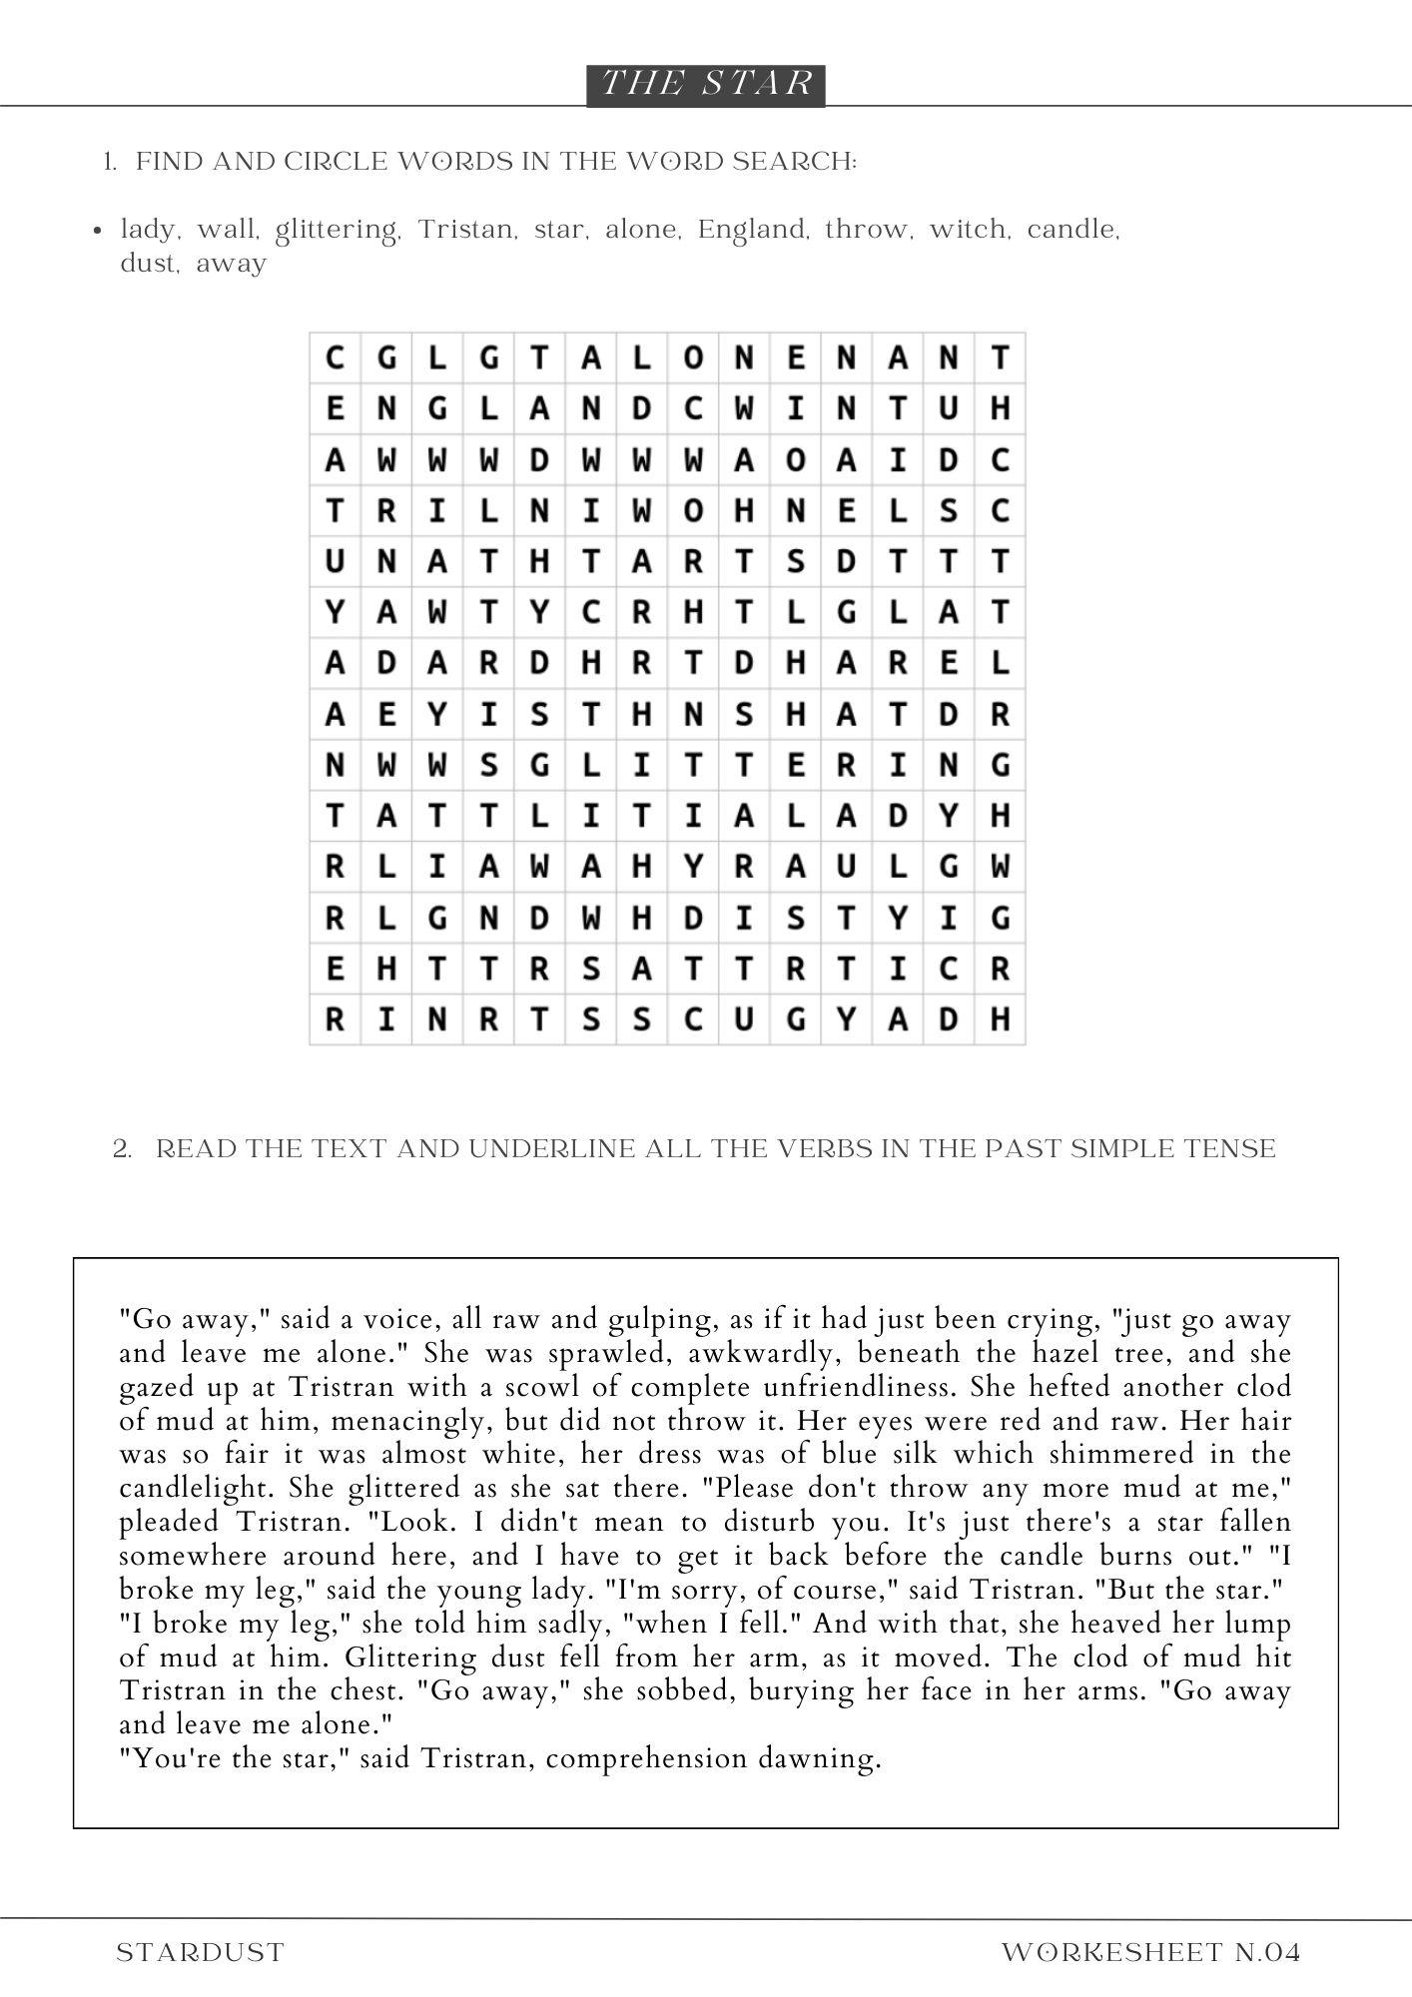

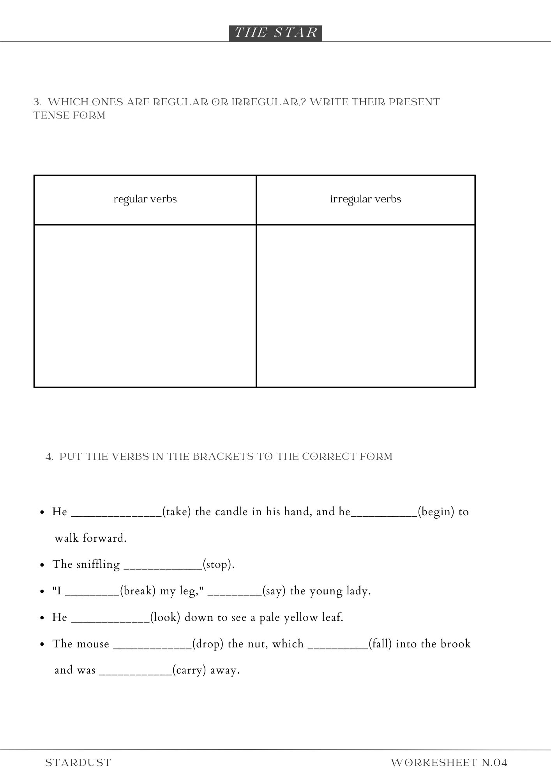

Resumé
Tato diplomová práce se zabývá využitím literatury ve výuce anglického jazyka. V teoretická část se zabývá touto problematikou, náležitostmi výuky cizího jazyka vymezenými dokumentem RVP ZV a Nielem Gaimanem. V rámci praktické části byly sestaveny čtyři výukové plány společně s čtyřmi pracovními listy na základě dvou knih Niela Gaimana (Koralína a Hvězdný prach). Tyto plány byly využity v hodinách anglického jazyka s žáky ve věku třináct až patnáct let a posléze analyzovány. Analýza zjistila, že žáci na texty obsahující fantastické prostory z knih Niela Gaimana reagují pozitivně a je možné využít v širším spektru žáků kteří jsou na různých jazykových úrovních. Výukové plány také pomáhají naplnit očekávané výstupy uvedené v RVP ZV. I přestože by pro prokázání dlouhodobého efektu byl třeba dlouhodobější výzkum, výukové plány mají potenciál rozvíjet klíčové kompetence uvedené v RVP ZV.

Annotation
Jméno a příjmení: | Zuzana Hálová
Katedra: | Ústav cizích jazyků, Pdf UP Olomouc
Vedoucí práce: | doc. Mgr. Janka Kaščáková, Ph.D
Rok obhajoby: | 2024
Název práce: | Výuka angličtiny skrze literaturu za použití fantastických proctor z díla Niela Gaimana
Název v angličtině: | Teaching English Through Literature using The Borders of Fantastic Space in Niel Gaiman's work.
Anotace práce: | Diplomová práce se zabývá využitím literatury v ELT se zaměřením na dílo Niela Gaimana. Zatímco v teoretické části je představeno využití literatury v ELT, kritéria výuky jazyka dle RVP a Niel Gaiman, praktická část se skládá z prezentace vytvořených výukových plánů a jejich analýzy. Veškerá data pro tuto analýzu byla shromážděna výzkumnou metodou pozorování, ke které došlo při použití vytvořených pracovních listů a výukových plánů na šestiletém gymnáziu a prvním ročníku střední školy.
Klíčová slova: | Literatura, fantasy literature, využití literatury ve výuce anglického jazyka, Koralína, Hvězdný prach, očekávané výstupy, klíčové competence, výukové plány, pracovní listy, analýza, žáci ZŠ, žáci SŠ, RVP ZV
Anotace v angličtině: | The diploma thesis is concerned with the usage of literature in ELT, with a focus on Niel Gaiman's work. While the theoretical part discusses the use of literature in ELT and, the criteria of teaching language set by FEP BE and Niel Gaiman, the practical part consists of the presentation of the created lesson plans and their analysis. All data were collected by using the method of observation which occurred while using the created worksheets and lesson plans in the lower secondary school and the first year of secondary school.
Klíčová slova v angličtině: | Literature, fantasy literature, use of literature in ELT, Neil Gaiman, Coraline, Stardust, Expected outcomes, key competencies, lesson plans, worksheets, analysis, lower secondary school learners, secondary school learners, the FEP BE
Přílohy vázané k práci: | Příloha č. 1 - 4
Rozsah práce: | 84 stran
Jazyk práce | Anglický

