COLLEDGE OF BUSINESS AND HOTEL MANAGEMENT

Field of study: Hospitality and Tourism Management

Valeria MELYNICSENKO

MARKETING COMMUNICATION MIX OF THE SELECTED REGION

BACHELOR THESIS

Thesis supervisor: Dr. Ing. Pavel Tvrzník

Brno, 2022

IDENTIFICATION DATA

Name and Surname: Valeria Melynicsenko

Title of bachelor thesis: Marketing communication mix of the selected region

Field of study: Hospitality and Tourism Management
Thesis supervisor: Dr. Ing. Pavel Tvrzník
Year of defense: 2022

ANNOTATION

This bachelor thesis concerns Marketing communication mix of the selected region.
To be more specific, Lviv region in Ukraine has been selected for that thesis.
The theoretical part describes the essence and components of marketing communications, then it mentions marketing communication of the tourism industry. It presents key advantages and disadvantages of marketing channels.
Explains main marketing tools such as SWOT-analysis, PEST-analysis, 4p and 8p, etc.
The practical part evaluates marketing communications of the tourism industry in the Lviv region. Analysis was carried out using marketing tools that were mentioned in the theoretical part and an online survey in form of a questionnaire. The survey is evaluated with the help of graphs and completed with commentaries

Key words: Marketing, Communcation mix, Ukraine, Lviv

COLLEDGE OF BUSINESS AND HOTEL MANAGEMENT
Department of Tourism and Specialized Subjects
Academic year: 2021/2022

BACHELOR THESIS ASSIGNMENT

Student's name and surname: Valeria Melynicsenko
Personal number: 14633080
Degree program: Gastronomy, Hotel Management and Tourism, B6503
Field of study: Hospitality and Tourism Management

TESIS TITLE: MARKETING COMMUNICATION MIX OF THE SELECTED
REGION

The goal set for Tesis
1. Theoretical part:
- The theoretical part will explain the basic marketing concepts, marketing mix with its specifics in tourism. Characteristics of destination management. Basic elements of marketing communication mix. Special emphasis will be placed on marketing research and the suitability of the use of marketing analysis.
2. Practical part:
- Analytical part - will focus on performing basic marketing analyzes of the communication mix of the selected region using a questionnaire survey. The results of the performed marketing analyzes and the questionnaire survey will be the basis for the elaboration of the design part.
- Design part - the results of the analytical part will form the basis for the design of a new marketing communication mix, including long-term strategy, costs of implementing the measures and expected benefits.

When processing BP, use the tool issued by VŠOH Brno.
Scope of bachelor thesis without appendices: 2 AA
Form of bachelor thesis: printed and electronic

List of recommended literature:
- [HOZA, I. - ŠTOFILOVÁ, J. Marketingový management v hotelnictví a cestovním ruchu. Skripta
VŠOH Brno, 2012. ISBN 978-80-87300-29-9.

- JAKUBÍKOVÁ, D. Marketing v cestovním ruchu. Praha: Grada, 2009. ISBN 978-80-247-3247-3.

- STOLIČNÝ P. Marketingová komunikace v hotelnictví a cestovním ruchu, skripta VŠOH Brno, 2012
ISBN078-80-87300-28-2

Further literature as recommended by the supervisor:
KOTLER, P., KELER, K. L. Marketing management, 12. vydání. Praha: Grada, 2007, ISBN 978-80-247- 1359-5.

HORNER, S., SWARBROOKE, J. Cestovní ruch, ubytování, stravování, využití volného času. Aplikovaný marketing služeb. Praha: Grada, 2006. ISBN 80-247-0202-9.

PELSMACKER, P., GEUENS, M., BERGH, J. Marketingová komunikace. Praha: Grada, 2006. ISBN 80- 247-0254-1

Thesis supervisor: Dr. Ing. Pavel Tvrzník Department of Tourism and Specialized Subjects
Signature:

Date of assignment of the bachelor thesis: 10.05.2021
Bachelor thesis submission deadline: 21.04.2022
L.S.

Dr. Ing. Pavel Tvrzník Ing. Zdeněk Málek, Ph.D.
Head of the department Vice-rector for educational activities

I declare that I have developed a bachelor thesis entitled Marketing communication mix of the selected region independently under the guidance of Dr. Ing. Pavel Tvrzník and listed in it all used literary and other professional sources in accordance with the currently valid legal regulations and internal regulations of the Colledge Of Business And Hotel Management.
Brno 19. 4. 2022

Valeria Melynicsenko

…………………………………….

CONTENT
INTRODUCTION 2
PART 1 THEORETICAL ASPECTS OF MARKETING COMMUNICATION MIX 3
1.1. The essence and components of marketing communications 3
1.2. Components of the marketing communication mix 5
1.3. Marketing communication of the tourism industry 11
PART 2 ANALYSIS OF MARKETING COMMUNICATIONS OF THE TOURISM INDUSTRY IN THE LVIV REGION 19
2.1. Analysis of the tourism industry of the region 19
2.2. Marketing communication mix of the region 25
2.3. Research of marketing communications of the tourist sector 31
PART 3 PROSPECTS FOR THE DEVELOPMENT OF MARKETING COMMUNICATIONS IN THE LVIV REGION 40
3.1. Ways to improve the marketing communication of the tourism industry in the Lviv region 40
3.2. Evaluation of the effectiveness of the proposed measures 44
CONCLUSIONS 48
REFERENCES 51
ATTACHMENT 53

INTRODUCTION

Tourism is one of the fastest growing industries in the world. Given the situation with the pandemic and anti-epidemiological measures around the world in 2020 there was a significant decline and reorientation in this area. In this regard, studies of the nature and peculiarities of tourism, tourism and services have begun to attract increased attention of researchers.
The success of modern tourism businesses largely depends on the proper organization of marketing communications, the methods of which have recently significantly shifted the focus to online communication, digital tools, the use of social networks, messengers, etc.
One of the specializations of enterprises in Lviv region is traditionally considered to be the tourism industry. Enterprises of the tourism industry, which mainly provide consumer and distribution services in social production, are the fundamental basis of tourism, not only meeting the domestic needs of the tourism segment, but also joining the national and international division of labor, which in turn provides the country world tourism exchange. However, there are still many unresolved issues for the proper development of tourism, including the use of marketing tools to increase the tourist attractiveness of the region.
The purpose of the study: to substantiate the possibilities of marketing communications for tourist regions of Ukraine (on the example of Lviv region).
To achieve this goal it is necessary to solve the following tasks:
- consider and describe the components of the complex of marketing communications;
- to determine the features of the use of marketing communications in the field of tourism;
- to study modern methods of communication;
- to characterize the tourist market of Lviv region and to analyze the main indicators;
- to open the marketing and communication system of the Lviv tourist market;
- assess the potential of the Lviv region;
- identify problems of development of marketing and communication activities in the region;
- substantiate and propose relevant tools for marketing communications;
- evaluate the effectiveness of the proposed measures.
The object of research is marketing communications.
The subject of research - features, current status and prospects for the development of marketing and communication activities in the Lviv region.

PART 1 THEORETICAL ASPECTS OF MARKETING COMMUNICATION MIX

1.1. The essence and components of marketing communications

Marketing is a complex, extraordinary and dynamic concept that justifies the impossibility of giving a complete and comprehensive description of it, taking into account the principles, goals, methods and functions in one definition. There are more than 2,000 different definitions that comprehensively reveal marketing with all its features and specifics.
All definitions of marketing are divided into 2 subgroups depending on their nature and period of formation:
1) classic or traditional
2) modern
In the classical concept, marketing is defined as an entrepreneurial activity that controls the promotion of goods and services from producer to consumer.
At the time of its inception in 1964, Columbia State University described it as a "social process that predicts, expands, and meets demand for goods and services through their development, promotion, and implementation."
The American Marketing Association defines marketing as an activity, a set of institutions and processes for creating, communicating, delivering, and exchanging offerings that are of value to customers, clients, partners, and society at large.
Thus, marketing must be considered in terms of a systems approach and invest the content of a complex socio-economic phenomenon, the foundations of which are laid in the use of systems analysis, program-target method of development and management decisions, management theory, mathematical statistics, programming, social psychology. In addition, marketing contains a set of forms and methods of organization, planning and promotion of products, market research and forecasting, needs and demand and more.
Thus, marketing is a type of activity that includes not only the study of the target market, which operates not in a vacuum, but in the current economic, social, political and other conditions, as well as the development of new products, planning their production, range, quality level (both the manufacture and sale and consumption of the product of social labor), and finally, stimulating demand through the use of information, advertising and other methods. And, in addition, the above research has shown that marketing is now a coherent science that allows you to conduct a business strategy of production.
Marketing communications is a concept according to which a company carefully considers and coordinates the work of its many communication channels to develop a clear, consistent and convincing view of the company and its products. The creation of integrated marketing communications involves defining the target audience and developing a carefully coordinated promotion program to obtain the desired appropriate response from consumers. Too often, marketing communications are aimed at solving acute problems of the target market related to consumer awareness, company image or consumer preferences.
Marketing communications are those methods that a company or a commercial person uses to convey advertising messages about their products and services. Marketing communications experts develop different types of persuasive communications and direct them to the target audience
Marketing communication is a fundamental and complex part of a company's marketing efforts. Broadly defined, it can be described as all the messages and media that a company uses to communicate with the market. Marketing communications include advertising, direct marketing, branding, packaging, the organization's online presence, printed products, PR activities, sales presentations, sponsorships, trade shows, etc.
Properly set goals of marketing communications will have a positive impact on efficiency. This conclusion follows from the goals of the integrated approach developed by Fischer, Maltz, Jaworski, and is based on the coordination behavior of individuals and groups in the organization to achieve certain goals. The approach is also based on cooperation and interaction between groups. Effective marketing communications are the result of a coordinated operation between the functions of the organization and its chosen marketing communication strategy, which follows from both strategic goals and the organization of business strategy. These correlations conclude that the development of marketing communication goals and coordination with the firm's business strategy can lead to a consistent and effective marketing communication strategy.
The marketing communication strategy must correspond to the vision, strategy and mission of the organization and correspond to the chosen market strategy. The results of some studies show the positive impact of the organization's mission on its financial results.
Effective marketing communications require consistency between all communication messages so that trust and consistency in the perception of the target audience can be established. The key to perception points management is the delivery and receipt of messages on the platform of strategic sequence. In accordance with the market orientation, the exchange of information between departments, the involvement of all departments in the preparation of business plans and strategies, the interaction of marketing staff with other departments are necessary prerequisites for better cross-functional coordination

1.2. Components of the marketing communication mix

Communication simply means the transfer of information from sender to recipient. But in practice it is a complex process that involves many other factors.
G. Assel, F. Kotler in the composition of marketing communications include four elements: advertising, sales promotion, personal selling and publicity. In general, EN Golubkova lists similar communication elements. The author specifies each of the proposed elements. In this case, publicity, as a free message about the company, its product or service in the media, should be supplemented by a wider arsenal of public relations tools, etc. Components of the complex of marketing communications are shown in Fig. 1.1.
Each component of the marketing communication process is characterized by certain principles that must be followed to optimize communication and the effects generated on the target audience. They can be outlined as follows:
- The sender of the message should be perceived as a “strong, attractive and reliable” source of information so that the recipient can identify it and imitate the behavior of customers about the goods / services that are the subject of the campaign;
- Communication is effective if the company knows well who are the recipients and what are their needs and expectations;
- The sender must find the best ways to express the idea conveyed through the message so that the recipient can correctly decode and understand the message sent to him. Regarding the message to be sent to the recipients, the most important decisions for the success of the campaign are the content, structure and form of the message;
- The message achieves its goal and produces effects on the receiver only if it is transmitted through the appropriate communication channel, with options focused on personal and non-personal communication channels;
- The response is the recipient's reaction to the message; the relationship between feedback and reaction is part of the whole; feedback is the part of the response that returns to the source of communication.

Fig. 1.1: Marketing communication complex

Classifying marketing communications - we divide them into two main groups by type of process organization: direct communication and communication through an intermediary.
1.) Direct communication is the communication of two or more people to get acquainted, discuss and / or promote a product or idea. The effectiveness of marketing communication in personal sales is determined only by the desires and skills of the seller, as the buyer's reactions are observed directly, and the seller can change their communication tactics according to the individual characteristics of each buyer.
2.) Marketing communications with the participation of communication intermediaries.
This type of marketing communications has several disadvantages and features:
- there is no possibility to "adapt" to a particular buyer,
- perception of information about the product depends on the attitude to the "transmitter" of information, the degree of trust in him;
- the main amount of information the consumer receives before planning or making a purchase, this must be considered in proper media planning.
- as mentioned above, messages can be conveyed to the target audience through means of communication (channels), each of which has advantages and disadvantages.
Most often, travel companies use such areas of PR activities as working with the media, conducting seminars, organizing study tours for employees of travel agencies, working with various information services. It is important to constantly search for new forms of PR activity
Personal selling is a tool of marketing communications, which is used to make sales directly during the personal contact of the seller and the buyer. Personal sales as one of the means of promotion and part of the complex of marketing communications has the character of direct personal contact.
Communicative features of personal sales:
- personal character. Allows you to establish a long-term personal relationship between seller and buyer. The presence of two-way communication between seller and buyer, dialog mode allows you to flexibly respond to customer requests, promptly make adjustments to the nature and content of communications, take into account the individual characteristics of the customer;
- definite and immediate reaction of the buyer. If the seller's offer is expressed quite skillfully, then answer "no" is very difficult. The process of personal selling makes a potential buyer feel somewhat obligated to have a commercial conversation with him. As a result, he feels a strong need to react in some way and at least listen to the seller. Personal selling - the only form of direct marketing that ends directly with the sale of goods;
- cost aspect of communication - a large share of costs is allocated to the remuneration of sales agents, transportation costs, entertainment costs;
- the small number of audiences affected, as the firm's staff can only have direct contact with a limited number of customers.
Another tool of marketing communications, which occupies a special and important place among the tools of modern tourism marketing are exhibitions. The advantage of exhibition events is that they provide a tourist enterprise with great opportunities to simultaneously disseminate and obtain a wide range of economic, organizational, technical, commercial and other information at relatively low cost.
Participation in exhibitions is an active and powerful means of forming marketing communications of tourist enterprises. In general, a tourist exhibition is a complex set of techniques and tools that reflect the basic elements of marketing communications - advertising, personal selling, sales promotion, public relations.
A well-known model of the marketing mix is the 4Ps model and its expansion of modifications. 4P in tourism is "product", "price", "place" and "promotion".
Product: Tourism includes components that range from niche to mass appeal, such as accommodation, food, drink, transportation, scenic beauty, historical significance of places, geographical status. These attractions can appeal to travelers in every segment of the tourist market. However, the packaging of the offer is also important, and each element is intangible and should improve the impression of the tourist.
Price: It is an important factor in 4Ps travel and tourism. All tourist products are unique. In many countries, the tourism business is seasonal. Thus, setting the price based on market competition is the most important component of the experience that travelers need. Their expectations must be met, whether they pay modestly, standardly or expensively.
Location: Distribution in tourism is a complex process, whether it occurs online or in storefronts. Technology has played a crucial role in the growth of the tourism industry, especially in the context of COVID-19, in terms of sustainability, design and safety.
Promotion: In tourism, advertising consists of inspiring, learning, persuasion and reminding travelers about a brand or product. This applies to marketing tactics used to spread awareness of a brand or product. The tourism industry uses various digital channels, including traditional and digital channels.
The most advanced model of the marketing mix is the 8P model, which is complemented by the following components: people, planning, programming and physical evidence.
People: Because a product is a collection of services, people who provide services are the key to transaction success. Operators must have the highest level of service to first complete the sale and encourage regular customers.
Planning: A key component of serving the tourism experience is planning. The client expects that the experience will exactly correspond to what he has acquired. The only way to ensure this type of correspondence is to carry out in accordance with detailed plans and have planning in case of unforeseen problems.
Programming: One way to add value to a standard product and distinguish a specific offering from competitors is to offer exclusive programming, a practice known as service marketing. Customers buy a product that meets their special interests. Special programming can consider such advantages and attract additional customers.
Physical Evidence: If possible, providing material evidence that a customer has experienced a particular travel product can help sales. Providing professional photos of customers at key events or supplying branded products are effective strategies for promoting certain travel products.

Table 1.: Key advantages and disadvantages of marketing channels
Means of communication | The main advantages | The main disadvantages
Newspapers | Flexibility; timeliness; good coverage of the local market; wide recognition | Short life; poor quality of distribution; small audience
Magazines | High geographical and demographic selectivity; authority and prestige; qualitative distribution; long life; good readership | Long time to buy advertising; some waste in circulation
TV | Combines sight, sound and movement; appeal to the senses; high attention; high coverage | High absolute cost; less selectivity of the audience
Radio | Mass use; high geographical and demographic selectivity; low cost | Audio presentation only; lower attention than television; non-standardized bid structures
External | Flexibility; high re-exposure; low cost; low competition | Limited audience selectivity; creative limitations
Brochures | Flexibility; full control; can dramatize messages | Overproduction can lead to costs
Direct mail | Audience selectivity; flexibility; lack of competition for advertising on the same media; personalization | Relatively high cost; Spam image
Newsletters | Very high selectivity; full control; interactive features; relatively low costs | Costs may run away
Phone | Many users; opportunity to provide personal contact | Relatively high cost; increasing consumer resilience
Internet | High selectivity; interactive features; relatively low cost | High competition for consumer attention
Source: Egan J. Marketings communicatios. Los Angeles: SAGE Publications Ltd, 2015, 421 p
Today, one of the most effective tools of marketing communication is Internet marketing, also called web marketing, online marketing or e-marketing - is the marketing of products or services over the Internet. The Internet has brought the media to a global audience. The interactive nature of Internet marketing in terms of providing instant answers and receiving answers is a unique quality of media.

Fig. 1.2: The most effective Internet marketing tools in 2020
Source: Most effective digital marketing techniques 2020. Statista. URL: https://www.statista.com/statistics/190858/most-effective-online-marketing-channels-according-to-us-companies/

Based on the responses of global marketers in early 2020, content marketing was considered the most effective digital technology. When asked to determine which activity they felt would have the greatest commercial impact on their own business or the business of their customers, 17% indicated content marketing. Next was marketing automation, big data, AI, and machine learning.

1.3. Marketing communication of the tourism industry

The Oxford Dictionary of Concepts and Terms interprets a destination as: "the place to which a person or thing is going"
The World Tourism Organization (UNWTO) considers a tourist destination as the main destination of a tourist trip, the territory of which is central to the decision to travel. That is, the destination is a defining element of the tourist system and considers it as a leading factor in the system of formation and delivery of tourism products.
World experience shows that the practical use of the concepts of destination competitiveness is manifested in the development of programs and strategies for the development of local administrative units (communities, districts, provinces) as areas attractive to skilled and discerning consumers. Local administrative units act as tourist destinations, and tourism is seen as a form of expanding sales of local goods and services. In conditions of increased competition, destinations increase their competitiveness only by implementing a mechanism of consistent accumulation of competence, innovation, quality of service, which leads to obtaining the necessary income to ensure a decent standard of living of the local population.
The specifics of the tourism industry are the basic competencies needed to manage a local tourist destination. Hence, the main requirements for destination management are as follows:
1) the ability to perform a cooperating function, taking into account the intersectoral production of tourism products;
2) the presence in the management system of not only vertical but also horizontal and diagonal connections (to overcome the barrier of interagency uncontrollability and reduce the time between the moment of decision-making and its implementation in practice);
3) a minimum of policy tools, as the success of the development of the service sector depends on the success of private business;
4) ensuring spatial planning and management of tourist flows - the main elements in the strategy arising from the geography of the tourist product.
Tourism marketing is designed to ensure the fullest possible satisfaction of the existing needs of tourists, as well as to anticipate possible changes in the structure of needs. Thus, the concept of marketing in tourism is holistic and comprehensive.
The main reason for the allocation of tourism marketing was the rapid development of tourism, which in many countries has become an important sector of the economy, and in some - and the main source of income. Other factors of emergence and development of tourist marketing:
- improving the living standards of the population and the availability of tourist services to the population;
- the development of transport communications contributes to the expansion of travel geography and the development of international tourism;
- the flourishing of international political, economic and cultural relations contributes to the formation of business tourism, business travel;
- the processes of globalization that have made it easier to travel the world.
Thus, the emergence of many tourists and the diversity of their requirements necessitated the implementation of marketing activities in the markets of tourist services.
At the same time, the development of marketing in tourism is due not only to consumer demand, but also the emergence of competition both between travel agencies and between travel products.
It should be noted that the formation of marketing in tourism was not autonomous. The theory and practice of tourism marketing have been largely adopted from the experience of industrial marketing. Therefore, we can assume that tourism marketing is only one of the subtheories of marketing.
Interacting with various subjects of tourism business, the company becomes an active participant in information and communication processes taking place in its information environment. Within the framework of these processes the movement of information resources and information flows, which are the basis for the formation of current and long-term communications of the enterprise
The most important target audiences (recipients) of marketing communications of the tourist enterprise are the following:
- Employees of the firm. Achieving the goals set for the company largely depends on the extent to which management has reached an understanding with staff, as a strong motivation of employees, the psychological climate prevails in the team.
- Actual and potential consumers (target market). The system of communications with the target market is characterized by an extraordinary variety of forms, tools and instruments (advertising, discounts, contests, games, etc.).
- Marketing intermediaries. These include trade intermediaries (travel agencies, tour operators, travel agencies), as well as individuals and companies that would perform certain marketing functions (eg, marketing research agencies, advertising agencies, etc.). The peculiarity of this recipient of communications is that the marketing intermediary can be an intermediate link in the communication of the firm with the target market and contact audiences.
- Contact audiences unite organizations and individuals who are not directly involved in the market activities of the enterprise. The main means of communication with contact audiences can be public relations (including propaganda), advertising, participation in solving social problems of the city, region, etc.
- Manufacturers of tourist services - companies that provide accommodation, food, transportation services, etc. Appropriate reaction is expected, business cooperation on mutually beneficial terms.
- Public authorities and administration (both legislative and executive). To establish and maintain relationships with them can be used: lobbying, participation in national programs (economic, environmental, cultural), presentations, participation in exhibitions, etc.
Internet communication tools have also led to major changes in the functioning of various economic sectors, such as marketing. As the name implies, Internet marketing is the act of promoting goods and services over the Internet. This is the type of marketing and advertising that the Internet uses to convey advertising marketing messages to customers. This is a subset of digital marketing. Internet marketing involves a greater variety of marketing components than regular marketing. The following figure shows the stages of formation of Internet marketing communication in the tourism industry

Fig. 1.3: Algorithm of Internet marketing activities for a travel company

At the first stage, all new existing marketing opportunities on the market are identified and evaluated. To analyze them, you need to collect maximum data both online and offline. With the help of marketing tools, in particular the use of SWOT-analysis, GAP-analysis, PESTEL-analysis, McKinsey 7s, Ansoff matrix, etc., it is necessary:
1) adjust the search and analysis of these opportunities in relation to the situation in the company - it is planned to create a new business / direction of the tourist enterprise or optimize or expand the existing one;
2) conduct careful segmentation of potential customer groups;
3) identify currently available in the company potential or ineffectively implemented proposals to meet customer needs;
4) critically evaluate the relevant resources for the implementation of potential offers to customers to meet identified needs;
5) assess the potential competitiveness, technological and financial attractiveness of the enterprise as a result of the potential realization of new marketing opportunities in the market.
The essence of PEST-analysis is to identify and assess the impact of macro-environmental factors on the results of current and future activities of the enterprise. PEST is an abbreviation of four English words: P – Political-legal, E - Economic, S - Sociocultural, T - Technological forces. The purpose of PEST-analysis is to track (monitor) changes in the macroenvironment in four key areas and identify trends, events that are not under the control of the enterprise, but have an impact on strategic decisions.
SWOT analysis is an analysis of the external and internal environment of the organization. Strengths, Weakness of the internal environment, as well as Opportunities and Threats of the external environment of the organization or destination are analyzed.
In the McKinsey 7-S model, all the elements are interconnected and divided into 2 large areas "hard" and "soft". The "hard" elements of the company's microenvironment are three components: the structure, strategy and management system in the organization. "Hard" elements are the easiest to describe, evaluate, and therefore easier to manage. "Soft elements", which include all other components of the model are more difficult to manage and evaluate, but are often the main components of the company and can make a long-term competitive advantage. The soft elements include: shared values, skills, style, staff.
In the second, key stage, it is necessary to form an Internet marketing strategy. Otherwise, with the wrong strategy, all subsequent stages, even with the right organization, will be ineffective. The formation of marketing strategy can be divided into the following stages:
1) marketing segmentation, ie search and identification of relevant marketing segments, the needs of which the company can potentially meet;
2) targeting, or choosing the most attractive specific marketing segment, the needs of which the company is able to meet taking into account the goals and available opportunities;
3) positioning, or strategic opportunities to work with this client segment.
In the third stage, the travel company must clearly define the expectations of the potential customer segment in order to effectively implement the new marketing opportunities identified in the first stage. We can highlight the main steps that the company must take to effectively implement this stage of the algorithm:
1) create a comprehensive description of target consumer groups of tourists;
2) develop step-by-step algorithms for interaction with each of the consumer groups;
3) consider and integrate both traditional and Internet marketing tools for effective interaction with each of these groups of tourists;
4) create a hierarchy of expectations of target groups and specific actions aimed at meeting them;
5) integrate monitoring mechanisms to promptly adjust their actions in order to fully meet the expectations of tourists groups.
The fourth stage involves the software implementation of the results of the previous stages - the creation of an interface to work with the consumer. The criterion of success will be the effectiveness of customer interaction with the software interface that the company will be able to develop. Today, it is no longer just the development and technical support of the company's website. The implementation of this stage should be carried out considering the content, methods of data transmission, means of communication used by potential tourists groups and ways of working with these groups in the Internet environment (by creating online communities, etc.). According to Forbes, in 2020, 72% of buyers in developed countries trusted online recommendations (in online communities or social networks) as if they were the recommendations of close friends or relatives; 81% of respondents said that information posted on online resources on social networks related to certain goods and services directly affects their purchases. According to the Internet resource SproutSocial, 74% of consumers before buying a product or service today are guided by information posted on social networks. In addition, there is a clear trend in favor of goods and services associated with well-known brands. The problem of online payment requires particularly careful consideration with the aspect of ensuring the security of customer data and ease of working with them, the choice of systems and methods of payment, their stability and reliability.
Upon completion of the fourth stage, at the stage of transition to the fifth stage - the formation of a marketing program, the company must have a clearly defined strategy for further development of marketing activities in the Internet environment. Digital implementation of a marketing program should include digital implementation of an effective model of interaction with the client. This model can be formed based on the cycle of relationships between the company (service provider) and the client, consisting of four phases:
- phase 1 - informing the consumer. At this stage, through the use of certain Internet technologies (for example, Google Ad Words, Yandex Direct, through online communities, etc.), the client gets acquainted with the offers of services or travel product;
- phase 2 - development of relations. The client weighs the pros and cons and then decides whether to use the services offered and / or purchase a travel product (at this stage, the company's social media activities are particularly important, which should be aimed at making a positive purchase decision; especially effective ) will promote the product or service in association with a well-known brand, if any);
- phase 3 - purchase and after sales service. The customer made a positive decision, the transaction was made through online payment or at the point of sale, depending on the chosen strategy of the company; At this stage, the company is in the process of fulfilling its obligations to the client, the quality of which will lead the client or again to phase 1 (which should be aimed at strategy and all actions of the company in online media and using traditional marketing tools in offline) or up to phase 4;
- phase 4 - termination of relations. Loss of customer interest in the company's services (for objective reasons, such as a single purchase, the customer no longer needs these services or travel product) or inexpediency of working with a particular customer for the company (for example, if the customer's goal is not to use company services , and the desire to profit from unfounded complaints).
The company's efficiency in selling services or tourism products, its competitiveness and future development will depend on how accurately the company's marketing activities both online and offline will meet customer requirements: whether the quality of services will exceed their expectations or not meet them. Success in this area can be achieved with the help of integrated rhubarb management technologies, the use of which is provided in our model at the sixth stage.
As part of the sixth stage, the company based on the use of mechanisms for collecting, analyzing and processing customer information, transactions, customer feedback received in various unobtrusive ways (for example, through crowdsourcing, questionnaires based on feedback processing) language from the Internet community), should be able to generate operational data on the necessary correction or optimization of marketing strategies. The purpose of this work is to retain existing and attract new customers, as well as to objectively analyze and assess the prospects of long-term cooperation with certain customer groups based on the study of cost structure and financial results. In addition, through the use of rhubarb management technologies can be found global strategic solutions to the feasibility of entering new markets in order to win new customer segments.
The task of the final stage is to evaluate the effectiveness of marketing activities in general and adjust the strategic goals and tactics of their implementation based on the analysis of the effectiveness of each stage of the marketing campaign. A clear correlation of the analyzed data sets with the model proposed for digital implementation of the marketing strategy in the fifth stage is needed. In particular, it is important to be able to qualitatively and quantitatively assess the effectiveness of consumer information, namely to have data on what part of informed consumers has entered the phase of relationship development and, most importantly, the buying phase. Qualitative and quantitative analysis of these data will help to understand whether the company successfully transforms the cost of informing consumers into financial results, and develop optimization strategies aimed at increasing the number of customers in the transition from phase 1 of the above model.

PART 2 ANALYSIS OF MARKETING COMMUNICATIONS OF THE TOURISM INDUSTRY IN THE LVIV REGION

2.1. Analysis of the tourism industry of the region

Lviv region is traditionally a region where the prospects of tourist and recreational recreation have been and remain one of the best in Ukraine. Its natural resource and historical potential, combined with its advantageous geographical location in the heart of Europe and many years of experience in tourism and recreation, is an essential prerequisite for the priority development of tourism, recreation and spa treatment. Local flavor, centuries-old history, various colors of nature, healing springs of mineral waters, picturesque landscapes of the Carpathians, preserved traditions, folk crafts, delicious cuisine of Galicia annually attract tourists and guests from many countries. Much of the historical, architectural and cultural monuments of Ukraine, represented by buildings from the princely era to the twentieth century, are concentrated in the Lviv region. Fortifications Tustan, Olesky, Zolochiv, Pidhirtsi, Svir castles, religious tourism centers of Krekhiv and Univ monasteries, historical cities of Zhovkva, Belz, Bibrka, Zolochiv, Zhydachiv, Sambir, Drohobych and Lviv are very popular among tourists. Lviv region is rich in enchanting nature, which has always been a special pride of Ukraine. This region is one of the leading places in Ukraine in terms of the availability of healing mineral waters and muds, on the basis of which such world-famous resorts as Truskavets, Skhidnytsia, Morshyn, Nemyriv, Velykyi Lyubin, Shklo are developed. Of great value are the mountains of the region, suitable for skiing and recreation - Slavske, Tysovets, Plave. Volosyanka, Rozluch, Turka. Friendly and hospitable hosts greet everyone who wants to relax and get to know the unique and wonderful Lviv region, leave unforgettable impressions and dream of coming back again.
The basis of the tourist and recreational potential of Lviv region are natural (climatic, balneological, landscape, water) and historical and cultural (archaeological, sacred, historical, architectural, artistic, event) tourist resources. This also includes the tourist infrastructure, which is formed due to the efficient operation of hotels and restaurants, sanatoriums, transport system and tourism enterprises.

Fig. 2.1: Components of the tourist and recreational potential of the Lviv region

The number of collective accommodation facilities, according to official data, in 2019 (excluding sole proprietorships) was 130, including 106 hotels and similar accommodation establishments, 24 other accommodation establishments, places in collective accommodation establishments - 13,188, the number of persons 533878, of which foreigners - 118204, the number of hotels and similar accommodation - 106 (5677 rooms). Number of tourists served by tour operators and travel agents by type of tourism: 249442, including inbound (foreign) tourists: 7929, outbound tourists (citizens of Ukraine who went abroad): 159164, domestic tourists: 82349. Number of farmsteads - 14 According to open sources, accommodation services are offered by more than 500 estates, the number of tourist information centers - 8.
It should be noted that the geospatial distribution of the nature reserve fund of Lviv region is very uneven. According to the scheme of physical and geographical zoning of the territory, the NPF objects are localized as follows (table 2.1).

Table 2.1: Division of territories and objects of the nature reserve of the Lviv region according to physical and geographical districts
Physical and geographical area | Total number of objects | Number of functional types of objects |  |  | % of objects of indirect environmental importance
 |  | planar objects | Parks, botanical gardens | "point" objects
Precarpathians | 105 | 17 | 26 | 61 | 82,9
Podillya | 114 | 47 | 25 | 38 | 55,3
Skib Carpathians | 44 | 19 | 2 | 20 | 50
Watershed Carpathians | 22 | 17 |  | 5 | 22,7
The plains of the Upper Bug and Styr | 33 | 18 | 0 | 5 | 45,5
Volyn upland | 6 | 3 | 10 | 2 | 50
Source: T.B. Nahirniak, B.M. Kalyn, Research of main problems of the natural reservoir fund of the Lviv region and the ways of their solvency, Scientific Messenger LNUVMB, 2017, vol. 19, no 79 (in Ukrainian)

According to the State Strategy for Regional Development until 2020, in 2017 the area of the nature reserve fund of Lviv region covered 7.98% of the entire territory of the region, and in 2016 this figure was 7.2%. The increase was achieved through the creation of the Boykivshchyna National Nature Park, the Volia Yakubova Nature Reserve, and the Bilogorscha Peat Landscape Nature Reserve. The territory of the Stilske Gorbohirya Regional Landscape Park was also expanded.
Lviv region is one of the richest regions of Ukraine in terms of the number and importance of architectural, cultural and sacred monuments. There are 8441 historical, 1235 architectural and 611 cultural monuments in the region. 5 sites of the region are included in the UNESCO World Heritage List: Ensemble of the historic center of Lviv and four wooden churches (Church of St. George in Drohobych XVI-XVII centuries., Church of the Holy Trinity in Zhovkva in 1720, Cathedral of the Blessed Virgin in Matkov, 1838 Church of the Descent of the Holy Spirit in Potelich in 1502).
Lviv region is one of the regions of Ukraine with the largest number of castles, namely 10 castles of the XIV-XVII centuries. (Brody, Dobromil, Zhovkva, Zolochiv, Lviv, Oles, Pidhirtsi, Pomorian, Svir, Starosil).
One of the largest historical and cultural monuments is the city of Lviv, where thousands of tourists come every year from both Ukraine and abroad. Architectural monuments of Lviv, their unique beauty are special not only in our country, but also in world art. It is an intertwining of the achievements of Eastern and Western cultures and Ukrainian folk art, an artistic ensemble that testifies to the high noble soul of the people, the sophistication of its tastes and customs. The uniqueness of the city harmonizes with the diversity of cultural traditions, styles of different eras from the XIII to XX centuries - Renaissance, Romanesque, Gothic, Baroque, Rococo, Empire, Classicism, Constructivism, Secession.
An extensive network of recreational facilities has been created in the region: 133 sanatoriums, 82 hotel establishments, about 500 private estates engaged in rural tourism. In addition to resorts, the most famous mineral water deposits are located in the village of Olesk, Baluchini, Novyi Mylyatyn, Soluki.

Fig. 2.2: Distribution of tourist entities by cities and counties in 2018

The largest number of tourists arriving in the Lviv region for the purpose of rest, in 2019 a record number of tourists was recorded - 215 thousand people, which is 145.79% more than in 2018, in 2020 there were only 86.9 thousand people . The next most popular is the category of tourists arriving for treatment, because in the Lviv region there is a large number of recreational resources and health facilities, such tourists in 2019 were about 31.9 thousand people, which is 59.3% less than in 2018. Significantly fewer people come for sports, special and other types of tourism, in 2018 there were 499 people, 656 people and 1 person, respectively.
Table 2.2: Distribution of tourists by directions and types of tourism
Tourists supported | 2015 | 2016 | 2017 | 2018 | 2019 | 2020 | 2019/ 2018 | 2020/ 2019
Tourists together | 112472 | 181827 | 175150 | 182255 | 249442 | 100824 | 36,86 | -59,58
including business trip, business, study | 842 | 816 | 300 | 747 | 979 | 140 | 31,06 | -85,7
rest | 86240 | 104913 | 120102 | 87637 | 215400 | 86901 | 145,79 | -59,66
treatment | 24231 | 74230 | 53768 | 78573 | 31908 | 13783 | -59,39 | -56,8
sports tourism | 397 | 406 | 153 | 15254 | 499 | 0 | -96,73 | -100
specialized tourism | 66 | 159 | 711 | 96 | 656 | 0 | 583,33 | -
other | 696 | 1303 | 116 | 2 | 1 | 0 | -50,00 | -

The largest number of incoming tourists comes steadily from Poland, about 26%, in second place are tourists from Azerbaijan - 21%, followed by tourists from Belarus - 15%, tourists from Germany and Austria are about 7%, Moldovans account for 5 %, Americans - 4%, tourists from other countries are 15%.
The study of the advertising market is designed to outline the competitive market picture among advertisers, agencies, advertising media. So let's consider the state of the advertising media market in Ukraine, analyze the dynamics of development for 2019-2020, identify the main reasons for the changes that have occurred (Table 2.3):
Table 2.3: Dynamics of development of the advertising media market of marketing communications of Ukraine for 2019-2020 and the forecast for 2021
Marketing communication tools | 2019, UAH million | 2020, UAH million | Deviation of 2020 from 2019, % | Forecast for 2021, UAH million | Deviation of 2021 from 2020, %
TV commercials, total | 11527 | 12175 | 5,62 | 13,392 | 10,00
Direct advertising | 10089 | 10593 | 5,00 | 11652 | 10,00
Sponsorship | 1438 | 1582 | 10,01 | 1740 | 9,99
Advertising in the press, total | 1850 | 1466 | -20,76 | 1541 | 5,12
National press | 1105 | 866 | -21,63 | 947 | 9,35
Regional press | 320 | 243 | -24,06 | 262 | 7,82
Specialized press | 425 | 357 | -16,00 | 332 | -7,00
Radio advertising, total | 717 | 717 | 0,00 | 825 | 15,06
National Radio | 528 | 512 | -1,16 | 595 | 16,21
Regional radio | 65 | 65 | 0,00 | 75 | 15,38
Sponsorship | 134 | 140 | 4,48 | 155 | 10,71
Outdoor advertising, total | 4240 | 3159 | -25,50 | 3695 | 16,97
Outdoor billboard advertising | 3283 | 2433 | -25,89 | 2799 | 15,04
Transport advertising | 600 | 350 | -41,67 | 402 | 14,86
Digital outdoor advertising | 357 | 376 | 5,32 | 494 | 31,38
Advertising in cinemas | 58 | 20 | -65,52 | 26 | 30,00
Internet advertising | 6379 | 6980 | 9,42 | 8977 | 28,61
Advertising media market, total | 24771 | 24517 | -1,03 | 28456 | 16,07
Source: Official site of the All-Ukrainian Advertising Coalition.URL: https://vrk.org.ua/ad-market

As we can see from the presented table, the volume of television advertising in 2020 compared to 2019 increased by 5.62%, experts predict that its growth in 2021 will be at least 10%. The volume of direct advertising in 2020 increased by 5.00%, and the volume of advertising in the form of sponsorship increased by 10.01% compared to last year.
The total volume of advertising in the press decreased by 20.76% in 2020, according to analysts, in 2021 is expected to rise to 5.12%. Most experts share the opinion that advertising in the press is one of the least promising tools of marketing communications in the digitalization period. The volume of advertising placed on the pages of national publications decreased by 21.63%, amounting to only UAH 866 million in 2020. Experts agree that in 2021 we should expect growth of 9.35%. There was a reduction in advertising placed on the pages of regional publications by almost a quarter (24.06%) compared to 2019. However, experts have an optimistic forecast for 2021, as it is expected to grow by 7.82%. The volume of advertising published in specialized publications decreased by 16.00% compared to last year, in 2020 it amounted to UAH 357 million. Experts say the decline in this segment to 7.00% in 2021. This forecast is due to declining demand for specialized publications from the population.
The volume of outdoor advertising decreased by more than a quarter (25.50%), and in 2020 it will amount to only UAH 3,159 million. However, the analytical forecast shows an increase in this niche by 16.97% in 2021. The volume of advertising located on outdoor billboards decreased by 25.89% in 2019-2020, amounting to UAH 2,433 million. in 2020. Experts predict growth of 15.04% in 2021. A record decline was recorded in the volume of advertising placed on vehicles and transport infrastructure: -41.67% in 2020 compared to 2019. Experts believe that a rise of 14.86% should be expected this year. Positive changes were recorded in the change in the volume of outdoor digital advertising, as we have an increase of 5.32%. Customer interest makes this segment attractive for investment, so experts expect growth in 2021 at least 30% from the previous year.
The implementation of quarantine measures has led to a sharp reduction in the volume of advertising in cinemas: we have a decline of 65.52% in 2020 compared to the previous year. However, experts have optimistic expectations for 2021 and believe that the stabilization of the epidemiological situation will contribute to recovery in this segment and lead to growth of 30%. Even with the increase of this segment by 30%, its volume in monetary terms will be less than half of the volume of 2019
The volume of advertising placed on the Internet increased in 2020 by 9.42%, which is in monetary terms UAH 6,980 million. According to experts, next year we should expect an increase of 28.61%. In general, the volume of the advertising media market in Ukraine decreased by 1.03% in 2020, but experts predict the situation and growth in 2021 at 16.07%.

2.2. Marketing communication mix of the region

Lviv has great ambitions. The ancient capital of Western Ukraine seeks to sell itself on the world stage, and it is one of the few places in the country where an international brand has been created for itself. The city's slogan «Lviv is open to the world» perfectly reflects these aspirations to strengthen international participation. Growing numbers outside the region seem to share this sentiment. Foreign investors are increasingly interested in Lviv and its environs, but many lack the necessary practical information and legal guidance to take advantage of the region's opportunities.
The main advantages of Lviv region are already well known to the public and do not require further elaboration. These include proximity to the EU border, deep historical and cultural ties with the rest of Central Europe, and a large number of well-educated professionals.
The analysis of the tourism industry of the Lviv region shows a great variety of tourist facilities and significant potential for the development of different types of tourism. Given this, the positioning of tourist products in the Lviv region also differs depending on the key wealth of the destination.
The most important tourist attraction in the region is the regional center, namely the city of Lviv. The positioning of the latter also differs depending on the segmentation of the target audience of arriving tourists. For many years, Lviv was famous for its historical and cultural monuments, tourists from all over Ukraine came here to experience the atmosphere of a European city. Today this is just one of the types of positioning Lviv in the tourist market of Ukraine.
The main driver of marketing communications is the use of the benefits of the Internet for direct communication with potential tourists. All tourist attractions have designed websites with all the necessary information for travelers. Travelers can get acquainted with the locations, find interesting places and plan a trip without additional help. In fig. 2.3 shows the main page of the tourist site of Lviv. On this website you can find information about current events in the city, they scroll through the main page, which is very convenient, because it is immediately possible to highlight the event that interests you. In addition, bookmarks with food outlets, places to visit, ready-made guides and tourist routes, as well as events that can be sorted by category (sports, art, music, etc.) are available. A separate section is devoted to the blog, ie articles about Lviv.
The advantages of such communication channels are that they are generally available to everyone, do not require additional time and money, contain a lot of useful information, links to partners, as well as available in Ukrainian and English.
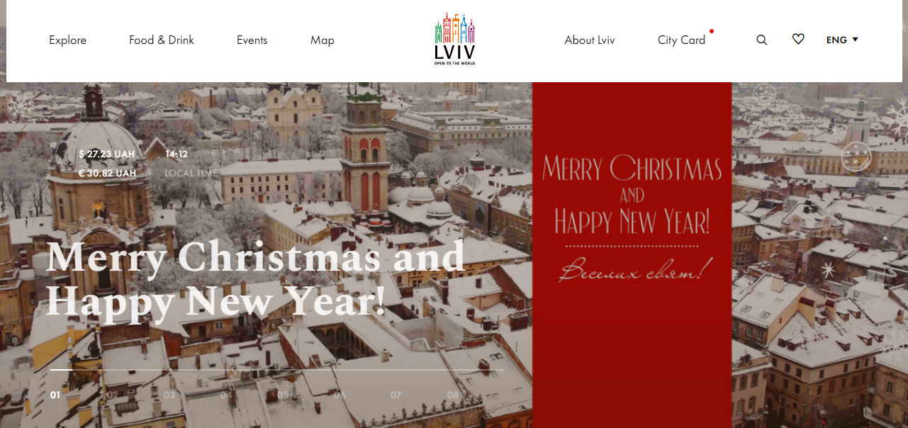
Fig. 2.3: The main page of the tourist site of Lviv
Source: Lviv. Open the world https://lviv.travel/en

Another example of digital communications is the site of the resort town of Truskavets (Fig. 2.4). The online resource also contains all the necessary information for travel planning, namely general information about the resort, category of accommodation in the city, all resorts, hotels, villas, boarding houses, restaurants and cafes, treatment section, which methods are used at the resort where you can diagnose and to undergo rehabilitation, as well as cultural places of rest in Truskavets.
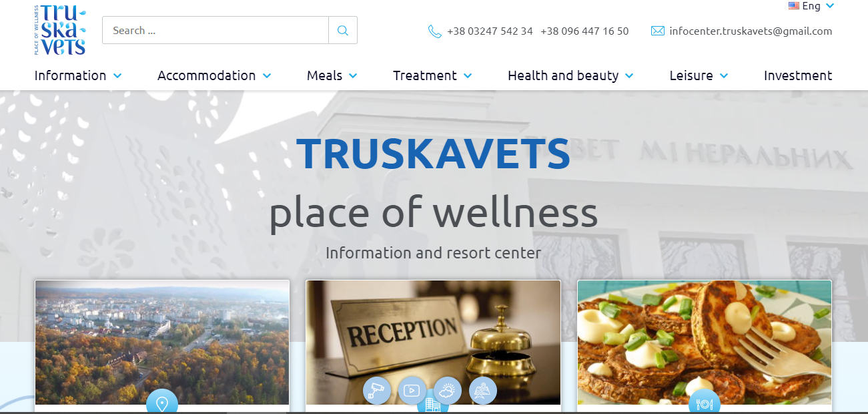
Fig. 2.4: The main page of the tourist site of Truskavets
Source: Truskavets place of wellness, URL: https://truskavets.ua/en

Hospitality communications are often through social media, as it is one of the fastest channels of communication with potential customers. In the social network Instagram, the institution can post the necessary information in the bio profile. Fixed highlights allow you to save short 15-second videos so that visitors can see them. Properly designed Instagram page attracts more tourists to visit this institution.
Implementation of algorithmic news feed and Instagram Business Tools provides the ability to customize and run targeted advertising; save other people's publications and create albums; delete unnecessary comments; add accounts and manage multiple commands at once; view subscription activity; save draft publications; hide previous publications in the archive; make reposts in the page and in the profile; use cross-posting
The functionality of the application began with the creation or upload of photos, videos and text; then gradually added the use of filters or more detailed color and art settings; commenting and marking publications (Likes); the ability to use hashtags (keywords); Instagram Direct (direct communication between accounts, in fact the functionality of the messenger), Stories (publications available within 24 hours), IGTV (publication of a full-fledged video product). All these tools allow the tourism business to get the following benefits:
1. Informing potential customers about the company's activities and travel products in the most multimedia, active, visual and easy to understand form of photo and video.
2. Ability to get feedback from the audience, analysis of the result and quick adjustment of advertising messages, communication with followers.
3. Forming the company's image, increasing brand awareness, building communication with subscribers, building customer loyalty.
4. Tools for a thorough study of the target audience, ranging from standard age, gender, location and up to such important details as online time, reactions to the topic of posts, preferences and comments of subscribers.
5. Mechanisms for measuring the effectiveness of activities in the form of statistics, comparative tables, graphs of different configurations and forms for selected periods of time.
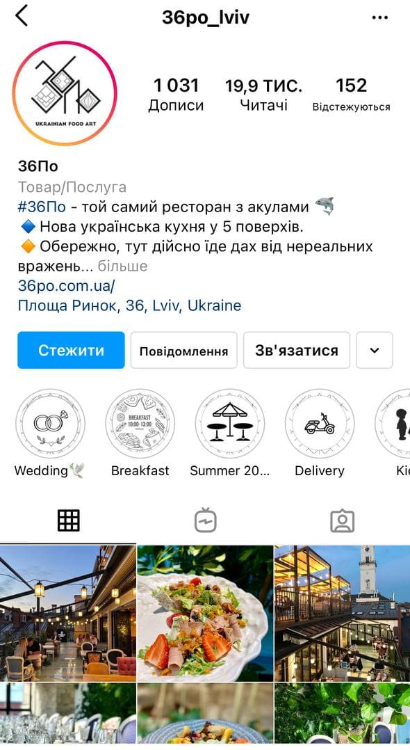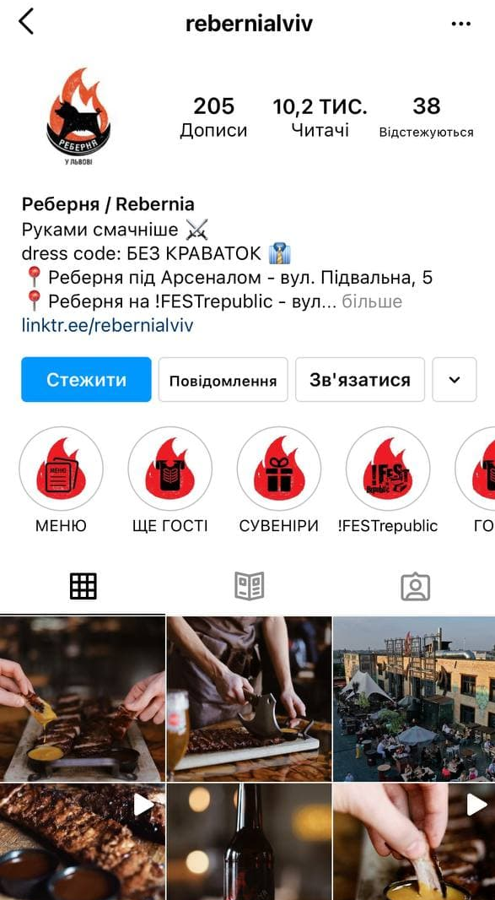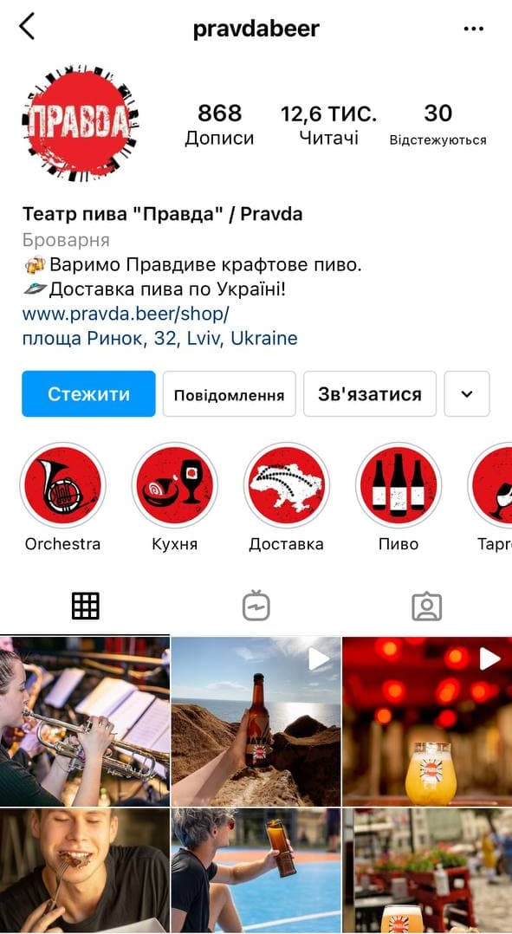
Fig. 2.5: Profiles of famous food establishments in Lviv on the social network Instagram
Source: Instagram

As we can see, the displayed profiles are bright and eye-catching, establishments publish photos of their own dishes, landscapes from the walls of the restaurant, cooking processes, the atmosphere inside, photos of their visitors with products. In the fixed stories, visitors can find menus, delivery information, video reviews and more, depending on the chosen institution. Social networks as a channel of communication are one of the most effective at this stage, because they have a full set of marketing tools. The key advantage is the possibility of two-way communication, not only the travel company can provide information to its target audience, but also customers can leave feedback on publications on the site, ask in private messages or write detailed comments on their own pages indicating a place that they visited. In addition, institutions can conduct their own surveys and increase the level of interaction with visitors, thereby improving customer loyalty.
To summarize the study of the potential of the tourism industry in the Lviv region, we will conduct a SWOT analysis.
Table 2.4: SWOT analysis of tourism in Lviv region
Strengths | Weakness
- available natural and recreational resources, historical  monuments;  - potential of religious and rural tourism;  - natural and climatic conditions;  - favorable transport and geographical position;  - developed ancillary services of accommodation and catering establishments, entertainment establishments, public and commercial organizations. | - inefficient activities of the authorities to ensure the environmental safety of the tourism industry.  - weak activity of executive bodies and local self-government bodies in ensuring the development of tourism in the region;  - inefficient use of recreational potential in rural areas;  - insufficient development of hotel and restaurant business outside the main tourist centers.
Opportunities | Threats
- development of tourist infrastructure;  - improvement of the ecological situation, preservation of the natural environment;  - creation of new tourist services and investment projects;  - growth of demand in the market of tourist services with efficient use of tourist resources and infrastructure;  - increasing the flow of foreign tourists;  - increasing the interest of citizens in recreation and leisure. | - decline of architectural monuments, urban structure of the city;  - reduction of effective demand of the population due to the reduction of profitability of major sectors of the economy, including industry;  - strengthening outbound tourism abroad by indigenous people;  - difficult ecological situation due to large tourist flows.

Therefore, from table. 2.4 shows that the Lviv region has many strengths to attract more tourists, market opportunities can increase the efficiency of the potential of the region. However, weaknesses and market threats can be an obstacle to this development. One way to reduce this risk is to successfully apply a marketing communication mix. Another tool for environmental analysis for the tourism industry of Lviv region is the already mentioned PEST analysis.

Table 2.5: PEST analysis of the tourism industry of Lviv region
Factor |  | Influence of a factor
Political | Political stability of the country | Increasing the flow of inbound tourism, increasing the tourist attractiveness of the region.
 | Openness / closedness of countries | Determines the possibility and permanence of travel.
 | Tourism policy of the state | Awareness and interest in countries.
 | Visa regime and entry restrictions | Determines the entry and exit flows of tourists, restricts the free movement of tourists
Economic | Dynamics of exchange rates | Exchange rate fluctuations lead to frequent changes in prices and risks for tourists and businesses
 | Income level of the population | Opportunity to travel
 | Development of tourist infrastructure | Increased inbound and domestic tourism flows
 | Tax policy | Tax pressure causes an increase in business costs, hence a massive increase in prices for services.
 | State support of innovative types of tourism (agritourism and ecological tourism) | Development of small business (expansion of production of many consumer goods and services, use of local sources of raw materials, solving the problem of employment).
Sociocultural | The level of culture of the population | Development of international tourism and increase in the number of travelers.
 | National features | Development of inbound and domestic tourism, increasing the tourist attractiveness of the state.
 | Level of education of the population | Activation of tourist demand.
 | Unemployment rate in the country | Increasing employment leads to an increase in the total income of local residents, gives the opportunity to travel.
Technological | Level of scientific developments | Improving the quality of tourist services.
 | Modern technologies of service in the field of tourism and hospitality | Increases the organizational and technical level of production, quality of products and services, reduces energy and capital expenditures, improves the leisure conditions of consumers and staff
 | Technology and computerization of the tourism industry | A key link in improving the economic efficiency of the tourism industry and increasing the quality of services.
In our opinion, political factors influencing the development of tourism in Ukraine include political stability of the country, openness / closedness of countries, changes in legislation, visa regime and restrictions on entry, tourism policy of the state. Regarding the factor of "tourism policy of the state", we note that one of the main advantages of Ukraine and Lviv region is that its tourist destinations are incredibly diverse: there are mountains, seas, various resorts, castles and architectural monuments.

2.3. Research of marketing communications of the tourist sector

We will conduct a study of marketing communications of the tourism sector of Lviv region through a questionnaire. To do this, a questionnaire was developed in Google forms, online survey is more convenient because it takes much less time and in a short time allows to get as many answers from respondents.
Thus, with the help of an online survey, 30 responses were received from Ukrainians regarding the planning of tourist trips to the Lviv region and the marketing communication channels they use for this purpose.

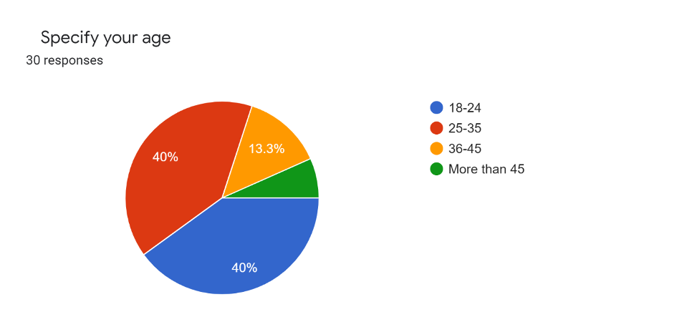
Fig. 2.6: Answer to 1st question

To begin with, respondents were asked to indicate their age, it was necessary to choose from 4 categories. The survey was conducted among people over 18 years of age. Among the respondents were 40% aged 18 to 25, and 40% aged 25 to 35, 13.3% of respondents were aged 36 to 45 and only 6.7% were older than 45. Thus, the youth audience prevailed.
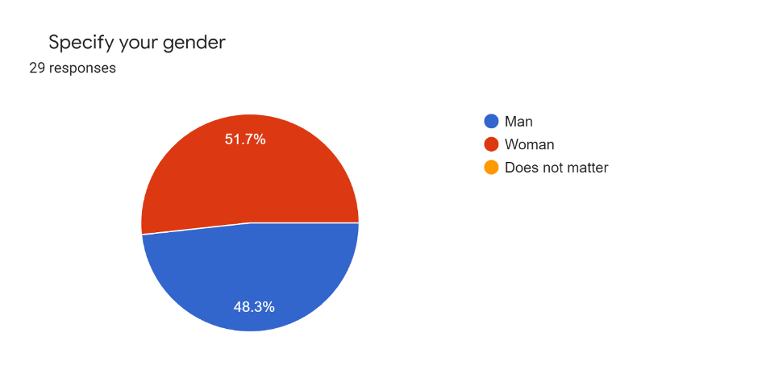
Fig. 2.7: Answer to 2nd question

It is also important to determine gender for the purity of the study. Among the respondents there were approximately the same number of men and women, with a slight predominance of women - 51.7% vs. 48.3%.

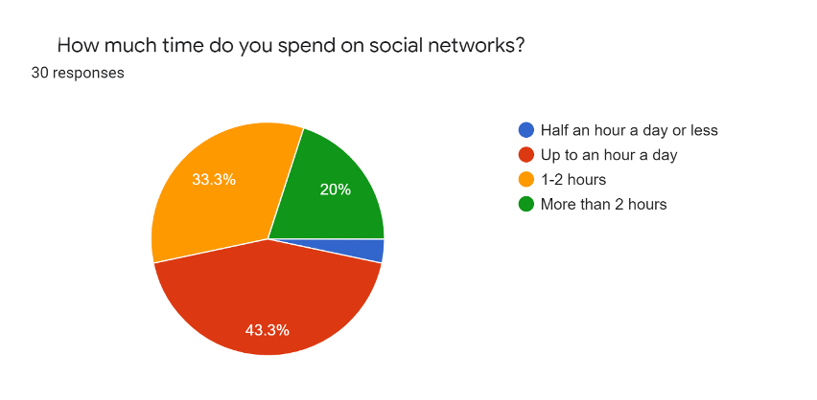
Fig. 2.8: Answer to 3rd question

Based on the analysis, it was determined that today Internet resources are becoming more important in the marketing activities of tourism enterprises than traditional media. That is why respondents were asked to answer the question of how much time they spend on social networks during the day. The results of the survey will identify highlights in improving marketing communications in the Lviv region. Thus, 43.3% of respondents spend up to an hour a day on social networks, 33.3% spend about 1-2 hours using social platforms, another 20% spend more than 2 hours a day. 3.3% of respondents spend less than half an hour a day on social networks.

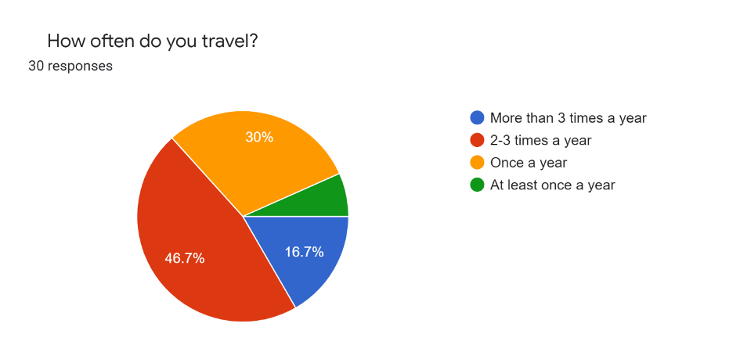
Fig. 2.9: Answer to 4th question

Judging by the chart above, young Ukrainians like to travel and do so quite often. Almost half of respondents, namely 46.7% travel 2-3 times a year. 30% of respondents make tourist trips once a year. Another 16.7% of respondents travel more than 3 times a year, and only 6.7% of people travel less than once a year. The obtained results indicate a significant potential for the development of the tourism industry of Ukraine, because there is a demand.

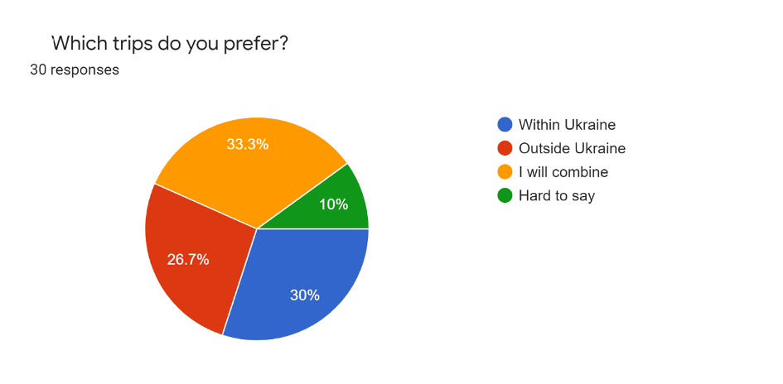
Fig. 2.10: Answer to 5th question
The next step is to determine the tourist destinations where Ukrainians travel, respondents were asked to choose from the following options: within Ukraine, outside Ukraine, I combine domestic and foreign travel and it is difficult to answer. The largest share of respondents - 33.3% combines tourist travel within Ukraine and abroad. About 30% choose Ukraine to plan their travels. More than a quarter of respondents (26.7%) prefer foreign travel. And 10% of respondents can not decide which places they like more.
So, we conclude that 63.3% of respondents like to travel inside Ukraine and do so quite often. This is a good indicator for the development of Ukrainian tourism.

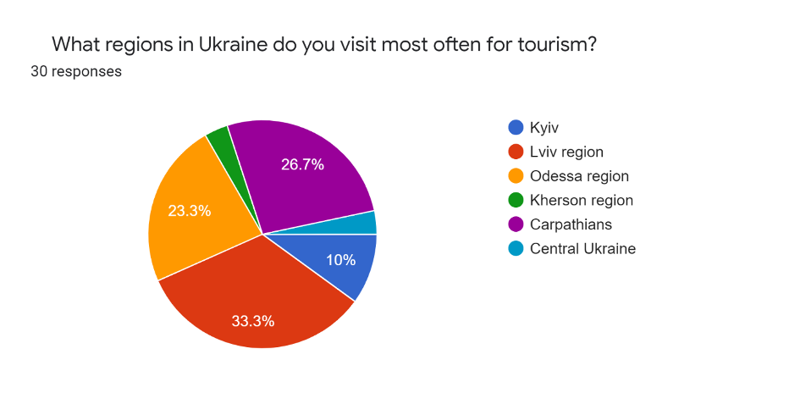
Fig. 2.11: Answer to 6th question

The next step of the study will be to determine the most visited regions among Ukrainian tourists. Judging by the answers received, the most attractive is the Lviv region (33.3%), Ukrainians like to spend their weekends in the city of Lviv, resting from the daily hustle and bustle and gaining new energy. Next in popularity are the Carpathian Mountains (26.7%), often tourists combine a holiday in the Carpathians with a one-day stop in Lviv, due to the close proximity. In third place is the Odessa region (23.3%), mostly coming for beach holidays, as well as for cultural and educational purpose of visiting, ie tourists visit the city of Odessa, which is also rich in architectural and historical monuments. Next on the list is the Ukrainian capital - Kyiv (10%). Central Ukraine and Kherson region received 3.3% each.
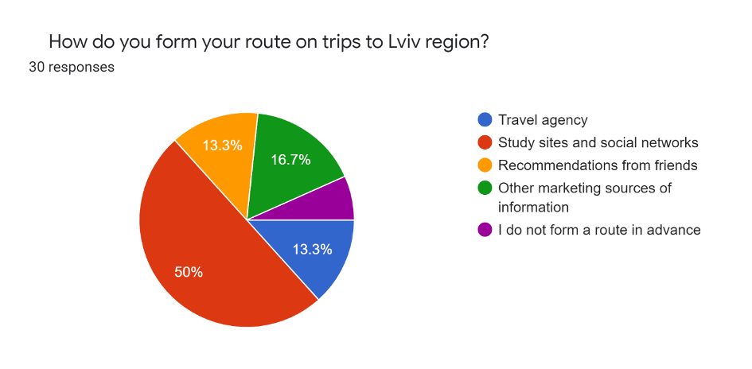
Fig. 2.12: Answer to 7th question

When planning a trip, tourists can choose from many different options, so for a beach holiday abroad mostly choose package tours, ie contact travel agencies or book online on their websites, the same situation when traveling to Europe. However, over a long period of time, more and more people are creating their own leisure routes. Let's consider what methods of planning a trip Ukrainians use when traveling to Lviv.
Thus, half of the respondents choose to search on the Internet, websites, blogs and social networks to plan a trip to Lviv region. 16.7% of respondents use other marketing resources, 13.3% of respondents choose to book a trip with the help of travel agencies and friends recommendation. About 6.7% of respondents do not plan in advance, but form a route based on the situation.
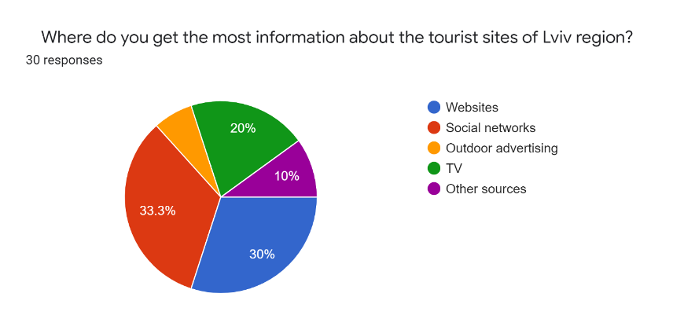
Fig. 2.13: Answer to 8th question

Even with the formed excursion tours, tourists always have free time that needs to be filled on their own, so people think of their own route. 33.3% of respondents use social networks for this, because there are special profiles where information is published about interesting events in the region, where to go, what cultural program is planned in the near future. 30% of respondents choose websites to search, another 20% receive information from television. 10% receive information from other sources and 6.7% through outdoor advertising.
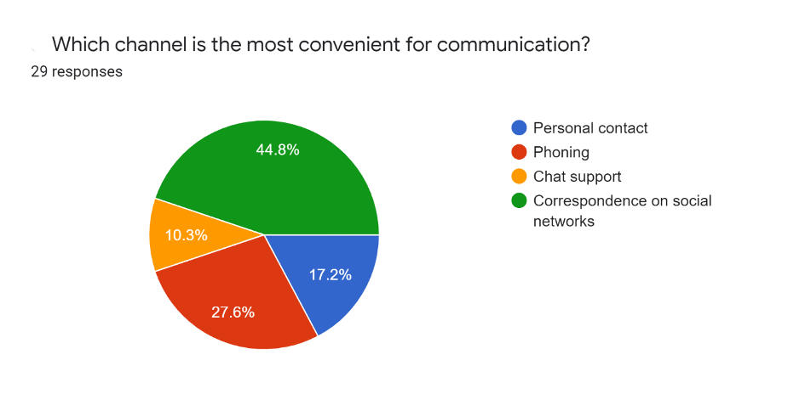
Fig. 2.14: Answer to 9th question

However, tourists often have to communicate with the staff of hotels or other types of accommodation, book tables in restaurants or specify how long the show will last and how many intermissions are planned. To do this, everyone chooses the most convenient channel of marketing communication. 44.8% of respondents choose to correspond via social networks, it is a convenient and fast way to get all the necessary information, because it offers many options for inquiries, tourists can write to the Direct, leave questions in special windows in the story, answer the story or leave a question under publication. 27.6% of respondents choose to talk on the phone, 17.2% prefer personal contact, 10.3% usually correspond with chat support on websites.
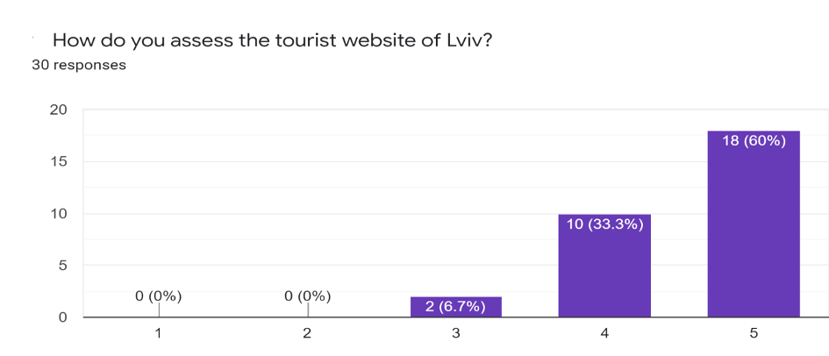
Fig. 2.15: Answer to 10th question

In this work examined the tourist site of the city of Lviv, respondents were also asked to assess its availability and content with the necessary information for tourists. Thus, 18 people or 60% of respondents rated the website with the highest score. 33.3% or 10 people rated the site on 4 points out of 5 possible and only 2 people believe that it is underdeveloped. Summing up we can say. That this site really contains a lot of relevant and necessary information, tourists can easily find answers to the desired questions.

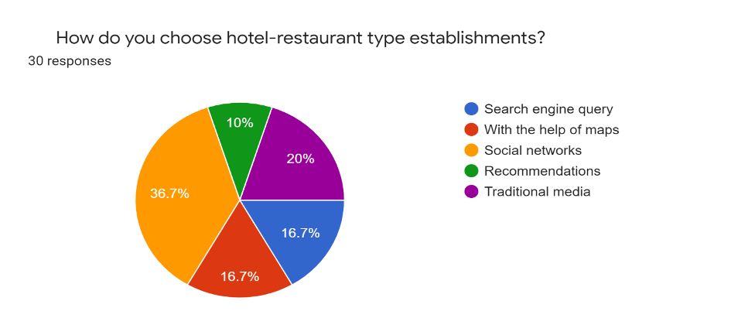
Fig. 2.16: Answer to 11th question

Most often, when traveling, tourists need to decide on the place of accommodation and restaurants, because other entertainment and cultural program is formed during the stay in the destination, except when cultural events are the purpose of the trip. 36.7% of respondents choose food and accommodation through social networks, Lviv is known for its hospitality for all tastes, most of them have developed Instagram profiles, where tourists can see the menu and prices, atmosphere, reviews of other visitors. 20% use traditional media for acquaintance, 16.7% choose locations by monitoring maps, another 16.7% of respondents choose to search the Internet. 10% of respondents visit hospitals according to the recommendations of friends.

The next important step is to identify the social networks that are most often used, to direct marketing efforts to them. The largest share of respondents spend time on Instagram, namely 40%, 26.7% prefer Facebook, another 20% spend time on Tik Tok, a relatively new and youth social network. Other social networks have the fewest respondents, about 6.7% of respondents spend time on Viber, and 3.3% on Pinterest and Telegram. So, Instagram is the most popular, it is the best solution for the tourism industry, because it is a visual platform that has many different advertising opportunities, a properly designed Instagram profile attracts thousands of users.

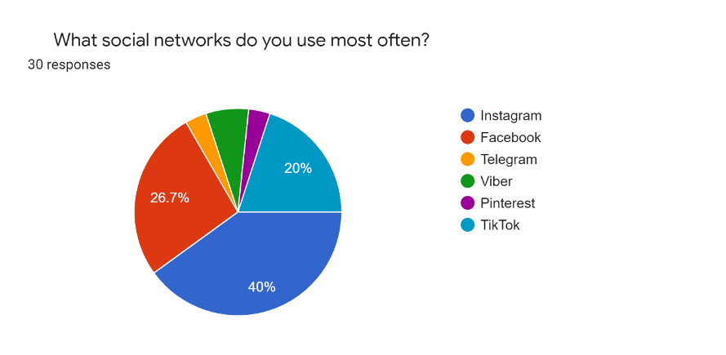
Fig. 2.17: Answer to 12th question

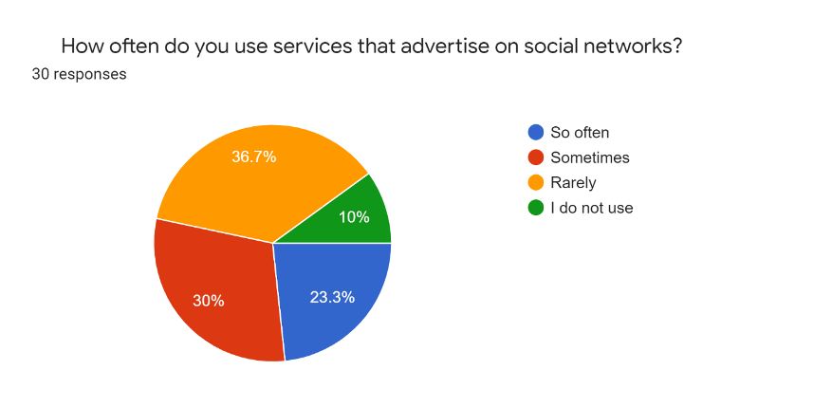
Fig. 2.18: Answer to 13th question
In addition to the fact that tourists spend time on social networks, it is important whether they make purchases on the recommendations of social networks. Today, there are many different ways to advertise on social media, the most popular of which are blog advertising and targeted advertising available for business accounts. Thus, 36.7% of respondents rarely buy products or services for advertising on social networks, 30% sometimes, 23.3% often and only 10% do not use products advertised on social networks. That is, half of the respondents still buy through social networks, so we can conclude that they are effective for the tourism sector.

PART 3 PROSPECTS FOR THE DEVELOPMENT OF MARKETING COMMUNICATIONS IN THE LVIV REGION

3.1. Ways to improve the marketing communication of the tourism industry in the Lviv region

To choose the most effective tools of marketing communication should consider the state of the market of marketing communications in Ukraine. To provide an objective assessment of the development of the marketing communications market for all its tools, we need to develop a classification of marketing tools, namely the advertising media market. Thus, the advertising media market is part of:
- TV advertising (direct advertising and sponsorship);
- advertising in the press (advertising in the national, regional and specialized press);
- radio advertising (national and regional radio);
- outdoor advertising (billboards, transport and digital);
- advertising in cinemas;
- Internet advertising.
New approaches to business organization, concentration processes in the field of tourism necessitate the systematization of advanced approaches to the marketing communication of tourism enterprises. Information and innovative technologies, modern business tools provide marketing support:
- by providing information on innovations needed to make marketing decisions, areas of use of marketing information in tourism;
- means of advertising on the Internet;
- a new interpretation of the concept of "e-business" and its main components (e-marketing, e-commerce), which are characterized in more detail, taking into account industry specifics.
The need to use powerful tools and management methods in competition determines the use of the most progressive, radical and universal method - business process reengineering with the use of integrative tools to support reengineering, where the interaction of business processes of tourism, market and consumers.
Fierce competition in the travel services market forces managers to make the most of new technologies, use new opportunities to meet the needs of constantly changing target consumers, and attract an out-of-reach segment of potential customers at the moment.
Given the current trends in consumer behavior and the survey conducted, tourism enterprises in Lviv region also need to actively use SMM strategies to promote their own products and promote the region.
Due to the fact that most companies now advertise their product through social networks, it becomes necessary to take online marketing measures to promote a product or service through communication with the target audience in social resources. Tourism is one of such areas of activity. Recommended tools in tourism are
- creation and further advertising of thematic products;
- work on promoting the existing product in social networks of one subject;
- product promotion through mobile applications;
- integration of the company's website with social networks;
- creation of unique links;
- maintaining and promoting corporate blogs;
- conducting conferences and webinars online.
Thanks to social networks, many travel companies have the opportunity to make more profit from the sale of their product, a new level of business and build a reputation through customer feedback on social networks. Services can be represented by the following works:
- conducting the necessary research and strategy development;
- creation of a brand platform and its quality content;
- engaging the audience and working with it;
- PR in social networks;
- monitoring the effectiveness of promotion.
One of the most important marketing strategies in social networks used by tourism enterprises in the Lviv region, mostly hospitality, is the "accompaniment" of tourists at all stages of travel (Fig. 3.1).

Fig. 3.1: Five stages of the Google journey

1) The dream of travel. Social media is becoming the main source of inspiration and choice of travel destination. Different platforms influence users with their tools. About 50% of Facebook users draw inspiration for travel directly from photos of their friends. 40% of Instagram users use content search by geolocation, and on the Pinterest platform there are thousands of boards with the title "inspiration for travel"
At this stage, the social media of tourism brands or companies focus on the visual design of pages, the use of hashtags, geology and other tools.
2) Booking services. About 40% of all tours are booked online via mobile devices. This is a fairly large market share. Modern travelers use their mobile phones to book trips around the world. Therefore, it is very important to adapt each individual element of the website or social networks for mobile devices, set up a convenient messenger to communicate with customers, add "hot buttons" for instant booking and for mobile versions. Because otherwise, companies risk losing 40% of consumers who use their phones to find inspiration for travel.
3) Planning. For example, a consumer bought plane tickets to Lviv and booked a hotel a month before the trip. From now on, he wants to get as much information as possible about interesting places in Lviv, where to go, where to eat, on which street he can take the best photos. And social media will help tourists in this. Therefore, it is important not to forget about the content of the pages, the use of accurate geolocations and online guides.
4) Active use of smartphones during the trip. Arriving at the destination, tourists again turn to social media to see what is happening in the place right now. News, current events, stories - this is what interests travelers at this stage of the journey.
5) Distribution. The journey does not end after returning home. Travelers post content on their social networks to share their experiences and recommendations, write reviews and their impressions of the trip - especially for the Millennial generation. Travelers mark travel brands in their publications, thus creating the best free advertising for the company
By using the means of promoting tourism services and based on choosing the optimal sales strategy, tourism enterprises can gain a competitive advantage over others by increasing market share and increasing the loyalty of end users. Instagram is one of the most effective tools for managing users in the digital age, and has communication, information, social, identification, presentation and entertainment functions, has a steady and rapid audience growth, the ability to implement user segmentation. The undoubted advantage of Instagram for the promotion of the tourism business is due to the relevant for tourism multimedia form of information, its high information content, the ability to actively communicate with customers, quick response to their preferences, forming a positive company image and customer loyalty. To increase the effectiveness of advertising on the Internet should be harmoniously combined with the traditional communication system.
Choosing the right most effective means of advertising largely determines the success of the entire advertising campaign. The correct solution to this problem determines how many potential consumers will reach signals, how strong the effect will be on them, what amount will be spent on advertising and how effective these costs will be.
It is advisable to place ads in travel magazines, because in this way we will attract the attention of target consumers of our product and inform them not only about the benefits of recreation in the Lviv region, but also about expanding the range. It is important to show the fact that the new products will be high quality, at reasonable prices and in line with fashion trends.
When choosing a magazine, attention is paid to its popularity, monthly circulation, purpose of publication and cost of advertising. A total of 5 magazines were selected: "TOTAL ESCAPE", "TRAVEL", "International Tourism", "Around the World", "World of Tourism". After the introduction of advertising in magazines, it is recommended to continue promoting the Lviv region through social networks and the Internet. Social Media Marketing (SMM) is a means of attracting potential customers to a company using social media
Today, when the Internet is almost ubiquitous, SMM has a huge set of tools to promote (according to some estimates, more than 100). From the set of methods for the promotion of the Lviv region, the following were selected:
1. Paid advertising on social networks such as Instagram, Facebook;
2. Promotion of content - audio content, video content, photos on social networks, writing articles for Wikipedia, distribution of unique free content;
3. Creation and promotion of interactive elements - promotional applications, widgets, etc.;
4. Work with opinion leaders - involving a famous person in a blog or discussion platform.;
5. Other tools - media or targeted advertising on social networks.
The main thing to keep in mind when using such methods is a thorough preliminary study of the audience of the social network in which the region plans to move, isolation from the total number of target users and address them.

3.2. Evaluation of the effectiveness of the proposed measures

Despite the great changes that 2020 has brought to people's lives, work and travel, the urge to travel has not disappeared. People continue to discover new ways to discover the world, and in 2021, people are increasingly thinking about what to expect in terms of travel in the near future.
At this stage of society, the main drivers are the Internet, social networks, artificial intelligence, virtual reality and other innovative tools. In our opinion, the basis of marketing of the tourism industry in Lviv region should be given to marketing on social networks, which in turn can be supplemented by other tools.
The most successful SMM strategy for a tourism business in 2021 is a harmonious combination of major trends and a detailed study of changes in consumer behavior. SMM managers must respond very quickly to the latest changes and trends.
Consumer behavior has changed dramatically, so marketers need to quickly change strategies and adapt to these changes. The following table shows the main trends in tourism and social networks.

Table 3.1: The main trends and trends for 2021 in tourism and SMM
Trends in tourism | Trends in social media
Technology driven spontaneity  - flexibility of plans  - personal approach  - Virtual reality  - the victory of real impressions | Socially Conscious and Ecological Content  - Demonstrating the brand's commitment to sustainable tourism and local communities
Work where it is convenient  - an increase in the number of long journeys  - the new MICE tourism format | Brand impersonation  - Transparency, authenticity and proximity to consumers
Price and value. Economical journey  - Special offers for tourists  - looking for flexible terms | Focus on health and relaxation services, social issues and integration
Conscious tourism  - eco travel options  - less plastic consumption  - profitable trips out of season  - support for local communities | Augmented / Virtual Reality
Safety first and foremost | Trading on social networks
Inspiration in search  - searching for ideas for traveling online  - nostalgia for tourism | Omni- and microinfuensers
Domestic tourism - economic, safe, ecological  -vacation with animals  - non-touristic destinations | More video content
Back to the simple joys of life  - relaxation, yoga and meditation  - recreation  - closer to nature | Game-style content (Gamification)
Source: Marketing and SMM trends in 2021. URL: https://onlypult.com/blog/marketing-and-smm-trends-2021

By analyzing the above trends, the company can increase its reach through search, actively use geolocations, communicate directly with tourists and ask what they lack, and set trends themselves (for example, offer tourists detox tours in a Carpathian mountain lodge, offer car rental, etc.). With the help of simple marketing tools on social networks, the tourist subconsciously chooses a nine-hour ride in a rented car with his family to nature in a Carpathian house.
By updating the content of tourism enterprises in Lviv region, it is necessary to invest in new types of content that give potential tourists an interactive way to explore the services of tourism enterprises - augmented/virtual reality. Create gamer-targeted content to test the market. Experiment with interactive content on the social network that adds a game element to the page.
When using social networks in the activities of a travel agency should be borne in mind that there are certain mistakes that should not be made. Such mistakes can be long answers to customer questions, lack of their own style (uniqueness), description in one post all the company's proposals, a large number of extra elements in the text (stickers), non-working links, lack of analysis of potential customer comments.
It should be noted that many tourism enterprises have limited financial opportunities, which do not allow to use the full potential of marketing communications, so a promising area of operation is a combination of tourism enterprises, NGOs and government, which will effectively use both financial and labor resources in the complex of marketing communications, to ensure the development of the tourism industry and meet the demand for tourism products and services offered by enterprises of the tourism industry.
In the future, we should implement a long-term marketing strategy focused on the most modern and effective marketing tools - social networks and the Internet.
Let's calculate the economic effect of conducting an advertising campaign on social networks.
The tool was chosen paid advertising on the social network Instagram to target the people of Ukraine. The main audience was selected women aged 18 to 45 years. Also, the main time of the ad was chosen in the morning (8.00-12.00) and evening (17.00-00.00), as the greatest efficiency and the largest number of views is at this time. The main content of advertising - informing about quality recreation at reasonable prices.
The ad will reach 3.5 million users. It is known that advertising on the social network Instagram for a thousand people is 11 dollars, ie for 3.5 million people advertising will cost us 1,078,000 hryvnias
To determine the economic effect, we use the experience of the Australian travel account (https://www.instagram.com/australia/), which already has almost 5 million subscribers. The country is actively using Instagram to promote its region, which is in demand due to skillful advertising. During the day, new publications gain about 34,000 views.
During such a campaign in 2020, the following results were obtained:
- the number of clicks and visits to the site amounted to 203 thousand times;
- 89 thousand people became subscribers to the "Australia" account;
- profit from the event amounted to UAH 2,010,000.
Thus, at a cost of 616 thousand hryvnias, income in the amount of 2,010,000 hryvnias was received.
Determine the profitability of the proposed measure:
𝑅m = 2 010 000/616 000 = 326.3%
The figure is very high, which proves the extraordinary effectiveness of this measure.
Thus, using the experience of an identical event, but with a different breadth of consumers, we will in theory obtain the following results for the Lviv region:
- the number of clicks and visits to the site can be 355,250 times;
- 155,750 people can become subscribers;
- the profit will be UAH 3,517,500.
Thus, at a cost of 1,078,000 hryvnias, income in the amount of 3,517,500 hryvnias will be received. The profitability of such an event will be the same as the profitability obtained from the advertising event in the account "Australia" - 326.3%, as the indicators were calculated proportionally, to give a rough idea of the economic effect of advertising on social networks.
Summing up the effectiveness of this advertising area, we can note the following:
- the considered advertising direction in the assumptions proved to be quite effective, as the invested UAH 1,078,000. we received UAH 3,517,500. profit, not taking into account:
• 155,750 attracted customers who have subscribed to the page and will be aware of the range of services in the Lviv region, which means increasing its visibility and brand.
The most important thing to remember when using such methods is a thorough preliminary study of the audience of the social network in which the region plans to move, isolation from the total number of target users and appeal to them.

CONCLUSIONS

So, summarizing all the above, we can conclude that tourism has now become widespread among all countries and has had a strong impact on the world economy. The effective development of the tourism business significantly increases the flow of foreign citizens to other countries, which affects the growth of tax contributions to the budget, helps develop related sectors of the economy, increases employment, and allows travelers to gain new experiences and positive emotions.
Marketing communications is a concept in which a company carefully designs and coordinates the work of its many communication channels to develop a clear, consistent and convincing view of the company and its products. The creation of integrated marketing communications involves defining the target audience and developing a carefully coordinated promotion program to obtain the desired appropriate response from consumers. Too often, marketing communications are aimed at solving acute problems of the target market, related to consumer awareness, company image or consumer preferences
Each component of the marketing communication process is characterized by certain principles that must be followed to optimize communication and the effects generated on the target audience.
Today, one of the most effective tools of marketing communication is Internet marketing, also called web marketing, online marketing or e-marketing - is the marketing of products or services over the Internet. The Internet has brought the media to a global audience. The interactive nature of Internet marketing in terms of providing instant answers and receiving answers is a unique quality of media.
Internet communication tools have also led to major changes in the functioning of various economic sectors, such as marketing. As the name implies, Internet marketing is the act of promoting goods and services over the Internet. This is the type of marketing and advertising that the Internet uses to convey advertising marketing messages to customers. This is a subset of digital marketing. Internet marketing involves a greater variety of marketing components than regular marketing.
Lviv region is traditionally a region where the prospects of tourist and recreational have been and remain one of the best in Ukraine. Its natural resources and historical potential, combined with its advantageous geographical location in the heart of Europe and many years of experience in tourism and recreation, are essential for the priority development of tourism, recreation and spa treatment. Local flavor, centuries-old history, various colors of nature, healing springs of mineral waters, picturesque landscapes of the Carpathians, preserved traditions, folk crafts, delicious cuisine of Galicia annually attract tourists and guests from many countries. Many historical, architectural and cultural monuments of Ukraine are concentrated in the Lviv region, represented by buildings from the princely period to the 20th century. Castles Tustan, Olesky, Zlochovsky, Pidhirtsi, Svirsky, religious tourism centers of Krechiv and Univ monasteries, historical cities Zholkev, Belz, Bubrka, Zlochiv, Zhydachiv, Sambor, Drohobych and are very popular among tourists. Lviv region is rich in enchanting nature, which has always been a special pride of Ukraine. This region is one of the leading places in Ukraine in the presence of healing mineral waters and mud, on the basis of which such world-famous resorts as Truskavets, Skhidnytsia, Morshyn, Nemyriv, Velykyi Lyubin, Shkol are developed.
Currently, 245 tourist enterprises, 124 sanatoriums, 500 agritourism farmsteads, 250 accommodation establishments, 280 catering establishments, 12 tourist information centers, more than 162 museums and state and public galleries, 10 theaters, etc. are fully operational in the region. interesting tourist routes guided by 750 qualified guides and translators.
As of 2018, there were 337 collective accommodation establishments in Lviv oblast, including 277 hotels and similar establishments, and 60 specialized establishments. Among them are 170 hotels of various categories, 39 motels, 11 hostels and 57 tourist bases. According to the placement of specialists in 2018, there were 37 health resorts, 5 children's sanatoriums, 4 recreation centers and 14 recreation centers. In 2015-2018, there was no significant increase or decrease in the number of collective nights, only a steady increase in the number of hotels.
One of the problems of the tourism industry is the unsatisfactory condition of monuments of historical and architectural heritage.
The most important tourist attraction of the region is the regional center, ie the city of Lviv. The positioning of the latter varies depending on the segmentation of the target audience of arriving tourists. For many years, Lviv was famous for its historical and cultural monuments, tourists from all over Ukraine came here to experience the atmosphere of a European city. Today it is only one of the types of positioning Lviv in the Ukrainian tourist market.
Communication in the field of hospitality is often carried out through social networks, as it is one of the fastest channels of communication with potential customers. On the social network Instagram, the institution can post the necessary information in the bioprofile. Permanent backlight allows you to save short 15-second videos for viewing by visitors. A well-designed Instagram page attracts more tourists to visit a tourist site, restaurant, hotel or other.
Tourist enterprises of Lviv region are starting to use SMM-strategies to promote their products and promote the region.
At this stage of development of society, the main drivers are the Internet, social networks, artificial intelligence, virtual reality and other innovative tools. In our opinion, marketing in the tourism industry of Lviv region should be based on marketing on social networks, which in turn can be supplemented by other tools.
Based on research, we can say that tourism companies are actively involving marketing in their activities, developing creative ways to promote, various plans and launch promotions. In the conditions of modern active development of tourism marketing activity becomes one of the most important for maintenance of steady positions in the market and stimulation of sale of a product.
Every enterprise in the tourism industry, forming a system of marketing communications, should focus its activities on profit and development, using marketing tools.
Summing up the effectiveness of proposed advertising area, we can note the following: the considered advertising direction in the assumptions proved to be quite effective, as the invested UAH 1,078,000. We received UAH 3,517,500. profit, not taking into account: 155,750 attracted customers who have subscribed to the page and will be aware of the range of services in the Lviv region, which means increasing its visibility and brand.

REFERENCES

ANUCHIN A. Interception of the client. The struggle for sales in conditions of fierce competition - St. Petersburg: Peter, 2009. 240 с
ASSEL G. Marketing: strategy and tactics. M., 1999.
AZAPYAN O.A., ZHYKOVA N.L., ISHCHENKO O. A., VOPOSHILOV G. O. Analysis of the complex of marketing on the international market of typical services: Donetsk: DonDYET, 2005. 135 p
BALABANOVA L.V, MITROKHIN YU. P. Management of sales policy: textbook. way. Kyiv: Center for Educational Literature, 2011. 240 p.
COSTIN KB RHUBARB Management as a basis for successful development of the tourism industry. Russian entrepreneurship. 2012. № 11 (209). Pp. 151–156
DAMJANA JERMAN & BRUNO ZAVRSNIK Model of Marketing Communications Effectiveness in the Business-to-Business Markets. Economic Research, 2012. Vol. 25, No. 1, P. 370
EGAN J. Marketings communicatios. Los Angeles: SAGE Publications Ltd, 2015, 421 p
FISHER, R., MALTZ, E., JAWORSKI, B. Enhancing communication between marketing and engineering: the moderating role of relative functional identification, Journal of Marketing, 1997. Vol. 61, P. 56 - 57
Forbes.com. Information for the world’s business leaders. URL: http://www.forbes.com/
Integrated Marketing Communication and Its Impact on Consumer Behavior. URL: https://sciendo.com/article/10.2478/sbe-2018-0022
Investment passport of Lviv region, URL:
https://sweden.mfa.gov.ua/storage/app/sites/73/uploaded-files/invetment-passport-of-lviv-region-2019-presentation-2.pdf
KLIATCHKO, J. The primacy of the consumer in the IMC: Espousing a personalist view and ethical implications, Journal of Marketing Communications, 2009 Vol. 15, No. 2-3. P. 177
KOTLER F. Fundamentals of Marketing. M .: Progress, 1999.
KOVALCHUK S.V., LAZEBNIK M.R. Market of marketing communications of Ukraine: review and development trends, Bulletin of Khmelnytsky National University. Economic Sciences Series, 2016, No. 5 (2). Pp. 126–136 (in Ukrainian)
Lviv. Open the world. URL: https://lviv.travel/en

Marketing Communications – Introduction URL:
https://www.tutorialspoint.com/advertisement_and_marketing_communications/marketing_communications_introduction.htm
Materialy do Natsionalnoi dopovidi Ukrainy pro stan navkolyshnoho pryrodnoho seredovyshcha u 2016 rotsi «Rehionalna dopovid pro stan navkolyshnoho pryrodnoho seredovyshcha u Lvivskii oblasti v 2016 rotsi». URL: http://www.ekologia.lviv.ua/file/monitoring/nacdop_2017.pdf (in Ukrainian)
Most effective digital marketing techniques 2020. Statista. URL:
https://www.statista.com/statistics/190858/most-effective-online-marketing-channels-according-to-us-companies/
NAHIRNIAK T.B, KALYN B.M., Research of main problems of the natural reservoir fund of the Lviv region and the ways of their solvency, Scientific Messenger LNUVMB, 2017, vol. 19, no 79 (in Ukrainian)
Official site of the All-Ukrainian Advertising Coalition.URL: https://vrk.org.ua/ad-market
RAIKO D.V., ZEITLIN L.M. Development of classification of marketing communication tools. Marketing and management of innovations. 2017, No 2. S. 36–46 (in Ukrainian)
SproutSocial. Evaluate your efforts with integrated social media analytics. URL: http://sproutsocial.com/features/social-media-analytics
SUSHCHENKO O.A., NAUMIK-GLADKA K.G., ALDOSHINA M.V., Marketing communications in tourism, Kharkiv: KhNEU. S. Kuznets, 2018. 218 p.
Tourism And Resort Development Program In The Lviv Region For 2021 – 2025, URL: https://loda.gov.ua/upload/users_files/32/upload/Programa%20rozvYtku%20turYzmu%20u%20L_vivs_kiy%20oblasti%20na%202021-2025%20rokY.pdf
Truskavets place of wellness, URL: https://truskavets.ua/en
What is marketing communication (MarCom)? URL: https://learn.marsdd.com/article/what-is-marketing-communication-marcom
Oxford Dictionary of Concepts and Terms. URL:
http://www.oxfordreference.com/search?q=tourist+destination&searchBtn=Search&isQuickSearch=true
UNWTO World Tourism Barometer. Edition 2016. URL:
http://unwto.org/facts/eng/barometer.htm.
Joshi M. Travelers’ Journey, Personas, and the 4Ps of Tourism Marketing Mix. URL: https://theilha.com/travelers-journey-personas-and-the-4ps-of-tourism-marketing-mix/
Marketing and SMM trends in 2021. URL: https://onlypult.com/blog/marketing-and-smm-trends-2021

ATTACHMENT
Questionnaire survey:
1. Specify your age
- 18-24
- 25-35
- 36-45
- More than 45
2. Specify your gender
- Man
- Woman
- Does not matter
3. How much time do you spend on social networks?
- Half an hour a day or less
- Up to an hour a day
- 1-2 hours
- More than 2 hours
4. How often do you travel?
- More than 3 times a year
- 2-3 times a year
- Once a year
- At least once a year
5. Which trips do you prefer?
- Within Ukraine
- Outside Ukraine
- I will combine
- Hard to say
6. What regions in Ukraine do you visit most often for tourism?
- Kyiv
- Lviv region
- Odessa region
- Kherson region
- Carpathians
- Central Ukraine
7. How do you form your route on trips to Lviv region?
- Travel agency
- Study sites and social networks
- Recommendations from friends
- Other marketing sources of information
- I do not form a route in advance
8. Where do you get the most information about the tourist sites of Lviv region?
- Websites
- Social networks
- Outdoor advertising
- TV
- Other sources
9. Which channel is the most convenient for communication?
- Personal contact
- Phoning
- Chat support
- Correspondence on social networks
10. How do you assess the tourist website of Lviv?
- Choose from 1-5(where 5 is the highest result)
11. How do you choose hotel-restaurant type establishments?
- Search engine query
- With the help of maps
- Social networks
- Recommendations
- Traditional media
12. What social networks do you use most often?
- Instagram
- Facebook
- Telegram
- Viber
- Pinterst
- TikTok
13. How often do you use services that advertise on social networks?
- So often
- Sometimes
- Rarely
- I do not use

Marketing Communications – Introduction/ URL: https://www.tutorialspoint.com/advertisement_and_marketing_communications/marketing_communications_introduction.htm
What is marketing communication (MarCom)? URL: https://learn.marsdd.com/article/what-is-marketing-communication-marcom
Fisher, R., Maltz, E., Jaworski, B. Enhancing communication between marketing and engineering: the moderating role of relative functional identiÖcation, Journal of Marketing, 1997. Vol. 61, P. 56 - 57
Kliatchko, J. The primacy of the consumer in the IMC: Espousing a personalist view and ethical implications, Journal of Marketing Communications, 2009 Vol. 15, No. 2-3. P. 177
Damjana Jerman & Bruno Zavrsnik Model of Marketing Communications Effectiveness in the Business-to-Business Markets. Economic Research, 2012. Vol. 25, No. 1, P. 370
Assel G. Marketing: strategy and tactics. M., 1999.
Kotler F. Fundamentals of Marketing. M .: Progress, 1999.
Integrated Marketing Communication and Its Impact on Consumer Behavior. URL: https://sciendo.com/article/10.2478/sbe-2018-0022
Anuchin A. Interception of the client. The struggle for sales in conditions of fierce competition - St. Petersburg: Peter, 2009. 240 с
Balabanova LV, Mitrokhin Yu. P. Management of sales policy: textbook. way. Kyiv: Center for Educational Literature, 2011. 240 p.
Joshi M. Travelers’ Journey, Personas, and the 4Ps of Tourism Marketing Mix. URL: https://theilha.com/travelers-journey-personas-and-the-4ps-of-tourism-marketing-mix/
Oxford Dictionary of Concepts and Terms. URL: http://www.oxfordreference.com/search?q= tourist+ destination &searchBtn =Search&isQuickSearch=true
UNWTO World Tourism Barometer. Edition 2016. URL: http://unwto.org/facts/eng/barometer.htm.
Azapyan O.A., Zhykova N.L., Ishchenko O. A., Voposhilov G. O. Analysis of the complex of marketing on the international market of typical services: Donetsk: DonDYET, 2005. 135 p
Sushchenko O.A., Naumik-Gladka K.G., Aldoshina M.V., Marketing communications in tourism, Kharkiv: KhNEU. S. Kuznets, 2018. 218 p.
Forbes.com. Information for the world’s business leaders. URL: http://www.forbes.com/
SproutSocial. Evaluate your efforts with integrated social media analytics. URL: http://sproutsocial.com/ features/social-media-analytics
Costin KB Rhubarb management as a basis for successful development of the tourism industry. Russian entrepreneurship. 2012. № 11 (209). Pp. 151–156
Investment passport of Lviv region, URL: https://sweden.mfa.gov.ua/storage/app/sites/73/uploaded-files/invetment-passport-of-lviv-region-2019-presentation-2.pdf
Materialy do Natsionalnoi dopovidi Ukrainy pro stan navkolyshnoho pryrodnoho seredovyshcha u 2016 rotsi «Rehionalna dopovid pro stan navkolyshnoho pryrodnoho seredovyshcha u Lvivskii oblasti v 2016 rotsi». Rezh. d.: http://www.ekologia.lviv.ua/file/ monitoring/nacdop_2017.pdf. (in Ukrainian)
T.B. Nahirniak, B.M. Kalyn, Research of main problems of the natural reservoir fund of the Lviv region and the ways of their solvency, Scientific Messenger LNUVMB, 2017, vol. 19, no 79 (in Ukrainian)
Tourism And Resort Development Program In The Lviv Region For 2021 – 2025, URL: https://loda.gov.ua/upload/users_files/32/upload/Programa%20rozvYtku%20turYzmu%20u%20L_vivs_kiy%20oblasti%20na%202021-2025%20rokY.pdf
Kovalchuk SV, Lazebnik MR Market of marketing communications of Ukraine: review and development trends, Bulletin of Khmelnytsky National University. Economic Sciences Series, 2016, No. 5 (2). Pp. 126–136 (in Ukrainian)
Raiko DV, Zeitlin LM Development of classification of marketing communication tools. Marketing and management of innovations. 2017, No 2. S. 36–46 (in Ukrainian)

