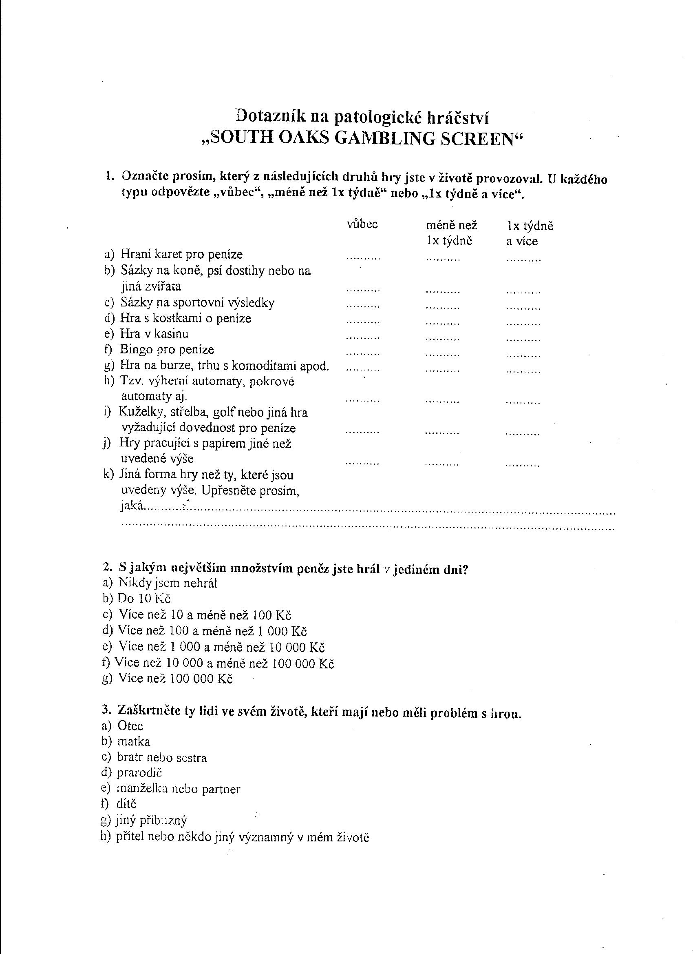

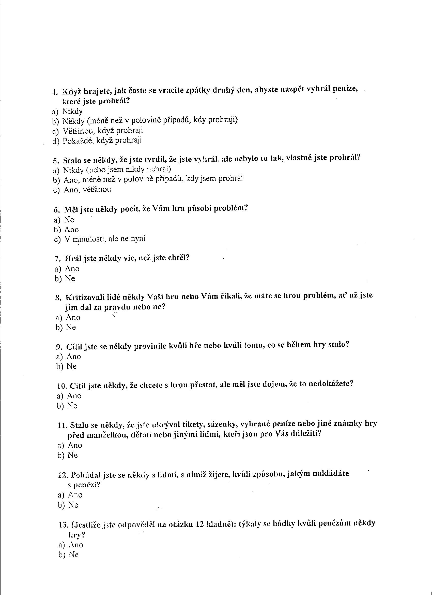

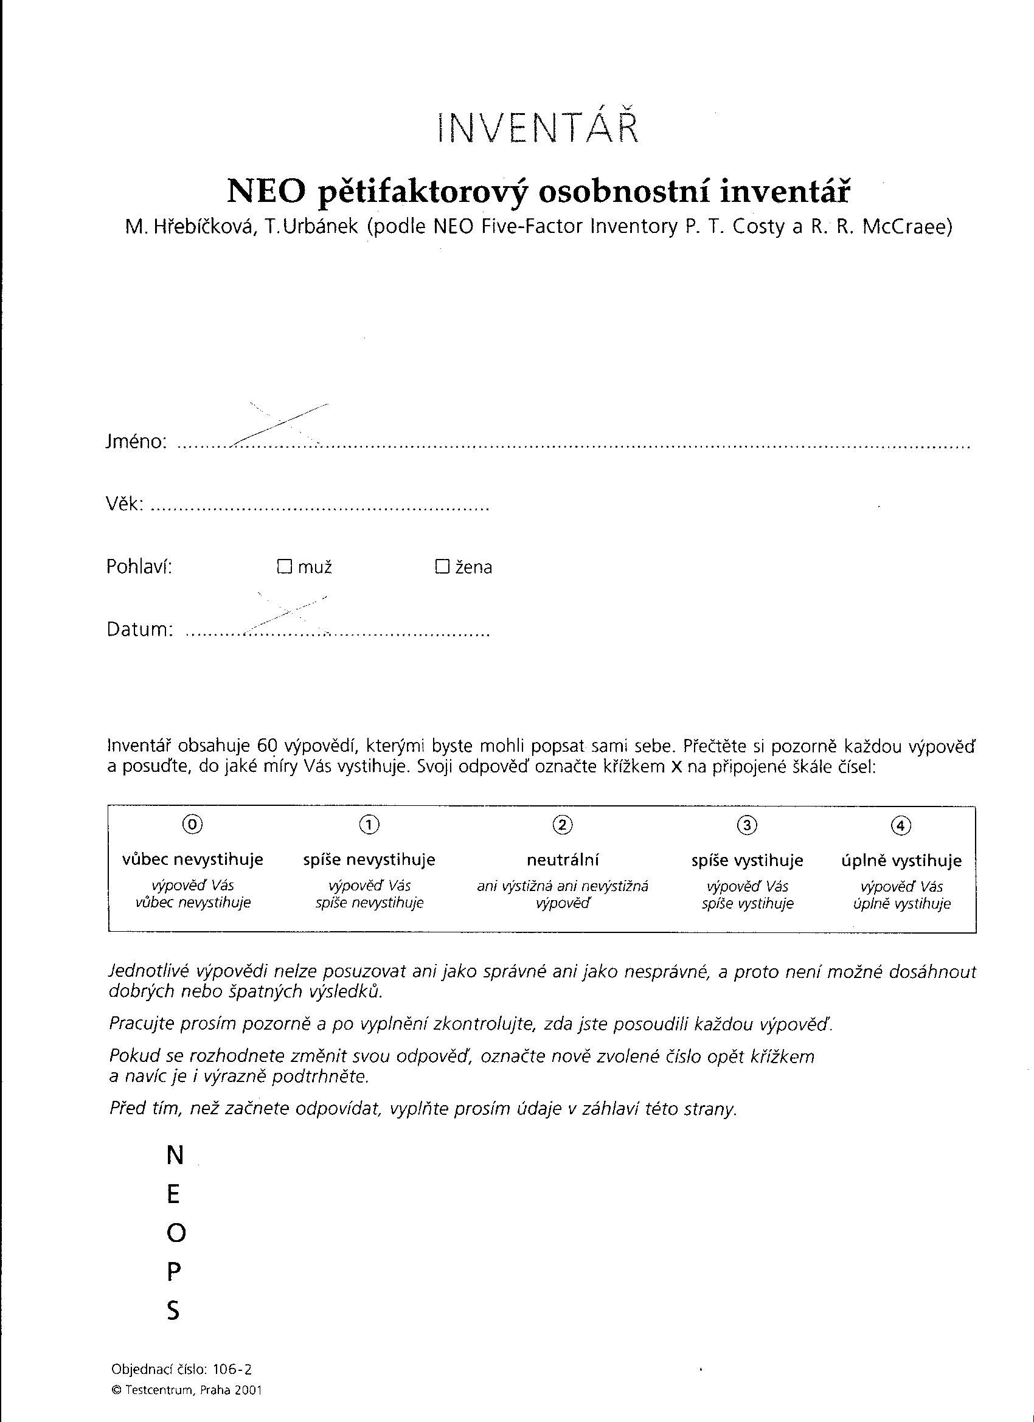

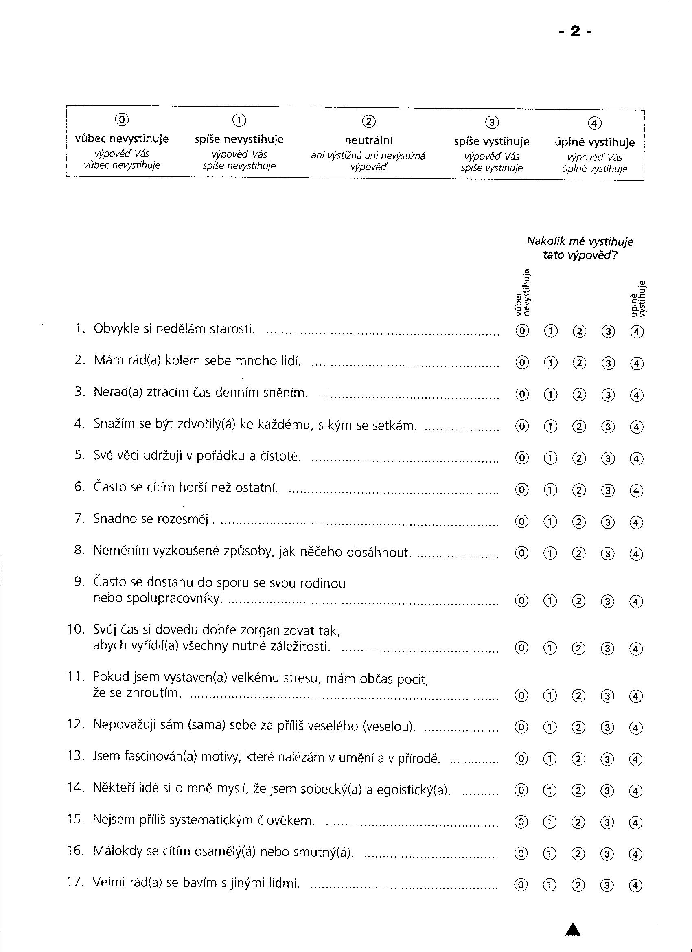

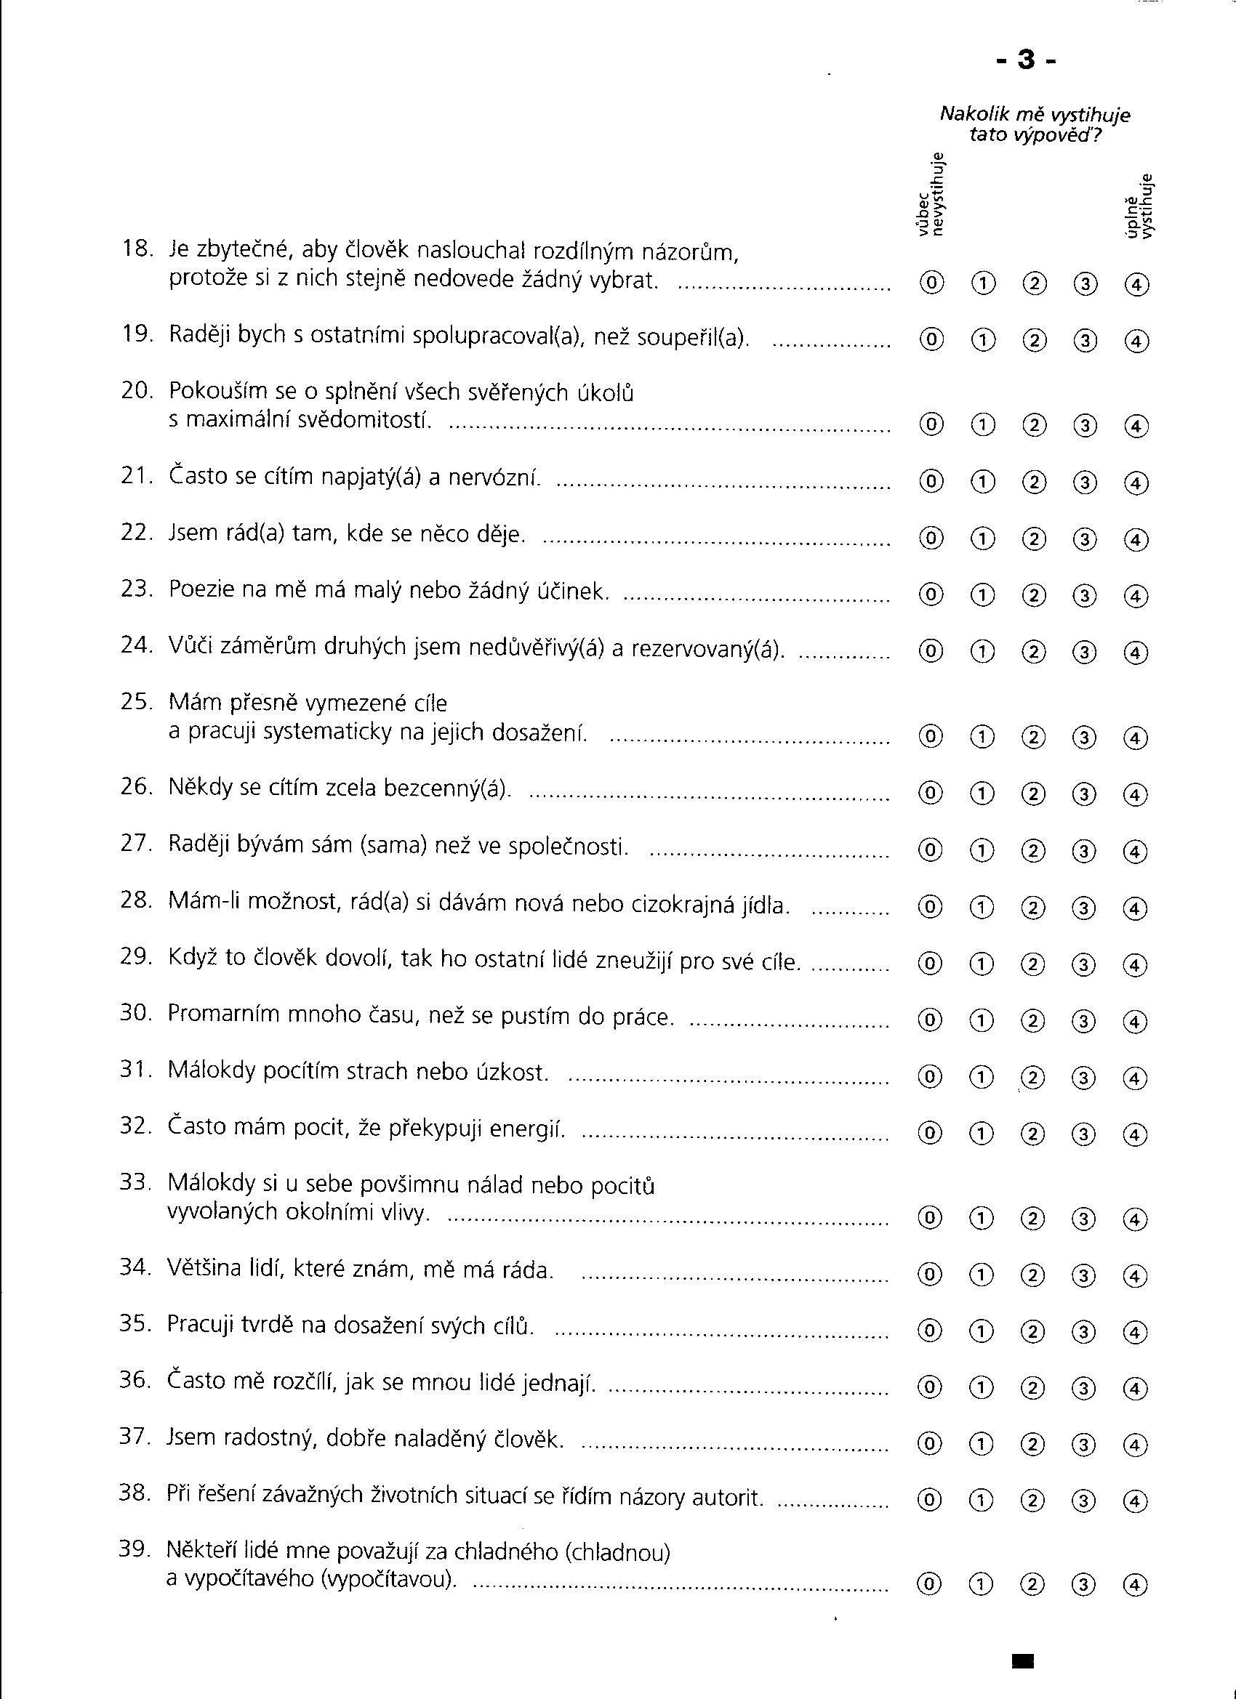

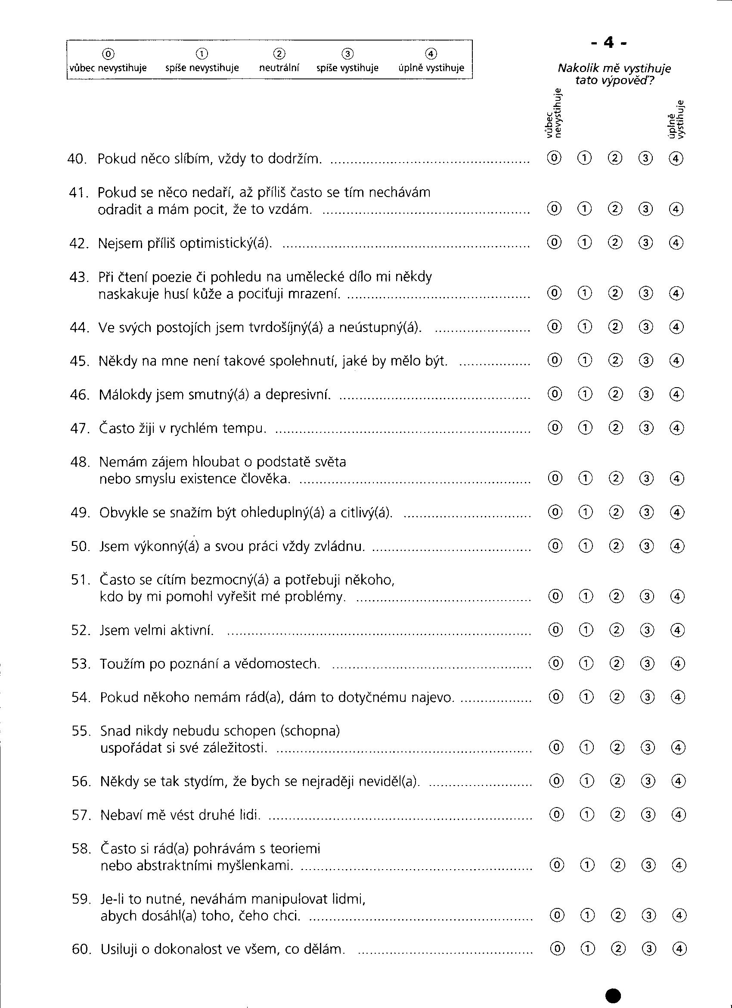

(Převzato Hřebíčková, Urbánek, 2001)

**Skóry gamblingu u dívek a chlapců** (k 1. hypotéze)

|  |  |  |
| --- | --- | --- |
|  | **dívky skóry gamb.** | **chlapci skóry gamb.** |
| 1. | 0 | 0 |
| 2. | 0 | 0 |
| 3. | 0 | 0 |
| 4. | 0 | 0 |
| 5. | 0 | 0 |
| 6. | 0 | 0 |
| 7. | 0 | 0 |
| 8. | 0 | 0 |
| 9. | 0 | 0 |
| 10. | 0 | 0 |
| 11. | 0 | 0 |
| 12. | 0 | 0 |
| 13. | 0 | 0 |
| 14. | 0 | 0 |
| 15. | 0 | 1 |
| 16. | 0 | 1 |
| 17. | 0 | 1 |
| 18. | 0 | 1 |
| 19. | 0 | 1 |
| 20. | 0 | 1 |
| 21. | 0 | 1 |
| 22. | 0 | 1 |
| 23. | 0 | 1 |
| 24. | 0 | 2 |
| 25. | 0 | 2 |
| 26. | 0 | 2 |
| 27. | 0 | 2 |
| 28. | 0 | 2 |
| 29. | 0 | 2 |
| 30. | 0 | 2 |
| 31. | 0 | 2 |
| 32. | 0 | 2 |
| 33. | 0 | 2 |
| 34. | 0 | 2 |
| 35. | 2 | 3 |
| 36. | 2 | 3 |
| 37. | 2 | 3 |
| 38. | 2 | 3 |
| 39. | 2 | 4 |
| 40. | 2 | 4 |
| 41. | 5 | 4 |
| 42. | 5 | 5 |
| 43. | 5 | 5 |
| 44. | 5 | 5 |
| 45. | 5 | 5 |
| 46. | 6 | 6 |
| 47. | 6 | 6 |
| 48. |  | 6 |
| 49. |  | 6 |
| 50. |  | 7 |
| 51. |  | 7 |
| 52. |  | 8 |
| 53. |  | 9 |
| 54. |  | 9 |

**Skóre extroverze x skóre gamblingu u dívek a chlapců** (ke 2. hypotéze)

|  |  |  |
| --- | --- | --- |
|  | **Chlapci: vysoké skóre extroverze x skóre gamblingu** | **Dívky: vysoké skóre extroverze x skóre gamblingu** |
| 1. | 0 | 5 |
| 2. | 1 | 0 |
| 3. | 0 | 0 |
| 4. | 0 | 0 |
| 5. | 5 | 0 |
| 6. | 2 | 0 |
| 7. | 2 | 0 |
| 8. | 5 | 0 |
| 9. | 6 | 1 |
| 10. | 1 | 0 |
| 11. | 2 |  |
| 12. | 9 |  |
| 13. | 0 |  |
| 14. | 5 |  |
| 15. | 1 |  |
| 16. | 5 |  |
| 17. | 0 |  |
| 18. | 3 |  |
| 19. | 1 |  |

**Skóry gamblingu u introvertů a extrovertů** (k 3. hypotéze)

|  |  |  |
| --- | --- | --- |
|  | **Introverti skóry gamb.** | **Extroverti skóry gamb.** |
| 1. | 0 | 0 |
| 2. | 1 | 5 |
| 3. | 7 | 0 |
| 4. | 2 | 0 |
| 5. | 0 | 0 |
| 6. | 6 | 1 |
| 7. | 0 | 0 |
| 8. | 5 | 0 |
| 9. | 0 | 0 |
| 10. | 5 | 5 |
| 11. | 0 | 2 |
| 12. | 2 | 0 |
| 13. | 8 | 0 |
| 14. | 0 | 5 |
| 15. | 0 | 0 |
| 16. |  | 0 |
| 17. |  | 6 |
| 18. |  | 1 |
| 19. |  | 1 |
| 20. |  | 2 |
| 21. |  | 9 |
| 22. |  | 0 |
| 23. |  | 5 |
| 24. |  | 0 |
| 25. |  | 0 |
| 26. |  | 1 |
| 27. |  | 5 |
| 28. |  | 0 |
| 29. |  | 2 |

**Skóre otevřenosti x skóre gamblingu** (k 4. hypotéze)

|  |  |  |
| --- | --- | --- |
|  | **vysoké skóre Otevřenosti x g.** | **nízké skóre Otevřenosti x g.** |
| 1. | 0 | 5 |
| 2. | 0 | 0 |
| 3. | 0 | 2 |
| 4. | 1 | 1 |
| 5. | 0 | 0 |
| 6. | 2 | 0 |
| 7. | 0 | 0 |
| 8. | 1 | 2 |
| 9. | 2 | 7 |
| 10. | 5 | 6 |
| 11. | 2 |  |
| 12. | 1 |  |