[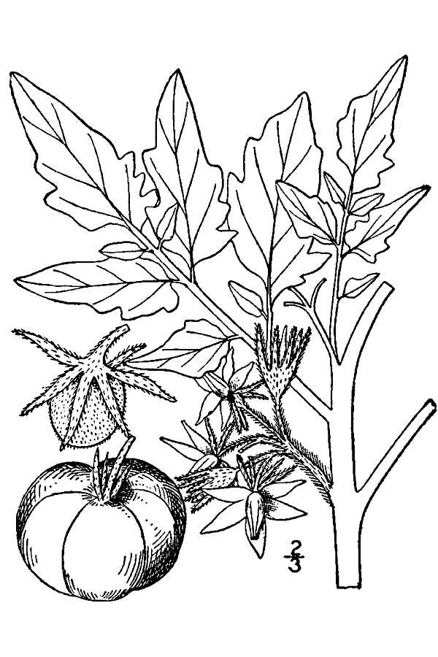](https://www.google.cz/url?sa=i&rct=j&q=&esrc=s&source=images&cd=&cad=rja&uact=8&ved=0ahUKEwi83e-ZoffSAhUKKywKHQPiAfkQjRwIBw&url=https%3A%2F%2Fplants.usda.gov%2Fjava%2FlargeImage%3FimageID%3Dlyly2_001_avd.tif&bvm=bv.150729734,d.bGg&psig=AFQjCNEeYSQ-R6ROmDc4oYxjOXKdkTtK_w&ust=1490723508035395)

Obr. 1: Lycopersicon lycopersicum (rajče jedlé) (Zdroj: https://plants.usda.gov/gallery/large/lyly2_001_lvd.jpg)

[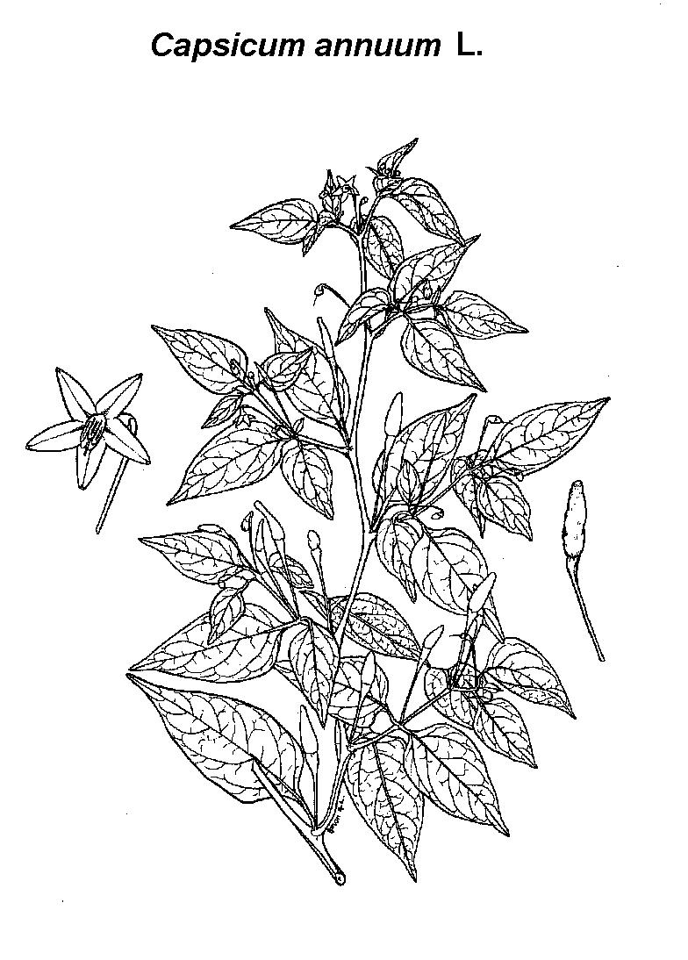](http://www.google.cz/url?sa=i&rct=j&q=&esrc=s&source=images&cd=&cad=rja&uact=8&ved=0ahUKEwjctdmBoffSAhVLCpoKHWgnCucQjRwIBw&url=http%3A%2F%2Fwww.ethnopharmacologia.org%2Frecherche-dans-prelude%2F%3Fplant_id%3D2420&bvm=bv.150729734,d.bGg&psig=AFQjCNEeYSQ-R6ROmDc4oYxjOXKdkTtK_w&ust=1490723508035395)

Obr. 2: Capsicum annum (paprika roční) (Zdroj: http://www.ethnopharmacologia.org/prelude2016/images/ha06capsicum-annuum.jpg)

[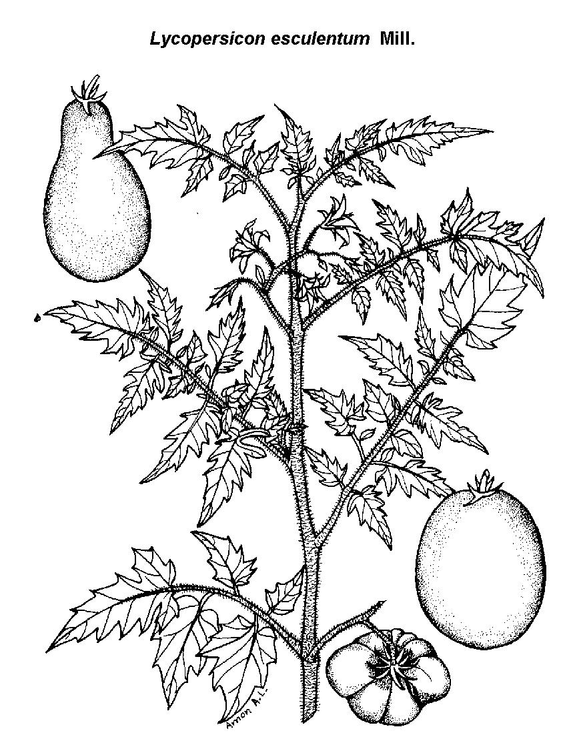](http://www.google.cz/url?sa=i&rct=j&q=&esrc=s&source=images&cd=&cad=rja&uact=8&ved=0ahUKEwjP7ImloPfSAhVFWCwKHVRFDyIQjRwIBw&url=http%3A%2F%2Fwww.ethnopharmacologia.org%2Frecherche-dans-prelude%2F%3Fplant_id%3D8310&bvm=bv.150729734,d.bGg&psig=AFQjCNEeYSQ-R6ROmDc4oYxjOXKdkTtK_w&ust=1490723508035395)

Obr. 3: Lycopersicon esculentum (lilek jedlý) (Zdroj: http://www.ethnopharmacologia.org/prelude2016/images/ha07lycopersicon-esculentum.jpg)

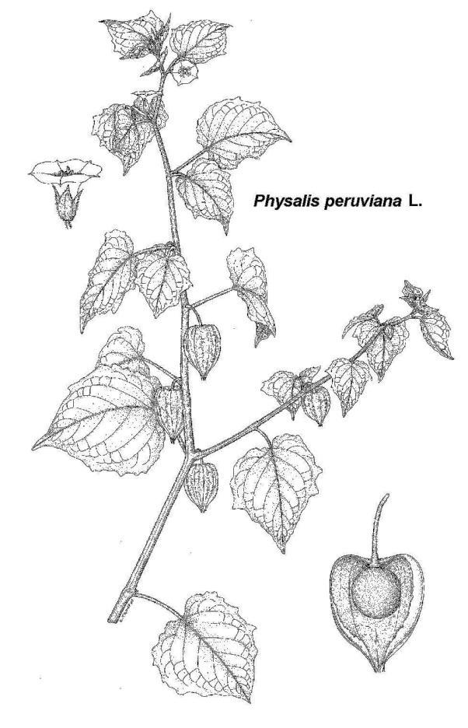

Obr. 4: Physalis peruviana (mochyně peruánská) (Zdroj: http://www.ethnopharmacologia.org/prelude2016/images/hr09physalis-peruviana.jpg)

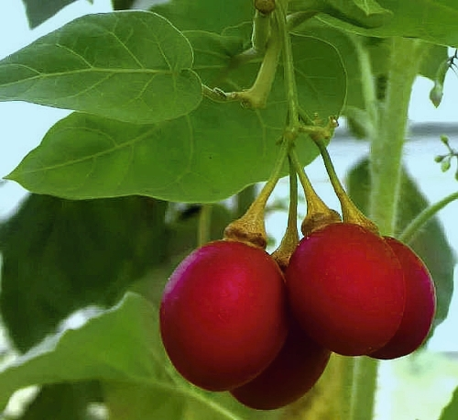 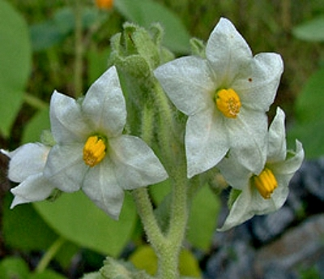

Obr. 5 a 6: Solanum esculentum (rajčenka jihoamerická) (Zdroj: http://exoticky.cz/pestujeme/tamarilo-lahodne-rajce-inku/)