Appendices
Appendix 1: OLS
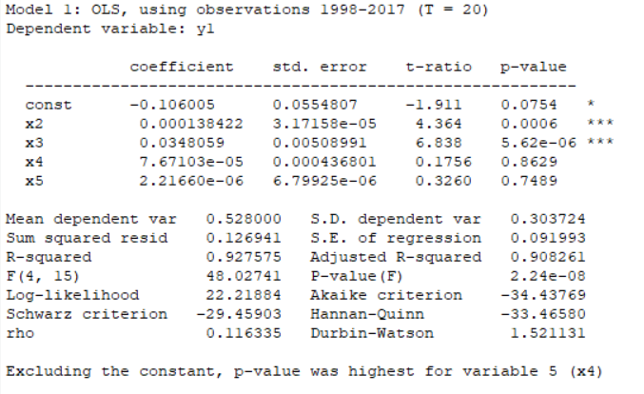
Source: Gretl output

Appendix 2: Correlation Matrix
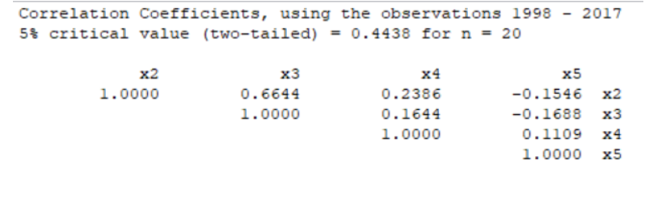
Source: Gretl output
Appendix 3: Autocorrelation test
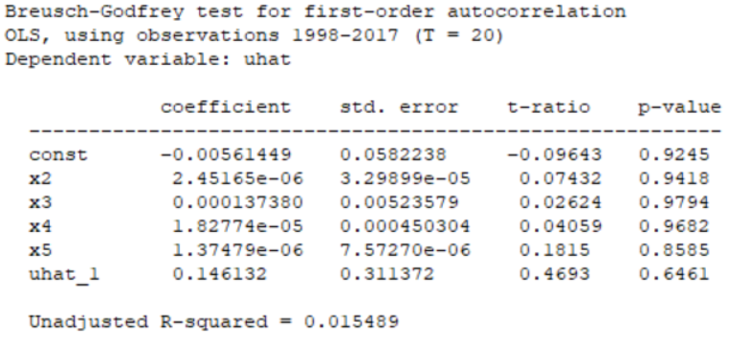
Source: Gretl output

Appendix 4: White test for heteroskedasticity
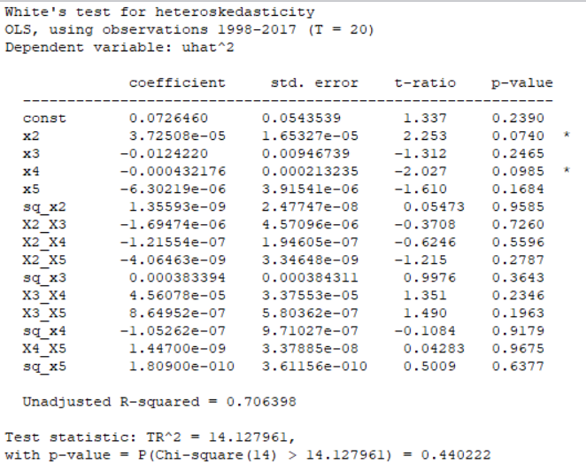
Source: Gretl output

Appendix 5: Normality test
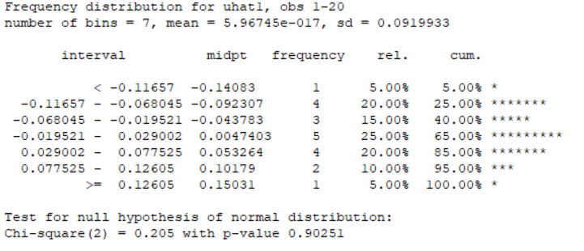
Source: Gretl output

Appendix 6: Normality – graph 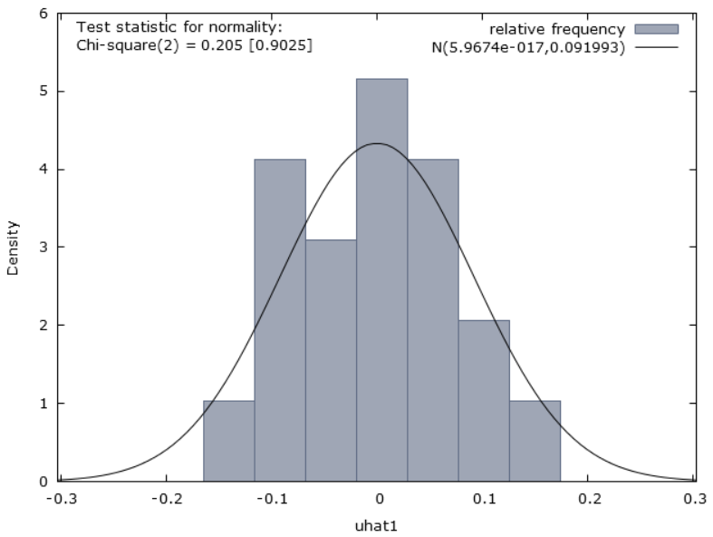
Source: Gretl output

