**UNIVERZITA PALACKÉHO V OLOMOUCI**

PEDAGOGICKÁ FAKULTA

Ústav cizích jazyků

Učitelství Anglického jazyka pro 2. stupeň ZŠ

Bc. Kateřina Zvolánková

**Use of student-engaging activities in ELT at lower secondary school**

Užití aktivizačních metod ve výuce anglického jazyka na 2. stupni ZŠ

Magisterská diplomová práce

Vedoucí závěrečné písemné práce: Mgr. Ondřej Duda

OLOMOUC 2023

Prohlašuji, že jsem diplomovou práci vypracovala samostatně a použila pouze uvedené prameny a literaturu.

V Olomouci dne ………… 2023 Bc. Kateřina Zvolánková

I would like to thank Mgr. Ondřej Duda for his guidance and support on this diploma thesis. My thanks also belong to all the teachers that helped me with practical part of my thesis.

**Abstract**

This theses focuses on the use of student-engaging methods in teaching the English language at the lower secondary school. student-engaging methods represent a modern pedagogical approach that emphasizes interactivity, student engagement, and practical knowledge application. In the context of the lower secondary school, where students already have basic language literacy, these methods become a key element for effective teaching. This thesis explores various student-engaging methods, such as games, dramatization, conversation exercises etc. and their impact on improving communicative skills and motivating students to learn the English language. The research shows that student-engaging methods have got their place in modern education, have positive results and encourage active student participation at a lower secondary school form.

**Table of content**

Introduction 1

1 THEORETICAL PART 3

1.1 Teaching methods and their classification 3

1.1.1 Definition of teaching methods 3

1.1.2 Classification of teaching methods 4

1.1.3 Choice of teaching methods 10

1.2 Classical and complex teaching methods 12

1.2.1 2.1 Classical teaching methods 12

1.2.2 2.2 Comprehensive teaching methods 16

1.3 Student engaging teaching methods 17

1.3.1 3.1 General characteristics of the term activating teaching method 17

1.3.2 3.2 Aims of activating teaching 17

1.3.3 3.3 Clasification of activating teaching methods 18

1.3.4 3.4 Types of activating teaching methods 20

1.4 Active and creative teaching 24

1.4.1 4.1 Motivation of learners 24

1.4.2 Activity in teaching 25

1.4.3 Creativity in teaching 26

1.4.4 Implementation of activating methods into teaching 27

1.4.5 Advantages and disadvantages of active teaching 27

2 PRACTICAL PART 28

2.1 Research 28

2.1.1 Method of research 29

2.1.2 Research questions 30

2.2 Analysis of the detected data 30

2.2.1 Verification of research questions 44

2.2.2 Overall results 47

2.3 Lesson plans based on activating methods 48

2.4 Recommendations for suitable activities 56

2.4.1 Grammar and vocabulary activities 57

2.4.2 Listening activities 58

2.4.3 7.3 Writing and reading activities 60

2.4.4 7.4 Speaking activities 61

Conclusion 64

Summary 65

Sources 66

Appendix No.1 70

# Introduction

Education plays a pivotal role in the development of every individual, and the English language has become one of the most significant international languages that influence the entire world. Proficiency in English opens door to new possibilities and equips students with valuable skills for both academic and professional pursuits. Particularly at the lower secondary school level, English language education becomes a vital component of the learning process, as students acquire essential language proficiency and prepare for the next phase of their education.

A critical question is how to structure this education and convey knowledge and skills to students in a way that is not only effective but also motivating. The frontal way of teaching is criticized at present and other ways how to teach effectivelly are looked for. There are many teaching methods and the right choise is important in gaining language abilities. If the teacher does not choose the right method, aquiring of language proficiency may be slower and less effective. Both for the teacher and the learners it is more interesting when the teacher changes the teaching methods through the class.

Student-engaging methods have become a cornerstone of modern education recently and play a significant role in the context of teaching the English language at the lower secondary school. These methods emphasize interactivity, student engagement, and the practical application of language skills in real-life situations.

The purpose of this thesis is to comprehensively explore the significance and effectiveness of student-engaging methods within the context of teaching the English language at the lower secondary school. I will focus on how these methods support effective education and contribute to the development of students' communication skills and how student-engaging methods motivate students to learn English and increase active participation in the learning process.

The aim of the thesis is to find out whether teachers use student-engaging methods in their classes and what methods they use most often. The research will be done by a quantitative method through questionaire, sent to English teachers at lower secondary schools in Vysocina region.

The thesis will also examine various specific student-engaging methods, such as games, dramatization, conversational exercises, and the utilization of modern technology in the learning proces. Teaching English at the lower secondary school should not only be about acquiring language skills but also an inspiration for students to explore new cultures and perspectives. I believe that student-engaging methods have the potential to be the key to achieving these goals and thereby provide students with a solid foundation for a successful future in a globalized world.

# THEORETICAL PART

## Teaching methods and their classification

### Definition of teaching methods

„In general, a teaching method is defined as the way in which the learning objectives are achieved“ (Kalhous, Obst, 2002). (own translation)

„An approach or method refers to a theoretically consistent set of teaching procedures that define best practice in language teaching. Particular approaches and methods, if followed precisely, will lead to more effective levels of language learning than alternative ways of teaching. The quality of language teaching will improve if teachers use the best available approaches and methods“ (Richards, 2001). (own translation)

J. Maňák and V. Švec (2003) state, that teaching methods are „orderly system of teaching activities of the teacher and learning activities of the pupils aimed at achievement of the educational goals.“ (own translation)

According to Mojžíšek (1988), the teaching methods are „planned and thought-out procedures of educational activities, which are governed by fixed principles and rules.“ (own translation)

Vališová (Vališová, Kasíková a kol., 2007). sees them as „a specific way of organizing the activities of the teacher (lecturer) and pupils (students), developing the student’s educational profile and acting in accordance with the educational goals.“ (own translation)

It is obvious from the definitions, that teaching methods are not just an activities of a teacher but also of a pupil, and their interaction is necessary*.* If the teaching method is chosen properly, the teaching tasks and given goals can be fulfilled (Maňák, 2003). (own translation)

In pedagogical practice, teaching methods sometimes become, in the hands of the teacher, a mere transmission tool, which, although necessary for conveying the subject matter, fulfills this function almost mechanically. While the dissemination of knowledge and skills is one of the most prominent functions of teaching methods, we must not neglect their other functions, as education would be deprived of the characteristics that are desirable for the sake of harmonious personal development. In addition to the mentioned central function of teaching methods, it is necessary to assign an activation function, through which students are motivated to learn to control procedures, tasks, and operations, as well as to acquire work and thinking techniques. Equally significant is the communicative function, which is an integral part for all pedagogically meaningful and effective interactions. (Maňák, Švec, 2003) (own translation)

### Classification of teaching methods

In the professional literature, we can find many classifications according to which teaching methods can be divided. Therefore, we will select only a few of them for our work and describe them. However, it is not possible to say with certainty which division is the most correct or the most accurate. "Field of teaching methods and methodological phenomena, as encountered by every educational participant, is extremely broad, diversified and often not very transparent, because in it there meet and connect different techniques, principles and concepts, their own methods, various methodological variants, techniques, procedures, organizational forms, etc.“ (Maňák and švec, 2003) (own translation)

The first classification we'll describe is the classification by I. J. Lerner, which Kalhous and Obst (2009) state is suitable for current needs in school teaching practice. This classification is based on the "nature of cognitive activities of students when acquiring educational content and the basic characteristics of the teacher's activities in organizing this activity in teaching." (Kalhous and Obst, 2009) (own translation)

Lerner (1986) presents a total of five teaching methods:

1. Information-receptive method
2. Reproductive method
3. Problem-based exposition method
4. Heuristic method
5. Research method

The mentioned methods can be divided into two basic groups. The first group consists of reproductive methods, where the student acquires ready-made knowledge and reproduces it. These methods include the information-receptive method and the reproductive method. In the second group, methods involve the student producing creative activity and thereby gaining new knowledge. This group includes the research method and the heuristic method. The problem-based exposition method cannot be unequivocally classified; it is thus located at the boundary between these two basic groups (Kalhous and Obst, 2009).

According to Lerner, the information-receptive method is considered one of the most effective and economical methods. This is because the teacher imparts specially selected knowledge to the student, organizes information, and presents examples of activities that apply this information in practice (Lerner, 1986). The acquisition of information may vary among individual students in terms of speed, scope, and depth. These differences depend on the students' temperamental and intellectual abilities, practical experiences, psychological and social traits (Kalhous and Obst, 2009).

The reproductive method is defined as a method of organizing the repetition of activities. It is based on the reproduction of individual activities by students (Lerner, 1986).

The essence of the problem-based exposition method lies in familiarizing the student not only with the solution to certain problems but also with the logic of finding these solutions (Lerner, 1986).

The heuristic method involves acquiring individual stages of solving problem tasks (Lerner, 1986).

The research method is considered the fundamental method for teaching experiences from creative activities. This means that when acquiring these experiences, the level is high, and it cannot be replaced by other methods (Lerner, 1986).

Pecina and Zormanová (2009) also mention, among the most common classifications of teaching methods, the classification by Mojžíšek (1988). Mojžíšek (1988) categorizes methods based on a logical perspective in one of his classifications. In this classification, we distinguish:

1. Analytical method
2. Synthetic method
3. Syncretic method (comparative method)
4. Inductive method
5. Deductive method
6. Genetic method
7. Dogmatic method

Furthermore, Mojžíšek (1988) presents a classification of teaching methods in which he seeks to combine the procedural and functional aspects. He introduces:

1. Motivational methods (Methods directing interest in learning)
2. Methods of direct transfer of knowledge from the subject to the object (Methods of direct communication of knowledge)
3. Fixation methods (Methods of repetition and practice of the material)
4. Diagnostic and classification methods (Methods of evaluation, control, and classification)

Another classification we will discuss is the comprehensive categorization of teaching methods by J. Maňák (2001). Pecina and Zormanová (2009) consider this classification to be the most frequently mentioned and cited. Maňák (2001) divides methods based on the source of knowledge (didactic aspect), the activity and independence of students (psychological aspect), the phases of teaching (procedural aspect), the types of thinking operations (logical aspect), and the forms and means of teaching (organizational aspect).

Of particular importance for our work is the classification according to Maňák and Švec (2003), on which the practical part of our work is based. According to this classification, we also compiled an observation sheet. "J. Maňák and V. Švec (2003) describe a combined view of teaching methods based on the criterion of increasing complexity of educational links" (Pecina & Zormanová, 2009) (own translation). Maňák and Švec (2003) categorize teaching methods into three basic groups: classical, activating, and complex teaching methods.

According to Maňák and Švec (2003), classical teaching methods include (own translation):

I. „Verbal methods

1. Monologic methods (e.g., explanation, lecture)

2. Dialogical methods (e.g., conversation, dialogue, discussion)

3. Methods of written work (e.g., written exercises, composition)

4. Methods of working with textbooks and books

II. Visual-demonstrative methods

1. Observation of objects and phenomena
2. Presentation (of objects, activities, experiments, models)
3. Demonstration of static images

III. Practical methods

1. Training in motor and practical skills
2. Student experimentation
3. Work activities (in workshops, on the premises)
4. Graphic and artistic activities

Student-engaging methods include:

1. Discussion methods
2. Situational methods
3. Dramatic methods
4. Didactic games
5. Heuristic methods, problems solving“

In my thesis I will focus on student-engaging teaching methods as I think they are most important in a teaching process.

„Active learning emphasizes engagement of students in the class. Thanks to that pupil gains more independence and creativity and is able to affect a bit the aims of the lesson. Student-engaging activities also have favourable impact on school climate“ (Grecmanová, 2000) (own translation).

Critics of these methods, and active teaching as a whole, object, that exclusive use of student-engaging activities does not provide such a level of educational achievement results, as in the case of classical methods (Zormannová, 2014) (own translation).

Various aspects of the classification of the student-engaging activities can be found in the literature. In my thesis I will use the classification according T.Kotrba and L.Lacina (2007).

### Choice of teaching methods

The selection of teaching methods is a crucial decision in the education process, with a significant impact on the effectiveness and success of learning. In making this decision, teachers need to focus on several important factors. The first factor is considering educational objectives and content. Different teaching methods may be suitable for various types of subjects and objectives. It is necessary to consider whether the goal is solely to convey information or to develop skills and critical thinking.

Another factor is understanding the students' abilities and knowledge. Teachers should take into account the individual needs and levels of their students. This allows for adapting teaching methods to be accessible and effective for the students.

It is also important to consider the diversity of teaching methods. Combining traditional methods like lectures and exercises with more modern approaches, such as active student engagement and the use of technology, can enhance the learning process and ensure that various learning styles are accommodated.

Finally, it's essential to be open to new teaching methods and continuously improve. Pedagogical practices evolve, and teaching methods can change and improve as well. Teachers should be willing to experiment with new approaches and respond to the needs of their students and the rapid changes in society. Choosing appropriate teaching methods is thus a dynamic process that requires flexibility and openness.

Maňák and Švec (2003) (own translation) state these criteria for choosing the teaching methods:

* „The principles of the teaching proces, both general and specific (logical, psychological, didactic)
* Goals and objectives of educateion, particularly related to work, interaction and language
* Content and methods of a specific field mediated through a given subject of instruction
* The level of physical and psychological development of students, their readiness to meet the demands of learning
* Specifics of a class or group of students, such as boys – girls, diverse ethnicities, formal and informal relationships within the collective
* External conditions of educational work, such as geographic environment, social environment, surrounding noise, technical fascilities of the school, etc.
* The teacher’s personality, his/her professional and methodological competence, experience, pedagogical mastery, etc.“

The decision of which teaching methods to choose may involve also these questions (Grecmanová, Urbanovská, 2007) (own translation):

* „Will they lead to the achievement of immediate goals?
* Will they contribute to deepening knowledge, skills and lead to a change in the approach to learning?
* Can they stimulate learning at multiple levels and influence multiple aspects of personality?
* Do they require a higer/lower level of knowledge, skills or attitudes (learning approaches) than the students possess?
* How much time will their application také?
* How much space is needed, and what kind of space, for their use?
* What equipment or materials need to be provided? Are they available?
* What specific skills are expected of the teacher? Can he/she handle the proces?
* Are they suitable for the teacher, and do they align with his/her work style?
* Are they suitable for the students? Do they fit their expectations?
* Do they elicit passive or active approach to work from the students?
* Do they set slow or fast pace?“

## Classical and complex teaching methods

„Traditional teaching methods interwine, influence and combine with each other“ (Průcha, 2009)(own translation). These are methods that still belong to most used in a Czech school education, while frontal teaching is the most used of all. „The teacher works collectively with all students in the class using a single common format, uniform pace, and the same content of activities“ (Průcha, 2013) (own translation). The main features of traditional methods include time efficiency, simple organization, and minimal need for materials. The learners are not used to interaction and communication and lack motivation to study.

### Classical teaching methods

#### Verbal methods

„Narration, communication, instruction, explanation, admonition, and similar verbal expressions of speech have been important pedagogical approaches since the dawn of human society, and their ancient history reaffirms the significance of verbal methods in today's educational proces“ (Maňák, Švec, 2003) (own translation).

* *„Stoytelling -* Storytelling is the art of using words, visuals and other forms of communication to create a narrative or story. It's a fundamental and ancient human activity through which people share their experiences, ideas and thoughts. Maňák and Švec, 2003 (own translation) define storytelling teaching method as “a method that belongs to the group of monologic verbal methods, and it is primarily characterized by a one-way flow of information from the teacher to the students.“

Petty (1996) states, „that a good explanation should contain only information essential for a clear and logically structured description of the explained reality and should be built exclusively on the knowledge that the listener already has.“

* *Explanation –* „The explanation method is a teaching approach in which an educator provides explanations to students to help them understand a particular concept, topic, or subject. Explanation is a universal and functional method used in most teaching situations. It is often associated with frontal teaching, characterized by a logical and systematic approach to conveying the subject matter to students“ (Maňák, Švec, 2003) (own translation).
* *Lecture –* According to Maňák and Švec, 2003 (own translation), „a lecture, unlike an explanation, is characterized by a longer, comprehensive speech delivering a substantial topic. It is a method of teaching or presenting information to an audience, typically in an educational or informative context. It involves a speaker, often an expert or teacher, delivering a structured, spoken presentation on a specific topic or subject to a group of listeners. Lectures are commonly used in academic settings, such as universities and schools, as a way to convey knowledge, theories, ideas, and information to students. They can cover a wide range of subjects and are usually designed to inform, educate, or inspire the audience.“
* *Working with text –* „Working with text typically refers to an instructional method based on processing textual information. It's a method in which the emphasis is on the student's learning. The learner either works with new information or with information he/she has already learned and deepens them“ (Maňák, 2003) (own translation*).* Students can use written or printed materials, books or articles being the primary focus of the learning process. Students engage with the text in various ways, they can read, analyze or discuss.
* *Conversation –* „The conversational method represents verbal communication in the form of questions and answers between two or more individuals (typically a teacher and students) on a specific educational topic. It is characterized by its internal focus on a predetermined goal“ (Maňák, Švec, 2003) (own translation). The main impact in this method have got active dialogue and discussion. It often involves open-ended questions, group discussions, debates, and other forms of conversation. The exchange of ideas and knowledge runs between the teacher and students, as well as among the students themselves.

#### Illustrative - demonstrative methods

„Illustrative-demonstrative methods are applied in the stage of sensory mediation of the subject matter. However, this group of methods should not be understood in isolation; on the contrary, it is necessary to emphasize their very close connections with skills-practical and verbal methods“ (Maňák, Švec, 2003) (own translation).

* *Demonstration and observation* – „The demonstration method conveys to the student sensations and experiences through sensory receptors, which become the building material for subsequent mental actions and processes. It is demanding for concentration“ (Maňák, 2003) (own translation).
* *Working with a picture* – „Wall paintings, illustrations in textbooks, or drawings on the chalkboard serve as sources of knowledge, conveying visual messages“ (Zormannová, 2012) (own translation). „It is an instructional approach that involves using visual materials, such as images, photographs, paintings, or diagrams, as a central element of the teaching and learning process.“ This method aims to engage students by presenting information or content through visual means. The main activities are analyzing and interpreting pictures, discussing their content, and using visual materials to enhance understanding and stimulate discussions related to the educational subject. This method is particularly effective for subjects where visual representations play a significant role, such as art, geography, history, or science. It encourages students to develop skills in visual literacy, critical thinking, and interpretation, as they work with visual content to gain a deeper understanding of the material being taught.

#### Skill - practical methods

„Teaching focused on enhancing the practical activities of students is also a response to the conditions in which today's children and youth are growing up“ (Maňák, Švec, 2003) (own translation).

* *Skill development* – Skill is defined as „the ability of a person to perform a specific aktivity“ (Průcha, Walterová, Mareš, 2013) (own translation). Skills constitute one of the key areas of the curriculum in a modern school and are often said to be the readiness of a pupil to an aktivity (eg. writing, counting, drawing, singing) (Maňák, Švec, 2003)(own translation).
* *Imitation* - Imitation is defined as „the process of adopting certain behaviors from others, especially from older individuals who hold authority“ (L.Ďurič, M.Bratská et al., 1977 in Maňák, Švec, 2003) (own translation). „From a pedagogical view it is very important whether it is intentional or unintentional“ (Maňák, Švec, 2003) (own translation).
* *Manipulation, laboring, experimentation* – The manipulation method helps to understand the environment, facilities, and equipment in which the student operates and is supposed to acquire. Specific forms take the handling of objects during various practical activities, such as cutting, gluing, modeling, and plant cultivation.

Laboring is primarily applied in physics, chemistry, and natural science subjects, which allow for conducting simple experiments where students verify principles or explain their observations(Maňák, Švec, 2003) (own translation).

* *Production methods* – „Production methods encompass all the procedures, actions, and operations that result in a product, performance, creation, or output that is perceptible by the senses. These methods are used to practice motor skills or fine motor performances.“ (Maňák, Švec, 2003) (own translation).

#### Clasical methods in ELT

Classical methods in ELT typically refer to traditional or conventional approaches to language instruction that have been used historically. These methods often involve a focus on grammar, vocabulary, and structured lessons. They may include techniques such as memorization, translation, and rote learning. These classical methods tend to emphasize accuracy in language use and are often contrasted with more modern, communicative approaches that focus on fluency and real-life communication skills (Ur, 2012).

* *Grammar-translation* – „Grammar-translation involves, as its name implies, explanation of grammar rules (by the teacher and in L1) and translation of texts from and to the target language. It focuses on the written form of the language and more formal registers, and does not include very much oral or communicative work“ (Ur, 2012).
* *The direct method* – „It emphasizes oral communication more and bans the use of the L1 in the classroom: everything should be taught through the target language“ (Ur, 2012).
* *Audio-lingualism* – Audiolingual methodology does its best to banish mistakes completely. The purpose was habit-formation through costant repetition of correct utterances, encouraged and supported by positive reinforcement (Harmer, 2007). „It‘s main aim is accuracy rather than fluency, and it focuses on grammar rather than vocabulary“ (Ur, 2012).
* *PPP* – Presentation, Practice, Production. It is based on a sklil-learning theory of language aquisition. „It emphasizes grammatical accuracy and is very teacher-dominated“ (Ur, 2012). A preselected grammar item is first presented to the learners, then it is practised in isolation, free production of grammar item in context then follows (Thornbury, 2006).
* *The communicative approach* – „It is based on the assumtion that language is (for) communication and that we learn it best through naturalistic acquisition proces (i.e. proces similar to those used when learning a native language).“ Learner-centred method (Ur, 2012).
* *The post-communicative approach* – The primary function of language is effective communication. „Therefore any methodology based on it should include plenty of activities that involve meaningful use of the target language in communicative tasks“ (Ur, 2012).

### Comprehensive teaching methods

The comprehensive methods defined by Maňák and Švec (2003) are described as "complex methodological structures that involve various but always integrated combinations and connections of several basic elements of the didactic system, such as methods, forms of organization of teaching, didactic resources, or life situations“.

Comprehensive methods expand the scope of teaching methods to include elements of organizational forms, didactic resources, and much more. Unlike previous groups of methods, they also reflect the overall goals of education and upbringing (Maňák, Švec, 2003).

Many of the methods listed in the category of comprehensive teaching methods can be classified as student-engaging methods. For example, group and cooperative learning, partnership learning, critical thinking, brainstorming, project-based learning, drama-based teaching, and others fall into this category. Some classical teaching methods can also be activating if used appropriately by the teacher.

According to Maňák and Švec (2003) there are these comprehensive teaching methods:

* *Frontal teaching*
* *Group and cooperative learning*
* *Partnership learning*
* *Individual and individualized teaching, independent work of students*
* *Critical thinking*
* *Brainstorming*
* *Project teaching*
* *Teaching through drama*
* *Open learning*
* *Learning in life situations*
* *Television-based education*
* *Computer-supported teaching*
* *Suggestopedia and superlearning*
* *Hypnopaedia*

## Student-engaging teaching methods

Through teaching methods knowledge, abilities and attitudes are presented to the learners.

In this thesis I want to focus on student-engaging teaching methods which I consider to be the main part of a teaching job. Currently, the application of these methods is essential in modern schools.

### General characteristics of the term student-engaging teaching method

Maňák and Švec (2003) (own translation) define student-engaging methods as „methods that contribute to overcoming entrenched stereotypes in education and support teachers' creative exploration.“

Student-engaging teaching methods are defined as „procedures that guide education in such a way that educational goals are mainly achieved through the students' own learning efforts, with an emphasis on thinking and problem-solving.“ (M.Jankovcová, J.Průcha, J.Koudela, 1988 in Maňák and Švec, 2003) (own translation).

### Aims of student-engaging teaching

*„My method aims to transform schoolwork into play and enjoyment.“*

Jan Amos Komenský (1669) (own translation)

Student-engaging teaching methods improve the teaching process from a methodological perspective and make instruction more effective. „The primary goal of student-engaging methods is to transform static monologic methods into a dynamic form that engages students in the subject matter in a non-coercive way, thereby increasing their interest in the topics being covered.“ Another aim is to improve the relationship between a student and a teacher. However, we must not forget that these methods are only supplementary to the primary learning; they cannot be used independently as a replacement for the entire teaching process. The teacher conveys the material in a new, engaging way. There are countless variations, and it always depends on the teacher's creativity. „The teacher should avoid addressing tasks in the same, habitual manner“ (Kotrba and Lacina, 2007) (own translation).

### Clasification of student-engaging teaching methods

Just like with traditional methods, classifying student-engaging teaching methods is neither easy nor straightforward.

For my work, the most essential classification will be the division according to Maňák and Švec (2003). They divide student-engaging teaching methods as follows:

* Discussion methods
* Heuristic methods
* Situational methods
* Staging methods
* Didactic games

Another classification is according to Kotrba and Lacina (2007). They consider many aspects of dividing student-engaging teaching methods.

* *„According the preparation time duration:*

a. up to 10 minutes;

b. up to 30 minutes;

c. 31 minutes and more.

* *According the time needed to apply the method:*

a. 5-10 minutes;

b. up to 30 minutes;

c. the whole lesson;

d. more than one lesson.

* *According the demandigness of preparation of materials and content:*

a. without demanding preparation;

b. preparation is needed to apply the method.

* *According the demandingness of materials needed for lesson (aids needed for realization,* *class equipment):*

a. without any materials (in a case the class equipment is sufficient);

b. classrooms equiped above standard (data projector, computer, interactive whiteboard);

c. more classrooms needed for realization, or more specific needs.

* *According to thematic classification into categorie:*

a. games;

b. situational methods;

c. discussion methods;

d. staging methods;

e. problematic tasks;

f. specific methods.

* *According to the purpose and objectives of use in teaching (appropriateness of methods):*

a. initial motivation of students;

b. abreaction of students;

c. diagnostics (exemining);

d. interpretation (diversification);

e. repetition of the materials discussed.

* *According to the requirements of the students themselves:*

a. without preparation;

b. with prior home preparation;

c. without the requirement of any knowledge;

d. the need for a certain knowledge base for implementation.“

### Types of student-engaging teaching methods

#### Discussion methods

Discussion methods belong to dialogic methods. „Their primary goal is to teach students to communicate with each other, but also to perceive others and be able to listen to them. There is also a consolidation of the collective“ (Kotrba and Lacina, 2007)(own translation).

The teaching method of discussion is defined as „a form of communication between the teacher and students, in which the participants exchange opinions on a given topic, present arguments for their statements based on their knowledge, and thereby jointly find a solution to the given problem“ (Maňák and Švec, 2003) (own translation).

According to Kotrba and Lacina (2007) (own translation), the teacher should always prepare for the discussion in writing. He should formulate the problem precisely, think through the task, or start the discussion, then the solution procedure and the main points of the discussion.

The discussion proves itself especially in (Maňák and Švec, 2003) (own translation):

* In situations and in cases where one can have different opinions on problems
* when it comes to getting to know new or interesting knowledge or experiences
* when forming own opinions and defending them
* in topics that contain objectively indisputable facts that are true and cannot be disputed

The best-known and most used discussion method in practice is brainstorming. The goal of brainstorming is primarily the production of new ideas and/or hypotheses that should lead to the solution of a given, not very complex and broad problem. Brainstorming participants are not prepared for the discussion in any way, no special qualifications are required. Main principles of brainstorming are according to Kotrba and Lacina, 2007 (own translation):

* „no criticism
* equality of participants
* complete freedom of ideas
* the principle of quantity over quality
* the principle of asociation and combination
* loss of copyright of an idea
* comfortable, calm surrounding“

Variation of brainstorming may be brainwriting.

#### Heuristic methods, problem solving

„Heuristics is a science investigating creative thinking, also heuristic activity, i.e. method

problem solving“ (Maňák and Švec, 2003) (own translation).

Heuristic methods are therefore methods by which the teacher tries to get students to independent, responsible and learning activity using various techniques. These techniques include asking problematic questions or exposing various contradictions and problems.

These methods are characterized by their ability to help individuals arrive at solutions or make decisions based on their experiences and intuition rather than relying on formal algorithms or exhaustive computations.

„In heuristic methods, the teacher does not directly communicate the knowledge to the students, but leads them to learn it independently, while of course, especially at the beginning, he helps, advises and guides and directs their discovery“ (Maňák and švec, 2003) (own translation).

Course of the heuristic method according to Lokša and Lokšová (2003) (own translation):

* „introductory part of the lesson (greetings, official records, etc.)
* raising the underlying problém
* preparation of study materials (pictures, preparations, etc.)
* discovery of knowledge (students are guided by the teacher, instruction sheet, etc.)
* summarizing partial knowledge into a comprehensive system (writings on the board, in workbooks, etc.)
* supplementing knowledge, correcting bad knowledge and conclusions
* end of class - topic of future class, homework, etc.“

An effective heuristic strategy is the problem-solving method(problem-based learning). „In the center of attention is an appropriately chosen problem, which the student solves with successful or unsuccessful attempts and learns from these attempts“ (Maňák and Švec, 2003) (own translation).

W.Okon (1966) in Maňák and Švec (2003) understands the problem as a theoretical or practical difficulty that the student must solve by active investigation.

Problem solving phases according to Maňák and Švec (2003) (own translation):

* „identification of the problem, i.e. its impairment, finding and definition
* analysis of the problem situation, penetration into the structure of the problem, differentiation of known and necessary, so far unknown information
* creating hypotheses, assumptions, proposals for solutions
* hypothesis verification, own problem solving
* reverting to earlier stages in case of solution failure“

#### Situational methods

„Situational methods refer to the wider background of the problem, to real cases from life, which represent specific, difficult phenomena provoking the need to deal with them, requiring committed efforts and decision-making“ (Maňák and Švec, 2003) (own translation). The essence of situational methods is the solution of a problem case that constitutes a real event.

Individual phases according to Maňák and Švec (2003) (own translation) of situational methods are as follows:

* „choice of topic
* familiarization with the materials
* own case study
* solution proposals, disscussion“

#### Staging methods

„The essence of staging methods consists in playing and possibly identifying with the assigned roles. It is based on direct experience, i.e. the rule that the student learns much more when he plays the given role than when it is passively conveyed to him as an outside observer. The inclusion of productions is advantageous in case of completion of a certain thematic area of ​​teaching“ (Kotrba and Lacina, 2007) (own translation).

„In the presented dramatization of problem cases, the acquired curriculum is deepened, questions of human fate are clarified, people's motives and feelings are illuminated and it is possible to understand and experience the depth of interpersonal relationships. The course of the production is usually divided into several phases“ (Maňák and Švec, 2003) (own translation):

* production preparation
* production realization
* evaluation of production

Directing productions and role-playing requires thoughtful preparation. Above all, the students must be familiar with the situation they are to demonstrate., it should be relatively simple and involve only a few characters (2-4) (Maňák and Švec, 2003).

#### Didactic games

„When searching for pedagogical solutions, play appears as a specific type of activity that is common to humans and animals, especially in the early stages of development. For humans, it is one of the basic forms of activity in addition to work and learning. It is a freely chosen activity that does not follow any special purpose, but has a goal and value in itself. The game should contribute to the development of students' social, cognitive, creative, physical and aesthetic competences.“ (Maňák and Švec, 2003) (own translation):

* „setting the goals of the game
* diagnosis of pupil’s readiness
* clarification of the rules of the game
* defining the role of a game manager
* determination of the evaluation method
* securing a suitable location
* preparation of aids, materiál and props
* determination of the time limitation of the game
* consideration of possible variations“

A didactic game awakens interest, increases pupils' involvement in the activities they are doing, stimulates their creativity, spontaneity, cooperation and competition, forces them to use various knowledge and skills to involve life experiences (Průcha, Walterová, Mareš, 2013). „Thanks to the increased interest and motivation caused by the shorter game, students can overnight acquire a positive relationship with the subject and the teacher that will last for weeks“ (Petty, 1996) (own translation).

## Active and creative teaching

Active and creative teaching is in line with modern pedagogical approaches, which emphasize the importance of developing critical thinking, problem solving and creativity in students. This approach to teaching can lead to a deeper understanding of the subject matter and prepare students for success in a changing and complex world.

Student-engaging teaching methods are in contrast to most traditional teaching methods in which the teacher is the center of action. He takes over most of the activities in the class and the pupils are rather passive. These so-called classical teaching methods are focused on the teacher, they suit him and are convenient for him. The student mostly remains in the background in the role of an observer and a passive participant in the teaching process. Therefore, teachers who want to teach in modern ways must constantly educate themselves in the field of methodology. They must know different ways of working with the class. They must have an overview of existing traditional and modern teaching methods. They must understand their importance and benefits. And above all, they must be able to and want to use them (Sitná, 2009).

### Motivation of learners

If the student is properly motivated, he is more active in class and remembers the material better. Motivating students involves strategies and techniques to encourage and inspire them to engage in learning activities, participate actively, and achieve their academic goals.

According to Lokšová and Lokša (1999) (own translation), there are three sources of motivation:

* „Cognitive - from the point of view of the process of cognition
* Social needs - from the point of view of social relations acting during the learning activity and as a consequence of their results
* Performance needs - from the point of view of the level of difficulty of the tasks that are assigned to the student during the learning aktivity“

To develop motivation, a democratic style of team management should be applied. Pupils should be given the space to self-express, explore and learn about their motivation to work, observe how they perceive the causes of their successes and failures. „The student's motivation to learn is also dependent on the subjective meaning of the subject matter. If the subject matter appears to the student to be unnecessary and self-serving, his motivation to learn also decreases. This is also one of the main reasons why the majority of teenage children are not very interested in school“ (Vágnerová, 2005) (own translation).

Teachers have a crucial role to play in increasing motivation to learn. We can influence learner’s motivation in three main ways (Ur, 2012):

* „By taking every opportunity to show them how important it is for them to know English – in today’s world the learners will need English in their future employment or while travelling
* By fostering their self-image as successful language learners – it is important to praise and encourage the learners
* By ensuring that classroom activities are interesting – we have to employ many strategies that can create and maintain learner’s interest“

### Activity in teaching

The basic starting point of all educational work is the pupil's activity. „Activity in the educational process is understood as increased intensive spontaneous or conscious activity of the pupil, the aim of which is to acquire relevant knowledge, skills, habits, attitudes and ways of behaving“ (Maňák and Švec, 2003) (own translation).

Various procedures are used to engage pupils (Maňák and Švec, 2003) (own translation):

* Forced activity
* Induced activity
* Independent activity
* Engaged activity

From this point of view, these levels of activity enable the teacher not only to monitor and diagnose the student, but also to guide and support him in achieving higher and higher goals. The independent work of pupils grows out of a valuable activity. If we want to make learners work on their own and creativly, we need to activize them. When engaging pupils, the role of teaching methods is emphasized above all (Maňák and Švec, 2003).

### Creativity in teaching

„The purpose of the teacher's activity is to stimulate the thinking and creative activities of the pupils. Creative teaching represents a comprehensive set of goals, methods and procedures aimed at developing students' creativity and forming a creative personality within teaching“ (Lokšová and Lokša, 1999) (own translation).

Principles of creativity according to Lokšová and Lokša (1999) (own translation):

* „Creativity is inherent in all mentally healthy individuals
* It has a procedural character
* The activity is developing
* It is not necessary to expect an immediate social benefit from the creative activity of pupils, but it is of great importance for the development of their cognitive and reasoning abilities and for the multifaceted development of personality“

Among the methods of creative teaching belong (Lokšová and Lokša, 2003) (own translation):

* „Problem methods
* Dialogic problém methods – creative workshops and seminars
* Research method, guided discovery method
* Methods of changing non-creative tasks into creative tasks
* Methods of choosing different tasks
* Inspirational methods – reading biographies of artists, scientists etc.
* Demonstrative and laboratory methods (experiments at school)
* Heuristic methods
* Didactic games
* Activating methods
* Relaxation activation methods“

A creative teacher is one who is able to interest his students, creates himself and involves his students in his work, activates students, is able to look at his subject through their eyes. The tasks that the teacher assigns to engage the pupils should be appropriate to their abilities, so they often have to differentiate these tasks. A creative teacher also provides a free environment to work, encourages students, respects their questions and opinions, ideas, gives students enough time to think, shows confidence in students (Maňák, 1998).

### Implementation of student-engaging methods into teaching

Every teacher is different, so introducing student-engaging methods into teaching can be challenging, but at the same time very rewarding. „Student-engaging methods aim to increase student engagement, stimulate their interest and provide them with space for independent thinking and creativity“ (Kotrba, Lacina, 2007) (own translation). If a teacher is popular and has the respect of his students, it will be easier for him to introduce new methods. When introducing student-engaging methods into teaching, several obstacles may arise, both on the part of the teacher and on the part of the pupils. The teacher may have a lack of experience, psychological barriers, may not be willing or have a lack of information, pupils may have an aversion to something new, sometimes pupils also understand these methods as fun and relief from regular teaching and stop perceiving new information (Kotrba, Lacina, 2007).

„The creation of studen-engaging materials can be time-consuming to prepare and implement, and the teacher must also stick to the curriculum“ (Pecina, Zormanová, 2009) (own translation).

### Advantages and disadvantages of active teaching

Introducing student-engaging methods into teaching can have a number of advantages, but also some disadvantages. In their book, Pecina and Zemanová (2009) formulated the following advantages and disadvantages of the contribution of student-engaging methods to teaching:

Advantages:

- An opportunity to fulfill the educational goals of various grades and levels

- Acquisition of knowledge, skills, habits and attitudes together with didactic requirements

- Development of logical thinking, fantasy, imagination, independence and creativity

- Developing other skills like cooperation, communication and responsibility

- Positive impact on students like socialization and self-confidence

- Possibility of individualization in the teaching process

Disadvantages:

- Obstacles on the part of the teacher because the methods may be difficult to prepare

- Obstacles on the part of the student

- Obstacles in the implementation of student-engaging methods like time and material consumption or discipline of pupils

# PRACTICAL PART

## Research

In the practical part of my diploma thesis, I delved into an investigation aimed at understanding the extent to which English language teachers in elementary schools incorporate activating teaching methods into their classrooms and what kinds of student-engaging activities they use to activate students.

The primary aim of my research centered on exploring the practical application of activating teaching methods in English classes. I sought to identify the specific types of methods employed by teachers and gain insights into whether these methods are welcomed by the students.

Furthermore, the aim of my study was to delve into the perspectives of these educators. I aimed to understand their views on the effectiveness of student-engaging methods, identify their preferred sources for obtaining innovative teaching ideas, and explore the range of materials and technological tools they integrate into their teaching practices.

In addition, the research aimed to uncover potential correlations between the use of activating methods and various factors such as the age and teaching experience of the educators, as well as their professional approval of these methods. By thoroughly examining these aspects, my research aspires to offer nuanced insights into the preferences, opinions, and practices of English language teachers. Ultimately, I aim to contribute valuable information to the ongoing discourse on effective teaching methodologies in elementary school settings, facilitating a better understanding of how educators can enhance the learning experience for their students.

1. Začátek formuláře

### Method of research

The research employed a quantitative research design, utilizing research tool, the questionaire, (refer to Appendix No. 1), distributed electronically to English language teachers across various elementary schools in the Vysočina region of the Czech Republic.

Comprising 14 questions, the questionnaire featured 13 closed-ended inquiries and 1 open-ended question, offering teachers the flexibility to choose from provided options or suggest alternatives better aligned with their perspectives.

The study specifically targeted English language teachers at the lower secondary school level in the Vysočina region. The questionnaires were distributed to the majority of elementary schools in the region, directly reaching teachers or directors of the schools through contact addresses available on the schools' websites.

A total of 66 views were recorded for the questionnaire, with 56 of these views resulting in completed responses, indicating a response rate of 84.8% (see Chart No. 1). The teachers, on average, spent between 2 to 5 minutes completing the questionnaire, with 31 teachers falling within this time range. Additionally, 24 teachers completed the questionnaire within 1 to 2 minutes, while one participant dedicated 5 to 10 minutes to the survey.

### Research questions

Based on the set goal, the following research questions were established:

1**. What student-engaging teaching methods do the teachers use in teaching at a lower secondary school?**

**2. What resources for active teaching do teachers at lower secondary school use?**

**3. What is teacher’s opinion on using student engaging activities in the classroom?**

## Analysis of the detected data

Based on the completed questionnaires, the data was evaluated and subsequently processed and interpreted. For better clarity, the questionnaire was evaluated after individual questions.

**Gender of respondents**

In the course of my research, a notable trend has emerged regarding the gender distribution among the participants, shedding light on the broader landscape of Czech primary education. An intriguing observation is the substantial overrepresentation of female respondents, aligning seamlessly with the prevailing gender makeup in this educational sector. The statistical breakdown reveals that men constitute a relatively modest 5.4% of the respondents, while a significant 94.6% are women, emphasizing the pronounced dominance of female educators in the study.

Delving deeper into the numerical specifics, this translates to a mere three male respondents juxtaposed against a more substantial cohort of fifty-three female participants. The graphical representation of this gender distribution, as depicted in Chart No. 1, serves as a visual testament to the pronounced prevalence of women in the surveyed group. This gender disparity prompts further reflection on the broader societal dynamics influencing the composition of educators in the primary education sector, raising intriguing questions about potential factors contributing to this observed pattern.

**Chart No.1 – Representation of men and women in the research**

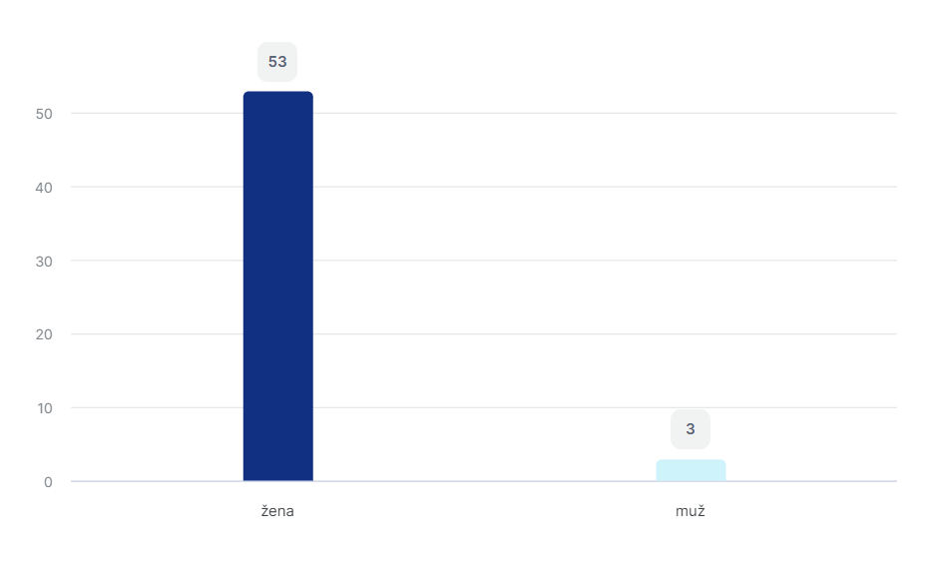

**Age of respondents**

A fascinating pattern unfolds when examining the age distribution of the respondents, highlighting distinctive trends within the surveyed group. Notably, middle-aged women, falling within the age range of 41 to 50 years old, emerge as the most prominently represented cohort, constituting a substantial 51.8% of the participants. This translates to 29 women within this age group, underscoring their significant presence in the study.

Following closely, women aged 31 to 40 years old represent the second-largest demographic, contributing to 23.2% of the overall participants. Conversely, the age group with the least representation comprises teachers aged over 61, indicating a lower participation rate within this specific demographic. These findings suggest that a considerable proportion of English language teachers engaged in this study are either in their younger years or situated within the middle age range.

To offer a visual representation of these age dynamics, Chart No. 2 has been included, providing a clear breakdown of the age distribution among the respondents. This visual aid serves to enhance our understanding of the age composition within the cohort and invites further exploration into potential implications and influences on teaching practices based on age demographics.

**Chart No.2 – Age of respondents**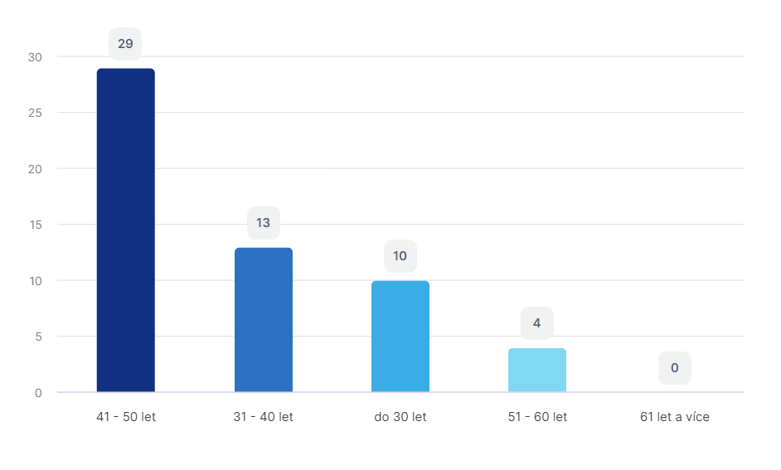

**Length of teaching experience**

Surprisingly it is clear that English language teachers are mostly younger and middle-aged people with a length of experience of 5 years and less, it is 30,4%. Next strong group are teacher with a length of teaching practise of 6-15 years, in which 19,6% of teachers have teaching practise of 6-10 years (11 of them) and 21,4% of teachers with a teaching practise of 10-15 years (that is 12 teachers). This fact can but may not mean an improvement or diversification of the quality of teaching, as teachers may fall into stereotype. The generation of these teachers already grew up with modern information technologies and we can assume that they know their way around these technologies more than their older colleagues, which, of course, cannot be universally accepted. Many older people do very quickly learned to work with the conveniences of the modern age, such as computers, internet, in education also interactive whiteboards. The ratio of the representation of respondents by length of teaching practice shows Chart No. 3.

**Chart No.3 – Length of teaching experience**

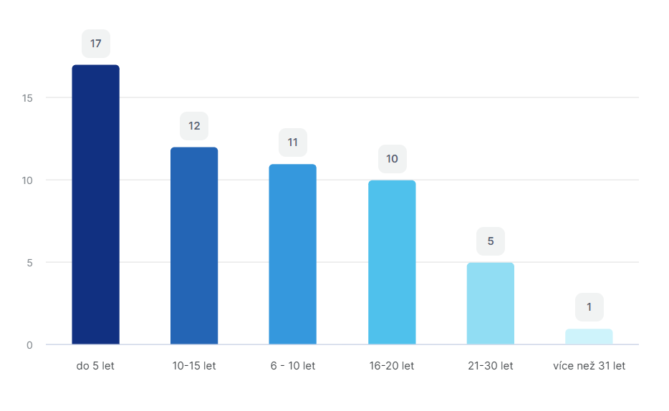  
**Qualification for teaching the English language** (i.e., having a relevant pedagogical degree in English language teaching)

The comprehensive data analysis indicates a notable predominance of approved teachers. Specifically, 76.8% of the respondents possess a relevant pedagogical degree, encompassing 43 teachers. In contrast, 14.3% of teachers hold a Bachelor's degree (8 individuals), and 8.9% of teachers (5 persons) do not have any formal degree. This disparity might suggest that some teachers are either pursuing their university education, as mentioned by some respondents, or they hold a university degree in a different field while teaching English without formal accreditation. The distribution between approved and unapproved teachers is visually represented in Chart No.4.

**Chart No.4 - Qualification for teaching the English language**

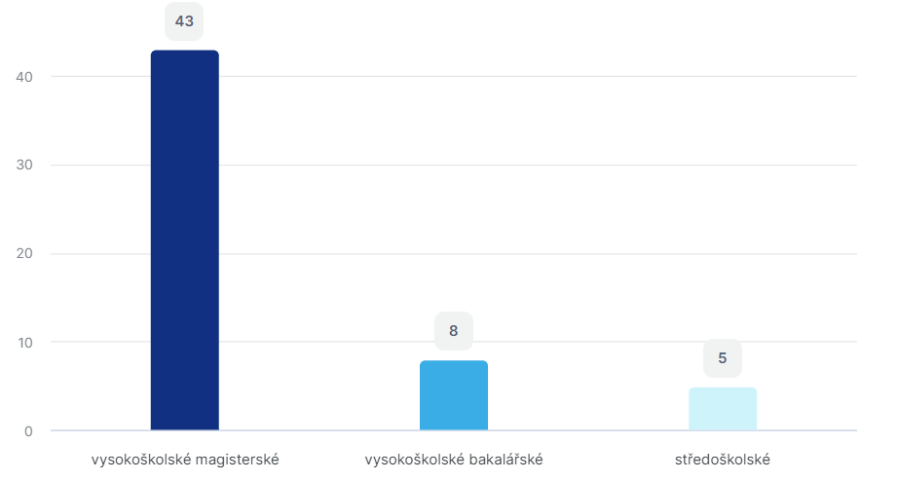

**Use of activating teaching methods**

With the exception of three respondents who expressed unfamiliarity with activating teaching methods, an overwhelming majority, constituting 94.6% of all participants, affirmed their utilization of activating teaching methods in their classes. This widespread adoption of activating methods is visually depicted in Chart No.5, providing a clear representation of the prevalence of such methodologies among the surveyed teachers.

**Chart No.5 - Use of student-engaging teaching methods**

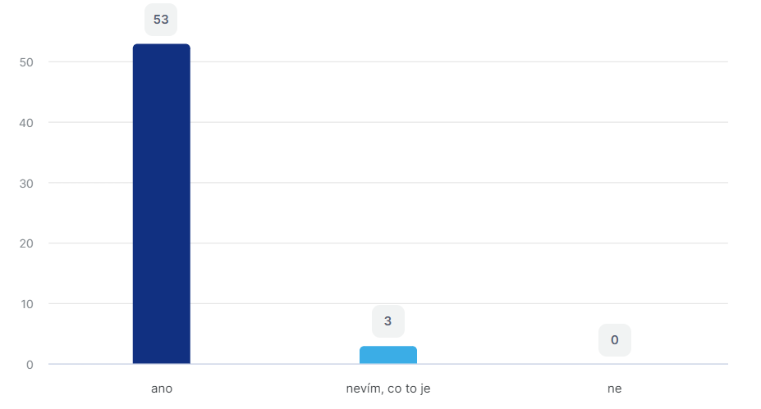

**Types of used student-engaging teaching methods**Teachers employ a diverse array of student-engaging methods, with didactic games emerging as the most prevalent and widely embraced approach. Conversely, problem teaching is the least employed method among the surveyed teachers. A closer examination of the data reveals that didactic games hold a considerable appeal, with 82.1% of respondents incorporating them into their classes. This suggests a strong inclination towards interactive and engaging teaching strategies.

Brainstorming follows closely, being utilized by an equivalent 82.1% of respondents, indicating a high level of enthusiasm for fostering creative thinking and collaborative ideation in the classroom. Discussion methods also enjoy substantial usage, with 73.2% of teachers incorporating them as a means of encouraging dialogue and interactive learning.

In descending order of popularity, situational methods are employed by 48.2% of respondents, staging methods by 35.7%, and heuristic and problem-solving methods by 28.6%. Problem teaching, while the least utilized, still finds application in 16.1% of respondents' teaching practices.

For a visual depiction of these methodological preferences, Chart No.6 has been included, offering a comprehensive overview of the activating methods most commonly employed by the surveyed teachers. This visual aid not only reinforces the prevalence of didactic games but also highlights the diverse landscape of student-engaging methods shaping the pedagogical approaches within the English language classrooms.

**Chart No.6 – Types of used student-engaging teaching methods**

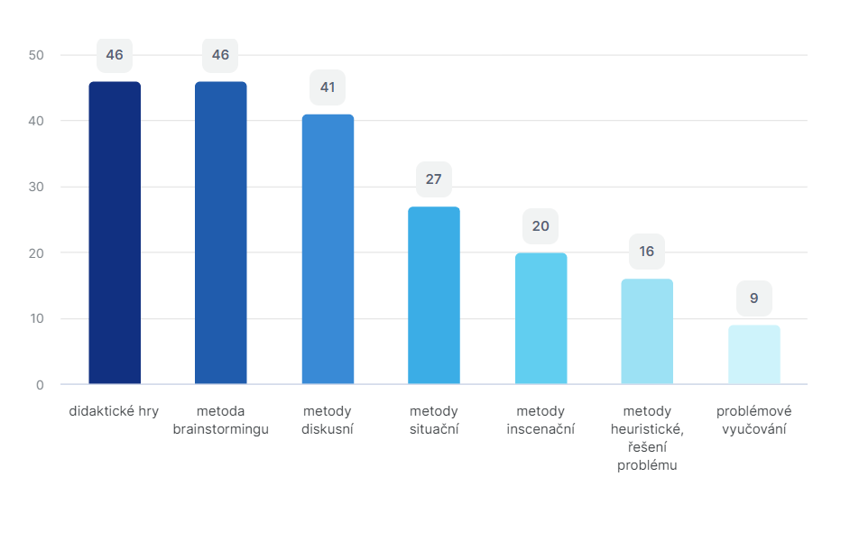

**Frequency of using student-engaging methods in teaching**

A mere 11.76% of respondents incorporate student-engaging methods in every class, underlining the challenges in integrating these methods consistently. A small percentage, 3.36%, utilizes student-engaging methods twice a week, while 7.84% opts for once a week. The majority of teachers, however, employ student-engaging methods sporadically, typically 1-2 times a month, and one respondent abstains from their use altogether.

Interestingly, several respondents expressed a desire to implement student-engaging teaching methods more frequently, ideally in every class. However, practical constraints, such as the need to adhere to the curriculum's predetermined thematic plans, restrict the feasibility of such aspirations. The majority of teachers grapple with time constraints, preventing them from incorporating student-engaging methods as frequently as they would prefer. This sentiment is echoed in Chart No.7, which visually outlines the overall frequency of student-engaging method usage among the respondents, shedding light on the prevalent challenges in consistent implementation.

Začátek formuláře

**Chart No.7 - Frequency of using activating methods in teaching**

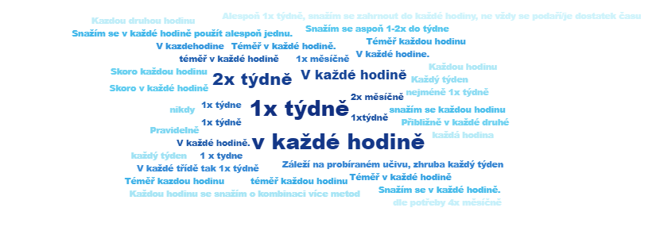

**Attractiveness of student-engaging methods for students**

The overwhelming consensus among respondents who employ student-engaging methods in their classrooms is that students find these methods enjoyable. Nearly all teachers share the view that learners derive satisfaction from engaging with student-engaging methods. However, a minor divergence exists, with two respondents expressing the belief that students are not particularly interested in student-engaging methods, and an additional two respondents indicating uncertainty on this matter.

Moreover, some nuanced opinions surfaced during the research. Some teachers observed that students occasionally forget the intended focus of student-engaging methods, suggesting a need for reinforcement in maintaining purpose during these activities. Additionally, a few respondents noted that students might sometimes prefer various games or alternative activities to sidestep the primary lesson objectives. The allure and appeal of student-engaging methods are depicted in Chart No.8, offering a visual representation of the perceptions regarding the attractiveness of these methods as reported by the surveyed teachers.

Začátek formuláře

**Chart No.8 - Attractiveness of student-engaging methods for students**

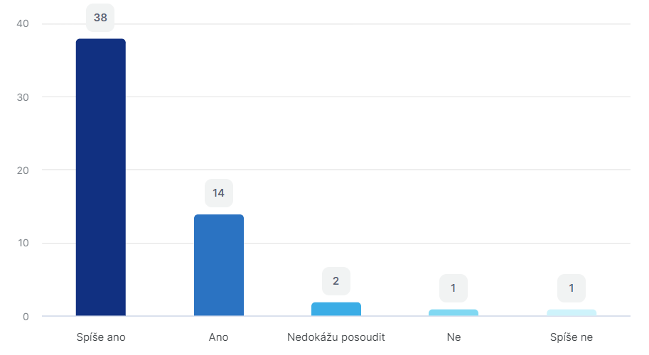

**Source for obtaining information or ideas for the use of individual activities**

Teachers exhibit a diverse and dynamic approach to acquiring information, with the majority relying on multiple sources rather than depending on a single outlet. Responding to this question allowed them to choose more than one answer, reflecting their varied preferences and strategies. The overwhelming trend is evident, with 96.4% of respondents seeking ideas from the internet, marking it as a dominant and widely embraced source.

However, it's crucial to note that teachers' resourcefulness extends beyond online platforms. A significant proportion of respondents, accounting for 64.3%, prefer to create their own activities, showcasing their creativity and ability to tailor content to their specific needs. Additionally, 62.5% of teachers actively exchange ideas and information with their colleagues, highlighting the significance of collaborative learning within the teaching community.

Furthermore, nearly 59% of respondents value information gained from various training sessions, emphasizing their commitment to continuous professional development. It's worth noting that 30.4% of teachers draw insights from professional literature, indicating a thoughtful engagement with established educational resources.

Chart No.9 visually represents the spectrum of sources that teachers employ to gather information, showcasing the multifaceted approach adopted by educators in expanding their knowledge and enhancing their teaching practices.

**Chart No.9 - Source for obtaining information or ideas for the use of individual activities**

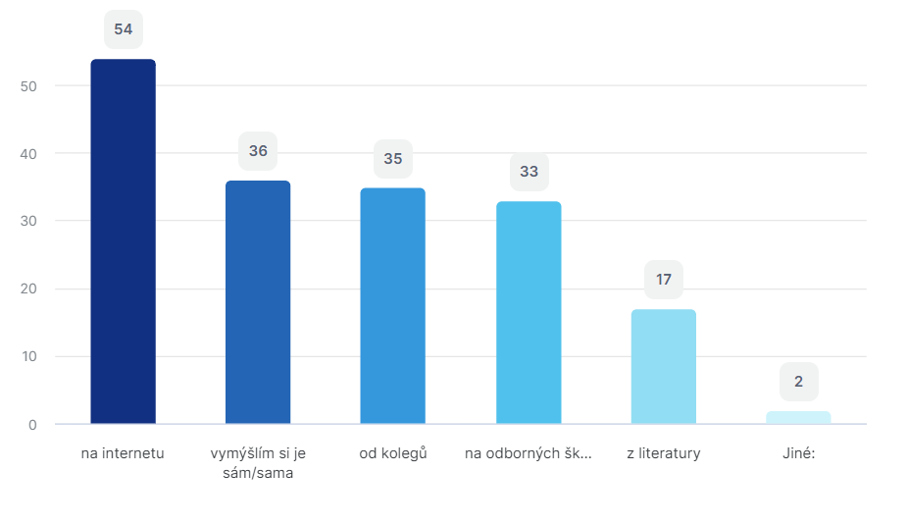

**Technical devices used in English language classes**

The survey findings reveal a significant embrace of modern technological tools by English language teachers, with an overwhelming 85.7% of respondents affirming the incorporation of interactive boards in their teaching practices. Recognizing the multifaceted nature of teaching, respondents had the option to select multiple devices that complement their instructional methods. Notably, 60.7% of teachers leverage computers, demonstrating their versatility in enhancing the learning experience. Mobile phones also play a role, being utilized by 51.8% of respondents, while tablets contribute to the pedagogical toolkit for half of the surveyed teachers.

This diversified use of technical devices is aptly captured in Chart No.10, which visually depicts the prevalence and distribution of these tools among educators. The results underscore the adaptability of teachers in integrating various technologies, reflecting a contemporary approach to language instruction that aligns with the evolving landscape of educational resources.

Začátek formuláře

**Chart No.10 - Technical devices used in English language classes**

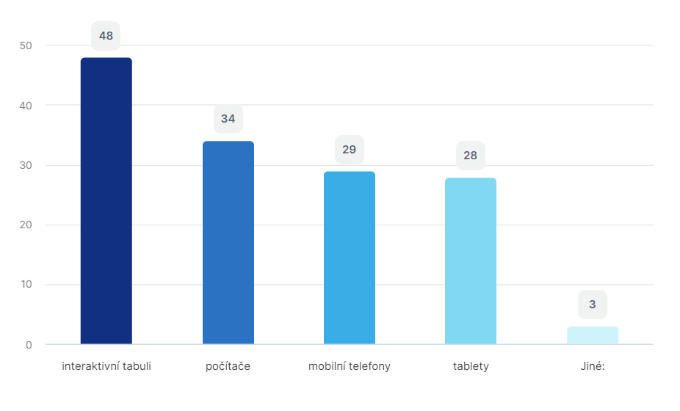

**Materials used in English language classes**

The survey findings highlight the diverse array of instructional materials employed by English language teachers, offering insights into the dynamic landscape of teaching resources. A significant 94.6% of respondents incorporate textbooks and workbooks into their lessons, underlining the continued relevance of traditional print materials in language instruction. Additionally, a substantial 92.9% of teachers utilize various worksheets, aligning with the prevalent use of the internet as a primary source of supplemental materials.

The evolving technological landscape is further evidenced by 89.3% of respondents incorporating internet applications or websites into their teaching methodologies. This trend is likely influenced by the contemporary adoption of interactive boards and related software, with many schools benefiting from EU funding for these advancements. Furthermore, the survey indicates a lower reliance on dictionaries, with only 33.9% of teachers incorporating them into their instructional strategies.

Chart No.11 visually captures the distribution and prevalence of these diverse teaching materials, providing a comprehensive overview of the instructional tools employed by English language educators. The results suggest a balanced integration of traditional and digital resources, showcasing the adaptability of teachers in catering to varied learning needs.

**Chart No.11 - Materials used in English language classes**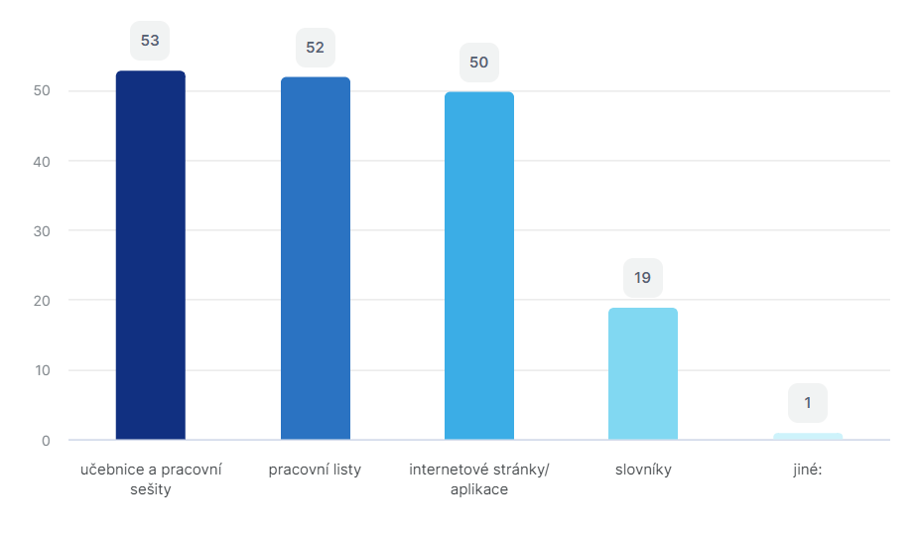

**Effectiveness of time spent with activating teaching methods**

When asked about their perceptions of the effectiveness of time dedicated to student-engaging methods, a notable 58.9% of respondents expressed a positive view, affirming that they consider the time spent with these methods to be effective. Additionally, 35.7% leaned towards a somewhat positive assessment. It's worth noting that a small group of three respondents indicated uncertainty, stating that they could not assess the effectiveness of student-engaging methods in their teaching practices.

These diverse responses contribute to a nuanced understanding of educators' perspectives on the impact of activating methods on student learning outcomes. The breakdown of opinions is visually represented in Chart No.12, providing valuable insights into the varied sentiments among surveyed teachers. This distribution highlights the multifaceted nature of evaluating the effectiveness of teaching methodologies, taking into account the dynamic interplay of factors influencing the learning environment.

Začátek formuláře

**Chart No.12 - Effectiveness of time spent with student-engaging teaching methods**

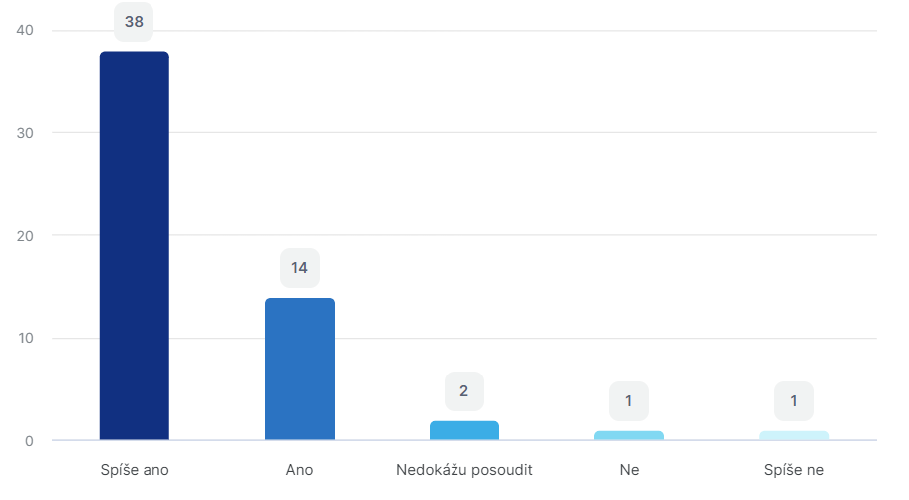

**Interest in modern teaching methods in language instruction**

The survey findings underscore the prevailing enthusiasm among teachers for contemporary and student-engaging teaching methods, with a substantial 75% of respondents expressing a strong interest. Moreover, an additional 11 respondents exhibited a somewhat positive inclination, emphasizing the widespread inclination towards embracing innovative and engaging approaches to teaching. Only a minimal 3 respondents indicated a lack of interest or partial interest in these dynamic teaching methodologies.

Delving into the avenues through which teachers explore and understand these modern methods, the survey uncovered that the internet stands out as the primary and overwhelmingly favored source. A significant 91.1% of respondents turn to online platforms for inspiration, ideas, and insights into cutting-edge teaching techniques. Concurrently, training sessions and seminars emerge as pivotal contributors, with 83.9% of teachers leveraging these events as valuable learning opportunities to stay abreast of modern teaching methodologies.

Interestingly, literature also plays a role, albeit to a lesser extent, with 32.1% of respondents gaining insights from various educational texts. This diversification in information sources underlines the adaptability and resourcefulness of educators in navigating a varied landscape of knowledge acquisition.

Chart No.13 visually encapsulates the diverse channels through which teachers gather ideas and information, providing a comprehensive overview of their information-seeking practices.Začátek formuláře

**Chart No.13 - Interest in modern teaching methods in language instruction**

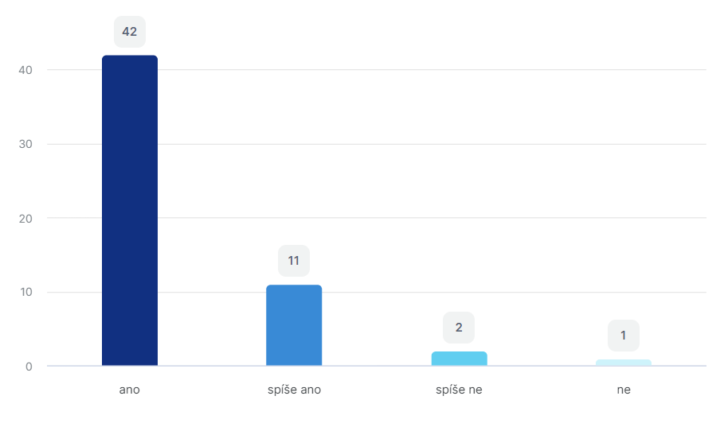

### Verification of research questions

Now we can answer the research questions that we set at the beginning of our research. The wording of the main research question was as follows:

**1. What student-engaging teaching methods does the teacher use in teaching at a lower secondary school?**

The study looked at seven different ways to make learning more interesting. The two methods that stood out the most were didactic and brainstorming.

Didactic games are the most used method because they make learning fun. They're not just about giving information but also about making students think and solve problems while working together. These games use elements that grab students' attention and make learning more enjoyable and memorable.

Brainstorming is another great way to learn. In brainstorming, everyone gets to share their ideas and thoughts. This helps students be more creative and participate actively in class. It's not just about finding answers; it's also about learning how to communicate well and solve problems together. Working as a team in brainstorming sessions creates a friendly environment in the classroom.

By using didactic games and brainstorming, teachers can make sure that all students, no matter how they like to learn, can enjoy and understand the lessons better. These methods make learning more interesting and help students develop different skills, like problem-solving and working with others.

In conclusion, using games and brainstorming in teaching makes learning more exciting and helps students grow in different ways. It goes beyond the usual way of teaching, making education fun and transforming experience for everyone involved.

**2. What resources for teaching do teachers at lower secondary school use?**

In teaching English to kids in the second level of elementary school, teachers rely a lot on different materials. The main things they use are textbooks and workbooks. These books help students learn new things and practice what they've learned. The teachers add more stuff to these, like worksheets and activities from the Internet.

Textbooks are big books that have lessons and stories. They help teachers guide students through what they need to learn. They are designed to follow school curriculum systém too. Workbooks are like practice books. Students use them to do exercises and get better at English. These two are the main tools teachers use in class.

Apart from books, teachers also use worksheets. Worksheets are sheets of paper with questions or tasks on them. They are a hands-on way for students to practice what they're learning. Teachers often get these sheets from the Internet, where there are lots of ideas and resources for teaching English. The Internet is like a big library for teachers. They find activities and games that make learning English fun and interesting.

Sometimes, teachers even create their own activities or get ideas from their friends who are also teachers. This way, they can make sure the activities fit well with what they're teaching in class. It's like adding a personal touch to make lessons more exciting.

Teaching English at this level involves using textbooks and workbooks, and then adding extra things like worksheets and activities from the Internet. The Internet is a big help for teachers, offering a variety of resources to make learning English a funny adventure for students.

**3. What is teacher’s opinion on using student engaging activities in the classroom?**

Many teachers believe that when students are actively involved in learning, it's a good thing. This is because it shows that the students are interested and paying attention. One way teachers make lessons engaging is by using tools like interactive whiteboards and computers. These are special helpers that make learning more interesting, and students really like them.

Interactive whiteboards are big computer screens that teachers can write on. It's like a high-tech chalkboard. Teachers can show pictures, write words, and even play games on it. Students find it fun because it's different from regular teaching tools. Computers are also useful tool because they can show videos, play educational games, and help with research.

When teachers use these tools, it's not just about making things look fancy. It is about making learning more exciting and interactive. Learning becomes a team activity, and everyone gets involved.

Students really like when lessons involve interactive whiteboards and computers because it feels modern and interesting. They get to see and do things in a way that is different from just reading from a book. This kind of teaching makes them more curious and eager to participate.

So, when teachers use interactive tools like whiteboards and computers, it is not just about using technology. It is about creating a learning environment that students enjoy and find exciting. Itr is like turning lessons into adventures, and students love that!

Začátek formuláře

### Overall results

The research revealed that English language teachers are interested in various teaching methods and do not want to limit their instruction solely to a standard approach using traditional teaching methods. Although these methods have their place in education, teachers acknowledge that each method is suitable for a different phase of the teaching hour and serves to practice and acquire various knowledge and skills.

Respondents unanimously confirmed that student-engaging methods contribute to the acquisition of language skills, and they consider the time spent with these methods to be effective. These findings are positive, indicating that when student-engaging methods are properly guided, they can effectively contribute to the development of students' language abilities.

Regarding obtaining ideas and information about various methods and activities, teachers use the internet, participate in training and seminars, and consult with colleagues. Furthermore, the research showed that teachers are not confined to a single proven method; they are open to new ideas and possibilities. They regularly rotate their activities to maintain students' interest and select the most suitable method for specific educational goals.

In today's era, almost every teacher uses the internet to find various ideas, worksheets, activities, games, and instructions. Although not all of them are suitable for a specific culture or educational system, teachers demonstrate creativity and the ability to modify activities according to their needs.

Moreover, teachers are increasingly utilizing interactive boards, providing a new point of interest for students. This technology allows students to work with various materials, practice diverse skills, and serves as a tool for playing videos and music. Despite the limitation that only one student can work with the interactive board at a time, this drawback can be addressed through worksheets for the rest of the class.

## Lesson plans based on student-engaging methods

**Lesson Plan: Engaging English Discussions for 7th Grade**

Objective:

Students will enhance their communication and critical thinking skills through active participation in English discussions.

Students will practice expressing their opinions, listening to others, and providing thoughtful responses.

Materials:

Whiteboard and markers

Printed discussion prompts or questions

Timer

Chart paper and markers

Introduction (10 minutes):

Begin with a brief discussion on the importance of effective communication and expressing opinions in English.

Explain the objective of the lesson: to improve communication skills through engaging discussions.

Establish a positive and open atmosphere, encouraging students to share their thoughts without fear of judgment.

Warm-up Activity - Quick Share (5 minutes):

Pose a simple question related to everyday experiences, such as "What is your favorite hobby?" or "What did you do over the weekend?"

Have each student share their response briefly with a partner.

Encourage a few students to share their partners' responses with the class.

Main Activity - Guided Discussion (25 minutes):

Divide the class into small groups, providing each group with a discussion prompt or question related to the current lesson topic or a recent reading.

Allow students 10-15 minutes to discuss the prompt within their groups.

Circulate among the groups, providing guidance, clarifications, and encouraging active participation.

After the group discussions, have each group summarize their key points or share an interesting perspective with the whole class.

Class Reflection (10 minutes):

Lead a class discussion reflecting on the group discussions.

Encourage students to share what they found interesting or challenging during the activity.

Discuss effective communication strategies, such as listening attentively, respecting different opinions, and using clear language.

Extension Activity - Debate (15 minutes):

Introduce a simple debate format on a relevant and engaging topic.

Divide the class into two groups – those in favor and those against the topic.

Allow each group time to prepare their arguments.

Conduct a structured debate with each group presenting their points.

Encourage students to respond respectfully to opposing arguments.

Conclusion (5 minutes):

Summarize the importance of effective communication and critical thinking skills.

Discuss how these skills can be applied not only in English class but also in various aspects of their lives.

Assign homework, such as writing a short reflection on what they learned from the discussion activities.

Assessment:

Observe students' participation and engagement during discussions.

Evaluate the quality of their contributions, including their ability to express opinions and respond to others respectfully.

**Lesson Plan: Problem-Solving Skills for 9th Grade Students**

Objective:

Students will develop critical thinking and problem-solving skills through real-world scenarios.

Students will collaborate in groups to analyze and solve problems, fostering teamwork.

Materials:

Whiteboard and markers

Printed problem-solving scenarios or case studies

Chart paper and markers

Timer

Small group workspaces

Introduction (10 minutes):

Begin with a brief discussion on the importance of problem-solving skills in everyday life.

Explain the objective of the lesson: to enhance critical thinking through practical problem-solving.

Establish a positive and collaborative atmosphere, emphasizing the value of teamwork.

Warm-up Activity - Brainstorming (10 minutes):

Engage students in a brainstorming session on common problems they encounter.

List these problems on the whiteboard.

Discuss potential solutions briefly as a class.

Main Activity - Group Problem-Solving (30 minutes):

Divide the class into small groups.

Distribute printed problem-solving scenarios or case studies to each group.

Instruct groups to read and analyze the problem, identify the key issues, and propose practical solutions.

Set a timer for 20-25 minutes to allow groups to collaborate and discuss.

Circulate among the groups, offering guidance and ensuring active participation.

Have each group present their identified problems and proposed solutions to the class.

Class Discussion and Analysis (15 minutes):

Lead a class discussion on the different approaches each group took in solving the problems.

Discuss the effectiveness of various problem-solving strategies.

Emphasize the importance of considering multiple perspectives and thinking critically.

Extension Activity - Real-World Application (20 minutes):

Introduce a real-world scenario or current event related to the problem-solving theme.

Ask students to discuss and propose solutions based on the problem-solving skills they've practiced.

Encourage creativity and outside-the-box thinking.

Conclusion (5 minutes):

Summarize the key points learned about problem-solving.

Discuss how these skills can be applied in various situations.

Assign homework, such as reflecting on how they might use problem-solving skills in their own lives.

Assessment:

Evaluate group participation and collaboration during the problem-solving activity.

Assess the quality of each group's analysis and proposed solutions.

Consider class engagement during the discussion and application of problem-solving skills to real-world scenarios.

**Lesson Plan: Learning Through Situational Methods for 9th Grade Students**

Objective:

Students will engage in learning through real-life situations to enhance understanding and application of knowledge.

Students will develop critical thinking skills by analyzing and responding to situational challenges.

Materials:

Whiteboard and markers

Printed situational scenarios or case studies

Chart paper and markers

Timer

Small group workspaces

Introduction (10 minutes):

Begin with a brief discussion on the concept of learning through real-life situations.

Explain the objective of the lesson: to apply knowledge to practical scenarios and enhance critical thinking.

Establish an open and collaborative atmosphere, emphasizing the value of learning from real-world situations.

Warm-up Activity - Icebreaker Situations (10 minutes):

Present a few light-hearted, everyday situations or challenges.

Have students discuss possible responses in pairs or small groups.

Share responses as a class, encouraging creativity and diverse perspectives.

Main Activity - Group Analysis of Situational Scenarios (30 minutes):

Divide the class into small groups.

Distribute printed situational scenarios or case studies to each group.

Instruct groups to read and analyze the situation, identify key elements, and discuss possible solutions.

Set a timer for 20-25 minutes to allow groups to collaborate and discuss.

Circulate among the groups, offering guidance and ensuring active participation.

Have each group present their analysis and proposed solutions to the class.

Class Discussion and Reflection (15 minutes):

Lead a class discussion on the different perspectives and solutions presented by each group.

Discuss the importance of critical thinking in analyzing and responding to real-life situations.

Encourage students to reflect on how they can apply these skills in their own lives.

Extension Activity - Application in Personal Context (20 minutes):

Ask students to think about a personal situation where they can apply the critical thinking skills practiced during the lesson.

Have students share their reflections with a partner or in small groups.

Encourage discussion on the practical application of situational learning.

Conclusion (5 minutes):

Summarize the key concepts learned about learning through real-life situations.

Discuss the relevance of critical thinking skills in various aspects of life.

Assign homework, such as journaling about a situation where they can apply critical thinking.

Assessment:

Evaluate group participation and collaboration during the analysis of situational scenarios.

Assess the quality of each group's analysis and proposed solutions.

Consider individual engagement during the class discussion and reflection on the application of critical thinking skills.

**Lesson Plan: Theatrical Staging Methods for 7th Grade Students**

Objective:

Students will explore the basics of theatrical staging methods to enhance communication and expressiveness.

Students will develop teamwork and creative thinking skills through practical exercises.

Materials:

Open classroom space

Whiteboard and markers

Costumes or props (optional)

Timer

Chart paper and markers

Introduction (10 minutes):

Begin with a brief discussion on the concept of theatrical staging and its importance in effective communication.

Introduce the objective of the lesson: to explore basic staging methods for better expression and communication.

Establish a positive and collaborative atmosphere, emphasizing the importance of creativity and teamwork.

Warm-up Activity - Group Movement (10 minutes):

Lead the class in a series of simple group movement exercises.

Encourage students to use their bodies to express different emotions or scenarios.

Discuss the importance of body language in communication.

Main Activity - Theatrical Staging Workshop (30 minutes):

Divide the class into small groups.

Provide each group with a short scenario or simple script (could be related to a topic from their curriculum).

Instruct each group to plan and perform the scenario using basic staging methods, such as blocking, gestures, and facial expressions.

Set a timer for 20-25 minutes to allow groups to collaborate and rehearse.

Encourage creativity and experimentation with staging elements.

Group Performances and Peer Feedback (15 minutes):

Have each group present their short performances to the class.

After each performance, facilitate a brief discussion for peer feedback.

Encourage constructive comments on effective staging elements and areas for improvement.

Class Discussion and Reflection (15 minutes):

Lead a class discussion on the impact of staging methods in communication.

Discuss the importance of non-verbal cues in conveying emotions and messages.

Ask students to reflect on what they learned and how they can apply these skills in different aspects of their lives.

Extension Activity - Improvisation (20 minutes):

Introduce a simple improvisation exercise where students have to create a short scene on the spot.

Encourage students to use staging methods to convey their characters and messages.

Discuss the challenges and successes of improvisation as a form of creative expression.

Conclusion (5 minutes):

Summarize the key concepts learned about theatrical staging methods.

Discuss the relevance of these skills in both theatrical performances and everyday communication.

Assign a small homework task, such as practicing a short scenario at home with family members.

Assessment:

Evaluate group participation and creativity during the theatrical staging workshop.

Assess the quality of each group's performance and their ability to apply basic staging methods.

Consider individual engagement during class discussions and reflections.

## Recommendations for suitable activities (didactic games)

The next sections will provide ideas for activities that can be applied in English language classes. These activities aim to inspire elementary school teachers and cover various aspects of language learning. They are categorized into four sections, each designed for practicing different language skills: grammar and vocabulary, reading and writing, listening, and speaking. These activities can be adapted to suit the specific needs and levels of students, offering a diverse range of engaging exercises to enhance language proficiency.

### Grammar and vocabulary activities

**Sentence smash up:**

This game is great for practising grammar structure and grammar points.

The grammar point that is being taught is used.

The teacher writes sentences in the computer, print them out and cut them into stripes, either multi-word pieces or single words.

Students in pairs or individually have to put the sentences back together in a given time.

**Word Relay Race:**

Divide the class into two or more teams.

Write a list of vocabulary words or sentences on the board related to the current lesson.

The first student from each team runs to the board and writes a synonym or a related word for the displayed word.

The next student continues the relay. The team that finishes first with correct answers wins.

**Grammar Bingo:**

Create Bingo cards with different grammar rules or vocabulary words.

Call out sentences or definitions related to the lessons.

Students mark the corresponding grammar rule or vocabulary word on their Bingo cards.

The first student to get a line shouts "Bingo!" and wins a small prize.

**Vocabulary Pictionary:**

Prepare a list of vocabulary words related to the current unit.

Assign each student a word without revealing it to others.

Students draw a picture representing their assigned word on the board without using letters.

Classmates try to guess the word based on the drawings.

**Grammar Jeopardy:**

Create a Jeopardy-style game board with different categories related to grammar and vocabulary.

Assign point values to each question based on difficulty.

Divide the class into teams and have them choose questions. If they answer correctly, they earn points.

The team with the most points at the end wins.

**Vocabulary Charades:**

Write various vocabulary words on pieces of paper and put them in a hat.

One student selects a word without revealing it to others.

Without speaking, the student acts out the word while the rest of the class tries to guess what it is.

Rotate roles, allowing each student to participate in acting and guessing.

These games add an element of fun and engagement to grammar and vocabulary lessons, making learning enjoyable for lower secondary school students.

### Listening activities

**Listen and Draw:**

Provide students with a simple drawing or diagram with missing elements.

Play an audio clip with instructions on how to complete the drawing, including details that are not shown.

Students listen carefully and follow the instructions to draw the missing parts.

**Guess the Sound:**

Play various sound effects or short audio clips related to everyday situations or objects.

Students listen and try to guess what each sound represents.

Encourage discussion and reasoning behind their guesses.

**Descriptive Dictation:**

Read a short paragraph describing a scene or object to the students.

As they listen, students draw what they imagine based on the description.

Afterward, compare their drawings with the actual scene or object.

**Story Sequencing:**

Choose a short narrative or story and divide it into key parts.

Play the audio of the story, then provide students with shuffled sentence strips representing different parts.

Students listen and rearrange the sentence strips in the correct order.

**Song Lyrics Gap Fill:**

Choose a song with clear and understandable lyrics related to the lesson.

Remove certain words or phrases from the lyrics.

Play the song, and students listen to fill in the gaps with the missing words.

These activities not only enhance listening skills but also make the learning experience enjoyable and interactive for lower secondary school students.

### Writing and reading activities

**Story Starters:**

Provide students with sentence prompts or story starters.

Ask them to continue the story by writing a paragraph or short narrative.

Encourage creativity and imagination in developing the plot and characters.

**Book Review:**

Assign students a book appropriate for their age and reading level.

After reading, have them write a book review, including a summary, their favorite part, and whether they would recommend it to their peers.

**Creative Letter Writing:**

Ask students to write a letter to their future selves, describing their goals, aspirations, and expectations.

They can seal the letters and revisit them at the end of the school year.

**Picture-Based Writing:**

Provide students with an interesting or thought-provoking image.

Ask them to create a story or descriptive paragraph inspired by the picture.

Emphasize the use of vivid language and sensory details.

**Literary Scavenger Hunt:**

Select a text and create a list of items or themes for students to find while reading.

Students read the text and mark off items on the list as they encounter them.

Encourage discussion about how each item contributes to the overall meaning of the text.

These activities aim to enhance both reading comprehension and writing skills while engaging students in creative and meaningful tasks.

### Speaking activities

**Role-Play Scenarios:**

Prepare various scenarios or situations (e.g., at a restaurant, in a store, at the airport).

Assign roles to students and have them act out the scenes, encouraging the use of relevant vocabulary and expressions.

**Show and Tell:**

Ask each student to bring an item from home that is meaningful to them.

Have students describe the item, explaining its significance, and answer questions from their peers.

**Debates:**

Choose age-appropriate topics for debates, such as "School Uniforms," "Benefits of Homework," or "Phone addiction."

Divide students into teams and encourage them to present arguments, fostering critical thinking and communication skills.

**Story Chain:**

Start a story with a sentence or scenario.

Each student adds a sentence to continue the story.

The goal is to build a collaborative narrative, enhancing creativity and oral communication.

**Interview a Classmate:**

Pair students and provide a list of interview questions (e.g., hobbies, favorite books, future aspirations).

Each student takes turns interviewing their partner and then introduces them to the class.

**Picture Descriptions:**

Show students a picture with various elements.

Ask them to take turns describing different aspects of the image, encouraging the use of descriptive language.

**Role-Playing Historical Figures:**

Assign each student a historical figure or character.

Have them research and prepare a short presentation, embodying the persona they've been assigned.

This activity combines research, public speaking, and creativity.

**Charades:**

Teacher prepares several lists of words.

Learners are divided into two teams.

A person from Team 1 comes to the board, chooses one list from the teacher and his task is to describe the words one by one in a given time (usually 8 words for two minutes) and his colleagues have to guess the words.

Then Team 2 follows.

The teams change in guessing, it depends how many lists the teacher has.

These speaking activities aim to promote communication, collaboration, and confidence in expressing ideas in English. They provide opportunities for students to engage in meaningful conversations while practicing language skills.

# Conclusion

In summary, the thesis focuses on the exploration of teaching methods designed to actively engage students in the learning process. These methods play a pivotal role in reshaping both the teaching approach and the learning experience for students.

The research highlights the critical importance of selecting effective teaching methods, particularly in the context of English language education at the lower secondary school level. Conventional teaching approaches are undergoing reevaluation, making room for innovative methods that capture students' interest and participation.

The study reveals that these student-engaging methods not only facilitate a quicker grasp of the English language but also contribute to the development of essential skills such as critical thinking, creativity, and self-directed learning. The thesis delves into a variety of methods, including games, dramatic activities, conversational exercises, and the integration of technology, showcasing their adaptability and varied applications.

Moreover, the evolving landscape of education is evident in the shift towards a student-centric approach that prioritizes individual needs. Student-engaging methods act as a bridge between traditional and modern teaching practices, creating vibrant and stimulating learning environments for educators and students alike.

In conclusion, the research presented in this thesis provides valuable insights into the transformative potential of student-engaging teaching methods within the education system. It goes beyond the mere acquisition of language skills, aiming to instill a passion for learning, encourage cultural exploration, and foster the development of skills crucial for success in a globalized world.

Therefore, student-engaging teaching methods emerge not merely as tools for language acquisition but as catalysts for a holistic and impactful educational experience. The thesis serves as a testament to the dynamic nature of education, showcasing the significant role student-engaging methods play in shaping the future of learning and adapting to the evolving needs of students and educators.

Začátek formuláře

# Summary

The theory of using student-engaging methods in English language teaching aligns with the research results. The survey revealed that English language teachers indeed show interest in various teaching methods and are unwilling to confine themselves to traditional approaches. Although classical methods remain important, teachers are aware that each method has its place and can be effective in different stages of teaching.

Respondents unanimously affirmed that activation methods contribute to the acquisition of language skills, and they consider the time spent with these methods to be effective. This agreement with the research results reinforces the positive nature of these methods and emphasizes that properly guided student-engaging methods can significantly contribute to the development of students' language abilities.

The research further showed that teachers actively utilize various sources to gather ideas and information about different methods and activities. The internet, participation in training and seminars, and consultations with colleagues have become common ways for teachers to acquire new insights and inspiration.

An essential aspect is the recognition that teachers do not adhere to a single method. They are open to new ideas and regularly modify their activities to maintain student interest, choosing the most suitable method for specific teaching goals.

Currently, the internet serves as a key source of information for the majority of teachers. Teachers use the internet to search for various ideas, worksheets, activities, games, and instructions. While not all are suitable for a specific culture or educational system, teachers demonstrate creativity and the ability to adapt activities to meet their students' needs.

Moreover, an increasing number of teachers are incorporating interactive boards, providing students with a new point of interest. Despite the limitation that only one student can work with the interactive board at a time, this challenge can be overcome by providing worksheets for the rest of the class.

# Sources

BEARD, Colin, and John P. WILSON. Experiential Learning: A Best Practice Handbook for Educators and Trainers. London: Kogan Page, 2006. Print.

BEDNÁŘ, Tomáš; GEARING, Suzannah. Vocabulary Maps. BG Publishing, 2018. ISBN: 978-80-270-7340-5

BETÁKOVÁ, Lucie, Eva HOMOLOVÁ a Milena ŠTULRAJTEROVÁ. 2017. Moderní didaktika anglického jazyka v otázkách a odpovědích. Praha: Wolters Kluwer. ISBN 978-80-7552-486-7.

BONWELL, Charles C. a James A. EISON. 1991. Active learning: creating excitement in the classroom. Washington, DC: School of Education and Human Development, George Washington University. ASHE-ERIC higher education report, 1991, no. 1. ISBN 1-878380-08-7.

BUTTNER, Amy. 2013. 100 aktivit, her a učebních strategií ve výuce cizích jazyků: praktické návody, jak zpříjemnit výuku studentům i sobě. Brno: Edika. ISBN 978-80-266-0203-3.

BUZAN, Tony a Jo Godfrey WOOD. 2014. Myšlenkové mapy pro děti: efektivní učení. Brno: BizBooks. ISBN 978-80-265-0263-0.

CLARK, Leonard H a Irving S STARR. Secondary and middle school teaching methods. 4th ed. New York: Macmillan, 1981. ISBN 0023226501.

ČAPEK, Robert. Moderní didaktika: Lexikon výukových a hodnotících metod. Grada, 2015. ISBN: 978-80-247-3450-7.

ČERVENKOVÁ, Iva (2013) Výukové medoty a organizace vyučování, [Online], Available: http://projekty.osu.cz/svp/opory/pdf-cervenkova-vyukove-metody-a-organizacevyucovani.pdf [15 June 2018]

DÖRNYEI, Zoltán. Murhey, Tim. Group dynamics in the language classroom, Cambridge: Cambridge University Press. 2003. Print.

DÖRNYEI, Zoltán. Motivational strategies in the language classroom. 1st publ. Cambridge: Cambridge Univ. Press, 2001. ISBN 0521793777.

EIBENOVÁ, Klaudia; VAVREČKA, Mojmír; FOLTOVÁ, Hana; EIBENOVÁ, Irena. Hry ve výuce angličtiny. Vyd.1. Brno: Edika, 2013. ISBN 978-80-266-0208-8.

GAVORA, P. (2000). Úvod do pedagogického výzkumu. Brno: Paido.

GRECMANOVÁ, Helena, Eva URBANOVSKÁ a Petr NOVOTNÝ. Podporujeme aktivní myšlení a samostatné učení žáků. Vyd. 1. Olomouc: Hanex, 2000. ISBN 80- 85783-28-2.

GRECMANOVÁ, Helena; URBANOVSKÁ, Eva. Aktivizační metody ve výuce, prostředek ŠVP. Vyd. 1. Olomouc: Hanex, 2007. Edukace. ISBN 978-808-5783-73-5.

HAMIDIZADEH, Meghdad a Fatemeh AZIZMOHAMMADI. 2014. The Role of Activation in Increasing ESL & EFL Learner’s Motivation. International Journal of Language Learning and Applied Linguistics World (IJLLALW). 5 (2), 544-549.

HANŠPACHOVÁ, Jana; ŘANDOVÁ, Zuzana. Angličtina plná her. Vyd.1. Praha: Portál, 2005. ISBN 80-7178-790-6.

HARMER, Jeremy. How to teach English.London: Longman, 2007. Print.

HARMER, Jeremy. 2007. The practice of English language teaching. Fourth edition. Pearson Education Limited. ISBN 978-1-4058-4772-8.

HORÁK, František. Aktivizující didaktické metody. Vydání 1. Olomouc: Rektorát Univerzity Palackého v Olomouci, 1991. ISBN 80-7067-003-7.

HOWELL, Jennifer. Teaching & learning: building effective pedagogies. Australia: Oxford University Press, 2014. ISBN 0195529065.

CHANDLER, John; STONE, Mark. The resourceful English teacher: A complete teaching companion. Repr. with modifications. Peaslake, Surrey: Delta Pub, 2003. ISBN 09-533-0981-9.

KALHOUS, Z., & Obst, O. (2009). Školní didaktika. Praha: Portál.

KLIČKOVÁ, Marie. Problémové vyučování ve školní praxi. Praha:SPN, 1989. ISBN 80-04-23522-0.

KOTRBA, Tomáš; LACINA, Lubor. Praktické využití aktivizačních metod ve výuce. Vydání první. Brno: Společnost pro odbornou literaturu, 2007. ISBN 978-80-87029-12-1

KOTRBA, T., & LACINA, L. (2011). Aktivizační metody ve výuce: příručka moderního pedagoga. Brno: Barrister & Principal.

LARSEN-FREEMAN, Diane a Marti ANDERSON. 2014. Techniques & principles in language teaching. Third edition. Oxford: Oxford University Press. ISBN 978-0- 19-442360-1.

LERNER, I.J. Didaktické základy metod výuky. Praha: SPN, 1986. ISBN 14-485-86.

LINDSAY, C.; KNIGHT, P. Learning and Teaching English: A course for teachers. Oxford: Oxford University Press, 2006. ISBN 0-19-442277-1.

LOKŠOVÁ, Irena a Jozef LOKŠA. Pozornost, motivace, relaxace a tvořivost dětí ve škole. Praha: Portál, 1999. ISBN 80-7178-205-X.

LOKŠOVÁ, Irena; LOKŠA, Jozef. Tvořivé vyučování. Vyd. 1. Praha: Grada, 2003, ISBN 80-247-0374-2.

MAŇÁK, J. (2003). Nárys didaktiky. 3. vyd. Brno: Masarykova univerzita.

MAŇÁK, J. (1998). Rozvoj aktivity, samostatnosti a tvořivosti žáků. Brno: Masarykova univerzita.

MAŇÁK, J., ŠVEC, V. Výukové metody. Brno: Paido, 2003. ISBN 80-7315-039-5.

MOJŽÍŠEK, Lubomír. Vyučovací metody. 2. vyd. Praha: SPN, 1988. ISBN 14-513-88.

PECINA, Pavel a Lucie ZORMANOVÁ. Metody a formy aktivní práce žáků v teorii a praxi. 1. vyd. Brno: Masarykova univerzita, 2009. Spisy Pedagogické fakulty Masarykovy univerzity, sv. č. 114. ISBN 978-802-1048-348.

PETTY, G., & FOLTÝN, J. Moderní vyučování. Vyd.2. Praha: Portál, 2002. ISBN 80-7178-681-0.

PHILLIPS, Diane, Sarah BURWOOD a Helen DUNFORD. 1999. Projects with young learners. Oxford: Oxford University Press. Resource books for teachers. ISBN 0194372219.

PRŮCHA, J., JANÍK, T., & RABUŠICOVÁ, M. Pedagogická encyklopedie. Praha: Portál, 2009. ISBN 978-80-7367-546-2.

PRŮCHA, J., WALTEROVÁ, E., & MAREŠ, J. (2013). Pedagogický slovník. Praha: Portál.

PUCHTA, Herbert a Marion WILLIAMS. 2011. Teaching young learners to think. First edition. Helbling Languages. ISBN 978-3-85272-428-7.

SCRIVENER, Jim. Learning teaching: a guidebook for English language teachers. 2nd ed. Oxford: MacMillan, 2005. ISBN 14-050-1399-0.

SITNÁ, Dagmar. Metody aktivního vyučování. Vyd.1. Praha: Portál, 2009. ISBN 978-80-7367-246-1.

SKALKOVÁ, Jarmila. Aktivita žáků ve vyučování.Praha: SPN, 1971. ISBN 14-474-71.

THE FLORIDA STATE UNIVERSITY (FSU), Office of Distance Learning. 2011. Chapter 8 – Using Active Learning in the Classroom. In: Instruction at FSU: A Guide to Teaching & Learning Practices. [online]. [cit. 2019-11-10]. Dostupné z: <https://distance.fsu.edu/instructors/instruction-fsu-guide-teaching-learning-practices>.

THORNBURY, Scott. An A-Z of ELT: a dictionary of terms and concepts used in English language teaching. 1st publ. Oxford: Macmillan, 2006. Macmillan books for teachers. ISBN 1-4050-7063-3.

UR, Penny. A course in English Language Teaching. Cambridge University Press, 2012. ISBN 978-1-107-68467-6.

VÁGNEROVÁ, Marie. Vývojová psychologie. Vyd. 1. V Praze: Karolinum, 2005. ISBN 978-802-4609-560.

VALIŠOVÁ, A., KASÍKOVÁ, H. Pedagogika pro učitele. Praha: Grada Publishing, 2007. ISBN 978-80-247-1734-0.

ZORMANOVÁ, Lucie*.* Obecná didaktika: pro studium a praxi. Vyd. 1. Praha: Grada, 2014. Pedagogika (Grada). ISBN 978-80-247-4590-9.

**Internetové zdroje:**

<https://clanky.rvp.cz/clanek/c/Z/14483/aktivizujici-vyukove-metody.html/>

LIU, Qing-xue a Jin-fang SHI. An Analysis of Language Teaching Approaches and Methods--Effectiveness and Weakness [online]. 2007 [cit. 2015-12-07]. Dostupné z: <http://files.eric.ed.gov/fulltext/ED497389.pdf>

MAŇÁK, Josef. Aktivizující výukové metody. Metodický portál: Články [online]. 2011 [cit. 2015-10-16]. Dostupný z . ISSN 1802-4785.

Moderní vyučovací metody. Čtenářská gramotnost a projektové vyučování [online]. 2011 [cit. 2015-11-18]. Dostupné z: http://www.ctenarska-gramotnost.cz/projektovevyucovani/pv-metody/metody-1

# Appendix

**DOTAZNÍK**

**Užití aktivizačních metod ve výuce anglického jazyka na 2. stupni ZŠ**

Dobrý den, věnujte prosím několik minut svého času vyplnění následujícího dotazníku k mé diplomové práci. Moc děkuji!

**1. Jsem:**

* žena
* muž

**2. Jsem ve věkové kategorii:**

* do 30 let
* 31 - 40 let
* 41 - 50 let
* 51 - 60 let
* 61 let a více

**3. Délka Vaší pedagogické praxe:**

* do 5 let
* 6 - 10 let
* 10-15 let
* 16-20 let
* 21-30 let
* více než 31 let

**4. Vaše nejvyšší dosažené vzdělání:**

* středoškolské
* vysokoškolské
* bakalářské
* vysokoškolské magisterské

**5. Používáte ve výuce aktivizující výukové metody?**

* ano
* ne
* nevím, co to je

**6. Pokud ano, jaké?**

Nápověda k otázce: Vyberte jednu nebo více odpovědí

* metody diskusní
* metody situační
* metody heuristické, řešení problému
* metody inscenační
* metoda brainstormingu
* didaktické hry
* problémové vyučování 7

**7. Jak často používáte aktivizujícívýukové metody?**

Nápověda k otázce: (v každé hodině, 1x týdně, 2x měsíčně, nikdy atd.....)

**8 Při. aktivizující výuce se žáci aktivně zapojují a výuka je pro ně zajímavá?**

* Ano
* Spíše ano
* Spíše ne
* Ne
* Nedokážu posoudit

**9. Kde hledáte nápady na aktivity do hodiny?**

Nápověda k otázce: Vyberte jednu nebo více odpovědí

* na internetu
* od kolegů
* z literatury
* na odborných školeních/seminářích
* vymýšlím si je sám/sama
* Jiné:

**10. Jaká technická zařízení pro aktivnívýuku používáte v hodině?**

Nápověda k otázce: Vyberte jednu nebo více odpovědí

* interaktivní tabuli
* počítače
* tablety
* mobilní telefony
* Jiné:

**11. Jaké výukové materiály pro svojivýuku používáte?**

Nápověda k otázce: Vyberte jednu nebo více odpovědí

* učebnice a pracovní sešity
* slovníky
* internetové stránky/ aplikace
* pracovní listy
* jiné:

**12. Považujete čas strávený aktivní výukou za efektivní:**

* ano
* spíše ano
* spíše ne
* ne
* nedokážu posoudit

**13. Zajímáte se o moderní výukové metody ve výuce jazyků?**

* ano
* spíše ano
* spíše ne
* ne

**14. Pokud ano, jakým způsobem?**

* školení, semináře
* odborná literatura
* internet
* Jiné: