Palacký University Olomouc
Faculty of Science
Department of Geology

Compositional Simulation Method for the Evaluation of Gas Condensate in Naturally Fractured Reservoir

Bachelor thesis
Mohammed Ali Ahmad
Petroleum Engineering (B0724A330002)
Fulltime study

Supervisors:
Dr. Jagar Ali
Dr. Pavel Spirov

Olomouc 2023
Compositional Simulation Method for Evaluation of Gas Condensate in Naturally Fractured Reservoir

Abstraktní:
Environmentální regulace a světová snaha najít čistší náhradu za energetické zdroje v dnešní době zvyšují poptávku po spotřebě plynu. Plynojem kondenzátu, jako unikátní druh zemního plynu, je považován za jeden z nejdůležitějších zdrojů energie díky dobré kvalitě uhlovodíků, které produkuje. Chování zásobníku plynového kondenzátu s úbytkem tlaku je však skutečným problémem pro výrobní inženýry kvůli tvorbě kondenzátu a zablokování cesty plynu. K překonání tohoto problému se používají různé metody pro zlepšení regenerace kondenzátu a udržení tlaku v nádrži. Tento výzkum studuje chování zásobníku plynového kondenzátu během výroby s cílem vyhodnotit výkon zásobníku a porovnat účinnost různých metod regenerace zásobníku plynového kondenzátu, zejména vstřikování tekutiny. Kromě toho byla vstřikována různá tekutina s různými rychlostmi vstřikování, aby se vyhodnotil účinek typu tekutiny a rychlosti vstřikování jak na tlak v zásobníku, tak na regeneraci kondenzátu. Výsledky této studie ukazují, že když jsou CO2, N2 a rozpouštědlo vstřikovány stejnou rychlostí do zásobníku kondenzátu, tlak v zásobníku bude 1,99krát vyšší kvůli vstřikování dusíku. Injekce rozpouštědla však fungovala nejlépe při zvýšení výtěžnosti kondenzátu faktorem 1,2. Kromě toho byl pro hodnocení výkonu v každém případě použit simulátor složení oleje „Eclipse 300“. Kromě toho jsou tato hodnocení založena na výkonu nádrže; pro definování nejlepší metody je lepší zvážit ekonomické hodnocení pro každý případ.

Klíčová slova: Zásobník plynového kondenzátu; Hodnocení výkonnosti; Vylepšení zotavení; Údržba tlaku; Vstřikování kapaliny.

Bibliographical identification:
Author´s first name and surname: Mohammed Ali Ahmad
Title: Compositional Simulation Method for the Evaluation of Gas Condensate in Naturally Fractured Reservoir
Type of thesis: bachelor
Institution: Palacký University in Olomouc, Faculty of Science, Department of Geology
Year of the presentation: 2023
Abstract:
Environmental regulation and world’s attempt to find a cleaner substitute for energy sources are increasing demand on gas consumption nowadays. Gas condensate reservoir, as a unique type of natural gas, is considered as one of the most important sources of energy due to the good hydrocarbon quality it produces. But the performance of the gas in condensate reservoir with the pressure reduction is a real concern to the production engineers due to condensate formation and gas path blockage. To overcome this problem, different methods is being used to enhance condensate recovery and maintain reservoir pressure. This research studies the performance of the gas inside condensate reservoir during production to evaluate and estimate this reservoir performance and compare with effectiveness of different recovery methods for gas condensate reservoir especially fluid injection. Moreover, different fluid was injected with different injection rates to evaluate effect of fluid type and injection rate on both reservoir pressure and condensate recovery. Results of this study shows that, when CO₂, N₂, and solvent are injected in the same rate to a condensate reservoir, reservoir pressure will be higher by a factor 1.99 due to injecting nitrogen. But solvent injection worked the best in enhancing condensate recovery by factor 1.2. Moreover, compositional oil simulator “Eclipse 300” was used to evaluate the performance in each case. Besides, these evaluations are based on the performance of the reservoir; to define the best method, it is better to consider the economic evaluation for each case.
Keywords: Gas Condensate Reservoir; Performance Evaluation; Recovery Enhancement; Pressure Maintenance; Fluid Injection.
Number of pages: 49 Number of annexes: 0

Declaration
We confirm that this work submitted for assessment is our own work and is expressed in our words. Any uses made within it of the works of other authors in any form (e.g., ideas, equations, figures, text, tables, programs) are properly acknowledged at the point of their use.
A list of references employed is included.
In Olomouc, February 27, 2023
…………………………………………
Mohammad Ali Ahmad

Acknowledgment
I would like to acknowledge and give my warmest thanks to my supervisor (Dr. Jagar Ali) and (Dr. Pavel Spirov) who made this work possible. Their guidance and advice carried me through all the stages of writing my project. I would also like to give special thanks to my family for their continuous support and understanding when undertaking my research and writing my project. Their belief in me has kept my spirits and motivation high during this process. I would also like to thank my committee members for letting my defense be an enjoyable moment, and for your brilliant comments and suggestions, thanks to you. Finally, I would like to thank God, for letting me through all the difficulties.

Table of contents
Declaration iv
Table of contents vi
List of figures viii
List of tables ix
List of abbreviations ix
Chapter 1: Introduction ׀ Research problem ׀ Research objectives 1
1.1 Introduction 1
1.2 Problem statement 2
1.3 Objectives 3
Chapter 2: Background ׀ Literature review 4
2.1 Background
2.2 Phase behavior of gas condensate
2.3 Recovery of gas condensate reservoir
2.3.1 Primary recovery
2.3.2 Secondary recovery
2.3.3 Tertiary Recovery
2.3.4 Condensate Gas Reservoir Recovery Methods
2.4. Fracture reservoir
2.5 Simulation of gas condensate reservoir
4.5.1 Effect of injection on recovery in gas condensate reservoir
4.5.2 Effect of well placement in gas condensate reservoir
4.5.3 Effect of wettability alteration on recovery enhancement
4.5.4 Hydraulic fracturing in gas condensate reservoir
Chapter 3: Data summary and methodology
3.1 Model description
3.2 PVT modeling
3.3 Dynamic modelling
Chapter 5: Results and discussion
4.1 Initial case
4.2 CO₂ injection
4.3 Nitrogen injection
4.4 Solvent injection
4.5 Summary
Chapter 5: Conclusions ׀ recommendations
5.1 Conclusions
5.2 Recommendation
References

List of figures
Figure 1: P-T phase diagram for retrograde gas reservoir shows the formation of condensate during pressure depletion (McCain,1990).
Figure 2: P-T phase diagram introducing the reservoir performance during pressure depletion due to production (McCain,1990).
Figure 3 :Show difference stage of oil Production as a function of time (Ali et al., 2018)..
Figure 4: Recovery methods (Rook and Zijlstra, 2006).
Figure 5: Effects of miscible CO2 injection on Production recovery (Feather and Archer 2010).
Figure 6: Oil and gas relative permeability curves (Kenyon, 1987).
Figure 7: Show oil distribution of the model.
Figure 8: Show permeability distribution of the model.
Figure 9: Phase plot of the reservoir fluid (Kenyon, 1987).
Figure 10: Pressure path of the reservoir due to production with reservoir's natural energy.
Figure 11: Condensate production path of the base case representing total oil production.
Figure 12: Reservoir pressure behavior due to CO2 injection starting from 6th year of field life.
Figure 13: Total Condensate production enhancement due to CO2 injection.
Figure 14: Pressure profile of gas condensate reservoir with N₂ injection compared to the base. case.
Figure 15: Field oil production total profile due to the injection of N2 after 6 years of production.
Figure 16: Pressure profile due to solvent injection.
Figure 17: Condensate production profile during productive life of the reservoir with and without injecting solvent.
Figure 18: Field pressure behavior due to injecting different types of fluid compared to the base case.
Figure 19: Field oil production behavior due to different types of fluid injection.
Figure 20: well reservoir production total vs time.

List of tables
Table 1: Summarizes all illustrated studies about fluid injection in gas condensate reservoir.
Table 2: Effect of wettability alteration on recovery enhancement and related references.
Table 3: Hydraulic fracturing in gas condensate reservoir and related references.
Table 4: Data of oil and gas relative permeability (Modified from Third SPE Comparative Solution Project, 1987).
Table 5: Properties of gas condensate model (Kenyon, 1987).
Table 6: Composition of Reservoir Fluid Sample (Kenyon, 1987).
Table 7: Table of results.

List of abbreviations
Abbreviations | Definition
EOR | Enhanced Oil Recovery
CO₂ | Carbone Dioxide
N₂ | Nitrogen
CGR | Condensate Gas Ratio
PSO-ANN | Particle Swarm Optimization- Artificial Neural Network
WAG | Water Alternating Gas
SWAG | Slugs of Water Alternating Gas
P/Z | Reservoir Pressure / Z- Factor
EGR | Enhanced Gas Recovery
GP | Cumulative Gas Production
NPV | Net Present Value
SCCO₂ | Super Critical Carbone Dioxide
PI | Productivity Index
MSCF | One thousand Standard Cubic Feet
K_{r} | Relative Permeability
K_{rg} | Gas Relative Permeability
S_{WC} | Connate Water
DME | Dimethyl Ether
MEOH | Methanol
ETOH | Ethyl Alcohol
CCE | Constant Compositional Expansion
CVD | Constant Volume Depletion
PV | Pore Volume

Chapter 1: Introduction ׀ Research problem ׀ Research objectives

1.1 Introduction
Gas is an important source of energy around the world and the demand on using gas for different industrial sectors are continually increasing because of its if it economic and environmental importance. (Ngene et al., 2016). The amount of gas that has been produced from condensate reservoir is considered as one of the cleanest burning hydrocarbons to the environment as it produces less greenhouse gas emission than other burning fossil fuels and produces less CO2 and other toxic gases. That is why the world is trying to substitute crude oil by gas, as environmental pollution is becoming a real danger to the earth and its creatures, especially in transportation sector in which natural gas engine transportation tools reduce greenhouse gas emission considerably. Moreover, environmental regulations to reduce greenhouse gas emission is another reason to drive countries to focus on using gas rather than other sources to be able to meet the global demand in reducing CO₂ emission (Feng et al., 2017; Rabl, 2002; Zhang et al., 2014). Gas condensate resources is a special type of natural gas that behaves differently than normal gas reservoirs, and optimizing hydrocarbon recovery necessitates thorough reservoir study, planning, and management. Gas condensates are frequently discovered in the reservoir as a single or one phase gas in time of discovery. Also, while reservoir is completely formed, there is a pressure droplet from the reservoir into wellbore and to the surface installations, causing liquids toward condense out from the gas inside the reservoir (Barnum et al.,1995). Retrograde condensation happens when there is pressure drops under dew point pressure inside original liquid as a result of isothermal condensation. Due to low liquid permeability as well as a high form of the liquid to gas viscosity ratios, the bulk from condensed liquid inside the reservoir remains impossible to recover and is referred to as "condensate loss." The loss of condensation is one of the most significant economic problems because condensate comprises important normal and light components of original fluid which is now trapped in the reservoir (Fan et al., 2005). Banking of condensate is a typical issue inside gas condensate reservoirs because it accumulates around well. Pressure reduces, formation of condensate around the well bore increases consequently, causing harm to production well. Most treatments rely heavily on injecting solvent; because their quality and properties are kind of complex in peculiar at retrograde inside gas condensate systems. Maximum widely that are used as injection/solvents, such as CO2, N2, and CH3OH, are well investigated at the laboratory also on the pitch scale (Rahimzadeh et al., 2016). Because of the risk and difficulties involved in repairing the well, picking the optimum remedy is a significant and important concern (Ahmed et al., 1998). As a result, the goal of this study is to evaluate and using compositional oil program called “Eclipse 300” to evaluate the reservoir that have condensation inside. also, for evaluate at efficiency from various gas injection strategies and characteristics. Furthermore, to acquire accurate findings, enhancing oil recovery (EOR) technology necessitates the use of realistic chemical and physical modeling systems. In this project, simulation is being used to assess the impact of process modifications, new processes and enhancing recovery methods, that allows comparing various solutions and designs and analyze the performance of current systems or anticipate the performance of a planned system. Furthermore, simulation is employed as a cost-effective alternative to evaluating hypotheses and adjustments in the actual world (Coats, 1985).

Problem statement
The accumulation of condensation or banking of condensate around wellbore in reservoir is known as one of the problems that engineers face when condensation happens. There is decreasing/declining in pressure that will upgrade making condensate around well bore also it causes the damage toward well productivity. Most cases, injecting /solvent works as essential role as their quality and properties are very complex or sensitive inside the unusual retrograde condensation in reservoir. Previously there is some most used injection of solvent that have carbon nitrogen, dioxide and methanol which has been studied in laboratory and field or pitch scale. When problem occurs, the best selection of treatment or injection is one of the biggest problems through field because any wrong decisions may break or damage the well. As it is shown in many investigations that have been studied that drilling technique can very effective for increasing productivity index inside condensate reservoir. Vertical drilling is the most used technique that are used. Although, couples of researches shows that horizontal technique of drilling has more efficiency and affect than main problem with the formation of the condensate bank is the loss of productivity, this happens until accumulation of condensate goes into near well. The radius of this condensate bank increases while the pressure within the reservoir reduces under pressure of dew. Main problem of accumulation of condensation in reservoir is loss of productivity. So, Condensation movement continuous as pressure is reducing till full of the liquid dropout is achieved.

1.3 Objectives
- Evaluation of gas condensate reservoir using Eclips300 simulator program.
- Comparing different injection liquid based of their effectiveness to enhance recovery of blocked condensate in retrograde system.
- Examine the effect of different injection rates of production profile of a gas condensate reservoir.

Chapter 2: Background ׀ Literature review

2.1 Background
Hydrocarbon is a complex mixture that is formed under definite circumstances beneath the surface. There are many factors affecting type and nature of hydrocarbon; but temperature and pressure are two essential factors in which not only affects the physical properties of the crude, but its phase diagram is significantly affected, and consequently different hydrocarbon types are formed. The initial pressure and temperature of the reservoir in combination with hydrocarbon fraction distribution will define the reservoir type and its fluid characteristics; based on this information, hydrocarbon is considered as volatile oil, black oil, gas condensation (dew point), or dry gas (McCain, 1991; Kool et al., 2001). likely, if tempreture of reservoir was located between these two cricondentherm and critical temperature, it will be defined as gas condensate or retrograde reservoir. This will give a special behavior of the hydrocarbon with pressure depletion during the production life of the reservoir. As condensation is a reason that liquid leaves the gas phase when the reduction of pressure is under dew point, condensation of gas can also be called dew point reservoir. Due to thermodynamic properties from the gas condensate reservoir, production from reservoir that we have condensation inside reservoirs can be very sensitive especially when the pressure of reservoir goes under the dew point pressure, which increases condensation of gas to liquid ratio. The composition of condensate, which is composed more of intermediate and less heavy fractions of hydrocarbon, makes it economically valuable. Its economic value is defined by the amount of the condensate that is been produced when it reaches the separator at the surface condition that is measured relative to the produced gas; and is known as condensate gas ratio CGR; according to (Zendehboudi et al., 2012) “mixture molecular weight among input parameters selected for PSO-ANN has the greatest impact on CGR value”. Moreover, as more as the condensate yield, as more valuable it will become. To achieve a good condensate yield, reservoir pressure must be maintained in order not to drop under dew point pressure. because, when the pressure of reservoir reaches dew point pressure both CGR and condensate yield are constant. With further pressure drop, condensate yield and CGR are reduced as well and this fluid behavior is called retrograde behavior, which is formation of liquid in gas reservoir with pressure depletion instead of expansion of the gas (Thomas et al., 2009; Katz and Kurata, 1940) as illustrated in the Figure 1. One of the main concerns for production engineers in gas reservoir, is the condensate loss. Because condensate yield more economically valuable portion in the gas reservoir than the original liquid in the reservoir since more economically valuable intermediate and heavy components of hydrocarbon are condensed to form condensate; but due to low formation permeability this liquid portion is blocked in the reservoir and cannot flow. As a result, inside reservoir the most portion of the liquid is still left in the reservoir, that is known as loss of condensate (Moses and Donhoe, 1962; Fan et al., 2005).
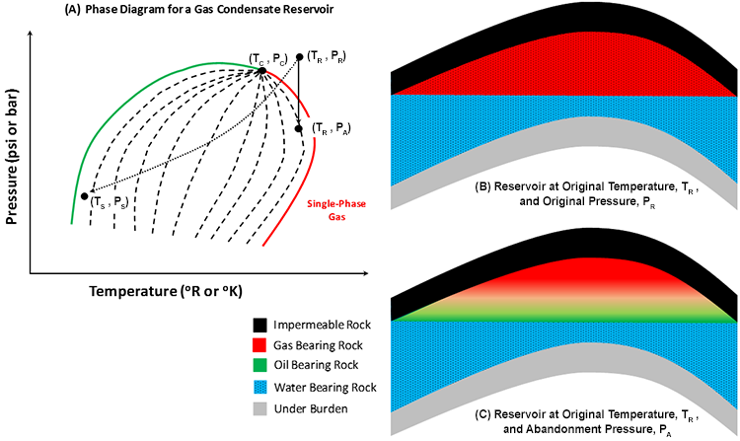
Figure 1: P-T phase diagram for retrograde gas reservoir shows the formation of condensate during pressure depletion (McCain,1990).

2.2 Phase behavior of gas condensate
What makes producing inside condensate reservoir be very difficult and challenging is that it is significantly which there are several factors that can affect the process, such as changes in phase, loss of condensate into tiny rock pores, the flow of multiple phases (wet gas, oil, and potentially water), redistribution of phases in and around the well, and the conversion of liquid back into condensate gas through vaporization. (Fasesan et al., 2003; Vo et al., 1989). The sensitivity of this reservoir type is due to the sensitivity of the phase behavior that is subjected by the amount of liquid that is associated with gas and its composition. Liquid composition considerably affects the phase change of crude type (Danesh, 1998). In gas condensate reservoir, hydrocarbons exist as vapor phase when the reservoir is established, thus it produces colorless or light-colored hydrocarbon with high API gravities ranges from 40 to 50. Additionally, the pressure and temperature of the reservoir at the start are between 3000 and 8500 PSI and 150 to 400 degrees Fahrenheit, respectively, which both together with liquid composition, which is mainly composed of methane 75 to 90 mole percent and less C7+ hydrocarbon fraction, cause a varying behavior of the gas with pressure reduction. Throughout the production process, maintaining the pressure of the reservoir above the dew point pressure proves to be the most difficult task. Because pressure drop will cause the condensate to drop out of the gas and occupy the small pores of the formation as it has higher tendency to spread over the rock phase. This liquid causes the gas to be lost in the reservoir since it reduces its relative permeability; As long as the saturation of condensate remains below the irreducible saturation level of oil, hydrocarbon movement will not be stopped. To ensure that pressure remains above the dew point limit for the maximum amount of time possible, various methods can be employed, such as pressure maintenance, production control, or hydraulic fracturing of the formation (Fevang, 1995; Shi, 2009). The retrograde effect is illustrated in Figure 2, When the pressure is decreased isothermally from point A to below the dew point, it enters a region of two-phase and the level of liquid gradually increases until it reaches its maximum level at point A'. The region when two phase exist together is called retrograde region and this gives a retrograde behavior for the reservoir which makes its behavior complicated. With further isothermal pressure depletion, reservoir liquid level starts to reduce until point A’’ and gas volume is gradually increased (Sadus, 2012). As mentioned earlier, fluid composition is the controlling factor of reservoir phase diagram which represent fluid behavior in the reservoir and at surface conditions. In contrast to gas condensate, oil reservoirs are less sensitive to production and pressure depletion as it starts with liquid hydrocarbon exist initially in the reservoir and eventually gas is formed due to isothermal pressure depletion.
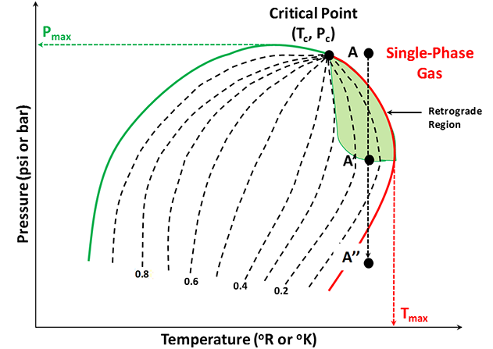
Figure 2: P-T phase diagram introducing the reservoir performance during pressure depletion due to production (McCain,1990).

2.3 Recovery of gas condensate reservoir
Oil is discovered far below in permeable rock layers. The sandstone's pores are connected and filled with hydrocarbons and salty water. Once wells are drilled into this rock and a pressure difference is created, the oil is displaced by water, gas, or other oil and migrates towards the production well-bore, ultimately reaching the Earth's surface. However, conventional engineering techniques leave a significant portion of the oil unrecovered due to droplets forming in small pores during displacement, or entire sections of the reservoir being overlooked. This leads to more than half of the original oil-in-place remaining unrecovered within the reservoir (Reilly and Ekblom, 2005). The recovery of oil is highly dependent on the behavior of the fluids that are displacing and displaced, and specifically, what takes place at their interface. Understanding the physics of surface tension, such as capillary pressure, contact angles, wettability, interfacial tension, and viscous forces, is essential in comprehending how residual oil is retained. Additionally, crude oil development and production can be categorized into three stages: primary, secondary, and tertiary recovery, as shown in Figure 3 (Ali et al., 2018).

2.3.1 Primary recovery
Primary recovery, often referred as "primary production," is the first step and natural method in the oil and gas production process. There are several types of primary recovery methods that can be employed in crude oil production, including Rock and Liquid Expansion Drive, Depletion Drive, Gas Cap Drive, Water Drive, Gravity Drainage Drive, and Combination Drive. The fact that the hollowed well bore drilled to reach the oil is engineered to have a reduced pressure than the oil deep in the earth is critical to primary recovery. This pressure differential may be raised further by using other means, like as pumping water into the well. This process, defined as “water drive,” works by pushing the oil deeper into the earth and raising its pressure. Other common approach is "gas drive," which uses the energy of expanding subsurface gas to propel oil to the surface. Oil pressure can eventually reach a threshold where the oil rapidly rushes upward into the well or out of the surface, resulting in an oil geyser (Roush and Lu, 2008). On the other hand, Primary recovery of petroleum reservoirs is impacted by the properties of the reservoir rock, fluid properties, and geological heterogeneities. As the natural energy of the reservoir depletes and the output rate of the oil well decreases during primary recovery, it becomes crucial to provide sufficient energy to the reservoir fluid system using secondary production methods based on fluid injection, in order to maintain or enhance production levels (Reilly and Ekblom, 2005).

2.3.2 Secondary recovery
As oil is steadily removed in the well, the subsurface pressure gradually decreases to the point where primary recovery is no longer practicable, even with the employment of artificial elevating mechanisms. Once this stage is reached, secondary recovery measures, such as further water injections, must be employed to push the oil toward production well and then to the surface by providing direct pressure, must be applied. Furthermore, Secondary recovery involves the use of immiscible methods such as water flooding and gas injection, or a combination of both, which is also known as water alternating gas injection (WAG). In WAG, water and gas are injected successively in slugs. Another technique, known as combined injection of water and gas (SWAG), is also used. However, water is the most commonly injected fluid due to its availability, low cost, and high specific gravity, which makes it easier to inject (Amit, 1986).

2.3.3 Tertiary Recovery
EOR or tertiary recovery, Also often called as improved oil recovery IOR, is the last and third step of the oil extraction process (EOR). Enhanced oil recovery is injecting elements not normally occurring in the reservoir to mobilize residual oil and boost sweep efficiency, such as CO₂, steam, or chemicals. EOR might begin following primary production or water floods. Furthermore, tertiary oil recovery can generate more crude oil, including leftover oil and residual oil, that cannot be recovered during secondary oil recovery (Sarem, 1974). Moreover, the objective of Enhanced Oil Recovery (EOR) is to improve the ultimate oil recovery by increasing the sweep efficiency, which is achieved by reducing the mobility ratio of the injected and displaced fluids, blocking the washed highly permeable water-saturated zones, and redirecting the injected fluid into the reservoir's low-permeable oil-saturated zones. The surface forces within the reservoir are also altered by decreasing the interfacial surface tension between the oil and the displacing fluid, mitigating the impact of capillary forces, and modifying the wettability of the reservoir rock (Thomas, 2008). In addition, Tertiary extraction of hydrocarbons takes place after the primary and secondary extraction techniques have been carried out. To conclude, Figure 4 illustrates all the types of recovery techniques that are practically used in oil and gas fields.
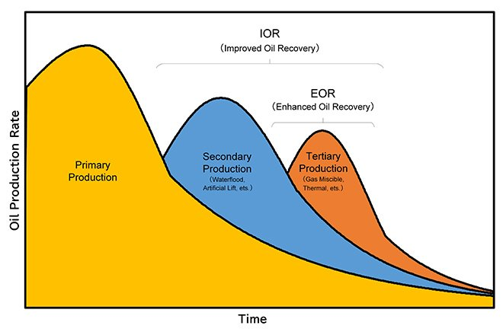
Figure 3 :Show difference stages of oil Production as a function of time (Ali et al., 2018).

Figure 4: Recovery methods (Rook and Zijlstra, 2006).

2.3.4 Condensate Gas Reservoir Recovery Methods
In gas condensate reservoirs, the corresponding fluid is a one-phase gas at the start of production from the reservoir. However, as the reservoir pressure decreases below the dew point pressure, condensate begins to accumulate in the vicinity of the wellbore and obstruct the fluid flow towards the well. At pressures under the dew point, some of the liquids start to separate out (Bradley, 1987). Also the collection of this liquid can reach a point where it inhibits gas flow, lowering the well's productivity. Furthermore, unconventional reservoirs, such as gas condensate reservoirs, have showed huge potential for long-term energy supply. Unconventional resources like as shale and tight formations are notable examples; and they are regarded as huge hydrocarbon resources due to their abundance and large storage capacity. However, hydrocarbon production from these sources poses significant difficulties, and a variety of recovery technologies have been employed to increase hydrocarbon production (Abel et al., 1970). In some cases, primary recovery, receiving hydrocarbons with reservoir’s natural energy, is sufficient to help producing oil and gas. Whereas, in many cases injection of water or gas, known as secondary recovery, is needed in order to produce the largest possible amount of hydrocarbon from the reservoir. After secondary recovery methods have been exhausted, tertiary techniques can be applied to extract additional amounts of oil. These methods typically involve the use of gaseous or chemical re-circulatory recovery methods, and in some cases, in situ heat recovery technologies. EOR is a common technique in tertiary recovery operations that involves injecting substances that are not usually present in the reservoir to increase oil recovery, prolong field life, and maximize economic returns. It involves injecting materials that are not commonly found in the reservoir to enhance oil recovery. EOR methods enable higher hydrocarbon recovery and longer field life, thus maximizing the economic value of existing fields (Geffen, 1973). Furthermore, because tertiary recovery is costlier and time-consuming than primary and secondary oil recovery, it is only employed after the primary and secondary recovery methods have been depleted. And the most common recovery ways for gas condensate reservoirs are discussed below.

2.3.4.1 Methane injection (gas cycling)
Gas cycling is a well-established technique for enhancing the recovery of condensate from gas-condensate reservoirs. In such reservoirs containing high concentrations of condensate, a reduction in reservoir pressure can lead to retrograde condensation. resulting in a similar loss in stock tank or gas plant liquid recovery. One technique for avoiding retrograde loss in gas-condensate reservoirs is to use gas cycling. This involves injecting dry gas, which is mainly composed of methane with small amounts of light and intermediate hydrocarbons like ethane, propane, and butane, into the reservoir from a distant point while it is being produced. Dry gas is commonly produced by processing hydrocarbon fluids and removing their liquid components through conventional lease facilities or a gas plant. The remaining residue, which is primarily composed of methane and minor amounts of light and intermediate hydrocarbons like ethane, propane, and butane, can then be reinjected into the reservoir as part of the cycling method to enhance recovery from gas-condensate reservoirs. (Sanger and Hagoort, 2013). This method of avoiding retrograde loss has the disadvantage of deferring the sale of the gas until the end of cycling operations, which could be 20 years or more, resulting in a reduction of more than 50% of the present-day value of the gas. Other drawbacks of this technology include:
(a) The high expense of compressing and injecting the dry gas.
(b) The substantial amount of gas consumed as compressor fuel, which reduces the total volume available for sale.
(c) The relatively low overall pattern and conformance efficiency, which seldom surpasses 75 percent, resulting in a substantial amount of Wet gas and condensate remaining in the reservoir. Wet gas is defined as gas that contains less methane and more enriching components of lighter typically gaseous hydrocarbons such as ethane, propane, butane, and so on (Dong, 2006).

2.3.4.2 Nitrogen and Carbone dioxide (CO₂) injection
Carbon dioxide (CO₂) is injected into a reservoir to boost output by lowering oil viscosity and allowing miscible or partially miscible displacement of the oil. If there is enough gas to inject into the reservoir, all of the condensate gas can be produced. The CO₂ injection can provide a vaporizing gas drive for stored condensate oil inside the formation, improve the effectiveness of condensate oil recovery. furthermore, the timing of injection and composition of the injected gas are two critical criteria in both miscible and immiscible gas injection scenarios (Liu and Li, 2018). Miscibility is the principal mechanism for condensate formation in the event of miscible gas injection, whereas vaporization of condensate by injected gas is a more efficient method for condensate recovery in the case of immiscible gas injection. Depending on miscibility mechanism, the gas-gas miscibility mechanism is more efficient than the gas-condensate miscibility mechanism. The recovery mechanism during a gas cap drive is comparable to immiscible gas injection in the reservoir. The volume and placement of gas, like water flooding, can be regulated to optimize sweep efficiency and maintaining reservoir energy or pressure. Methane, nitrogen, carbon dioxide, and air, for example, are common gases for immiscible floods, as shown in Figure 5. Many of these gases aren't fully inert when it comes to oil. Carbon dioxide, for example, almost always has a limited miscibility with oil; and, as a result, can cause oil expansion and reduce its viscosity, both of which can help with recovery. Carbon dioxide, on the other hand, is relatively expensive to inject as an immiscible gas and is therefore rarely employed in this manner today (Al-Nakhli et al., 2019). As previously stated, retrograde condensation may be avoided by keeping the reservoir pressure above the dewpoint pressure by gas injection. Dry hydrocarbon gases have excellent physical qualities that make them ideal for injection gas. However, hydrocarbon gas is not always accessible for (re)injection. As a result, nitrogen gas injection is an appealing option. Nitrogen is inexpensive, safe, non-corrosive, and non-polluting, and it is widely available. Nitrogen has the drawback of causing liquid drop-out in the mixed layer between the injected nitrogen and the gas condensate. This occurs exclusively at the displacement front in a homogenous reservoir. However, further mixing, and therefore drop-out, happens at the boundary between layers with varying permeability in a stratified reservoir (Alagorni et al., 2015).
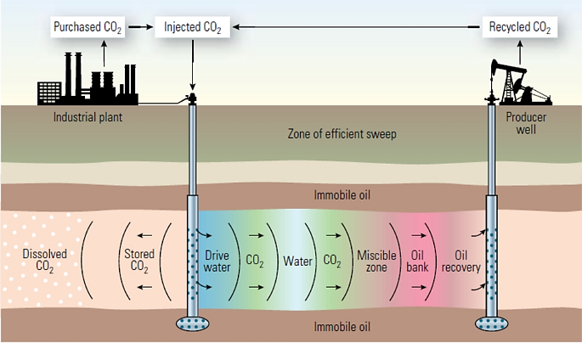
Figure 5: Effects of miscible CO2 injection on Production recovery (Feather and Archer 2010).

2.4. Fracture reservoir
A fractured reservoir is a type of hydrocarbon reservoir in which the fluid (e.g oil or gas) is stored in rock fractures instead of the pore spaces within the rock matrix. Fractured reservoirs are formed due to tectonic activity, which results in the creation of fractures in the rocks. These fractures provide pathways for fluid migration and can enhance the permeability of the reservoir, making it easier for the fluid to flow (Gulbis et al., 2000). Fractured reservoirs play an important role in the production of natural gas and are often characterized by complex and heterogeneous fracture systems. In gas simulation, fractured reservoirs are modeled as a combination of matrix blocks and fracture networks. The matrix blocks represent the rock matrix and the fracture networks represent the interconnected fractures that allow fluid flow. The characterization of fractured reservoirs is a challenging task due to the complex geometry and heterogeneity of the fractures. Traditional methods, such as core analysis and log interpretation, can provide limited information about the fractures and their distribution. Therefore, innovative techniques, such as microseismic monitoring, fractal analysis, and numerical simulation, have been developed to improve our understanding of these reservoirs (Zendehboudi et al., 2014). The production of hydrocarbons from fractured reservoirs often requires unconventional extraction methods, such as hydraulic fracturing (fracking), which involves the injection of fluid into the rock at high pressure to create or enhance the fractures (Gulbis et al., 2000). This can increase the permeability of the reservoir and allow the fluid to flow more easily. However, the use of hydraulic fracturing has raised concerns about its environmental impact and potential groundwater contamination. In conclusion, fractured reservoirs are a unique type of hydrocarbon reservoir that present both challenges and opportunities for the hydrocarbon industry. Further research and development of innovative techniques will continue to improve our understanding of these reservoirs and enhance their production potential (Zendehboudi et al., 2014).

2.5 Simulation of gas condensate reservoir
Gas condensate behavior estimation is a default task; to be performed properly, there are a lot of methods that were used in previous works. In each method there are some variables that were considered in definite circumstances. Moreover, every parameter can affect the fluid behavior in different ways. Simulation is a widely used method to estimate reservoir behavior by considering different variables in order to predict their effects on specific parameters. Simulation was used for many reasons in previous works; for instance; to evaluate reservoir behavior due to injection of fluid, evaluating the effect of well placement on reservoir behavior, and so on. Therefore, simulation is used to improve the reservoir performance and predict its behavior.

4.5.1 Effect of injection on recovery in gas condensate reservoir
Because formation and accumulation of condensate due to pressure drop is the main concern in gas condensate reservoir, many production strategies are used nowadays to help maintaining reservoir pressure above dew point and enhance gas recovery. According to (Izuwa et al., 2014), cycling is the best strategy to keep reservoir pressure controlled in order to prevent condensate accumulation especially when applied while the reservoir pressure is still above the dew point. Moreover, this study illustrates that injection pressure and injection rate can considerably affect the gas production performance, in which extra gas can be produced at higher injection rates when applied at the optimum pressure; it concluded that Nitrogen (N₂) significantly increased the reservoir pressure compared to Methane, carbon dioxide and separator gas (solvent) when injected at the same pressure and rate. (Wang et al., 2000) explores three enhanced gas recovery (EGR) strategies, including generated gas injection, CO₂ injection, and water injection, to improve well production in a confined gas condensate reservoir in Canada's Montney Formation. The NPV (Net Present Value) calculation also shows that generated gas is the most cost-effective technique, leading to increasing rate of production, quick access to the injection gas resource, but no gas separation charge compared to CO₂ and water. On the other hand, CO₂ was the best fluid to be injected into condensate reservoir to enhance recovery of gas when injected at production injection rate of 1:1 according to (Wu et al., 2021) in which it allowed condensate recovery rate to increase up to 95.11%. Similarly, Super Critical Carbon Dioxide (SCCO₂) enhances gas recovery by reducing tension between liquid and gas inside the reservoir which allow the gas molecules to escape easier; consequently, condensate accumulation will decrease (Kurdi et al., 2012). Also, dry gas injection was used by (Nasiri Gghiri et al., 2015); gas cycling was performed for nitrogen, pure methane, a composition of ethane and methane, and carbon dioxide separately. This study illustrates that a mixture fluid of ethane and methane with increased ethane mole, to reduce the difference between mixture’s mole with reservoir fluid in order to be mixed properly and prohibit fluid formation, works the best to enhance gas recovery. Recovery of gas can be improved from 29 to 89% according to (Hassan et al., 2020) by thermochemical injection in which it helps removing near wellbore damage by dissolving the accumulated condensate and improve gas recovery through generating heat and pressure in place. According to (Hassan et al., 2019). injecting an eco-friendly chemical can increase hydrocarbon production by removing accumulated liquid and increasing gas relative permeability by a factor of 1.2. Also, (Ahmed et al., 2016) compared effect of CO₂, Nitrogen, and lean gas injection to show that CO₂ injection was the most effective one among them in which gas recovery can increase up to 65.38% from 45.83% when injected to on a low permeability reservoir. To conclude, the bellow Table 1 summarizes all of the mentioned studies on the effect of fluid injection in retrograde gas condensate reservoir where different types of fluid were used, and their effects were examined by simulation studies.

Table 1: Summarizes all illustrated studies about fluid injection in gas condensate reservoir.
Reference | Injected fluid | Injection rate  (mscf/day) | Injecting press.  (psi) | Results
Izuwa (2014) | Nitrogen N₂ | 12400 | 5883 | Field life is 6700 days longer due to injection, and gas production rate increases
Wang (2018) | CO₂ | 200 | 4550 | Enhancement of CGP from 37% to 50%
Wu (2021) | CO₂ | - | - | Condensate recovery enhanced by 95.11%
Kurdi (2012). | SCCO₂ | 200 | 3500 | Enhancement of gas recovery by 1600MSCF
Nasiri Gghiri (2015) | 20%Ethane, 80%Mithane mixture | 14400 | - | Maximum liquid recovery of 88.1%
Hassan (2020) | Thermochemical | - | - | Gas recovery improved from 29% to 89%
Ahmed (2016) | CO₂ | - | 3100 | Gas recovery increased from 45.83% to 65.38%

4.5.2 Effect of well placement in gas condensate reservoir
Optimum well location is crucial in gas condensate reservoir to be obtained as it effects the condensate formation and consequently gas recovery. According to (Abdul-Latif et al., 2017) the optimum position for a well is the area with the greatest porosity, permeability and oil saturation which will reduce the effect of condensate blockage and consequently increase the production rate depending on genetic algorithms optimization through different runs in simulation to evaluate the effect of these variables. But, according to (Evans et al., 2016) the best position for a well to be drilled is at the top of the fractured zones to allow the condensate move to the fractures; and hence, well productivity will be enhanced. It shows that well placement is a key factor in reducing formation damage due to condensate blockage. It resulted in the fact that the shallower the well placed the better performance it gave and the productivity index increased, because at a shallower depth oil is mobilized easier with gravity drainage. Horizontal wells’ flow behavior is much more complex than vertical well in gas condensate reservoir, but formation of condensate is almost similar in both well types (Hashemi et al., 2004). moreover, condensate production is greater with horizontal wells and pressure drawdown is slower in horizontal wells under the same condition (Dehane et al., 2000). horizontal well reduce condensate accumulation near the wellbore; hence, PI of horizontal wells is greater than vertical wells below dew-point pressure due to the ability of horizontal wells to reduce condensate buildup (Miller et al., 2010). Also, liquid recovery will increase in horizontal wells compared to the vertical ones due to the fact the pressure drop is four times less than the pressure drop that accrues in vertical (Marir and Djebbar, 2006).

4.5.3 Effect of wettability alteration on recovery enhancement
Since condensate banking is the main concern in retrograde reservoir which blocks gas movement to the production well, many studies have been done to treat the reservoir in order to reduce condensate formation or dissolve the condensate that already exists (Miller, 2010). indicates that wettability alteration is an effective treatment to retrograde reservoir to reduce condensate blockage and enhance gas production. due to the large volume of the reservoir, treating the entire reservoir will be costly task to do. Thus, if wettability was altered from oil wet to intermediate by treating 9ft from the wellbore by FC-722, then gas production can change from 2.20E 8 MSCF to 2.28E8 MSCF in 5 years in which production profits can increase up to $456 million for a 9ft injection; as more as the volume of treated area as more enhancement of gas will occur consequently better profit will be achieved. Wettability alteration from oil wet to gas wet considerably increases gas saturation in gas condensate reservoir according to (Noh and Firoozabadi, 2008). by using alcohol bases surfactant/ polymer solution. Results of this study show that water saturation is reduced 40 to 90% after treatment of the reservoir when the experiment takes place at 140*C; also, water mobility is directly proportional to treatment concentration. Moreover, altering wettability of the gas condensate reservoir towards moderate gasphilic is another solution for condensate blockage that is been studied by (Nowrouzi et al., 2020). in which R134A and R404A, which are two fluoride types of gas, were used as chemical to treat the reservoir. This treatment reduces the rock ability to adsorb condensate and water in which it blocks gas flow to the wellbore. The results show that R134A can reduce wettability by imbibed water to 8.1 and condensate to 7.9%PV; and R404A decreased wettability to 6.2 and condensate to10.3%PV which they were initially 93 and 81%PV respectively. Wettability was altered from water-wet to gas wet by injecting low cost, and a thermal stable chemical to the reservoir (Li et al., 2011; Liu et al., 2006) which resulted in gas production enhancement due to increasing water and gas relative permeability after wettability alteration; relative gas permeability Krg increased to 0.366 from 0.217 and residual water saturation Swc decreased to 26.77 from 42.37%. Besides, (Karandish et al., 2015) used an anionic fluorinated surfactant to alter near wellbore wettability from water wet to partial gas wet in order to enhance gas production and reduce condensate blockage. It shows that Krg increases by factor of 1.7 in which Kr increased to 0.231 from 0.151. According to (Al-Anazi et al., 2007), changing wettability to gas wet from liquid wetness is an efficient way to enhance production in retrograde reservoir which resulted in increasing gas production by 42% by increasing Krg to 0.080 from 0.058. Table 2 illustrates a summary of the above researches.
Table 2: Effect of wettability alteration on recovery enhancement and related references.
Reference | Wettability alteration | Used treatment | Results
Miller (2010). | Oil-wet to intermediate | FC-722 | Gas production can change from 2.20E 8 MSCF to 2.28E8 MSCF
Noh and Firoozabadi (2008) | Oil-wet to gas-wet | Alcohol bases Surfactant/ Polymer | Water saturation is reduced 40 to 90%
Nowrouzi (2020) | Gas-wet to moderate gasphilic | R134A and R404A | Reduction in wettability by imbibed water and condensate
Li, 2011; Liu (2006) | Water-wet to gas-wet | Thermal stable chemical | Increasing krg to 0.366 from 0.217, and decreasing Swc to 26.77 from 42.37%
Karandish (2015) | Water-wet to partial gas-wet | Anionic Fluorinated Surfactant | Krg increases by factor of 1.7
Al-Anazi (2007) | Liquid wetness to gas wet | - | Increasing gas production by 42% by increasing Krg to 0.080 from 0.058.

4.5.4 Hydraulic fracturing in gas condensate reservoir
Fracking is well treatment process to increase well deliverability and reduce skin and other harmful effects of drilling on the reservoir rocks. Accumulation of condensate in the tiny fractures cause a barrier to gas production in retrograde reservoir; according to (Ganjdanesh et al., 2016) fracturing with chemical solvent is a good method to enhance productivity of this reservoir. This research shows the effect of three different solvents and compare their performance; it resulted that DME is the best solvent compared with MeOH and EtOH to be used for fracking in which gas relative permeability can increase by a factor of 2.5 and hence reservoir productivity increases. But, according to (Wang et al., 2000) fracture productivity index decreases by injecting proppant for cracking in gas condensate reservoir because of the damage that it causes fractures due to polymer residue; but the results depend primarily on fracture permeability and length. Similarly, hydrocracking by using proppant negatively impacted well productivity according to (Butula et al., 2005) when used in Yamburskoe gas condensate field by injecting less than 10 tones, which was considered not to be an adequate amount for that reservoir. Thus, a number of different simulations was done to find out that gas composition of Neocomian reservoir does not likely produce huge amount of condensate and non-darcy effect is to be considered. On the other hand, relation between length, width and height is observed by (Langedijk et al., 2000) in which proppant was used for hydraulic fracturing resulted in increasing well capacity to 2.75 from 0.75 when used in injection concentration of 1 to 2 Ib/gal. Also, according to (Ahmed et al., 2016) hydraulic fracturing in gas condensate reservoir is very sensitive to the relation between height, half length, and width which does not allow it to be very effective in recovery enhancement due to the geometric effect which affects fracture velocity consequently; but recovery enhancement appears when hydraulic fracturing was followed by fluid injection especially CO₂ injection. Hydraulic fracturing can increase production rate and producing time of gas condensate reservoir when there is a good relation between geometric parameters which affect velocity; also, it can reduce accumulation of condensate and is more applicable in low permeability reservoirs as pressure reduction is less after dewpoint (Bagherzadeh et al., 2018). Moreover, in low permeability reservoirs, hydraulic fracturing enhances gas production and reduce condensate blockage near wellbore by reducing pressure drawdown near production well (Sedarat et al., 2014). Even though fracturing can increase liquid recovery up to 10.2% by increasing half length, width, and height of fracture, it is not economically profitable compared to the additional cost of hydraulic fracturing (Kerunwa et al., 2020). All of the above studies can be concluded in Table 3.
Table 3: Hydraulic fracturing in gas condensate reservoir and related references.
Reference | Type of fluid | Depth  (ft) | Injected amount  (bbl) | Results
Ganjdanesh (2016) | DME | 5000 | 300 | Gas production rate increased from 1.0E+6 to 7.0E+6 scf/d
Wang (2000) | Proppant | 4000 | 318 | PI increased by less than 1.6
Butula (2005) | Proppant | 10330 | - | No noticeable improvement in PI due to fluid nature in this reservoir
Langedijk (2000) | Proppant | 14700 | - | Increase in well capacity from 0.75 to 2.75 MMm^3/day
Ahmed (2016) | Proppant | - | 277 | Recovery enhancement appears when hydraulic fracturing was followed by fluid injection
Kerunwa (2020) | - | 1000 | - | Increase in liquid recovery up to 10.2% but it is not economic

Chapter 3: Data summary and methodology

3.1 Model description
ECLIPSE simulator is used for static modeling, and all relevant data is inserted into the software to create a hypothetical gas condensate reservoir. The reservoir model is based on data from the Third SPE Comparative Solution Project (Kenyon, 1987). However, in order to meet this project's goal, some changes are made to the data and the relative permeability data in this study is illustrated in Table 4 and is graphically shown in Figure 6. The gas-oil permeability is critical in this project since it focuses on the flow of both phases and how it influences condensate recovery.
Table 4: Data of oil and gas relative permeability (Modified from Third SPE Comparative Solution Project, 1987).
SL | Kro | Krog
0.2 | 0 | 0.79
0.25 | 0.02 | 0.7
0.3 | 0.05 | 0.6
0.35 | 0.07 | 0.55
0.4 | 0.08 | 0.45
0.45 | 0.095 | 0.35
0.5 | 0.15 | 0.3
0.55 | 0.18 | 0.25
0.6 | 0.2 | 0.2
0.65 | 0.3 | 0.18
0.7 | 0.4 | 0.125
0.75 | 0.5 | 0.1
0.8 | 0.8 | 0.09
0.85 | - | 0.05
0.9 | - | 0.03
0.95 | - | 0.01
1 | - | 0

When it comes to reservoir grid and saturation data. The model will have 18x18x4 grids in the i, j, and k directions. The grid will have the same width and length because it is symmetrical, which is 146.65 feet for each grid. The model is 160 feet thick, with the first two layers measuring 30 feet each and the final two layers measuring 50 feet each. Because the model is supposed to have a simple geological characterization, the porosity used is 0.13, which is expected to remain consistent throughout. To make the study more realistic and practical, different horizontal permeabilities have been applied to each reservoir grid layer (Table 5). and Figure 8 also shows the gas condensate model but it has some fractures in yellow grids. Figure 9 shows the high permeability location inside the reservoir.

Figure 6: Oil and gas relative permeability curves (Kenyon, 1987).

Table 5: Properties of gas condensate model (Kenyon, 1987).
Properties | Values
Grid Dimension | 18x18x4
Hydrocarbon pore volume | 20.24MMrb
Datum (subsurface) | 7500 ft
Gas/water contact | 7500 ft
Water saturation at contact | 1.00
Initial pressure at contact | 3550 psia
Water density at contact | 63.0 lbm/ft³
PV compressibility | 4.0 x 10⁻⁶
Horizontal permeability | Layer 1 - 130 mD  Layer 2 - 40 mD  Layer 3- 20 mD  Layer 4 - 150 mD

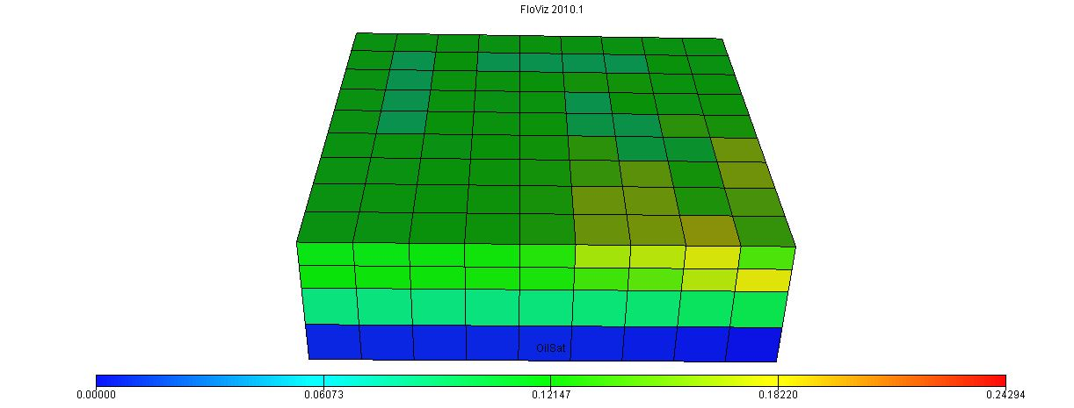
Figure 7: Show oil distribution of the model.

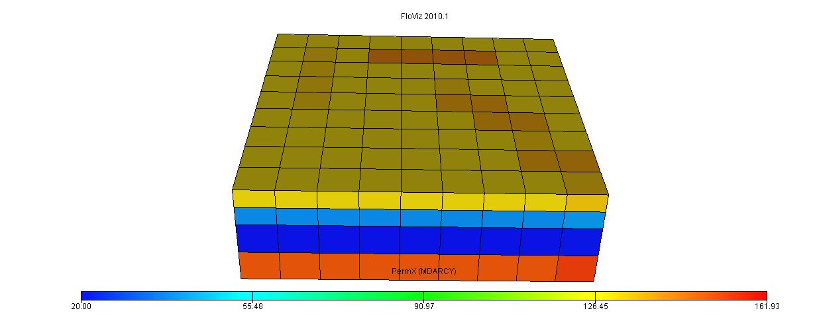
Figure 8: Show permeability distribution of the model.

3.2 PVT modeling
The fluid data is produced from the Third SPE Comparative Solution Project (Kenyon, 1987). The fluid molecular weight, fluid composition, constant composition expansion (CCE), and constant volume depletion (CVD) data for PVT are synthesized in the lab. Because of its consistency, this composition is commonly utilized in gas condensate study. Peng-Robinson EOS was used to model the PVT. PVT calculations and reservoir fluid characterization are performed using PVTi. The hydrocarbon analysis used in this project is depicted in Table 6. The phase envelop of the reservoir fluid is depicted in Figure 10. The observed dew point pressure is 3816 psi at a gas temperature of 200 F in the hypothetical gas condensate reservoir.

Table 6: Composition of Reservoir Fluid Sample (Kenyon, 1987).
Component | Mol %
Carbon dioxide | 1.21
Nitrogen | 1.94
Methane | 65.99
Ethane | 8.69
Propane | 5.91
C4-6 | 9.67
C7⁺¹ | 4.7448
C7⁺² | 3.5157
C7⁺³

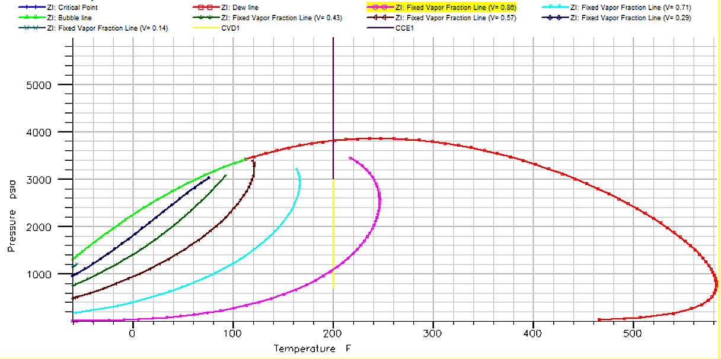
Figure 9: Phase plot of the reservoir fluid (Kenyon, 1987).

3.3 Dynamic modelling
The gas condensate model has been initialized for the simulation run after all of the data has been incorporated. Dynamic modeling is used to simulate our cases based on the goal that has been set. Various scenarios have been studied in order to assess the performance of the gas condensate reservoir. The first scenario, which is designated as a base case in this study, is that the reservoir produces due to natural depletion. The influence of carbon dioxide, nitrogen, and solvent as injection gases on condensate recovery was then investigated. For each case, one pore volume (1 PV) of slug is injected over a ten-year period, averaging 0.1 PV per year. The reservoir produces during the first five years under the natural depletion scenario. 5 years of natural depletion is used to create a condensate blockage. As a result, the simulation will be divided into two parts: pretreatment and posttreatment. The results are analyzed using ECLIPSE Office, which generate a graphical representation of the data for easier comprehension. To compare the performance of each case of condensate recovery, the majority of the cases are compared using the overall condensate production result. Other results will be used as a support to justify the condensate production total result. ECLIPSE simulator is used for static modeling, and all relevant data is inserted into the software to create a hypothetical gas condensate reservoir. The reservoir model is based on data from the Third SPE Comparative Solution Project (Kenyon, 1987). However, in order to meet this project’s goal, some changes are made to the data. The gas-oil permeability is critical in this project since it focuses on the flow of both phases and how it influences condensate recovery.

Chapter 5: Results and discussion

4.1 Initial case
Reservoir pressure declines rapidly due to production from gas condensate reservoir with its natural energy. This pressure reduction cause fluid accumulation around the wellbore as the pressure declines, two phase will occur in the reservoir. Condensate accumulation in fine reservoir fractures will block gas movement to the wellbore and hence production rate will decline. As shown in Figure 11. reservoir’s initial pressure starts at 3550 psia, due to production, reservoir pressure will decrease nearly 450 psia in 12 years. As a result, total production of the liquid fraction of the hydrocarbon in 12 productive years will increase to 100400 STB from 2000 STB as shown in Figure 12, which is mainly due to condensate formation and accumulation around the wellbore.
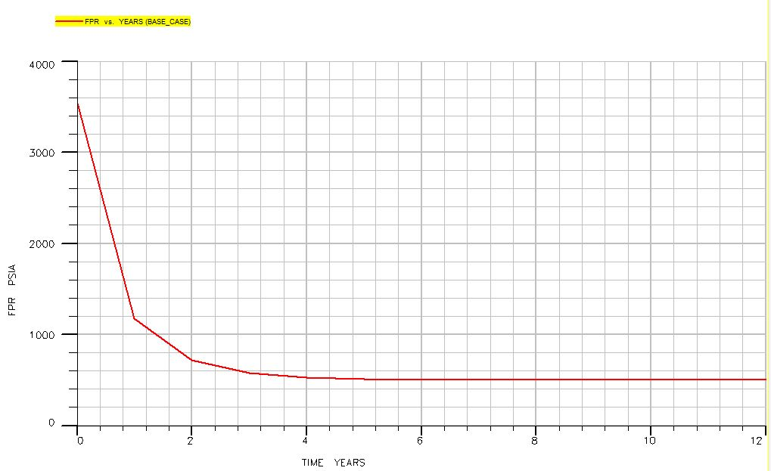
Figure 10: Pressure path of the reservoir due to production with reservoir's natural energy.
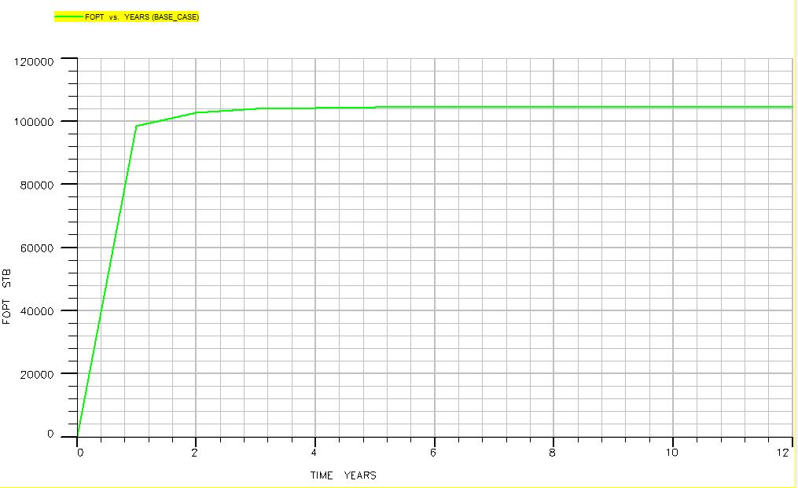
Figure 11: Condensate production path of the base case representing total oil production.

4.2 CO₂ injection
CO₂ injection is the technique of injecting CO₂ gas into a gas condensate reservoir in order to maintain the reservoir pressure from further decreasing to prevent or reduce condensate accumulation around the wellbore. To measure the effect of CO₂ injection eclipse 300 was used to show how reservoir pressure and total production recovery changes with time the Figure 13 shows the pressure change with time when CO₂ is injected into the well in 6th year it causes the production to increase. It is clear that CO₂ injection help maintaining the reservoir pressure; thus, fluid total production must increase and well productivity increases during 12 production years consequently as shown in the Figure 14. CO₂ when injected at a rate 4500 scf/day, the pressure increases by +38% and total production increased by +7.70%.
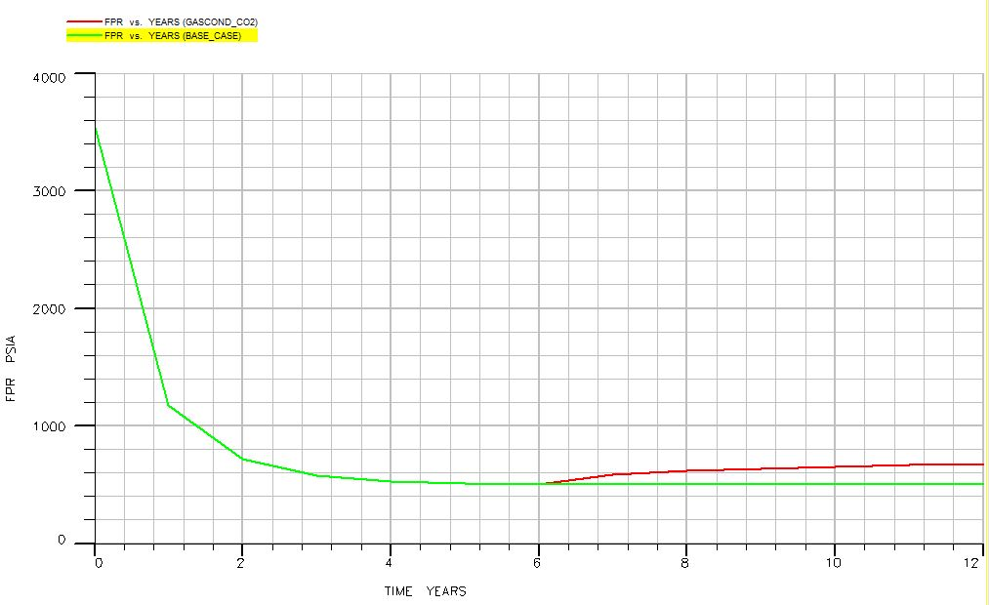
Figure 12: Reservoir pressure behavior due to CO2 injection starting from 6th year of field life.
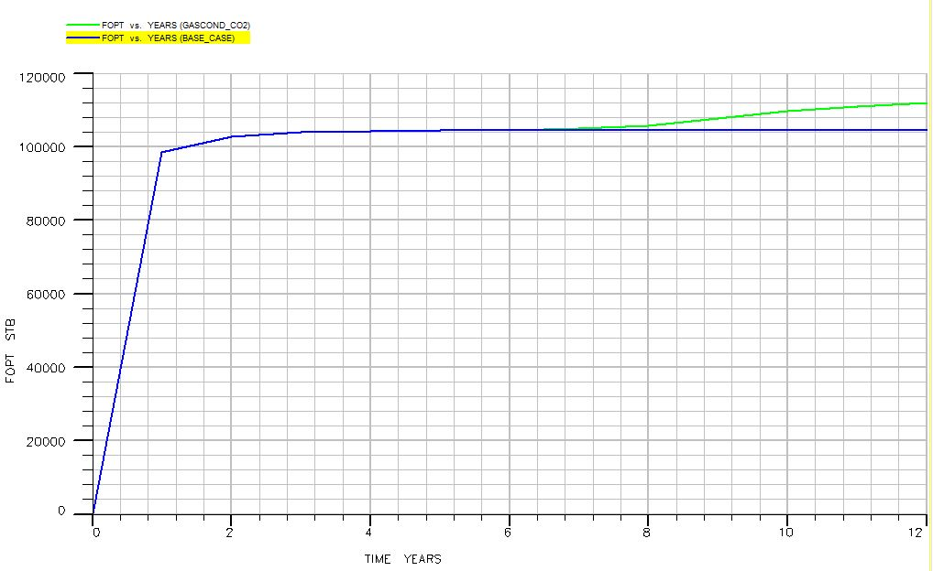
Figure 13: Total Condensate production enhancement due to CO2 injection.

4.3 Nitrogen injection
To evaluate fluid type behavior with the reservoir, nitrogen was injected to the retrograde reservoir. Later, reservoir pressure was declining slower through 12 producing years, which consequently results in a longer production life of the reservoir, pressure decline occurs after 6 years from the production which resulted in lower pressure compared to the base case. After nitrogen injected the pressure increased by +40% when nitrogen is injected to the reservoir compared to our base case as shown in Figure 17. Whereas also nitrogen can affect total condensate production behavior which is changing significantly after N2 is injected in 7th year of field production it increases by +6.73% which is shown in Figure 18.
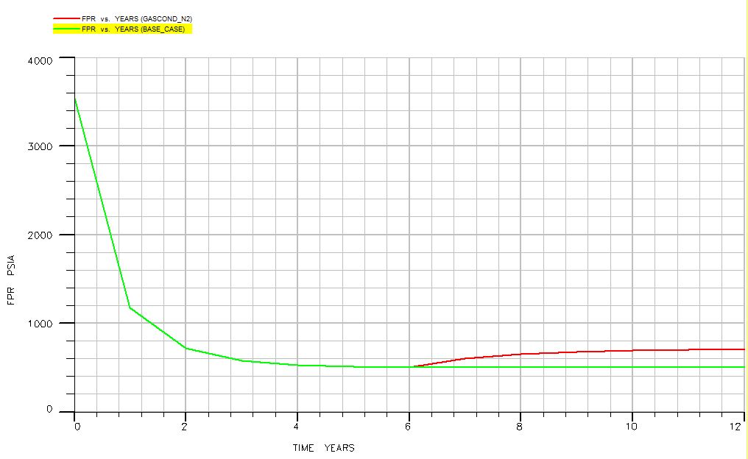
Figure 14: Pressure profile of gas condensate reservoir with N₂ injection compared to the base. case.
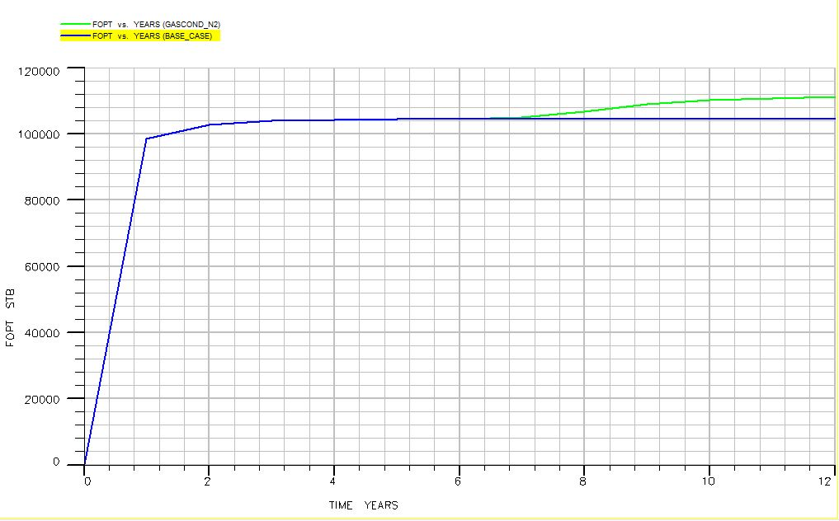
Figure 15: Field oil production total profile due to the injection of N2 after 6 years of production.

4.4 Solvent injection
Solvent injection increases the field pressure during the production life of the reservoir, which results in higher reservoir pressure by +24% after producing from the reservoir for 12 years as illustrated in Figure 21. For this case, a mixture of carbon 1, 2, and 3 was used as a solvent. Also, due to solvent injection condensate production increases because of dissolving the condensate and opening the fractures to allow liquid and gas flow to the wellbore by increasing reservoir pressure and temperature to dissolve the accumulated liquid around the wellbore. Solvents are usually used for hydraulic fracturing to reduce the skin around the wellbore due to pressure reduction and production. production of condensate due to injecting solvent is greater by +8.55% as shown in Figure 22.
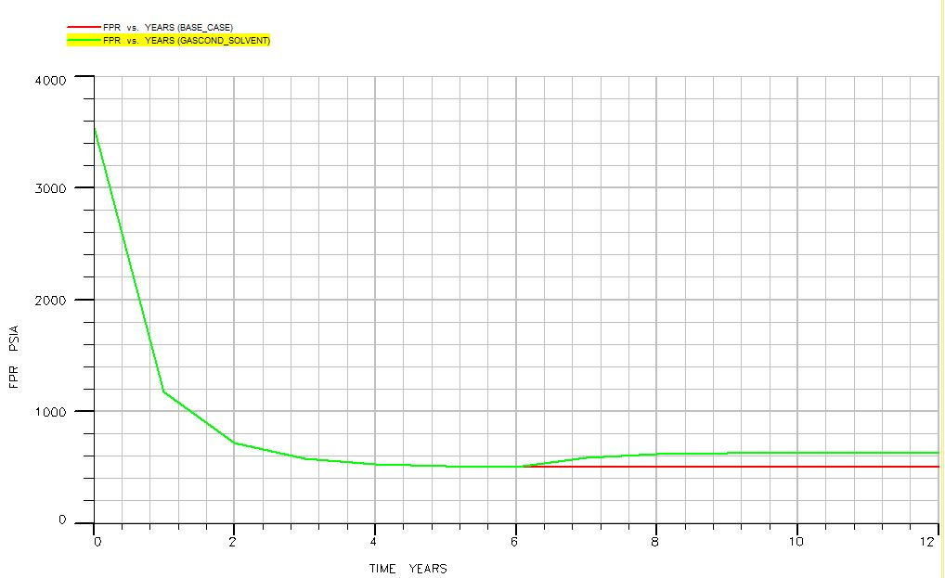
Figure 16: Pressure profile due to solvent injection.
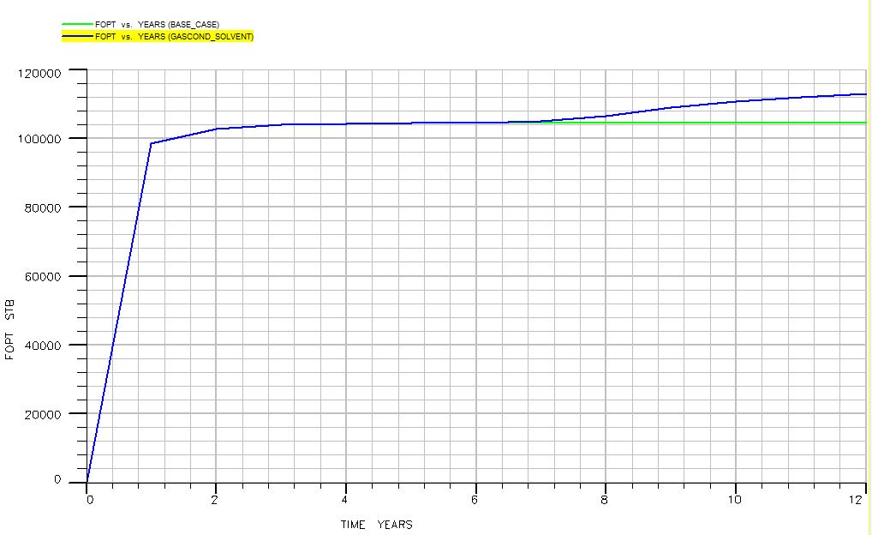
Figure 17: Condensate production profile during productive life of the reservoir with and without injecting solvent.

4.5 Summary
After evaluating all the results using Eclips300 simulator and comparing the different results, the reservoir’s best performance was selected based on the graphical data for each of reservoir pressure and condensate production. To sum up, reservoir pressure will decline slower in 12 years due to injecting nitrogen. Then, CO2, and finally solvent effect the maintenance of reservoir pressure respectively in comparison with the base case, production without injection depending on the reservoir’s natural energy. Moreover, total condensate and oil production due to solvent is the greatest compared to N₂, CO₂, and the base case when injected at the same rate 4500 scf/day under the same reservoir condition. Also, reservoir field pressure increases with increasing injection rate for all injected fluid. But condensate recovery relies more on fluid type rather than injection rate. Figures 25 and 26 shows all injected fluid effects on field pressure and oil production respectively. Also, Table 7 is a summary of result data from the software.
Table 7: Table of results.
Fluid type | Injection rate (scf/day) | Factor of change
 |  | Total field liquid condensate production | Pressure maintenance
CO2 | 4500 | +7.70% | +38%
N2 | 4500 | +6.73% | +40%
Solvent | 4500 | +8.55% | +24%

Nitrogen has a lower density than CO2 and solvents, which means that it can be injected at higher rates and lower pressures, resulting in a better sweep efficiency and improved recovery rates. Additionally, nitrogen gas has a high solubility in oil and condensate, which can help to reduce the interfacial tension between the oil and gas phases and improve the flow of hydrocarbons through the reservoir. In addition to its physical properties, nitrogen gas injection can also help to mitigate some of the challenges associated with CO2 and solvent injection. CO2 injection can be challenging due to the high reactivity of CO2 with some types of reservoir rock, which can lead to mineral dissolution and reduced reservoir permeability. Solvent injection can also be problematic due to the potential for solvent trapping and the risk of solvent contamination. Overall, nitrogen injection can be an effective method for increasing pressure in gas condensate reservoirs due to its favorable physical properties, high solubility in hydrocarbons, and ability to mitigate some of the challenges associated with other gas injection methods, Also solvents can reduce the viscosity of the condensate, making it easier to flow and be produced from the reservoir the effectiveness of solvent injection will depend on the specific characteristics of the reservoir, and factors such as cost and environmental impact will also need to be considered.
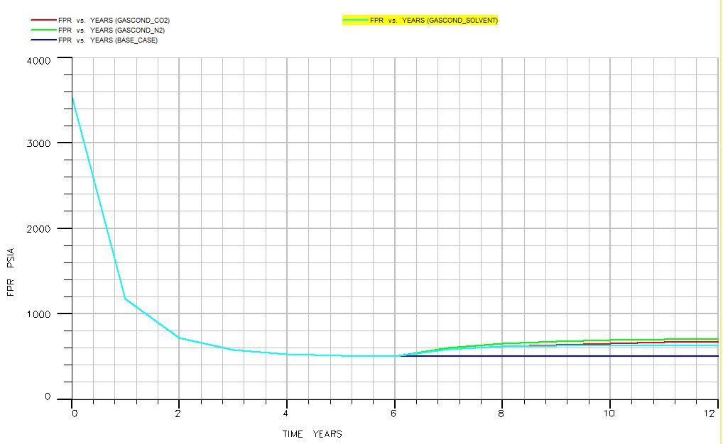
Figure 18: Field pressure behavior due to injecting different types of fluid compared to the base case.
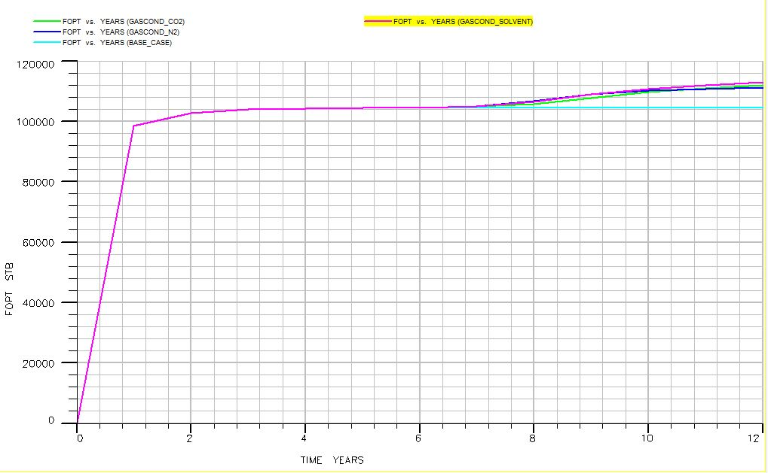
Figure 19: Field oil production behavior due to different types of fluid injection.

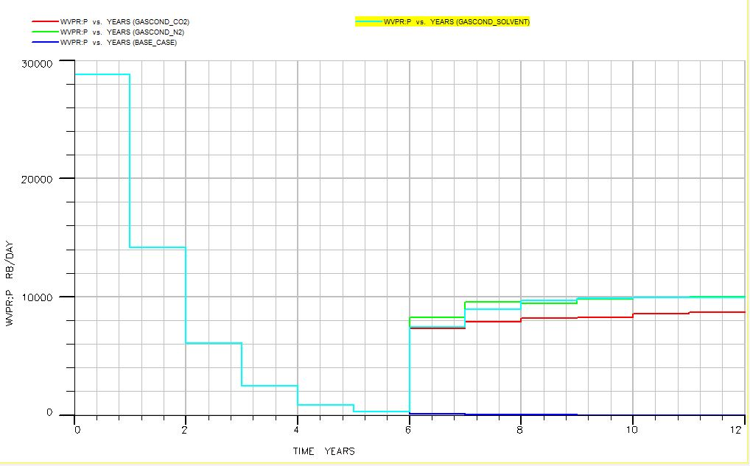
Figure 20: well reservoir production total vs time.

Chapter 5: Conclusions ׀ recommendations

5.1 Conclusions
In this project, a gas condensate reservoir was studied in order to evaluate its performance and enhance fluid recovery. Condensate blockage is the main concern that face production engineers when producing from retrograde reservoir due to is complex behavior especially when reservoir pressure reduces to below bubble point. Fluid injection is one way to help solving this problem. But, to evaluate the best fluid to be injected different types of fluid was injected to the reservoir and the results were compared. Also, the effect of injection rate was examined by trying different injection rates for each fluid. The production system was simulated by Eclips300, a computer program for simulating different scenarios. The following important results can be concluded in this study:
- In natural depletion scheme, reservoir fluid production rate declines significantly after 6 years of production. This pressure reduction is due to blocking near wellbore by the condensate due to pressure reduction.
- CO₂ injection caused the reservoir pressure to be higher by +38% and the total liquid production increased by +7.70%. Increasing injection rate significantly improves the field pressure but fluid recovery is not affected considerably by the injection pressure in this case.
- N₂ injection increased reservoir pressure by +40% and production of liquid condensate increased by +6.73%
- Solvent injection, can increase the filed pressure by +24% and give the maximum liquid production that is higher by +8.55% compared to the base case. Similarly, field pressure increases as the injection rate is increased; but, the effect of injection rate on oil production is very small in this case but cannot be ignored.

5.2 Recommendation
This research studied the performance of different fluid injection based on maintaining pressure and the condensate recovery. But, to have more accurate and realistic results that will be closer to the real case, there are some points to be considered, such as:
- This research assumes uniform porosity distribution of the reservoir, but in real cases this assumption is not possible. Considering porosity heterogeneity will give more realistic results.
- The best recovery enhancement method was evaluated based on the reservoir performance, while to choose the most accurate method net present value needs to be calculated to establish the most economic and effective method.
- Also, environmental point of view consideration is necessary to define which one among the used methods are less harmful to the environment.

References
Abdul-Latif, B.L., Edem, T.D. and Hikmahtiar, S., 2017, October. Well placement optimisation in gas-condensate reservoirs using genetic algorithms. In SPE/IATMI Asia Pacific Oil & Gas Conference and Exhibition. OnePetro.
Abel, W., Jackson, R.F. and Wattenbarger, R.A., 1970. Simulation of a partial pressure maintenance gas cycling project with a compositional model, Carson Creek Field, Alberta. Journal of Petroleum Technology, 22(01), pp.38-46.
Al-Nakhli, A., Mahmoud, M., Al-Badairy, H. and Alqam, M., 2019, March. Advanced study of pore structure and mechanical property change of tight sand due to thermochemical treatment. In International Petroleum Technology Conference. OnePetro.
Al-Anazi, H.A., Xiao, J., Al-Eidan, A.A., Buhidma, I.M., Ahmed, M.S., Al-Faifi, M. and Assiri, W.J., 2007, May. Gas productivity enhancement by wettability alteration of gas-condensate reservoirs. In European formation damage conference. OnePetro.
Alagorni, A.H., Yaacob, Z.B. and Nour, A.H., 2015. An overview of oil production stages: enhanced oil recovery techniques and nitrogen injection. International Journal of Environmental Science and Development, 6(9), p.693.
Ahmed, T., Evans, J., Kwan, R. and Vivian, T., 1998, November. Wellbore liquid blockage in gas-condensate reservoirs. In SPE eastern regional meeting. OnePetro.
Ahmed, S., Khakwani, A.M., Ahmed, I. and Khan, O.H., 2016, November. Enhancing Recoveries from a Low Permeable Gas-Condensate Reservoir through Hydraulic-Fracturing & EOR Technologies. In PAPG/SPE Pakistan Section Annual Technical Conference and Exhibition. OnePetro.
Ali, J.A. et al. (2018) “Recent advances in application of nanotechnology in chemical enhanced oil recovery: Effects of nanoparticles on wettability alteration, interfacial tension reduction, and flooding,” Egyptian Journal of Petroleum, 27(4), pp. 1371–1383. Available at: https://doi.org/10.1016/j.ejpe.2018.09.006.
Amit, R., 1986. Petroleum reservoir exploitation: switching from primary to secondary recovery. Operations research, 34(4), pp.534-549.
Barnum, R.S., Brinkman, F.P., Richardson, T.W. and Spillette, A.G., 1995, October. Gas condensate reservoir behaviour: productivity and recovery reduction due to condensation. In SPE annual technical conference and exhibition. OnePetro.
Bradley, H.B., 1987. Petroleum engineering handbook.
Butula, K.K., Maniere, J.L.J., Shandrygin, A., Rudenko, D. and Zynchenko, I.A., 2005, May. Analysis of Production Enhancement Related to Optimization of Propped Hydraulic Fracturing in GAZPROM's Yamburskoe Arctic Gas Condensate Field, Russia. In SPE European Formation Damage Conference. OnePetro.
Bagherzadeh, A., Shahbazi, K., Fattahi, M. and Gerami, S., 2018. Investigating the applicability and effects of hydraulic fracturing technology on well productivity in one of the Iranian gas condensate reservoirs. Carbonates and Evaporites, 33(4), pp.637-650.
Coats, K.H., 1985. Simulation of gas condensate reservoir performance. Journal of Petroleum Technology, 37(10), pp.1870-1886.
Danesh, A., 1998. PVT and phase behaviour of petroleum reservoir fluids. Elsevier.
Dawe, R.A. and Egbogah, E.O., 1978. The recovery of oil from petroleum reservoirs. Contemporary Physics, 19(4), pp.355-376.
Dehane, A., Tiab, D. and Osisanya, S.O., 2000, October. Comparison of the performance of vertical and horizontal wells in gas-condensate reservoirs. In SPE Annual Technical Conference and Exhibition. OnePetro.
Dong, M., Huang, S.S.S. and Hutchence, K., 2006. Methane pressure-cycling process with horizontal wells for thin heavy-oil reservoirs. SPE Reservoir Evaluation & Engineering, 9(02), pp.154-164.
Fasesan, S.O., Olukini, O.O. and Adewumi, O.O., 2003. Characteristics of gas condensate. Petroleum science and technology, 21(1-2), pp.81-90.
Feng, F., Song, G., Shen, L. and Xiao, J., 2017. Environmental benefits analysis based on life cycle assessment of rice straw-based synthetic natural gas in China. Energy, 139, pp.341-349.
Fevang, O., 1995. Gas condensate flow behavior and sampling. In Division of Petroleum Engineering and Applied Geophysics. The Norwegian Institute of Technology, University of Trondheim, Norway.
Feather, B. and Archer, R.A., 2010, December. Enhanced natural gas recovery by carbon dioxide injection for storage purposes. In 17th Australia Fluid Mechanics Conference held in Auckland, New Zealand (pp. 1-4).
Geffen, T.M., 1973. Oil production to expect from known technology [Tertiary recovery]. Oil Gas J.;(United States), 71(19).
Ganjdanesh, R., Rezaveisi, M., Pope, G.A. and Sepehrnoori, K., 2016. Treatment of condensate and water blocks in hydraulic-fractured shale-gas/condensate reservoirs. SPE Journal, 21(02), pp.665-674.
Gulbis, J., Hodge, R.M., Economides, M.J. and Nolte, K.G., 2000. Fracturing fluid chemistry and proppants. Reservoir stimulation, pp.7-1. Evans, E., Ghalambor, A. and Orangi, A., 2016, February. Well placement optimization in a gas condensate reservoir to prevent condensate banking. In SPE International Conference and Exhibition on Formation Damage Control. OnePetro.
Hassan, A., Abdalla, M., Mahmoud, M., Glatz, G., Al-Majed, A. and Al-Nakhli, A., 2020. Condensate-banking removal and gas-production enhancement using thermochemical injection: A field-scale simulation. Processes, 8(6), p.727.
Hashemi, A., Nicolas, L.M. and Gringarten, A.C., 2004, September. Well test analysis of horizontal wells in gas-condensate reservoirs. In SPE Annual Technical Conference and Exhibition. OnePetro.
Izuwa, N.C., Obah, B. and Appah, D., 2014, August. Optimal gas production design in gas condensate reservoir. In SPE Nigeria Annual International Conference and Exhibition. OnePetro.
Kool, H., Azari, M., Soliman, M.Y., Proett, M.A., Irani, C.A. and Dybdahl, B., 2001, April. Testing of gas condensate reservoirs-sampling, test design and analysis. In SPE Asia Pacific Oil and Gas Conference and Exhibition. OnePetro.
Katz, D.L. and Kurata, F., 1940. Retrograde condensation. Industrial & Engineering Chemistry, 32(6), pp.817-827.

Kurdi, M., Xiao, J. and Liu, J., 2012, March. Impact of CO2 injection on condensate banking in gas condensate reservoirs. In SPE Saudi Arabia section Young Professionals Technical Symposium. OnePetro.
Karandish, G.R., Rahimpour, M.R., Sharifzadeh, S. and Dadkhah, A.A., 2015. Wettability alteration in gas-condensate carbonate reservoir using anionic fluorinated treatment. Chemical Engineering Research and Design, 93, pp.554-564.
Kerunwa, A., Ariche, P.O. and Izuwa, N.C., 2020. Economic Evaluation of Hydraulic Fracturing in a Gas Condensate Reservoir Operating below Dewpoint. Open Journal of Yangtze Oil and Gas, 5(3), pp.73-86.
Kenyon, D., 1987. Third SPE comparative solution project: gas cycling of retrograde condensate reservoirs. Journal of Petroleum Technology, 39(08), pp.981-997.
Liu, H. and Li, J., 2018. The US shale gas revolution and its externality on crude oil prices: A counterfactual analysis. Sustainability, 10(3), p.697.
Li, K., Liu, Y., Zheng, H., Huang, G. and Li, G., 2011. Enhanced gas-condensate production by wettability alteration to gas wetness. Journal of Petroleum Science and Engineering, 78(2), pp.505-509.
Liu, Y., Zheng, H., Huang, G., Li, G. and Li, K., 2006, April. Improving production in gas/condensate reservoirs by wettability alteration to gas wetness. In SPE/DOE symposium on improved oil recovery. OnePetro.
Langedijk, R.A., Al-Naabi, S., Al-Lawati, H., Pongratz, R., Elia, M.P. and Abdulrab, T., 2000, October. Optimization of hydraulic fracturing in a deep, multilayered, gas-condensate reservoir. In SPE Annual Technical Conference and Exhibition. OnePetro.
McCain, W.D., 1991. Reservoir-Fluid Property Correlations-State of the Art (includes associated papers 23583 and 23594). SPE Reservoir Engineering, 6(02), pp.266-272.
Moses, P.L. and Donohoe, C.W., 1962. Gas condensate reservoirs. Petroleum engineering handbook, 39, pp.1-28.

McCain Jr, W.D., 1990. The Properties of Petroleum Fluids, secondedition. Tulsa, Oklahoma: PennWell Publishing Company.
Miller, N., Nasrabadi, H. and Zhu, D., 2010, June. Application of horizontal wells to reduce condensate blockage in gas condensate reservoirs. In International Oil and Gas Conference and Exhibition in China. OnePetro.
Marir, B. and Djebbar, T., 2006, October. Performance of Horizontal Wells In Gas Condensate Reservoirs: Hassi R'Mel, Algeria. In SPE Russian Oil and Gas Technical Conference and Exhibition. OnePetro.
Miller, N., 2010. Increasing well productivity in gas condensate wells in Qatar's North Field (Doctoral dissertation, Texas A & M University).
Ngene, S., Tota-Maharaj, K., Eke, P. and Hills, C., 2016. Environmental and economic impacts of crude oil and natural gas production in developing countries. International Journal of Economy, Energy and Environment, 1(3), pp.64-73.
Nasiri Ghiri, M., Nasriani, H.R., Sinaei, M., Najibi, S.H., Nasriani, E. and Parchami, H., 2015. Gas injection for enhancement of condensate recovery in a gas condensate reservoir. Energy Sources, Part A: Recovery, Utilization, and Environmental Effects, 37(8), pp.799-806.
Noh, M.H. and Firoozabadi, A., 2008. Wettability alteration in gas-condensate reservoirs to mitigate well deliverability loss by water blocking. SPE Reservoir Evaluation & Engineering, 11(04), pp.676-685.
Nowrouzi, I., Khaksar Manshad, A. and Mohammadi, A.H., 2020. Wettability alteration and enhanced gas condensate recovery by treatment of carbonate reservoir rock using supercritical R134A and R404A gases. Journal of Petroleum Exploration and Production Technology, 10(8), pp.3751-3766.
Rabl, A., 2002. Environmental benefits of natural gas for buses. Transportation Research Part D: Transport and Environment, 7(6), pp.391-405.
Rahimzadeh, A., Bazargan, M., Darvishi, R. and Mohammadi, A.H., 2016. Condensate blockage study in gas condensate reservoir. Journal of Natural Gas Science and Engineering, 33, pp.634-643.
Reilly, T. and Ekblom, B., 2005. The use of recovery methods post‐exercise. Journal of sports sciences, 23(6), pp.619-627.
Roush, D.J. and Lu, Y., 2008. Advances in primary recovery: centrifugation and membrane technology. Biotechnology progress, 24(3), pp.488-495.
Rook, J.W. and Zijlstra, F.R., 2006. The contribution of various types of activities to recovery. European journal of work and organizational psychology, 15(2), pp.218-240.
Sadus, R.J., 2012. High pressure phase behaviour of multicomponent fluid mixtures. Elsevier.
Sarem, A.M., 1974, April. Secondary and tertiary recovery of oil by MCCF process. In SPE California Regional Meeting. OnePetro.
Sedarat, E., Taheri, A. and Ataei, A.R., 2014. The Effect of Hydraulic Fracturing on the Performance of Gas Condensate Systems. Petroleum science and technology, 32(8), pp.912-921.
Sanger, P.J. and Hagoort, J., 2013. Recovery of gas-condensate by nitrogen injection compared with methane injection. SPE Journal, 3(01), pp.26-33.
Shi, C., 2009. Flow behavior of gas-condensate wells. Stanford University.
Thomas, F.B., Bennion, D.B. and Andersen, G., 2009. Gas condensate reservoir performance. Journal of Canadian Petroleum Technology, 48(07), pp.18-24.
Thomas, S., 2008. Enhanced oil recovery-an overview. Oil & Gas Science and Technology-Revue de l'IFP, 63(1), pp.9-19.
Vo, D.T., Jones, J.R. and Raghavan, R., 1989. Performance predictions for gas-condensate reservoirs. SPE formation evaluation, 4(04), pp.576-584.
Wang, X., Indriati, S., Valko, P.P. and Economides, M.J., 2000, November. Production impairment and purpose-built design of hydraulic fractures in gas-condensate reservoirs. In International oil and gas conference and exhibition in China. OnePetro.
Wu, Y., Yao, K., Liu, Y., Li, X., Wu, M., Cheng, R. and Wang, B., 2021. Experimental Study on Enhanced Condensate Recovery by Gas Injection in Yaha Condensate Gas Reservoir. Geofluids, 2021.
Zhang, X., Myhrvold, N.P. and Caldeira, K., 2014. Key factors for assessing climate benefits of natural gas versus coal electricity generation. Environmental Research Letters, 9(11), p.114022.
Zendehboudi, S., Rajabzadeh, A.R., Bahadori, A., Chatzis, I., Dusseault, M.B., Elkamel, A., Lohi, A. and Fowler, M., 2014. Connectionist model to estimate performance of steam-assisted gravity drainage in fractured and unfractured petroleum reservoirs: enhanced oil recovery implications. Industrial & Engineering Chemistry Research, 53(4), pp.1645-1662.
Zendehboudi, S., Ahmadi, M.A., James, L. and Chatzis, I., 2012. Prediction of condensate-to-gas ratio for retrograde gas condensate reservoirs usingg artificial neural network with particle swarm optimization. Energy & Fuels, 26(6), pp.3432-3447.

