# Appendices

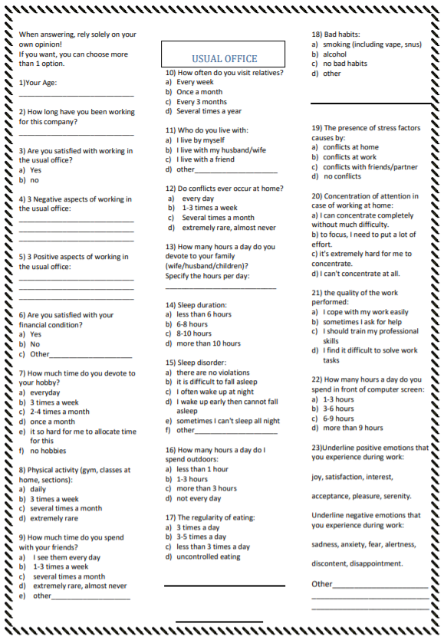

Figure 8 Social survey Usual Office

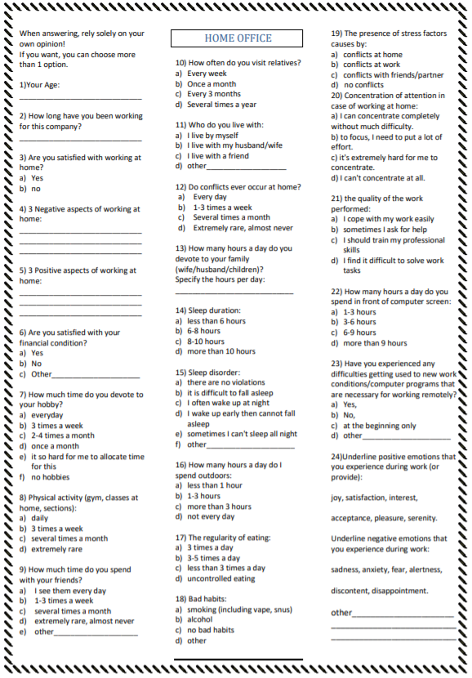

Figure 9 Social survey Home Office

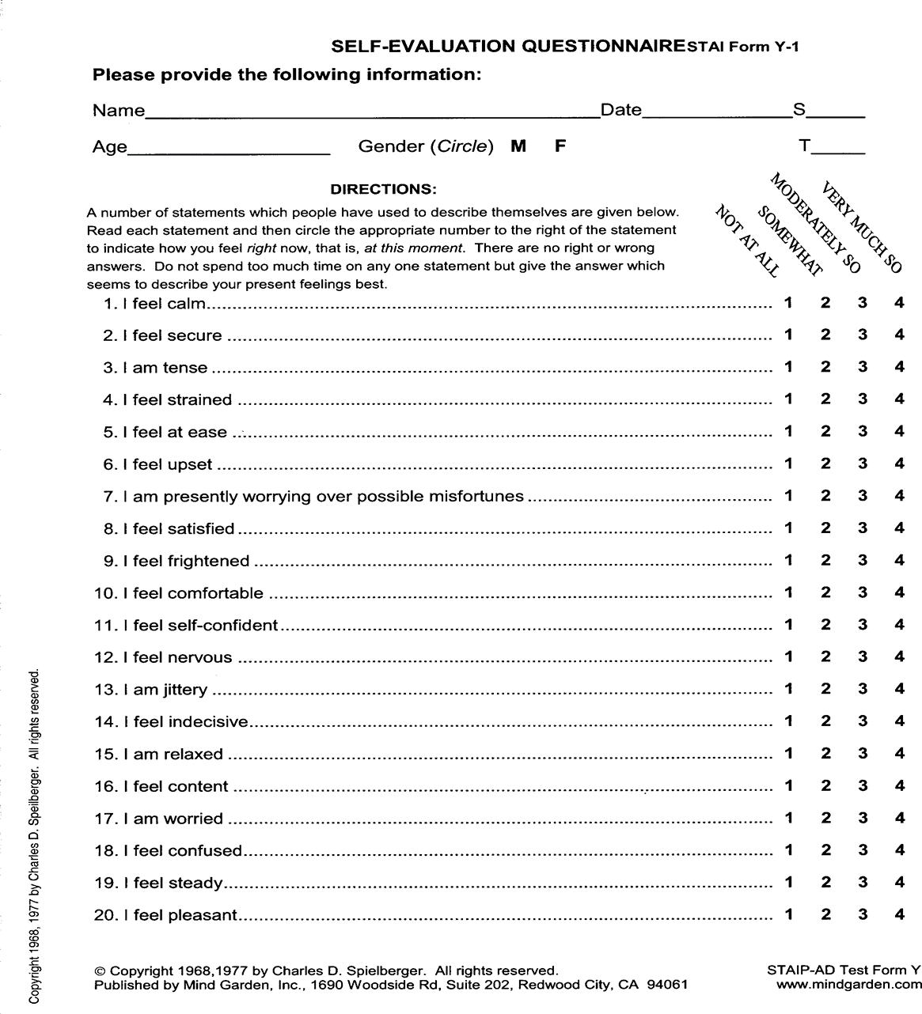

Figure 10 STAI questionar form Y-1

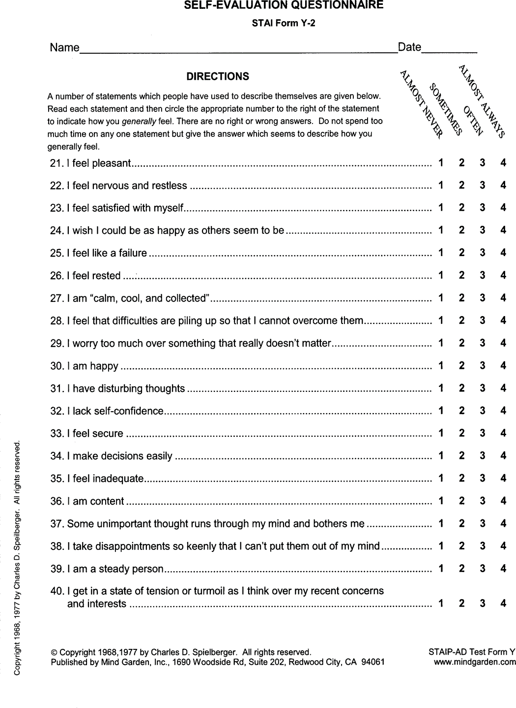

Figure 11 STAI questionar form Y-2

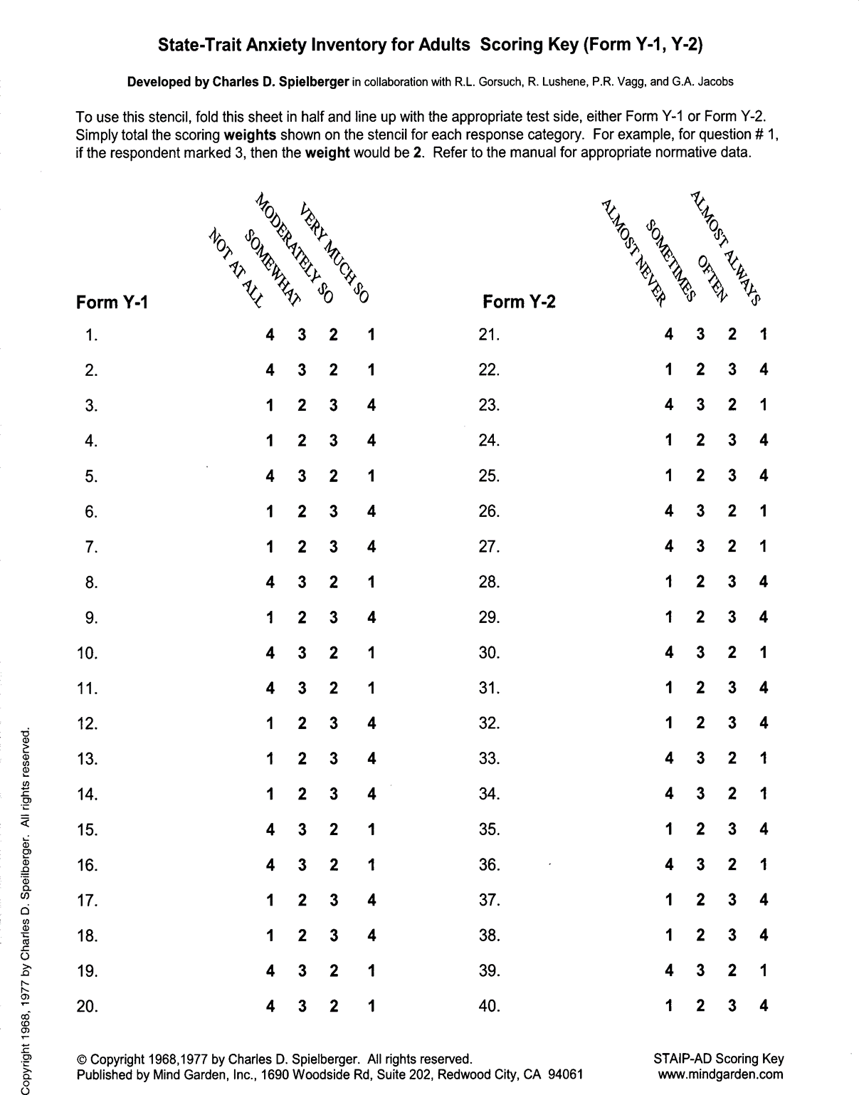

Figure 12 STAI Scoring Key