Palacky University Olomouc
Faculty of Education
Research and Development in Educational Studies

MASTER THESIS
Imran Akhtar

Pedagogical Competencies in school leaders in Pakistan
at primary level

Olomouc 2023 Supervisor: Mgr. Peng Danping, Ph.D.

Bibliographical Identification

Author: Imran Akhtar
Title: Pedagogical Competencies in school leaders in Pakistan at the primary level
Thesis type: Master thesis
Department: Faculty of Education, Institute of Education and Social Studies.
Year of Defense: 2023
Study field: Research and Development in Educational Studies
Supervisor: Mgr. Peng Danping, Ph.D.
Page count: 86 pages; 144390 characters.
Supplements: Appendix (04 pages; 5422 characters).
Thesis language: English

Declaration
The thesis entitled ‘Pedagogical Competencies in school leaders in Pakistan at primary level" has been undertaken by me at the Faculty of Education, Palacky University Olomouc, under the supervision of Mgr. Peng Danping, Ph.D.
I declare that the information in this thesis is shared from the result of my research conducted, and it has not previously been submitted to any other institution. Any content derived from the work of others is properly referenced and cited.

Imran Akhtar
Olomouc, 20 June 2023 Signature: …………...
Acknowledgment
I am deeply grateful to my supervisor Mgr. Peng Danping, Ph.D., for unwavering support and guidance through this research. Her expertise and patience have been invaluable to me and have played a crucial role in the study's success.
I am grateful to Palacky University, Faculty of Education, for providing me with the opportunity to conduct my research and for all the resources and support they provided; I would like to extend special thanks to the international office of the faculty for their support.
I am deeply thankful to my father, Mr. Akhtar Hussain, my mother, Mrs. Shamim Akhtar, my loving wife, my family, and my friends for their love and support during this whole process. Without their encouragement and motivation, I would not have been able to complete this journey.
Finally, I would like to extend my sincere gratitude to all the participants in my study. Their willingness to share their experiences and insights has been invaluable to my research and helped to make this thesis successful. Thank you for your time and contribution.
I am grateful to everyone who has supported me throughout this process. Without your help and guidance, this thesis would not have been possible.

Contents
Abstract 8
1. Introduction 8
1.1. Rationale of the Study 8
1.2. Statement of the Problem 9
1.3. Significance of the Study 10
2. Literature Review 11
2.1. Pedagogical Competencies and its importance 11
2.2. A Look at Pakistan's educational culture 14
2.3. Educational Structure in Pakistan 17
2.4. Role of a School Leader 19
2.5. Challenges of School Leadership 21
3. Methodology 27
3.1. Research Aim 30
3.2. Research Question 32
3.3. Research Design 32
3.4. Research Sample 33
4. Results 36
4.1. Participant's Portfolio 36
4.2. Competencies in focus 38
4.2.1. Professional Qualification 39
4.2.2. Communication Skill 41
4.2.3. Decision-making and Problem-solving Skills 43
4.2.4. Collaboration and Management Skills 44
4.3. Role of Effective School Leader 46
4.3.1. Leader in actual means 46
4.3.2. Qualified and Trained Resource 47
4.3.3. Acceleration of the Learning Process 48
4.3.4. Impact on the pedagogical process 50
4.3.5. Teacher’s Skills Development 52
4.4. Designatory Role 54
4.4.1. Supervisory Role of school leader 54
4.4.2. Teacher’s Pedagogical needs 56
4.4.3. Teaching Assignments in School 58
4.4.4. The Duties of the school leader 59
4.5. Learning Outcomes 61
4.5.1. Competencies Segregation 61
4.5.2. Qualities in School Leaders 63
4.5.3. Improvement of Pedagogical Skills 64
4.6. Conclusive Approach 66
4.6.1. Feedback & Reflection 66
4.6.2. Continuous Training. 67
5. Discussion 69
5.1. Necessity of Pedagogical Skills 70
6. Recommendations 73
6.1. Training 73
6.2. Professional Development 73
6.3. Competence development 73
7. Conclusion 74
8. References 78
9. Appendix (Questionnaire) 83

List of Figures

Figure 2.1.1 Pedagogical Competencies Structure (Suciu et al., 2011) 13
Figure 2.3.1The structure of school education system in Pakistan 19
Figure 3.4.1 Participant’s Portfolio 34
Figure 4.1.1 Experience Level 38
Figure 4.2.1 Professional Qualification 39
Figure 4.2.2 Communication Skills Need in School Leaders 41
Figure 4.2.3 Decision-making & Problem-solving Skills 43
Figure 4.2.4 Management & Collaboration Competencies 45
Figure 4.3.1 Role of school leader in Pedagogical Process 46
Figure 4.3.2 Necessity of Pedagogical Needs 48
Figure 4.3.3 Pedagogical Competencies' impact on Learning Process 50
Figure 4.3.4 Influence on Pedagogical Process 52
Figure 4.3.5 Teacher’s Skills Improvement 54
Figure 4.4.1 Supervisory Role of School Leader 56
Figure 4.4.2 Performance of Teaching Staff 58
Figure 4.4.3 Teaching Assignments for Schoo Leaders 59
Figure 4.4.4 Duties of School Leaders at Primary School Level 61
Figure 4.5.1 Pedagogical Process effectiveness 63
Figure 4.5.2 Qualities in School Leaders 64
Figure 4.5.3 Measures to improve pedagogical performance 66
Figure 4.6.1 Feedback Response from Participants 68
Figure 5.1.1 Pedagogical Competencies for School Leaders 72

Abstract
This research examines school leaders' pedagogical competencies, their impact on student performances and learning process achievements, and the development of an educational environment conducive to teaching and learning. This research applied a questionnaire survey with eighty-four participants. The participants are professional teachers, educators, and pedagogical team members at the primary school level in Pakistan, which belongs to urban and rural areas within the public and private schools’ domain. The questionnaire findings indicate that effective school leaders possess a range of pedagogical competencies, including instructional leadership, curriculum development and implementation, team professional development, feasible learning and teaching environment, and skills development. This research provides recommendations for the role of school leaders in identifying the weak areas overcoming them, and enhancing the pedagogical competencies of school leaders, and it also explores the strategies to improve teaching practices and educational outcomes for learners at the primary school level in Pakistan.
Keywords: pedagogical competencies, school leaders, educational environment, competency building, pedagogical staff, the mixed research method.

Introduction

Rationale of the Study
To enable civilization to progress as well as for a person to achieve its objectives, education is necessary to achieve this goal. The efficient functioning of school leaders' management is essential for the school system's success due to the significant influence of school leaders' performance in influencing learners' academic results. There has been a boom in devotion to the research of their pedagogical competencies throughout recent decades, particularly at the primary level. By analyzing the pedagogical competencies literature that is currently available, the goal of the research is to examine the pedagogical competencies of school leaders at the primary level in Pakistan, with a focus on the knowledge, skills, and mindsets necessary to serve in a leadership capacity in schools. An individual capable of altering the learning atmosphere is a school leader with strong teaching capabilities. With the increased demands of the modern world, school leaders need to possess the necessary skills and knowledge to foster effective teaching and learning practices within their domains and institutions.
"It is widely believed that a good principal is the key to a successful school" (Hanushek, 2012). It explores the various dimensions of pedagogical competencies that primary school leaders should possess and the factors which influence their development. This research will help you understand the importance of school leaders, principals, and head teachers in your school. Pedagogical competencies are the extended term used for teachers and school leaders to know their abilities to manage the learning process and to modify the structure of teaching and learning if needed or to update with the need of the situation and the time. Pedagogical competencies include the process of assessment and evaluation to know the learning outcomes. A specific focus is placed in the study on the school leaders, and their role to develop the educational and learning environment for teachers and learners, they also have roles and tasks with managing all academic activities to accomplish the organization's academic goals for students and teachers.

Statement of the Problem
A school leader is a person to lead the whole education process, including teaching and learning, managing the continuity, and providing the best possible support for the achievement of the set objectives. The lack of pedagogical competencies and skills in school leaders to develop a productive and positive environment and efficiently oversee the process and improve the learning and teaching practices can be referred to as a problem at the primary school level in Pakistan. As a result of such inefficiency of a school leader, student learning affects badly, motivation for teachers becomes weaker, and it creates a lack of communication and cooperation between teachers and school leadership. The inadequate oversight of the curriculum, lack of guidance and encouragement for teachers, poor observation and assessment in the classroom, and incapacity to provide constructive feedback to improve the teaching and learning process may be caused by the school leaders' insufficient pedagogical competencies. This problem is a major obstacle to the improvement of Pakistan's education system, which ultimately affects the future of students and their ability to contribute meaningfully to the nation.

Significance of the Study
This research encourages effective teaching and learning practices that enhance students' performance in primary educational institutions. It will contribute to the understanding of the pedagogical competencies of school leaders at the primary school level and provide helpful information for teachers and school leaders to improve their development as professionals. When school leaders have the subject knowledge and the interpersonal abilities to pass this understanding to their pupils, teachers and these are people who are an essential component of any school. Teachers and the pedagogical teams in a school also need a leader who can oversee their progress at every stage. However, it is common for school leaders, supervisors, principals, headmistresses, management, etc., to adopt various phrases for those responsible for leading according to the nation's level and context. The team leader, however, must possess professional skills and competencies to accomplish the set objectives. Pedagogical competencies in school leaders are key to developing an educational environment and the material for a learner, enhancing their interest, and activating them to achieve assigned tasks within the educational setting.
In other words, this is the set standard for hiring a person on a pedagogical team or as a school leader. If the person does not have pedagogical competencies, he/she is unskilled and unsuitable for the responsibilities. The person should be competent in pedagogy and professionally equipped with the required skills to lead the staff to attain the tasks. This research topic focuses on the role of school leaders in the educational structure, especially at the primary level. School leaders are important in educational settings as the body's backbone. "The principal as a leader, mentor, and instructor is the link that connects the school and the home. This is important both for students' development and success of schools." (Mansoor, 2015, as cited in Payne, 2006) There are a lot of information and core roles performing the school leaders simultaneously, the role of mentor, the role of a support system, and trying to develop a positive and effective environment for learners and teachers. School leaders need to develop the skills, acquire competencies, desire to lead, and gain consent to guide and fulfill their duties within the school. It is all about the school leaders at the primary school research studies such as this one enable researchers to understand the obligations, working style, and educational culture of Pakistan's primary school leaders. Structure and culture differ greatly from the European countries, including curricula structure and development, educational policies, administrative style, the role of government in schools, fiscal management, etc.

Literature Review

Pedagogical Competencies and its importance
In this research, various pedagogical competencies in school leaders were studied, and data was collected from the official database about the educational statistics of the education ministry of Pakistan with the name of Academy of educational planning and management (AEPAM Library, n.d “Research and practice confirm that a school head teacher (school leader) has a tremendous capacity to revolutionize school culture to promote success and change” (Waheed & Raza, 2021). A bunch of competencies were taken into consideration and studied in the research literature to find the impact has on the performance of the school leaders in their work and task achievements; there are many competencies required for a successful school leader, but in this research, some of the competencies discussed who have a vital and prominent role in the educational process and the role of the school leader. Such may be the curriculum development, assessment, and evaluation processing, supportive role to teachers, and professional development “the qualities of professional development for teachers and principals that improve leadership, teaching, and the learning of all students” (Dennis, 2002). A review of the literature on the pedagogical competencies of school leaders and their role in creating a productive, supportive environment for teachers and encouraging students was conducted as part of this study. “Schools are social institutions established to provide educational opportunities to its stakeholders. Professionally speaking, schools bear lots of pressures from all around comprising of community, society, students, parents, teachers, and other institutions” (Khalil, 2013)
To gain a deeper understanding of the concept of pedagogical competencies and the knowledge gleaned from previous studies, research papers, articles, journals, books, and other available resources are cited and used as the most relevant materials. It would bring clarity to the concept of the research study and its results. “Leadership in education means leading the actions of those engaged in teaching towards achieving the set organizational goals. “This leadership is carried out in the educational set up by the school’s head, principals” (Mansoor, 2015). Different domains of educational leadership need to be managed and controlled to achieve set goals; it requires professionalism and continuous development. Essentially, it is about managing the system, implementing policies, and developing the curriculum, and the school leaders can modify the curriculum if necessary. Keeping the educational process running smoothly requires coordination with teachers and other staff.
“International studies confirm a positive relationship between the role of head teacher (School leader) and school success (Raza et al., 2021; Hayden, 2007; Letithwood et al., 2006; Winton, 2013). The educational environment and its effectiveness, particularly at the primary level, depends on the pedagogical skills of school leaders. The pedagogical skills of primary school leaders have been explored in the literature study. “a good knowledge of pedagogical competence, their typology, and principles of development will lead to a future successful application and use in any field developing interdisciplinary thinking, creativity and managerial qualities in any field.” (Suciu et al., 2011). “Implementing change in educational practice directed by policy decisions demands effective leadership of schools and educational institutions. (Hallinger, 2003)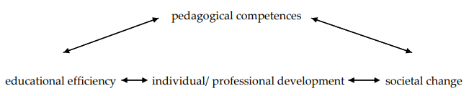
Figure 2.1.1 Pedagogical Competencies Structure (Suciu et al., 2011)
This image is for convenient understanding of the concept for developing a clear image in mind for describing the effectiveness of pedagogical competencies, they are dynamic to develop the working, and their importance in the efficiency of the learning process at every level and for every age of the learner, personal development, and professional development as well. Providing well-equipped professionals for work, business, or any other task, also brings a positive change in a person's life by enabling them to perform effectively and successfully. Additionally, it produces productive individuals who contribute positively to society through their work and business. As an introduction to effective pedagogical schooling with a view towards quick and adaptable collaboration in today's context of professional growth within a world that is interconnected, "communication in the mother tongue, communication in foreign languages, mathematical competence, and basic competencies in science and technologies, digital competence, meta-cognitive competences (learning to learn), social and civic (interpersonal) competences, sense of initiative and entrepreneurship, cultural awareness (intercultural competence) and expression" (Suciu et al., 2011). "As a degree of generality, pedagogical competencies are part of professional competence for the teaching career. The framework of professional competencies in Romania includes six categories of competencies, methodological, communication and relationship, student assessment, psycho-social, technical, and technological, and career management." (Gliga, 2002).

A Look at Pakistan's educational culture
Geographically speaking, Pakistan is in Asia, and it borders Afghanistan, Iran, China, India, and China. Up until 1947, Pakistan was a colony of the British Empire, and as a result, the whole educational system was conceptualized by that entity. Yet, British educational approaches have an impact on the overall system and structure of the educational system. In Pakistan, specifically in basic-level schools, the role of school leaders is examined in this research study. We must offer an overview of Pakistan's educational system and structure to provide clarity and help people comprehend their roles and pedagogical skills. There are different types of schools in the country, public (Government owned), private (Individual, group, company) and missionary schools, community, and religious educational institutes. "These can be divided into six major groups: government-run institutions, Christian missionary institutions, institutions run by the community members or local organizations, English-medium private schools, community schools and colleges, and religious, educational institutions. (Khalid & Khan, 2006).
There are multiple stages in the whole school structure in Pakistan. Pre-School Kindergarten, or Montessori, is the first phase for kids aged four to six. There are three steps normally in pre-schooling, the first is called playgroup, the second is called the nursery, and the third step is called prep. The second stage of the student educational process is called the primary school stage; in this section, students come from the first stage, and in this category, there are five classes, from one to class fifth. The main research aim of this study is to know the pedagogical competencies of the school leaders at the primary school level, who are responsible for managing the students who just came from kindergarten, Montessori, or pre-level schooling. They are at the initial stage of their learning life, and they do not know about this level because it is completely different from the first and initial categories. In the first category, there were basic and initial activities for practicing and learning about the basic information, ethics, rules, and interpersonal development of the learners, and the data was very basic. However, at the primary school level, some subjects are compulsory to study: Science, social studies, Urdu Literature, English Literature, Mathematics, Art & Drawing, General Knowledge or lifelong learning, and Islamic Studies. So, it is not easy to learn for children who just came after pre-level completion. Finding out what pedagogical skills are necessary for school leaders at this particular level of education, primary-level schooling in Pakistan is one of the research goals of this study. As previously noted, learners in this category have advanced from the pre-level group; they have a foundational understanding of the alphabet and its order, mathematical ideas, lingual material to help them better their mother tongue, lifetime learning, and general information.
The promotion of fundamental standards and the teaching and practice of fundamental rules in groups, classes, and schools take priority at the first level. Because they are coming from households, a teacher and other staff members work with the children to help them acquire manners, ethics, and responsibility. To live, share, communicate, and comprehend with siblings and family members rather than strangers or members of the community is the culture that the kids learn at home. So, in their school settings, they interact with peers, teachers, staff members, and strangers. So, at school, this is the priority of teachers in Pakistan to develop a sense of care, responsibility, respect, and patience. They play with peers, share with them, and communicate with them to learn and grow and follow the classroom and school norms and regulations. In this way, they get promoted to the next classes and experience new things, new learnings, and much more. As a primary school teacher and a school leader at this level, handling these kids with little experience with books, academic material, and assessment systems is quite challenging and manageable.
The teachers and the pedagogical team working at the primary school level have the task of building the base for learning with books, preparing tasks, conducting evaluation and testing, and different type of interaction with peers, group members, class fellows, and schoolmates. The pedagogical team, teachers, and school leaders need more attention, keen interaction, and patience to work with the students. At the early stage for clarity, going to share the temporary structure of practices for providing comprehensive information about the primary level. At the pre-level, a teacher starts working in the first year of the kid with the recognition of alphabets, numbers, and linguistics with many activities and projects involved. In the second year at pre-level, the teacher works with blending of alphabets and more concepts to develop the senses and awareness of norms. The third year at the pre-level in the educational settings in Pakistan, working in the learning environment focused on word and sentence making and phrase development. It is a harder task and activity than the previous classes' tenure. When the learners come to the primary school level, the teachers focus on them to involve them in different subjects simultaneously. It is difficult to manage those students who need to learn these subjects, materials, information, and concepts. Even if they do not know how to read in a sentence case, primarily the teacher focuses on sentence making and teaches them the structure of the sentence. After that, the teacher focuses on developing a sense of responsibility to do their work and tasks in such a manner guided. So, here is the level where the teachers, pedagogical team, and school leaders' skills are required to manage the whole system and achieve the set objective for the unprepared learners. School leaders plan with the pedagogy team and the helping staff to manage different activities, workshops, pieces of training, and continuous development of their skills and competencies.

Educational Structure in Pakistan
In Pakistan, the school's educational structure is divided into four stages, the first of which is the pre-classes, or kindergarten. This stage has three different grades or steps; students who graduate from the pre-level move on to the primary section. In the pre-level, the learner joins the school at the age of approximately four years. At the primary level, there are five grades; a grade means an educational setting for a whole year in the school. Grades one to five are called primary school levels. After that, the student proceeds to elementary school, which includes three grades (6th, 7th, and 8th); after successfully graduating from the elementary level, the learners will continue to secondary school, which provides for classes 9th and 10th. Matriculation, or matriculation," is another term for a degree obtained upon completing secondary school. After matriculation, all the students have the liberty to choose the line of study as per their interest, i.e., medical science, engineering, business administration, commerce, art, general sciences, etc. There are two years of education at the college level at this stage, and it is called higher secondary education. Twelve years of regular education from grade one to grade 12 provide the foundation to choose their professional education, and then they will go to the university. At university, a learner can attend different types of professional education with various programs for two, three, or four years. It is called graduation; this process will continue after successful assessment or evaluation at the university level, and one can get a higher education after graduation. It is a short intro about the structure of the information to make it clear and meaningful to dig out the problem and provide solutions and recommendations.
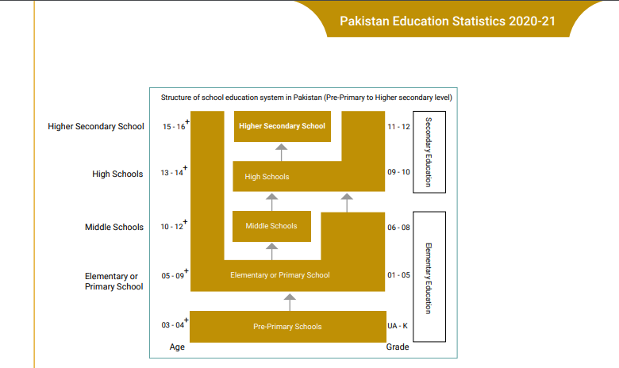
Figure 2.3.1The structure of school education system in Pakistan
(Pre-Primary to Higher Secondary)
Teachers in Pakistani primary schools understand the fundamental and essential knowledge needed to function in the classroom, through their education, professional diplomas, or degrees and by training at the school level or a large level. There are degrees, diplomas, and certifications, i.e., bachelor's degrees in education (B.Ed.). A person with a B. Ed degree can do a master's in Education (M.Ed.) in two years. There are also certifications for the professional growth of working teachers or interested in starting a career as a teacher at the primary or pre-level; they can get the (CT) certificate in Teaching and (PTC) certificate in primary Teaching; these certifications and diplomas are specially designed for providing professional knowledge and for training them for an initial start in the field of education. Moreover, a wide variety of training, workshops, seminars, and conferences are conducted to boost the teachers' skills and knowledge to meet the needs of the students and compete in the world's educational development. There is also a special department at the provincial level called the Directorate of staff development; their domain is to design different kinds of training, workshops, and activities to promote the teacher's knowledge and competencies to work effectively.

Role of a School Leader
Pedagogical leaders work in common educational settings as a principal, a leader of the team, a mentor to motivate, and an instructor as a bridge between the school and the home, between the teachers and the parents. A school leader’s role is to coordinate with parents, which brings more success to the school and the student’s development. In a broad sense, schools are the social institutions established to provide the most feasible educational environment for students, teachers, and guardians to connect. For this purpose, there is a lot of pressure on schools to manage, provide quality education to learners, collaborate with teachers, and connect with parents and the community. It depends on the competencies and skills of a school leader that how they manage it, who are responsible for leading the school as a head and principal in the learning and teaching process. School leaders have an important place in the school and the community. Also, they have a position in a school with the responsibility to coordinate with the parents and teachers with reliability. They are bound to be answerable for actions taken for accountability. In addition, by completing assigned tasks, a school leader also produces fertile and creative minds for the nation’s development to fulfill future obligations. For school leaders, this theme about their role as nation-builder gives them an aim and an inspiration to work hard and passionately. Even though school leadership is a demanding position today, it is also imperative that school leaders provide excellent services to students, teachers, parents, guardians, and the community. Consequently, school leaders always have pressure to overcome these challenges and to provide the best possible solution.
The most relevant example of the importance of education is its process, the whole process of learning, teaching, and the educational environment, how to develop interaction, and how it is relevant today. It was 2004 when Singapore’s prime minister Mr. Lee Kuan put forth the idea for teachers to “teach less” to help students “learn more.” In 2005, the Ministry of Education Singapore clarified this philosophical statement passed by the prime minister of Singapore, which means transforming learning from quantity to quality, “more quality and less quantity” in education. Accordingly, this motto fits the vision of “thinking schools, learning nation.” This policy initiative, which began in 2004, was farmed to bring change in the fundamental nature of education in Singapore. It reflects the importance of education and how to develop the educational environment in the learning process and the whole structure and emphasizes the immense role of a leader, a school leader. Research shows the critical importance of leadership in schools and the role of effective role models in developing suitable educational environments. A key literature review to share here is the one on school leaders at primary schools and their importance as well as their impact. “Leadership is considered a key element in institutional effectiveness. It is a core element in which private organizations are more effective than their public sector counterparts." (Murphy et al., 2006). The school leader has the position to develop the competencies in teachers and can update them time-to-time. Here is a step-by-step process to develop the skills and competencies of the teachers and pedagogical staff of the school leaders. “The National Centre for the Formation of Teachers from Pre-academic Education has developed a 5-level grid for basic competencies in the didactic profession with three levels of manifestation, from simple to complex: - basic competence 1 – facilitating innovative processes of teaching and learning focused on students; - basic competence 2 – evaluating and monitoring results in teaching and learning; - basic competence 3 – planning and playing the curriculum, syllabi and didactic methods and materials of formation; - basic competence 4 – forming partnerships inside and outside of school; - basic competence 5 – involvement in the process of individual and professional development.” (Suciu et al., 2011). Furthermore, the different countries’ leadership also expressed their concerns and elaborated on the importance of school leaders in schools in their speeches and public gatherings. In education, leadership issues have also been addressed, as former British prime minister Tony Blair argued: “You are critical agents for change and high standards, school by school. There is no more important job in Britain today than yours (Blair, 1999; Niqab et al., 2014).

Challenges of School Leadership
To bring desired changes and improvement into the education system of Pakistan, the school leaders may be called different names as educational leaders, head teachers, headmasters, headmistresses or principals need to play an important role and need to be trained in team building, reflection, and development a collaborative culture (Teacher Education, Position Paper, 2004). In the current era, it is not an easy task to manage the whole educational structure in a school and control all the happenings professionally, there are multiple tasks to handle, i.e., pedagogical staff, all are of different nature, different experiences, different educational background, different classes, different learners, and curriculum tasks. But the school leader is the only person who is responsible to deal with them in their own capacity. The sensitive nature of the role makes them conscious, keen, and curious. it needs a lot of work, experience, skills, and competencies for success. In Pakistan, it is not easy to depute the school leaders who already have the needed skills and competencies, because there are different criteria for deputation or appointment. It needs time and continuous effort to become an effective and successful school leader, especially at primary level schooling. In the educational system of Pakistan, after appointment as a school leader, the next phase is to develop the capacity of school leaders, and it is a big challenge for the working person to manage all the academic and management issues simultaneously without having any special training, skills development, and experimental learnings.
Most of the school leaders appointed through the direct appointment policy of recruitment, lack of experience, skills, and competencies may bring a lot of hidden problems in this case. It can be enhanced through training, workshop, and refresher courses, which in turn may enable them to strengthen the teachers' ability to teach better. If the school leaders have effective training for their role performance, then it could make it easier for them to motivate and lead their teams in the way they need to in order to accomplish their goals. Therefore, the development of the capacity of school leaders is as crucial to the success of the teachers as the development of their competence and school environment for teaching and learning. The development of skills and competencies in school leaders has a large impact on the whole environment of the school and the working of the teachers. It needs to be focused on at every level of schooling and lead the whole process successfully. A review of the literature and data available on the official website of the education ministry of Pakistan “The public sector portrays 78 percent institutions, with 53 percent enrolment and 37 percent teachers at primary level. However, the private sector contributes with 24 percent institutions and 13 percent teachers educating a much higher percentage of students (60%) at the primary level.” AEPAM Library. (n.d) shared in clear words that there is a different structure in public and private schools, where principals, head teachers, or headmistresses work within the systematic management structure of the government and are obliged to follow the instructions of the bureaucracy and in the private sector, where appointed principals are primarily subject to the direct and personal influence of trustees, directors, and network partners. Non-government headteachers have considerable managerial powers, including new appointments, discipline management, and the salary package and budgeting. In contrast, government headteachers have limited powers of management and control. "The private school culture dominates the public-school culture in Pakistan. In the absence of a central regulatory organization, private schools in the country autonomously construct their educational philosophy, which underpins curriculum choices, pedagogical approaches, and school operations". (Raza & Waheed, 2021). Approximately one-third of school-age children in Pakistan attend private schools (Raza & Waheed, 2021; Nguyen & Raju, 2014).
The role of school leaders has always been perceived as a demanding, challenging, and critical job by its very nature, and therefore, many factors influence the development of novice school leaders into veterans. It has been determined that school leaders' positions are too demanding, stressful, multi-tasking, and poorly supported, resulting in poor training opportunities, unattractive pay structures, no set working hours, unsatisfactory incentives, and serious accountability from the board, the government authorities, network associates, and trustees, if any. Unfortunately, these factors give rise to the idea that school leaders may not be a role that attracts the best brains. As a result, the best potential candidates feel uncomfortable starting their careers as school leaders. "Schools in public and private sectors are mostly led by untrained headteachers, recruited based on teaching experience rather than management and administrative experience. The need for professional development of school leaders is recognized". (Simkins et al, 2003). It shows that there is a strong need for professional development programs for school leaders. Over a while, it has been found that school leaders usually have yet to gain prior experience or formal training in the job description of a school leader. Therefore, this need needs to be addressed primarily on a war footing.
The literature mentioned here shows that, "research reinforces the importance of effective school leaders for high student achievement, the principal (school leader) has the strongest impact on student achievement in the areas of life, school practices, culture and quality of achievement (Gilani et al., 2021; Boyko, 2015; Bohlmark et al., 2016; Day et al., 2016; Felix-Otuorimuo, 2019; Gurr et al., 2003). "The education system of Pakistan needed immersive improvement in primary levels of school to upbringing a significant change with strengthening the teachers and learners and to get the benefit of creativity to deal with new practices. The primary level of an education system, i.e., the school, has the potential to approve, adjust, create, or decline the innovation.” (Niazi, 2012). The research focuses on the pedagogical competencies of school leaders in primary schools, there are several research studies, articles, and journals available on the role of principals, their position, needs, inputs, and outcomes also, but not specifically on the pedagogical competencies and for the primary level in Pakistan. Thus, one of the important sectors of the learner's schooling where a learner experiences a different world from home and interaction with unkwn people, peers, and teachers also focuses entirely on the mental grooming, upbringing, well-being, knowledge-building, awareness of norms and values to the students. A teacher with the support of a well-equipped and trained school leader can make this possible; it is not a one-person contribution; it needs the full support of a team in terms of classroom management, teachers and assistant teachers, support staff, principals, psychologists, physical activities, curricular and co-curricular activities, practice, and evaluation. "Learning from colleagues within the school has been recognized as an inestimable source for constant professional growth". (Niazi, 2012; Fullan, 2001; Guskey, 2002; Retallick, 1999).
A multi-tasking school leader is responsible for managing and providing the necessary support and developing a positive and productive environment to achieve set goals, whether academic or non-academic. At all levels of education, including school, college, and university, the literature review discusses the competencies and skills needed by school leaders. The core value of the research is to evaluate and find out what competencies are required and how to develop school leaders in a way that is appropriate at the primary level and possible to develop and bring the desired outcomes in the system, the school, teachers, and learners. When school leader effectively leads their teams and builds good coordination with them, they can confidently discuss classroom work, methodology, assessment, and development, and the whole process of teaching.
The school leader is a person who “Cultivating leadership in others so that teachers and other adults assume their parts in realizing the school vision, managing people, data and processes to foster school improvement” (The Wallace Foundation, the school principal as leader, Edition, E. (2013), who can motivate their teams to learn if notice any deficiency in performance or management. Normally a teacher wants to find the solution to their problems, so they become more aware and eager to learn. It can be called problem-based learning. In educational settings and teaching environments, school leaders rely on their pedagogical team to successfully manage the classroom environment and the activities that take place there, to develop and promote a learning environment for students, to provide them with the best supporting materials and information, to build their confidence, to improve their teaching techniques and interaction with students. Teachers are also curious about their performance in the classroom and try to learn unique methods and share their experiences because the whole process of development requires training, patience, passion, interest, and hard work. It is only possible through a continuous process of development.
School leaders in Pakistan are assessed for their pedagogical competencies in this research. “It seems unlikely that leadership is a culturally neutral concept” (Koopman, 1999), and the writers also shared their concerns about the educational system of developing countries and wrote about the effectiveness of the degree to which schools leaders do, or might be expected to, act effectively as effective school leaders in their institutes (Simkins et al., 2003; Ali,1993; Memon, 1998; Warwick, 1995). The reasons for this approach have various factors, first already referred, control of the bureaucracy and hierarchical structures and rules and regulations and strictly implemented and also followed in public schools; moreover, limited professional training and socialization experiences of the majority of the teachers and this is also dominant in school leaders. Another important factor about the national culture is its strong image of trends in developing countries like Pakistan. It is dependency, autocratic management styles, and aversion to risk. (Sisum, 2003; Hofstede, 1980, 1991; Shaw, 1998; Shaw & Welton, 1996). This research about the pedagogical competencies of school leaders specifically aims to explore some of the issues mentioned above.

Methodology
In this research, the mixed research approach is applied to collect the data from the participants, and it is the quan-qual format. Most of the research approach is based on the quantitative method; due to the nature of the research topic, it is found that the quantitative research method is suitable for finding accurate, scientific, and relatable results. It is also fast in the process. "Collecting numeric data from a large number of people using instruments with preset questions and responses" (Creswell, 2012). Its efficiency and speed bring quick and clear results, and data processing and analysis are faster than others. Statistical analysis can extract important facts and valuable insights from numerical data. One of the basic aims of this research study is to explore the pedagogical competencies of school leaders in Pakistan, specifically in primary schools. The primary school level is an initial level of schooling, and it is very important for the child's upbringing, learning, knowledge building, and many other domains. School leaders work as team leaders at school; they are responsible for multi-tasks. To know the core role of the school leader, the method adopted for research in this study is to collect the data with a clear and confirmed understanding, i.e., figures, numbers, multiple choice questions, given options, etc., without any doubt, the best possible information and also with the authenticity of the source. "Describing a research problem through a description of trends or a need for an explanation of the relationship among variables" (Creswell, 2012). To explore what pedagogical competencies school leaders have as well as what tools they should have to perform effectively and ensure that these are productive and progressive.
The descriptive questionnaire was created in Google form and shared with the participants of the research, which were teachers and pedagogical staff of primary schools in private and public schools in Pakistan, intending to collect data to explore the role of school leaders in the educational process and the development of productive and positive environment. For the validity of the results, both reliability and validity were taken into consideration when examining the pedagogical competencies of school leaders in Pakistan at the primary school level. Research measures used to evaluate pedagogical competencies are referred to as reliable, they are consistent and stable. There are a number of techniques used in the research study to establish reliability, including pilot testing, inter-rater reliability checks, and test-retest reliability, to ensure that the data collection tools produce consistent results over time and among evaluators.
Research findings that are considered accurate and significant are defined as valid. There are various strategies for increasing validity, such as content validity, construct validity, and criterion validity, in order to ensure that the measures capture the intended constructs accurately and can be extrapolated to the primary school leaders in Pakistan. Studying the pedagogical skills of school leaders will shed light on leadership practices' effectiveness and influence on enhancing primary education in Pakistan, addressing both reliability and validity concerns. In order to collect the relevant and correct data about the school leader s pedagogical competencies from the participants, most of the questions were added as close-ended questions in the questionnaire. It was used with the aim of keeping the participants intact within the pedagogical framework and sharing their experiences on the role, skills, and competencies of the school leader. To gather the feedback of participants about the school leaders on their experiences and expectations, along with any suggestions or recommendations for change in the educational settings, two open-ended questions were added to the questionnaire. “It is a more useful instrument, especially in sociodemographic, economic, and KAP (Knowledge, Attitude, and Practice) studies. It is one of the most important aspects of good results. Validity and reliability condition is an essential part for questionnaire” (Singh, 2017). Analyzing the data collected from the participants is another important and curious step to gain insights into the study results. “The measurement tool can produce accurate findings when compared to a standardized finding.” (Singh, 2017, p. 794). The data analysis process is statistical a major; in this questionnaire design created, diagrams and graphs of responses were collected against every question. In this way, it generates clearer and consolidated results.
The participants rated the competencies in response to the different questions about the school leaders and submitted their feedback. This methodology aims to provide a descriptive design research approach, data collection, and data analysis process to explore the pedagogical competencies of school leaders at the primary level in Pakistan. It is suitable to find out the relationship between variables and determine the differences in the level of pedagogical competencies of school leaders. In the annexure part, the questions added in the questionnaire with the aim to collect reliable data from the participants without any influence and to achieve the aim of the study and use the strategy of the questions test and retest. Most of the questions used multiple-choice options to figure out the task. The link to the questionnaire is also shared in the chapter of the annexure to provide insight to the reader.
All the collected results and responses from the participants are shared here in the part of the results with details separately and diagrams, graphs, and tables. Having a clear understanding of the pedagogical competencies of school leaders and their role and how they relate to curriculum development, creating a feasible instructional and teaching environment, creative and supportive atmosphere is the core of this research methodology at the primary school level, which is one of the most important parts of the educational system. The data collection and analysis results are also presented here, as well as the feedback and questionnaire collected about the necessary competencies of the school leaders. Consequently, there will be a greater amount of clarity and coherence about the pedagogical competencies and the role of school leaders as a result.

Research Aim
This thesis focused on identifying the pedagogical competencies that school leaders at the primary school level possess and need, the key competencies, and how they use them to improve student learning outcomes and for effective teaching and transformation of knowledge and understanding. It also provides an overview and analysis of feedback from teachers and educational staff on the role and place of school leaders in educational settings, particularly at the primary level in Pakistan. "A variable is an attribute (e.g., attitude towards the school bond issue) or a characteristic of an individual (e.g., gender)" (Creswell, 2012). In order to achieve the research objective, the questionnaire was shared with the teachers of public and private schools at the primary level in Pakistan and the data was collected from them. The aim of this research is to gain a deeper understanding of the pedagogical competencies of principals in Pakistani primary schools, so that everyone can better understand how principals are able to create a productive and positive educational environment for learners and teachers, and how to acquire the competencies required to fulfil the responsibilities assigned to principals. Authorities assess the competencies and skills of an individual before assigning responsibilities as a school leader, but the reality on the ground may differ from the assumptions of the authorities. This is a general concept about school leaders that they should have pedagogical competences and also the ability to deal with any situation in schools.
In the context of this study, to gather information about the current situation and the leadership of school leaders as well as their competencies in managing the whole educational process of education in schools and their inputs and support for improving the weak points in the process, as well as their cooperation and role in creating a suitable and positive and productive environment for teachers and students alike. The research study explores the role of school leaders in educational settings, the competencies required to become a successful school leader, and an effective role of the school leader are all discussed to illustrate the importance in helping their schools for the achievement of their objectives. Through data collected from teachers who worked in Pakistani primary schools, this research study highlighted how school leaders can help schools accomplish their objectives.
As part of the research objective for this study, school leaders in Pakistan at the primary school level must exhibit pedagogical competencies, as well as know how to work with their subordinates, how to create a learning environment, and how to use their skills with pedagogical techniques to enhance the learning and teaching environment. The first step in gathering responses was to determine the appropriate level of competence for a school leader. Based on the data collected from the participants, a competence development structure and its implementation in the school have been developed to help students successfully complete the study objectives at their particular level. This was done in collaboration with teachers and pedagogical teams. In order to foster an environment that is both productive and innovative for teaching and learning, school leaders play a critical role, and their pedagogical competencies are crucial to this process.. However, there is limited research on the specific pedagogical competencies that school leaders need to cultivate a productive and creative environment for teaching and learning, especially in the context of emerging technologies and changing educational paradigms. In recent years, there has been a growing emphasis on the need for school leaders to develop their pedagogical competencies to meet the changing needs of 21st-century learners. As schools embrace new technologies and new approaches to teaching and learning, school leaders need to have a deep understanding of pedagogy in order to lead their schools effectively. However, it remains unclear what specific pedagogical competencies school leaders need to cultivate a productive and creative environment for teaching and learning. Furthermore, the role of school leaders in developing stimulating and innovative learning environments is intricate and multifaceted. In addition to pedagogical competencies, school leaders need to be able to create a supportive and inclusive school culture, build relationships with teachers and pupils, and manage the day-to-day running of the school. Therefore, there is a need to explore the relationship between school leaders' pedagogical competencies and their ability to create a productive and creative environment for teaching and learning, considering the broader context of school leadership.

Research Question
How can the pedagogical competencies of school leaders support the learning and teaching process?
The mentioned research objective could be divided into more specific sub-research questions as follows:
- How do school leaders use their competencies to support teachers’ performances?
- How to do school leaders can improve the learning outcomes of students by using pedagogical competencies?
- What key competencies should school leaders have for developing an educational environment to motivate learners and pedagogical staff?
To explore the relationship between school leaders' pedagogical competencies, their effectiveness in promoting student learning outcomes, and their supporting role toward teachers and pedagogical staff. The study focuses to find out the school leaders' role at school, in the educational process and school settings, in creating a supportive environment and accelerating the learning, and teaching process.

Research Design
It would be most appropriate for this research to conduct quantitative research in order to obtain more accurate and authentic results. In the research study, the specific respondents were active participants and real people who have worked and experienced the whole activity with school leaders in their educational settings. To collect data on the responsibilities and activities of school leaders at the primary level in Pakistan. At this level in educational institutions, there are employed teachers, teaching assistants, instructors, classroom assistants, classroom supervisors, and pedagogical staff who participated in this research study as a research sample. Quantitative aspects include a questionnaire survey of research samples to assess the pedagogical competencies of school leaders and their perceptions of their impact on student learning. The collected data has been analyzed using statistical analysis for quantitative data. The main research method is quantitative, but the qualitative method is also mentioned here because two open-ended questions were added to the questionnaire to collect feedback, suggestions, and recommendations about participants' experiences, learning, interactions, and expectations from school leaders, thus it is referred to as qualitative-quantitative research. Through this method, we can get insight into their interests, learnings, expectations, and needs for improvement purposes, and they may be able to overcome their reservations easily. The majority of participants, according to feedback from the participants, were satisfied with the question regarding the role and responsibilities of school leaders for the development of an educational environment and effective learning outcomes. The highlighted issues were simple to understand due to the questionnaire's straightforward design.

Research Sample
The research samples are teachers and pedagogical staff members in schools at the primary level in Pakistan. In this research work, the data was collected from Public and Private sector educational institutes. The data was collected from eighty-four teachers who are working in different schools and teaching different subjects and different classes and belong to different areas, i.e., urban, and rural areas in Pakistan. These teachers are the research sample for collecting data in the research thesis work. Likewise, the data and analysis are presented for your consideration and understanding of the importance of school leader pedagogical competencies and their impact on the day-to-day activities in the school. The researcher analyzes the data to determine how skills development contributes to achieving the objectives and obtaining desired results. A total of eighty-four participants were surveyed from Pakistani primary schools, including public and private schools, urban and rural areas, and the participants were males and females.
Ethical guidelines and considerations followed to research pedagogical competencies in school leaders, including obtaining informed consent from participants and maintaining participant anonymity and confidentiality.
Research Participants Classification
Professional Degree |  | Area Wise |  | Sector of Working
Yes | No | Urban | Rural | Public | Private
56.6 | 43.4 | 48.4 | 51.6 | 24 | 76

Figure 3.4.1 Participant’s Portfolio
In this study, a survey was conducted in Pakistan to data collected they were in a total of eighty-four participants, including males and females. An overview is presented here about their professional education in the above table for better understanding; 56.6% of total participants are professionally qualified teachers working in primary schools and can effectively teach their students with the best of their knowledge and learning skills. The rest of them are well educated but do not have any professional degree or diploma needed for the teaching profession. It is possible to work as a teacher in Pakistan if a person does not have any specific professional degree or diploma in the field of education; they can work as a subject teacher according to their major.
Three dimensions are mentioned in the upper table for a better understanding of the study. The first one is about their professional diploma and degree in the field of education, and the second one is about their area of work; they tried to make a balanced work for collecting data from the urban and rural areas of Pakistan; almost 48% of teachers are from the urban area, and the 52% are from the different rural areas because there may be the difference in the background of students, school leaders, educational environment, learners background, and their upbringing, professionally trained teacher, s availability, training and development. So, for better understanding tried to collect accurate data without any influence and discrimination of people from different genders, backgrounds, localities, and availability of facilities there. And the third and one of the most important for data collection is that the study's participant belongs to the public school, which means the state-owned and administrated school and the private schools owned by private persons, companies, or groups, and the community or missionary schools. Almost 76% of participants were from private sector schools because the share of private schools is the same. And collected the data from them to understand the pedagogical competencies of school leaders there, and it will bring the overall view for shaping the results and feedback.

Results
The findings and outcomes of the study on the pedagogical skills of school leaders in Pakistan's primary schools are presented in this section. The goal of the study was to examine and evaluate school leaders' current pedagogical knowledge, abilities, and practices as well as their influence on academic results. The results also shed light on the difficulties faced by school leaders, such as scarce resources, bureaucratic restrictions, and a lack of autonomy, which limit their capacity to fully utilize their pedagogical competencies. Below are the results with graphs, tables, and diagrams to explain the situation more clearly.

Participant's Portfolio
One of the interesting things about the participants in this study is that they belong from each span of experiences, like some of the teachers who are at the beginning of their careers and the most experienced also. Almost 18% of the participants are fresh, or their maximum work experience is about one year. There are four categories for collecting the data for better understanding and uninfluenced results from the participants, first for freshly joined the noble profession of Teaching, second up to two years, thirdly the participants belong from the experienced group of 2 to 5 years, and the last category for participants about more than five years.
The objective of each category would have been to gather data about the individual's level of experience. Data collecting offers an understanding of the educational abilities of school leaders at the primary school level in Pakistan without having any influence. In this survey, teachers who had just started their careers were also included to collect data on the latest trend and experiences they had while working and their pedagogical learnings. Instructors in the highest category have worked for more than five years and have experience with various pedagogical competencies. They shared feedback for a better understanding of the pedagogical competencies of school leaders; these are the most experienced resources in this research study, their observations, and their understanding of school leaders' role in promoting a positive learning environment and enhancing teaching support to their pedagogical team. their keen knowledge and experience provided a base to know the role of school leaders at school in the primary level in Pakistan. Detailed data, facts, and figures are shared in upcoming pages with graphs or tables with clear and analyzed data.
An overview is shown in the diagram. Less than a year of experienced teachers is about 18%, and the second type of experienced pedagogical staff is approximately 32%. And up to 5 years of experienced team members of pedagogical staff at schools at the primary level is all about 18%, and the most experienced teachers in the list of participants are about 37%. As part of the data collection process, all types of participants, whether they are fresh, experienced, well-trained, or working participants, can reflect on their observations and understanding of school leaders' pedagogical competencies as well as their role as a model for educators and pedagogical staff in creating the educational environment in which teachers become learners through the development of their pedagogical competencies. This is an interesting point to understand the information gathered from participants in this research study, who have a professional diploma or degree to work in the educational sector as teachers or pedagogical employees, they can elaborate the pedagogical competencies of school leaders deeply.
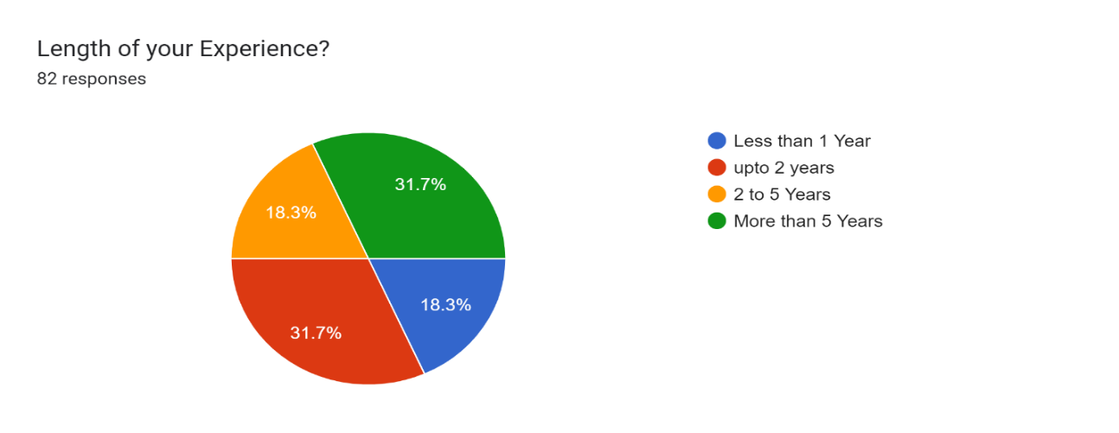
Figure 4.1.1 Experience Level

Competencies in focus
“A good knowledge of pedagogical Competencies, their typology, and principles of development will lead to a future successful application use in any field developing interdisciplinary thinking, creativity and managerial qualities in any field.” (Suciu & Mata, 2011). Here are the details from the data collected in this research about some of the core competencies in school leaders and their impact on the whole education process and fulfilling the goals. Some of the competencies discussed in this research are because it is impossible to cover all the professional and pedagogical competencies of school leaders at the primary school level in Pakistan.

Professional Qualification
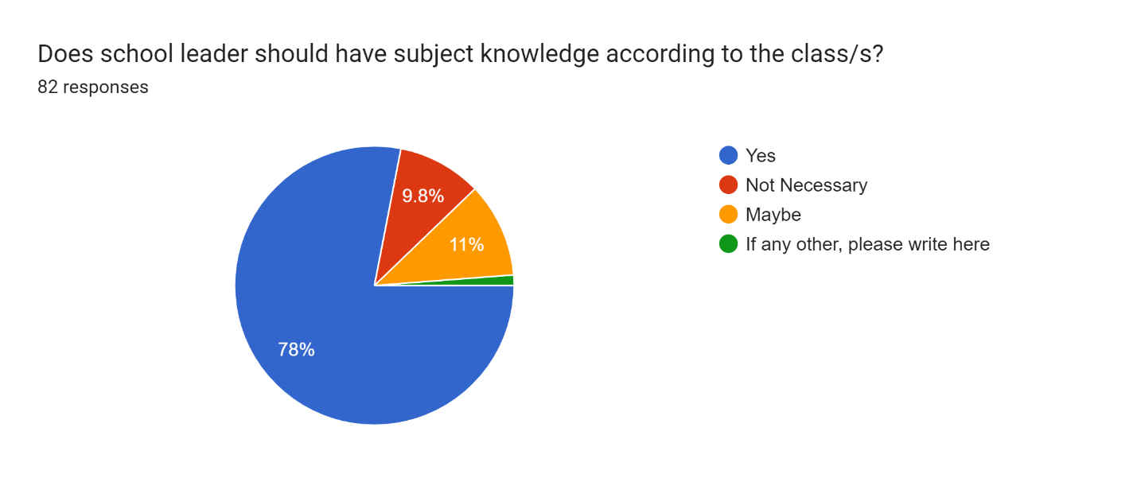
Figure 4.2.1 Professional Qualification
"Development and enhancement are not possible without the expertise and knowledge of the head" (Niazi, 2012). For the school's successful management and supporting teachers to provide high-quality education to the learners, it is considered to improve their knowledge and to date themselves to compete with others. According to the overview of the research study findings, professional development by attending seminars, workshops, refresher courses, and short-term practices in the field of education brings improvement in the pedagogical competencies. It can play a vital role effectively and successfully as a school leader. Graph 4.2.1 is for your understanding of the data collected in this research study.
School leaders such as principals or head teachers must have subject-specific knowledge for each class. So far, supporting teachers and making smart recommendations about instructional techniques and processes can be made easier by having a general knowledge of the curriculum and the contents delivered in each subject. A strong understanding of pedagogy, leadership, and management abilities is also important for building a supportive learning environment, motivating students' learning, and successfully managing the team. If the school leader needs to gain subject knowledge, they rely on their team of teachers to provide expertise in their respective subject areas. It is also common for school leaders to receive ongoing professional development to enhance their knowledge of different subjects and improve their leadership skills. School leaders, such as principals or headmasters, are often considered qualified and trained sources for educational work. Before being a school leader, they are frequently expected to obtain a teaching qualification or education degree and prior classroom experience. Pedagogy, educational theory, and instructional approach training and curricula are common in school leadership programs.
Some school leaders may be highly qualified with advanced degrees in pedagogy or related subjects. Others, who may have a deep understanding of the operational elements of pedagogy, may have started their careers as teachers and were promoted through the levels with due course to become school leaders. There may be some school leaders like, though they might have yet to have a formal background in education, who came from other disciplines or sectors. In such circumstances, they can rely on other sources of expertise, like engaging highly qualified teachers and professionals to give feedback on pedagogical issues. The skills and background of individual school leaders and the objectives and requirements of the school activities define how well they are considered qualified and trained sources.

Communication Skill
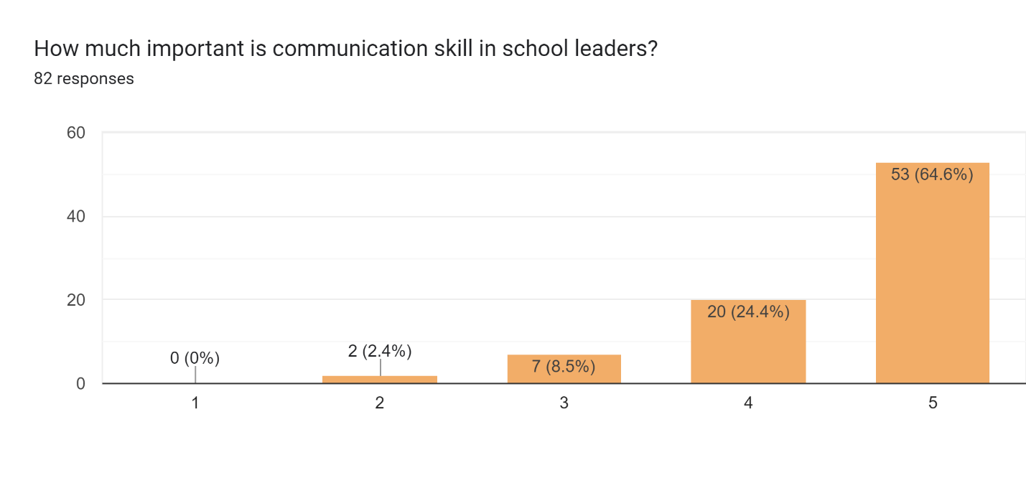
Figure 4.2.2 Communication Skills Need in School Leaders
School leaders need communication skills because they have to lead and manage a diverse range of stakeholders, including students, parents, teachers, government officials, administrators, and community members. Communicating well, persuading, conveying their vision, clarifying goals, and sharing expectations are achievable through strong communication skills. "Communication in the mother tongue, communication in foreign languages, mathematical competence, basic competencies in science and technologies, digital competence, meta-cognitive competencies (learning to learn), social and civic (interpersonal) competencies, sense of initiative and entrepreneurship, cultural awareness (intercultural competence) and expression" (Suciu et al., 2011). School leaders responsible for school environments must inspire and motivate others to participate in positive relationship-building to ensure a progressive and productive learning environment. In this way, collaborative relationships will be improved, and trustworthiness will be enhanced.
To present the understanding of the participants at the primary level and the importance of communication skills of school leaders, the researcher has prepared a table. There are different parameters in this table, some of which are shared here. Almost 65% of the participants choose the option at the highest level. The questionnaire revealed the importance of communication skills as a school leader in the eyes of the participants, and the remaining 25% of the participants expressed their opinion regarding the second highest ranking level in the questionnaire designed to collect the data. Almost 90% of the total participants agreed and shared their feedback. In response to the question about the importance of communication skills in a school leader, their opinion is helpful to recognize the need for competence to effectively manage the role of school leader with the school and the team. Participants emphasize that the school leader needs more focus on improving communication skills; the second and third levels of grading express their concerns in this regard.
Furthermore, effective communication skills enable school leaders to deal with challenging situations and resolve conflict, and it reflects professionalism and crisis management as well. Therefore, communication skills are essential for school leaders to achieve their aims and objectives, promote student success, and create a positive and inclusive learning environment. For this purpose, the school leaders in schools need to be effective communicators too. They must be capable of interacting with parents, students, learners, and other participants in a precise, comfortable, and friendly style. Meaningful cooperation between educational institutions and the community is established with communication skills, which assures that all individuals are familiar with the school's requirements, goals, and priorities. Trust building and cooperation between teachers, learners, and families are encouraged through efficient communication among school leaders, that increases pedagogic achievements.

Decision-making and Problem-solving Skills
Result of the Research study about mentioned skills
Rating (1 - 5) | 1 | 2 | 3 | 4 | 5
Decision-Making skill | 0 | 1.20% | 7.20% | 21.70% | 69.90%
Problem-Solving skill | 1.20% | 1.20% | 3.60% | 24.10% | 69.90%
The data is shared in the following table: - 4.2.3 is from the data collected for this research study. Moreover, it reflects the mindset of the participants that 70% of the participants choose the option of the highest score for the critical need of decision-making and collaboration skills in school leaders. Moreover, almost 22% of the teachers and pedagogical staff participating in the research study as sample research shared their mindset about the decision-making skill at the second highest score, which is also a significant number. It drew attention to the need to improve decision-making skills and abilities and to deal with problems as they arise. There are five levels for rating skills in the following table, 1 being the lowest level and 5 being the highest, reflecting the feedback accordingly. Using a 5-point rating system, participants can rate their knowledge and understanding from 1 to 5. As you can see, the rest of the numbers around these average scores are based on their position in the table.

Figure 4.2.3 Decision-making & Problem-solving Skills
"Leithwood and Steinbach (1991, 1993) stress that values influence the problem-solving process both directly and indirectly. In direct influence, values act as preferences and dictate the school leaders' actions. Concerning indirect influence, values act as filters for determining the saliency of external factors in problem-solving." (Baig, 2011, p. no 28). Data collected from participants revealed their understanding and observations of school leaders' decision-making and teamwork skills as an important indicator of how well they are running the school. Effective school leaders can collaborate comfortably with others to make decisions, open to all participants, as they have strong teamwork capacities to lead. When pedagogic teachers think their school leaders can make equitable policies to their school's benefit and goodwill and deal equally with all, they will be more likely to become curious and participate actively in the school's success.
Similarly, assume that teachers and staff perceive their school leader as interactive, cooperative, and responsive to suggestions. In that case, they are also more inclined to feel that they belong to an organization and working towards a common goal. Because of this, participant observations and reservations they shared in response to the questionnaire were useful for school leaders to evaluate their performance and pinpoint areas that need improvement. Participants expressed their concern about leaders in schools and emphasized the need to be able to make fact-based decisions. They should be able to use information gathering and analysis to support decision-making; it is necessary to improve teaching methods and techniques and continuous development in educational settings. School leaders must identify gaps, improve instructional techniques, and provide focused support to learners and teachers by analyzing and monitoring information about student achievement. Taking timely decisions can ensure that the educational approach is grounded in reality and delivers outstanding returns keeping in mind the needs of the learners. In this way, a school leader resolves the problems and issues that arise within the team or at school effectively and improves the working performance and outcomes.

Collaboration and Management Skills
Competencies in school leaders and collaboration are essential to functioning effectively in any team or workplace environment. Planning, organizing, coordinating, delegating, and overseeing are just a few of the talents that are included in management competencies. Task prioritization, goal setting, resource allocation, and strategic decision-making are skills that effective school leaders possess and use to support operational goals. Competencies in school leadership and collaboration are essential to functioning effectively in any team or workplace environment. Planning, organizing, coordinating, delegating, and overseeing are just a few of the talents that are included in management competencies. These are the competencies highlighted by the participants and shared their responses in this research study in the questionnaire. They expressed concerns about the management and collaboration skills in the educational settings for the achievement of goals and upbringing of the learners.
Participants agreed with the question about the competencies of school leaders. They submitted their responses about the need for and importance of the competencies of collaboration and management in the school leaders. Combining management and collaboration skills can enable people and teams to work more productively and successfully. They also emphasized that school leaders must have excellent management and organizational skills. To promote the pedagogical process, they should effectively manage resources such as time, budget, and staff. Organizations and frameworks that encourage effective pedagogical practices, such as planning, content mapping, and evaluation processes, should be implemented by school leaders. School leaders can develop an environment that facilitates the execution of quality education and enhances the whole didactical method by ensuring that resources are distributed accurately and effectively. Table: - 4.2.4 reflects the data collected from the participants, and the results showed that the school leaders at the primary school level in Pakistan need to focus on and improve the needed competencies to perform efficiently. It brings confidence in the team and the improvement in the working style of the teachers in classrooms with the learners.

Result of the Research study about mentioned Competencies
Rating Score (1 - 5) | 1 | 2 | 3 | 4 | 5
Management Competencies | 1.20% | 1.20% | 12.00% | 28.90% | 56.60%
Collaboration Competencies | 0.00% | 2.50% | 14.80% | 30.90% | 51.90%
Figure 4.2.4 Management & Collaboration Competencies

Role of Effective School Leader

Leader in actual means
School leaders, such as principals or headmasters, play a crucial role in the whole process of pedagogy at school. In the general concept of the working of school leaders, it is the core responsibility of school leaders to develop a positive and suitable learning environment, support teachers to deliver their best high-quality teaching and achieve the set goals with effective learning with students. Almost all agreed that school leaders are responsible for providing educational support and implementing curricula designed for each level, class, learner, subject, or skill development. School leaders set a school vision to provide a road map for teachers and students. They include the process of development, which involves identifying the school's educational goals, values, and priorities. Graph 4.3.1 shows the data about the role of school leaders, and the percentage of data collected can be categorized for better understanding. The questionnaire contained a question to gather information regarding the function of the school leader, with 79.5% of participants responding that they believed the school leader had an executive and complementary role in school settings. It needs to be improved professionally and technically. The results collected for this question are clearly stated in the graph with percentages.
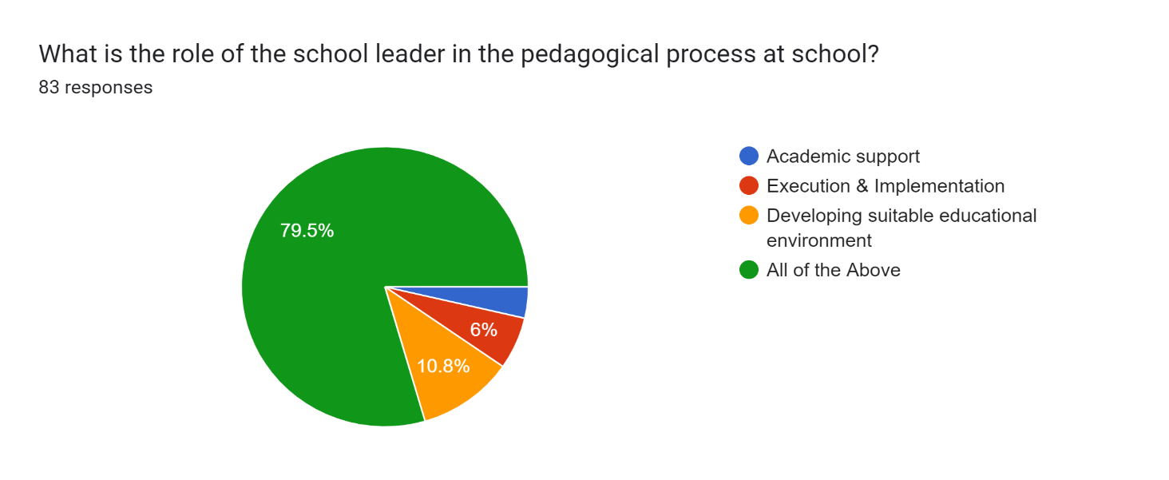
Figure 4.3.1 Role of school leader in Pedagogical Process

Qualified and Trained Resource
The questionnaire was designed to collect data about the role of school leaders or administrators in leading the entire educational program or managing the school effectively. Who is the most appropriate person or authority, school principal or administrator, to achieve the school's objectives? The response submitted by the participants is very clear and confident. 58% of the participants consider that the school leaders are the key person who can lead the school and effectively manage and control all the activities happening in teaching and learning. Nevertheless, it is quite significant that almost 39% of the participants share their opinion that school administrators or managers also can manage the school, but at the end of the questionnaire and in the verbal discussion with the participants who choose this option of school managers and administrators considers them for overall non-academic work management only, not for academics. They were also sure that the educational process could be achievable only by the well-qualified, professional, trained, designated, and well-motivated school leader. The participants generally consider that school leaders must have a solid understanding of academic standards, teaching skills, and pedagogical competencies to support the team. Otherwise, they need to do their work effectively. The question was based on two parts, one was about the role of supervision, and the second was about achieving set goals.
Additionally, it is about achieving the set goals in a school, including learning achievements and academic outcomes. It reflects the structure in Pakistani schools that two dimensions exist for the head of the school, the first is school leaders, and the second is school administrators or managers. There are a lot of factors that have an impact on the structural development of education in Pakistan. One of them is a big number of populations, so, consequently, there are also many students in schools. It shows that it is not an easy job to manage the whole system in a school for a single person, so, in most schools, especially with a big number of students, there is an additional designation of administrator called admin officer, head clerk, admin, or manager in Pakistani school, especially at the primary level. However, the administrator works under the command of the school leader. The school leader is the principal in private-sector educational institutes; it is called the headmaster or headmistress in public-sector schools.
The data showed many expectations for the teachers from their school leaders who can accomplish duties if they are trained, qualified, and have competencies and skills.
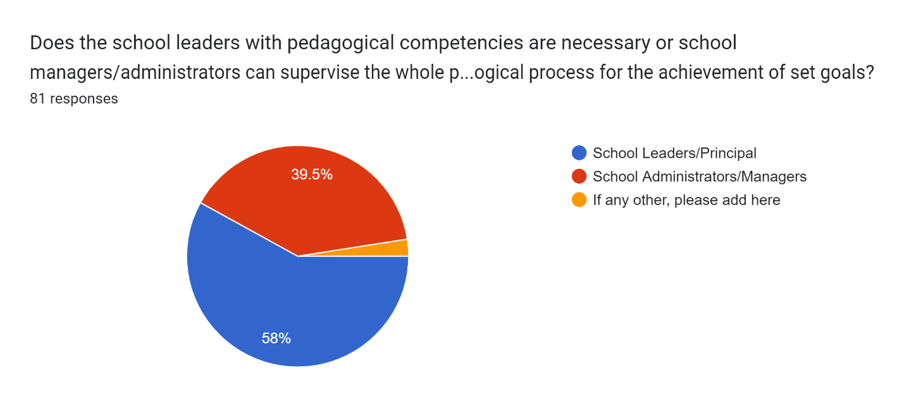
Figure 4.3.2 Necessity of Pedagogical Needs

Acceleration of the Learning Process
It was a very interesting question that was added to the questionnaire to collect the response and to know that the accelerated learning process is based on the pedagogical competencies of the school leader. The key factor is how the school leader shapes such a learning process. School administrators and principals must create a supportive environment to ensure that children achieve the best possible learning outcomes. Academic competencies, or the knowledge, skills, and abilities related to the teaching and learning process, are essential for successful school leadership. The question is raised: Do the teaching skills of school leaders support the accelerated learning process? This study explores this question from several angles and argues that the pedagogical skills of school leaders do accelerate learning. School leaders with strong pedagogical skills can create and manage project-based teaching practices and programs. They are familiar with relevant courses and the latest trends in the field, which helps them to choose curricula, teaching materials, and assessment techniques that meet the needs of learners. School leaders can create an educational environment that supports learners' diverse needs and active participation and improve learning outcomes through experimental teaching techniques such as teaching methods, learning strategies, and individualized learning. Highly competent school leaders can evaluate and analyze pupil progress effectively.
Suppose they have the skill of making decisions based on the teachers' and learners' data. They can analyze student performance data to identify improvement areas and implement necessary changes. Educational leaders continuously monitor and evaluate students who may be experiencing problems and then plan special support and assistance, like additional materials and activities, to support students in moving ahead and improving their learning performance. Early diagnosis and correction of academic deficiencies, which greatly affect student performance, is achieved through an aggressive strategy to assess learner performance.
The participants also share their concerns about the role of school leaders in the process of teaching and the performance of staff to work efficiently. School leaders with pedagogical competencies can create a friendly and positive school environment that encourages teaching. They emphasize the need to build connections with pupils, guardians, parents, and teachers to develop a safe and supportive place where learners feel motivated, recognized, and encouraged to learn. A positive school environment encourages students to take the initiative, discuss issues, and actively participate in school studies. It also builds a sense of connection. School leaders with pedagogical Competencies encourage a collaborative, dynamic, and critical-thinking culture in their school, allowing pupils to acquire knowledge very efficiently. It is important to acknowledge that school leaders cannot alone accelerate the process of learning. Effective teaching strategies and student interest are critical elements of the learning process. So far, educational leaders who owns strong teaching skills to develop a positive environment, enhance teachers' performance, and provide them with the opportunity to provide strong teaching, which accelerates learning outcomes.
In conclusion, school leaders with pedagogical competencies can speed up the learning process. The majority of the participants agreed with this statement, and data is shared in Table 4.3.3 with the rating criteria from 1, lowest level to the highest level of 5 in the table, which reflects the collective response of the participants in detail.
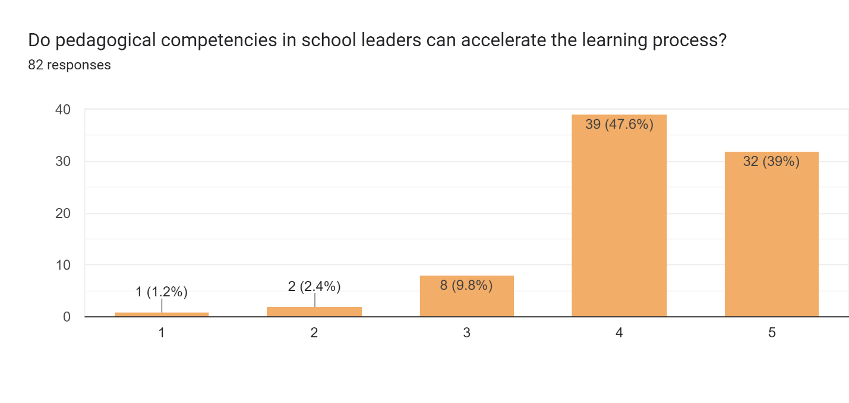
Figure 4.3.3 Pedagogical Competencies' impact on Learning Process

Impact on the pedagogical process
In this question about knowing the impact of skills and competencies of school leaders in the educational process, the participant's response was unanimous and clear. 85.4% of the participants choose the yes option in favor of the statement. It is clearly stated that it has a big impact in this regard. School leaders significantly impact the teaching process because their skills and talents influence how well learners are being taught. The concepts, techniques, methods, and perspectives educators use are too important to create awareness of progress in school and are known to it as teaching methods. Effective school leaders have a wide range of skills that significantly impact the educational approach, enhancing academic results and the effectiveness of the school across the board. Initially, school leaders must be well-trained in educational ideas and techniques. To supervise and encourage their academic colleagues, they must be thoroughly competent in diverse pedagogical approaches, educational backgrounds, and assessment methods. School leaders need to understand learning concepts, curriculum, and teaching methods. Due to this, they will be prepared and able to facilitate continuous professional growth, give useful feedback, and link the teaching approach with the school's objectives. Effective school leaders also have excellent leadership skills, positively impacting learning.
School leaders also have the ability to create an environment in schools that promotes teamwork, creativity, and continuous development. Competent school leaders who encourage and lead their academic teams always establish a positive and welcoming culture that approaches development, growth, and achievement. Educational leaders can create a culture of competence by setting high expectations for learners and teachers. The school environment helps lead the pedagogic practice in the direction that produces the expected outcomes. The result of the data collected in this research study is tremendous 85.4% of the total participants chose the option yes in response to the question about the school leader's skills and competencies impacting the pedagogical process. Many participants were convenience with the statement to know the impact of school leaders' skills in the pedagogical process and learning. By choosing the option yes, they admitted the importance and impact of school leaders in achieving the set objectives with the coordination of teaching staff and for the satisfaction of the students in the school.
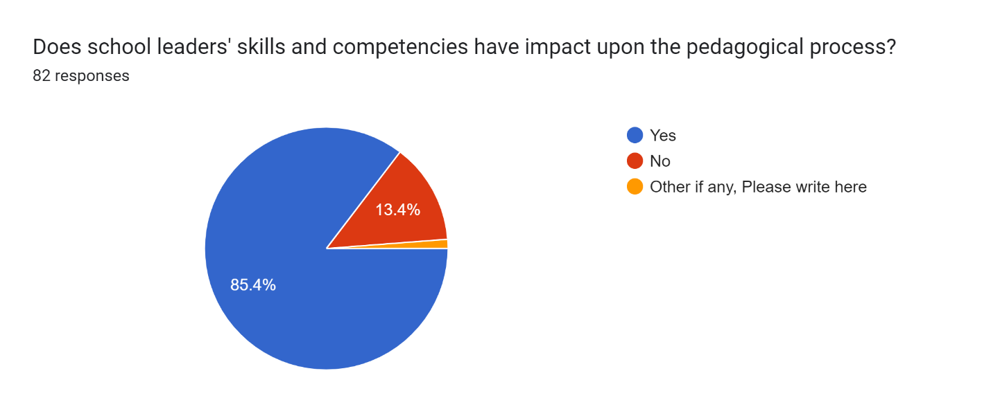
Figure 4.3.4 Influence on Pedagogical Process

Teacher’s Skills Development
85.5% of the participants agreed with the statement that the pedagogical competence of school leaders influences the improvement of teachers' skills. They were clear about their impression of the development of teachers' skills and their work. The competence of school leaders influences the improvement of teachers' competence for effective teaching in schools. Teachers are crucial to the development of our students' ideas and potential and are the foundation of any society. Teachers collaborate with others in this endeavor. "Learning from colleagues within the school is recognized as an invaluable source of continuing professional development." (Niazi, 2012; Fullan, 2001; Guskey, 2002; Retallick, 1999).
The educational experience is also strongly influenced by school leaders, principals, and administrators. Pedagogical competencies, the understanding, skills, and abilities that school leaders have about learning and teaching, are important for successful school leadership. "School leadership is not a one-person show; it requires the collaboration of all stakeholders inside and outside the school. It would recognize the active involvement of parents, academic liaison with other educational organizations, academics and professionals, and even the findings of the latest research on school leadership". (Raza et al. 2021). This study analyses how the pedagogical engagement of school leaders can enhance teacher competencies and improve student outcomes. Strong pedagogical skills enable school leaders to support their teachers through stronger instructional leadership. This requires careful assessment of learning and formulation of instruction.
In addition, learners receive support and feedback and are motivated by effective teaching methods. Teachers' teaching skills could be more equally valued, and specific areas of professional improvement could be provided by school leaders competent in pedagogical matters and their continuous development. They could set an example for their team in lesson management, planning, lecturing, training, coaching, and mentoring, focusing on effective teaching strategies and assessment procedures, including classroom implementation plans. Participants emphasize a school leader's productive role in developing teachers' desired skills to be effective and productive.
Principals with pedagogical skills can create a positive school environment that supports the continuous professional development of teachers. When school leaders have such a strong understanding of the educational process, they can create an environment that enables teachers to actively evaluate current teaching activities, collaborate with their colleagues, and encourage continued participation in professional development. School leaders need to model good teaching practices in regular interaction with teachers by setting performance standards. Teachers should be encouraged to develop their skills and keep abreast of the latest research and teaching standards in order to achieve excellence in their teaching in an environment that encourages continuous improvement. Consequently, teachers' confidence in teaching particular subjects has a positive impact on pupils' academic outcomes. Teachers can be evaluated and given appropriate feedback by school leaders with academic skills and content knowledge. As part of their role in classroom management, school leaders need to analyze teachers' work and provide feedback that motivates them to be more aware and effective.
Principals with methodological experience can provide meaningful classroom assessments, analyze student records and offer helpful advice based on standard educational practices. With such input, teachers can evaluate their approach, identify areas for improvement and adapt materials as necessary. To help teachers address their specific issues and weaknesses to improve their teaching skills and student success, school leaders can use their pedagogical expertise to continue to provide specific resources and encouragement. The development of teachers' skills, and ultimately the level of pupils' learning, depends largely on the pedagogical competence of teachers and school leaders. School leaders can lead teachers and create a positive and productive school environment if they are equipped with strong pedagogical skills, competencies, and capabilities. Here is the graph of the results collected from the participants in this research study.
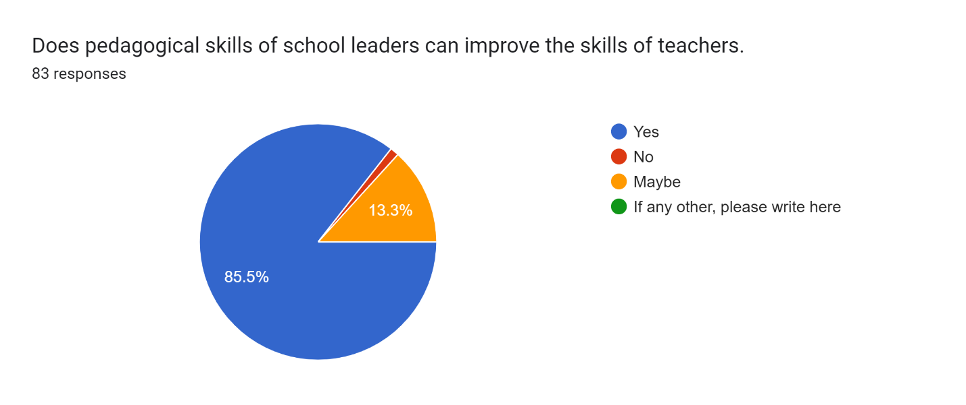
Figure 4.3.5 Teacher’s Skills Improvement

Designatory Role

Supervisory Role of school leader

School leaders, such as headteachers or principals, who are working to oversee the primary level of schooling, including pupils in grades one to five who have moved on from preschool to primary. Many aspects are considered important for the involvement of school leaders at the primary level. To ensure that the primary school functions efficiently and effectively, school leaders monitor and manage it continuously. In addition to managing resources, developing policies, and managing staff and teachers, they typically make decisions that have a major impact on the organization’s overall functioning. One of their basic responsibilities is to ensure that the curriculum and syllabus are implemented as planned.
School leaders are necessary for the effective delivery of the curriculum at the primary level. School leaders work with teachers to ensure that the curriculum follows pedagogical excellence, monitor their teaching practice, and help and support teachers to improve and modify current strategies where necessary. The development of learners is the responsibility of school leaders. Teachers ensure that children are comfortable, and motivated, and have enough materials and support to develop. They can organize student support, deal with disciplinary matters, liaise with parents, and build links with the community. Staff development is the responsibility of school leaders to keep them updated with the best techniques and information regarding their work and needs. School leaders provide guidance, analysis, and collaboration to strengthen pedagogical approaches, motivate continuous learning, and encourage the personal and professional growth of the team.
In order to work co-operatively and to develop a positive reputation in the school's community, school leaders need to engage with parents, guardians, and the community. Headteachers may organize meetings with prominent community members from different fields, academics, educators, social workers, etc., parent-teacher meetings to gather feedback on teaching, and some other programs to involve families and special individuals in the activities of the primary school. In a general understanding of the school leaders at primary schools in Pakistan, there is no need to teach a class or a subject; they are responsible for supervising the whole teaching process and supporting them with all other responsibilities. However, their supervision and leadership are necessary to play an effective role in primary schools and to maintain the best possible learning opportunities for pupils. School leaders need to keep an eye on the teaching and learning process under their supervision. The supervisory role of the school leader is perceived by respondents to be dominant at the primary school level, with almost 64% of respondents giving the highest score to the role of the school leader. Many dimensions need to be addressed in order to satisfactorily fulfillment of the responsibilities of a school leader in a primary school. The second highest score in support of this option is almost 23%. Interestingly, almost 11% of participants felt that there was no need for the supervision of primary school leaders. However, the majority of participants agreed and chose the option to supervise the school leader at the primary level.
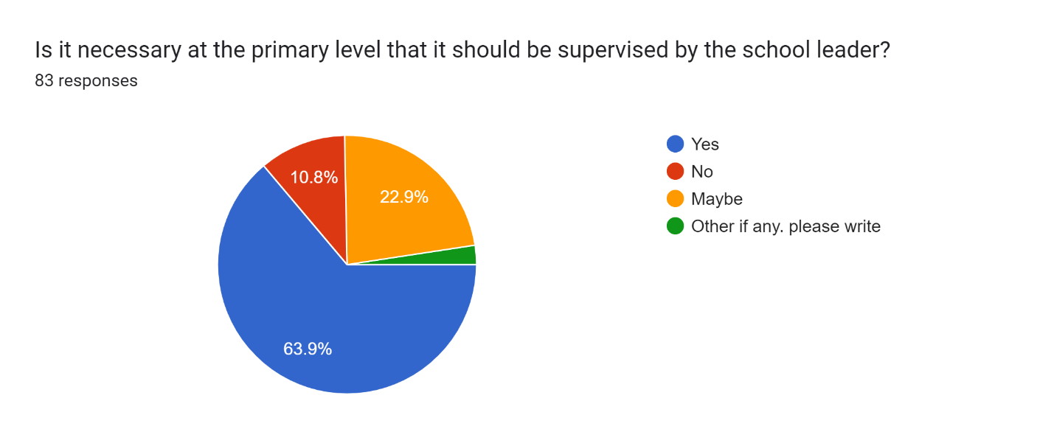
Figure 4.4.1 Supervisory Role of School Leader

Teacher’s Pedagogical needs
Having pedagogical competencies in school leaders can improve the performance of teaching staff was a question added to the questionnaire to collect responses. 85.5% of the participants agreed that the presence of pedagogical competencies in school leaders can improve the performance of the teaching staff and the pedagogical team. It reflects the understanding of participants toward the role of school leaders in this regard. Certainly, the presence of pedagogical competence in school leaders can significantly improve the effectiveness of teaching staff. The understanding, skills, and capacities associated with productive teaching and learning methods are considered pedagogical competencies. Effective pedagogical competencies enable school leaders to actively support and guide their academic staff, which in turn has a positive impact on both teacher and student performance. Effective instructional leadership involves setting clear expectations for teacher effectiveness, paying attention to classroom management, and providing helpful advice to teachers. School leaders with pedagogical skills can provide this kind of supervision. As a result, schools and teachers can improve their pedagogical practices and promote a favorable learning atmosphere for pupils. Professional development is an important influence on teacher performance. It is based on school leaders' understanding of and best practices in learning and teaching. School leaders with academic skills plan and implement comprehensive professional development initiatives to improve their teachers and staff. Improved academic performance in the classroom ensures that teachers are working effectively and receiving appropriate and effective support to develop their professional skills. Ongoing curricular and instructional support to teachers with expertise and instructional skills from school leaders can provide direction and guidance for achieving school goals and effective learning for students in the program. The result can be improved in student achievement and results by enabling teachers to provide strong teaching.
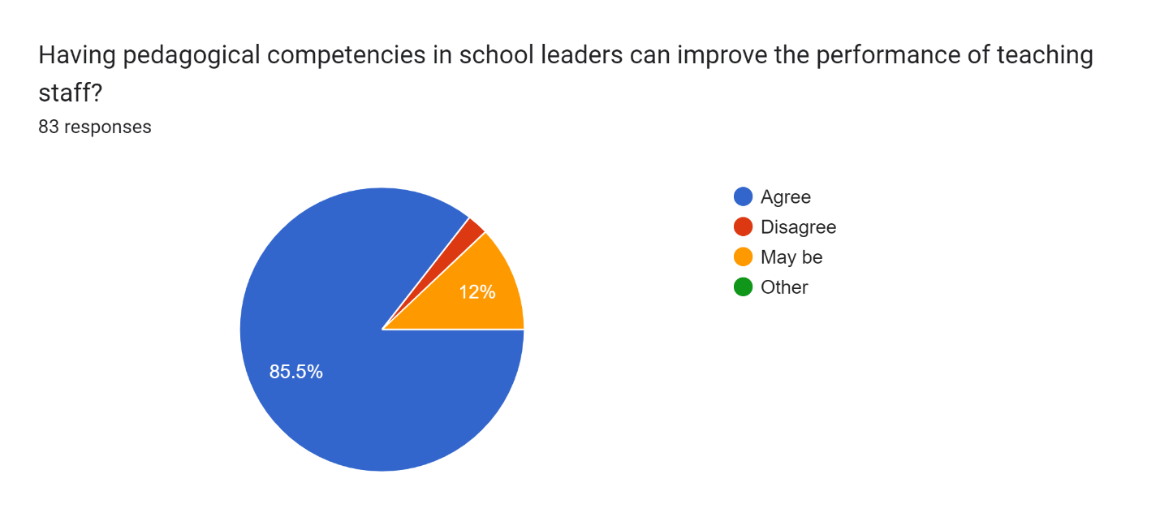
Figure 4.4.2 Performance of Teaching Staff

Teaching Assignments in School
The research was conducted on Pakistan's education system, the role of school leaders, and the competencies and skills required to work effectively in schools, particularly primary schools. Based on the graph at the end of the narrative, 51.8% of the participants chose the option, which indicates that it depends on the school leader. It is not a hard and fast rule to teach in classes, give lectures, or tackle a certain subject in any class. In terms of visiting a class or subject, or cooperating with the pupils and teachers, the headteacher is completely in charge. The basic and main purpose of interacting with students is to know the actual state of learning and to evaluate the teaching methodology in the class.
School leaders in Pakistan are primarily responsible for overseeing the whole teaching and learning process, managing classrooms, implementing syllabuses and curriculums, completing tasks, modifying them as necessary, and interacting with staff and teachers in order to understand the classroom working conditions and discuss the progress of students. As a result of these school leaders' responsibilities, visiting classes or subjects will be very difficult. This graph clearly illustrates that almost 70% of all participants agree that school leaders are not required to perform regular classroom duties. 18% of them chose the option that it depends on the school leader. This is because some of the participants have worked with school leaders who have special classes or subject classes in primary schools.
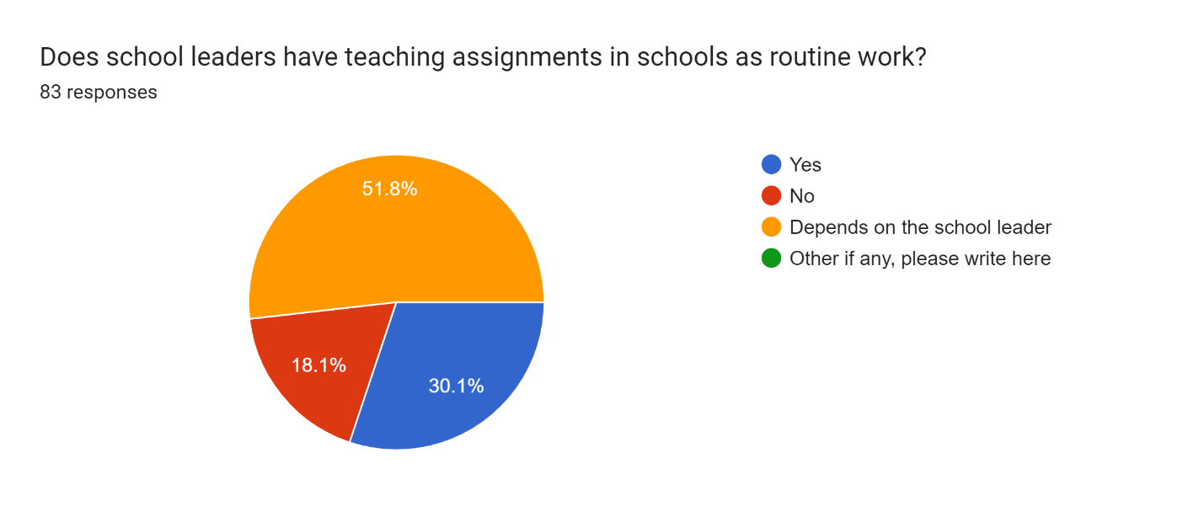
Figure 4.4.3 Teaching Assignments for School Leaders

The Duties of the school leader
In a primary school, a school leader's major responsibility is to manage and lead the school efficiently to ensure its success. "When it comes to leadership in primary schools, the subject matters. More sophisticated constructions of teaching are necessary that take into account the subject matter (e.g., mathematics or literacy) and the dimension of teaching (e.g., content and teaching strategies)" (Spillane, 2006). A primary school leader's core roles include academic leadership. The only individual with the authority to establish and enforce high standards for instruction for both instructors and students has been the school's leader.
Program development, instructional techniques, analysis techniques, and ensuring that all students and teachers achieve the school's objectives and aims are all included in this process. The school's leader is also in charge of overseeing daily operations, including resource allocation, hiring, and scheduling. Implementing educational procedures and rules, ensuring compliance with essential rules and regulations, and building a constructive school environment are all part of his or her duties to make it assure. In order to help instructors, improve their teaching methods, the school administrator oversees and controls them. It includes reviewing and evaluating student work, giving teachers feedback and chances to enhance the quality of their work, and supporting teaching methods that are beneficial in raising students' academic progress. School leaders have the major responsibility of creating an environment conducive to teaching and learning to promote overall success, including the well-being of students, employees, and the school environment. The main duty of a school leader at a primary school is to establish a workable, innovative, and productive environment and to oversee the entire teaching and learning process in order to accomplish goals. Using information gathered from respondents to determine the primary responsibility of a school leader among the options provided, it was discovered that 47.6% of all respondents believed that a school leader's main duty is to develop the skills of their staff to be effective teachers and training resources. The primary duty of a school leader might undoubtedly be this.
Also, creating a suitable and productive environment in the school received the participants' second-strongest view. This Competence has a 41.5% support score. This places it rather high and indicates how significant it is as one of the top and most important Skills needed for a school leader. Also, in this research investigation, the only factor that received a score of 8.5% was the supervision of the academic process. Different regions, localities, degrees of education, length of experience, and other elements of the job description of school leaders could affect it differently. The fact that school leaders form the foundation of the entire school system in every aspect is, however, evident and resounding. The participants showed concern about the school leader’s skills and competencies in schools at the primary level, but they have different opinions and some of them were hesitant to respond due to their experiences at their schools, or have confusion about the prime duties of the school leaders.
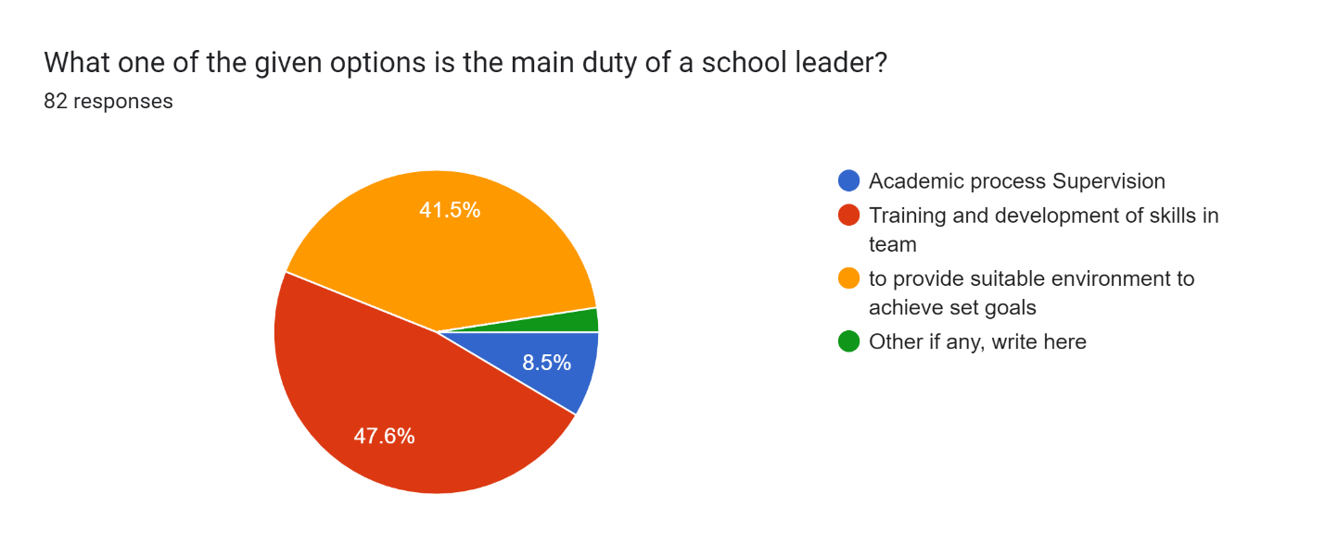
Figure 4.4.4 Duties of School Leaders at Primary School Level

Learning Outcomes

Competencies Segregation
This research study aimed to identify the pedagogical competencies required of school leaders in Pakistan, specifically at the primary level, and to what level and to what degree proficiency is required. A division was made of the most focused competencies of the school leader as a researcher to identify the level of need and fulfill his or her responsibilities. There were five options provided in total. The first was with the title of academic material development and support, the second was teaching skills, the third was about the subject knowledge, and the fourth was about developing an effective environment. Furthermore, the last one was about if the respondent of the research questionnaire think that all of the competencies mentioned are necessary for the successful role of the school leader. They can choose the last option, with the title of all of the skills mentioned earlier and competencies necessary for school leaders to lead their teams and manage the school effectively. The results are displayed in a graph here; 51.2% of the total participants selected the last option, which says all of the competencies listed in the questionnaire are necessary for a school leader to be effective and successful.
Moreover, the rest of the participants chose different opinions. For example, the second highest score was about 24.4% for teaching necessary skills, and the third highest score was for developing an effective and positive environment, with a total percentage of 11%. Furthermore, 8.5% for academic material and support to their teams and pedagogical staff for better teaching, and the least score acquired in the questionnaire in this specific question was about the subject knowledge. It acquired only 5.1% of the total score. Moreover, this is the total responses collected to know the priority of skills in the eyes of participants working in the educational environment and experiencing different scenarios.
It reflects the importance and crucial role of school leaders in the schools and the educational system. school leader brings continuity to the process of learning for students and in providing a suitable and productive environment for teachers to deliver the right and accurate knowledge and content to learners, with quality education, effective method of teaching, skill-based teaching, focused teaching on the weak areas to improve the learning with students bring the desired results. Different competencies are required as an effective school leader, and all skills possess their place. No one can deny the importance of the school leader’s role in managing and creating the environment for teachers to teach with their best and provide support in any query as an immediate resource. Yet, it is exceedingly challenging for one person to hold all of the necessary abilities and competencies while serving as a school leader. Participants then share their responses following their needs and comprehension. and the data gathered indicated that there is an urgent need to concentrate on these competencies.
There are a lot of competencies and skills required for a successful school leader in terms of responsibilities and fulfilling duties effectively. Some of them are mentioned here for acquiring a general overview, but here are some more competencies for information and more clarity of the concept, for example, educational management, community connection building, technology literacy or ICT knowledge and awareness, positive behavior, continuous development, self-assessment, and self-reflection and much more needed. These skills and competencies bring positivity to their characters and extensive growth in their professional life.
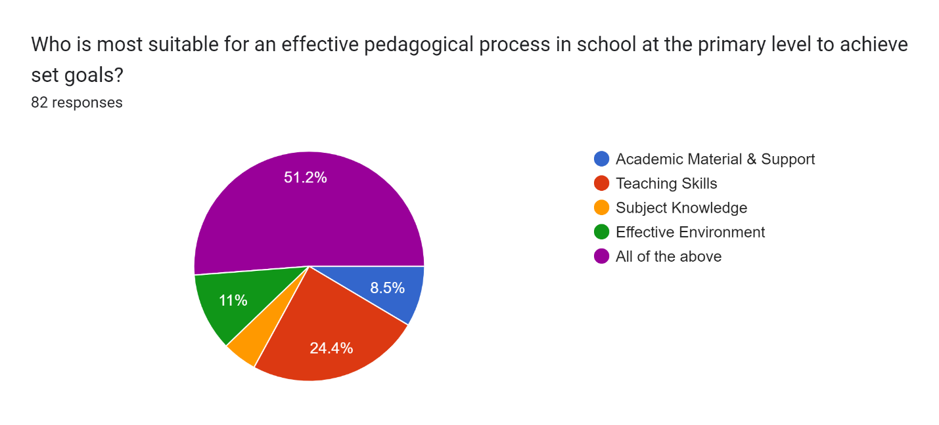
Figure 4.5.1 Pedagogical Process effectiveness

Qualities in School Leaders
Studies have shown that depending on the situation and the capabilities of the school, education leadership requires a variety of degrees of competencies and that this involves a wide range of skills. A school leader should have a clear vision, excellent communication skills, effective leadership and management abilities, pedagogical competencies, emotional intelligence, ethical and moral integrity, multicultural and inclusive behavior, adaptability, academic knowledge, etc. Among other qualities, these are a handful that are deemed important and might even be considered necessary. As was previously said, an effective school leader may require a variety of skills. Four separate sets of competencies were added to the questionnaire to offer a list of the competencies and skills that should be shortlisted in this study to better understand the attitude of teachers working in Pakistani elementary schools. Options were added in four categories: highly qualified, executive education, and experience. Only 16% of the participants chose this option. The second category was professionally qualified, pedagogical skills and experience for school leaders, scoring the highest feedback from the participants, 45.7%. The third option was that the school leader should be well experienced and educated as required for the designation and be a mentor. 37% of the participants chose this option and provided them with an option for their view to add the required Competencies in the school leader. The result collected in this research study shows that professionally qualified with pedagogical skills and competencies should be in the qualities and skills of school leaders to effectively manage the whole structure with their teams and for developing a learning environment for students and a supportive and productive environment for teachers to achieve set objectives.
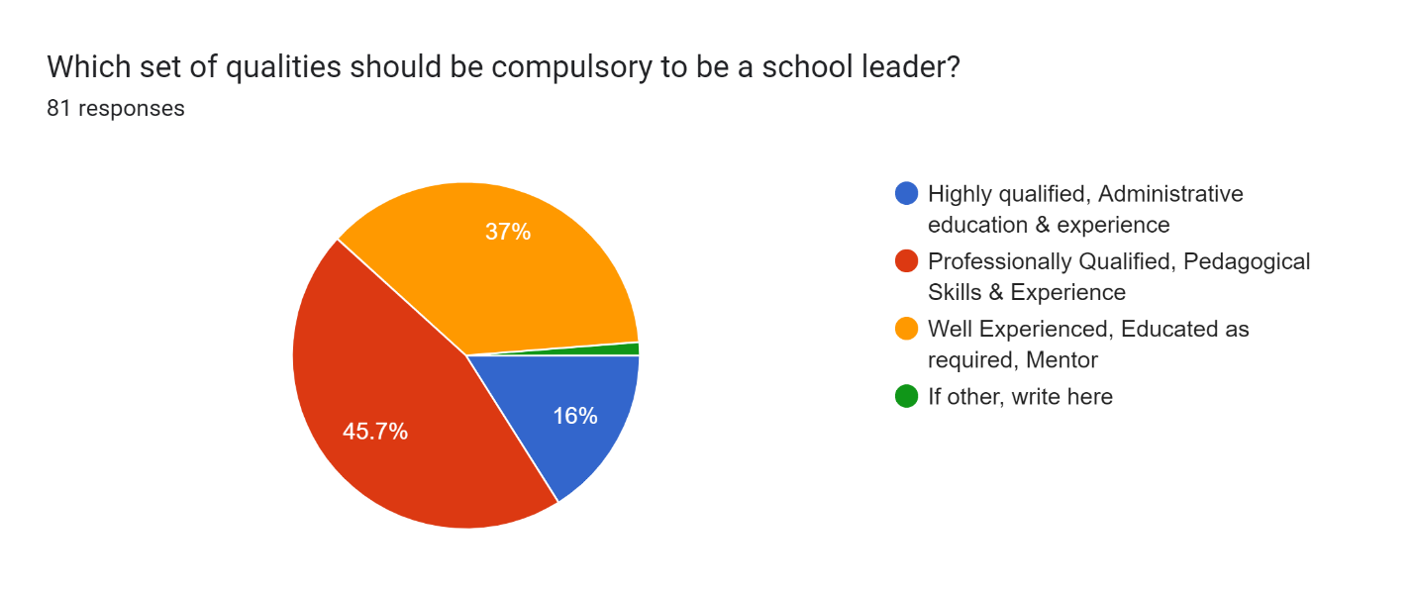
Figure 4.5.2 Qualities in School Leaders

Improvement of Pedagogical Skills
To enhance pedagogical performance at the primary level of the school, a variety of methods and platforms can be used. Several of the tactics, which are helpful in influencing teaching practices, are discussed here. Student-centered Strategies spend time and effort creating a learning environment that is focused on the needs, goals, and abilities of specific students. To inspire students and foster their capacity for critical thought, passionate teachers can also use inquiry-based pedagogies, individualized learning plans, and curriculum design. Teachers who pursue professional development have an ongoing opportunity to improve their instructional abilities. It may also cover lesson planning, the use of technology in the classroom, and training in efficient teaching and evaluation strategies. When educators struggle, it's crucial to support and encourage them.
One of the key components to enhancing effective teaching strategies in schools is the use of the right learning resources. Use the curriculum's resources and materials under the demands and prowess of elementary school students. Use diverse teaching tools, such as multimedia components, flashcards, and technology, to make learning more fun and useful. Make sure the educational resources are pertinent, helpful, and thorough to meet the learners' varied learning needs. Create an environment that values collaboration, creativity, and active student participation to establish a healthy classroom culture. Promote group work, conversations, and social contact. to foster a friendly learning environment and a strong teacher-student connection based on trust and open communication. Use ongoing evaluations and formative tests to monitor the development of your students.
There are different ways of improvement in skills and competencies in teachers' performance at school in classrooms. Some of the points mentioned in the questionnaire are to collect the response of the experienced teachers as participants. There is a way to develop the skill through continuous training and workshops arranged for teachers and pedagogical staff. Different exercises can be practiced to address the issues that arise with students in class. Almost 24.4% of participants responded in favor of continuous training to develop the skill and practice different teaching methods and techniques in training and workshops arranged by the school, group, district authority, or state level. It can be beneficial and strongly influence teachers to work efficiently. Allama Iqbal open university (AIOU) is a prominent university established in 1970 in Islamabad, the capital city of Pakistan, which aims to distance learning programs, refresher courses, and short courses in every field. It mainly builds educational capacity by providing distance and teacher education courses leading to PTC (Primary teaching course), CT, and B. Ed degrees. (Kizilbash, 1998). “The university also offers courses in the education of managers and planners. Those courses included pre-service and in-service programs for teacher certification and other graduate and post-graduate professional qualifications in education. The basic aim is to promote professional education and Competency building of accreditation of this university”. (Teacher Education, position paper, 2004).
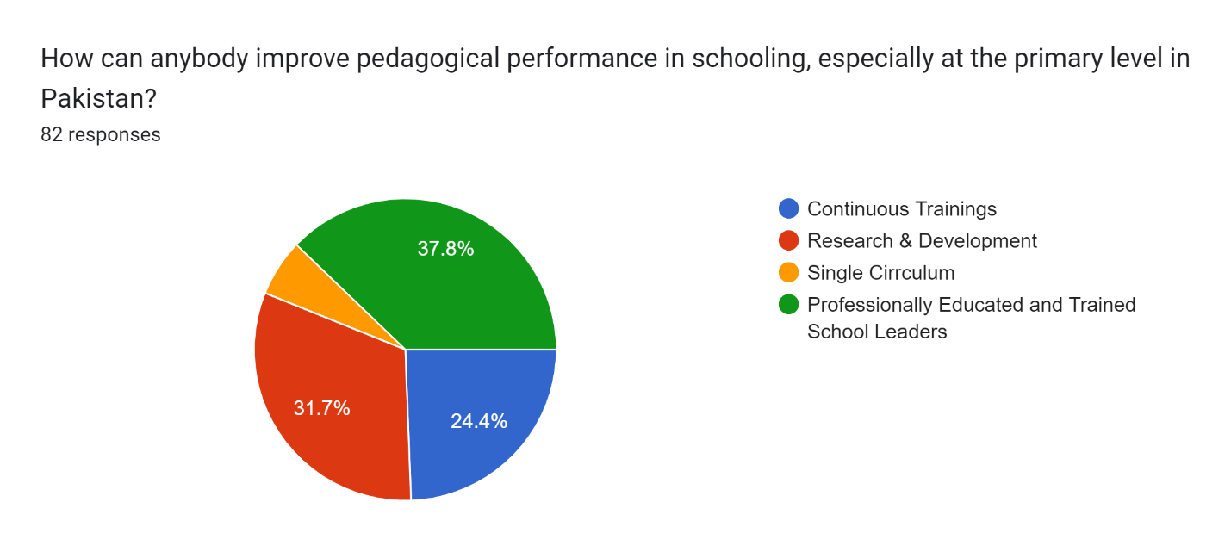
Figure 4.5.3 Measures to improve pedagogical performance

Conclusive Approach

Feedback & Reflection
A question was asked to get feedback and learn the perspectives of Pakistani primary school teachers who were research participants. This study explores the impact of school leaders' pedagogical competencies. The question was added to help clarify the results of the data gathered in response to the questionnaire. The main research methodology is a quantitative approach, but as an additional component of the research methodology, a qualitative research approach is also used here. Below is a brief explanation of the major issues they have with the highlighted points. Their pedagogical expertise in educational settings has a significant and discernible influence on the methods and strategies used in managing the classroom and the academic success of the pupils. A school leader has a challenging professional obligation, particularly in Pakistan's primary schools. Participants shared their feedback in an open-ended question, some of the main points are shared here. most of them are explored in the content shared.

Continuous Training.
The majority of participants express worries about continuing their professional development after entering the noble profession of teaching. To adapt to the needs of a changing world, however, they must constantly upgrade. Professional training sessions are not frequently organized and held in Pakistan, nor are any events, or workshops organized at the state level or by any pertinent ministry or body. Through the training and workshops, the teachers can make use of their prior knowledge and abilities, and their thinking styles will change. They can also acquire the necessary skills to effectively manage the classroom, which adds value to their attitudes, ideas, motives, and intentions for their professional lives and growth. By enabling teachers to contribute useful ideas to their schools, training empowers them, and school administrators will benefit from team coordination. (Higgs and Higgs, 1994). Mayer and Lloyd (2011) cited Knapp’s (2003) definition of professional development as ‘the full range of activities, formal and informal, that engage teachers or administrators in new learning about their professional practice’ (p.112). The majority of the respondents express their reservations and concerns in this area regarding their encounters with and expectations from the schools where they are employed. The lack of pre-service and in-service training was the main source of worry. When discussing and making recommendations, specifics are presented.
Figure 4.6.1 Feedback Response from Participants

Discussion
Further discussion of the research dimensions and the study's findings is provided in this chapter to help the reader understand them. Some of the details are not included in the results chapter because they pertain to the educational culture and structure of Pakistani schools, particularly those at the primary level, rather than the study's findings.
The study's major goal is to learn more about the role, essential capabilities, and abilities of school leaders in Pakistani primary schools. In this approach, the leadership development process at the school may advance and bring about beneficial and necessary changes in educational culture and environment settings, some of the important aspects addressed in previous chapters with facts and statistics for better and clearer comprehension. The study's participants provided the data used in the graphs, diagrams, and tables that were disseminated. Based on the data gathered, one can comprehend the skills needed to effectively perform the function of a school leader and what teachers anticipate of them. This study tries to understand how a school leader may create an appropriate teaching and learning environment to increase instructors' engagement with students. First off, due to their exposure and learning, professionally trained and seasoned school leaders have a greater influence on the teaching and learning that takes place with their team and staff members. The findings indicate that more qualified school administrators are needed in order to alter their teams’ performance and help the school reach its objectives quickly and significantly. While they are still fairly young, primary school students require extra care and frequent practice in order to get better outcomes. It is one of the most important requirements for staff workers and teachers with advanced degrees.
The study reveals that the majority of participants expressed their worries and gave an answer in support of the improvement of leadership skills in schools. Because instructors concentrate on classroom instruction, lesson planning, and student-related issues, there needs to be more interaction between school administrators and teachers. The position of the school head is, nevertheless, fairly extensive in Pakistan. Lesson preparation, execution, resource management, formal matters, team monitoring of documents, cooperation with higher authorities or offices, meetings, training, assessments, and evaluation are just a few of the many aspects it has. There aren't many opportunities for teachers and their performance reviews to communicate. For the weak points in class management to be strengthened, effective teaching requires ongoing and adequate attention. Establishing ties with the community and parents is one of the main responsibilities of school administrators. Therefore, there is a need to better segregate the roles and responsibilities of school leaders in order for them to work efficiently, play an inclusive role in participating in the entire teaching process, and develop a positive and productive environment with the interaction of teachers in order to achieve the goals and obtain the best results from students.

Necessity of Pedagogical Skills
Pedagogical competencies are very important for a person who works as a teacher or a member of the pedagogical staff in a school because pedagogical competencies are the main and important requirement for effective teaching to the learners to achieve the set goals. Pedagogical practice is a way to provide a way and strategy for the teacher and members of the pedagogical team to educate the learner by providing knowledge and information with developing the correlation with their prior knowledge and improvising the understanding. The more important aspect of pedagogy is to build on the learner's learning and develop skills to achieve the objectives.
A question was added to the questionnaire to know the necessity of pedagogical competencies for the role of school leaders. A further intriguing finding from the study was that 42% of the participants believed it should be necessary for a school leader. Moreover, the highest score is 54.3% in favor of the professional knowledge that a school leader should have. A large number of participants share the view that a successful school leader should have professional knowledge such as pedagogy, teaching skills, collaborative skills, assessment, and evaluation skills to give feedback and support their team to project their teaching and classroom management properly. Providing classroom management, professional development, guidance and encouragement, pedagogical support, and maintaining pupils' academic records, school leaders with pedagogical skills could significantly improve teachers' performance. School leaders develop a positive and supportive environment for teachers and learners to improve their performance and outcomes for both learners and educators. Their understanding of effective approaches to teaching and learning learned and experienced throughout their careers, equips them to lead the team in a school.
The pedagogical competence needed in a school leader to successfully manage staff and the teaching team, to create an environment conducive to successful teaching and learning outcomes, and to use effective management and leadership strategies. Pedagogical skills are necessary for school leaders in their role in the school to create a viable environment for teaching and learning, evaluate the whole teaching process from time to time, analyze teaching practices, and, most importantly, manage the appropriate environment and resources. It may be different at different levels of the school, e.g. preschool may be different from primary school, and primary and secondary schools may require different levels of competence. For successful teaching and an effective learning process, the school leader should have strong pedagogical competencies; they strongly influence the routine work and the objective achievement of the school's learners and teachers.
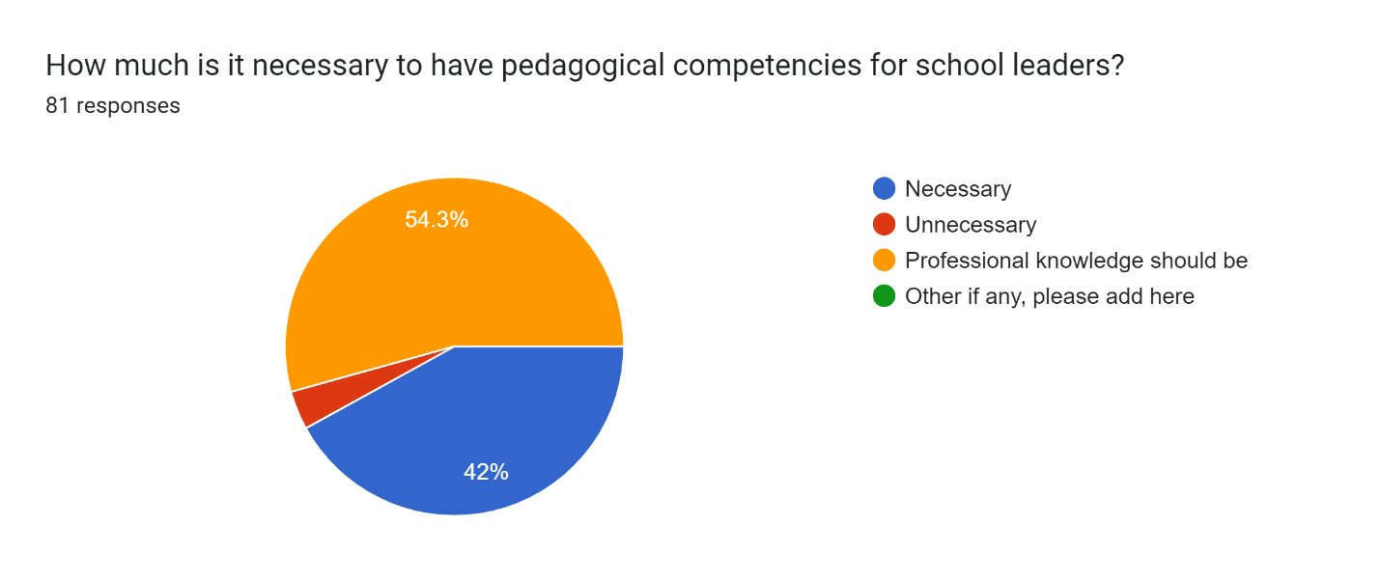
Figure 5.1.1 Pedagogical Competencies for School Leaders
The educational system in Pakistan has a short history and structural development. This information is shared in order for the reader to gain a better understanding of the concept. A new country came into being with the name of Pakistan in the year 1947. 32.5 million people were living in Pakistan at the time of independence, and 15.1 million of them were women. "A high-ranking British official, General Sir William Sleeman (1788–1856), writes in his memoirs about Muslims' position in education in the early 19th century (when Muslims had lost even the weak government in the Center): "Perhaps there are few communities in the world among whom education is more generally diffused than among Muhammadans in India. He, who holds an office worth twenty rupees a month, commonly educates his sons to be equal to a prime minister. They learn, through the medium of Arabic and Persian languages, what young men in our colleges [British] learn through those of Greek and Latin grammar, rhetoric, and logic. After seven years of study, the young Muhammadan binds his turban upon a head almost as well filled with things which appertain to these branches of knowledge as the young man from Oxford. they will talk as fluently about Socrates and Aristotle, Plato, and Hippocrates, Galen, and Avicenna". He has learned what those which he most requires through life are. Therefore, he thinks himself as well fitted to fill the big offices now filled exclusively by Europeans." (Khalid et al., 2006).

Recommendations
In the context of the results, some recommendations are given in this thesis for improving the pedagogical competencies and skills of school leaders at the level of primary schools in Pakistan. A short note is presented here.

Training
The first is the necessity of comprehensive pre-service and in-service training courses to focus on acquiring educational competencies with management and administration capabilities. All schools, especially those located in remote and underprivileged regions, must have accessibility and be able to pay for these initiatives, which should be customized to meet the particular needs of school leaders. Targeted training, workshops, and refresher courses can improve the work of school leaders and overcome the deficiencies, if any, they have.

Professional Development
In order to provide a supportive and inclusive culture for continuous professional development, schools, and relevant authorities must provide a supportive and inclusive learning environment. There should be opportunities for school leaders to get involved in blended learning, mentoring, coaching sessions, and experiential learning belongs to this group. It also includes developing a creative environment, exploration, and continuous growth in terms of pedagogical approaches.

Competence development
Thirdly there should be considerable efforts to resolve relevant factors that prevent the development of pedagogic competencies. This might include working for major reforms, solving social inequality, and increasing and simplifying systems and procedures to facilitate the ability of individuals to access data for leadership learning. This study also indicates that further research is needed to examine the impact of school leaders' pedagogical competencies on learning outcomes and explore additional variables related to developing these competencies. In Pakistan, similar studies across different regions and learning environments, primary methods, and observational research are all likely to be useful in spotlighting the problems in the pedagogical learning process.

Conclusion
“Effective leaders view data as a means not only to pinpoint problems but to understand their nature and causes” (The Wallace Foundation, The school principal as leader, Edition, E. (2013). Research findings are expected to contribute to the understanding of pedagogical competencies necessary to develop creative and productive learning environments. The results of the study will be used to identify the factors that contribute to successful professional development programs aimed at enhancing these competencies, as well as how they can be developed. School leaders may face challenges and barriers to achieving these competencies, and the study will offer strategies for overcoming them. Finally, the study will contribute to the body of knowledge on the impact of school leaders' pedagogical competencies on the teaching and learning experiences of students and teachers in their schools. The findings of the research could have significant implications for school leadership development programs, as well as for the design and implementation of school-based professional development initiatives. By identifying the specific pedagogical competencies that school leaders need to cultivate a productive and creative environment for teaching and learning, this research could help to inform the development of targeted leadership development programs that can effectively support school leaders in meeting the needs of 21st-century learners. In conclusion, a school leader who possesses the above-discussed aspects can be a good and effective leader at school, enhance the performance of teachers and staff, and improve the administrative structure, professional development, and management capabilities. The desired outcome is possible with teacher training programs, meaningful curriculum design, and implementation. There should be space for modification if needed, work on the teaching techniques and methodology, school culture improvement plans execution, collaborative relation with the teachers and staff, taking into consideration important decisions for better output, up to date themselves and their teachers also, and always try to learn new strategies and bring into stream step by step. Professional development is a way to bring positive and immersive changes in the whole structure, productivity, and positivity in the teaching and learning environment. "Professional learning community is a group of behavioral complexity and implementations of policy and planning, for those administrations which can move into a future with a broad perspective in mind and ensuring the long-term changes. (Niazi, S, 2012)".
The study presented in this thesis reveals the vital position of pedagogics in school leaders at the level of primary schools in Pakistan. A study shows that effective primary school leadership involves more than simply having administrative and management skills; it requires a solid understanding of the pedagogical process of teaching and learning and the ability to guide and support teachers effectively. Pedagogical competencies in school leaders are multidimensional, covering domains including curriculum planning, classroom management, evaluation and review, professional growth, and developing a positive atmosphere for learning, based on a review of the research. According to a study, school leaders with significant pedagogical content knowledge are more capable of creating an environment with a positive attitude and being productive for effective teaching and learning, encouraging practical teaching techniques, and enhancing students' performance. The outcomes of this thesis give insight into the key importance of pedagogical competencies in primary school leaders in Pakistan. The research has shown that solid pedagogical competencies are required of successful school principals to provide high-quality educational experiences. In the review of the literature and in the research that was conducted, the significance of pedagogical competencies was highlighted for strengthening student performance and overall educational effectiveness.
According to the research, many primary school leaders in Pakistan need to have the required pedagogical skills, which may create difficulties in the quality of teaching within those schools. When many school leaders have leadership and management skills, they sometimes need the understanding, knowledge, and capabilities required to effectively teach and design coursework, and teaching strategies, evaluate learners' progress and many other academic aspects. Based on this research, such pedagogical Competency deficits may result in ineffective teaching approaches, poor student performance, and unsatisfactory academic achievement. Also, the research study discovered several factors that impact Pakistani primary school leaders' inadequate pedagogical competencies. Participants shared their responses with scores, which reflect insufficient pre-service and in-service training programs, inadequate opportunities for professional development, a lack of a school environment that encourages continuous learning, and time and workload-associated requirements. The following factors, like economic factors, cultural values, and organizational difficulties, additionally influence how effectively school leaders improve particular pedagogical skills.
In summary, school leader competencies at the primary level schools in Pakistan are the topic of this research study to know the pedagogical staff's and teachers' experiences and observations. Pedagogical competencies are necessary for school leaders to ensure the success of student learning outcomes and general well-being. Many competencies are also needed at the same time to manage the whole learning process and continuous development, curriculum knowledge, and its implementation, pedagogical techniques, effective teaching, valuable assessment and evaluation of staff and students to know the real situation, as well as the continuous training and refresher courses; these are all areas in which effective school leaders can be competent and eligible to conduct the process of teaching and learning. On the other hand, they should be skilled at creating a welcoming and effective learning environment, promoting teacher cooperation and professional growth, forging strong bonds with students and their families, and maintaining their institutions' efficiency and performance in the way needed. School administrators with strong pedagogical skills can manage their budgets, personnel, and physical space. This study's conclusion highlights the usefulness of pedagogical competencies of school leaders at the primary school level in Pakistan. The research shows the figures and stats to explore and ensure efficient school leadership and, to fulfill the best teaching and learning environment needs, must promote the development of all these competencies. Pakistani educational institutions and government authorities must take significant steps to improve the quality of primary education teaching and to provide the support necessary to increase overall student achievement by addressing the discrepancies in didactic competencies through specific skill training programs. Establishing a positive learning environment and providing supportive tools and platforms for learning, including educational games, games, activities, workshops, seminars, and conferences, are important ingredients for effective teaching and learning. This study will contain useful information for educational authorities, school leaders, and researchers about how to strengthen pedagogical competencies in school leadership so that student’s learning needs are satisfied, and schools' set goals are achieved. This study adds to the data on pedagogical competencies needs in school leaders, competence building, positive and productive environment development, educational process management, and pedagogy in Pakistan.

References
AEPAM Library. (n.d.) Academy of educational planning and management. http://library.aepam.edu.pk/
Afzal Tajik, M., & Wali, A. (2020). Principals’ strategies for increasing students’ participation in school leadership in a rural, mountainous region in Pakistan. Improving Schools, 23(3), 245-263.
Ahmad, N., & Hamid, S. (2021). An Analysis of Instructional Leadership Practices of Primary School Head-Teachers on Teacher Effectiveness: A Qualitative Study of Teachers' Perceptions.
Alam, S. (2012). Crafting leaders for educational change: Head teacher’s perspectives. International Journal of Social Sciences and Education, 2(1), 193.
Baig, S. (2011). The personal values of school leaders in Pakistan: A contextual model of regulation and influence. The Journal of Values-Based Leadership, 4(2), 26.
Bajunid, I. A. (1995). The educational administrator is a cultural leader. Journal of the Malaysian Educational Manager, 1(1), 12-21.
Bashiruddin, A. (2018). Teacher development and teacher education in developing countries: On becoming and being a teacher. Springer.
Begum, A. (2016). A study of a head teacher's perception of her role as an educational leader. Journal of Educational Leadership, Policy, and Practice, 31(1/2), 180-191.
Branch, G. F., Hanushek, E. A., & Rivkin, S. G. (2013). School leaders matter. Education Next, 13(1), 62-69.
Cabigao, J. (2019). Professional Competencies of School Heads and Their Impact on School Outcome, Organizational Culture, and Principals' Performance. La Consolacion University Philippines.
Channa, W. M., & Sahito, Z. (2022). Pedagogical Competencies of Teachers and the Achievement of Students: Explorations of Best Practices through a Literature Review. Webology, 19(3), 2927-2943.
Creswell, J. W. (2012). Educational research: Planning, conducting, and evaluating quantitative and qualitative research. Pearson Education, Inc.
Cruickshank, V. (2017). The influence of school leadership on student outcomes. Open Journal of Social Sciences, 5(9), 115-123.
Edition, E. (2013). The school principal as leader: Guiding schools to better teaching and learning.
Fazal, R. (2012). Readiness for inclusion in Pakistani schools: Perceptions of school administrators. International Journal of Social Science & Education, 2(4), 825-832.
Fullan, M. (2014). Teacher development and educational change. Routledge.
Hallinger, P., & Heck, R. H. (2002). What do you call people with visions? The role of vision, mission, and goals in school leadership and improvement. Second international handbook of educational leadership and Administration, 9-40.
Hoyle, J. R. (1985). Skills for successful school leaders.
Kandasamy, M., & Blaton, L. (2004). School principals: Core actors in educational improvement. UNESCO: International Institute for Educational Planning.
Khalid, S. M., & Khan, M. F. (2006). Pakistan: The state of education. The Muslim World, 96(2), 305-322.
Khalid, S. M., & Khan, M. F. (2006). Pakistan: The state of education. The Muslim World, 96(2), 305-322. part2_18http://www.columbia.edu/itc/mealac/pritchett/00islamlinks/ikram/part2_18.html
Kizilbash, H. H. (1998). Teaching teachers to teach. Education and the state: Fifty years of Pakistan, 102-135.
Mansoor, Z. (2015). The Paradigm Shift: Leadership Challenges in the Public Sector Schools in Pakistan. Journal of Education and Practice, 6(19), 203-211.
Naidoo, P., & Petersen, N. (2015). Towards a leadership program for primary school principals as instructional leaders. South African Journal of Childhood Education, 5(3), 1-8.
Nasreen, A., & Odhiambo, G. (2018). The Continuous Professional Development of School Principals: Current Practices in Pakistan. Bulletin of Education and Research, 40(1), 245-266.
Nasreen, A., & Odhiambo, G. (2018). The Continuous Professional Development of School Principals: Current Practices in Pakistan. Bulletin of Education and Research, 40(1), 245-266.
Ng, P. T. (2008). Educational reform in Singapore: From quantity to quality. Educational research for policy and practice, 7, 5-15.
Niazi, S. (2012). School leadership and educational practices in Pakistan. Academic Research International, 3(2), 312.
Niqab, M., Sharma, S., Wei, L. M., & Maulod, S. B. A. (2014). Instructional Leadership Potential among School Principals in Pakistan. International Education Studies, 7(6), 74-85.
Noor, T., & Nawab, A. (2022). Are school leaders working as instructional leaders? Exploration of school leadership practices in rural Pakistan. Cogent Education, 9(1), 2109315.
Pasha, S. (2012). Readiness of Urban Primary Schools for Inclusive Education in Pakistan. Journal of Research & Reflections in Education (JRRE), 6(2).
Peterson, K. D., & Deal, T. E. (1998). How leaders influence the culture of schools. Educational leadership, 56, 28-31.
Pont, B., Moorman, H., & Nusche, D. (2008). Improving school leadership (Vol. 1, p. 578). Paris: OECD.
Raza, M., Gilani, N., & Waheed, S. A. (2021, August). School Leaders' Perspectives on Successful Leadership: A Mixed Methods Case Study of a Private School Network in Pakistan. In Frontiers in Education (Vol. 6, p. 656491). Frontiers Media SA.
Retallick, J., & Farah, I. (2005). Transforming schools in Pakistan: Towards the learning community. Oxford University Press.
Rizvi, M. (2015). Teacher education pedagogies related to preparing preservice teachers as leaders in Pakistan. In International teacher education: Promising pedagogies (Part B) (Vol. 22, pp. 7-30). Emerald Group Publishing Limited.
Salfi, N. A. (2011). Successful leadership practices of head teachers for school improvement: Some evidence from Pakistan. Journal of Educational Administration, 49(4), 414-432.
Showunmi, V., & Kaparou, M. (2017). The challenge of leadership: ethnicity and gender among school leaders in England, Malaysia, and Pakistan. Cultures of Educational Leadership: Global and Intercultural Perspectives, 95-119.
Simkins, T., Sisum, C., & Memon, M. (2003). School leadership in Pakistan: Exploring the headteacher’s role. School Effectiveness and School Improvement, 14(3), 275-291.
Sparks, D. (2002). Designing powerful professional development for teachers and principals.
Spillane, J. P. (2005). Primary school leadership practice: How the subject matters. School leadership and management, 25(4), 383-397.
Suciu, A. I., & Mata, L. (2011). Pedagogical competencies–the key to efficient education. International online journal of educational sciences, 3(2), 411-423.

Appendix (Questionnaire)
In order to inform readers about the structure and available options, questions from the questionnaire are shared here.
Pedagogical Competencies in School Leaders at Primary Level in Pakistan
This is a questionnaire for an educational survey to collect data to know the mindset and understanding of pedagogical staff and teachers about the school leaders in the schools at the primary level in Pakistan. Teachers and pedagogical staff are the only resources who can assess and can give feedback about the school leaders at the primary level. You can choose one of the options given below as per your understanding, experience, expectations, and needs of the educational environment. This questionnaire is anonymous and intended for research purposes only. Highly thankful for your voluntary participation and for sharing your response. This data will be collected in google forms; you use the sent tab at the right top of the form after filling in all. This questionnaire is part of a thesis in the Program of Educational Research & Development at Palacky University for Mr. Imran Akhtar.
- Your name please?
- Select of your experience?
    - Public/semi-government / Government owned
    - Private / missionary / organization / chain school system
- Does your school is in rural or urban area?
- Urban
- Rural
- Length of your experience?
- Less than 1 year
- Up to 2 years
- Up to 5 years
- More than 5 years
- Do you have any specific professional degree or diploma for working as a teacher in a school?
- Yes
- No
- Do you have any specific professional degree or diploma for working as a teacher in a school?
- Yes
- No
- What is the role of the school leader in the pedagogical process at school?
- Academic support
- Execution & implementation
- Developing a suitable educational environment
- All of the above
- Does the school leader should have subject knowledge according to the class/s?
- Yes
- Not necessary
- Maybe
- If any other, please write here
In this part, there are linear scales optional against each question. The scales are from 1 to 5, the lower is 1 and the highest is 5.
- How much important is communication skill in school leaders?
(1. Not necessary ……………… 5. Compulsory)
- How important is decision-making skill in school leadership?
(1. Not necessary ……………… 5. Compulsory)
- How much important is a problem-solving skill for a school leader?
(1. Not necessary ……………… 5. Compulsory)
- How much important is management competence for school leaders?
(1. Not necessary ……………… 5. Compulsory)
- How much important is collaboration skill in school leaders?
(1. Not necessary ……………… 5. Compulsory)
- Do you think the school leader is a leader in actual means?
(1. Not necessary ……………… 5. Compulsory)
- Do you think that school leaders are considered qualified and trained sources for pedagogical work?
(1. Not necessary ……………… 5. Compulsory)
- Do pedagogical competencies in school leaders can accelerate the learning process?
(1. Not necessary ……………… 5. Compulsory)
- Do the school leaders with pedagogical competencies are necessary or school managers/administrators can supervise the whole pedagogical process for the achievement of set goals?
- School leaders/principal
- School administrators/managers
- If any other, please add them here
- Is it necessary at the primary level that it should be supervised by the school leader?
- Yes
- No
- Maybe
- Other if any, please write
- Does school leader’s skills and competencies have an impact on the pedagogical process?
- Yes
- No
- Other if any, please write here
- Do pedagogical skills of school leaders can improve the skills of teachers?
- Yes
- No
- Maybe
- Other if any
- Does school leaders have teaching assignments in schools as routine work?
- Yes
- No
- Depends on the school leader
- Having pedagogical competencies in school leaders can improve the performance of teaching staff?
- Agree
- Disagree
- Maybe
- How much is it necessary to have pedagogical competencies for school leaders?
- Necessary
- Unnecessary
- Professional knowledge should be
- Other if any
- Who is most suitable for an effective pedagogical process in school at the primary level to achieve set goals?
- Academic material & support
- Teaching skills
- Subject knowledge
- Effective environment
- All of the above
- What one of the given options is the main duty of a school leader?
- Academic process supervision
- Training and development of skills in team
- To provide a suitable environment to achieve set goals
- Other if any
- Which set of qualities should be compulsory to be a school leader?
- Highly qualifies, administrative education & experience
- Professionally qualified, pedagogical skills & experience
- Well experienced, educated as required, mentor
- If other, write here
- How can anybody improve pedagogical performance in schooling, especially at the primary level in Pakistan?
- Continuous training
- Research & Development
- Single curriculum
- Professionally educated and trained school leaders
- Suggest some changes in your school settings to improve the performance of pedagogical staff? (Open-ended Question)
- Share few words about your experience as a pedagogical member in school? (open-ended question)
- Are you in favor of conducting surveys for educational development or not?
- Yes
- No
- maybe
Link to the questionnaire.
https://docs.google.com/forms/d/e/1FAIpQLScEwCPzP_WUHcI3uN3dz8aqDX8LABrWTFRkF4uKxcnWgsXLIQ/viewform

