PALACKÝ UNIVERSITY OLOMOUC
Faculty of Arts
Department of Asian Studies

BACHELOR'S DIPLOMA THESIS

Comparison of Microtransactions and the Issue
of the Gacha System in Korean, Japanese, and Chinese Mobile Videogames
Komparace mikrotransakcí a problematiky systému gacha
v korejských, japonských a čínských mobilních videohrách

OLOMOUC 2024 Matouš Olah

Diploma Thesis Supervisor:
Dr.Phil. Martin Šturdík M.A.

Declaration
I hereby declare that I have elaborated this bachelor's diploma thesis by myself and that I have provided a full list of used bibliography and internet sources.

In Olomouc 6. 5. 2024

Abstract
This paper concerns the microtransactions and gacha system of Korean, Japanese, and Chinese mobile videogames. With the ever-increasing popularity and profit of the mobile videogaming market, East Asian game developers started to seek an opportunity to penetrate said market.
As a result, the gacha system was born. The paper aims at the overall comparison
of the economic situation of mobile gacha videogames from the three discussed countries
as well as the description of the multitude of fiddles and practices which are used to influence a psyche of a player, much like in casinos. The thesis also includes analyses of the gacha animation sequences from different mobile videogames done personally by the author to easily address the discussed issue.
Title: | Comparison of Microtransactions  and the Issue of the Gacha System  in Korean, Japanese, and Chinese Mobile Videogames
Author: | Matouš Olah
Supervisor: | Dr.Phil. Martin Šturdík M.A.
Language: | English
Number of Pages: | 59
Number of used Sources: | 33
Number of Appendices: | 6
Keywords: | videogames, mobile videogames, microtransactions, gacha, lootbox,  game-of-chance, gambling, South Korea, Japan, China, Genshin Impact, Hoyoverse, miHoYo, Uma Musume, Nikke

Anotace
Tato práce se zabývá mikrotransakcemi a systémem gacha v korejských, japonských a čínských mobilních videohrách. S nárůstem popularity a zisku mobilních videoher se snaží
i východoasijské země proniknout do tohoto trhu. Výsledkem se stalo zrození systému gacha. Práce cílí k celkové komparaci ekonomické situace mobilních gacha videoher ze všech tří projednávaných zemí, a také cílí k popisu množství triků a praktik pomocí kterých tyto videoherní praktiky ovlivňují psychiku jedince, podobně jako v kasinech.
Diplomová práce také zahrnuje autorovu analýzu gacha animačních sekvencí z různých mobilních videoher sloužící k lehčímu poukázaní na diskutovanou problematiku.
Název práce: | Komparace mikrotransakcí a problematiky systému gacha v korejských, japonských  a čínských mobilních videohrách
Autor: | Matouš Olah
Vedoucí práce: | Dr.Phil. Martin Šturdík M.A.
Jazyk práce: | Angličtina
Počet stran: | 59
Počet použitých zdrojů: | 33
Počet příloh: | 6
Klíčová slova: | videohry, mobilní videohry, mikrotransakce, gacha, lootbox, hra o šanci, hazardní hra, Jižní Korea, Japonsko, Čína,  Genshin Impact, Hoyoverse, miHoYo,  Uma Musume, Nikke

Acknowledgements
First and foremost, I would like to thank and express my deepest gratitude
towards the supervisor of my bachelor's diploma thesis, Dr.Phil. Martin Šturdík M.A. who has helped me tremendously throughout the process of working on my thesis and provided me
with valuable pieces of knowledge which will also be of help during my future studies
and career. I am deeply thankful to my family and friends for always pushing me
towards achieving my goals during my studies. I would like to especially thank
Barbora Jelínková, Veronika Bučková, Stanislav Hnilo, Nikol Krejčová, Mirek Sláma,
Lukáš Jeníček and David Skalička for always being by my side. Lastly, I am forever grateful
to my father for introducing me to videogaming from a very young age of mine.
This thesis is my love letter dedicated to videogaming.
Table of Contents
List of Figures, Graphs, Diagrams and Tables 8
Editorial Note 10
Introduction 11
Objectives and Methods 12
1 Terminology 13
1.1 Microtransactions 13
1.2 Lootbox and Gacha 14
1.2.1 Types of Gacha 21
1.3 Roll/Pull 22
1.4 Whale 22
2 Mobile Videogames in East Asia 23
2.1 History 23
2.2 Economic Significance 25
3 Microtransactions and Gacha system in Korean, Japanese and Chinese Mobile Videogames 27
3.1 Economic Framework 27
3.1.1 South Korea 28
3.1.2 Japan 29
3.1.3 China 30
3.1.4 Overall Comparison 31
3.1.5 Future Development 32
3.2 Psychological Framework 33
3.2.1 Engaging Aspects 34
3.2.2 Sensory, Neural and Hormonal Cues 37
4 Analysis of Gacha Animation Sequences 39
4.1 South Korea (Goddess of Victory: Nikke) 40
4.1.1 Unsuccessful Roll 40
4.1.2 Successful Roll 41
4.2 Japan (Uma Musume: Pretty Derby) 43
4.2.1 Unsuccessful Roll 43
4.2.2 Successful Roll 44
4.3 China (Genshin Impact) 45
4.3.1 Unsuccessful Roll 45
4.3.2 Successful Roll 46
4.4 Summary 47
Conclusion 48
Bibliography 49
List of Appendices 53
Appendices 54

List of Figures, Graphs, Diagrams and Tables
Figure 1: Gachapon machines found all over Japan 15
Figure 2: A case from the game Counter-Strike 2 17
Figure 3: Drop rates of items from the cases of the game Counter-Strike 2 17
Figure 4: The in-game table of probability rates of the LB system in Apex Legends 18
Figure 5: The limited-time banner of the game Honkai: Star Rail 19
Figure 6: The “View Details” text disclosing the probability drop rates of items in Honkai: Star Rail 20
Figure 7: The featured cookie banner screen from the videogame Cookie Run: Kingdom 21
Figure 8: The probabilities table of the items from the pool of rewards from Cookie
Run: Kingdom 21
Figure 9: The identification cue of an unsuccessful roll in Goddess of Victory: Nikke 41
Figure 10: The identification cue of a successful roll in Goddess of Victory: Nikke 42
Figure 11: Audio analyses of the gacha sequences in Goddess of Victory: Nikke
(Upper: Unsuccessful, Lower: Successful) 42
Figure 12: The rainbow post-position gate in Uma Musume: Pretty Derby 44
Figure 13: Audio analyses of the gacha sequences in Uma Musume: Pretty Derby
(Upper: Unsuccessful, Lower: Successful) 44
Figure 14: The identification cue of an unsuccessful roll in Genshin Impact 46
Figure 15: The identification cue of a successful roll in Genshin Impact 47
Figure 16: Audio analyses of the gacha sequences in Genshin Impact
(Upper: Unsuccessful, Lower: Successful) 47

Graph 1: Top 6 most grossing countries/regions in the mobile videogaming market in 2023 27
Graph 2: Percentage share of China, Japan, and South Korea on the mobile videogaming market in 2023 28
Graph 3: The share of Japanese, Chinese and Korean gacha videogames on the whole mobile gaming market (in 2023) 32

Table 1: The market revenue and number of downloads of the top 5 Korean mobile gacha videogames 29
Table 2: The market revenue and number of downloads of the top 5 Japanese mobile gacha videogames 29
Table 3: The market revenue and number of downloads of the top 5 Chinese mobile gacha videogames 30
Table 4: Top 10 of the most grossing mobile gacha videogames in 2023 31

Editorial Note
Because of the modern nature of this bachelor's diploma thesis' topic, I have chosen a unique way to preserve the unification of the transcription of foreign words and/or names
which could appear throughout the text. For the elaboration of this thesis, I am going to be using
the normalised Romanization (transliteration to the Roman alphabet) of all three appearing languages. For Korean it is the Revised Romanization of Korean, for Japanese the Hepburn Romanization and system Pinyin for the Chinese characters.
The words (such as the names of the videogames, etc.) which already have their official English counterpart written in the Roman alphabet are going to be listed as such.

Introduction
Mobile videogaming has been the most prominent and profitable part of the gaming market worldwide for quite some time and with the rising usage and popularity of microtransactions and practices associated with them, many scientific and academic researchers as well
as gamers and the general public started a heated discourse regarding them.
This thesis, called Comparison of Microtransactions and the Issue of the Gacha System in Korean, Japanese, and Chinese Mobile Videogames, is going to concern
the ever-controversial microtransactions and mainly the monetization practice of gacha
which is being implemented in mobile videogames from South Korean, Japanese, and Chinese game developers. As it currently stands, this discussed system is expected to keep appearing
in many future videogames from developers worldwide, so a thorough investigation
of the legality and prosperity of this practice is needed.
Sources, used throughout this thesis, come from different fields of scientific
and academic research ranging from popular researchers of videogaming such as David Greenspan and Dal Yong Jin, to assessments from many law institutions such as the European Parliament. There are also many sources used from analyst companies, such as Sensor Tower
or Newzoo.
The motivation of writing this thesis stems from the low number of academical research
and studies regarding the monetization practice of gacha as well as from the author's personal motivation.

Objectives and Methods
This bachelor's diploma thesis aims to define and compare microtransactions and mainly
the underlying monetization practice of gacha in mobile videogames from South
Korea, Japan, and China. The content of the whole thesis is going to lead and follow two main research questions/fields which are as follows;
- How do Korean, Japanese, and Chinese mobile videogames make profit
through the means of microtransactions and gacha system? Which country makes
the most revenue through the means of gacha?
- Why are Korean, Japanese, and Chinese mobile videogames, using the gacha monetization practice, popular? How do they influence a person? Do they really constitute gambling?
To properly compare and differentiate each country's market situation of their gacha games, the author will use, process, and analyse data by an analytics company called Sensor Tower. However, Gacharevenue.com, a website which publicly provides Sensor Tower's
data, does not report data of the revenue from the market in mainland China.
Nevertheless, the rough estimate of gacha market revenue in 2023 could be of great use
in understanding the importance of this fairly new monetization practice for game developers worldwide in the future. One of the goals of this economic framework part is to compare
the market revenue of gacha games from the three discussed countries and confirm or refute the initial hypothesis of the author stating that China's gacha market revenue is the highest.
The author will also analyse self-captured gacha animation sequences/cutscenes
from three different mobile videogames (from South Korea, Japan, and China, respectively)
while referencing the information provided in the theoretical psychological framework.
For easier analysing of auditory cues and their tone, the author will use an open-source software called Audacity. The key intention of this part is to support or debunk the allegations regarding gacha videogames being a constitute of gambling. Another goal is to compare and discuss
if gacha game developers of all three countries use similar fiddles and practices to influence
a person's psyche.

1 Terminology
For easier navigation of the readers who may not be familiar with the field being
discussed, this thesis is going to start off with an explanation of important words
regarding the area of mobile videogaming especially the games having the gacha system implemented in them.

1.1 Microtransactions
Companies making videogames have made revenue through one-time retail sales of their games for decades, but as more and more videogame developing companies started to make
free-to-play games to allow gaming to be available for the public, the lack of profit accumulated from these types of games had to be compensated in a different way. Thus, microtransactions came to be. Microtransactions are a form of monetization practice which is not obligatory
to play and enjoy a game but could improve the overall gaming experience of a player.
While players can play free-to-play games without spending any real-life money, they are prompted to engage in microtransactions while doing so. Through microtransactions, people are able to spend a small (micro) amount of real-life money to purchase services available
in the game. This amount has ranged around 1 to 18 Euro, but now the end amount of the range can even reach hundreds of Euros. There are many aspects of the player behaviour
regarding in-game microtransactions but the biggest one being that people are more willing
to spend money on games which are free-to-play rather than spending extra money
on videogames which they have already bought once.
Through microtransactions players are allowed to be provided with number of services inside of the game. These include getting in-game currency, in-game items, cosmetic items and/or engaging in chance-based systems such as lootbox and gacha which both use
the in-game currency to be played nowadays.

1.2 Lootbox and Gacha
As previously mentioned, lootboxes (LBs) are a chance-based system used in videogames
to obtain in-game virtual items by random. LBs require the player to pay a specified amount
of in-game currency to buy them. In most games currently, consumers can acquire this currency for free thanks to gameplay but if they wish, they may use a shortcut and buy
the currency with real-life money.
Most of the times LBs and their animation sequences are designed to look like a spinning wheel or a treasure chest. This only deepens the feeling of anticipation in a person thus trying to make them buy more and more LBs while spending more real-life money.
The correlating characteristics with gambling are apparent making this umbrella term
for chance-based systems start a controversial argument amongst experts and regulators.
After the implementation of LBs into the videogaming industry, many gamers started
to feel that this monetization practice may constitute gambling and called for regulatory solutions from the law institutions of their respective countries. However, due to different gambling regulatory schemes of different countries, the way to properly solving this issue
has proven quite difficult. The Entertainment Software Association of the US has publicly stated that LBs are not gambling, because consumers of games are not required to use
and/or purchase them and that they may receive them through the means of gameplay.
On the other side, the National Council on Problem Gambling of the US conveyed a more pessimistic statement regarding LBs, especially seeing the overlapping psychological principles of both the monetization practice of LBs and the slot machines or roulette of casinos.
Many expert studies also agree with this pessimistic perspective, suggesting that LBs really do share similarities with gambling. The official gambling regulatory law, which is in effect
in the US state of California, declares that something is considered an illegal lottery if there are three main elements of gambling present, which are prize, distribution by chance
and consideration. All three of those are also apparent in the virtual LBs, which suggests
that they are indeed constituents of gambling or a lottery. However, the state of California still does not consider LBs gambling to this day. In many European countries, like Belgium
or the Netherlands, the lawmakers officially declared that LBs do constitute
gambling, thus obliging many game developing companies to follow their countries' gambling laws if they wish to continue providing this service to their residents.
Just like LB, gacha is a game-of-chance based system in videogames mainly utilized
for getting virtual items through a randomized manner. There are many types of gacha
but in games of today two prevail all, the types where players use this system to get a desired item by a random manner with a set and shown probability, called open gacha and box gacha. The origin of this word is rooted in the name of the Japanese toy claw or slot machines called gachapon. These machines are purely for entertainment purposes, but they may make consumers want to obtain their desired toy and play with the gachapon repeatedly.
Making this 'blind purchase' and not knowing what you can get is the sole purpose of both
the gachapon and the gacha, a virtual version derived from the machines.
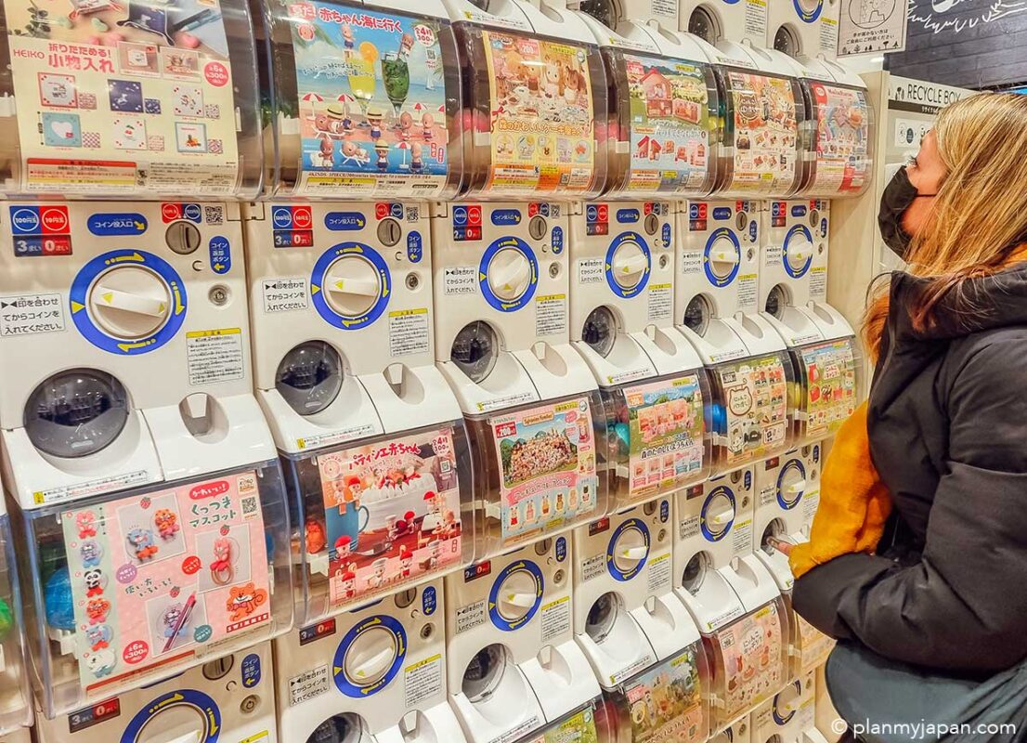
Figure 1: Gachapon machines found all over Japan

Both systems mentioned above could be seen as synonymous with lootbox being the main umbrella term for all chance-based systems in the videogaming industry. However, to easily categorize and differentiate the practices, we may look at both words in a broader view and call the game-of-chance systems in games from Western companies lootbox and those from Eastern companies gacha.
Another difference might be the level of certainty and probability
in both systems. While most games with the LB system use a set percentage of acquiring items of a given rarity, gacha games mix this randomized probability with certainty.
In games with the gacha system implemented, players may roll for their specific desired item with a set amount of relative probability to getting it (a percentage). The probability of getting the desired item gets higher with each roll made in the game until reaching a point
where a person is guaranteed (the percentage being 100%) to get said item in the next roll.
This difference shows that since players of gacha games can expect a successful roll, the gacha system is not such a predatory gambling service as the LB system. Nevertheless, the gacha system is regulated by strict regulatory laws in many Asian countries which also explains
the less predatory nature of this monetization practice.
To demonstrate how different the level of certainty and probability in both systems
is, we may analyse the monetization chance-based systems and the disclosure of probability and drop rates of items from the pool of rewards of 4 chosen videogames. Two of the chosen videogames are representatives of the lootbox system (from Western developers) and the other two are representatives of the gacha system (from Eastern developers).
The first analysed videogame is Counter-Strike 2 (Valve, 2023), an American game
which uses the LB system in a form of “cases”. Every one of these boxes, stylised to look like metal or plastic cases, require a key to be opened. Different kind of cases are worth a different amount of real-life money, but the keys all cost 2.35 Euro (in Czechia). Figure 2 depicts
how a case in Counter-Strike 2 may look like. When a consumer decides to unlock it, they are prompted to look at all the virtual items which are contained within the case.
Every item is labelled with a different colour, showcasing its rarity. From all the 18 items
shown, we may notice that 7 items are of blue rarity, 5 items are of purple rarity, 3 items
are of pink rarity, 2 items are of red rarity and there is one yellow/gold item, which is supposed to be of the highest rarity. However, there is no way to find the true probability rates of each rarity dropping as well as having an offer at knowing when the gold item is going to certainly drop. Since this has been a great issue with the release of this system in countries with strict regulatory law, like China, Valve has been compelled to release the official drop rates online. Figure 3 shows the probability rates provided by Valve even though they are still not disclosed in-game before unlocking a case. Due to this reason, many players believe that these rates are highly speculative.
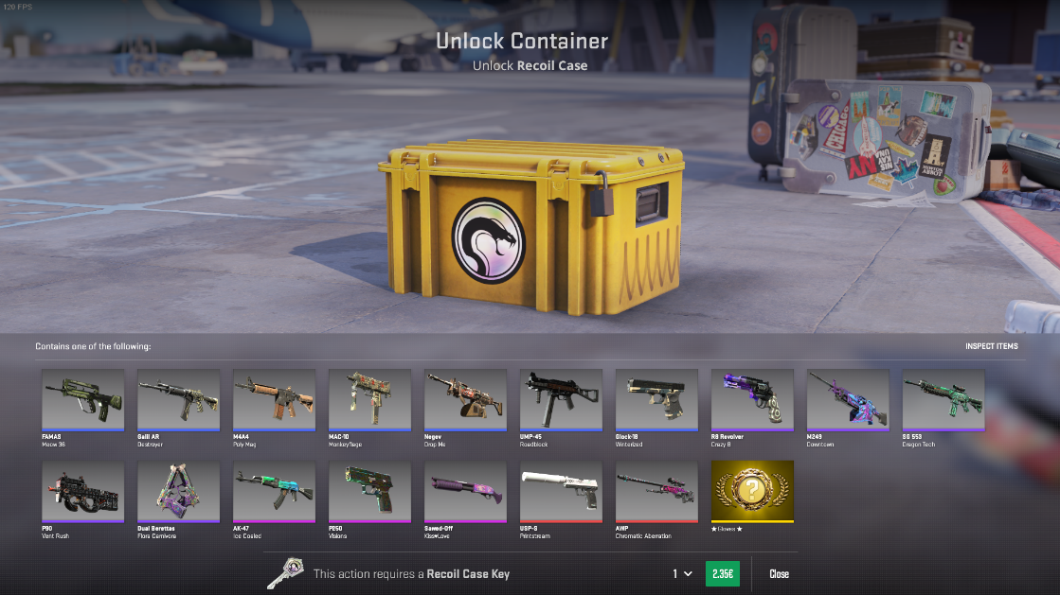
Figure 2: A case from the game Counter-Strike 2
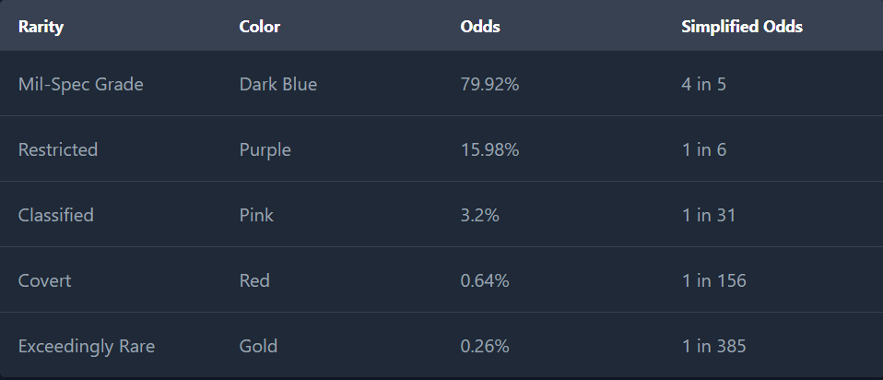
Figure 3: Drop rates of items from the cases of the game Counter-Strike 2

S Apex Legends (Respawn Entertainment, 2019) is another American videogame
which utilizes the LB system for the gain of profit. The Apex packs, available to gamers
for puchase, do show probability rates in-game if a player decides to click on a designated button. Figure 4 illustrates the pop-up window which opens after clicking on that button.
As we may see, there are 3 types of Apex packs, each with different pool of rarities which are to be obtained from the pack. The initial premise states that in the case of the LB system, players are not always 100% certain about getting their desired item, but the legendary Apex pack
and all of the other packs have a disclosed guaranteed option of getting a virtual item
of the highest rarity (100% in the case of legendary Apex packs or in the case of every 30 rare and/or epic Apex packs opened). However, players are still not certain about the specific legendary virtual item they are going to receive upon opening an Apex pack with the guaranteed legendary drop. This, again, alligns with the premise as consumers may never know the number of packs they should buy and open until the point of getting their specific desired item
(being a skin, frame, pose or an item of another category shown in Figure 4).
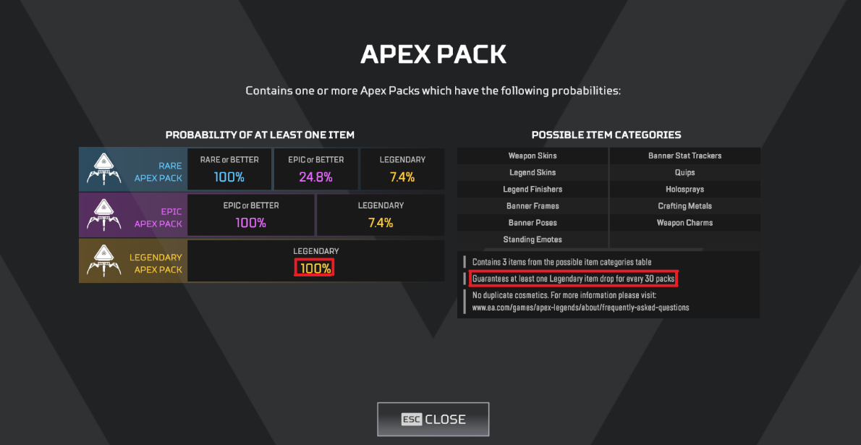
Figure 4: The in-game table of probability rates of the LB system in Apex Legends
The first chosen representative of the gacha system is a Chinese multi-platform videogame called Honkai: Star Rail (Hoyoverse, 2023). The rate-up virtual items obtainable
through the means of this chance-based system are portrayed before a player decides to roll
for their desired item. As shown in Figure 5, the specific character of the highest rarity
(in this case 5-stars) available for a limited-time is the dominant feature of the whole screen. This suggests that a consumer, spending real-life currency to participate in this gacha
system, most likely aims at getting this new and limited character. But do the players
of this game have a chance at knowing how much money they must spend to certainly (100%) get this specific desired character/virtual item? They do as after clicking on the “View Details” button a long article pops up in-game showing all of the items available in the pool of rewards as well as a very detailed text disclosing the precentage probability drop rates of everything.
If we examine the contents of this text in Figure 6, we may come across two important pieces of information. In the “Warp Rate” part of the text, there is a disclosure of the guaranteed rate of any 5-star character; “Within 90 Warps, at least one 5-star character is guaranteed.”
and the first bullet point in the “Boosted Rate” part further mentions and explains the gacha system of this game; “The first time you obtain a 5-star character in this Warp event, there is
a 50% chance it will be the promotional character X. If the first 5-star character you obtain
in this Warp event is not the promotional character, then the next 5-star character you obtain is guaranteed to be the promotional character.”. Both of the meanings of these parts suggests
that if a player does not get the limited character after 90 warps/pulls, they are guaranteed
to get them after another 90 warps/pulls. In addition, players are able to keep track
of the number of wraps they have already done in the “Records” tab. All in all, a player
is certain that their specific desired virtual item is going to drop after 180 instances of using
the gacha system of Honkai: Star Rail.
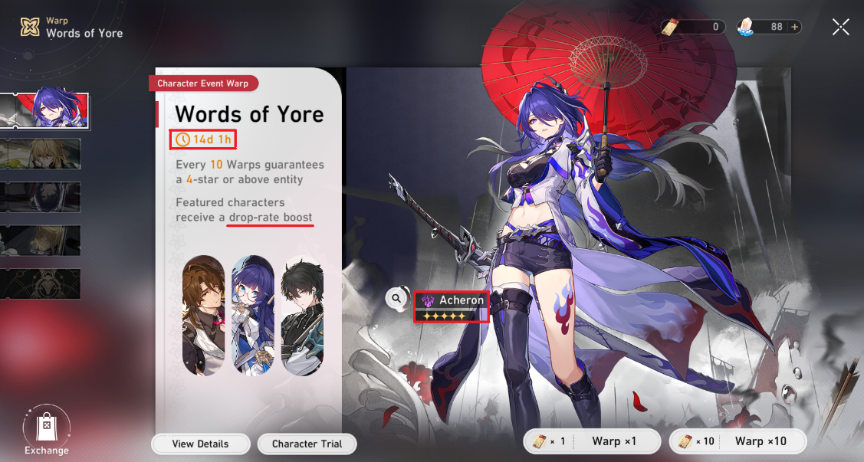
Figure 5: The limited-time banner of the game Honkai: Star Rail

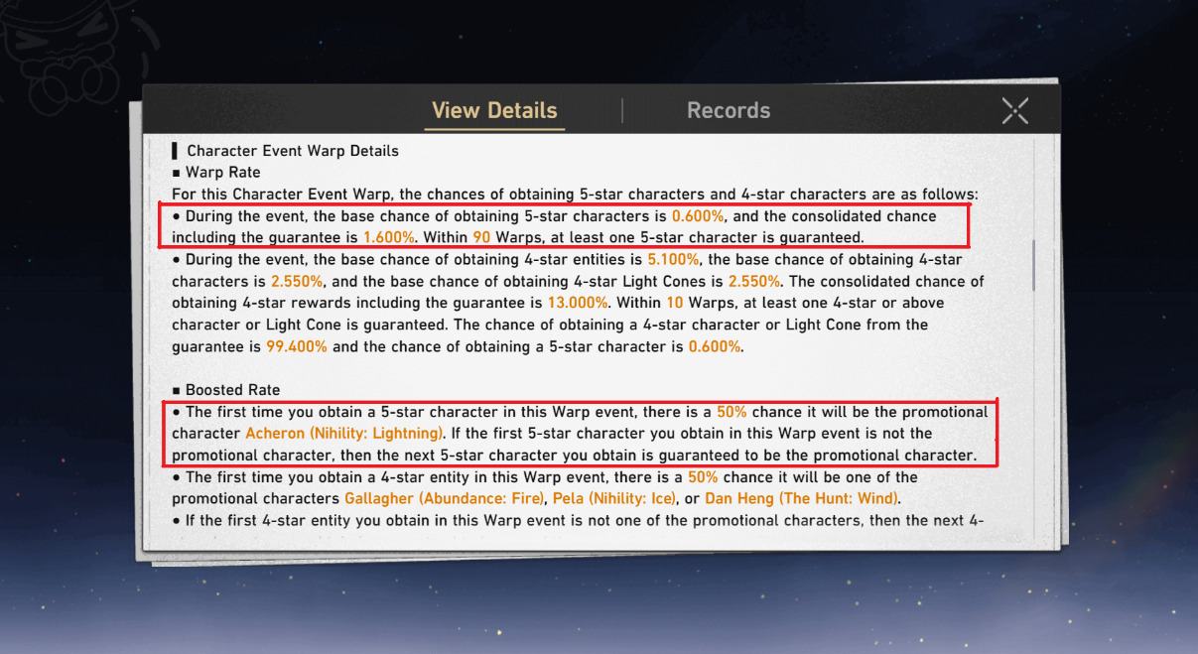
Figure 6: The “View Details” text disclosing the probability drop rates of items in Honkai: Star Rail
The last analysed videogame is the South Korean Cookie Run: Kingdom
(Devsisters, 2021). The developers and distributors of this mobile gacha game, released
for Android and iOS, also implemented this monetization system into their videogame.
Just as in Honkai: Star Rail, Cookie Run: Kingdom shows a short animation of the rate-up limited-time featured character (cookie) beforehand. However, this character is of “epic” rarity which is not exactly the most valuable rarity in this videogame. After clicking
on the “Probabilities” button, players are shown a list of every single item and their drop rate in precentage. The table of probabilities, as stated by Figure 8, reveals the rarity, type
of the vritual item and its probability rate. Although, in clash with the initial premise, this time there is no way to see the exact point at which a player is guaranteed to get the specific desired
character, in this case the featured rate-up cookie. Every videogame is unique and has its unique set of employees who are behind it so this premise is not going to be true for every LB or gacha videogame. Nevertheless, the thorough and exact disclosure of probability drop rates suggests
that this is indeed a gacha game obliging more to the East Asian legislation and lawmakers.

Figure 7: The featured cookie banner screen from the videogame Cookie Run: Kingdom
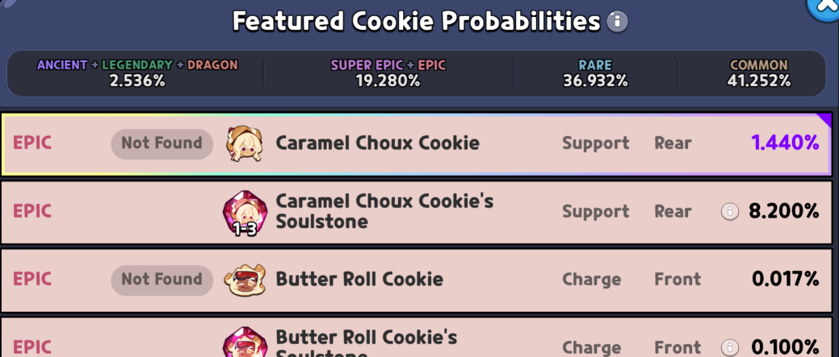
Figure 8: The probabilities table of the items from the pool of rewards from Cookie Run: Kingdom

1.2.1 Types of Gacha
Koeder and Tanaka (2018) divide the monetization system of gacha into the following types;
- Kompu Gacha – Players were obliged to get every single item from a set pool of items through the means of gacha in order to get one final exclusive reward (due to this
system, driven by uncertainty, becoming illegal in Asian countries, it has been discontinued).
- Box Gacha – A consumer has a shot at getting a reward from a set pool of items, each with a designated probability shown as a percentage beforehand.
- Sugoroku Gacha – Popular gacha system during seasonal events in videogames.
The system is stylized as the Ludo boardgame, where players roll a dice to advance
and get the reward depicted on the board.
- Redraw Gacha – Consumers may redraw/reroll after getting an item so they have a shot at another reward from the prize pool, which might not always be for the better.
- Consecutive Gacha – When players use this system in bulks, they are rewarded
with an increased chance of getting the rarest item from the pool of items.
- Open/Closed Gacha – If players take part in a closed gacha, they are uncertain
about the probabilities as this type does not explicitly show any percentage beforehand.
On the other hand, just like box gacha, open gacha presents
a percentage probability of acquiring each item. Because of the current law situation
in East Asian countries as well as other countries globally, open gacha is the legal
and widely used variant of the two (closed gacha is illegal).
- Discounted Gacha – A type of gacha used as a marketing strategy, as it is mostly introduced during the release of new updates or events. Consumers are able to pay less virtual currency to partake in this gacha for a limited number of draws/rolls.

1.3 Roll/Pull
Roll (sometimes referred to as pull) is one instance of trying to acquire an item
through chance-based monetization systems in videogames. After this instance consumers may get an item of a specific rarity based on the probability which is disclosed beforehand.
In this thesis, rolls will be categorized into successful and unsuccessful. The former being a roll where a player gets their desired item and/or an item of the highest rarity and the latter being
a roll where a player does not get such item.

1.4 Whale
A whale refers to a person, who spends significant amount of real-life money
on microtransactions in videogames. The term suggests that for developers, keeping these consumers happy and loyal is much more important for maximalization of profit rather
than having many “small fish in the sea” while not accumulating any significant revenue.
Players, who are perceived as “fish” refer to themselves as free-to-play players.
Another term used for consumers who spend real-life money but do so cleverly and sparingly is dolphins.

2 Mobile Videogames in East Asia
Videogaming has always been an important part of the East Asian culture being
it in the form of PC bangs in South Korea or Japanese and Chinese arcades. With the rise
of smartphones and tablets, East Asian countries sought after the opportunity to make gaming accessible to a broader audience through mobile technologies while making significant profit. This topic is going to be discussed in the sections below.

2.1 History
With the introduction of mobile gaming and its rising popularity in the early 2000s, consumers of every generation got a chance to enjoy their leisure time with a videogame from the comfort of their sofa or bed through a screen of a smart device, such as a smartphone, tablet, or a PDA (personal digital assistant). But the scope of the meaning of mobile gaming changed
with the introduction of several wireless handheld consoles, mostly the PlayStation Portable (PSP) and Nintendo DS (NDS). Handheld gaming is also mobile gaming in theory
since players may use these handheld devices anywhere. However, as smartphones became popular, so did mobile gaming. This is the sole reason why mobile gaming
is separated from handheld gaming because it followed the trajectory of the development
and usage of cell phones and smartphones throughout last decades.
Mobile games were originally intended to be casual for a wider demographic of people.
This correlates with the evolution of communication technologies and their parameters.
Mobile devices were not always able to run difficult online videogames. Dal Yong Jin describes the announcement and launch of iPhone in 2007 as one of mobile videogaming's most important pillars. The introduction of new apps, properties and the App Store shifted the possibilities
of this type of gaming. Fast forward to 2023 and Apple continues to influence mobile gaming with its addition of iPhone 15 Pro. Thanks to this device consumers can run system-demanding games (originally released for PC and consoles), such as the remake of Capcom's game Resident Evil 4 or Hideo Kojima's Death Stranding.
Dal Yong Jin further mentions the shift in Nintendo's strategy following
the announcement of their plan to invest in videogames for smart phones in March 2015. Nintendo, being the pioneer of console gaming and console-technology research in Japan
with a very strong brand and image, was not expected to nest into the worldwide mobile gaming market. Thus, their entry into the global mobile gaming sector was a shock to many and it only supports the truth that the previously popular console gaming is being expansively overshadowed by mobile gaming, especially with South Korean and Chinese
videogame-developing companies following suit.
Other important events in the journey of mobile gaming's popularisation may include
the introduction of the 5G network in 2017 or the convergence of mobile videogames. Convergence in this sense can be understood as the effort to embed and include
a certain form of media into other elements of the age of technology. Since digital PC
and console games were an important part of ICT before the mobile ones, many interested parties had to push through and cooperate in the quest to make mobile videogames famous.
Convergence of mobile videogames in East Asia is rooted in the form of mobile social media apps such as KakaoTalk and Line in South Korea or WeChat in China.
These instant-messaging providers integrated simple videogames into them, thus giving its consumers the chance to unwind and play from the comfort of their applications.
This, together with the rising usage of information technologies and app stores in the countries of East Asia, served as the basis for the rising popularity of mobile videogames across
the region.
East Asia is the cradle of many electronics and information technology
companies, for example the Chinese Huawei and HCT or South Korean Samsung
and LG, so there is no surprise in the rising effort of those countries in the pursuit of being
a significant part of the mobile gaming market, in which they succeeded, because today these nations are one of the biggest in the game.

2.2 Economic Significance
There still lies a question about why mobile gaming became so popular in East Asia since
the region has been known for its console gaming (Japan with PlayStation and Nintendo)
and online gaming (South Korea with MMORPGs and PC bangs) for decades.
The answer is fairly simple, the trend of focusing on the development of mobile videogames is mostly because of significant profit and the rising usage of smartphones in East Asia.
The transition to development of mobile videogames has been simple thanks
to the relatively low market barriers, since developers are able to distinguish the target group
of consumers and tailor a game to their needs. Mobile videogames are distributed through platforms in which consumers may easily and quickly download games and play them in short sessions throughout the day.
Still as of 2024, the biggest distributor platforms are Apple's App Store and Google's Play Store, which offer a wide selection of apps as well as mobile videogames.
However, due to legal reasons these platforms have limited accessibility in China.
Big corporations have developed their own 3rd party platforms, such as Tencent's My App
which provide the same service as the platforms above but for residents of mainland China. South Korean company Samsung also has their own platform called Galaxy Store.
An important thing to realise about East Asia's (and mostly China's) videogaming developers
is that they usually release their mobile videogames twice, the first time in the land of their origin (South Korea, Japan, China) and the second time globally through App Store
and/or Google Play Store.
Other important fact about mobile gaming is that it has overshadowed console gaming
in earnings long ago with China dominating the whole market. The whole revenue of mobile gaming is equal to around 50% of the global market of the videogaming industry.
Again, this is achieved thanks to the extensive number of different genres of mobile
videogames, people of all walks of life can play their desired mobile
videogames, being it the cozy and casual genre of games like Gardenscapes to the large online MMORPGs of games like Diablo Immortal.
For instance, when it comes to profit, the instant-messaging apps mentioned
in the previous section revealed that their biggest source of revenue is from in-app
free-to-play games which have microtransactions implemented in them.
South Korean KakaoTalk has disclosed that in the last quarter of 2014, they have grossed over 49 million Euro through a Swedish game called Candy
Crush, which was playable in the app. This has led to other companies following suit and trying to have a greater share in the global mobile videogaming market.
If we look at the exact revenue, China is currently on top of the global mobile videogaming market with revenue of around 28.2 billion Euro in 2023.
The USA is close second (23.5 billion Euro) with Japan and South Korea far behind
with revenue of mobile gaming in 2023 being around 13.1 billion Euro and 5.6 billion Euro respectively. The whole region of Europe grossed around 14.1 billion Euro in 2023 (especially the UK, Germany and France). To compare it to overall numbers, Newzoo states that the worldwide mobile gaming market grossed over 85 billion Euro in 2023, making it the biggest part of the videogaming market (around 49%). Newzoo also predicts that the Asia-Pacific region will continue to increase their mobile gaming market through the years.
This should be achieved also due to the extensive popularity of East Asian mobile gacha
and free-to-play games.
Graph 1: Top 6 most grossing countries/regions in the mobile videogaming market in 2023
One of the most widely used microtransaction practices of Korean, Japanese and Chinese mobile videogames, called gacha is going to be discussed more in detail in chapter 3.

3 Microtransactions and Gacha system in Korean, Japanese and Chinese Mobile Videogames

3.1 Economic Framework
Microtransactions as well as the gacha system in Korean, Japanese and Chinese mobile videogames are tightly connected because if a videogame has the gacha system
implemented, most of the virtual currency bought through the means of microtransactions are then spent on gacha. This subsection is going to thoroughly analyse and compare mobile gacha games of the three countries discussed on a level of overall mobile-gaming market revenue
and popularity in the form of the number of downloads worldwide.
For better navigation, let us recall the market revenue situation of the videogaming industry in 2023. Per Newzoo, the overall videogaming industry grossed approximately
172.5 billion Euro, with the mobile videogaming market corresponding to over 85 billion Euro (49%) of the whole industry. China makes up 28.2 billion Euro, Japan 13.1 billion Euro
and South Korean 5.6 billion Euro of the whole mobile videogaming industry
(including non-gacha games). Graph 2 portrays the share of each of these East-Asian countries on the whole mobile gaming industry in 2023.
Graph 2: Percentage share of China, Japan, and South Korea on the mobile videogaming market in 2023
The data analysed in the upcoming subsections are from Sensor Tower, an analytics
company, which does not report nor has any access to Chinese Android revenue and revenue from Chinese 3rd party app stores. The overall revenue of Korean, Japanese and Chinese gacha games could be even higher
if we regard the dominance of Chinese mobile-videogaming market. If a videogame is on multiple
platforms, Sensor Tower calculates only the revenue from mobile app stores (Android and iOS).
Also, gacharevenue.com, a website which uses Sensor Tower's data, only reports the revenue of around 84
of the most critically acclaimed and famous mobile gacha videogames (as of April 2024). Thus, the analysis
below is a rough estimate of the gacha market revenue in 2023.

3.1.1 South Korea
South Korea has many globally famous developers of mobile videogames, such as Netmarble or Smilegate. According to gacharevenue.com, the overall market revenue of Korean gacha games has reached approximately 700 million Euro in 2023, that's roughly 10% of the whole Korean mobile videogaming industry. Table 1 shows the market revenue and approximate number of downloads of the top 5 South Korean gacha games.
Gacha game | Publisher, Year  of Release | Market Revenue (2023) | Number  of Downloads (2023)
Goddess of Victory: NIKKE | SHIFT UP Corporation, 2022 | 293 bil. € | 2,1M
Blue Archive  (Japanese Release) | Yostar, 2021 | 122 bil. € | 520K
Summoners War | Com2uS, 2014 | 117 bil. € | 600K
Epic Seven | Smilegate Entertainment, 2018 | 42 bil. € | 850K
Blue Archive  (Global Release) | Nexon, 2021 | 35 bil. € | 970K
Table 1: The market revenue and number of downloads of the top 5 Korean mobile gacha videogames

3.1.2 Japan
Japan, as the cradle of the gacha monetization practice, is a country with the highest number
of mobile gacha videogames released (as of 2024). The overall market revenue in 2023 was around 1.5 billion Euro, also being around 10% of the whole Japanese mobile gaming market. Table 2 contains the top 5 Japanese mobile gacha videogames of 2023, regarding market revenue.
Gacha game | Publisher, Year  of Release | Market Revenue (2023) | Number  of Downloads (2023)
Uma Musume: Pretty Derby  (Japanese Release) | Cygames, 2021 | 329 bil. € | 270K
Fate/Grand Order  (Japanese Release) | Aniplex Inc., 2015 | 313 bil. € | 768K
Heaven Burns Red  (Japanese Release) | Wright Flyer Studios, 2022 | 116 bil. € | 239K
Hatsune Miku: Colorful Stage!  (Japanese Release) | Sega, 2020 | 115 bil. € | 980K
Memento Mori | Bank of Innovation, Inc., 2022 | 82 bil. € | 540K
Table 2: The market revenue and number of downloads of the top 5 Japanese mobile gacha videogames

3.1.3 China
Chinese mobile gacha videogames grossed around 1.1 billion Euro globally in 2023.
However, the real overall number is, naturally, much higher as the Chinese Android revenue and revenue from Chinese 3rd party app stores contribute significantly to the overall market
of Chinese mobile videogames (as well as Korean and Japanese). The data provided by Sensor Tower suggests that Chinese mobile gacha videogames make less than 5% of the overall Chinese mobile videogame market. Much like the 2 tables before, Table 3 has data
about the top 5 Chinese mobile gacha videogames.
Gacha game | Publisher, Year  of Release | Market Revenue (2023) | Number  of Downloads (2023)
Genshin Impact | Hoyoverse, 2020 | 486 bil. € | 18M
Honkai: Star Rail | Hoyoverse, 2023 | 358 bil. € | 10.6M
Arknights  (Japanese Release) | Yostar, 2020 | 63 bil. € | 159K
Arknights  (Global Release) | Yostar, 2020 | 27.7 bil. € | 510K
Azur Lane  (Japanese Release) | Yostar, 2017 | 27.5 bil. € | 88K
Table 3: The market revenue and number of downloads of the top 5 Chinese mobile gacha videogames

3.1.4 Overall Comparison
To compare the market situation of mobile gacha games of all three countries, we may look
at Graph 3. The overall market revenue of gacha games originating from the discussed countries suggests that gacha games contributed 4% to the whole global mobile gaming market revenue in 2023. Japanese gacha videogames are the most profitable, followed by the Chinese ones
and South Korean gacha videogames are on the last place in terms of revenue. Table 4 shows data of the top 10 mobile gacha videogames. Hoyoverse's surge to popularity starting
from 2020 with their release of Genshin Impact (Hoyoverse, 2020) has tremendously contributed to the mobile gaming industry of China. However, in the year 2023, Japanese mobile gacha games have still hold their own and Japanese developers and publishers have continued being the most popular and profitable in terms of the gacha videogaming market. Interestingly, there are 15 games of Japanese origin in the list of top 25 most grossing mobile gacha videogames with Bandai Namco, Cygames and Aniplex Inc. being the most prominent publishers in said list.
Gacha game | Country of Origin | Publisher, Year  of Release | Market Revenue (2023)
Genshin Impact |  | Hoyoverse, 2020 | 486 bil. €
Honkai: Star Rail |  | Hoyoverse, 2023 | 358 bil. €
Uma Musume: Pretty Derby  (Japanese Release) |  | Cygames, 2021 | 329 bil. €
Fate/Grand Order  (Japanese Release) |  | Aniplex Inc., 2015 | 313 bil. €
Goddess of Victory: NIKKE |  | SHIFT UP Corporation, 2022 | 293 bil. €
Blue Archive  (Japanese Release) |  | Yostar, 2021 | 122 bil. €
Summoners War |  | Com2uS, 2014 | 117 bil. €
Heaven Burns Red  (Japanese Release) |  | Wright Flyer Studios, 2022 | 116 bil. €
Hatsune Miku: Colorful Stage!  (Japanese Release) |  | Sega, 2020 | 115 bil. €
Memento Mori |  | Bank of Innovation, Inc., 2022 | 82 bil. €
Table 4: Top 10 of the most grossing mobile gacha videogames in 2023

Graph 3: The share of Japanese, Chinese and Korean gacha videogames on the whole mobile gaming market (in 2023)

3.1.5 Future Development
The whole mobile gaming industry of China is projected to gross over 31.7 Euro
in 2024, while Japan's and South Korea's mobile video gaming markets are projected to reach
15.3 Euro and 5.6 Euro respectively. This will also be achieved thanks to the ever-increasing popularity and profit of gacha videogames.
Following the example of China and Japan, South Korean game-developing studios are trying to reach the same level of popularity and profitability of mobile gacha videogames.
There have been several announcements made by South Korean developers about creating new mobile gacha videogames such as Netmarble with their The Seven Deadly Sins: Origin (Netmarble, TBA) or Solo Leveling: Arise (Netmarble, 2024).
Another interesting fact is the announcement of Persona 5: The Phantom X
(Perfect World Games, 2024). Persona, a critically acclaimed and globally fan-beloved game series developed by Atlus and published by SEGA, is getting a mobile gacha instalment
which is being developed by a Chinese studio. Most likely, due to the strict law barriers
of releasing a Chinese version, SEGA has entrusted development and sold licensing rights
to a Chinese game-developing studio which is going to make it easier for SEGA to take advantage of the huge scale of the Chinese market. The original developers
of Persona, Atlus, are still going to oversee the development of Persona 5: The Phantom X.

3.2 Psychological Framework
Although there are hundreds of Korean, Japanese and Chinese mobile videogames, they use very similar properties to convey a thorough influence on the human brain, similarly, to slot machines in casinos. For this reason, this section is not going to be divided by country
separately, because the gacha system and animation sequences also use similar, if not
the same, tricks to keep the player invested.
This similarity is also rooted in cultural differences. Eastern cultures pay attention
to multiple cues as a single entity, apart from Westerners. To put this to an example, Japanese reality TV shows are sometimes very overwhelming for the eye of a Westerner.
There are a lot of visual and sound stimulants on the screen at the same time.
To Westerners, this is sometimes viewed upon as overstimulating and maybe even
strange, but people in Japan, South Korea and China fully enjoy having very
stimulative, expressive, or even affective multisensory visual cues because they can easily view everything as a single image.
Thus, those same cues, mentioned above, are used even for the animation sequences which accompany a roll in mobile gacha games. However, to ensure that the videogames appeal to a wider and, most importantly, global audience, the developers are trying to make
the animations cater to the Western audience as well, using similar fiddles to casinos and other institutions of gambling.

3.2.1 Engaging Aspects
To keep the players engaged in the monetization practice of gacha, there must be enough appeal kept even before a player decides to spend real-life money and roll for their desired items.
It is a common occurrence that at the release time of any gacha mobile
videogame, the initial player base and revenue are at their highest, which also corresponds
to the size of the development company as well as the popularity of the game and the marketing strategy used before the release. After that, because of the competitive environment
of mobile videogame market, developers must keep the momentum of their game going
regarding all its aspects and their updates, which should be done regularly.
As to the engaging aspects of gacha games, the reasons for continuous playing and paying may differ from person to person (and from whales to fish). The most common aspects being;;
- Narrative
- Collective Value
- Time Availability
- Fanservice/Characters
- Rate-Up or Price Reduction
- Gameplay Enjoyment
- Pay-To-Win
First, let's discuss narrative. Every videogame has its own story, some games may
be more story-driven than others, but for Easterners, they really like telling diverse
and meaningful stories. Thus, gacha mobile videogames maintain a good reputation
when it comes to narrative. Consumers, both Western and Eastern, like to be engaged
in it for years to come, given today's nature of free-to-play mobile videogames being online
and regularly updated. And through this narrative, players have a chance to learn more
about the items, which then may be provided through the gacha system, the better if the item is
a character featured in the story.
Collective value and time availability are related in a sense that most items acquired through gacha are available in so called “banners”, which have a designated amount of low
and high tier items that can be rewarded through its means.
These “banners” almost always include an exclusive item of the highest rarity and are limited in time, thus making the players feel like if they want to pull for this limited-time
item, they should do so as soon as possible, because they never know when the item and its banner is going to come back (and if it even is). This further stimulates the mind of a person
and pressures them to act in time. “Banners” are updated regularly according to the state
of the game regarding gameplay and narrative (characters that appear in the real time story
in-game are more likely to appear in a limited-time “banner”).
Collective value is important to a consumer because if they are not able
to receive the desired item in time, they may never get the chance to get it again as the item
and its “banners” is limited in time. And because of that they have a feeling of accomplishment after getting the desired exclusive item, which has a high collective value for them, increasing with time. However, this value only counts in the gacha game in which the item
is acquired, because as the definition of gacha rewards states, they have no real-life currency value and cannot be exchanged or sold for it. Moreover, if a truly limited, high-tier item
is available only if a player spends huge amounts of real-life money, the collective value plays a huge part in influencing a person's brain. For people that consider themselves
as collectors, this is a huge engaging aspect in playing and paying in mobile gacha videogames.
Most, if not all mobile gacha videogames' visuals are stylised as to those of anime.
Big expressive eyes, cutesy characters with chubby cheeks and immersive battles are all part
of them. This also corresponds to the appeal of anime in Korean, Japanese and Chinese modern pop-culture. The attracting element of characters is maybe the most important aspect
to consumers when it comes to engaging in the chance-based system of gacha. If a player really likes a certain character, their personality, and their part in the narration of the story, the chance of pulling for that specific character in the gacha system rises. Thus, to appeal to the male fantasy, fanservice may be used in-game or through social media accounts of the videogame. Most of the times, fanservice means making a character's visual portrayal very
obscene, especially if the character is a female. Through the unique properties of the anime design, the characters may have very voluptuous bodies with revealing clothing.
What's more, in games filled with fanservice (e.g. Azur Lane), a system where a player may imaginatively marry a certain character further deepens their adoration of this fictional persona.
Through social media accounts, developer studios may release or share fan-art
of characters from their mobile videogame. Since fan-art is not an official property
of the developer and does not belong to the game's gameplay and narrative, the portrayal
of a character by a fan may be done even more obscenely to appeal to the audience.
This is also supported by a phenomenon called “genderbending”. As the word
suggests, “genderbending” means changing the gender of a character, together
with the proportion of their bodies. Artists may make a fan-art of a highly popular male character and change their sex to female to please the fans of the game.
Other elements of fanservice may include offline events and collaborations with international restaurants and fast-food brands, where fans of the videogame are able to order a menu and get exclusive merchandise with the portrayal of their favourite characters. All in all, off-game fanservice is also an important part of gacha mobile videogames.

Rate-Up or price reduction events happen frequently as a marketing strategy as players feel an urge to participate in the corresponding “banner” to acquire their desired item
for a reduced price or with a higher probability of it dropping.
According to players, gameplay is an essential part in the engaging aspects of gacha mobile videogames as consumers feel that if they spend real-life money, they would like to see the value being carried over into the enjoyment and/or improvement of the gameplay.
Many times, especially in action gameplay-driven mobile videogames, new characters introduced also introduce new ways to play the game through their skills and other game-related properties. Having to master these new attributes creates exciting new challenges to players
and may extend their willingness to keep playing the videogame.
Sometimes gamers want to obtain their desired items due to advantages they may bring during the gameplay. These items are referred to as pay-to-win since they create a gameplay advantage to whales and dolphins over people who do not spend any real-life currency to obtain in-game virtual items. In games with PvP (player vs. player) modes and functions, this type
of items results in great discourse among players as they feel like gameplay and skill should
not be influenced by spending money.

3.2.2 Sensory, Neural and Hormonal Cues
As stated before, game-developing companies and distributors of mobile gacha videogames use different sensory and neural cues to influence the psyche of a person and raise the chance of them taking part in their game-of-chance monetization practice. These hedonic consumption strategies are a common occurrence also happening in gambling
institutions, such as casinos, to sprout a mild Gambling Disorder in consumers.
This subsection will try to pinpoint the underlying similar cues between gacha with its animation sequences and gambling to support or refute the claim that gacha may indeed constitute gambling.
Nowadays, digital, or virtual gambling sites try to mimic similar situations as real-life gambling institutions through multisensory stimulation, mostly auditory and visual, as they are emotionally and motivationally intriguing. Identically, gacha animation sequences try
to include visual and acoustic effects as well as successful or unsuccessful features to appeal
to players. These features imitate the loud sounds or flashing lights of slot
machines, lottery, or wheel of fortune. Sensory cues may be positively associated
with the system of gacha even if a player does not get the rarest virtual item from the pool
of rewards. These cues are pleasing to players, so they keep on paying and using
the monetization system even disregarding their previous unsuccessful roll.
Sometimes, the visuals have very distinct casino-like features, especially in the case
of sugoroku gacha, where the system tries to be an animated imitation of slot
machines, roulette, or other gambling games. In the case of open or box gacha, the visual
and auditory cues differ between an unsuccessful and a successful roll, changing the brightness and colour of the visual effects and/or turning up the decibels of the auditory effects.
This aligns with casinos as they try to reach the levels of volume indoors at around 77 decibels (dB), much like the sound system in concerts or cinemas to easily stimulate the attention
of people.
Regarding the psychological reasons for a person's pull towards gambling may vary
but they are always rooted in our neural, hormonal, and other psychological activity.
The first aspect that psychoanalysis considers as important is a behaviour referred
to as “compulsive masturbation”. Game-of-chance monetization systems provide a thrilling excitement and lead to the behaviour mentioned above. As players' level of excitement increases prior to making a roll in a gacha game, they then reach a point where they experience
an “orgasm”, which immediately disappears as the roll result is finally displayed.
This hormonal activity feels good and may make players continue using the gacha systems
to experience this feeling again and again. Secondly, avoidance of negative emotions also plays a big role in engaging in monetization systems such as gacha. If the desired virtual item does not appear and a person feels as if the amount of real-life money spent is wasted, they may feel angry and anxious due to the negative emotions associated with their money not being transformed into value of the rare and desired virtual item. The person then wants to escape those negative emotions by further rolling and acquiring their desired virtual item.
This also corresponds to error in self-justification as a person tries to falsely rationalize their actions and believes that getting duplicate items of lower rarity may even become useful someday. Other scientifically mentioned cues are arousal and the near-miss experience. Consumers of videogames love to have their physical and mental parts activated
through the means of gameplay or, in this case, the arousing gacha mechanic. The near-miss experience aligns with the tension a person feels before seeing the results of their roll
in chance-based monetization systems. Many developers use this cue to signalise that a player almost received a rare, desired item, thus deceiving the player into believing that they are close to getting said item. This results in a more risk-taking behaviour and stimulates a player
into further spending money and using the system of gacha.
The analysis of gacha animation sequences of 3 different mobile videogames
regarding the sensory and neural cues will be conveyed in section 4 Analysis of Gacha Animation Sequences.

4 Analysis of Gacha Animation Sequences
The analysis of gacha animations sequences/cutscenes from three different mobile videogames is going to be done regarding the information as presented in 3.2 Psychological Framework. The three analysed games, each from one of the discussed countries
(South Korea, Japan, China), have been selected based on Table 4. The most profitable gacha game from South Korea, Japan, and China have been selected according to said table.
Every single video-file was taken personally by the author on PC which has been accomplished
through PC versions of the gacha videogames or different PC emulators to ensure the best video quality and readability. The auditory cues are analysed through software called Audacity.
Gacha game developers excel at differentiating successful (winning) and unsuccessful (losing) rolls thanks to the means of auditory and visual cues or other psychological practices. These differences are going to be showcased in the following subsections. The final aim
of the analysis is to determine if different gacha game developers from different East Asian countries use the same or similar practices and fiddles to influence the psyche of their consumers.
The selected games are South Korean Goddess of Victory: Nikke
(SHIFT UP Corporation, 2022), Japanese Uma Musume: Pretty Derby (Cygames, 2021)
and Chinese Genshin Impact (Hoyoverse, 2020).

4.1 South Korea (Goddess of Victory: Nikke)
Goddess of Victory: Nikke was released in 2022, it was developed by a South Korean videogaming studio SHIFT UP Corporation. It features very obscenely portrayed female characters with voluptuous bodies and humanly impossible body proportions
and physics. This is one of the first engaging aspects of this mobile videogame as players usually pull for these fictional characters and their equipment/weapons.

4.1.1 Unsuccessful Roll
The video-file analysed in this subsection is referenced in Appendix A. In this game, a player can make a bulk roll consisting of 10 individual rolls and rewarded virtual items.
As portrayed in Figure 9 (00:12), the first identification of an unsuccessful roll is shown
through the flashing purple light after the upper and lower parts of the machine doors collide. This collision is made quite beautifully as a player needs to swipe the lower part with their mouse cursor or their finger in the case of a smartphone screen. The interactive sensation is one of the first cues which fill a person with anticipation and excitement.
The animation of the machine door opening is not very eye-popping in this case
with minimal loud tones and bright lights. The loudest sound of this section being the machine door clicking at the 00:12 timestamp. As the door opens, the display shows the rarity
of every single item through the black and purple icons of humans (00:18). A player may
then click through the animation as each reward is properly displayed. The SR (blue) and SSR (purple) characters first show a square with their icon before appearing as a silhouette
and finally showing themselves. The time of these sections takes around 2 seconds for both SR and SSR rarities with no significant auditory differences, only the interference changes colour according to the rarity (blue or purple). At the end, a summary screen shows all
the rewards obtained during the bulk pull and the “compulsive masturbation” finally comes
to an end.

Figure 9: The identification cue of an unsuccessful roll in Goddess of Victory: Nikke

4.1.2 Successful Roll
The video-file analysed in this subsection is referenced in Appendix B. The distinguishing part of a successful roll in Goddess of Victory: Nikke is the much brighter flashing gold light
which shows after the machine collides (00:10), as stated by Figure 10. Moreover, the sound accompanied with the collision is more intense with a higher tone. The machine doors opening section (00:10–00:16) is also much brighter with more notable auditory cues. Figure 11 displays the differences of the auditory cues heard during this section in unsuccessful
and successful rolling attempts. Both sound analyses show two notable bumps. The first bump signalises the collision of the machine parts and the second sequence of bumps is the portrayal of the doors opening section. As we can see, the lower audio (belonging to a successful roll) has a steady and more balanced sound during the opening section as it stays on the same high volume and tone levels to retain the excitement of a player. The collision is also notably louder and more prominent.

Figure 10: The identification cue of a successful roll in Goddess of Victory: Nikke
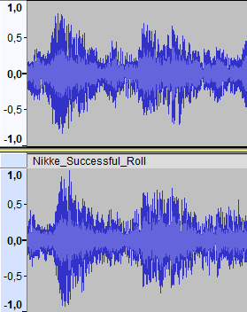
Figure 11: Audio analyses of the gacha sequences in Goddess of Victory: Nikke
(Upper: Unsuccessful, Lower: Successful)
After a player sees a shiny gold human icon in the initial display of the rarities
of all the virtual items, they may click through the cutscene as in the unsuccessful roll.
This time, as a player approaches the character of the highest rarity (SSR), the whole background flashes multiple times and changes to black to signalize a difference and to increase the anticipation of a player. As before, the screen first displays a rectangle icon
of a character, then showing the silhouette of them and finally displaying them in their full glory. However, in this case, this section (00:32–00:39) is much more delayed to stimulate the arousal of a player. The whole section takes around 7 seconds, so it is about 5 second longer
than if the character had been of lower rarity. In the end of the cutscene, the screen showcasing all rewarded virtual items makes an exciting sound and the SSR character is showcased
under a much shinier gold light.

4.2 Japan (Uma Musume: Pretty Derby)
Uma Musume: Pretty Derby was released in 2021 and developed and published
by a Japanese company Cygames. Players may use the gacha system implemented
in this mobile videogame to collect support card and female athletes
who, instead of a common running track, run on a derby track just like horses would.
Again, the engaging aspect is created as the female characters are visualised rather obscenely and the game is stylised as an anime.

4.2.1 Unsuccessful Roll
The video-file analysed in this subsection is referenced in Appendix C. A player of Uma Musume: Pretty Derby can also make bulk 10-rolls to get multiple virtual items at once.
When a player clicks on the corresponding button, the animation starts. After that, there
is a cutesy character running through a hallway, dressed in green, who seemed to be one
of the first characters who welcomes us to some sort of “boarding school for derby athletes”. At the end of the hallway, she opens the huge doors revealing the derby stadium (00:09).
As we may analyse in the cutscene sequence of a successful roll during the upcoming
subsection, there seems to be no real distinction between the unsuccessful and the successful gacha animation sequences. Both have the same audio and visual characteristics and the text above the derby post-positions seems to not be of any help in distinguishing both. After the reveal of the stadium, there is a section showcasing each post-position while the gates change colours according to the rarity of the virtual athlete hiding behind them.
The 1-star characters have silver gates while the 2-star characters hide behind gold gates.
As this section ends, a red starting light is shown (00:20) and then each one of the girls quickly runs out of their post-position. Player may then click through the animation and no real exciting cue is being played or showcased after that as the 1-star and 2-star characters run away.
Lastly, a screen, showing all the virtual items obtained, is displayed to the player.

4.2.2 Successful Roll
The video-file analysed in this subsection is referenced in Appendix D.
Just like during the unsuccessful roll, the initial section of the animation is very similar, if not the same. However, this time, one of the gates changes into a rainbow palette
of colours, as shown in Figure 12. As the athlete of the highest rarity (3-star) runs out
(00:40), they are firstly displayed as a silhouette behind a bright light. After that, their signature voice line is being played, signalizing their approach (if a player is familiar with all
of the characters in the pool of rewards). Finally, an exciting cutscene (00:47–00:59)
is played as the character and their name is being displayed at the end of said cutscene.
At the end of the whole gacha animation sequence, the obtained virtual items are displayed altogether. Figure 13 shows the audio differences of the gate colour-changing sounds
of an unsuccessful and a successful roll (the peak points of each audio analyse).

Figure 12: The rainbow post-position gate in Uma Musume: Pretty Derby
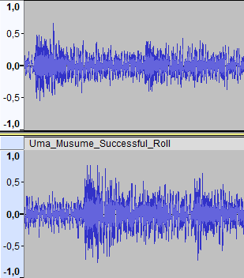
Figure 13: Audio analyses of the gacha sequences in Uma Musume: Pretty Derby
(Upper: Unsuccessful, Lower: Successful)

4.3 China (Genshin Impact)
Genshin Impact was released and developed by Hoyoverse in 2020. It quickly surged
to the top with its popularity and market revenue and has been keeping its first spot
for the past three years. Players roll for different playable characters and their weapons. However, unlike the previous two games, Genshin Impact is an open-world
action-adventure game where the characters play a big part in the gameplay as players personally control them in the extensive environment. Also, Genshin Impact
was released on multiple platforms and is popular on all of them.

4.3.1 Unsuccessful Roll
The video-file analysed in this subsection is referenced in Appendix E. When a player engages in the gacha system of this mobile videogame, they are also able to do so in a bulk of 10.
As a player clicks on the initiation button, they are welcomed by a section showing something falling from the sky (00:05–00:11). This section is the first differentiating clue
of an unsuccessful roll. Figure 14 portrays the moment when the comet/star cluster changes
into a bright light with hints of the purple colour. As the screen finally zooms into the purple comet, it flashes for a second before starting to display each virtual item rewarded. Players then may, once again, click through the cutscene while the animation first shows a silhouette
of the item before the anticipated reveal. This time, the visual and auditory cues of 3-star (blue) and 4-star (purple) virtual items are slightly different. Timestamp of 00:11–00:13 records
the reveal of an item of the lowest rarity (3-star/blue). The delay between the silhouette first showing itself and then the item finally revealing is around 1.75 seconds.
In comparison, the reveal of the 4-star (purple) character, Lynette (00:35–00:38), plays
a slightly different audio cue which is not necessarily louder but could be described as more arousing. The delay between showing the silhouette and then the full character art is around 2.1 seconds this time. At the end of the cutscene, a screen showcasing all received items is displayed as they were in the previous two games.

Figure 14: The identification cue of an unsuccessful roll in Genshin Impact

4.3.2 Successful Roll
The video-file analysed in this subsection is referenced in Appendix F. During Genshin Impact's successful roll animation, the identification cue (00:07) is displayed as the comet changes its colour to gold with much brighter light and hints of rainbow (see Figure 15). The audio is also different than in the unsuccessful roll sequence, however, the audio analyses do not show
that the volume levels are any different between the winning and losing rolls.
As the rewards are displayed, a player is bound to reach the character of the highest rarity (5-star). The revealing section (00:29–00:32) is much grander in scale, the audio cue
is more intense and has higher volume levels than before and the visuals display a flashing “boom” effect with gold extensions beaming out from the silhouette as the character and their art is finally shown. The delay this time is around 2.5 seconds which is the longest out of all
the rarities, stimulating a player's anticipation and excitement. Figure 16 describes the different sound levels of a 4-star (purple) and a 5-star (gold) character being revealed. After the 5-star (gold) character is finally shown, their long voice line is played, this is not an indicator
of an item's rarity as much as it is an indicator of getting a new character. If a player gets
a 4-star (purple) character for the first time, their voice line is also played. At the end of the gacha animation sequence, all items obtained are displayed with the character of the highest rarity illuminating with gold shining background and the “New” tag.

Figure 15: The identification cue of a successful roll in Genshin Impact
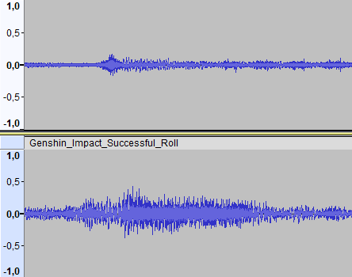
Figure 16: Audio analyses of the gacha sequences in Genshin Impact
(Upper: Unsuccessful, Lower: Successful)

4.4 Summary
In comparison, gacha game developers and publishers of all three discussed East Asian countries use very similar or even same fiddles and practices to exploit a person's psyche.
Just like gambling institutions and games, gacha videogames use multisensory stimulation
to convey an immersive gambling experience during the rolling animations and cutscenes.
The louder auditory cues and bright visual cues make a big part of distinguishing successful and unsuccessful rolls. Usage of practices which embrace hormonal or neural activity are also apparent. As it currently stands, gacha videogames are and should be of great discourse
among law enforcers and regulators from countries globally.

Conclusion
Currently, as the mobile videogame market continues to expand, many game developers will seek an opportunity to penetrate said market. As many mobile games are
free-to-play, developers and publishers need to find another source of profit.
They started implementing microtransactions into their mobile videogames which provide players with the option to buy and use many services of a game by spending real-life currency. South Korean, Japanese, and Chinese mobile videogame developers brought this
to a brand-new level by creating the gacha system, a game-of-chance monetization practice.
In conclusion, from an economic standpoint, gacha has proven quite profitable
with shared revenue of around 3.3 billion Euro in 2023. When a player wants to use gacha, they would need to spend the virtual currency which is bought through microtransactions, thus
the source of revenue is born. To compare the gacha market situation of all three discussed countries, Japan leads with global revenue of 1.55 billion Euro in 2023. This also refutes author's initial hypothesis because China is not the leader of gacha gaming on a global scale. China is in second place with revenue of 1.07 billion Euro in 2023. South Korea is last
with 689 million Euro in 2023 but with bright future as many developers announce their future gacha projects.
Gacha mobile videogames are widely popular and played for many different reasons.
The main engaging aspects for gamers may include the characters and their visuals, narrative, gameplay enjoyment and/or collective value. A player chooses to engage in the monetization practice of gacha for those reasons and because of the animation sequences/cutscenes they convey. Developers use tactics and fiddles commonly found among gambling institutions, such as “compulsive masturbation”, near-miss experience and multisensory stimulation.
These practices are evidence of gacha really being a constitute of gambling, thus pointing
to the fact that law makers of countries globally should be taking this practice seriously as they do with regular gambling, because gacha (as of 2024) is still usable to children and teenagers as well. Many countries, such as Belgium and the Netherlands, have already started to properly take care of the legality of this system. Lastly, in comparison of South Korea, Japan, and China, developers from all three countries convey the same fiddles and practices to influence
the psyche of a player so they keep using their gacha system.

Bibliography
(1) arstechnica. “First wave of AAA iPhone games sees a big new release—and a notable delay.“ Last modified December 20, 2023.
https://arstechnica.com/gaming/2023/12/first-wave-of-aaa-iphone-games-sees-a-big-new-release-and-a-notable-delay/.
(2) Behuria, Sworup Kumar. “Microtransactions as a Business Model in Video Gaming Industry: Its comparison with Traditional Model and effect on other Industries.” Master's Thesis, 2022. https://papers.ssrn.com/sol3/papers.cfm?abstract_id=4418003.
(3) Brevers, Damien et al. “Examining Neural Reactivity to Gambling Cues in the Age of Online Betting.“ Current Behavioral Neuroscience Reports 6 (2019): 59–71.
https://doi.org/10.1007/s40473-019-00177-2.
(4) Britt, Brian C., and Rebecca K. Britt. “From waifus to whales: The evolution of discourse in a mobile game-based competitive community of practice.” Mobile Media & Communication, Vol. 9(1) (2021): 3–29.
https://doi.org/10.1177/2050157920934509.
(5) Bueno, Christian R.“West and East, Cultural Differences.“ YouTube video, published December 6, 2012, 45:42. https://www.youtube.com/watch?v=ZoDtoB9Abck&ab_channel=ChristianR.Bueno.
(6) Capermint. “Mobile Gaming Market Worldwide Size – Facts & Statistics by Country & Region.“ Last accessed April 27, 2024.
https://www.capermint.com/blog/mobile-gaming-market-size/.
(7) Cerulli-Harms, Anette et al. Loot boxes in online games and their effect on consumers, in particular young consumers. Brussels: Policy Department for Economic, Scientific and Quality of Life Policies Directorate-General for Internal Policies of the European Parliament, 2020.
https://www.europarl.europa.eu/thinktank/en/document/IPOL_STU(2020)652727.
(8) csgoskins.gg. “CS2 Case Odds: The Official Numbers Published By Valve.“ Last modified September 28, 2023.
https://csgoskins.gg/blog/csgo-case-odds-the-official-numbers-published-by-valve.
(9) Cygames, Uma Musume: Pretty Derby, Cygames. Android, iOS, Windows. 2021.

(10) Digre, Dan.“Creating an Audio Experience that Meets Guest Expectations.”
Indian Gaming (2016): 54–55.
https://www.miscospeakers.com/application/files/7415/4999/9488/Creating_An_Audio_Experience.pdf.
(11) Drummond, Aaron, and James D. Sauer. “Video game loot boxes are psychologically akin to gambling.” Nature Human Behaviour 2(8) (August 2018): 530–532.
doi.org/10.1038/s41562-018-0360-1.
(12) engadget. “A free-to-play 'Persona 5' mobile game is on its way.“ engadget. Last modified March 17, 2023.
https://www.engadget.com/free-to-play-persona-5-mobile-game-114009191.html?guccounter=1&guce_referrer=aHR0cHM6Ly93d3cuZ29vZ2xlLmNvbS8&guce_referrer_sig=AQAAAMsS46ly95dZPJ-cYYe9XyKy7zk6cF4jMD-Pw8Ico3b4UFKw2n8R1ePGqS4NMLrGvBRrqCS5fyeyBDDvZvLKrddZloBKiOzXACMpVqZfi805DfuLyqbEFyp80PokfPxMkx58XCKwrKLsezqH6lIyoHuid0awB60XZkMM-xyu6w7I.
(13) Gacharevenue.com. Last accessed April 27, 2024.
https://www.gacharevenue.com/.
(14) Greenspan, David, and Gaetano Dimita. “Chapter 9: The Mobile Gaming Market,”
In Mastering the Game: Business and Legal Issues for Video Game Developers – A Training Tool, edited by David Greenspan and Gaetano Dimita, 284–314. Geneva: WIPO, 2022.
https://doi.org/10.34667/tind.45851.
(15) Hollebeek, Linda D. et al. “Hedonic consumption experience in videogaming: A multidimensional perspective.” Journal of Retailing and Consumer Service 65 (2021).
https://www.sciencedirect.com/science/article/abs/pii/S0969698921004586.
(16) Hong, Edwin. “Loot Boxes: Gambling for the Next Generation.” Western State Law Review
Vol. 46 #1 (2019): 61–84.
https://heinonline.org/HOL/LandingPage?handle=hein.journals/wsulr46&div=9&id=&page=.
(17) Hoyoverse. Genshin Impact. miHoYo Co., Ltd. Android, iOS, PlayStation 4 and 5, Windows, Nintendo Switch. 2020.
(18) Hoyoverse, Honkai: Star Rail. miHoYo Co., Ltd. Windows, iOS, Android, PlayStation 5. 2023.
(19) Ismail, Ida Farina binti, Mimi Fitriana, and Chan Li Chuin. “The Relationship Between Loneliness, Personality Differences, Motivation and Video Game Addiction in the Context of Gacha Games in F2P Mobile Games: A Global Setting.” Proceedings of The 1st Borneo Psychology Seminar (2021): 125–134.
https://www.researchgate.net/publication/354692266_THE_RELATIONSHIP_BETWEEN_HELICOPTER_PARENTING_AND_NONSUICIDAL_SELF-INJURY_AMONG_ADOLESCENTS_IN_KEDAH_MALAYSIA.
(20) Jin, Dal Yong. “Chapter 1: The Emergence of Asian Mobile Games: Definitions, Industries and Trajectories,” In Mobile Gaming in Asia: Politics, Culture and Emerging Technologies, edited by Dal Yong Jin, 3–20. Dordrecht: Springer Netherlands, 2017.
https://link.springer.com/book/10.1007/978-94-024-0826-3.
(21) Kim, Soul 김소울. “Geim nae kaerikteo ppopgi sayongjaui gwageum simni bunseong : peojeul aen deuraegoneul jungsimeuro.“ 게임 내 캐릭터 뽑기 사용자의 과금 심리 분석 : 퍼즐 앤 드래곤을 중심으로 [Psychological Analysis on Consumer Sentiment for Gacha].
Journal of Korea Game Society 한국게임학회 논문지 vol. 16(3) (2016): 77–86.
https://doi.org/10.7583/JKGS.2016.16.3.77
(22) Koeder, Marco, and Ema Tanaka. “Exploring the Game-of-Chance Elements in Japanese F2P Mobile Game. Qualitative Analysis of Paying and Non-Paying Players Emotions.”
DHU JOURNAL 5 (2018): 16–28.
https://www.researchgate.net/publication/334760855_Game_of_chance_elements_in_free-to-play_mobile_games_A_freemium_business_model_monetization_tool_in_need_of_self-regulation.
(23) Medium. “Take your game's retention to the next level with collaboration events.“ Medium, Last modified July 7, 2020.
https://medium.com/ironsource-levelup/take-your-games-retention-to-the-next-level-with-collaboration-events-911d5d190386.
(24) Nam, Kyungjin, and Hye-jin Kim. “The determinants of mobile game success in South Korea.” Telecommunications Policy 44(2) (2020).
https://doi.org/10.1016/j.telpol.2019.101855.
(25) Newzoo. “Newzoo's games market revenue estimates and forecasts by region and segment
for 2023.” Last modified February 8, 2024.
https://newzoo.com/resources/blog/games-market-estimates-and-forecasts-2023.
(26) Plan my Japan. “Gachapons in Japan – 43 Cool Gachapon Capsule Toys.” Last modified April 12, 2023.
https://www.planmyjapan.com/cool-gachapon-toys-japan-guide/.
(27) Rentia, George-Gabriel, and Anastasia Karaseva. “What Aspects of Gacha Games keep the Players Engaged?” Bachelor's Thesis, Uppsala University, 2022.
https://www.diva-portal.org/smash/record.jsf?pid=diva2%3A1665022&dswid=2368.
(28) Respawn Entertainment, Apex Legends, Electronic Arts. Windows, PlayStation 4, Xbox Live Arcade. 2019.
(29) SHIFT UP Corporation, Goddess of Victory: Nikke, Tencent Games: Level Infinite. Android, iOS, Windows. 2022.
(30) statista. “Mobile Games – Worldwide.” Last accessed April 27, 2024.
https://www.statista.com/outlook/dmo/digital-media/video-games/mobile-games/worldwide.
(31) The Audacity Team. Audacity (open-source software). The Audacity Team. multiplatform. ver. 3.5.1, 2024.
(32) The Economic Times. “Solo Leveling: Arise: Here's everything we know so far about game, release date and more.“ Last modified April 20, 2024.
https://economictimes.indiatimes.com/news/international/us/solo-leveling-arise-heres-everything-we-know-so-far-about-game-release-date-and-more/articleshow/109443574.cms?from=mdr.
(33) Valve. Counter-Strike 2. Valve Corporation. Windows, Linux. 2023.

List of Appendices
Appendix A – Unsuccessful Roll of Goddess of Victory: Nikke 54
Appendix B – Successful Roll of Goddess of Victory: Nikke 55
Appendix C – Unsuccessful Roll of Uma Musume: Pretty Derby 56
Appendix D – Successful Roll of Uma Musume: Pretty Derby 57
Appendix E – Unsuccessful Roll of Genshin Impact 58
Appendix F – Successful Roll of Genshin Impact 59

Appendices
Appendix A: Unsuccessful Roll of Goddess of Victory: Nikke
File Name: Nikke_Unsuccessful_Roll.mp4
Creator: Matouš Olah (©All Rights Reserved 2024)
Type of File: .mp4 video file
File Description: The video file showcases the gacha animation sequence of an unsuccessful (R or SR) roll in the South Korean mobile videogame Goddess of Victory: Nikke
(SHIFT UP Corporation, 2022).
File Storage: Student Agenda of Palacký University Olomouc (Olah_Matouš_Nikke .zip folder)

Appendix B: Successful Roll of Goddess of Victory: Nikke
File Name: Nikke_Successful_Roll.mp4
Creator: Matouš Olah (©All Rights Reserved 2024)
Type of File: .mp4 video file
File Description: The video file showcases the gacha animation sequence of a successful (SSR) roll in the South Korean mobile videogame Goddess of Victory: Nikke
(SHIFT UP Corporation, 2022).
File Storage: Student Agenda of Palacký University Olomouc (Olah_Matouš_Nikke .zip folder)

Appendix C: Unsuccessful Roll of Uma Musume: Pretty Derby
File Name: Uma_Musume_Unsuccessful_Roll.mp4
Creator: Matouš Olah (©All Rights Reserved 2024)
Type of File: .mp4 video file
File Description: The video file showcases the gacha animation sequence of an unsuccessful (1- or 2-star) roll in the Japanese mobile videogame Uma Musume: Pretty Derby
(Cygames, 2021).
File Storage: Student Agenda of Palacký University Olomouc (Olah_Matouš_Uma_Musume .zip folder)

Appendix D: Successful Roll of Uma Musume: Pretty Derby
File Name: Uma_Musume_Successful_Roll.mp4
Creator: Matouš Olah (©All Rights Reserved 2024)
Type of File: .mp4 video file
File Description: The video file showcases the gacha animation sequence of a successful
(3-star) roll in the Japanese mobile videogame Uma Musume: Pretty Derby (Cygames, 2021).
File Storage: Student Agenda of Palacký University Olomouc (Olah_Matouš_Uma_Musume .zip folder)

Appendix E: Unsuccessful Roll of Genshin Impact
File Name: Genshin_Impact_Unsuccessful_Roll.mp4
Creator: Matouš Olah (©All Rights Reserved 2024)
Type of File: .mp4 video file
File Description: The video file showcases the gacha animation sequence of an unsuccessful
(3- or 4-star) roll in the Chinese mobile videogame Genshin Impact (Hoyoverse, 2020).
File Storage: Student Agenda of Palacký University Olomouc (Olah_Matouš_Genshin_Impact .zip folder)

Appendix F: Successful Roll of Genshin Impact
File Name: Genshin_Impact_Successful_Roll.mp4
Creator: Matouš Olah (©All Rights Reserved 2024)
Type of File: .mp4 video file
File Description: The video file showcases the gacha animation sequence of a successful
(5-star) roll in the Chinese mobile videogame Genshin Impact (Hoyoverse, 2020).
File Storage: Student Agenda of Palacký University Olomouc (Olah_Matouš_Genshin_Impact .zip folder)

Sworup Kumar Behuria, “Microtransactions as a Business Model in Video Gaming Industry: Its comparison with Traditional Model and effect on other Industries” (Master's Thesis, 2022), 11–14.
Ibid.
Annette Cerulli-Harms et al., Loot boxes in online games and their effect on consumers, in particular young consumers (Brussels: Policy Department for Economic, Scientific and Quality of Life Policies Directorate-General for Internal Policies of the European Parliament, 2020), 13–14.
For further research see: Aaron Drummond and James D. Sauer, “Video game loot boxes are psychologically akin to gambling,” Nature Human Behaviour 2(8) (August 2018): 530–532.
Edwin Hong, “Loot Boxes: Gambling for the Next Generation,” Western State Law Review Vol. 46 #1 (2019): 63–62; 65–66.
More about that in the section 1.2.1 Types of Gacha.
Cerulli-Harms et al., Loot boxes, 19.
“Gachapons in Japan – 43 Cool Gachapon Capsule Toys,” Plan my Japan, last modified April 12, 2023, https://www.planmyjapan.com/cool-gachapon-toys-japan-guide/.
Based on the author's extensive knowledge
Valve, Counter-Strike 2, Valve Corporation. Windows, Linux. 2023.
“CS2 Case Odds: The Official Numbers Published By Valve,“ csgoskins.gg, last modified September 28, 2023, https://csgoskins.gg/blog/csgo-case-odds-the-official-numbers-published-by-valve.
Ibid.
Respawn Entertainment, Apex Legends, Electronic Arts. Windows, PlayStation 4, Xbox Live Arcade. 2019.
Hoyoverse, Honkai: Star Rail, miHoYo Co., Ltd. Windows, iOS, Android, PlayStation 5. 2023.
Hoyoverse, Honkai: Star Rail.
Marco Koeder and Ema Tanaka, “Exploring the Game-of-Chance Elements in Japanese F2P Mobile Game. Qualitative Analysis of Paying and Non-Paying Players Emotions,” DHU JOURNAL 5 (2018): 18.
Brian C. Britt and Rebecca K. Britt, “From waifus to whales: The evolution of discourse in a mobile game-based competitive community of practice,” Mobile Media & Communication, Vol. 9(1) (2021): 6–7.
PC bangs (Korean: PC방) = Internet and videogame cafés of South Korea
Dal Yong Jin, “Chapter 1: The Emergence of Asian Mobile Games: Definitions, Industries and Trajectories,” In Mobile Gaming in Asia: Politics, Culture and Emerging Technologies, ed. Dal Yong Jin (Dordrecht: Springer Netherlands, 2017), 3–5.
Ibid, 6.
“First wave of AAA iPhone games sees a big new release—and a notable delay,“ arstechnica, last modified December 20, 2023, https://arstechnica.com/gaming/2023/12/first-wave-of-aaa-iphone-games-sees-a-big-new-release-and-a-notable-delay/.
Yin, “Chapter 1: The Emergence,” 8–10.
Ibid, 11–12.
David Greenspan and Gaetano Dimita, “Chapter 9: The Mobile Gaming Market,” In Mastering the Game: Business and Legal Issues for Video Game Developers – A Training Tool, ed. David Greenspan and Gaetano Dimita (Geneva: WIPO, 2022), 284–285.
Kyungjin Nam and Hye-jin Kim, “The determinants of mobile game success in South Korea,” Telecommunications Policy 44(2) (2020): 10.
Greenspan and Dimita, “Chapter 9: The Mobile,” 289.
Ibid, 285.
Greenspan and Dimita, “Chapter 9: The Mobile,” 289.
Yin, “Chapter 1: The Emergence,” 11–13.
“Mobile Gaming Market Worldwide Size – Facts & Statistics by Country & Region,“ Capermint, last accessed April 27, 2024, https://www.capermint.com/blog/mobile-gaming-market-size/.
“Newzoo's games market revenue estimates and forecasts by region and segment for 2023,” Newzoo, last modified February 8, 2024, https://newzoo.com/resources/blog/games-market-estimates-and-forecasts-2023.
“Mobile Gaming Market Worldwide Size – Facts & Statistics by Country & Region.“
“Newzoo's games market revenue estimates and forecasts by region and segment for 2023.”
“Mobile Gaming Market Worldwide Size – Facts & Statistics by Country & Region.“
Ibid.
Data analysed by author from: Gacharevenue.com, last accessed April 27, 2024, https://www.gacharevenue.com/.
Data analysed by author from: Gacharevenue.com, last accessed April 27, 2024, https://www.gacharevenue.com/.
Ibid.
Data analysed by author from: Gacharevenue.com, last accessed April 27, 2024, https://www.gacharevenue.com/.
Ibid.
Ibid.
Data analysed by author from: Gacharevenue.com, last accessed April 27, 2024, https://www.gacharevenue.com/.
Ibid.
“Mobile Games – Worldwide,” statista, last accessed April 27, 2024, https://www.statista.com/outlook/dmo/digital-media/video-games/mobile-games/worldwide.
“Solo Leveling: Arise: Here's everything we know so far about game, release date and more,“ The Economic Times, last modified April 20, 2024, https://economictimes.indiatimes.com/news/international/us/solo-leveling-arise-heres-everything-we-know-so-far-about-game-release-date-and-more/articleshow/109443574.cms?from=mdr.
“A free-to-play 'Persona 5' mobile game is on its way,“ engadget, last modified March 17, 2023, https://www.engadget.com/free-to-play-persona-5-mobile-game-114009191.html?guccounter=1&guce_referrer=aHR0cHM6Ly93d3cuZ29vZ2xlLmNvbS8&guce_referrer_sig=AQAAAMsS46ly95dZPJ-cYYe9XyKy7zk6cF4jMD-Pw8Ico3b4UFKw2n8R1ePGqS4NMLrGvBRrqCS5fyeyBDDvZvLKrddZloBKiOzXACMpVqZfi805DfuLyqbEFyp80PokfPxMkx58XCKwrKLsezqH6lIyoHuid0awB60XZkMM-xyu6w7I.
Christian R. Bueno, “West and East, Cultural Differences,“ YouTube video, published December 6, 2012, https://www.youtube.com/watch?v=ZoDtoB9Abck&ab_channel=ChristianR.Bueno, 29:00–33:15.
Nam and Kim, “The determinants of mobile,“ 2.
George-Gabriel Rentia and Anastasia Karaseva, “What Aspects of Gacha Games keep the Players Engaged?” (Bachelor's Thesis, 2022), 27–32.
Ida Farina binti Ismail, Mimi Fitriana and Chan Li Chuin, “The Relationship Between Loneliness, Personality Differences, Motivation and Video Game Addiction in the Context of Gacha Games in F2P Mobile Games: A Global Setting,” Proceedings of The 1st Borneo Psychology Seminar (2021): 130.
Rentia and Karaseva, “What Aspects of,” 31.
Ibid, 4.
Ibid, 7.
Britt and Britt, “From waifus to whales,” 6.
“Take your game's retention to the next level with collaboration events,“ Medium, last modified July 7, 2020, https://medium.com/ironsource-levelup/take-your-games-retention-to-the-next-level-with-collaboration-events-911d5d190386.
Rentia and Karaseva, “What Aspects of,” 27–28.
Sworup, “Microtransactions as a Business,” 14.
Linda D. Hollebeek et al., “Hedonic consumption experience in videogaming: A multidimensional perspective,” Journal of Retailing and Consumer Service 65 (2021): 8.
Damien Brevers et al., “Examining Neural Reactivity to Gambling Cues in the Age of Online Betting,“ Current Behavioral Neuroscience Reports 6 (2019): 64.
Cerulli-Harms et al., Loot boxes, 26.
Dan Digre, “Creating an Audio Experience that Meets Guest Expectations,” Indian Gaming (2016): 54.
Soul Kim, 김소울, “Geim nae kaerikteo ppopgi sayongjaui gwageum simni bunseong : peojeul aen deuraegoneul jungsimeuro,“ 게임 내 캐릭터 뽑기 사용자의 과금 심리 분석 : 퍼즐 앤 드래곤을 중심으로 [Psychological Analysis on Consumer Sentiment for Gacha]. Journal of Korea Game Society 한국게임학회 논문지 vol. 16(3) (2016): 80–81.
Hollebeek et al., „Hedonic consumption,“ 4.
Cerulli-Harms et al., Loot boxes, 26.
The Audacity Team, Audacity (open-source software), The Audacity Team. multiplatform. ver. 3.5.1, 2024.
Cygames, Uma Musume: Pretty Derby, Cygames. Android, iOS, Windows. 2021.
SHIFT UP Corporation, Goddess of Victory: Nikke, Tencent Games: Level Infinite. Android, iOS, Windows. 2022.
Hoyoverse, Genshin Impact, miHoYo Co., Ltd. Android, iOS, PlayStation 4 and 5, Windows, Nintendo Switch. 2020.

