**Univerzita Palackého v Olomouci**

**Pedagogická fakulta**

**Ústav cizích jazyků**



Bakalářská práce

**Contemporary American views of the Czech Republic**

Daniela Cáceres

Olomouc 2021 Vedoucí práce: Mgr. Petr Anténe, M.A., Ph.D.

**Prohlášení**

Prohlašuji, že jsem bakalářskou práci vypracovala sama, a s pomocí zdrojů uvedených v seznamu literatury.

Souhlasím, aby byla práce uložena na Univerzitě Palackého v Olomouci a zpřístupněna ke studijním účelům v souladu s příslušnými normami.

V Olomouci dne 02. 07. 2021 …………………………………………….

**Abstract**

This thesis aims to compare two different cultures, which are the Czech Culture and the American Culture. Since the Czech Republic is in the centre of Europe and a part of the European Union, European culture is also described. Each of these cultures has its dreams. The main thoughts and input is taken from American authors still alive, so we can call it the Contemporary American views. These American authors had one purpose in mind: to give an opinion about their European experiences. Some of them still live in the Czech Republic and continue to study and discover its people. It also informs on the results of two cultural studies done about European and Czech characteristics. It ends with a survey on the views of regular Americans and their overall knowledge about the Czech Republic.

**List of Content**

Introduction……………………………………………………………………………………………4

Theoretical part

1. American Dream…………………………………………………………………………………….5
   1. Understanding the American Dream…………………………………………..5
   2. American Dream versus European Dream…………………………………..6
2. The Europeans and their Dream
   1. Western and Eastern Europe…………………………………….………………11
   2. What is European Dream? – survey…………………………….…………...11
   3. The European Dream……………………………………………….…………….…14
   4. Europeans and their characteristics………………….………………………15
3. The Czech Republic and Czechs………………………………….………………………..16
   1. Comparison by Hofstede insights………………….………………………….21
   2. Dream Prague……………………………………..………………………………..…25
   3. Czech Dream……………………………………………………………………………27

Conclusion…………………………………………………………………………………………..29

Resumé……………………………………………………………………………………………….30

Annotation………………………………………………………………………………………….31

References………………………………………………………………………………………….32

Practical part

Survey…………………………………………………………………………………………………34

**Introduction**

How do people in America view and perceive a small European country? This question was a starting point of a long journey to discover the Czech heritage. Europeans have a specific national character that their ancestors and history have shaped. As there is a European view of America and Americans, there are many American views of Europeans.

How do Czech people live and behave from an American point of view? Would an American freely choose to live in the Czech Republic for the rest of his life? For example, Sinclair Nicholas, who gladly became "Czech," wrote a humorous description of the main differences between these two nationalities, *The AmeriCzech Dream* (2005). Since I am Czech and live in the Czech Republic and my ex-husband is an American, who lived in America till he moved to Europe 18 years ago, this was the most exciting topic.

The theoretical part of the thesis is divided into three chapters. The first two chapters of this research draw on books written by American authors who have travelled and lived in Europe. These authors have studied and observed the European lifestyle, history, and customs. In addition, they tried to understand what has shaped Europeans into who they are. Finally, the differences and similarities between Americans and Europeans will be described in a survey summary.

The third part of this project will focus on Czechs versus Americans and outline tourists and expatriates' current thoughts and insights. Another study comparing Czech and American Culture will be summarised here.

This project will close with a survey on Americans' overall knowledge and awareness of our country.

Theoretical part

1. **American Dream**

After the 1970s, there was in America an invisible dream of a new age: "where each person's rights were respected, no one was left behind, cultural differences were welcomed, everyone could enjoy a good quality of life sustainably with the Earth, and people could live together in peace and harmony."(Rifkin, 2005, pg. 2). While still young, the author was one of the American activists who believed that the fundamental changes in society were to occur or start in America and spread to the rest of the world. They were convinced that America is a special place with a special calling. Many young people thought that in this country, anything and everything is possible to achieve if only they feel strong enough and are determined enough to make a difference.

"The American dream is the belief that anyone, regardless of where they were born or what class they were born into, can attain their version of success in a society where upward mobility is possible for everyone. The American Dream is achieved through sacrifice, risk-taking, and hard work rather than by chance."(Barone, 2021, *American Dream,* Investopedia)

* 1. Understanding the American dream

The term was mentioned by writer and historian James Truslow Adams in his best-selling 1931 book *Epic of America*. He described it as "that dream of a land in which life should be better and richer and fuller for everyone, with opportunity for each according to ability or achievement." (Columbia University, James Truslow Adams Papers 1918-1949, n.d.)

Adams went on to explain, "It is a difficult dream for the European upper classes to interpret adequately, and too many of us ourselves have grown weary and mistrustful of it. It is not a dream of motor cars and high wages merely, but a dream of social order in which each man and each woman shall be able to attain to the fullest stature of which they are innately capable. Recognised by others for what they are, regardless of the fortuitous circumstances of birth or position." (Columbia University, James Truslow Adams Papers 1918-1949, n.d.)

The idea of the American Dream has much deeper roots. Its tenets can be found in the Declaration of Independence, which states: "We hold these truths to be self-evident, that all men are created equal, that they are endowed by their Creator with certain unalienable Rights, that among these are Life, Liberty, and the pursuit of Happiness." (National Archives*, Declaration of Independence:* A Transcription, 2020*)*

* 1. American Dream versus the European Dream

Not many Europeans know that a famous American visionary, Jeremy Rifkin, who has more than twenty years of experience working in Europe, has found The European Dream. In his book *The European Dream* (2004), he writes about Americans losing the vision. However, according to him, around half of Americans still believe in the American dream, and it is a social glue that keeps America together.

Every European is aware of the American dream and its meaning, but when asked: "What is the European Dream? "they say, "What? Only Americans can dream." J. Rifkin noticed that Europeans began to create a dream only three generations ago, not knowing about it. But not only him.

Victor Hugo played an influential role in the idea of the United States of Europe. In an excerpt from his speech in August 1849, he announced the creation of the United States of Europe, whose commercial and cultural ties with the United States of America would influence the entire world.

"A day will come when all nations on our continent will form a European brotherhood… A day will come when we shall see The United States of America and the United States of Europe face to face, reaching out for each other across the seas."(Metzidakis,1994, pg. 72)

Europeans are talking about America, looking to America. However, on the other hand, Americans never think about Europe until it is time for a vacation. When it is time to revitalise their spirit and to feed their soul, they flock to Europe. "We like to vacation there. Many of us still have deep roots in Europe. It is like being in a giant outdoor museum – full of treasures and memories, some horrifying, others noble. It feels good visiting the "Old World". For most Americans, Europe is a place to relax, awaken their senses, rejuvenate their spirits, and feed their souls."(Rifkin, 2004, pg. 58)

"When we think of Europe, our context is cultural or historical. However, when we think of commerce and politics, our frame of reference quickly shifts to the individual countries of Europe – Germany, the U.K., France, and Italy. While making comparisons between the US and particular countries in Europe still makes some sense, at least in the political realm, especially in foreign – policy matters, it makes less and less sense in the commercial sphere. Just as in the United States, companies long ago stopped thinking of themselves as New York companies or California companies and American and global companies. It means that we have to begin to reframe our very concept of European states and start thinking of them as a part of the European Union, just as we think of the fifty American states as part of the United States."(Rifkin, 2004, pg. 65)

Following is Institutional Europe for Americans, according to (Rifkin 2005): anti-market bias, inflexible labour, pampered workers, ageing population, bloated government bureaucracy, welfare system near collapse.

Rifkin is amazed that there are 455 million human beings across 25 member states (at the time of writing) from the Irish sea to the doorsteps of Russia, and they have forged a political union. It is the strangest political experiment in history. If we look back in history, every nation, empire, or kingdom is born in violent coercion and street revolution. Still, a new political experiment (the European Union) is built based on cooperation, trust, reciprocity, and waging peace.

The most exciting thing about the European Union (and a vision fulfiled) is that, for example, young people at the age of 18-31 in Germany now say they feel "European" first. We see it even more among college students. They love their country. They feel German. Nevertheless, they feel European. Try to imagine grandparents thinking, "I am a European first".(Rifkin, 2005)

It took Rifkin 20 years of commuting to Europe to realise that Americans think fundamentally differently from Europeans. Before, he felt the difference was just the style and language.

When American parents teach their children what freedom is, European parents have in mind something completely different. American parents teach their children that freedom is self-reliance, independence, autonomy, and mobility. We can picture an automobile, and their freedom is like getting behind the wheel, feeling that they are self-sufficient, independent, self-reliant, and when no one tells them what to do. They are on their own, and they are responsible for their right. The government and neighbours are not going to help them; it is a rugged country. So they teach them how to be self-sufficient.(Rifkin, 2005)

On the other hand, a continental European teaches their child that freedom is the quality of our relationships. The extent to which we are connected and have access to the community. The more embedded and the higher the quality of our relationships, the more choices we have for a fulfilling life.

If we ask an American, "What is the American dream?" the answer we will get is: "That I should make something out of my life."

If we ask a European the same question, this will be their answer: "A better quality of life for my children and those yet to come."(Rifkin, 2005)

Rifkin believes that Europeans discovered the American Dream and that the American dream is a European transplant. The founding fathers came to America during the long process of reformation. In the early stages of enlightenment in Europe. Reformation and enlightenment are two different ideas. How can Americans be so religious and so materialistic at the same time? The reformation says: "Suffer with Christ, and your reward is eternal salvation.“ Enlightenment says: "No, pursue happiness, and your reward is progress." What connects both of these ideas is the individual at the centre of each.(Rifkin, 2005)

**The Following points are Rifkin's insights on the American dream compared to his view of European thinking:**

* The American Dream focuses heavily on property rights and civil rights because they extend their individuality.

They think: "If I have a property, I am independent. If I have civil rights, the right of Freedom of Expression, of the Press, of assembly, the right to have a gun, no one tells us what to do; we are independent". **In Europe**, we focus very little attention on property rights and civil rights. Instead, we spend much time on social rights, health care, retirement benefits, maternity leave, paid vacations, and what we call universal human rights.

* Americans believe in assimilation.

Americans are an assimilationist culture. They are more comfortable with immigrants and are not as afraid of them. However, there is a condition: Come to America, we will accept you, but get rid of your other former culture, get into the melting pot, be a free agent in the market. **In Europe** - except for France, which is an assimilationist culture - Germany and the rest of Europe say, "Unity in Diversity". That is the motto of the European Union. A hundred different cultures in Europe. The strength is the creativity of each culture. They are a gift to share, and it is part of the postmodern idea. Every culture has the talent to share.

* Europeans are long-distance runners

There is an older mentality that follows this idea: "If you follow your nest, you can move to the following virgin territory and create something new. So we will see senior communities that look bad and brand new ones here in Europe. By the 17th century, their spatial-temporal orientation was impenetrable; they had nowhere to go. So they learned, you cannot follow your nest; there is nothing else out there to go. So it is no accident in history that Europe is the first region in the world that's thinking more in terms of sustainable development: The earth counts, our biosphere matters, our fellow creatures are co-journeyers with us."(Rifkin, 2005)

* The American Dream focuses on religion.

Americans are the most religious of any Christian country among the industrial countries."A majority of Americans have a personal relationship with God, including members of my own family. Some of you Europeans are rolling your eyes. However, it is heartfelt. Fifty per cent of Americans go to church at least once a week, 93% of Americans own a Bible, the vast majority of Americans believe in a literal interpretation of the Bible, not that it is inspired, but the word of God. A vast majority believe in heaven and hell. There is a cute little anecdote: The overwhelming majority of my countrymen and women believe in heaven and hell, but only 4% think they are going to hell. So that is a pretty good deal. We are very confident people. Here **in Europe**, you are increasingly secular with each generation."(Rifkin, 2005)

* The American Dream is patriotic.

"We are the most patriotic of 50 countries surveyed; our children will die for their country in uniform, sometimes needlessly in wars we should not be. **In Europe**, when you hear the word "patriotism", you get nervous. It seems like an old geopolitical concept we should have left beside in the 1920s. Patriotism and love of Germany make you nervous. Understandable. It is not that Germans do not love Germany. I meet someone from Bavaria, and they say, "I am Bavarian". Then an hour later, they say, "I now feel German."

Furthermore, an hour later, they say, "You know what? I feel European". Then they say, "Do not typecast me; I am a person of the world". Your identities are very complex, and they are layered, at least among the middle class and the college generation. In America, our identity is still pretty fixed and frozen with the Enlightenment - God and country. We start every political speech with "God bless America", which is how we end it. Try to imagine Europe, your political leaders saying, "God bless Germany". You would think, "What the heck was that? Has that person lost their marbles?" We are thinking differently, we Americans and you Europeans."(Rifkin, 2005)

1. **The Europeans and their Dream**
   1. Western and Eastern Europe

The Czech Republic is in the centre of the European continent, so Czechs get offended by labelling our country as an eastern European country. An American woman in the Czech Republic responds to comments and explains why some Americans think or present that thought. [Video file]. Retrieved from https://www.youtube.com/?v=ys19wDl6IpA

She describes that while receiving public education 30 years ago, she and her classmates were shown a map of Europe with a distinct line separating the east from the west. It was more political than geographical separation. Furthermore, back then, Czechoslovakia was on the eastern side of the map. When Americans look at the map of Europe now, they do not argue that the Czech Republic is in the heart of Europe. However, according to her, Geography is not the best skill for many Americans.

My ex-husband (who grew up in America) even says that Americans are now looking at the Czech Republic as an entirely Western country since rents and property prices have risen so high that they now match theirs.

On the other hand, the author of a book called *Living in freedom – The new Prague* talks about Czechoslovakia and The Czech Republic as part of an Eastern block. However, why does it matter in which direction a country is? Is the north better than the south or the west better than the east?

2.2. What is European Dream?

In 2019 between July and August, a "Survey on European Dreams for a future of Europe "was conducted in 14 most populous European countries (including the Czech Republic). In each country, 1 000 people were asked twelve specific questions about European Dreams for the future of Europe:

Survey on European Dreams for future of Europe

1. **Which country do you consider the best one to live in and why?**

Europe remains a dreamland and their own country (of each respondent) is the best, followed by Switzerland, Germany and Nordic countries. The most influential is economic performance and the excellent living standards and style of these countries.

1. **Which of the following are most likely to make you happier?**

Greater financial security was closely followed by having more free time to spend with family or friends.

1. **Do you think future generations will have a better quality of life or a worse quality of life?**

One-third of respondents believe that future generations quality of life will not be better.

1. **What will make your dreams come true?**

Surprisingly, one-third believe in luck and miracles, the other third in working hard, and the rest rely on family help or do not know or do not have any dreams.

1. **Who helps the fulfilment of your dreams?**

Europeans mostly rely on themselves.

1. **Choose from the following pairs of values the ones that are more important for you:**

Figure 1: The most important values for Europeans.

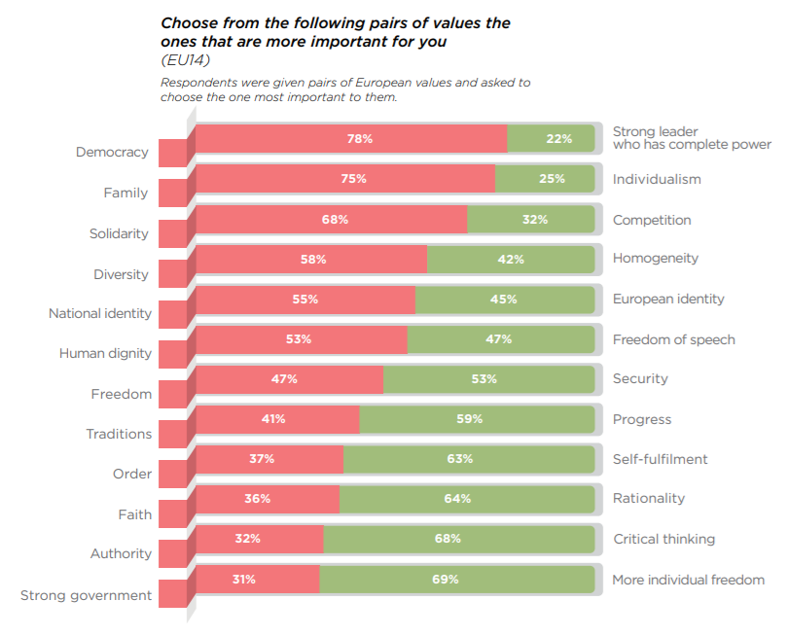

1. **Which of the following will be the most significant issue facing Europe over the next decade?**

Europe's biggest issues over the next ten years are climate change and migration.

1. **Which of the following organisations should have a more significant role in handling these issues related to the future of Europe?**

There is a division between European institutions and national governments about who should determine the future of Europe.

1. **On which of the following policy issues do you think your national government should spend more money?**

The majority chose healthcare, pensions and education.

1. **Do you agree or disagree that each citizen, including those in work, should receive a guaranteed income from the state without work requirements?**

One of every fourth respondent did not have an opinion about universal basic income (UBI). However, the majority of Europe support it.

Figure 2: The Czech Republic does not want universal basic income (UBI).

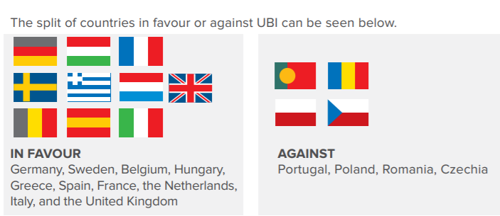

1. **What is the minimum monthly net sum that would be necessary for you personally to live a comfortable life?**

Twice the minimum wage.

1. **What do you think should be the minimum retirement age in your country?**

Age 60 is the golden year of choice.

Conclusion: the European Dream is Europe itself. Citizens want to strengthen Europe. (Survey on European Dreams for the future of Europe, 2019)

* 1. The European Dream

The creation of the European Union could be, in a way, a European Dream. It was for sure for the founders of the EU. Its proclaimers advertised and promised freedom, tolerance, democracy, justice and economic prosperity. How could one not believe the European Union? Moreover, the single market has laid the foundation for a more accessible Europe, where all of its inhabitants will feel the benefits. Free movement of people, goods and capital. Millions of people are part of the new Europe enriched and democratic in which we put significant force in the struggle for peace and global stability.

For example, European citizens can now move and work freely all over the EU. In the beginning, the EU's founding countries drew new members into their strong economies. It was to encourage growth and positive competition. The result was competition between workers. First, industries relocated, then foreigners came. People from poorer eastern European countries began to move and work for more significant wages in wealthier countries but paid lower social contributions back home. So Eastern Europeans turned its benefits to a way to earn a better living. They could be more prosperous together rather than stand against their neighbours, was the leading thought. So the EU is sending funds that are supposed to help develop the poorer countries and decrease their poverty. As a result, all member states apart from Greece have become more prosperous. However, great promises lead to great disappointments. Poor states have turned the benefit budgets for the benefit of the rich. Therefore the EU is now trying to stop financing companies that belong to politicians. Otherwise, the rich get richer, which is the opposite of what the EU is trying to do.

Not everyone would agree with Rifkin's idea of a European Dream and that it exists. However, the online periodical The Globalist noticed Rifkin's work and has included his ideas and thoughts in their web magazine.(Rifkin, 2017, *The American Dream vs the European Dream,* The Globalist)

A young European ambassador from Armenia, Stepan has experienced his European Dream in the last two years. Thanks to the Erasmus+, Jean Monet and Young European Ambassadors EU programs, he has lived and studied in four European countries and travelled to 21 states. He calls his experience "the European Dream.

(Sargsyan,2020, *What about your European Dream?*,European Union)

* 1. Europeans and their characteristics

Stuart Miller lived in different European countries several times over three decades. First, as a graduate student in literature, then as a research director, editor, working psychologist and writer. Finally, he wrote a book called *Understanding Europeans* (1990). In this book, he explains how Europeans think. It also helps them to understand themselves and their fellow Americans. The reader can see the contrast he drew between Americans and Europeans.

Americans are described here as children of Utopian Puritans. Though confined to cities and suburbs, they are still descendants of restless cowboys, aching for European culture, but caught up in hectic producing, buying and spending, and getting ahead – the American character. Americans are unique. American "exceptionalism" has been a theme in their history, from the puritan "The city on a hill" to their government's military expeditions to save any part of the world. Nevertheless, any generalisation is a lie in the sense that it can only be a partial truth. The pre-Socratic philosopher Heraclitus wrote that you could not step into the same stream twice. Europeans and Americans have changed since he wrote this book. Once a particular set of water molecules has passed downstream, the stream itself is different. So too, with nations and cultures. America and Europe are moving closer together every day through forces of modern culture – electronic communication, travel, global markets, global fashion, worldwide democracy – pushing the two worlds toward a central sameness.

However, the fundamental differences outlined here remain. "The more things change, the more they stay the same." So even though Europe is modernising and America is becoming more aesthetic and corrupted, the essential contrasts will exist.

"All educated Americans, first or last, go to Europe. "Ralph Waldo Emerson

1. **The Czech Republic and Czechs**

In his book *The AmeriCzech Dream*, Nicholas Sinclair describes how he sees our country and its people. He observes that Czechs alone admit a high level of social corruption and crime. "Ever since I arrived in the Czech Republic, I am noticing an absence and disinterest in etiquette around me. Fraud, theft, and deception have become so common that they are considered a clever shortcut to the goal. It is a sad phenomenon that brings out a question: Has Czech society had a stronger sense of etiquette in the past? Furthermore, if so, why has it stunted? I am talking about the general state of this country. "(Nicholas, 2005, pg.46 – 48)

It leaves him with the opinion that Czech society thinks and behaves less ethically than Americans. Only a noble community can follow a great man. In the past, humanity has chosen a villain instead of a hero—one of the examples of a collective mistake in allowing Hitler to become a leader. (Nicholas, 2005, pg.155)

Another point he talks about is that Czechs tend to complicate problems while Americans have a more superficial view. However, unfortunately, both tendencies can mask an essential truth: Complication will turn into confusion, and simplification will degrade it into faulty generalisation.

He also mentions religion, as Rifkin did. "I may be bold to say it, but I believe Czechs would be better off if they believed in God. Of course, a good man may also exist who does not think about God and does not need religion or faith for him to act in the name of decency. Many uneducated Christians generally act more reasonably and think more about their neighbours than the same uneducated group of atheists. I see many Czechs as people who do not believe in anything, and therefore, their faith is closely related to agnosticism or, as I would prefer to call it, 'Czechticism'. The majority of Czechs are Czechticists. " (Nicholas, 2005, pg.157)

We can say that religion and church have no role in Czech society and everyday life. What does play a significant role in our society is beer and pubs that bring tranquillity and entertainment into the Czech Society. Americans have a far more robust sense of guilt than Czechs, which is uncomfortable. He wishes that more Czechs would adopt it concerning theft and corruption. It could be the beginning of change for the better.

He then says: "John Hus believed that it is necessary to have the Bible in the Czech language, so he even tried to translate it himself. He believed in truth. By reading his words and seeing his actions, everyone could learn how to think and act like him (highly moral and ethical). It was a quality social revolution because a bit of etiquette and compassion would not hurt humanity. Biblical wisdom adds the ability to independently think, enabling people to trust and be governed from above. Marx correctly recognised that religion is mass opium, but he did not realise that personal religious conviction strengthens a person as an independent individual. Christ said: "Do not trust the leaders just because they are leaders, be vigilant, and think independently. It shows who you are and your souls."(Nicholas, 2005, pg.158) Thus, he showed us that the poor man has the same value or even greater value than the rich man with a high government title. This philosophical basis says that being poor with a clear conscience is better than being rich and having no conscience. True religion proclaims all people as equal before God. Proof of a specific 'cleansing' of Christianity in Czech history not so long ago is the speed at which the communist and Marxist dogmas in regards to 'the opium of the masses were able to wipe Christianity from the Czech society."(Nicholas, 2005, pg.160)

He does not believe that a community strong in their faith would give up their faith only because they are threatened by a couple of men in black suits.

Nicholas writes that Americans would never reconcile with a loss of religious liberty; they would rather pay their lives for it (and with an assurance of a heavenly reward). The first colonists (including Czech brothers) came to America just because they refused to give up their religious freedom. Therefore is the faith in protecting this fundamental human right an essential part of what is called 'an American'? (it would be appropriate to mention that religious freedom is part of the basic human rights listed in the 'Bill of Rights).

Czech lands experienced religious reformation and persecution a long time ago. Religion used to be one of the many political instruments and powerful institutions able to destroy those who had professed the wrong belief at the wrong time and help those who have at least made an appearance that they are supporting the right church. Therefore it is not surprising that so few Czechs genuinely believe in Christianity.

In his understanding, one of the most important events of Czech history is the Battle of White Mountain. By its nature, it is very similar to the rise of communism in the last century. Many Czech writers and historians proclaim that the Battle of White Mountain had a bad influence on the Czech people. It is a source of a lack of confidence, a tendency to steal, has created an air of deception and a belief that they are victims of uncontrollable powers. Some Czech historians and writers say that this event has beaten all ethical sense out of Czechs.

Sinclair found out that before the deciding Battle of White Mountain, most of the Czechs were protestants, but ten years later, most of the population were registered Catholics. With the support of Emperor Ferdinand II of Habsburg, the Catholic church played the role of authoritarianism for a few centuries before communism. Because of this, it prepared Czech society for a national future under totalitarian tact. The leaders of the Protestant Rebellion were executed at the Old Town Square. Their heads were hung on the gate to the Charles Bridge for the next ten years as a reminder of the importance of obedience to authority. The Catholic church was officially proclaimed as the only church allowed. All the Protestant Churches were forcefully shut, and their religious leaders were expelled from the country. The emperor's edict commanded all the people from 1627 to become Catholics or leave the country, which forced many faithful Czech protestants into exile. The emperor confiscated their possessions. In those times, 400 years ago, Czechs experienced a vast wave of socio-political execution for the first time, after which came others and others. The internal disunion of this kind with which the Czechs have struggled for centuries most likely plays a role today in informing Czech national character. (Nicholas, 2005, pg. 154 - 159)

In summary: Was it the brave ones who emigrated and those who stayed considered cowards and collaborators? Far from the truth! Czech history cannot be viewed in black and white.

Sinclair writes: "Most of the Czech emigrants that I have met in the west and most of those who returned from exile after the last revolution are much more critical of Czech society. They cannot bear the selfishness, the tendency for provincialism, and narrow-mindedness of the Czech environment in contrast with openness and directness, which comes naturally to democratic societies. Czechs do not understand how is a community different from America unless they have an opportunity to spend some time in such a country and look around."(Nicholas, 2005, pg.161-162)

After the Battle of White Mountain, there grew many greedy and immoral coat changers. They were willing to do anything just to gain the properties of the crazy Protestants who were adamant in their right to secure religious freedoms. The Czechs who believed in religious freedom had no other choice than to board ships to the American wilderness, full of Native Americans, and sacrifice all they had and known, including their homeland.

Whenever Nicolas returns to the USA, he can always be confident that he will be welcomed as a fellow American and feel at home. However, many Czech emigrants from America do not feel at home here. Moreover, they feel at home in America, whilst he will always feel like a foreigner in their country.

Protestants converting to Catholicism and Catholics converting to Marxists are necessary for the success of authoritarian systems. Thanks to these people, the country survived the masses of Czechs who did not mind losing their freedom. Some of them got richer when they served authoritarian systems and climbed the ladder of success. This historical research enabled him to understand the thinking of these ordinary Czech people: they either had to join or be silent and never share what they thought. It is the kind of thinking that is not black or white but perfectly grey from a moral perspective. 'Ok, I will sign it, but it does not change what I think. If they leave me alone to live as I want (with the advantages that I would not have), then what does it matter if I will be in the church/political party or not?'

He understood that the Czechs, as a nation, could never realise what they wanted, and they never fought for it. Nevertheless, the Velvet Revolution was undeniably a shining moment in the nation's history. Maybe one day, it will be considered the most critical event in an incredibly long national history.

Another interesting multicultural experiment for him lies in the comparison of sayings and phrases. Czechs have an expression that describes the tendency to avoid difficulties very well: 'Who escapes, wins.' Americans do not have a similar saying, and they most likely would think that one who escapes is a coward.(Nicholas, 2005, pg. 165)

Regarding the relationship between religion and Czech history, for Nicholas, the current prevalence of atheism or Czechticism is beginning to make sense. The church represents more of an authoritarian power and tax collector than a charitable organisation that would help people and encourages compassion and ethics. Moreover, there is one thing about the Czech society that makes him uneasy: That there is no more sympathy connected with an aversion to foreigners (many Czechs also consider each other an unnecessary stranger, while for Americans, a stranger is a neighbour). On the contrary, Americans are more accepting of foreigners, probably due to Christ's words engraved into the minds of Puritan American society. ...' you accepted me when I was a stranger. Whenever you showed kindness to each other or strangers, you were doing it to me.' American society is more tolerant of foreigners, including immigrants from the troubled Czech history. Americans may be pretending, but deep inside, they genuinely believe in moral principles by talking about them, but they do not always know how to live them. America is full of people like preachers and presidents caught with prostitutes and secretaries (and a disappointed public condemning them).(Nicholas, 2005, pg.166)

He thinks that Czechs pretend to keep what they preach whilst Americans honestly believe what they preach, but they often only pretend to keep it. So these are the two versions of national hypocrisy.

In his research, he realised that during Communism, Czechs respected the laws out of fear, but it is not the same as respecting the law from moral and ethical motives. People with strong moral and ethical sense were either burnt, emigrated, or imprisoned because they wrote about what others only dared to think. Children obey because of the fear of punishment. Czechs obeyed because of the fear of authorities. 'You will talk back? Go to prison!' As soon as the door with the evil, totalitarian step-parent had shut, the absence of ethics still prevailed in Czech society.

America is perhaps the only country in the world that declares its faith in God on its banknotes. However, this is exaggerated. American society has a spiritual insight that Czech culture is missing. It demonstrates their tendency to lean towards Christianity. As such, they understand that the torments of Iranians in Baghdad prisons are un-Christian like, and therefore have something to say about that society. (Nicholas, 2005, pg.160 - 167)

3.1. The Czech Republic compared to the United States by Hofstede insights

Country culture comparison has been used to analyse groups' behaviour and assess the likelihood of groups of people acting in a certain way. The founder of one finish company specialising in intercultural management, professor Geert Hofstede wrote: "Culture is the software of the mind. It is the programming of the human mind by which one group of people distinguishes itself from another group."(Hofstede Insights, 2020)

Culture is being compared to an onion with several layers. Each layer represents different things such as symbols (food, logos, colours, monuments), heroes (real-life public figures or fictional figures), rituals (spare-time activities, work meetings) and at the centre of it are values. Moreover, culture is a group phenomenon. That means the whole group cannot be represented just by one individual. However, a group of people from the same culture will most likely behave similarly.

Figure 3: culture compas – country comparison of the Czech Republic versus the USA

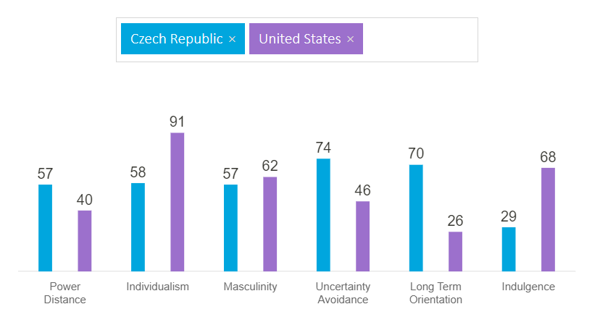 **Power distance** deals with the fact that people do not behave equally in expressing attitudes toward differences among us. It shows how the less powerful members of any group accept and count on power not being distributed.

The Czech Republic scored higher than the USA. It means that we are a hierarchical society, where people expect to be told what they should do. Centralisation is welcomed. The majority of people have their place in a hierarchical order without further justification.

In the United States, the less powerful members of institutions and organisations within a country expect and accept that power is distributed unequally. These individuals (leaders or followers) express their attitudes toward these inequalities.

**Individualism** reveals how interdependent are the individuals on each other in society. Is people's image defined by the term "I "or "We "? Do people, in general, look after themselves and their families only, or do they belong to groups where they take care of themselves in exchange for their loyalty?

The Czech Republic is an individualist society. There is a preference for a loose social framework where individuals are expected only to take care of themselves and their families. Offence makes them feel guilty; they lose self-esteem. An employee relationship is a contract based on mutual advantage, and preferred is the management of individuals.

The United States are one of the most individualist cultures in the world. The expectation in society is that people look after themselves and their close family only. However, in the business world, people are expected to be self-reliant and initiative.

**Masculinity** indicates if society will be driven by competition, achievement, and success. Success is defined by the best in the field, the winners – a value system that starts in school and continues through life. Low scores on masculinity indicate that society cares for others and emphasises the quality of life. Standing out from the crowd is not welcomed. What drives the people is either wanting to be the best – masculine or like what you do – feminine.

The Czech Republic is a masculine society. That means people "live in order to work". Therefore, competition, performance and equity are essential. Conflicts are solved by fighting them out.

In the USA, society's high masculinity drive is combined with the most individualist drive in the world. In other words, they show their masculine drive individually. In school, work and play, people try to be "the best they can be". They like to talk about their achievements in life; their success must be visible (all kinds of different prices). They have a "can-do "mentality, which means that there is always a possibility to do things in a better way. They "live to work "as well as Czechs do. They work to obtain money and higher status based on how good they can be. This mentality is raising inequality which endangers democracy. Consequently, the gap between social classes is wider, and power distance with individualism fall slowly down.

**Uncertainty avoidance** shows if society tries to control what might happen in the future or just lets things happen. So how are different cultures coping with the anxiety the unknown future brings? The way that people cope with it could be by creating beliefs and institutions by which they try to avoid these fears.

The Czech Republic scored high; therefore, there is an emotional need to keep rules, even though they never seem to work. People feel the need to be busy and work hard. Security is the primary motivation for punctuality and precision. Innovation is somewhat avoided.

The USA scored below the average. That means that people are open to trying new and different things in all areas. They accept new ideas and innovative products. It allows freedom of expression and tolerance of ideas or opinions from anyone. Americans do not need many rules and are less emotionally expressive. However, 9/11 has created much fear, which resulted in extreme control and monitoring of people.

**Long term orientation** describes how society is linked to the past while living in the present and looking into the future. Countries scoring high (the Czech Republic) are more pragmatic and prepare for the future. They also encourage modern education. Countries scoring low (the USA) maintain and keep old traditions. They look at the social changes with suspicion.

**Indulgence** separates countries as indulgent or restrained. It defines how people control or restrain their impulses and gratify their desires based on their upbringing.

The low score of the Czechs means that they are generally not Indulgent. Society tends towards pessimism. Leisure time is not emphasised, and gratification of their desires is looked upon as wrong. The restriction is felt like a social norm.

The USA's high score in this dimension reflects a "work hard and play hard" attitude. Although the states wage against drug abuse, its addiction is higher than in any other wealthy country. It is a prudish society, yet even some well-known evangelists seem to be immoral. (Hofstede Insights, 2020)

* 1. Dream Prague

There are many exciting and trendy bloggers on the internet, and choosing one for this project was going to be tricky in that I knew I would have to spend much time searching the internet trying to find the perfect one. Finally, I found a Youtuber from Los Angeles, California, who lives in Prague for a little more than eight years. She is the funniest, most popular, down to Earth and a real blogger. Her blogs are primarily about comparing the Czech Republic and the United States. Mainly California, LA and also Prague, where she still lives. Her name is Jen, who is short for Jennifer, and her funny stories reminded me of my ex-pats' friends and my ex-husband, who also comes from California. Jen does blogging and is a Youtuber for quite a while, and has around 40 thousand subscribers, with many of her videos hitting hundreds of thousands of views. Most of her videos reveal facts about the Czech Republic and the USA from the foreigners' perspective. Her goal is to compare life in the Czech republic to life in the United States. It shows us what she finds shocking or exciting and different.

* Public transport

It brings us to the following comparison Jen noticed. When she moved here, she had to have a car as she was used to the car culture in California. Public transportation is almost non-existent and very hard to access, with most people being impoverished who use it. The next point that she brings out due to the car culture and differences here in Prague and LA has to do with her weight loss. She mentions that most 16 years old teenagers dream of getting a car and license at that age as a car is a must for almost any activity. Living here in Prague, though, she was shocked at how efficient, well priced, and practical it is not to have a car. She pretty much sold her car and talked about the freedom of moving around the city practically without a car and having to worry about tickets, oil changes, tires, and car repairs which save her hundreds of dollars or czech crowns. Since it is a car culture in California, she pretty interacted with people only in cars by signalling to them. She mentioned that in Prague, she was moved to be more compassionate with people, say, for example, riding the tram as they may be old or blind, and because of this, she is more sympathetic here in Prague than she was at home. Since her trips to the store, school, bars, and friends' house almost always included getting in her car, driving and practically no walking, she was way heavier and fatter than here. After a couple of months living here, she was surprised at all the weight she lost and how her legs got in shape due to walking to the tram, the parks, and almost everywhere.

* Making friends

In her blog Dream of Prague, Jen, the blogger, also mentioned how she was moved to make friends that she usually would have never made friends of in America. In California, she mentioned that one picks their lifelong friends with the people they meet at College or University. They go through the same things in life after, say marriage, kids, jobs, bond, and they pretty much stick for life. Jen mentioned that here in Prague, she meets so many different ex-pats and friends she would have never met otherwise had she not moved here. It has made her meet interesting Czech people and other ex-pats from all over the world. She looks for one or two things that they may have in common instead of California, where most of her friends were those that she has shared college or University. She saw two hugely different things as different, and where again she gave the upper hand to the Czech Republic. In another blog, she mentioned the pub culture a lot and how to have a relatively good time in a pub with somewhat less significant expenses. The beer here is cheaper than in most of Europe but cheaper than in the US, especially California, where a beer can cost five to eight dollars. Here, the average price is around 2 Euro and some expensive Prague places in the centre being 3 to 4 Euro.

* Holidays

Something that struck me was how Jen talked about the open spaces and the parks where friends meet and gather and have picnics. In one of her blogs entitled Which country has a better quality of life. Jen mentions that Prague does have more of a good quality of life for her. She has grown in her arts and cultural life here as she is surrounded by it and has now more free time to do as she wishes. In California, most people live to work and take very little time for holidays as they must work. She praises how here a 4 to 5 week holiday is the norm, and people are encouraged to take good holidays and enjoy the time with family in friends. In Los Angeles, people must work and can not take time off. Unless one is rich, he cannot take time to enjoy the holidays. On this point, she agrees with Rifkin's observations about Europeans and how their aim is to live a good quality of life.

* Family

Going back to her first blog of living eight years in Prague, she mentions family and how her relations with her family improved since living here. In California, seeing family once a year is pretty average as living 3 hours away and everybody just working and having little time off makes it hard to visit them. Since she moved here, her friends and family try to see her once a year. She spends quality time showing them Prague and surrounding cities that they all look forward to spending time together. Jens Czech friends put family very high visiting at least parents once a month or pretty regularly. These significant differences have helped her see things differently and put the Czech Republic and Prague at an advantage as people and family are very important. Again it correlates with what Rifkin says about having quality time with one's family.

* 1. Czech Dream

Exactly 31 years ago, another American moved to Czechoslovakia, David Livingstone, and since then, he lives here his Czech Dream. He appreciates the different values with the emphasis o friendship, family and culture. He repeats what Rifkin says, that it is opposite to the American way of living.(Havranová. 2016)

Mark Sommer, in his book Living in Freedom, says:"Having grown up in culture and political systém in which liberty has been guaranteed by law and celebrated as our most precious inheritance, I had always imagined freedom to be the bright side of a broad spectrum of human experience, a linear progression toward the good and the true, where it is joined by peace, prosperity, and happiness. On closer examination, I see that freedom cannot be possessed at all – only experienced as a ceaselessly shifting set of paradoxes and ironies. Freedom is more a dream than a materiál reality, an aspiration never more than partially fulfilled. Each of us defines it differently our perceptions shaped by our personal history and cultural milieu. For those who live on the edge of survival, it represents a release from the struggle to meet their basic needs. For those assured of survival but denied the rights to speak, think, and act, it means the liberty to express themselves in word and deed."(Sommer, 1994, pg. 254) He goes on to describe the meaning of different freedoms, but let us part with our own personal definition of freedom inside of us and let us not only dream of it but live it.

# **Conclusion**

Our analysis showed the main cultural features of America, Europe and the Czech republic. It is only one point of view from many we could have chosen. Our view focused on the American and European dreams.

Americans are driven chiefly by their competitive, individualistic and short term oriented mindset, while Europeans think more in long-term visions, including the environment and the consequence of their actions.

Dreams are changing with the times we live. For example, Europeans had the vision of freedom from oppression in the past, and they found their freedom in a new"promised land", America. There the Dream was being painstakingly fulfiled, while Europeans who stayed in Europe looked at it with envy. However, then, European Dream started to form in people's hearts, and the borders were removed, countries joined, and the European Union formed. Soon the eyes of Americans turned back to Europe and observed what impact this would have on each culture. So now these countries divided by the ocean are watching and comparing each other in all areas of life. People are moving to different parts of the world. There are some Americans who have gladly adopted Czech customs. They assimilated into our culture, and there are many Czechs who have moved and adopted American culture as well. As long as we learn the good from each other, our society and coming generations will benefit.

In the global era, we were particularly interested in Americans’ knowledge of the Czech Republic, which is the focus of a questionnaire in the practical part of the thesis. The results show that Americans overall knowledge of our country is good and positive. Even though they do not know which continent it is found on, they have been here and enjoyed their stay.

# **Resumé**

Cílem této bakalářské práce je uvědomit si a vnímat rozdíly mezi americkou a evropskou kulturou se zaměřením se na Českou republiku a Spojené státy americké. Jako podklad pro zkoumání jsem použila literaturu amerických autorů, kteří se nejen zajímají o evropskou a českou kulturu, ale také mají i dlouholeté praktické zkušenosti s pobytem v Evropě nebo v České republice. K porovnání jejich zkušeností nám poslouží i jedna studie a dotazník Evropské unie, ve kterých se vykrystalizuje americká, evropská i česká společnost a jejich kultura. Pohledy na toto téma mohou být různé a tak, jak se mění společnost, tak se také budou měnit i pohledy na ni. To už je ale otázka dalších generací. V dnešním světě se spolu mísí dohromady americký a evropský sen, tak, jako se národy spojují díky neúprosné globalizaci. Bližší studie našich kultur, ať už historických nebo současných nám pomáhá v porozumění a vzájemné toleranci. Jakýkoli pohled na společnost, který sbližuje je dobrý pohled. Současné Americké pohledy na Českou republiku jsou proto v této práci pozitivní a inspirující k dalšímu zkoumání.

# **Annotation**

|  |  |
| --- | --- |
| **Jméno a příjmení:** | Daniela Cáceres |
| **Katedra:** | Ústav cizích jazyků |
| **Vedoucí práce:** | Mgr. Petr Anténe, M.A., Ph.D. |
| **Rok obhajoby:** | 2021 |

|  |  |
| --- | --- |
| **Název práce:** | Současné americké pohledy na Českou Republiku |
| **Název práce v angličtině:** | Contemporary American views of the Czech Republic |
| **Anotace práce:** | Tato bakalářská práce popisuje to, jak se američané dívají na evropany. Líčí jejich sny a porovnává je. Obě části této práce obsahují dotazníky, které představují Evropský sen a znalost České republiky a čechů. Převážně mladší lidé a lidé středního věku zde vyjadřují své pohledy a znalosti o České republice a popisují svůj evropský sen. |
| **Klíčová slova:** | Společnost, současné pohledy, americký sen, evropský sen,Spojené státy americké, Česká Republika, Evropská Unie |
| **Anotace v angličtině:** | This thesis describes the way Americans look at Europeans. It tells of their dreams and compares them. Both parts of this work contain surveys in which the European Dream and the Czech Republic with Czechs are represented. Mostly young to middle-aged people express their opinions of the European Dream and overall knowledge about the Czech Republic. |
| **Klíčová slova v angličtině** | Culture, contemporary views, American Dream, European Dream, The |United States of America, the Czech Republic, the European Union |
| **Rozsah práce:** | 57 stran (cca 61 000 znaků) |
| **Přílohy:** | Survey – Contemporary American Views on the Czech Republic |

**References**

MILLER, Stuart. *Painted in Blood: Understanding Europeans*, 1st ed.; Collier Macmillian Canada, Inc.: Canada, 1987. ISBN 0-689-11531-8.

MILLER, S. *Understanding Europeans*, 2nd ed.; Group West: Emeryville, California, 1996. ISBN 1-56261-294-8.

NICHOLAS, Sinclair. *The AmeriCzech Dream: Cizinec v cizí zemi*. Čelákovice: WD Publications, 2005. ISBN 80-239-5602-7.

RIFKIN, Jeremy. *The European Dream*. New York: Penguin Group (USA), 2004. ISBN 1-58542-345-9.

SOMMER, M. *Living in freedom, The New Prague*. 4th ed. 1994. ISBN 1-56279-054-4.

Riffkin, J. *The European Dream. How Europe's Vision of the Future is Quietly Eclipsing the American Dream.* Vortrag an der Humboldt Universität zu Berlin [Online] **18. April 2005**, (FCE3/05). (accessed June 27, 2021).

**Online sources:**

Barone, A. *American Dream*, 2021. Investopedia. <https://www.investopedia.com/terms/a/american-dream.asp>.

Columbia University. "[*James Truslow Adams papers, 1918 - 1949*.](http://www.columbia.edu/cu/lweb/archival/collections/ldpd_4078384/) <<http://www.columbia.edu/cu/lweb/archival/collections/ldpd_4078384/>>.

Havranová, A. *Czechoslovakia has changed his life*, 2016. UPMEDIA. <https://pres.upmedia.cz/publicistika/czechoslovakia-has-changed-his-life , Livingstone David>.

Jennifer *Culture Shock*, 2021. Dream Prague. <https://www.dreamprague.com/>.(accessed June 14, 2021) >.

Jennifer *Czechia nebo Czech Republic: Co říkají cizinci?*, 2021. Dream Prague. <https://www.youtube.com/?v=ys19wDl6IpA>.

Metzidakis, A. *Victor Hugo and the Idea of the United States of Europe*, 1849. JSTOR.<https://www.jstor.org/stable/23537320>., Nineteenth-century - French studies, Vol. 23, No. 1/2 (Fall-Winter 1994-95), pp. 72, Published by: University of Nebraska Press.

Havranová, A. *Czechoslovakia has changed his life*, 2016. UPMEDIA. <https://pres.upmedia.cz/publicistika/czechoslovakia-has-changed-his-life , Livingstone David>.

Hofstede, I. The Culture Compass, 2021. Hofstede Insight. <https://www.hofstede-insights.com/country/czech-republic/>.

National Archives*. "Declaration of Independence: A Transcription,* <https://www.archives.gov/founding-docs/declaration-transcript>.

Prof. Dr Calliess, Ch. *Berlin e-workers papers on European Law*, 2005. paper 30. <https://www.jura.fu-berlin.de/forschung/europarecht/bob/berliner_online_beitraege/Paper30-Pernice/Paper30---*Coalition-of-the-Willing-and-European-Integration*---Different-Speed---A-Core-Europe.pdf>.

RIFKIN, Jeremy. DOI: <<http://www.ecln.net/documents/rifkin.pdf>.>.

Jeremy Rifkin, August 18, 2005, *The Globalist* <<https://www.theglobalist.com/the-american-dream-vs-the-european-dream/>>.

<https://www.euneighbours.eu/en/east/eu-in-action/youth/stories-young-european-ambassadors/what-about-your-european-dream>.

Practical Part:

**Survey:**

This online survey was done in the summer of 2019. Different people from all over America were asked questions on overall general knowledge about the Czech Republic. The aim was to find out if regular American citizens know at least about our country's existence. Thus, the questionnaire proceeds from a broad view to more narrow views and knowledge about our country and culture.

**Contemporary American views of the Czech Republic**

Figure 1:

- 306 people viewed the overall survey, from which more than three-quarters of them completed it

- the exact number is 138 respondents

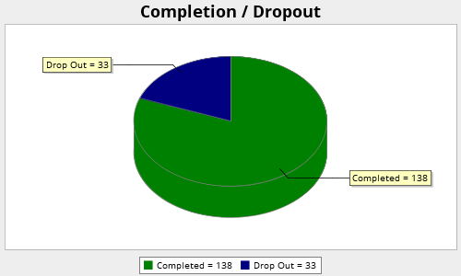

**Q3. Country of your birth?**

Figure 2:

- this question was to find out whether the respondents are truly American

- half of them come from the USA

- almost all of them are from America

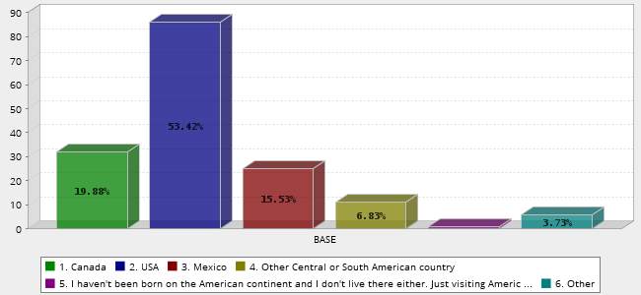

**Q5. Country of  your residence:**

Figure 3:

- this question was to ensure that not only the respondents have been born in America, but that they still live there

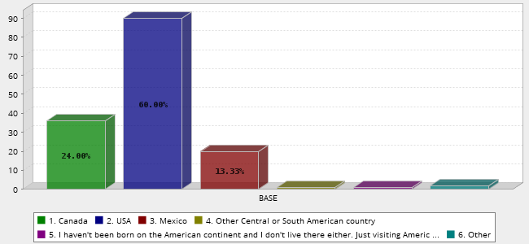

**Q5. What is your gender?**

Figure 4:

- the answers are almost equally distributed with the difference of 18 more answers by men

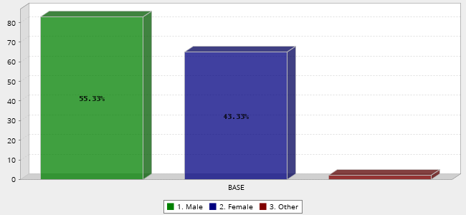

**Q6. What is your current age?**

Figure 5:

- the majority of the respondents were from the age 18 to 45

- the most answers come from students and middle-aged people with more opportunities to travel

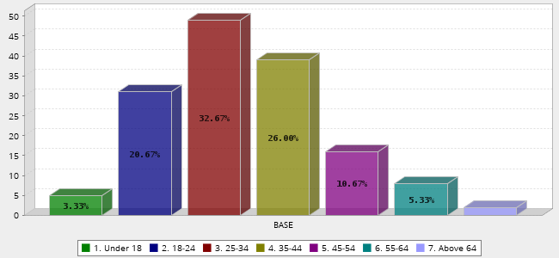

**Q7. Have you ever visited the Czech Republic?**

Figure 6:

- most of the answers come from the people who have been to the Czech Republic

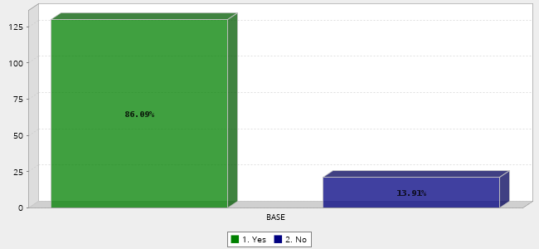

**Q8. Would you like to visit this country?**

Figure 7:

- those few respondents who have not visited the Czech Republic would like to come here

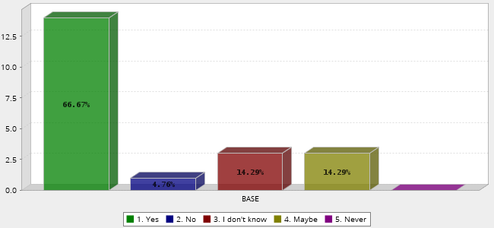

**Q9. Was your visit pleasant?**

Figure 8:

- peoples' stay in the Czech Republic was good to enjoyable

- three respondents had a bad stay

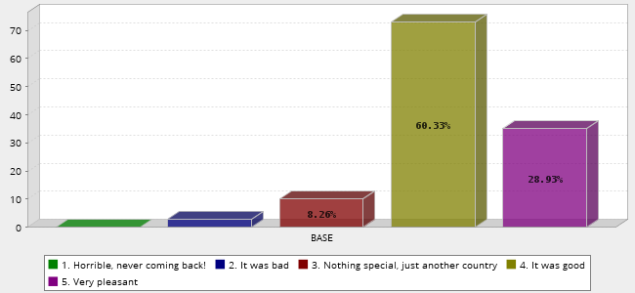

**Q10. Of which continent is the Czech Republic part?**

Figure 9:

- only half of the people asked knew on which continent was the Czech republic

- many of them thought it is somewhere in America, and others wrote it was in Asia

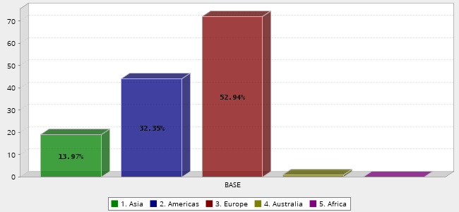

**Q11. Your knowledge about the Czech Republic comes from:**

Figure 10:

- their overall knowledge about the Czech republic comes mostly from social talk connected with having relatives here and their own research.

–they hear about the Czech republic also on the TV, through social media and at school

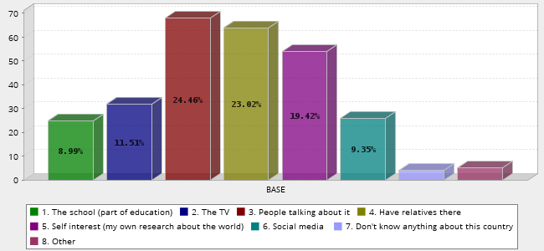

**Q12. Which famous Czech people have you heard of (from what industry)?**

Figure 11:

- Czech historical figures, athletes, scientists and models are the ones Americans hear the most of

- little less famous are the Czech politicians, musicians, Czech actors

- the least popular is the Czech artists

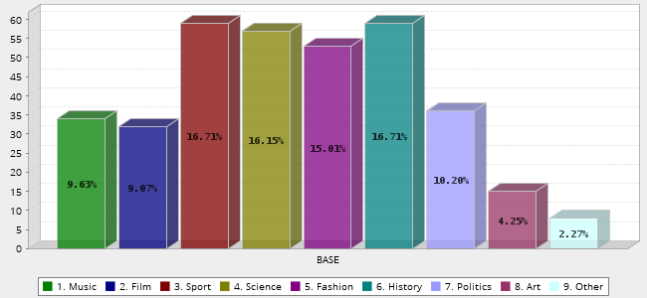

**Q13. By what war was the Czech country involved in or affected?**

Figure 12:

- by half of the respondents, it is by both wars

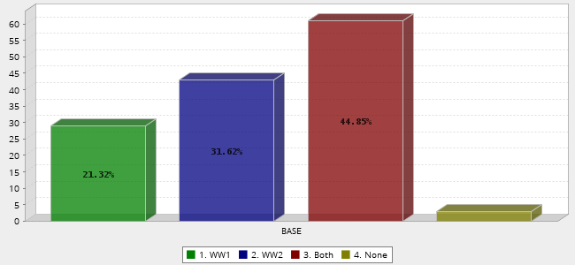

**Q14. The capital city of the Czech Republic is:**

Figure 13:

- more than half of the respondents chose the correct answer

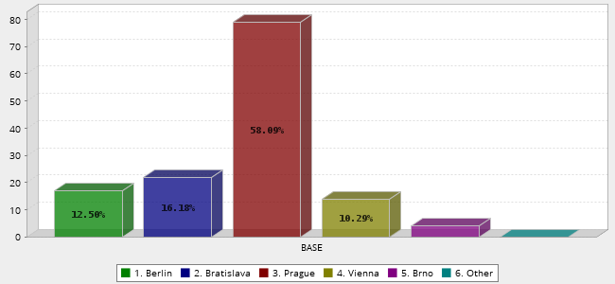

**Q15. Do you find Czech people:**

Figure 14:

- Americans find Czechs mostly friendly and reserved, some of them even rude and hostile

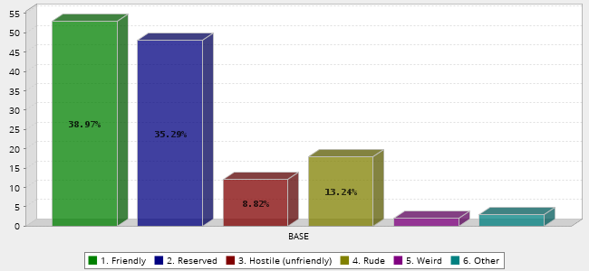

**Q16. How satisfied were you with these Czech things:**

Figure 15:

- American tourists in the Czech Republic are the most satisfied with the sights, talking to people (communication), entertainment, accommodation and reasonable prices

- the lowest scored Czech cuisine, the Czech mentality and customer service

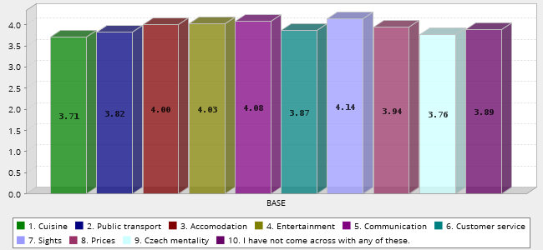

**Q17. What is the first thing that comes to your mind when hearing about the Czech Republic?**

Figure 16:

- the first thing that comes to most Americans in mind is Prague

- half of them think about Czech cuisine, then pretty girls and beautiful nature

- then the thoughts go to Czech people and communism

- the last thought is on Czech beer

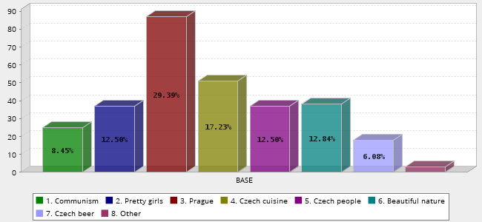

**Q18. When I visited the Czech Republic, it felt like**

Figure 17:

- half of 131 Americans feel just as if they are in a similar country to theirs while visiting the Czech Republic

- the other half feels like they were back 10 to 20 years ago

- few of them feel even better than in America

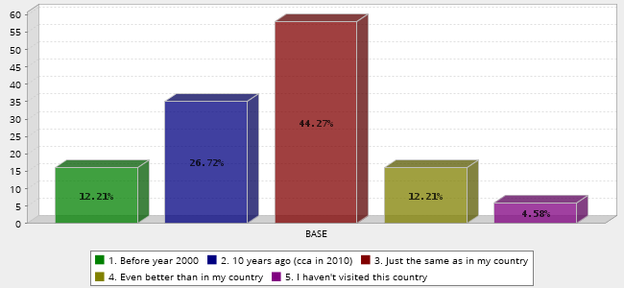

**Q19. Did you feel sorry for the Czech people while visiting the country?**

Figure 18:

- around one-third of respondents felt sorry for the Czech people while visiting the Czech republic

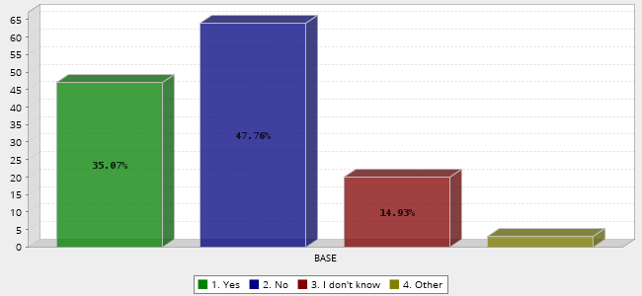

**Q20. What kind of impression did the Czech people leave on you in general?**

Figure 19:

- on more than half of respondents left Czech people the happy and cheerful impression

- around a quarter of Americans asked still think Czechs are cold and reserved

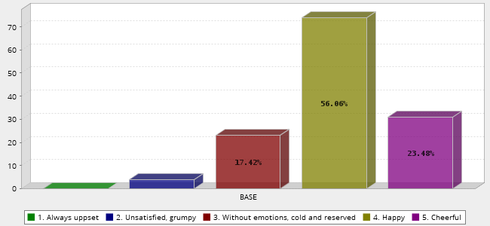

**Q23. Please rate their overall English language skills:**

Figure 20:

- according to most of the respondents, Czechs English language skills are good and impressive

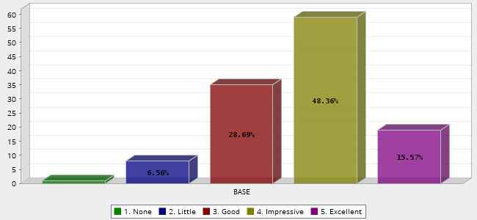

**Q24. How satisfied are you with their approach to foreigners?**

Figure 21:

- only one respondent was not satisfied; the rest were satisfied, neutral or very satisfied

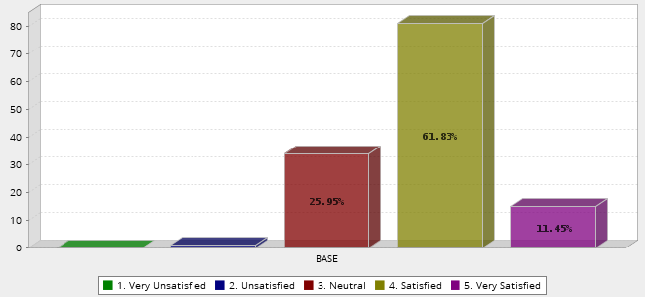

**Q25. How does the Czech language sound to you?**

Figure 22:

- to the majority of respondents Czech language sounds similar to other Slavic languages

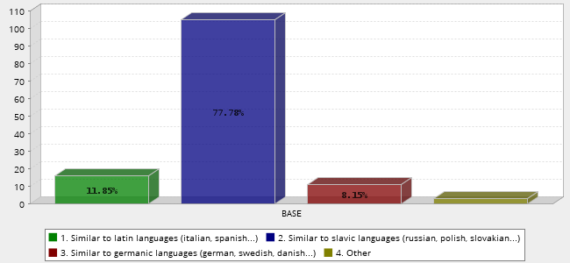

**Q26. Is President Donald Trump in any way related to the Czech Republic?**

Figure 23:

- most of the respondents knew their former president's past

