Czech University of Life Sciences Prague

Faculty of Economics and Management

Department of Economics


Diploma Thesis

International Agricultural Trade of Wheat: Case Study of the United States of America

Author: Kamil Maitah

Supervisor: Ing. Jiří Mach, Ph.D.

© 2018 CULS Prague
Summary
The diploma thesis is divided into two main parts, theoretical and practical. The first part describes wheat and its uses. Moreover, it characterizes the wheat market in terms of international trade. The wheat foreign trade development and its impact on U.S. wheat export have been explored.
The second part is analytically oriented, for that, a linear regression analysis has been conducted using the ordinary least squares method to analyse dependency between U.S. wheat export and selected macroeconomic indicators within the years 1995–2016. The econometric model has examined the relationship between U.S. wheat export and U.S. wheat production, U.S. wheat price, U.S. export promotion (MAP, FMD programs), value of U.S. dollar (U.S. dollar index), competing country wheat price (Canada), and wheat importing country GDP (Japan).
The export of U.S. wheat is impacted by 74% by changes in the chosen variables. It means that significant variables were contained in the model, both statistically and economically. The estimated model reports which factors significantly affect the export of U.S. wheat. It reveals that the export is largely affected by the changes in the production, price and export promotion. For instance, if the price of U.S. wheat increases by 1 dollar, the export of U.S. wheat will decrease by 58 thousand metric tons per year. By contrast, if U.S. export promotion increases by 1 million dollars, the export of U.S. wheat will increase by 55 thousand metric tons per year. This underlines the significance of the programs supporting export.
Based on this model, the forecast of U.S. wheat export for the next four years is derived (2017–2020). It predicts that the export of U.S. wheat will increase in the following years except 2017. The export is projected at 34,302 thousand metric tons in 2019. That would be the largest exported quantity since 2010. Moreover, if the forecast holds, it is expected that the U.S. will regain its position as the world’s largest wheat exporter.
Keywords: foreign trade, international trade, agriculture, wheat, U.S.
Objectives
One of the main objectives of this thesis is to analyse the global trade of wheat commodity with emphasis on the United States. In particular, to characterize and investigate the aspects of international trade of wheat in terms of production, export and import. The key players will be listed and described. Furthermore, to use statistical and econometric methods to investigate a relationship between U.S. wheat export and selected macroeconomic indicators within the period 1995–2016. On the basis of the regression analysis, the aim will be to determine the impact of the chosen variables on U.S. wheat export, and make the forecast for the coming four years.
Hypotheses:
- If the production of U.S. wheat increases, the export of U.S. wheat will increase.
- If the price of U.S. wheat increases, the export of U.S. wheat will decrease.
- If the export promotion increases, the export of U.S. wheat will increase.
- If the U.S. dollar index increases, the export of U.S. wheat will decrease.
- If the price of Canadian wheat increases, the export of U.S. wheat will increase.
- If the GDP of Japan increases, the export of U.S. wheat will increase.
Methodology
To analyse the subject in detail, the thesis will be divided into the theoretical and practical part. The methodology of the thesis should therefore first provide literature review and theoretical information on wheat and its utilization. For that purpose, secondary data from articles, books, official documents, publications, reports, statistical bulletins and other materials relevant to the topic were used. Then collect and process the data on U.S. wheat export and selected indicators during the period 1995–2016, and that graphically display using charts and tables. Firstly, the practical part will deal with the developments of the chosen variables. Then, all the data will be examined by employing the linear regression analysis in Gretl software to determine dependency and validity of the relationship of the variables. The obtained results will be verified with the use of economic, statistical and econometric verifications. The last part of the econometric analysis will deal with the application of the given model for the forecasting purposes.

Conclusion
The thesis focused on the factors affecting how much amount of wheat is exported by the United States. In the first phase, the developments of U.S. export and chosen determinants such as U.S. wheat price, U.S. wheat export promotion, U.S. dollar index, Canadian wheat price, and Japan GDP were analysed. During the monitored period 1995-2016 U.S. wheat export decreased by 15%, representing a decrease of 241 thousand metric tons each year on average. The relationship between U.S. wheat export and U.S. wheat production might be referred as a positive relationship, because if there is a change with the production, then there will likely be a corresponding change in the export that is typically in the same direction. Furthermore, it shows that the export had been declining mainly due to the increase in the price and stronger U.S. dollar. Nevertheless, U.S. wheat export promotion has been constantly increasing by how it helped increase the exports. Throughout the entire period the export promotion increased by 63%. The development of Canadian wheat price is similar to the development of U.S. wheat price with just the opposite effect. Japan GDP has a positive trend, however, it seems it doesn't have a significant impact on the wheat export. This corresponds with the assumptions drawn from this research.
In the second phase, the linear regression model was developed to explain the behaviour of U.S. wheat export. The export of U.S. wheat is affected by 74% by changes in the explanatory variables. This implies that significant variables were included in the model, both statistically and economically. The estimation of the model also revealed that the assumptions correspond to the economic theories about the dependency of explanatory variables on the explained variable. Based on the estimation, if the production of U.S. wheat increases by 1 thousand metric tons, the export of U.S. wheat will increase by 0.29 thousand metric tons per year. Furthermore, it shows that the wheat export is largely affected by the value of U.S. dollar. If the dollar index increases by 1 index point, the export of U.S. wheat will decrease by 83 thousand metric tons per year. Even though the variable is not statistically significant according to the statistical verification. Similarly, if the price of U.S. wheat increases by 1 dollar, the export of U.S. wheat will decrease by 58 thousand metric tons per year. On the other hand, if U.S. export promotion increases by 1 million dollars, the export of U.S. wheat will increase by 55 thousand metric tons per year. That emphasizes a positive and statistically significant impact of the programs. Besides, the estimated model demonstrates the importance of competition price, if the price of Canadian wheat increases by 1 dollar, the export of U.S. wheat will increase by 58 thousand metric tons per year. The variable Japan GDP appeared as not statistically significant with a little impact.
At the end, the forecast was derived from the econometric model for the period 2017–2020. It predicts that the U.S. wheat export will increase in the coming years with exception of the year 2017. Particularly, in the year 2019, the export is projected at 34,302 thousand metric tons. That would be the largest exported quantity since 2010. Based on the forecast, the United States in 2019–20 will account for a larger proportion of world wheat export than in 2011–16. Moreover, if the forecast holds, it is expected that the U.S. will regain its position as the world’s largest wheat exporter.
U.S. Wheat Export 1995–2020
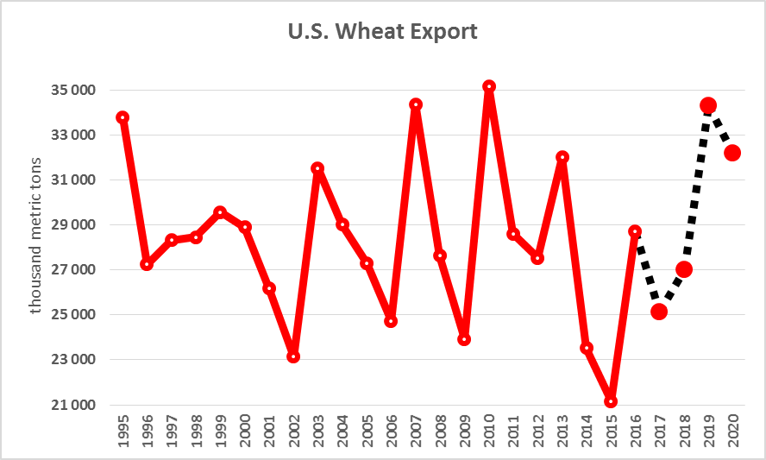
Source: Own calculation and elaboration
At the time when the forecast had been conducted, the exported quantity of U.S wheat for the year 2017 was already known. The U.S. has exported 25,855 thousand metric tons in that year, down 12% from 2016 and 3% behind the 5-year average. By how the U.S. lost its leading position in the market. Moreover, the number is very close to the projected value, 25,139 thousand metric tons. This may serve as evidence regarding the forecast relevance.
Selected References
- Allen, Michael: "Understanding Regression Analysis." 2004. ISBN: 978-0306484339.
- Bushuk, Walter: "Wheat - Production, Properties and Quality." 1994. ISBN: 978-0751401813.
- Carver, Brett: "Wheat - Science and Trade." 2009. ISBN: 978-0813820248.
- Davidson, Russell: "Econometric Theory and Methods." 2004. ISBN: 978-0195123722.
- Droke, Clif: "How to Trade Wheat Futures." 2002. ISBN: 978-0971785205.
- Gooding, Mike: "Wheat Production and Utilization - Systems, Quality and Environment." 1997. ISBN: 978-0851991559.
- Leeflang, Peter: "Advanced Methods for Modeling Markets." 2017. ISBN: 978-3-319-53469-5.
- Ramu, Ramanathan: "Introductory Econometrics with Applications." 2001. ISBN: 978-0030343421.
- Singh, S. S.: "Wheat - Productivity Enhancement Under Changing Climate." 2012. ISBN: 978-8184871487.
- Vance, Martin: "Econometric Modelling with Time Series - Specification, Estimation and Testing." 2012. ISBN: 978-0521139816.

