UNIVERZITA PALACKÉHO V OLOMOUCI
Pedagogická fakulta
Ústav cizích jazyků

Using Classic Literature in English Lessons at Secondary Schools – Charles Dickens´s Oliver Twist

Diplomová práce

2023 Bc. Karolina Malychová
Using Classic Literature in English Lessons at Secondary Schools – Charles Dickens´s Oliver Twist

(Diplomová práce)

Autor: Karolina Malychová
Studijní obor: Učitelství anglického jazyka pro základní školy
Vedoucí práce: doc. Mgr. Janka Kaščáková, PhD.
Počet stran (podle čísel): 83
Počet znaků (bez mezer): 113 306
Olomouc 2023

Prohlašuji, že jsem tuto diplomovou práci vypracovala samostatně a uvedla úplný seznam citované a použité literatury.

V Olomouci dne 20.4. 2023 ……………………………… podpis

I would like to thank doc. Mgr. Janka Kaščáková, PhD. for her humane attitude and valuable advice during the process of writing this thesis.
Table of Contents
Abstract 6
1. Introduction 7
2. Theoretical Part 8
2.1 Classic Literature 8
2.1.1 ‘Classic Literature’ as a term 8
2.1.2 Significance of Reading 10
2.2 ESL Literature Classes 13
2.2.1 Importance of Literature at School 13
2.2.2 Classic Literature at School 15
2.2.3 Reading in Second Language 21
2.2.4 Teaching ESL Literature Lessons 23
2.3 Conclusion 29
3.Practical Part 30
3.1 Oliver Twist 30
3.2 Preparation of Lesson Plans 32
3.3 Pre-reading Activities 35
3.3.1 Pre-reading Activities for 6th grade 35
3.3.2 Pre-reading Activities for 7th grade 36
3.3.3 Pre-reading Activities for 8th grade 37
3.3.4 Pre-reading Activities for 9th grade 39
3.4 Reading 40
3.4.1 Reading Activities for 6th grade 40
3.4.2 Reading Activities for 7th grade 41
3.4.3 Reading Activities for 8th grade 41
3.4.4 Reading Activities for 9th grade 42
3.5 Post-reading Activities 43
3.5.1 Post-reading Activities for 6th grade 43
3.5.2 Post-reading Activities for 7th grade 44
3.5.3 Post-reading Activities for 8th grade 44
3.5.4 Post-reading Activities for 9th grade 45
3.6 Additional Activities 47
3.7 Feedback and Results 51
3.7.1 Feedback 51
3.7.2 Results 53
4.Conclusion 60
References 63
Appendices 66
Annotation 82
Résumé 83

Abstract

This diploma thesis deals with the importance of the use of classical literature in English lessons at secondary schools and its benefits for learning English. The aim of this work is to find out if using classical literature in English lessons helps students to improve their language competence, and also, how do students perceive the classical literature in lessons – as the compulsory obligation or as a possible benefit for their future. The theoretical part of this work is focused on the significance of reading in general and on the convenient methods in literature lessons teaching. The practical part deals with the specific lesson plans and their impact on students.

Introduction

The importance of using classical literature at schools is one of the most discussed issues when talking about literature lessons. There are arguments pro and con why (not) to use classical literature and obligatory reading lists at schools in native language lessons – in this case in Czech literary lessons. Literature in second language, in this case in English language, is often overlooked although there are many findings about its benefits to learning the language in general.
This diploma thesis is focusing on benefits of the use of classical literature at lower secondary schools and its impact from the students’ perspective. The theoretical part of this thesis is focusing on the term ‘classical literature’ and its meaning. In following chapters there is described the significance of reading in general, of reading at schools and the reading and teaching of classical literature at schools. In the practical part of this thesis, there is made an analysis of specific lesson plans focusing on the novel Oliver Twist by Charles Dickens and the research is based on teaching these lessons, on students’ work during lessons and their following evaluation.
The aim of this thesis is to find out how can the use of classical literature (Oliver Twist) in English lessons contribute to the improvement of students’ English language, specifically to the language skills and vocabulary. The other aim is to ascertain how do students perceive using classical English literature in lessons, if rather as a compulsory obligation or as a benefit for their future. Using the novel Oliver Twist may prove that there are many possible activities which may be used in lesson plans with the same topic.
Although, there are many scholars who are dedicating their work to this topic – of classical literature at schools, I would like to propose a new sight to this topic and I would like to use different types of teaching materials and lesson plans dedicated specifically to this topic, because throughout the years as a student and during few experiences as a teacher, I have met many opinions that classical literature is boring and cannot be used to entertain students nowadays. I would like to suggest that there are many options how to include classical literature into English lessons and that it may also interest students who are usually non-readers.

2. Theoretical Part

2.1 Classic Literature

‘A classic is a book which with each rereading offers as much of a sense of discovery as the first reading.’
- Italo Calvino
The theoretical part of this work will focus on the classic or classical (used interchangeably when speaking about literature) literature in general, specifically on the classical English literature and its usage in ESL education. I will try to find answers on the questions as if there is an importance of reading such literature when learning English and what are the convenient ways of using classical literature at secondary schools. Before answering more complex questions, it is necessary to explain some basic terms (as follows) which will be used throughout the whole work.

2.1.1 ‘Classic Literature’ as a term

According to the Britannica dictionary, the term ‘literature’ is understood as ‘written works (such as poems, plays, and novels) that are considered to be very good and to have lasting importance’ or ‘books, articles, etc., about a particular subject’. It is very complicated to more specify the meaning of the word literature and it also slightly differs according to the author who defines it, but the core meaning is always the same. In simple terms, it is practically anything we can read (written works) and benefit from. Results of using literature (reading) are naturally very individual and each person perceives the same text differently, but it could be said that reading literature, and it does not matter which genre, somehow uplifts the reader (his general and specific knowledge, his fantasy, attitude, emotions etc.).
For this thesis, it is more important to limit the term ‘classic English literature’ rather than the general term ‘literature’, and to stay coherent, I will use the definition by the Encyclopaedia Britannica, which says that ‘Classical literature [is] the literature of ancient Greece and Rome […]. The term […] is also used for the literature of any language in a period notable for the excellence and enduring quality of its writers’ works.’ During the years, the meaning of ‘classic literature’ extended not only to other languages, but also to other periods of time. It is not simple to state the accurate definition for this term and scholars use slightly different explanations, although they define almost the same features which make a book classic. For example, T. S. Eliot (1944) speaks about the maturity as the main feature of classic literature, according to him, only the mature civilization is capable of having classic literature which means that ‘maturity of mind, maturity of manners, maturity of language and the perfection of the common style’ are characteristics which are necessary for this kind of literature to exist. Esther Lombardi (2021) sees the biggest importance of classic literature in the cultural importance; she thinks that classic literature is a well-written work which is ‘culturally significant’. Although, labels used by these authors are different, the substance is the same, classic literature (a classic) is a well-written work written by the popular author, it is popular by the general public, it has a great review and it impinges the society (both, good and bad emotions are acceptable). This does not mean that the classic has to have all these features, but at least the most of them are required.
As an example, I can mention the novel Oliver Twist by Charles Dickens which will be the piece of the classic literature used throughout the whole thesis, principally in the practical part. Charles Dickens as an author was very popular even before writing the Oliver Twist, his short stories in newspaper were approved by the public and he is considered one of the greatest novelists. For its startling topic it became a very shocking work which stirs up the emotions even in these days. As the novel Oliver Twist fulfils these features as the popular author, great reviews, or the interest of the society, it is considered to be a typical example of classic literature which was one of the reasons I have chosen this work to be a main example of the classic literature possibly used in ESL teaching.

2.1.2 Significance of Reading

Before the practical part of this thesis, it is important to mention what is the primal motive to write this work. Even before stating the thesis statements (the substance of this work), there is a general question which is researched by many scholars and also asked by many ‘ordinary’ people, no matter if they are readers or non-readers. Is it important to read? There are many factors which influences a relation people have towards reading – social status, family model, personal experience, etc. These factors lead to a conviction people make about reading which means there are two main opinions about reading. The first group considers reading necessary for the person’s personal growth and the other one believe that reading is just a time-consuming pastime. But which opinion is the right one? As with many other questions which divide the humanity, there is no need to think only one answer is correct. Although, the belief supporting the importance of reading prevails.
For example, Paulo Freire says that ‘[r]eading the world always precedes reading the word, and reading the word implies continually reading the world’. This thought refers to the fact of the interconnection between the real world and literature. There are millions of people around the whole world writing about their feelings, their inner thoughts, or fantasies, but also about issues of other distant countries, problems of other nations, genders, or races. The ordinary person has a little chance of traveling the whole world and experiencing these problems on his own, so it is literature which mediates all this to people everywhere. No matter which genre of literature a person choose, in every text there is something from the real world. This thought is confirmed also by Christina Clark and Kate Rumbold (2006) who say that even reading just for pleasure has a positive impact on people (children and adults). They claim that except of the great impact on reading achievement, reading for pleasure also increases:
- general knowledge (e.g.: Cunningham & Stanovich, 1998)
- a better understanding of other cultures (Meek, 1991)
- community participation (e.g.: Bus, van Ijzendoorm & Pellegrini, 1995)
- a greater insight into human nature and decision-making (Bruner, 1996)
Other skills (than social) developed by reading are the language skills. Probably the most discussed benefit of reading is the increase of vocabulary knowledge. During the spoken language (communication), people tend to use just a limited range of words, opposed to reading where people passively absorb the great variety of new words. According to Falk Huettig and Martin J. Pickering (2019) ‘[s]uch developments [greater lexical precision] also benefit spoken language because most predictive (e.g.: associative) dependencies and linguistic (e.g.: semantic) representations are shared between written and spoken language.’ Huettig and Pickering (2019) also speak about verbal working memory which is also influenced by reading. It does not matter what kind of a text a person read but it is necessary to keep in mind information to make a text coherent, which ‘requires keeping track of multiple entities and so enhances memory’, practising then ‘supports the development of short-term memory functions, including subvocal rehearsal and, as a consequence, working memory for serial order information’.
Benefits of reading mentioned above are relevant for both, children, and adults, but here arise a question: When is the right time for children to start reading? Scholars often discuss if there is a boundary which determines when children start to profit from the literature. Many people think that babies/toddlers are not capable to profit from reading because of their undeveloped nerve system and often call it ‘useless’ to read them. Niklas, Cohrssen, and Tayler (2016) have made a study about the influence of the age at which children were first read to, they claim that ‘[e]arly support of children’s linguistic competencies is essential as linguistic and literacy skills play a major role in everyday life and are important for later academic achievement and life success in general’ and findings of their study show that ‘starting early can support the development of children’s language abilities […] parents should be encouraged to start reading to their children when they are very young— the sooner, the better’.
As it is necessary to introduce literature to children when they are very little, parents are first who influence the relation children have towards reading. Before starting the school, which can change children’s opinion (in the positive or negative way), children imitate their parents which, according to Christina Clark and Kate Rumbold (2006), results in following findings:

- Children who know adults who read for pleasure take it for granted that reading is a valuable and worthwhile activity (Csikszentmihalyi, 1991)
- Children whose home experiences promote the view that reading is a source of entertainment are likely to become intrinsically motivated to read (Baker, Serpell & Sonnenschein, 1995)
- The home environment exerts a significant effect on academic motivation, which is over and above that predicted by socio-economic status (Gottfried, Fleming & Gottfried, 1998). Thus, children whose home environment is more cognitively stimulating have higher academic motivation than children whose home is lacking such stimulation
- The beliefs held by children’s parents about the purposes of reading and how children learn to read relate to children’s motivations for reading. More specifically, parents who believe that reading is a source of entertainment have children with more positive views about reading than parents who only emphasise the skills aspect of reading (e.g.: Sonnenschein et al., 2000)
- Children of parents who believed that reading is a source of pleasure had greater reading motivation scores in primary school (Baker & Scher, 2002)
- Children are more likely to continue to be readers in homes where books and reading are valued (Baker & Scher, 2002).

After explaining what the classic literature means and showing that there are many benefits of reading as vocabulary knowledge, general knowledge, better memory, social skills and many others, there is also important to mention how crucial is the role of family in first years of the child’s life when comes to the reading. Except of the family, there is another significant factor which influences reading of children, that is a school or education in general, which I will focus on in the next chapter.

2.2 ESL Literature Classes

2.2.1 Importance of Literature at School

As was already mentioned in the previous chapter, school plays a significant role in the formation of children’s relation to reading. Every child comes to the school with some predispositions (from the family) to be a good reader and also to like reading itself. The second step in this journey depends on the child’s school. From my own experience, and experience of my friends and family members, I may mention two common ways schools approach literature lessons or reading in the case of little children. The first way is the obsolete one, which is used mostly by older teachers, or it is used generally at schools without innovation in this field – this approach is based on the strictly given compulsory reading, drilling of the facts, years, or literary terms. The other way consists in building a positive relation to book and reading in general. Teachers who use the second way are focusing on the children’s emotions when reading, on thoughts that they naturally obtain by reading and then they can learn also about authors or literary periods. The second way is supported by Geoff Dean’s (2005) claim that ‘[a]ny teacher cultivating ‘enjoyment’ and promoting greater learning of reading will have brought about a most desirable set of outcomes’.
What influences students the most, when speaking about reading at schools, is the sufficient motivation. There are several possible ways how to motivate students to read, the most significant ones are probably marks and the interesting choice of books (topics attractive for the given age group). What way is teacher going to choose has an impact on the relation to reading in general. It is easier to motivate younger students, as they are more open to get positively evaluated. Older students are not always keen on reading although they are motivated by marks. Students in puberty are mostly influenced by attractive topic which may be an image of their own life when they are not understood. One way to solve this possible problem is to let students choose the book they want to read and discuss. Results of this method are mostly positive, as students read what they like, they may want to read more but as Ivana Gejgušová (2012) mentions, there are also some negative aspects as ‘the trivialization of the reading’ and ‘stereotype of genres’. When students have the opportunity to choose what to read at school (or for school purposes) they often choose from works that are undemanding and suitable for younger students as it is easier to read and work with or they read just one specific (favourite) genre without choosing anything else to broaden their own horizons. These aspects lead to the necessity of creating limits for school reading by a teacher. For example, the possibility to choose their own book but they should choose different genres throughout the school year, chosen books should be also firstly approved by the teacher in case of picking too simple literature for their age.
Kelly Gallagher (2009) is talking about the term called ‘readicide’ which she describes as ‘the systematic killing of the love of reading, often exacerbated by the inane, mind-numbing practices found in schools.’ Gallagher also mentions negative trends in schools that cause this readicide:
1. There is a dearth of interesting reading materials in our schools.
2. Many schools have removed novels and other longer challenging works to provide teachers and students with more test preparation time.
3. Students are not doing enough reading in school.
Gallagher’s main idea is that schools or teachers are spending most of the time in lessons with ‘preparing students for tests’ instead of preparing them for the future in the real life. Teachers are often focusing just on the fulfilment of necessary duties, as tests, examinations, graduation, but they are not trying to really engage students or leave some positive impact. Dr. Seuss once said: ‘The more that you read, the more things you will know. The more that you learn, the more places you'll go.’ And this quote should be a motto for all teachers and students (or people in general) because literature has a great impact on the person’s life even though it is not obvious at the first sight. No matter which way of teaching literature a teacher choose, there is an unquestionable result and that is reading positively influences not only how the student expresses, but also his vocabulary, general knowledge, perception of the world and social interactions. As was mentioned above, a family is the main factor which influences the attitude of children to literature, either in the positive, or in the negative way. But in the certain time of the children’ s life, they spend most of the time at school which means schools should be shaping their personalities or at least trying to. Not all children have the positive role model in the family, and they are starting with negative or non-existent experience with reading. This is the reason why school should not overwhelm students just with ‘heavy’ reading but there should be an opportunity to read just for pleasure to shape children’s reading relation if anybody else does it. Gallagher (2009) sums up this idea as follows:

To become a lifelong reader, one has to do a lot of varied and interesting reading. If students don’t read much at home, school becomes the only place where “lighter” reading can take hold. When schools deprive students of the pleasures of recreational reading, we end up graduating test-takers who may never again read for pleasure.

It is clear that reading accompanies students through the whole education, but it is also important to focus on different genres. As already mentioned, to build a positive relation in students, it is necessary to read their favourite genres, which might be really diverse, but there are also types of literature or genres that are not so popular but cannot be unheeded. For example, it can be poetry, specialized literature, or classics which I will discuss in the next chapter.

2.2.2 Classic Literature at School

It is unquestionable that reading at schools is important for many already mentioned reasons, but it is also necessary to say that there should be balance in the school literature. School should serve as a secondary source for students’ reading relation, if children do not have the model role in their family; a school needs to work with student to create a positive relation towards reading. But it is not possible to read only modern literature and genres popular by the majority of teenagers. Their general knowledge should be broadened and one of the ways to do so is reading classic literature. Students are often discouraged from reading classic literature even before really starting to read it. They think that these books are old, topics are not relevant nowadays and the language is odd. According to the research of Vala (2017), from the several book extracts students have chosen two classic literature excerpts as the least attractive to read. The reasons were that the language structure was too outdate and complicated to understand and also topic was not making any sense to them. The complicated language (vocabulary or grammar structures) and outdate topics and beliefs seem to be the biggest obstacles when reading the classics at school.
Many teachers, who teach literature lessons in native language (specifically in Czech language), are using the same methods for many years. Students have to read many classics, learn facts about author and do some text analysis that is all what they do. This attitude just causes the aversion towards reading, nothing else. Of course, also unpopular classics need to be read and taught about, but teachers should learn how to learn it properly and successfully which means that previously mentioned obstacles should be got over. Teachers need come up with methods they do not usually use, they need to use new activities which would be interesting and fun for students but at the same time informational and practical enough to teach them (students) what is expected and necessary to fulfil school standards. There are many innovations which can be used when teaching literature lessons and which are popular among students but unfortunately teachers are not seeking for new techniques because the stereotype is always easier. I will discuss these methods, techniques, activities, and ways of teaching literature lessons in general in the subchapter 2.2.4 (Teaching ESL Literature Lessons).
In the literature lessons, teachers have to prepare students for their graduation exam which means they need to follow a reading list and a literature lesson plan which is already given (by the school and other institutions). This limits teachers because they need to teach students the chosen literature, or more precisely, information and analyses about given classics but they do not have enough time to add other, more attractive literature for students. The compulsory reading given by the CERMAT is the same for many years and there are minimal changes made which is also necessary to mention. Older generations are against the modern literature of new generation (as well as the previous generation were), but books which are written nowadays will be also classics one day. Many years need to pass but it will happen because this is the natural cycle of human culture. There should be added new books to compulsory reading lists to give these books a chance. And a chance for students to fall in love with books. Unfortunately, this process is a long-distance run and a language teacher himself cannot change it, so he has to focus on the way of teaching this classic literature and choose wisely among the obligatory books. Lišovská (2022) claims that according to her research (made among librarians and teachers of different length of school practice) literature for student should be recommended, not obligatory to let students have the chance to choose, also the half of the works should be picked from the ‘golden canon’ and the other half can be the modern contemporary literature. As the literature lessons prepares students for their graduation, there are more strict rules at high school learning, this thesis deals with the literature at primary schools, so it is not necessary to pay more attention to the creation of the reading list. On the other hand, it was important to state some basic information.
Schools create their own list of recommended reading based on what is necessary to know at high schools (examples follow):
- Mňák V.: Muž z hodin
- Fišerová I.: Na orlích křídlech
- Březinová E.: Lentilka pro dědu Edu
- Soukupová P.: Bertík a Čmuchadlo
- Kratochvíl M.: Pachatelé dobrých skutků – PUNTÍKÁŘI.
- Stará E.: Dům za mlhou
- Vladislav J.: Propánakrále!
- Čech P.: Poklad – dobrodružství rychlé veverky
- Armstrong Thomas: Každý je na něco chytrý
- Březinová I.: Začarovaná třetí třída
- Plachý J.: Velká kniha čůrání
- Malý R.: Příhody matky přírody

The list of recommended literature above is offered for children in 3rd grade by Prague’s ZŠ Angel. To make a comparison, ZŠ Velké Pavlovice offers the following list:
- Bernardinová, E. : Ahoj bráško!
- Braunová P. : O chlapci, který spadl z nebe
- Březinová I. : Trosečníci- Dobrodružství řehtajícího koně
- Dvořák, J.: Slepice a televize
- Fabiánová, T.: Jak jsem chodila do školy
- Fischerová, D. : Duhové pohádky
- Frynta, E. : Písničky bez muziky
- Hanzlík, J.: Pimpilim Pampam
- Horelová, E. : Tománek ve škole
- Horváthová, T.: Modrý tygr
- Kratochvíl, M.: Deset malých Bohoušků
- Kratochvíl, M.: Potkal kočkodán kočkonora
- Krejčí, J.: To jsem blázen
- Lindgrenová, A.: Pipi dlouhá punčocha
- Ochová, S.: Náš pes Balabán
- Osbornová, M. P.: Výprava za tajemným rytířem
- Pražáková, H.: Dárek pro Moniku
- Stránský, J.: Povídačky pro Kláru
- Šrut, P.: Příšerky & příšeři
- Šrut, P.: Kočičí král
- Štuka, I.: Kde bloudí velbloudi?
- Voldřichová – Kyrčivová, M.: Kam plaveš Gastone?
- Zinerová, M.: Indiáni z Větrova
- Žáček, J.: Krysáci

If we compare these two lists for the 3rd grade students, it is evident that there is not any specific canon which would serve as a model. These lists differ in the number of books and none of the literary works are the same. Requirements on the reading for students are also distinct. When looking at the reading lists of the 3rd, 4th and 5th grade of primary school, there are more differences rather than similarities. But there are some factors which are the same as the chosen book are short, topics are convenient for children and language is easy to understand. Younger students who have recently learnt to read are expected to read more for fun and to make a positive bond towards books. Opposed to 6th, 7th, 8^{th,} and 9th grades of primary schools where are students gradually introduced to literature necessary for passing the graduation exam. If looking at the next list of reading which is made by ZŠ Litvínov we can notice that the selection of books is completely different from books of the 3rd grade students:

- Karel Čapek: Povídky z jedné kapsy a Povídky z druhé kapsy
- Karel Čapek: Krakatit
- Karel Čapek: Válka s mloky
- Anne Franková: Deník
- Radek John: Memento
- Michal Viewegh: Báječná léta pod psa
- Mika Waltari: Egypťan Sinuhet
- Ota Pavel: povídka Smrt krásných srnců
- Ota Pavel: povídka Jak jsem potkal ryby
- Bohumil Hrabal: Slavnosti sněženek
- Karel Poláček: Bylo nás pět
- Eduard Bass: Klapzubova jedenáctka
- Josef Škvorecký: soubor povídek Prima sezona
- Arnošt Lustig: Modlitba pro Kateřinu Horovitzovou
- Zdeněk Jirotka: Saturnin
- Romain Rolland: Petr a Lucie
- Halina Pawlowská: Díky za každé nové ráno

Books are longer and they have more complicated language and more elaborated topics and themes. To have a comparison, here is the list offered for 9th grade by ZŠ Kosmonosy:

- Charles Dickens – Oliver Twist
- Karel Havlíček Borovský – Křest sv. Vladimíra, Král Lávra, Tyrolské elegie
- Josef Karel Šlejhar – Kuře melancholik
- Jan Neruda – Balady a romance, Povídky malostranské
- Edgar Allan Poe – Havran, Jáma a kyvadlo
- Oscar Wilde – Slavík a růže, Obraz Doriana Graye, Strašidlo cantervillské
- Viktor Dyk – Krysař
- Petr Bezruč – Slezské písně
- Fráňa Šrámek – Stříbrný vítr, Splav
- J. Hašek – Osudy dobrého vojáka Švejka za světové války
- Romain Rolland – Petr a Lucie
- Erich Maria Remarque – Na západní frontě klid
- E. Hemingway – Stařec a moře
- G. B. Shaw – Pygmalion
- Karel Čapek – Válka s mloky, R.U.R.
- William Styron – Sophiina volba
- Isac Asimov – Já robot
- Ray Bradbury – 451 stupňů Fahrenheita
- George Orwell – Farma zvířat, 1984
- Jan Drda – Němá barikáda
- Ladislav Fuks – Spalovač mrtvol (budeme pracovat s filmem)
- Jan Otčenášek – Romeo, Julie a tma
- Ota Pavel – Smrt krásných srnců
- Bohumi Hrabal – Ostře sledované vlaky (budeme pracovat s filmem), Postřižiny
- Ivan Martin Jirous – Magorovy labutí písně
- Petr Šabach – Hovno hoří
- M. Viewegh – Báječná léta pod psa
- R. John – Memento

These two lists, made for 9th grade, have more similarities, not in the number of books but definitely in the choice of concrete books. The majority of titles are mentioned in both reading lists and, last but not least, these lists of recommended reading are already similar to those made by secondary (high) schools. It gives 9th grade students a bigger chance to adapt in literature lessons at secondary schools, then it depends just on primary school teachers how much they fulfil the given requirements.

When learning literature at primary schools it is necessary to use classic literature but to do it with deliberation. The knowledge and reading of classic literature is very important for broadening students’ general knowledge, but it is convenient to use also modern and popular literature. Students will have bigger chance to choose something they truly enjoy reading which leads to positive relation towards reading. When using both, classic and modern literature, students gain more than choosing just one way of teaching. Teachers need to adjust the reading according to the age of students and together with suitable methods and innovative activities, students may even enjoy learning and reading of books from so called ‘golden canon’. This chapter was focused on the classic literature at (primary) schools in general, in the next chapter I will discuss in detail a reading in second language, as the practical part of this thesis is based on the classic literature in English literature lessons (ESL).

2.2.3 Reading in Second Language

Teaching literature lessons at schools is extremely complicated and teachers have partly a responsibility for the students’ relation to books. Still, reading in mother tongue is a lot easier than reading in other language. For students at Czech schools, English is the second language which they have been taught. They start to learn English at primary school, and they need to cover all language skills – listening, speaking, writing, and reading, which may be sometimes very difficult. As this thesis focus on the literature, I will discuss the reading skill.
When reading in the mother tongue, people may understand not only the content of the book (a topic) but also the smallest details as feelings of characters which are not directly written, readers can easily identify with character when they understand what is written between the lines. Moreover, readers reading in the mother tongue have the possibility to relax when they are reading, but what about reading in the second language (English)? These readers may have problem with the vocabulary or the language structure which can lead to incomprehension of the main content. If readers do not understand what is going on in the book, they can hardly relate to some characters, understand they feelings or learn some lesson from the book. The reading may be so demanding for them that they do not enjoy it, they use books only as a source of studying. This leads to the way learners use when starting to read in English. Ozek and Civelek (2006) describe the method of reading in second language as follows:
[the] identification of the meaning and grammatical category of a word, sentence syntax, and text details, etc. While processing information provided them by each sentence, readers check to see how this information fits, again employing […] background knowledge, prediction, getting the gist of a text, skimming, scanning, etc.

Except of the mentioned linguistic issues, reading in second language is also influenced by socio-cultural and individual factors. Skopečková (2006) speaks about the different attitude of various cultures to reading, text structure and specific topics. In the individual layer of meaning, she mentions the personal reading literacy, experiences with various texts and the motivation to read.
Students start to read in second language at the same time as they are learning vocabulary, grammar, language structure, etc. Opposed to mother tongue, when children start to read after they really know understand their language and they know how to speak. When reading in second language, students need to multitask and still develop all the language skills. Grabe (1991) mentions how complex activity reading in second language is and how researchers (Carpenter & Just, 1986; Carr & Levy, 1990; Haynes & Carr, 1990; Rayner & Pollatsek, 1989) divide the knowledge areas which need to be developed to six categories:
1. Automatic recognition skills
2. Vocabulary and structural knowledge
3. Formal discourse structure knowledge
4. Content/world background knowledge
5. Synthesis and evaluation skills/strategies
6. Metacognitive knowledge and skills monitoring

In lessons, students need to sufficiently develop and practise all these categories to have an opportunity to improve their own reading in second language. Except of practicing the language skills, methods used by teachers are one of the most important factors when learning reading. Ozek and Civelek (2006) suggest that:

relating the title, illustrations/pictures and background knowledge to the text, skimming, using dictionary parsimoniously, guessing, remembering a word through situations, rereading, using the first language as a base, visualizing events, being careful about how the text is organized, making notes and summaries of the important information, and classifying words are the strategies help readers to improve their reading ability significantly.

Their (Ozek and Civelek, 2006) research confirms that teachers who use various teaching methods during the literature lessons show students what strategies they may use to help them to understand any text better.

2.2.4 Teaching ESL Literature Lessons

As was already mentioned in previous chapters, the way teacher mediates literature to students is crucial to their learning process and their future relation to literature. Teaching ESL literature lessons is even more challenging because students have to read in second language which leads to a lot of issues with understanding. Also, to prevent boredom caused by demanding tasks it is necessary to choose convenient activities according to the age and/or level of their English. It is required to change activities during the lesson to keep students motivated enough. Fortunately, there are lots of methods and activities to choose from when teaching literature lessons so I will provide some of the most successful ones.
To start with supporting materials, some teachers use course books in literature and some of them don’t. For students, it is useful to have some summarizing source when learning that’s why it is sufficient to use some course book in lessons. There is no need to stick only with this book, other activities and sources may be used, but it helps to have some overview. Teacher may provide basic information about literature periods, terms and authors which are available and then extend their knowledge by using other methods. Although, the majority of literature course books contain excerpts from different books which is very useful when trying to do a literature analysis. Chou (2010) says that ‘when the teachers are teaching each unit in the course books, there is a consistency in the topics and genres in the four skills area (listening, speaking, reading, and writing)’. When not using course books, teachers are often concentrating just on one or two language skills per lesson which is why a course book helps with consistency of lessons; students have more opportunities to practice various skills. Of course, there aren’t only advantages when speaking about the use of literature course books, after a few lessons, many students may find the learning process boring and uninteresting. In addition, the reading selections in the ESL course books are often quite short and they often fail to present appropriate and realistic language models (Kayapinar, 2009). Also, texts in the majority of course books are not long enough to provide students with the sufficient amount of reading and learning material.
Another necessary part of the literature teaching is choosing the right text and making suitable adjustments. Factors for choosing the right text are an interesting topic, a language level of the text, an appropriate length according to the time, cultural and literary background knowledge, and a utilization of the text for language purposes (Duff a Maley, 2011). The topic needs to attract students and motivate them to learn more which is connected with the suitable language level. Students have to be capable of reading it on their own, because the use of dictionary is sometimes rather discouraging (depends on the students’ motivation). Even though students in one class are of the same age group and their language level should be the same, it is not always the case. The background knowledge also plays the role here. Students who have no problem with English grammar may have issues when reading when they do not know the cultural and/or literary context, and vice versa. It is required that text should be long enough to give students information necessary for literary analysis, but at the same time, it should not be too long to keep their attention and to have time to do other activities connected to the reading. When adjusting the chosen text, a teacher needs to have in mind factors which are necessary to focus on:
- Linguistic factors (language structures, new vocabulary)
- Storyline (how much adjustment it withstands)
- Cultural factors (how much cultural information text contains and how much is it important for understanding)
Choosing the right text and its adjustment is an overly complex action which should not be underestimated as it serves as a base of the literature learning, and it is also a starting point for other activities (pre-reading and post-reading activities) as they are mostly directly connected with the given text.
There are many possible divisions of teaching approaches and methods in literature lessons, some scholars divide them to just a few groups, some of them distinguish merest details and thus speak about more approaches or methods, often only labels of these groups differ. Ikonne (2016) divides literature teaching approaches and methods as follows:

Approaches
- Thematic
- Stylistic
- Group
- Response
- Integrated
- Problem posing

Methods
- Criticism
- Discussion
- Discovery
- Questioning
- Project
- Activity
- Read and explain

The thematic approach focuses on the theme and topic of the text, the stylistic one deals with the style of writing which is used by an author. The group method is about dramatization of the text, the response method could be connected with the critical method of teaching literature. When using integrated approach, students are dealing the text as the entire system and in problem posing approach they are searching for some mystery in the text. Approaches in teaching literature are more general and methods are in fact particular steps when dealing with the text during some activities.
Beach et al. suggest different dividing of approaches or strategies when teaching literature:
- Perspective-taking
- different perspectives of theme, topic, and characters
- dramatization
- Restorying
- entering the worlds of texts
- imagination
- Explaining Characters’ Actions
- formulation of characters’ behaviour, beliefs, emotions etc.
- role plays
- Making Connections
- questioning of the real world and other texts (global context)
- build on individual knowledge
- Posing Questions/Problem-solving/Rereading
- exploring questions
- Applying Critical Perspectives
- multiple perspectives and multiple interpretations
- Critical Literacy Pedagogy
- critical analysis
- social changes

Although, the division of Beach et al. seems different from Ikonne’s one, after the detail look it is clear that in the majority only labels of approaches/strategies/methods differ.

When teaching literature classes, no matter if ESL or not, it is necessary to use a great variety of different activities during the lesson. It prevents the loss of students’ motivation, it keeps students active, and it helps with the multiple intelligences problem as different activities focus on all language skills (speaking, listening, reading, and writing) and students have better opportunity to learn and remember necessary information, as well as they train their personal/individual thinking methods when working with the text using various methods. Some of the activities which are convenient to use in literature lessons are videos connected with the text (plot summary, analysis, description of characters etc.) because it connects visual and audio elements with the modern technique as using online technologies which is very close to students nowadays. Other activities are diverse types of games as kinaesthetic games (where students need to move), memory games, group games, quizzes, and others. Games are considered to be suitable only for younger students but when adjusting the game and choosing the right one, it is also immensely popular with older students who may appreciate unusual way of teaching. If focusing on the text analysis, there is no need to just read, translate and answer some questions. Students may have discussion in groups about some pattern in the given texts; they may read the text in pair and share their thoughts when reading or students may dramatize the text to understand it better. Last but not least, there are activities which combines art and imagination as the graphical illustration of the text, drawings or writing the own text inspirated by the analysed one or using just some feature from the text or the whole literary work and remake it in the students’ works.

There are a wide variety of different approaches, strategies, methods, and activities which may be used in literature lessons. Many books, articles and online sources are dedicated to the ways how to teach and not to be stereotypical. It depends on the teacher and his/her manner of teaching which he/she likes the most and what is more suitable for certain students. A teacher who wants to really engage students and motivate them enough needs to spend time with planning these lessons, but in the end, students really benefit from such a teaching as they learn more. It is generally known that it is necessary to use more methods and activities when teaching to make the learning process more effective.

2.3 Conclusion

In the theoretical part of this thesis, I summed up the basic terms which are necessary to know before the practical part. I stated the term literature and classic or classical literature which is fundamental for this thesis as it deals with the usage of this kind of literature at secondary schools. It was also crucial to mention reasons for reading, how necessary reading is for people, and which benefits it takes. Not only for children, but also for adults. According to many scientific researches, it can be concluded that starting reading in the early childhood helps with many linguistic and social problems. Reading helps to widen the vocabulary; it helps with the speaking confidence, and it improves the grammar of the individual. Except of the linguistic benefits, reading broadens the general knowledge of the reader and it may prevent the social insecurities.
Other topic dealt with in the theoretical part was teaching of literature at secondary schools. When stating the importance of reading in general, it was found out that except of the family, schools have the biggest impact on students’ relationship to reading. Although, reading in general is beneficial for children, it can be also concluded that using specifically classical literature at schools as it propose the great variety of personal thoughts and opinions to discuss.
There were also mentioned ways to maintain students’ motivation and approaches and methods used when teaching literature at schools. All these statements are applicable at all literature classes but in this thesis, I am focusing specifically on the literature lessons taught in second language – English language. The other conclusion is that reading in other than mother language is more demanding, and activities need to be adjusted to this fact. Students, especially younger ones, are not capable to thought in the target language, and many students have even problems to understand emotions and inner world of characters when reading in another language. Many factors which were mentioned in the theoretical part have an impact on how to choose the concrete approach or method of teaching. Each teacher should consider all these factors together with students and their personalities and adapt it for his/her lessons to make the lesson the most beneficial.

Practical Part

The practical part of this thesis is based on the literature lessons which are focusing on the classic literature – specifically on the novel Oliver Twist by Charles Dickens. In this thesis I am dealing with the literature lessons of the lower secondary school, which means 6th, 7th, 8^{th,} and 9th grade of secondary school. In each grade there will teach a literature lesson focusing on the novel Oliver Twist. I prepared lesson plans consisting of different activities according to the level of students’ English, and also, to make the lesson more interesting there were used different teaching methods. After each lesson, students fill in the questionnaire about their own reading experience, their opinions about classic literature and about the taught lesson. I will describe these lessons and activities (pre-reading, reading, post-reading and additional activities) and in the end of the practical part I will make an evaluation of taught lessons which will be based on the mentioned questionnaires and feedback from these literature lessons.

3.1 Oliver Twist

Before describing teaching activities used during these literature lessons, it is necessary to introduce the novel which comprises the core of the lesson plans. As the classic literature work used in the practical part of this thesis, I have chosen the novel Oliver Twist by the English writer Charles Dickens. The author of this novel was very popular when writing and the novel became very popular as well, the topic brought up many (especially negative) emotions when it was published, and it is controversial topic till these days. There are many themes, characters, symbols, and other features to analyse, and all factors mentioned above make it a classic literature, which also appears in the majority of mandatory and voluntary reading lists of classic literature.

Oliver Twist or also Oliver Twist; or The Parish Boy’s Progress is the (social) novel written by Charles Dickens. The author published this work originally serially under the pseudonym ‘Boz’ in the Bentely’s Miscellany from 1837 to 1839. In 1838 it was published in the three-volume book. Charles Dickens described the impoverished London underworld and expressed his belief that poverty leads to the crime.

The main character of the novel is the boy Oliver Twist who was born in 1820s in the workhouse and who is an orphan since he was born. He spent his childhood in the orphanage, with many children and little food, about 70 miles outside London. At the age of nine, Oliver dares to ask for more gruel which is unacceptable, so he is sent to work as an apprentice to an undertaker Mr. Sowerberry. Oliver is mistreated here for some time, and he decides to run away to London where he meets Artful Dodger who introduces him to Fagin – an old man who trains boys for pickpocketing. One day, Oliver is caught during the pickpocketing, and he needs to attend the trial where he passes out because of the fever. The target of the pickpocketing, Mr. Brownlow, then offers Oliver to take care of him in his home. Unfortunately, after Oliver recovers, he is recaptured and returned to Fagin. During the burglary with Bill Sikes, Oliver is shot but then the family of Maylies takes care of him. This family is then trying to find out Oliver’s identity. Meanwhile, Fagin and one of his henchman Monks make plan to get Oliver Back. Rose Maylie meets Nancy (who ran away from Sikes) who tells her about the evil plan of Fagin. Unfortunately, after Sikes finds out about Nancy’s betrayal, he murders her. Fagin and his henchmen are caught and convicted for the committed murder. Later, Oliver and Rose learns about his identity, that Oliver’s mother was a true love of Mr. Brownlow’s close friend and thus Oliver is Monk’s half-brother. Oliver then gets his inheritance, and he is adopted by Mr. Brownlow.

The novel Oliver Twist became a significant work when speaking about the social criticism and a problem of poverty in the 19th century. The work was considered very realistic, because of Dickens’ writing technique, but also for his personal life experiences. Because of its scandalous subject matter, it became very popular among people when it was firstly published. Nowadays, the novel still may offer a lot. Its historical context, social problems which may be also shifted to today’s world. These are some of the reasons why is this novel still popular and many adaptations were made since then.

Preparation of Lesson Plans

As the basis of the practical part of this thesis I have chosen to prepare four lesson plans for the literature lessons focusing on the novel Oliver Twist by Charles Dickens. As a student, I have no previous experience as a full-time teacher except of my teaching practice. I am thus proceeding from lessons of my teaching practice and activities I have try with students on my own, my personal experience as a student and experiences of other teachers I have talked to.
I have prepared a lesson plan for each grade of the lower secondary school (6th, 7th, 8^{th,} and 9th grades) to demonstrate that one novel could be adjusted for more grades and levels of English when using suitable activities and materials. Also, it helps to make more general results of this practical part when trying to teach this type of literature lesson in classes of different age groups.
Each lesson plan I have prepared is consisted of some introduction pre-reading activities, the reading itself, post-reading activities and the brief evaluation of the lesson. I was trying to put enough time for each activity as during my teaching practice I found out that my previous lesson plans were too demanding for students, and it was not possible to complete all activities I had prepared. Except of the time-organization, I was trying to put emphasis on the diversity of activities during these lessons. Although, these plans were focusing on one novel and it was meant to be a purely literature lesson, I was trying to show that there are many various activities which may be used in these lessons. Also, I wanted students to practice as many language skills during one lesson as possible.
Individual activities and their organization are described in three following chapters (pre-reading activities, reading and post-reading activities) and all materials which were used are to be seen in Appendices. However, I would like to briefly introduce and comment these lesson plans from the point of view of their preparation.
Students of the 6th grade are not used to literature lesson in their second language – English language. It is something new for them, so it was important to make this lesson more entertaining than informational; of course, some knowledge and new information are definitely passed on students. In this lesson I used activities focused on vocabulary, listening skill, and reading skill, and in the end, I have also used a game. Students are used to these types of activities, so it was not anything new for them except of the topic. Some of the activities were meant to be completed individually and some of them collectively which makes it more interesting for them.
For students in 7th grade, I could prepare something more challenging than for the previous class, but still, they were quite familiar with these types of activities as the passive transfer of information, vocabulary, grammar exercise or reading. What was new for students was the speaking activity. Or to make it clearer, students in 7th grade are not used to speak only in their second language. This activity is, in my opinion, very important in English lesson so I was trying to use it in the majority of lesson plans. It may seem too much complicated for this level of English, but it was possible to make this activity using only vocabulary they are familiar with, and the teacher was very supportive.
As I have already mentioned, I was using the speaking a lot in these lesson plans, so I did in the lesson plan for the 8th grade too. The speaking activity were more challenging for them but not impossible to fulfil. Other activities used were listening, some fill in worksheet with different exercises to practice this kind of diversity and reading, of course.
For students in 9th grade, I have prepared the lesson plan which was the most complicated but corresponding with their level of English. I was trying to use activities which are also used at high schools; I just adjusted it to be more comprehensible for them. It is important for students in 9th grades to be familiar with activities which are used in following years to prepare them a little bit. In this lesson plan, the practice of all four language skills (listening, reading, speaking, and writing) was organized. Students had opportunity to try types of activities which they already experienced but with the new focus.
The aims of these four lesson plans were to focus it purely on the literature and specifically on one novel – Oliver Twist by Charles Dickens. The other aim was to use diverse activities focusing on all four language skills and adjusting them to the level of English of these students. Reading, speaking, and listening were practiced quite equally, opposed to writing which was practiced the least of these four language skills. The reason for it is mainly time-organization because writing activities last more time. The majority of activities were using technologies like online worksheets, videos, online quizzes etc. As some students find the literature lessons more boring than other language lessons, I was trying to use materials which are more popular nowadays and students are more motivated to learn something when doing online activities.

3.3 Pre-reading Activities

Pre-reading activities are those activities and exercises which precede the reading itself. These activities should prepare students for reading, introduce the topic or the text, it should help with the vocabulary or other factors which may be problematic. It is convenient to prepare activities which motivate students (games, videos, or entertaining activities) because demanding activities before reading may cause the lack of interest.

3.3.1 Pre-reading Activities for 6th grade

In the beginning of the lesson (after some organization part), the literature topic is introduced by the online vocabulary worksheet. As mentioned above, new vocabulary as a pre-reading activity is a very convenient way how to introduce the literature in the lesson. Furthermore, online worksheets are nowadays far more popular among students as they may use technology which is close to them. This specific worksheet is from the website www.liveworksheets.com (see the Appendices) and it consists of twelve words which should be matched to their meaning (synonyms). These words are from the beginning of the novel Oliver Twist, from the same part as the text for reading is chosen. Some of the words are already known by students, some of them are new, and students are also asked to write down the unfamiliar words to their dictionaries to widen their vocabulary knowledge. Students are asked one by one to match the word with its correct meaning, it the student does not know the answer, other one tries to choose right. After the correct match, the teacher explains it in own words to make it more clear for students. This activity should not last more than eight minutes, and it should prepare students also for the other pre-reading activity.

The second pre-reading activity is more time-consuming as there is twenty minutes of the lesson dedicated to this activity. It is a video introducing the plot summary of the whole novel. The video is available on the www.youtube.com under the ‘Oliver Twist – Stories for Teenagers’ on the channel ‘English Fairy Tales’. The level of English may be too advanced, but the video is animated and shows illustratively everything that is said. In fact, it is a cartoon accompanied by the spoken word. Also, there are some lines said directly by the characters, which makes the video more entertaining. Thus, even though students do not understand each word which is said, they should understand the plot in general and also passively get some new vocabulary. Although the video last about sixteen minutes, it is a popular activity for students as they may feel like watching a film during the class. After the video, the teacher sum up the video in few sentences. Just to make sure, students understand the main points of the plot and to emphasize the most important facts, necessary for the reading and following activities. Not only that this type of activity is attractive for students, and it makes them more motivated, it is also a great practise of the listening skill.

These two activities are enough to prepare students for the reading part itself. Also because of the time-consuming listening activity – the video. These two activities are fulfilling both – the preparedness for the next section of the lesson, but also the ‘fun part’ of the lesson. New vocabulary is used in the text for reading and the video gives student some general knowledge about the novel and its plot, thanks to it the reading will be more comprehensible for them. Because of the online form of these activities, students should be more motivated and not bored.

3.3.2 Pre-reading Activities for 7th grade

After the organization issues, the teacher tells students some basic information about the novel Oliver Twist and its author Charles Dickens (see the Appendices). It is the example of the classic lecture or in this case rather the teacher talking time. Students will passively listen and try to remember something new. The teacher says only few important points to not overwhelm students, just about eight minutes total. Unless it is the passive activity for students, some of them are learning threw listening so it is a possible way to transfer the information (multiple intelligences theory). If necessary, students may ask questions after this little lecture. It is important to keep it short to maintain students’ motivation and to have enough time for other (more active) activities.

As the second pre-reading activity I have chosen the same vocabulary activity as in the 6th grade. It is also the online vocabulary worksheet from the page www.liveworksheets.com (see the Appendices) but the level of English (vocabulary) is little bit higher. Students should match the words with their explanation. There are twelve words from the beginning of the novel, and it could be said that these words are quite specific ones (e.g.: to fire a gun, dragged etc.). Students go one by one to the whiteboard, and they try to connect the word with its synonym using an interactive pen. After connecting all words, the worksheet is automatically corrected. The teacher than gives students feedback when repeating words and their correct explanation. Activity should not last for more than seven minutes.

The third (and last) pre-reading activity in this lesson is another online worksheet from the web page www.liveworksheets.com (see the Appendices). This time it is focusing on the grammar, specifically on the past tense. It is the simplified retelling of one part of the story. This worksheet is on the right level of English for this class so there should not be any problems with understanding it. In this text, there are several blank spaces followed by the verb in the bracket (in the infinitive) and these verbs should be put to the correct form of the past tense to make the story comprehensible. Each student tries to read sentence with the correct form of the verb. If it is said correctly, next student may read. If student makes a mistake, the teacher (or classmate) helps him/her. Students in the 7th grade should be able to use past tense with confidence so it should not be a problematic exercise. It serves to practice past tenses and also to practice reading already.

These three pre-reading activities should be consistent enough to prepare students for the reading part, but at the same time, because of the online activities, it should maintain their motivation. At this moment, students have some surface knowledge about the literary work and its author, they learnt new vocabulary connected with the novel and they practiced past tenses at the same time when they already practiced their reading skill. Students should be prepared and motivated to start the reading part of the lesson.

3.3.3 Pre-reading Activities for 8th grade

The literature lesson of 8th grade students is started by the video called ‘Oliver Twist by Charles Dickens (Animated Book Summary)’ by the channel ‘Books Mandala’ available on www.youtube.com. The video is really convenient as a pre-reading activity as it uses the animated form; the author is using photos and drawings accompanied by writings and a spoken commentary. The spoken language is simple and clear, on students’ level of English. It is quite easy to follow, and students should understand it without any issues. The video lasts about eight minutes, so it is not too long to lose students’ attention. These types of videos are usually popular with students so it should be an appropriate activity to start this lesson. After the video, students should briefly speak with the teacher about the lesson’s topic. Students should understand why this video was played and what are they going to do in this class. The teacher may outline the organization of this literature lesson.

This type of an activity (video) usually catches students’ attention, and they are more motivated to learn something new. Although, videos are usually considered as the entertaining activities, it does not make them as wild as games, for example. Students may also practice their listening skill, and at the same time, they may learn something new.

The following pre-reading activity is related with the video from the beginning of the lesson. Students will fill in two online worksheets from the web page www.liveworksheet.com according to the information they heard in the listening activity. The first worksheet is consisted of two types of exercises – the first one is ‘true or false statement’ and the second one is ‘choose the correct option’. In the first exercise, there are five statements about Oliver Twist’s life and students should choose if the statement is true or false. In the second exercise there are also five sentences with the blank spaces, these sentences are about the plot of this novel. Students should choose the correct answer from three options. This worksheet may be filled in collectively where projected on the board, each student may answer one question, or the teacher reads the question and anyone who knows the answer may speak.

The second worksheet is formed by pictures with the short descriptions of some part of the story. Students should put these pictures and their description in the correct order by numbering them. In this exercise, I recommend students to read these descriptions one by one with some brief explanation of unknown vocabulary, which may be written on the board by the teacher. Then, it is easier to order pictures correctly. This exercise can be also done collectively using the data projector.

This type of activity may be more entertaining for students then just passively listening to teacher’s explanation. It is made in the form of the quiz so students may try to answer quickly and correctly. Although, the information is acquired from the previous activity when listening the video and students are then strengthening their new knowledge. Using more types of exercises in this worksheet helps them to practice for various language tests.

3.3.4 Pre-reading Activities for 9th grade

In the beginning of the lesson, the teacher asks students about their previous knowledge of the novel Oliver Twist and its author Charles Dickens. Students may tell anything they already know to share some information. The teacher may write their knowledge on the board. After students’ talk, the teacher tells them some compact information about the novel, like the year and a manner of publication, some information about author’s life etc.
This activity is in fact the kind of lecture accompanied by students’ previous findings. It should give them some general knowledge to orientate them during this lesson and other activities. This handing over of information should not be too long to maintain students’ attention and motivation.
The next pre-reading activity is watching a video on www.youtube.com, called Oliver Twist Plot Summary made by Teresa Rueda. It is a short video (about two minutes) summarizing the story of the novel Oliver Twist. The language of the video is comprehensible, and the narrating is supplemented with some animations. There is a possibility to use subtitles, if necessary, which I really support because it is easier for student to catch more information.
This activity shows students information they probably wants to know the most – the plot. They also practice their listening skill, and at the same time, they perceive some grammar, sentence structure and vocabulary through subtitles. This type of activity (the video) usually starts student’s motivation to learn something new.

3.4 Reading

Reading activities usually signifies the reading text, and alternatively questions connected directly with this reading. What is the most important when dealing with the reading part of the lesson is choosing the right text. It should be long enough to show different linguistic features, to enable understanding the plot and to have content to analyse. On the other hand, it should not be too long because it could be a reason for the loss of motivation; it is also very time-consuming to read a long text in the lesson. It is more convenient to use shorter texts and various activities connected with this text. Other factor necessary when preparing the reading part is the level of English. It is pointless to use texts where students do not understand the word or the sentence structure. For this reason, the teacher should choose parts which are comprehensible for students or adjust the original text (simplify it).

3.4.1 Reading Activities for 6th grade

As the reading activity for the 6th grade, I have chosen the most classical one, which is not convenient for older students but on this level of English, it is more beneficial. Students get a short text to read and translate. The text is not too long so the reading should last about twelve minutes. The text is from the beginning of the novel, it is the same part as the vocabulary from the pre-reading activity. It is a simplified text because the original would be too advanced for students at this level of English. Some more complicated words have notes with their meaning under the text to make it more comprehensible for students. Although, when they do not understand something, the teacher explains it or helps them to translate it. Students take turns in reading and each student reads one sentence and translates it.

As mentioned above, this type of the reading activity is convenient for younger students on the lower level of English. It helps them to practise reading at the same time with translating it, because their vocabulary knowledge is not broad enough to make deep analysis of the text.

3.4.2 Reading Activities for 7th grade

The reading activity should last about ten to fifteen minutes depending on the previous pre-reading activity. Students get the printed reading activity (see Appendices) with the descriptions of some characters of the novel Oliver Twist. The text is not too long to make it well arranged. There are eight short paragraphs describing eight characters from the book (Oliver Twist, John Dawkins, Fagin, Nancy, Mr. Brownlow, Bill Sikes, Mr. Bumble and Rose Maylie). In each paragraph there is a brave inner and outer description of the certain character. The instructions for the reading are as follows: ‘Read the descriptions and underline the adjectives’. Instructions are clear so students should read the text and underline all the adjectives. Students may use dictionaries (which are prepared) if necessary or they may ask the teacher when they do not understand some word.

This type of reading activity is different from the classical excerpt from the book. For some students it may look like another exercise while they are already reading, some descriptions are given directly from the novel; some of them are created on the basis of indirect description. This reading activity is focusing rather on the vocabulary and adjectives specifically, rather than plot or language structure. I have chosen this activity to show how variable the reading itself can be.

3.4.3 Reading Activities for 8th grade

As the reading activity for this class, I have prepared the comparation of two excerpts from the novel Oliver Twist representing the same passage (part of the story) – the beginning of the book, the part with the famous line: ‘Please, sir, I want some more.’ The first excerpt is the simplified version of the original adapted by Lisa Mullarkey (see the Appendices) and the second excerpt is the original one (Oliver Twist by Charles Dickens). The excerpt is of the same length and is not too long to remain clear and easy to follow. Students should read both texts on their own and they do not have to do any other activities with the text right in this moment. What is necessary is to read it and understand it. Student may use dictionaries, if necessary, or they may ask the teacher for help if they do not know some word, sentence structure etc.

This reading activity is chosen purely to practice students’ reading skill and to make them think about what they are reading about. They will surely notice that both texts are representing the same part of the story and they may think about why was these text chosen. These thoughts are necessary for the post-reading activity.

3.4.4 Reading Activities for 9th grade

The reading activity for the 9th grade is similar as they may get at high schools; it was chosen this way to practice it and not to be surprised when they have to read the original excerpt. The text (see the Appendices) is almost from the end of the book, when Nancy speaks to Rose Maylie. This text was chosen because the storyline is important for the next actions of characters and there are also some points which are necessary for the post-reading activity. Even though, the text is from the original novel, there are some translations of unknown words in the brackets behind these words. This helps students to understand the text better, because some vocabulary is really complicated for this grade and level of English.
Students should read the text by themselves to have an opportunity to think about it, to think about what they are reading. They may use dictionaries, if necessary. The teacher is walking through the class and students have the opportunity to ask him/her if there is something unclear for them.

3.5 Post-reading Activities

Post-reading activities are those activities which come after the reading part and should extend the knowledge based on the previous reading. Often post-reading activities are also practising speaking skills as it may be some kind of open discussion, answering questions or retelling the story in own words. Other type of activities is focusing on the written part – grammatical fill in exercises, writing the possible continuation of the excerpt or answering the questions by written word. The third possible type of post-reading activities is more relaxed. It should close the lesson and the topic positively and give students the opportunity to remember new information in the entertaining way. Activities used for this type may be various games or quizzes.

3.5.1 Post-reading Activities for 6th grade

Because of the time organization of this lesson, it was needed to find some short post-reading activity which would check students’ new knowledge about the novel. I have chosen the online quiz about Oliver Twist on the popular page www.wordwall.net. The quiz is consisted of just ten questions, and it covers the basic information from the lesson. The online activity is very attractive for students, and it is in the form of the game which makes it more fun. There are three possible ways to play this game and I would prefer to try all three ways, because every class has different dynamics and prefers distinct types of games. The first way to play this game is for learning purposes (practice) rather than to entertain children. Each student will get one question a try to answer on his/her own. It serves as a revision and each student may try to answer for himself/herself. The second way of playing is making three groups of students and after getting the question they may discuss it in their group, who will answer correctly, will get the point and the group with the most points, wins. The last way is to play in pairs. Each pair will get the question and who answers first, keeps standing, then, new pairs are made and who stands in the end is the total winner. It is convenient in classes with fewer children which is usual in language classes.

This type of post-reading activity is chosen rather to relax students after the whole lesson and to show them that the classic literature may be entertaining when picking right activities.

3.5.2 Post-reading Activities for 7th grade

The post-reading activity in this lesson is directly connected with the reading exercise. After students read the text and underline all adjective they have found it is time to speak about the reading and these adjectives. It is not a classical discussion about the text and its meaning, but it is rather focused on the vocabulary – adjectives. Each student may read one paragraph and students together say which adjectives are there in the text. The teacher writes these adjectives on the board and explains their meaning, not as a translation but as an explanation (synonym) in English. Students may try themselves to explain these adjectives in their own words.

This post-reading activity practice mostly vocabulary and the speaking skill. Students find adjectives and they speak about them, all only in English without using their native language. It may be the simple explanation, because this activity is focusing on the way how students think in English language and how are they capable to express themselves. The teacher has a role of a ‘hint-maker’, he/she tries to support students to speak without immediately telling them the meaning of an adjective. It is convenient to try this type of activity more often, not only during the literature lessons, but it is one possible activity which may be used after reading.

3.5.3 Post-reading Activities for 8th grade

The post-reading activity for 8th grade is connected directly with the texts they have previously read. It is probably the most used post-reading activity and that is the speaking activity. Students surely noticed that two texts they have read are representing the same part of the story from the novel Oliver Twist (the original and the simplified version). They should discuss with their classmates and with the teacher which excerpt they find easier to read and why. They may discuss the vocabulary, sentence structure, language and other factors which come on their minds. They may also try to understand why these two texts were chosen, what they are supposed to show.

The discussion should be open, among all students in the class, the teacher should maintain the activity of the discussion, he/she should give it some direction or ask questions, but he/she should not answer these questions. This discussion should be a practice of the speaking skill, of course, but in addition, it should help students to get used to this type of analysis in literature classes which are used at many high schools. Also, they may try to stand up for their own opinion and understand other’s opinions. It is surely the activity which may last for the whole lesson, in this case, it is something new for these students and they are just learning how to discuss in the literature lesson, so ten to fifteen minutes is enough time for this class.

3.5.4 Post-reading Activities for 9th grade

The first post-reading activity is the discussion about the text students have already read. Students make groups of four (they may make groups of two pairs sitting in the row) and in these groups they will discuss two main questions: Why do you think Nancy does not want Roses’ help? What is your own opinion on the given excerpt?
Students then discuss, in English language, their own thoughts and they also hear the other’s opinions. The teacher walks through the class and stays a while with each group to listen to student’s discussion and to help them, if necessary.
Although, this type of activity is used with older students and it is possible to discuss about the excerpt for the whole lesson, this post-reading activity should show students which activities they may experience at high school or on other places. Students practice their speaking ability, and they practice the discussion in general.
The next post-reading activity is the grammar exercise (see the Appendices). It is the short text from the novel Oliver Twist with ten blank spaces to fill in ten suitable words, there is no limitation of the word class, and the only rule is to fill in ONE word to ONE blank space. The text was chosen to be comprehensible for students, but the can, of course, ask the teacher if they do not understand something.
The exercise is not marked, after all students finish, it is checked collectively. This type of activity was chosen to make activities of this lesson more diverse, and it is important for student to practice as many language skills as possible.

3.6 Additional Activities

As was previously mentioned, there are many possible activities which should be used in literary lessons at secondary schools when using classic literature as a topic. In the practical part of this thesis, I was using mostly listening and speaking activities via online sources. Naturally, the reading (reading activities) were the most important as it covers literature lessons. I have not used written activities enough because it is very time demanding, even though there are many interesting written activities which may be used. For this, reason I would like to mention some of them as possible additional activities to lesson plans I have made for this thesis. Some of them were practiced with students during my teaching practice but it is not relevant for this specific research.
For the 6th grade students, I would recommend easier writing activities because they are not used to express their thoughts in English. For their level of English, it would be adequate to use this activity at the end of the lesson and write five sentences about Oliver Twist, regardless of if it is about his life, about the plot or any other relevant information from this literature lesson. These sentences have to be grammatically correct but is understandable that sentences will be only of the factual character – using present tense, specifically the verb ‘to be’ as students do not know many other tenses. These sentences may be corrected by the teacher according to the grammar use or they may be checked collectively considering new information students have got.
For the 7th grade students, I would use a writing activity related to other activities in that lesson – that is the activity focusing on adjectives. They may write eight sentences about Oliver Twist’s characters using minimally ten different adjectives, which were practiced during previous activities. This activity is appropriate to practice adjectives and to revise some new vocabulary from this lesson. I would recommend checking this written activity collectively by letting students read their own sentences.
For the 8th grade students, there are possible to use more challenging writing activity as they are already able to express themselves using a written word. I would let students to answer the given question by writing few sentences (about ten sentences). The question may be for example: Do you like the story of Oliver Twist? Why yes/no? Students practice correct (grammatical) writing, and at the same time, they learn how to express and justify their own opinion. This activity should be handed out to the teacher but not marked; it could serve as the feedback to the literature lesson.
The writing activity for 9th grade students is in fact the practice of high school literature activities which is the suitable way how to make them familiar with some new types of activities they have not practiced yet. Students may write their own opinion on the novel Oliver Twist by Charles Dickens. They should proceed from information they have got during the lesson. They may write about anything they find relevant, for example, how they like the story, which characters they like/do not like, if it can be somehow transferred to the present day, etc. Students may practice how to express their own thoughts about the literary work without any limitations.
These writing activities are some examples which are suitable to use according to lesson plans I have created for these literature lessons. Some of them were practiced and effective but these results are not relevant for the practical part of this thesis because the lesson plans were made for the one teaching lesson.
The additional activity which was, in fact, used in the end of each literature lesson taught by already mentioned lesson plans was filling in the questionnaire (see Appendices) which serves as feedback of these lessons, and at the same time, answers to this questionnaire serve as results of the practical part of this thesis. Results are shown in the end of this thesis, but now, I would like to analyse individual questions and their meaning for this thesis. The questionnaire is in Czech language to make it easier for students to really understand the meaning of questions and all four grades have the same version of it to make results more unified.
- Do you like to read in your free time? This simple question serve as the indicator of how many students, in fact, like reading and are open to literature lessons and reading activities. Students which do not like reading in general usually tend to negatively react to all activities related to reading. This may also help to prove/disprove this claim.

- Are you interested in reading classical literature? When students like to read, it does not automatically mean they are open to classical literature. This question helps to find out how many readers (those who likes to read) do like to read classical literature. The rest of responders prefer new/popular literature which is assumed to predominate.

- If you have answered ‘no’ in previous question, what is the reason? There exists a notional rule when children think that classical literature is boring, and lessons dedicated to this type of literature cannot be entertaining. This question helps to prove/disprove this claim.

- Do you think that the reading of classical literature may help you when learning English? Other general question which is focusing on students’ belief. It is a ‘yes/no’ question which is elaborated in the next question.

- Why yes/no? Answering this question helps to justify students’ opinion on the usefulness of classical literature. It may tell us if students understand the hidden meaning of using this type of literature at secondary schools and if they really understand its benefits.

- Does the teaching about the novel Oliver Twist engage your attention? Next questions are focusing specifically on taught literature lesson. Even though, their answers will give us the feedback rather on the topic (Oliver Twist by Charles Dickens) than on the types of activities.

- Was this lesson too demanding for you? This question serve as feedback for me personally as I created these lesson plans and its activities, but at the same time, it may help teachers in general when making lesson plans for literature lessons at secondary schools as it shows if these activities are adequate for the certain level of English (for the certain grade). Other feedback (oral), with the specific class may help to create the lesson plan suitable for the specific class.

- Was the lesson diverse enough, when speaking about activities? The diversity of learning activities is important to maintain students’ attention and motivation. When using distinct types of activities enough and combining traditional ones with innovative (entertaining) ones, students tend to remember more information and learn more as they find it less boring. This question thus serves as feedback when planning lessons which may be too demanding for students.

- Would you appreciate to have this type of lessons more often? These literature lessons would be more beneficial and productive if there will be an interest of students, so teachers may prepare more suitable lessons.

- Do you consider using classical literature at schools as the duty rather that the possibility to improve your English? The last question of this questionnaire answers also one of the research questions and that is, if students understand using classical literature in lessons as a compulsory obligation or they think they may benefit from it later in their life as it can help them with their English.

The majority of these questions should be answered by yes/no answers for making results clear. Some of answers thus need to be more justified to serve as feedback of this research and also to answer some research questions.

In this chapter I have summed up some additional activities, some of them were already used in these literature lessons (questionnaire) or may be used if there would be more time in the lesson or it can be used as a continuation of this topic – the novel Oliver Twist.

3.7 Feedback and Results

To conclude the practical part, it is necessary to comment on results of my findings and to give some feedback about its time course. Firstly, I would like to thank Mgr. Jan Tomíček from the primary school Dvořákův okruh 2, for helping me with the practical part, specifically with providing feedback of taught lessons and for mediating the results of given questionnaires.
The brief feedback is provided by the English teacher (Mgr. Jan Tomíček) and it helps in general, together with open answers from questionnaires, to give a complete perspective on how students worked during these classes and how they reacted to the topic and individual activities. Results are made according to answers in questionnaires filled in (anonymously) by students. Both parts (feedback and results) are necessary for concluding this thesis and answering thesis statements in the end.

3.7.1 Feedback

Students in 6th grade were reacting mostly positively; they were enjoying the concept of the lesson and new activities – some innovation in teaching. Students enjoyed the online method of vocabulary teaching, and it prepares them for other activities. Listening activity was prolonged for them, remembering details was too demanding and they were losing their attention. Reading and translating the text is not popular among these students so they were working just mechanically. The greatest success was the quiz in the end of the lesson, which they find interesting and entertaining. Next time, I would choose shorter video with only main – most important – information. I would also use different reading task for them to make less stereotypical.
In the 7th grade, the majority of students also reacted positively, and they would like to have this type of lessons more often. According to the English teacher, and also answers of students, this lesson plan was the most successful one when speaking about the composition of activities. Online vocabulary worksheets were the great beginning and students were actively cooperating. The only trouble was with the grammar exercise, where students were supposed to use correct forms of past tense. Students are not so confident with irregular verbs yet, so some sentences were too complicated for them. With the teacher’s help they finished the exercise and came across some new verbs. According to the teacher, the text was very suitable and the level of English corresponding to this class. Students were supposed to find all adjectives in the text and when they found some unknown adjective, they were trying to guess the meaning according to the sentence. This activity was thus unintentionally converted into the game, so it has a greater success among students. In this lesson plan I would adjust the grammar exercise a little bit to make it more comprehensible for students.
The lesson of 8th grade started with the video which could be shorter because of too much information; nevertheless, students were paying attention during the whole video. During other activities, online worksheets, students were actively working, and exercises were unproblematic, almost without any mistakes made by students. Students’ motivation was lowered when doing the reading task and the following discussion. Suddenly, students became more passive, and they were not trying to speak. After the evaluation in the end of the lesson, they admitted that they liked the lesson plan and its activities, but they are not interested in the story of Oliver Twist what caused their passivity. When trying this lesson concept with other literary work, it may be very successful lesson for both, students, and the teacher.
The lesson plan taught in 9th grade was the least successful one. There are two possible reasons, the unsuitable combination of activities or the fact that this group of students is not active in English lessons in general. Also, it may be the combination of both mentioned factors. During the whole lesson, students were more passive and there were not enough motivation to work actively. When reading, students were unwilling to cooperate and the following discussion was pointless as, despite the teacher’s effort, it was mostly teacher’s monologue rather than the discussion of the whole class. The only activity from students was during the last exercise – filling in the correct words. Still, they did not find it enjoyable enough. During the evaluation and according to their answers in questionnaires, they are not interested in the story of Oliver Twist, and they were not motivated to actively work in the lesson.
According to the teacher’s feedback, students were interested more in pre-reading activities, in online worksheets (vocabulary and grammar) and they enjoyed quizzes and games. Reading tasks and post-reading activities were successful in two classes out of four. The same results were found when discussing the topic – the novel Oliver Twist. More accurate and more objective results will be discussed in the next chapter.

3.7.2 Results

As was already mentioned, results of the practical part of this thesis are based on students’ answers to the questions in the questionnaires I have made for all four classes. I will present results of each class individually with the commentary to the open answers, and in the end of this chapter, I will sum up the results for all four classes as for the whole thesis.
The first group of participants was consisted of 10 students in the 6th grade, who are 11 or 12 years old.
Question | Yes | No
Do you like to read in your free time? | 40% | 60%
Are you interested in reading classical literature? | 30% | 70%
Do you think that the reading of classical literature may help you when learning English? | 70% | 30%
Does the teaching about the novel Oliver Twist engage your attention? | 50% | 50%
Was this lesson too demanding for you? | 0% | 100%
Was the lesson diverse enough, when speaking about activities? | 70% | 30%
Would you appreciate to have this type of lessons more often? | 60% | 40%
Do you consider using classical literature at schools as the duty rather that the possibility to improve your English? | 40% | 60%
Table 1

In the Table 1, there are closed answered questions from the questionnaire given to students after the lesson. In the second and third column there may be seen proportional representation of their answers (yes or no). Two out of ten questions were open to give students the space for their own thoughts.
Results state that the majority of this group do not like to read in the free time which answers also the next question about the interest in classic literature. Even though 40% of students like to read, not all of them are interested in classic literature, because only 30% are likely to also read this genre of literature. All students who answer that they do not like to read classic literature wrote that they do not find this genre interesting, but they do not know specific reason why. Even though, students do not like to read classic literature, the majority agreed that it may help them to learn English more easily, because they learn more new words when reading and they may also learn some grammar – sentence structures.
The rest of questions were related with the specific lesson plan and its activities. The topic – the novel Oliver Twist by Charles Dickens – interested only the half of the group, the second half does not find it engaging. The whole group agreed that activities were corresponding to their level of English, and thus, activities were not too demanding for them. Also, the lesson was diverse enough when speaking about different types of activities. 60% of student would like to have this type of lesson more often as they found it innovative, and the same percentage of students admitted that the use of classic literature in English lessons may positively influence their English and it is not only the duty they should fulfil.
Although, the majority of students in this group are non-readers, they admitted that reading of classical literature helps in the learning process. They found the lesson plan interesting, and they are open to try it more often, only with the different literature work, because Oliver Twist was not so interesting for them.
The second group of participants was consisted of 17 students in the 7th grade, who are 12 or 13 years old. The organization of results in the table will be the same as with the previous group of students.

Question | Yes | No
Do you like to read in your free time? | 24% | 76%
Are you interested in reading classical literature? | 6% | 94%
Do you think that the reading of classical literature may help you when learning English? | 53% | 47%
Does the teaching about the novel Oliver Twist engage your attention? | 41% | 59%
Was this lesson too demanding for you? | 24% | 76%
Was the lesson diverse enough, when speaking about activities? | 35% | 65%
Would you appreciate to have this type of lessons more often? | 53% | 47%
Do you consider using classical literature at schools as the duty rather that the possibility to improve your English? | 47% | 53%
Table 2
Opposed to the previous group, fewer students like to read in their free time (only 24%) and only 6% of students are interested in classic literature which is a minimum. As arguments they wrote that they do not like to read at all, those who like to read, they would rather pick other literature genres, but mostly they would choose newer literary works published in latest years. To the question if they think that reading in English may help them with learning the language, answers were almost equal, opposed to the previous group where the majority thinks it can definitely help them.
Students were not really engaged by the story of Oliver Twist, but answers were not differing so much, 41% liked the topic and 59% do not. Only 24% of students find the lesson plan too demanding so it was still corresponding to their level of English. Despite the fact that the majority of participants do not consider the lesson plan diverse enough, they would like to have this type of lesson more often. Even though, they do not like the story of Oliver Twist, they liked the concept of this lesson. Answers to the last question were also almost equal but 53% of students admitted that using classic literature in lessons may help them with improving their English.
The third group of participants was consisted of 12 students in the 8th grade, who are 13 or 14 years old.
Question | Yes | No
Do you like to read in your free time? | 42% | 58%
Are you interested in reading classical literature? | 25% | 75%
Do you think that the reading of classical literature may help you when learning English? | 58% | 42%
Does the teaching about the novel Oliver Twist engage your attention? | 50% | 50%
Was this lesson too demanding for you? | 25% | 75%
Was the lesson diverse enough, when speaking about activities? | 58% | 42%
Would you appreciate to have this type of lessons more often? | 33% | 67%
Do you consider using classical literature at schools as the duty rather that the possibility to improve your English? | 66% | 34%
Table 3
In the Table 3, there is possible to see that in the 8th grade, more students like to read in their free time, opposed to previous groups. 42% of students answer that they like reading and 58% that they do not like it. As in previous groups, the number of participants, who are interested in classic literature, is lower than the number of readers, only 25% here. 58% of students admitted that reading English may help them with learning this language by the passive receiving of vocabulary and grammar.
The novel Oliver Twist and its topic in general interested the half of students, the other half was not engaged enough to enjoy the lesson. Activities were well-chosen as 75% claims that it was not too demanding for them and for 58% the lesson was diverse enough. Opposed to the previous groups, this class do not want to have this type of lesson regularly as they were not too attracted. This is also the reason why they (66%) think that using classic literature at schools is rather the necessary duty than the possibility to improve their English language.
The fourth group of participants was consisted of 9 students in the 9th grade, who are 14 or 15 years old.
Question | Yes | No
Do you like to read in your free time? | 22% | 78%
Are you interested in reading classical literature? | 22% | 78%
Do you think that the reading of classical literature may help you when learning English? | 55% | 45%
Does the teaching about the novel Oliver Twist engage your attention? | 55% | 45%
Was this lesson too demanding for you? | 0% | 100%
Was the lesson diverse enough, when speaking about activities? | 55% | 45%
Would you appreciate to have this type of lessons more often? | 55% | 45%
Do you consider using classical literature at schools as the duty rather that the possibility to improve your English? | 11% | 89%
Table 4
In the last group of participants, the number of readers and those who are interested in the classic literature equal, but the number in general is the minority of the whole group. Only 22% to 78% who do not like to read and are not interested in the classic literature, because they find it ‘boring’. 55% of students think that reading in English helps to learn the language and the reasons for them are the same as in previous groups – the passive income of vocabulary and grammar as sentence structures and tenses.
The topic and the novel Oliver Twist, which was used in the lesson, engaged 55% of students and in the whole group nobody considers activities too complicated. 55% of participants find the lesson diverse enough as there were used different types of activities and the same percentage of students would like to have this kind of literature lesson regularly. The majority of students (89%) think that using classic literature in English lessons may improve their English. This number (percentage) is the biggest when considering all groups.
After presenting results of all four groups of participants (all four grades), and commenting on their answers, I would like to sum up all the results into the one table. Table 5 shows results for the whole practical part of this thesis, that is for the whole group of participants labelled as ‘the lower secondary school’ that was essential for this research. Summing up previously mentioned results of individual classes to the one table makes it clearer and it enables to make better conclusions.
As was already mentioned, Table 5 illustrates results of the research for the lower secondary school.
Question | Yes | No
Do you like to read in your free time? | 31% | 69%
Are you interested in reading classical literature? | 19% | 81%
Do you think that the reading of classical literature may help you when learning English? | 60% | 40%
Does the teaching about the novel Oliver Twist engage your attention? | 48% | 52%
Was this lesson too demanding for you? | 15% | 85%
Was the lesson diverse enough, when speaking about activities? | 52% | 48%
Would you appreciate to have this type of lessons more often? | 50% | 50%
Do you consider using classical literature at schools as the duty rather that the possibility to improve your English? | 44% | 56%
Table 5
The majority of participants (students), 69%, do not like to read in their free time at all, no matter of literature genre. 31% of students like to read but only 19% are interested in the classic literature and read it sometimes. The rest of the group, that is 81%, are not interested in this literature genre, which means that also students who actually like to read do not choose classic literature when reading. Although, the majority of students do not read and are not interested in classic literature, 60% of them think that reading classic literature in English helps with learning the language and that it has many benefits as learning vocabulary or grammar.
When speaking about the specific lesson plans which were focusing on the topic of Oliver Twist, results were almost equal, 48% of students were engaged by this topic and 52% were not. The biggest prevalence could be seen in the question about the difficulty of certain lesson plans, because only 15% of students answered that activities were too demanding for them, 85% answered that activities were corresponding with their actual level of English. Answers about the diversity of activities were also nearly equal. For 52% of students, the lesson was diverse enough and activities were of different types, but 48% of student would make the lesson more diverse by using more distinct types of activities. The one question ended up with totally equal results, that is question about the willingness of repeating this type of lesson plans regularly (more often), 50% of students would like to because it was innovative but 50% would not because it was not ‘interesting enough’ (answers from their questionnaires) for them. 55% of them also admitted that using classical literature in English lessons may improve their skills in English language.
In the commentary above, there are summed up results of all groups, that means from the lower secondary school. In the next chapter, I would like to conclude results of the whole research (practical part) and this thesis in general. I will also answer the thesis statements and research questions.

Conclusion

This thesis was focusing on the benefits of classical literature at lower secondary schools. In the theoretical part of this work, there were used many sources of scholars who prove that reading in general has many benefits for people – in the knowledge, language, and social fields. The sooner children start to read and create the strong bond to reading, the better for their future development. As schools are the second biggest influence in this way, after the family, there should be made appropriate steps to create relationships toward reading. Although, the literature classes are more often the matter of native language, it is proved that reading in second language (English) has benefits when learning the language, as readers passively acquire the vocabulary of given language, grammatical and cultural knowledge. When reading in English regularly, students are more capable of acquiring certain language skills. There were also described methods used by teachers when teaching literary lessons which are especially important not to underestimate. Students may be easily influenced by inconvenient and stereotypical way of teaching literature, to prevent the loss of motivation and attention, it is necessary to use various approaches and methods of teaching, as well as using unconventional materials and activities. Learning activities should be interesting, entertaining, but also educative and focused on all four language skills.
In the practical part of this thesis, I created four lesson plans for four grades of lower secondary school. All four lesson plans were focusing on the novel Oliver Twist by Charles Dickens but were adjusted to the given grade and students’ level of English. I was trying to use various activities which would make the lesson more diverse and interesting for students. Then, the action research was made where there was made the participant observation and commented using the teacher’s feedback. Along with the analysis of these lesson plans there were also evaluated the questionnaires which were filled in by participants to get their own reflections to these lessons and to reading of classical literature in general. Results were summed up and are shown in individual tables, together with the commentary of those results and some open answers students have made.
Except of proving that the novel Oliver Twist may be adapted to make diverse lesson plans using various activities there were two main aims of this research. The first one was to find out how can the use of classical literature in English lessons contribute to the improvement of students’ English language, specifically to the language skills and vocabulary and the other aim is to find out how do students perceive using classical English literature in lessons, if rather as a compulsory obligation or as a benefit for their future.
During the research, there was confirmed that it is possible to make various lesson plans for distinct levels of English and using different activities, all focusing to the one topic, one classical work, the novel Oliver Twist. Although, 48% of students were interested in this topic and the rest of the group was not, the half of the group would like to have this type of lesson more often. 52% of students also think that lesson was diverse enough and activities were well-chosen. The majority of students then admitted that if using different classical literary work which would be more interesting for them, they would be able to change their answers and they would agree with having this kind of literary lesson more often. This means that the particular literary work has the enormous influence on students’ opinions about this lesson (lesson plan), with the classical literature work which would be more engaging for them, they would be more active and more positive about its benefits.
In the theoretical part there were many sources which prove that reading classical literature contribute to the improvement of English language, but this research question was almost confirmed by students (60%) who admitted that reading this genre of literature in English may help them with the language and some of them also added subjective experiences with better vocabulary knowledge. Although, students who are not interested in reading conceded that when reading some excerpt or even book at school, it helped them in other lesson during activities practicing various language skills, specifically listening, and reading. Even though, results were not showing a big enthusiasm of students, when speaking about a new type of literature lessons, 56% of them agreed that using classical literature in English lessons may improve their language and it is beneficial for their future life. Opposed to 44% of students, who think that it is only a compulsory obligation at school.
To add my personal opinion on the research, I expected students would be more appreciate the change of stereotypical teaching and they would appreciate various activities which they normally do not use in lesson. Results were more even than I expected before the research. On the other hand, when thinking about opinions of many people that children nowadays do not read and it is impossible to engage them by using classical literature, I must admit that results are in the end favourable, it is just few per cents, but the positive approach predominates.

References

Bibliography
Beach, R., Appleman, D., Fecho, B., & Simon, R. (2016). Teaching literature to adolescents. Routledge.

Dean, G. (2005). Teaching reading in secondary schools. Routledge.

Dickens, Ch. (2015). Oliver Twist. Praha: Omega (Dobrovský). ISBN 978-807-3901-783.

Duff, A., Maley, A. (2011). Literature. Oxford: OUP. ISBN 978-0-19-442576-6.

Eliot, T. S. (1945). What is a classic?. London: Faber

Gallagher K. & Allington R. L. (2009). Readicide : how schools are killing reading and what you can do about it. Stenhouse.

Skopečková, Eva. (2016). Porozumění textu v mateřském a cizím jazyce: Odlišnost, podobnost, přenositelnost. ORBIS SCHOLAE. 2015. 27-38. 10.14712/23363177.2016.2.

Vala, J. (2017). Komenského spisy jako četba žáků základní školy? Pedagogika, 3., s. 279–294.

Vraštilová, Olga. (2019). Využití dětské literatury ve výuce angličtiny na 1. a 2. stupni základní školy - praktický průvodce pro studenty učitelství. Gaudeamus. ISBN: 978-80-7435-663-6

Online sources
Angel: základní a mateřská škola [online]. Praha: Web školy, 2023 [cit. 2023-01-29], https://www.zsangel.cz/zaci/tridy/4-d/aktuality/povinna-a-doporucena-cetba-3-rocnik.907

Britannica, The Editors of Encyclopaedia. (2017). "Classical literature". Encyclopedia Britannica, https://www.britannica.com/art/classical-literature. Accessed 3 January 2023.
Chou, P. T. (2010). Advantages and disadvantages of ESL course books. The Internet TESL Journal, 16(11).

Clark, C., & Rumbold, K. (2006). Reading for Pleasure: A Research Overview. London: National Literacy Trust.

Dr. Seuss Quotes. BrainyQuote.com, BrainyMedia Inc, 2023, [cit. 2023-01-11], https://www.brainyquote.com/quotes/dr_seuss_597901.

Freire, P. (1983). The Importance of the Act of Reading. Journal of Education, 165(1), 5–11. https://doi.org/10.1177/002205748316500103

Huettig, F., Pickering, M. J. (2019). Literacy Advantages Beyond Reading: Prediction of Spoken Language, Trends in Cognitive Sciences, Volume 23, Issue 6 (464-475), https://doi.org/10.1016/j.tics.2019.03.008.

Ikonne, U. H. (2016). The teaching of literature: Approaches and methods. International Institute of Academic Research and Development, 2(5), 73-78.

Italo Calvino quote. In: AZ Quotes [online]. Boston: Houghton Mifflin Harcourt, 2014 [cit. 2023-01-03]. https://www.azquotes.com/quote/844365

Jaffe, R. [Course Hero]. (2019). Oliver Twist by Charles Dickens | Plot Summary [Video]. Youtube. https://www.youtube.com/watch?v=ssC1J1UhHjM

Kayapinar, U. (2009). Course book evaluations by English teachers. Inonu University Journal of the Faculty of Education, 10 (1), 69 – 78.

LIŠOVSKÁ, Pavlína. (2022). Doporučená četba pro žáky z 2. stupně ZŠ z pohledu knihovníků pro děti a mládež – výsledky ankety. Impulsy: Inspirace, náměty a trendy dětského čtenářství [online], roč. 8, č. 2. impulsy.kjm.cz/impulsy-clanek/doporucena-cetba-pro-zaky-z-2-stupne-zs-z-pohledu-knihovniku-pro-deti-a-mladez-vysledky-ankety. ISSN 2336-727X.

Lohnes, K. 2022. "Oliver Twist". Encyclopedia Britannica, https://www.britannica.com/topic/Oliver-Twist-novel-by-Dickens.

Lombardi, E. (2021). "What's the Difference Between Classical and Classic Literature?" ThoughtCo, thoughtco.com/what-is-classical-literature-739321.

Niklas, F., Cohrssen, C., & Tayler, C. (2016). The Sooner, the Better: Early Reading to Children. SAGE Open, 6(4). https://doi.org/10.1177/2158244016672715

Ozek, Y., & Civelek, M. (2006). A study on the use of cognitive reading strategies by ELT students. The Asian EFL Journal, 14(1), 1-26.

Rigg, P. (1991). Whole language in TESOL. Tesol Quarterly, 25(3), 521-542.

Současná literatura pro děti a její vliv na rozvoj čtenářství: sborník textů z ... ročníku odborného semináře pořádaného ... Městskou knihovnou v Přerově a Muzeem Komenského v Přerově. V Přerově: Městská knihovna v Přerově. (2012). https://www.digitalniknihovna.cz/nkp/uuid/uuid:5e7d3790-5313-11ea-a568-5ef3fc9ae867

SSZŠ Litvínov [online]. Litvínov: Web školy, 2023 [cit. 2023-01-29]. https://www.sszslitvinov.cz/

The Britannica Dictionary Online. (2023). The Britannica Dictionary, https://www.britannica.com/dictionary.

ZŠ Kosmonosy [online]. Kosmonosy: ZŠ Kosmonosy, 2021 [cit. 2023-01-29]. https://zskosmonosy.cz/

ZŠ Velké Pavlovice [online]. Velké Pavlovice: KyberSoft, 2011 [cit. 2023-01-29]. https://zs.velke-pavlovice.cz/

Appendices

- Lesson Plans

A Lesson Plan 1
English Language Lesson – Literature
Oliver Twist by Charles Dickens (1838)
February 2023, 6th grade

- The class is focused (its aim) on certain literature, its cultural background and practice of all language skills.

Introduction and Vocabulary (8 minutes) – a teacher introduces the topic by the vocabulary worksheet, students match the right word with its description.
https://www.liveworksheets.com/lh200720fm

Listening (20 minutes) – a video with the plot summary, students try to understand the basic storyline.
https://www.youtube.com/watch?v=o909brBJvCo (16.08)

Reading (12 minutes) – students read and translate the excerpt from the book.

Game (5 minutes) – a quiz about Oliver Twist
https://wordwall.net/resource/38837538/oliver-twist-quiz

Total time: 45 minutes

A Lesson Plan 2
English Language Lesson – Literature
Oliver Twist by Charles Dickens (1838)
February 2023, 7th grade

- The class is focused (its aim) on certain literature, its cultural background and practice of all language skills.

Introduction (8 minutes) – a teacher will give students basic information about the book and its author.

Vocabulary (7 minutes) – students match the right word with its description.
https://www.liveworksheets.com/kx932890xy

Exercise (10 minutes) – students will fill in the online worksheet practising past tense.
https://www.liveworksheets.com/worksheets/en/English_language/Past_simple/Oliver_Twist_-_Part_1_lz1931129ao

Reading (10 minutes) – students will read the descriptions of the main characters and they will try to find all adjectives. Students may use dictionaries, if necessary.

Speaking (10 minutes) – students discuss all the adjectives they have found; a teacher writes vocabulary on the board.

Total time: 45 minutes

A Lesson Plan 3
English Language Lesson – Literature
Oliver Twist by Charles Dickens (1838)
February 2023, 8th grade

- The class is focused (its aim) on certain literature, its cultural background and practice of all language skills.

Introduction and Listening (12 minutes) – a teacher introduces the lesson’s topic by playing a video with the plot summary of the book.
https://www.youtube.com/watch?v=msCI_C5wDAU (8.18)

Exercises (10 minutes) – students will fill in online worksheets according to the previous video, a teacher may write the vocabulary on the board.
https://www.liveworksheets.com/worksheets/en/English_as_a_Second_Language_(ESL)/Reading_comprehension/Oliver_Twist_*_exercises_on_the_story_dg2597410ho

https://www.liveworksheets.com/worksheets/en/English_as_a_Second_Language_(ESL)/Reading_comprehension/Oliver_Twist_*_put_the_pictures_in_the_correct_order_to_tell_the_story_vh2598203py

Reading (12 minutes) – students will read excerpts from the book.

Speaking (11 minutes) – students will discuss with the teacher which of the two excerpts they liked more and why (level of English, vocabulary, comprehension,…).

Total time: 45 minutes

A Lesson Plan 4
English Language Lesson – Literature
Oliver Twist by Charles Dickens (1838)
February 2023, 9th grade

- The class is focused (its aim) on certain literature, its cultural background and practice of all language skills.
- Materials and aids used in class – computer (video, subtitles), the passage from the book (printed), dictionaries, grammar exercise (own version, printed).

Introduction (8 minutes) – a teacher asks students about their previous knowledge of this book and its author; a teacher briefly tells them some basic information to introduce the topic.

Listening (3 minutes) – video with subtitles, plot summary of the book.
https://www.youtube.com/watch?v=MOlBLrbafT8 (1.57)

Reading (16 minutes) – students will read the passage from the book (excerpt from the page 355, students may use dictionaries if necessary).

Speaking (10 minutes) – group work (groups of 4 students), discussion about the excerpt.
Why do you think Nancy doesn’t want Rose’s help?
Your opinion?

Grammar (8 minutes) – the fill in exercise (p. 14 in the book). Students may use dictionaries, the exercise is not marked, it is checked collectively.

Total time: 45 minutes

- Pre-reading Activities

Pre-reading activity 1
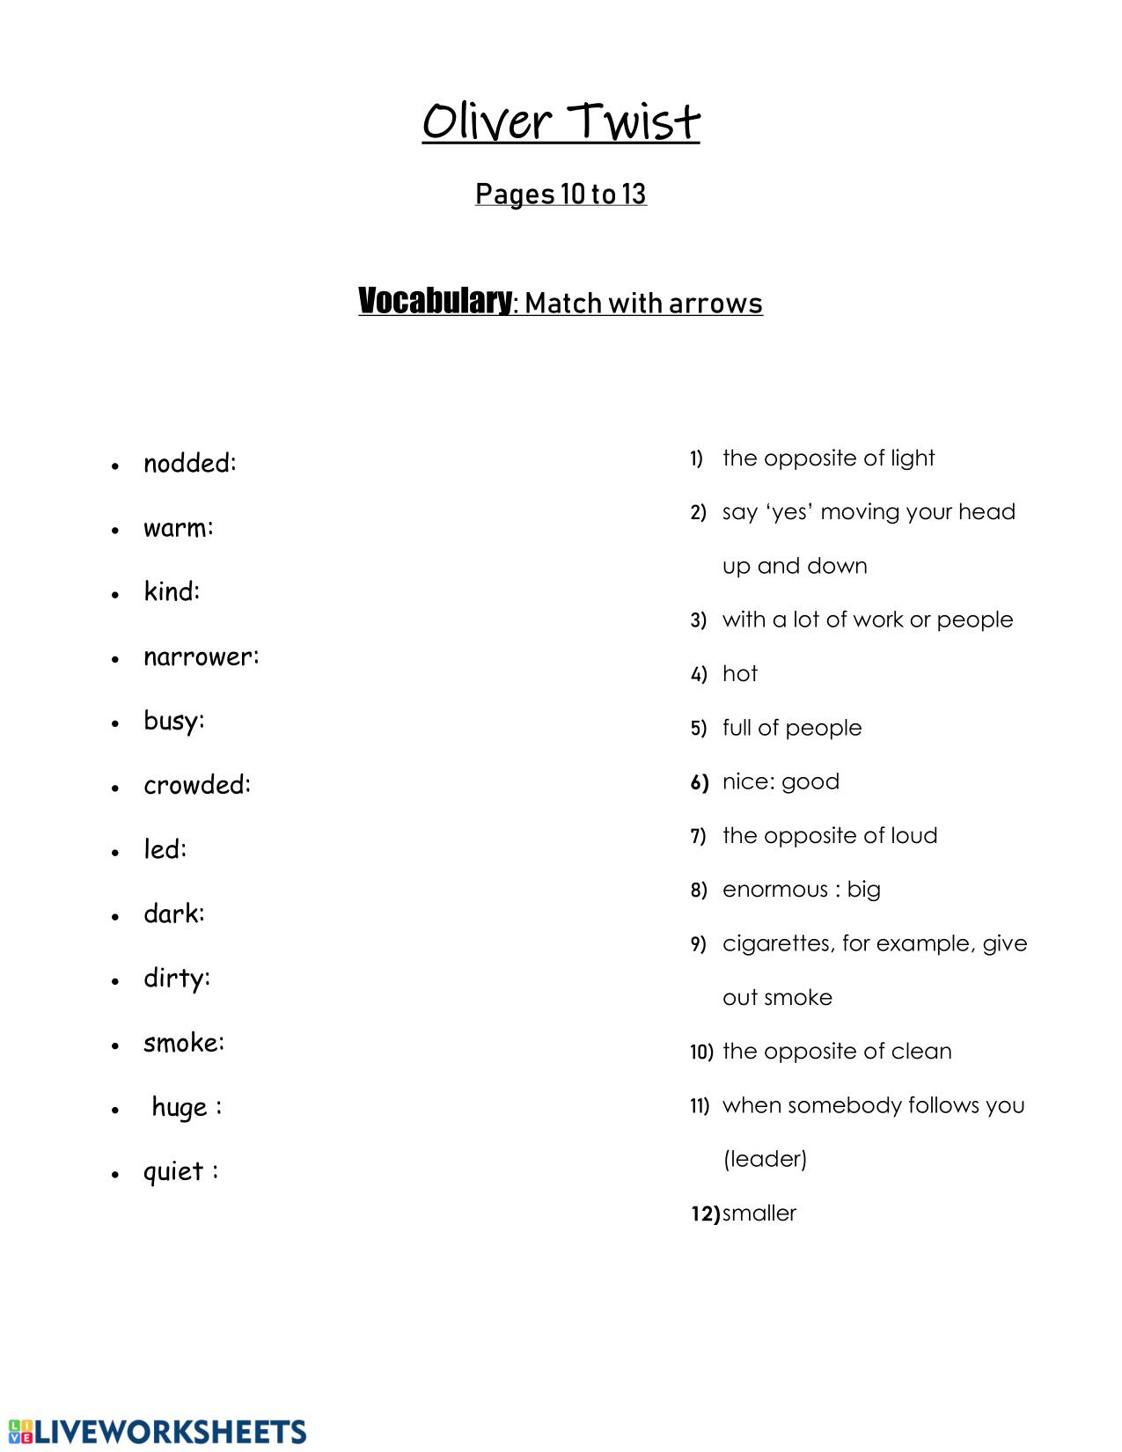

Pre-reading activity 2

Basic information
Oliver Twist; or, The Parish Boy's Progress, is the second novel by English author Charles Dickens. It was originally published as a serial from 1837 to 1839, and as a three-volume book in 1838. The story follows the titular orphan, who, after being raised in a workhouse, escapes to London, where he meets a gang of juvenile pickpockets led by the elderly criminal Fagin, discovers the secrets of his parentage, and reconnects with his remaining family.
In an early example of the social novel, Dickens satirises child labour, domestic violence, the recruitment of children as criminals, and the presence of street children. The novel may have been inspired by the story of Robert Blincoe, an orphan whose account of working as a child labourer in a cotton mill was widely read in the 1830s. It is likely that Dickens's own experiences as a youth contributed as well, considering he spent two years of his life in the workhouse at the age of 12 and subsequently, missed out on some of his education.
Oliver Twist has been the subject of numerous adaptations, including a 1948 film of the same title, starring Alec Guinness as Fagin; a highly successful musical, Oliver! (itself adapted into a multiple Academy Award-winning 1968 motion picture), and Disney's animated film Oliver & Company in 1988.

Pre-reading activity 3
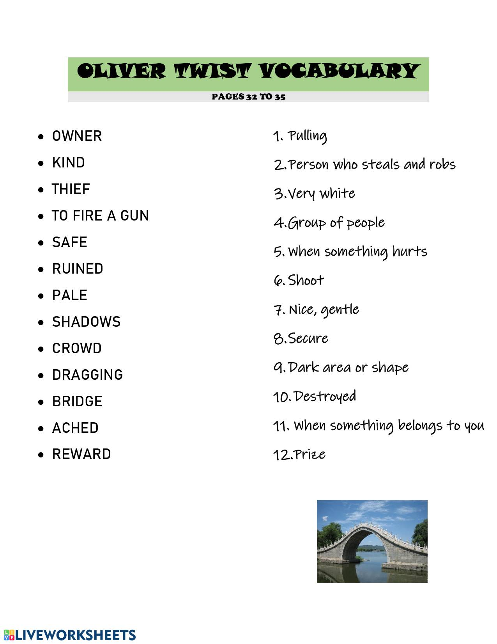

Pre-reading activity 4
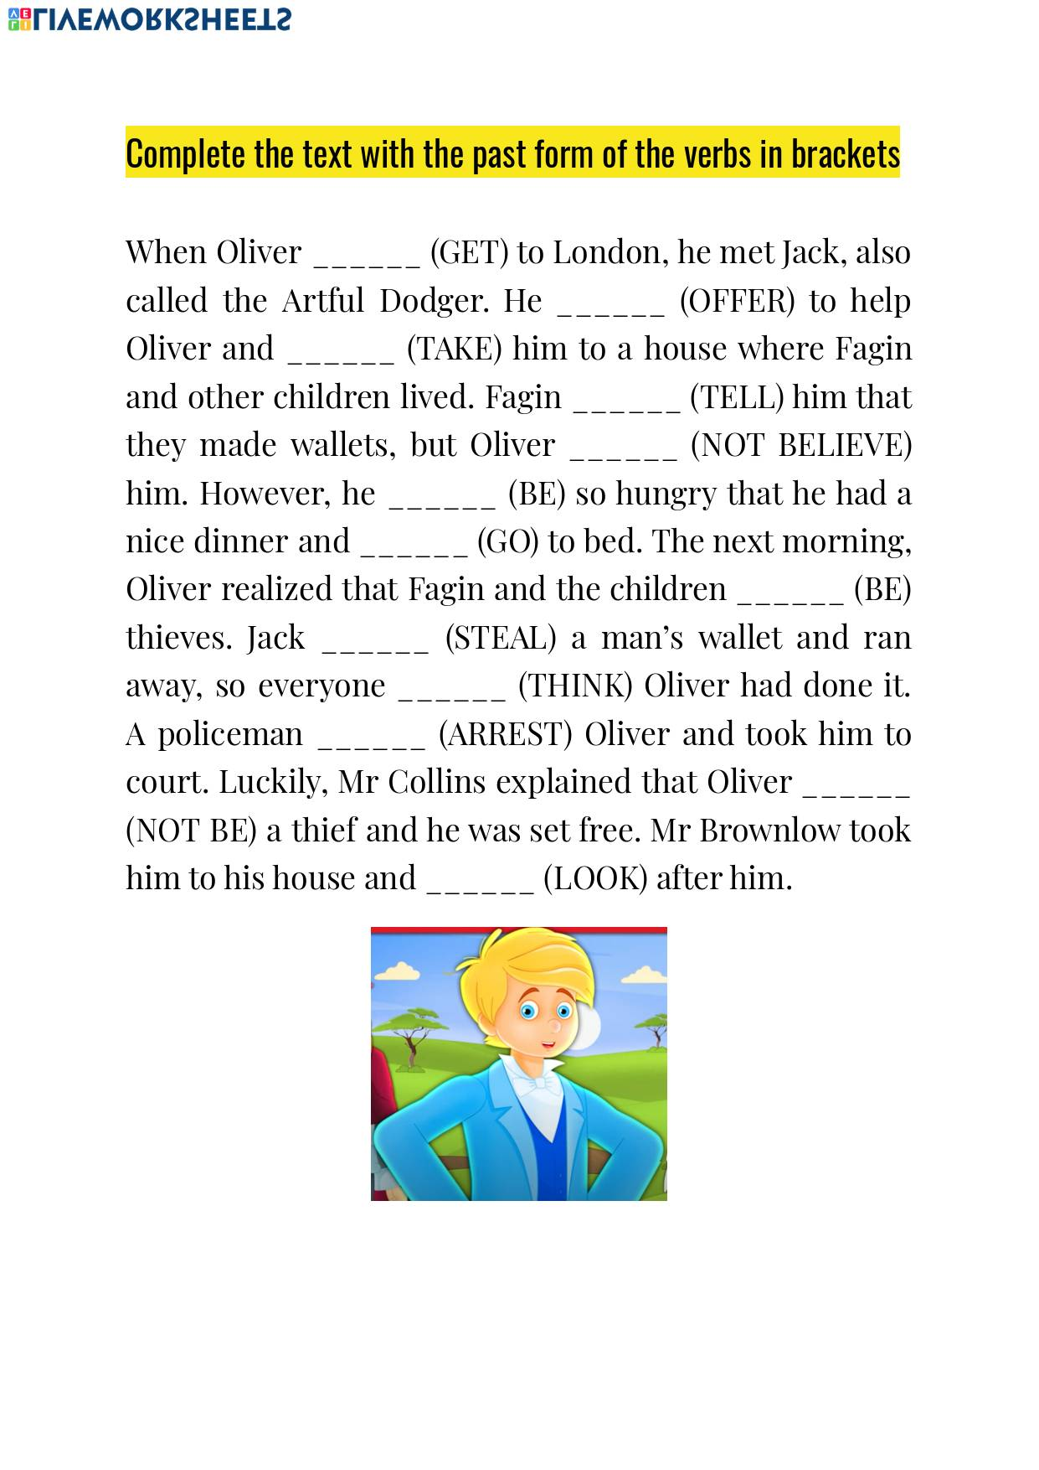
Pre-reading activity 5
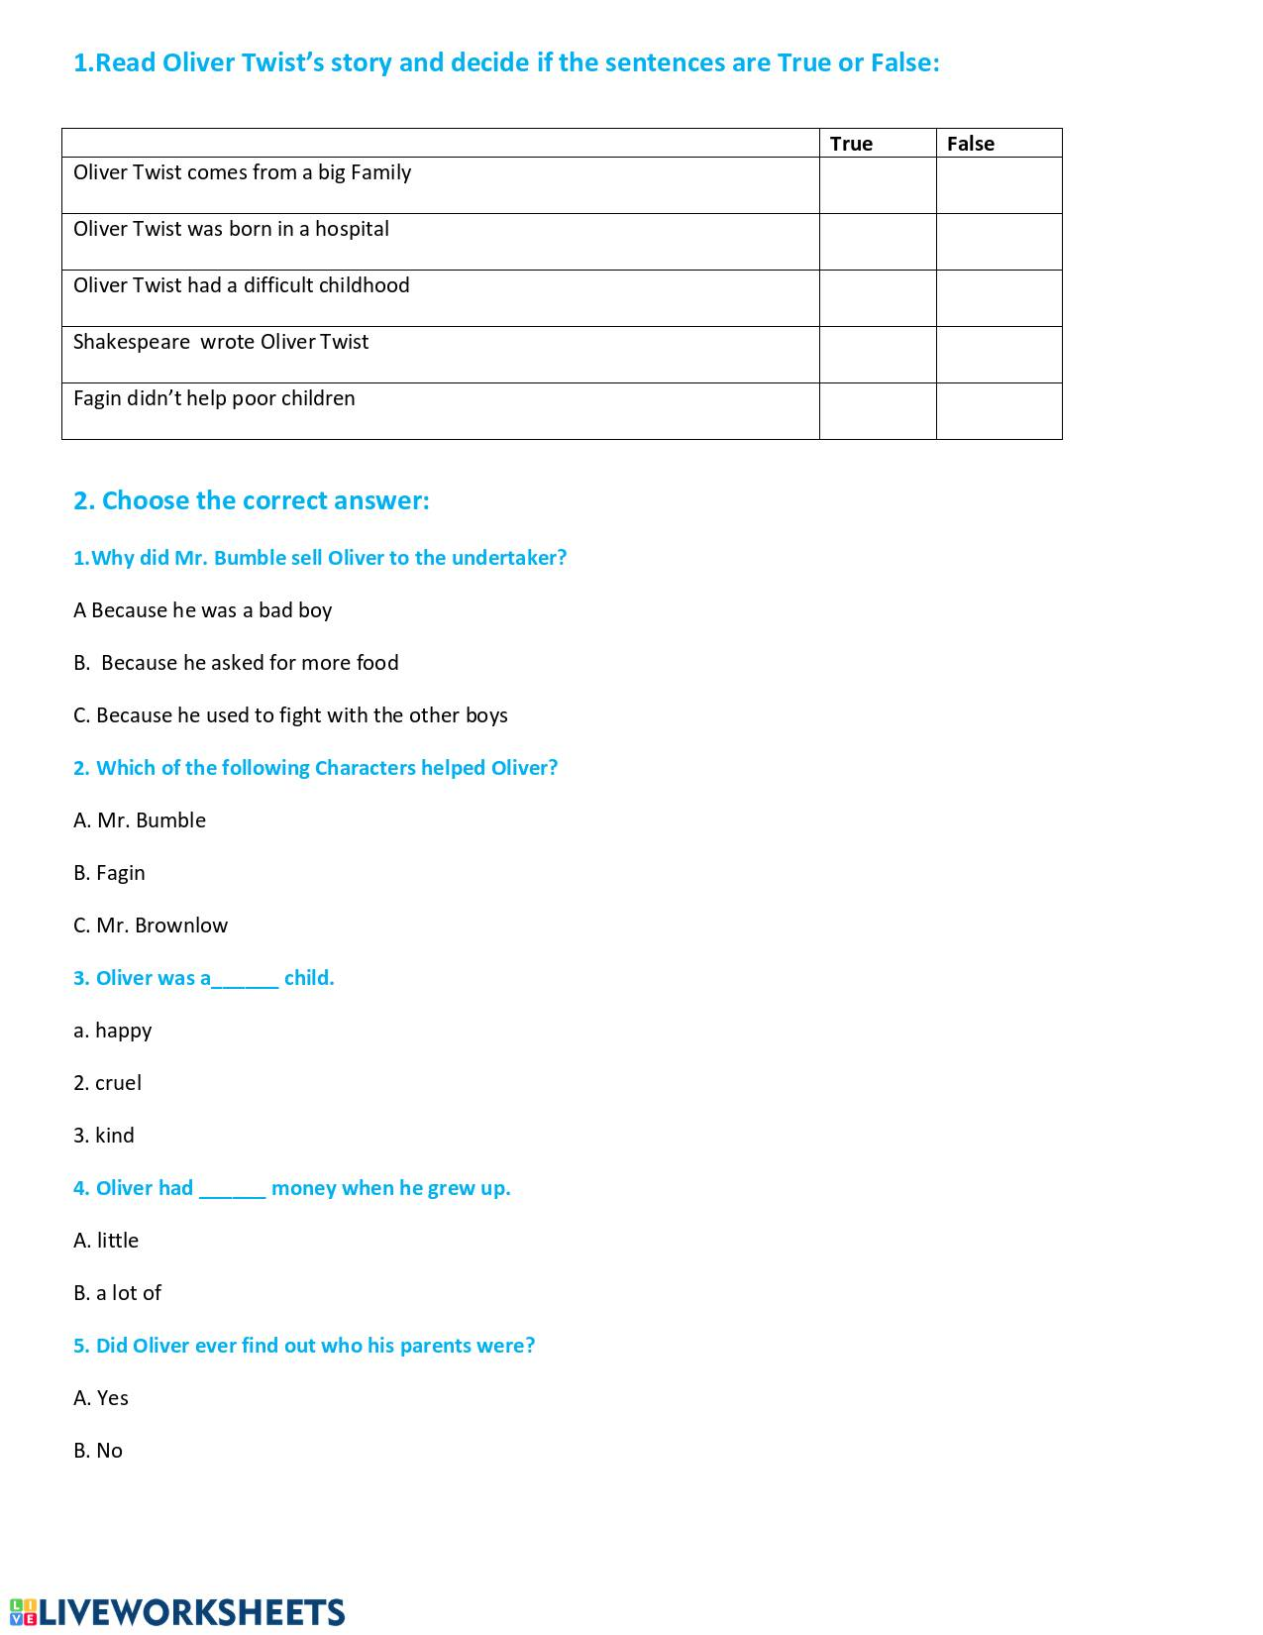

Pre-reading activity 6
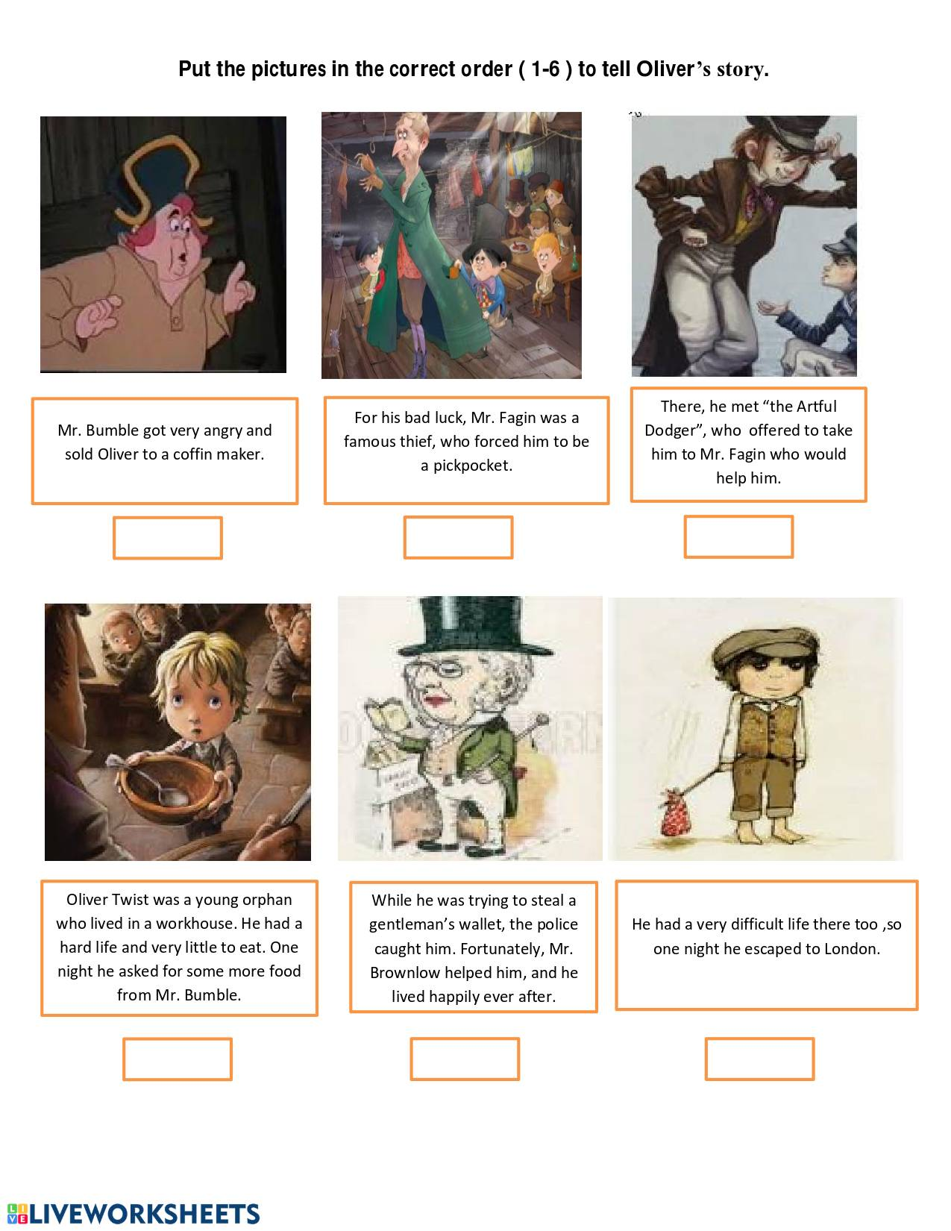

- Reading Activities – texts

Text 1

Read and translate.

When Oliver was small his home was an orphanage, where he lived with other young orphans. The children of the orphanage were given very little food and very little love. Many of the orphans died because they were cold and hungry. The orphanage was an unhappy place. Oliver survived, although he was pale, small and thin.
At the age of nine Oliver had to leave the orphanage and the only friends he had. This made him very sad because now he was really alone in the world. He was taken to a workhouse¹ , a miserable place where he had to work long hours. He was given only one small bowl of porridge² three times a day and an onion twice a week. Because Sunday was a special day he was given a small piece of bread.

¹workhouse : a place where very poor people live.
² porridge : warm breakfast food made with cereal and milk or water

Text 2

Read the descriptions and underline the adjectives.

- Oliver Twist. The protagonist of our story, Oliver is a grateful and gentle boy, who is easy for the reader to root for. His characterisation allowed Dickens to show that poverty was not a reason to judge moral character.
- John Dawkins. ‘The Artful Dodger’ is a streetwise and charismatic character, who tries to take Oliver under his wing. His entertaining mischievousness contrasts with Oliver’s complete innocence.
- Fagin. Though Fagin first appears to be an unusual kind of father-figure to his band of thieves, he is one of the main villains in the text, he is very selfish and controlling.
- Nancy. This kind-hearted character makes brave sacrifices in trying to save Oliver’s life. She is also one of the few characters who is capable of both good and evil within the text.
- Mr Brownlow. This wealthy and kind man sees the good in Oliver, even when he suspects him of stealing. He is one of the main characters to fight for Oliver’s right to a good life.
- Bill Sikes. This villainous character is known for his violent and angry qualities. No matter the version you are reading, he is responsible for the scariest parts of the story.
- Mr. Bumble. One of the first evil characters of the book, Mr Bumble is a power-obsessed and he bullies the children in the workhouse.
- Rose Maylie. The sister of Agnes Fleming, it is revealed that Rose is Oliver’s Aunt. She, along with Nancy and Mr Brownlow, is a character fighting in Oliver’s corner.

Text 3

Read and compare.

- The boys ate in a large stone hall. A copper stove stood at one end with a master constantly stirring the gruel in it. There was never a need to wash the bowls, as the boys licked them clean. Oliver and his friends suffered a slow starvation for three months. One day, a new boy came along. He wasn’t used to hunger. His father had owned a small cookshop before he had died and left the boy an orphan. The boy’s eyes grew wild with hunger. “If I don’t get more food, I shall eat one of you.” This frightened all the other boys. Oliver was picked to get more food for this boy. He took his bowl and presented it at the stove. “Please, sir, I want some more.”
(DICKENS, Charles. Oliver Twist. Adapted by Lisa Mullarkey, 2011)

- The evening arrived; the boys took their places. The master, in his cook’s uniform, stationed himself at the copper; his pauper assistants ranged themselves behind him; the gruel was served out; and a long grace was said over the short commons. The gruel disappeared; the boys whispered each other, and winked at Oliver; while his next neighbors nudged him. Child as he was, he was desperate with hunger, and reckless with misery. He rose from the table; and advancing to the master, basin and spoon in hand, said: somewhat alarmed at his own temerity: “Please, sir, I want some more.”
(DICKENS, Charles. Oliver Twist. London: HarperCollinsPublishers, 2010)

Text 4

Excerpt (p. 355)
'Stay another moment,' interposed [prohodila] Rose, as the girl moved hurriedly towards the door. 'Think once again on your own condition, and the opportunity you have of escaping from it. […] Will you return to this gang of robbers, and to this man, when a word can save you? What fascination is it that can take you back, and make you cling [lpět] to wickedness [špatnosti] and misery? Oh! is there no chord in your heart that I can touch! Is there nothing left, to which I can appeal against this terrible infatuation [pobláznění]!'
'When ladies as young, and good, and beautiful as you are,' replied the girl steadily, 'give away your hearts, love will carry you all lengths--even such as you, who have home, friends, other admirers, everything, to fill them. When such as I, who have no certain roof but the coffin [rakev] lid, and no friend in sickness or death but the hospital nurse, set our rotten [prohnilý] hearts on any man, and let him fill the place that has been a blank through all our wretched [ubohý] lives, who can hope to cure us? Pity us, lady--pity us for having only one feeling of the woman left, and for having that turned, by a heavy judgment, from a comfort and a pride, into a new means of violence and suffering.'
'You will,' said Rose, after a pause, 'take some money from me, which may enable you to live without dishonesty--at all events until we meet again?'
'Not a penny,' replied the girl, waving her hand.
'Do not close your heart against all my efforts to help you,' said Rose, stepping gently forward. 'I wish to serve you indeed.'
'You would serve me best, lady,' replied the girl, wringing her hands, 'if you could take my life at once; for I have felt more grief [žal] to think of what I am, to-night, than I ever did before, and it would be something not to die in the hell in which I have lived. God bless you, sweet lady, and send as much happiness on your head as I have brought shame on mine!'

- Post-reading Activities

Fill in the most suitable words (one empty gap/one word):
The evening arrived; the boys …… their places. The master, in …… cook’s uniform, stationed himself at the copper; his pauper assistants ranged themselves behind ……; the gruel …… served out; and a long grace was said over the short commons. The gruel disappeared; the …… whispered each other, and winked …… Oliver; while his next neighbors nudged him. Child …… he was, he was desperate with hunger, and reckless with misery. He rose …… the table; and advancing to the master, basin and spoon …… hand, said: somewhat alarmed at his own temerity: “Please, sir, …… want some more.”

The Key:
The evening arrived; the boys took their places. The master, in his cook’s uniform, stationed himself at the copper; his pauper assistants ranged themselves behind him; the gruel was served out; and a long grace was said over the short commons. The gruel disappeared; the boys whispered each other, and winked at Oliver; while his next neighbors nudged him. Child as he was, he was desperate with hunger, and reckless with misery. He rose from the table; and advancing to the master, basin and spoon in hand, said: somewhat alarmed at his own temerity: “Please, sir, I want some more.”

- Questionnaire

Dotazník: Klasická literatura na ZŠ

- Čtete rádi ve svém volném čase?
Ano Ne

- Zajímáte se o četbu klasické literatury?
Ano Ne

- Pokud jste na otázku č.2 odpověděli "ne", co je pro vás důvodem?
______________________________________________
______________________________________________
______________________________________________

- Myslíte si, že vám klasická literatura může nějakým způsobem pomoci při studiu anglického jazyka?
Ano Ne

- Proč ano/ne?
______________________________________________
______________________________________________
______________________________________________

- Zaujala vás výuka věnující se knize Oliver Twist?
Ano Ne

- Byla pro vás tato výuka příliš náročná?
Ano Ne

- Obsahovala podle vás výuka dostatek různorodých aktivit?
Ano Ne

- Ocenili byste tento druh výuky pravidelně?
Ano Ne

- Vnímáte užití klasické literatury při výuce spíše jako nutnou povinnost, než jako možnou výhodu při dalším studiu?
Ano Ne

Annotation

Anotace diplomové práce

Jméno a příjmení: | Karolina Malychová
Katedra nebo ústav: | Ústav cizých jazyků
Vedoucí práce: | doc. Mgr. Janka Kaščáková, PhD.
Rok obhajoby: | 2023

Název práce: | Užití klasické literatury v hodinách AJ na 2. Stupni ZŠ – Oliver Twist od Charlese Dickense
Název v angličtině: | Using Classic Literature in English Lessons at Secondary Schools – Charles Dickens´s Oliver Twist
Anotace práce: | Tato diplomová práce je zaměřena na užití klasické literatury v hodinách anglického jazyka na základní škole. Cílem bylo zjistit, jaké dopady má klasická literatura na jazykové kompetence žáků, a jak sami žáci spatřují aktivity zaměřené na novelu Oliver Twist při výuce.
Klíčová slova: | klasická literatura, Oliver Twist, základní škola, aktivity, anglický jazyk
Anotace v angličtině: | This diploma thesis deals with using classical literature in English lessons at secondary schools. The aim was to find out what impacts do classical literature has on students’ language competences and how do students perceive activities focusing on the novel Oliver Twist during lessons.
Klíčová slova v angličtině: | classical literature, Oliver Twist, secondary school, activities, English language
Přílohy vázané v práci: | ne
Rozsah práce: | 83 stran
Jazyk práce: | AJ

Résumé

Tato diplomová práce je zaměřena na užití klasické literatury v hodinách anglického jazyka na základní škole a z toho plynoucí benefity. Cílem bylo zjistit, zda má využití klasické literatury v hodinách dopad na jazykové kompetence žáků, a zda žáci sami spatřují její užití jako výhodu či nevýhodu při výuce. Analýzou plánů hodin, pozorováním žáků při práci a vyhodnocením dotazníků bylo zjištěno, že klasická literatura při výuce zlepšuje jazykové dovednosti žáků v několika oblastech (slovní zásoba, gramatika, poslech) a také, že se žáci domnívají, že takto vedená výuka může mít spíše pozitivní vliv na jejich schopnost se učit jazyku. Zpětná vazba umožňuje budoucí úpravu plánů hodin vedoucí k efektivnější výuce.

Italo Calvino quote. In: AZ Quotes [online]. Boston: Houghton Mifflin Harcourt, 2014 [cit. 2023-01-03]. Dostupné z: https://www.azquotes.com/quote/844365
The Britannica Dictionary Online. 2023, The Britannica Dictionary, https://www.britannica.com/dictionary.
Britannica, The Editors of Encyclopaedia. "Classical literature".
Eliot, T. S. 1945. What is a classic?
Lombardi, Esther. 2021. "What's the Difference Between Classical and Classic Literature?"
Freire, Paulo. 1983. ‘The Importance of the Act of Reading’.
Clark, Christina. Rumbold, Kate. 2006. Research about reading for pleasure.
Falk Huettig, Martin J. Pickering. 2019. Literacy Advantages Beyond Reading: Prediction of Spoken Language.
Niklas, F., Cohrssen, C., & Tayler, C. 2016. Study – The Sooner, the Better: Early Reading to Children, Fawcett, 2003; Lyon, 2002.
Niklas, F., Cohrssen, C., & Tayler, C. 2016. Study – The Sooner, the Better: Early Reading to Children.
Clark, Christina. Rumbold, Kate. 2006. Research about reading for pleasure.
Gejgušová, I. 2012, p. 10
Allington R. 2009, Foreword to Readicide : how schools are killing reading and what you can do about it.
Gallagher K. 2009, p. 45.
Dr. Seuss. 1978, I Can Read With My Eyes Shut!.
Gallagher K. 2009, p. 45
Vala, J. (2017). Komenského spisy jako četba žáků základní školy? , shortened version: https://www.ped.muni.cz/komensky/clanky/co-necist-v-literarni-vychove-v-9-rocniku-zs
LIŠOVSKÁ, P. Doporučená četba pro žáky z 2. stupně ZŠ z pohledu knihovníků pro děti a mládež, p. 3-4.
ZŠ Angel in Prague, recommended reading at: https://www.zsangel.cz/zaci/tridy/4-d/aktuality/povinna-a-doporucena-cetba-3-rocnik.907
ZŠ Velké Pavlovice – recommended literature at: http://zs.velke-pavlovice.cz/sites/default/files/field_files/682/seznamdoporuceneliteraturypro3.pdf
SSZŠ Litvínov – recommended literature at: https://www.sszslitvinov.cz/files/posts/358/files/cetba-pro-9-rocnik[1].pdf
ZŠ Kosmonosy – recommended literature at: https://zskosmonosy.cz/cesky-jazyk/doporucena-cetba-9-rocnik-2/
Ozek, Y., & Civelek, M. 2006, p. 3.
Skopečková, E. 2016, p. 31-32.
Grabe, W. 1991, Current Developments in Second Language Reading Research, p. 379.
Ozek, Y., & Civelek, M. 2006, p. 23-24.
Chou, P. T. 2010, Advantages and disadvantages of ESL course books.
Chou, P. T. 2010, Advantages and disadvantages of ESL course books.
DUFF, A., MALEY, A. Literature, p. 7.
Vraštilová, Olga. 2019, Využití dětské literatury ve výuce angličtiny na 1. a 2. stupni základní školy, p.35.
Ikonne, U. H. 2016, The teaching of literature: Approaches and methods, p. 77.
Beach, R., Appleman, D., Fecho, B., & Simon, R. Teaching literature to adolescents, p. 10-13.
Lohnes, K., 2022, britannica.com, Oliver Twist – novel by Dickens.
Jaffe, R. on Youtube [Course Hero]. 2019. Oliver Twist by Charles Dickens | Plot Summary

