Response to opponent’s review on 02/05/2022 – Dr. Zdeněk Opršal
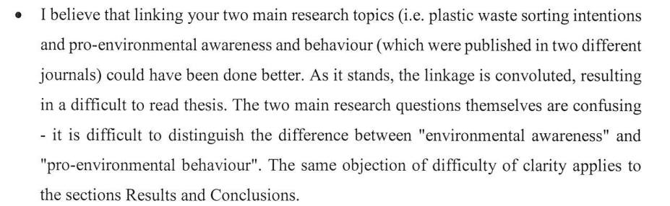
R: Environmental awareness was captured through the evaluation of student’s performance on Sustainability Literacy Test (SLT) (Akeel et al., 20190; Zwickle et al., 2014); whereas Pro-environmental behaviour was assessed by examining the determinants of attitude, subjective norms, perceived behavioural control and other background factors (TPB) (Zhang et al., 2017; Azjen, 2013). The research methodology overview (figure 5) was an attempt to clarify both objectives
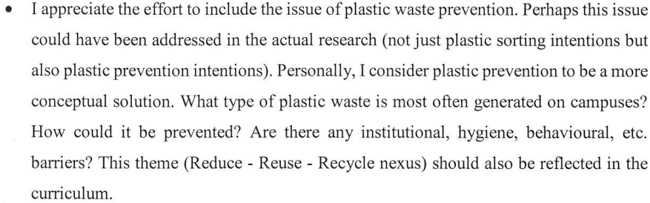
R: The types of plastic wastes mostly generated on campus are Low density polyethylene e.g. plastic water bottles and plastic bags. A preventive suggestion is to promote the three R’s (reduce, reuse and recycle) concept on campus and provide more sustainable alternatives such as more long-lasting shopping bags (Yeow et al., 2014). Raising awareness beyond the classroom and reaching vendors and policy makers will also prevent future creation of plastic waste on campus (Singh and Cooper, 2017). A similar recommendation was rendered by Susanto et al. (2019), stating that government should create awareness campaigns of 3R, to change negative perceptions of people’s attitude and subjective norms towards the environment. (thesis page 93)

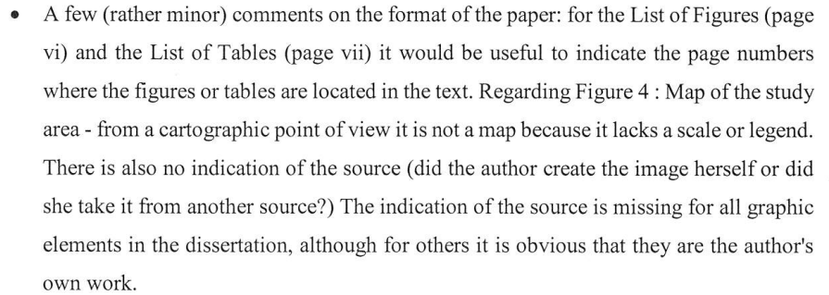

R: The thesis has been formatted according to opponent’s recommendations. All sources have also been cited for the figures.

