PALACKY UNIVERSITY IN OLOMOUC

Faculty of Arts

Bachelor thesis

Olomouc 2020 Naila Kerimova

The Kurt and Ursula Schubert Center for Jewish Studies

Faculty of Arts

Palacky University in Olomouc

Naila Kerimova

Female Immigration from Eastern Europe before and after the Shoah: Portrayed in Israeli feature films

Bachelor thesis

Olomouc 2020 Supervisor: PhDr. Lenka Ulicna, Ph.D

I hereby declare that this thesis is my own work and effort. Wherever contributions of others are involved, every effort is made to indicate this clearly, with due reference to the literature, and acknowledgement of collaborative research and discussions.

Olomouc 5.3.2020
Naila Kerimova

Acknowledgement
I would like to thank The Kurt and Ursula Schubert Centre for Jewish Studies for priceless knowledge and experience I got during these years.
Also, I would like to express my deepest gratitude to the supervisor of the thesis PhDr. Lenka Ulicna, Ph.D for incredible support, advises and patience.

Contents

Introduction …………………………………………………………………...…8
1 Historical background of the movies………………………………………...…9
2. Social situations in pre-state, state of Israel………………………………….12
2.1 Creation of the Sabra......................................................................................12
2.2 Sabra vs Sabriot situation in pre-sate Israel and state of Israel......................14
2.2.1 First Aliyah 1881-1903…………………………………………………...15
2.2.2 Second Aliyah 1904-1914………………………………………………...16
2.2.3 Women in the Defense Force…………………………………………......17
2.3 The Shoah survivors as the others and their image in the movies shown by the Second and recent generations.......................................................................18
3. How the second and recent generations reflect women immigrants in pre-state Israel / state of Israel in the movies: Summer of Aviya, Wooden gun, A tale of love and darkness…………………………………………………………...…..22
3.1 Women as others…………………………………………………………....22
3.2 The Social Identity Theory……………………………………………...…..24
3.3 Summer of Aviya ………………………………………………………......25
3.3.1 Image of the main characters, their social position and their relations with men…………………………………………………………………………...…26
3.3.2 Development of the main characters during the storyline and their social identifications…………………………………………………………………...29
3.3.3 Cinematic language……………………………………………………….31
3.4 Wooden gun……………………………………………………………...…32
3.4.1 Image of the main characters, their social positions and relations with men…………………………………………………………………………...…33
3.4.2 Development of the main characters during the storyline and their social identifications………………………………………………………………...…34
3.4.3 Cinematic language……………………………………………………….36
3.5 A tale of love and darkness……………………………………………...….37
3.5.1 Image of the main characters, their social position and relations with men…………………………………………………………………...…………38
3.5.2 Development of the main characters during the storyline and their social identifications………………………………………………………...…………39
3.5.3 Cinematic language………………………………………………...……..41
4 Feminist film theory……………………………………………………...…...43
4.1 Сomparison table based on the Feminist Film Theory ……………………..44
5 Visual tools of the movies………………………………………………...…..45
5.1 A bench as a connection of two generations………………………….….....46
5.2 The image of the Shoah survivors……………………………………...…...48
5.3 Images of the women………………………………………………...……..50
5.4 Mothers-children relationships………………………………………...…....52
6 Comparison of women protagonists of the movies……………………..….…54
Conclusion…………………………………………………………..…….…….55
Bibliography……………………………………………………………..….…..58
Annotation…………………………………………………………………...….63

Introduction

The movies “Wooden gun”, “Summer of Aviya” and “The tale of love and darkness” are three different stories made at the end of the 70s, 80s and in 2015. In these movies, immigration life is well depicted in pre-state of Israel and Israel. They capture the period from 1930 until 1950, showing the important historical background of that time. This period is incredibly important for the whole world and the Jewish world particularly. It is a time of the most significant changes in ordinary people’s lives. A Jewish man became a new Hebrew man, and a Jewish woman – a new Hebrew woman. What does it mean? When did these changes happen? And how was it implemented in the new state? I will try to answer these and other questions in this analysis.
In all three movies, the main protagonists are the “others” – women, children and the Shoah survivors portrayed by the next generation. “Summer of Aviya” is based on an autobiographical novel by Gila Almagor about her life as a child, and her mother, the Shoah survivor, who suffered because of mental breakdowns. “The tale of love and darkness” is also based on a novel by Amos Oz, a world famous writer. This movie is about Amos’ childhood in Jerusalem and the main tragedy of his life – his mother’s death. The movie was made in 2015, and it has the biggest time gap of these three films between the time the novel was written and when the movie was created. The last picture is “Wooden gun”, the only movie which is not based on a novel. It is about a conflict between Sabra children, who are “playing” at war for the yard.
These movies have a common goal of portraying the large differences between two generations: the survivors and their children. Another common theme is the depiction of their relationships.
The main aim of this work is to research through the movies, the women Shoah survivors’ lives in their new country. In other words, I will be interested in their immigration experience from Europe to pre-state Israel and the state of Israel, how they processed their integration into the new society, and if they succeeded in keeping their social identities. I will also analyze their relationships with their children, as the children are the main protagonists of the films, and through whom, we are able to observe the women. As the movies are made by the second and recent generations, I will also analyze the differences and the common characteristics of the way they portrayed the female Shoah survivors.
I will divide the text into two parts: theoretical and practical. The theoretical part will focus on the historical background of the movies, specifically on women’s experiences in Europe during 1930-1950, and on the history of pre-state Israel and the state of Israel. I will research the creation of the new Hebrew nation and the Jewish woman’s place in it. The practical part is an analysis of the movies using feminist film theory. It focuses on the theme in the movies of the women Shoah survivors, their children as a new Hebrew generation, and an analysis of visual tools as a way to express the inner side of the main protagonists.

1 Historical context of the movies

Why is it important to analyze women history in the Shoah? What is the difference between history and “herstory”? For centuries, herstory was untold and covered by men’s experiences while focusing on Him. Women were in the background of the historical arena and their lives were researched through men’s stories.
Women’s experiences before, during and after the Shoah were different from men’s and played a significant role in their lives. But what was the difference? Did the Nazis treat Jewish women different from Jewish men?
During the pre-war time, poor families were struggling to feed themselves and women had to manage the household under limited amounts of money, helping their children to cope with abasement in schools. In Poland, women were playing a more significant role in the social life than men. They were the power, which helped Polish Jewry, especially children, in acculturation. Thus, women were more accommodated in the Nazi era, due to acculturation. They had greater connections and important skills. In pre-war times, Jewish girls were more likely to attend regular government Polish schools than Jewish boys. They learned the Polish language and participated in secular activities. They had contacts outside of the Jewish world, which later helped them to survive. On the other hand, single women were the ones who took care of their old parents and did not want to leave Europe, which endangered them.
Nazis’ laws, regulations, and some rules specifically targeted Jewish women. One of the main targets was birth control. In Lithuania, pregnancy was prohibited. A doctor caring for a Jewish woman, had to report if she were pregnant, and if he did not, they both would be killed. Later, in concentration camps, pregnancy was also a death-sentence.
The role of a woman during the War changed. For the first time, they could take leading positions, often in the underground movements of ghettos. Men were humiliated because they lost their jobs, and harassed in the streets for their specific look as a religious person. Most of them were arrested, so they simply were afraid to leave their home, and women were relied on for the duty of earning money. The women had to create different ways to earn money and food to feed their children. The problem was that they had never worked before, so how could they do men’s work if they had no experience? Some of them had to find jobs at factories or do the laundry, ironing and sewing, but most of the women could not find anything because in the ghettos there were no steady jobs.
There was another group of women who were not married, did not have children and were not caregivers. These women took part in the Jewish underground resistance and some of them took leadership roles. Women were active in different forms of resistance. They organized illegal schools, libraries, and underground cultural events. In Eastern ghettos, there were groups of women who were underground couriers. They spread news from outside the ghetto. If they heard about mass killing, they immediately warned people inside. They smuggled in not only news, but food and medical supplies.
After the Second World War, Jewish society was changing - the image of a Diaspora Jew was called into question. It was clear that changes were needed. Thus, there appeared articles about the New Hebrew Man by the first authors of Eretz Israel. The New Hebrew man was strong and independent. He worked in a field, close to a nature, and his mission was to create a new nation. The idea of a New Hebrew Man appeared before the Sabra. This idea was applied in schools of Yaffo by teachers who created the Hebrew education system. The Zionist revolution was centered on masculinity. Logically, next to the New Hebrew Man should be a New Hebrew Woman; brave, well-educated and having equal rights with men. Thus, the double image of the new Hebrew woman was created.
Already in the schools of the first Aliya, girls had the right to study next to boys in mixed classes. Girls had a special mission to spread Hebrew, knowledge, and education in their own environments. Eliezer ben Yehuda thought that language lives only with women, and if a woman writes, she makes the language richer, more emotional and flexible. Schools were hiring women as teachers, and in 1903, the teachers’ association was established. Women’s rights were acknowledged to be equal to men. However, the reality was different, and next to a few relatively emancipated women were a vast majority of Diaspora women.

2 Social situations in pre-state, state of Israel

In this part of the work, I would like to analyze the social situation in the pre-state of Israel and the state of Israel. In order to do that, I will first research how the new nation was created, when it all began and how. Were women involved in this process, and what was their role in it? In the end, I would like to analyze the image of the Shoah survivor in the new society of pre-state Israel, state of Israel, as the main protagonists are the female Shoah survivors. It is also very important to analyze here the image of the Shoah survivors from the Second generation, or their children’s point of view, as the movies show the relationship between these two generations.

2.1 Creation of the Sabra

I would like to focus on the Sabra history, the purposes of his creation and his evolution in pre-state and the state of Israel. I will also be interested in his relations with the rest of society. My source is an article by Ilan Avisor “The Holocaust in Israeli cinema as a conflict between survival and morality”. This material will help in analyzing the attitude of the Israeli society toward the Holocaust and its survivors, which is depicted in the Israeli cinema. I will also use the articles “The privatization of the Holocaust: memory historiography, and politics” by Daniel Gutwein, and “The past that does not pass: Israelis and Holocaust memory” by Dalia Ofer, to see if the attitude changed through time and what events predetermined it.
I chose the book by Oz Almog “The Sabra: the creation of the new Jew” and the article “The double or multiple image of the new Hebrew women” by Margalit Shilo. The book talks about the New Jew only as a men’s history, with little mention of women’s participation. The article tells the history of the Sabra and Sabriot, and women’s roles in creating the new history.
The 19th century was a time of change for the European Jewry. Under the influence of the Enlightenment the Haskalah (Jewish Enlightenment) was created, and some of the Jewish population was going through emancipation. This period also marked the time when practical Zionism appeared to create Jewish agricultural communities in pre-state Israel (kibbutz Hebrew). Political and practical Zionism united as one after the World Zionist Congress in 1897, which was established by Theodor Herzl. In the very beginning, it was established around several ideas: 1. The necessity of internal freedom from galut (Jewish life in Exile), 2. Organization of the Aliyah and kibbutz movement 3. Creation of the New Hebrew man.
Many Jewish authors in Europe and later in the pre-state, state of Israel, played a big role in the popularization of the image of the New Hebrew man. The new image appeared in the following writings: Hanoch Bartov's The Fabricator (1975), Amnon Jackont's Borrowed Time (1981), Yoram Kaniuk's The Last Jew (1981) and Michal Govrin's The Name (1995).
The main idea of the New Hebrew man was to set apart the image as far as possible from Galut. It was radically different from the Diaspora Jew, or better to say, the image that anti-Semites had built – weak, cowardly, helpless, and greedy. The New Hebrew man was supposed to be “young, daring, down-to earth, ideologically committed and ready to defend his people to the bitter end”.
Sabra is a desert fruit that is prickly on the outside and sweet on the inside. A native-born Israeli, much like his fruit namesake, wore a rough exterior hiding a kind core. Many historians write about a sabra as a model for the socialization of the new immigrants. “The Israeli writer and Holocaust survivor, Aharon Appelfeld, describes his difficulty in holding on to the elusive memories of his prewar childhood and war experiences soon after the war ended. Arriving in Palestine as a young adult, he felt the pressure not only to suppress those remnants of memory but also to change his personality and even his physiognomy in order to accommodate himself to the Mythological Sabra”.

2.2 Sabra vs Sabriot situation in pre-state Israel and state of Israel

The creation of the new Hebrew man and later sabra excluded women from the very beginning. Even the name of the image appeals to men. But what roles did women take, and was there a place in the history for them?
Historians began to research Herstory relatively recently, that is why most of the materials written about this topic are about the men’s role in sabra history. The other reason that not many historians talk about women is because of the diminishing role of women in Israeli society in the described period. Oz Almog, in his detailed research of sabra’s history, mentions women only a few times. He explains that his terminology includes both men and women, but he used the masculine form even though women were important part of sabra culture. In giving a portrait of typical sabra, he excluded women. Therefore, in the book he does not mention sexism, which took place in the culture. He also quotes a slogan ‘Ha-tovim le-tayas’ – ‘The best boys are for the air force’, but he did not mention the second part ‘VehaTovot le-tayasim’ – ‘and the best girls are for the air force boys’. The author describes the sabra’s culture as something romantic and subjective, avoiding the history of most of the population of Israel: women, Palestinians, and Mizrachi. I will not discuss the topic of Mizrahi and Palestinians, but I will focus on relations between women, the Shoah survivors, and sabras.
What does history know about the Sabriot? Did they appear at the same time as Sabras? What was their role in the creation of the country and making the history of the state of Israel? What relationship did they have with their families/men?
The Zionism revolution was focused on masculinity, on the idea of a biblical man who worked in a field and was close to nature. His mission was to create a new nation. Logically, next to a New Hebrew man was supposed to be a New Hebrew woman: brave, educated and with equal rights, but the reality was not quite like this.

    - First Aliyah 1881-1903

The idea of the New Hebrew woman appeared earlier than the foundation of state of Israel. The image was described for the first time in literature and philosophy. There were also mentions of her in research about the First Aliyah . There were educated women in pre-state Israel, teaching in a new nursery school and other schools of yeshivas. There were a few of them, but most of the women of the First Aliyah remained invisible and passive in taking action to change the social situation. The few women who worked in agriculture in documents remained as wives and mothers.
Schools of the First Aliyah were teaching both boys and girls. They had a special mission – to provide further education to their children and teach them Hebrew. Eliezer ben Yehuda (the father of the modern Hebrew) thought that the language will live only with the help of women because they will enrich it with emotions and flexibility.
Women were able to get professions in the field of education, and in 1903, the Teachers’ Association was established where women were members with equal rights. Interestingly, the idea of equal rights for women belonged to men and they were promoting it. Meanwhile, most of the women of the First Aliyah remained passive and invisible.

2.2.2 Second Aliyah (1904-1914)

Women of the Second Aliyah were more aware of their significance in the new society, they were ready to fight for better role for themselves. This wave of immigrants was mostly from Russia, who were escaping from growing anti-Semitism and the Pale of settlement. Women there were more active, they took part in the underground organizations. Logically, they did not want to be passive in this important period of the history. But here I am talking about women without families of their own, they were free and ready to sacrifice personal and domestic needs over national ideas. Besides not all women were able to work on the fields as men did and most of the men did not want to hire them, instead, they would take Arabs for agricultural works. Thus, in 1911 was founded women’s farm in Kineret. Another organization was also supporting women in their request for equal rights, the Hebrew Gymnasium in Jaffa had a goal to create New Hebrew Woman: “Through the emancipation of women, we will change the face of the world”.

    - Women in the Defense Force

This institution is more male oriented than any other. Was there a place for a New Hebrew woman, and if so, how was her role developing there?
In pre- state time, only a few women participated in the defense force. They took part in guard duty and later in Hagana; in the different women’s corps of the British army and in the Palmach. This created a myth of a fighting Hebrew woman, but in pre-state only 20% of the Defense Force were women. After a conference in Mishmar, HaEmek in 1943, where the roles of women were discussed, it was decided that they would measure every girl by her own abilities and that the girl’s place was guaranteed. Some girls viewed this role as a domestic role. They thought it may be useful to know how to protect their own families. But in reality, the girls were taking positions in communications, instructions, and other various services. Before the War of the Independence, women were pulled back from the front. Pre-state and the state of Israel lived with a double image of the Hebrew woman. Traditional and New as a reflection of the new society of the state.

2.3 The Shoah survivors as the others and their image in the movies shown by the Second and recent generation

For the new immigrants there is a new Hebrew word, Olim (from the Hebrew verb לעלות [la’a lot] – rise). New olim came to Israel, picked a new Hebrew name, and tried to distinguish themselves and their families from their European past. With new names, the new immigrants started their new life on the new land becoming a new nation. It meant that they should adopt the new model of behavior and create a new common history. The rejection of the national past was a highlight in the attitude of sabras toward the Shoah.
People did not talk about the past. Silence was encouraged on a personal and collective level, not only because it was difficult topic, but there was a fear that the creation of the New Hebrew man and the new nation would fail. The Shoah experience played significant part in shaping the younger generation. Some of the survivors were saying those: “who have lived through the dark period in Europe and experienced on our flesh great atrocities…must forget the past, start toward a new future and heal our soul from the bottom up – simply be born again”. The first time the subject of the Shoah was included in the schools’ program in 1953, only two hours was devoted to the subject.
There were three main periods of the memory of the Shoah in Israel: divided, nationalized and privatized according to the article by the Daniel Gutwein “The privatization of the Holocaust”.
The divided period of memory began when the horrors of the Shoah were first uncovered and being told among people, and ended with the Eichmann trial. The perception of the Shoah was influenced by people’s feelings towards it, and identification with the victims. Also, critics of the obedience took a huge part. The torment of victims was used for stimulation of the Jewish rights for their own land according to the Zionist ideology. Some of the ghetto fighters were made national heroes and were used to blame Diaspora Jews for their passivity. Those who survived were called Israeli Ashkenazi, and at the same time they were called “others”. The attitudes towards them were changing according to the period of national memory of the Shoah.
The second period started with the Eichmann trial. The lesson was “never again” and became a corner stone in the ideology of Israeli ethos. After the 6-day War the attitude shifted, and Israeli perception of the Shoah memory became more empathic. This period showed a growing interest in The Shoah history. It became one of the most defining historical events of the Jewish nation and Israeli collective consciousness. Israelis realized that their situation was similar to the European Jew’s situation under the Nazi’s regime. They were surrounded by enemies and it seemed like the whole world preferred to collaborate with Arab countries rather than with them. The situation of national vulnerability made Israelis identify themselves with the European Jews. The conflict between victimized Jews and Israelis faded away. In the 70s, there were great changes in the history of “Others”: women, Arabs, Sephardi Jews. They demanded equal rights and greater representation in the history of the state of Israel. They wanted to take a bigger role in the social and political life of the state.
The third period, named privatized memory began in 1980. First, the Lebanon War and 1st Intifada turned the Shoah to the personal experience of every Jew: victims and survivors. Post Zionists claimed that Israeli hegemony with the help of privatization of the Shoah justified the denial and suppression of the “others”.
Ilan Avisor in his article “The Holocaust in Israeli cinema as a conflict between survival and morality” divides Israeli movies about the Shoah into decades. He writes that “Summer of Aviya” (1988) was made by the Second generation, who took an active part in the rebuilding of the history of their parents. He aligned the movie “Wooden gun” (1979) to the decade of 1960-80. It was a time when the Shoah was depicted through the Eichmann trial, ethical dilemma of a war – a burdened society has given way to extreme expressions against national ideas in the Israeli culture.
Beginning in 1980, the Second generation took an active part in shaping the Holocaust memory. They were making movies, doing research and writing books. Those people were the new voice of the Shoah in the Israeli culture. “The term of Second generation is used for the children of the Shoah survivors who appeared in psychological literature dealing with the survivors’ post-traumatic stress disorder and its’ transfer to their offspring”.
“Summer of Aviya”, as previously mentioned, belongs to a decade of the Second generation. In the movie, the representor of the next generation is Aviya, daughter of Henya, the Shoah survivor. The story is shown through Aviya’s memories about her mother and the last summer with her. The story takes place in the early years of the state of Israel in 1952. She and Henya are outsiders in their neighborhood. Children do not want to accept the girl and grown-ups treat her mother the same way. Henya is the Shoah survivor and she gets contemptuous attitudes towards her like other survivors at that time. Here, Aviya is the main representor of the Second generation, but as a child she is still connected to her mother and to the past she is living in. She does not deny the trauma and does not try to distance herself from the past of her family. Aviya is on a quest of searching for her identity.
“Wooden gun” was made in 1979, and the action takes place in 1950. It is relatively the same time period as “Summer of Aviya”. The main protagonist is a young boy named Yoni, also Second generation, who is dealing with military belligerence. The Shoah survivor is a woman named Palestina, and a few strangers on the streets, who Yoni and his friends mock. The attitude toward them is shown mostly from the children, who are obsessed with wars and dreaming about glorious victory over their enemy. The situation changes for Yoni only after the local war they were planning, almost kills a boy from the opposite gang. He runs away and meets Palestina, who helps him gently. He sees inside her hut as if he sees inside her soul with the trauma and the memories.
The movie “Tale of love and darkness” was made by the recent generation and the view on the war experience is radically different from the other two movies I am analyzing. The movie itself is based on a book by Amos Oz, son of Polish immigrants. He was by determination sabra, but it is doubtful that he thinks about himself this way, at least in the described period. The story takes place in Jerusalem in pre-state and the state of Israel. Natalie Portman, the director of the movie, shows us the relationships between the son, young sabra, and his parents. However, the only attitude toward the Shoah survivors we can see belongs to Natalie Portman, who shows it as the director of the picture. She uses cinematic language in order to understand the psychology of Amos’ mother. She tries to understand her soul and the actions she took.

Summary

The movies I am analyzing are focused on the weakest part of the Israeli society in pre-state and the state of Israel. Relations between the second generation and their parents as the survivors are shown through the children’s point of view. “Summer of Aviya” is a story told by a daughter of a survivor about her transformation from a Jewish girl to an Israeli young woman. The transformation goes through the acceptance of the tragic past as one of the bases of her life. Meanwhile “The wooden gun” as a product of military times. It shows the ignorance and denial of the common past of European Jewry by young sabras, which in the end must face it and accept it. “The tale of love and darkness” is different from other two movies because of the time gap between them. The last movie deals with the Jewish trauma psychologically, trying to understand the survivors and how they were dealing with the new reality. This analysis is made behind the camera and uses modern visual tools.
I think it is important for further analysis of the movies to research the historical background from the gender point of view. In order to better understanding the inner text of the movies, I briefly showed Jewish women’s experience in Europe in the pre-war time and during the Shoah. Then I focused on women’s lives and emancipation in pre-state and the state of Israel. All the information above will help in understanding women’s roles in the times captured in the films. I will also focus on the relationship between women, the Shoah survivors, and their children in later chapters.

3 How the Second and recent generations reflect women immigrants in pre-state Israel / state of Israel in their movies: Summer of Aviya, Wooden gun and A tale of love and darkness

3.1 Women as others

In this chapter, I will analyze women’s role in the Jewish society of pre-state Israel and the state of Israel through the movies. Two of the movies are based on Israeli novels: “A Tale of love and darkness” by Amos Oz and “The Summer of Aviya” by Gila Almagor. Both contain some biographical facts and both authors were children of European immigrants who were born in pre-state Israel. The time difference between “The Wooden gun”, 1979 and “A Tale of love and darkness”, 2015 is almost 40 years. This detail is significant for analyzing the historical background, the vision of those times and the survivors of the society of the late 80s and modern times. In all three films, the main characters are the Others: women, kids, survivors. Men went into the background according to the reality they lived in. The concept of the Others in leading roles of motion pictures was infrequent at that time.
In order to analyze these films, I will use the book by Miri Talmon and Yaron Peleg” Israeli Cinema: Identities in Motion”, and an article by Liat Steir-Livny “Near and Far: The representation of Holocaust Survivors in Israeli feature films”. For analyzing the historical background of the movies, I will refer to the work by Margalit Shilo “The double or multiple image of the new Hebrew woman”. For the other important part of analyzing characters of the films, I will use sociological identity theory and will refer to Jan E. Stets and Peter J. Burke, "Identity Theory and Social Identity Theory”, and Dina Wardi, “The dialogue between survivor mothers and their infants” from her book “Memorial Candles: Children of the Holocaust”.
Steir-Livny in “Near and Far: The representation of Holocaust Survivors in Israeli feature films”, researches the time period between 1980-2000 in terms of Survivors in society. In her opinion, Zionist movies of 1940-1950 were made to “glorify achievements of Zionists”, and movies of the 70s used stereotypes by picturing Holocaust victims as weak with broken spirits and bodies.
Another important article is “The double or multiple image of the new Hebrew woman”, by Margalit Shilo. In this article, she researches the subject of double image: new Hebrew woman vs. traditional woman in the period of first Aliya, their life in pre-state Israel and second Aliya.
In order to analyze the movies, I will divide them into two parts: 1) “The Summer of Aviya”, “The Wooden gun” and 2) “A Tale of love and darkness”. The first group of movies were made at about the same time, in the 70s -80s, and the second in 2015. This time the difference is very significant as the movies were made by different generations.

3.2 The social identity theory

The Shoah studies have numerous texts and research on different topics and from different points of view, but only recently scholars have started to study the history from the gender point of view. In order to look closer at the main protagonists, I will use the social identity theory and will deconstruct each character and the different social roles they play.
There is a free-floating concept of self-identity, proposed by Butler, which often happened during wars with women who had gone through trauma, and after, had to reconstruct their social and self-identity. For women immigrants, who survived the Shoah and had to fit into a new reality, the success of the process of adaptation and building a self-identity was a result of many aspects, but first of all, they had to realize that they survived. In doing so, they had to deal with the long-term memory and learn how to cope with it every day. The next step is to restore gender identity. Many women in concentration camps went through humiliation and destruction of their gender. Many of them experienced sexual violence, medical experiments, abortions etc. After the war, women would distance themselves from gendered identity and gender performance. What does gender performance for women mean? It is pregnancy, motherhood, being a partner of a man. I would like to analyze women characters by using this theory and see if they were successful in identifying themselves. Were they able to play the social roles according to gender? This analysis will help me in further research of female immigration experience, who survived the Shoah and escaped to pre-state Israel and state of Israel.

3.3 Summer of Aviya

The film was based on a semi-autobiographical novel by Gila Almagor. The book was written in 1985, and the movie was released in 1988. Gila wrote about one summer that was especially important in her life for many reasons. She was born four months after her father was shot in Petah-Tikva, Mandatory Palestine, where the film was shot in 1939. She was left alone with her mother and grew up caring for her. At age 15, she was accepted into acting school and became a successful actress and writer.
“Summer of Aviya” is an image of survivors’ lives, women, children and the state in the year 1952. Aviya was living in a boarding school before her mother Henya takes her away on summer holidays to live together on the edge of a small village. They both are outsiders and their house location emphasizes it even more. Henya is a survivor, neighbors call her “Partizani” and “the crazy woman” and Aviya is banned from a local ballet class that all the other girls in the village attend. Henya, every few months, is hospitalized in a mental institution. She is losing her sanity because all her family was killed in the Shoah. She tries to build a close relationship with her daughter, but the past drags her back and does not allow her to live in the present. The attitude of Aviya toward her mother is complex, on one hand she loves her, and on the other she is afraid of her. She dreams about her father, imagining he is alive and will soon come back to her. We will never see him, but we will always feel his presence through the dreams of the girl. During the summer they spend together, Aviya will be caught between the past of her mother, and a reality of the new state where she is not accepted.
The main characters here, as in the other two movies are children and women, a mother and her child. Women as others. Henya, the mother of Aviya, is not only a woman, a weak member of a new society but also a survivor, which brings her special treatment from her neighbors. She is a woman with a tragic past and a miserable present. Aviya is a 10-year girl, she is artistic and has a vivid imagination. The relationship between these two women is difficult. Men here are only a dreamy image or the tragic image of a survivor.

3.3.1 Image of the main characters, their social position and relations with men

There are two main protagonists: Henya the mother, and Aviya, her daughter. However, I will mention one more character who I think is significant for the analysis, Aviya’s personal development and the image of Israel in the 50s; Maya Abramson, the ballet class teacher. I think Maya is a good example of a young generation from Europe living in the new state and trying to adjust to new conditions. She is nothing like the main protagonists. She is a different age, a different social level and seems to have a better education. Unlike Aviya, she is not trying to understand her mother or build a better relationship with her. Also, I think an important part is that Maya becomes friends with Aviya, considering that the latter did not have any friends at all. Their short friendship becomes a symbolical bridge between two worlds: Others and Israelis. This connection plays a significant role for both of them.
- Henya
Henya appears in a small village, she is nervous, and her movements are fast. As an immigrant, she has an accent when she speaks Hebrew. She is obviously different from the other inhabitants. The opening scene when she meets her daughter shows us she is a tough individual, she missed her daughter and wants to be together, but shows no tenderness and softness toward the child. Her face always appears to be in a thought process, she is concentrated, always ready to fight. Henya brings her daughter to a poor, small house on the edge of the village and the first thing she does is cut her girl’s long beautiful hair. The Israeli girl from now on has the image of the shaved head prisoners of the concentration camps. Henya is a mysterious woman, she does not talk about herself. She is used to being alone and is not used to loving her own daughter. She has forgotten what it means to be loved. “Trains” are coming to her head more and more and she is slowly losing her mind.
- Aviya
Aviya is a girl who is looking for her identity, like she is looking for her father. For a few moments in the beginning, she has her long hair wrapped in fabric and she does not look like a girl. After, with a shaved head, it is like she is caring her mother’s past. Is she lost or maybe she has not found herself yet? The little girl, like her mother, is banned from the society of the village, her peers mock her, and the ballet class teacher Maya Abramson does not want to accept Aviya into the class. She looks different from the others. She does not have nice dresses and shoes, she looks like a “kibbutznik”, a new Hebrew woman. She does not realize that and desperately wants to be accepted. She is ready to fight for acceptance and she takes action, too rough, but as a little Hebrew woman she cannot sit still without actions. Aviya almost took away Maya’s vision in order to be part of the class.
- Maya
Maya Abramson is a ballet class teacher, she is a young woman, who runs away from Europe. The movie does not tell us much about her but with time we can see her character developing and the past slowly opens to us. We know that she was born in Europe and still dreams about those peaceful times. By her manners, it is clear that her family was from the high level of society, rich and maybe famous in small circles. Maya is arrogant and spoiled, which looks unrealistic in her current reality. Her life is stuck between her memories of the past and her dreams about the future. She cannot move because of her mother who holds her in that village. She does not enjoy her classes. She is well educated and there are no people in the surrounding area with whom she can communicate. She is bored. Maya is more like a shadow or a ghost of her beautiful past until one little Hebrew woman stormed into her life. I think Aviya is some kind of a push for her, which awakened Maya and symbolically and physically opened her eyes.
- Men
Men take a small part in the movie; and their figures are not realistic. Aviya’s father died, but she dreams about him and makes up the story that he is alive. A new neighbor family arrives in the village and Aviya’s imagination creates a legend, which in her head very logical. She is a child with a vivid imagination, who tries to find stability and build a full family.
The other man in the movie is a survivor who just arrived. He looks like he has endured a lot, exhausted and very skinny. People avoid him, they try not to notice his existance. He is another pale shadow of a man in Avia’s summer. On one hand, there is the survivor with whom she cannot communicate, and on the other, an ideal, unrealistic image of a father who does not exist.

3.3.2 Development of the main characters during the storyline and their social identifications

Why was it important to have changes in the new state, in people’s minds and in the life of Israeli society? The story took place in 1952, the new state was created and most of the people wanted to forget their past. Children heard about the War from their parents when they were whispering with each other about the past. From the sad and heavy silence, all of a sudden, from hope, when they heard names on the radio program of those who survived in the Shoah.
The atmosphere of the film is deliberately slow and leaves the feeling of an Israeli summer with moist and hot air, when days are heavy, and nights are choking. This feeling gets stronger with the music in the background. There appears a strong desire to take this blanket off and take in fresh air. A new chapter for the Jewish people is beginning and the director emphasizes it with the atmosphere.
Henya is known as “the crazy woman” and “partizani”, which is what the village children call her. First of all, is she a woman, mother, wife, survivor or a member of Jewish resistance?
Henya as a mother. The connection between these two women: Henya and Aviya is extraordinarily strong. Aviya sees how her mother loves her and does everything for her in her own manner. The scene from Aviya’s birthday shows all the depth, tenderness, and at the same time, sadness of that love. Nobody wants to come to her celebration. From a lost woman, Henya turns into a cunning, adventurous person, a mother who will do anything to make her child happy.
Does she fulfil the mother’s role? Can she stay present for her daughter? The ability of a mother to stay connected with her children depends on her identification with her past and her mother. In my opinion, Henya loses her identification as mother with the development of her disease and disconnection with her past.
Henya as a woman. This part she shows in a culmination scene with dancing. She suddenly awakens and remembers that she loves to dance. And she dances with Aviya, laughing and completely happy. But this part of her lasts not long, probably that is the most lost part of her identity.
Henya as the survivor. This part of her she shows most of the time, she lives in the past with “trains” in her head which drive her crazy. In this state of mind, she does not notice anything, she looks in front of her to the emptiness, she does not care if she lives or not. The newcomer survivor remembers her and calls her Nushka. She was a brave partisan in a Jewish resistance, she was known as the most beautiful and smart woman, full of life.
In the final scene, after the dance episode, the “trains” come to her and after that they never leave. She shot inside of her house with Aviya, screaming and losing her mind. She asks Aviya to shut all the doors and windows and from that point she is cut off from reality.
Aviya is a child who was born in mandatory Palestine. She is the next generation; she is the generation of kibbutznik and the new Hebrew woman. She belongs to the people who built the country.
She is a shy girl. Her peers are different and stay together in groups. She is an outcast, wearing boys’ clothes with a shaved head. Aviya is a loving daughter, who misses her mother and father. She is lonely and does not have friends. What is her dream? She desperately wants to join ballet class with beautiful music because she is an artistic person. What does she do in order to be accepted? She asks, and when nobody listens to her, she fights. She shows herself as a strong person who gets what she wants. Even her walk changes to be fast and decisive. Another turning episode for her is when Henya goes back to a hospital and Aviya goes to a boarding school. She does not seem lost anymore. The camera follows from a distance, while she is climbing up a hill to her school, symbolically growing up.

3.3.3 Cinematic language

The rhythm of the movie is calm, which is underlined by sad melancholic music. Altogether, it gives the audience the feeling of a hot Israeli summer in a small town.
Sound. There is non-diegetic narration of grown up Aviya, who is telling us her story. The movie itself is full of non-diegetic music, mixed with diegetic music from a piano lesson, the dancing evening scene and from a radio.
The mirror scene. This object is used in movies with many meanings, it can refer to mythos about Narcissus, Medusa the Gorgon, it can be used as the 4th wall or simply for dragging the attention of the viewer. Henya shaved Aviya’s hair and she saw the image of a prisoner from a concentration camp. Aviya looked at herself in the mirror and was terrified. She cried for her beautiful hair and because of her new look. Her mother covered the mirror, and until the very end after Aviya has to grow up and accept her life the way it is, she does not see herself. The last time she looks in the mirror it is with a quite different look. She is smiling.

Summary

In my opinion, this movie captures an important historical moment of the creation of the New Hebrew woman. Two main protagonists represent two different worlds of Jewish people, their past and future in the Promised land. The past is represented by a grown woman and the future, symbolically, by a young girl as one of the faces of the emerging state of Israel.
The movie is made from memories of Aviya as a young girl, everything captured on the screen is through her eyes. Thus, it can be said that the Second generation, sabras, are telling the story about their families, fresh immigrants from Europe, the Shoah survivors. The image of the survivors here is as a weak part of the nation, people who lost their families and identity, while the young sabras are building the new country.

3.4 Wooden gun

The movie was made in 1979, relatively close to the movie “Summer of Aviya”. The difference in time is just 9 years. The setting of the movie is 1950, the same as in “Summer of Aviya”, in a neighborhood of Tel Aviv. The main characters are also children of immigrants from Eastern Europe and an outsider woman, named Palestina. Unlike the other two movies I will analyze, “Wooden gun” is not based on a book.
Israel is a new state. It was established only three years ago and already survived The Independence War. Moreover, the echo of the Second World War is still strong. More and more of the Shoah survivors are coming to the newborn state.
Local boys are grouped into two bands and are fighting against each other to get the yard as their personal territory. The boys’ game during the movie becomes more serious and crueler. In the opening scene, one of the main protagonist Yoni is already beaten by his enemies, and during the fight they break his arm. From that moment on, all the boy thinks about is getting revenge.
The culmination of the revenge story and the growing up process of Yoni is shown in the final fight. One of the members of his gang brings a wooden gun, and Yoni, dreaming of revenge and victory, shoots the boy. He gets scared and runs away to hide at the seashore, where he meets Palestina. She helps him and in her hut, he discovers old photos of her family lost in the Shoah. The photo of a little boy with raised hands in front of the Nazis, reminds Yoni of the recent situation, which changes his opinion about the war.

3.4.1 Image of the main characters, their social position and relations with men

As the main protagonist is a boy named Yoni, the whole story is captured through his eyes and his life experience.
- Mother of Yoni
His mother is the only woman in his life. She is an immigrant from Poland, who has headaches and sometimes loses herself in the past, “sinking” in old photos. She is pictured as a weak woman, who does not have a voice in her own house. The father of Yoni, her husband, is the head of the family. Their relations are cold and distanced. She is lonely, as with other immigrants, her family does not understand her. Yoni is just a child and her husband is a stern man. She does not seem happy, but there is no way out of this life. Other people leave the country, but she does not see other places to go. She accepts this reality. Her relationship with Yoni seems warm and present when she is “present”. During the times when her memories come back, she loses her connection with the entire world and her family, thus she is losing her identity.
- Yoni
The young boy named Yoni is a son of European immigrants. His mother listens to the radio lists of people who survived and hopes to hear familiar names. His father is a tough man, who raises him as a soldier who will protect the country. From the beginning until the end, all he dreams about is war. He dreams about war and military glory. Yoni, like other sabra children, is not afraid to be strong. He is ready to fight against the whole world.
What does he know about war? He has pictures of a war on his wall. When he looks at it, the images become alive and his eyes at that moment are full of excitement.
- Palestina
Another important figure in the movie is a woman named Palestina. She lives on the seashore in a hut she probably built by herself. During the movie she appears here and there singing with a street band. People call her “Crazy” and children mock her, like the other survivors. Why was she named Palestina? There are only guesses, but the director plays with her name very beautifully: “Palestina will cure the boy”, she says in the final scene.
Palestina as a woman, wife, daughter and mother. What does the film tell about her? Not much. Only photos in her home, hanging on the walls reveal her story. She was born in Europe, probably in Poland. She had a family and all of them died in the Shoah. Some people say she had two children who also did not survive. She has probably lost her mind, but keeps smiling and singing, repeatedly saying that everybody will come to Palestina.
Does she identify herself in the new reality? It seems like she is more present and connected with the new place and reality. In the movie, we never see her rapidly changing mood and other symptoms of emotional instability. She is kind, warm and calm. But on the other hand, she does not react to external events and is living in her own world.

3.4.2 Development of the main characters during the storyline and their social identifications

The movie was made as a first wave of criticism against the labor hegemony after the 1973 Yom Kippur War. Cruel fighting between two gangs is the centric element of the movie. Young boys as a group are heartless and disrespectful: they harm and threaten each other, they are especially mean to the weak ones (scene with children mocking an old lady without an eye and with Palestina).
Yoni has two defining characteristics in the movie that conflict with each other: as a child of European immigrants and as the Second generation. In this paper, I will not analyze his mother or Palestina. In my opinion, their storylines are not as developed as Yoni’s.
Yoni as a child of European immigrants.
He is sabra and the son of immigrants. He is an only child and he feels lonely with his unsympathetic father, and mother, who spends her time dreaming about the past. At home, he is an ordinary boy who sometimes stands against his parents, observing their life with each other and dreaming about glory. In the very beginning, his role at home is mostly observing and silent, but after his parents find out about his dream to defeat the other gang he opposes them, running away from home, losing connection. As a child, he does not know much about the Shoah. He has only heard parts of conversations from grownups. He tries to ask his mother but did not get an answer. His memory starts in this land where his was born.
Yoni as a Second generation.
He is seeking his identity, his own opinions and place in the new world. As a new generation, he is stronger than the previous one. He has a military spirit and is not afraid of anyone. In the final scene, after he shoots a boy from the opposite gang, he runs away to hide at the sea. There he meets Palestina, who tries to help him. She is kind and cares about him as a mother. In her hut, he sees old photos of her family and a famous picture of a little boy in a Warsaw ghetto with his hands raised in front of a Nazi soldier. At this moment, his mind changes and he gets the answer he is seeking. In a way, it is his second birth. Ecce Homo in his article comes to an interesting interpretation of the ending of the movie. He links the ending to “the mythic literary Elik from Shamir’s novel”, who came out of the sea.
I think it is significant that the young sabra is cured and saved by Palestina. She showed him the truth of her past and the past of the Jewish people. She helps this New Hebrew man understand that there is a weakness and shame in the war that goes together with the strength and the glory. Accepting it, young boy made an “Aliyah” physically and symbolically, climbing up the hill, above his friends from the gang.

3.4.3 Cinematic language

The opening scene begins with romantic music, which probably is playing in one of the apartments through the open window, where a couple is dancing. It is April 1950, and in Tel Aviv summer has already begun. The next scene is in opposition to a peaceful moment from a warm Tel Aviv evening with classical music. The scene is of a fight, where boys are beating Yoni and break his arm. This way the director is showing us the controversial concept of the movie and the time in Israel.
The first and final frames of the movie is archived photos of. The opening scene starts with old photos from the history of pre-state Israel and Israel. War, ships with newcomers, life in tents, kibbutz and young Tel Aviv inhabitants. The final scene ends with pictures from the Second World War coming alive. The frame shows Jewish history in reverse, revealing their sad past and the new reality. The significant part is that the opening photos capture the First Aliyah and the final scene is closed by Yoni’s spiritual Aliyah.
The film has poems which are read by their teacher and diegetic music played by Palestina and her band. These artistic expressions give the movie a poetic atmosphere combined with pain.

Summary

The second generation is represented by Yoni and his friends, who link the past of European Jewry and their own future as sabras. The director tries to show that accepting the past of the Jewish people with all of the weakness, shame and suffering is the answer to moving on as a new state.
The images of the Others: women and survivors are arguably more positive than in “Summer of Aviya”. Yoni’s mother is in the family, sometimes losing herself in the past. Palestina and other survivors are presented as weak people. Some of them, like Palestina are homeless, living next to the sea. But in spite of everything, they seem relaxed and maybe happy to finally be at home, even without a place to live.

3.5 A Tale of love and darkness

The movie was directed by Natalie Portman in 2015, and based on the autobiographical novel by Amos Oz. The story takes place in Jerusalem in pre-state Israel. Amos is a young boy born in Jerusalem who lives together with his parents, immigrants from Poland. He is the only child. A voiceover of grown up Amos tells the story of his childhood, up until it ends with the death of his mother Fanya.
His father, Arieh, is a writer, he loves books and passes this passion to his son. He teaches him the deep meanings of Hebrew words and introduces great Jewish writers. Amos was very close with his mother. They spend most of their time together, creating new stories. She is mysterious and has a vivid imagination, which Amos inherits from her.
On November 29, 1947, the United Nations Assembly offered a resolution to admit Mandatory Palestine as independent Arab and Jewish states. People were happy and excited, but soon the Arab-Israeli War began, which Amos and his father take part in. Fanya falls into a depression from which she cannot find a way out. After a fight against the depression, she goes to Tel Aviv to visit her sisters and kills herself by overdose. After her death, Amos leaves Jerusalem and his father and goes to live in a kibbutz. He meets his father again only as a teenager, when his father visits him in the kibbutz.
The movie starts with Amos’ mother and ends with the word אמא (mother). He is writing in his notes.
In my opinion, the movie shows two visions of Fanya’s personality: one is through Amos‘ eyes, and second is through the eyes of Natalie Portman as a director.

3.5.1 Image of the main characters, their social position and relations with men

Mother
One of the main protagonists is Amos’ mother Fanya. Through her son ‘s eyes, she opened up as a mother, Natalie showed the other parts: as a woman and as a wife. The opening scene starts with darkness and with the voice over of Fanya. She is telling Amos one of her stories. Symbolically, for him she is the beginning of everything, and as in the Bible: “In the beginning was the Word”.
Fanya was a well-educated young woman. She loved to read books and had a vivid imagination. Together with Amos they create new mysterious stories. It is their way of hiding from the rest of the world. She seems to have taught him about life through her stories. She used it as a teaching method.
She is fragile, mysterious, full of secrets and dreams. Reality for her is unbearable. All her dreams about the new beautiful country did not come true. They are poor and in the daily routine there is not space for romantic dreaming. The only man she is close to is her son and an imaginary man she has in her imagination – a muscular pioneer and worker. Strong, but intellectual with a deep soul.

Amos. The storyteller, the child, the old, the son and sabra.
He is presented in the movie not only in different social roles but also in different ages: as a young boy, teenager and as an old man, who is telling the story. Amos Oz is a sabra, but in the movie he is a young boy whose world is shaped not only by Jerusalem but also by the Jewish experience in Eastern Europe. He is an Ashkenazi, who seems to be haunted by the complexes and fears his parents brought from the diaspora. The scene, when he and his father are growing plants, shows how far they both are from the image of an ideal kibbutznik. They fail and both find .comfort in books. One of the images of a Zionist was as a strong agricultural worker. Amos’ father did not want to fail in that vision, at least not in his own yard, so he cheated, saying if there needs to be a lie for a Zion dream, there will be a lie. Amos tries to prove that he can be a worker, kibbutznik, an ideal sabra, but as he admits, he stayed a pale Ashkenazi, a son of immigrants. Amos brings to question the very existence of a united image of the ideal Israeli.

3.5.2 Development of the main characters during the storyline and their social identifications

Fanya
Has Fanya ever been happy? In her childhood, dreaming about a beautiful Jerusalem, a strong Jewish man and reading novels she was probably happy. When she has to face reality, she cannot handle it and every time runs away to her books or stories for Amos. She has a mother in Mandatory Palestine and sisters in Tel Aviv, besides her own family. But despite all of this, she is very lonely.
Communication with people did not come easily to her. The scenes with Arieh’s parents, her mother, sisters and even her friends show her as distant and absent. Amos used to hide under the table and watch her behind the tablecloth, like there was her and the entire world.
The crueler the circumstances became, the weaker she became. What was her life like? Everyday endless lines for food, poverty, misery, loneliness and broken dreams. In the end, she gave up and the depression ate her alive. There did not remain any social role for her. She disappeared as a mother and wife. She allowed her husband to be with another woman, which probably caused her great pain. Arieh did not take a meaningful part in her sickness, saying to Amos, that she is punishing herself to punish him. So, she remained alone in the darkness.
Fanya as a mother. Amos is seeking her attention and seeking company from his cold father. She is the opposite of Arieh, warm, tender and romantic. She tells him stories from her childhood and all of them are dark with sad endings. She sings him songs in Russian and gives him advice in her own manner. In the way he pictures her, she seems mysterious, unattainable, fragile, beautiful and different from others. For him, she is everything, as shown in the final scene. He sees himself in her stories as her partner, lover, savior.
Her identification with the past and with her mother is destroyed and it is impossible to build a new one. She could give him love and everything that remained in her, but she could not give him a healthy strong motherhood. Her connection with Amos was dependent on her mood and inner condition, which in the end just disappeared.
Fanya as a wife. She was raised on Chopin, Dostoyevsky and Tolstoy. The novels were full of romantic melancholy and she grew up unprepared for real life. The life that was expected of her in Jerusalem at that time was for her like an exile. Her dreams fell on Jerusalem’s stones and she could not bear it. Romantic, melancholic and with a vivid imagination, Fanya was the opposite of Arieh, Amos’ father. The only thing they had in common was a love for words, but this love was also different. Arieh liked to seek the roots and deep meanings of every word, and Fanya liked to build dark fairytales from them. In her inner world, she was still a little girl living in Poland. She never grew up, and for that reason, it seemed impossible to identify herself as a woman and later as a wife.
During the storyline she changed. One of the main things she loved to do was dream. She would dream about the pioneer, the future and her childhood, sharing her imaginary world with Amos. In the end, she could not dream, and as Mrs. Portman interpreted Amos Oz’s memories of his mother, Fanya died of not being able to dream.
After his mother death, Amos denies the past. As the 2nd Aliyah he goes against the previous generation, celebrating the new idea of a new Hebrew society while rejecting the past as a sign of social and cultural decay.He leaves Jerusalem to go to the kibbutz Hulda and changes his Ashkenazi name to Israeli – Oz, in Hebrew meaning Courage. But in his own words, he cannot become one of them. He is still a pale intellectual, a son of European immigrants.

3.5.3 Cinematic language
The movie is relatively new and that is why there are a lot of cinematic decisions.
The first scene, where she tells the story, ends with crows covering the whole sky turning it to darkness and the voiceover saying that only a young boy can open the door. Most likely, this means that only the next generation can defeat the darkness.
The story is partly revealed by non-diegetic narration, by an actor who is playing the voice of Amos Oz and who a couple of times appears on the screen.
The movie was made in 2015 and had much more technical opportunities than the other two. The director plays with lights, colors, flash backs, animation and the shooting methods. Portman often uses metaphorical graphics and apocalyptic landscapes to underline her stories or the inner condition of Fanya.
The movie has several dominant colors: blue, sand and white. After the death of Fanya, in the teenage years of Amos, colors are brighter, showing the time difference and different stage of the state of Israel.
The important part is that Natalie Portman, who is a director of the movie, also plays Fanya.

Summary

In my opinion, this movie provides the image of the survivors in a different way from the two previous movies I analyzed. Here, the image is romantic and melancholic. It is presented more from the side of observing and attempting to understand their lives. This shift appeared because of the time difference between the actual story, the book and the movie. So, the initial story was retold by the Second generation and then by the recent generation. Each of them gave their own opinions and visions.
Natalie Portman builds the story of Amos Oz’s childhood, and the key element is the death of his mother. She tries to understand Fanya’s soul, get into her thoughts and show it to the audience.

4 Feminist film theory

In order to analyze the role of women in the movies more deeply, I will look at it from the other side and will use Feminist film theory. British feminist film theorist Laura Mulvey wrote an essay in the journal Screen “Visual pleasure and Narrative cinema” in 1975. She was influenced by works of Sigmund Freud and Jacques Lacan. This essay was one of the first major works about women’s studies in movies and expanded the film theory field.
Mulvey researches the way the unconscious of the patriarchal society shapes film. For that purpose, she uses the psychoanalysis of Freud and Lacan in terms of feminist critique. Meanwhile, the classic psychoanalysts never did. In her essay, she claims that women in classic Hollywood movies were positioned as a subject of a male gaze and their desire. Thus, the audience was looking at the movie from the man’s point of view and it basically was made for a masculine audience. She offered two different male ways of watching a move: scopophilia – as an object of a male gaze and fetishistic – observing a woman as a substitute for "the lack", the underlying psychoanalytic fear of castration.
The process of watching a movie in a cinema is one of the kinds of scopophilia. A viewer observing the life of movie heroes in the dark is similar to voyeurism. Another observation Mulvey writes about is narcissism; when a viewer watches a movie hero and identifies himself with this character. According to Lacan, every person experiences a so-called stage of “a mirror” being a child. As a rule, in classic Hollywood movies women were portrayed as a speechless part of a beautiful picture and destructing the storyline in a moment of erotic observation of her body. She was an object of observation for a male viewer, and as a woman, she had to accept the man’s point of view. Altogether, the woman was an object of desire and brought the fear of castration – a beautiful form with a dangerous content.
Mulvey’s theory is claims that there is no possibility for a woman’s image to develop, a woman will always stay an erotic object, thus an audience is male. She did not take into account the historical background and power of an audience, who can have different positions.
The sociological stream of English literature is known as the images of women approach, and it researches development of women in movies. This approach to the problem is made through research of the historical background, and it follows the changes and development of women. I will use this tool to compare women’s images, their position in society, the roles they have and their relationship with men.

4.1 Сomparison table based on the Feminist Film Theory

Summer of Aviya | Wooden gun | The tale of love and darkness
There are two main women protagonists and one small additional story of the piano teacher Maya.  The voiceover belongs to Gila Almagor (in the movie as Henya).  Behind the camera: the director is Eli Cohen, producer Eli Cohen and Gila Almagor.  Men are in the background or they are part of the memories and imagination of Aviya.  There are few moments of sexual observation by the camera of Aviya: an episode in the shower, an episode of half-naked Aviya in the morning in her bed, when Henya soothed her after sleepless night.  The movie is speaking to the viewer as a woman, also it was made with co-operation with woman. | The main protagonist is a boy, Yoni.  Two female parts: Yoni’s mother and the Shoah survivor Palestina.  The movie has a military atmosphere as the main character and his friends are “playing” at war for the yard.  Behind the camera: the director and script writer is Ilan Moshenson.  This movie is concentrated on a man’ story with help by women. | The movie is made through the eyes of a boy Amos.  The story is mainly an analysis of the final life period of his mother.  The female protagonist is Fanya, Amos’ mother.  Behind the camera: the only female director out of these 3 movies, Natalie Portman.  This movie is probably the most feminist out of the three. It is made by a woman, about a woman and the movie approaches us as a woman.

5 Visual tools of the movies

This chapter will analyze the visual tools which were used in the movies in order to show the inner side of the protagonists and depict the time they were living. It can be shown through the light, colors, positions in the camera, environment of the characters, cut, mirrors etc.

5.1 A bench as a connection of two generations

a.
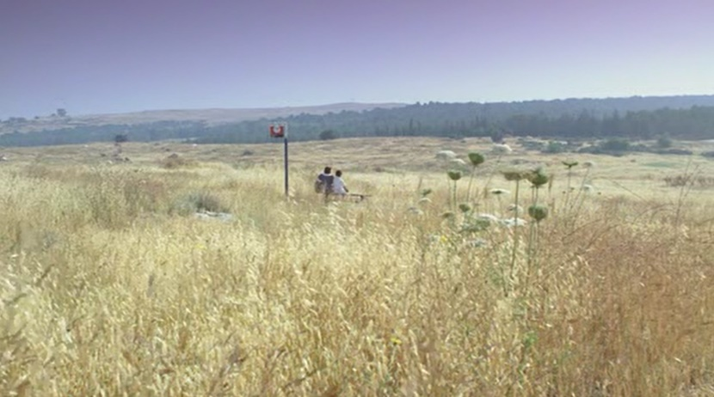
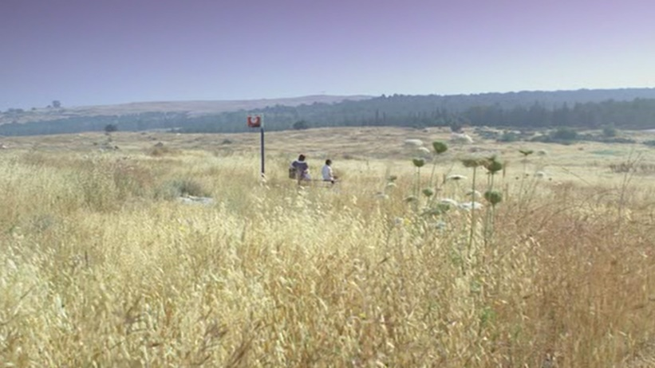

b.
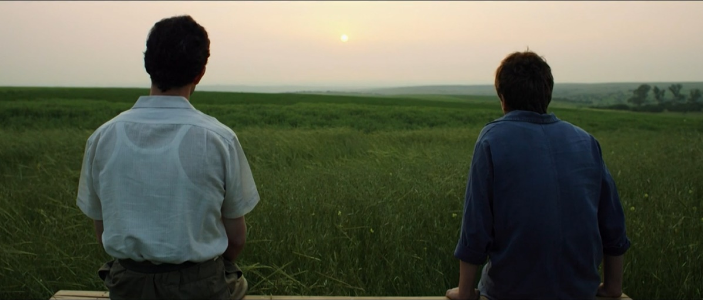

c.
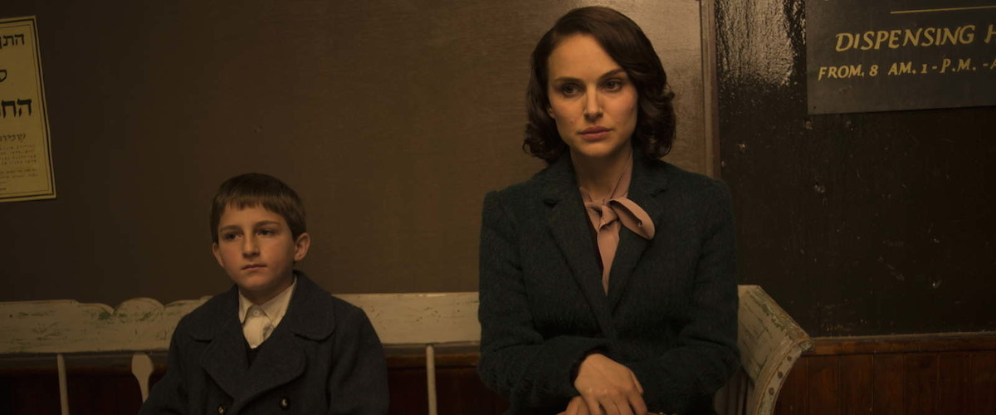

Interestingly, in two of the movies a bench was used as a symbol of the relationship between two generations. In the first two pictures a., Aviya and her mother are shown in the very beginning, when they were leaving the school. Here an extreme long shot is used, which increases the distance between the two women. It also gives the feeling of their loneliness and outsider position. Compared to picture b., it is obviously two different situations. In a shot from “A tale of love and darkness” (b.), the father Arieh and Amos are shown in the final scene. Meanwhile, picture a. was in the beginning of the movie. The colors used in this scene are soft, both watching the sunset, a peaceful romantic moment. In a. the picture’s dominant color is the light yellow of grass parched by the sun. Meanwhile, in b. the dominant colors are green, blue and white. The shirts of the father and son have the symbolic colors of the flag of Israel on a live nature background. Picture c. (“The tale of love and darkness” -Fanya and Amos) has something in common with the first picture a. Two situations with mothers and one situation with a father, obviously here the mother-child connection is stronger.

5.2 The image of the Shoah survivors

a.
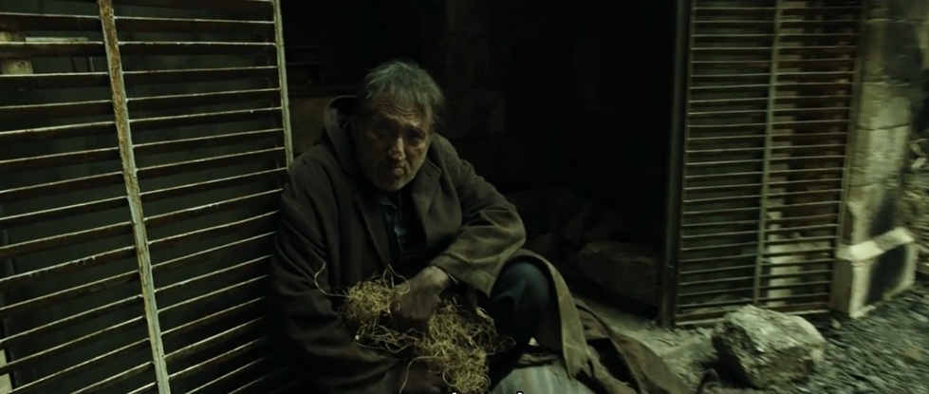

b.
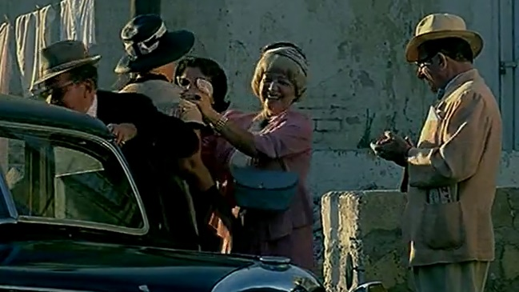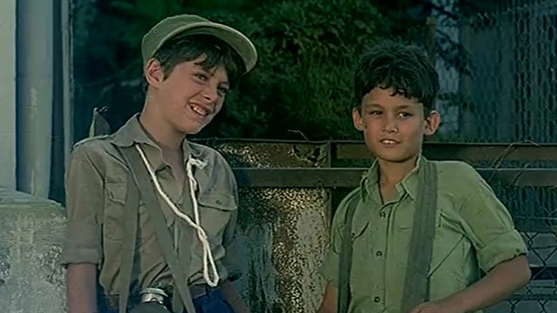

c.
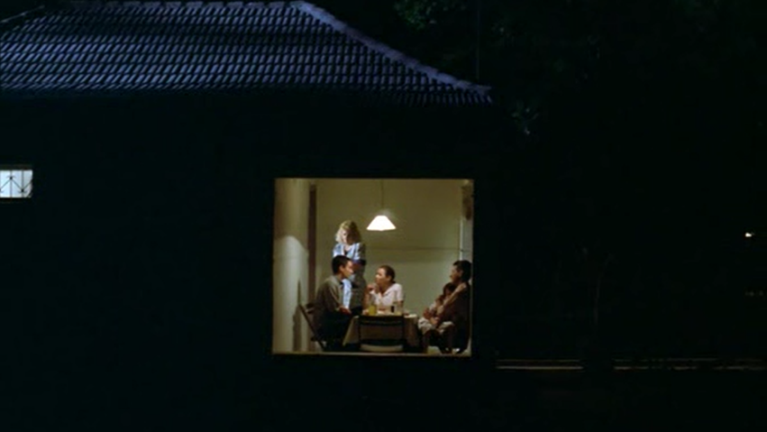

Screenshot a. was taken from “A tale of love and darkness” of a homeless man who repeated the same phrase over and over again about a million children murdered during the Shoah. We see this man from Amos’ point of view and the camera moves together with Amos’ gaze.
Picture b. from “Wooden gun” is the scene with the new immigrants from Europe. Children are standing on the opposite side of the road. They are different from the immigrants and they have nothing in common, which can bring them together in the same frame. Both boys have simple clothes of military colors in opposition to the dressed-up Europeans.
The next screenshot c. is from “Summer of Aviya”, the scene when a young man appears in their village who does not speak Hebrew, but Yiddish, and only Nushka (that is what he called Henya) understands him. He is pale, lost and out of his mind. The lightened window is in the middle of the frame and all around it is a darkness. Survivors are in the light because they survived.

5.3 Images of the women

a.
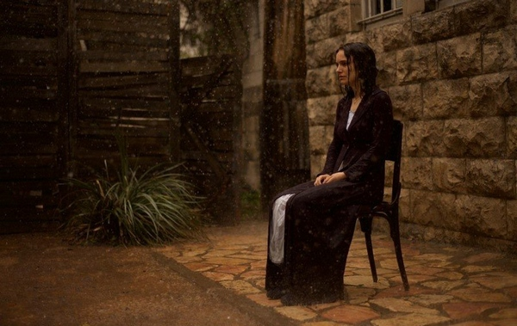

b.
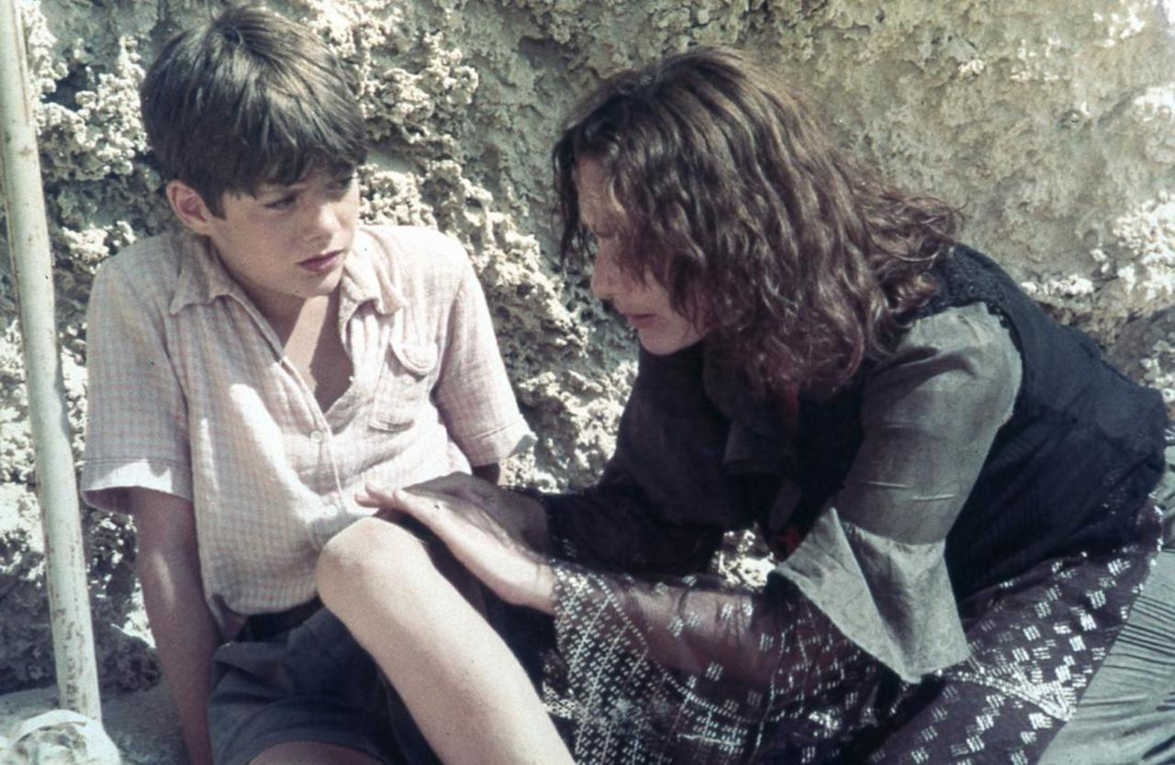
c.
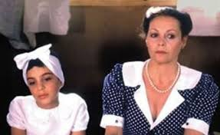
d.
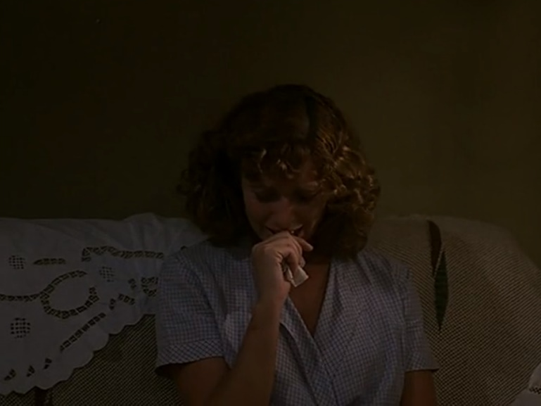
The picture a. is an image of Fanya from “The tale of love and darkness”. In my opinion, it is the best picture showing her inner condition, which was probably like this for a long time. It is an image of a broken women, who gave up on fighting for her life.
The next photo b. is a scene from the movie “Wooden gun”. It is with Palestina and Yoni. It is the turning point for the boy, when she helps him with his wound, and with his understanding of the national past. Particularly, his mother’s past. It is an image of a gentle woman, who takes care of him as if he were her own child.
Photo c. is an image of two women Henya and Aviya on the girl’s birthday when nobody came to her party. The image is of a woman who loves her child and will do anything for her, and a child, who loves her mother.
The last photo d. is from “Wooden gun” of Yoni’s mother Maya. It is also her constant condition: despair, helplessness and a feeling of being stuck.

5.4 Mothers-children relationships

a. “A tale of love and darkness”
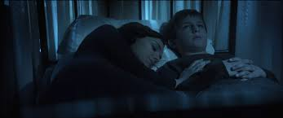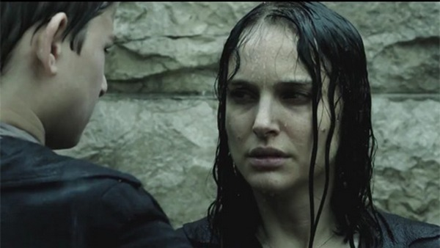

b. “Summer of Aviya”
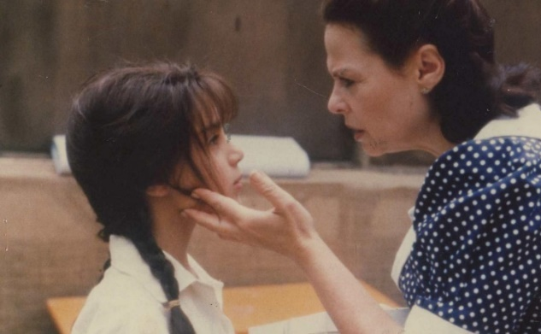
c. “Wooden gun”
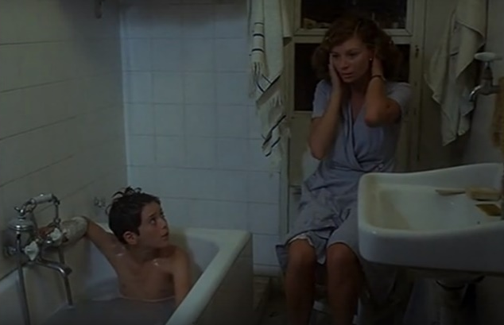

The pictures show two different stages of relationships between a mother and her child. As they all survived the Shoah, they have trauma and their emotional and mental health is unstable. As the story develops, they feel worse, and it is a turning point for the children to change. Amos leaves home at age 14, changes his last name and joins the kibbutz Hulda. Aviya is left alone and returns to the boarding school and is left in the last summer with her mother. Yoni leaves his obssesion of a war and his dreams of military glory.
The movies are lead by children and they tell about their childhood and life with their parents. In my opinion, it is a great shift in film history as it shows not only children as main characters in a serious topic, but also women. These three particular movies are interesting because they show the trauma from a child’s perspective and the way their parents, and especially women, were dealing with it. As a result, we have as main protagonists Others: women and children.

6 Comparison of women protagonists of the movies

I would like to compare the experiences of women portrayed in the movies. This will help me to understand the female immigration process and how successfully or unsuccessfully they integrated into their new lives.
I will analyze Henya from “Summer of Aviya”, Fanya from “A tale of love and darkness” and Palestina from “Wooden gun”. Those three characters are the clearest examples of the women Shoah survivors.
The movies portray the early years of Israel and last years of pre-state Israel. These are difficult times from many perspectives. The immigrants escaped the War in Europe only to encounter wars in the new land. There is uncertainty in everything, and the necessity to adjust in the new world. Two of the movies were made at relatively the same time and they have a similar atmosphere and way of portraying those times. “A tale of love and darkness” was made in 2015, so the events and atmosphere were built using memoirs and archive materials. Thus, they already portray the same situation differently. The films also have different goals. Natalie Portman’s movie is aiming to understand the psychology of Fanya and show her inner side through a variety of cinematic tools. Unlike “Wooden gun”, which is concentrated more on children and their experience. “Summer of Aviya” portrays the Second generation’s way of becoming a Sabra through a mother’s experience.
How are mothers portrayed in the movies? What are the differences between their immigration experience? Did any of them succeed in the integration process? And, finally, how did their life and the past affect their children’s lives?
Henya is portrayed as a strong person with a military past, who was broken mentally and struggles in everyday life. According to the way Aviya describes her, it is obvious that she loves her mother and is proud of her, but unfortunately, cannot reach her. Fanya is the opposite of Henya. She is gentle, well educated, fragile and dreamy. The film pictures the process of her breakdown with a romantic atmosphere built by her dreams and stories. Palestina is a survivor, who was first portrayed as a target for mocking, and then as a tool that helped Yoni to make a spiritual Aliyah.
There are many more common themes in their experience than differences. All of them are mothers or were mothers. They are the Shoah survivors, and unfortunately, they all lost their identities and had mental diseases. The only positive example is Palestina. She helped the young boy to find the way to himself. Meanwhile, Henya and Fanya contributed to the psychological trauma of their children.
In my opinion, none of the women succeeded in their integration to a new life or in identifying themselves in every role they played in society. None of them were ready to start a new life and raise their children.

Conclusion

The main aim of the thesis was to analyze the female immigration experience from Europe to pre-state Israel and the state of Israel portrayed in three feature films. I was interested in the female Shoah survivors and analyzed their social roles, their relationships with men and with their children. The movies are made by later generations, thus we are looking at the women from their descendants’ point of view: the Second generation and the recent generation. For a better understanding of the film events, I analyzed the historical background of “herstory” in Europe and the time periods that are depicted in the movies. I discovered that during the Shoah women started to take men’s positions in their own houses: feeding a family and earning the money. Some of them worked in underground unions and fought against the Nazis. It was a great change for Jewish women.
Parents are represented by the mothers, the Shoah survivors, who live with their trauma and have the most impact on their children. The men are in the background and do not play a significant role in the storylines. I analyzed women’s immigration experience from different angles: social identity theory, relationships with a family and with the rest of society. The movies are made by the Second and recent generations, which are projecting their point of view on the women who survived.
These are different women with different stories, but they all have a common trauma. All of them are damaged inside and have problems finding a place in society. Relationships with their children remained strong, but with a great deal of trauma in them. They all lose their social identities piece by piece. Henya’s strongest identity was as a mother, but in the end, she lost it and left Aviya alone. Fanya could not bear the roles of wife, daughter, sister, friend or mother. She gives up on every part of herself during the movie, slowly dying. Palestina’s protagonist was used for Yoni’s development. And among the other characters, she is the only one who has a positive result.
A major difference in portraying women from the Second generation to the recent, is that the recent generation analyzes the trauma psychologically, opening the viewer to a more complex situation.
I tried to analyze the main protagonists to understand how much they succeeded in their immigration process. The survivors’ past was a heavy burden for them and their families. The trauma affected their whole life and made it impossible to integrate into a new life in a new country. They all were miserable and could not remain in their social identities because of the trauma. However, their trauma pushed their children to separate from the family and to assimilate, becoming sabras.

Bibliography

Primary sources
Films:
A tale of love and darkness, directed by Natalie Portman, USA, 2015
Summer of Aviya, directed by Eli Cohen, Israel, 1988
“Wooden gun”, directed by Ilan Moshenson, Israel, 1979

Printed sources:
[1] BORDWELL, David, Kristin THOMOPSON a Jeff SMITH. Film Art: An Introduction. 12th Edition. McGraw-Hill Education, 2019. ISBN 1260565661
[2] MULVEY, Laura: Visual pleasure and narrative cinema. Iluminace, 5, 1993. No. 3(11), pp. 43-52
[3] RINGELBLUM, Emanuel, SLOAN, Jacob, ed. Notes from the Warsaw ghetto: the journal of Emanuel Ringelblum. New York: Schocken Books, 1974. ISBN 0-8052-0460-1
Online sources:
[4] Baskin, Judith R. Signs, [online] vol. 27, no. 1, 2001, pp. 268–271. JSTOR. Available on WWW: http://<www.jstor.org/stable/3175876>
[5] Stets, Jan E., BURKE. J. Peter. "Identity Theory and Social Identity Theory." [online] Social Psychology Quarterly 63, no. 3 (2000): 224-37. Available on WWW: http//<www.jstor.org/stable/2695870>
Secondary sources:
Printed sources:
[6] ALMOG, Oz. Haim WATZMAN. The Sabra: The Creation of the New Jew. Berkeley: University of California Press, 2000. ISBN 9780520216426.
[7] AVISAR, Ilan. “The Holocaust in Israeli Cinema as a Conflict between Survival and Morality.” Israeli Cinema, edited by Miri Talmon and Yaron Peleg, University of Texas Press, 2011, p.165
[8] BACON, Gershon, 1999, The Missing Fifty-Two Percent: Research on Jewish Women in Interwar Poland and Its Implications for Holocaust Studies. In: Women in the Holocaust. New Haven: Yale University Press. p. 55-67.
[9] BAUMEL-SCHWARTZ, Judith. “We were there too”. Women’s Commemoration in Israeli War memorials. KARK, Ruth, Margalit SHILO a Galit HASAN-ROKEM. Jewish women in pre-state Israel: life history, politics, and culture. Hanover N.H: Published by University Press of New England, 2008, s. 321-337. ISBN 9781584657026.

[10] Baumel-Schwartz, Judy Tydor, et al., editors. “The Identity of Women in the She’Erit Hapletah: Personal and Gendered Identity as Determinants in Rehabilitation, Immigration, and Resettlement.” Holocaust Survivors: Resettlement, Memories, Identities, 1st ed., Berghahn Books, New York; Oxford, 2012, pp. 16–45.
[11] BERNSTEIN, Deborah. Pioneers and Homemakers Jewish Women in Pre-State Israel. Alabany: State University of New York Press, 1992. ISBN 0791409058
[12] BUTLER, Judith. Gender Trouble: Feminism and the Subversion of Identity (Routledge Classics). New york: Routledge, 2006. ISBN 978-0415389556.
[13] Hanich, Julian. “Reflecting on Reflections: Cinema’s Complex Mirror Shots.” Indefinite Visions: Cinema and the Attractions of Uncertainty, edited by Martine Beugnet et al., Edinburgh University Press, Edinburgh, 2017, pp. 131–156
[14] KAPLAN, Eran. Amos Oz's A Tale of Love and Darkness and the Sabra Myth. Jewish Social Studies. New Series, Vol. 14, No. 1 (Fall, 2007), pp. 119-143
[15] PELEG, Yaron. “Ecce Homo: The Transfiguration of Israeli Manhood in Israeli Films.” Israeli Cinema, edited by Miri Talmon and Yaron Peleg, University of Texas Press, 2011, p.34
[16] Pfefferkorn, Eli. "The Sabra Model”. The Müselmann at the Water Cooler, 110-18. Brighton, MA: Academic Studies Press, 2011.
[17] RINGELHEIM, Joan, 1985, Women and the Holocaust: A Reconsideration of Research. Signs: Journal of Women in Culture and Society. 1985. Vol. 10, no. 4, p. 741-761. DOI 10.1086/494181. University of Chicago Press
[18] SHILO, Margalit, The double or multiple image of the new Hebrew woman in Nashim: A Journal of Jewish Women's Studies & Gender Issues. No. 1, Women and the Land of Israel (Winter, 5758/1998), pp. 73-94
[19] SHILO, Margalit, The Transformation of the Role of Women in the First Aliyah, 1882-1903. Jewish Social Studies, New Series, Vol. 2, No. 2 (Winter, 1996), pp. 64-86
[20] WARDI, Dina. Memorial Candles: Children of the Holocaust (The International Library of Group Psychotherapy and Group Process). New York: Routledge, 1992. ISBN 978-0415060998.

Online sources:
[21] BAR-YISHAY, Hanna. "Women in the Yishuv Workforce." Jewish Women: A Comprehensive Historical Encyclopedia. [online] 27 February 2009. Jewish Women's Archive. Available on WWW: <https://jwa.org/encyclopedia/article/women-in-yishuv-workforce>

[22] Bartal, Nira, Nursing as a Female Profession in Palestine (1918-1948)." Jewish Women: A Comprehensive Historical Encyclopedia. [online] 20 March 2009. Jewish Women's Archive.Available on WWW: <https://jwa.org/encyclopedia/article/nursing-as-female-profession-in-palestine-1918-1948>
[23] Ben-zvi, Yael. Blind Spots in Portraiture: On Oz Almog's "Ha-tsabar: Dyokan, Sabra: The Creation of the New Jew". [online] Jewish Social Studies, New Series, 7, no. 1 (2000): 167-74. Available on WWW: <http://www.jstor.org/stable/4467597>
[24] GALLEZ, Douglas W., 1970, Theories of Film Music. Cinema Journal. 1970. Vol. 9, no. 2, p. 40. [online] Available on JSTOR, www.jstor.org/stable/1225202
[25] Gutwein, Daniel. “The Privatization of the Holocaust: Memory, Historiography, and Politics.” [online] Israel Studies, vol. 14, no. 1, 2009, pp. 36–64. JSTOR. Available on WWW:http://www.jstor.org/stable/30245843
[26] Izraeli, Dafna N. "Israel Defense Forces." Jewish Women: A Comprehensive Historical Encyclopedia. [online] 27 February 2009. Jewish Women's Archive. Available on WWW: <https://jwa.org/encyclopedia/article/israel-defense-forces>.
[27] Ofer, Dalia. "The Past That Does Not Pass: Israelis and Holocaust Memory." [online] Israel Studies 14, no. 1 (2009): 1-35. Available on WWW: http//www.jstor.org/stable/30245842
[28] STEIR-LIVNY, Liat. “Near and Far: The Representation of Holocaust Survivors in Israeli Feature Films.” [online] Israeli Cinema, edited by Miri Talmon and Yaron Peleg, University of Texas Press, 2011, pp. 168–180. [online] JSTOR. Available on WWW: http//< www.jstor.org/stable/10.7560/725607>
[29] "Teachers' Association in Israel." Encyclopedia Judaica. [online] Encyclopedia.com. Available on WWW:<https://www.encyclopedia.com/religion/encyclopedias-almanacs-transcripts-and-maps/teachers-association-israel >
[30] “The Emergence of a Native Hebrew Culture in Palestine, 1882-1948.” [online] Poetics Today, vol. 11, no. 1, 1990, pp. 175–191. JSTOR. Available on WWW: <http:// www.jstor.org/stable/1772679>
[31] Winters, Ben. “THE NON-DIEGETIC FALLACY: FILM, MUSIC, AND NARRATIVE SPACE.” Music & Letters, vol. 91, no. 2, 2010, pp. 224–244. [online] Available on JSTOR, www.jstor.org/stable/40871578.
[32] Ury, Scott. "Zionism and Zionist Parties." YIVO Encyclopedia of Jews in Eastern Europe [online] 15 November 2010. 23 April 2020. Available on WWW: <https://yivoencyclopedia.org/article.aspx/Zionism_and_Zionist_Parties>.
[33] Zerubavel, Yael. “The ‘Mythological Sabra’ and Jewish Past: Trauma, Memory, and Contested Identities.” [online] Israel Studies, vol. 7, no. 2, 2002, pp. 115–144. JSTOR. Available on WWW: <http://www.jstor.org/stable/30245588>

Annotation
Name of Author: Naila Kerimova
Name of Faculty: Faculty of Arts
Name of Department: Kurt and Ursula Center for Jewish Studies
Name of Thesis: Female immigration from Eastern Europe, before and after the Shoah: Portrayed in Israeli feature films
Name of Supervisor: PhDr. Lenka Ulicna, Ph.D
Number of Characters: 94 60
Number of Works Cited: 33
Keywords: Jewish women, sabra, the Shoah, pre-state Israel, state of Israel, Israeli movie, the second generation, the Shoah survivor, social identity, feminism

The thesis aims to analyze the female Shoah survivors and their immigration portrayed in Israeli movies. The first part of the work includes the history of Jewish women in Europe during the 30s-50s and a brief introduction of the social situation in pre-state/state of Israel and woman placed in it. The second part includes an analysis of the main female protagonists using the social theory identity and the feminist film theory.

Anotace
Jméno a příjmení autora: Naila Kerimova
Název fakulty: Filozofická fakulta
Název katedry: Centrum judaistických studií Kurta a Ursuly Schubertových
Název bakalářské práce:
Zobrazení imigrace žen z Východní Evropy před a po Šoa v Izraelských filmech
Vedoucí bakalářské práce: PhDr. Lenka Ulicna, Ph.D.
Počet znaků: 94 360
Počet titulů použité literatury: 33
Klíčová slova: židovské ženy, sabra, Šoa, Izrael, izraelský film, druhá generace, přeživší šoa, sociální identita, feminizmus

Tato práce si klade za cíl analyzovat imigraci žen přeživších Šoa, znázorněnou v izraelských filmech. První část práce zahrnuje historii židovských žen v Evropě ve 30.-50. letech a stručné představení sociální situace v Izraeli (před vznikem a po vzniku státu) a místo, které v něm žena nastává. Druhá část představuje analýzu hlavních ženských postav pomocí teorie sociální identity a feministické filmové teorie.

Sabra – native born Israeli
RINGELHEIM, Joan, 1985, Women and the Holocaust: A Reconsideration of Research. Signs: Journal of Women in Culture and Society. 1985. Vol. 10, no. 4, p. 741-761. DOI 10.1086/494181. University of Chicago Press
RINGELBLUM, Emanuel, SLOAN, Jacob, ed. Notes from the Warsaw ghetto: the journal of Emanuel Ringelblum. New York: Schocken Books, 1974. ISBN 0-8052-0460-1
BACON, Gershon, 1999, The Missing Fifty-Two Percent: Research on Jewish Women in Interwar Poland and Its Implications for Holocaust Studies. In: Women in the Holocaust. New Haven: Yale University Press. p. 55-67.
Baskin, Judith R. Signs, [online] vol. 27, no. 1, 2001, pp. 268–271. JSTOR. Available on WWW: <http://www.jstor.org/stable/3175876>
RINGELHEIM, Joan. Ref.2
RINGELHEIM, Joan. Ref.2
SHILO, Margalit, The double or multiple image of the new Hebrew woman in Nashim: A Journal of Jewish Women's Studies & Gender Issues. No. 1, Women and the Land of Israel (Winter, 5758/1998), pp. 73-94.
SHILO, Margalit, The Transformation of the Role of Women in the First Aliyah, 1882-1903. Jewish Social Studies, New Series, Vol. 2, No. 2 (Winter, 1996), pp. 64-86
Ury, Scott. "Zionism and Zionist Parties." YIVO Encyclopedia of Jews in Eastern Europe [online] 15 November 2010. 23 April 2020. Available on WWW: <https://yivoencyclopedia.org/article.aspx/Zionism_and_Zionist_Parties>.
“The Emergence of a Native Hebrew Culture in Palestine, 1882-1948.” [online] Poetics Today, vol. 11, no. 1, 1990, pp. 175–191. JSTOR. Available on WWW: <http:// www.jstor.org/stable/1772679>
Pfefferkorn, Eli. "The Sabra Model”. The Müselmann at the Water Cooler, 110-18. Brighton, MA: Academic Studies Press, 2011.
Zerubavel, Yael. “The ‘Mythological Sabra’ and Jewish Past: Trauma, Memory, and Contested Identities.” [online] Israel Studies, vol. 7, no. 2, 2002, pp. 115–144. JSTOR. Available on WWW: <http://www.jstor.org/stable/30245588>
ALMOG, Oz. Haim WATZMAN. The Sabra: The Creation of the New Jew. Berkeley: University of California Press, 2000. ISBN 9780520216426.
Ben-zvi, Yael. Blind Spots in Portraiture: On Oz Almog's "Ha-tsabar: Dyokan, Sabra: The Creation of the New Jew". [online] Jewish Social Studies, New Series, 7, no. 1 (2000): 167-74. Available on WWW: <http://www.jstor.org/stable/4467597>
BERNSTEIN, Deborah. Pioneers and Homemakers Jewish Women in Pre-State Israel. Alabany: State University of New York Press, 1992. ISBN 0791409058
Bartal, Nira, Nursing as a Female Profession in Palestine (1918-1948)." Jewish Women: A Comprehensive Historical Encyclopedia. [online] 20 March 2009. Jewish Women's Archive.Available on WWW: <https://jwa.org/encyclopedia/article/nursing-as-female-profession-in-palestine-1918-1948>
"Teachers' Association in Israel." Encyclopedia Judaica. [online] Encyclopedia.com. Available on WWW:<https://www.encyclopedia.com/religion/encyclopedias-almanacs-transcripts-and-maps/teachers-association-israel >
Bernstein, Deborah ref.16
BAR-YISHAY, Hanna. "Women in the Yishuv Workforce." Jewish Women: A Comprehensive Historical Encyclopedia. [online] 27 February 2009. Jewish Women's Archive. Available on WWW: <https://jwa.org/encyclopedia/article/women-in-yishuv-workforce>
Izraeli, Dafna N. "Israel Defense Forces." Jewish Women: A Comprehensive Historical Encyclopedia. [online] 27 February 2009. Jewish Women's Archive. Available on WWW: <https://jwa.org/encyclopedia/article/israel-defense-forces>.
BAUMEL-SCHWARTZ, Judith. “We were there too”. Women’s Commemoration in Israeli War memorials. KARK, Ruth, Margalit SHILO a Galit HASAN-ROKEM. Jewish women in pre-state Israel: life history, politics, and culture. Hanover N.H: Published by University Press of New England, 2008, s. 321-337. ISBN 9781584657026.
Zerubavel, Yael. ref.13
Gutwein, Daniel. “The Privatization of the Holocaust: Memory, Historiography, and Politics.” [online] Israel Studies, vol. 14, no. 1, 2009, pp. 36–64. JSTOR. Available on WWW:<http://www.jstor.org/stable/30245843>
Gutwein, Daniel. Ref.24
Ofer, Dalia. "The Past That Does Not Pass: Israelis and Holocaust Memory." [online] Israel Studies 14, no. 1 (2009): 1-35. Available on WWW: http//<www.jstor.org/stable/30245842>
STEIR-LIVNY, Liat. “Near and Far: The Representation of Holocaust Survivors in Israeli Feature Films.” [online] Israeli Cinema, edited by Miri Talmon and Yaron Peleg, University of Texas Press, 2011, pp. 168–180. [online] JSTOR. Available on WWW: http//< www.jstor.org/stable/10.7560/725607>
Stets, Jan E., BURKE. J. Peter. "Identity Theory and Social Identity Theory." [online] Social Psychology Quarterly 63, no. 3 (2000): 224-37. [online] Available on WWW: http//<www.jstor.org/stable/2695870>
BUTLER, Judith. Gender Trouble: Feminism and the Subversion of Identity (Routledge Classics). New york: Routledge, 2006. ISBN 978-0415389556.
Baumel-Schwartz, Judy Tydor, et al., editors. “The Identity of Women in the She’Erit Hapletah: Personal and Gendered Identity as Determinants in Rehabilitation, Immigration, and Resettlement.” Holocaust Survivors: Resettlement, Memories, Identities, 1st ed., Berghahn Books, New York; Oxford, 2012, pp. 16–45.
WARDI, Dina. Memorial Candles: Children of the Holocaust (The International Library of Group Psychotherapy and Group Process). New York: Routledge, 1992. ISBN 978-0415060998.
AVISAR, Ilan. “The Holocaust in Israeli Cinema as a Conflict between Survival and Morality.” Israeli Cinema, edited by Miri Talmon and Yaron Peleg, University of Texas Press, 2011, p.165
Wardi, Dina. Ref.31
Winters, Ben. “THE NON-DIEGETIC FALLACY: FILM, MUSIC, AND NARRATIVE SPACE.” Music & Letters, vol. 91, no. 2, 2010, pp. 224–244. [online] Available on JSTOR, www.jstor.org/stable/40871578.
GALLEZ, Douglas W., 1970, Theories of Film Music. Cinema Journal. 1970. Vol. 9, no. 2, p. 40. [online] Available on JSTOR, www.jstor.org/stable/1225202
Hanich, Julian. “Reflecting on Reflections: Cinema’s Complex Mirror Shots.” Indefinite Visions: Cinema and the Attractions of Uncertainty, edited by Martine Beugnet et al., Edinburgh University Press, Edinburgh, 2017, pp. 131–156
PELEG, Yaron. “Ecce Homo: The Transfiguration of Israeli Manhood in Israeli Films.” Israeli Cinema, edited by Miri Talmon and Yaron Peleg, University of Texas Press, 2011, p.34
PELEG, Yaron. Ref.37
GALLEZ, Douglas W., ref.35
KAPLAN, Eran. Amos Oz's A Tale of Love and Darkness and the Sabra Myth. Jewish Social Studies. New Series, Vol. 14, No. 1 (Fall, 2007), pp. 119-143
BORDWELL, David, Kristin THOMOPSON a Jeff SMITH. Film Art: An Introduction. 12th Edition. McGraw-Hill Education, 2019. ISBN 1260565661.
MULVEY, Laura: Visual pleasure and narrative cinema. Iluminace, 5, 1993. No. 3(11), pp. 43-52

