**UNIVERZITA PALACKÉHO V OLOMOUCI**

PEDAGOGICKÁ FAKULTA

Ústav cizích jazyků

Bakalářská práce

Tereza Mikulecká

Music and its use in English language studies

Olomouc 2021 vedoucí práce: Mgr. Ondřej Duda

Prohlašuji, že jsem bakalářskou práci na téma Hudba a její využití při výuce anglického jazyka vypracovala samostatně a použila jen uvedených pramenů a literatury.

V Olomouci dne………………. podpis……………........

I would like to thank Mgr. Ondřej Duda for his valuable advice and overall support during the creation of my bachelor’s thesis.

Contents

Abstract 6

Introduction 7

Theoretical part 9

1 Music and language 9

1.1 Music 9

1.2 Language 10

1.3 Similarities between music and language 11

2 Music and its effects on humans 14

2.1 Physiological responses to music 14

2.2 Psychological responses to music 15

3 Music in English language teaching 18

3.1 Music as a motivational element 18

3.2 Music and emotion 18

3.3 Music and language skills 19

Practical part 23

4 Description of the research 23

4.1 Aims of the research 23

4.2 Research questions 24

4.3 Methodology 24

4.3.1 Research instrument 24

4.3.2. Procedure 25

4.3.3 Subjects of the research 26

4.3.4 Data collection 26

5 Research results 27

5.1 Research results and their analysis 27

5.1.1 Questionnaire for teachers 27

5.1.2 Questionnaire for pupils 30

5.2 Discussion 33

Conclusion 35

Bibliography 37

Appendices 40

Appendix 1: The results of the questionnaire for teachers 40

Appendix 2: The results of the questionnaire for pupils 50

Résumé 58

Annotation 59

# Abstract

The bachelor’s thesis addresses the theme of music and its effects on humans and discusses the usage of music as a pedagogical tool in English language teaching. The theoretical part introduces the concepts of music and language and emphasizes the similarities between them. Next, it explores the impact of music on a person’s physiological and psychological state and presents several ways of applying music in English lessons. The practical part of the thesis is based on research, determining the approach of English language teachers to use of music in their lessons and the level of music training of pupils, together with their attitude to learning English language.

# Introduction

‘Music produces a kind of pleasure which human nature cannot do without.’

Confucius

For many people, music is an integral part of life. There are people who use music for relaxation or as a means of momentarily freeing themselves from reality. Others consider music to be a pleasant source of fun or a way to enhance boring moments during the day.

Moreover, many people found music intriguing enough to become their way of livelihood. Whatever the reason for the popularity of music is, clearly it has great potential in many areas of life, including the field of education. At schools, music is taught as a separate subject. In addition, music is an important part of many other subjects. In history lessons, it can introduce students to the culture of the time. In physical education classes, it can motivate pupils during exercise. Presumably the most important use of music is in teaching foreign languages. In these classes, songs are often used, for example to help pupils memorize new vocabulary or improve their listening skills.

The potential of music in educational area originates in the connection between music and psychological processes of an individual (Koelsch, 2013). For instance, listening to music or performing it can influence a person’s cognitive functions, such as memory and attention (Koelsch, 2013). In addition, music can serve as a motivational element. A considerable number of pupils and students have difficulties with learning a foreign language, and music could be a convenient and entertaining way of alleviating these difficulties, at least for some of them.

My personal experience as someone with a relatively large musical background is, that I have never encountered significant problems with learning foreign languages. Therefore, the thesis is a great opportunity to explore, whether and to what extent this experience applies to other learners of foreign languages, specifically English language learners, as well as to find out teachers’ views on the use of music as a teaching aid.

The above together with additional reasons (see subchapters 4.1 and 4.2) raises following questions: What is the attitude of English language teachers in Czech primary and lower secondary schools to use of music during English lessons? What is the level of music training of pupils in Czech lower secondary schools? What is the attitude of Czech lower secondary school pupils with previous music training of at least one year to learning English? What is the attitude of Czech lower secondary school pupils without previous music training of at least one year to learning English? The goal of the thesis is to answer these questions.

The thesis is divided into two parts. The first part is theoretical and the second part is practical. The purpose of the theoretical part is to acquaint the reader with the given topic and explain the relevant concepts of the theme. Providing different interpretations, it introduces what music and language is, and continues by exploring the connections between them. Thereafter, it addresses the influence of music on humans, and concludes by dealing with use of music in English lessons.

The practical part of the thesis is based on the knowledge gained in the theoretical part. The data contained in this part are collected using the questionnaire method. Two types of questionnaires are used, focusing on two target groups, namely pupils in lower secondary schools and teachers in both primary and lower secondary schools. The intention of this part is to answer the above-mentioned research questions.

In my opinion, the theme of music and its use in English language teaching is highly interesting and has great potential. I believe the findings of the thesis to be beneficial, if only for inducing the readers to reflect on the presented ideas.

# Theoretical part

# 1 Music and language

To acquaint the reader with the essential concepts of this thesis, it is necessary to provide basic information about music and language separately. Then, it is possible to explore the connections between them. The aim of this thesis is to determine, whether music can be used in the teaching of English language. Therefore, this chapter focuses mainly on finding resemblances between music and language, although there are obviously many differences between them.

## 1.1 Music

Defining music is definitely not easy, as its concept depends on various perspectives. Although many authors agree that music is a combination of sounds, there is no uniform definition of music.

For instance, some people perceive music primarily as an artistic value. As Zenkl (1991, p. 7) writes, ‘*music is a widely branched field of art with a significant multifaceted mission in the life of both individual and society*’ (translation of the author). According to Zenkl (1991, p. 7), a musically educated person is characterized not only by theoretical knowledge in the field of music, but also by the ability to comprehend the artistic value of music.

However, Poledňák (2006, p. 139) warns against such interpretations, emphasizing that art itself is an ambiguous term understood in various ways. In general, Poledňák (2006, p. 139–140) draws attention to the incompleteness or inaccuracy of many definitions of music. Therefore, he does not attempt to provide an all-encompassing definition, but rather to highlight different aspects of the concept. For example, Poledňák (2006, p. 142) refers to music as an essential part of both individual and society, a way of exploring the world, or a means of communication.

The last of these aspects is emphasized by Gispert (2000, p. 6), stating that ‘*music originated in the search for speech, thus from the basic need for communication*’ (translation of the author). As early as in the Palaeolithic, people created percussion musical instruments from various material (Gispert, 2000, p. 6). As Gispert (2000, p. 6–7) claims, playing these instruments was very rhythmic and helped the development of speech.

Regardless its origin, music is an ingrained part of human community. In ancient times, people showed musical creativity and involved music in many socially important events and rituals (Gispert, 2000, p. 6). And as it turns out, music is an integral part of many social ceremonies even today.

## 1.2 Language

Like music, language cannot be unambiguously defined, as it always depends on the author’s point of view. Therefore, different sources provide different definitions. However, there is a feature that many authors agree on. Just like some authors consider music to be a means of communication, many others attribute this function to language.

For instance, Sternberg (2002, p. 318) describes language as *‘the usage of organized means of word combination for the purpose of communication’* (translation of the author). Communicative function is also emphasized by Čermák (2011, p. 13), who considers language to be *‘a system of units, rules, models and conventional collective norms stored in the brain to create speech. This system serves primarily for coding and decoding of conveyed information of many kinds, and for understanding such speeches, or texts, that are the content of both common and less common communication’* (translation of the author).

Both of the above authors describe language as a system of units. Chomsky (1966, p. 14) provides similar definition, specifying the mentioned units as sentences, composed of letters. As he claims, sentences (by their length) and letters (by their number) are finite elements. However, there is an inexhaustible number of their combinations, which results in obtaining either finite or infinite set. Chomsky believes this set to be language.

However, Saussure (1989, p. 44) points out that there are more approaches to the concept of language. Among these approaches, he mentions understanding language as sound. Furthermore, Saussure (1989, p. 45) highlights that language is not an independent unit, but functions in coexistence with other units. This coexistence includes the relationship between language and sound. As Saussure explains, while producing language, sounds are made. However, it would not be possible to make sounds without vocal organs that enable articulation. Therefore, Saussure is convinced that language and sound are inseparable and simultaneously functioning units.

If considering sound as part of music, the above demonstrates a clear link between music and language. To explore connections between music and language in more depth, the next subchapter is provided.

## 1.3 Similarities between music and language

As already mentioned, in order to explore the possible advantages of the use of music in English language teaching, the thesis focuses on finding connections between music and language. Nevertheless, before concentrating on the similarities, it is appropriate to mention one of the basic differences between music and language, which is their different processing in the brain, namely in its two hemispheres.

The left hemisphere of the brain is generally known to control logical thinking and speech, while the right hemisphere is believed to be responsible for creativity or imagination, among other things. The reason why music and language are processed in the particular hemispheres is well described by, for example, Koelsch (2013, p. 241–242). He begins his explanation by stating that both music and language consist of small acoustic segments. According to him, the perception of both music and language requires the recognition of these acoustic segments, which are then evaluated and identified in the brain. However, the segments of acoustic information of music differ from the acoustic segments of language. As Koelsch puts it, the acoustic segments of language change much faster than those of music. Therefore, as Koelsch suggests, the recognition of the acoustic segments of language is much more complicated and requires the left hemisphere, while the recognition of the acoustic segments of music involves the right hemisphere.

However, recent studies examine the interconnection of both hemispheres, indicating that music can be processed both in the right and the left cerebral hemisphere. For instance, Besson and Schön (2001, p. 238) stress that both music and language can be divided into individual components, and therefore ‘some aspects of language processing may preferentially involve left cerebral structures, whereas others require structures on the right. The same remark applies to music as well.’

Concentrating on the links between music and language, these features should definitely be mentioned:

* Communicative function
* Ability to express emotion
* Rhythm
* Melody
* *Communicative function*

The existence of this common feature was indicated in the previous subchapters. With regard to language, the communicative function is clear. Language is apparently the most important means of communication, both in spoken and written form. However, music can also be very important in terms of communication, especially at an early age. Trehub (2003) points out the significance of perception of music by young children, to whom their parents sing lullabies or other songs. In her article, she suggests that this way of communication allows children to develop properly, mainly in the social and emotional area. Murphey and Alber (1985) have similar opinion, emphasizing the emotional importance of the melodic and affectionate voices parents use with their children. They highlight this attentive aspect of communication between parents and their children, assuming that the lack of such attention in adolescence might be the reason why young people relish pop music so much.

* *Ability to express emotion*

Another common feature of both music and language is their ability to express emotion. To achieve such effect, music uses various tone colours, pitch, rhythm, phrasing or melody. In case of language, this is done similarly, using speech prosody which can be defined as ‘the patterns of stress and intonation in a language’ (Collins Dictionary, © 2021). Due to these common emotional features, many studies also assume a common origin of music and language. A study by Thompson, Marin and Stewart (2012) addresses this issue, assuming that music and emotion in speech are processed similarly in the brain. This study was based on an experiment in which a total of 24 participants listened to various emotionally coloured phrases. The task was to recognize the relevant emotions. Half of the participants suffered from amusia, which is a disorder of music perception. The other half did not suffer from this disorder; these participants were used to compare the obtained data. The experiment showed that the group suffering from amusia could not recognize emotions in speech as well as the control group. Therefore, the results of the study suggest that both music and language express emotion based on common mechanisms.

* *Rhythm*

Other aspects connecting music and language definitely include rhythm. Generally, rhythm is understood as periodic repetition. However, Patel (2008, p. 96) argues that periodicity is only one of the aspects of rhythm and defines rhythm as ‘the systematic patterning of sound in terms of timing, accent, and grouping.’ As Patel (2008, p. 176–177) claims, both music and language share these rhythmic features. Specifically, he highlights the similar way in which both music and language systematically group their smaller units into higher ones, for instance words into sentences or tones into phrases. This opinion is shared by Besson and Schön (2001, p. 235), who state that these structured processes follow the syntactic and harmonic standards.

* *Melody*

Similarities between music and language can also be found in terms of melody. Generally, melody is likely to be understood as a system of various tones changing over time. However, such definitions may give the impression that the concept of melody is understood only in the context of music. For language, the term intonation is usually used. For instance, Patel (2008, p. 182) points out the importance to include both music and speech in the concept of melody. He attempts to do so in his own definition, stating that melody is ‘an organized sequence of pitches that conveys a rich variety of information to a listener.’ Patel (2008) then explores the connections between musical and speech melody, highlighting the common mechanisms of their processing in the brain and their similar structure. As for the latter, he provides an example of composers, who use similar patterns both in structuring different tones in their speech and in their musical works.

To conclude, although music and language may seem completely different at first glance, common features can be found, as presented by this subchapter. However, it should be noted that many studies are currently exploring the connections between music and language and although certain issues have been explained, the problematics is still largely shrouded in questions and requires further research.

# 2 Music and its effects on humans

As demonstrated by the previous chapter, both music and language share certain common features. To further explore the importance of music, this chapter focuses on the influence of music on human beings. In order to discover the benefits of music, the chapter describes both the physiological and psychological responses to music. The chapter addresses not only the effects of music induced by listening to it, but also the impacts caused by the creation of music and singing.

## 2.1 Physiological responses to music

Many people occasionally use music to relax. It is not unknown for music to have calming effects, if appropriately selected (Sedlák, 1990, p. 224). Furthermore, some aspects of a person’s physiological state, such as heart rate, can differ depending on whether the person is calm or not (Pickering, 2013). These findings draw attention to the possible connection between music and physiological state of human body, being worth of further exploration.

Loomba et al. (2012) are the authors of one of the studies devoted to this topic. Their study examined two groups of patients of approximately equal size, one group undergoing music therapy and the other group not. In both groups, patients were measured for systolic blood pressure, diastolic blood pressure and heart rate. The results of the study showed that all these parameters were lower in the group of patients receiving music therapy, than in the other group. Because of these results, the authors also believe that music can be beneficially used to help patients suffering from anxiety.

The possible use of music as a means of helping patients suffering from stress and anxiety was discussed, for instance, in a study by Bradt et al. (2013). The study was aimed at patients with coronary heart disease who often suffer from stress and various anxieties. The results of the study suggested that listening to music can have beneficial effects on patients with coronary heart disease, successfully reducing not only anxiety (especially in patients with myocardial infarction), but also systolic blood pressure, heart rate and respiratory rate.

The effects of music on physiological condition have been studied by many other authors. According to Koelsch (2013, p. 93), ‘music listening, and perhaps even more so music making, can have vitalizing effects on an individual.’ Koelsch (2013, p. 93–94) mentions these effects in relation to the autonomic nervous system as well as the endocrine system, pointing out the interconnection between activity of both systems. In other words, he believes that listening to music and music making can influence not only activity of the autonomic nervous system, but also endocrine activity, such as hormone secretion. Additionally, Koelsch (2013, p. 94) emphasizes that both the autonomic nervous system and the endocrine system affect the immune system, and therefore our immunity may be influenced by music.

## 2.2 Psychological responses to music

As demonstrated by the previous subchapter, music can affect many aspects of physiological state of an individual. However, its influence is not limited to physiological condition. For many people, music is a way to change their current emotional state, to lift their spirits. The above-mentioned importance of music in reducing stress and anxiety can serve as an example, among other things showing the frequent interconnection between physiological and psychological state.

In order to discover means that could help students increase their learning abilities, the subchapter explores connections between music and following cognitive functions:

1. Perception
2. Attention
3. Memory
4. *Perception*

According to Piaget and Inhelder (2000, p. 33), perception is ‘*a special case of sensorimotor activities. Its specific character consists in the fact that it belongs to the figurative aspect of cognition of reality*…’ (translation of the author). The influence of music on perception was examined, for example, in a study by Jolij and Meurs (2011). The authors assumed that the way we perceive the world can be affected by our emotion at the moment. The study was based on visual recognition of happy and sad faces, while the participants’ mood was controlled by listening to music. The study showed that the participants were more successful in recognizing faces corresponding to their mood. Therefore, the authors believe that music, as a means of affecting our mood, can change the perception of our surroundings.

The impact of music on perceptual skills was also addressed by Koelsch (2013, p. 236–237), who believes in the beneficial effects of music making in this area. Based on other studies, he is convinced that these effects can be used to help children with language comprehension difficulties. Moreover, he emphasizes the possible significance of music making in preventing certain learning difficulties, such as reading disorders, that many children struggle with at school.

1. *Attention*

Another way to improve children’s learning skills is to increase their attention, which Sternberg (2002, p. 90) defines as ‘*a device through which we actively process a limited amount of information from a huge supply of data in long-term memory, as well as information reaching our sensory systems, or information from other cognitive processes*’ (translation of the author). Again, this could be influenced by music. Music and attention are often related, particularly when creating music. As Koelsch (2013, p. 237) puts it, attention is involved especially if more than one person participates in the creation of music. Therefore, it can be assumed that being involved in musical activities might have a positive impact on our attention.

Indeed, research in this area seems to support this assumption. For instance, a study by Roden et al. (2014), concentrating on primary school children, showed that music training increased the children’s visual attention in a longer period of time. Teachers might appreciate such discovery, because ensuring that pupils are properly focused might facilitate their efforts to pass on the intended information. Likewise, increased attention is bound to help pupils in absorbing the transmitted information.

1. *Memory*

According to Pugnerová (2019, p. 30), ‘*memory means an ability to receive, keep and revive past perceptions*’ (translation of the author). Many studies have questioned the influence of music on memory, searching for possible benefits of such impact. Indeed, the results of research in this area seem to be rather promising. For instance, George and Coch (2011) proved that there is a connection between previous long-term musical training and improvement in working memory, which is a type of short-term memory associated with immediate processing of information (Sternberg, 2002, p. 96).

Another study demonstrated that it does not necessarily require prior music training to enhance memory. The study by Simmons-Stern et al. (2010) was focused on patients suffering from Alzheimer’s disease. The task of the patients was to remember lyrics of unknown children’s songs; the lyrics were either plainly spoken or sung. The task was completed with higher success if the lyrics were sung, indicating that it was preferable for the patients to receive words in musical form in order to remember them.

Influence of music on verbal memory was also addressed in a study by Chan et al. (1998). However, this study explored effects of music training. The participants of the study were college students. Part of these students received music training in childhood, while the other part did not. To determine the state of their verbal memory, each participant was told a list of words. After listening to it, the participants were asked to provide as many words from the list as they could remember. The study showed that the group of participants who received music training in childhood accomplished the given task better than the group without music training. The results demonstrate that music training received in childhood may later have beneficial influence on remembering spoken words.

The above findings could be used for educational purposes. With regard to learning foreign languages, their application certainly has great potential. Naturally, the ability to speak a foreign language is associated with the knowledge of vocabulary. Still, many pupils find gaining such knowledge rather problematic. Hence, previous music training could become an efficient way to alleviate these difficulties and help the learners master the foreign language with less effort.

The chapter clearly demonstrated the impact that music can have on both physiological and psychological state of an individual. Multiple evidence was provided to support the assumption that music can beneficially influence human abilities. Examples concerning the effects of music on cognitive functions showed the potential of music in the field of education. Although further research in this area is still required, it seems that music might be an efficient way to facilitate the learning of foreign languages.

# 3 Music in English language teaching

The previous chapter predominantly covered the theme of music training. To take advantage of this possible means of improving the learners’ language skills, however, it would be necessary for all the pupils to have undergone the training, preferably the long-term one. In their classes, though, teachers cannot rely on such ideal arrangement, and therefore need to consider other ways of using music, that would not depend on the previously gained abilities and would allow for immediate application. As Cross (1995, p. 164) suggests, one of the options is the usage of music and songs to appropriately motivate pupils, lift their spirits, and simultaneously practice their language skills.

## 3.1 Music as a motivational element

According to Harmer (1991, p. 3) motivation is one of the most important aspects of learning a foreign language. As he points out, sufficiently motivated students are guaranteed to be successful in their efforts, regardless of the possible inconveniences during their studies. Analysing the importance of motivation in children, Harmer (1991, p. 7) emphasizes the vital role of the teacher. As he claims, it is the teacher’s responsibility to provide the pupils with enough praise and stimulating activities, and thus increase their motivation.

The specific ways to achieve this goal include the use of music and songs. The positive impact of using songs in lessons is highlighted, for example, by Cross (1995, p. 164), who regards the authenticity of songs to be one of the major reasons for their motivating effects. Additionally, he draws attention to the popularity of songs among wide range of learners. Therefore, he advises teachers to include songs and singing in their lessons, not only to induce the pupils’ interest by interpolating the lesson with a different activity, but to generally enhance their motivation for the subject.

## 3.2 Music and emotion

In their classes, teachers may encounter several conditions, such as the pupils’ passivity or indifference, requiring a change of mood in the classroom. Murphey (1995, p. 37) believes, that music can serve as an effective means of improving such an unfavourable atmosphere, given its stimulating and inspiring effects. As he points out, music is frequently used to set a good mood and create the desired atmosphere on various occasions, for instance during hospital surgeries or while having a dentist appointment. Harmer (2009, p. 143) agrees with the stimulating effects of music and songs, claiming that ‘we can use instrumental music to get students in the right mood, or as a stimulus for any number of creative tasks…’

According to Sedlák (1990, p. 223–224), there are many reasons for the power of music to shape human emotions. In his opinion, aspects such as melody, rhythm, dynamics and especially their sudden changes play a role in this. He mentions several examples of the possible use of such aspects to evoke specific feelings in people. For instance, he claims that fast tempos, increasing tones or notes played in major key (although the last statement applies only in certain cases) induce positive emotions such as joy or excitement, while music performed in small intervals tends to be rather soothing.

Considering the field of education, the above could be used by teachers to help them create the required atmosphere in the classroom. Thus, for example, playing music with calming effects could ensure restoration of calmness in case of disquiet or excessive noise in the classroom. On the contrary if the pupils appear to be downcast or show disinterest, it might be convenient to provide them with stimulating music, that will lift their spirits and increase their excitement.

## 3.3 Music and language skills

As mentioned earlier, using songs in lessons can lead to improvement in pupils’ language skills. According to Harmer (1991, p. 16), the four main language skills include reading, listening, writing and speaking. These can be further divided into two subgroups, one of them containing reading and listening and the other writing and speaking. As Harmer writes, the chief difference between the subgroups is that while reading and listening are based on obtaining information from the surroundings (and therefore belong to receptive skills), the essence of speaking and writing is active creation, making them productive skills. However, Harmer points out that in many cases the skills are related. Murphey (1995, p. 69) agrees with this statement, presenting numerous musical activities aimed at practicing several language skills simultaneously.

* *Receptive skills*

To practice pupils’ receptive skills, Murphey (1995, p. 69–70) recommends using songs with omitted words. The beginning of this activity requires the teachers to distribute the modified lyrics and ask the pupils to read them. Next, the pupils are supposed to propose different words which could fill in the blanks in accordance with the context. In this step, reading skills and language comprehension are being worked on. To improve the pupils’ listening skills, Murphey advises the teachers to play the recordings of the songs until the pupils have no doubt about the correctness of their answers. The idea of using songs to improve listening comprehension is also supported by Ur (2012, p. 109).

The above draft can serve as a simple and efficient way to practice receptive skills. No complicated preparation is necessary, the duration of the activity is not long, and the selection of songs can be adapted to the level of the pupils and their musical tastes. In addition, it is possible to adjust the activity to focus on productive skills as well, for example by dividing the pupils into groups and demanding them to devise and write another verse of the song.

* *Productive skills*

Murphey (1995) offers language teachers a variety of interesting activities with songs. One of them, based on evaluation of diverse song lyrics and subsequent self-creation, seems to be a suitable means of practicing productive skills (Murphey, 1995, p. 82–83). The teacher initiates the activity by placing the lyrics around the classroom. The pupils’ task is to read the individual samples and grade them according to how much they enjoyed them. After revealing the overall class opinion, the pupils should discuss the reasons for the popularity or dislike of the songs, thus applying their speaking skills. To involve writing skills as well, Murphey expects the teachers to request the pupils to write their own lyrics, which can similarly be assessed later. Again, the presented activity appears to be appropriate for a range of language levels, knowing the degree of difficulty can be regulated accordingly. Likewise, the required length of the writing task can be adjusted. In addition, as Murphey (1995, p. 82) himself suggests, should any problems with lack of time arise, it is possible to assign the written part of the activity to the pupils as homework.

As Harmer writes (2015, p. 357), another possibility of practicing productive skills is an activity based on listening to different music samples. The principle of the activity is story writing according to the feelings that the music evokes in the pupils, and a discussion concerning the pupils’ views on the music samples.

The above activities generally aim at mastering the four basic language skills. Nevertheless, teachers may sometimes need their pupils to pay attention to specific language aspects, such as grammar, pronunciation or vocabulary. Cross (1995, p. 164) is convinced, that all these features can be absorbed with the help of songs and rhymes.

* *Vocabulary*

The importance of the knowledge of vocabulary in order to learn a foreign language is emphasized, for example, by Cross (1995, p. 5), who claims that ‘a good store of words is crucial for understanding and communication.’ To ensure the students’ correct usage of the newly learned vocabulary, he highlights the necessity for a thorough explanation of the unfamiliar words. Harmer (1991, p. 86) warns about the occasional difficulty of this act and encourages teachers to concentrate on the context while clarifying the meanings.

Since songs are authentic texts which tend to tell a story, and their content therefore often stands in a certain context, it is feasible to use them for this purpose. A particular way of their application as a means of teaching vocabulary is described by Cross (1995, p. 166). At the beginning of the activity, the pupils can see the lyrics of a chosen song on the board, singing it together. Gradually, however, the teacher erases the words, so that at the end the pupils are forced to sing the lyrics by heart. Even beginners can benefit from learning vocabulary through songs. As Harmer (2015, p. 358) believes, ‘…they are often used to help children learn such things as the alphabet, numbers and colours.’

* *Grammar*

Various song lyrics display countless grammatical features students may notice while reading or singing them. As Murphey (1995, p. 134–136) demonstrates, teachers can specifically select songs to practice individual grammatical categories, such as tenses, modals, prepositions and others. A convenient approach to covering multiple grammatical aspects simultaneously may be, for instance, an activity during which the teacher distributes lyrics to the pupils and asks them to make required grammatical changes, such as tense or person modifications (Murphey, 1995, p. 79). Thereby, pupils can at the teacher’s discretion deal with significant or problematic grammatical features. However, it is not indispensable to apply music with lyrics to practice grammar. For instance, Ur (2009, p. 267) mentions an activity, in which instrumental music can serve as an initiative for pupils to invent and write a film plot, using required tenses.

* *Pronunciation*

As Cross (1995, p. 224) writes, native speakers use the prosodic features of their language, such as intonation or rhythm, in a certain way, that distinguishes them from foreign language learners, who apply these features differently. According to him, the correct usage of prosody enables the students both to improve their listening skills and to ensure that they will be properly understood.

Practicing pronunciation with songs is simple because, as Cross (1995, p. 164) states, ‘when students sing or recite, they automatically assume command of the prosodic features of the language.’ Therefore, teachers only need to prepare songs suitable for the age and level of their students and include them occasionally in their lessons.

The presented chapter introduced numerous possibilities of using music and songs in a classroom, showing their potential as a means of establishing a pleasant atmosphere, motivating the learners, and practicing their language skills. The provided examples proved that the preparation of musical activities does not have to be complicated or time-consuming in order to be effective. To conclude, it depends on teachers to decide whether and how often they will include music in their lessons.

# Practical part

# 4 Description of the research

The practical part of the thesis provides the reader with a general overview of the research and its results. The goal of this chapter is to describe the aims of the research and the methodology, and to formulate research questions. First, the chapter summarizes the findings from the theoretical part to explain the reader what initiated the research. Furthermore, it outlines the whole procedure, including the reasons for selection of the chosen method.

## 4.1 Aims of the research

The theoretical part of the thesis contained several examples of how music can affect cognitive functions, such as perception, attention and memory. Since I would like to teach English to lower secondary school children in the future, the results of the previously presented studies, which seem to be rather encouraging, made me contemplate how music could be used to help pupils learn English.

As shown, for instance, by the aforementioned study by Chan et al. (1998), a group of participants who received music training in childhood was more successful at memorizing words they listened to, than a group of participants without music training. Other given studies dealing with long-term music training and its effects had promising results as well. However, the potential application of these findings in the field of education requires the learners to be musically trained. Therefore, one of the aims of the research is to explore the level of pupils’ music training.

The information about the possible benefits of long-term music training, stemming from the theoretical part of the project, was an incentive for me to focus separately on two groups of pupils, namely pupils with previous music training of at least one year and pupils without previous music training of at least one year. The already mentioned studies assessing the impact of long-term music training differed in the duration of this training. For example, in the study by Roden et al. (2014), the subjects of the research were given music training over a period of 18 months. The limit used in my research is one year. It seems to me to be suitable enough not to make completing the questionnaire items excessively complicated for the pupils. The goals of the research are to reveal for each of the above groups of pupils their attitude to learning English language.

The third chapter of the theoretical part of the project covered the theme of active usage of music by English language teachers in their lessons. Examples of application of music in order to improve the atmosphere in the classroom or to motivate pupils were provided. Specific activities which various authors consider appropriate for practicing pupils’ language skills were presented. The elaboration of this part of the thesis convinced me that numerous ways of using music in English language teaching are possible. However, this does not necessarily mean that all English language teachers incorporate music in their lessons or find it beneficial. Thus, the last aim of the research is to determine what is the attitude of English language teachers to use of music during English lessons.

## 4.2 Research questions

As stated before, the research is based on questioning two target groups, namely pupils and teachers. Since I assume that music can be adequately used as a teaching aid even with young learners, it seemed convenient to me to ask both primary and lower secondary school teachers for their opinion on the matter. With regard to pupils, however, the target group of my research consists merely of lower secondary school pupils. The decision to concentrate on older pupils was made partly because of my plans to teach learners of this age in the future, and partly because of my belief that a considerable number of pupils start their music training later in childhood.

Considering the aims of the research and the above, following research questions can be formulated:

1. What is the attitude of English language teachers in Czech primary and lower secondary schools to use of music during English lessons?
2. What is the level of music training of pupils in Czech lower secondary schools?
3. What is the attitude of Czech lower secondary school pupils with previous music training of at least one year to learning English?
4. What is the attitude of Czech lower secondary school pupils without previous music training of at least one year to learning English?

## 4.3 Methodology

### 4.3.1 Research instrument

The basis of the practical part of the thesis is quantitative research. As research instrument, electronic questionnaires were employed. The reasons for this choice were mainly the large number of research subjects and the not too time-consuming nature of this method. To create the questionnaires, I selected a software Google Forms, provided by Google LLC company. The compilation in this web application was quick and simple. The prepared questionnaires were comfortably distributed by sending the respondents a generated link to open them. Moreover, the efficiency of the service was its automatic and immediate production of relevant figures each time an answer was obtained, together with presenting both absolute and relative frequencies of the answers.

### 4.3.2. Procedure

To fulfil the goals of the research, two separate questionnaires were formed, one of them intended for English language teachers in primary and lower secondary schools, and the other for lower secondary school pupils. Both questionnaires contained purely closed questions with a range of answers the respondents could pick from. This arrangement was chosen to make the respondents more willing to answer the questions and not to discourage them from completing the questionnaires by the necessity to write their own answers. To ensure that the questionnaires would be fully completed, I marked all the questions as compulsory. For example, if any pupil or teacher forgot to answer a question, they were alerted to such omission after attempting to send the questionnaire. Consequently, only fully completed questionnaires were received.

When preparing the questionnaire for pupils (see subchapter 5.1.2), I took the opportunity to divide the respondents according to their answer (yes or no) into two groups, while each group was redirected to its own section of other questions. To explicate, the questionnaire for pupils consisted of three sections. The first section, containing questions 1–6, focused on lower secondary school pupils in general. Question 4 served as a dividing point, because it placed the pupils into two groups; the first group included pupils with previous music training of at least one year, the second group included pupils without previous music training of at least one year. Respondents who replied positively to this question (the musically trained pupils) were redirected to section 2, where they were supposed to fill the remaining questions 7–9 regarding their attitude to learning English. Respondents with negative reaction to question 4 (pupils without music training of at least one year) were redirected to section 3, which comprised the same three questions as section 2. The reason for the division was the existence of different target groups. Using this method, it was possible to gain separate responses (including individual graphs) from each of the target groups. Concerning the questionnaire for teachers (see subchapter 5.1.1), no sections were necessary, as the respondents formed single target group.

Both questionnaires (for pupils and for teachers) were formulated and distributed in Czech to avoid any misunderstandings about the meaning of the questions and answers, and to make the respondents more willing to cooperate by increasing the comprehensibility of the questionnaires’ content.

### 4.3.3 Subjects of the research

The basis of quantitative research is to obtain data from a large number of respondents. In this case, however, addressing all members of the target groups would be very demanding, especially in terms of time, given the number of primary and lower secondary schools in the Czech Republic. Therefore, I focused only on schools of the Pardubice Region and the Olomouc Region. The questionnaires were distributed to the principals of the schools by email, containing the individual links to the questionnaires and a request to send them to the relevant teachers and pupils. After the end of data collection, I received a total of 515 completed questionnaires from pupils and 163 completed questionnaires from teachers.

### 4.3.4 Data collection

The whole process of data collection lasted for 14 days. During the first day the principals of the schools were contacted, at the end of the fourteenth day the acceptance of answers was stopped. The increase of received questionnaires was continuously monitored; when the number of answers no longer changed, the collection was terminated.

The research had several potential problems. Firstly, it was necessary for the participants to have access to the Internet, given the electronic form of the questionnaires. Due to the closed form of the questions, there was also a chance that the respondents did not always find a suitable answer in the range of options, which might mispresent the research results. Next, it was problematic to ensure filling the questionnaires only once by each respondent. For this purpose, the respondents would have had to sign into their Google Account. However, it was impossible for me to know whether all the respondents had this account. Furthermore, demanding registration would have increased the risk of lower willingness to participate in the research. Therefore, the respondents were not required to sign into their accounts to complete the questionnaires, despite the possibility of them repeatedly sending the completed questionnaires (which did not seem probable to me).

# 5 Research results

The previous chapter introduced the reader to the aims of the research and described its implementation. As the whole procedure was explained, the results of the research can be presented. Firstly, the chapter analyses findings from the questionnaires for teachers, then it focuses on the questionnaires for pupils. Next, the results of the research are discussed. The previously formulated research questions are answered in the following chapter.

## 5.1 Research results and their analysis

### 5.1.1 Questionnaire for teachers

The questionnaire for teachers contained 6 questions in total, the sixth question consisted of 7 subcategories. Questions 1–2 were used for general characterization of the target group, questions 3–6 were designed to answer the first research question. For the results of the questionnaire for teachers, see Appendix 1.

**Question number 1: How long have you been teaching English language?**

12.3 % of the respondents have been teaching English language for up to two years, 16 % for 2–5 years, 17.8 % for 5–10 years, 35.6 % for 10–20 years, and 18.4 % for more than 20 years (see Table 1 or Figure 1 in Appendix 1). Overall, more than half of the respondents (54 %) have been teaching English language for at least 10 years. Thus, most of the respondents were teachers with years of experience.

**Question number 2: Where do you teach English language?**

Almost half of the respondents (49.1 %) were primary school teachers only. 12.3 % of the respondents taught English in lower secondary school only, and 38.7 % taught English in both primary and lower secondary school (see Table 2 or Figure 2 in Appendix 1).

**Question number 3: Have you ever used music as a teaching aid in your English lessons?**

Almost all the respondents (98.2 %) have used music as a teaching aid in their English lessons. Only three respondents replied that they have never used music in their English lessons (see Table 3 or Figure 3 in Appendix 1). Still, it was surprising for me that some English language teachers do not incorporate music in their lessons, considering the numerous ways of its usage and the mostly positive opinion of the teachers on the beneficial effects of music (see Questions 4–6). Searching the individual responses, I found that two of the teachers who have never used music in their English lessons, have been teaching English up to two years. In their case, not using music in their English lessons might be caused by their short teaching experience. This reason does not apply to the third of the teachers who have never used music in their English lessons. He or she has been teaching English language between 10 and 20 years, and his or her opinion on the effects of music was positive. One of the possible explanations for not using music in his or lessons I can think of is that the teacher considers the preparation too difficult.

**Question number 4: Do you think that music can be used to create a pleasant atmosphere in the classroom?**

85.3 % of the respondents thought that music can be used to create a pleasant atmosphere in the classroom. The opinion of 14.1 % of the respondents was that music can mostly be used for this purpose, only one respondent was not sure whether music can be used to create a pleasant atmosphere in the classroom or not (see Table 4 or Figure 4 in Appendix 1). Given the information from the theoretical part of the thesis (see subchapter 3.2), these results were rather expected.

**Question number 5: Do you think that using music during lessons is motivating for pupils?**

54.6 % of the teachers claimed that using music during lessons is motivating for pupils, 43.6 % assumed that it is motivating for most pupils/mostly. Two respondents were not sure whether using music in lessons is motivating for pupils or not, only one respondent believed that using music during lessons is not motivating for most pupils/mostly (see Table 5 or Figure 5 in Appendix 1). Altogether, the majority of the teachers considered music to be rather motivating. These results are similar to the results of the previous question. The findings support my assumption that music can beneficially affect pupils during their lessons.

**Question number 6: On a scale from 1 to 10, rate for each of the following areas of English language the extent to which music (for example in the form of songs) can help to their improvement (1 – music does not contribute to improvement of the area at all, 10 – music has a crucial role in improving the area):**

**Writing:**

The results (see Table 6 or Figure 6 in Appendix 1) show that the respondents were not uniform in assessing the importance of music in improving writing skills, considering each value was selected at least by 6 respondents. The most frequent value (5) was assigned by 32 respondents (19.6 %). Generally, values 1–5 were selected by 106 respondents in total, while values 6–10 only by 57 respondents. Although the respondents did not agree on the extent to which music can help to improvement of writing skills, they mostly considered music to have relatively little influence on this area of English language.

**Reading:**

Rating the extent to which music can help to improve reading skills was similar to the previous case, in terms of ambiguous results (see Table 7 or Figure 7 in Appendix 1). Again, the teachers had different opinions about the matter. Each value was selected, except for value 1, which proves that the teachers believed music to have at least some influence on improving reading skills. The most frequent value this time was value 8, chosen by 42 respondents (25.8 %). Unlike the assessment of the role of music in improving writing skills, most of the respondents (115) selected values 6–10, while lower values were picked by 48 respondents. Thus, the teachers felt music to be rather important in improving reading skills.

**Listening:**

The respondents were noticeably more united in their evaluation of the role of music in improving listening skills (see Table 8 or Figure 8 in Appendix 1) than in the previous two cases regarding writing and reading skills. Values 1–7 were assigned by a minimum of respondents (4 respondents per value at most). Value 8 was selected by 16 respondents (9.8 %), value 9 by 49 respondents (30.1 %) and value 10 by 85 respondents (52.1 %). The results demonstrate that the teachers presumed music to be of high importance in improving listening skills. Actually, more than half of the respondents were convinced of its crucial role. These findings did not surprise me, as I believe that listening to English songs is one of the most common and enjoyable ways to practice listening skills.

**Speaking:**

The three most frequent values determining the extent to which music can help improve speaking skills were values 8, 9 and 10, chosen by 28 (17.2 %), 34 (20.9 %) and 57 respondents (35 %) respectively. As is evident, most of the respondents agreed that music is very important in improving the area, although some respondents considered it to have medium or low significance (see Table 9 or Figure 9 in Appendix 1). In my opinion, the lower rating appeared because more than one person is usually required for practicing speaking skills, and it cannot therefore be relied solely on music, as in the case of practicing listening.

**Pronunciation:**

The results illustrating the importance of music in improving pronunciation were similar to those dealing with speaking skills. Value 10 was chosen by 69 respondents (42.3 %), value 9 by 38 respondents (23.3 %) and value 8 by 27 respondents (16.6 %). Values 5–7 were picked by 23 respondents in total, few respondents decided for lower values (see Table 10 or Figure 10 in Appendix 1). The positive assessment corresponds to my conviction that correct pronunciation is automatically accepted while listening to English songs. On the other hand, it is probably listening comprehension that is primarily practiced when applying English songs, which is why I suppose some respondents gave lower ratings.

**Grammar:**

The teachers’ views on the role of music in improving grammar differed. Values 1–4 were chosen by a total of 27 respondents, a similar number (28 respondents) opted for values 9–10. However, the majority of responses ranged from value 5 to value 8 (see Table 11 or Figure 11 in Appendix 1), indicating that the teachers generally regarded music quite an important means of improving grammar, although not the most important. I trust that the reason for this is the necessity of using suitably selected lyrics, displaying grammatical features appropriate to the level of pupils.

**Vocabulary:**

As demonstrated by the results (see Table 12 or Figure 12 in Appendix 1), the respondents assigned music a high importance in improving vocabulary. Value 10 was selected by 60 (36.8 %), value 9 by 40 (24.5 %) and value 8 by 37 (22.7 %) respondents. Values 5–7 were picked by 24 respondents in total, only two respondents gave lower ratings, namely value 1. Still, the choice of these two teachers was rather unexpected, as I consider music to be a useful aid for remembering unknown words, especially given its catchy melodies and rhymes.

### 5.1.2 Questionnaire for pupils

The questionnaire for pupils consisted of 9 questions. For general characterization of the respondents, questions 1–3 were asked. Questions 4–6 focused on answering the second research question. Furthermore, question 4 divided the respondents into two additional target groups, namely pupils with previous music training of at least one year and pupils without previous music training of at least one year. The partition made it possible for each group of respondents to complete questions 7–9 separately. The aim of these last three questions was to answer the third and fourth research question. For the results of the questionnaire for pupils, see Appendix 2.

**Question number 1: What is your gender?**

Boys versus girls ratio was 225 to 290 out of 515 pupils in total (see Table 13 or Figure 13 in Appendix 2). Hereby, more than half of the pupils were female (56.3 %), whereas a smaller proportion were male (43.7 %).

**Question number 2: What is your age?**

The age of the respondents ranged from 10 to 16 years. However, most of the pupils were between the ages of 12 and 15 (see Table 14 or Figure 14 in Appendix 2).

**Question number 3: What grade are you in?**

The largest group were 9th graders (33.2 %), followed by 7th (26.2 %), 6th (22.3 %) and 8th (18.3 %) graders (see Table 15 or Figure 15 in Appendix 2).

**Question number 4: Have you been actively learning to sing or play any musical instrument/instruments (for example in music school) for at least one year?**

Out of 515 pupils, 177 (34.4 %) have been learning to sing or play a musical instrument/musical instruments for at least one year, 338 (65.6 %) have not (see Table 16 or Figure 16 in Appendix 2). In general, approximately one third of the pupils received previous music training of at least one year while two thirds did not. These results clearly demonstrate that not all pupils can profit from the potential benefits resulting from long-term music training.

**Question number 5: How long have you been learning to sing?**

Most of the pupils (79.6 %) have never been learning to sing. 5.6 % of the pupils have been learning to sing for up to one year, 7 % for 1–3 years, 3.3 % for 3–5 years, 2.7 % for 5–7 years, 0.6 % for 7–9 years and 1.2 % for more than 9 years (see Table 17 or Figure 17 in Appendix 2). It is apparent, that learning to sing was not very common among the pupils.

**Question number 6: How long have you been learning to play a musical instrument/musical instruments?**

Regarding musical instruments, the situation was better than in the case of singing, although there were again many pupils (51.8 %) who have never been learning to play a musical instrument/musical instruments (see Table 18 or Figure 18 in Appendix 2). As to the rest of the pupils, 14.8 % have been learning to play a musical instrument/musical instruments for up to one year, 15.5 % for 1–3 years, 6.2 % for 3–5 years, 7.6 % for 5–7 years, 2.9 % for 7–9 years and 1.2 % for more than 9 years. To conclude, learning to play a musical instrument/musical instruments was more common among the pupils than learning to sing; approximately one half of the pupils had experience with playing a musical instrument, while the other half did not.

**Question number 7: How difficult is it for you to learn English language?**

The responses of pupils with and without previous music training of at least one year to this question were not significantly different. The group of pupils with previous music training who claimed that it was difficult for them to learn English language (see Table 19 or Figure 19 in Appendix 2) was less numerous than the group without previous music training having the same opinion (see Table 22 or Figure 22 in Appendix 2). On the other hand, the group of pupils with music training who did not consider learning English language to be difficult at all was smaller than the group without music training choosing this answer. In both groups, approximately three quarters of the pupils found English language easy or not very difficult to learn, while for one quarter it was (rather) difficult. It was a nice finding that most of the pupils regarded English language quite effortless to learn.

**Question number 8: Outside the classroom, do you need help from another person to learn English?**

44.1 % of the pupils with previous music training of at least one year replied that outside the classroom they did (almost) not require help from another person to learn English language, 35.6 % did usually not need the help, while 17.5 % usually did and 2.8 % did (see Table 20 or Figure 20 in Appendix 2). The answers of the pupils without previous music training of at least one year were relatively analogous (see Table 23 or Figure 23 in Appendix 2). Outside the classroom, 48.2 % of the pupils did (almost) not require help from another person to learn English language, 32 % did usually not need the help, 16.3 % usually did and 3.6 % did. To summarize, for each of the target groups, approximately one in five pupils (usually) needed help when learning English outside the classroom.

**Question number 9: Do you like learning English language?**

Comparing the answers of pupils with and without previous music training of at least one year once again showed similar distribution of their respective answers. 78.5 % of the pupils with music training liked or rather liked learning English language (see Table 21 or Figure 21 in Appendix 2), the percentage of the mentioned answers in case of the pupils without music training (see Table 24 or Figure 24 in Appendix 2) was almost the same (78.1 %). These results seemed very positive to me, seeing that roughly four fifths of the pupils took pleasure in learning English language. In my opinion, awareness of the popularity of their subject must be motivating for teachers, as I believe that it is always easier to teach learners who are interested in the subject.

## 5.2 Discussion

The theoretical part of the thesis presented many ways to use music (both instrumental music and songs with lyrics) during English lessons. Specific examples of activities aimed at practicing individual language skills, whose preparation did not seem very demanding, were provided. From a theoretical point of view, therefore, incorporating music in English lessons should be relatively simple and effective. Indeed, the results of the research showed that the vast majority of participating teachers have used music in their English lessons.

The teachers’ opinions about the power of music to create a pleasant atmosphere in the classroom and to motivate pupils were generally positive. Thus, the views of the authors mentioned in the theoretical part of the thesis (see subchapters 3.1 and 3.2) were supported by a significant number of English language teachers.

When analysing the data from the questions concerning the influence of music on improving language skills, a tendency of the answers to increase their frequency from value 8 to value 10 was observed several times, these three values being the most selected. The language skills in question were listening, speaking, pronunciation and vocabulary. The respondents expressed their belief in the great contribution of music to improvement of these skills. In the case of reading skills and grammar, the distribution of responses was more scattered, although most of the teachers agreed that the role of music in their development is quite important. The theoretical part of the thesis (see subchapter 3.3) provided the reader with many examples of the application of music to practice language skills. The practical part then demonstrated that the teachers who participated in the research indeed believed in its benefits in all areas except writing. This skill was the only one to which the respondents did not consider music to contribute very much. In my opinion, a possible explanation is the necessity to be creative or talented to some extent to master writing skills. In other words, music can inspire pupils and help them create, but a certain degree of aptitude is still needed.

The second chapter of the theoretical part of the project dealt with physiological and psychological responses to music. The chapter contained several findings on the beneficial effects of music training, for instance on some cognitive functions. Moreover, possible benefits that such training could bring to English language learners were pointed out. Hence, the aim of the practical part of the thesis was to determine the level of pupils’ music training. As it transpired, most of the research participants (aged 10–16) have not been learning to sing or play a musical instrument for at least one year. The results of the research therefore confirmed my assumption that not all pupils can profit from the potential benefits of previous music training. Furthermore, the collected data revealed that learning to sing was less common among the pupils than learning to play a musical instrument. This conclusion was rather anticipated, as I personally believe that playing a musical instrument is more popular among children than singing, partly due to the variety of musical instruments.

Another part of the research focused on exploring the approach of pupils with previous music training of at least one year and pupils without this training to learning English language. No noticeable difference in the opinions of the two target groups was observed, the results did not indicate that the group of pupils with music training would enjoy learning English language more or considered it less difficult than the other group, although this tendency might be assumed given the knowledge from the theoretical part of the thesis. On the other hand, the research examined pupils’ subjective feelings, not their objective abilities. In general, the attitude of the pupils to learning English language was mostly positive, which would undoubtedly please their teachers.

# Conclusion

The main objectives of the thesis were to explore how music can affect people and how it can be used to help learners of English language in their studies. The theoretical part of the project referred to commonalities which music and language share. Next, several studies proved that music can positively influence a person’s physiological and psychological state. Especially the knowledge about the beneficial effects of long-term music training, for instance on some cognitive functions, became an initiative to partially focus the content of the practical part of the thesis on this area. The rest of the research concentrated on the attitude of English language teachers to use of music in their lessons and was based on the opinions and suggestions of the authors mentioned in the last chapter of the theoretical part of the project.

The implementation of the practical part of the thesis enabled me to answer the formerly formulated research questions:

1) What is the attitude of English language teachers in Czech primary and lower secondary schools to use of music during English lessons? The teachers who participated in the research generally agreed that music can create a pleasant atmosphere in the classroom and motivate pupils. Most of the respondents were convinced that music can help to improvement of pronunciation, grammar, vocabulary, reading, speaking and listening skills, while its contribution to development of writing skills is of little importance.

2) What is the level of music training of pupils in Czech lower secondary schools? Approximately two thirds of the participating pupils have not been learning to sing or play a musical instrument for at least one year. Accordingly, only a minority of the pupils received long-term music training. Furthermore, learning to play a musical instrument was more than twice as common among the pupils as learning to sing.

3) What is the attitude of Czech lower secondary school pupils with previous music training of at least one year to learning English? This group of pupils generally expressed that they quite enjoyed learning English language, did not consider it very demanding and usually did not require help from another person with it outside the classroom.

4) What is the attitude of Czech lower secondary school pupils without previous music training of at least one year to learning English? The attitude of the pupils in question was very similar to the other group’s statements. Again, the majority of the pupils rather liked learning English language, regarded it relatively easy and mostly did not need help from another person with it outside the classroom.

As indicated in the introduction of the thesis, one of the stimuli for addressing the topic of music and its use in English language studies was my relatively large musical background and the fact that learning foreign languages, English included, has always been rather pleasant and has never caused me significant problems. The practical part of the project showed that these feelings were common for most of the pupils with previous music training participating in the research, although the pupils without previous music training generally shared it too. I believe that such popularity of English language is very encouraging, considering the knowledge of English language is required in many areas nowadays. Moreover, my conviction is that music can serve as a useful and effective aid in teaching English, and as the opinions of the teachers participating in the research demonstrated, their faith in this matter was also high. The activities and suggestions which were presented in the third chapter of the thesis, can be applied by English language teachers as specific ways of incorporating music in their lessons. The theoretical knowledge about the impact of music on humans can induce the reader to explore this area more profoundly or provide a topic for other theses.

# Bibliography

BESSON, Mireille a Daniele SCHÖN. Comparison between Language and Music. *Annals of the New York Academy of Sciences*. 2001, **930**(1), 232-258. ISSN 00778923. Dostupné z: doi:10.1111/j.1749-6632.2001.tb05736.x

BRADT, Joke, Cheryl DILEO a Noah POTVIN. Music for stress and anxiety reduction in coronary heart disease patients. *Cochrane Database of Systematic Reviews*. 2013, (12). ISSN 14651858. Dostupné z: doi:10.1002/14651858.CD006577.pub3

CHAN, Agnes S., Yim-Chi HO a Mei-Chun CHEUNG. Music training improves verbal memory. *Nature*. 1998, **396**(6707), 128. ISSN 0028-0836. Dostupné z: doi:10.1038/24075

CHOMSKY, Noam. *Syntaktické struktury: logický základ teorie jazyka: o pojmu "gramatické pravidlo"*. Praha: Academia, 1966.

CROSS, David. *A Practical Handbook of Language Teaching*. Hemel Hempstead: Phoenix ELT, 1995. ISBN 0-13-380957-9.

ČERMÁK, František. *Jazyk a jazykověda: přehled a slovníky*. Vydání 4., v Karolinu 2., doplněné. Praha: Univerzita Karlova, nakladatelství Karolinum, 2011. ISBN 978-80-246-1946-0.

GEORGE, Elyse M. a Donna COCH. Music training and working memory: An ERP study. *Neuropsychologia*. 2011, **49**(5), 1083-1094. ISSN 00283932. Dostupné z: doi:10.1016/j.neuropsychologia.2011.02.001

GISPERT, Carlos. *Svět hudby: velcí skladatelé a velká díla*. Praha: Ikar, 2000. ISBN 80-7202-712-3.

HARMER, Jeremy. *The Practice of English Language Teaching*. Fourteenth impression. London: Longman, 1991. Longman Handbooks for Language Teachers. ISBN 0-582-74612-4.

HARMER, Jeremy. *How to Teach English*. Fourth impression. Harlow: Pearson, 2009. How to... ISBN 978-1-405-85309-5.

HARMER, Jeremy. *The Practice of English Language Teaching*. Fifth edition. Harlow: Pearson, 2015. Always learning. ISBN 978-1-4479-8025-4.

KOELSCH, Stefan. *Brain and Music*. Oxford: Wiley, 2013. ISBN 9780470683408.

LOOMBA, Rohit S., Rohit ARORA, Parinda H. SHAH, Suraj CHANDRASEKAR a Janos MOLNAR. Effects of music on systolic blood pressure, diastolic blood pressure, and heart rate: a meta-analysis. *Indian Heart Journal*. 2012, **64**(3), 309-313. ISSN 00194832. Dostupné z: doi:10.1016/S0019-4832(12)60094-7

MURPHEY, Tim. *Music & Song*. Fourth impression. Oxford: Oxford University Press, 1995. Resource Books for Teachers. ISBN 0-19-437055-0.

MURPHEY, Tim a Jean Luc ALBER. A Pop Song Register: The Motherese of Adolescents as Affective Foreigner Talk. *TESOL Quarterly*. 1985, **19**(4). ISSN 00398322. Dostupné z: doi:10.2307/3586679

PATEL, Aniruddh D. *Music, Language and the Brain*. New York: Oxford University Press, 2008. ISBN 978-0-19-975530-1.

PIAGET, Jean a Bärbel INHELDER. *Psychologie dítěte*. Vyd. 3., v nakl. Portál 2. Praha: Portál, 2000. ISBN 80-717-8407-9.

POLEDŇÁK, Ivan. *Hudba jako problém estetiky*. Praha: Karolinum, 2006. ISBN 80-246-1215-1.

PUGNEROVÁ, Michaela. *Psychologie: pro studenty pedagogických oborů*. Praha: Grada, 2019. Pedagogika (Grada). ISBN 978-80-271-0532-8.

RODEN, Ingo, Tanja KÖNEN, Stephan BONGARD, Emily FRANKENBERG, Esther Kamala FRIEDRICH a Gunter KREUTZ. Effects of Music Training on Attention, Processing Speed and Cognitive Music Abilities-Findings from a Longitudinal Study. *Applied Cognitive Psychology*. 2014, **28**(4), 545-557. ISSN 08884080. Dostupné z: doi:10.1002/acp.3034

SAUSSURE, Ferdinand de. *Kurs obecné lingvistiky*. Praha: Odeon, 1989. ISBN 80-207-0070-6.

SEDLÁK, František. *Základy hudební psychologie*. Praha: Státní pedagogické nakladatelství, 1990. Učebnice pro vysoké školy. ISBN 80-04-20587-9.

SIMMONS-STERN, Nicholas R., Andrew E. BUDSON a Brandon A. ALLY. Music as a Memory Enhancer in Patients with Alzheimer's Disease. *Neuropsychologia*. 2010, **48**(10), 3164-3167. ISSN 00283932. Dostupné z: doi:10.1016/j.neuropsychologia.2010.04.033

STERNBERG, Robert J. *Kognitivní psychologie*. Praha: Portál, 2002. ISBN 8071783765.

THOMPSON, W. F., M. M. MARIN a L. STEWART. Reduced sensitivity to emotional prosody in congenital amusia rekindles the musical protolanguage hypothesis. *Proceedings of the National Academy of Sciences*. 2012, **109**(46), 19027-19032. ISSN 0027-8424. Dostupné z: doi:10.1073/pnas.1210344109

TREHUB, Sandra E. The developmental origins of musicality. *Nature Neuroscience*. 2003, **6**(7), 669-673. ISSN 1097-6256. Dostupné z: doi:10.1038/nn1084

UR, Penny. *Grammar Practice Activities: A practical guide for teachers*. Second edition. Cambridge: Cambridge University Press, 2009. Cambridge Handbooks for Language Teachers. ISBN 978-0-521-73232-1.

UR, Penny. *A Course in English Language Teaching*. Second edition. Cambridge: Cambridge University Press, 2012. ISBN 978-1-107-68467-6.

ZENKL, Luděk. *ABC hudební nauky*. 6. vyd. Praha: Editio Supraphon, 1991. Příručky ABC. ISBN 80-7058-284-7.

Online sources

JOLIJ, Jacob a Maaike MEURS. Music Alters Visual Perception. *PLoS ONE* [online]. 2011, **6**(4) [cit. 2021-03-23]. ISSN 1932-6203. Dostupné z: doi:10.1371/journal.pone.0018861

PICKERING, Dianne. How to measure the pulse. *Community Eye Health Journal* [online]. 2013, **26**(82), 37 [cit. 2021-5-4]. Dostupné z: https://s160131.gridserver.com/wp-content/uploads/how-to-measure-the-pulse.pdf

Prosody definition and meaning | Collins English Dictionary. *Collins Dictionary* [online]. Glasgow: Collins, © 2021 [cit. 2021-03-05]. Dostupné z: https://www.collinsdictionary.com/dictionary/english/prosody

# Appendices

## Appendix 1: The results of the questionnaire for teachers

Table 1: How long have you been teaching English language?

|  |  |  |
| --- | --- | --- |
| **Answer** | **Number** | **Percentage** |
| Up to two years | 20 | 12.3 |
| 2–5 years | 26 | 16 |
| 5–10 years | 29 | 17.8 |
| 10–20 years | 58 | 35.6 |
| More than 20 years | 30 | 18.4 |

Table 2: Where do you teach English language?

|  |  |  |
| --- | --- | --- |
| **Answer** | **Number** | **Percentage** |
| In primary school only | 80 | 49.1 |
| In lower secondary school only | 20 | 12.3 |
| In both primary and lower secondary school | 63 | 38.7 |

Table 3:Have you ever used music as a teaching aid in your English lessons?

|  |  |  |
| --- | --- | --- |
| **Answer** | **Number** | **Percentage** |
| Yes | 160 | 98.2 |
| No | 3 | 1.8 |

Table 4: Do you think that music can be used to create a pleasant atmosphere in the classroom?

|  |  |  |
| --- | --- | --- |
| **Answer** | **Number** | **Percentage** |
| Yes | 139 | 85.3 |
| Mostly yes | 23 | 14.1 |
| I do not know | 1 | 0.6 |
| Mostly not | 0 | 0 |
| No | 0 | 0 |

Table 5: Do you think that using music during lessons is motivating for pupils?

|  |  |  |
| --- | --- | --- |
| **Answer** | **Number** | **Percentage** |
| Yes | 89 | 54.6 |
| Mostly yes/for most pupils yes | 71 | 43.6 |
| I do not know | 2 | 1.2 |
| Mostly not/for most pupils not | 1 | 0.6 |
| No | 0 | 0 |

Table 6: The importance of music in improving writing skills (1 – music does not contribute to improvement of the area at all, 10 – music has a crucial role in improving the area)

|  |  |  |
| --- | --- | --- |
| **Answer** | **Number** | **Percentage** |
| 1 | 19 | 11.7 |
| 2 | 14 | 8.6 |
| 3 | 23 | 14.1 |
| 4 | 18 | 11 |
| 5 | 32 | 19.6 |
| 6 | 18 | 11 |
| 7 | 12 | 7.4 |
| 8 | 15 | 9.2 |
| 9 | 6 | 3.7 |
| 10 | 6 | 3.7 |

Table 7: The importance of music in improving reading skills (1 – music does not contribute to improvement of the area at all, 10 – music has a crucial role in improving the area)

|  |  |  |
| --- | --- | --- |
| **Answer** | **Number** | **Percentage** |
| 1 | 0 | 0 |
| 2 | 3 | 1.8 |
| 3 | 12 | 7.4 |
| 4 | 8 | 4.9 |
| 5 | 25 | 15.3 |
| 6 | 9 | 5.5 |
| 7 | 19 | 11.7 |
| 8 | 42 | 25.8 |
| 9 | 22 | 13.5 |
| 10 | 23 | 14.1 |

Table 8: The importance of music in improving listening skills (1 – music does not contribute to improvement of the area at all, 10 – music has a crucial role in improving the area)

|  |  |  |
| --- | --- | --- |
| **Answer** | **Number** | **Percentage** |
| 1 | 1 | 0.6 |
| 2 | 0 | 0 |
| 3 | 0 | 0 |
| 4 | 3 | 1.8 |
| 5 | 4 | 2.5 |
| 6 | 1 | 0.6 |
| 7 | 4 | 2.5 |
| 8 | 16 | 9.8 |
| 9 | 49 | 30.1 |
| 10 | 85 | 52.1 |

Table 9: The importance of music in improving speaking skills (1 – music does not contribute to improvement of the area at all, 10 – music has a crucial role in improving the area)

|  |  |  |
| --- | --- | --- |
| **Answer** | **Number** | **Percentage** |
| 1 | 3 | 1.8 |
| 2 | 4 | 2.5 |
| 3 | 2 | 1.2 |
| 4 | 6 | 3.7 |
| 5 | 8 | 4.9 |
| 6 | 12 | 7.4 |
| 7 | 9 | 5.5 |
| 8 | 28 | 17.2 |
| 9 | 34 | 20.9 |
| 10 | 57 | 35 |

Table 10: The importance of music in improving pronunciation (1 – music does not contribute to improvement of the area at all, 10 – music has a crucial role in improving the area)

|  |  |  |
| --- | --- | --- |
| **Answer** | **Number** | **Percentage** |
| 1 | 1 | 0.6 |
| 2 | 2 | 1.2 |
| 3 | 2 | 1.2 |
| 4 | 1 | 0.6 |
| 5 | 9 | 5.5 |
| 6 | 9 | 5.5 |
| 7 | 5 | 3.1 |
| 8 | 27 | 16.6 |
| 9 | 38 | 23.3 |
| 10 | 69 | 42.3 |

Table 11: The importance of music in improving grammar (1 – music does not contribute to improvement of the area at all, 10 – music has a crucial role in improving the area)

|  |  |  |
| --- | --- | --- |
| **Answer** | **Number** | **Percentage** |
| 1 | 4 | 2.5 |
| 2 | 6 | 3.7 |
| 3 | 10 | 6.1 |
| 4 | 7 | 4.3 |
| 5 | 28 | 17.2 |
| 6 | 25 | 15.3 |
| 7 | 30 | 18.4 |
| 8 | 25 | 15.3 |
| 9 | 14 | 8.6 |
| 10 | 14 | 8.6 |

Table 12: The importance of music in improving vocabulary (1 – music does not contribute to improvement of the area at all, 10 – music has a crucial role in improving the area)

|  |  |  |
| --- | --- | --- |
| **Answer** | **Number** | **Percentage** |
| 1 | 2 | 1.2 |
| 2 | 0 | 0 |
| 3 | 0 | 0 |
| 4 | 0 | 0 |
| 5 | 7 | 4.3 |
| 6 | 5 | 3.1 |
| 7 | 12 | 7.4 |
| 8 | 37 | 22.7 |
| 9 | 40 | 24.5 |
| 10 | 60 | 36.8 |

Figure 1: How long have you been teaching English language?

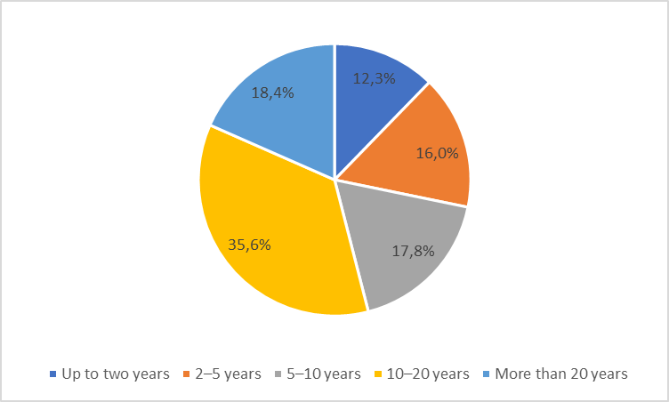

Figure 2: Where do you teach English language?

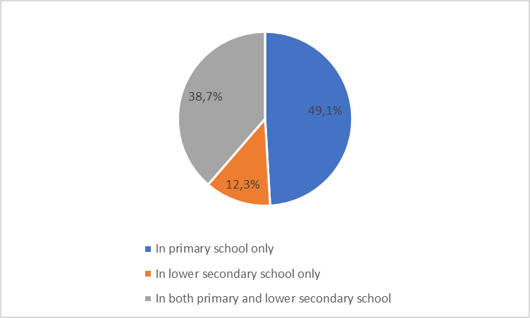

Figure 3:Have you ever used music as a teaching aid in your English lessons?

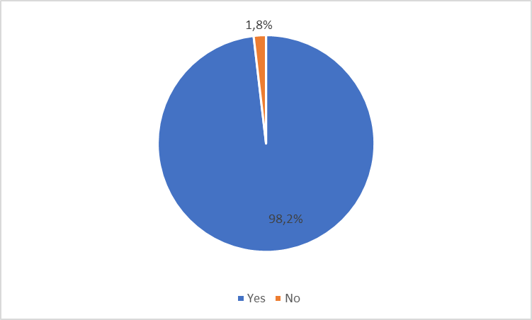

Figure 4: Do you think that music can be used to create a pleasant atmosphere in the classroom?

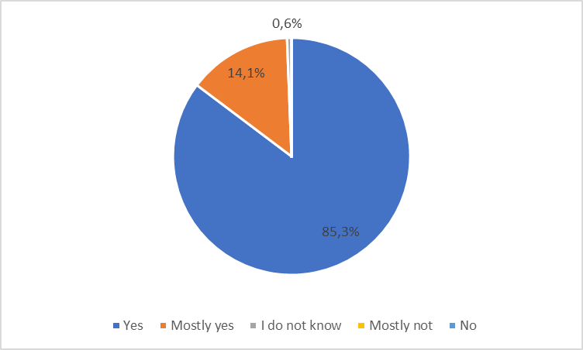

Figure 5: Do you think that using music during lessons is motivating for pupils?

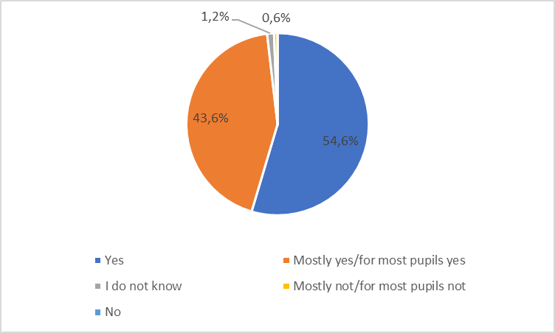

Figure 6: The importance of music in improving writing skills (1 – music does not contribute to improvement of the area at all, 10 – music has a crucial role in improving the area)

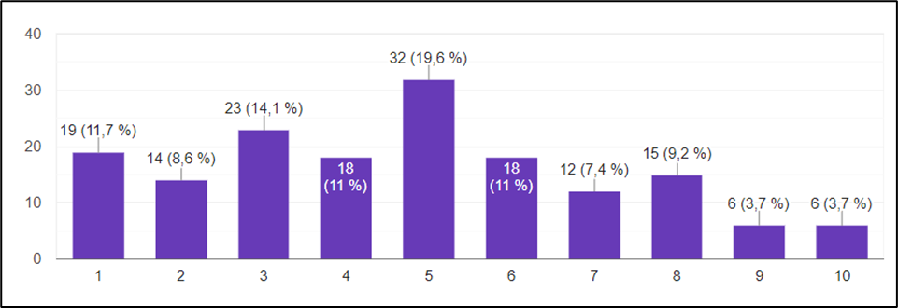

Figure 7: The importance of music in improving reading skills (1 – music does not contribute to improvement of the area at all, 10 – music has a crucial role in improving the area)

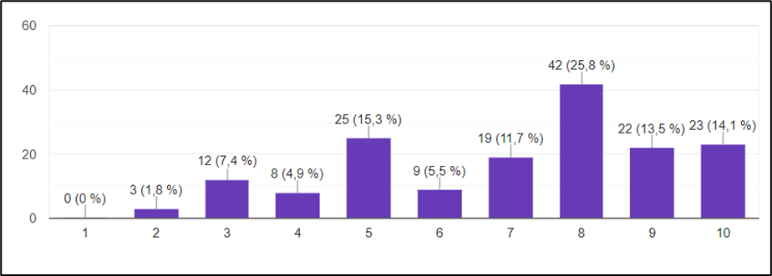

Figure 8: The importance of music in improving listening skills (1 – music does not contribute to improvement of the area at all, 10 – music has a crucial role in improving the area)

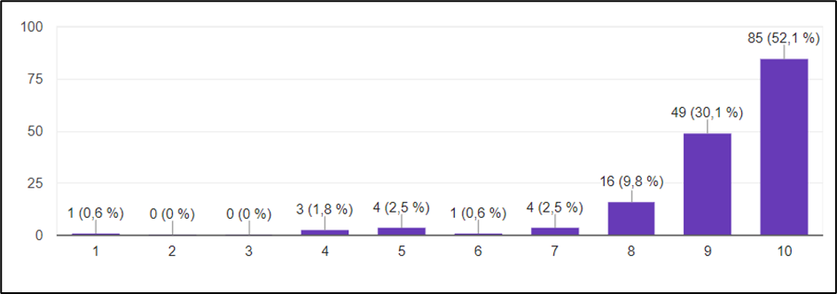

Figure 9: The importance of music in improving speaking skills (1 – music does not contribute to improvement of the area at all, 10 – music has a crucial role in improving the area)

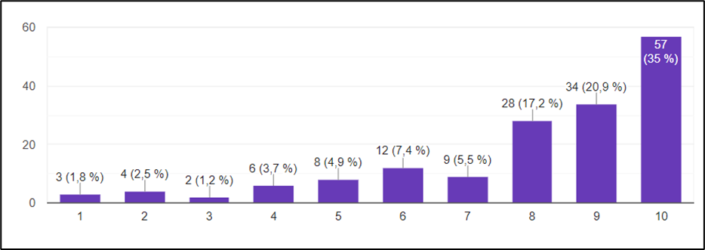

Figure 10: The importance of music in improving pronunciation (1 – music does not contribute to improvement of the area at all, 10 – music has a crucial role in improving the area)

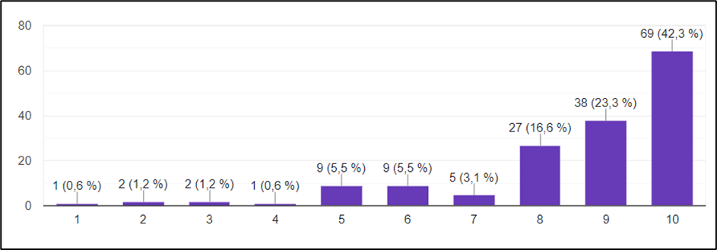

Figure 11: The importance of music in improving grammar (1 – music does not contribute to improvement of the area at all, 10 – music has a crucial role in improving the area)

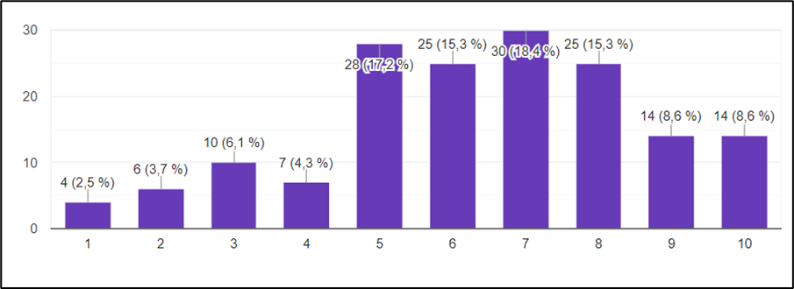

Figure 12: The importance of music in improving vocabulary (1 – music does not contribute to improvement of the area at all, 10 – music has a crucial role in improving the area)

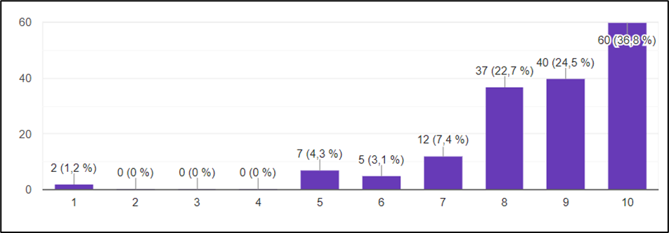

## Appendix 2: The results of the questionnaire for pupils

Table 13:What is your gender?

|  |  |  |
| --- | --- | --- |
| **Answer** | **Number** | **Percentage** |
| Male | 225 | 43.7 |
| Female | 290 | 56.3 |

Table 14:What is your age?

|  |  |  |
| --- | --- | --- |
| **Answer** | **Number** | **Percentage** |
| 10 years | 3 | 0.6 |
| 11 years | 12 | 2.3 |
| 12 years | 118 | 22.9 |
| 13 years | 114 | 22.1 |
| 14 years | 112 | 21.7 |
| 15 years | 128 | 24.9 |
| 16 years | 28 | 5.4 |

Table 15:What grade are you in?

|  |  |  |
| --- | --- | --- |
| **Answer** | **Number** | **Percentage** |
| 6th | 115 | 22.3 |
| 7th | 135 | 26.2 |
| 8th | 94 | 18.3 |
| 9th | 171 | 33.2 |

Table 16:Have you been actively learning to sing or play any musical instrument/instruments (for example in music school) for at least one year?

|  |  |  |
| --- | --- | --- |
| **Answer** | **Number** | **Percentage** |
| Yes | 177 | 34.4 |
| No | 338 | 65.6 |

Table 17:How long have you been learning to sing?

|  |  |  |
| --- | --- | --- |
| **Answer** | **Number** | **Percentage** |
| Never | 410 | 79.6 |
| Up to 1 year | 29 | 5.6 |
| 1–3 years | 36 | 7 |
| 3–5 years | 17 | 3.3 |
| 5–7 years | 14 | 2.7 |
| 7–9 years | 3 | 0.6 |
| More than 9 years | 6 | 1.2 |

Table 18:How long have you been learning to play a musical instrument/musical instruments?

|  |  |  |
| --- | --- | --- |
| **Answer** | **Number** | **Percentage** |
| Never | 267 | 51.8 |
| Up to 1 year | 76 | 14.8 |
| 1–3 years | 80 | 15.5 |
| 3–5 years | 32 | 6.2 |
| 5–7 years | 39 | 7.6 |
| 7–9 years | 15 | 2.9 |
| More than 9 years | 6 | 1.2 |

Table 19: Pupils with previous music training of at least one year – How difficult is it for you to learn English language?

|  |  |  |
| --- | --- | --- |
| **Answer** | **Number** | **Percentage** |
| Difficult | 6 | 3.4 |
| Rather difficult | 42 | 23.7 |
| Not very difficult | 73 | 41.2 |
| Not difficult at all | 56 | 31.6 |

Table 20:Pupils with previous music training of at least one year – Outside the classroom, do you need help from another person to learn English?

|  |  |  |
| --- | --- | --- |
| **Answer** | **Number** | **Percentage** |
| I do not/Almost not | 78 | 44.1 |
| I usually do not | 63 | 35.6 |
| I usually do | 31 | 17.5 |
| I do | 5 | 2.8 |

Table 21:Pupils with previous music training of at least one year – Do you like learning English language?

|  |  |  |
| --- | --- | --- |
| **Answer** | **Number** | **Percentage** |
| Yes | 69 | 39 |
| Rather yes | 70 | 39.5 |
| Rather not | 30 | 16.9 |
| No | 8 | 4.5 |

Table 22: Pupils without previous music training of at least one year – How difficult is it for you to learn English language?

|  |  |  |
| --- | --- | --- |
| **Answer** | **Number** | **Percentage** |
| Difficult | 26 | 7.7 |
| Rather difficult | 63 | 18.6 |
| Not very difficult | 122 | 36.1 |
| Not difficult at all | 127 | 37.6 |

Table 23: Pupils without previous music training of at least one year – Outside the classroom, do you need help from another person to learn English?

|  |  |  |
| --- | --- | --- |
| **Answer** | **Number** | **Percentage** |
| I do not/Almost not | 163 | 48.2 |
| I usually do not | 108 | 32 |
| I usually do | 55 | 16.3 |
| I do | 12 | 3.6 |

Table 24:Pupils without previous music training of at least one year – Do you like learning English language?

|  |  |  |
| --- | --- | --- |
| **Answer** | **Number** | **Percentage** |
| Yes | 140 | 41.4 |
| Rather yes | 124 | 36.7 |
| Rather not | 55 | 16.3 |
| No | 19 | 5.6 |

Figure 13:What is your gender?

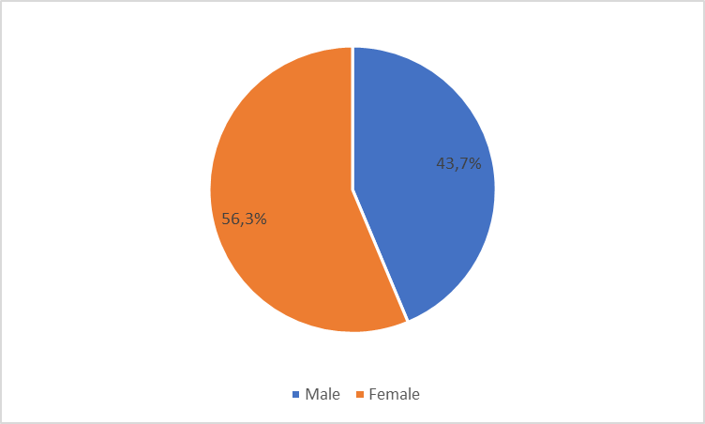

Figure 14:What is your age?

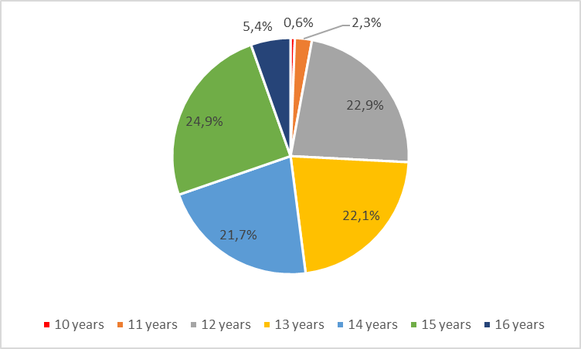

Figure 15:What grade are you in?

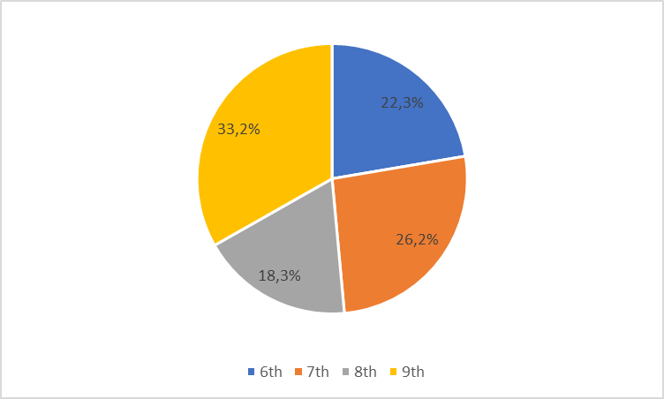

Figure 16:Have you been actively learning to sing or play any musical instrument/instruments (for example in music school) for at least one year?

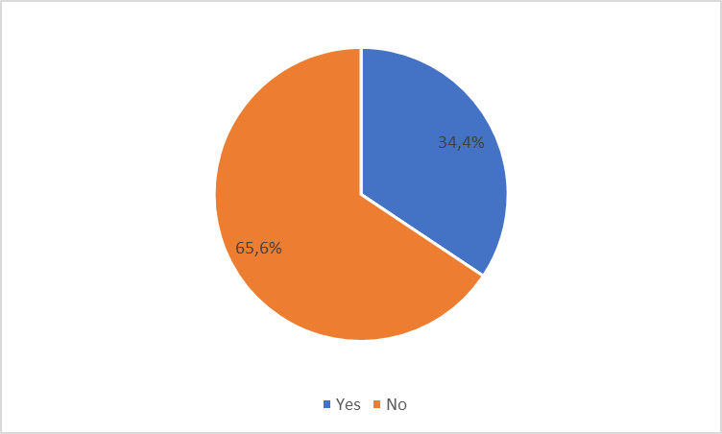

Figure 17:How long have you been learning to sing?

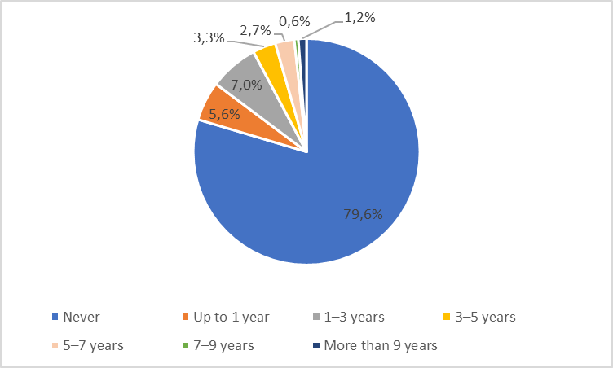

Figure 18:How long have you been learning to play a musical instrument/musical instruments?

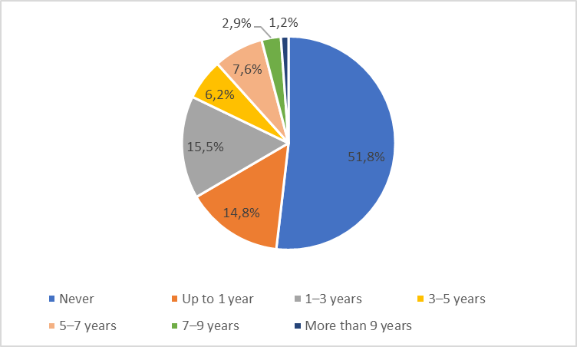

Figure 19: Pupils with previous music training of at least one year – How difficult is it for you to learn English language?

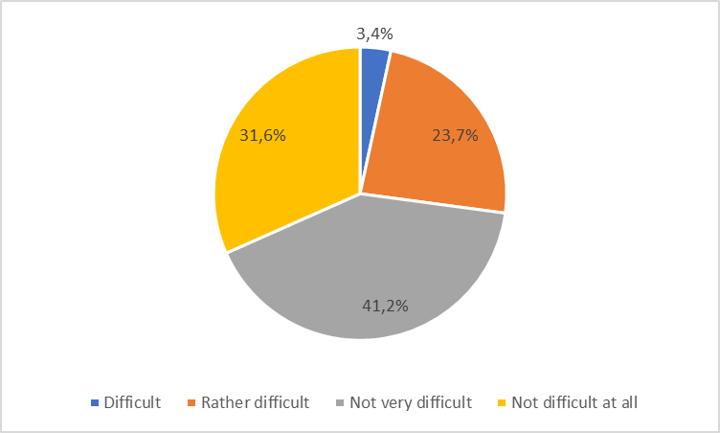

Figure 20:Pupils with previous music training of at least one year – Outside the classroom, do you need help from another person to learn English?

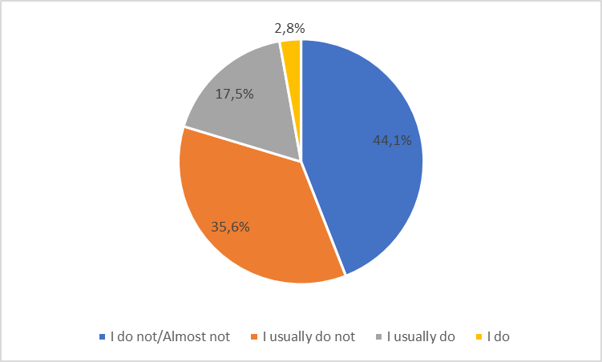

Figure 21:Pupils with previous music training of at least one year – Do you like learning English language?

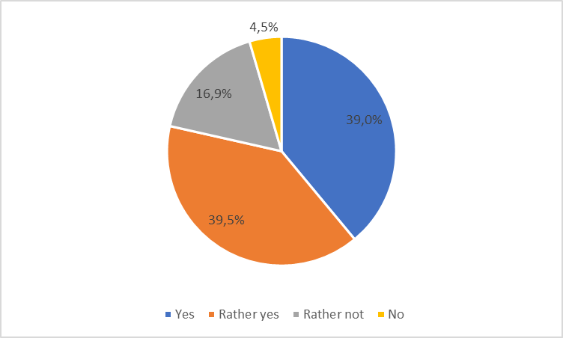

Figure 22: Pupils without previous music training of at least one year – How difficult is it for you to learn English language?

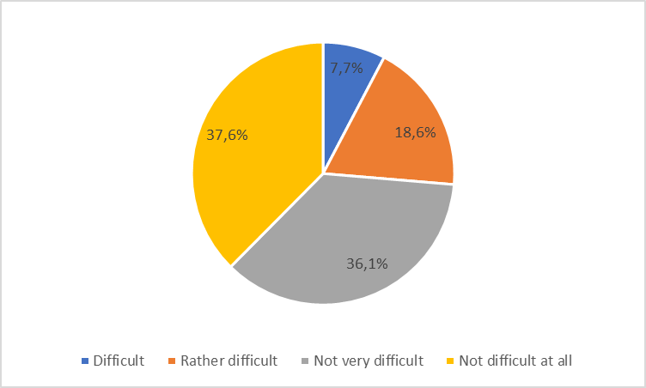

Figure 23: Pupils without previous music training of at least one year – Outside the classroom, do you need help from another person to learn English?

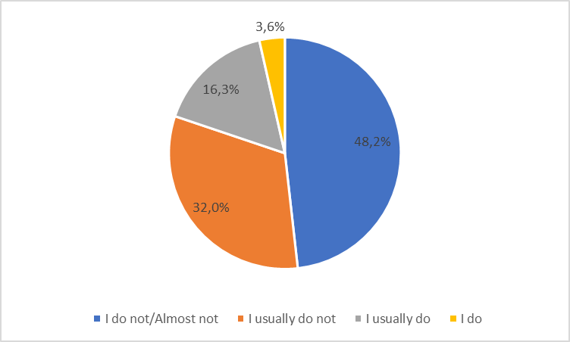

Figure 24:Pupils without previous music training of at least one year – Do you like learning English language?

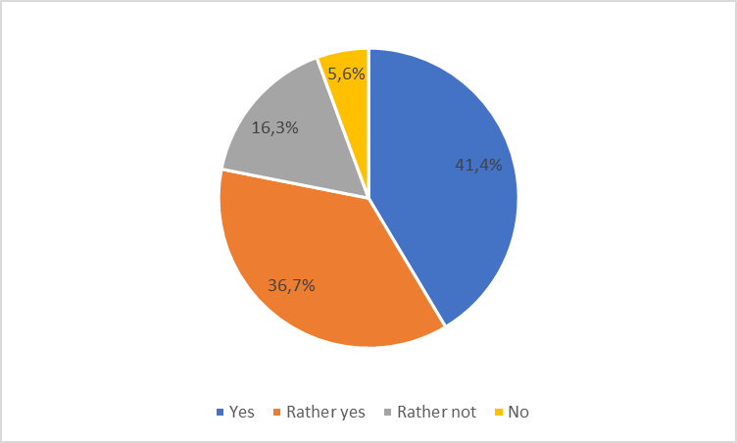

# Résumé

Bakalářská práce se zabývá hudbou a možnostmi jejího využití při studiu anglického jazyka. Výzkumná část práce je zaměřena na přístup učitelů anglického jazyka na základních školách k využívání hudby během výuky anglického jazyka, dále se soustředí na žáky 2. stupně základních škol a na jejich postoj k učení se anglickému jazyku, s ohledem na úroveň jejich hudebního zázemí. Výsledky výzkumu představily míru, do jaké se žáci věnují zpěvu nebo hře na hudební nástroje a ukázaly na jejich převážně kladný postoj k učení se anglickému jazyku, stejně jako na poměrně pozitivní smýšlení učitelů, co se týče přínosu hudby do hodin.

# Annotation

|  |  |
| --- | --- |
| **Jméno a příjmení** | Tereza Mikulecká |
| **Katedra nebo ústav** | Ústav cizích jazyků |
| **Vedoucí práce** | Mgr. Ondřej Duda |
| **Rok obhajoby** | 2021 |

|  |  |
| --- | --- |
| **Název v angličtině** | Music and its use in English language studies |
| **Anotace práce** | Bakalářská práce se zabývá hudbou a možnostmi jejího využití při studiu anglického jazyka. Teoretická část práce zkoumá podobnosti mezi hudbou a jazykem, dále se zaměřuje na účinky hudby na člověka a na způsoby její aplikace v hodinách anglického jazyka. Praktická část je založena na dotazníkovém šetření. |
| **Klíčová slova** | hudba, písně, jazyk, kognitivní funkce, výuka anglického jazyka |
| **Anotace v angličtině** | The bachelor’s thesis deals with music and the possibilities of its use in English language studies. The theoretical part of the thesis explores the similarities between music and language and focuses on the effects of music on humans and the ways of application of music in English lessons. The practical part is based on a questionnaire survey. |
| **Klíčová slova v angličtině** | music, songs, language, cognitive functions, English language teaching |
| **Přílohy vázané v práci** | Příloha č. 1: výsledky dotazníku pro učitele  Příloha č. 2: výsledky dotazníku pro žáky |
| **Rozsah práce** | 59 stran |
| **Jazyk práce** | Anglický jazyk |