PALACKY UNIVERSITY IN OLOMOUC
FACULTY OF ARTS

Cultural Specifics of Spain and Recommendations for Incoming Students
Bachelor thesis

Olomouc 2023 Alexandra Sládková
PALACKY UNIVERSITY IN Olomouc
FACULTY OF ARTS

Cultural Specifics of Spain and Recommendations for Incoming Students
Bachelor thesis

Author: Alexandra Sládková
Supervisor: Assoc. Prof. Jaroslava Kubátová, Ph.D.

Olomouc 2023
Declaration
I hereby declare that the bachelor thesis Cultural Specifics of Spain and Recommendations for Incoming Students was written by me under the guidance of Assoc. Prof. Jaroslava Kubátová Ph.D. All used sources cited in any form have been acknowledged in the list of sources.

In Olomouc ……21. 3. 2023…… Signature: ……Sládková………

Acknowledgement
I would like to acknowledge the valuable comments and suggestions of my supervisor Assoc. Prof. Jaroslava Kubátová, Ph.D., which have improved the quality of this thesis. I am thankful for her patience, leadership, and support while writing the thesis. I would also like to acknowledge the Erasmus+ students willing to fill out my questionnaire survey; thank you for your insights, experiences, and time devoted to answering my questions.

Abstract
The Bachelor thesis aimed to introduce Spanish national culture, analyse it from the perspective of other cultures and propose cultural recommendations to incoming students to be able to effectively orientate themselves in this environment.
In the theoretical part of the thesis, I described the specifications of Spanish national culture and their reflection on multicultural communication. The method used for this part of the thesis was a literature review.
In the practical part of the thesis, I conducted a questionnaire survey that was completed by university students of other national cultures studying in Spain.
This questionnaire aimed to discover the perceptions of students from different national cultures about Spanish people and Spanish national culture.
Based on the synthesis of knowledge from the specifics of Spanish national culture described in the theoretical part of the thesis and answers from the questionnaire survey, I developed a set of recommendations for incoming students.

Keywords
Spain, national culture, cultural dimensions, communication, recommendations for students

Table of contents
Introduction 8
Theoretical part of the thesis 9
1. National culture 9
2. Visible and invisible culture 10
2.1 Visible culture 11
2.2 Invisible culture 11
2.3 Monochronic and Polychronic cultures 11
2.4 High-context and Low-context cultures 13
2.5 Communication 16
2.5.1 Principles of intercultural communication 16
2.5.2 Non-verbal communication 17
3. The six dimensions of national culture by Geert Hofstede 18
3.1 Power Distance 18
3.2 Uncertainty Avoidance 19
3.3 Individualism versus Collectivism 21
3.4 Masculinity versus Femininity 22
3.5 Long-Term versus Short-Term Orientation 23
3.6 Indulgence versus Restraint 24
4. Spain 26
5. Visible and invisible culture in Spain: cultural specifics of Spanish people 27
5.1 Visible culture 27
5.2 Invisible culture 38
5.2.1 Polychronic culture 41
5.2.2 High-context culture 41
6. Reflection of Spanish culture on multicultural communication 43
6.1 Spanish verbal communication 43
6.2 Spanish non-verbal communication 45
6.3 Multicultural communication 47
7. The six dimensions of national culture by Geert Hofstede applied to Spain 48
7.1 Power Distance 48
7.2 Individualism 48
7.3 Masculinity 49
7.4 Uncertainty Avoidance 49
7.5 Long-Term Orientation 49
7.6 Indulgence 50
Practical part of the thesis 51
8. Methodology and data acquisition method 51
9. Introduction of the questionnaire, the questions, and their aim 52
10. Results and interpretation 55
11. Set of recommendations for students of other national cultures coming to Spain …………………………………………………………………………………..62
Summary 69
References 71
List of figures and pictures 74
List of tables 75

Introduction
The thesis aims to introduce Spanish national culture, analyse it from the perspective of other cultures, and propose cultural recommendations to incoming students to be able to effectively orientate themselves in this environment.
To achieve this outcome I will write a theoretical part of the thesis based on a literature review where I will describe national culture, visible and invisible culture, monochronic and polychronic cultures, high-context and low-context cultures, communication, and the six dimensions of national culture by Geert Hofstede; after introducing all of the topics mentioned I will apply them to Spain and describe Spanish national culture and its main aspects. For the practical part of the thesis, I will create a questionnaire survey about Spanish national culture and personal experiences and collect responses from students of other national cultures studying in Spain. This questionnaire will aim to discover the perceptions of students from different national cultures about Spanish people and Spanish national culture. Answers to the questions will be analysed based on the method of textual analysis.
As for the final part of the thesis, I will create a set of recommendations (what to do, what not to do, what to expect) for other students coming to Spain based on the synthesis of knowledge from the theoretical part and the results of the questionnaire survey.

Theoretical part of the thesis
- National culture
Professor Geert Hofstede (2001, p. 1) defines culture as “the collective programming of the human mind,” by which one group of people distinguishes itself from another group. Culture is learned from your surroundings and is always a shared, collective phenomenon. (Hofstede Insights, n.d.)
National culture is the culture one is born into. We grow up in a particular environment and people around us behave consciously but also unconsciously according to our national culture, which sets our standards for that environment and behaviour to appear “normal” or “traditional” to us. The terms “typically Spanish” or “typically Czech” behaviour are what people are referring to when we compare and analyse across national cultures. (Hofstede, 2010)

- Visible and invisible culture
There is not one aspect of human life that is not touched and altered by culture. This means personality, how people express themselves (including shows of emotion), the way they think, how they move, how problems are solved, how their cities are planned and laid out, how transportation systems function and are organised, as well as how economic and government systems are put together and function. However, … it is frequently the most obvious and taken-for-granted and therefore the least studied aspects of culture that influence behaviour in the deepest and most subtle ways. (Hall, 1976, p. 16)
Edward T. Hall refers to culture as an iceberg; Figure 1 interprets his idea visually.
We cannot judge the culture based on what we observe easily; we can only see the smallest parts of it. Underneath this visible side of culture is an enormous cultural base which, if we try to discover more, helps us understand people's behaviour better.
Geert Hofstede pictures culture as an onion; see Figure 2; where symbols, heroes, rituals, and values are perceived as the layers of an onion. “Symbols represent the most superficial and values the deepest manifestations of culture, with heroes and rituals in between”. (Hofstede, 2010, p. 7)
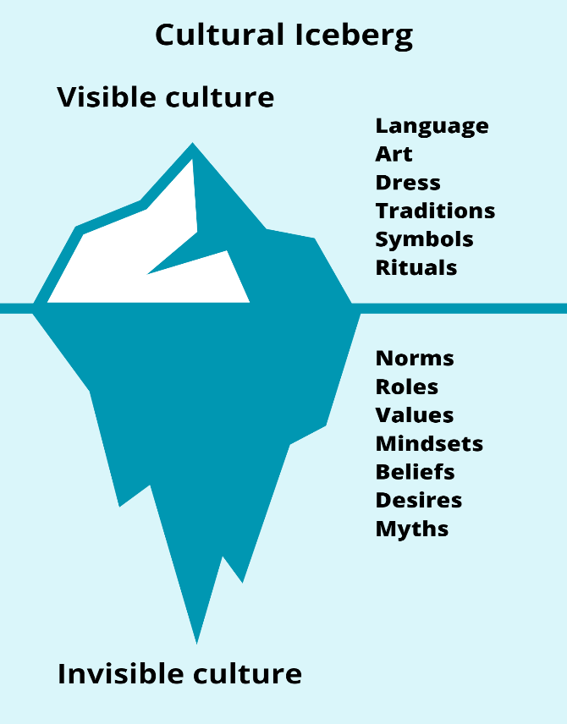
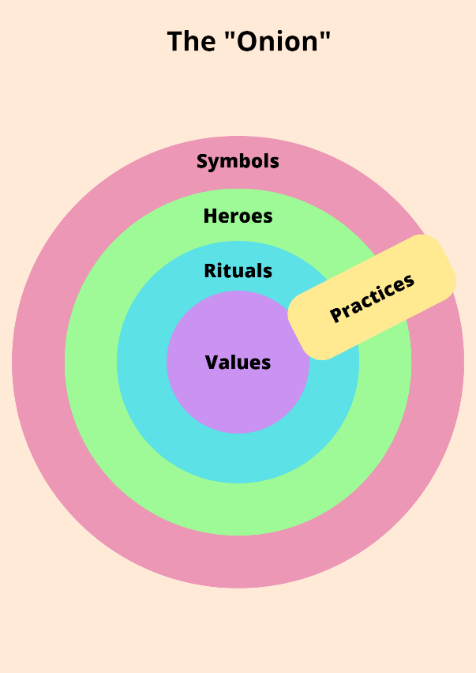
Figure 1. Cultural Iceberg Figure 2. The “Onion”

When briefly encountering other cultures, we can only see the visible part; most of the culture stays hidden, and we can discover those parts over a longer period of time spent with people of a particular culture.
  - Visible culture
The visible part of culture consists of:
- Language
- Art
- Dress
- Traditions
- Symbols
- Rituals
and many more. (Daipov, 2017)

  - Invisible culture
The invisible part of culture Edward T. Hall (1976) divides into cognitive and emotional;
The "cognitive invisible culture" refers to the way of thinking and consists of norms, roles, ideologies, beliefs, and mindsets.
The "emotional invisible culture" refers to the way of experiencing and consists of values, expectations, assumptions, desires, and myths.

  - Monochronic and Polychronic cultures
The use of time and space as organising frames for activities comes in two different forms: monochronic and polychronic (space is included because time and space are functionally interrelated). (Hall, 1976)
Monochronic cultures emphasise schedules, segmentation, and promptness. Individuals in monochronic cultures set their priorities so that the important things are taken first. Monochronic time is linear—segmented like a road or a line, going forward into the future and backward into the past; this also influences how monochronic cultures think—in segmented components. (Hall, 1976; Kubátová, 2014)
According to Kubátová (2014), it is important to understand the following when we come into contact with someone from a monochronic culture:
- time is perceived as linear and measurable, it can be organised;
- time is/must be controlled; "time is money";
- activities are performed gradually;
- changes are accepted with difficulty;
- interruptions are considered inappropriate and impolite;
- the individual is more important than the group;
- performance and speed are important;
- a business partnership is possible without a personal relationship;
- schedules and deadlines are accurate and must be adhered to;
- the meetings start and end exactly, and they have a set program.
Polychronic cultures are characterised by several things happening at once. Individuals from polychronic cultures tend to be more spontaneous, and they simply go with the flow, unconcerned by minor last-minute changes. Things are constantly shifting around, and for polychronic people, it is difficult to make scheduling work. (Hall, 1976; Kubátová, 2014)
According to Kubátová (2014), it is important to understand the following when we come into contact with someone from a polychronic culture:
- time is perceived as an unstructured, endless, cyclical continuum;
- time is experienced, it is an experience;
- many things (activities) take place at the same time;
- changes and disruptions are accepted lightly;
- plans and deadlines are not important;
- relationships are important;
- the establishment of a relationship precedes business activities;
- it is important to complete the agreed plans;
- meetings tend to be late.
  - High-context and Low-context cultures
By differing between high- and low-context cultures, it is possible for humans to communicate more efficiently; know when explicit information is needed or when it can be omitted in messages.
Kubátová (2014) states that high-context communication has the following main characteristics:
- the meaning of the message is hidden in its context, it has an implicit character;
- messages contain less data compared to low-context communication;
- wishes and needs are expressed indirectly in order to preserve the face of the recipient of the message;
- low-context communication is perceived as impolite in high-context cultures;
- receivers of messages from low-context cultures find it unclear, evasive;
- communication is typical for China, Japan, India, and other Asian countries, where the importance of relationships is greater than the importance of performance;
- feelings and intuition are more important than rationality and logic in decision-making in high-context cultures.
And low-context communication has the following main characteristics:
- the message is very direct and explicit;
- more data is used in communication;
- wishes and needs are clearly expressed, which should help the recipient understand the message - possible loss of face when communicating with partners from high-context cultures;
- typical of the US, Germany, and Western cultures in general, which are individualistic and performance-oriented;
- when arguing, logic and rationality prevail over intuition and feelings.
In general, high-context communication is economical, fast, and efficient; however, communication would be incomplete if time were not devoted to programming. Low-context communication does not unite, but it is quickly and easily modifiable. (Hall, 1976; Kubátová, 2014)
According to Hall (1976), low-context communication is typical for individualistic and monochronic cultures. On the contrary, high-context communication is typical for collectivistic and polychronic cultures.
Another set of related intercultural differences between these two groups are:
- Distance and personal space
- Interaction and touch
- Learning, sharing, and the acquisition of knowledge
- Task fulfilment
(Kubátová, 2014)
Table 1 on the next page interprets mentioned differences between the two cultural groups.

Table 1. Differences between the two cultural groups, low-context + monochronic + individualistic vs high-context + polychronic + collectivistic (Kubátová, 2014, p. 39).

 | Low-context, monochronic, individualistic cultures | High-context, polychronic, collectivistic cultures
Distance and personal space | Space is perceived as personal  The space between communication partners is approximately 80-100 cm | Space is perceived as public  The space between communication partners is approximately 30-50 cm
Interaction and touch | Restricted nonverbal communication  Touches between communication partners are not common | Significant nonverbal communication  Touches between communication partners are common to emphasize
Learning, sharing, and the acquisition of knowledge | Reality is divided into parts  Thinking is inductive – from the specific to the general  Paying attention to details | Everything is interconnected and related  Thinking is deductive – from the general to the specific
Task fulfilment | Everything is done according to rules and instructions  Attention is paid to the process and the goal | Everything is done based on the relationships between participants  Attention is paid to the relationships and interests of the group
  - Communication
Communication is the act of sharing thoughts, feelings, and information between people or groups, often through language, symbols, or other means of expression. For communication to be effective, it is important to be able to clearly and accurately convey messages, as well as to understand the cultural and social contexts in which communication occurs. (Adler et al., 2013). Upcoming chapters describe the principles of intercultural communication as well as non-verbal communication.

    - Principles of intercultural communication
Many misunderstandings can happen during intercultural communication, even cultural shocks. How people communicate, how they are taught to communicate, and how they interpret things are profoundly affected by culture. We tend to understand every message under the influence of our own cultural interpretations. When we communicate with people of different cultures we need to understand that cultural differences will influence communication and its interpretations. The greater the difference between two cultures the greater the modification of interpretations can occur. That is because people of different cultures perceive the world differently, and their values and beliefs differ. If we try to understand their point of view we can avoid cultural shocks and misunderstandings. (Kubátová, 2014)
According to Kubátová, these are the factors affecting intercultural communication:
- Interpretation,
- Beliefs,
- Values;
And these are the barriers to intercultural communication:
- Ethnocentrism
- Stereotyping
- Prejudices
- Language
- Non-verbal communication
    - Non-verbal communication
The definition of non-verbal communication is “the act of conveying information without the use of words." The expression of non-verbal communication involves facial expressions, hand gestures, eye contact (or the lack of it), physical proximity, posture, tone of voice, and many more aspects. (Cherry, 2022)
There are nine types of non-verbal communication according to Cherry:
- Facial expressions. While nonverbal communication can differ significantly between cultures; happiness, sadness, anger, and fear all have similar facial expressions all around the world.
- Gestures. Waving, pointing, and making the "thumbs up" sign are typical gestures. Other hand gestures are arbitrary and culturally specific.
- Paralinguistics; refers to vocal communication - tone of voice, loudness, inflection, and pitch.
- Body language and posture; can indicate attitudes and feelings.
- Proxemics. The amount of distance that we see as “our personal space”.
- Eye gaze. We can look for cues such as blinking, staring, steady eye contact, or the inability to make eye contact.
- Haptics; communicating through touch.
- Appearance; first impressions, attraction, our choice of clothing, hairstyle, …
- Artifacts; objects and images that communicate who we are and what we like.
The context of nonverbal communication is always important to understand; in fact, the context of the verbal portion of the message is frequently heavily reliant on nonverbal communication. It is no exaggeration to say that non-verbal systems are intimately connected to ethnicity—they are ethnicity itself. (Hall, 1976)

- The six dimensions of national culture by Geert Hofstede
Professor Geert Hofstede, Gert Jan Hofstede, Michael Minkov, and their teams conducted extensive research that served as the foundation for the six dimensions of national culture.
“The concept of dimensions of culture is introduced through an inquiry into the philosophical opposition between the specific and the general, the different and the similar. Such dimensions should represent fundamental problems, each related to a dimension of culture: power distance, uncertainty avoidance, individualism, masculinity, and long-term orientation.” (Hofstede, 2001, p. 1) The last dimension, indulgence versus restraint, was added later.
Each country has been positioned relative to other countries through a score on each dimension.
Introduction of the six dimensions (Hofstede, 2001, 2011):
  - Power Distance
This dimension describes how much a society's weaker members accept and expect that power is not distributed fairly. It is, in short, how a society deals with social inequality and authority. It can be related to prestige, wealth, or power.
People in societies with high Power Distance accept and respect the authorities, and no further reasoning is necessary, whereas people in societies with a low Power Distance want to equalise the power distribution and demand reasoning for inequalities of power. (Hofstede, 2001, 2011)
Table 2. Differences between Small and Large Power Distance societies (Hofstede, 2011, p. 9).
Small Power Distance | Large Power Distance
The use of power should be legitimate and is subject to criteria of good and evil | Power is a basic fact of society antedating good or evil: its legitimacy is irrelevant
Parents treat children as equals | Parents teach children obedience
Older people are neither respected nor feared | Older people are both respected and feared
Student-centered education | Teacher-centered education
Hierarchy means inequality of roles, established for convenience | Hierarchy means existential inequality
Subordinates expect to be consulted | Subordinates expect to be told what to do
Income distribution in society is rather even | Income distribution in society is very uneven
Religion stresses the equality of believers | Religions with a hierarchy of priests
Table 2 shows the variations between national cultures that the validation study revealed to be related to the Power Distance dimension. The examples mentioned are extremes; real-world circumstances might exist anywhere in the middle. The Power Distance Index is typically higher for East European, Latin American, Asian, and African countries and lower for Germanic and English-speaking Western countries. (Hofstede, 2011)
  - Uncertainty Avoidance
Uncertainty Avoidance is not the same as avoiding risks; rather, it has to do with how well-tolerated ambiguity is in culture. It reveals the extent to which society teaches its citizens to feel either at ease or uneasy in unstructured situations. Unstructured situations are unusual, unexpected, and apart from the norm. Cultures that avoid uncertainty do so by enforcing strict moral standards, laws, and regulations. (Hofstede, 2001, 2011)
Table 3. Differences between Weak and Strong Uncertainty Avoidance societies (Hofstede, 2011, p. 10).
Weak Uncertainty Avoidance | Strong Uncertainty Avoidance
The uncertainty inherent in life is accepted and each day is taken as it comes | The uncertainty inherent in life is felt as a continuous threat that must be fought
Ease, lower stress, self-control, low anxiety | Higher stress, emotionality, anxiety, neuroticism
Higher scores on subjective health and well-being | Lower scores on subjective health and well-being
Tolerance of deviant persons and ideas “what is different is curious” | Intolerance of deviant persons and ideas “what is different is dangerous”
Comfortable with ambiguity and chaos | Need for clarity and structure
Teachers may say “I do not know” | Teachers supposed to have all the answers
Changing jobs is no problem | Staying in jobs even if disliked
Dislike of rules - written or unwritten | The emotional need for rules – even if not obeyed
In religion, philosophy, and science: relativism and empiricism | In religion, philosophy, and science: believe in ultimate truths and grand theories
According to research, people who live in nations where uncertainty tends to be avoided are more emotional and driven by internal nervous energy. The opposing type, uncertainty-embracing cultures, attempt to have fewer norms and are empiricist, and relativist, and allow various currents to flow side by side on a philosophical and religious level. They are also more tolerant of viewpoints that differ from what they are used to. (Hofstede, 2001, 2011)
Uncertainty Avoidance ought to be higher in East and Central European countries, Latin countries, Japan, and German-speaking countries, and lower in English-speaking, Nordic, and Chinese culture countries. (Hofstede, 2011)

  - Individualism versus Collectivism
Individualism and its opposite Collectivism (as a societal, not individual characteristic), is the degree of integration of societies' individuals into primary groups.
On the individualist side, there are societies where there are weaker bonds between people and where everyone is expected to take care only of themselves and their close family members. On the collectivist side, there are societies where people are raised in strong, cohesive in-groups, frequently extended families with grandparents, uncles, and aunts who continue to look out for each other under every condition. (Hofstede, 2001, 2011)
Table 4. Differences between Collectivist and Individualist societies (Hofstede, 2011, p. 11).
Individualism | Collectivism
Everyone is supposed to take care of themselves and their immediate family only | People are born into extended families or communities who protect them in exchange for loyalty
“I” consciousness | “We” consciousness
Right of privacy | Stress on belonging
Speaking one´s mind is healthy | Harmony should always be maintained
Others classified as individuals | Others classified as in-group or out-group
Personal opinion expected | Opinions predetermined by in-group
Transgression of norms leads to guilty feelings | Transgression of norms leads to shameful feelings
Languages in which the word “I” is indispensable | Languages in the word “I” is avoided
The purpose of education is to learn how to learn | The purpose of education is to learn how to do
Task prevails over relationship | Relationship prevails over task
Table 4 lists the differences that the research showed are related to this dimension. Collectivism predominates in less developed Eastern nations and less developed Western nations. (Hofstede, 2011)
  - Masculinity versus Femininity
Masculinity versus Femininity again refers to the societal, not individual level, this dimension defines “masculine” and “feminine” societies, meaning the masculine societies are more assertive and competitive, whereas the feminine societies are more modest and caring.
In masculine societies, it shows a gap between men's and women's values because while in feminine societies both men and women are more modest and caring, in masculine societies women are not as assertive and competitive as men. (Hofstede, 2001, 2011)
Table 5. Differences between Masculine and Feminine societies (Hofstede, 2011, p. 12).
Femininity | Masculinity
Minimum emotional and social role differentiation between the genders | Maximum emotional and social role differentiation between the genders
Men and women should be modest and caring | Men should be and women may be assertive and ambitious
Balance between family and work | Work prevails over family
Sympathy for the weak | Admiration for the strong
Both fathers and mothers deal with facts and feelings | Fathers deal with facts mothers with feelings
Both boys and girls may cry but neither should fight | Girls cry, boys do not: boys should fight back, girls should not fight
Mothers decide on the number of children | Fathers decide on family size
Religion focuses on fellow human beings | Religion focuses on God or gods
Matter-of-fact attitudes about sexuality: sex is a way of relating | Moralistic attitudes about sexuality: sex is a way of performing
In Masculine Societies, this dimension is often taboo. This taboo demonstrates how the Masculinity/Femininity dimension impacts fundamental, frequently unconscious beliefs that are too painful to be discussed openly in some civilizations.
In Japan, German-speaking nations, and some Latin American nations like Italy and Mexico, masculinity is high and moderately high in English-speaking Western nations. In Nordic nations and the Netherlands, it is low and moderately low in some Latin and Asian nations like France, Spain, Portugal, Chile, Korea, and Thailand. (Hofstede, 2011)
  - Long-Term versus Short-Term Orientation
Dimension related to the choice of focus for people's efforts: the future or the present and past.
The long-term pole values are perseverance, thrift, ordering relationships by status, and having a sense of shame. Values at the opposite, short-term pole, are reciprocating social obligations, respect for tradition, protecting one's 'face', and personal steadiness and stability. (Hofstede, 2001, 2011)

Table 6. Differences between Short- and Long-Term Oriented societies (Hofstede, 2011, p. 15).
Short-Term Orientation | Long-Term Orientation
Most important events in life occurred in the past or take place now | Most important events in life will occur in the future
Personal steadiness and stability: a good person is always the same | A good person adapts to the circumstances
There are universal guidelines about what is good and evil | What is good and evil depends upon the circumstances
Traditions are sacrosanct | Traditions are adaptable to changed circumstances
Family life guided by imperatives | Family life guided by shared tasks
Supposed to be proud of one's country | Trying to learn from other countries
Service to others is an important goal | Thrift and perseverance are important goals
Social spending and consumption | Large savings quote, funds available for investments
Students attribute success and failure to luck | Students attribute success to effort and failure to lack of it
Slow or no economic growth of poor countries | Fast economic growth of countries up till a level of prosperity
Long-term oriented are East Asian countries, followed by Eastern and Central Europe. Medium-term oriented are South and North-European and South Asian countries. Short-term oriented are the United States, Australia, and also Latin American, African, and Muslim countries. (Hofstede, 2011)
  - Indulgence versus Restraint
The newest additional dimension named Indulgence versus Restraint is related to the gratification versus control of basic human desires related to enjoying life and having fun.
Indulgence refers to a culture that permits the satisfaction of fundamental human needs connected to having fun and enjoying life relatively freely. Restraint refers to a society that restricts and controls the satisfaction of demands through rigid social standards. (Hofstede, 2001, 2011)
Table 7. Differences between Indulgent and Restrained societies (Hofstede, 2011, p. 16).
Indulgence | Restrained
Higher percentage of people declare themselves very happy | Fewer very happy people
Perception of personal life control | Perception of helplessness “what happens to me is not my own doing”
Freedom of speech is seen as important | Freedom of speech is not a primary concern
Higher importance of leisure | Lower importance of leisure
More likely to remember positive emotions | Less likely to remember positive emotions
In countries with educated populations, higher birth-rates | In countries with educated populations, lower birth-rates
More people actively involved in sports | Fewer people actively involved in sports
In countries with enough food, higher percentages of obese people | In countries with enough food fewer, obese people
In table 7 we can see differences between societies under this dimension.
Indulgence is more dominant in parts of Sub-Saharan Africa, Western Europe, and South and North America. Restraint is the norm in Eastern Europe, Asia, and the Muslim world. Mediterranean Europe stands in the middle. (Hofstede, 2011)

- Spain
The following chapters will revolve around Spain and its culture; I will apply previously mentioned topics of national culture to the national culture of Spain.
Spain (the Kingdom of Spain) is a European country located on the Iberian Peninsula. It is a country with a diverse range of distinct regions, languages, and cultures; two nearby towns can appear to be worlds apart. The population of Spain is currently slightly over 47 million inhabitants. The most inhabited cities are the capital city of Madrid (over 6 million people) and the port city of Barcelona (over 5 million people), followed by Valencia (nearly 1 million people). Spain is divided into 17 autonomous communities; the division of the country is shifted around former historic kingdoms like Aragón, Castile, León, and Murcia. (Central Intelligence Agency, 2022; Whittaker, 2008)
I chose to analyse Spanish culture because I studied for half a year in Spain, specifically in the capital city of Madrid, and also because Spain is the second most popular tourist destination in the world, receiving close to 60 million visitors annually. (Whittaker, 2008)

- Visible and invisible culture in Spain: cultural specifics of Spanish people
The chapter on visible and invisible culture in Spain will describe the cultural specifics of Spanish national culture. In the visible culture, I mention aspects of language, literature, art, architecture, music, dress, food and eating habits, sports, customs and traditions, and symbols of Spain. In the invisible culture, I mention roles, politics, education and school systems, values, the religion of Spain, and lastly polychronic and high-context aspects that are part of Spanish national culture.
  - Visible culture
Colourful architecture, delicious cuisine, and lively music and dance traditions are just a few of the immediately apparent and distinctive features of Spanish culture. Upcoming paragraphs describe the more and less visible parts of Spanish national culture:
Language
Language can be considered a part of both, visible and invisible culture, depending on the context:
On one hand, language is a visible aspect of culture because it is often spoken or written down and can be observed and heard by others. On the other hand, language is also an invisible aspect of culture because it is a shared system of symbols, rules, and meanings that is learned and transmitted through socialization and often goes unnoticed by those who are fluent in it. In this sense, language is a deeply ingrained aspect of a culture's worldview, values, and beliefs, which may not be readily apparent to outsiders. Overall, language is typically considered a visible aspect of culture, however, it also has important invisible dimensions that are closely tied to a culture's identity and way of life.
According to the most recent statistics provided by the Instituto Cervantes, 480 million people worldwide are native speakers of Spanish, a Romance language that is descended from Vulgar Latin. It is the official tongue of Spain, 19 Latin American nations, and Equatorial Guinea in Africa. Additionally, the United Nations recognises Spanish as one of its official languages. (GoinGlobal, 2019)
Castilian, also known as Castellano, is what is commonly referred to as Spanish and is the language that the majority of people in Spain are likely to speak or understand. The autonomous communities of the Basque Country, Catalonia, and Galicia, where Basque (Euskera), Catalan (Català), Galician (Galego), and Aranese (Aranés) are the official languages, are the principal exceptions to this rule. And although some linguists view it as a Catalan dialect, the Valencian community also has its own official second language, known as Valenciá or Valencian. (GoinGlobal, 2019)
All official languages of Spain:
- Castilian (Spanish)
- Catalan
- Valencian
- Galician
- Basque
- Aranese
(Chakraborty, n.d.)
Literature
Spaniards are proud of their writers and for the right reason. Cantar de Mío Cid, Don Quixote, novels by Galdós, and the poetry of Lorca are known and adored worldwide. Mainly Spanish women love to read, but many Spaniards in general are keen readers. (Whittaker, 2008)
Art
The rich artistic heritage of Spain has not always received the credit it deserves. The country has given the world a few very well-known artists to admire, including Goya, Velázquez, and Picasso. And yet, big names are frequently introduced as unusual flowers in a generally dry field of work, however, Spain has in reality thousands of talented artists. (Whittaker, 2008)
How Spaniards perceive their art:
The Spanish are proud of their artistic heritage and eager to appreciate the works of past masters as well as new creations. To name the biggest and most visited museums, there is the oldest, the Prado, then the Centro de Arte Reina Sofía, and the Museo Thyssen-Bornemisza, all situated in Madrid. (Whittaker, 2008)
Architecture
Spain's mediaeval architecture reflects the country's multicultural history and background. As for modern architecture, a variety of innovative, avant-garde structures has elevated Spain to the forefront country's modernness. (Whittaker, 2008)
Barcelona is probably the most famous city in Spain for its architecture; that is where Antoni Gaudí left his legacy. But no matter where you go, you will encounter breathtaking buildings, mostly cathedrals or churches.
Spanish homes:
As one might anticipate, regionalism leads to significant variance in Spain's traditional vernacular architecture, making it difficult to categorise. How people construct their homes has always been influenced by the availability of building materials and, more importantly, by the environment. The Spanish way of living is simpler to sum up. They are very social; in contrast to northern Europeans, who divide off their own plot of solid ground, Spaniards appear to enjoy living next to one another in densely packed homes and apartments near the main square. It is not like they lack space either; their population density is one of the lowest in Europe at just 85 inhabitants per square kilometre. (Whittaker, 2008)
Music
The music of Spain is undoubtedly mostly represented by flamenco, but there is much more to the country's musical heritage, from the folk-classicism of Manuel de Falla to the melancholic pipes of Galicia and the furious rap of Mala Rodríguez. (Whittaker, 2008)
Music is in Spaniard's blood. Everywhere you go, you hear people playing, singing, and dancing. Modern Spanish music (reggaeton) is popular worldwide, and Spaniards are proud of their artists. It is probably their favourite and most often played genre.

Dress
The Spanish fashion industry set trends throughout the 16th and 17th centuries. The classic matador costume (Picture 1) and dress for flamenco (Picture 2) depict Spain. (Whittaker, 2008)
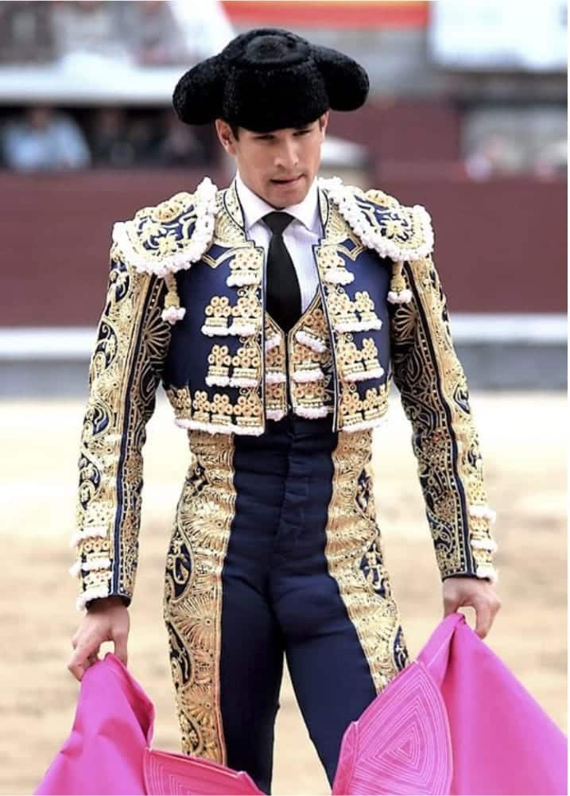
Picture 1. Matador (Toroshopping, 2022).
Matadors' costumes are known as “suits of lights" because of their detailed embroidery, gold or silver threads, and sequins. (Don Quijote, n.d.)

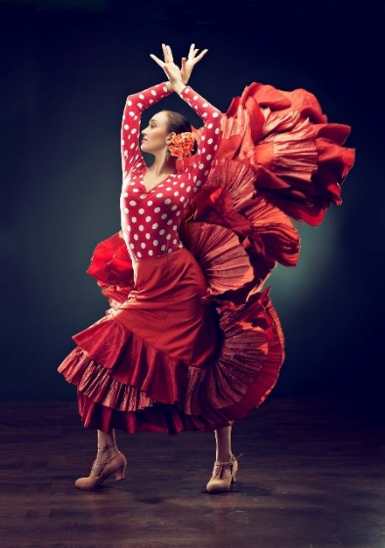
Picture 2. Flamenco dress (Bennahum, 2021).
The flamenco look is completed by securing the hair in a bun and putting a rose behind an ear. The male performers' outfit is simpler, they typically wear black or red tuxedo shirts and a pair of slacks. (Don Quijote, n.d.)

The Spanish fan (Picture 3), also known as the "pericón" in Spanish, continues to be one of the most well-known and often used accessories worldwide. Due to its size and use for both training and performances, the fan is mostly used for flamenco dancing. It adds variety and effects to the choreography. Señoritas in the 19th century also created their own symbolic language with pericón. Now it is a cultural icon that embodies passion and romance. (Rhys, n.d.)

The majority of traditional Spanish attire is saved for festivities and special occasions. Today's most frequently utilised pieces are:
- the mantilla (Picture 4), which is a component of the traditional veil frequently worn at religious festivities like Spanish weddings;
- the peineta (Picture 5) a decorative comb that holds the mantilla;
- the gilet (Picture 6) a vest or waistcoat that is a key component of traditional Spanish dress.
(Don Quijote, n.d.)

Nowadays, Spanish fashion is thriving. Cheap-but-chic (fast-fashion chain) mass production has opened up a profitable new market for designers, and customer favourites like Zara, Bershka, Mango, Pull & Bear, and many more have gone global. (Whittaker, 2008)

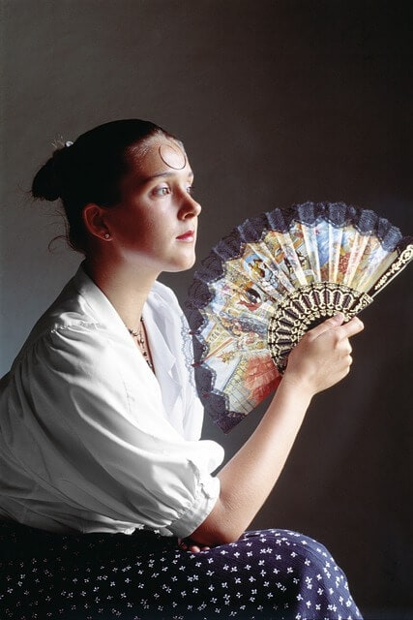
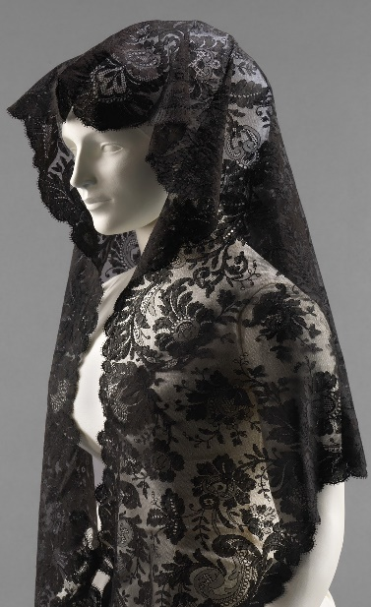
Picture 3. Pericón (the Spanish fan) (Rhys, n.d.). Picture 4. The mantilla (Bush, 2022).

Picture 5. The peineta (Smithsonian, 2018). Picture 6. The gilet (The Met, n.d.)
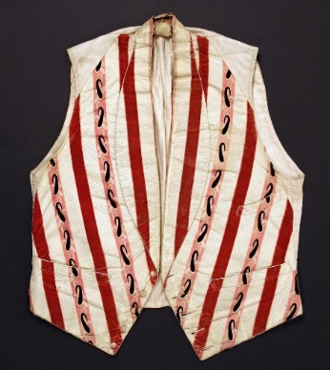

Food and eating habits
Spanish cuisine's geographical location is the basis for its evolution. Seafood naturally forms one of the foundations of Spain's cuisine. The country also qualifies as having a Mediterranean diet. The whole of Spain has a varied landscape made up of mountain ranges, green pastures, productive farmland, long coasts, and more, which combined provide a wide range of fresh goods. Spain's hams are produced in the mountains, vast tracts of land are covered in vineyards and olive groves, and fresh fruit and vegetables are grown all over the country. (Chakraborty, n.d.)
Traditional dishes
Mediterranean-style elements like olive oil, garlic, onions, tomatoes, peppers, and shellfish are frequently used in Spanish cuisine. Additionally, it includes meat and animal products; vegetarians and vegans could find it challenging to eat at some restaurants.
Spanish cuisine is known for its paella (a rice dish with vegetables and meat), gazpacho (cold tomato soup), and tortillas (thick egg omelettes made with potatoes and onions and fried in olive oil). Spanish people also enjoy tapas, which are small plates of food like olives, jamón (cured ham), vegetables, meats, cheeses, shellfish, and many other traditional recipes served in small portions, as well as bocadillos, which are long sandwiches typically filled with ham and cheese or other regional ingredient combinations. (GoinGlobal, 2019)

Tapas were originally small portions of food to accompany alcoholic drinks, but lately, they have become a national favourite, and almost every bar or restaurant serves tapas or bigger portions to share, raciónes. The verb tapear is commonly used among Spaniards and means to go get tapas. (GoinGlobal, 2019)
Typical drinks
Spain has been producing wine for over 2,000 years, the most famous of which is undoubtedly Rioja. The Spanish also enjoy a variety of other native tipples, ranging from almond-flavoured horchata to thick chocolate.
Beer: Spaniards consume more beer than wine, typically in small caña glasses. Some of the popular breweries are Mahou-San Miguel, Estrella Galicia, and Cruzcampo.
Sangría is made of red wine, orange or lemon juice, soda, and brandy. Similar to Sangría, we can come across Tinto de verano, which is red wine mixed with lemonade. (Chakraborty, n.d.)
Spanish eating habits:
Eating habits in Spain are slightly changing. Particularly in cities, people nowadays do not spend as much time at the table as they formerly did. For commuters in Madrid, for example, who are unable to return home for lunch and a siesta, lunch has been reduced to an hour. Everyday life in the modern era is obstructive. The customs determining when the Spanish eat, however, continue to be unique. They eat their big meals much later than the majority of Europe;
Breakfast (desayuno) usually consists of a cup of coffee or freshly squeezed juice accompanied by a pastry or traditional churros (unsweetened deep-fried dough) with hot chocolate, in which you dip them.
Lunch (comida) takes place between two and four in the afternoon. It will typically have more plates: first – lighter, like salad or soup; second – meat, fish, or other alternatives; and ending with a dessert – a piece of fruit, pastry, cake, or a traditional flan.
After lunch, the majority of Spaniards are taking a "siesta." It refers to a part of the day (usually from two to five in the afternoon) when the time is devoted to eating, leisure activities, and relaxation in general. During this time, many businesses and stores shut down.
Dinner (cena) is a smaller meal than a mid-day lunch. It can be, for example, a salad, a sandwich, or some tapas. The Spanish eat dinner later in the evening, commonly from nine to eleven in the evening. (Chakraborty, n.d.; Whittaker, 2008)
Feast food
Christmas: On December 24, traditionalists dine on roast capon or turkey, stuffed with different ingredients depending on the region. In Galicia, they put chestnuts in stuffing; in Austrias apples and plums; and Catalonia, pine nuts and raisins. Other favourite Christmas meals are artichokes with béchamel or almond sauce, suckling pig, and turrón (the Andalusian nougat).
Epiphany: children are eating cream-filled cakes and trying to find a bean or coin inside, whoever finds one gets to wear a crown for that day.
Easter: roasted suckling pig or lamb is the Spaniards' traditional meal. Catalonians also eat doughnuts on Good Friday, and on Easter Monday they have mona de Pasqua, a yeasted cake. (Chakraborty, n.d.)
Sports:
Warner (n.d.) states that the most popular sports in Spain are:
- Football (or soccer) – by far the most popular sport of all, Real Madrid and FC Barcelona are the most cherished Spanish teams.
- Tennis – Spain has their very own tennis superstar, Rafael Nadal, plus the climate is perfect for tennis games most days.
- Padel – a similar game to tennis that has become widely popular in Spain.
- Cycling – Vuelta a España is being hosted in Spain, which is a race around Spain; the scenery and climate have made cycling very popular in Spain.
- Basketball – the second most popular sport in Spain after football, the highest Spanish league is considered one of the best in the world.
- Handball – the Spanish national team has won two world championships and is now the best in Europe.
Customs and traditions
I previously mentioned one of the main traditions, which is flamenco, a national and international sensation. It is essentially a form of song, dance, and instrumental music. Other traditional Spanish dances are Jota Aragonesa, Sardana, Muñeira, Zambra, Bolero, Fandango, Paso Doble, and Sevillana. (Bennahum, 2003; Chakraborty, n.d.)
Another deeply rooted tradition is bullfighting, the traditional cultural performance of Spain and many other Spanish-speaking nations, in which a matador usually kills a bull after a ceremonial battle in a sand arena. The ethics of bullfighting have been the subject of debate and discussion for a very long time; however, it has been considered a protected activity by the European Union under the concept of "national culture." (Conrad, 2023)
Spanish festivals
The Spanish are a people with a rich history, which is why they celebrate often and with joy.
In addition to religious (Catholic) holidays, people in Spain have many other festivals and festivities that are characteristic of their country. Spanish festivities range from regional to national, from one day to full weeks, from jubilant partying to solemn parades, and everything in between, from Sevilla's cheerful Feria de Abril to Pamplona's wild Running of the Bulls. (Chakraborty, n.d.)
Some of the most famous Spanish festivals according to Corrigan (2022):
Semana Santa (Holy Week), is the best-known festival of religious origin. It is celebrated during April in all the cities and towns of Spain. It commemorates the Passion, Death, and Resurrection of Jesus. Throughout many parts of Spain, enormous parades carrying Jesus Christ and the Virgin Mary take place.
San Fermín (Pamplona Bull Run), the bull runs are part of a larger local festival known as San Fermín, taking place in the northern city of Pamplona for a week in early July. Each morning, participants race in front of the bulls; they are running to the bullring, where a bullfight will take place later that day.
Tomatina (Tomato Fight), every year on the last Wednesday in August, Buñol transforms from a sleepy village into a party central where streets full of people are throwing tomatoes at each other.
Las Fallas, for several nights in mid-March, the streets of Valencia come alive with giant paper sculptures. On the last night, most of the sculptures, or fallas, are burned in epic bonfires throughout the city.
Carnival, extravagant costumes, exciting parades, and plenty of music and alcohol, the most famous ones take place in Tenerife and Cádiz.
Christmas and New Year's:
In Spain, Christmas begins on December 22, which is the day of El Gordo – the lottery.
December 24 is Nochebuena (Christmas Eve) – the family gets together for dinner. After dinner, Christmas carols are sung.
December 25th is Navidad (Christmas). It is celebrated with a special meal, like on Christmas Eve. Then toast with cava and spend the day with the family.
December 28 is Santos Innocentes (Holy Innocents). That is the official day for pranks. Fake news is reported in newspapers and on television, similar to April Fool's Day.
Night 31 is Nochevieja (New Year's Eve). People usually watch television because, at a quarter to twelve, it connects with the Puerta del Sol in Madrid, where the clock will strike twelve, announcing the New Year. With each bell, a grape is eaten, and at midnight, it is toasted with cava.
January 1 is Día de Año Nuevo (the New Year).
On the 5th at night, Reyes Magos (the Three Wise Men) arrive. Children often get a small number of presents on Christmas Eve and Christmas Day, with the bulk of the items being given out on January 6 in honour of the Epiphany. Therefore, it is the Three Wise Men who bring the presents to Spanish children.
(Don Quijote, n.d.)

Symbols
Each region of Spain will have different symbols based on the roots of the region; however, according to Rhys (n.d.), these are considered national:
- National Day: 12th October
- Anthem: La Marcha Real (The Royal March)
- Currency: Euro
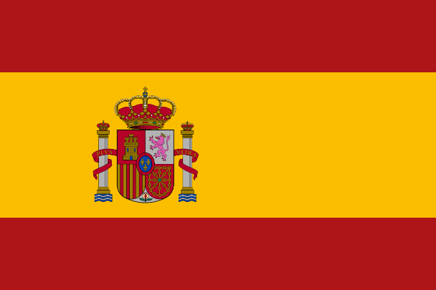
- Colours: Red and yellow Picture 7. The flag of Spain (Rhys, n.d.)
- Tree: Evergreen oak
- Flower: Red carnation
- Animal: Bull
- Bird: Short-toed eagle
- Dish: Paella
- Sweet: Flan
According to legend, the flag's colours were chosen to symbolise bullfighting, one of the most widely known Spanish traditions. Red signifies the blood shed by bulls during the fight, while yellow symbolises the sand in the bullring. There is also the coat of arms, where we can find the Pillars of Hercules, the Spanish motto: Plus Ultra (further beyond), and the Royal Crown symbolising the Crown of Spain. (Rhys, n.d.)
The bulls have developed cultural and aesthetic value over time and are now a part of Spain's culture. The very first inhabitants of Spain were the Iberians, and they worshipped bulls as mythical gods in their culture. Bullfighting was perceived as sacrificing God to save humanity. (Rhys, n.d.)
Another national symbol is flamenco, a very challenging kind of art that expresses passion using music, dance, and song. Its origins are in Andalusia, and the people of Andalusia regard flamenco as a narrative art that has been handed down over many centuries. (Rhys, n.d.)

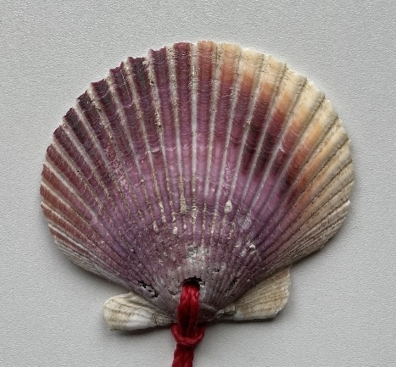
Picture 8. The scallop shell.
One of the most well-known symbols connected with the Camino de Santiago, a journey to St. James's shrine, is the scallop shell. In the past, travellers have used the scallop shell as a navigational aid, a sign of their journey, and a symbol of their pilgrimage. (Rhys, n.d.)

  - Invisible culture
The attitudes and beliefs that influence how people think and act in Spain are considered to be a part of the country's invisible culture.
Roles:
Family is the most important pillar of Spanish society and Spaniards like to keep it traditional. In the past, the men provided for the family and women took care of the children, nowadays in some regions, these traditional views on family remain the same, however mostly it has changed because most likely both parents are now working and providing for the family; regarding other roles, the term “machismo” was created by older men, and its meaning is “male dominance." As of now, this term is less relevant as the women's movement is on the rise. It dates back to Franco's dictatorship when he treated women as second-class citizens. They were prohibited from getting a job or even opening a bank account without their husband's consent. The men could harass women on the streets as they were seen by society as nothing but baby makers. When the revolution came, divorce became legal in 1981, and abortion in 1985. The pressure was on the government to provide equal opportunities for women. Shortly after, women entered the workforce in massive numbers. The structure of families began to change. In most industries today, women make up about half of the labour force, and more than half of Spanish students are female. There is still work to be done. Women are underrepresented in the majority of top positions, continue to earn less than men, and sexism has not suddenly vanished. The prevalence of domestic violence against women is not declining, and many men still have outdated attitudes toward gender. It is difficult to change the outdated prejudices in rural communities, especially in the South. However, most young Spaniards regard gender equality as the norm, which was unthinkable thirty years ago. As for now, Spanish women know how to speak up for themselves, and with feminism on the rise, equity is becoming more approachable. (Chakraborty, n.d.; Whittaker, 2008)
Regarding the LGBTQ+ community, Spain was one of the first countries to legalise same-sex marriages (in 2005), and the whole country, especially its main city Madrid, is considered very LGBTQ+ friendly. (GoinGlobal, 2019)
Politics:
After Franco's regime fell apart, Spain became a parliamentary monarchy, a democratic political system where the monarch is the head of state and the prime minister is the head of government. Currently, they are King Felipe VI. and Prime Minister Pedro Sánchez. (Carr et al., 2023)
Spaniards care about the elections. Around 70% of the adult population often votes in general elections in Spain. Regardless of broader political participation, the moderately interested Spaniard retains a pessimistic attitude brought on by persistent political corruption. The spontaneous protest march is one aspect of political participation that the Spaniards appear to have mastered. Since the beginning of democracy, the Spanish have demonstrated in large numbers on the streets countless times to make a point. (Whittaker, 2008)
Education and school system
Spanish education falls short of EU standards. The level of funding is still among the lowest in Europe, and too many youths leave the school underqualified. (Whittaker, 2008)
Breaking down the Spanish education system:
Pre-school (three to six years) (three to six years). Even though almost 90% of children attend by the time they are five years old, it is not required and is quite inexpensive. An introduction to Spanish group activities is just as important as any academic knowledge.
Primary (six to twelve years). Three two-year cycles of compulsory education.
Secondary (twelve to sixteen years). The successful students get the Graduado en Educación Secundaria Obligatoria (GESO) diploma, which qualifies graduates for further academic or vocational study. Unsuccessful students receive a certificate of attendance and are placed on a waiting list for jobs.
Further education (sixteen to eighteen years). The options are two-year bachillerato or career training that combines theory and practise. Most kids complete their bachillerato at the same institution where they completed their secondary-level studies.
University can be attended by students who have completed bachillerato; Bachelor's degree usually takes up to four years and a Master's one or two more years. (Whittaker, 2008)
Values:
The family is the foundation of society; it involves close and extended family members and functions as both social and financial support. Spanish culture places a high priority on belonging to a family, organisation, or community. Some of the most valued traits among Spaniards are personal character, modesty, and integrity. (Chakraborty, n.d.; GoinGlobal, 2019)
Religion:
Roman Catholicism is the religion of the majority of Spaniards, however, other religions are well tolerated. Throughout Spain's history, Christians, Jews, and Muslims all coexisted peacefully. Every tiny town has a religious past, and the church is usually the most majestic building there. Cathedrals in big cities resemble museums in many ways. (Chakraborty, n.d.)
Around 80 percent of Spaniards identify as Roman Catholics, making it the country's predominant religion. Although estimates vary, most agree that less than 30 percent of people identify as practising Catholics. Two percent of people practise other religions, with Islam now accounting for the largest percentage, and about 18 percent of people identify as non-religious or atheist. (Whittaker, 2008)
Even though church attendance is declining, religion, especially Roman Catholicism, nevertheless influences several aspects of Spanish life. Ceremonies like weddings and baptisms are still quite significant, however, fiestas are undoubtedly the most obvious way that religion is expressed in contemporary Spanish culture. The influence of Christian traditions may be seen in many parts of Spanish culture, including street names, regional holidays, city monuments, and the fact that most stores are often closed on Sundays. (GoinGlobal, 2019; Whittaker, 2008)
    - Polychronic culture
As a polychronic society, Spain is thought to have people who have a flexible and fluid sense of time. The emphasis is on relationships and interpersonal connections over rigid plans and punctuality. The deadlines are considered flexible. This may result in a more relaxed attitude toward time as well as the ability to multitask and take care of several tasks at once. (Hall, 1976)
Time Management
The unhurried pace of life in Spain might be its best attribute. Things do get done eventually, despite frequent delays. Foreign visitors should strive to "go with the flow" and not get too irritated by this. In Spain, everything is done later, including leaving for work, eating, and going to bed. (GoinGlobal, 2019)
Referring to the previous chapter about monochronic/polychronic cultures, according to Kubátová (2014) some of the characteristics of a polychronic society can be:
- time is perceived as an unstructured, endless, cyclical continuum;
- time is experienced, it is an experience;
- many things (activities) take place at the same time;
- changes and disruptions are accepted lightly;
- plans and deadlines are not important;
- relationships are important;
- the establishment of a relationship precedes business activities;
- it is important to complete the agreed plans;
- meetings tend to be late.
    - High-context culture
The use of nonverbal and contextual cues in communication is strongly valued in Spain, which is frequently referred to as a high-context culture. People in high-context societies tend to grasp communication more through their common relationships, history, and cultural norms. This might result in more emphasis on close friendships and indirect communication. (Hall, 1976)
Referring to the previous chapter about high-context/low-context cultures, according to Kubátová (2014) some of the characteristics of a high-context society can be:
- the meaning of the message is hidden in its context, it has an implicit character;
- messages contain less data compared to low-context communication;
- wishes and needs are expressed indirectly in order to preserve the face of the recipient of the message;
- low-context communication is perceived as impolite in high-context cultures;
- receivers of messages from low-context cultures find it unclear, evasive;
- communication is typical for China, Japan, India, and other Asian countries, where the importance of relationships is greater than the importance of performance;
- feelings and intuition are more important than rationality and logic in decision-making in high-context cultures.

- Reflection of Spanish culture on multicultural communication
This chapter discusses the reflection of Spanish national culture on multicultural communication. To discover that reflection I first describe aspects of Spanish verbal communication, followed by the aspects of Spanish non-verbal communication, and lastly multicultural communication. If you are of a different national culture and communicating with Spaniards, this chapter can help you understand what to anticipate.
  - Spanish verbal communication
Spaniards’ daily lives tend to adjust around the structures of their mealtimes; this includes the greetings:
“buenos días” is the greeting used up until before lunch (comida), around two in the afternoon,
“buenas tardes” from that point on till about nine in the evening or just about when it is time to eat dinner (cena)
“buenas noches” from dinner until the rest of the night.
(Vassar-Wesleyan Program in Madrid, n.d.)
How do Spaniards talk?
Any foreigner familiar with Spaniards will confirm the high speed at which native speakers most of the time speak. Their intentions are straightforward; expressed loudly and passionately. The Spanish seem to be more chatty than northern Europeans. They also have a tendency to make prolonged eye contact, lots of gestures, and facial expressions. Another common practise in discussion is an interruption, which is seen as a sign of interest in the topic at hand rather than as an insult. (Whittaker, 2008)
The tone of voice:
When speaking Spanish, the only grammatical difference between a statement and a question or an exclamation is frequently the tone of voice. In order to make the speaker's intent clear to the reader, written Spanish uses an inverted question/exclamation mark at the beginning of sentences. (Whittaker, 2008)
For example:
Question: ¿Are we going to the beach? (¿Vamos a la playa?)
Statement: We are going to the beach. (Vamos a la playa.)
The directness of communication:
Spanish people tend to communicate straightforwardly. You can rely on Spaniards to respond honestly; many of them also feel at ease expressing their feelings. They make their points with clarity, and they typically desire to leave a conversation having spoken all of their thoughts. They anticipate the same level of honesty from their conversation partner in return. (Evason, 2018)
Requests:
Spanish requests are typically expressed very clearly and directly. For example, when they ask for tea, it can go like this: Would you give me tea? (¿Me pones un té?) / Give me some tea, please. (Ponme un té, por favor.) Whereas in English, it is common to use a more polite form; for example: Could I please have some tea? (Evason, 2018)
Common courtesy:
Consider the fact that in Spain, saying "please" and "thank you" is not as common. It is not meant to be disrespectful; as a matter of fact, some Spanish speakers could consider being overly kind and polite in everyday interactions to be a bit overdone. (Evason, 2018)
Silence:
Keep in mind that Spaniards sometimes find it difficult to maintain silence for extended periods. They do not feel particularly at ease in social settings when people are silent. The relationship with the discussion partner may be negatively viewed if there are a lot of silence periods in the conversation. (Evason, 2018)

Informality:
Spanish has a variety of expression styles that convey different degrees of formality and politeness. The formal you (usted, pl. ustedes) is used when addressing somebody in polite conversation. Today, it is not common to use it in day-to-day conversations. The informal you (tú, pl. vosotros) is typically used by Spaniards in most contexts. (Evason, 2018)
People are typically addressed by their first name, whether on formal or informal occasions. On formal occasions, they sometimes add Don/Dona or Señor/Señora (Chakraborty, n.d.; Evason, 2018)
Interruption and volume:
It is considered normal and appropriate for friends to interrupt and talk over one another. People may occasionally shout in order to be heard. It does not seem rude; on the contrary, it shows participation and engagement in the conversation. (Evason, 2018)
Swearing:
Spaniards are used to swearing; it is acceptable and common among friends and usually not taken harshly. (Evason, 2018; Whittaker, 2008)
Humour:
Spanish people enjoy making jokes throughout conversations. The best way to enjoy Spanish humour, like so much else in Spain, is in a group. People frequently have a variety of humorous tales ready to share to make a place more lively. Be mindful, though, that it is uncommon for people to "banter" by making mean jokes about one another.
Although irony and satire are common, their humour typically hits you in the face because it is very direct and can have a sexual context. (Evason, 2018; Whittaker, 2008)
  - Spanish non-verbal communication
As for non-verbal communication, we consider body language, facial expressions, and gestures. Here I point out what to expect from greetings and introductions, personal space, physical contact, eye contact, and body language when it comes to Spaniards.

Greetings/Introduction:
People in Spain give each other "besitos" (little kisses) as a kind of greeting. This occurs when you simply touch the other person's left cheek against their right cheek. Males and females both give besitos, although men often do not give besitos to other males (unless they are family or good friends). They usually give each other a handshake and/or a pat on the back (sometimes a half hug). Not just when you first meet someone, but also any other time you see them, you can expect this kind of greeting. (Centro MundoLengua, n.d.)
Personal space:
Spaniards often maintain a personal distance of roughly half a metre between one another. They feel comfortable being close to their communication partner. (Evason, 2018)
Physical contact:
Spanish people tend to express themselves physically and quite tactilely. Couples frequently engage in public displays of affection. People frequently stroll hand in hand or with their arms interlaced while walking with companions. Friends may touch your arm, elbow, or leg to emphasise their views during chats, put an arm across your shoulder to demonstrate support or hug both of your shoulders to express their sincere gratitude. Other people's clothing may even be lightly touched or neatened up for them. All of these instances of physical contact are supposed to convey warmth, friendliness, and approachability. (Evason, 2018)
Eye contact:
In Spain, direct eye contact is expected when speaking. It is crucial for nonverbal communication in Spanish culture and is typically regarded as impolite to ignore whether speaking or listening. (Evason, 2018)
Body language:
In casual conversation, Spaniards might gesticulate more. They frequently use their hands to emphasise their arguments and have highly expressive faces. (Evason, 2018)

  - Multicultural communication
Multicultural communication has been significantly influenced by Spanish culture, both within Spain and outside of it.
A variety of regional identities and dialects have emerged throughout Spain as a result of the nation's varied history and culture; also, with a long history of immigration and cultural exchange, Spain is a diverse and multicultural nation. Because of this, Spaniards are more likely than those from more homogenous societies to be used to communicating with people from other cultural backgrounds. As a result, they may be more at ease with multicultural communication.
Since many people speak Spanish as a first or second language it has a significant impact on multicultural communication. The majority of Spaniards do not speak any other languages, despite the younger generation's significant improvement in their ability to understand and speak English. Depending on the location or city and the target audience, the amount of English spoken varies greatly. (GoinGlobal, 2019)
It is crucial to always be conscious of cultural variations and approach communication with tact and an open mind. As in any other country, it is crucial to pay close attention when others are speaking and make an effort to comprehend their perspective, especially if it differs from your own. If you are unsure of how to perceive what someone said or did, it can also be beneficial to clarify things and ask questions.
Communicating with Spaniards can be a rewarding experience if you are open to learning about their culture and customs. Showing interest and respect for their way of life can go a long way in building positive relationships. Overall, being open, respectful, and eager to learn and listen are essential for effective multicultural communication.

- The six dimensions of national culture by Geert Hofstede applied to Spain
According to Hofstede's country comparison (Hofstede Insights, n.d.), Spain scores as follows:
Figure 3. Spain's score on Hofstede's dimensions (Hofstede Insights, n.d.).

Figure 3 shows how Spain scores in each dimension in comparison to other countries.
  - Power Distance
Spain scored highly on this dimension (57), indicating that their society is hierarchical. This means that society accepts a hierarchical structure where everyone has a position and which does not require any extra justification. In an organisation, hierarchy is considered to reflect innate inequities, centralisation is preferred, employees expect to be given instructions, and the ideal boss is a tender despot. (Hofstede Insights, n.d.)
  - Individualism
Spain is more collectivist than the rest of Europe because of its score on this dimension: 51 (only Portugal scores higher). However, it is perceived as being blatantly individualist when compared to other parts of the world. This has made it relatively easy for Spaniards to relate to some non-European cultures and vice versa, while other cultures may come across as forceful and direct. Collaboration is seen as completely natural. (Hofstede Insights, n.d.)
People in this country generally place great value on belonging to and supporting extended families and larger social groups. In Spain, it is common for people to have close relationships with their relatives and to spend a lot of time with them.
  - Masculinity
Spain, which has a score of 42 on this dimension, emphasises consensus. Therefore, neither polarisation nor extreme competition is valued. Children in Spain receive an education that highlights cooperation and discourages taking sides or sticking out. There is a natural sympathy that arises from caring about weak or needy people.
When it comes to management, managers like to talk to their staff members to get their thoughts and then act accordingly. In order to prevent the dominance of a single winning party, all minorities should participate in politics. It is the nation that rejects the idea of "the winner takes it all." (Hofstede Insights, n.d.)
Traditional masculine values such as achievement and power are not as highly valued in this country as in other cultures. Instead, more value is placed on feminine values such as caring and nurturing.
  - Uncertainty Avoidance
Uncertainty Avoidance has a high score of 86, which is indicative of how well it defines Spain in this area. People like to have rules for everything since changes can be stressful, but they also have to avoid regulations and laws because they make life more complicated. Confrontation is avoided since it is stressful and quickly escalates to a personal level. Situations that are constantly shifting, unclear, and undefined are of tremendous worry.
In a recent survey, for instance, 75% of young people in Spain expressed a desire to work in the civil service (i.e., a job for life with no concern for the future), compared to only 17% of young people in the USA that would prefer it this way. (Hofstede Insights, n.d.)
  - Long-Term Orientation
Spain is a normative country despite having an intermediate score of 48. Without being overly concerned with the future, Spaniards like to live in the present moment. Spain is the nation that gave the word "fiesta" its current definition. People in Spain seek out immediate solutions without waiting. However, in the long run, it is important to have clear frameworks and standards. (Hofstede Insights, n.d.)
Spaniards tend to be more flexible and adaptable in their approach to change and more focused on short-term goals. This is reflected in the way that people in Spain have a more relaxed attitude toward time and the concept of mañana (tomorrow).
  - Indulgence
Spain's score of 44 indicates that it is not an indulgent society. Societies that score low on this dimension tend to be cynical and pessimistic. Restrained cultures also place less value on leisure time and restrict the satisfaction of their wishes than indulgent societies do. People with this perspective feel that enjoying themselves is somewhat bad and that their activities are constrained by social norms. (Hofstede Insights, n.d.)

Practical part of the thesis
- Methodology and data acquisition method
For this part of the thesis, I created a questionnaire survey about Spanish national culture and personal experiences and collected responses from 25 students of other national cultures studying in Spain (that were part of the Erasmus exchange programme). The period for collecting answers was June-July 2022.
This questionnaire aims to discover the perceptions of students from different national cultures about Spanish people and Spanish national culture.
I will review all the answers that I managed to collect, find commonalities in multiple answers, and draw general experiences and unique insights from them.

- Introduction of the questionnaire, the questions, and their aim
___________________________________________________________
QUESTIONNAIRE FOR ERASMUS+ STUDENTS COMING TO SPAIN
The aim of this questionnaire is to discover the experiences of students from different cultures with Spanish people and their perceptions of Spanish national culture.*
*National culture = norms, behaviours, beliefs, customs, and values shared by the population of a nation (e.g., a Chinese or Canadian national culture). It refers to specific characteristics such as language, religion, ethnic and racial identity, cultural history, and traditions. (IGI Global, n.d.)
___________________________________________________________

  - Where are you from? (optional question)
This question aims to know the diversity of respondents´ cultures.

  - How long have you stayed in Spain? (optional question)
This question aims to determine their length of stay in Spain.

- What do you think of Spanish national culture*?
*National culture = norms, behaviours, beliefs, customs, and values shared by the population of a nation (e.g., a Chinese or Canadian national culture). It refers to specific characteristics such as language, religion, ethnic and racial identity, cultural history, and traditions. (IGI Global, n.d.)
This question aims to know how students of other cultures perceive Spanish culture.

- What are some general differences Spanish people do that are not common in your culture?
This question aims to identify the differences between Spanish culture and other cultures.

- Were you surprised by any Spanish habits? Please describe what surprised you.
This question aims to discover cultural shocks or factors that students of other national cultures found surprising.

- How would you describe Spanish people? (characteristics)
This question aims to know how people of other cultures perceive a Spanish person.

- What is your most memorable intercultural experience* with a Spanish person?
*Intercultural experience = something that happens between people of different cultures
This question aims to know the most memorable multicultural experience of the students with Spanish people.

- Have you ever worked in a team with a Spanish student?
Yes / No

- If you answered „Yes“ in the previous question – how were Spanish students behaving as a member of a team and how were they communicating with the rest of the team? (if it is possible to generalise – do you think it is an aspect of behaviour of all Spanish students?)
The aim of questions 8 and 9 is to know how Spanish people work in a team.

- What would you recommend to other students coming to Spain?
(what to do/what not to do/what to expect – especially in the context of cultural differences)
This question aims to get advice and tips from students who stayed in Spain for other students who will come to Spain.
_____________________________________________________________

- Results and interpretation
Answers to the questions were analysed based on the method of textual analysis. The most important statements appeared more than once, and a selection of unique answers and experiences is also quoted. Every question required a different form of outcome, based on that I chose to summarize the main points from all the answers, or/and created a bullet list, or/and quote some selected answers.
__________________________________________________
  - Where are you from?
- Austria – 2 responses
- Denmark – 2 responses
- France – 2 responses
- Germany – 3 responses
- Greece – 3 responses
- Italy – 2 responses
- Moldova – 1 response
- Poland – 3 responses
- Romania – 2 responses
- The Czech Republic – 3 responses
- The Netherlands – 1 response
- Turkey – 1 response
The responses gathered indicate a diverse range of respondents. The students come from twelve countries, and the most common responses were from the Czech Republic, Germany, Greece, and Poland.
  - How long have you stayed in Spain?
- ½ months – 5 responses
- months – 4 responses
- months – 13 responses
- months – 2 responses
- 12 months – 1 response
The majority of respondents stayed in Spain for five months. However, one respondent (from Denmark) stayed for twelve months, which was the longest period. The shortest stay was four and a half months.
  - What do you think of Spanish national culture?
Most respondents from Czechia, Austria, Germany, and Romania liked the architecture, language, and people's passion and open-mindedness; some also liked the traditional music and dance, flamenco, and modern reggaeton, which are heard everywhere in Spain. The Polish respondent appreciated the Spaniards' strong family bonds, their many customs and traditions, and the way they celebrate holidays.
According to a Danish respondent, Spanish culture is easy to integrate into because it is very relaxed and open to anyone.
Respondents from the Czech Republic and Austria pointed out that they are against bullfights and the festivities connected to them. Another thing mentioned by the Czech and Moldovan respondents was the recurring non-punctuality of Spanish people.
“In terms of freedom of expression and showing sexual orientation and identity, Spanish culture is very well developed. On the other hand, I was a bit shocked when I discovered that the majority cannot speak English, and they expect foreigners to talk in Spanish.” (Turkish respondent)
“I prefer Spanish culture and mentality to Polish ones. People are open-minded, positive, helpful, and tolerant. The food is delicious, and the climate is better.” (Polish respondent)
A German respondent stated that Spaniards seem to be more relaxed and easier to talk to than Germans.
Most of the respondents found the Spanish national culture interesting and liked discovering it.
The respondents from Greece and Italy stated that Spanish culture is very similar to their own, they share similar habits and beliefs. The reason for sensing these similarities can be that all countries (Spain, Italy, Greece) are considered high-context, polychronic, and collectivist cultures.
Respondents from France mentioned they had some commonalities with Spaniards; however, there are still a lot of things to discover.
  - What are some general differences Spanish people make that are not common in your culture?
Statements mentioned in most of the answers were: the whole day being postponed, siesta, and Spanish eating habits (by respondents from Czechia, France, Romania, and Austria)
Other differences mentioned were:
- small talks with strangers (by Czech, German, and Polish respondents),
- Spaniards are very tolerant, open-minded, and welcoming (by Moldovan, Polish, and French respondents),
- talking and laughing loudly (by German, and Romanian respondents),
- living in the present moment (by Czech and Polish respondents),
- Non-punctuality (by Czech respondents)
- Spaniards are more religious (by Czech respondents)
- Sharing food and serving tap water (by German respondent)
- LGBTQ+ people live completely free in terms of what they wear and can show their love to their partners in public. (by Turkish respondent)
“Breaks at work are much longer here, so workers can go home and eat lunch with the family. It is easier to approach people in any social circumstance if you speak Spanish. Many live at home until they finish studying, which is the opposite in Denmark.” (Danish respondent)
“Italians and Spaniards are similar, however, Spaniards are less reserved and more friendly.” (Italian respondent)
“Greece is very similar to Spain in many aspects; the only thing is that Spanish people communicate and make friends more easily.” (Greek respondent)

  - Were you surprised by any Spanish habits? Please describe what surprised you.
Most of the answers mentioned siesta, eating late, being informal with almost everyone, having worse English speaking abilities than expected, their rhythm and natural flow, talking loudly, making the most of their free time, and the joy of their culture and traditions.
Someone was also surprised by the number of smokers among students. Also by observing people of all ages exercising. Another respondent was surprised by how Spaniards are disciplined and followed the rules; connection to Hofstede´s dimension – Uncertainty Avoidance.
Nothing surprised the Italian respondents.
  - How would you describe Spanish people? (characteristics)
Most of the answers mentioned these qualities: talkative, open-minded, warm, friendly, welcoming, loud, worry less, nice, spontaneous, and passionate. Also, Spaniards are proud of their country and culture.
  - What is your most memorable intercultural experience with a Spanish person?
Many friendships were built quickly; respondents received small talks, flamenco dance lectures, or had a 90-year-old boxing coach. I selected a few responses for demonstration:
“Being two hours late to a meetup with friends only to be one of the first to arrive.” (Danish respondent)
“Celebrations of victory in football—I've never seen anything like this in the Czech Republic. I liked how it connected people of all ages; everyone was just genuinely happy, dancing and singing.” (Czech respondent)
“In the supermarket, an old woman talked to me in Spanish, and I could not understand her, but I guess it was something fun because she started laughing and so did I. We had a fun moment together even though we did not speak the same language.” (Austrian respondent)
“After one meeting I felt like a best friend of a Spanish person while in Poland it is not that sure after a short time spent together how are your relations.” (Polish respondent)
“Our Spanish neighbour was very kind and helpful in every way possible! Our landlord was also very nice. In general, every Spanish person I met was wonderful, like sunshine in a human form - people were smiling a lot, they were helpful and generous.” (Czech respondent)
  - Have you ever worked in a team with a Spanish student?
- No – 14
- Yes – 11
Fourteen respondents have not worked in a team with a Spanish student, and eleven respondents have worked in a team with a Spanish student; the following question (9) is answered only by those eleven respondents.
  - If you answered „Yes“ in the previous question – how were Spanish students behaving as a member of a team and how were they communicating with the rest of the team? (if it is possible to generalise – do you think it is an aspect of the behaviour of all Spanish students?)
Respondents did not have a single answer; some had positive experiences, others negative ones; however, most of them would not say their experience can be applied to working in a team with Spaniards in general.
The Italian respondent stated that the Spaniards on their team were too relaxed. The respondent from Moldova had very active and helpful Spanish team members. Many Czech respondents mentioned that Spaniards had ideas and tried to be helpful; however, not many of them felt confident enough to speak English, so they kept quiet or spoke Spanglish (a mix of Spanish and English). A French respondent said that Spanish team members often do their tasks quite late. The Romanian respondent had the opposite experience; their Spanish teammates respected the deadlines and completed tasks on time. The Greek respondent has worked with two different groups of Spaniards; with the first group, teamwork did not go well, but with the second, it did.
“Some people were rather reliable and worked hard; others (a lot of them) were rather reluctant and only did the most necessary things.” (German respondent)
“We had excellent cooperation because I realised that during their school and university years, they emphasise group projects, so they know how to act and behave in a group. The negative thing is the language barrier; they have so many ideas that they cannot express because their English is not very good.” (Greek respondent)
For the Polish respondent, the teamwork was terrible: “They have their “mañana” and do not do anything on time. It is hard to work with them, and I think most Spaniards have a laid-back attitude when it comes to projects.”
  - What would you recommend to other students coming to Spain?
Answers sorted from the most mentioned recommendations to the least:
- try Spanish cuisine (Austrian, Romanian, French, Turkish, Greek, Dutch, and German respondents),
- try to learn the language, even at least a few phrases to get by (Czech, Austrian, Greek, Turkish, German, Dutch respondents),
- be spontaneous and enjoy living in the moment (Austrian, Italian, Romanian, Polish, Czech respondents),
- discover the city/village, nightlife and travel around the country (Romanian, French, Turkish, Greek, German respondents),
- try to get used to the Spanish lifestyle - postponed and relaxed (Austrian, Danish, Moldovan, Dutch respondents),
- be open-minded and approach as many people as you can, do not be afraid to ask for help (Polish, Czech, German, Moldovan respondents),
- learn about the Spanish culture and share yours (Romanian, Polish, German respondents),
- go to a pub or even better to a stadium to watch football, to feel the atmosphere (Czech, and French respondents),
- get in touch with the locals in order to get the best information and recommendations. (French, and German respondents),
- be patient with Spanish people, they take their time (Czech, Moldovan respondents),
- watch your stuff, especially if you go to a club, pick-pocketing is very common in big cities of Spain (Czech, Dutch respondents),
- never disturb Spaniards' siesta (Czech respondent),
- do not mention Franco (Danish respondent),
- follow the rules (Polish respondent).
“Spain is one of the most beautiful countries, especially because it includes everything. There are sea, sun, and beaches; cities with archaeological monuments or beautiful mountains for hiking.” (Polish respondent)
“Learn basic Spanish phrases; the people there are not used to talking in English. Feel the atmosphere; it is different from everywhere else. Take it slow and enjoy every moment. If you have any trouble, do not be shy and ask for help; Spanish people are very kind and will help you.” (Czech respondent)

- Set of recommendations for students of other national cultures coming to Spain
As for the final part of the thesis, I will create a set of recommendations (what to do, what not to do, what to expect) for other students coming to Spain based on the synthesis of knowledge from the theoretical part and the results of the questionnaire survey. The recommendations are listed accordingly in order of the topics of the thesis in each category, first are the ones that are based solely on the theoretical part, continuing by the recommendations based solely on the practical part (the questionnaire survey), and finally, the ones based on both, theoretical and practical part of the thesis.
What to do:
The following recommendations were chosen to help determine what is polite to do while staying in Spain.
- Be conscious of cultural differences and make an effort to understand their perspective, especially if it differs from your own – being open, respectful, and eager to learn and listen are essential for effective multicultural communication. This recommendation is based on the theoretical part of the thesis, specifically the chapter on “Multicultural communication.” I cover the topic of cultural differences to be conscious of in the chapter on “Visible and invisible culture in Spain: cultural specifics of Spanish people” and also on “The six dimensions of national culture by Geert Hofstede applied to Spain.”
- Learn at least basic Spanish phrases, not many Spaniards know or will want to communicate in English, I chose to recommend this because it was mentioned many times by the students filling out the questionnaire survey.
- Approach people and talk to them. Spaniards are talkative, open-minded, warm, friendly, and proud of their country and culture. The best way to get to know the culture is through the people living in it. Respondents of the survey recommended approaching people. Mentioned traits of Spaniards are also taken from the answers to the questionnaire survey.
- Discover the city/village or the whole country. This recommendation comes from me personally, and other respondents of the questionnaire survey. By exploring your surroundings you will get to know people, learn new things and dive deeper into a particular culture.
- Watch your stuff in crowded places. I recommend this based on the personal experiences of students responding to the survey; pick-pocketing happens quite often in big cities like Madrid and Barcelona.
- Enjoy the present moment. This recommendation was mentioned by many respondents in the questionnaire survey. It is the best way to enjoy your stay; try to not speculate about the past or worry about the future.
- Respect the beliefs, values, and traditions of others. Professor Geert Hofstede (2001, p. 1) defines culture as “the collective programming of the human mind,” by which one group of people distinguishes itself from another group. Everyone is different, and has a different perception of life, values, and beliefs; however, having different opinions than ours does not mean that theirs are questionable or less valuable. This recommendation is based on both the theoretical part of the thesis and the questionnaire survey, where it was mentioned by some respondents, one respondent also added that “we should learn about other cultures and share our own.”
- Be patient. Spaniards are going with the flow, and they most likely do not hurry. This recommendation is from one respondent of the questionnaire survey; it is also related to Spanish culture being polychronic; the chapter on “Invisible culture,” subchapter “Polychronic culture.”
- Try Spanish cuisine. Most of the respondents of the questionnaire survey recommended trying Spanish foods, it was the most mentioned recommendation of all. Referring to the chapter on “Visible culture,” subchapter “Food and eating habits.” Spanish cuisine is known for its paella (a rice dish with vegetables and meat), gazpacho (cold tomato soup), and tortillas (thick egg omelettes made with potatoes and onions and fried in olive oil). Spanish people also enjoy tapas, which are small plates of food like olives, jamón (cured ham), vegetables, meats, cheeses, shellfish, and many other traditional recipes served in small portions, as well as bocadillos, which are long sandwiches typically filled with ham and cheese or other regional ingredient combinations. (GoinGlobal, 2019)
- Follow the rules. Spanish people are used to having rules and following them. This recommendation is referring to the answer of one respondent in the questionnaire survey; it is also related to higher Uncertainty Avoidance; in the chapter “The six dimensions of national culture by Geert Hofstede applied to Spain,” subchapter “Uncertainty Avoidance.” Spaniards like to have rules for everything since changes can be stressful, but they also have to avoid regulations and laws because they make life more complicated. (Hofstede Insights, n.d.) It is polite to respect and follow the same rules.
What not to do:
The following recommendations were chosen to help determine what is impolite to do or expect while staying in Spain and what behaviour should be restricted.
- Try not to say “please” and “thank you” more often than necessary. This recommendation is based on the chapter “Reflection of Spanish culture on multicultural communication,” subchapter “Spanish verbal communication”.
- Do not expect them all to speak English. Some respondents of the questionnaire were not prepared to talk in Spanish, when they encountered Spaniards they were surprised some of them could not speak English or they chose not to.
- Avoid mentioning or asking about Franco. Among Spaniards, there is “Pacto del Olvido” (Pact of Forgetting), which aim is to smoothly transition from autocracy to democracy. Franco and everything involving him and the previous regime is a sensitive topic. I would recommend avoiding these topics or to think thoroughly about who to ask. This recommendation is based on a response from the questionnaire survey.
- Try not to spend most of the time at your flat or dormitory. Some respondents recommended exploring and spending time outside, rather than inside.
- Do not be scared to try new things. According to the respondent to the questionnaire survey, you should not be scared to try new things during your stay in Spain. The respondent also added: “Do not be scared to get out of your comfort zone, Spain has so many things to offer.”
- Do not be afraid to ask for help. Spanish people are kind and will help you if you ask them. This recommendation comes from my personal experience and also the experiences of the respondents of the survey.
- Do not disrespect their beliefs, values, or traditions. As I mentioned in “What to do”: Everyone is different, and has a different perception of life, values, and beliefs; however, having different opinions than ours does not mean that theirs are questionable or less valuable. Try to understand the perspective of others.
- Do not rush anywhere or anyone. Spaniards are a Polychronic society, which means they perceive time as fluid and many things that can be happening at once. This recommendation is based on a response from the questionnaire survey and also the chapter on “Invisible culture,” specifically the subchapter on “Polychronic culture.”
What to expect:
The following recommendations should help determine what to anticipate from the Spanish national culture and Spaniards based on the theoretical part of the thesis and answers from the questionnaire survey.
- Rich culture worth exploring. Every culture has aspects we cannot see and discover without immersing in it, and Spanish national culture is no exception; further outlining expectations are described in the chapters on “Visible culture” and “Invisible culture.”
- Polychronic society – Spanish people have a flexible and fluid sense of time, they put emphasis on relationships, deadlines are considered flexible, and they can multitask. I cover this topic in the chapter on “Invisible culture,” subchapter “Polychronic culture.”
- High-context society – the use of non-verbal and contextual cues in communication is very common among Spaniards; also feelings and intuition are more important than rationality and logic. This topic is covered in the chapter on “Invisible culture,” subchapter “High-context culture.”
- Greetings by „besitos“ (little kisses on each cheek) or a handshake/half-hug. You can expect natural, warm, physical greetings. More description of greetings can be found in the chapter on “Reflection of Spanish culture on multicultural communication,” subchapter “Spanish non-verbal communication.”
- Smaller personal space and physical contact during the conversations. Spaniards are used to having approximately half a meter distance from their communicating partner and engaging in conversations with slight touches of their partner. Theoretical knowledge about personal space and other aspects of Spaniard´s non-verbal communication is described in the chapter “Reflection of Spanish culture on multicultural communication,” subchapter “Spanish non-verbal communication.”
- Hierarchical society (higher Power Distance index number) – Spanish society accepts a hierarchical structure where everyone has a position and which does not require any extra justification. Details about hierarchy and Power Distance can be found in the chapter on “The six dimensions of national culture by Geert Hofstede,” subchapter “Power Distance,” and also in relation to Spain in the chapter on “The six dimensions of national culture by Geert Hofstede applied to Spain,” subchapter “Power Distance.”
- Collectivist society, strong family bonds, and close relationships. I cover this in the theoretical chapter on “Invisible culture,” subchapter “Values.” Also, collectivism can be found in the chapter on “The six dimensions of national culture by Geert Hofstede,” subchapter “Individualism versus Collectivism,” and in relation to Spain in the chapter on “The six dimensions of national culture by Geert Hofstede applied to Spain,” subchapter “Individualism.”
- A society that is more focused on short-term goals and immediate solutions. Theoretical knowledge about this point can be found in the chapter on “The six dimensions of national culture by Geert Hofstede,” the subchapter “Long-Term versus Short-Term Orientation,” and in relation to Spain in the chapter on “The six dimensions of national culture by Geert Hofstede applied to Spain,” subchapter “Long-term Orientation.”
- Talkative, open-minded people who will always help you. Respondents mentioned in the questionnaire survey that they had only pleasant experiences when they needed advice from Spaniards. Other characteristics of Spaniards that were mentioned the most are: warm, friendly, welcoming, loud, worry less, nice, spontaneous, and passionate.
- Mediterranean climate – hot, dry summers and mild, rainy winters; many sunny days. I mention this useful tip based on general knowledge and personal experience; I recommend keeping it in mind and looking up the weather for the months of your stay so you can pack your things accordingly.
- The Spanish lifestyle is slow and present, their eating habits determine how the day is postponed for people coming from other countries. Most of the respondents of the survey pointed out this as the primary cultural difference between their national culture and their habits. This topic is also described in the chapter on “Visible culture,” particularly the subchapter “Food and eating habits.”
- Siesta – part of the afternoon dedicated to relaxing and leisure activities; most businesses and stores are closed during this time of the day. Another often-mentioned cultural difference in the questionnaire survey was siesta. Further description can be found in the chapter on “Visible culture,” subchapter “Food and eating habits.”
- Protests are happening in big cities quite often. The context can be, for example, political, economic, or about roles in society and equity. This topic is also discussed in the chapter on “Invisible culture, ” subchapter “Politics” and “Roles.” I personally experienced a lot of protests in the streets of Madrid so I decided to include this expectation here.
- Spaniards celebrate a lot; other events that happened regularly in the streets of the main city of Spain were celebrations or parades. No matter when you come to Spain, many celebrations and festivals are happening every season of the year. This expectation is based on my personal experience and the experiences of respondents; I also cover this topic in the chapter on “Invisible culture,” subchapter “Customs and traditions.”
- LGTBQ+ friendly country, especially big cities. Some respondents mentioned in the survey how LGTBQ+ friendly country Spain is. I also mention this in the chapter on “Invisible culture,” subchapter “Roles.”
- Religion – the majority of Spaniards are Roman Catholics, however, other religions or non-religious people are respected and accepted. This expectation was observed and mentioned by respondents of the questionnaire survey, and theoretical knowledge about religion in Spain is described in the chapter on “Invisible culture,” subchapter “Religion.”
- Straightforward verbal communication accompanied by a lot of gestures, direct eye contact, and facial expressions. Expectations based on personal experience as well as theoretical knowledge from the chapter on “Reflection of Spanish culture on multicultural communication.”
- Except for very formal occasions, expect to be addressed by your first name and be automatically on informal terms with most people. My personal experience is that we were addressed and were addressing our university professors by their first names. Theoretically, I cover this topic in the chapter on “Reflection of Spanish culture on multicultural communication,” subchapter “Spanish verbal communication.”
- Education that highlights cooperation. According to some respondents, Spanish education emphasises cooperation; in my personal experience, I can confirm we worked in teams a lot and had many group projects. From the theoretical point of view I describe the Spanish education system in the chapter on “Invisible culture,” subchapter “Education and school system,” and I also mention it in the chapter on “The six dimensions of national culture by Geert Hofstede applied to Spain,” subchapter “Masculinity.” Respondents´experiences of working in teams with Spanish people are listed in the “Results and interpretation” chapter, under question number 9.
Summary
The aim of the thesis was to introduce Spanish national culture, analyse it from the perspective of other cultures, and propose cultural recommendations to incoming students to be able to effectively orientate themselves in this environment.
Based on the literature review I introduced national culture, visible and invisible culture, monochronic and polychronic cultures, high-context and low-context cultures, communication, and the six dimensions of national culture by Geert Hofstede, and accordingly described the main aspects of Spanish national culture, where I included visible and invisible culture in Spain – the cultural specifics of Spanish people. In the visible culture, I mention aspects of language, literature, art, architecture, music, dress, food and eating habits, sports, customs and traditions, and symbols of Spain. In the invisible culture, I mention roles, politics, education and school systems, values, the religion of Spain, and lastly polychronic and high-context aspects that are part of Spanish national culture. The following chapter discussed the reflection of Spanish national culture on multicultural communication. To discover that reflection I first described aspects of Spanish verbal communication, followed by the aspects of Spanish non-verbal communication, and lastly multicultural communication. Finalizing the theoretical part of the thesis by the six dimensions by Geert Hofstede applied to Spain, where Spain stands at a slightly higher Power Distance, inclines to Collectivism and Femininity, has high Uncertainty Avoidance, is more Short-Term Oriented, and is a Restrained society.
For the practical part of the thesis, I created a questionnaire survey about Spanish national culture and personal experiences and collected responses from 25 students of other national cultures studying in Spain (that were part of the Erasmus exchange programme). This questionnaire aimed to discover the perceptions of students from different national cultures about Spanish people and Spanish national culture. Answers to the questions were analysed based on the method of textual analysis. The questionnaire can be found on page 52, chapter “Introduction of the questionnaire, the questions and their aim.”
As for the final part of the thesis, I created a set of 37 recommendations in total (what to do, what not to do, what to expect) for other students coming to Spain based on the synthesis of knowledge from the theoretical part and the results of the questionnaire survey. The set of recommendations can be found on page 62, chapter “Set of recommendations for students of other national cultures coming to Spain.” Most of the recommendations are based on both, the theoretical knowledge and answers of the respondents. This indicates that the theoretical part of the thesis describes valuable components of Spanish national culture that can be put into practice and that the facts known are interrelated with the insights of the respondents, resulting in helpful recommendations for students of other national cultures coming to Spain.

References
5 biggest cultural differences in Spain. (n.d.). Centro MundoLengua. Retrieved February 8, 2023, from https://centromundolengua.com/5-biggest-cultural-differences-spain/
Adapting to Life in Spain: Personal Reflections from the Program Staff. (n.d.). Vassar-Wesleyan Program in Madrid. Retrieved February 10, 2023, from https://vwmadrid.org/adapting-to-life-in-spain/
Adler, R. B., Rosenfeld, L. B., & Proctor, R. F. (2013). Interplay: The process of interpersonal communication. Oxford University Press.
Bennahum, N. D. (2021). Flamenco. Britannica. Retrieved February 8, 2023, from https://www.britannica.com/art/flamenco
Carr, R., Delano Smith, C., Harrison, R. J., Koenigsberger, H. G., O'Callaghan, J. F., Richardson, J. S., Rodriguez, V., Shubert, A., Vernet Ginés, J. & Viguera, M. J. (2023). Spain. Britannica. Retrieved February 2, 2023, from https://www.britannica.com/place/Spain
Chakraborty R. (n.d.). Spanish culture, traditions, and language manual. Language manuals. Retrieved January 9, 2023, from http://languagemanuals.weebly.com/uploads/4/8/5/3/4853169/spanishmanual.pdf
Cherry, K. (2022). What Are the 9 Types of Nonverbal Communication You Might Be Missing? Verywell Mind. Retrieved January 25, 2023, from https://www.verywellmind.com/types-of-nonverbal-communication-2795397
Christmas in Spain. (n.d.). Don Quijote. Retrieved February 8, 2023, from https://www.donquijote.org/spanish-culture/holidays/christmas/
Conrad, B. (2023). Bullfighting. Britannica. Retrieved February 8, 2023, from https://www.britannica.com/sports/bullfighting
Corrigan, D. (2022). The 10 Best Traditional Festivals to Experience in Spain. Tripsavvy. Retrieved February 12, 2023, from https://www.tripsavvy.com/traditional-festivals-in-spain-1644314
Country comparison – SPAIN. (n.d.). Hofstede Insights. Retrieved January 28, 2023, from https://www.hofstede-insights.com/country-comparison/spain/
Daipov G. (2017). Communicating with patients from different cultures: Intercultural medical interview - Scientific Figure on ResearchGate. Retrieved February 20, 2023, from: https://www.researchgate.net/figure/Visible-and-Non-Visible-Aspects-of-Culture_tbl1_318855603
Evason, N. (2018). Spanish Culture: Communication. Cultural Atlas. Retrieved February 9, 2023, from https://culturalatlas.sbs.com.au/spanish-culture/spanish-culture-communication
Hall, E. T. (1976). Beyond Culture. New York: Anchor Press.
Hofstede, G. (2001). Culture's consequences: Comparing values, behaviors, institutions, and organizations across nations. Sage Publications.
Hofstede, G. (2011). Dimensionalizing Cultures: The Hofstede Model in Context. Online Readings in Psychology and Culture, Unit 2. Retrieved January 6, 2023, from http://scholarworks.gvsu.edu/orpc/vol2/iss1/8
Hofstede, G., Hofstede, G. J., & Minkov, M. (2010). Cultures and organizations: Software of the mind, third edition (3rd ed.). McGraw-Hill Professional.
Kubátová, J. (2014). Řízení lidského kapitálu v interkulturním prostředí. Univerzita Palackého v Olomouci. Retrieved January 5, 2023, from http://old.psych.upol.cz/wp-content/uploads/2014/09/Kubatova-Rizeni-lidskeho-kapitalu-v-interkulturnim-prostredi-1.pdf
Rhys, D. (n.d.). Symbols of Spain. Symbolsage. Retrieved February 9, 2023, from https://symbolsage.com/symbols-of-spain-with-images/
Spain – The World Factbook. (2022). Central Intelligence Agency. Retrieved January 26, 2023, from https://www.cia.gov/the-world-factbook/countries/spain/
Traditional Spanish dress. (n.d.). Don Quijote. Retrieved February 8, 2023, from https://www.donquijote.org/spanish-culture/traditions/spanish-clothing/
Understanding Spanish Culture. (2019, October 22). GoinGlobal. Retrieved January 26, 2023, from http://blog.goinglobal.com/understanding-spanish-culture/
Warner, L. (n.d.). Spain’s Most Popular Sports. Citylife: Madrid. Retrieved February 8, 2023, from https://www.citylifemadrid.com/spains-popular-sports/
What is National Culture. (n.d.). IGI Global. Retrieved May 5, 2022, from www.igi-global.com/dictionary/national-culture-and-the-social-relations-of-anywhere-working/19905
Whittaker, A. (2008). Speak the culture: Spain: Be Fluent in Spanish Life and Culture. Thorogood.

List of figures and pictures
Figure 2. Cultural Iceberg. Source: own creation inspired by E. T. Hall. ……………..10
Figure 2. The “Onion”. Source: own creation inspired by G. Hofstede………………..11
Figure 3. Spain's score on Hofstede's dimensions. Source: Country comparison – SPAIN. (n.d). Hofstede Insights. Retrieved January 28, 2023, from https://www.hofstede-insights.com/country-comparison/spain/ ………………………………………………48

Picture 1. Matador. Source: ¿Which colors are the matadors’ favorites for their suits of lights?. (2022, August 26). Toroshopping. Retrieved February 20, 2023, from https://www.toroshopping.com/en/colors-suits-of-lights/ ……………………………..30
Picture 2. Flamenco dress. Source: Bennahum, N. D. (2021). Flamenco. Britannica. Retrieved February 8, 2023, from https://www.britannica.com/art/flamenco ............... 30

Picture 3. Pericón (the Spanish fan). Source: Rhys, D. (n.d). Symbols of Spain. Symbolsage. Retrieved February 9, 2023, from https://symbolsage.com/symbols-of-spain-with-images/ ……………………………………………………………….…….31

Picture 4. The mantilla. Source: Bush, M. P. (2022, July 4). The Lace Mantilla: A Centuries-Old Spanish Tradition. Piecework. Retrieved February 20, 2023, from https://pieceworkmagazine.com/lace-mantilla-centuries-old-spanish-tradition/ ………31
Picture 5. The peineta. Source: Intricate beauty. (2018, October 15). Smithsonian. Retrieved February 20, 2023, from https://www.si.edu/newsdesk/snapshot/intricate-beauty …………………………………………………………………………………. 32
Picture 6. The gilet. Source: Vest. (n.d.) The Met. Retrieved February 20, 2023, from https://www.metmuseum.org/art/collection/search/91076 …………………………… 32
Picture 7. The flag of Spain. Souce: Rhys, D. (n.d). Symbols of Spain. Symbolsage. Retrieved February 9, 2023, from https://symbolsage.com/symbols-of-spain-with-images/ ………………………………………………………………………….…….. 37

Picture 8. The scallop shell. Source: own photography. ……………………………… 38

List of tables
Table 1. Differences between the two cultural groups, low-context + monochronic + individualistic vs high-context + polychronic + collectivistic. Source: Kubátová, J. (2014). Řízení lidského kapitálu v interkulturním prostředí. Univerzita Palackého v Olomouci. Retrieved January 5, 2023, from http://old.psych.upol.cz/wp-content/uploads/2014/09/Kubatova-Rizeni-lidskeho-kapitalu-v-interkulturnim-prostredi-1.pdf ………………………………………………………………………… 15

Table 2. Differences between Small and Large Power Distance societies. …………… 19
Table 3. Differences between Weak and Strong Uncertainty Avoidance societies……. 20
Table 4. Differences between Collectivist and Individualist societies. …………………21
Table 5. Differences between Masculine and Feminine societies……………………... 22
Table 6. Differences between Short- and Long-Term Oriented societies. ……………. 24
Table 7. Differences between Indulgent and Restrained societies. …………………… 25
Source for Table 2-7: Hofstede, G. (2011). Dimensionalizing Cultures: The Hofstede Model in Context. Online Readings in Psychology and Culture, Unit 2. Retrieved January 6, 2023, from http://scholarworks.gvsu.edu/orpc/vol2/iss1/8

