**UNIVERZITA PALACKÉHO V OLOMOUCI**

PEDAGOGICKÁ FAKULTA

Ústav cizích jazyků

Učitelství Anglického jazyka pro 2. stupeň ZŠ

Bc. Kateřina Zvolánková

**Use of student-engaging activities in ELT at lower secondary school**

Užití aktivizačních metod ve výuce anglického jazyka na 2. stupni ZŠ

Diplomová práce

Vedoucí závěrečné písemné práce: Mgr. Ondřej Duda, Ph.D.

OLOMOUC 2024

Prohlašuji, že jsem diplomovou práci vypracovala samostatně a použila pouze uvedené prameny a literaturu.

V Olomouci dne ………… 2024 Bc. Kateřina Zvolánková

I would like to thank Mgr. Ondřej Duda, Ph.D. for his guidance and support on this diploma thesis. My thanks also belong to all the teachers that helped me with practical part of my thesis.

**Abstract**

The theses focuses on the use of student-engaging methods in teaching the English language at the lower secondary school. student-engaging methods represent a modern pedagogical approach that emphasizes interactivity, student engagement, and practical knowledge application. In the context of the lower secondary school, where students already have basic language literacy, these methods become a key element for effective teaching. This thesis explores various student-engaging methods, such as games, dramatization, conversation exercises etc. and their impact on improving communicative skills and motivating students to learn the English language. The research shows that student-engaging methods have got their place in modern education, have positive results and encourage active student participation at a lower secondary school form.

**Table of content**

Introduction 1

1 THEORETICAL PART 3

1.1 Teaching methods and their classification 3

1.1.1 Definition of teaching methods 3

1.1.2 Classification of teaching methods 4

1.1.3 Choice of teaching methods 9

1.2 Classical and complex teaching methods 11

1.2.1 Classical teaching methods 11

1.2.2 Comprehensive (complex) teaching methods 15

1.3 Student-engaging teaching methods 17

1.3.1 General characteristics of the term student-engaging teaching method 17

1.3.2 Aims of student-engaging teaching 17

1.3.3 Clasification of student-engaging teaching methods 18

1.3.4 Types of student-engaging teaching methods 20

1.4 Active and creative teaching 27

1.4.1 Motivation of learners 27

1.4.2 Activity in teaching 28

1.4.3 Creativity in teaching 30

1.4.4 Implementation of student-engaging methods into teaching 32

1.4.5 Advantages and disadvantages of active teaching 33

2 PRACTICAL PART 36

2.1 Research 36

2.1.1 Research questions and objectives 36

2.1.2 Methods of research 37

2.2 The research process 37

2.2.1 The first phase – The questionnaire 37

2.2.2 The second phase – The interview 51

3 RESEARCH SUMMARY AND DISCUSSION 57

4 Examples of lesson plans 62

5 Recommendations for suitable activities (didactic games) 70

5.1.1 Grammar and vocabulary activities 71

5.1.2 Listening activities 72

5.1.3 Writing and reading activities 73

5.1.4 Speaking activities 74

Conclusion 77

Sources 78

Appendix 87

# Introduction

Education plays a pivotal role in the development of every individual, and the English language has become one of the most significant international languages that influence the entire world. Proficiency in English opens door to new possibilities and equips students with valuable skills for both academic and professional pursuits. Particularly at the lower secondary school level, English language education becomes a vital component of the learning process, as students acquire essential language proficiency and prepare for the next phase of their education.

A critical question is how to structure this education and convey knowledge and skills to students in a way that is not only effective but also motivating. The frontal way of teaching is criticized at present and other ways how to teach effectivelly are looked for. There are many teaching methods and the right choise is important in gaining language abilities. If the teacher does not choose the right method, aquiring of language proficiency may be slower and less effective. Both for the teacher and the learners it is more interesting when the teacher changes the teaching methods through the class.

Student-engaging methods have become a cornerstone of modern education recently and play a significant role in the context of teaching the English language at the lower secondary school. These methods emphasize interactivity, student engagement, and the practical application of language skills in real-life situations.

The purpose of this thesis is to comprehensively explore the significance and effectiveness of student-engaging methods within the context of teaching the English language at the lower secondary school. I will focus on how these methods support effective education and contribute to the development of students' communication skills and how student-engaging methods motivate students to learn English and increase active participation in the learning process.

The primary objective of the thesis is to investigate whether teachers implement student-engaging activities in foreign language instruction at the lower-secondary school level. The additional objectives include:

Identifying the types of student-engaging activities employed by teachers.

Determining the primary sources for active teaching methods.

Examining teachers' perspectives on whether these activities motivate students to learn foreign languages.

To achieve these goals, the following research questions have been formulated:

1 - What student-engaging teaching methods do teachers use in teaching at lower secondary school?

2 - What resources for active teaching do teachers at lower secondary school use?

3 - What are teachers’ opinions on using student engaging activities in the classroom?

The research is done by a quantitative method through questionair, sent to English teachers at lower secondary schools in Vysocina region supplemented by interviews with English teachers from the same school where I teach.

The thesis also examines various specific student-engaging methods, such as games, dramatization, conversational exercises, and the utilization of modern technology in the learning proces.

Teaching English at the lower secondary school should not only be about acquiring language skills but also an inspiration for students to explore new cultures and perspectives. I believe that student-engaging methods have the potential to be the key to achieving these goals and thereby provide students with a solid foundation for a successful future in a globalized world.

# THEORETICAL PART

## Teaching methods and their classification

### Definition of teaching methods

“In general, a teaching method is defined as the way in which the learning objectives are achieved“ (Kalhous, Obst, 2009). (own translation)

A teaching method refers to the principles and strategies used by educators to facilitate learning and impart knowledge to students. This encompasses a wide range of approaches, techniques, and activities designed to meet the educational objectives and cater to the diverse needs of learners. Teaching methods are informed by educational theories and research, and they vary depending on factors such as subject matter, student demographics, and learning environments.

According to Gage and Berliner (1992), a teaching method involves the systematic implementation of pedagogical strategies aimed at achieving specific learning outcomes. These methods include direct instruction, where the teacher explicitly teaches the material, and more student-centered approaches such as inquiry-based learning, cooperative learning, and project-based learning.

Joyce, Weil, and Calhoun (2015) categorize teaching methods into four broad families: information-processing models, personal models, social interaction models, and behavior modification models. Each category emphasizes different aspects of learning, from cognitive processing to social interaction and behavioral change, highlighting the multifaceted nature of teaching methods.

J. Maňák and V. Švec (2003) state, that teaching methods are “orderly system of teaching activities of the teacher and learning activities of the pupils aimed at achievement of the educational goals.“ (own translation)

According to Mojžíšek (1988), the teaching methods are “planned and thought-out procedures of educational activities, which are governed by fixed principles and rules.“ (own translation)

Vališová (Vališová, Kasíková and col., 2007). sees them as “a specific way of organizing the activities of the teacher (lecturer) and pupils (students), developing the student’s educational profile and acting in accordance with the educational goals.“ (own translation)

It is obvious from the definitions, that teaching methods are not just activities of a teacher but also of a pupil, and their interaction is necessary*.* If the teaching method is chosen properly, the teaching tasks and given goals can be fulfilled (Maňák, 2003). (own translation)

In summary, teaching methods are comprehensive frameworks that guide educators in delivering instruction effectively. They are rooted in educational theories and adapted to suit various teaching and learning contexts. Effective use of teaching methods can enhance student engagement, understanding, and achievement.

In pedagogical practice, teaching methods sometimes become, in the hands of the teacher, a mere transmission tool, which, although necessary for conveying the subject matter, fulfills this function almost mechanically. While the dissemination of knowledge and skills is one of the most prominent functions of teaching methods, we must not neglect their other functions, as education would be deprived of the characteristics that are desirable for the sake of harmonious personal development. In addition to the mentioned central function of teaching methods, it is necessary to assign an activation function, through which students are motivated to learn to control procedures, tasks, and operations, as well as to acquire work and thinking techniques. Equally significant is the communicative function, which is an integral part for all pedagogically meaningful and effective interactions. (Maňák, Švec, 2003) (own translation)

### Classification of teaching methods

Teaching methods can be broadly classified into several categories based on the underlying educational theories, learning objectives, and instructional strategies they employ. Understanding these classifications helps educators select the most appropriate methods to enhance learning outcomes. However, it is not possible to say with certainty which division is the most correct or the most accurate. "Field of teaching methods and methodological phenomena, as encountered by every educational participant, is extremely broad, diversified and often not very transparent, because in it there meet and connect different techniques, principles and concepts, their own methods, various methodological variants, techniques, procedures, organizational forms, etc.“ (Maňák and Švec, 2003) (own translation)

Key classifications include teacher-centered methods, student-centered methods, and blended methods, each with its unique characteristics and advantages.

**Teacher-Centered Methods**

Teacher-centered methods, also known as traditional or direct instruction methods, focus on the teacher as the primary source of knowledge and authority in the classroom. These methods emphasize structured lesson plans, clear objectives, and systematic presentation of content. According to Gage and Berliner (1992), direct instruction involves explicit teaching through lectures, demonstrations, and guided practice. The main features include a focus on mastery of basic skills and factual knowledge, teacher control over the learning environment, and frequent use of assessment to monitor progress.

Prominent examples include:

Lecture Method: Often used in higher education, where the teacher delivers content through oral presentations. It is efficient for covering a large amount of information in a limited time but may not engage all students equally (Bligh, 2000).

Demonstration Method: The teacher shows how to perform a task or experiment, allowing students to observe and understand the process before attempting it themselves (Joyce, Weil, & Calhoun, 2015).

**Student-Centered Methods**

Student-centered methods shift the focus from the teacher to the students, emphasizing active learning, collaboration, and student autonomy. These methods are based on constructivist theories, which argue that learners construct their own understanding and knowledge through experiences and interactions (Vygotsky, 1978). Key features include fostering critical thinking, encouraging exploration and inquiry, and supporting collaborative learning environments.

Prominent examples include:

Inquiry-Based Learning: Encourages students to ask questions, investigate, and discover answers independently or in groups. This method promotes deep understanding and critical thinking (Llewellyn, 2005).

Project-Based Learning (PBL): Students work on complex, real-world projects over an extended period, which helps develop problem-solving skills and knowledge application (Thomas, 2000).

Cooperative Learning: Involves students working in small groups to achieve common goals, which enhances teamwork and communication skills (Johnson, Johnson, & Smith, 1991).

**Blended Methods**

Blended methods combine elements of both teacher-centered and student-centered approaches to create a balanced instructional strategy. These methods aim to leverage the strengths of both approaches to cater to diverse learning needs and contexts.

Prominent examples include:

Flipped Classroom: Students first engage with new material outside of class (e.g., through video lectures) and then apply their knowledge during in-class activities. This method encourages active learning and allows for more interactive class time (Bergmann and Sams, 2012).

The classification of teaching methods into teacher-centered, student-centered, and blended approaches highlights the diverse strategies available to educators. Each category offers unique benefits and can be selected based on the specific educational goals and student needs. By understanding and applying these classifications, educators can create effective and engaging learning environments that foster student achievement and growth.

Another classification can be described by I. J. Lerner, which Kalhous and Obst (2009) state is suitable for current needs in school teaching practice. This classification is based on the "nature of cognitive activities of students when acquiring educational content and the basic characteristics of the teacher's activities in organizing this activity in teaching." (Kalhous and Obst, 2009) (own translation)

Lerner (1986) presents a total of five teaching methods:

1. Information-receptive method
2. Reproductive method
3. Problem-based exposition method
4. Heuristic method
5. Research method

The mentioned methods can be divided into two basic groups. The first group consists of reproductive methods, where the student acquires ready-made knowledge and reproduces it. These methods include the information-receptive method and the reproductive method. In the second group, methods involve the student producing creative activity and thereby gaining new knowledge. This group includes the research method and the heuristic method. The problem-based exposition method cannot be unequivocally classified; it is thus located at the boundary between these two basic groups (Kalhous and Obst, 2009).

According to Lerner, the information-receptive method is considered one of the most effective and economical methods. This is because the teacher imparts specially selected knowledge to the student, organizes information, and presents examples of activities that apply this information in practice (Lerner, 1986). The acquisition of information may vary among individual students in terms of speed, scope, and depth. These differences depend on the students' temperamental and intellectual abilities, practical experiences, psychological and social traits (Kalhous and Obst, 2009).

The reproductive method is defined as a method of organizing the repetition of activities. It is based on the reproduction of individual activities by students (Lerner, 1986).

The essence of the problem-based exposition method lies in familiarizing the student not only with the solution to certain problems but also with the logic of finding these solutions (Lerner, 1986).

The heuristic method involves acquiring individual stages of solving problem tasks (Lerner, 1986).

The research method is considered the fundamental method for teaching experiences from creative activities. This means that when acquiring these experiences, the level is high, and it cannot be replaced by other methods (Lerner, 1986).

Another classification stated is the comprehensive categorization of teaching methods by J. Maňák (2003). Pecina and Zormanová (2009) consider this classification to be the most frequently mentioned and cited. Maňák (2003) divides methods based on the source of knowledge (didactic aspect), the activity and independence of students (psychological aspect), the phases of teaching (procedural aspect), the types of thinking operations (logical aspect), and the forms and means of teaching (organizational aspect).

Of particular importance for our work is the classification according to Maňák and Švec (2003), on which the practical part of our work is based. According to this classification, we also compiled an observation sheet. "J. Maňák and V. Švec (2003) describe a combined view of teaching methods based on the criterion of increasing complexity of educational links" (Pecina & Zormanová, 2009) (own translation). Maňák and Švec (2003) categorize teaching methods into three basic groups: classical, student-engaging, and complex teaching methods.

According to Maňák and Švec (2003), classical teaching methods include (own translation):

I. “Verbal methods

1. Monologic methods (e.g., explanation, lecture)

2. Dialogical methods (e.g., conversation, dialogue, discussion)

3. Methods of written work (e.g., written exercises, composition)

4. Methods of working with textbooks and books

II. Visual-demonstrative methods

1. Observation of objects and phenomena
2. Presentation (of objects, activities, experiments, models)
3. Demonstration of static images

III. Practical methods

1. Training in motor and practical skills
2. Student experimentation
3. Work activities (in workshops, on the premises)
4. Graphic and artistic activities

Student-engaging methods include:

1. Discussion methods
2. Situational methods
3. Dramatic methods
4. Didactic games
5. Heuristic methods, problems solving“

In my thesis I will focus on student-engaging teaching methods as I think they are most important in a teaching process.

“Active learning emphasizes engagement of students in the class. Thanks to that pupil gains more independence and creativity and is able to affect a bit the aims of the lesson. Student-engaging activities also have favourable impact on school climate“ (Grecmanová, 2000) (own translation).

Critics of these methods, and active teaching as a whole, object, that exclusive use of student-engaging activities does not provide such a level of educational achievement results, as in the case of classical methods (Zormannová, 2014) (own translation).

Various aspects of the classification of the student-engaging activities can be found in the literature. In my thesis I will use the classification according T.Kotrba and L.Lacina (2007).

### Choice of teaching methods

The choice of teaching methods is a critical decision that educators make to enhance learning outcomes and meet the diverse needs of their students. Selecting the appropriate teaching methods involves considering various factors, including the subject matter, student characteristics, learning objectives, and available resources. Effective teaching requires a flexible and adaptive approach to instruction, guided by educational theories and empirical research.

**Factors Influencing the Choice of Teaching Methods**

Subject Matter and Curriculum Goals: The nature of the subject matter significantly influences the choice of teaching methods. For example, subjects that require the acquisition of practical skills, such as science and technology, often benefit from hands-on approaches like laboratory experiments and project-based learning (Prince & Felder, 2006). In contrast, subjects like history or literature might employ discussion-based methods to encourage critical analysis and interpretation (Parker, 2006).

Student Characteristics and Learning Styles: Understanding the diverse needs and learning styles of students is crucial in selecting effective teaching methods. Gardner's theory of multiple intelligences (1983) suggests that students have different strengths and preferred ways of learning, such as visual, auditory, or kinesthetic. Tailoring instruction to accommodate these differences can enhance engagement and comprehension. For instance, visual learners might benefit from multimedia presentations, while kinesthetic learners might engage more with interactive activities and physical models.

Learning Objectives: The goals of the lesson or course also dictate the choice of teaching methods. Bloom’s Taxonomy (1956), which classifies educational objectives into cognitive, affective, and psychomotor domains, can help teachers align their methods with desired outcomes.

Class Size and Learning Environment: The physical and social context of the classroom impacts the feasibility of certain teaching methods. Large classes might require more structured approaches like lectures to manage time and resources effectively, while smaller classes can facilitate more interactive methods such as group work and discussions (Bligh, 2000).

Technological Resources: The availability of technology can expand the range of teaching methods. Digital tools and online platforms enable innovative approaches such as flipped classrooms, where students access instructional content outside of class and engage in collaborative activities during class time (Bergmann & Sams, 2012). The integration of technology should be thoughtfully planned to enhance, rather than detract from, the learning experience (Mishra and Koehler, 2006).

**Balancing Traditional and Innovative Methods**

Balancing traditional and innovative teaching methods can address the varied needs of learners and adapt to different educational contexts. Traditional methods, such as lectures and direct instruction, provide clear structure and are effective for delivering large amounts of information quickly (Exley & Dennick, 2004). However, relying solely on these methods can limit student engagement and critical thinking.

Innovative methods, such as collaborative learning and inquiry-based learning, encourage active participation and deeper understanding (Johnson, Johnson, & Smith, 1991). These methods align with constructivist theories, which emphasize the importance of students constructing their own knowledge through experience and interaction (Vygotsky, 1978).

The choice of teaching methods is a dynamic process that requires careful consideration of various factors to optimize learning outcomes. By understanding the subject matter, student characteristics, learning objectives, class size, and available resources, educators can select and adapt teaching methods that foster an engaging and effective learning environment. Balancing traditional and innovative approaches ensures that instruction is both comprehensive and responsive to the needs of all students.

Finally, it's essential to be open to new teaching methods and continuously improve. Pedagogical practices evolve, and teaching methods can change and improve as well. Teachers should be willing to experiment with new approaches and respond to the needs of their students and the rapid changes in society. Choosing appropriate teaching methods is thus a dynamic process that requires flexibility and openness.

## Classical and complex teaching methods

The landscape of education encompasses a broad spectrum of teaching methods, ranging from classical approaches that have stood the test of time to complex, modern strategies designed to address the multifaceted nature of contemporary learning environments. Understanding both classical and complex teaching methods allows educators to effectively tailor their instruction to diverse student needs and educational objectives.

“Traditional teaching methods interwine, influence and combine with each other“ (Průcha, 2009)(own translation). These are methods that still belong to most used in a Czech school education, while frontal teaching is the most used of all. “The teacher works collectively with all students in the class using a single common format, uniform pace, and the same content of activities“ (Průcha, 2013) (own translation). The main features of traditional methods include time efficiency, simple organization, and minimal need for materials. The learners are not used to interaction and communication and lack motivation to study.

### Classical teaching methods

Classical teaching methods are traditional approaches that have been widely used in education for centuries. These methods often emphasize direct instruction, memorization, and teacher-centered delivery.

#### Verbal methods

“Narration, communication, instruction, explanation, admonition, and similar verbal expressions of speech have been important pedagogical approaches since the dawn of human society, and their ancient history reaffirms the significance of verbal methods in today's educational proces“ (Maňák, Švec, 2003) (own translation).

* *“Stoytelling -* Storytelling is the art of using words, visuals and other forms of communication to create a narrative or story. It's a fundamental and ancient human activity through which people share their experiences, ideas and thoughts. Maňák and Švec, 2003 (own translation) define storytelling teaching method as “a method that belongs to the group of monologic verbal methods, and it is primarily characterized by a one-way flow of information from the teacher to the students.“

Petty (2002) states, “that a good explanation should contain only information essential for a clear and logically structured description of the explained reality and should be built exclusively on the knowledge that the listener already has.“

* *Explanation –* “The explanation method is a teaching approach in which an educator provides explanations to students to help them understand a particular concept, topic, or subject. Explanation is a universal and functional method used in most teaching situations. It is often associated with frontal teaching, characterized by a logical and systematic approach to conveying the subject matter to students“ (Maňák, Švec, 2003) (own translation).
* *Lecture –* According to Maňák and Švec, 2003 (own translation), “a lecture, unlike an explanation, is characterized by a longer, comprehensive speech delivering a substantial topic. It is a method of teaching or presenting information to an audience, typically in an educational or informative context. It involves a speaker, often an expert or teacher, delivering a structured, spoken presentation on a specific topic or subject to a group of listeners. Lectures are commonly used in academic settings, such as universities and schools, as a way to convey knowledge, theories, ideas, and information to students. They can cover a wide range of subjects and are usually designed to inform, educate, or inspire the audience.“
* *Working with text –* “Working with text typically refers to an instructional method based on processing textual information. It's a method in which the emphasis is on the student's learning. The learner either works with new information or with information he/she has already learned and deepens them“ (Maňák, 2003) (own translation*).* Students can use written or printed materials, books or articles being the primary focus of the learning process. Students engage with the text in various ways, they can read, analyze or discuss.
* *Conversation –* “The conversational method represents verbal communication in the form of questions and answers between two or more individuals (typically a teacher and students) on a specific educational topic. It is characterized by its internal focus on a predetermined goal“ (Maňák, Švec, 2003) (own translation). The main impact in this method have got active dialogue and discussion. It often involves open-ended questions, group discussions, debates, and other forms of conversation. The exchange of ideas and knowledge runs between the teacher and students, as well as among the students themselves.

#### Illustrative - demonstrative methods

“Illustrative-demonstrative methods are applied in the stage of sensory mediation of the subject matter. However, this group of methods should not be understood in isolation; on the contrary, it is necessary to emphasize their very close connections with skills-practical and verbal methods“ (Maňák, Švec, 2003) (own translation).

* *Demonstration and observation* – “The demonstration method conveys to the student sensations and experiences through sensory receptors, which become the building material for subsequent mental actions and processes. It is demanding for concentration“ (Maňák, 2003) (own translation).
* *Working with a picture* – “Wall paintings, illustrations in textbooks, or drawings on the chalkboard serve as sources of knowledge, conveying visual messages“ (Zormannová, 2012) (own translation). “It is an instructional approach that involves using visual materials, such as images, photographs, paintings, or diagrams, as a central element of the teaching and learning process.“ This method aims to engage students by presenting information or content through visual means. The main activities are analyzing and interpreting pictures, discussing their content, and using visual materials to enhance understanding and stimulate discussions related to the educational subject. This method is particularly effective for subjects where visual representations play a significant role, such as art, geography, history, or science. It encourages students to develop skills in visual literacy, critical thinking, and interpretation, as they work with visual content to gain a deeper understanding of the material being taught.

#### Skill - practical methods

“Teaching focused on enhancing the practical activities of students is also a response to the conditions in which today's children and youth are growing up“ (Maňák, Švec, 2003) (own translation).

* *Skill development* – Skill is defined as “the ability of a person to perform a specific aktivity“ (Průcha, Walterová, Mareš, 2013) (own translation). Skills constitute one of the key areas of the curriculum in a modern school and are often said to be the readiness of a pupil to an aktivity (eg. writing, counting, drawing, singing) (Maňák, Švec, 2003)(own translation).
* *Imitation* - Imitation is defined as “the process of adopting certain behaviors from others, especially from older individuals who hold authority“ (L.Ďurič, M.Bratská et al., 1977 in Maňák, Švec, 2003) (own translation). “From a pedagogical view it is very important whether it is intentional or unintentional“ (Maňák, Švec, 2003) (own translation).
* *Manipulation, laboring, experimentation* – The manipulation method helps to understand the environment, facilities, and equipment in which the student operates and is supposed to acquire. Specific forms take the handling of objects during various practical activities, such as cutting, gluing, modeling, and plant cultivation.

Laboring is primarily applied in physics, chemistry, and natural science subjects, which allow for conducting simple experiments where students verify principles or explain their observations(Maňák, Švec, 2003) (own translation).

* *Production methods* – “Production methods encompass all the procedures, actions, and operations that result in a product, performance, creation, or output that is perceptible by the senses. These methods are used to practice motor skills or fine motor performances.“ (Maňák, Švec, 2003) (own translation).

#### Clasical methods in ELT

Classical methods in ELT typically refer to traditional or conventional approaches to language instruction that have been used historically. These methods often involve a focus on grammar, vocabulary, and structured lessons. They may include techniques such as memorization, translation, and rote learning. These classical methods tend to emphasize accuracy in language use and are often contrasted with more modern, communicative approaches that focus on fluency and real-life communication skills (Ur, 2012).

* *Grammar-translation* – “Grammar-translation involves, as its name implies, explanation of grammar rules (by the teacher and in L1) and translation of texts from and to the target language. It focuses on the written form of the language and more formal registers, and does not include very much oral or communicative work“ (Ur, 2012).
* *The direct method* – “It emphasizes oral communication more and bans the use of the L1 in the classroom: everything should be taught through the target language“ (Ur, 2012).
* *Audio-lingualism* – Audiolingual methodology does its best to banish mistakes completely. The purpose was habit-formation through costant repetition of correct utterances, encouraged and supported by positive reinforcement (Harmer, 2007). “It‘s main aim is accuracy rather than fluency, and it focuses on grammar rather than vocabulary“ (Ur, 2012).
* *PPP* – Presentation, Practice, Production. It is based on a sklil-learning theory of language aquisition. “It emphasizes grammatical accuracy and is very teacher-dominated“ (Ur, 2012). A preselected grammar item is first presented to the learners, then it is practised in isolation, free production of grammar item in context then follows (Thornbury, 2006).
* *The communicative approach* – “It is based on the assumtion that language is (for) communication and that we learn it best through naturalistic acquisition proces (i.e. proces similar to those used when learning a native language).“ Learner-centred method (Ur, 2012).
* *The post-communicative approach* – The primary function of language is effective communication. “Therefore any methodology based on it should include plenty of activities that involve meaningful use of the target language in communicative tasks“ (Ur, 2012).

### Comprehensive (complex) teaching methods

Complex teaching methods are contemporary approaches that address the diverse and dynamic nature of modern education. These methods often emphasize student-centered learning, critical thinking, collaboration, and the integration of technology.

The comprehensive methods defined by Maňák and Švec (2003) are described as "complex methodological structures that involve various but always integrated combinations and connections of several basic elements of the didactic system, such as methods, forms of organization of teaching, didactic resources, or life situations“.

Comprehensive methods expand the scope of teaching methods to include elements of organizational forms, didactic resources, and much more. Unlike previous groups of methods, they also reflect the overall goals of education and upbringing (Maňák, Švec, 2003).

Many of the methods listed in the category of comprehensive teaching methods can be classified as student-engaging methods. For example, group and cooperative learning, partnership learning, critical thinking, brainstorming, project-based learning, drama-based teaching, and others fall into this category. Some classical teaching methods can also be student-engaging activities if used appropriately by the teacher.

According to Maňák and Švec (2003) there are these comprehensive teaching methods:

* *Frontal teaching*
* *Group and cooperative learning*
* *Partnership learning*
* *Individual and individualized teaching, independent work of students*
* *Critical thinking*
* *Brainstorming*
* *Project teaching*
* *Teaching through drama*
* *Open learning*
* *Learning in life situations*
* *Television-based education*
* *Computer-supported teaching*
* *Suggestopedia and superlearning*
* *Hypnopaedia*

Classical and complex teaching methods each offer unique benefits and can be effectively employed depending on the educational context and goals. Classical methods provide a strong foundation of structured, teacher-led instruction, while complex methods offer innovative, student-centered approaches that cater to the diverse and evolving needs of learners. By understanding and integrating both types of methods, educators can create a balanced and dynamic learning environment that promotes both foundational knowledge and critical, independent thinking.

## Student-engaging teaching methods

Student-engaging teaching methods are instructional strategies designed to actively involve students in the learning process, fostering participation, motivation, and deeper understanding. These methods prioritize student-centered learning, collaboration, and hands-on experiences, aiming to make learning more meaningful and enjoyable.

Through teaching methods knowledge, abilities and attitudes are presented to the learners.

In this thesis I want to focus on student-engaging teaching methods which I consider to be the main part of a teaching job. Currently, the application of these methods is essential in modern schools.

### General characteristics of the term student-engaging teaching method

Maňák and Švec (2003) (own translation) define student-engaging methods as “methods that contribute to overcoming entrenched stereotypes in education and support teachers' creative exploration.“

Student-engaging teaching methods are defined as “procedures that guide education in such a way that educational goals are mainly achieved through the students' own learning efforts, with an emphasis on thinking and problem-solving.“ (M.Jankovcová, J.Průcha, J.Koudela, 1988 in Maňák and Švec, 2003) (own translation).

### Aims of student-engaging teaching

*“My method aims to transform schoolwork into play and enjoyment.“*

Jan Amos Komenský (1669) (own translation)

Student-engaging teaching methods improve the teaching process from a methodological perspective and make instruction more effective. “The primary goal of student-engaging methods is to transform static monologic methods into a dynamic form that engages students in the subject matter in a non-coercive way, thereby increasing their interest in the topics being covered.“ Another aim is to improve the relationship between a student and a teacher. However, we must not forget that these methods are only supplementary to the primary learning; they cannot be used independently as a replacement for the entire teaching process. The teacher conveys the material in a new, engaging way. There are countless variations, and it always depends on the teacher's creativity. “The teacher should avoid addressing tasks in the same, habitual manner“ (Kotrba and Lacina, 2007) (own translation).

### Clasification of student-engaging teaching methods

Just like with traditional methods, classifying student-engaging teaching methods is neither easy nor straightforward.

For my work, the most essential classification will be the division according to Maňák and Švec (2003). They divide student-engaging teaching methods as follows:

* Discussion methods
* Heuristic methods
* Situational methods
* Staging methods
* Didactic games

Another classification is according to Kotrba and Lacina (2007). They consider many aspects of dividing student-engaging teaching methods.

* *“According the preparation time duration:*

a. up to 10 minutes;

b. up to 30 minutes;

c. 31 minutes and more.

* *According the time needed to apply the method:*

a. 5-10 minutes;

b. up to 30 minutes;

c. the whole lesson;

d. more than one lesson.

* *According the demandigness of preparation of materials and content:*

a. without demanding preparation;

b. preparation is needed to apply the method.

* *According the demandingness of materials needed for lesson (aids needed for realization,* *class equipment):*

a. without any materials (in a case the class equipment is sufficient);

b. classrooms equiped above standard (data projector, computer, interactive whiteboard);

c. more classrooms needed for realization, or more specific needs.

* *According to thematic classification into categorie:*

a. games;

b. situational methods;

c. discussion methods;

d. staging methods;

e. problematic tasks;

f. specific methods.

* *According to the purpose and objectives of use in teaching (appropriateness of methods):*

a. initial motivation of students;

b. abreaction of students;

c. diagnostics (exemining);

d. interpretation (diversification);

e. repetition of the materials discussed.

* *According to the requirements of the students themselves:*

a. without preparation;

b. with prior home preparation;

c. without the requirement of any knowledge;

d. the need for a certain knowledge base for implementation.“

### Types of student-engaging teaching methods

#### Discussion methods

Discussion methods are instructional strategies that involve engaging students in dialogue, debate, and critical reflection to explore concepts, analyze ideas, and deepen understanding. These methods encourage active participation, collaboration, and the exchange of diverse perspectives, fostering intellectual growth and development.

“Their primary goal is to teach students to communicate with each other, but also to perceive others and be able to listen to them. There is also a consolidation of the collective“ (Kotrba and Lacina, 2007)(own translation).

The teaching method of discussion is defined as “a form of communication between the teacher and students, in which the participants exchange opinions on a given topic, present arguments for their statements based on their knowledge, and thereby jointly find a solution to the given problem“ (Maňák and Švec, 2003) (own translation).

The discussion proves itself especially in (Maňák and Švec, 2003) (own translation):

* In situations and in cases where one can have different opinions on problems
* when it comes to getting to know new or interesting knowledge or experiences
* when forming own opinions and defending them
* in topics that contain objectively indisputable facts that are true and cannot be disputed

The best-known and most used discussion method in practice is brainstorming. The goal of brainstorming is primarily the production of new ideas and/or hypotheses that should lead to the solution of a given, not very complex and broad problem. Brainstorming participants are not prepared for the discussion in any way, no special qualifications are required. Main principles of brainstorming are according to Kotrba and Lacina, 2007 (own translation):

* “no criticism
* equality of participants
* complete freedom of ideas
* the principle of quantity over quality
* the principle of asociation and combination
* loss of copyright of an idea
* comfortable, calm surrounding“

Variation of brainstorming may be brainwriting.

Other forms of discussion may be:

Fishbowl Discussion: In a fishbowl discussion, a small group of students sits in a circle at the center of the room, while the rest of the class observes from the outside. The inner group engages in a facilitated discussion on a specific topic or text, while the outer group listens attentively. After a set period, the roles may switch, allowing all students to participate actively (Wheeler, 2014).

Jigsaw Technique: The jigsaw technique involves dividing students into small expert groups, where each group explores a specific aspect of a larger topic. After becoming experts in their respective areas, students reconvene in new groups, where they share their knowledge and collaborate to construct a comprehensive understanding of the topic (Aronson et al., 1978).

Debate: Debates require students to argue opposing viewpoints on a controversial issue. Through research, preparation, and presentation of arguments, students develop critical thinking, communication, and persuasion skills. Debates encourage students to consider multiple perspectives and engage in respectful discourse (Johnson & Johnson, 2009).

Think-Pair-Share: Think-pair-share is a simple yet effective discussion technique. Students first reflect on a question or prompt individually (think), then share their thoughts with a partner (pair), and finally, contribute their ideas to the larger group discussion (share). This method encourages active participation and ensures that all students have a voice (Lyman, 1981).

#### Heuristic methods, problem solving

Heuristic methods, also known as heuristic teaching or heuristic learning, are instructional approaches that emphasize discovery, problem-solving, and self-directed inquiry. Derived from the Greek word "heuriskein," meaning "to discover," heuristic methods encourage learners to actively explore concepts, make connections, and construct their understanding of the material. These methods aim to foster critical thinking skills, creativity, and independent learning.

Here are some key characteristics and examples of heuristic methods:

Discovery Learning: Discovery learning encourages students to explore and uncover knowledge through firsthand experiences, experimentation, and observation. Instead of providing all the answers, instructors present open-ended problems or tasks that prompt students to investigate, analyze, and draw conclusions on their own (Bruner, 1961).

Problem-Based Learning (PBL): Problem-based learning presents students with real-world problems or challenges to solve, often in interdisciplinary contexts. Through guided inquiry and collaborative problem-solving, students develop critical thinking skills, teamwork abilities, and practical knowledge applicable to authentic situations (Savery and Duffy, 1996).

Inquiry-Based Learning: Inquiry-based learning involves posing questions, conducting investigations, and seeking answers through systematic inquiry. Students engage in active exploration, data collection, and analysis to develop hypotheses, test predictions, and draw conclusions (National Research Council, 2000). This method fosters curiosity, problem-solving skills, and a deeper understanding of concepts across various disciplines.

Constructivist Approaches: Heuristic methods align with constructivist theories of learning, which emphasize the active construction of knowledge by learners. According to constructivism, learners build their understanding through experiences, interactions, and reflection (Vygotsky, 1978). Heuristic teaching encourages students to construct meaning by connecting new information with prior knowledge, experiences, and social interactions.

Simulation and Modeling: Simulations and modeling activities provide immersive, hands-on experiences that allow students to explore complex systems, phenomena, and scenarios. By interacting with dynamic simulations or creating models, students gain insights into cause-and-effect relationships, patterns, and emergent properties (Sims and Kearsley, 1995).

Heuristic methods empower learners to take ownership of their learning, develop problem-solving skills, and engage in deep, meaningful exploration of concepts. By encouraging curiosity, experimentation, and reflection, these approaches foster lifelong learning and prepare students to tackle complex challenges in diverse contexts.

Heuristic methods are therefore methods by which the teacher tries to get students to independent, responsible and learning activity using various techniques. These techniques include asking problematic questions or exposing various contradictions and problems.

These methods are characterized by their ability to help individuals arrive at solutions or make decisions based on their experiences and intuition rather than relying on formal algorithms or exhaustive computations. “In heuristic methods, the teacher does not directly communicate the knowledge to the students, but leads them to learn it independently, while of course, especially at the beginning, he helps, advises and guides and directs their discovery“ (Maňák and Švec, 2003) (own translation).

#### Situational methods

Situational methods in teaching refer to instructional approaches that adapt to the specific context, needs, and characteristics of the learners and the learning environment. These methods prioritize flexibility, responsiveness, and relevance, aiming to create dynamic and engaging learning experiences tailored to the unique circumstances of each situation. Situational methods draw upon various pedagogical strategies and techniques to address diverse learning contexts effectively.

“Situational methods refer to the wider background of the problem, to real cases from life, which represent specific, difficult phenomena provoking the need to deal with them, requiring committed efforts and decision-making“ (Maňák and Švec, 2003) (own translation). The essence of situational methods is the solution of a problem case that constitutes a real event.

Individual phases according to Maňák and Švec (2003) (own translation) of situational methods are as follows:

* “choice of topic
* familiarization with the materials
* own case study
* solution proposals, disscussion“

Here are some examples of situational methods commonly used in education:

Case-Based Learning: Case-based learning presents students with real-life scenarios or case studies that simulate authentic situations relevant to their field of study. Students analyze the cases, identify problems, propose solutions, and make decisions based on the information provided (Herreid, 1994). Case-based learning fosters critical thinking, problem-solving skills, and application of theoretical knowledge to practical situations.

Role-Playing: Role-playing activities involve students assuming specific roles or characters and participating in simulated interactions or scenarios. Through role-playing, students explore different perspectives, practice communication and interpersonal skills, and develop empathy and understanding for diverse viewpoints (Bakal, 2011).

Field-Based Learning: Field-based learning involves taking students out of the traditional classroom setting and immersing them in real-world environments relevant to their studies. Whether through field trips, internships, or community-based projects, students engage in hands-on experiences, data collection, and observations that enhance their understanding and application of concepts (Krippendorff, 1989). Field-based learning fosters experiential learning, contextual understanding, and connections between theory and practice.

Simulations and Games: Simulations and educational games provide interactive, immersive learning experiences that simulate real-world situations or phenomena. Whether through computer-based simulations, role-playing games, or board games, students engage in problem-solving, decision-making, and exploration of complex systems (Gee, 2003). Simulations and games promote active learning, motivation, and deep engagement with content.

Adaptive Teaching: Adaptive teaching involves dynamically adjusting instructional strategies, pacing, and content delivery to meet the evolving needs of students in real time. By monitoring student progress, providing timely feedback, and modifying instruction based on student responses, instructors ensure that learning experiences are responsive and personalized (VanLehn, 2011). Adaptive teaching enhances student engagement, comprehension, and retention of information.

Situational methods in teaching recognize the importance of tailoring instruction to the specific context, learners, and objectives. By embracing flexibility, responsiveness, and innovation, educators can create meaningful and effective learning experiences that empower students to succeed in diverse educational settings.

#### Staging methods

“The essence of staging methods consists in playing and possibly identifying with the assigned roles. It is based on direct experience, i.e. the rule that the student learns much more when he plays the given role than when it is passively conveyed to him as an outside observer. The inclusion of productions is advantageous in case of completion of a certain thematic area of ​​teaching“ (Kotrba and Lacina, 2007) (own translation).

“In the presented dramatization of problem cases, the acquired curriculum is deepened, questions of human fate are clarified, people's motives and feelings are illuminated and it is possible to understand and experience the depth of interpersonal relationships. The course of the production is usually divided into several phases“ (Maňák and Švec, 2003) (own translation):

* production preparation
* production realization
* evaluation of production

Directing productions and role-playing requires thoughtful preparation. Above all, the students must be familiar with the situation they are to demonstrate., it should be relatively simple and involve only a few characters (2-4) (Maňák and Švec, 2003).

#### Didactic games

Didactic games, also known as educational games, are interactive activities designed to facilitate learning and reinforce educational concepts in an engaging and enjoyable manner. These games incorporate educational content and learning objectives into gameplay, providing opportunities for students to practice skills, apply knowledge, and solve problems in a playful context. Didactic games leverage the motivational power of gaming to enhance student engagement, motivation, and retention of information.

Here are some key features and examples of didactic games:

Integration of Learning Objectives: Didactic games are designed with specific learning objectives in mind, aligning gameplay with educational content and curriculum standards. Whether targeting math skills, language proficiency, science concepts, or social studies topics, these games provide opportunities for students to practice and apply targeted skills and knowledge (Gee, 2003).

Interactivity and Engagement: Didactic games offer interactive experiences that actively engage players in gameplay, decision-making, and problem-solving. Through challenges, puzzles, quizzes, simulations, and role-playing scenarios, students immerse themselves in dynamic learning experiences that promote exploration, experimentation, and discovery (Prensky, 2001).

Feedback and Assessment: Didactic games provide immediate feedback to players, allowing them to monitor their progress, identify areas for improvement, and adjust their strategies accordingly. Feedback mechanisms, such as scoring systems, progress indicators, and performance analytics, help students track their achievements and gauge their mastery of educational concepts (Garris et al., 2002).

Adaptability and Differentiation: Didactic games can be tailored to accommodate diverse learning needs, preferences, and skill levels. Adaptive features, such as adjustable difficulty levels, customizable content, and personalized challenges, ensure that gameplay remains engaging and accessible to all students, regardless of their individual abilities or backgrounds (Gee, 2003).

Collaboration and Social Interaction: Some didactic games incorporate multiplayer modes or collaborative elements that foster teamwork, communication, and social interaction among players. By working together to achieve common goals, students develop collaboration skills, negotiation abilities, and a sense of community within the gaming environment (Steinkuehler & Duncan, 2008).

Contextualization and Relevance: Didactic games often situate educational content within meaningful contexts or narratives that resonate with students' interests, experiences, and cultural backgrounds. By contextualizing learning objectives within familiar scenarios or real-world contexts, games enhance relevance, motivation, and transferability of knowledge (Annetta et al., 2009).

A didactic game awakens interest, increases pupils' involvement in the activities they are doing, stimulates their creativity, spontaneity, cooperation and competition, forces them to use various knowledge and skills to involve life experiences (Průcha, Walterová, Mareš, 2013). “Thanks to the increased interest and motivation caused by the shorter game, students can overnight acquire a positive relationship with the subject and the teacher that will last for weeks“ (Petty, 2002) (own translation).

Didactic games offer a dynamic and immersive approach to learning, harnessing the engaging and motivational qualities of gaming to enhance educational experiences and outcomes.

## Active and creative teaching

Active and creative teaching is in line with modern pedagogical approaches, which emphasize the importance of developing critical thinking, problem solving and creativity in students. This approach to teaching can lead to a deeper understanding of the subject matter and prepare students for success in a changing and complex world.

Student-engaging teaching methods are in contrast to most traditional teaching methods in which the teacher is the center of action. He takes over most of the activities in the class and the pupils are rather passive. These so-called classical teaching methods are focused on the teacher, they suit him and are convenient for him. The student mostly remains in the background in the role of an observer and a passive participant in the teaching process. Therefore, teachers who want to teach in modern ways must constantly educate themselves in the field of methodology. They must know different ways of working with the class. They must have an overview of existing traditional and modern teaching methods. They must understand their importance and benefits. And above all, they must be able to and want to use them (Sitná, 2009).

### Motivation of learners

If the student is properly motivated, he is more active in class and remembers the material better. Motivating students involves strategies and techniques to encourage and inspire them to engage in learning activities, participate actively, and achieve their academic goals.

Engagement theory and motivation theory are closely connected, with each influencing the other (Fredricks, Blumenfeld, and Paris, 2004; Reeve, 2012). Motivational theories look at student interest (intrinsic motivation) and responses to outside factors like parental expectations or grades (extrinsic motivation) (Ryan & Deci, 2000). However, some studies suggest that motivation alone isn't enough for students to keep learning (Boekaerts, 2016; Poskitt and Gibbs, 2010). They propose that even if students don't want to use self-regulatory strategies, they can still stay engaged (Boekaerts, 2016). Other studies show a strong link between engagement and learning, saying that if students aren't engaged, they won't learn (Reeve, 2012). Reeve (2012) argues that engagement is crucial for learning and might even be a better predictor of school success than teacher instruction. Engagement is a visible and measurable result of motivation (Boekaerts, 2016; Fredricks and McColskey, 2012). Additionally, student engagement is important because it helps drive learning and predict success in school for all students (e.g., Boekaerts, 2016; Fredricks et al., 2004).

According to Lokšová and Lokša (1999) (own translation), there are three sources of motivation:

* “Cognitive - from the point of view of the process of cognition
* Social needs - from the point of view of social relations acting during the learning activity and as a consequence of their results
* Performance needs - from the point of view of the level of difficulty of the tasks that are assigned to the student during the learning activities“

To develop motivation, a democratic style of team management should be applied. Pupils should be given the space to self-express, explore and learn about their motivation to work, observe how they perceive the causes of their successes and failures. “The student's motivation to learn is also dependent on the subjective meaning of the subject matter. If the subject matter appears to the student to be unnecessary and self-serving, his motivation to learn also decreases. This is also one of the main reasons why the majority of teenage children are not very interested in school“ (Vágnerová, 2005) (own translation).

Teachers have a crucial role to play in increasing motivation to learn. We can influence learner’s motivation in three main ways (Ur, 2012):

* “By taking every opportunity to show them how important it is for them to know English – in today’s world the learners will need English in their future employment or while travelling
* By fostering their self-image as successful language learners – it is important to praise and encourage the learners
* By ensuring that classroom activities are interesting – we have to employ many strategies that can create and maintain learner’s interest“

### Activity in teaching

The basic starting point of all educational work is the pupil's activity. “Activity in the educational process is understood as increased intensive spontaneous or conscious activity of the pupil, the aim of which is to acquire relevant knowledge, skills, habits, attitudes and ways of behaving“ (Maňák and Švec, 2003) (own translation).

Activity-based teaching has become a central approach in modern education, emphasizing the active participation of students in the learning process. This method is grounded in the belief that students learn more effectively when they are engaged in hands-on activities that stimulate their curiosity and critical thinking. Theoretical and practical insights from various educational theorists and researchers support this approach, highlighting its benefits and implementation strategies.

One of the foundational theories supporting activity-based teaching is John Dewey's experiential learning theory. Dewey posited that learning is most effective when students are directly involved in the educational process, rather than passive recipients of information (Dewey, 1938). He advocated for a curriculum that incorporates real-world experiences, allowing students to connect their learning to everyday life. This approach not only makes learning more relevant but also enhances student engagement and motivation.

Building on Dewey's ideas, Jerome Bruner introduced the concept of discovery learning, which encourages students to explore and discover concepts on their own through structured activities (Bruner, 1961). Bruner argued that learning is an active process in which learners construct new ideas based on their current and past knowledge. This constructivist approach underlines the importance of activities that challenge students to think critically and solve problems, thereby fostering deeper understanding and retention of knowledge.

Research by Fredricks, Blumenfeld, and Paris (2004) underscores the link between student engagement and educational outcomes. Their work demonstrates that when students are actively engaged through activities, they are more likely to develop a sustained interest in the subject matter, which can lead to better academic performance. This engagement is facilitated by activities that are not only intellectually stimulating but also enjoyable, thus blending cognitive and emotional aspects of learning.

Another significant contribution to the field comes from Reeve (2012), who explored the role of engagement as a mediator of learning. Reeve's research indicates that engagement, often spurred by interactive and hands-on activities, is a critical factor in achieving educational success. He suggests that engagement can be a stronger predictor of academic achievement than traditional teaching methods, such as direct instruction. This is because engaged students are more likely to invest effort, persevere through challenges, and employ self-regulatory strategies in their learning.

Practical applications of activity-based teaching can be seen in various educational settings. For instance, project-based learning (PBL) is an instructional methodology that involves students in complex, real-world projects. According to Thomas (2000), PBL helps students develop critical thinking, collaboration, and communication skills by working on projects that require sustained inquiry and problem-solving. The role of the teacher in PBL shifts from knowledge provider to facilitator, guiding students through the learning process and encouraging them to take ownership of their education.

In addition to PBL, inquiry-based learning is another approach that emphasizes student activities. As described by Llewellyn (2005), inquiry-based learning involves posing questions, problems, or scenarios to students, and allowing them to investigate and discover answers through experimentation and research. This method aligns with the constructivist principles of Bruner and Dewey, fostering an environment where students actively construct knowledge through exploration and inquiry.

The effectiveness of activity-based teaching is supported by numerous studies. For example, a study by Hattie (2009) found that active learning strategies, such as cooperative learning and peer tutoring, have a significant positive impact on student achievement. Hattie's meta-analysis of educational research highlights the importance of activities that promote interaction and collaboration among students, reinforcing the idea that learning is a social process.

In conclusion, activity-based teaching, supported by the theoretical frameworks of Dewey, Bruner, and contemporary researchers, offers a robust approach to education that prioritizes student engagement and active participation. By incorporating hands-on activities, project-based learning, and inquiry-based methods, educators can create dynamic and stimulating learning environments that not only enhance academic outcomes but also foster a lifelong love of learning.

### Creativity in teaching

“The purpose of the teacher's activity is to stimulate the thinking and creative activities of the pupils. Creative teaching represents a comprehensive set of goals, methods and procedures aimed at developing students' creativity and forming a creative personality within teaching“ (Lokšová and Lokša, 1999) (own translation).

Creativity in teaching is an essential component of effective education, promoting an engaging and dynamic learning environment that fosters critical thinking, problem-solving, and innovation. The integration of creative approaches in teaching not only makes learning more enjoyable but also helps students develop the skills necessary for success in the 21st century. Various educational theorists and researchers have underscored the importance of creativity in the classroom, providing both theoretical frameworks and practical strategies for educators.

One of the foundational theories supporting creativity in teaching is Howard Gardner's theory of multiple intelligences. Gardner (1983) posited that individuals possess different kinds of intelligences, such as linguistic, logical-mathematical, musical, spatial, bodily-kinesthetic, interpersonal, intrapersonal, and naturalistic. Recognizing these diverse intelligences allows teachers to design creative instructional strategies that cater to the varied strengths and learning styles of their students, thereby enhancing engagement and comprehension.

Ken Robinson, a leading advocate for creativity in education, argued that traditional education systems often stifle creativity by prioritizing conformity and standardized testing over divergent thinking (Robinson, 2006). In his influential book "Out of Our Minds: Learning to Be Creative," Robinson (2001) called for a radical rethink of education to prioritize creativity and innovation. He emphasized the need for an educational paradigm that values imagination and encourages students to explore their ideas freely.

The benefits of creativity in teaching are supported by research indicating that creative teaching strategies can lead to improved student outcomes. For instance, a study by Sternberg (2006) found that teaching for creativity, which involves encouraging students to generate novel and useful ideas, significantly enhances their problem-solving abilities and academic performance. Sternberg's Triarchic Theory of Intelligence, which includes analytical, creative, and practical intelligence, highlights the importance of nurturing creativity as a vital aspect of cognitive development.

Practical strategies for fostering creativity in the classroom include project-based learning (PBL), arts integration, and the use of open-ended questions. Project-based learning, as described by Thomas (2000), involves students in complex, real-world projects that require creative thinking and collaboration. This method not only engages students but also helps them develop critical thinking and problem-solving skills.

Arts integration is another effective strategy for promoting creativity in education. According to a report by the Arts Education Partnership (Deasy, 2002), incorporating the arts into the curriculum can enhance student learning and achievement across various subjects. By engaging in artistic activities, students can express their ideas creatively and develop a deeper understanding of the content.

The use of open-ended questions in teaching also encourages creative thinking. As noted by Torrance (1972), open-ended questions stimulate students' imagination and allow them to explore multiple perspectives and solutions. This approach fosters a classroom environment where creativity is valued and nurtured.

Additionally, technology can be a powerful tool for enhancing creativity in teaching. Digital tools and resources, such as interactive whiteboards, online collaboration platforms, and multimedia projects, provide new avenues for creative expression and learning. As Mishra and Koehler (2006) highlighted in their Technological Pedagogical Content Knowledge (TPACK) framework, effective integration of technology in education requires a creative approach that considers the interplay between content, pedagogy, and technology.

A creative teacher is one who is able to interest his students, creates himself and involves his students in his work, activates students, is able to look at his subject through their eyes. The tasks that the teacher assigns to engage the pupils should be appropriate to their abilities, so they often have to differentiate these tasks. A creative teacher also provides a free environment to work, encourages students, respects their questions and opinions, ideas, gives students enough time to think, shows confidence in students (Maňák, 1998).

In conclusion, creativity in teaching is crucial for cultivating an engaging and effective learning environment. Theoretical perspectives from Gardner, Robinson, and Sternberg, along with practical strategies like project-based learning, arts integration, and the use of open-ended questions, demonstrate the value of fostering creativity in education. By embracing creative approaches, educators can help students develop essential skills for academic success and lifelong learning.

### Implementation of student-engaging methods into teaching

Every teacher is different, so introducing student-engaging methods into teaching can be challenging, but at the same time very rewarding. “Student-engaging methods aim to increase student engagement, stimulate their interest and provide them with space for independent thinking and creativity“ (Kotrba, Lacina, 2007) (own translation). If a teacher is popular and has the respect of his students, it will be easier for him to introduce new methods. When introducing student-engaging methods into teaching, several obstacles may arise, both on the part of the teacher and on the part of the pupils. The teacher may have a lack of experience, psychological barriers, may not be willing or have a lack of information, pupils may have an aversion to something new, sometimes pupils also understand these methods as fun and relief from regular teaching and stop perceiving new information (Kotrba, Lacina, 2007).

“The creation of studen-engaging materials can be time-consuming to prepare and implement, and the teacher must also stick to the curriculum“ (Pecina, Zormanová, 2009) (own translation).

### Advantages and disadvantages of active teaching

Introducing student-engaging methods into teaching can have a number of advantages, but also some disadvantages.

Active teaching methods, which prioritize student engagement, participation, and interaction, offer numerous benefits for both students and educators. However, they also come with certain challenges and limitations. Here, we explore the advantages and disadvantages of active teaching in the classroom.

**Advantages:**

Increased Engagement: Active teaching methods actively involve students in the learning process, fostering higher levels of engagement and motivation (Bonwell & Eison, 1991). By participating in hands-on activities, discussions, and collaborative projects, students become more invested in their learning and are more likely to retain information.

Enhanced Learning Outcomes: Active teaching encourages deeper learning and understanding of concepts by allowing students to apply knowledge in meaningful contexts (Freeman et al., 2014). Through activities such as problem-solving, critical thinking, and experiential learning, students develop higher-order thinking skills and gain a deeper appreciation for the subject matter.

Improved Retention and Recall: Active teaching methods promote active processing of information, leading to improved retention and recall of content (Prince, 2004). By engaging in activities that require students to manipulate, discuss, and apply concepts, memory consolidation is enhanced, resulting in better long-term retention.

Development of Communication and Collaboration Skills: Active teaching fosters the development of communication, teamwork, and collaboration skills, which are essential for success in academic and professional settings (Johnson & Johnson, 2009). Through group discussions, cooperative projects, and peer interactions, students learn to articulate their ideas, listen to others' perspectives, and work effectively in teams.

Promotion of Critical Thinking and Problem-Solving: Active teaching methods encourage students to think critically, analyze information, and solve complex problems independently (Bonwell & Eison, 1991). By engaging in inquiry-based activities, simulations, and real-world scenarios, students develop analytical skills and learn to approach challenges systematically.

**Disadvantages:**

Time-Consuming Preparation: Implementing active teaching methods often requires extensive planning, preparation, and resource allocation (Bonwell & Eison, 1991). Designing engaging activities, gathering materials, and coordinating group work can be time-consuming for educators, especially when teaching large classes or multiple subjects.

Management of Classroom Dynamics: Active teaching can present challenges in managing classroom dynamics, particularly in terms of maintaining focus, managing disruptions, and ensuring equitable participation (Gallagher et al., 1995). In highly active classrooms, it can be challenging for educators to provide individualized attention and support to every student.

Assessment Complexity: Assessing student learning in active teaching environments can be more complex than in traditional lecture-based settings (Prince, 2004). Evaluating students' understanding and mastery of content may require diverse assessment strategies, such as project-based assessments, portfolios, and performance tasks, which can be time-consuming to develop and administer.

Resistance to Change: Some students and educators may resist active teaching methods due to a preference for more passive, lecture-based approaches (Gallagher et al., 1995). Resistance to change can stem from unfamiliarity with active teaching strategies, concerns about academic rigor, or discomfort with increased student autonomy and responsibility.

Resource Constraints: Limited resources, such as technology, materials, and space, can pose challenges in implementing active teaching methods effectively (Freeman et al., 2014). Inadequate access to resources may hinder educators' ability to design and facilitate engaging activities that meet the diverse needs of students.

In conclusion, while active teaching methods offer numerous advantages for promoting student engagement, learning outcomes, and critical thinking skills, they also present challenges in terms of preparation, classroom management, assessment, resistance to change, and resource constraints. Educators must carefully consider these factors when implementing active teaching approaches and strive to strike a balance between innovation and practicality in the classroom.

# PRACTICAL PART

## Research

In the practical part of my diploma thesis, I delved into an investigation aimed at understanding the extent to which English language teachers at lower- secondary schools incorporate student-engaging teaching methods into their classrooms and what kinds of student-engaging activities they use to activate students.

This study aims to compare the results from the literature review, presented in the theoretical section, with the hands-on experiences of lower-secondary school teachers who use student-engaging activities in teaching foreign languages. The research is conducted in two stages. A mixed-method approach was chosen, with the first stage utilizing questionnaire survey (quantitative research) and the second stage employing interviews (qualitative research).

In the practical part of this thesis, the research objectives, questions, and methods are outlined first. This is followed by an overview of the research process, and then the results are presented.

### Research questions and objectives

Before starting this research, I needed to take the following steps. First, I defined the research problem:

What is the attitude of lower-secondary school teachers toward using student-engaging activities in foreign language teaching?

Next, I identified the research objectives and formulated the research questions.

The main aim of this thesis is:

* to find out whether teachers use student-engaging activities in foreign language teaching at lower-secondary school.

The other objectives are:

* to define what kind of student-engaging activities teachers use in their teaching
* to find out the main sources for active teaching
* to explore teachers’ opinion on whether the use of student-engaging activities motivates students to learn foreign languages.

Based on the set goal, the following research questions were established:

1**. What student-engaging teaching methods does the teacher use in teaching at a lower secondary school?**

**2. What resources for active teaching do teachers at lower secondary school use?**

**3. What is teacher’s opinion on using student engaging activities in the classroom?**

### Methods of research

I chose mixed methods research, which combines both qualitative (interview) and quantitative (questionaire) approaches. This combination helps researchers understand the topic more thoroughly by using the strengths of each method. Qualitative research gives detailed, context-based insights, while quantitative research provides broader, statistically backed data that can be generalized to a larger group.

## The research process

As previously mentioned, this study employed a mixed-methods approach. In the first phase, a quantitative survey was administered to a larger sample of teachers to gather all possible data needed. In the second phase, a qualitative method involving interviews was conducted, gathering data from five lower-secondary school teachers.

### The first phase – The questionnaire

For the first phase of my research, I chose quantitative approach using a questionnaire survey to collect data from English teachers who teach English at lower secondary school in Vysocina region. Data from this survey are then compared with data from interviews, qualitative approach. This type of research presents its results verbally, using detailed and vivid descriptions. Unlike quantitative research, qualitative research typically does not represent reality through numerical data. (Gavora, 2000; Dörnyei, 2007; Creswell, 2009). This method aims to either confirm or challenge the findings from the first phase. Quantitative research gathers data in numerical form and then analyzes it through statistical techniques (Dörnyei, 2007; Creswell, 2009; Chráska, 2016).

The first stage of the research employed a quantitative research design, utilizing research tool (refer to Appendix No. 1), distributed electronically to English language teachers across various elementary schools in the Vysočina region of the Czech Republic.

Comprising 14 questions, the questionnaire featured 13 closed-ended inquiries and 1 open-ended question, offering teachers the flexibility to choose from provided options or suggest alternatives better aligned with their perspectives.

The study specifically targeted English language teachers at the lower secondary school level in the Vysočina region. The questionnaires were distributed to the majority of elementary schools in the region, directly reaching teachers through contact addresses available on the schools' websites.

A total of 66 views were recorded for the questionnaire, with 56 of these views resulting in completed responses, indicating a response rate of 84.8% (see Figure 1). The teachers, on average, spent between 2 to 5 minutes completing the questionnaire, with 31 teachers falling within this time range. Additionally, 24 teachers completed the questionnaire within 1 to 2 minutes, while one participant dedicated 5 to 10 minutes to the survey.

**Gender of respondents**

In the course of my research, a notable trend has emerged regarding the gender distribution among the participants, shedding light on the broader landscape of Czech primary education. An intriguing observation is the substantial overrepresentation of female respondents, aligning seamlessly with the prevailing gender makeup in this educational sector. The statistical breakdown reveals that men constitute a relatively modest 5.4% of the respondents, while a significant 94.6% are women, emphasizing the pronounced dominance of female educators in the study.

Delving deeper into the numerical specifics, this translates to a mere three male respondents juxtaposed against a more substantial cohort of fifty-three female participants. The graphical representation of this gender distribution, as depicted in Chart No. 1, serves as a visual testament to the pronounced prevalence of women in the surveyed group. This gender disparity prompts further reflection on the broader societal dynamics influencing the composition of educators in the primary education sector, raising intriguing questions about potential factors contributing to this observed pattern.

**Chart No.1 – Representation of men and women in the research**

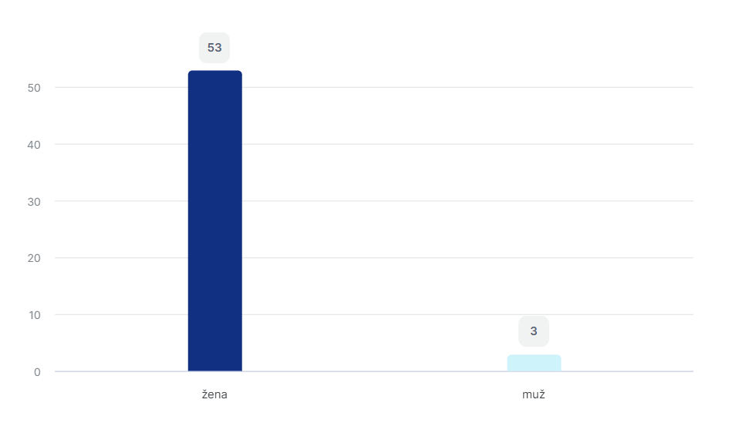

**Age of respondents**

A fascinating pattern unfolds when examining the age distribution of the respondents, highlighting distinctive trends within the surveyed group. Notably, middle-aged women, falling within the age range of 41 to 50 years old, emerge as the most prominently represented cohort, constituting a substantial 51.8% of the participants. This translates to 29 women within this age group, underscoring their significant presence in the study.

Following closely, women aged 31 to 40 years old represent the second-largest demographic, contributing to 23.2% of the overall participants. Conversely, the age group with the least representation comprises teachers aged over 61, indicating a lower participation rate within this specific demographic. These findings suggest that a considerable proportion of English language teachers engaged in this study are either in their younger years or situated within the middle age range.

To offer a visual representation of these age dynamics, Chart No. 2 has been included, providing a clear breakdown of the age distribution among the respondents. This visual aid serves to enhance our understanding of the age composition within the cohort and invites further exploration into potential implications and influences on teaching practices based on age demographics.

**Chart No.2 – Age of respondents**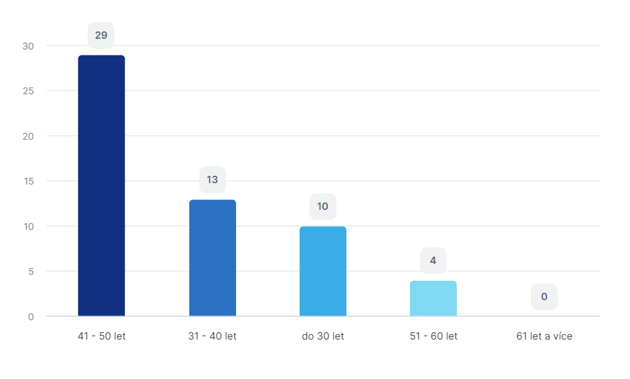

**Length of teaching experience**

Surprisingly it is clear that English language teachers are mostly younger and middle-aged people with a length of experience of 5 years and less, it is 30,4%. Next strong group are teacher with a length of teaching practise of 6-15 years, in which 19,6% of teachers have teaching practise of 6-10 years (11 of them) and 21,4% of teachers with a teaching practise of 10-15 years (that is 12 teachers). This fact can but may not mean an improvement or diversification of the quality of teaching, as teachers may fall into stereotype. The generation of these teachers already grew up with modern information technologies and we can assume that they know their way around these technologies more than their older colleagues, which, of course, cannot be universally accepted. Many older people do very quickly learned to work with the conveniences of the modern age, such as computers, internet, in education also interactive whiteboards. The ratio of the representation of respondents by length of teaching practice shows Chart No. 3.

**Chart No.3 – Length of teaching experience**

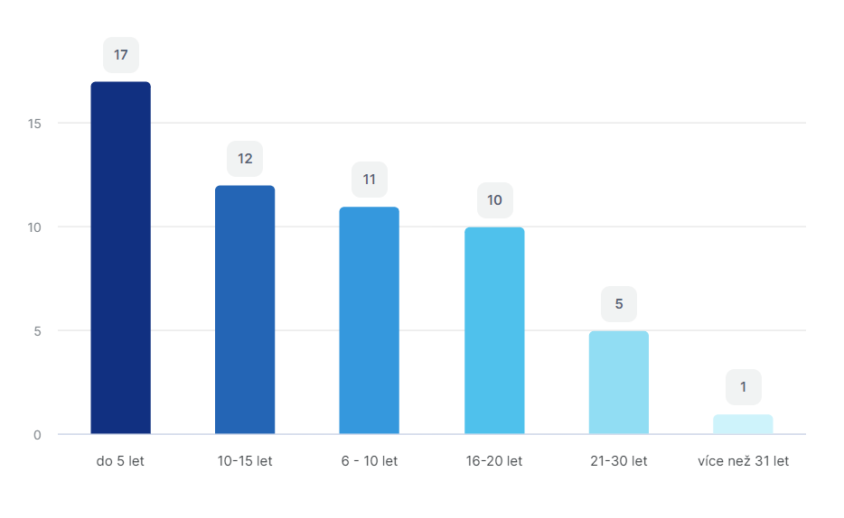

**Qualification for teaching the English language** (i.e., having a relevant pedagogical degree in English language teaching)

The comprehensive data analysis indicates a notable predominance of approved teachers. Specifically, 76.8% of the respondents possess a relevant pedagogical degree, encompassing 43 teachers. In contrast, 14.3% of teachers hold a Bachelor's degree (8 individuals), and 8.9% of teachers (5 persons) do not have any formal degree. This disparity might suggest that some teachers are either pursuing their university education, as mentioned by some respondents, or they hold a university degree in a different field while teaching English without formal accreditation. The distribution between approved and unapproved teachers is visually represented in Chart No.4.

**Chart No.4 - Qualification for teaching the English language**

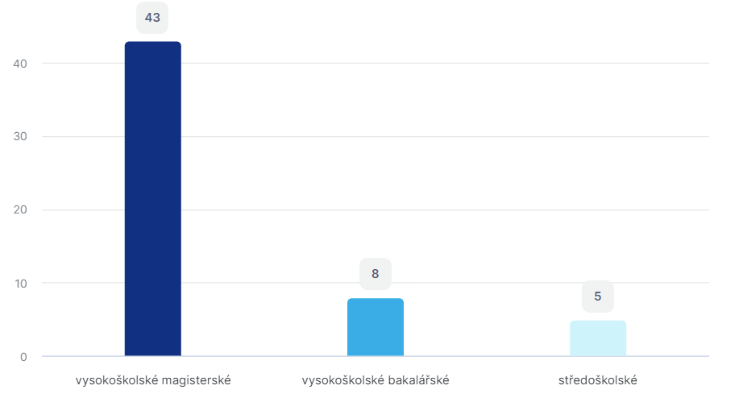

**Use of student-engaging activities**

With the exception of three respondents who expressed unfamiliarity with student-engaging activities, an overwhelming majority, constituting 94.6% of all participants, affirmed their utilization of activating teaching methods in their classes. This widespread adoption of activating methods is visually depicted in Chart No.5, providing a clear representation of the prevalence of such methodologies among the surveyed teachers.

**Chart No.5 - Use of student-engaging teaching methods**

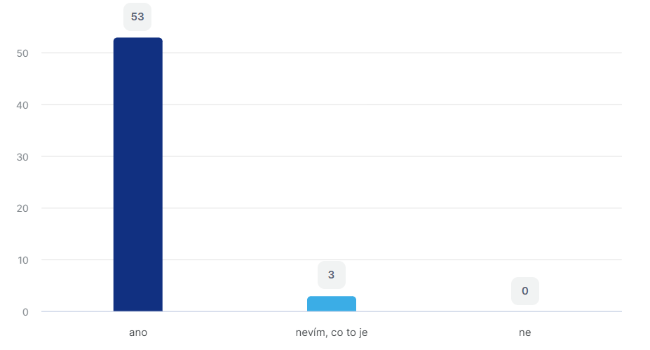

**Types of used student-engaging teaching methods**Teachers employ a diverse array of student-engaging methods, with didactic games emerging as the most prevalent and widely embraced approach. Conversely, problem teaching is the least employed method among the surveyed teachers. A closer examination of the data reveals that didactic games hold a considerable appeal, with 82.1% of respondents incorporating them into their classes. This suggests a strong inclination towards interactive and engaging teaching strategies.

Brainstorming follows closely, being utilized by an equivalent 82.1% of respondents, indicating a high level of enthusiasm for fostering creative thinking and collaborative ideation in the classroom. Discussion methods also enjoy substantial usage, with 73.2% of teachers incorporating them as a means of encouraging dialogue and interactive learning.

In descending order of popularity, situational methods are employed by 48.2% of respondents, staging methods by 35.7%, and heuristic and problem-solving methods by 28.6%. Problem teaching, while the least utilized, still finds application in 16.1% of respondents' teaching practices.

For a visual depiction of these methodological preferences, Chart No.6 has been included, offering a comprehensive overview of the activating methods most commonly employed by the surveyed teachers. This visual aid not only reinforces the prevalence of didactic games but also highlights the diverse landscape of student-engaging methods shaping the pedagogical approaches within the English language classrooms.

**Chart No.6 – Types of used student-engaging teaching methods**

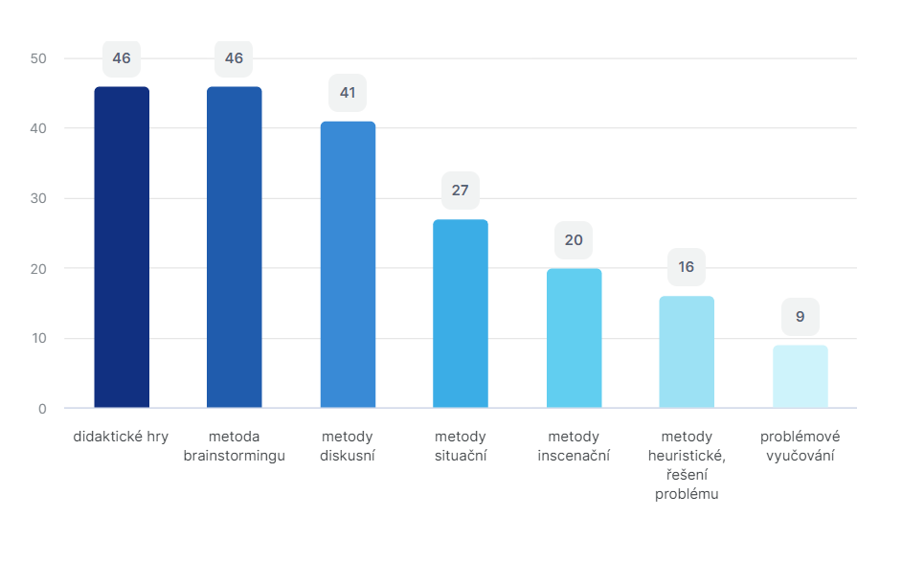

**Frequency of using student-engaging methods in teaching**

A mere 11.76% of respondents incorporate student-engaging methods in every class, underlining the challenges in integrating these methods consistently. A small percentage, 3.36%, utilizes student-engaging methods twice a week, while 7.84% opts for once a week. The majority of teachers, however, employ student-engaging methods sporadically, typically 1-2 times a month, and one respondent abstains from their use altogether.

Interestingly, several respondents expressed a desire to implement student-engaging teaching methods more frequently, ideally in every class. However, practical constraints, such as the need to adhere to the curriculum's predetermined thematic plans, restrict the feasibility of such aspirations. The majority of teachers grapple with time constraints, preventing them from incorporating student-engaging methods as frequently as they would prefer. This sentiment is echoed in Chart No.7, which visually outlines the overall frequency of student-engaging method usage among the respondents, shedding light on the prevalent challenges in consistent implementation.

Začátek formuláře

**Chart No.7 - Frequency of using activating methods in teaching**

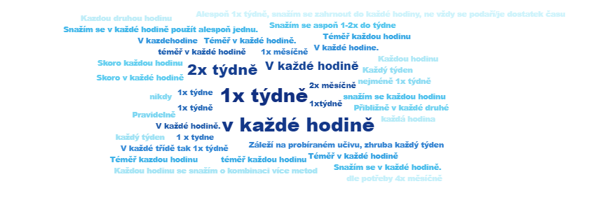

**Attractiveness of student-engaging methods for students**

The overwhelming consensus among respondents who employ student-engaging methods in their classrooms is that students find these methods enjoyable. Nearly all teachers share the view that learners derive satisfaction from engaging with student-engaging methods. However, a minor divergence exists, with two respondents expressing the belief that students are not particularly interested in student-engaging methods, and an additional two respondents indicating uncertainty on this matter.

Moreover, some nuanced opinions surfaced during the research. Some teachers observed that students occasionally forget the intended focus of student-engaging methods, suggesting a need for reinforcement in maintaining purpose during these activities. Additionally, a few respondents noted that students might sometimes prefer various games or alternative activities to sidestep the primary lesson objectives. The allure and appeal of student-engaging methods are depicted in Chart No.8, offering a visual representation of the perceptions regarding the attractiveness of these methods as reported by the surveyed teachers.

Začátek formuláře

**Chart No.8 - Attractiveness of student-engaging methods for students**

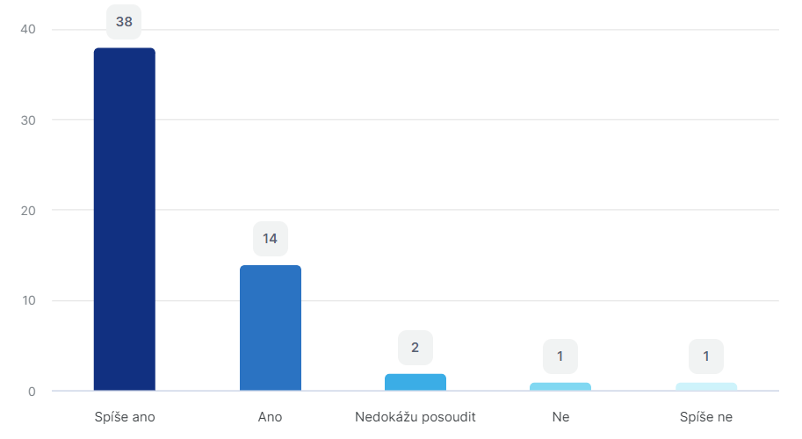

**Source for obtaining information or ideas for the use of individual activities**

Teachers exhibit a diverse and dynamic approach to acquiring information, with the majority relying on multiple sources rather than depending on a single outlet. Responding to this question allowed them to choose more than one answer, reflecting their varied preferences and strategies. The overwhelming trend is evident, with 96.4% of respondents seeking ideas from the internet, marking it as a dominant and widely embraced source.

However, it's crucial to note that teachers' resourcefulness extends beyond online platforms. A significant proportion of respondents, accounting for 64.3%, prefer to create their own activities, showcasing their creativity and ability to tailor content to their specific needs. Additionally, 62.5% of teachers actively exchange ideas and information with their colleagues, highlighting the significance of collaborative learning within the teaching community.

Furthermore, nearly 59% of respondents value information gained from various training sessions, emphasizing their commitment to continuous professional development. It's worth noting that 30.4% of teachers draw insights from professional literature, indicating a thoughtful engagement with established educational resources.

Chart No.9 visually represents the spectrum of sources that teachers employ to gather information, showcasing the multifaceted approach adopted by educators in expanding their knowledge and enhancing their teaching practices.

**Chart No.9 - Source for obtaining information or ideas for the use of individual activities**

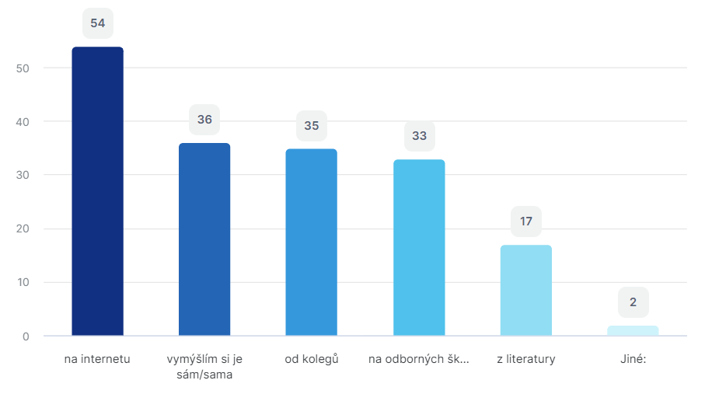

**Technical devices used in English language classes**

The survey findings reveal a significant embrace of modern technological tools by English language teachers, with an overwhelming 85.7% of respondents affirming the incorporation of interactive boards in their teaching practices. Recognizing the multifaceted nature of teaching, respondents had the option to select multiple devices that complement their instructional methods. Notably, 60.7% of teachers leverage computers, demonstrating their versatility in enhancing the learning experience. Mobile phones also play a role, being utilized by 51.8% of respondents, while tablets contribute to the pedagogical toolkit for half of the surveyed teachers.

This diversified use of technical devices is aptly captured in Chart No.10, which visually depicts the prevalence and distribution of these tools among educators. The results underscore the adaptability of teachers in integrating various technologies, reflecting a contemporary approach to language instruction that aligns with the evolving landscape of educational resources.

Začátek formuláře

**Chart No.10 - Technical devices used in English language classes**

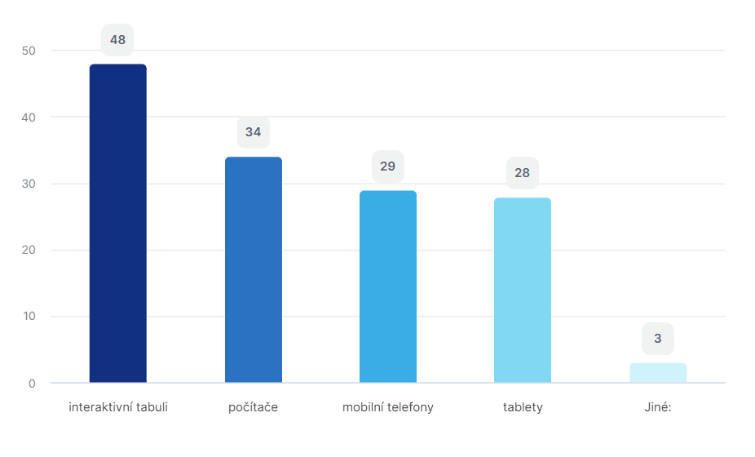

**Materials used in English language classes**

The survey findings highlight the diverse array of instructional materials employed by English language teachers, offering insights into the dynamic landscape of teaching resources. A significant 94.6% of respondents incorporate textbooks and workbooks into their lessons, underlining the continued relevance of traditional print materials in language instruction. Additionally, a substantial 92.9% of teachers utilize various worksheets, aligning with the prevalent use of the internet as a primary source of supplemental materials.

The evolving technological landscape is further evidenced by 89.3% of respondents incorporating internet applications or websites into their teaching methodologies. This trend is likely influenced by the contemporary adoption of interactive boards and related software, with many schools benefiting from EU funding for these advancements. Furthermore, the survey indicates a lower reliance on dictionaries, with only 33.9% of teachers incorporating them into their instructional strategies.

Chart No.11 visually captures the distribution and prevalence of these diverse teaching materials, providing a comprehensive overview of the instructional tools employed by English language educators. The results suggest a balanced integration of traditional and digital resources, showcasing the adaptability of teachers in catering to varied learning needs.

**Chart No.11 - Materials used in English language classes**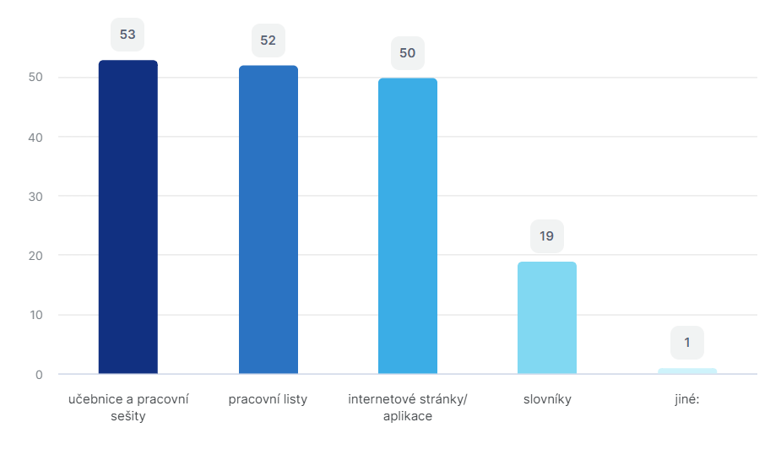

**Effectiveness of time spent with activating teaching methods**

When asked about their perceptions of the effectiveness of time dedicated to student-engaging methods, a notable 58.9% of respondents expressed a positive view, affirming that they consider the time spent with these methods to be effective. Additionally, 35.7% leaned towards a somewhat positive assessment. It's worth noting that a small group of three respondents indicated uncertainty, stating that they could not assess the effectiveness of student-engaging methods in their teaching practices.

These diverse responses contribute to a nuanced understanding of educators' perspectives on the impact of student-engaging methods on student learning outcomes. The breakdown of opinions is visually represented in Chart No.12, providing valuable insights into the varied sentiments among surveyed teachers. This distribution highlights the multifaceted nature of evaluating the effectiveness of teaching methodologies, taking into account the dynamic interplay of factors influencing the learning environment.

Začátek formuláře

**Chart No.12 - Effectiveness of time spent with student-engaging teaching methods**

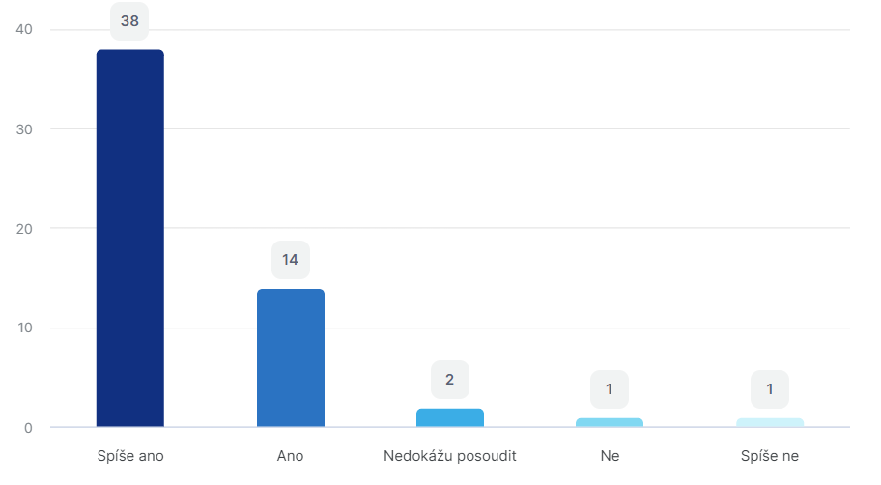

**Interest in modern teaching methods in language instruction**

The survey findings underscore the prevailing enthusiasm among teachers for contemporary and student-engaging teaching methods, with a substantial 75% of respondents expressing a strong interest. Moreover, an additional 11 respondents exhibited a somewhat positive inclination, emphasizing the widespread inclination towards embracing innovative and engaging approaches to teaching. Only a minimal 3 respondents indicated a lack of interest or partial interest in these dynamic teaching methodologies.

Delving into the avenues through which teachers explore and understand these modern methods, the survey uncovered that the internet stands out as the primary and overwhelmingly favored source. A significant 91.1% of respondents turn to online platforms for inspiration, ideas, and insights into cutting-edge teaching techniques. Concurrently, training sessions and seminars emerge as pivotal contributors, with 83.9% of teachers leveraging these events as valuable learning opportunities to stay abreast of modern teaching methodologies.

Interestingly, literature also plays a role, albeit to a lesser extent, with 32.1% of respondents gaining insights from various educational texts. This diversification in information sources underlines the adaptability and resourcefulness of educators in navigating a varied landscape of knowledge acquisition.

Chart No.13 visually encapsulates the diverse channels through which teachers gather ideas and information, providing a comprehensive overview of their information-seeking practices.Začátek formuláře

**Chart No.13 - Interest in modern teaching methods in language instruction**

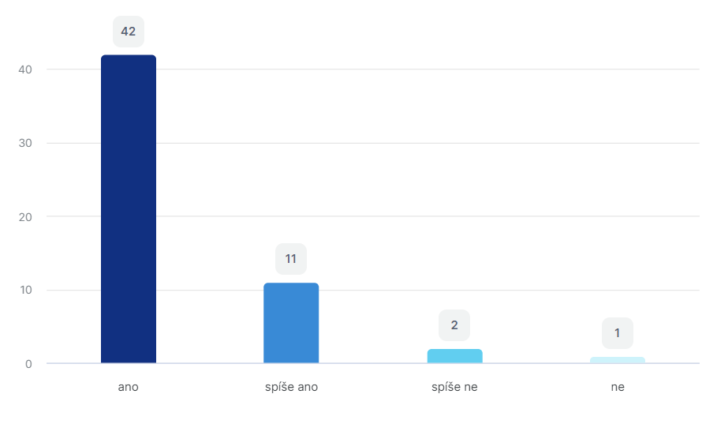

### The second phase – The interview

To get data from interview I reached out to my colleagues at a basic school in Jihlava, asking them for interviews on using student-engaging activities in their English classes.

For this phase of the research, five lower-secondary school teachers were chosen. All of them are my colleagues from the school in the town of Jihlava and they all teach English language:

The teacher 1 – female, 30 years old, 6 years of teaching practice, teaches English and History, fully qualified.

The teacher 2 – female, 34 years old, 10 years of teaching practice, teaches English and Geography, fully qualified.

The teacher 3 – female, 68 years old, 40 years of teaching practice, teaches English and Chemistry, fully qualified.

The teacher 4 – male, 41 years old, 10 years of teaching practice, teaches English, not qualified yet.

The teacher 5 – female, 44 years old, 20 years of teaching practice, teaches English and German languages, fully qualified.

I prepared a semi-structured interview with questions on this topic. The interviews were conducted one-on-one, each lasting about 30-40 minutes on average. All respondents were asked the same set of questions, with flexibility to probe deeper based on their responses. At the start of each interview, I introduced the research topic and obtained their consent to participate. I took written notes of the interviews as my colleagues didn’t want to be recorded. The questions centered on the use of student-engaging activities in lesson planning and lesson structure, teachers' digital literacy, teaching methods, and student motivation. Based on the completed questionnaires, the data was evaluated and subsequently processed and interpreted.

**The list of questions prepared before the interviews:**

1. Do you know what are student-engaging activities?
2. Do you use student-engaging activities in your classes?
3. How often do you use student-engaging activities in your classes?
4. What kinds of student-engaging activities do you use in your classes?
5. Do you think that these activities are attractive for students?
6. Where do you get ideas for student-engaging activities?
7. Do you use any technical devices in your English classes?
8. What programmes/apps/websites do you use to get inspiration?
9. What teaching materials do you use in you classes?
10. Do you think that the time spent with student-engaging activities is effective?
11. Are you interested in modern teaching methods?

I analyzed the interviews with individual teachers using open coding. This method involves breaking down the text into smaller pieces and assigning words or short phrases as labels, or "codes." To choose the codes, I used guiding questions like "what," "who," "how," and "why" (Švaříček, Šeďová et al., 2007). Each interview was coded separately, and then the codes were grouped into categories to find connections. Finally, I used the “card layout” method to process the results, which means summarizing key information with these codes.

The interviews:

The teacher 1 – interview results:

Based on a verbal conversation with Teacher 1, I assigned the following codes:

* Often uses student-engaging activities
* a high level of digital skills, certainty
* a positive attitude towards student-engaging activities, enthusiasm
* a great ability to produce custom materials
* online resources combined with traditional materials
* a strong sense of cooperation and sharing
* learners’ positive motivation thanks to student-engaging activities, competitiveness, excitement
* uses student-engaging activities every lesson
* most often uses didactic games and online games.

The teacher 2 – interview results:

Based on a verbal conversation with Teacher 2, I assigned the following codes:

* Often uses student-engaging activities
* a lower level of digital skills, uncertainty
* a positive attitude towards student-engaging activities, enthusiasm
* a low ability to produce custom materials, uses ready-made activities
* online resources combined with traditional materials
* a strong sense of cooperation and sharing
* learners’ positive motivation thanks to student-engaging activities, competitiveness, excitement
* uses student-engaging activities very often
* most often uses worksheets and online games.

The teacher 3 – interview results:

Based on a verbal conversation with Teacher 3, I assigned the following codes:

* No use of student-engaging activities
* Very low level of digital skills, uncertainty
* Mostly negative attitude towards student-engaging activities
* no ability to produce custom materials
* traditional materials combinded with printed worksheets
* a strong sense of cooperation and sharing
* doesn’t find student-engaging activities positive, distraction of students
* most often uses printed worksheets

The teacher 4 – interview results:

Based on a verbal conversation with Teacher 4, I assigned the following codes:

* Often uses student-engaging activities
* a high level of digital skills, certainty
* a positive attitude towards student-engaging activities, enthusiasm
* a great ability to produce custom materials
* online resources
* a low sense of cooperation and sharing
* learners’ positive motivation thanks to student-engaging activities, competitiveness, excitement
* uses student-engaging activities every lesson
* most often uses didactic and online games, discussion, project teaching

The teacher 5 – interview results:

Based on a verbal conversation with Teacher 5, I assigned the following codes:

* Often uses student-engaging activities
* a good level of digital skills, certainty
* a positive attitude towards student-engaging activities, enthusiasm
* a low ability to produce custom materials
* online resources combined with traditional materials
* a strong sense of cooperation and sharing
* learners’ positive motivation thanks to student-engaging activities, competitiveness, excitement
* uses student-engaging activities twice a week
* most often uses didactic games and online games, worksheets.

After completing the teacher interviews, I analyzed the results by assigning codes to different sections of the interview and then categorizing them. The outcome of grouping these codes and creating categories, based on the interviews with five foreign language teachers, is displayed in the table below.

Začátek formuláře

|  |  |  |  |
| --- | --- | --- | --- |
| **Grouping the codes into categories** | | | |
| **Categories** | **Sub-categories** | **Codes** | **Notes** |
| Use of student-engaging activities | Teachers | Often uses student-engaging activities | T1, T2, T4, T5 |
| Uses student-engaging activities every lesson | T1, T4 |
| uses student-engaging activities twice a week | T5 |
| No use of student-engaging activities | T3 |
| a high level of digital skills, certainty | T1, T4, T5 |
| a lower level of digital skills, uncertainty | T2, T3 |
| a positive attitude towards student-engaging activities, enthusiasm | T1, T2, T4, T5 |
| Mostly negative attitude towards student-engaging activities | T3 |
| a great ability to produce custom materials | T1, T4 |
| a low ability to produce custom materials, uses ready-made activities | T2, T5 |
| no ability to produce custom materials | T3 |
| online resources combined with traditional materials | T1, T2, T4, T5 |
| traditional materials combinded with printed worksheets | T3 |
| most often uses didactic games and online games | T1, T5 |
| most often uses worksheets and online games. | T2 |
| most often uses printed worksheets | T3, T5 |
| most often uses didactic and online games, discussion, project teaching | T4 |
| Uses technical devices during classes | T1, T2, T4, T5 |
| No use of technical devices | T3 |
| Cooperation |  | a strong sense of cooperation and sharing | T1, T2, T3, T5 |
|  | a low sense of cooperation and sharing | T4 |
| Motivation | Teachers' view | learners’ positive motivation thanks to student-engaging activities, competitiveness, excitement | T1, T2, T4, T5 |
| doesn’t find student-engaging activities positive, distraction of students | T3 |

The purpose of interviewing five teachers was to gain insights into the dynamics of a typical lower-secondary school. The questions posed during these interviews addressed two key aspects: the use of interactive activities for teaching English and the overall effectiveness of such activities in the classroom. Additionally, the interviews explored the teachers' perspectives on student motivation.

Four out of the five teachers indicated that they incorporate interactive activities into their English lessons. Most of them have at least some proficiency with digital tools, allowing them to create custom teaching materials. The exception was the oldest teacher, who has limited digital skills and doesn't develop personalized resources.

The teachers rely on a combination of online sources and traditional materials, such as textbooks, workbooks, and printed worksheets (like those from ISL Collective), to create engaging classroom experiences. Digital and didactic games are the most commonly used interactive activities, with popular platforms including Baamboozle, Wordwall, Blooket, and Kahoot. Four teachers reported frequent use of iPads for online games, especially Blooket and Kahoot.

There was a strong sense of teamwork and resource-sharing among the teachers, with each teacher following their unique teaching style. The choice of teaching methods depended on the individual teacher's approach, the subject matter, the learning objectives, and classroom dynamics.

Regarding student motivation, most teachers agreed that interactive activities tend to boost students' interest in learning English, transforming lessons from passive to active experiences. In English language classes, students often use mobile phones, interactive whiteboards, and iPads. Collaboration among students is more likely when teachers implement comprehensive and engaging teaching methods. Four teachers noted that using digital tools has a positive effect on students' enthusiasm for learning foreign languages, observing increased excitement and engagement when these tools are used.

However, one teacher expressed concern over the competitive nature of some activities, which can disadvantage slower learners or those with special needs. She suggested that such activities might distract students and make it harder for them to stay focused.

Overall, the interviews highlighted the varied approaches to teaching and the impact of use of student-engaging activities on student engagement and motivation, underscoring the importance of flexibility in addressing diverse learning needs.

Začátek formuláře

# 3 RESEARCH SUMMARY AND DISCUSSION

This study aimed to explore the use of student-engaging activities during English lessons at lower secondary schools. The primary objective was to determine whether teachers incorporate these activities in foreign language teaching at this level.

The additional objectives were:

To identify the types of student-engaging activities teachers use

To discover the main sources for active teaching

To examine teachers' opinions on whether using student-engaging activities motivates students to learn foreign languages

To achieve these objectives, three research questions (RQ) were formulated. A mixed-methods approach was employed: the first phase involved a questionnaire survey, and the second phase included interviews with teachers.

RQ 1. What student-engaging teaching methods does the teacher use in teaching at a lower secondary school?

Except for three respondents who were unfamiliar with student-engaging activities, the overwhelming majority of participants, 94.6%, confirmed that they use activating teaching methods in their classes.

Only a small portion of respondents use student-engaging methods in every class, highlighting the challenges of consistent integration. A few teachers use these methods once or twice a week, but most employ them sporadically, typically 1-2 times a month, with one teacher not using them at all. Many respondents expressed a desire to use student-engaging methods more frequently, ideally in every class. However, practical constraints, such as adhering to the curriculum's predetermined plans and time limitations, make it difficult for the majority of teachers to incorporate these methods as often as they would like. These information is also confirmed in the interviews, all of the teachers, except one, use student-engaging activities very often, mostly every lesson. One of the teachers uses student-engaging activities very rarely.

Teachers use a variety of student-engaging methods, with didactic games being the most common and widely accepted approach. Problem teaching, on the other hand, is the least utilized method. The data shows that didactic games are highly popular, with a significant majority of teachers incorporating them into their classes, indicating a strong preference for interactive and engaging teaching strategies. These results from questionnaire survey were also confirmed in the interviews, didactic games are most often used tool to engage students, from these online games play significant role. This trend is seen mainly at younger teachers, while older teachers prefer worksheets as they are less familiar with modern technologies.

Brainstorming is also widely used, reflecting teachers' enthusiasm for fostering creative thinking and collaboration in the classroom. Discussion methods are similarly popular, as many teachers use them to encourage dialogue and interactive learning.

Other methods, such as situational methods, staging methods, and heuristic and problem-solving methods, are less frequently used but still have a notable presence. Problem teaching, though the least employed, is still utilized by some teachers.

RQ 2. What resources for active teaching do teachers at lower secondary school use?

The survey shows that English teachers use different things to help them teach. Most teachers use books and workbooks. This shows that paper materials are still important for teaching English. Also, many teachers use worksheets, which they often get from the internet.

Teachers also use technology in their teaching. They use websites and apps on the internet to help students learn. This might be because some schools get money from the EU to buy special boards and software for teaching. But not many teachers use dictionaries in their lessons.

Overall, the survey shows that teachers use a mix of old-fashioned paper materials and new digital resources. This means they can change how they teach to help different students learn. There's a chart in the survey that shows all the different materials teachers use.

From the first phase of the research is obvious that teachers demonstrate a diverse and dynamic approach to acquiring information, typically relying on multiple sources rather than a single outlet. Most teachers seek ideas from the internet, making it a dominant and widely used resource. However, their resourcefulness extends beyond online platforms.

Many teachers prefer to create their own activities, showcasing their creativity and ability to tailor content to their specific needs. Additionally, a significant number of teachers actively exchange ideas and information with colleagues, highlighting the importance of collaborative learning within the teaching community.

Training sessions are also valued by nearly 59% of respondents, emphasizing their commitment to continuous professional development. Moreover, a portion of teachers draw insights from professional literature, indicating thoughtful engagement with established educational resources. This multifaceted approach underscores the varied strategies teachers employ to enhance their teaching practices.

The second phase of the research supported outcome from the first phase. All the interviewed teachers, except one, look for sources on the internes and combine them with traditional materials such as student books, workbooks and printed worksheets.

RQ 3. What is teacher’s opinion on using student engaging activities in the classroom?

Most teachers consider the time spent in active teaching to be beneficial, which means that the pupils are interested in such teaching. This may be supported by the fact that teachers use interactive whiteboards and computers the most in active learning, which are the teaching aids that students prefer.

When asked about the effectiveness of time dedicated to student-engaging methods, in the first phase of the research, a significant portion of respondents expressed positive views, affirming the methods' effectiveness. A substantial number also had a somewhat positive assessment. A small group of respondents indicated uncertainty, unable to assess the effectiveness of these methods in their teaching practices. These varied responses provide a nuanced understanding of educators' perspectives on the impact of student-engaging methods on student learning outcomes.

In the second phase of the research, during the interviews, the teachers supported the positive approach towards using student-engaging activities and showed enthusiasm for active teaching. One of the teachers doesn’t share the positive attitude for the student-engaging activities and finds them distracting. This teacher is much older then the others and finds the classical teaching approach more suitable.

The theory of using student-engaging methods in English language teaching aligns with the research results. The survey revealed that English language teachers indeed show interest in various teaching methods and are unwilling to confine themselves to traditional approaches. Although classical methods remain important, teachers are aware that each method has its place and can be effective in different stages of teaching.

Respondents unanimously affirmed that activation methods contribute to the acquisition of language skills, and they consider the time spent with these methods to be effective. This agreement with the research results reinforces the positive nature of these methods and emphasizes that properly guided student-engaging methods can significantly contribute to the development of students' language abilities.

The research further showed that teachers actively utilize various sources to gather ideas and information about different methods and activities. The internet, participation in training and seminars, and consultations with colleagues have become common ways for teachers to acquire new insights and inspiration.

An essential aspect is the recognition that teachers do not adhere to a single method. They are open to new ideas and regularly modify their activities to maintain student interest, choosing the most suitable method for specific teaching goals.

Currently, the internet serves as a key source of information for the majority of teachers. Teachers use the internet to search for various ideas, worksheets, activities, games, and instructions. While not all are suitable for a specific culture or educational system, teachers demonstrate creativity and the ability to adapt activities to meet their students' needs.

Moreover, an increasing number of teachers are incorporating interactive boards, providing students with a new point of interest. Despite the limitation that only one student can work with the interactive board at a time, this challenge can be overcome by providing worksheets for the rest of the class.

The research revealed that English language teachers are interested in various teaching methods and do not want to limit their instruction solely to a standard approach using traditional teaching methods. Although these methods have their place in education, teachers acknowledge that each method is suitable for a different phase of the teaching hour and serves to practice and acquire various knowledge and skills.

Respondents unanimously confirmed that student-engaging methods contribute to the acquisition of language skills, and they consider the time spent with these methods to be effective. These findings are positive, indicating that when student-engaging methods are properly guided, they can effectively contribute to the development of students' language abilities.

Regarding obtaining ideas and information about various methods and activities, teachers use the internet, participate in training and seminars, and consult with colleagues. Furthermore, the research showed that teachers are not confined to a single proven method; they are open to new ideas and possibilities. They regularly rotate their activities to maintain students' interest and select the most suitable method for specific educational goals.

In today's era, almost every teacher uses the internet to find various ideas, worksheets, activities, games, and instructions. Although not all of them are suitable for a specific culture or educational system, teachers demonstrate creativity and the ability to modify activities according to their needs.

Moreover, teachers are increasingly utilizing interactive boards, providing a new point of interest for students. This technology allows students to work with various materials, practice diverse skills, and serves as a tool for playing videos and music. Despite the limitation that only one student can work with the interactive board at a time, this drawback can be addressed through worksheets for the rest of the class.

Results from the second phase of the research confirmed the data collected in questionaries.

# Examples of lesson plans

These lesson plans were used during English project days at our schools. Students worked in blocks so that is why the plans do not have 45 minutes each.

**Lesson Plan: Engaging English Discussions for 7th Grade**

Objective:

Students will enhance their communication and critical thinking skills through active participation in English discussions.

Students will practice expressing their opinions, listening to others, and providing thoughtful responses.

Materials:

Whiteboard and markers

Printed discussion prompts or questions

Timer

Chart paper and markers

Introduction (10 minutes):

Begin with a brief discussion on the importance of effective communication and expressing opinions in English.

Explain the objective of the lesson: to improve communication skills through engaging discussions.

Establish a positive and open atmosphere, encouraging students to share their thoughts without fear of judgment.

Warm-up Activity - Quick Share (5 minutes):

Pose a simple question related to everyday experiences, such as "What is your favorite hobby?" or "What did you do over the weekend?"

Have each student share their response briefly with a partner.

Encourage a few students to share their partners' responses with the class.

Main Activity - Guided Discussion (25 minutes):

Divide the class into small groups, providing each group with a discussion prompt or question related to the current lesson topic or a recent reading.

Allow students 10-15 minutes to discuss the prompt within their groups.

Circulate among the groups, providing guidance, clarifications, and encouraging active participation.

After the group discussions, have each group summarize their key points or share an interesting perspective with the whole class.

Class Reflection (10 minutes):

Lead a class discussion reflecting on the group discussions.

Encourage students to share what they found interesting or challenging during the activity.

Discuss effective communication strategies, such as listening attentively, respecting different opinions, and using clear language.

Extension Activity - Debate (15 minutes):

Introduce a simple debate format on a relevant and engaging topic.

Divide the class into two groups – those in favor and those against the topic.

Allow each group time to prepare their arguments.

Conduct a structured debate with each group presenting their points.

Encourage students to respond respectfully to opposing arguments.

Conclusion (5 minutes):

Summarize the importance of effective communication and critical thinking skills.

Discuss how these skills can be applied not only in English class but also in various aspects of their lives.

Assign homework, such as writing a short reflection on what they learned from the discussion activities.

Assessment:

Observe students' participation and engagement during discussions.

Evaluate the quality of their contributions, including their ability to express opinions and respond to others respectfully.

**Lesson Plan: Problem-Solving Skills for 9th Grade Students**

Objective:

Students will develop critical thinking and problem-solving skills through real-world scenarios.

Students will collaborate in groups to analyze and solve problems, fostering teamwork.

Materials:

Whiteboard and markers

Printed problem-solving scenarios or case studies

Chart paper and markers

Timer

Small group workspaces

Introduction (10 minutes):

Begin with a brief discussion on the importance of problem-solving skills in everyday life.

Explain the objective of the lesson: to enhance critical thinking through practical problem-solving.

Establish a positive and collaborative atmosphere, emphasizing the value of teamwork.

Warm-up Activity - Brainstorming (10 minutes):

Engage students in a brainstorming session on common problems they encounter.

List these problems on the whiteboard.

Discuss potential solutions briefly as a class.

Main Activity - Group Problem-Solving (30 minutes):

Divide the class into small groups.

Distribute printed problem-solving scenarios or case studies to each group.

Instruct groups to read and analyze the problem, identify the key issues, and propose practical solutions.

Set a timer for 20-25 minutes to allow groups to collaborate and discuss.

Circulate among the groups, offering guidance and ensuring active participation.

Have each group present their identified problems and proposed solutions to the class.

Class Discussion and Analysis (15 minutes):

Lead a class discussion on the different approaches each group took in solving the problems.

Discuss the effectiveness of various problem-solving strategies.

Emphasize the importance of considering multiple perspectives and thinking critically.

Extension Activity - Real-World Application (20 minutes):

Introduce a real-world scenario or current event related to the problem-solving theme.

Ask students to discuss and propose solutions based on the problem-solving skills they've practiced.

Encourage creativity and outside-the-box thinking.

Conclusion (5 minutes):

Summarize the key points learned about problem-solving.

Discuss how these skills can be applied in various situations.

Assign homework, such as reflecting on how they might use problem-solving skills in their own lives.

Assessment:

Evaluate group participation and collaboration during the problem-solving activity.

Assess the quality of each group's analysis and proposed solutions.

Consider class engagement during the discussion and application of problem-solving skills to real-world scenarios.

**Lesson Plan: Learning Through Situational Methods for 9th Grade Students**

Objective:

Students will engage in learning through real-life situations to enhance understanding and application of knowledge.

Students will develop critical thinking skills by analyzing and responding to situational challenges.

Materials:

Whiteboard and markers

Printed situational scenarios or case studies

Chart paper and markers

Timer

Small group workspaces

Introduction (10 minutes):

Begin with a brief discussion on the concept of learning through real-life situations.

Explain the objective of the lesson: to apply knowledge to practical scenarios and enhance critical thinking.

Establish an open and collaborative atmosphere, emphasizing the value of learning from real-world situations.

Warm-up Activity - Icebreaker Situations (10 minutes):

Present a few light-hearted, everyday situations or challenges.

Have students discuss possible responses in pairs or small groups.

Share responses as a class, encouraging creativity and diverse perspectives.

Main Activity - Group Analysis of Situational Scenarios (30 minutes):

Divide the class into small groups.

Distribute printed situational scenarios or case studies to each group.

Instruct groups to read and analyze the situation, identify key elements, and discuss possible solutions.

Set a timer for 20-25 minutes to allow groups to collaborate and discuss.

Circulate among the groups, offering guidance and ensuring active participation.

Have each group present their analysis and proposed solutions to the class.

Class Discussion and Reflection (15 minutes):

Lead a class discussion on the different perspectives and solutions presented by each group.

Discuss the importance of critical thinking in analyzing and responding to real-life situations.

Encourage students to reflect on how they can apply these skills in their own lives.

Extension Activity - Application in Personal Context (20 minutes):

Ask students to think about a personal situation where they can apply the critical thinking skills practiced during the lesson.

Have students share their reflections with a partner or in small groups.

Encourage discussion on the practical application of situational learning.

Conclusion (5 minutes):

Summarize the key concepts learned about learning through real-life situations.

Discuss the relevance of critical thinking skills in various aspects of life.

Assign homework, such as journaling about a situation where they can apply critical thinking.

Assessment:

Evaluate group participation and collaboration during the analysis of situational scenarios.

Assess the quality of each group's analysis and proposed solutions.

Consider individual engagement during the class discussion and reflection on the application of critical thinking skills.

**Lesson Plan: Theatrical Staging Methods for 7th Grade Students**

Objective:

Students will explore the basics of theatrical staging methods to enhance communication and expressiveness.

Students will develop teamwork and creative thinking skills through practical exercises.

Materials:

Open classroom space

Whiteboard and markers

Costumes or props (optional)

Timer

Chart paper and markers

Introduction (10 minutes):

Begin with a brief discussion on the concept of theatrical staging and its importance in effective communication.

Introduce the objective of the lesson: to explore basic staging methods for better expression and communication.

Establish a positive and collaborative atmosphere, emphasizing the importance of creativity and teamwork.

Warm-up Activity - Group Movement (10 minutes):

Lead the class in a series of simple group movement exercises.

Encourage students to use their bodies to express different emotions or scenarios.

Discuss the importance of body language in communication.

Main Activity - Theatrical Staging Workshop (30 minutes):

Divide the class into small groups.

Provide each group with a short scenario or simple script (could be related to a topic from their curriculum).

Instruct each group to plan and perform the scenario using basic staging methods, such as blocking, gestures, and facial expressions.

Set a timer for 20-25 minutes to allow groups to collaborate and rehearse.

Encourage creativity and experimentation with staging elements.

Group Performances and Peer Feedback (15 minutes):

Have each group present their short performances to the class.

After each performance, facilitate a brief discussion for peer feedback.

Encourage constructive comments on effective staging elements and areas for improvement.

Class Discussion and Reflection (15 minutes):

Lead a class discussion on the impact of staging methods in communication.

Discuss the importance of non-verbal cues in conveying emotions and messages.

Ask students to reflect on what they learned and how they can apply these skills in different aspects of their lives.

Extension Activity - Improvisation (20 minutes):

Introduce a simple improvisation exercise where students have to create a short scene on the spot.

Encourage students to use staging methods to convey their characters and messages.

Discuss the challenges and successes of improvisation as a form of creative expression.

Conclusion (5 minutes):

Summarize the key concepts learned about theatrical staging methods.

Discuss the relevance of these skills in both theatrical performances and everyday communication.

Assign a small homework task, such as practicing a short scenario at home with family members.

Assessment:

Evaluate group participation and creativity during the theatrical staging workshop.

Assess the quality of each group's performance and their ability to apply basic staging methods.

Consider individual engagement during class discussions and reflections.

# Recommendations for suitable activities (didactic games)

The next sections will provide ideas for activities that can be applied in English language classes. These activities aim to inspire elementary school teachers and cover various aspects of language learning. They are categorized into four sections, each designed for practicing different language skills: grammar and vocabulary, reading and writing, listening, and speaking. These activities can be adapted to suit the specific needs and levels of students, offering a diverse range of engaging exercises to enhance language proficiency. I personnaly use these activities as warm-ups or short in-cuts during teaching.

### Grammar and vocabulary activities

**Sentence smash up:**

This game is great for practising grammar structure and grammar points.

The grammar point that is being taught is used.

The teacher writes sentences in the computer, print them out and cut them into stripes, either multi-word pieces or single words.

Students in pairs or individually have to put the sentences back together in a given time.

**Word Relay Race:**

Divide the class into two or more teams.

Write a list of vocabulary words or sentences on the board related to the current lesson.

The first student from each team runs to the board and writes a synonym or a related word for the displayed word.

The next student continues the relay. The team that finishes first with correct answers wins.

**Grammar Bingo:**

Create Bingo cards with different grammar rules or vocabulary words.

Call out sentences or definitions related to the lessons.

Students mark the corresponding grammar rule or vocabulary word on their Bingo cards.

The first student to get a line shouts "Bingo!" and wins a small prize.

**Vocabulary Pictionary:**

Prepare a list of vocabulary words related to the current unit.

Assign each student a word without revealing it to others.

Students draw a picture representing their assigned word on the board without using letters.

Classmates try to guess the word based on the drawings.

**Grammar Jeopardy:**

Create a Jeopardy-style game board with different categories related to grammar and vocabulary.

Assign point values to each question based on difficulty.

Divide the class into teams and have them choose questions. If they answer correctly, they earn points.

The team with the most points at the end wins.

**Vocabulary Charades:**

Write various vocabulary words on pieces of paper and put them in a hat.

One student selects a word without revealing it to others.

Without speaking, the student acts out the word while the rest of the class tries to guess what it is.

Rotate roles, allowing each student to participate in acting and guessing.

These games add an element of fun and engagement to grammar and vocabulary lessons, making learning enjoyable for lower secondary school students.

### Listening activities

**Listen and Draw:**

Provide students with a simple drawing or diagram with missing elements.

Play an audio clip with instructions on how to complete the drawing, including details that are not shown.

Students listen carefully and follow the instructions to draw the missing parts.

**Guess the Sound:**

Play various sound effects or short audio clips related to everyday situations or objects.

Students listen and try to guess what each sound represents.

Encourage discussion and reasoning behind their guesses.

**Descriptive Dictation:**

Read a short paragraph describing a scene or object to the students.

As they listen, students draw what they imagine based on the description.

Afterward, compare their drawings with the actual scene or object.

**Story Sequencing:**

Choose a short narrative or story and divide it into key parts.

Play the audio of the story, then provide students with shuffled sentence strips representing different parts.

Students listen and rearrange the sentence strips in the correct order.

**Song Lyrics Gap Fill:**

Choose a song with clear and understandable lyrics related to the lesson.

Remove certain words or phrases from the lyrics.

Play the song, and students listen to fill in the gaps with the missing words.

These activities not only enhance listening skills but also make the learning experience enjoyable and interactive for lower secondary school students.

### Writing and reading activities

**Story Starters:**

Provide students with sentence prompts or story starters.

Ask them to continue the story by writing a paragraph or short narrative.

Encourage creativity and imagination in developing the plot and characters.

**Book Review:**

Assign students a book appropriate for their age and reading level.

After reading, have them write a book review, including a summary, their favorite part, and whether they would recommend it to their peers.

**Creative Letter Writing:**

Ask students to write a letter to their future selves, describing their goals, aspirations, and expectations.

They can seal the letters and revisit them at the end of the school year.

**Picture-Based Writing:**

Provide students with an interesting or thought-provoking image.

Ask them to create a story or descriptive paragraph inspired by the picture.

Emphasize the use of vivid language and sensory details.

**Literary Scavenger Hunt:**

Select a text and create a list of items or themes for students to find while reading.

Students read the text and mark off items on the list as they encounter them.

Encourage discussion about how each item contributes to the overall meaning of the text.

These activities aim to enhance both reading comprehension and writing skills while engaging students in creative and meaningful tasks.

### Speaking activities

**Role-Play Scenarios:**

Prepare various scenarios or situations (e.g., at a restaurant, in a store, at the airport).

Assign roles to students and have them act out the scenes, encouraging the use of relevant vocabulary and expressions.

**Show and Tell:**

Ask each student to bring an item from home that is meaningful to them.

Have students describe the item, explaining its significance, and answer questions from their peers.

**Debates:**

Choose age-appropriate topics for debates, such as "School Uniforms," "Benefits of Homework," or "Phone addiction."

Divide students into teams and encourage them to present arguments, fostering critical thinking and communication skills.

**Story Chain:**

Start a story with a sentence or scenario.

Each student adds a sentence to continue the story.

The goal is to build a collaborative narrative, enhancing creativity and oral communication.

**Interview a Classmate:**

Pair students and provide a list of interview questions (e.g., hobbies, favorite books, future aspirations).

Each student takes turns interviewing their partner and then introduces them to the class.

**Picture Descriptions:**

Show students a picture with various elements.

Ask them to take turns describing different aspects of the image, encouraging the use of descriptive language.

**Role-Playing Historical Figures:**

Assign each student a historical figure or character.

Have them research and prepare a short presentation, embodying the persona they've been assigned.

This activity combines research, public speaking, and creativity.

**Charades:**

Teacher prepares several lists of words.

Learners are divided into two teams.

A person from Team 1 comes to the board, chooses one list from the teacher and his task is to describe the words one by one in a given time (usually 8 words for two minutes) and his colleagues have to guess the words.

Then Team 2 follows.

The teams change in guessing, it depends how many lists the teacher has.

These speaking activities aim to promote communication, collaboration, and confidence in expressing ideas in English. They provide opportunities for students to engage in meaningful conversations while practicing language skills.

# Conclusion

In conclusion, the thesis focuses on the exploration of teaching methods designed to actively engage students in the learning process. These methods play a pivotal role in reshaping both the teaching approach and the learning experience for students.

The theoretical part focused on the description of basic terms such as teaching methods and their classification, active and creative teaching and motivation. Based on the literature review, the main factors and barriers affecting the use of student-engaging methods were defined. Furthermore, the main strategic documents related to student-engaging methods were presented.

The practical part of this thesis explored the significance and effectiveness of student-engaging methods within the context of teaching the English language at the lower secondary school and how these methods support effective education and contribute to the development of students' communication skills and how student-engaging methods motivate students to learn English and increase active participation in the learning process.

A mixed methods research design was chosen, combining qualitative and quantitative methods. Research was done through questionaire, sent to English teachers at lower secondary schools in Vysocina region supplemented by interviews with English teachers from the same school where I teach.

In the first phase, a quantitative survey was administered to a larger sample of teachers to gather all possible data needed and the obtained data were evaluated and compared with the results from the second phase. In the second phase, a qualitative method involving interviews was conducted, gathering data from five lower-secondary school teachers from our school. The aim was to outline the situation in a mainstream school and to find out the views of the language teachers and to support the outcome from the first phase.

The thesis delves into a variety of methods, including games, dramatic activities, conversational exercises, and the integration of technology, showcasing their adaptability and varied applications. Student-engaging methods act as a bridge between traditional and modern teaching practices, creating vibrant and stimulating learning environments for educators and students alike.

Every teacher has his or her own teaching style. When choosing methods and tools, it is always necessary to consider the learning objectives, needs and abilities of the students.

Teaching English at the lower secondary school should not only be about acquiring language skills but also an inspiration for students to explore new cultures and perspectives. I believe that student-engaging methods have the potential to be the key to achieving these goals and thereby provide students with a solid foundation for a successful future in a globalized world.

Based on the research conducted, it can be concluded that, in general, the interviewed English language teachers have a positive attitude towards the use student-engaging activities in their lessons, they use them on regular basis and they also believe that these methods are motivating for the students.

To summarize, the survey results indicate a growing interest among teachers in integrating student-engaging activities into their lessons, they are willing to create their own materials and study new approaches and methods how to increase students’ motivation for learning English. In the light of the research findings and the eagerness of teachers to improve students’ motivation by using student-engaging activities, it is clear that there is great potential in the future of English language teaching.

Začátek formuláře

# Sources

ANNETTA, L. A., MINOGUE, J., HOLMES, S. Y., & CHENG, M. T. (2009). Investigating the Impact of Video Games on High School Students' Engagement and Learning about Genetics. Computers & Education, 53(1).

AUSUBEL, D. P. (1963). The Psychology of Meaningful Verbal Learning. Grune & Stratton.

ARONSON, E., BLANEY, N., STEPHAN, C., SIKES, J., & SNAPP, M. (1978). The Jigsaw Classroom. Beverly Hills: Sage Publications.

BAKAL, C. (2011). Role-Playing as a Teaching Methodology. Journal of Management and Marketing Research.

BEARD, Colin, and John P. WILSON. Experiential Learning: A Best Practice Handbook for Educators and Trainers. London: Kogan Page, 2006. Print.

BEDNÁŘ, Tomáš; GEARING, Suzannah. Vocabulary Maps. BG Publishing, 2018. ISBN: 978-80-270-7340-5

BERGMANN, J.; SAMS, A. (2012). Flip Your Classroom: Reach Every Student in Every Class Every Day. International Society for Technology in Education.

BETÁKOVÁ, Lucie, Eva HOMOLOVÁ a Milena ŠTULRAJTEROVÁ. 2017. Moderní didaktika anglického jazyka v otázkách a odpovědích. Praha: Wolters Kluwer. ISBN 978-80-7552-486-7.

BLIGH, D. A. (2000). What's the Use of Lectures? Jossey-Bass.

BLOOM, B. S. (Ed.). (1956). Taxonomy of Educational Objectives: The Classification of Educational Goals. Longman.

BONWELL, Charles C.; EISON, James A. 1991. Active learning: creating excitement in the classroom. Washington, DC: School of Education and Human Development, George Washington University. ASHE-ERIC higher education report, 1991, no. 1. ISBN 1-878380-08-7.

BRUNER, J. S. (1961). The Process of Education. Harvard University Press.

BUTTNER, Amy. 2013. 100 aktivit, her a učebních strategií ve výuce cizích jazyků: praktické návody, jak zpříjemnit výuku studentům i sobě. Brno: Edika. ISBN 978-80-266-0203-3.

BUZAN, Tony a Jo Godfrey WOOD. 2014. Myšlenkové mapy pro děti: efektivní učení. Brno: BizBooks. ISBN 978-80-265-0263-0.

CHRÁSKA, Miroslav. Metody pedagogického výzkumu. Základy kvantitativního výzkumu. 2., aktualizované vydání. Praha: Grada Publishing, 2016. ISBN 978-80-247-5326-3.

CLARK, Leonard H a Irving S STARR. Secondary and middle school teaching methods. 4th ed. New York: Macmillan, 1981. ISBN 0023226501.

CRESWELL, John Ward. Research Design. Qualitative, Quantitative and Mixed Methods Approaches. Third Edition. California: SAGE Publications, 2009. ISBN 978-1-4129-6557-6.

ČAPEK, Robert. Moderní didaktika: Lexikon výukových a hodnotících metod. Grada, 2015. ISBN: 978-80-247-3450-7.

DEASY, R. J. (Ed.). (2002). Critical Links: Learning in the Arts and Student Academic and Social Development. Arts Education Partnership.

DEWEY, J. (1938). Experience and Education. Macmillan.

DÖRNYEI, Zoltán. Murhey, Tim. Group dynamics in the language classroom, Cambridge: Cambridge University Press. 2003. Print.

DÖRNYEI, Zoltán. Motivational strategies in the language classroom. 1st publ. Cambridge: Cambridge Univ. Press, 2001. ISBN 0521793777.

DÖRNYEI, Zoltán. Research Methods in Applied Linguistics. Quantitative, Qualitative and Mixed Methodologies. Oxford University Press, 2007. ISBN 978-019-442-258-1.

EIBENOVÁ, Klaudia; VAVREČKA, Mojmír; FOLTOVÁ, Hana; EIBENOVÁ, Irena. Hry ve výuce angličtiny. Vyd.1. Brno: Edika, 2013. ISBN 978-80-266-0208-8.

EXLEY, K., & DENNICK, R. (2004). Giving a Lecture: From Presenting to Teaching. Routledge.

FREDERICKS, J. A., BLUMENFELD, P. C., PARIS, A. H. (2004). School Engagement: Potential of the Concept, State of the Evidence. Review of Educational Research.

FREEMAN, S., EDDY, S. L., McDONOUGH, M., SMITH, M. K., OKOROAFOR, N., JORDT, H., & WENDEROTH, M. P. (2014). Active Learning Increases Student Performance in Science, Engineering, and Mathematics. Proceedings of the National Academy of Sciences.

GAGE, N. L., & BERLINER, D. C. (1992). Educational Psychology (5th ed.). Houghton Mifflin.

GALLAGHER, S. A., STEPIEN, W. J., & ROSENTHAL, H. (1995). The Effects of Problem-Based Learning on Problem Solving. Gifted Child Quarterly.

GARDNER, H. (1983). Frames of Mind: The Theory of Multiple Intelligences. Basic Books.

GARRIS, R., AHLERS, R., & DRISKELL, J. E. (2002). Games, Motivation, and Learning: A Research and Practice Model. Simulation & Gaming

GAVORA, P. (2000). Úvod do pedagogického výzkumu. Brno: Paido.

GEE, J. P. (2003). What Video Games Have to Teach Us About Learning and Literacy. Palgrave Macmillan.

GRECMANOVÁ, Helena, Eva URBANOVSKÁ a Petr NOVOTNÝ. Podporujeme aktivní myšlení a samostatné učení žáků. Vyd. 1. Olomouc: Hanex, 2000. ISBN 80- 85783-28-2.

GRECMANOVÁ, Helena; URBANOVSKÁ, Eva. Aktivizační metody ve výuce, prostředek ŠVP. Vyd. 1. Olomouc: Hanex, 2007. Edukace. ISBN 978-808-5783-73-5.

HAMIDIZADEH, Meghdad a Fatemeh AZIZMOHAMMADI. 2014. The Role of Activation in Increasing ESL & EFL Learner’s Motivation. International Journal of Language Learning and Applied Linguistics World (IJLLALW). 5 (2), 544-549.

HANŠPACHOVÁ, Jana; ŘANDOVÁ, Zuzana. Angličtina plná her. Vyd.1. Praha: Portál, 2005. ISBN 80-7178-790-6.

HARMER, Jeremy. How to teach English.London: Longman, 2007. Print.

HARMER, Jeremy. 2007. The practice of English language teaching. Fourth edition. Pearson Education Limited. ISBN 978-1-4058-4772-8.

HATTIE, J. (2009). Visible Learning: A Synthesis of Over 800 Meta-Analyses Relating to Achievement. Routledge.

HERREID, C. F. (1994). Case Studies in Science: A Novel Method of Science Education. Journal of College Science Teaching.

HORÁK, František. Aktivizující didaktické metody. Vydání 1. Olomouc: Rektorát Univerzity Palackého v Olomouci, 1991. ISBN 80-7067-003-7.

HOWELL, Jennifer. Teaching & learning: building effective pedagogies. Australia: Oxford University Press, 2014. ISBN 0195529065.

CHANDLER, John; STONE, Mark. The resourceful English teacher: A complete teaching companion. Repr. with modifications. Peaslake, Surrey: Delta Pub, 2003. ISBN 09-533-0981-9.

JOHNSON, D. W., & JOHNSON, R. T. (2009). An Educational Psychology Success Story: Social Interdependence Theory and Cooperative Learning. Educational Researcher.

JOHNSON, D. W., JOHNSON, R. T., & SMITH, K. A. (1991). Active Learning: Cooperation in the College Classroom. Interaction Book Company.

JOYCE, B., WEIL, M., & CALHOUN, E. (2015). Models of Teaching (9th ed.). Pearson.

KALHOUS, Z., & Obst, O. (2009). Školní didaktika. Praha: Portál.

KLIČKOVÁ, Marie. Problémové vyučování ve školní praxi. Praha:SPN, 1989. ISBN 80-04-23522-0.

KOTRBA, Tomáš; LACINA, Lubor. Praktické využití aktivizačních metod ve výuce. Vydání první. Brno: Společnost pro odbornou literaturu, 2007. ISBN 978-80-87029-12-1

KOTRBA, T., & LACINA, L. (2011). Aktivizační metody ve výuce: příručka moderního pedagoga. Brno: Barrister & Principal.

KRIPPENDORFF, K. (1989). On the Use of the Media for Experiential Learning: Learning Styles and the Conduct of Inquiry in Field Settings. Lawrence Erlbaum Associates.

LARSEN-FREEMAN, Diane a Marti ANDERSON. 2014. Techniques & principles in language teaching. Third edition. Oxford: Oxford University Press. ISBN 978-0- 19-442360-1.

LERNER, I.J. Didaktické základy metod výuky. Praha: SPN, 1986. ISBN 14-485-86.

LINDSAY, C.; KNIGHT, P. Learning and Teaching English: A course for teachers. Oxford: Oxford University Press, 2006. ISBN 0-19-442277-1.

LLEWELLYN, D. (2005). Teaching High School Science Through Inquiry: A Case Study Approach. Corwin Press.

LOKŠOVÁ, Irena a Jozef LOKŠA. Pozornost, motivace, relaxace a tvořivost dětí ve škole. Praha: Portál, 1999. ISBN 80-7178-205-X.

LOKŠOVÁ, Irena; LOKŠA, Jozef. Tvořivé vyučování. Vyd. 1. Praha: Grada, 2003, ISBN 80-247-0374-2.

LYMAN, F. (1981). The Responsive Classroom Discussion: The Inclusion of All Students. Mainstreaming Digest.

MAŇÁK, J. (2003). Nárys didaktiky. 3. vyd. Brno: Masarykova univerzita.

MAŇÁK, J. (1998). Rozvoj aktivity, samostatnosti a tvořivosti žáků. Brno: Masarykova univerzita.

MAŇÁK, J., ŠVEC, V. Výukové metody. Brno: Paido, 2003. ISBN 80-7315-039-5.

MISHRA, P., & KOEHLER, M. J. (2006). Technological Pedagogical Content Knowledge: A Framework for Teacher Knowledge. Teachers College Record.

MOJŽÍŠEK, Lubomír. Vyučovací metody. 2. vyd. Praha: SPN, 1988. ISBN 14-513-88.

NATIONAL RESEARCH COUNCIL. (2000). How People Learn: Brain, Mind, Experience, and School. National Academies Press.

PARKER, W. C. (2006). Public Discourses in Schools: Purposes, Problems, Possibilities. Educational Researcher.

PAUL, R., & ELDER, L. (2006). Critical Thinking: Tools for Taking Charge of Your Professional and Personal Life. Pearson Prentice Hall.

PECINA, Pavel a Lucie ZORMANOVÁ. Metody a formy aktivní práce žáků v teorii a praxi. 1. vyd. Brno: Masarykova univerzita, 2009. Spisy Pedagogické fakulty Masarykovy univerzity, sv. č. 114. ISBN 978-802-1048-348.

PETTY, G., & FOLTÝN, J. Moderní vyučování. Vyd.2. Praha: Portál, 2002. ISBN 80-7178-681-0.

PHILLIPS, Diane, Sarah BURWOOD a Helen DUNFORD. 1999. Projects with young learners. Oxford: Oxford University Press. Resource books for teachers. ISBN 0194372219.

POSKITT, J., & GIBBS, R. (2010). Student engagement in the middle years of schooling (year 7-10): A literature review. New Zeeland.

PRENSKY, M. (2001). Digital Game-Based Learning. McGraw-Hill.

PRINCE, M. (2004). Does Active Learning Work? A Review of the Research. Journal of Engineering Education.

PRINCE, M. J., & FELDER, R. M. (2006). Inductive Teaching and Learning Methods: Definitions, Comparisons, and Research Bases. Journal of Engineering Education.

PRŮCHA, J., JANÍK, T., & RABUŠICOVÁ, M. Pedagogická encyklopedie. Praha: Portál, 2009. ISBN 978-80-7367-546-2.

PRŮCHA, J., WALTEROVÁ, E., & MAREŠ, J. (2013). Pedagogický slovník. Praha: Portál.

PUCHTA, Herbert a Marion WILLIAMS. 2011. Teaching young learners to think. First edition. Helbling Languages. ISBN 978-3-85272-428-7.

REEVE, J. (2012). A Self-determination Theory Perspective on Student Engagement. In S. L. Christenson, A. L. Reschly, & C. Wylie (Eds.), Handbook of Research on Student Engagement. Springer.

ROBINSON, K. (2001). Out of Our Minds: Learning to Be Creative. Capstone Publishing.

ROBINSON, K. (2006). Do Schools Kill Creativity? TED Talks. Retrieved from TED.

SAVERY, J. R., & DUFFY, T. M. (1996). Problem-Based Learning: An Instructional Model and Its Constructivist Framework. Educational Technology.

SCRIVENER, Jim. Learning teaching: a guidebook for English language teachers. 2nd ed. Oxford: MacMillan, 2005. ISBN 14-050-1399-0.

SIMS, R., & KEARSLEY, G. (1995). Exploring Problem-Based Learning. Educational Technology Publications.

SITNÁ, Dagmar. Metody aktivního vyučování. Vyd.1. Praha: Portál, 2009. ISBN 978-80-7367-246-1.

SKALKOVÁ, Jarmila. Aktivita žáků ve vyučování. Praha: SPN, 1971. ISBN 14-474-71.

STEINKUEHLER, C., & DUNCAN, S. (2008). Scientific Habits of Mind in Virtual Worlds. Journal of Science Education and Technology.

STERNBERG, R. J. (2006). The Nature of Creativity. Cambridge University Press.

ŠVAŘÍČEK, Roman, Klára ŠEĎOVÁ a kol. Kvalitativní výzkum v pedagogických vědách: pravidla hry. Praha: Portál, 2007. ISBN 978-80-7367-313-0.

THOMAS, J. W. (2000). A Review of Research on Project-Based Learning. Autodesk Foundation.

THORNBURY, Scott. An A-Z of ELT: a dictionary of terms and concepts used in English language teaching. 1st publ. Oxford: Macmillan, 2006. Macmillan books for teachers. ISBN 1-4050-7063-3.

TORRANCE, E. P. (1972). Torrance Tests of Creative Thinking. Personnel Press.

UR, Penny. A course in English Language Teaching. Cambridge University Press, 2012. ISBN 978-1-107-68467-6.

VÁGNEROVÁ, Marie. Vývojová psychologie. Vyd. 1. V Praze: Karolinum, 2005. ISBN 978-802-4609-560.

VALIŠOVÁ, A., KASÍKOVÁ, H. Pedagogika pro učitele. Praha: Grada Publishing, 2007. ISBN 978-80-247-1734-0.

VANLEHN, K. (2011). The Relative Effectiveness of Human Tutoring, Intelligent Tutoring Systems, and Other Tutoring Systems. Educational Psychologist.

VYGOTSKY, L. S. (1978). Mind in Society: The Development of Higher Psychological Processes. Harvard University Press.

ZORMANOVÁ, Lucie*.* Obecná didaktika: pro studium a praxi. Vyd. 1. Praha: Grada, 2014. Pedagogika (Grada). ISBN 978-80-247-4590-9.

**Internetové zdroje:**

<https://clanky.rvp.cz/clanek/c/Z/14483/aktivizujici-vyukove-metody.html/>

BOEKAERTS, M. (2016). Engagement as an inherent aspect of the learning process. Learning and Instruction, 43, 76–83. <http://doi.org/10.1016/j.learninstruc.2016.02.001>

ČERVENKOVÁ, Iva (2013) Výukové medoty a organizace vyučování, [Online], Available: http://projekty.osu.cz/svp/opory/pdf-cervenkova-vyukove-metody-a-organizacevyucovani.pdf [15 June 2018]

FREDERICKS, J., BLUMENFELD, P., & PARIS, A. (2004). School Engagement: Potential of the Concept, State of the Evidence. Review of Educational Research Spring, 74(1), 59–109. <http://doi.org/10.3102/00346543074001059>

FREDERICKS, & MCCOLSKEY. (2012). The Measurement of Student Engagement: A Comparative Analysis of Various Methods and Student Self-report Instruments. In Handbook of Research on Student Engagement (pp. 763–782). Boston, MA: Springer US. <http://doi.org/10.1007/978-1-4614-2018-7_37>

LIU, Qing-xue a Jin-fang SHI. An Analysis of Language Teaching Approaches and Methods--Effectiveness and Weakness [online]. 2007 [cit. 2015-12-07]. Dostupné z: <http://files.eric.ed.gov/fulltext/ED497389.pdf>

MAŇÁK, Josef. Aktivizující výukové metody. Metodický portál: Články [online]. 2011 [cit. 2015-10-16]. ISSN 1802-4785.

Moderní vyučovací metody. Čtenářská gramotnost a projektové vyučování [online]. 2011. Dostupné z: <http://www.ctenarska-gramotnost.cz/projektovevyucovani/pv-metody/metody-1>

REEVE, J. (2012). A Self-determination Theory Perspective on Student Engagement. In Handbook of Research on Student Engagement (pp. 149–172). Boston, MA: Springer US. <http://doi.org/10.1007/978-1-4614-2018-7_7>

RYAN, R. M., & DECI, E. L. (2000). Intrinsic and Extrinsic Motivations: Classic Definitions and New Directions. Contemporary Educational Psychology, 25(1), 54–67. <http://doi.org/10.1006/ceps.1999.1020>

THE FLORIDA STATE UNIVERSITY (FSU), Office of Distance Learning. 2011. Chapter 8 – Using Active Learning in the Classroom. In: Instruction at FSU: A Guide to Teaching & Learning Practices. [online].<https://distance.fsu.edu/instructors/instruction-fsu-guide-teaching-learning-practices>.

WHEELER, R. (2014). The Fishbowl: A Classroom Activity for Discussion. Faculty Focus. Retrieved from <https://www.facultyfocus.com/articles/teaching-and-learning/the-fishbowl-a-classroom-activity-for-discussion/>

TOPPO, G. (2010). Students Choose Their Own Learning Path with ‘Philosophical Chairs’. USA Today. Retrieved from <https://www.usatoday.com/story/news/education/2014/04/09/philosophical-chairs-classroom-debate-education/7421843/>

# Appendix

**DOTAZNÍK**

**Užití aktivizačních metod ve výuce anglického jazyka na 2. stupni ZŠ**

Dobrý den, věnujte prosím několik minut svého času vyplnění následujícího dotazníku k mé diplomové práci. Moc děkuji!

**1. Jsem:**

* žena
* muž

**2. Jsem ve věkové kategorii:**

* do 30 let
* 31 - 40 let
* 41 - 50 let
* 51 - 60 let
* 61 let a více

**3. Délka Vaší pedagogické praxe:**

* do 5 let
* 6 - 10 let
* 10-15 let
* 16-20 let
* 21-30 let
* více než 31 let

**4. Vaše nejvyšší dosažené vzdělání:**

* středoškolské
* vysokoškolské
* bakalářské
* vysokoškolské magisterské

**5. Používáte ve výuce aktivizující výukové metody?**

* ano
* ne
* nevím, co to je

**6. Pokud ano, jaké?**

Nápověda k otázce: Vyberte jednu nebo více odpovědí

* metody diskusní
* metody situační
* metody heuristické, řešení problému
* metody inscenační
* metoda brainstormingu
* didaktické hry
* problémové vyučování 7

**7. Jak často používáte aktivizujícívýukové metody?**

Nápověda k otázce: (v každé hodině, 1x týdně, 2x měsíčně, nikdy atd.....)

**8 Při. aktivizující výuce se žáci aktivně zapojují a výuka je pro ně zajímavá?**

* Ano
* Spíše ano
* Spíše ne
* Ne
* Nedokážu posoudit

**9. Kde hledáte nápady na aktivity do hodiny?**

Nápověda k otázce: Vyberte jednu nebo více odpovědí

* na internetu
* od kolegů
* z literatury
* na odborných školeních/seminářích
* vymýšlím si je sám/sama
* Jiné:

**10. Jaká technická zařízení pro aktivnívýuku používáte v hodině?**

Nápověda k otázce: Vyberte jednu nebo více odpovědí

* interaktivní tabuli
* počítače
* tablety
* mobilní telefony
* Jiné:

**11. Jaké výukové materiály pro svojivýuku používáte?**

Nápověda k otázce: Vyberte jednu nebo více odpovědí

* učebnice a pracovní sešity
* slovníky
* internetové stránky/ aplikace
* pracovní listy
* jiné:

**12. Považujete čas strávený aktivní výukou za efektivní:**

* ano
* spíše ano
* spíše ne
* ne
* nedokážu posoudit

**13. Zajímáte se o moderní výukové metody ve výuce jazyků?**

* ano
* spíše ano
* spíše ne
* ne

**14. Pokud ano, jakým způsobem?**

* školení, semináře
* odborná literatura
* internet
* Jiné: