List of Appendices

Appendix 1. Assessing some of the studied rice cultivars at the market point of sale……...II
Appendix 2. Packaged samples of the studied rice cultivars at the warehouse……………III
Appendix 3. Sample analysis in the laboratory…………………………………………..IV
Appendix 4. Some pictures of morphometric analysis of the rice grains; A= grain length, B= Grain width…………………………………………………………………………....V
Appendix 5. Chroma Meter (CR-410) colorimeter used for grain colour analysis…….....VI

Appendices

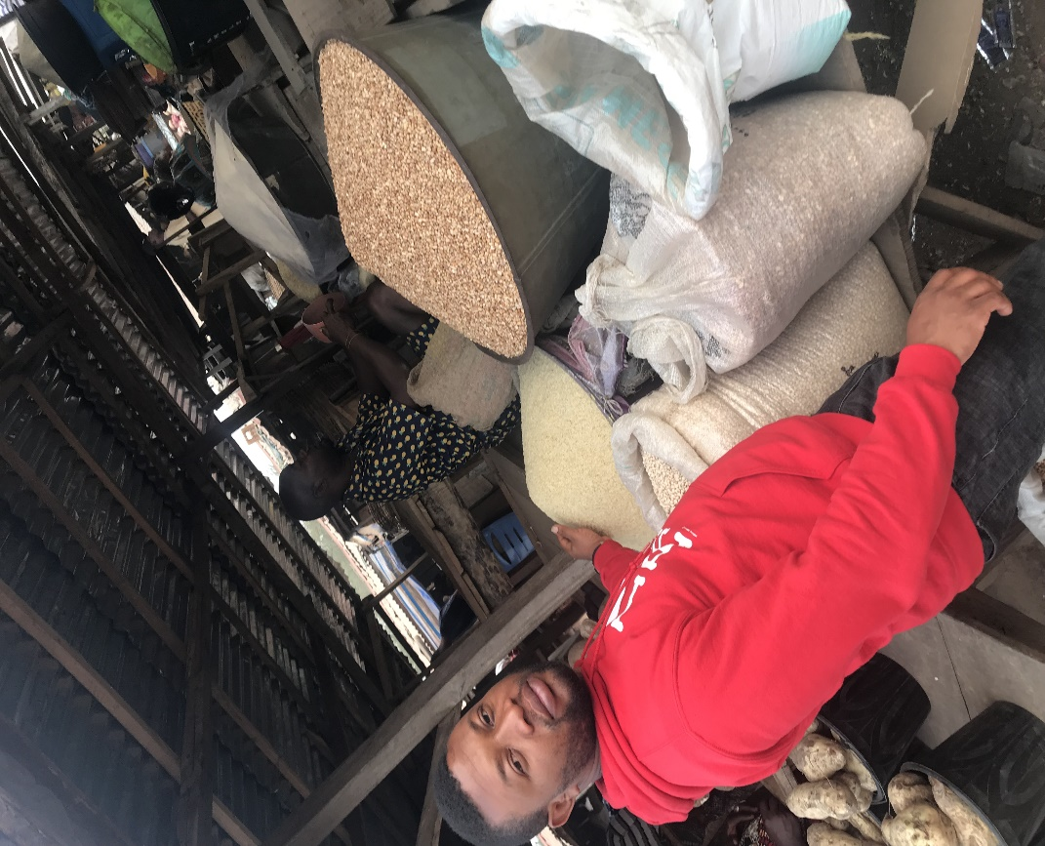

Appendix 1. Assessing some of the studied rice cultivars at market point of sale.

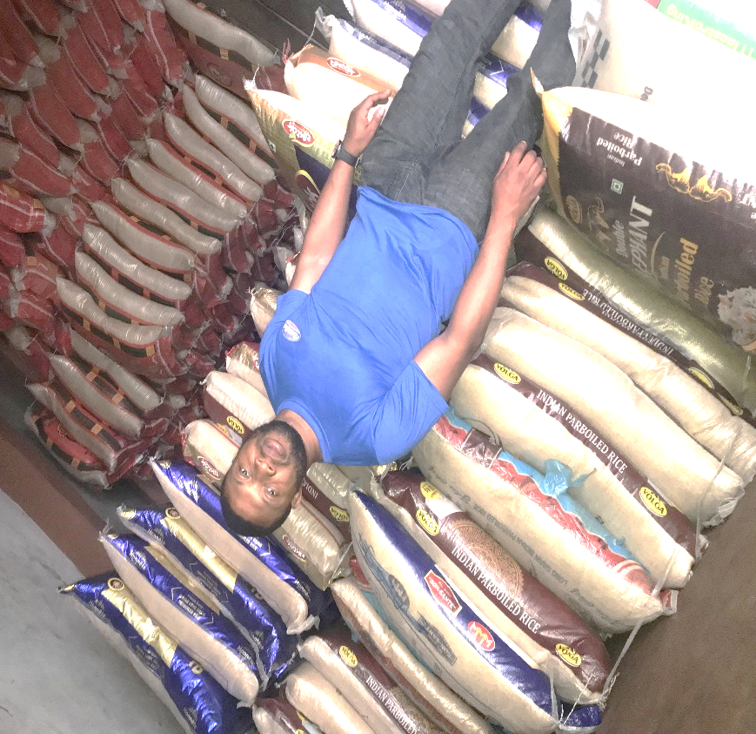

Appendix 2. Packaged samples of the studied rice cultivars at the warehouse.

Appendix 3. Sample analysis in the laboratory.

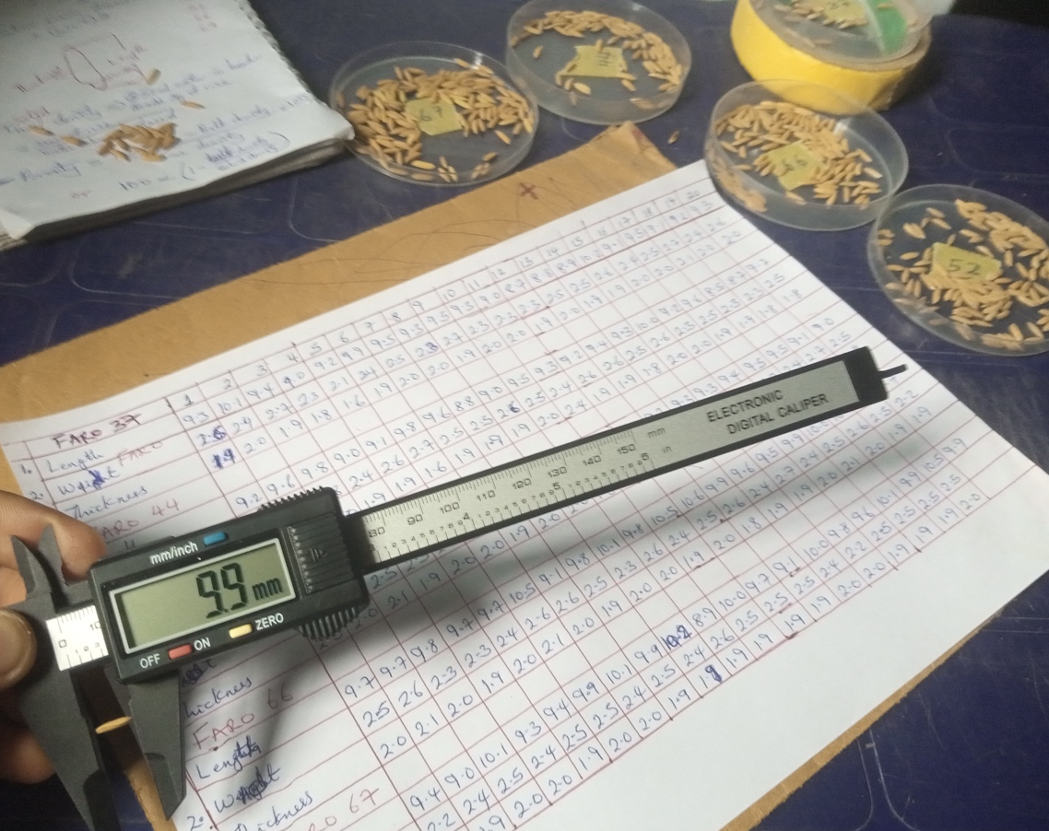
A

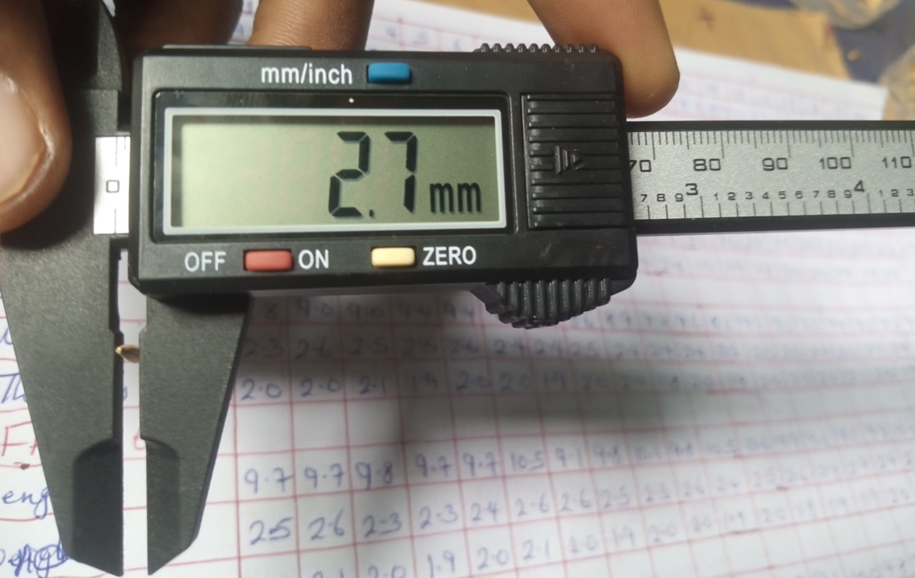
B

Appendix 4. Some pictures of morphometric analysis of the rice grains; A = Grain length, B = Grain width.

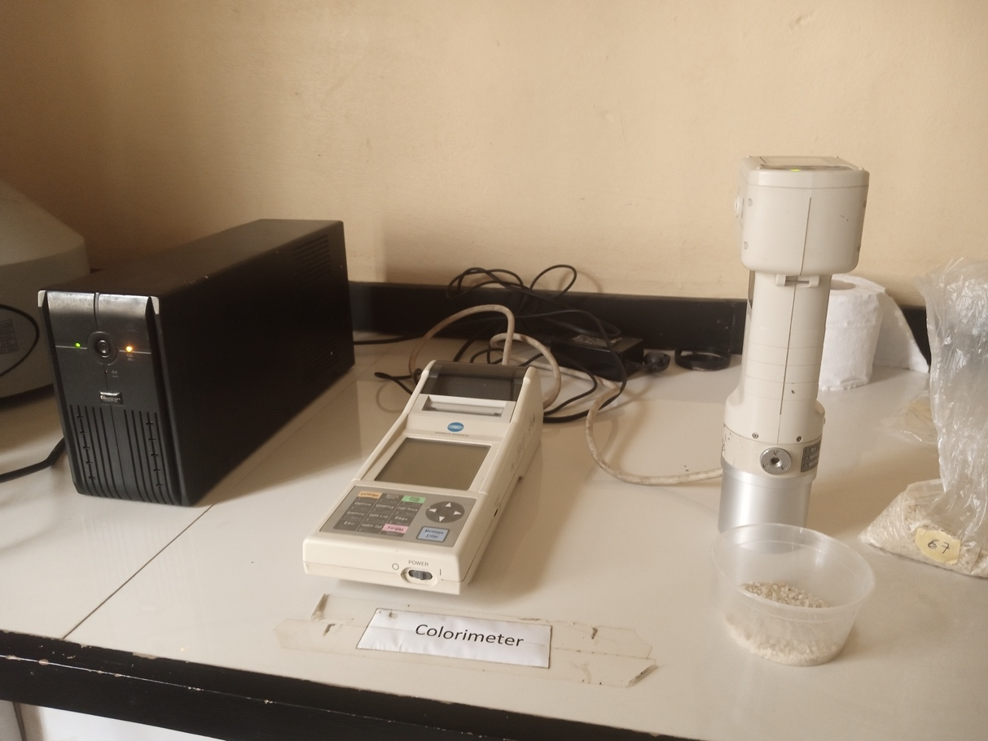

Appendix 5. Chroma Meter (CR-410) colorimeter used for grain colour analysis.

