Palacky University Olomouc
Faculty of Physical Culture

Game Position Impacts on Angle-Specific and Non-Angle-Specific Hamstring-to-Quadriceps Ratios in the Czech Republic First League Soccer Players

Umur Sisli. BSc.

Supervised by:
Javad Sarvestan. MSc.
Game Position Impacts on Angle-Specific and Non-Angle-Specific Hamstring-to-Quadriceps Ratios in the Czech Republic First League Soccer Players.
Umur Sisli. BSc.
Abstract
Background: Due to nature of soccer which hires constant contact with opponents, sudden sprinting, changing directions and repetitive landing, injuries are unavoidable part of it. Knee injuries in football are the most common, especially those to the anterior or posterior cruciate ligament (ACL/PCL) and hamstring strains. The most important step to avoid such injuries is to correctly identify the cause of the injuries by biomechanical tests, which shows us strength imbalances on specific muscle groups of the body. Some studies shown that strength imbalances in the quadriceps and hamstring muscles can play an important role in knee injuries.
Aims: The main aim of this study was to investigate differences between the functional hamstring to quadriceps (H:Qfunc) and conventional hamstring to quadriceps (H:Qconv) ratios between the Czech first league soccer players with different game positions.
Methods: This study adopted a cross-sectional study design. A total of 104 soccer players from the Czech Republic 1st league teams, including 11 goalkeepers, 34 defenders, 35 midfielders and 24 forwards. The participants performed the knee concentric extension/concentric flexion and eccentric extension/concentric flexion tests with their maximum strength. The maximal range of movement was defined between 180˚ (full knee extension) to 100˚, and the players performed the test at an angular velocity of 60˚/s for concentric/concentric contraction and 30˚/s for eccentric contraction. As for angle-specific H:Q ratio calculation, the hamstrings eccentric concentric angle-specific torque, at each knee-joint angle, was divided by the quadriceps concentric angle-specific torque, at the same knee-joint angle. For calculation of the non-angle-specific conventional H:Q ratio, the hamstrings eccentric and concentric peak torques were divided by the quadriceps concentric peak torque.
Results: The outcomes of this study shown that the non-angle specific conventional H:Q_{func} ratios were significanty more in forwards, compared with other game positions (p<0.001). This ratio, on the other hand, were almost similar between defenders and midfielder, where no significant differences were observed. Nevertheless, the peak and mean H:Q_{func} and H:Q_{conv} ratios of these 2 groups were significantly more than goalkeepers (p<0.001), which portrayed the least peak and mean H:Q_{func} and H:Q_{conv} ratios. As for the angle-specific ratios, One-Way ANOVA showed significant differences between the angle-specific H:Q_{func} ratios in the first 8% of knee flexion among the different game positions. Bonferroni post-hoc test portrayed a statistically significant difference between the angle-specific H:Q_{func} ratios of the goalkeepers and defenders (from 1% to 8% of knee flexion), goalkeepers and midfielders (in first 7% of knee flexion), defenders and midfielders (from 91% to 93% of knee flexion), defenders and forwards (from 4% to 10% of knee flexion), and midfielders and forwards (in first 8% of knee flexion).
Conclusions: Outcomes of this study portrayed although the peak and mean non-angle-specific H:Q_{func} and H:Q_{conv} ratios were signficantly lower among the goalkeepers in comparison with other game positions, but the angle-specific H:Q_{func} revealed that defenders and midfilders were more prone to the knee injuries due to their weak H:Q ratios. It highlights that angle-specific H:Q ratios could higlight the points that athletes are more succeptibe to injury, while the non-angle-specific H:Q could not picture it.
Table of contents
- Introduction | 07
- Aims | 10
- General aim | 10
- Specific aims | 10
- Research hypothesis | 11
- Confirmation/rejection criteria | 12
- Conceptual framework of the study | 12
- Methods | 12
- Study design | 12
- Setting | 13
- Participants | 13
- Procedure and instrument | 13
- Data analysis | 15
- Statistical analysis | 17
- Results | 18
- Discussion | 24
- Limitations | 28
- Conclusion | 28
- References | 29

List of figures:
Figure caption | Page
Figure 1. Manner of performing the concentric knee flexion/extension from 180° (full-extension) to 100°. | 15
Figure 2. Angle-specific H:Qfunc ratios from 180° knee full extension to 110° knee extension in goalkeepers, defenders, midfielders and forwards. | 21
Figure 3. One-Way ANOVA (a) showed significant differences between the angle-specific H:Qfunc ratios in the first 8% of knee flexion among the different game positions. Bonferroni post-hoc test (b) highlighted (in purple) the precise angle-specific H:Qfunc ratios differences between individual game positions. | 22
Figure 4. Angle-specific H:Qconv ratios from 180° knee full extension to 110° knee extension in goalkeepers, defenders, midfielders and forwards. | 23
Figure 5. One-Way ANOVA (a) showed significant differences between the angle-specific H:Qconv ratios in the first 12% of knee flexion among the different game positions. Bonferroni post-hoc test (b) highlighted (in cyan) the precise angle-specific H:Qconv ratios differences between individual game positions. | 23

List of tables:
Table titles | Page
Table 1. Physical characteristics of the goalkeepers, defenders, midfielders and forwards. | 18
Table 2. Differences between age, height, weight and BMI of goalkeepers, defenders, midfielders and forwards (ANOVA). | 19
Table 3. Non-angle-specific peak and mean H:Q_{func} and H:Q_{conv} ratios in goalkeepers. defenders. midfielders and forwards. | 20
Table 4. Differences between non-angle-specific peak and mean H:Q_{func} and H:Q_{conv} of goalkeepers, defenders, midfielders and forwards (Checked by ANOVA). | 20

- INTRODUCTION
With the range of 10 to 12-kilometre travelling, over than 200 sprintings, and various types of tackling, kicking and jumping per match, soccer players suffer a wide spectrum of loads in lower extremities joints (Mohr, Krustrup, & Bangsbo, 2003). It has been brought up that soccer-specific activities could be linearly related to the player’s game position (Carvalho & Cabri, 2007; Mohr et al., 2003). Certain physical parameters, including strength status or speed, could develop due to the demands of specific game positions (Carvalho & Cabri, 2007; Weber, Silva, Radaelli, Paiva, & Pinto, 2010). Given that muscle strength is the backbone of the entire movements in soccer (e.g., jumping, tackling, change of direction speed), individual players’ tasks (from different game positions) could modify either strength or asymmetry in lower limbs muscles strengths (Goulart, Dias, & Altimari, 2007; Tourny-Chollet, Leroy, Léger, & Beuret-Blanquart, 2000).
Muscular strength is an essential contributor to athletic performance. It is well documented that muscular strength is vital in reducing the risk of injury in athletes and enrich their capabilities for performing necessary skilled movements safely (Hewett, 2000). The strength profiles of the knee joint extensors and flexors could feed the strength trainers with the lower limbs muscular adaptations to the training programs, and the physiotherapists with any risks of injury as a result of muscle imbalances (Ortmaier et al., 2020; Voutselas, Papanikolaou, Soulas, & Famisis, 2007). To this effect, monitoring the knee joint strength status could provide both athletes and trainers with any strength or weakness points and warn them if there would be any potential injury risk factors.
Knee joint muscle imbalances are being abundantly highlighted as the most probable risk factor for hamstring strains and also non-contact knee joint ligament injuries, (Yeung, Suen, & Yeung, 2009). Hamstring strains, highlighted as the most prevalent injuries among the soccer players (with 12-16% injury rate), are the main cause of quitting the sports career (Woods, Hawkins, Hulse, & Hodson, 2003). Woods et al. (2003) reported that individual soccer players roughly missed 90 training days and 15 matches annually due to hamstring strains. This numbers could increase up to 6 to 9 months for the injuries to the anterior cruciate ligaments (ACL).
ACL ruptures are placed at top of the most prevalent non-contact injuries, particularly among soccer players (Alentorn-Geli et al., 2009a, 2009b; Hewett, 2000). Biomechanically, the produced anterior-directed sheer force to the proximal tibial during landing (mainly by quadriceps to control landing manoeuvre) results in forward translation of the tibia and excessive forward gliding movement in the knee joint, and end up with ACL rupture (Boden, Sheehan, Torg, & Hewett, 2010). This could be exacerbated by a sudden external rotation in the femur (Boden et al., 2010). Former studies brought up that hamstring and quadriceps imbalances could highly increase the rate of non-contact ACL injury (Croisier, Forthomme, Namurois, Vanderthommen, & Crielaard, 2002; Myer et al., 2009). Therefore, investigation through the strength ratios between the hamstring-to-quadriceps (H:Q) muscles could provide us with useful information about the safety zones of the ACL.
Reciprocal H:Q ratio is consistently employed to describe the knee dynamic stability, detect the non-contact knee joint risk factors, and to determine the return-to-play time among injured athletes (Ayala, Croix, de Baranda, & Santonja, 2012; Devan, Pescatello, Faghri, & Anderson, 2004). As for monitoring the knee joint muscle imbalances, various methods have been undertaken to analyse the knee joint status (Aagaard, Simonsen, Magnusson, Larsson, & Dyhre-Poulsen, 1998; El-Ashker, Allardyce, & Carson, 2019; Evangelidis, Pain, & Folland, 2015; Sousa et al., 2019). Functional (H:Q_{func}) and Conventional (H:Q_{conv}) H:Q ratios are the generally adopted approaches in the analysis of knee joint muscle imbalances (El-Ashker et al., 2019; Evangelidis et al., 2015). Within the reported literature, the H:Q_{func} was calculated by dividing the eccentric hamstrings peak torque by the concentric quadriceps peak torque, while the H:Q_{conv} was calculated by dividing the concentric hamstrings peak torque by the concentric quadriceps peak torque (Aagaard et al., 1998; Evangelidis et al., 2015). Nevertheless, since the angle of reaching to the peak quadriceps torque is different than the angle of reaching to the peak hamstrings torque, this value could not be a proper scale for predicting or anticipating the injury risk factors.
When assessing the H:Q_{func} ratio, athletes who score an equivalent to 1 are in the secure knee joint zone, while this ratio for the H:Q_{conv} is considered equal to 0.6 to 0.7 (Aagaard et al., 1998; Aagaard, Simonsen, Trolle, Bangsbo, & Klausen, 1995; Hughes & Watkins, 2006). The ratios of less than 0.6 are highlighted to be directly linked with a 17-fold increase in the hamstring risk of injuries, and also considered at a greater risk of ACL injury (Yeung et al., 2009). Hence, the H:Q function could be considered as a proper scale for anticipating the hamstring and ACL injuries, and also help the trainers and physiotherapists with planning the interventions that aid in the increment of the injury risks.
Former studies have tried to analyse the lower extremities muscle imbalances among large groups of soccer players (Croisier, Ganteaume, Binet, Genty, & Ferret, 2008; Fousekis, Tsepis, & Vagenas, 2010; Ruas, Minozzo, Pinto, Brown, & Pinto, 2015; Tourny-Chollet et al., 2000). Tourny-Chollet et al. (2000) studied the average and relative torque values of hamstrings and quadriceps in both eccentric and concentric conditions among defenders (n=7), midfielders (n=5) and attackers (n=7). They found significant differences between the concentric hamstring torque values at the angular velocity of 60°/s among the studied groups. In another study, Ruas et al. (2015) investigated the non-angle-specific H:Q_{func} and H:Q_{conv} ratios among goalkeepers, side backs, central backs, midfielders and forwards. They reported no significant differences between the game positions, and only found significant differences between the H:Q_{func} ratios of preferred and nonpreferred legs. In a uniquely designed study, Evangelidis et al. (2015) investigated the differences between angle-specific isometric H:Q_{func} and H:Q_{conv} ratios between soccer players and normal active participants in 105°, 120°, 135°, 150° and 165° of knee angles. In this study, however, no differences were observed among the participants. More recently, Andrade et al. (2020) tried to study the angle-specifc differences between the three groups of girl soccer players, aged from 11 to 18. Although they did not adopt the angle-specific data from time series in their studies, no significant difference was distinguished among the groups. On the whole, no study investigated the angle-specific H:Q_{func} and H:Q_{conv} ratios at each data point of the recorded data to precisely scrutiny the risk factors for the non-contact knee injuries at each specific angle or angle zones.
According to the background covered throughout the introduction, although various research studies are tried to investigate the non-angle-specific and angle-specific H:Q_{func} and H:Q_{conv} ratios among different sample groups or dominant and non-dominant legs in soccer players, there is lack of sufficient knowledge about how the game position could potentially impact the angle-specific H:Q_{func} and H:Q_{conv} throughout the knee joint range of motion. Furthermore, since the peak torque was independent of knee-joint angle, the peak H:Q_{func} and H:Q_{conv} ratios may not be a good scale for prediction of the non-contact knee joint injury risk factors. Investigations on this topic could increase our perspective that to what extend any soccer player is at risk of non-contact knee injuries due to his game position-related tasks and requirements.

- AIMS
  - General aim
The main aim of this study was to investigate differences between the H:Q_{func} and H:Q_{conv,} respectively) ratios between soccer players with different game positions.
  - Specific aims
- To investigate the differences between non-angle-specific functional hamstring to quadriceps (H:Q_{func}) ratios between goalkeepers, defenders, midfielders and forwards.
- To investigate the differences between angle-specific functional hamstring to quadriceps (H:Q_{func}) ratios between goalkeepers, defenders, midfielders and forwards.
- To investigate the differences between non-angle-specific conventional hamstring to quadriceps (H:Q_{conv}) ratios between goalkeepers, defenders, midfielders and forwards.
- To investigate the differences between angle-specific conventional hamstring to quadriceps (H:Q_{conv}) ratios between goalkeepers, defenders, midfielders and forwards.
  - Research hypothesis
H1. and H2. There is a difference between non-angle-specific and angle-specific H:Q_{func} ratios between soccer players with different game positions.
Rationale: It has been highlighted that the produced quadriceps hamstring peak torques were significantly higher in goalkeepers compared with the side backs, midfielders and forwards (Ruas et al., 2015). Furthermore, it has been brought up that players’ tasks, regarding their field position, may modify the lower extremities’ strength (Tourny-Chollet et al., 2000). To this effect, it has been expected that different game positions would result in different non-angle-specific and angle specific H:Q_{func} ratios among the goalkeepers, defenders, midfielders and forwards.
H3. and H4. There is a difference between non-angle-specific and angle specific H:Q_{conv} ratios between soccer players with different game positions.
Rationale: Similar as H1 and H2, former studies brought up that the game position would impact the concentric to concentric torque ratios (functional ratios) between the soccer players (Weber et al., 2010). Hence, it was speculated that the non-angle-specific and angle specific H:Q_{conv} ratios would be significantly different among the goalkeepers, defenders, midfielders and forwards.
  - Confirmation and rejection criteria
In this study, we did calculate and compared the angle-specific and non-angle-specific H:Qconv ratios among goalkeepers, defenders, midfielders and forwards. Hence, the confirmation criteria were any statistically significant differences between angle-specific and non-angle-specific H:Qconv ratios of the goalkeepers, defenders, midfielders and forwards. On the other hand, the hypotheses were rejected in case no statistically significant differences were observed between the angle-specific and non-angle-specific H:Qconv ratios among selected soccer players.
  - Conceptual framework of the study
In this study, the differences between angle-specific and non-angle-specific H:Qconv ratios were analysed among four different game positions (goalkeepers, defenders, midfielders and forwards) in the Czech Republic first league soccer players. It was expected that angle-specific and non-angle-specific H:Qconv ratios would be significantly different between different game positions due to their particular defined duties regarding their positions. To this end, the non-angle-specific and the angle-specific H:Qconv ratios were considered as the dependent variable. This study also considered the game position as an independent variable. Several other parameters such as age, fatigue and fitness level are considered as moderating variables, while the state of mind and psychological factors are considered as mediators in this study.
- METHODS
  - Study design
This study adopted a cross-sectional study design.
  - Setting
Biomechanical laboratory.
  - Participants
A total of 104 soccer players, including 11 goalkeepers, 34 defenders, 35 midfielders and 24 forwards, voluntarily participated in this study. All the participants were recruited from the Czech Republic 1st league teams, including F.C. MFK Karvina, F.C. Slovacko, F.C. Fastav Zlin, and F.C. Banik Ostrava. Of the inclusion criteria, the players were required to be engaged in a soccer training routine with a minimum frequency of four times a week, for two years, and additionally, strength training two times a week. No history of muscle or ligament rupture or surgery, joint laxation and bone fracture within the previous 12 months of the measurement was reported by the participants (Gribble et al., 2013). During the measurement, no acute pain was reported by participants. The entire measurement protocol, aims, measurement-related risks of injury and benefits, as well as the objectives and justification of the research, was comprehensively explained to individuals. The Palacky University’s Institutional Review Board ethically approved this study and the entire participants signed the written informed consent, which meets the ethical standards of the Declaration of Helsinki.
  - Procedure and instruments
Prior to the measurement, the following tests were conducted to identify lower limb dominance: 1) the Ball Kick Test, and 2) the Balance Recovery Test (Lim & Yoon, 2014; Schrodt, Mercer, Giuliani, & Hartman, 2004). The limb that was predominantly employed to perform the above-mentioned tasks was detected as functionally dominant. Thereafter, following a 15-minute dynamic cardiovascular warm-up, including 5-minute cycling on a stationary Kettler ergometer (Heinz Kettler GmbH and Co. KG, Ense-Parsit, Germany), with an exercise workload of 1.5 W/kg BW at a constant 70 rpm pedal rate (Dirnberger, Kösters, & Müller, 2012; Roth, Donath, Kurz, Zahner, & Faude, 2017), and several dynamic stretching exercises of the lower extremity muscles (Verstegen & Williams, 2004), the participants prepared for the test.
Forthwith the participants were seated on the Iso-Med 2000 isokinetic dynamometer (D&RFerstl, Hemnau, Germany) with the hip joint at 75˚ (full hip extension was defined as 0˚, level 1 seat height) to perform the knee extension/flexion test (Dirnberger et al., 2012). The shoulders, chest, hip and femur were fixed by adjustable pads and straps to provide the most isolated position possible (Roth et al., 2017). Participants were asked to maintain their hands on their chest, to minimize the effects of the upper extremities strength on the moment produced. Using the mechanical axis (on dynamometer’s head), the lateral femoral epicondyle was located as the joint centre of rotation, and the dynamometer shin brace was set approximately 3 cm above the lateral malleolus. The thigh-shank alignment with the dynamometer rotational axis during active muscle contractions was accurately checked by the examiner. Thereafter, the mechanical stops were fixed at two maximum flexion and extension ends to prevent any unpredicted errors of the dynamometer adaptor and maximize the safety. In order to check the neutral position of the ankle during the test, and also easier manipulation of the ankle position by the researcher, the players were asked to take off their shoes.
The participants, in the familiarization phase, were then asked to execute the test three times with roughly 50% of the maximal force, 75% of the maximal force, and the maximum possible force, respectively, interseparated with 15 seconds of rest. Then, the gravity compensation procedure was carried out to counterbalance the weight of the tested leg. The maximal range of movement (ROM) was defined between 180˚ (full knee extension) to 100˚, and the players performed the test at an angular velocity of 60˚/s for concentric/concentric contraction and 30˚/s for eccentric contraction (Figure 1) (Davies, Riemann, & Ellenbecker, 2018; Evangelidis et al., 2015; Sarvestan, Kovacikova, Linduska, Gonosova, & Svoboda, 2020).
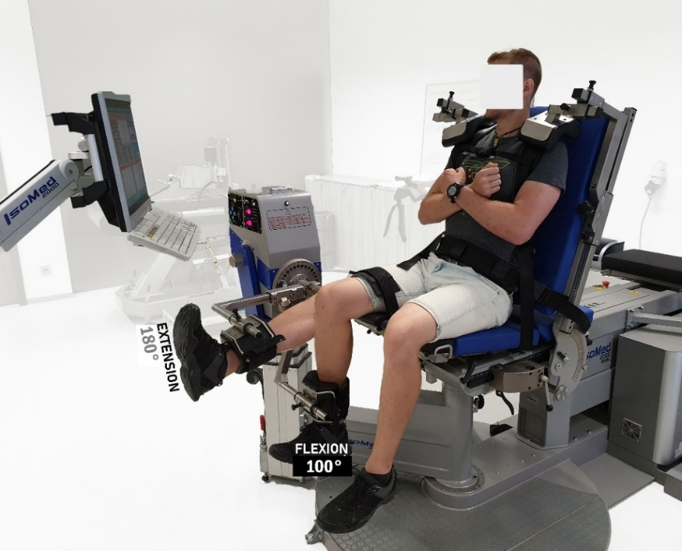 | Figure 1. Manner of performing the concentric knee flexion/extension from 180° (full-extension) to 100°.

The maximum strength of knee extensors and flexors was measured using four concentric contractions, separated by 15-s periods of rest. During the test, the ankle joint was ensured to be in a neutral position to avert unwanted calf muscle cramps. The second limb was immediately tested in the same manner, during which the individual settings were automatically activated, rechecked, and adjusted if necessary. All along with the testing procedure, the participants were requested to keep the maximum force throughout the entire ROM, while they were provided with visual feedback from the researcher.
  - Data analysis
The average of four isotonic contractions of both legs in flexion and extension movements was extracted for further analysis. The IsoMed Analyze V.1.0.5 (D. & R. Ferstl GmbH, Hemau, Germany) was employed for data recording and reduction. Peak torque and power of knee extensors and flexors were the variables extracted in the first analysis. All mentioned variables were normalized by the body mass to calculate relative measures. Afterwards, the average values of relative peak torque and peak power of both legs were calculated as the general lower limb strength and used for further statistical analysis.
As for angle-specific H:Q ratio calculation, the isotonic torque-knee-joint angle data for each muscle group, from 110° to the 180° of knee flexion, was smoothed by applying 2nd order polynomial curve fitting to the raw torque measures (torque data interpolation between 0 to 101) (Evangelidis et al., 2015). Then, the hamstrings concentric angle-specific torque, at each knee-joint angle, was divided by the quadriceps concentric angle-specific torque, at the same knee-joint angle (Equation 1) (Aagaard et al., 1998; Evangelidis et al., 2015).
$H:Q_{CONVθ}= H_{CONθ} /Q_{CONθ}$ (1)
While for calculation of the non-angle-specific conventional H:Q ratio, the hamstrings concentric peak and mean torques were divided by the quadriceps concentric peak torque (Equation 2) (Evangelidis et al., 2015).
$H:Q_{CONV}= H_{CON} /Q_{CON}$ (2)
Since the peak torque was independent of knee-joint angle, the peak torque values for each trial was placed at different angles. In order to calculate the H:Q_{func}, the hamstrings eccentric angle-specific torque, at each knee-joint angle, was divided by the quadriceps concentric angle-specific torque, at the same knee-joint angle (Equation 3) (Aagaard et al., 1998; Evangelidis et al., 2015).
$H:Q_{FUNCθ}= H_{ECCθ} /Q_{CONθ}$ (3)
And for calculation of the non-angle-specific conventional H:Q ratio, the hamstrings eccentric peak and mean torques were divided by the quadriceps concentric peak torque (Equation 4) (Evangelidis et al., 2015).
$H:Q_{FUNC}= H_{ECC} /Q_{CON}$ (4)
The contractions that the players were not successful to reach the maximal applied torque throughout the ROM were discarded. Data analysis was performed using the MATLAB software (v. 2020a, MathWorks, Inc., Natick, MA, USA).
  - Statistical analysis
The Shapiro-Wilk statistical test was used to check the normality of variable distribution. Then, the Levene test was employed to assess the equality of variances. One-way ANOVA was utilized to analyse the differences between the non-angle-specific H:Q_{conv} and H:Q_{func} ratios, peak torque and peak power of the goalkeepers, the defenders, the midfielders and the forwards. When significant group-by-group interactions were present, Bonferroni posthoc correction was employed to identify the specific differences. Analysis of the time series data (the angle-specific H:Q_{conv} and H:Q_{func} ratio throughout the knee ROM), were performed employing the spm1d package (v0.4.3) (www.spm1d.org). The effect size was estimated using Cohen’s d, and the values were interpreted as follows: d < 0.2 = small effect size, 0.2 < d < 0.8 = moderate effect size and d > 0.8 = large effect size (Urdan, 2016). The significance level was set at α = 0.05. The entire statistical analyses were performed using SPSS (version 26.0, IBM Corp., Armonk, NY, USA) and MATLAB (v. 2020a, MathWorks, Inc., Natick, MA, USA).
- RESULTS
Variable distribution was approved by the Shapiro-Wilk test, and variability by the Levene test. Physical characteristics of the goalkeepers, defenders, midfielders and forwards are summarized in table 1. The One-Way Analysis of Variance (ANOVA) test showed a significant difference between the height and weight measures of the entire groups (p<0.05), except the defenders and forwards groups (Table 2).
Table 1. Physical characteristics of the goalkeepers, defenders, midfielders and forwards.
 | Goalkeeper  n=11 | Defender  n=34 | Midfielder  n=35 | Forward  n=24
Age (years) | 25.73±5.67 | 26.44±5.42 | 25.6±4.74 | 26.04±4.31
Height (cm) | 189.82±2.64* | 182.62±4.46* | 178.34±5.98* | 185.17±4.54*
Body mass (kg) | 84.73±3.58* | 77.21±4.68* | 72.63±5.17* | 76.83±5.10*
BMI (kg/m²⁾ | 23.52±0.98 | 23.17±1.54 | 22.89±2.03 | 22.40±1.25
*. The mean difference is significant at the 0.05 level between all groups, except the defenders-forwards (Bonferroni correction posthoc test).

Table 2. Differences between age, height, weight and BMI of goalkeepers, defenders, midfielders and forwards (ANOVA).
 |  | Sum of Squares | df | F | Sig. | d
Age | Between Groups | 13.070 | 3 | .167 | .918 | .07
 | Within Groups | 2583.921 | 99
 | Total | 2596.990 | 102
Height | Between Groups | 1358.892 | 3 | 18.709 | .000 | .75
 | Within Groups | 2396.856 | 99
 | Total | 3755.748 | 102
Weight | Between Groups | 1286.764 | 3 | 18.199 | .000 | .74
 | Within Groups | 2333.216 | 99
 | Total | 3619.981 | 102
BMI | Between Groups | 12.208 | 3 | 1.537 | .210 | .22
 | Within Groups | 262.113 | 99
 | Total | 274.321 | 102

As it is depicted in tables 3 and 4, the peak and mean H:Q_{func} and H:Q_{conv} ratios were significantly more in forwards, compared with other game positions (p<0.001). This ratio, on the other hand, were almost similar between defenders and midfielder, where no significant differences were observed. Nevertheless, the peak and mean H:Q_{func} and H:Q_{conv} ratios of these 2 groups were significantly more than goalkeepers (p<0.001), which portrayed the least peak and mean H:Q_{func} and H:Q_{conv} ratios.

Table 3. Non-angle-specific peak and mean H:Q_{func} and H:Q_{conv} ratios in goalkeepers. defenders. midfielders and forwards.
 | Goalkeeper  n=11 | Defender  n=34 | Midfielder  n=35 | Forward  n=24
H:Q_{func} Peak | 0.71±0.12* | 0.79±0.14* | 0.78±0.12* | 0.84±0.16*
H:Q_{func} Mean | 0.73±0.14* | 0.83±0.14* | 0.81±0.13* | 0.92±0.17*
H:Q_{conv} Peak | 0.57±0.13* | 0.65±0.11* | 0.67±0.09* | 0.78±0.12*
H:Q_{conv} Mean | 0.69±0.16* | 0.75±0.14* | 0.73±0.08* | 0.80±0.09*
*. The mean difference is significant at the 0.01 level between all groups, except the defenders-midfielders (Bonferroni correction posthoc test).

Table 4. Differences between non-angle-specific peak and mean H:Q_{func} and H:Q_{conv} of goalkeepers, defenders, midfielders and forwards (Checked by ANOVA).
 |  | Sum of Squares | df | F | Sig. | d
H:Q_{func} Peak | Between Groups | 15.188 | 3 | 17.011 | .000 | .79
 | Within Groups | 24.368 | 99
 | Total | 42.556 | 102
H:Q_{conv} Peak | Between Groups | 13.074 | 3 | 15.934 | .000 | .72
 | Within Groups | 25.459 | 99
 | Total | 38.533 | 102
H:Q_{func} Mean | Between Groups | 14.502 | 3 | 16.250 | .000 | .73
 | Within Groups | 27.291 | 99
 | Total | 41.793 | 102
H:Q_{conv} Mean | Between Groups | 16.047 | 3 | 15.741 | .000 | .71
 | Within Groups | 31.508 | 99
 | Total | 47.555 | 102

As for the angle-specific ratios, the H:Q_{func} ratios of all four groups were approximately 1 in full knee extension (180°), and moved above 1 in first 15% of the knee flexion (figure 2). Afterwards, this ratio decreased and shifted below 1 from 15% to the end of the movement (110 of knee extension) in defenders, midfielders and forwards. Goalkeepers, in last 10% of the movement, portrayed a different pattern, where their angle-specific H:Q_{func} ratios increased to the maximum ratio of 1.3. One-Way ANOVA showed significant differences between the angle-specific H:Qfunc ratios in the first 8% of knee flexion among the different game positions (figure 3). Bonferroni post-hoc test portrayed a statistically significant difference between the angle-specific H:Q_{func} ratios of the goalkeepers and defenders (from 1% to 8% of knee flexion), goalkeepers and midfielders (in first 7% of knee flexion), defenders and midfielders (from 91% to 93% of knee flexion), defenders and forwards (from 4% to 10% of knee flexion), and midfielders and forwards (in first 8% of knee flexion).
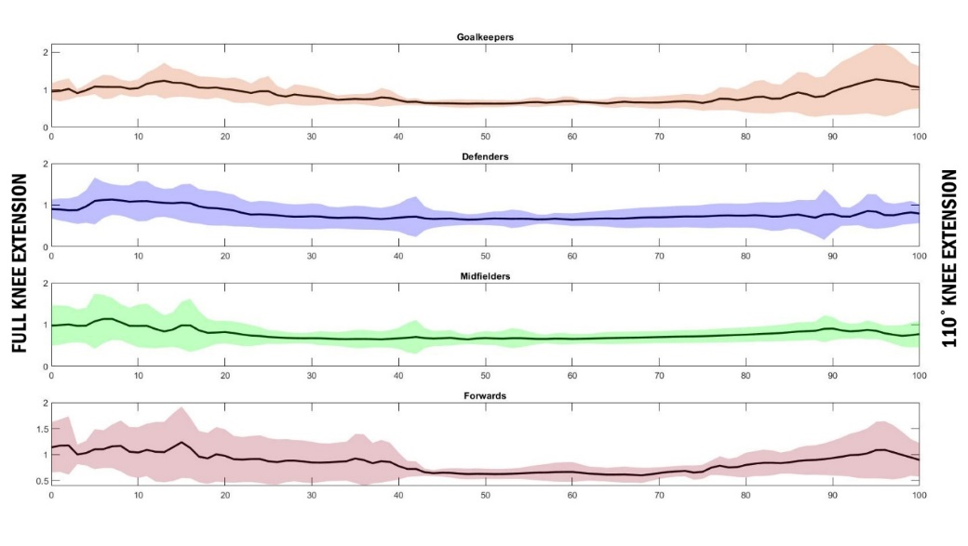 | Figure 2. Angle-specific H:Q_{func} ratios from 180° knee full extension to 110° knee extension in goalkeepers, defenders, midfielders and forwards.

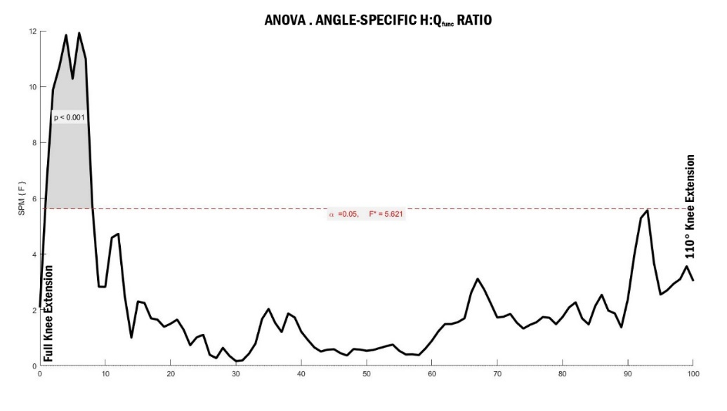  a | Figure 3. One-Way ANOVA (a) showed significant differences between the angle-specific H:Q_{func} ratios in the first 8% of knee flexion among the different game positions.  Bonferoni post-hoc test (b) highlighted (in purple) the precise angle-specific H:Q_{func} ratios differences between individual game positions.
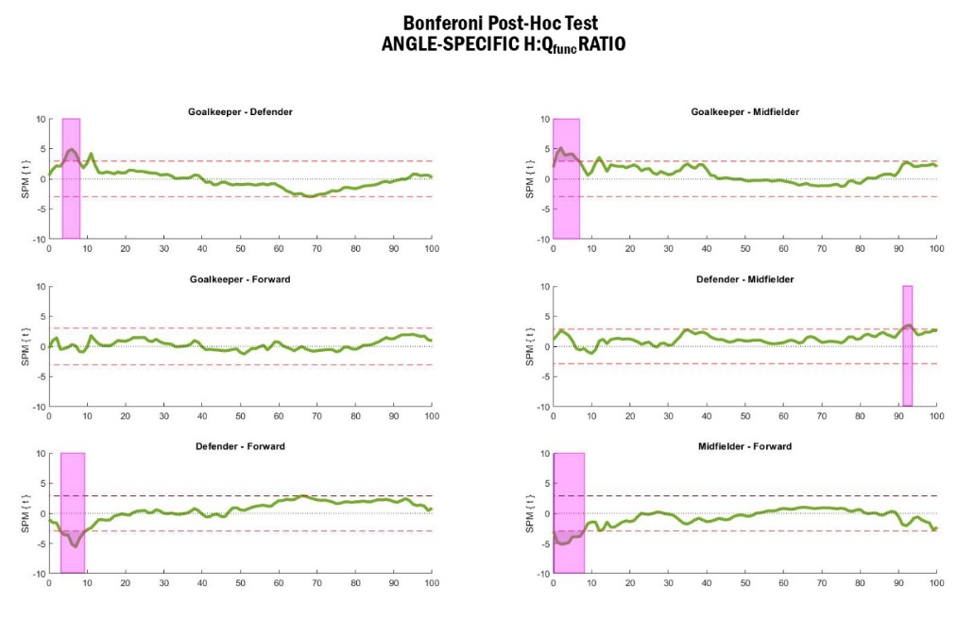
b

Slightly different, the angle-specific H:Q_{conv} ratios of the entire groups were less than 1 in full knee extension (180°), and remained below 1 throughout the whole ROM, except the first 15% of the goalkeepers (figure 4). This ratio also moved to below 0.55 from 50% to 93% for the goalkeepers. One-Way ANOVA showed significant differences between the angle-specific H:Qconv ratios in the first 12% of knee flexion among the different game positions (figure 5). Results from Bonferroni post-hoc test revealed a statistically significant difference between the angle-specific H:Q_{conv} ratios of the goalkeepers and defenders (from 6% to 8% of knee flexion), goalkeepers and midfielders (in first 14% of knee flexion), defenders and midfielders (in first 17% of knee flexion), defenders and forwards (from 6% to 9% of knee flexion), and midfielders and forwards (in first 20% of knee flexion).
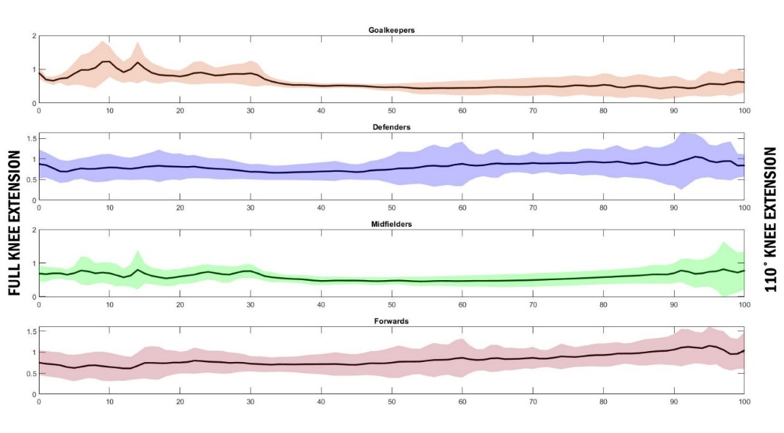 | Figure 4. Angle-specific H:Q_{conv} ratios from 180° knee full extension to 110° knee extension in goalkeepers, defenders, midfielders and forwards.

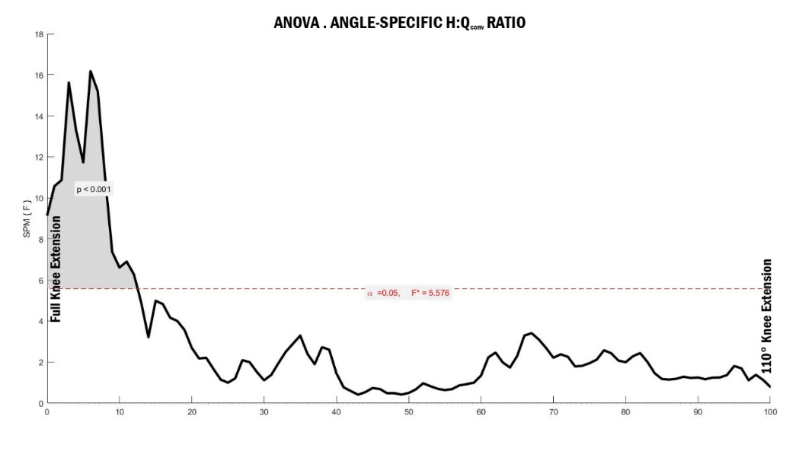  a | Figure 5. One-Way ANOVA (a) showed significant differences between the angle-specific H:Q_{conv} ratios in the first 12% of knee flexion among the different game positions.  Bonferroni post-hoc test (b) highlighted (in cyan) the precise angle-specific H:Q_{conv} ratios differences between individual game positions.
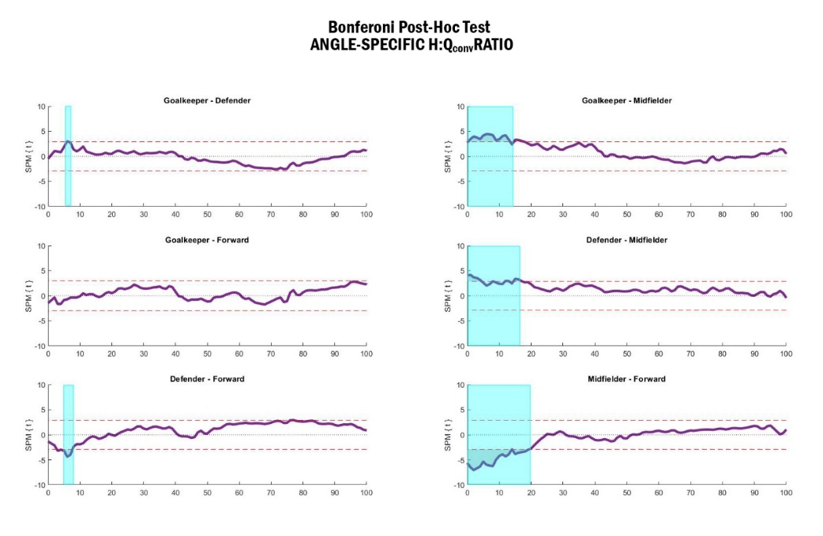
b

- DISCUSSION
This study was designated to investigate the differences between the non-angle-specific and angle-specific H:Q_{func} and H:Q_{conv} ratios of soccer players based on their game positions. 104 soccer players, including 11 goalkeepers, 34 defenders, 35 midfielders and 24 forwards performed knee eccentric and concentric flexion/extension tests at the angular velocities of 30°/s and 60°/s, respectively. The main outcomes of this study revealed significant differences between the non-angle-specific of H:Q_{func} and H:Q_{conv} ratios among all four groups. The analysis of the time series data also showed a significant difference between angle-specific of H:Q_{func} and H:Q_{conv} ratios of all four groups in the first 8% and 12% of the knee flexion phase, respectively.
In this study the non-angle-specific the peak and the mean H:Q_{func} ratios were significantly lower in goalkeepers (0.71 and 0.73 respectively), compared with the rest of the players in different game positions. In this regard, forwards portrayed significantly higher values of peak (0.84) and the mean (0.92) H:Q_{func} ratios compared with all players from different positions. These ratios were slightly higher than the non-angle-specific of H:Q_{func} ratios reported by Ruas et al. (2015), where the average non-angle-specific H:Q_{func} ratios were approximately 0.79 among different game positions in soccer players. Similarly, the reported ratios in this study were considerably higher than the ratios of the soccer players in the study conducted by Correia et al. (2020), where the non-angle-specific of H:Q_{func} ratios for 12 uninjured soccer players were 0.73. According to the knee joint safety zone reported by Aagaard et al. (1998), and also the outcomes of the reported studies, results of this study show that, on general, the functional stability of the knee joint is in proper levels for the Czech Republic 1st league soccer players, regardless of their game positions. Nevertheless, this fact must not be ignored that the game position had a significant impact on this ratio among soccer players, as the forward players had the highest ratios, midfielders and defenders had roughly similar ratios and the goalkeepers recorded the least ratios.
Similarly in the non-angle-specific the peak and the mean H:Q_{conv} ratios, goalkeepers recorded considerably low ratios compared with other game positions, while the forwards, suchlike the H:Q_{func} ratios, had relatively better status. These H:Q_{conv} ratios for the goalkeepers were also lower than the average H:Q_{conv} ratios reported for all soccer players by Voutselas et al. (2007) (0.67). In one of the current studies, which reported almost similar results as the goalkeepers in this study, Correia et al. (2020) reported the H:Q_{conv} ratios of 0.55 for 12 uninjured soccer players, which were even less than the minimum range reported by (Aagaard et al., 1998). Another study, carried out by Clemente, Nikolaidis, Rosemann, and Knechtle (2019), reported approximately higher H:Q_{conv} ratios (0.70) in soccer players after training programs, compared with formerly reported studies. These outcomes highlight that the midfielders, defenders and forwards playing in the Czech Republic 1st league are in the safety zone for the knee stability; however, the goalkeepers are in demands of higher knee flexors’ strength training. Nevertheless, from a different perspective, although the goalkeepers are shown to have less H:Q_{conv} ratios, but to what extent this ratio could be dangerous for their knee safety? Having a different view to this point, we realize that most of the actions happening in the soccer, expecially for the goalkeepers, such as landing or decelration, are in demands of concentric quadriceps/eccentric hamstring activity. To this end, admitting the fact that the H:Q_{conv} ratios were considerably less for the goalkeepers, this may not be so crititcal to their knee joint safety.
Regardless of the results discussed in last 2 paragraphs, there is still controversial debate on the fact that peak H:Q ratios might not be the best scale for predicting the knee joint safety zone since different knee angles are reported for the peak hamstring and quadriceps maximum produced torque (Evangelidis et al., 2015). To this end, in the first inventional analysis, we compared the non-angle-specific mean H:Q_{func} and H:Q_{conv} ratios among different game positions. Yet, similar differences could be observed in the non-angle-specific mean H:Q_{func} and H:Q_{conv} ratios of the players, while these ratios were more than non-angle-specific peak H:Q_{func} and H:Q_{conv} ratios. These outcomes, afresh, portray significantly weaker H:Q ratios among goalkeepers and stronger among forwards H:Q ratios, and as a result, could be considered to have same value as non-angle-specific peak H:Q ratios.
In a more recent method adopted to study the knee joint risks of injuries, the angle-specific H:Q_{func} and H:Q_{conv} ratios have been studied to investigate the climax hazardous muscle strength imbalance throughout the knee joint range of motion (El-Ashker et al., 2019; Evangelidis et al., 2015). Evangelidis et al. (2015) compared the angle-specifc H:Q_{func} and H:Q_{conv} ratios between the soccer players and normally active people, and found no significant differences; however, they have calculated the ratios from similar eccentric/concentric velocities. The reported angle-specific H:Q_{func} ratios for the ordinary male at the 15, 30 and 45 degrees were 78.75%, 80.18% and 83.11%, respectively in the study conducted by (El-Ashker et al., 2019). in the study carried out by (Andrade et al., 2020), the maximum reported angle-specific H:Q_{func} ratios were 110%, 105% and 100% for the under 13, under 16 and under 18 years old girl soccer players; nevertheless, the angles have not been reported. Results of this study, different from former studies, precisely investigated both angle-specific H:Q_{func} and H:Q_{conv} ratios throughout the knee joint range of motion.
At the starting point of the knee flexion, when the knee was fully extended, the H:Q_{func} ratios were almost 100% for the goalkeepers and midfielders, while it was approximately 110% for the forwards and 95% for the defenders, by decreasing the knee angles to approximately 150°-125° the angle-specific H:Q_{func} ratios decreased to less than 70% among all players, and significantly among the forwards (minimum ratio of 55%). These ratios, from 125° to 110°, increased to over than 75% to 110% among the players. This detailed information, expecially sudden drops among the forwards emphasizes on the fact that the soccer players are seriously susceptible to the knee injuries from 150° to 125° of knee angles. This would be a crucial moment since the knee joint loose pack position starts from the 155° to 150° of knee angle. Hence, this results portrayed that the players playing in the Czech Republic 1st league, are at the high danger of the non-contact knee joint injuries around 150° to 125° of knee angles.
As for the angle-specific H:Q_{conv} ratios, all four groups started with ratios of less than 100%, where the goalkeepers portrayed 90%, defenders shown 85%, midfielders had 65% and forwards illustrated 70%. Except for the first 10° among the goalkeepers, and last 10% among the defenders and forwards, the rest of the angle-specific H:Q_{conv} ratios remained under the ratio of 100% for all groups. In defenders and forwards, the ratios were almost between 70 to 90% throughout the whole range of motion, while the ratios alarmingly moved below 50% and 60% among the goalkeepers and the midfielders, respectively from 160° of knee angles. This point, reinforced by the fact that the H:Q_{func} rations were almost in a red zone around these knee angles, highlights the fact that goalkeepers and midfielders are under severe muscle imbalances around specific knee angles (where the knee is positioned at its loosest position).
Delays in activities of the knee flexors are one of the key factors in ACL injuries (Markolf et al., 1995; Pollard, Sigward, & Powers, 2017). Resulting forward shear forces generated by quadriceps eccentric forces at small knee flexion angles, combined with delays in hamstring activities end up with ACL rupture (Markolf et al., 1995). Outcomes of this study portrayed significant differences in the first 8% and 12% of the angle-specific H:Q_{func} and H:Q_{conv} ratios of the players, where the forward produced the most H:Q_{func} ratios and the goalkeeper produced the most H:Q_{conv} ratios. Nevertheless, since both angle-specific H:Q_{func} and H:Q_{conv} ratios were above or within the range of safety zone for all groups of the players, it could be claimed that the risks factors of non-contact knee injuries were almost minimum among the players, regardless of their game position.
- LIMITATIONS
Since we used the archived data from the IsoMed data bank, we only had an access to the tests with 60 in concentric tests and 30 in eccentric tests. Given that different tasks in soccer are required to be executed in different angular velocities (e.g. 120°/s or 180°/s), it was one of the study limitations, that we could not analyse and compare the H:Q ratios in different angular velocities.
- CONCLUSION
Particular game position in soccer players not only leads to different anthropometrical-morphological characteristics but also results in different strength status. These strength differences could lead to an increment in the risks of injuries during the training or competition. Goalkeepers, due to their less physical contacts with other players during the matches, are less noticed in the strength training programs, and it may end up with a long-term deficit in lower limbs strength or injury to the knee joint in a non-contact situation (e.g. landing with one leg after jumping to catch the ball). On the contrary, since the forwards are in demands of jumping high, sprinting, cutting manoeuvre and quick acceleration/deceleration, they are under a supervised strength training programs and are the highly tracked by the trainers. To this effect, it is highly suggested to the soccer trainers to try to roughly equalise the strength training for different game positions for less risk of a knee injury. Although, generally according to the reported non-angle-specific of H:Q_{func} and H:Q_{conv} ratios, the Czech soccer players are in proper levels of dynamic knee stability, but all of them are at high risks of non-contact knee injuries in 150° to 125° knee angles, especially there the knee joint is at its loosest position.
- REFERENCES
Aagaard, P., Simonsen, E. B., Magnusson, S. P., Larsson, B., & Dyhre-Poulsen, P. (1998). A new concept for isokinetic hamstring: quadriceps muscle strength ratio. The American journal of sports medicine, 26(2), 231-237.
Aagaard, P., Simonsen, E. B., Trolle, M., Bangsbo, J., & Klausen, K. (1995). Isokinetic hamstring/quadriceps strength ratio: influence from joint angular velocity, gravity correction and contraction mode. Acta Physiologica Scandinavica, 154(4), 421-427.
Alentorn-Geli, E., Myer, G. D., Silvers, H. J., Samitier, G., Romero, D., Lázaro-Haro, C., & Cugat, R. (2009a). Prevention of non-contact anterior cruciate ligament injuries in soccer players. Part 1: Mechanisms of injury and underlying risk factors. Knee surgery, sports traumatology, arthroscopy, 17(7), 705-729.
Alentorn-Geli, E., Myer, G. D., Silvers, H. J., Samitier, G., Romero, D., Lázaro-Haro, C., & Cugat, R. (2009b). Prevention of non-contact anterior cruciate ligament injuries in soccer players. Part 2: a review of prevention programs aimed to modify risk factors and to reduce injury rates. Knee surgery, sports traumatology, arthroscopy, 17(8), 859-879.
Andrade, M. S., Junqueira, M. S., Andre Barbosa De Lira, C., Vancini, R. L., Seffrin, A., Nikolaidis, P. T., . . . Knechtle, B. (2020). Age-related differences in torque in angle-specific and peak torque hamstring to quadriceps ratios in female soccer players from 11 to 18 years old: Α Cross-sectional study. Research in sports medicine, 1-13.
Ayala, F., Croix, M. D. S., de Baranda, P. S., & Santonja, F. (2012). Absolute reliability of hamstring to quadriceps strength imbalance ratios calculated using peak torque, joint angle-specific torque and joint ROM-specific torque values. International journal of sports medicine, 33(11), 909-916.
Boden, B. P., Sheehan, F. T., Torg, J. S., & Hewett, T. E. (2010). Non-contact ACL injuries: mechanisms and risk factors. The Journal of the American Academy of Orthopaedic Surgeons, 18(9), 520.
Carvalho, P., & Cabri, J. (2007). Avaliação isocinética da força dos músculos da coxa em futebolistas. Revista Portuguesa de Fisioterapia no Desporto, 1(21), 4-13.
Clemente, F. M., Nikolaidis, P. T., Rosemann, T., & Knechtle, B. (2019). Dose-response relationship between external load variables, body composition, and fitness variables in professional soccer players. Frontiers in Physiology, 10, 443.
Correia, P., Santos, P., Mil-Homens, P., Gomes, M., Dias, A., & Valamatos, M. J. (2020). Rapid hamstrings to quadriceps ratio at long muscle lengths in professional football players with previous hamstring strain injury. European Journal of Sport Science, 1-9.
Croisier, J.-L., Forthomme, B., Namurois, M.-H., Vanderthommen, M., & Crielaard, J.-M. (2002). Hamstring muscle strain recurrence and strength performance disorders. The American journal of sports medicine, 30(2), 199-203.
Croisier, J.-L., Ganteaume, S., Binet, J., Genty, M., & Ferret, J.-M. (2008). Strength imbalances and prevention of hamstring injury in professional soccer players: a prospective study. The American journal of sports medicine, 36(8), 1469-1475.
Davies, G. J., Riemann, B., & Ellenbecker, T. (2018). Role of Isokinetic Testing and Training After ACL Injury and Reconstruction. In ACL Injuries in the Female Athlete (pp. 567-588): Springer.
Devan, M. R., Pescatello, L. S., Faghri, P., & Anderson, J. (2004). A prospective study of overuse knee injuries among female athletes with muscle imbalances and structural abnormalities. Journal of athletic training, 39(3), 263.
Dirnberger, J., Kösters, A., & Müller, E. (2012). Concentric and eccentric isokinetic knee extension: A reproducibility study using the IsoMed 2000-dynamometer. Isokinetics and Exercise Science, 20(1), 31-35.
El-Ashker, S., Allardyce, J. M., & Carson, B. P. (2019). Sex-related differences in joint-angle-specific hamstring-to-quadriceps function following fatigue. European Journal of Sport Science, 19(8), 1053-1061.
Evangelidis, P. E., Pain, M. T. G., & Folland, J. (2015). Angle-specific hamstring-to-quadriceps ratio: a comparison of football players and recreationally active males. Journal of sports sciences, 33(3), 309-319.
Fousekis, K., Tsepis, E., & Vagenas, G. (2010). Lower limb strength in professional soccer players: profile, asymmetry, and training age. Journal of sports science & medicine, 9(3), 364.
Goulart, L. F., Dias, R. M. R., & Altimari, L. R. (2007). Isokinetic force of under-twenties soccer players: Comparison of players in different field positions. Brazilian Journal of Kinanthropometry and Human Performance, 9(2), 165-169.
Gribble, P. A., Delahunt, E., Bleakley, C., Caulfield, B., Docherty, C., Fourchet, F., . . . Kaminski, T. (2013). Selection criteria for patients with chronic ankle instability in controlled research: a position statement of the International Ankle Consortium. In: JOSPT, Inc. JOSPT, 1033 North Fairfax Street, Suite 304, Alexandria, VA ….
Hewett, T. E. (2000). Neuromuscular and hormonal factors associated with knee injuries in female athletes. Sports medicine, 29(5), 313-327.
Hughes, G., & Watkins, J. (2006). A risk-factor model for anterior cruciate ligament injury. Sports medicine, 36(5), 411-428.
Lim, H. S., & Yoon, S. (2014). The influence of short-term aquatic training on obstacle crossing in gait by the elderly. Journal of physical therapy science, 26(8), 1219-1222.
Markolf, K. L., Burchfield, D. M., Shapiro, M. M., Shepard, M. F., Finerman, G. A., & Slauterbeck, J. L. (1995). Combined knee loading states that generate high anterior cruciate ligament forces. Journal of Orthopaedic Research, 13(6), 930-935.
Mohr, M., Krustrup, P., & Bangsbo, J. (2003). Match performance of high-standard soccer players with special reference to development of fatigue. Journal of sports sciences, 21(7), 519-528.
Myer, G. D., Ford, K. R., Foss, K. D. B., Liu, C., Nick, T. G., & Hewett, T. E. (2009). The relationship of hamstrings and quadriceps strength to anterior cruciate ligament injury in female athletes. Clinical journal of sport medicine, 19(1), 3-8.
Ortmaier, R., Fink, C., Schobersberger, W., Kindermann, H., Leister, I., Runer, A., . . . Mattiassich, G. (2020). Return to sports after anterior cruciate ligament injury: a matched-pair analysis of repair with internal brace and reconstruction using hamstring or quadriceps tendons. Sportverletzung· Sportschaden.
Pollard, C. D., Sigward, S. M., & Powers, C. M. (2017). ACL injury prevention training results in modification of hip and knee mechanics during a drop-landing task. Orthopaedic journal of sports medicine, 5(9), 2325967117726267.
Roth, R., Donath, L., Kurz, E., Zahner, L., & Faude, O. (2017). Absolute and relative reliability of isokinetic and isometric trunk strength testing using the IsoMed-2000 dynamometer. Physical therapy in sport, 24, 26-31.
Ruas, C. V., Minozzo, F., Pinto, M. D., Brown, L. E., & Pinto, R. S. (2015). Lower-extremity strength ratios of professional soccer players according to field position. The Journal of Strength & Conditioning Research, 29(5), 1220-1226.
Sarvestan, J., Kovacikova, Z., Linduska, P., Gonosova, Z., & Svoboda, Z. (2020). Contribution of lower limb muscle strength to walking, postural sway and functional performance in elderly women. Isokinetics and Exercise Science(Preprint), 1-8.
Schrodt, L. A., Mercer, V. S., Giuliani, C. A., & Hartman, M. (2004). Characteristics of stepping over an obstacle in community dwelling older adults under dual-task conditions. Gait & posture, 19(3), 279-287.
Sousa, L. A., Soares, A. L., Lima, A. B., Paes, R. R., Nakamura, L. R., & Carvalho, H. M. (2019). Modeling the Angle-Specific Isokinetic Hamstring to Quadriceps Ratio Using Multilevel Generalized Additive Models. Medicina, 55(8), 411.
Tourny-Chollet, C., Leroy, D., Léger, H., & Beuret-Blanquart, F. (2000). Isokinetic knee muscle strength of soccer players according to their position. Isokinetics and Exercise Science, 8(4), 187-193.
Urdan, T. C. (2016). Statistics in plain English: Taylor & Francis.
Verstegen, M., & Williams, P. (2004). Core performance: the revolutionary workout program to transform your body and your life: Rodale.
Voutselas, V., Papanikolaou, Z., Soulas, D., & Famisis, K. (2007). Years of training and hamstring-quadriceps ratio of soccer players. Psychological reports, 101(3), 899-906.
Weber, F. S., Silva, B. G. C. d., Radaelli, R., Paiva, C., & Pinto, R. S. (2010). Isokinetic assessment in professional soccer players and performance comparison according to their different positions in the field. Revista Brasileira de Medicina do Esporte, 16(4), 264-268.
Woods, C., Hawkins, R., Hulse, M., & Hodson, A. (2003). The Football Association Medical Research Programme: an audit of injuries in professional football: an analysis of ankle sprains. British journal of sports medicine, 37(3), 233-238.
Yeung, S. S., Suen, A. M., & Yeung, E. W. (2009). A prospective cohort study of hamstring injuries in competitive sprinters: preseason muscle imbalance as a possible risk factor. British journal of sports medicine, 43(8), 589-594.

