Czech University of Life Sciences Prague

Faculty of Economics and Management

Department of Management

Thesis Appendix

Bc. Mahair Kumar Shahdadpuri

© 2023 CZU Prague
Appendices

List of Tables & Graphs
List of Tables
Table No | Title | Page No
1 | Digital Marketing Strategy Models | 39
2 | SOSTAC Strategy Process | 40
3 | SWOT Analysis | 60
4 | Competitor Digital Strategy | 61
5 | Competitor Social Media | 62
6 | Yearly Strategy | 64
7 | Organic Traffic Improvement Tactics | 69
8 | Paid Traffic Improvement Tactics | 70
9 | YouTube Growth Tactics | 71
10 | Twitter Growth Tactics | 73
11 | Email marketing Tactics | 75
 | Company Actions | 77
12 | Digital Marketing Calendar | 78 & 79

List of Graphs
Graph No | Title | Page No
1 | Digital Advertising Market | 17
2 | Digital Retail Growth | 18
3 | Digital Content Growth | 20
4 | Social Media Growth | 23

List of Figures
Picture No | Title | Page No
1 | Company Structure | 44
2 | Company Location | 45
3 | Website Report Overview | 47
4 | Website Usability Audit | 48
5 | Website Performance Audit | 49
6 | Website Organic Traffic Audit | 50
7 | Website Paid Traffic Audit | 50
8 | Current Keyword Intent | 51
9 | Website Domain Overview | 52
10 | Company YouTube | 53
11 | Company Facebook | 54
12 | Company Twitter | 55
13 | Company Instagram | 56
14 | Company Google Page | 57
15 | PPC Campaign Example | 70
16 | Meta Campaign Example | 72
17 | Twitter Post Example | 74

Generated Reports
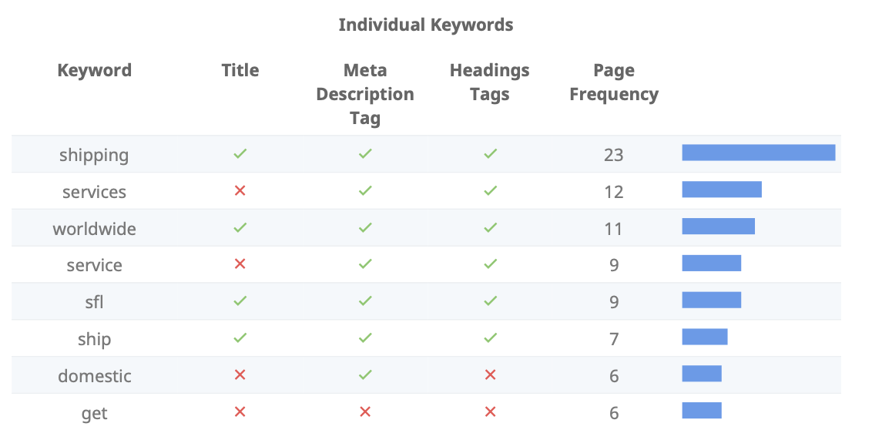

Individual keyword check (SEMRUSH)
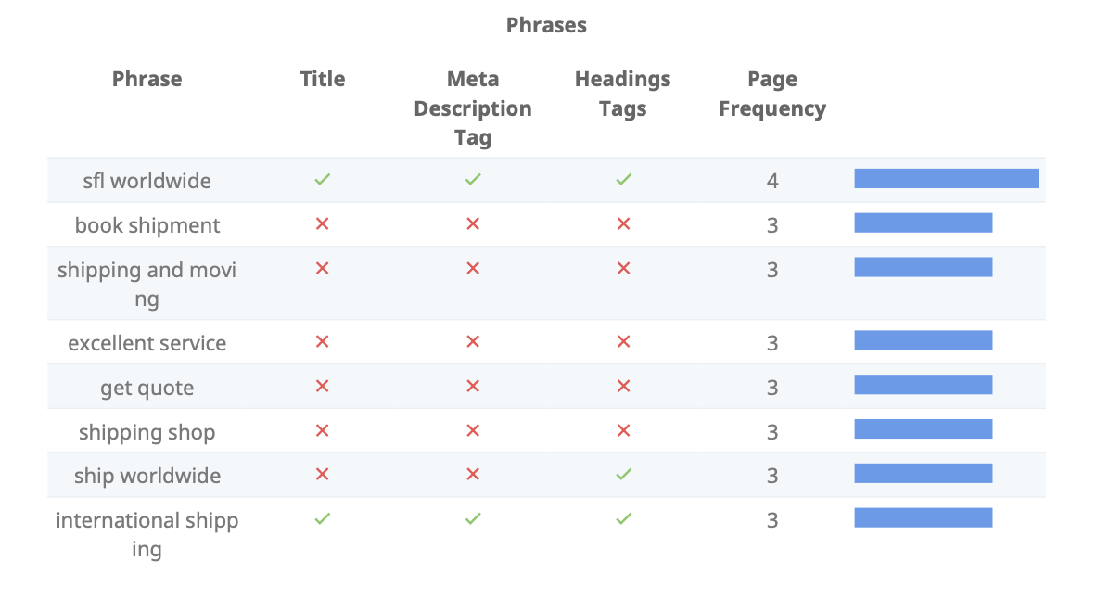

Phrases keyword check (SEMRUSH)

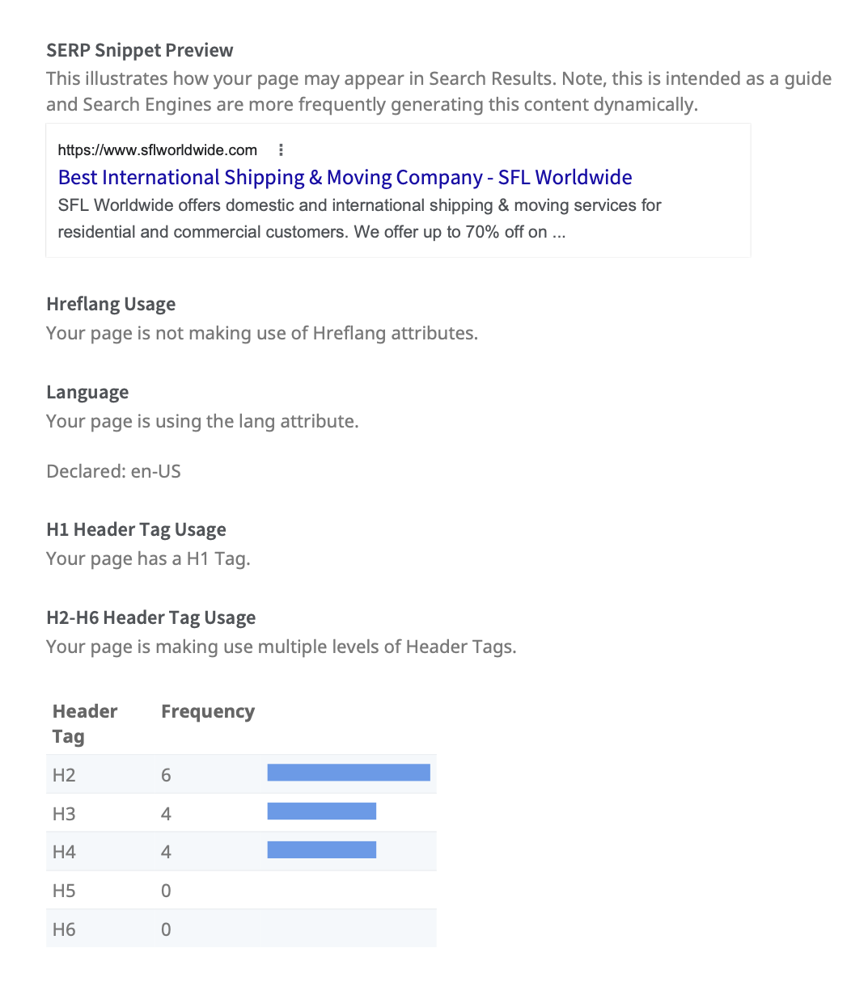

SERP check (SEO Optimzer)

Social Platforms Connectivity and Tags

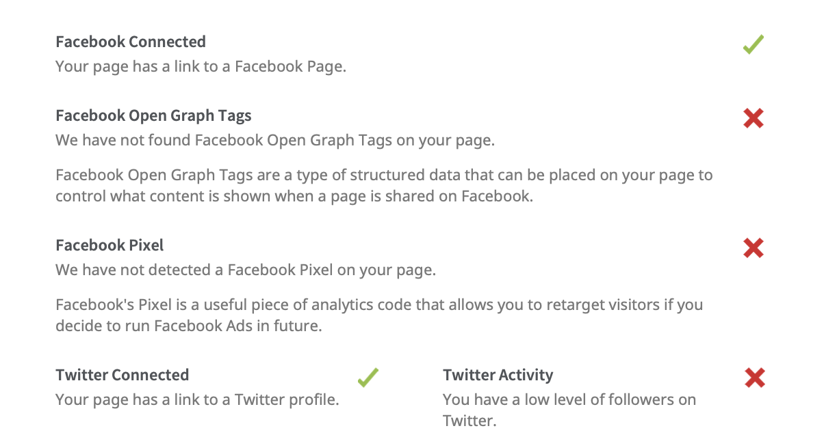

Website-social connectibity check (SEO Optimzer)

