THESIS

Master of Arts Thesis
Euroculture

University of Uppsala

University of Olomouc

The bittersweet taste of Mexico’s
Green Gold
–
A cross-country study on the development and the awareness of sustainable avocados

Submitted by:

Susanne Link
Student number first university: 910618-T465
Student number second university: F170973
Contact details: s.usanne.link@web.de/ +491786919562

First semester university: University of Uppsala
Second semester university: Palacký University of Olomouc

Olomouc, 10.07.2019
MA Programme Euroculture Declaration

I, Susanne Link, hereby declare that this thesis, entitled “The bittersweet taste of Mexico’s Green Gold – A cross-country study on the development and the awareness of sustainable avocados”, submitted as partial requirement for the MA Programme Euroculture, is my own original work and expressed in my own words. Any use made within this text of works of other authors in any form (e.g. ideas, figures, texts, tables, etc.) are properly acknowledged in the text as well as in the bibliography.

I declare that the written (printed and bound) and the electronic copy of the submitted MA thesis are identical.

I hereby also acknowledge that I was informed about the regulations pertaining to the assessment of the MA thesis Euroculture and about the general completion rules for the Master of Arts Programme Euroculture.

Signature:

Date: 10.07.2019

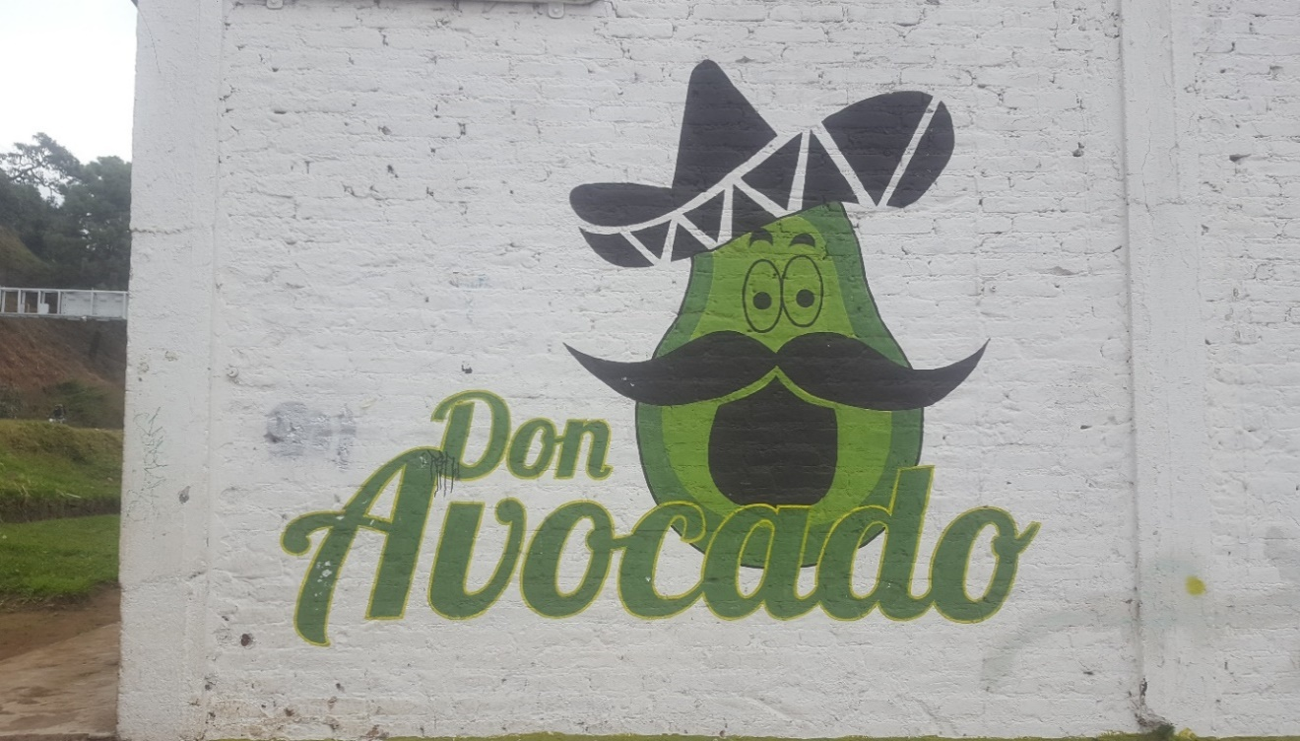
Photo taken in Uruapan, Michoacán (Mexico) on 18 December 2018.

Table of Contents
Abstract 6
Chapter 1: Introduction 7
1.1 Research Aims 9
1.2 Organisation of the Thesis 9
Chapter 2: Literature Review: Previous Case Studies 12
Chapter 3: Legal Aspects of Sustainability 15
  - Sustainability and Globalization 15
  - Sustainability and the Law 17
    - EU-Mexico Global Agreement 17
    - The modernized EU-Mexico Global Agreement 19
    - Requirements for the EU Market 22
    - Standards and Certificates 23
  - Mexico Statement 28
3.4 EU Statement 30
Chapter 4: Meeting Commitments – Interviews Mexican Civil Society 32
  - Farmers from Michoacán 32
  - Scholar from UNAM 33
  - Alternare 34
  - World Resources Institute México 36
  - Reforestamos 36
Chapter 5: Socio-Psychological Aspects of Sustainability 40
Chapter 6: Survey EU Citizens 46
  - Survey Structure 46
  - Socio-demographic Details 47
  - Consumer Behaviour 49
  - Awareness and Knowledge 51
  - Effects of Raising Awareness 55
  - Promotion, Responsibility and Influence 55
Chapter 7: Ideas for Solutions 60
Chapter 8 : Conclusion 65
References 68
Appendix 76
Annex 1 : Questionnaire Interviews Mexico 76
Annex 2 : Questionnaire Survey EU 78
Annex 3 : Statistics Survey EU 86

Abstract
The avocado production and trade impose economic, social and environmental challenges for producers, and concerns for consumers. This ‘sustainability challenge’ will be analysed from a social- psychological viewpoint. The case study follows a two-method based approach: a combination of qualitative and quantitative research.
Laws and restrictions on the avocado production in Mexico exist, still, avocados are not sustainable. The reasons are unveiled by a closer look into the trade agreements and by interviews with the Mexican civil society. The responsibility for the implementation of controls on sustainable avocados is pushed in a circle from the governments to civil society and back. Ideas on how to change the system are mainly based on EU citizens. Can a greater knowledge and awareness of EU citizens improve the sustainable avocado production in Mexico? The survey reveals that only few participants are fully informed and highly interested in eco-friendly produced avocados. The low percentage can be explained through the high costs for certified avocados, the mistrust in the certification system and the lack of the certified fruit in the supermarkets. However, after some background information the participants stated that they would change their behaviour: buying certified avocados, spending more money and going to special supermarkets. To raise awareness and clarify doubts, civil society in Mexico suggested campaigns in cooperation with civil society in the EU. The idea for the campaign is based on behaviourist theories. A further step is a cooperation between EU citizens with civil societies from Mexico and the EU to pressure the government into a system change to support the offer of cheaper certified sustainable avocados in the EU supermarkets, and thus to raise the standards and controls for the avocado production.

Keywords: Avocados; Sustainability; EU; Mexico; Monitoring; Trade Agreement; Civil Society; EU Citizens; Awareness; Behaviour
1 Introduction
The “green gold” of Mexico, another name for avocados, known for its health benefits, is booming in Europe. First avocado shipments from Mexico arrived in Europe in 1982. Since then the consumer demand rose and is still expected to rise. The largest importers of avocados are the Netherlands with over 250.000 tonnes in 2017, France and the United Kingdom with over 100.000 tonnes in 2017, Spain, Germany, Belgium, and Sweden with under 100.000 tonnes in 2017. The agri-food sector is becoming a growing opportunity for Mexico’s economy. In 2017 the Agroalimentary Trade Balance reported the largest positive balance in 25 years. The avocado trade even surpassed the income from tourism and petroleum and is the exported agricultural product with the highest sales abroad. With almost 2 million tonnes in 2017 Mexico is by far the largest producer of avocados worldwide. Even though Mexico is only ranked fourth of the main suppliers of avocados to Europe after Peru, Chile, and Israel, the EU is an alternative market after the US, as the export has risen remarkably since 2015. Mexico puts an effort in “gaining a larger role in the international markets and engaging in trade with other countries, especially in Asia and Europe.”
However, Mexico’s sustainable development is suffering under the avocado trade due to its environmental vulnerability. The agribusiness is mostly not sustainable and causes environmental and social problems. Newspapers and documentaries like Les avocats du diable (The devil’s avocados) by France 2 from 2017 are depicting the horrendous consequences the avocado production provokes. “98 percent of deforestation in Mexico” are caused by agribusiness, with avocado orchards increasing by 1.6, 5.1, and 10 times in the most productive areas Michoacán, Mexico, and Jalisco. The expansion of the avocado orchards and the resulting threats are fuelled by subventions from the municipalities, as they are providing “1.25 million pesos from the Ministry of Agriculture and Rural Development (SAGARPA).” The contamination of soil and ground water through nitrogen and phosphate is the consequence. Bigger quantities in highly productive avocado areas increase pollution issues. The high amount of water consumption for the avocado agriculture even jeopardizes the nearby communities and cities. Consuming one avocado per day equals almost 90 litres of water per day or 32843 litres per year. The total annual water withdrawal of the agricultural sector in Central America and the Caribbean with 64 percent is six times higher than the water withdrawal for the industry sector and 2.5 times higher than the water withdrawal for the municipal sector. Additionally, one avocado per day contributes to 0.4 kilograms of greenhouse gas emissions per day or 144 kilograms per year. The same amount of water equals 6.2 apples or 3 tomatoes a day, whereas apples cause 12 times less and tomatoes cause 2.4 times less greenhouse gas emissions than avocados. As a comparison, apples and tomatoes are the most produced fruit and vegetable in the EU with 12.7 and 17.7 million tonnes harvested in 2015. Due to the excessive, aggressive and uncontrolled use of pesticides and herbicides in the avocado orchards, the health of farmers and the population living near the orchards are seriously threatened. Especially women and children are in danger. Cancer is the third most common cause of death for infants and one new case of breast cancer is discovered each day in areas near avocado orchards. Besides health issues, criminal gangs, the so-called avocado mafia, are pressing the avocado farmers. Up to 0.7 percent of the GDP are spent on the protection for the workers and the businesses themselves. Almost one third of the agricultural businesses are under the control of cartels. The state is being infiltrated and institutions are actively involved in the criminal acts. Journalists who report about forbidden practices on land use change in favour of avocado plantations are threatened. Recently, Artículo 19, a British human rights organisation specialized on freedom of expression and information, reported on the threat of a journalist by Mexican cartels after she documented the increase of slash-and-burn practices to support avocado cultivation in Michoacán in connection with organized crime. After the given background information on avocado practices, the following question arises: Why is the avocado production in Mexico despite legal commitments with the EU not sustainable and how can civil society and EU citizens influence a more sustainable avocado development through an applied social-psychological approach?

1.1 Research Aims
The thesis discusses the reason why the avocado production in Mexico is not sustainable even though the legal agreements between the EU and Mexico are committed to improve the sustainable development. Furthermore, the influence of the Mexican and the EU civil society, and EU citizens in this context, as well as the actions that could help improving the sustainable development in Mexico will be discussed. The thesis is mainly based on quantitative and qualitative research.

1.2 Organisation of the Thesis
A first look will be taken at the previous case studies by Deborah Barndt on tomatoes from Mexico and by Ian G. Baird and Noah Quastel on dolphin-safe tuna from Thailand. After some information on the negative aspects of the avocado production, the question arises why the situation does not improve, even though there are trade agreements, market requirements and certificates. To solve this question the legal background of the avocado trade will be analysed: the current EU-Mexico Global Agreement and the agreement of principle, the EU market requirements for avocados and the most common certificates regarding eco-friendliness, environmental and civil protection. The focus lies on the control mechanism and the performing authorities. Clear statements and pledges to implement sustainable development in agricultural production are noted for example in the draft agreement of the EU-Mexico Global Agreement from April 2018. The meeting of the commitments of the pledges are commented on by official statements from the EU and the Mexican governments and interviews with the Mexican civil society. The weak spot of the production which causes unsustainable avocados is the control system. The interviews with the Mexican civil society revealed that the monitoring of the avocado production by the authorities is insufficient or lacking. Each authority assigns the task to another one, thus a circle emerges (see Figure 1.1). The EU government together with the Mexican government, which agrees to the trade agreements with its restrictions, hands the responsibility over to civil society in Mexico. They for their part pass it on to the EU civil society and EU citizens. They in turn call the EU government to be in charge. The research resulted in the following cycle of involved actors:
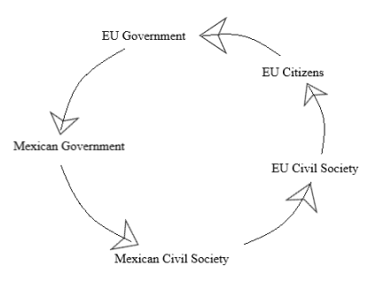
Figure 1.1 Responsibility circle for the monitoring of the pledges on sustainability in the avocado production in Mexico.
However, the solution to this problem might be found in Europe, more precisely in the consumption power of EU citizens. Despite the threats of unsustainable avocado production, the consumption of the fruit is very popular, especially among the younger generation aged between 20 and 35 years, the so called Millennials generation. To give a more precise idea for a solution, the following question arises: To which extend are EU citizens informed and aware of the avocado problem? The answer to this question will be provided by a survey launched in April 2019. The outcome can be split in two parts: unaware EU citizens and aware EU citizens. After the survey two more questions arise: How could the consumers be made aware of their possible impact and how could the consumer’s awareness influence the sustainable development in Mexico then? A social-psychological approach will be used to answer the last questions of the research. Studies on sustainable psychology, based on behaviourism and Freud’s theories will be considered to find solutions. Other possible ideas are based on the previous case studies, the interviews with the Mexican civil society and the EU survey and will be attached and discussed. To break up the system, civil society and EU citizens need to work together. The conclusion will summarize the findings and give suggestions for further research.

The topic of sustainable avocado production is mostly approached from an economic or political viewpoint. These viewpoints are important to understand the situation. However, a social and psychological approach in order to find a solution in the case of awareness on sustainable avocados is promising and not sufficiently discovered yet.

2 Literature Review: Previous Case Studies
Deborah Barndt analysed a similar case on tomatoes in 2001. In her study she referred to the tomato production in Mexico as a “globalization-from-below.” As well as the severe conditions on the avocado plantations, the severe working conditions on the tomato plantations existed already at the end of the 20th century. The workers were neither sufficiently protected against the pesticides used on the tomatoes nor were they informed or educated about health and safety risks. Children living near the plantations suffered from health conditions. The workers’ rights were disrespected as they didn’t “get unemployment insurance, [paid] overtime […] or vacations [and were] not covered by the Occupational Safety and Health Act.”
Barndt concentrated on a social viewpoint, the production-consumption and the human-nature relation. She focused on the human-nature alienation, as well as the work-home distance of the plantation workers and the nature-product distance, as in her study the tomatoes became more and more a number in the supermarkets and not a vegetable anymore. Barndt used the theoretical frame of “distancing” to explain the gap between product and consumer. This theory can be described as suppressed unpleasant thoughts about environmental problems through defence mechanisms of the unconsciousness to reduce stress. Barndt’s study already dealt with the problems of globalized foods, but rather described the situation without theoretical explanations or solutions.

Baird and Quastel researched on a similar social-environmental problem in 2011, the dolphin-safe tuna production and trade between Thailand and California. The study described the process of solution finding through certification in global production networks (GPN). The GPN approach is based among others on the convention theory, which has its
“focus on the [… union of] consumers, producers, and others […] participating in the commodity network and [on] the ways in which certiﬁcation labels play a coordinating role. […] NGOs and other actors work together to forge quality aspects of products that match the […] ethical or aesthetic concerns of consumers.”
Especially the work of an environmental American NGO with focus on international awareness is described with the “complex interactions of political and consumer awareness, knowledge, certiﬁcation systems, and production processes typical of regulatory networks” as the central key. Consumers are cooperating with “ethically structured networks” on civic and environmental, but also commercial and industrial conventions. Regulations take place through institution networks “with formalized norms and standards that coordinate network actors.“ Finally, the NGO achieved dolphin-safe tuna standards and labelling schemes in several countries by negative public attention on irresponsible producers through videos and banners in the news. Strict and qualitative guidelines for producers and consumers, and promotion for the label, as well as threats for not obeying to it, were established.
Despite the success in the tuna case some problems occurred. The American NGO held the only power for the certification scheme and the monitoring in Thailand. Through their first world view on the tuna production problems of the developing country, for example social issues caused by the certification networks, were overlooked, which caused unsteadiness in the Thai population.

The dolphin-safe tuna case is similar to the avocado case, as Mexico and Thailand are developing countries according to the DFG stood April 2019. Both countries suffer from corruption and thus political instability. Thailand ranks 99 and Mexico 139 out of 180 according to the Corruption Perceptions Index 2018 by Transparency International. Both cases are concerned with environmental problems and search for solutions with the help of civil society from abroad. The tuna case mainly focused on a solution approach from the United States. However, a solution for the avocado case could concentrate on a cooperative approach connecting Mexico and the EU. As the tuna study already demonstrated, the inconvenience for the consumers to change to sustainable avocados as they are more expensive might be solved by a production change of all big avocado producers at the same time. This method functioned with dolphin-safe tuna. A method to achieve a price reduction to attract the consumer will be considered for the avocado study. Furthermore, concerns about the avocado mafia need to be respected in the solution finding process.
Analyzing the dolphin-safe commodity network helps show the complex intertwining of environmental discourses […], nongovernmental and private regulatory orderings […], and the role of scale in shaping certiﬁcation standards, institutions, and processes.
In comparison to the tuna case, there already are certificates, which also concern sustainable avocados, e.g. the Rainforest Alliance Certificate. However, the certificates are rather general for a variety of food, not entirely known and too expensive as the survey demonstrates in chapter six. Furthermore, a special certificate only for avocados does not exist yet.

The previous case studies are taken into consideration for the avocado issue, however, improvements are necessary. To start with the avocado case, the following chapter will provide background information on the legal regulations.

3 Legal Aspects of Sustainability
This chapter starts with a definition on sustainability and the connection between sustainability and globalization. In the second part, the legal background of the avocado production in Mexico and the import to the EU is described. The third part provides statements of the EU and the Mexican government on the meeting of the commitments. The focus lies on the monitoring methods, their realization and reliability in terms of sustainable agricultural development and social and environmental protection.

3.1 Sustainability and Globalization
The concept of sustainability consists of three pillars: economy, society and environment. Thus, it represents the meeting point of environment, community and industry. Sustainable development describes the arrangement of the present generations’ needs with those of the future generation.
The overall goal of sustainable development (SD) is the long-term stability of the economy and environment; this is only achievable through the integration and acknowledgement of economic, environmental, and social concerns throughout the decision-making process.
Globalization is decisive for the discussion of sustainable avocado production, as it provides the link between economic benefits, the “increased standardization of product quality in avocado” and the political, economic and social responsibility. However, the global impact of the rapidly changing food system provokes inequalities between global productions and food consumption, from the individual to humanity. The political system favours powerful players in the agribusiness. Global trade since the 1980s is reinforced and concentrates the economic benefits in powerful Agrobusinesses. Thus, sustainability is threatened, as monopolies in the agribusiness rather enhance their commerce oriented chemical business instead of using environmental protecting substances. This issue is reinforced through the demand for exotic fruits and vegetables throughout the entire year. Governmental restrictions in the agri-food sector are less strict and interventions and controls are weakened in favour of the private stakeholders. Globalization and the consequences as mentioned lead to a loss of relevance of the spatial dimension of the food chain. The phenomenon of distancing covers trade actors and their actions, as they are spatially far away, and thus it is difficult to control them and hold them accountable for the deplorable state of the environmental and social status in the food systems.
Food has an inside, cultural, and an outside, political economic, meaning, which together create a powerful force for the global order, that effects the production and consumption. One reason for the problem lies on the democratic political aspect and policy-making institutions. Agribusiness and trade are affected by constraints of the natural environment and politics in terms of opposing individual world views, which lead to “forms of ‘greenwash’” and corruption in the land use. “Irreversible social and environmental impacts” occurred due to these practices and the new food culture. Connected to the biological modification and the resulting pollution McMichael rose the concern that a full WTO regime, a stronger economic influence, could cause environmental dangers, which are far more troubling than chemical pollution. Institutional structures, rules and norms are not fully developed yet and tensions between the actors of the agri-industrialization and resistance movements, especially agri-social and agri-environmental ones, rise.
The unbalanced globalization disrespects citizen’s rights in favour of corporate privileges and repealing of the governments’ responsibility on environmental and social sustainability in favour of the preservation of the Western lifestyle. However, the responsibility rests within the governmental agencies “to establish and develop control systems to protect consumers and eliminate illegal activities in avocado commercialization.” Especially social, political and economic power are important as frame conditions for sustainable food systems.
The concept of food systems, which can be used as basis for political suggestions on the improvement of sustainability and food security, could improve the crisis. The concept follows a holistic approach, as it reveals cause and effect connections, especially on the interdependency between humans and nature. Alternative Food Networks like Fair-Trade, which try to respect the interaction between health and environment and the producer and the consumer, are another sustainable food production concept. Organisations like Land Matrix or GRAIN gather information to provide a more transparent land use with the help of citizens, scholars, authorities, researchers and specialists. However, the development is constantly changing, as projects are not conducted fully or later than planned.

3.2 Sustainability and the Law
This section of the chapter refers to the legal agreements. First, the current agreement and the agreement of principle of the EU-Mexico Global Agreement will be displayed with focus on sustainability. Second, the different requirements for avocados for the EU market and third, certificates for avocados will be listed and explained. An overview on the adherence of the pledges agreed between the EU and Mexico is provided in the end.

3.2.1 EU-Mexico Global Agreement
In 1997, the Global Agreement (GA) between the EU and Mexico was signed and in 2000 the GA, based on the principles of “Economic Partnership, Political Coordination and Cooperation,” came into force. Concerning the trade relations, the GA was changed “into a comprehensive Free Trade Agreement” split in trade with goods and services. An update of the EU-Mexico Global Agreement was decided in 2013, discussed in 2016 and an agreement of principle of the modernized GA was reached in April 2018.
The current GA from 2000 concentrates mainly on a Free Trade Area between the EU and Mexico. However, chapter two article 20 on sanitary and phytosanitary measures (SPS), states that the parties “shall cooperate in the area of sanitary and phytosanitary measures.” The GA refers to the reaffirmation of the WTO Agreement for the rights and obligations of the parties on the application measures, but rather concentrates on the objectives to facilitate trade. However, the Joint Council “establish[ed] a Special Committee on Sanitary and Phytosanitary Measures [… with] representatives from both parties,” which is said to report annually to the Council. The Committee is planned to meet once a year with an agenda which is agreed on beforehand. One of the functions of the Special Committee is to monitor the application of the provision of the sanitary and phytosanitary measures, to establish a problem spotting and solving platform concerning the measures and to arrange information exchange between the parties. Article 22 of the same chapter speaks against the preclusion of measures such as the protection of human, animal or plant health or the conservation of exhaustible natural resources, if the measures do not affect the domestic production or consumption, and if the measures do not provoke arbitrary or unjustifiable discrimination between the parties.
The before mentioned Agreement on Agriculture of the WTO which came into force during the Uruguay Round in 1995 begins with a speech on the equitable commitments among all members, the respect to food security and “the need to protect the environment,” but as well mainly concentrates on economic benefits and restrictions for trade. However, annex two on general services states that
[p]olicies […] involve expenditures […] in relation to programmes which provide services or benefits to agriculture or the rural community […] including […] research in connection with environmental programmes, […] the provision of means to facilitate the transfer of information and the results of research to producers and consumers, […] general inspection services and the inspection of particular products for health, safety, grading or standardization purposes.
Part eight article 14 on SPS refers to the agreement on the application of SPS. The members have the rights and obligations to only apply SPS measures in the most necessary amount to protect humans, animals and plants, based on scientific proof and information with a valid risk assessment and according to international standards. All members must respect the prevailing conditions for SPS application to not restrict international trade and to “minimize negative trade effects.” The procedure to monitor the SPS application is developed and conducted by international organisations and the Committee on Sanitary and Phytosanitary Measures. However, the risk assessment of the SPS measures should take economic factors into consideration, in case of production loss due to pests or diseases, the cost for monitoring and control, and the cost-effectiveness of alternatives, as stated in article five of the WTO agreement on the Application of Sanitary and Phytosanitary Measures (SPS Agreement). Furthermore, the article noticed that
Members shall take into account […] control programmes, […] appropriate criteria or guidelines which may be developed by the relevant international organizations […] and the effectiveness of sanitary or phytosanitary controls. […] [R]easonable access shall be given, upon request, to the importing Member for inspection, testing and other relevant procedures.
Article 13 additionally mentions that the “Members are fully responsible under this Agreement for the observance of all obligations set forth herein.” According to the Annex C of the agreement on the topic of control, inspection and approval procedures, the members themselves are responsible to ensure “with respect to any procedure to check and ensure the fulfilment of sanitary or phytosanitary measures [… and] [m]ember[s] in whose territory the production takes place shall provide the necessary assistance to facilitate such control and the work of the controlling authorities.”

3.2.2 The modernized EU-Mexico Global Agreement
The current GA does not involve a section of food and drink and the potential to improve social and environmental conditions in connection to the agricultural sector. Thus, to respect the agricultural sector and sustainable development, the modernized GA includes regulations in this field. The existing agreement until today facilitates the trade in goods, government procurement and competition. This means that the cooperation between the EU and the Mexican authorities got improved including food safety, testing and international product standards. The EU and Mexico are cooperatively working on the strict adherence to the law on the market with different methods. The new EU-Mexico GA will open the trade market to new areas including food and drink. Mexico agreed on the SPS rules, international standards to ensures food safety and animal and plant health, and on the regular contact between the Mexican and EU agencies responsible for the SPS rules enforcement and control. Additionally, to ease the trade between the EU and Mexico, the new agreement promotes environmentally friendly production towards sustainable development and strong legally binding commitments on basic labour rights. Schemes including sustainability assurance and sustainable sourcing, certifying that companies use resources in a sustainable way and produce in a respectful way to people and environment, are promoted. To protect the European consumer and to keep food safe, the new Global Agreement safeguards the EU’s right to apply its standards on food safety and SPS. Every product must meet the EU existing rules on food safety and genetically modified organisms, environmental protection, plant health and consumer safety. Furthermore, the agreement guarantees that the EU can change the regulations in the future and become stricter. As the agreement in principal states, Europe and Mexico share many similar values including an established democracy, high standards for the health and safety of the products, and similar mindset on the rules to protect society. Therefore, common challenges on labour rights and environmental protection are promoted through the new trade agreement. As it is a “progressive trade agreement […] some of the strongest commitments” on sustainable development linked to trade are promoted. This includes the strengthening of people’s basic rights at work by “implementing the fundamental conventions of the International Labour Organization (ILO)” and protecting the environment by putting “into practice all the Multilateral Environmental Agreements […] including the Paris climate agreement.” Commitments regarding the sustainable management of forests, the conservation of biodiversity and the trade of eco-friendly and sustainably produced products like cocoa and coffee, and the promotion of initiatives like Fair-Trade are as well considered. The commitments of the new agreement will be binding with the same legal value. Both sides agree on applying international rules on these topics, with Mexico supplementary pledging to be more transparent, fighting corruption, and defending human rights. “The modernization would include a review clause on the need to include provisions on the free flow of data.”
However, the agreement of principal for the modernized GA was criticised by civil society for still being more focused on trade and commercial benefits from the side of the EU rather than on the “protection of human rights and social and environmental standards in Mexico.” Which can be seen on the statement of the Commissioner for Agriculture Phil Hogan on the modernized Global Agreement in the press release of the European Commission in April 2018:
Our commitment is to deliver benefits for our citizens at home through closer cooperation with our partners abroad. This deal is very positive for our agri-food sector, creating new export opportunities for our high-quality food and drink products, which in turn will create [and] support more jobs and growth, particularly in rural areas.
Furthermore, the exact measures for the control and monitoring of the pledges are vague. There is a Joint Council and a Special Committee on Sanitary and Phytosanitary Measures, which are responsible for surveying the commitments and handing in annual reports, but there are no precise instructions. Moreover, the Special Committee is only concerned with the SPS measures.

Further chapters of the thesis refer to the current Global Agreement as it still is in use. At the time of the research from October 2018 until May 2019 the report could only be used ad referendum as it was not the end of the negotiation process. The EU ratification of the agreement will most likely be completed only after the European Parliament elections in the end of May 2019. Until then the trade relations will be governed under the EU-Mexico Economic Partnership, Political Coordination and Co-operation Agreement, the Global Agreement.

3.2.3 Requirements for the EU Market
Third country suppliers to the EU market must comply with the European law and regulations to export their products. These requirements include legal, which are important to enter the EU market, common, which are important for the market competition, and niche market, such as organic fruits, requirements. According to the CBI Ministry of Foreign Affairs, “[t]he food safety requirements for avocados are the same as for other fresh fruit and vegetables.“ According to the EU import procedures from 2011, information about all goods that enter the EU must be lodged in the first customs office. Released for free circulation are only goods that comply with the formalities and carry an import certificate. To meet the legal requirements, avocados must comply with the EU standards on pesticide residues, which is defined through the maximum residue levels (MRLs) inside and outside of the fruit. The MRLs varies between the different EU member states, the UK, Germany, the Netherlands and Austria are stricter than the EU law, with supermarket chains being the strictest and demanding between 33 up to 70 per cent more than the legal MRL. Information on the pesticides, the spray programmes and the spraying records are of the interest of the buyers and thus shipments are controlled before they are sent to the retailers. The implemented checks are concerned with identity, documentary and conformity to marketing standards. The overall concern is focused on environmental damage of the importing country, and not on the exporting country due to hazards, and thus controls are conducted in the importing country.
In case of repeated non-compliance of specific products originating from particular countries, the European Union can decide to carry out controls at an increased level or lay down emergency measures. Controls can be carried out at all stages of import and marketing in Europe. However, most checks are done at the points of entry.
Besides food safety and quality, also “social, environmental and business compliance” of the imported fruit or vegetable is important, after the product quality. According to the CBI, buyers in Eastern Europe are less strict on social compliance in comparison to Western Europe, where “some multinationals even have their own compliance programme” and promote “[i]nitiatives and attention […] to corporate social responsibility […] includ[ing] [for example] Unilever’s Sustainable Agriculture Code and Tesco’s Nurture accreditation.”

3.2.4 Standards and Certificates
“Certiﬁcation standards are central to how many networks are put together, including what values, politics, and power relations are at play.” Next to the common market requirements there are additional specific buyer requirements. As the EU and its member states are very strict when it comes to food and as they become more and more interested in sustainable food,
[e]nvironmental and social issues are becoming more and more important in the supply of fresh fruit and vegetables. This is also the case for avocados, for example in water usage during production. Certification schemes […] will have a higher chance of being accepted by European supermarkets.
Since the 1990s the food quality as part of the private standards, which are developed by NGOs, companies or multi-stakeholder coalitions are controlled at the most by public actors. Private standards were proven to be a useful tool for the governance of the global agri-food chains. The monitoring of the standards is normally conducted by the audit industry, organisations which verify and certify the correct adherence. The external monitoring provides security for the enterprises in case of scandals related to food products. However, in case of developing countries the private standards can obstruct farmers and their access to international markets due to expensive certification and operational conditions, even though the private standards are destined to develop a more effective production and stimulate modernization and good agricultural practices.

Standardization in the sense of rules and guidance for trade products can be connected to public standards on health characteristics and to the development of globalization under the influence of the WTO and multilateral agreements on food safety. A range of standards, for example TESCO Nature Choice for single enterprises, the British Retail Consortium (BRC) for common national systems or GLOBALGAP as international standard, are already developed. Private standards are ascribed to the Corporate Social Responsibility (CSR) strategies of enterprises who voluntarily want to take responsibility of environmental and social concerns, use these strategies as branding for their products, as protection of the market or in general to generate profit. However, the mass on certificates and standards at international markets causes confusion for consumers and actors of the agri-food chain, as there is no credible, central and neutral register for standards until now. The international standards concerned phytosanitary practises already lead to phytosanitary campaigns and export bans from Mexico to the US until 1997. Consequently, “phytosanitary quality [and] commercial quality” are interdependent. The testable standardization and globalization, causing an international standard system, “increased [the] use of certification and verification systems” to assure the products’ quality and safety. Compliance with the market standards is achieved through certificates that require the governments permission and validation. The avocado is important in terms of “a fruit of higher quality” that needs to be noticed on the markets. However, international standards on phytosanitary practices are difficult to reach due to cultural and country wide diversity and lead to the problem that national market avocado producers do not benefit economically from this institutional change.

The most common certificate for avocados is called GLOBALG.A.P., established in 1997 as EUREPGAP, which is
a pre-farm-gate standard that covers the whole agricultural production process, […] focuses on food safety […] the environment, labour conditions and product quality [and] has become a minimum standard for most European supermarkets.
GLOBALG.A.P. belongs to the private sector and is an independent and voluntary certification program, which aligns with the government requirements and regulations on public health and the environment “by establishing minimum standards for food production [… and seeking to] support growers in meeting and exceeding expectations.” Other examples for required food safety systems, which are recognised by the Global Food Safety Initiative (GFSI) and which function additionally to GLOBALG.A.P. are the BRC (British Retail Consortium), a “north-western European market […] standard for hygiene and safety,” industry-developed standards like the IFS (International Food Standard), FSSC 22000 (Food Safety System Certification) and the SQF (Safe Quality Food Programme).
Besides the certification on food safety standards, also organically produced avocados must be marked with an accredited organic certificate to be allowed on the EU market. According to the European Commission, appointed authorities from the EU member states are responsible to apply inspection measures and control schemes on organic agricultural products. The organic fruit is only allowed to the market after complying “with production rules and [after being] subject to inspection arrangements” which are followed by a “thorough investigation into the arrangements in the country concerned, examining not only the requirements imposed in production but also the measures applied to ensure effective control” of the European Commission. Furthermore, the Commission established “a list of control authorities and control bodies to carry out inspections in countries not included in the list of recognised third countries.” There are four basic principles for organic agricultural practices by the International Federation of Organic Agricultural Movements (IFOAM) from 2008. The principle of health should protect and strengthen the health of the soil, plants, animals, humans and the planet as a whole, the principle of ecology should reassure that organic land use should imitate already existing eco-systems, the principle of fairness should provide and guarantee fair relations in regard to a common environment, and the principle of care should guarantee that organic farming is responsible and sustainable.
There are three different certifications with their relevant criteria for good agricultural production of avocados: the Institute of Ethical and Environmental Certification (Italian seal), which indicates an exclusive application of organic fertilizers and pesticides and offers valid certifications and accreditations by national and international institutions for the global market, the Fair-Trade International, which guarantees a fair distribution of the benefits throughout the entire production chain, and the Rainforest Alliance, which states the conservation and restoration of the biodiversity and native vegetation, as well as the protection of natural ecosystems within the property, and the conservation of the forests and protected areas.
The Italian ICEA certification concentrates on the sustainable development of organic farming. Besides controls and certifications to increase the product value and the prestige of the company in terms of voluntary ethical and environmental standards on food and corporate responsibility, the ICEA also offers services in research support, training and cooperation projects “with the purpose of creating economic value for companies and territories in the different areas in which it operates.“
Besides a fair distribution of benefits, Fair-Trade also promotes good working conditions, non-discrimination, environmental protection, protection of labour rights, equal opportunities and transparency. The Fair-Trade movement is a compilation of initiatives, which want to balance the commodity networks between the producers and the consumers. To improve their living conditions, producers should obtain higher prices, better market information and stable acceptance specification. To improve the poverty of the producers, special trade conditions on socially and ecologically responsible consume is necessary. Special independent control systems guarantee the practical realization. Traders use these certificates to indicate an ethical and moral image, but also as a sign for high quality products. However, the percentage of Fair-Trade goods is still very small in comparison to conventional trade. Nevertheless, the impact was proven by the difference-in-difference case studies in 2008, which measured the living standards of groups with and without Fair-Trade certified trade. Especially the producers in Africa and Latin America, including Mexico, benefited from Fair-Trade.
In 2018 Rainforest Alliance and UTZ, which labels coffee, tea, nuts and cacao, merged to improve their impact and in the end of the year 2019 a new agriculture certification program is planned to be published, focused on sustainability “to maximize positive social, environmental, and economic impact, while offering farmers an enhanced framework to improve their livelihoods while protecting the landscapes where they live and work.”
The mentioned certification systems are all members of the ISEAL alliance, an “association for credible sustainability standards.” However, they are based on voluntary standards. Nevertheless, the impact of these seals on social, environmental and economic indices measured in 2014 by the State of Sustainability Initiatives Review are quite high. “The Rainforest Alliance/ Sustainable Agriculture Network scored the highest overall average (84 percent) in terms of social impact, above Fairtrade (73 percent), UTZ (58 percent), and Organic (51 percent).” Even though agricultural practices urgently need to transform, Fair-Trade labels are connected to complex requirements and high costs and thus are not a top priority for the buyers. Only GRASP, the Risk Assessment on Social Practices of the GLOBALG.A.P., is becoming more important as it is better accessible. GRASP is concerned with the “social practices on the farm, addressing specific aspects of workers’ health, safety and welfare.”
However, the certificates are limited and only the recent implementation of the Rainforest Alliance guarantees a sustainable avocado production through the highly credible certification system. A better certification on sustainable land use would give Mexico a greater access to markets in Europe. In August 2017 the Mexican government started to sign agreements with avocado producers in Michoacán. These contracts allow the producers to cultivate the land, to change the land use and to convert the forest use. The APEAJAL, the association of exporting producers of avocado, in Jalisco signed a cooperation agreement in 2017 with Rainforest Alliance and the government of the State for a sustainable avocado production chain. Almost one third of the Rainforest Alliance certified hectares in Mexico, that allow priority access to markets in Europe, are in Jalisco.

3.3 Mexico Statement
Government intervention in agriculture is the rule in both industrial and developing countries, and it is here to stay. Public investment in agricultural research and extension services, assisted farm credit and marketing services, and a range of other support systems have all played parts in the successes of the last half-century. In fact, the real problem in many developing countries is the weakness of these systems.
Enrique Peña Nieto, the former Constitutional President of the United States of Mexico, stated in 2014 under the Special Climate Change Program 2014 - 2018 that “Mexico has assumed with responsibility the challenge [… and] has an international leadership as regards the development of a state policy to face such challenge.” Furthermore, he conveyed that Mexico is building an entire “National System to consolidate efficient institutions” to help reduce Mexico’s environmental vulnerability and to develop sustainability. The Federal Government enhances its pledges to implement concrete actions and to counteract on the effects of the environmental, social and economic issues by aligning the program on climate change on the National Development Plan and the Sector Programs. To combat climate change, the government under Nieto established the National Climate Change System as a solid and coordinated institutional framework. The instruments implemented to achieve the objectives were listed and a concrete plan for the implementation and monitoring was given.
The new Mexican government under Andrés Manuel López Obrador since December 2018 is focusing on the socioeconomic development, with special focus on the promotion of sustainability in the agricultural sector, as well as the aim to increase the productivity and inclusiveness. The Ministry of Agriculture will invest in programs including “Social and Sustainable Agribusiness” with a strong support to community organisations through capacity building, economic integration within production chains, agricultural extension and technology transfer.
During the interview with CONAFOR, the National Forestry Commission of Mexico under SEMARNAT, which was conducted in February 2019 in Mexico City, a staff member stated that agricultural controls on avocado plantations are thoroughly carried out by the ministries and profepa (Procuraduría Federal de Protección al Ambiente), the federal government's environmental protection agency in Mexico. Profepa carries out regular inspections on the ports for imports and exports. Furthermore, the agency shuts down avocado plantations for illegal deforestation and installations of “roads and irrigation systems in the reserve, which suppl[y] much of Mexico City with drinking water.” The government of the state Michoacán takes great effort to implement a new program, a new scheme for agricultural production in the avocado field, which includes better standards. The cooperation with the farmers is difficult, however, as the producers work in the illegal land use chain. Furthermore, efforts are made to implement the Rainforest Alliance certificate in Michoacán. Moreover, the minister for agriculture launched a strategy for climate change and agricultural production last year (in 2018), including the avocado production. Environmental certificates on a cleaner production must be encouraged. Furthermore, the ministry for agriculture launched a program on agroforestry systems to increase the income from communities in rural areas and protect the environment.

3.4 EU Statement
The European Commission commented in their staff working document on the impact assessment of the modernised GA that future monitoring and evaluation will require “several means of data collection as not all objectives are equally quantifiable and some monitoring may depend on a qualitative evaluation based for example on feedback from stakeholders obtained through a survey.” The monitoring needs depend on the negotiations with Mexico. Furthermore, it can be facilitated
by short and medium-term analysis of the measurable indicators […], [c]onvergence of standards and changes in regulations and law can be analysed by gathering information on the legal and administrative sources.
Additionally, surveys conducted in Mexico could measure the increase of available information and transparency. “Such surveys could be combined, for example, with existing programmes such as the EU Gateway Programme organising business missions to Mexico. However, in order to obtain more extensive feedback, additional business surveys or surveys could be set up in Mexico.” The EU plans to enforce the agreements’ pledges on sustainable development, workers’ rights, the environment and climate change,
through a dispute settlement mechanism […including] external review by an independent panel of experts, a role for civil society, including representatives of employers and trade unions, at all stages, and expertise of international bodies such as the International Labour Organization.
On their website, the European Commission directly gives answers on how they plan to implement the aspects of the modernized Global Agreement. For the promotion of human rights in Mexico, the EU wants to support projects that are implemented by NGOs, as well as intensify the discussion with Mexican authorities. Under the question how the GA will help to fight corruption, one of the problems obstructing the controls, the EU states: “The Global Agreement enables civil society to hold the EU and Mexico accountable for fulfilling their pledges in the agreement.” In this case, the power rests on civil society, for example NGOs, community groups or charitable organisations, to influence the actions of the authorities.
The following chapter provides insights in form of interviews of the Mexican civil society on the implementation and monitoring of the pledges, and their impact on the actions of the authorities.

4 Meeting Commitments – Interviews Mexican Civil Society
This Chapter concentrates on the interviews I conducted with avocado producers in Michoacán, a scholar from UNAM, the National Autonomous University of Mexico and the NGOs Alternare, World Resources Institute México and Reforestamos in Mexico in December 2018, and January and February 2019.
The interviews started with three general questions on the environmental impact, the social impact and the controls of the avocado production. More questions were asked on the agreements and certificates, standards and restrictions and their implementation. The complete questionnaire can be found in annex 1.

4.1 Farmers from Michoacán
Farmers from conventional and organic avocado plantations in Uruapan in the Mexican state of Michoacán confirmed the environmental impact of the production. They supported a mixed cultivation of avocado and pine trees in a common forest, as pine trees are capable to absorb more rainwater and store it longer than avocado trees and thus keep the ground humid and the plantations healthy. This method opposes the severe disadvantages of land use change. However, SEMARNAT and profepa prohibit this method and prevent the farmers from getting cultivation permissions.
The avocado producers stated that the farms for national production are never controlled or monitored on their use of chemicals, only farms for exports. However, one of the farmers cultivating for export committed that his farm does not get regulated or monitored, as his avocado trees are younger than one year, and he exports the entire plant not only the fruit. The same farmer stated that laws are established on environmentally friendly production measures, but farmers are lacking awareness and thus preparation of the fields according to the standards. Other farmers added that organic avocado cultivation is too lavish and expensive, and thus not attractive for them, as they would have to change their entire farming processes. They agreed that phytosanitary measures are important, but the protection material is very cost intensive. However, the government supports the water and electricity supply financially, as the avocado market provides a high income. Farmers can apply for water certificates from SAGARPA.
4.2 Scholar from UNAM
The scholar from UNAM, a biologist, stated in the interview that toxic pesticides are applied on the avocado plantations. Workers are not protected, they apply toxics while regulations are low. Products that are forbidden in Europe or North America are allowed on the avocado plantations. There is no appropriate monitoring on how the workers carry out cultivating practices. Normally they are exposed to the pesticides and don’t exactly know the pesticides. There are no official numbers about illnesses or sicknesses caused by the pesticides. Mostly because no correct data or information is collected in the hospitals, as there is a lack of research and of collecting systematic data.
Besides the lack of monitoring on prohibitions there is no medical insurance and social security. In Mexico restrictions can be avoided or overlooked. It depends on the owners of the avocado orchards if social insurances and security are covered. The same and even less applies on unemployment or any form of social insurance. Also labour laws, for example entry age or retirement are not respected. Officially no children or teenagers are working in avocado orchards, but unofficially there are. The main problem with avocado farms is the lack of institutions. There are no institutions for health, environment, labour (social security), thus, no one is monitoring the running of the farms.
There are many informal farms, but only the most formal ones are exporting. Selling the fruits abroad requires stricter regulations, which are demanded by other countries. However, the importing countries could influence the controls and environmental certificates by changing their demand on the imported products to ensure proper avocado cultivation.
There are already organic producers due to the high demand from abroad. However, most people still buy the conventional avocado, disregarding the production methods. Thus, it is easier for farmers to avoid the complication of producing organic or environmentally sound, as few benefits are not worth the complication. In Mexico enterprises regulate certifications, but they are mainly based on fertilization records. Tests are done rarely. For exportation, an additional international test applies, depending on the trade company. Europe could influence and change the avocado market through stricter controls and regulations, and harder verifications that the products are produced correctly. The big labels are only conventional and organic. Organic cultivation indicated a substitution of the chemicals, but there are no other environmental practices or changes. The creation of a different label, which is more environmentally friendly, is still in process. The new label is meant to go beyond substituting chemical products and promotes a more environmentally friendly management, concerning forest conservation, biodiversity conservation, social and economic issues.
There are no official records on criminal organisations, but unofficially avocado orchards are used for money laundering. A lot of farms in naturally protected areas only exist for the purpose to clean money generated from drug trafficking. The institutions and the police should prevent this development, but the institutional support is slow. If the importing countries were informed, they could pressure the Mexican government to work on the problem. As this matter goes beyond the Mexican capacity a cooperation and a solution on the institutional level is needed. Consumers in Europe are more willing to pay the extra price for a labelled product. Locally, on the national level people are not interested. Avocados are not cheap, but awareness rose, and the organic market is growing continually, but slowly. In Mexico more pressuring issues need to be fixed before the demand for safer and environmentally friendly food can be tackled. Simply the security of life and integrity are priorities. Furthermore, there is no preference for organic avocados. If the people want to change their diet they have to invest, but the income is too low. Among the wealthy people in Mexico organic is more popular and widespread.
Furthermore, retailers could make a difference. They could attract peoples’ attention, but so far, no one is advocating a change in diet, eating healthier and clean food. Additionally, a competitiveness for sellers on healthy avocados does not exist. Furthermore, the solution must include a mechanism to survive corruption. The ideas on how making avocados more environmentally friendly are already understood, but how can the production be made profitable and simultaneously separated from corruption? The new government seems to be more engaged in achieving Mexico’s independence in terms of food. They are implementing a program on the national level to convert conventional production systems to agroforestry systems. According to the scholar, this will also permeate avocados.

4.3 Alternare
A staff member of Alternare located in Michoacán stated in the interview that the price and the value of avocados on the international market motivates farmers in Michoacán to cultivate the fruit. The NGO confirms that only avocado plantations which produce for the international market are stricter on fertilizers and are better monitored. Farms which produce for the local and national market are not controlled or restricted. The organic and certified avocado orchards are very few, but mostly located in Michoacán.
There are two laws on restrictions: the general law on ecological balance, which purpose it is to regulate the environmental protection in relation to the EU, as well as the establishment and management of the nature reserves of the federation, and the general law on the sustainable forest development, which purpose it is “to regulate and promote the conservation, protection, restoration, production, management, cultivation and use of the country's forest ecosystems and their resources, as well as the distribution of forestry competencies to the federation, the states, the district, and the communities to promote sustainable forestry development.” Both laws are monitored by the federal prosecutor for environmental protection according to Alternare. However, besides the already mentioned disadvantages for the environment, Alternare explained that the density of the forests is shrinking due to the avocado forestry. One hectare of forest normally holds between 1000 and 2000 naturally grown trees, but avocado forests only contain 100 trees at the most, as avocado tress need more space.
According to Alternare, the consumers are not informed about criminal avocado organisations. However, the government is informed. The farmers are not able to counteract, as the avocado orchards secure their income they cannot denunciate criminal agencies. Control institutes from the government must investigate.

4.4 World Resources Institute México
Furthermore, the NGO World Resources Institute México stated that the Mexican ministries SAGARPA and SEMARNAT are rather working against than with each other and thus hinder the work and improvement of sustainable agricultural practices. There are restrictions on agricultural land use and natural protected areas that are not respected. However, they are written down in the operational program of the national protected area and should be controlled. Authorities and NGOs work in the area and monitor the development according to the NGO.

4.5 Reforestamos
The NGO Reforestamos in Mexico City stated that Asia, Europe and Canada have higher environmental and social standards for avocados and are demanding sustainable procedures from the avocado farmers. They are expecting clean avocados, which do not require deforestation, violence nor child labour. However, producers in Michoacán are not aware of the desertification and pollution their agricultural practices cause. There are restrictions, but some people deforest the forests to develop avocado plantations without permission. There is informal and illegal avocado production, but nobody talks about it. Mexico is proud of their avocado production, which provides a huge income, higher than from oil production. However, the agriculturally used land was not authorized, because the government is lacking. There has no detection method been developed so far on for example the Global Forest Watch, a platform to monitor forest use, to see avocado areas. The algorithm is not capable to detect them yet.
The WRI México explained the main problem of the Global Forest Watch. Many of the green spots (one spot equals one tree) might be avocado plantations, but authorities need to check in person. The satellite pictures spot tree by tree: when trees get cut the spot is pink, but if an avocado tree is planted instead the spot will become blue. Thus, the avocado tree counts as tree cover again (pink refers to tree cover loss, blue indicates tree cover gain). Blue spots from 2001 until now show that farmers are in the process of taking natural trees off and rebuilding avocado plantations instead. However, google earth depicts the natural protected areas of the butterfly region of Michoacán and the avocado orchards, which have a distinctive shape like little roses from above and thus differ from the natural vegetation in these areas. Google earth reveals that avocado orchards are expanding into the rain forests and natural protected areas, which can be spotted easily. But even if the monitoring and surveying institutions spot the violation against the contracts, the farmers must only pay a small fine, which is smaller than their monthly salary from planting more trees in forbidden areas. Furthermore, the government supports these orchards and agricultural incentives. Farmers get money for not cutting down trees, but at the same time they get more money for planting avocado trees. There are laws against this development, but they are not applied on the fields. There are sanctions and penalties, but they are very rare. Farmers only get a temporary prohibition to cultivate avocados from three to six months and after that period they repeat their methods. Mexico lacks transparency in this matter.
Furthermore, avocado producers are developing little towns, which can also be seen on google earth to keep the water for watering the avocados. However, this is illegal, because the natural water flow gets interrupted and the water quality is influenced.
Reforestamos confirmed the statement from the farmers and the scholar from UNAM that the government supports monocultures in favour of the avocado plant, but there should be a balance between avocados and pines, as pines are more water effective and inject water into the soil.
Moreover, in terms of certification, Reforestamos stated that the Mexican region of Jalisco is the only region with the Rainforest Alliance certification exporting to Asia, Canada and Europe. As already mentioned, the Rainforest Alliance certificate is not only concerned with environmental, but also social aspects. Farmers from Jalisco with the Rainforest Alliance certificate are the only ones who are legally producing avocados. The rest is mostly without a land change or land use permit, which means that there has not been an official go for the avocado plantations. The demand for organic and pesticide free avocados and thus avocado orchards is increasing, but Rainforest Alliance has more specific requirements on avocado products than organic certificates. Furthermore, organic avocado trees produce less fruits and thus for the same amount of fruit more tress must be planted, which need more space, water and fertilizers and finally harm the environment even more. If the avocado production exclusively produced organic fruit, there would be no space left for other agricultural products.
Moreover, the issue of deforestation could be experienced as less urgent, as avocado trees can be considered as forest. Reforestamos argued, however, that avocado trees are a different sort of trees, demanding more water than pine trees and thus causing a bigger risk for desertification.
Furthermore, fertilizers, the avocado fields in Michoacán are overfertilized by 1000 times, pesticides and herbicides pollute the water and the soil. On the question if the Mexican standard for pesticide meets the standards of the importing EU countries, Reforestamos commented that there are banned pesticides for agricultural use in general, but the producers do not respect the regulations. On the question if there are controls in the importing countries, the NGO answered that there are supposed to be controls, but that the avocado trade is enormous and economically beneficial, so that the Mexican producers created their own corporations and lobbies to go about the controls. However, sustainable supermarkets most likely check their avocados, because they are very environment-friendly sellers. Furthermore, Reforestamos indicated that Mexico even had regulatory instruments for territorial organisations, for example the Change of Land Use in Forest Land, short CUSTF (Proyectos de compensación ambiental por Cambio de Uso de Suelo en Terrenos Forestales), whose management is carried out before SEMARNAT.
The purpose of the project is to restore the soil and maintain the deteriorated forest ecosystems, so that once the rehabilitation is achieved, the environmental services provided by the ecosystems that were affected by the change in land use are compensated.
However, there is no information on the existence of CUSTF in the avocado producing regions. This means that most of the avocado production is carried out illegally. Furthermore, the NGOs questioned the transparency of the government and criticised the insufficient reliability of reports from the institutions and ministries.
Especially the interviewees from the non-governmental organisations stated that the responsibility mostly rests on them, which seems logic after the statement from the European Commission on the accountability of civil society for the fulfilment of the pledges of the GA. However, Reforestamos noted that NGOs do not have the means to accomplish this task. The only comment in the agreement on the assessment of the regulations are regular reports between the Mexican and EU agencies which are responsible. However, the Mexican agencies do not pay attention to strict or just any regular controls. The country has huge troubles fighting corruption besides other pressing issues and thus cuts down less important tasks that cannot be proven from the outside, unless agencies or institutions from abroad come directly to Mexico and monitor actively the implementation processes. Civil society, especially non-governmental organisations do not have the means to do so and additionally interfering negatively in the avocado business became very dangerous, as the regions for the avocado cultivation are taken up by cartels, the so-called avocado mafia. There should be responsible authorities who restore the land and control it. To create sustainable avocado productions the state government must intervene. All the stakeholders are separated, especially the local producers, and even the organized crime is evolved. The only way the situation can be changed according to Reforestamos is an independent non-Mexican institution checking on the maintenance of the agreement. But to achieve a more independent control both governments must be interested and willing in doing so. However, sending controls from outside Mexico might be expensive and question the trust between the EU and Mexico.
One way to work with the consumers is working with the retailers, however, this would require high efforts. On the question if the consumers could influence the application of the controls, Reforestamos answered with yes, but it is not about stopping the avocado production. The aim is to make people aware of the production methods and hence influence the implementation of good agricultural practices.

After the interviews the question rose how the consumers, in this case EU citizens could provoke a change in the avocado problematic. But before the outcome of the survey and the possible solutions can be discussed, a description of the connection between socio-psychological theories, sustainability and EU citizens must be given.
5 Socio-Psychological Aspects of Sustainability
food deals with issues of production and consumption […], and especially global patterns and relationships [which are] affecting who produces food, where and how, who consumes it and what links there are between producers and consumers.
Although the “social and political complexity” remains unrecognized, the human behaviour is the main actor in the “transformation of production systems.” As “[n]utrition is a mirror of the environment [and] of the available resources, but also of the culture of human societies and their dealings with these resources,” the behaviour of the consumers must be analysed. McMichael already described sustainable development in food as “an ongoing struggle between forms of social organization” in 2000. The sustainable development crisis is besides an institutional and governmental crisis connected to a philosophical and ethical crisis in terms of social inequality in wealth. This crisis leads to a loss of control and results in the loss of knowledge on sustainable land use.
The environmental crisis is an outward manifestation of a crisis of mind and spirit. There could be no greater misconception of its meaning than to believe it is concerned only with endangered wildlife, human-made ugliness, and pollution. These are part of it, but more importantly, the crisis is concerned with the kind of creatures we are and what we must become in order to survive.
The destruction of the environment is human-made, caused by the mental needs of human beings. Consequently “’environmental problems’ are really behavioral problems.” Hence, a psychological approach on the social awareness of the population is crucial for the sustainable development. Even though most of the population knows about the environmental problems that are caused by their behaviour they perceive and react on the information according to their psychological needs, but this “psychological issue […] is rarely addressed.”
One possible tool to influence the sustainable development are behavioural theories to improve the awareness and knowledge of the population and “to target strategies for a change in behavior. […][T]o predict and understand motivational influences on behavior” first, the theories of planned behaviour and reasoned action will be analysed more closely. The psychological needs, in other words attitudes and subjective norms, lead to behavioural intentions and finally to behaviour, as explained in the theory of reasoned action. People know about sustainable behaviours and in this case sustainable purchasing behaviours, but do not put their knowledge into practice. This could be explained, as besides reacting according to facts people are influenced by anxiety, values, assumptions, denial, ignorance, “’affluenca’, an unsustainable addiction to consumption and materialism,” religion and tradition, their economic role, inconvenience and environmental beliefs.
The latest split the population in two groups according to the New Ecological Paradigm Scale: the New Environmental Paradigm (NEP), those who think environmental issues are urgent and serious, and the Dominant Social Paradigm (DSP), those who tend to be less environmentally friendly and having less environmental concerns. The modern Western world view, more of the DSP, is shaped by institutions and cultures provoking distance from the natural world and thus promoting an unsustainable resource use. As world views are social constructs they can shift from economic growth to “a new goal of ecological sustainability,” but in order to do so people have to become aware of their behaviour and act consciously. Madden, Ellen and Ajzen only concentrated on the intrinsic behavioural control in their article, however, another assumption could be that the perceived behavioural control can be influenced externally by institutions like NGOs.
Figure 5.1 shows the external influence on the perceived behavioural control through NGOs. The figure is adapted from Madden, Ellen and Ajzen and slightly changed.
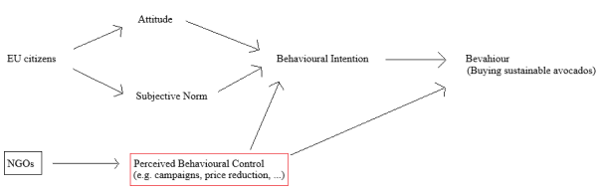
Figure 5.1 Perceived behavioural control through NGOs.
To influence the populations behavioural intentions externally, their perceived behavioural control needs to be strengthened according to the theory of planned behaviour which is an extension of the theory of reasoned action.
This is accomplished by including believes regarding the possession of requisite resources and opportunities for performing a given behavior. The more resources and opportunities individuals think they possess, the greater should be their perceived behavioral control over the behavior.
The theory of planned behavior which focuses on intentions that are based on attitudes, norms and perceived behavioural control describes the believe to be able to provoke change by actions and the concept of constraints. Low constraints or barriers are raising the believe that environmentally friendly actions have an impact, however when barriers are high the constraints overcome attitudes and values. Thus, in order to strengthen environmentally friendly behaviour, the constraints and barriers which influence the perceived behavioural control need to be psychologically reduced in smaller steps. The cognitive dissonance theory for example describes the connection between attitude and behaviour with the foot-in-the-door-technique according to which small actions are most likely leading to bigger actions, so that “behavior […] determines attitudes.”
A tool to externally influence perceived behavioural control in small steps is operant conditioning, which works with stimuli which are added or taken away to increase or decrease a certain behaviour. Four types of operant conditioning exist: positive and negative reinforcement, which increase a behaviour, and positive and negative punishment, which decrease a behaviour. Positive reinforcement provides a reward environmentally friendly behaviour, whereas positive punishment adds a negative aspect. On the other side negative reinforcement takes off a negative aspect and negative punishment takes off a reward.
Behaviour is separated in two parts: discriminative stimuli (SD) which evoke a reaction and reinforcing (SR) or punishing (SP) stimuli which follow the reaction to control or shape the response of the person. However, changing a behaviour to achieve better long-term outcomes involves a short-term cost, which is also called contingency trap and needs to be overcome. Thus, the change of behaviour can be facilitated by changing the context of the behaviour, the so called behavioral engineering, which is divided in two strategies: antecedent strategies, which concentrate on the signal for behaviour (SD) and consequence strategies, which focus on the outcome of a behaviour (SR or SP). “[P]rompts, information and modeling” are antecedent strategies to signal environmentally friendly behaviour. Prompts provoke appropriate actions through verbal instructions that are “polite, specific, and well-placed reminders.” Not education or general information, but “clear and precise information about how and why […], procedural and persuasive information” trigger a change in behaviour. The direct demonstration of behaviour is the most successful practice and called modelling. Environmentally friendly behaviours under antecedent stimuli are for example activism, nonactivist political behaviour, consumer or ecosystem behaviours. However, also methods of direct confrontation for example through “shock[ing] […] video footage” or images on the television news or “high-proﬁle banner hangings” are successful, as Baird and Quastel demonstrated in their dolphin-safe tuna study.
However, currently environmentally appropriate behaviours are not promoted, but even punished, and inappropriate behaviours are rewarded “by convenience, social status, comfort, and pleasure.” According to Koger and Winter, the best strategy to create a more environmentally friendly behaviour is intrinsic reinforcement, because extrinsic rewards are only temporary and do not lead to a long-term change. This could be refuted in the dolphin-safe tuna case, as “negative publicity,” as the shocking video campaign, changed the purchasing behaviour of the population on the long-term. A “majority of consumers [were] showing awareness of the links between” an unsustainable purchasing behaviour and environmental damages after the campaign.
Feedback as a reward on the results of a behaviour change pushes the person’s values and motivation towards a more environmentally friendly behaviour. The Community Based Social Marketing (CBSM) strategy concentrates on a less punishing method to promote behaviour by recognizing and addressing barriers. Informing and charging the population the “[p]rices, incentives, and real cost” of the products they purchase are efficient strategies to promote a behaviour change. However, real costs can only be based on assumptions and thus are difficult to calculate and charge. This affects the economy and competitiveness of the producers which would also require governmental intervention and lead to lobbying. Changing the reinforcement contingencies can provoke a more sustainable behaviour by displaying the long-term costs more openly and contrasting them to the short-term costs or supporting environmentally friendly behaviour by governmental incentives or punishments for example through tax reduction.
However, these strategies are difficult to implement, and strong habits are difficult to change. To understand behavioural actions, it is necessary to understand thought processes, thus, cognitive psychology. Mental maps and associative networks facilitate the reaction to certain situations and experiences, as they interconnect information units. Only the most necessary information is taken in to deal with a situation, thus, too complicated and complex information leads to “confusion, overwhelm, and inaction.” The input to mental maps thus needs to be accurate, unlimited and relevant. Environmental stress, anxiety and inappropriate information input can lead to behavioural disorders, which can cause environmentally unfriendly reactions or habits and psychological disorders, which can cause loss of control and inaction and prevent the positive effect of perceived behavioural control.
A natural protection system against environmental pressure, which needs to be overcome, is explained by the Object Relations Theory. The theory deals with the separation of the human mind and awareness of environmental problems and unconscious behaviour, and connects environmental problems to unconscious motives to achieve solutions. The defence mechanisms are categorized in several different behaviours: rationalization (finding incorrect but attractive excuses for one’s behaviour), intellectualization (emotional distance to a problem by ignoring one’s own contribution to it), displacement (replacement of the actual problem by a less imminent one), suppression (active attempt to be aware of a conscious problem), repression (unconscious defence), denial (claim that the problem doesn’t exist), reaction formation (converting denial to the opposite feeling), projection (spotting and criticising own failures in others), apathy (indifference to the problem) and sublimation (“channel unconscious anxiety into socially acceptable projects”).
According to Freud, growing aware of one’s unconscious character patterns and fears is the key to act environmentally friendly. However, fear leads to defence mechanisms and thus proposals with concrete actions are more useful instead of threatening facts. To release the blocked energy that is used for defence mechanisms to find creative solutions to change behaviour, people need to deal with unpleasant thoughts. Discussing sustainability problems in a safe environment with trusted allies in a social network, so called despair and empowerment groups, provides more comfort. This could be supported by popular members of the society. These groups are based on social and personal norms and values, which again can be influenced by perceived behavioral control. Finally, the norm activation theory of altruism and the Values Beliefs Norms (VBN) theory, which is divided in three categories: egoistic, altruistic, and biospheric, refer to the personal emotional involvement in problems based on one’s believes and values. European citizens tend to have more egoistic norms and values.

In the next step, the question to which extend EU citizens are actually aware of the avocado problematic must be clarified.
6 Survey on EU citizens
The fifth chapter assesses the awareness and knowledge of EU citizens on avocados, based on an anonymous survey, which was launched in April 2019. The survey was taken online and distributed via social media to achieve an independent and relevant outcome. The age frame was set between 20 and 35 years, also referred to as the Millennials generation. This group is discussed to be more concerned about environmental sustainability and social issues and using awareness to provoke change. The results are not representative in a statistical sense, as there were only 228 participants in comparison to around 512.6 million EU citizens in 2018. However, the survey serves to understand the depth of the awareness and knowledge on the topic of young EU citizens. Special remarks will be made on the deviation from the average. As the survey also provides open questions, more precise answers can be given. Quotes in this chapter are all taken from the open question parts from the survey and will not be referenced.

6.1 Survey structure
The survey contained 26 questions in 23 sections. The first four sections served the socio-demographic analysis with a comparison to the mentioned tendencies from the chapters before, and concerned the age, gender, country of origin and location, school education and subject area of the participants. The focus lies on the country of origin and not on the current place of residence, because of the connection between the avocado consumer behaviour to the nationality and not to the place of residence. Sections five, six, nine, ten, eleven and twelve concentrate on the consuming and purchasing habits of the participants. Sections seven, eight, thirteen, fourteen and fifteen concentrate on the participants’ awareness and knowledge related to avocados. After some background information on the avocado production and the resulting problems, the survey continued with seven more sections. Repeated questions on consuming and purchasing habits and additional questions to sustainability promotion, influence and responsibility were asked. The survey consisted of obligatory and optional, as well as open and closed questions. Seven open and five closed questions, excluding the end comment, were voluntary, to not demotivate the participants. In average the voluntary questions were answered by 124 participants. The countable questions were answered by 77 persons in average. The following results always refer to a total of 228 participants or 115 participants who indicated that they eat and buy avocados, which is then mentioned on the title of the statistic. The complete questionnaire can be found in annex 2, the complete statistics, the authors’ own depictions, can be found in annex 3.

6.2 Socio-demographic details
The majority of the participants were 24 (17.1%) or 26 (12.3%) years old, the least participants were 31 years old (1.3%). Around one third were male and two thirds female. Participants from 21 countries from the EU took part in the survey (Czech Republic 32%, Germany 28.9%, France 7.9 %, Italy 4.8%, Sweden 3.9%, Spain 3.5%, Netherlands 3.0%, Austria and the UK 2.6%, Belgium, Poland and Slovenia 1.7%, Latvia 1.3%, Slovakia 0.9%, and Denmark, Finland, Greece, Hungary, Lithuania, Portugal and Republic of Cyprus 0.4%) and over three quarters of the participants live in urban areas (78%). The highest school-leaving qualification is a master’s degree (39.3%), followed by a bachelor’s degree (34.9%) and the high school certificate (14.1%). The main subject areas were humanities (30.2%) and science (23.2%), other areas were business/ management, technical, economics, medicine, law (3.5%-7%) and other (19.7%).
Koger and Winter claimed in 2011 that women are more interested in environmental topics and are better informed as they tend to have a “greater environmental concern.” However, almost about the same amount of men (46.6%) and women (50.3%) know different production types for avocados. Additionally, over a quarter (27.4%) of the male participants stated that they know the meaning behind the different certificates, in comparison to one fifth (18.0%) of the female participants. However, women (48.4%) tend to be more informed about the concerns connected with the avocado production than men (39.7%). On the question if they inform themselves about food both sexes confirmed (male 63%; female 63.9%) and negated (male 37%; female 36.1%) to the same percentage. Organic and eco-friendly avocados (calculated on the importance levels 4 and 5) are more important to women (29.7%; 23.2%) than to men (26%; 17.8%). A low price (levels 4 and 5) is less important to men (17.8%) than to women (44.5%). The country of origin of avocados achieved the same level of importance for both sexes.
According to the CBI, extra guarantees in form of certifications on food safety are highly required, especially in the northern European countries. Buyers in Eastern Europe are less strict on social compliance in comparison to Western Europe. In a study of Schultz et al. in 2005 Germany and Czech Republic scored higher in biospheric concerns. The study confirms that Germany (25%) and Czech Republic (12.5%), but also Sweden (12.5%) are more informed than other nationalities. However, the highest numbers of participants were from Germany and Czech Republic. The participants were counted on if they inform themselves, know about avocado concerns, know different production types and the meanings of the certificates. However, there were no participants from Eastern Europe. The survey was answered mostly by Western or Central European nationalities, according to the Ständiger Ausschuss der europäischen Gliederung (Permanent Committee of the European Organisation). However, European citizens tend to have more egoistic norms and values based on convenience (for example low price), social status, comfort (for example shopping at close discounters instead of special supermarkets) and pleasure (for example deciding for the taste and quality of avocados), than environmentally friendly norms and attitudes, which will be discussed later.
75.7% of the participants noted that their highest school-leaving qualification is a university degree. The higher qualified population most likely is related to a higher income. “In 2012 the highly qualified population earned 74 percent more than the gainfully employed, who didn’t attend university after school,” according to a study from the Organization for Economic Co-operation and Development (OECD). Thus, this part of the population can invest more in sustainable avocados.
6.3 Consumer Behaviour
A fifth (21.5%) of the participants indicated that they do not eat avocados and over one quarter (28%) does not buy avocados by themselves. These participants were not counted for the sections on the consume and purchase but were included for the section on awareness and information.
On a total of 215 participants, 19% buy avocados at least once a week, 41.4% once a month, 17.7% once a year and 21.8% never. On the question what is most important (level 5) for them, 19.4% of the total of 155 people answered a low price. Figure 6.1 presents the results for the purchase and consume importance. Between the options of low price, organic, eco-friendliness and country of origin, the section low price resulted the highest percentage (19.4%) in the section very important. The least important (level 1) with 25.8% in this section is the country of origin. Certified avocados (eco-friendly) are rather not important (level 1 and 2) for 46.4% of the participants or medium important (level 3) for 31.6%. Organic avocados are more important to the consumers and buyers with 28.3% who opted for rather important (level 4 and 5) and 40.6% medium importance (level 3). Apart from the country of origin, with the peak at level 2, all other criteria, with organic on top, have the highest votes on level 3.
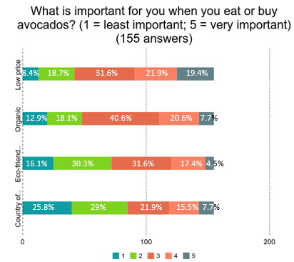
Figure 6.1 Importance ranking for the avocado consume/ purchase. Answered by 155 participants.
Other important criteria mentioned by 37 participants are depicted in figure 6.2., the ripeness (60%), the quality (22.2%) and the size of the fruit (6.7%). 42.5% of the participants who mentioned these criteria also opted for a high importance (level 4 and 5) for a low price. The participants who stated before that eco-friendliness is more important to them (level 4 and 5) also indicated that the packaging, “The less plastic and useless packaging the better” (4.4%), the carbon footprint, “Carbon print due to transport” (4.4%) and the support of the local supermarket, “[s]upporting the local people is nr. 5 for me for sure […] I prefer local small shops and vendors to supermarkets” (2.2%) are very important to them.
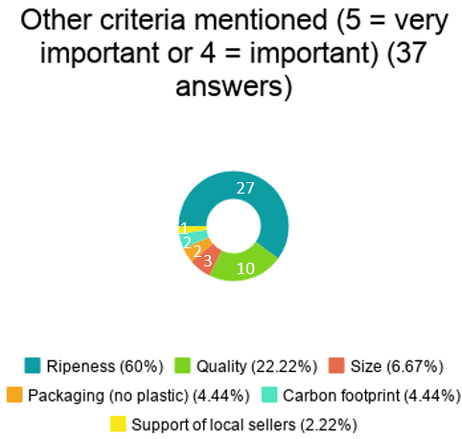
Figure 6.2 Criteria mentioned besides low price, organic, eco-friendliness and country of origin. Answered by 37 participants. Multiple options allowed.
According to Baird and Quastel, “complex standards such as for Fair Trade coffee have at times raised the cost of certiﬁcation and created barriers.” A Forsa survey from 2016 in Germany proved that the quality (40%), price (29%) and freshness (55%) of the groceries is more important than fairly traded (21%) or organic (17%) products. The results from the Forsa survey can be confirmed by this survey on young EU citizens, as a low price (36%) is more important to them than eco-friendly (19.1%) or organic (24.7%) avocados. The tendency could be explained by the fact that most people follow convenient and instinct driven behaviours, for example buying cheap avocados instead of sustainable certified, and thus less expensive ones. As was already mentioned before: “Unfortunately, most environmentally inappropriate behaviors are currently rewarded […] whereas environmentally appropriate behaviors are not—and they may even be punished.”

6.4 Awareness and knowledge
Referring to the entire group of 228 participants, almost half of the participants (49.1%) stated that they know about different production types for avocados or certificates, e.g. organic, Fair-Trade or Rainforest Alliance, but only 21% confirmed that they know about the meaning behind the certificates. This reflects also on the question why or why not organic and certified avocados are important to the participants. Statements like: “[I]f certification were made clearer […] it would be very important to me” and “I’m not always sure what certifications you can trust. I’ve heard for example that the rainforest alliance [sic!] certification really doesn’t make any difference. But I trust the fair trade [sic!] certificate and the EU organic certification” confirm the tendency that consumers rather buy organic, as they are already familiar with the label. “If certification could present a solution to problems caused in the countries of production maybe I would consider buying them, so far I feel that reduction of consumption is the most reasonable way.” This comment shows that doubts on the certificates rather lead to a boycott in the avocado purchase. However, boycotts rather enforce the conventional avocado production, as consumers interested in sustainability who could make a difference are not only not supporting sustainably produced avocados, but the less interested consumer with focus on cheap conventional avocados are the only purchasing power left then. Thus, to stay competitive, sustainable avocados are getting even more expensive. In comparison, a survey from Eurobarometer from 2006 on Health and food states that “[t]wo-thirds of EU citizens believe that it is easy to eat a healthy diet” and only few EU citizens think that there is a lack of information about the food they eat (16%) or that the available information about the food is of poor quality (15%).
Furthermore, 44.3% of the participants do not know if their supermarket offers organic avocados, 20.2% negated and 35.5% confirmed the question. The same question on certified avocados was only confirmed by 9.3% and negated by 22.5 participants. 68.3% don’t know if there is an offer for certified avocados. 63.6% of the participants indicated that they inform themselves about the food they consume, but 96% think that people are not well informed about the avocado production. Figure 6.3 reveals that most people inform themselves via internet (43.9%), the labels or the package of the product (16.6%), and news(papers) or magazines (10.2%). Other sources mentioned are books or articles (7%), contacts, e.g. with friends or relatives, (6.4%), documentaries or TV (5.3%), social media platforms or blogs (3.7%), supermarkets (2.7%), NGOs or associations (2.1%), governments (1.6%) and events (0.5%).
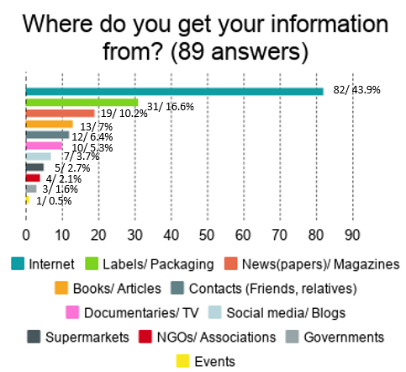
Figure 6.3 Information procurement. The first number indicates the absolute number, the second the relative value. Answered by 89 participants. Multiple options allowed.
In contrast, the following groups are split in the informed group, participants who know about different production types and certificates with their meaning and inform themselves about food in general and avocados in specific, and in the uninformed group, people who do not know about the production types, certificates and do not inform themselves about the food they consume and avocados.

The informed group, which could be rather referred to as the New Environmental Paradigm (NEP) group, achieved the following results:
24 participants out of 228 (10.5%) know about the different production types for avocados or certificates (e.g. organic, Fair-Trade, Rainforest Alliance), know what the different certificates indicate, know about concerns related to the avocado production and inform themselves about the food they consume at the same time. 50% of this group are highly interested (level 4 and 5) in eco-friendly avocados and 37.5% are highly interested in organic avocados. However, only 62.5% of the group are buying and eating avocados and from this part only 33.3% are highly interested (level 4 and 5) in eco-friendly and 20% in organic avocados. Reasons for the informed group to choose organic avocados are “a better tasting product on the whole”, the “[i]mportan[ce] for both health and environment” or the “care about the use of pesticides and the impact this has on our ecosystems. However, when there are no organic avocado's available […] the taste wins and I buy them anyway.” Statements on the reasons why the participants would not choose organic are: “[T]here’s seldom an organic choice […] at the street market”, “too expensive.”, “not more [important] than the quality […]. Due to the long journey or mistreatment they are quite often damaged or rotten”, “[o]rganic is a stupid meaningless label”, “I've never seen organic avocados in my store. And it would make them even more expensive than they already are, so I guess I wouldn't buy them. The price makes me buy way less avocados than I would like” and “I have not heard about how avocados are produced and what would than [sic!] be different in the way avocados are produced for organic avocados.” A survey from the Eurobarometer from 2009 on Europeans’ attitudes towards the issue of sustainable consumption and production found out that slightly over 50% of EU citizens are “fully aware or know about the most significant impacts of [the] products [they buy or use] on the environment” and over 80% claimed “that a product’s impact on the environment is an important element when deciding which products to buy. […] Nevertheless, only a minority rated environmental impact as more important than a product’s quality or price.” However, this tendency does not apply for the avocado consumption, as only few participants from the avocado survey claimed to be fully informed and thus are not fully aware of the impact of their avocado consumption. Nevertheless, the price is still more important than the environmental impact.

The uninformed group, which could rather be referred to as the Dominant Social Paradigm (DSP) group, achieved the following results:
40 participants out of 228 (17.5%) do not know about different production types or certificates and their meanings, and do not inform themselves about the food they consume or know about avocado concerns. None of the participants of this group indicated that certified avocados are highly important to them (level 5). However, 7.5% of this group are rather highly interested (level 4) in certified avocados. Organic avocados are highly important (level 4 and 5) to 27.5% of the participants. Slightly more participants from this group also buy and eat avocados (67.5%). With respect to this parameter, 11.1% indicated certified and 33.3% organic avocados as highly important. Even though participants indicated that organic avocados are highly important to them, statements like “I've never really payed attention to whether my avocados are organic or not” or “[d]on't know” were mentioned for the question on why organic is important to them. “Yes, as they’re are being grown in certain ways and there are some restrictions on the amount of helical used” was the answer from the only participant who indicated high importance (level 4) on certified avocados and who explained why certified avocados are important to him.
When comparing the informed with the uninformed group, a tendency can be described in which the informed group rather prefers certified avocados, whereas the uninformed group has few interests in either certified or organic avocados. The same tendency can be observed for avocado buyers and eaters. However, participants who eat and buy avocados from the uninformed group are as interested in organic avocados as the informed group is interested in certified avocados.

6.5 Effects of Raising Awareness
After the participants could read some quotes and background information on the social and environmental problems that the avocado production cause, the average of the participants, who consumed and bought avocados already before, stated that they would still consume and buy avocados now (73.6%). However, 87,1% stated that they would rather buy certified avocados and 94% are willing to spend more money on sustainable avocados. 62.9% of the participants also agreed on going to special supermarkets with an offer on sustainable avocados. Almost all participants from the informed group would continue to buy and eat avocados (93.3%). 86.7% would rather buy certified avocados now, 78.6% would spend more on sustainable avocados and 53.3% would go to special supermarkets. Three quarters of the uninformed group would still consume and buy avocados (74%) but is still less interested than the average in buying certified avocados now (77.8%) and would be less willing to spend more money on sustainable avocados (76%). Less than half of the participants from this group (48.2%) would be willing to go to special supermarkets to buy sustainable avocados.

6.6 Promotion, responsibility and influence
The question on what could be done to promote awareness on sustainable avocados was answered by 123 participants and the results are shown in Figure 6.4. Additionally, some participants gave ideas for the promotion of sustainable avocados in the section for comments in the end of the survey. Most participants mentioned “[a]dvertising [c]ampaign[s]” for example on social media platforms to “[r]aise awareness on the mainstream media (in social media as well but only from trusted sources), [or] interview[s with] experts on the subject, [or] presentations at university's [sic!], schools […],” as well as additional information in supermarkets. People mostly referred to the packaging of the product: “I think that possibly for food on the whole there should be a way of seeing the environmental impact of its production. This could be done much like the nutritional information already displayed on most packaging,” “[through] a sticker on each avocado” or “[by] invent[ing] an evident signal (like a traffic light for example) that everyone know [sic!] an [sic!] shows everyone immediately whats [sic!] going on.” Some participants also argued that documentaries or news articles with explanations and information on the different certificates could provoke a higher percentage of informed people. “Give detailed information about the farming conditions in supermarkets combined with explanations about different certificates; film documentaries and show them on "new" sources e.g. Netflix etc.” Some participants even gave direct suggestions for social media campaigns, for example to “reach out to food bloggers”, “[s]tart some popular hashtag for it with some celebrities retweeting it. […] #avocadolivesmatter” and even named celebrities to lead the campaigns, for example “Jamie Oliver” as a popular cook with “great marketing.” One participant suggested to “[p]romote especially the certified avocados (so the 'alternative' way) because […] it will be hard to persuade people to stop eating them completely.” One participant advised to “[m]ake sure sustainable avocados can also be bought in regular supermarkets.” Four participants also commented on the responsibility of the government: “EU food policies could/ should restrict the commercial selling of uncertified products.” One participant even suggested to “[b]oycott[] supermarkets selling non-certified avocados [and to] [d]emand[] more [engagement] from supermarkets.” According to Skinner’s behaviourist theories this would count to negative punishment stimulus (SP), as an award (income) is taken off to decrease a behaviour (provide certified avocados). However, negative punishments are less effective. “[P]ositive reinforcement is generally more effective because […] punishment often produces undesirable behavioural (sic!) side effects such as aggression or avoidance […].” Five participants in contrast saw the responsibility on the citizens and commented that an “[i]ncrease [of] the price of avocados […] make people think twice.” However, this would probably rather lead to a complete avoidance of the fruit. “Lower [the] price for better avocado on the start” another participant commented on the contrary.
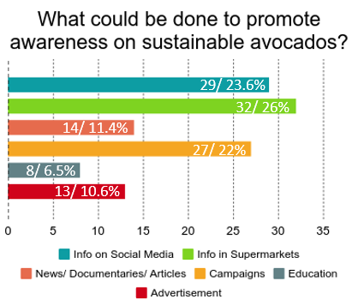
Figure 6.4 Ideas on the promotion of awareness on sustainable avocados. The first number indicates the absolute number, the second the relative value. Answered by 123 participants.
On the questions who is responsible to take action in the current situation (first number, depicted in figure 6.5, left) and who could influence a change or improve the current situation (second number, depicted in figure 6.5, right), the participants voted mainly for the governments (16.2%/15.3%) and the supermarkets (16.1%/16.2%). The social media (12.1%/14.6%) is named on third place, political institutions (10.7%/11.8%) and the supplier from the producing country (11.9%/10.4%) are named thereafter. In both cases, EU citizens see themselves only on spot number six with 7.9% and 9.2%.
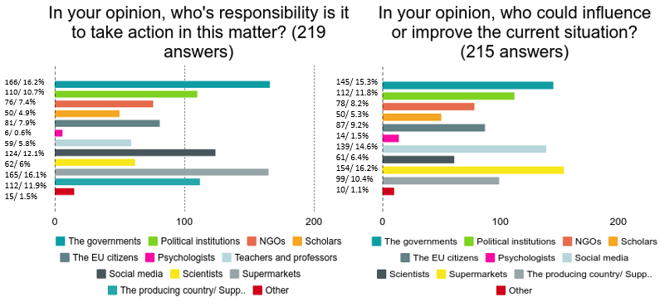
Figure 6.5 The responsible actors and influencers to provoke a change. The first number indicates the absolute number, the second the relative value. Answered by 219 and 215 participants. Multiple options allowed.
This tendency confirms a Eurobarometer study from 2008. 75% of EU citizens stated that they are willing to buy environmentally friendly products even if they are more expensive, however, only 17% follow their intentions. EU citizens are most likely not changing to an eco-friendlier behaviour in their most close surroundings connected to their daily life, as most don’t see their consumption behaviour as the problem (11%). Furthermore, EU citizens expect global answers to environmental problems and that environmental protection is more important (64%) than economic competition (18%) from the governmental view point. A recent Eurobarometer survey from 2017 indicates that EU citizens want more action towards environmental protection and shared responsibilities which besides the personal one must include “big companies and industry, national governments and the EU.” Additionally, the majority of EU citizens would like the EU to “invest more money in projects and programmes supporting the environment, nature conservation and climate action [and to] assist non-EU countries to improve their environmental standards.”
As Die Zeit stated a Forsa study, 94% of the German citizens believe that environmental protection improves their quality of life, but 68% have troubles implementing environmentally friendly behaviour. According to the author, the reason could be the inconvenience to inform oneself about everything one consumes or something else might be more important. The reason why people tend to ignore and don’t inform themselves about the problems behind the avocado production could be explained by Freud’s defence mechanism. However, psychologists, and thus psychological methods, are voted on the last place for responsibility to take action (0.6%) and on the second last place for the possibility to influence or change the situation (6.5%).

7 Ideas for Solutions
After concentrating on the situation how it currently is in chapter three and four, how the situation could be influenced through a behavioural approach in chapter five, and after checking the awareness of EU citizens on the situation in chapter six, this chapter will focus on solutions to the situation. Two approaches must be considered: how to strengthen the awareness of uninformed people and how to support the informed population to influence the situation.

If the consumers wanted to have clean avocados, there must be some social noise that would make retailers react to clean their production chains. However, this would take some time and awareness, and only very few people are concerned about this. Normally, the majority of the globally produced fruits and vegetables are consumed in the producing country itself. However, in the case of the avocado, more fruits get exported than consumed in Mexico and thus the importing countries are more powerful. Consumers with bigger purchasing power have a bigger saying. The WRI México stated that importing countries could influence the situation of the avocado production. There is for example a restaurant in the UK that used avocados as a specialty, but after learning about the unsustainable side of avocados they refused to use them. However, a boycott only gives more weight to conventionally produced avocados as mentioned before. A change cannot be forced through the producers, a prohibition could be achieved, but would be unsuccessful. However, a change through the demand of stricter controls could work. No support for informal production, only buying avocados from registered farms can make a difference. The production of timber is an example.
According to Reforestamos, Greenpeace could have an impact, but in Mexico the NGO does not have much influence. However, Greenpeace in the US or in the EU have more resources and thus a bigger impact and could work together with NGOs from Mexico, for example with Reforestamos, WRI or Alternare, or organisations for sustainability in Europe, especially in the Netherlands, France, the UK, Germany, Belgium and Sweden, as they register the highest import of avocados. Solutions must be found for the regions in Mexico, as avocados are produced locally. However, first awareness is needed to achieve the means to work on solutions, as people from outside Mexico do not know fully about the concerns regarding the avocado production.
The NGO Reforestamos suggested campaigns to raise awareness in society on the deficiency in the avocado production to emphasise the problems so that they become more visible. By reporting the circumstances to leading press agencies all over the EU, the awareness of the consumers on the deplorable state could improve and the consumers could pressure the authorities. A similar movement to the dolphin-safe tuna campaign explained in chapter two, or the more recent Fridays for Future demonstration on climate protection launched in Sweden, lead by Greta Thunberg, which already pushed the governments into more concrete actions could also pressure to more sustainable avocado practices inside and outside the EU.
Combined with this solution, another idea could be a price increase for avocados to raise awareness on the real cost of avocados, like Koger and Winter already described on the case of lumber. The real cost “reflect[s] the cost of resource replacement or the pollution clean up involved in production.” Hence, conventional avocados would turn more expensive than sustainable ones. The answers to the question on the promotion of environmentally friendly products in the Flash Eurobarometer 256 from 2009 concerned the provision of better information on the product and a better visibility and availability of eco-friendly products by the retailer (30% and 25%), as well as a shift in the taxation system. Interestingly, a behaviouristic approach was mentioned, as
in all countries in the survey, a taxation system – to promote eco-friendly products – based on reducing taxes for more environmentally-friendly products received more support than a system based on increasing taxes for environmentally-damaging products [and] at least half of interviewees answered that the best taxation system to promote environmentally-friendly products would be to reduce taxation for the more environmentally-friendly products, in combination with increasing taxes for environmentally-damaging products.
Furthermore, more certificates like Fair-Trade, who cooperate with consumers not only to support producers, but to create awareness and launch campaigns to change rules and practices, are needed. This could help reduce the mistrust of EU citizens in sustainability certificates. The scholar from UNAM mentioned coffee as another example. Mexico was at some point the largest producer of coffee. The demand from abroad rose on producing standards and the incentive was selling to the huge market. This could also work for the avocado production.
An action plan with NGOs and consumers as main influencing parties is shown in figure 7.1 inspired by the dolphin-safe tuna case. The impact mechanism is mainly triggered by the pressuring of the authorities through the purchasing power of the population on the industry, thus the consumers hold the biggest power to cause a change through an economic influence. The dolphin-safe tuna campaign emphasized on consumer choices thus the inﬂuence on the overall market for tuna forced the industry to take the issue seriously.

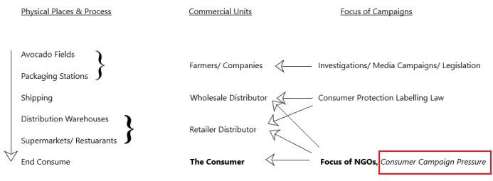

Figure 7.1 Action plan for sustainable avocados from Mexico inspired by the scheme on strategic action in the tuna dolphin commodity network.
Besides raising awareness in the population and pressuring the government into a financial support for sustainable certified avocados in the supermarkets, the development and implementation of a new certification scheme could be considered, in case EU citizens do not recover their trust in the existing certificates (especially the Rainforest Alliance certificate) and also to include more aspects tailored specifically on avocados.
A successful case for certification standards pressured by a cooperation between NGOs and citizens is the dolphin-safe tuna campaign in the United States. The dolphin-safe tuna certification network
combined perceived consumer demand, product labels, U.S. government labeling laws, and United Nations resolutions with strong media-based negative advocacy [and] highlighted links between world trade and environmental issues, exposed the pitfalls of commodity regulation in the existing international legal order, and brought consumer concern with the processes behind products to the forefront of environmental activism.
Based on the concept of the tuna study, a clean avocado certification network could emerge with the help of NGOs, “[b]y providing a closed list of standards that are easily mobilized across expansive networks […] [and b]y allowing for narrowly focused action with large effects” on sustainable avocado certificates.
NGOs and other actors work together to forge quality aspects of products that match the shifting or constructed ethical or aesthetic concerns of consumers […]. In turn, consumers and other network participants become “enrolled” in networks and take on novel imaginaries […]. Conventions theory points to a focus on the discourse and practices that unite consumers, producers, and others in participating in the commodity network and the ways in which certiﬁcation labels play a coordinating role.
A similar case to the avocado cultivation is the palm oil production. Due to the scale of deforestation and environmental degradation caused by the unsustainable palm oil production the Roundtable on Sustainable Palm Oil, RSPO, has been established, as Gabriela Barrera Flores reported in her article on forests and avocado in 2018. The association implemented global sustainability standards regarding palm oil, to mitigate the damage the cultivation causes and to give certainty to the consumer. Similar regulations for the avocado production are important according to Barrera Flores.
A solution suggested on the political stage is the TEEBAgriFood project. The Mexican Agricultural Ministry, the Mexican Ministry of Environment and Natural Resources together with the GIZ, the German Agency for International Co-operation, the UN Environment and the FAO launched a project in 2016, the global TEEB for Agriculture and Food initiative, in Mexico to gather information and create methods to protect the biodiversity and promote sustainable agricultural practices which will be implemented through pilot projects. The research focuses on the connection between agriculture systems, human systems and ecosystems in the production stage.
Through capacity building and awareness-raising directed to producers, consumers, and decision makers, this project will foster behavioural changes, which will secure the conservation of biodiversity […and the] integration of the importance of biodiversity and ecosystem services into policies and strategies related to the agricultural sector will promote sustainable agriculture and biodiversity conservation at the local, federal and national level.

8 Conclusion
This thesis is not meant to propagate a warding off the avocado consume, but rather to promote a more conscious consumption towards sustainable food with the avocado as a pilot project. Concentrating on and supporting sustainable food production is more successful on the long-term than avoiding or prohibiting certain food as people will very likely continue buying and consuming them, as a part of convenience or luxury, as has become visible through the responses in the survey. However, sustainably produced products are less harmful than conventional ones, and as food trends move on avoiding one fruit doesn’t make a difference. The sustainable production needs to become the trend. As Die Zeit, a supra-regional German weekly newspaper, already stated in an article about avocados in 2016, “[d]ie Umwelt schützen will so gut wie jeder, sich konkret einschränken kaum einer,” which can be translated to everyone wants to protect the environment, but nobody wants to restrict themselves. Furthermore, the article claims that nowadays the environmental protection is only reduced to a status symbol for a certain social class and that it has become more or less a fairy tale; its degree of reality is not examined anymore. The intention thus is to change every consumers’ mind and behaviour towards a more thoughtful eating habit to provoke a change in harmful production methods and to reconnect and thus protect the human being and its surroundings. “Some suggest that the problems can only be solved by massive governmental regulations, while others argue that only transformation of people’s […] values will provide deliverance.” . Campaigns led by NGOs including a co-operation between the EU and Mexico could raise the awareness level of the citizens and lead to a higher pressure on the EU government to subsidy the sustainable certified avocado production.
Coming back to the responsibility circle for the monitoring of the pledges on sustainability in the avocado production in Mexico (Figure 1.1 from the introduction), the proposals to solve the problem can be summed up as following:

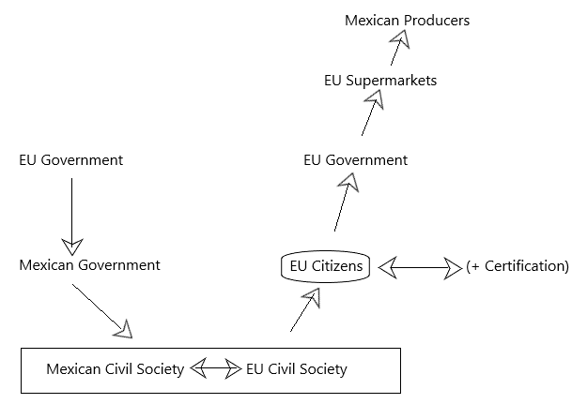
Figure 8.1 A way out of the postponement of responsibility for sustainable avocados.
The illustration (Figure 8.1) shows the broken circular postponement of the responsibility for actions for sustainably produced avocados. The EU government worked on agreements about sustainable agricultural practices together with the Mexican government. The governments gave pledges, but barely named control methods and exercising institutions. However, they named civil society as the regulatory body in charge. During the interviews it became clear that the Mexican civil society cannot follow their duty as they don’t have the means and protection. However, the NGO mentioned that EU citizens could influence the government to implement other methods on sustainability, but EU citizens are mostly not informed or aware about the concerns. EU citizens who actually are informed stated that the sustainable certificated fruit is too expensive, that they do not fully trust in the certificates and that certified sustainable avocados are rarely available in the supermarkets. To solve this issue, the Mexican civil society needs to cooperate with the EU civil society in working on campaigns to inform the population, especially on the indication of the certificates, the availability in the supermarkets and the trustworthiness of the certificates. This could happen for example via internet, for example through social media (as mentioned by several survey participants) or labels and packages of the products, as these are the most popular sources for information. As role models play an important role, these campaigns should be led or supported by known and popular celebrities or politicians. For the implementation of the campaigns, social and psychological concepts need to be considered. Especially the theories of planned behaviour, observational learning and defence mechanisms must be respected and taken into consideration. Furthermore, certification authorities, for example from Fair-Trade, need to support these campaigns and work together with the citizens. After EU citizens gained solid background knowledge of the avocado situation, they can use their power to influence the EU government. In cooperation with the European retailers and supermarkets, the government can lower the prices for certificated avocados (in the beginning as a pilot project) to additionally support the purchase of sustainable avocados. The important part is to avoid corruption and crime in the institutional field in Mexico and concentrate on a change in the EU system. Thus, the certificated avocado producers will be supported, and the benefits of sustainable and certified avocados can raise the willingness to change the production methods permanently in the producing country.
Besides the change in the awareness of EU citizens towards sustainable avocados and the financial support from the government, different ideas on how to solve the problem of monitoring, surveying and controlling in the third country producer need to be analysed and discussed by the certification institutions. This approach could include programs, projects, campaigns, such as mentioned, and strategies which are borrowed from other international traded food products. CONAFOR mentioned in their interview that a technical cooperation between Mexico and the EU could improve the food standards and should be investigated on.

9 References
Baird, Ian G., and Noah Quastel. “Dolphin-Safe Tuna from California to Thailand: Localisms in Environmental Certification of Global Commodity Networks.” Annals of the Association of American Geographers 101, no. 2 (2011): 337-355. Accessed 23 May 2019. doi: 10.1080/00045608.2010.544965.
Barndt, Deborah. “On the Move for Food: Three Women Behind the Tomato’s Journey.” Women's Studies Quarterly Vol. 29 No. 1/2 (2001): 131-143. In Earthwork: Women and Environments. The Feminist Press, City University of NY, 2001.
Barrera Flores, Gabriela. Avocado Fact Sheet: Avocado and Forests: What is at stake? Mexico: Reforestamos México, 2018. Unpublished document.
Barrera Flores, Gabriela. Bosques y aguacate: ¿Qué está en riesgo? Mexico: Reforestamos México, 2018. Unpublished document.
Benthin, Rainer, and Angelika Gellrich, eds. Umweltbewusstsein in Deutschland 2016. Ergebnisse einer repräsentativen Bevölkerungsumfrage. Berlin: Bundesministerium für Umwelt, Naturschutz, Bau und Reaktorsicherheit (BMUB), 2017. Accessed 09 April 2019. https://www.umweltbundesamt.de/sites/default/files/medien/376/publikationen/umweltbewusstsein_deutschland_2016_bf.pdf.
Cámara de Diputados del H. Congreso de la Unión. Reglamento de la ley general del equilibrio ecológico y la protección al ambiente en materia de áreas naturales protegidas. Estados Unidos Mexicanos, 2014. Accessed 02 May 2019. https://www.google.de/url?sa=t&rct=j&q=&esrc=s&source=web&cd=3&cad=rja&uact=8&ved=2ahUKEwjjypTDtf3hAhWhzoUKHd-6BkIQFjACegQIBBAC&url=http%3A%2F%2Fdsiappsdev.semarnat.gob.mx%2Fdatos%2Fjuridico%2Freglamentos%2FRgto.%2520de%2520la%2520Ley%2520General%2520del%2520Equilibrio%2520Ecol%25C3%25B3gico%2520y%2520la%2520Protecci%25C3%25B3n%2520al%2520Ambiente%2520en%2520materia%2520de%2520Areas%2520Naturales%2520Protegidas%2520DOF~1.doc&usg=AOvVaw02iikYhKN41M24s75LEWB5.
CBI Ministry of Foreign Affairs. Exporting fresh avocados to Europe. The Hague: Ministry of Foreign Affairs, 2018. Accessed 18 January 2019. https://www.cbi.eu/market-information/fresh-fruit-vegetables/avocados/europe.
CBI Ministry of Foreign Affairs. What requirements should fresh fruit or vegetables comply with to be allowed on the European market? CBI Ministry of Foreign Affairs, 2018. Accessed 15 April 2019. https://www.cbi.eu/node/2441/pdf.

Comisión Nacional Forestal. Proyectos de compensación ambiental por Cambio de Uso de Suelo en Terrenos Forestales (CUSTF). Comisión Nacional Forestal, 2017. Accessed 04 May 2019. https://www.gob.mx/conafor/acciones-y-programas/proyectos-de-compensacion-ambiental-por-cambio-de-uso-de-suelo-en-terrenos-forestales-custf.
Deutsche Forschungsgemeinschaft e.V.. Liste von Entwicklungsländern und - gebieten in Bezug auf DFG-Verfahren, Stand April 2019. Deutsche Forschungsgemeinschaft e.V., 2019. Accessed 05 June 2019. https://www.dfg.de/download/pdf/foerderung/internationales/entwicklungslaender/entwicklungslaender_liste.pdf.
Dokumentation Mexiko: Die Macht der Kartelle und Drogenmafia. Directed by Agnès Gattegno. ARD, Arte, 2014. Accessed 12 February 2019. https://www.youtube.com/watch?v=OaTPGW709Nc.
Dominguez Caballero, Xiomara Nataly, and Gabriela Giovana Barrera Flores. Forests Falling Fast to Make Way for Mexican Avocado. Global Forest Watch, 2019. Accessed 27 March 2019. https://blog.globalforestwatch.org/commodities/forests-falling-fast-to-make-way-for-mexican-avocado.
ECOLEX. Ley General de Desarrollo Forestal Sustentable. FAO, 2017. Accessed 02 May 2019. https://www.ecolex.org/es/details/legislation/ley-general-de-desarrollo-forestal-sustentable-lex-faoc036056/.
Emas, Rachel. Brief for GSDR 2015 The Concept of Sustainable Development: Definition and Defining Principles. Florida International University, 2015. Accessed 18 March 2019. https://sustainabledevelopment.un.org/content/documents/5839GSDR%202015_SD_concept_definiton_rev.pdf.
Europäische Kommission. Spezial Eurobarometer 295. Einstellungen der europäischen Bürger zur Umwelt. Brussels: European Opinion Research Group EEIG, 2008. Accessed 10 April 2019. http://ec.europa.eu/commfrontoffice/publicopinion/archives/ebs/ebs_295_de.pdf.
European Commission. Commission staff working document. Impact Assessment. Brussels, 2015. Accessed 23 April 2019. http://trade.ec.europa.eu/doclib/docs/2016/march/tradoc_154396.034027.1.SWD_2015_289_EN%20IAR.pdf.
European Commission. Countries and Regions. Mexico. European Commission, 2018. Accessed 03 April 2019. http://ec.europa.eu/trade/policy/countries-and-regions/countries/mexico/.
European Commission. EU Trade Helpdesk. Import Procedures: European Union – Overview of Import Procedures. Spain: TARIC S.A., 2010. Accessed 04 April 2019. http://trade.ec.europa.eu/tradehelp/myexport#?product=0804400000&partner=MX&reporter=DE#EU_CustomsUnion.
European Commission. EU Trade Helpdesk. Product requirements: Voluntary - Products from organic production. Spain: TARIC S.A., 2010. Accessed 04 April 2019. http://trade.ec.europa.eu/tradehelp/myexport#?product=0804400000&partner=MX&reporter=DE#EU_CustomsUnion.
European Commission. Flash Eurobarometer 256 - The Gallup Organisation. Europeans’ attitudes towards the issue of sustainable consumption and production. Brussels: European Commission, 2009. Accessed 10 April 2019. http://ec.europa.eu/commfrontoffice/publicopinion/flash/fl_256_en.pdf.
European Commission. Guide to the new EU-Mexico Trade Agreement April 2018. European Commission, 2018. Accessed 14 March 2019. http://trade.ec.europa.eu/doclib/docs/2018/may/tradoc_156888.pdf.
European Commission. New EU-Mexico agreement: The Agreement in Principle and its texts. Brussels: European Commission, 2018. Accessed 14 March 2019. http://trade.ec.europa.eu/doclib/docs/2018/april/tradoc_156791.pdf.
European Commission. Press release. EU and Mexico reach new agreement on trade. Brussels: European Commission, 2018. Accessed 08 April 2019. http://europa.eu/rapid/press-release_IP-18-782_en.htm.
European Commission. Special Eurobarometer 246. Brussels: TNS Opinion & Social. Health and food, 2006. Accessed 10 April 2019. http://ec.europa.eu/health/ph_publication/eb_food_en.pdf.
European Commission. Special Eurobarometer 468. Summary. Attitudes of European citizens towards the environment. Brussels, 2017. Accessed 10 April 2019. http://webcache.googleusercontent.com/search?q=cache:4_gReCPl2fMJ:ec.europa.eu/commfrontoffice/publicopinion/index.cfm/ResultDoc/download/DocumentKy/81259+&cd=1&hl=de&ct=clnk&gl=cz.
European Commission. The EU-Mexico Trade Agreement explained. European Commission, 2018. Accessed 17 March 2019. http://ec.europa.eu/trade/policy/in-focus/eu-mexico-trade-agreement/agreement-explained/.
Eurostat. Apples and tomatoes were the top fruit and vegetable produced in the EU in 2015. Eurostat Press Office, 2016. Accessed 27 March 2019. https://ec.europa.eu/eurostat/documents/2995521/7517627/5-22062016-AP-EN.pdf/8247b23e-f7fd-4094-81ec-df1b87f2f0bb.
FAO. Country fact sheet on food and agriculture policy trends. Food and Agriculture Organization of the United Nations, 2016. Accessed 16 March 2019. http://www.fao.org/3/a-i6006e.pdf.
FAO. The State of the World’s Land and Water Resources for Food and Agriculture. Managing systems at risk. London: Food and Agriculture Organization of the United Nations, 2011.
Farrell, Sarah. “Millennials and their Impact on Sustainability.” Sustainability Management School, 22 January 2019. Accessed 06 May 2019, https://sumas.ch/millennials-and-sustainability/.
Federal Government of Mexico. Special Climate Change Program 2014-2018. Mexico: Federal Government of Mexico, 2014. Accessed 18 March 2019. https://www.cakex.org/sites/default/files/documents/SpecialClimateChangeProgram20142018Englishversion.pdf.
Gavito Pardo, Mayre Elena, Dra. Marta Astier Calderón, M. C. Juan Martínez Cruz, Dr. Ricardo Ayala Barajas, M. C. Enrique Ramírez García, M. C. Tamara Ortiz Ávila, M. C. Yair Merlín Uribe, M. C. Miguel Prado López, and QFB. Ana Lidia Sandoval Pérez. Evaluación del impacto ecológico del cultivo de aguacate a nivel regional y de parcela en el Estado de Michoacán: calidación de indicadores ambientales en los principales tipos de producción. Morelia, Michoacán: Informe Final Eapa 1, 2011.
GLOBALG.A.P. Government Requirements. GLOBALG.A.P. Accessed 23 April 2019. https://www.globalgap.org/uk_en/for-producers/government-requirements/.
GLOBALG.A.P. GRASP. GLOBALG.A.P. Accessed 23 April 2019. https://www.globalgap.org/uk_en/for-producers/globalg.a.p.-add-on/grasp/index.html.
Graffham, Andrew. “EU legal requirements for imports of fruits and vegetables (a suppliers guide).” Fresh Insights no. 1. UK: Natural Resources Institute, 2006. Accessed 14 March 2019. https://lwecext.rl.ac.uk/PDF/60506EU_REGULATIONS_GUIDE_2006.pd.
Handelsblatt. OECD-Studie. Deutschland hat wenig Hochgebildete. Handelsblatt, 2014. Accessed 18 May 2019. https://www.handelsblatt.com/politik/deutschland/oecd-studie-hohe-bildung-hohes-einkommen/10675720-2.html?ticket=ST-428237-IekzE0raZ77hKNhUdHOU-ap3.
ICEA certifica. ICEA Certified. ICEA, 2018. Accessed 01 May 2019. https://icea.bio/cosa-facciamo/?lang=en.
Illegal Deforestation Monitor. Illegal deforestation for avocado production in Mexico spreads as US relaxes import controls. IDM, April 2017. Accessed 01 May 2019. http://www.bad-ag.info/illegal-deforestation-for-avocado-production-in-mexico-spreads-as-us-relaxes-import-controls/.
ISEAL Alliance. Homepage. ISEAL Alliance. Accessed 22 April 2019. https://www.isealalliance.org.
Jezard, Adam. “Who and what is ‘civil society?’” World Economic Forum, 23 April 2018. Accessed 18 March 2019. https://www.weforum.org/agenda/2018/04/what-is-civil-society/.
Kahn, Carrie. “Blood Avocados No More: Mexican Farm Town Says It's Kicked Out Cartels.” National Public Radio, 02 February 2018. Accessed 27 March 2019. https://www.npr.org/sections/parallels/2018/02/02/582086654/mexicos-avocado-capital-says-it-s-kicked-cartels-off-the-farm?t=1553705947401.
Koger, Susan M., and Deborah Du Nann Winter. The Psychology of Environmental Problems. Psychology for Sustainability. Taylor & Francis e-Library, 2011.
Lavelle, Daniel. ”Should you stop eating ‘blood avocados’?” The Guardian, 10 December 2018. Accessed 29 June 2019, https://www.theguardian.com/food/shortcuts/2018/dec/10/should-you-stop-eating-blood-avocados?CMP=share_btn_link.
Lemus, Jesús. “El Cáncer en la Zona Aguacatera de Michoacán, un drama que nadie observa: no hay regulación oficial en el uso de pesticidas.” Zenzontle 400 Las voces críticas del periodismo, 25 March 2019. Accessed 27 March 2019. https://zenzontle400.com.mx/2019/03/05/el-cancer-en-la-zona-aguacatera-de-michoacan-un-drama-que-nadie-observa-no-hay-regulacion-oficial-en-el-uso-de-pesticidas/?fbclid=IwAR0HN1YZ7M_xvizPl_2ex_aLCbsptbtR40YOmZzoJCVH4Nll-3r7ALyCb-s.
Les avocats du diable. Directed by Virginie Vilar, Alex Gohari, Nils Montel, and Vivien Roussel. France: Franceinfo, Envoyé spécial, 2017. Accessed 18 January 2019. https://www.youtube.com/watch?v=lrpZS1zIrXA.
Madden, Thomas J., Pamela Scholder Ellen, and Icek Ajzen. “A Comparison of the Theory of Planned Behavior and the Theory of Reasoned Action.” In PSPB Vol. 18, No. 1, 3-9. Society for Personality and Social Psychology, Inc., 1992.
McMichael, Philip. “The power of food.” In Agriculture and Human Values Vol. 17, Issue 1, 21-33. Kluwer Academic Publishers, 2000.
Noticias TM. “Periodista Alejandra Jiménez pide protección tras recibir amenazas de muerte por denunciar incendios provocados en Michoacán.” Noticias TM, 30 May 2019. Accessed 09 June 2019. https://www.noticiastm.com.mx/nacional/amenazan-a-periodista-por-denunciar-incendios/.
Official Journal of the European Communities. Decision No 2/2000 of the EC-Mexico Joint Council of 23 March 2000 (2000/415/EC). EUR-Lex, 2000. Accessed 08 April 2019. https://eur-lex.europa.eu/resource.html?uri=cellar:a024c280-a801-4dcd-bc46-a3afdd86c3ba.0005.02/DOC_1&format=PDF.
Personal Interviews with avocado producers (anonymous), Uruapan Michoacán, December 2018; with the NGO Reforestamos (anonymous), Mexico City, January 2019; with the NGO World Resources Institute México (WRI) (anonymous), Mexico City, January 2019; with a scholar from UNAM (anonymous), Mexico City, January 2019; with the NGO Alternare (anonymous), Mexico City, February 2019; with a staff member of CONAFOR (anonymous), Mexico City, February 2019.
Raether, Elisabeth. “Das Märchen von der guten Avocado.“ Die Zeit No. 43, 13 October 2016. Accessed 09 April 2019. https://www.zeit.de/2016/43/avocado-superfood-anbau-oekologie-trend.
Rainforest Alliance. FAQ: What is the difference between Rainforest Alliance Certification, Fairtrade, and UTZ Certification? Rainforest Alliance, 2018. Accessed 22 April 2019. https://www.rainforest-alliance.org/faqs/difference-rainforest-alliance-certified-fair-trade-utz.
Ritz, Michael. Landkarte der europäischen Gliederung (Nord-, Ost-. West-, Süd-, und Südosteuropa) (Deutsch) Ständiger Ausschuss für geographische Namen (StAGN). Landkarten und Stadtplan Index, 2000-2018. Accessed 18 May 2019, https://www.landkartenindex.de/weltatlas/?p=13182.
Rodríguez-Piñero Fernández, Inmaculada. European Parliament. European Parliament, 2019. Accessed 15 March 2019. http://www.europarl.europa.eu/legislative-train/theme-a-balanced-and-progressive-trade-policy-to-harness-globalisation/file-modernisation-eu-mexico-global-agreement.
Schmied, Doris. Nahrungsgeographie. Das Geographische Seminar. Westermann, 2018.
Stanford, Lois. “Constructing ‘quality': The political economy of standards in Mexico's avocado industry.” In Agriculture and Human Values Vol. 19, Issue 4, 293-310. Kluwer Academic Publishers, 2002.
Statista. Europäische Union & Euro-Zone: Gesamtbevölkerung von 2008 bis 2018 (in Millionen Einwohner). Statista, 2019. Accessed 24 April 2019. https://de.statista.com/statistik/daten/studie/14035/umfrage/europaeische-union-bevoelkerung-einwohner/.
Stylianou, Nassos, Clara Guibourg, and Helen Briggs. Climate change food calculator: What’s your diet’s carbon footprint? BBC News, 2018. Accessed 27 March 2019. https://www.bbc.com/news/science-environment-46459714.
The Economics of Ecosystems and Biodiversity. TEEB for Agriculture and Food. The Economics of Ecosystems and Biodiversity, 2016. Accessed 17 March 2019. http://www.teebweb.org/teeb-mexico/teebagrifood/.
Transparency International. Corruption Perceptions Index 2018. Transparency International, 2018. Accessed 20 June 2019. https://www.transparency.org/country/MEX, https://www.transparency.org/country/THA.
UTZ. New certification program. UTZ - Rainforest Alliance. Accessed 22 April 2019. https://utz.org/new-certification-program/.
WFTO. 10 Principals of Fair Trade. World Fair Trade Organization, 2017. Accessed 22 April 2019. https://wfto.com/fair-trade/10-principles-fair-trade.
Widter, Sarah. “Demonstrationen für den Klimaschutz in über 1000 Städten.“ Welt, 15 March 2019. Accessed 19 April 2019.
https://www.welt.de/politik/deutschland/video190348047/Fridays-for-Future-Greta-Thunberg-Schueler-demonstrieren-fuer-den-Klimaschutz.html.
World Commission on Environment and Development. Report of the World Commission on Environment and Development: Our Common Future. UN-documents, 1984. Accessed 17 March 2019. http://www.un-documents.net/our-common-future.pdf.
World Trade Organization. Sanitary and Phytosanitary Measures. The WTO Agreement on the Application of Sanitary and Phytosanitary Measures (SPS Agreement). WTO. Accessed 09 April 2019. https://www.wto.org/english/tratop_e/sps_e/spsagr_e.htm.
World Trade Organization. Uruguay Round Agreement. Agreement on Agriculture. WTO. Accessed 09 April 2019. https://www.wto.org/english/docs_e/legal_e/14-ag_01_e.htm#articleI.
WRI. EOI Template for Food Systems, Land Use and Restoration Impact Program. World Resources Institute, 2019.

Appendix
Annex 1: Questionnaire Interviews Mexico
- In your opinion, does the cultivation and exportation of avocados influence the environment? If yes, how? Do you think that there is a relation between the production of avocados and climate change/ pollution and/ or pest control?
- Do you think that the production and the exportation of avocados influence the Mexican society? Do you think that there is a relation between the avocado production and the organisations/ health/ social conditions of the workers?
- What do you think about the avocado production and the quality control/ environmental certificates/ the commercial trades with the EU?

- Are there any international agreements that influence the avocado products that Mexico sends to the EU?
- Are there any standards or restrictions around the production and consumption of avocados to protect the environment?
- Are there any restrictions in the use of pesticides/ herbicides/ fungicides for the avocado production? If yes, do the workers respect them and are there any exceptions?
- Can the avocado production be connected to any health problem for the workers and/ or consumers? If yes, which ones and is there any protection?
- Do criminal organisations influence the avocado production and exportation? If yes, how? Do the consumers know about it? Does the government react to it?
- Does the work in the avocado production influence the social status or the worker? For example, does the socio-economic situation change remarkably in comparison to other jobs?
- Is there any social security for the workers and a syndicate?
- Does the avocado export to the EU influence the Mexican economy?
- Are there any norms for the exportation to the EU? If yes, which ones and do they differ from other countries? Does food security/ control in the EU differ from Mexico?
- Are controls mentioned in the contracts between the producing and consuming countries?
- Are there any restrictions concerning avocados in cosmetic products, for example certificates for environmental protection? Do certificates influence the end price for the product and/ or the production expenses?
- Are there any certificates for the export/ import of avocados?

Annex 2: Questionnaire Survey EU
Anonymous survey about avocados
Research for the master thesis of Susanne Link
* Obligatory
Section 1:

1. Please indicate your age *
Section 2:
2. Please select your gender *
- Female
- Male
- Other
Section 3:

3. Where are you from? *
(Country of origin)
- Austria
- Belgium
- Bulgaria
- Croatia
- Republic of Cyprus
- Czech Republic
- Denmark
- Estonia
- Finland
- France
- Germany
- Greece
- Hungary
- Ireland
- Italy
- Latvia
- Lithuania
- Luxembourg
- Malta
- Netherlands
- Poland
- Portugal
- Romania
- Slovakia
- Slovenia
- Spain
- Sweden
- UK

Are you living in a city or in the countryside? *
- City
- Countryside
Section 4:

4. Which is your highest school-leaving qualification? *
(Type of education)
- Secondary school
- High school
- College
- University (bachelor)
- University (master)
- University (PhD)
- Other

5. Which subject area? *
- Technical
- Science
- Humanities
- Economics
- Business/ Management
- Medicine
- Law
- Other
Section 5:

6. Do you eat avocados? *
e.g. in restaurants/ Eating at friends or family
- Yes
- No
Section 6:

7. Do you buy avocados by yourself? *
- Yes
- No

8. If yes, how often do you buy avocados?
- At least once a week
- At least once a month
- At least once a year
- Never
Section 7:

9. Do you know about different production types for avocados or certificates (e.g. organic, Fair-Trade, Rainforest Alliance)? *
- Yes
- No

10. Do you know what the different certificates indicate? *
- Yes
- No
Section 8:

11. Is there an offer for avocados of different production types (e.g. organic) in your supermarket? *
- Yes
- No
- I don’t know

12. Is there an offer for certified avocados (e.g. Rainforest Alliance) in your supermarket?
- Yes
- No
- I don’t know
Section 9:

13. What is important for you when you eat or buy avocados? *
(1 = least important, 5= very important)
 | 1 | 2 | 3 | 4 | 5
Low price
organic
Certificates (e.g. on eco-friendliness)
Country of origin

If you have other criteria that is important for you please name it and indicate with number:
_________________________________________________________________
Section 10:
14. Do you know the country of origin of the avocados you buy? *
- Yes
- No

If yes, please indicate from which country:
_____________________________________________________________
Section 11:
15. Are organic avocados important for you? Please indicate why or why not:
_____________________________________________________________
Section 12:
16. Are certified avocados important for you? Please indicate why or why not:
______________________________________________________________
Section 13:
17. Do you know about any concerns/ problems connected with the avocado production? *
- Yes
- No

If yes, please indicate which concerns/ problems and how you found out about them:
___________________________________________________________________

Section 14:

18. Do you inform yourself about the food you consume? *
- Yes
- No

If yes, where do you get your information from?
_______________________________________________________________

Section 15:

19. Do you think that people are well informed about the avocado production? *
- Yes
- No

Section 16:

Background information on the avocado production:

“A pine forest captures four times more CO2 per hectare than an avocado orchard.”
“The clearing of wild herbaceous, widespread monoculture, along with deforestation, are the main cause of soil degradation and diminishing population of pollinators inside the (avocado) orchards.”
“A study regarding avocado orchards in Michoacán found that all of them are overfertilized. These chemicals pollute the groundwater.”
(Reforestamos, NGO)
One avocado per day equals almost 90 litres of water per day or 32843 litres per year. One avocado per day contributes to 0,4 kilogram of greenhouse gas emissions or 144 kilogram per year. The same amount of water equals 6,2 apples or 3 tomatoes a day, whereas apples cause 12 times less and tomatoes cause 2, 4 times less greenhouse gas emissions than avocados.
(BBC Climate change food calculator:
https://www.bbc.com/news/science-environment-46459714
Avocados are “more valuable than cannabis in Mexico – and drug syndicates have taken notice, forming veritable avocado cartels.”
(Erik Pape, Journalist)
In the avocado production area, cancer is the third most common cause of death for infants and one new case of breast cancer is discovered per day.
(Jesús Lemus, Journalist)
For more details: Les avocats du diable. France: Franceinfo, Envoyé spécial, 2017
https://www.youtube.com/watch?v=lrpZS1zIrXA

Section 17 :

19. With this in mind, would you still consume and/ or buy avocados? *
- Yes
- No

Section 18:

20. Would you rather buy certified avocados now? *
- Yes
- No

21. If yes, would you spend more money for more sustainable avocados?
- Yes
- No

Section 19:

22. Would you be willing to go to special supermarkets to buy more sustainable avocados?
- Yes
- No

Section 20:

23.In your opinion, what could be done to promote awareness on sustainable avocados?

____________________________________________________________

Section 21:

24. In your opinion, who's responsibility is it to take action in this matter? *
- The governments
- Political institutions
- NGOs
- Scholars
- EU citizens
- Psychologists
- Teachers and professors
- Social media
- Scientists
- Supermarkets
- The producing country/ Supplier
- Other

Section 22:

25. In your opinion, who could influence or improve the current situation?
- The governments
- Political institutions
- NGOs
- Scholars
- EU citizens
- Psychologists
- Social media
- Scientists
- Supermarkets
- Producing countries
- Other

Section 23:

26. Is there anything else you would like to comment on or add?
____________________________________________________________

Thank you very much!

Annex 3: Statistics Survey EU
The following statistics are the authors’ own depictions. The statistics follow the same order than the survey questions.

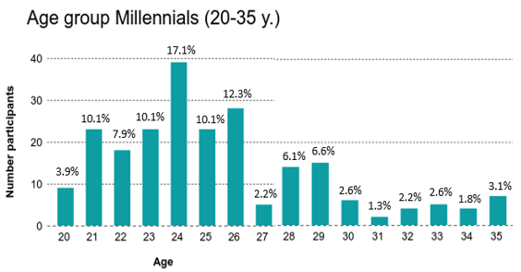
Figure Annex 3.1 Age group Millennials (20-35 years). Answered by 228 participants.

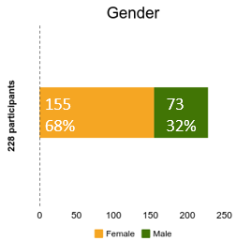

Figure Annex 3.2 Gender of the participants. Answered by 228 participants.
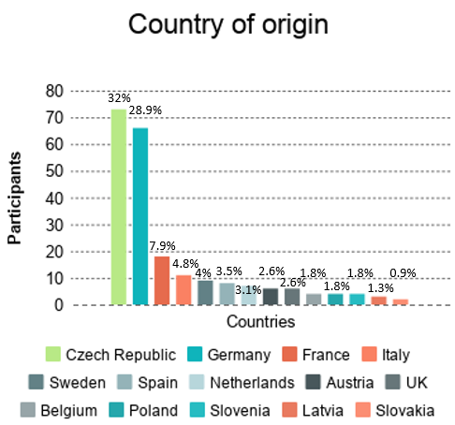
Other countries with each 1 participant are:
Denmark, Finland, Greece, Hungary, Lithuania, Portugal, Republic of Cyprus.
Figure Annex 3.3 Country of origin of the participants. Answered by 228 participants.
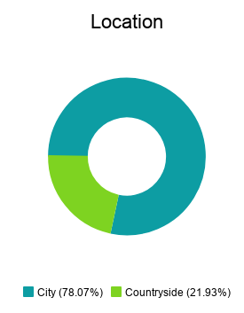
Figure Annex 3.4 Location of the participants. Answered by 228 participants.
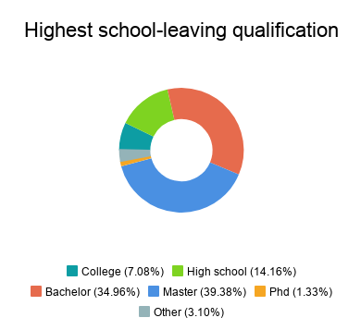
Figure Annex 3.5 Highest school-leaving qualification of the participants. Answered by 228 participants.
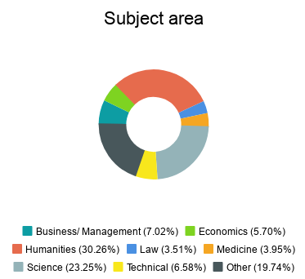
Figure Annex 3.6 The subject area of the participants. Answered by 228 participants.
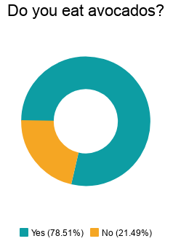
Figure Annex 3.7 General avocado consume of the participants. Answered by 228 participants.
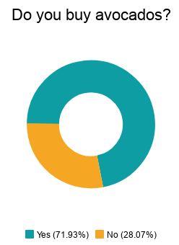
Figure Annex 3.8 General avocado purchase of the participants. Answered by 228 participants.
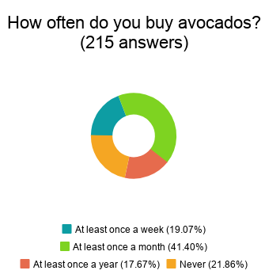
This question was not obligatory.
Figure Annex 3.9 Frequency of the avocado purchase of the participants. Answered by 215 participants.
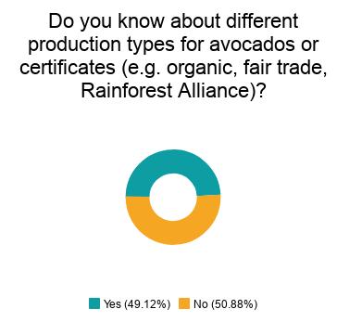
Figure Annex 3.10 Knowledge of the participants on different production types for avocados. Answered by 228 participants.
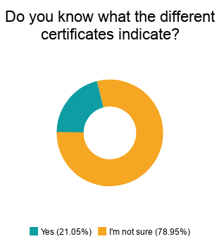
Figure Annex 3.11 Knowledge of the participants on the indication of certificates. Answered by 228 participants.
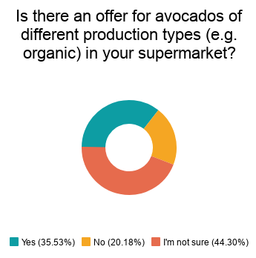
Figure Annex 3.12 Offer of different types of avocados in the participants’ supermarkets. Answered by 228 participants.
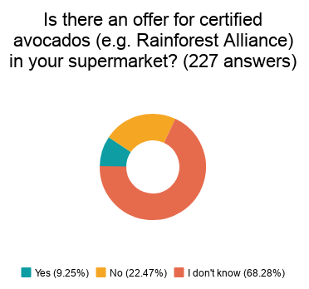
This question was not obligatory.
Figure Annex 3.13 Offer of certified avocados in the participants’ supermarkets. Answered by 227 participants.
Figure Annex 3.14 Importance ranking for the avocado consume/ purchase. Answered by 155 participants.
This was an open question. Only participants who buy and eat avocados were counted.
Figure Annex 3.15 Criteria mentioned besides low price, organic, eco-friendliness and country of origin. Answered by 37 participants. Multiple options allowed.
This question was not obligatory. Only participants who eat and buy avocados were counted. Multiple answers were allowed.
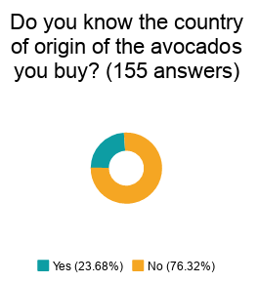
Figure Annex 3.16 The knowledge on the country of origin of the purchased avocado. Answered by 155 participants.
This question was not obligatory. Only participants who buy and eat avocados were counted.
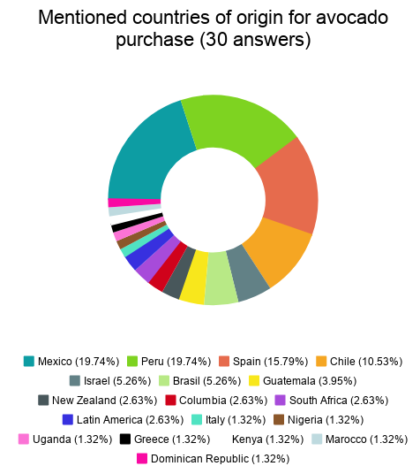

Figure Annex 3.17 Different countries of origin for the avocado purchase. Answered by 30 participants. Multiple options allowed.
This open question was not obligatory. Only participants who buy and eat avocados were counted.

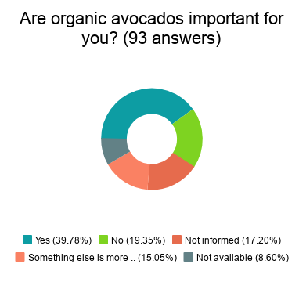
Figure Annex 3.18 Importance of organic avocados for the participants. Answered by 93 participants.
This question was not obligatory. Only participants who buy and eat avocados were counted.
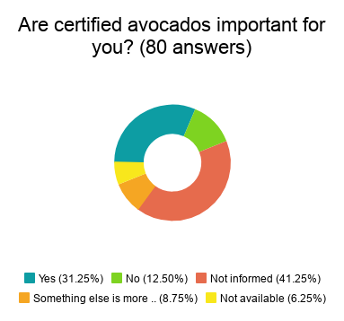
Figure Annex 3.19 Importance of certified avocados for the participants. Answered by 80 participants.
This question was not obligatory. Only participants who buy and eat avocados were counted.
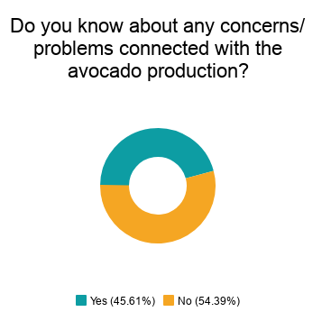
Figure Annex 3.20 Concerns and problems connected to the avocado production. Answered by 228 participants.

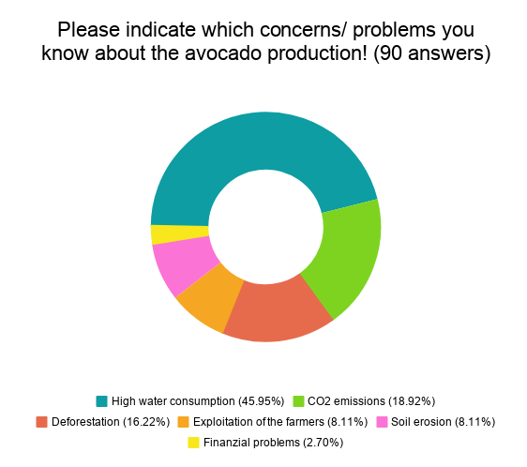
Figure Annex 3.21 Indication of concerns and problems connected to the avocado production. Answered by 90 participants. Multiple options allowed.
This open question was not obligatory.
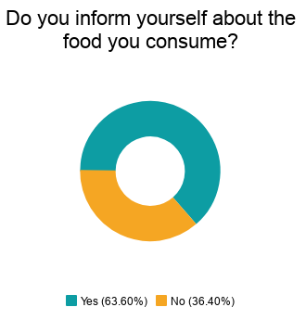
Figure Annex 3.22 Level of information of the participants. Answered by 228 participants.

Figure Annex 3.23 Information procurement of the participants. The first number indicates the absolute number, the second the relative value. Answered by 89 participants. Multiple options allowed.
This open question was not obligatory.

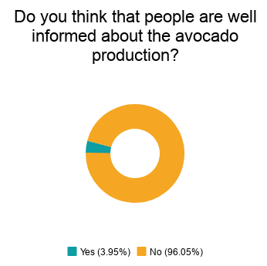
Figure Annex 3.24 The perception of the participants on the knowledge of the population on the avocado production. Answered by 228 participants.

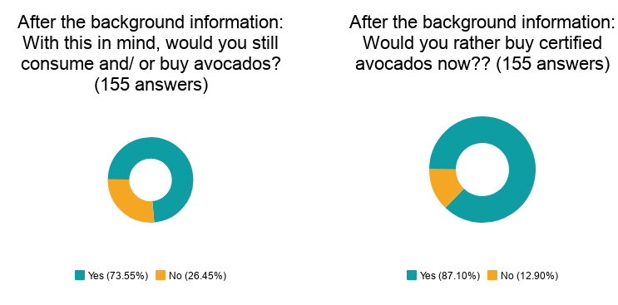
Figure Annex 3.25 Consume and purchase behaviour of the participants after the background information was given. Answered by 155 participants.
Only participants who indicated already before that they buy and eat avocados were counted.
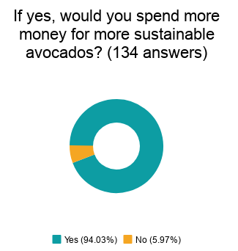
Figure Annex 3.26 Purchase behaviour for sustainable avocados related to finances. Answered by 134 participants.
This question was not obligatory. Only participants who answered the question before with yes were counted.
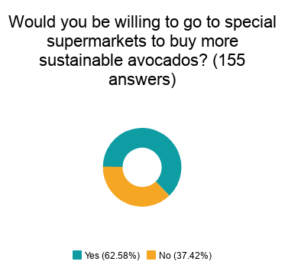
Figure Annex 3.27 Purchase behaviour for sustainable avocados related to supermarkets. Answered by 155 participants.
This question was not obligatory. Only participants who indicated already before that they buy and eat avocados were counted.
Figure Annex 3.28 Ideas on the promotion of awareness on sustainable avocados. The first number indicates the absolute number, the second the relative value. Answered by 123 participants.

Figure Annex 3.29 The responsible actors and influencers to provoke a change. The first number indicates the absolute number, the second the relative value. Answered by 219 and 215 participants. Multiple options allowed.

The authors’ own depiction.
Lois Stanford, “Constructing ‘quality': The political economy of standards in Mexico's avocado industry,” in Agriculture and Human Values (Kluwer Academic Publishers, 2000), 287.
CBI Ministry of Foreign Affairs, Exporting fresh avocados to Europe (The Hague: Ministry of Foreign Affairs, 2018), 5, accessed 18 January 2019, https://www.cbi.eu/market-information/fresh-fruit-vegetables/avocados/europe.
Gabriela Barrera Flores, Bosques y aguacate: ¿Qué está en riesgo? (Mexico: Reforestamos México, 2018), 11, unpublished document.
CBI Ministry of Foreign Affairs, Exporting fresh avocados to Europe, 11-13.
FA0, Country fact sheet on food and agriculture policy trends (Food and Agriculture Organization of the United Nations, 2016), 5, accessed 16 March 2019, http://www.fao.org/3/a-i6006e.pdf.
Les avocats du diable, directed by Virginie Vilar et al., (France: Franceinfo, Envoyé spécial, 2017), accessed 18 January 2019, https://www.youtube.com/watch?v=lrpZS1zIrXA.
Xiomara Nataly Dominguez Caballero and Gabriela Giovana Barrera Flores, Forests Falling Fast to Make Way for Mexican Avocado (Global Forest Watch, 2019), accessed 27 March 2019, https://blog.globalforestwatch.org/commodities/forests-falling-fast-to-make-way-for-mexican-avocado.
Ibid.
Mayra Elena Gavito Pardo et al., Evaluación del impacto ecológico del cultivo de aguacate a nivel regional y de parcela en el Estado de Michoacán: calidación de indicadores ambientales en los principales tipos de producción (Morelia, Michoacán: Informe Final Eapa 1, 2011), 66.
Gabriela Barrera Flores, Avocado Fact Sheet: Avocado and Forests: What is at stake? (Mexico: Reforestamos México, 2018), unpublished document.
FAO, The State of the World’s Land and Water Resources for Food and Agriculture. Managing systems at risk (London: Food and Agriculture Organization of the United Nations, 2011), 27.
Nassos Stylianou, Clara Guibourg and Helen Briggs, Climate change food calculator: What’s your diet’s carbon footprint? (BBC News, 2018), accessed 27 March 2019, https://www.bbc.com/news/science-environment-46459714.
Eurostat, Apples and tomatoes were the top fruit and vegetable produced in the EU in 2015 (Eurostat Press Office, 2016), accessed 27 March 2019, https://ec.europa.eu/eurostat/documents/2995521/7517627/5-22062016-AP-EN.pdf/8247b23e-f7fd-4094-81ec-df1b87f2f0bb.
Jesús Lemus, “El Cáncer en la Zona Aguacatera de Michoacán, un drama que nadie observa: no hay regulación oficial en el uso de pesticidas,” Zenzontle 400 Las voces críticas del periodismo, 25 March 2019, accessed 27 March 2019, https://zenzontle400.com.mx/2019/03/05/el-cancer-en-la-zona-aguacatera-de-michoacan-un-drama-que-nadie-observa-no-hay-regulacion-oficial-en-el-uso-de-pesticidas/?fbclid=IwAR0HN1YZ7M_xvizPl_2ex_aLCbsptbtR40YOmZzoJCVH4Nll-3r7ALyCb-s.
Carrie Kahn, “Blood Avocados No More: Mexican Farm Town Says It's Kicked Out Cartels,” National Public Radio, 02 February 2018, accessed 27 March 2019, https://www.npr.org/sections/parallels/2018/02/02/582086654/mexicos-avocado-capital-says-it-s-kicked-cartels-off-the-farm?t=1553705947401.
Dokumentation Mexiko: Die Macht der Kartelle und Drogenmafia, directed by Agnès Gattegno (ARD, Arte: 2014), 2:15 – 7:25, accessed 12 February 2019, https://www.youtube.com/watch?v=OaTPGW709Nc.
Noticias TM, “Periodista Alejandra Jiménez pide protección tras recibir amenazas de muerte por denunciar incendios provocados en Michoacán,” Noticias TM, 30 May 2019, accessed 09 June 2019, https://www.noticiastm.com.mx/nacional/amenazan-a-periodista-por-denunciar-incendios/.
The author’s own depiction.
Sarah Farrell, “Millennials and their Impact on Sustainability,” Sustainability Management School, 22 January 2019, accessed 06 May 2019, https://sumas.ch/millennials-and-sustainability/.
Deborah Barndt, “On the Move for Food: Three Women Behind the Tomato’s Journey,” in Women's Studies Quarterly Vol. 29 No. 1/2 (2001): 131-143, in Earthwork: Women and Environments (The Feminist Press, City University of NY, 2001).
Ibid., 131.
See introduction.
Deborah Barndt, “On the Move for Food: Three Women Behind the Tomato’s Journey,” 137.
Ibid., 133-141.
Ibid., 132.
Susan M. Koger and Deborah Du Nann Winter, The Psychology of Environmental Problems. Psychology for Sustainability (Taylor & Francis e-Library, 2011), 63-72.
Ian G. Baird and Noah Quastel, “Dolphin-Safe Tuna from California to Thailand: Localisms in Environmental Certiﬁcation of Global Commodity Networks,” Annals of the Association of American Geographers 101, no. 2 (2011), accessed 23 May 2019, doi: 10.1080/00045608.2010.544965.
Ibid., 339.
Ibid.
Ibid., 340.
Ibid., 340.
Ibid., 348.
Ibid., 349.
Deutsche Forschungsgemeinschaft e.V., Liste von Entwicklungsländern und - gebieten in Bezug auf DFG-Verfahren, Stand April 2019 (Deutsche Forschungsgemeinschaft e.V., 2019), accessed 05 June 2019, https://www.dfg.de/download/pdf/foerderung/internationales/entwicklungslaender/entwicklungslaender_liste.pdf.
Transparency International, Corruption Perceptions Index 2018 (Transparency International, 2018), accessed 20 June 2019, https://www.transparency.org/country/MEX, https://www.transparency.org/country/THA.
Ian G. Baird and Noah Quastel, “Dolphin-Safe Tuna from California to Thailand,” 343.
Ibid., 339.
Susan M. Koger and Deborah Du Nann Winter, The Psychology of Environmental Problems, 198.
Rachel Emas, Brief for GSDR 2015. The Concept of Sustainable Development: Definition and Defining Principles (Florida International University, 2015), accessed 18 March 2019, https://sustainabledevelopment.un.org/content/documents/5839GSDR%202015_SD_concept_definiton_rev.pdf.
Lois Stanford, “Constructing ‘quality',” 293.
Doris Schmied, Nahrungsgeographie. Das Geographische Seminar (Westermann, 2018), 13-17.
Lois Stanford, “Constructing ‘quality',” 294.
Doris Schmied, Nahrungsgeographie, 45-47.
Philip McMichael, “The power of food,” in Agriculture and Human Values Vol. 17, Issue 1, 21-33, (Kluwer Academic Publishers, 2000), 25-30.
Doris Schmied, Nahrungsgeographie, 77.
Ibid., 230-233.
Philip McMichael, “The power of food,” 23-31.
Ibid., 22.
Ibid., 22.
Ibid., 25-30.
Ibid., 45-47.
Lois Stanford, “Constructing ‘quality',” 305.
Doris Schmied, Nahrungsgeographie, 13-17.
Ibid., 155-158.
European Commission, Countries and Regions. Mexico (European Commission, 2018), accessed 03 April 2019, http://ec.europa.eu/trade/policy/countries-and-regions/countries/mexico/.
Ibid.
Ibid.
Official Journal of the European Communities, Decision No 2/2000 of the EC-Mexico Joint Council of 23 March 2000 (2000/415/EC) (EUR-Lex, 2000), 9, accessed 08 April 2019, https://eur-lex.europa.eu/resource.html?uri=cellar:a024c280-a801-4dcd-bc46-a3afdd86c3ba.0005.02/DOC_1&format=PDF.
Ibid.
Ibid., 10.
Ibid.
World Trade Organization, Uruguay Round Agreement. Agreement on Agriculture (Articles 1-7) (WTO), 43, accessed 09 April 2019, https://www.wto.org/english/docs_e/legal_e/14-ag_01_e.htm#articleI.
Ibid.
World Trade Organization, Sanitary and Phytosanitary Measures. The WTO Agreement on the Application of Sanitary and Phytosanitary Measures (SPS Agreement) (WTO), accessed 09 April 2019, https://www.wto.org/english/tratop_e/sps_e/spsagr_e.htm.
Ibid.
Ibid.
Ibid.
European Commission, Guide to the new EU-Mexico Trade Agreement April 2018 (European Commission, 2018), 3-4, accessed 14 March 2019, http://trade.ec.europa.eu/doclib/docs/2018/may/tradoc_156888.pdf.
Ibid., 9-13.
Ibid., 23.
Ibid., 30.
Ibid., 31.
Ibid.
Ibid., 29-31.
Inmaculada Rodríguez-Piñero Fernández, European Parliament (European Parliamanet, 2019), accessed 15 March 2019, http://www.europarl.europa.eu/legislative-train/theme-a-balanced-and-progressive-trade-policy-to-harness-globalisation/file-modernisation-eu-mexico-global-agreement.
Ibid.
European Commission, Press release. EU and Mexico reach new agreement on trade (Brussels: European Commission, 2018), accessed 08 April 2019, http://europa.eu/rapid/press-release_IP-18-782_en.htm.
European Commission, New EU-Mexico agreement: The Agreement in Principle and its texts (Brussel: European Commission, April 2018), 1, accessed 14 March 2019, http://trade.ec.europa.eu/doclib/docs/2018/april/tradoc_156791.pdf.
Inmaculada Rodríguez-Piñero Fernández, European Parliament.
Andrew Graffham, EU legal requirements for imports of fruits and vegetables (a suppliers guide), Fresh Insights no. 1 (UK: Natural Resources Institute, 2006), 1, accessed 14 March 2019, www.agrifoodstandards.org.
CBI Ministry of Foreign Affairs, Exporting fresh avocados to Europe, 9.
European Commission, EU Trade Helpdesk. Import Procedures: European Union – Overview of Import Procedures (Spain: TARIC S.A., 2010), accessed 04 April 2019, http://trade.ec.europa.eu/tradehelp/myexport#?product=0804400000&partner=MX&reporter=DE#EU_CustomsUnion.
CBI Ministry of Foreign Affairs, What requirements should fresh fruit or vegetables comply with to be allowed on the European market? (CBI Ministry of Foreign Affairs, 2018), 1, accessed 15 April 2019, https://www.cbi.eu/node/2441/pdf.
Ibid., 4-5.
Ibid., 1.
Ibid., 6-7.
Ian G. Baird and Noah Quastel, “Dolphin-Safe Tuna from California to Thailand,” 340.
CBI Ministry of Foreign Affairs, Exporting fresh avocados to Europe, 7.
Doris Schmied, Nahrungsgeographie, 233-235.
Ibid., 199-200.
Ibid., 233-235.
Lois Stanford, “Constructing ‘quality',” 293.
Ibid., 304.
Ibid., 294.
Ibid., 293.
CBI Ministry of Foreign Affairs, What requirements should fresh fruit or vegetables comply with to be allowed on the European market?, 5.
GLOBALG.A.P., Government Requirements (GLOBALG.A.P.), accessed 23 April 2019, https://www.globalgap.org/uk_en/for-producers/government-requirements/.
CBI Ministry of Foreign Affairs, What requirements should fresh fruit or vegetables comply with to be allowed on the European market?, 5.
Ibid.
CBI Ministry of Foreign Affairs, Exporting fresh avocados to Europe, 10.
European Commission, EU Trade Helpdesk. Product requirements: Voluntary - Products from organic production (Spain: TARIC S.A., 2010), accessed 04 April 2019, http://trade.ec.europa.eu/tradehelp/myexport#?product=0804400000&partner=MX&reporter=DE#EU_CustomsUnion.
Ibid.
Ibid.
Doris Schmied, Nahrungsgeographie, 174.
Gabriela Barrera Flores, Bosques y aguacate, 14.
ICEA certifica, ICEA Certified (ICEA, 2018), accessed 01 May 2019, https://icea.bio/cosa-facciamo/?lang=en.
WFTO, 10 Principals of Fair Trade (World Fair Trade Organization, 2017), accessed 22 April 2019, https://wfto.com/fair-trade/10-principles-fair-trade.
Doris Schmied, Nahrungsgeographie, 196-199.
UTZ, New certification program (UTZ - Rainforest Alliance, 2019), accessed 22 April 2019, https://utz.org/new-certification-program/.
ISEAL Alliance, Homepage (ISEAL Alliance, 2019), accessed 22 April 2019, https://www.isealalliance.org.
Rainforest Alliance, FAQ: What is the difference between Rainforest Alliance Certification, Fairtrade, and UTZ Certification? (Rainforest Alliance, 2018), accessed 22 April 2019, https://www.rainforest-alliance.org/faqs/difference-rainforest-alliance-certified-fair-trade-utz.
GLOBALG.A.P., GRASP (GLOBALG.A.P.), accessed 23 April 2019, https://www.globalgap.org/uk_en/for-producers/globalg.a.p.-add-on/grasp/index.html.
CBI Ministry of Foreign Affairs, What requirements should fresh fruit or vegetables comply with to be allowed on the European market?, 7-14.
World Commission on Environment and Development, Report of the World Commission on Environment and Development: Our Common Future (UN-documents,1984), 110, accessed 17 March 2019, http://www.un-documents.net/our-common-future.pdf.
Federal Government of Mexico, Special Climate Change Program 2014-2018 (Mexico: Federal Government of Mexico, 2014), 10, accessed 18 March 2019, https://www.cakex.org/sites/default/files/documents/SpecialClimateChangeProgram20142018Englishversion.pdf.
Ibid.
Ibid.
Ibid., 66-68.
WRI, EOI Template for Food Systems, Land Use and Restoration Impact Program (World Resources Institute, 2019), 1.
Ibid.
Illegal Deforestation Monitor, Illegal deforestation for avocado production in Mexico spreads as US relaxes import controls (IDM, April 2017), accessed 01 May 2019, http://www.bad-ag.info/illegal-deforestation-for-avocado-production-in-mexico-spreads-as-us-relaxes-import-controls/.
Personal interview with a staff member from CONAFOR (anonymous), Mexico City, February 2019.
European Commission, Commission staff working document. Impact Assessment (Brussels, 2015), 47, accessed 23 April 2019, http://trade.ec.europa.eu/doclib/docs/2016/march/tradoc_154396.034027.1.SWD_2015_289_EN%20IAR.pdf.
Ibid.
Ibid., 48.
European Commission, The EU-Mexico Trade Agreement explained (European Commission, 2018), accessed 17 March 2019, http://ec.europa.eu/trade/policy/in-focus/eu-mexico-trade-agreement/agreement-explained/.
Ibid.
Adam Jezard, “Who and what is ‘civil society?’” World Economic Forum, 23 April 2018, accessed 18 March 2019, https://www.weforum.org/agenda/2018/04/what-is-civil-society/.
Personal interview with avocado producers (anonymous), Uruapan Michoacán, December 2018.
Personal interview with a scholar from UNAM (anonymous), Mexico City, January 2019.
Cámara de Diputados del H. Congreso de la Unión, Reglamento de la ley general del equilibrio ecológico y la protección al ambiente en materia de áreas naturales protegidas (Estados Unidos Mexicanos, 2014), accessed 02 May 2019, https://www.google.de/url?sa=t&rct=j&q=&esrc=s&source=web&cd=3&cad=rja&uact=8&ved=2ahUKEwjjypTDtf3hAhWhzoUKHd-6BkIQFjACegQIBBAC&url=http%3A%2F%2Fdsiappsdev.semarnat.gob.mx%2Fdatos%2Fjuridico%2Freglamentos%2FRgto.%2520de%2520la%2520Ley%2520General%2520del%2520Equilibrio%2520Ecol%25C3%25B3gico%2520y%2520la%2520Protecci%25C3%25B3n%2520al%2520Ambiente%2520en%2520materia%2520de%2520Areas%2520Naturales%2520Protegidas%2520DOF~1.doc&usg=AOvVaw02iikYhKN41M24s75LEWB5.
ECOLEX, Ley General de Desarrollo Forestal Sustentable (FAO, 2017), accessed 02 May 2019, https://www.ecolex.org/es/details/legislation/ley-general-de-desarrollo-forestal-sustentable-lex-faoc036056/.
Personal interview with a staff member from the NGO Alternare (anonymous), Mexico City, February 2019.
Personal interview with a staff member from the NGO WRI (anonymous), Mexico City, January 2019.
Interview avocado producers.
Personal interview with staff members from the NGO Reforestamos (anonymous), Mexico City, January 2019.
Interview WRI.
Ibid.
Interview Reforestamos.
Ibid.
Comisión Nacional Forestal, Proyectos de compensación ambiental por Cambio de Uso de Suelo en Terrenos Forestales (CUSTF) (Comisión Nacional Forestal, 2017), accessed 04 May 2019, https://www.gob.mx/conafor/acciones-y-programas/proyectos-de-compensacion-ambiental-por-cambio-de-uso-de-suelo-en-terrenos-forestales-custf.
Gabriela Barrera Flores, Bosques y aguacate, 9.
See chapter 3.4 on the EU statement on the impacts of the agreements.
Interview Reforestamos.
Doris Schmied, Nahrungsgeographie, 13.
Lois Stanford, “Constructing ‘quality',” 293.
Ibid., 294.
Doris Schmied, Nahrungsgeographie, 27.
Philip McMichael, “The power of food,” 31.
Ibid., 24.
Susan M. Koger and Deborah Du Nann Winter, The Psychology of Environmental Problems, 1.
Ibid., 2.
Ibid., 19.
Thomas J. Madden, Pamela Scholder Ellen and Icek Ajzen, “A Comparison of the Theory of Planned Behavior and the Theory of Reasoned Action,” in PSPB Vol. 18, No. 1, 3-9, (Society for Personality and Social Psychology, Inc., 1992), 3.
Ibid., 4.
Susan M. Koger and Deborah Du Nann Winter, The Psychology of Environmental Problems, 21-25.
Ibid., 46-52.
Ibid., 69.
Ibid., 32-37.
Ibid., 61.
Thomas J. Madden, Pamela Scholder Ellen and Icek Ajzen, “A Comparison of the Theory of Planned Behavior and the Theory of Reasoned Action,” 4.
Depiction taken with small changes from Thomas J. Madden, Pamela Scholder Ellen and Icek Ajzen, “A Comparison of the Theory of Planned Behavior and the Theory of Reasoned Action,” 4.
Ibid.
Susan M. Koger and Deborah Du Nann Winter, The Psychology of Environmental Problems, 110-113.
Ibid., 115.
Ibid., 135-140.
Ibid., 140.
Ibid.
Ibid., 141.
Ian G. Baird and Noah Quastel, “Dolphin-Safe Tuna from California to Thailand,” 342.
Ibid.
Susan M. Koger and Deborah Du Nann Winter, The Psychology of Environmental Problems, 142.
Ibid.
Ian G. Baird and Noah Quastel, “Dolphin-Safe Tuna from California to Thailand,” 342.
Ibid.
Susan M. Koger and Deborah Du Nann Winter, The Psychology of Environmental Problems, 141-145.
Ibid., 145.
Ibid., 148-151.
Ibid., 197.
Ibid., 195-199.
Ibid., 236-243.
Ibid., 63-72.
Ibid., 72-78.
Ibid., 84-89.
Thomas J. Madden, Pamela Scholder Ellen and Icek Ajzen, “A Comparison of the Theory of Planned Behavior and the Theory of Reasoned Action,” 4.
Susan M. Koger and Deborah Du Nann Winter, The Psychology of Environmental Problems, 102-107.
Sarah Farrell, “Millennials and their Impact on Sustainability.”
Statista, Europäische Union & Euro-Zone: Gesamtbevölkerung von 2008 bis 2018 (in Millionen Einwohner) (Statista, 2019), accessed 24 April 2019, https://de.statista.com/statistik/daten/studie/14035/umfrage/europaeische-union-bevoelkerung-einwohner/.
Susan M. Koger and Deborah Du Nann Winter, The Psychology of Environmental Problems, 80.
To facilitate the analysis, the importance level is always indicated in brackets. Low importance is indicated by number 1, high importance is indicated by number 5.
CBI Ministry of Foreign Affairs, What requirements should fresh fruit or vegetables comply with to be allowed on the European market?, 5-7.
Susan M. Koger and Deborah Du Nann Winter, The Psychology of Environmental Problems, 110-113.
Michael Ritz, Landkarte der europäischen Gliederung (Nord-, Ost-. West-, Süd-, und Südosteuropa) (Deutsch) Ständiger Ausschuss für geographische Namen (StAGN) (Landkarten und Stadtplan Index, 2000-2018), accessed 18 May 2019, https://www.landkartenindex.de/weltatlas/?p=13182.
Susan M. Koger and Deborah Du Nann Winter, The Psychology of Environmental Problems, 142.
Handelsblatt, OECD-Studie. Deutschland hat wenig Hochgebildete (Handelsblatt, 2014), accessed 18 May 2019, https://www.handelsblatt.com/politik/deutschland/oecd-studie-hohe-bildung-hohes-einkommen/10675720-2.html?ticket=ST-428237-IekzE0raZ77hKNhUdHOU-ap3.
The author’s own depiction.
The author’s own depiction.
Ian G. Baird and Noah Quastel, “Dolphin-Safe Tuna from California to Thailand,” 340.
Rainer Benthin and Angelika Gellrich, Umweltbewusstsein in Deutschland 2016. Ergebnisse einer repräsentativen Bevölkerungsumfrage (Berlin: Bundesministerium für Umwelt, Naturschutz, Bau und Reaktorsicherheit (BMUB), 2017), 54, accessed 09 April 2019, https://www.umweltbundesamt.de/sites/default/files/medien/376/publikationen/umweltbewusstsein_deutschland_2016_bf.pdf.
Susan M. Koger and Deborah Du Nann Winter, The Psychology of Environmental Problems, 69-70.
Ibid., 142.
European Commission, Special Eurobarometer 246 (Brussels: TNS Opinion & Social. Health and food, 2006), 25, accessed 10 April 2019, http://ec.europa.eu/health/ph_publication/eb_food_en.pdf.
Ibid., 27.
The author’s own depiction.
European Commission, Flash Eurobarometer 256 - The Gallup Organisation. Europeans’ attitudes towards the issue of sustainable consumption and production (Brussels: 2009), 5, accessed 10 April 2019, http://ec.europa.eu/commfrontoffice/publicopinion/flash/fl_256_en.pdf.
Ibid.
Susan M. Koger and Deborah Du Nann Winter, The Psychology of Environmental Problems, 132.
The author’s own depiction.
The author’s own depiction.
Europäische Kommission, Spezial Eurobarometer 295. Einstellungen der europäischen Bürger zur Umwelt (Brussels: European Opinion Research Group EEIG, 2008), 78-79, accessed 10 April 2019, http://ec.europa.eu/commfrontoffice/publicopinion/archives/ebs/ebs_295_de.pdf.
European Commission, Special Eurobarometer 468. Summary. Attitudes of European citizens towards the environment (Brussels, 2017), 36, accessed 10 April 2019, file:///C:/Users/Susi/Downloads/ebs_468_sum_en.pdf.
Ibid.
Elisabeth Raether, “Das Märchen von der guten Avocado,“ Die Zeit No. 43, 13 October 2016, accessed 09 April 2019, https://www.zeit.de/2016/43/avocado-superfood-anbau-oekologie-trend/seite-5.
Susan M. Koger and Deborah Du Nann Winter, The Psychology of Environmental Problems, 69-70.
Doris Schmied, Nahrungsgeographie, 77.
Interview Reforestamos.
Daniel Lavelle, ”Should you stop eating ‘blood avocados’?,” The Guardian, 10 December 2018, accessed 29 June 2019, https://www.theguardian.com/food/shortcuts/2018/dec/10/should-you-stop-eating-blood-avocados?CMP=share_btn_link.
Interview WRI.
Interview Reforestamos.
Sarah Widter, “Demonstrationen für den Klimaschutz in über 1000 Städten,“ Welt, 15 March 2019, accessed 19 April 2019, https://www.welt.de/politik/deutschland/video190348047/Fridays-for-Future-Greta-Thunberg-Schueler-demonstrieren-fuer-den-Klimaschutz.html.
Susan M. Koger and Deborah Du Nann Winter, The Psychology of Environmental Problems, 146.
European Commission, Flash Eurobarometer 256, 6.
Doris Schmied, Nahrungsgeographie, 196-199.
Interview scholar UNAM.
Ian G. Baird and Noah Quastel, “Dolphin-Safe Tuna from California to Thailand,” 346.
Ibid., 343.
The author’s own depiction.
Ian G. Baird and Noah Quastel, “Dolphin-Safe Tuna from California to Thailand,” 338.
Ibid., 351.
Ibid., 340.
Gabriela Barrera Flores, Bosques y aguacate, 9.
The Economics of Ecosystems and Biodiversity, TEEB for Agriculture and Food (The Economics of Ecosystems and Biodiversity, 2016), accessed 17 March 2019, http://www.teebweb.org/teeb-mexico/teebagrifood/.
Elisabeth Raether, “Das Märchen von der guten Avocado,“ 5.
Ibid., 6.
Susan M. Koger and Deborah Du Nann Winter, The Psychology of Environmental Problems, 22.
The author’s own depiction.
See chapter 5.
Interview CONAFOR.

