No missing; Maximum likelihood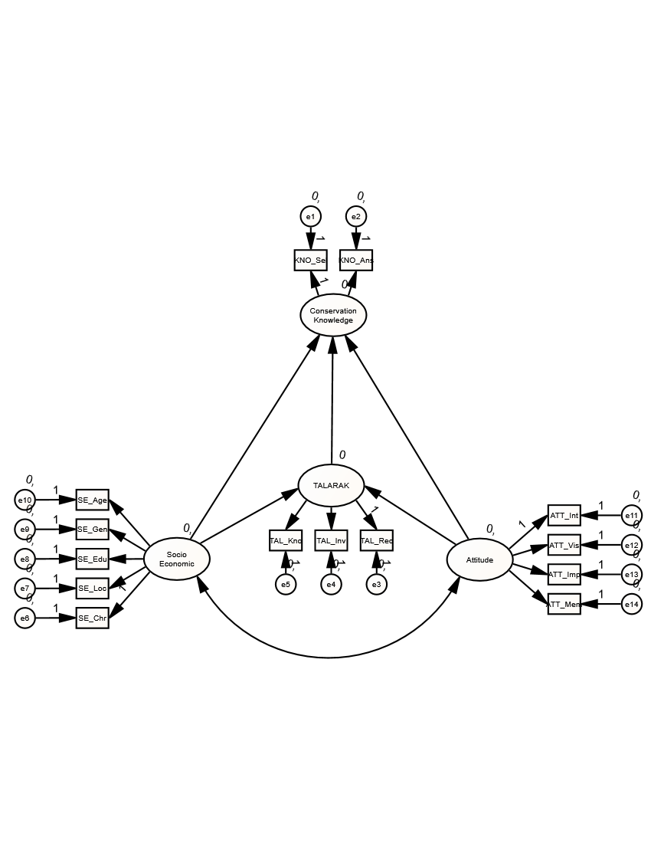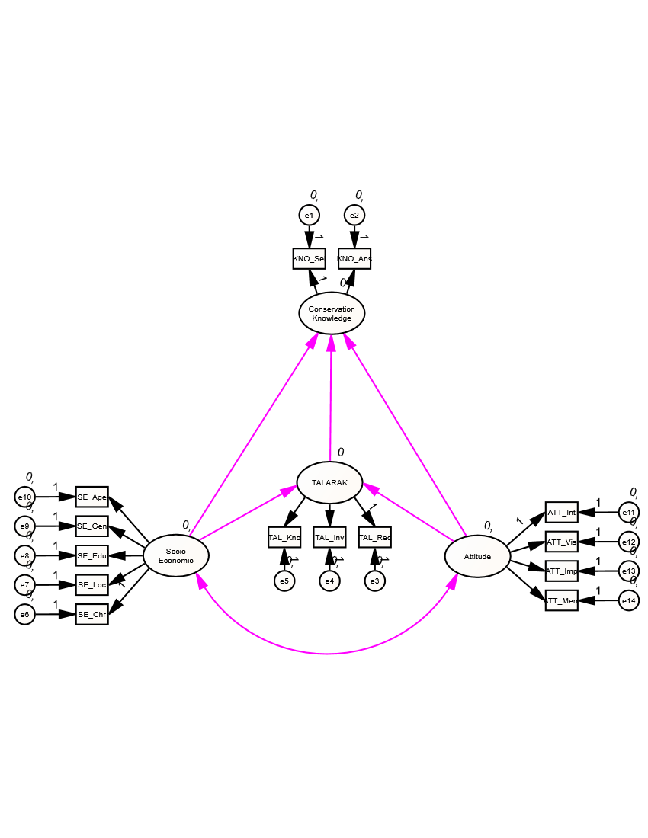

Model 2

Model 1

