Appendices
Appendix 1: Schedule of Project Activities
Table 12: Schedule of Project Activities
 | Activity | Time Frame
1 | Approval of Master’s Thesis Topic | May
2 | Writing and Approval of Proposal | August
3 | Review of Literature | 3 weeks
4 | Design of Methodology and Approval | 1 week
5 | Questionnaire Design and Approval | 3 days
6 | Data Collection and Collation | December 5th – 30th
7 | Data Entry and Analysis | January 6th – 20th
8 | Interpretation of Result | January 23rd - 29th
9 | Conclusion and Recommendation | February 1st – 8th
10 | Review of Thesis | February 13th – 24th
11 | Final Submission | April

Appendix 2: Images of study area
Annex 1: Dump site of waste products
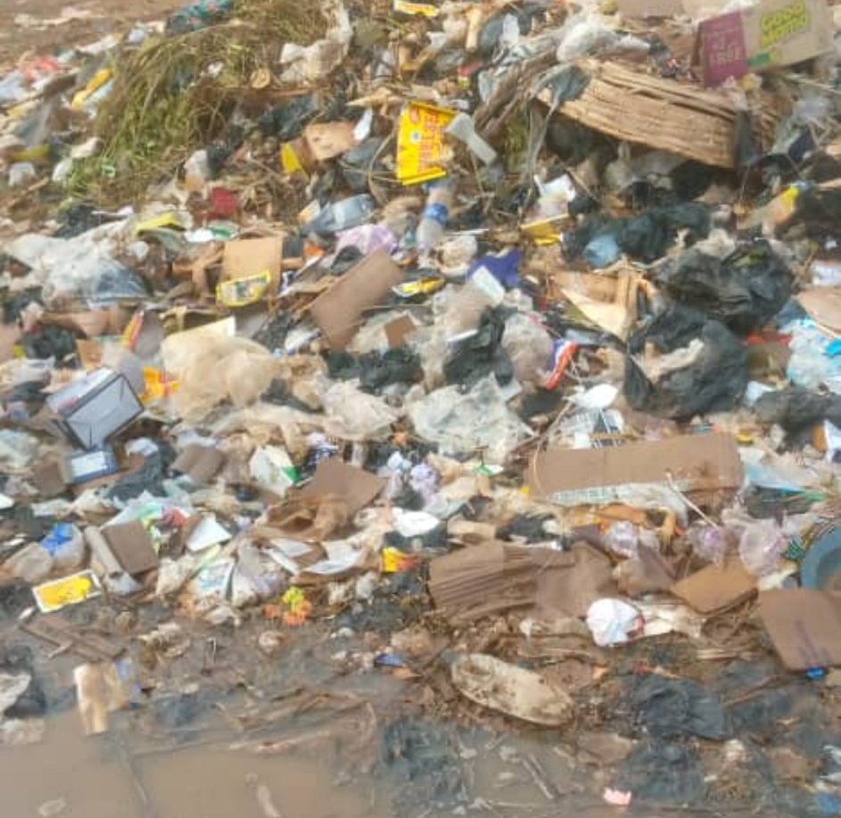
Annex 2: waste being disposed using fire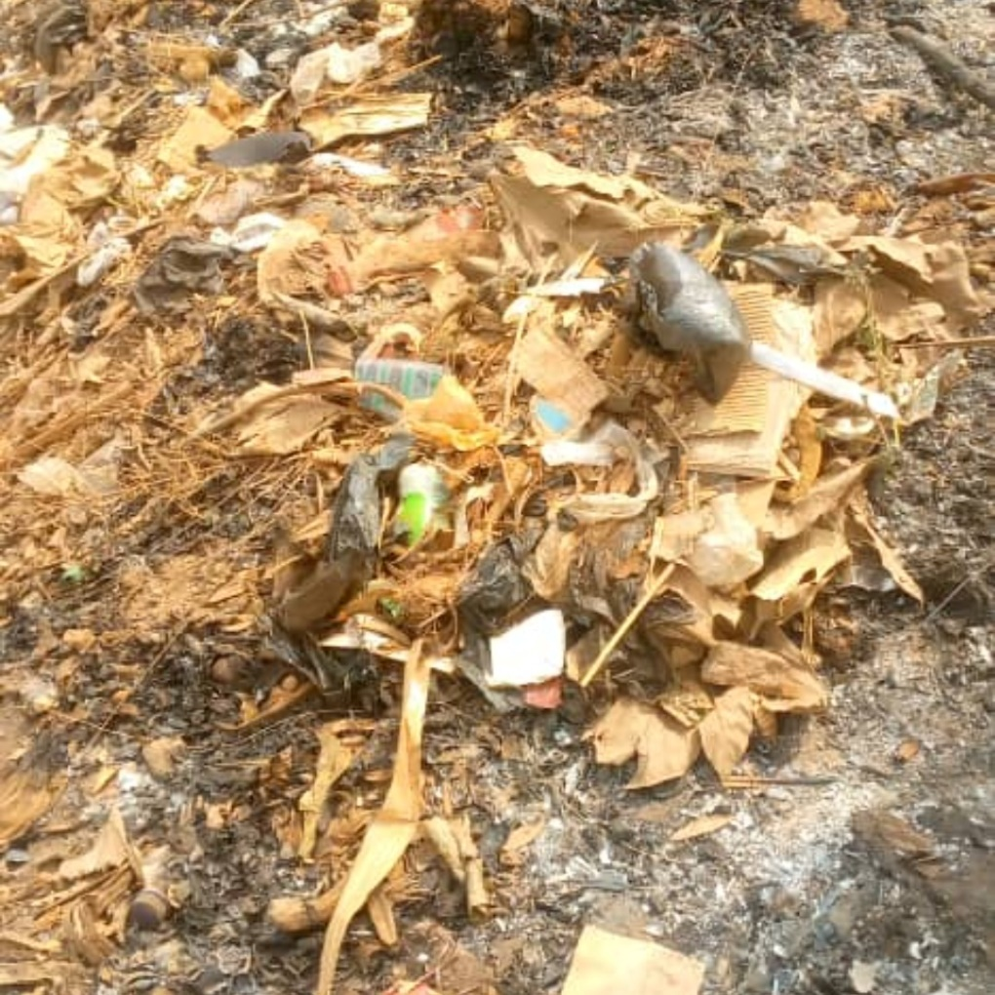

Appendix 3: Questionnaire
Questionnaire no…………
TOPIC: VEGETABLE AND FRUIT WASTE AS A SOURCE OF BIOGAS: CASE OF IPOKIA, NIGERIA
Dear Sir/Ma,
This Questionnaire is designed to collect data for use in the above stated research. Your sincere responses to the questions will be of great value to the study. Kindly supply the information and please be assured that the information provided will be treated with a high level of confidentiality and will be used for the advancement of the course for which the study is intended. Thanks for your anticipated co-operation.
Section A
Socio Economic Characteristics of the Respondents
Please fill/tick (√) the boxes with the most appropriate response
- Age Group (Years): …………………………
- Sex: Male Female

- Religion: Christian Islam Traditional Others

- Marital Status: Single ( ) Married ( ) Divorced ( )
- Household Size: ……………………………
- What is your Highest Level of education: ……………………
- How long have you been producing/marketing vegetables and Fruits (Years): …………
- Average Monthly Income (N): ………………………………….
- Average monthly income from Vegetable and fruit production and Marketing ……………

Section B
Waste Disposal Method
- Is there a formal waste disposal system in your vicinity?
- What form of waste disposal system is available in your vicinity and how frequently do you use it (Please tick appropriately and select the frequent of use)
 | Availability | Frequency of Use
 | Y=Yes  N=No | Always | Very Often | Sometimes | Rarely | Never
Open Burning
Open Dumping
Composting
Dumping into drain Channels, Rivers and Streams
Recycling (Conversion into other uses)
Landfills
Government Certified Waste Collectors
Conversion into Biogas

Section C
Vegetable and Fruit Waste
- What is the volume of Vegetable and fruit waste that you produce weekly ………….. kg
- What percentage of it is lost as waste …………………..%
- What method do you use in the disposal of your vegetable and fruit waste
Leave in the open to rot ( )
Use as Biogas ( )
Open burning ( )
Dispose in abandoned lands ( )
Use as compost ( )
Use government disposal systems ( )
Dump in drains, river and streams ( )
Others…………………… ( )
- Is there any cost associated with the disposal of the waste using any of the system? Yes ( ) No ( )
- What is the financial cost? …………………….
- Do you see the disposal of your vegetable and fruit waste as an environmental challenge? Yes ( ) No ( )
- Are you willing to accept an alternative means of disposing your vegetable and fruit waste? Yes ( ) No ( )
- Are you willing to utilise your vegetable and fruit waste for the generation of energy in your vicinity? Yes ( ) No ( )
Section D
Biogas utilisation, use and Perception
- What is the Present source of energy you are using (You can select more than one option if it applies to you).
Please tick the one’s that applies to you and your household stating the main source of energy and the secondary sources
Energy Source | Main Source  (Select only one option that serves as your main energy source) | Secondary Source (Select as many other sources that apply to you apart from the main source)
Charcoal
Wood
Gas
Kerosene
Gas (LPG)
Biogas
Electricity
Solar
Others ……………………………

- Are you aware of biogas? Yes ( ) No ( )
- How did you get to know about biogas? …………………………..
- Are you aware that Vegetable and fruit waste can be used to produce biogas? Yes ( ) No ( )
- Are there any biogas facility within your vicinity Yes ( ) No ( )
- Select your level of awareness and adoption from the option in the table below as regards the use of biogas. (Please select only one of the options from the table that applies to you)
Level of awareness and adoption of technology
Not Aware at all
Awareness (You have heard about it)
Interest (You are Aware and interested in using it but need more information)
Evaluation (You have the information but want to be sure about the technology)
Trial Stage (You are giving the technology a trial on a small scale)
Adoption Stage (You have started using it but not sure of using it continually)
Post Adoption (You feel contented using it and will continue using it)

- Are there agents who sell digesters and service the facility available in your vicinity? Yes ( ) No ( )
- Perceptions about Biogas
What are your perceptions about the use of Biogas?
Tick (√) the appropriate response.
SA= Strongly Agree, A=Agree, N= Neutral, D=Disagree, SD= Strongly Disagree.
 | Item | SA | A | N | D | SD
1 | The Biogas can be an alternative fuel for cooking
2 | Biogas can be used to generate electricity
5 | Using biogas can create job opportunities
6 | Using biogas can improve public health
7 | Biogas is an environmentally friendly way of disposing vegetable and fruit waste.
8 | Biogas is expensive to install
9 | The technology is too complicated to use
10 | Adoption of Biogas will not totally solve the problem of vegetable and fruit waste in the vicinity.
11 | Biogas is cheaper when compared to other energy sources
12 | Biogas is only for the rich and those with financial capacity

Section E
Factors Influencing the Use of Vegetable and Fruit Waste as a source of Biogas
Tick (√) the appropriate response to understand the factors influencing the use of vegetable and fruit waste as a source of biogas. SA= Strongly Agree, A=Agree, N= Neutral, D=Disagree, SD= Strongly Disagree.
 | Constraints | SA | A | N | D | SD
1 | Availability of vegetable and fruit waste
2 | Capital
3 | Technical Expertise
4 | Awareness about Biogas
5 | Closeness of Biogas production facility
6 | Access to Information
7 | Access to credit
8 | Government Support
9 | Availability of technology in close proximity to market and farms
10

Section F
Barrier to the Use of Vegetable and Fruit Waste for the generation of Biogas

 | Constraints | Very High | High | Medium | Low | Very Low
1 | High Cost of Biodigester
2 | Lack of parts for the construction of the biogas facility
3 | No knowledge about the importance of biogas in utilisation in waste management
4 | Lack of skills to manage the waste and biogas facility
5 | High cost of moving the vegetable and fruit waste to the biogas facility
6 | Low level of Demand for Biogas
7 | Climatic condition
8 | Lack of finance and capital to procure the technology
9 | Low Awareness Level
10 | Limited Knowledge on the Benefits of Adopting the Technology
11 | Inability to test the efficacy of the Technology

Other barriers affecting the use of vegetable and fruit waste for biogas ………………………. ......................................................................................................................................................
Thank You

