UNIVERZITA PALACKÉHO V OLOMOUCI

Pedagogická fakulta

Katedra anglického jazyka

THE NORTHERN IRELAND
FROM THE CAMPAIGN FOR THE SUPPORT OF CIVIL RIGHTS TO AN ARMED CONFLICT

Bakalářská práce

Vedoucí práce: Mgr. Jiří Flajšar, Ph.D.

Vypracovala:

Martina Karvanová

Olomouc 2023

I declare that I have worked on this thesis independently,
using only the primary and secondary sources listed in the bibliography.

Martina Karvanová

……………………….

Author’s signature

Acknowledgements:
I would like to thank Mgr. Jiří Flajšar, Ph.D. for his supervision on my thesis. Also, I want to express my thanks to other professors. Further my thanks belong to my family and friends for their support.

Table of Contents

INTRODUCTION …………………………………………………………………………… 1
1 HISTORY OF IRELAND ………………………………………………………………… 2
  - PREHISTORY ……………………………………………………………………… 2
  - EARLY MIDDLE AGES …………………………………………………………… 2
  - ADDOPTION OF PROTESTANTISM AND THE SUPPRESSION OF CATHOLICISM …………………………………………………………………….. 3
  - ANTI-ENGLISH REBELLION AND OLIVER CROMWELL ………………… 3
  - JAMES II., WILLIAM OF ORANGE AND PENAL LAWS …………………… 3
- 19TH CENTURY, PARTITION OF IRELAND …………………………………… 4
  - ACT OF UNION ……………………………………………………………………. 4
  - 19TH CENTURY …………………………………………………………………… 4
  - IRISH AUTONOMY EFFORT ……………………………………………………. 5
  - GOVERNMENT OF IRELAND ACT ……………………………………………..6
  - EASTER RISING ……………………………………………………………………6
  - ANGLO-IRISH WAR ………………………………………………………………..7
  - PARTITION OF IRELAND …………………………………………………………7
  - ANGLO-IRISH TREATY ……………………………………………………………8
- NORTHERN IRELAND BETWEEN 1945 AND THE BEGINNING OF THE TROUBLES ……………………………………………………………………………10
  - POST-WAR SITUATION ………………………………………………………….10
  - TERENCE O’NEIL AND IAN PAISLEY ………………………………………..10
  - CIVIL RIGHT MOVEMENT FORMATION …………………………………….11
- THE TROUBLES …………………………………………………………………….12
  - FIRST PROTEST MARCHES ……………………………………………………12
  - RISING TENSION …………………………………………………………………12
  - IRA AND PIRA ……………………………………………………………………..13
    - NEW PARTIES …………………………………………………………………… .14
    - BLOODY SUNDAY ………………………………………………………………..14
  - BRITISH GOVERNMENT IN THE NORTHERN IRELAND ………………. 16
    - SUNNINGDALE AGREEMENT …………………………………………………17
    - HUNGER STRIKE ………………………………………………………………..19
    - ANGLO-IRISH RELATIONSHIP IN THE EIGHTEES ………………………20
    - NEW IRELAND FORUM ………………………………………………………. 21
  - ANGLO-IRISH AGREEMENT ……………………………………………….... 21
  - PIRA ……………………………………………………………………………….. 23
- PEACE PROCESS ………………………………………………………………….. 24
  - SECRET DIALOGUES …………………………………………………………. 24
  - USA INVOLVEMENT ……………………………………………………………. 26
  - GOOD FRIDAY AGREEMENT ………………………………………………… 27
  - 1998-2000 ………………………………………………………………………… 28
  - DECOMMISSIONING …………………………………………………………… 29
  - BREXIT ……………………………………………………………………………. 30
CONCLUSION ………………………………………………………………………………31
BIBLIOGRAPHY ……………………………………………………………………………32
APPENDICES ……………………………………………………………………………….35
RÉSUMÉ …………………………………………………………………………………….38

List of Abbreviations

AIA Anglo-Irish Agreement
APNI Alliance Party of Northern Ireland
DUP Democratic Unionist Party
IRA Irish Republican Army
NICRA Northern Ireland Civil Right Association
NIO North Ireland Office
NP National Party
OUP Official Unionist Party
PIRA Provisional Irish Republican Army
PUP Progressive Unionist Party
PSF Provisional Sinn Féin
RIRA Real IRA
RUC Royal Ulster Constabulary
SDLP Social Democratic and Labour Party
UDA Ulster Defence Association
USC Ulster Special Constabulary
UUP Ulster Unionist Party
UUUC United Ulster Unionist Council
UVF Ulster Volunteer Force
UWC Ulster Workers Council

Abstract/Annotation

KARVANOVÁ, Martina, Bachelor thesis advisor Mgr. Jiří Flajšar, Ph.D. The Northern Ireland - From the campaign for the support od civil rights to an armed conflict. [Bachelor thesis]. Olomouc: Pedagogical Faculty at Palacký University Olomouc, 2023.

The bachelor thesis deals with the violent conflict of the 20th century known as the Troubles. This conflict had and still has an impact on the lifes of people living in the UK and Ireland. The main goal is to show why and how this conflict started. The first chapter is about the history of Ireland. The next chapter is about the end of the 19th century and the emigration of many Irish people to USA and about the events till the end of the Fifties. The following chapter describes the formation of the civil right movements and the problems between Catholics and Protestants. Then we will move to the violence between these two communities and the searching of the political solution. The last chapter focuses on the peaceful proces and the beginning of the collaboration of Catholics and Protestants.

KEY WORDS: the Troubles, violence, Catholics, Protestants, Unionists, Loyalists, Nationalists, IRA, SDLP, Sinn Féin, agreement, Belfast, Ulster

Abstrakt/Anotace
KARVANOVÁ, Martina, vedoucí bakalářské práce Mgr. Jiří Flajšar, Ph.D. Severní Irsko-od kampaně na podporu občanských práv k ozbrojenému konfliktu. [Bakalářská práce]. Olomouc: Pedagogická fakulta, univerzita Palackého v Olomouci, 2023.

Bakalářská práce se zabývá násilným konfliktem 20. století, známého jako the Troubles. Tento konflikt měl a stále má vliv na obyvatele Spojeného království a Irska. Hlavním úkolem je ukázat, proč a jak konflikt vznikl. První kapitola nás seznamuje s historií Irska. Další kapitola pojednává o konci 19. století, imigraci irských obyvatel do USA a o událostech, které se staly do padesátých let našeho století. Následující kapitola popisuje vznik hnutí za občanská práva a problémy, které mezi sebou měli katolíci a protestanti. Poté se posuneme k násilným událostem mezi těmito dvěma komunitami a hledáním politického řešení. Poslední kapitola se zaměřuje na mírový proces a následnou spolupráci katolíků a protestantů.

KLÍČOVÁ SLOVA: the Troubles, násilí, katolíci, protestanti, unionisté, loajalisté, nacionalisté, IRA, SDLP, Sinn Féin, dohoda, Belfast, Ulster

INTRODUCTION
I can't believe the news today
I can't close my eyes and make it go away.
How long, how long must we sing this song?
How long, how long?
'Cos tonight
We can be as one, tonight.
Broken bottles under children's feet
Bodies strewn across the dead-end street.
But I won't heed the battle call
It puts my back up, puts my back up against the wall.
Sunday, bloody Sunday.
……
U2. War [CD]. Island Records; 1983. 1CD: 42:03 min.

U2 song is about an incident that happened during the violent conflict between Catholics and Protestants living in the Northern Ireland. This long lasting conflict is known as the Troubles. How is it possible that in the twentieth century can appear such conflict, especially between people who are living together for hundreds of years. What was the reason that people living in the democratic countries could not solve the problems peacefully and the conflict became violent and very bloody?

Many innocent people had to die including children, young people, old people. In total more than 3.500 people died, more than 47.500 people were injured from late sixties till 1998. (Sutton) The walls in the cities were built to protect one neighbour from another. And these walls exist in the cities unfortunately till these days.

This conflict is not the only one we could see in Europe or we can see on the other continents. We can see an analogy between them. Usually we can see the problems of the nationalities, religion, different social conditions.

- HISTORY OF IRELAND

  - PREHISTORY

The first people came and started to live in Ireland in the 6th millennium B.C. The first were the hunters and collectors. In the 5th millennium B.C. they became to farm. The coming of Celtic tribes started the Iron Age. The Ireland was not the united state during the 1st millennium A.D. The very important position within the small kingdoms had the druids.

  - EARLY MIDDLE AGES

The coming immigrants brought the Christianity to Ireland. But the main influence had
St. Patrick – the first Irish bishop. He became a bishop in 432 A.D. The monasteries were built over the country in the 6th century. At the end of the 8th century the Vikings started to undertake raids to Ireland. The political situation was unstable till the second half of the 12th century. At the end of the 12th century the Anglo-Normans sent by Henry II. landed and gained the large territory. When the Irish king died, Henry II. lads to establish the English presence and Ireland became known as Lordship of Ireland. “Three-quarters of the land was in English hands by 1280.” (Healy, 1999)
The occupation of the land led to conflict between the Irish and English, but also to the mixture of the cultures. But not only the English and Normans occupied the land in the Ireland. Also the Welsh and Flemish came to live in Ireland. (Frank, 2006)

  - THE ADOPTION OF PROTESTANTISM AND THE SUPPRESSION OF THE CATHOLICISM

The Ireland was never fully conquered and there were still the
rebellions and the attempts to get rid of an English domination. During the reign of Elizabeth I. (English queen 1558-1603) the Protestantism was fastened. The conflicts began to have the religious context too. During the reign of Jacob I. (English king between 1603-1625) the colonization of Ulster began. Ulster is a traditional Irish province. It is located in the Northern Ireland. The English protestant families were privileged. They got the land of the original catholic residents.
The tension between the catholic residents and the Protestants increased. The Catholicism was suppressed, it was forbidden to produce the catholic books.

  - ANTI-ENGLISH REBELLION AND OLIVER CROMWELL

In 1641 the Irish uprising broke out against the English domination. During this rebellion thousands of protestants died and it was ended in 1649 by Oliver Cromwell when he came to Ireland. His army killed many of the catholic civilians. Thousands of catholic had to leave the country and their land got the English and Scottish Protestants. Just one fifth of the land was owned by Catholics. (Frank, 2006) After this intervention the life of the Irish Catholics was worse than before.

  - JAMES II., WILLIAM OF ORANGE AND THE PENAL LAWS

James II. was the English, Scottish and Irish King between 1685 and
1688. He converted to Catholicism and the Irish citizens hoped the situation in the country become better. But it was unacceptable for the English citizens in the country. They invited William of Orange and he became King of England, Ireland and Scotland in 1689. James II. wanted to come back and get the countries back but he was defeated at the Battle of the Boyne in 1690. He had to leave the country and he spent rest of his life in France. The end of this war in 1691. The new Penal Laws deprived the Catholics their civil and the political laws.
“Catholics were forbidden to practise their religion, could not acquire land nor educate their children at home or abroad. Many of the professions were closed to them and their permitted possessions might not rise above a fixed level.” (Healy, 1999)

- 19TH CENTURY, PARTITION OF IRELAND

2.1 ACT OF UNION

At the end of the 18th century the new rebellions started in Ireland.
The leader of them was Theobald Wolfe Tone. He was a Dubliner’s lawyer and founded organisation called United Irishmen. He wanted to achieve a national unification and an electoral reform. Tone got a support in France but in 1798 was captive and finally committed suicide in the prison. Wolfe became one of the icon of the Republican movement.
The Act of Union came into force in 1801 and in fact the Irish parliament ceased to exist and became the part of the English parliament. And Ireland became a part of the United Kingdom of Great Britain and Ireland. (Melichar, 2017)

  - 19TH CENTURY

The position of Catholics was stronger than in the previous centuries. They became a success when Daniel O’Connell was elected to Parliament in 1828. Daniel O’Connell was Catholic lawyer and was known as “The Liberator”. He enforced the Catholic Relief Act in 1829. Thanks to this act the Irish could enter the Parliament and get the high military positions. After this success he tried to repeal the Act of Union. But this effort was useless.
There was the Great Irish Famine between 1845 and 1849 in the Ireland. The potato crop failed and the grain was too expensive. As a result of this the Irish population had fallen from 8 to 6,5 million by 1851 and to 4,4 million by 1911. The reasons of such decrease were the death
and the emigration – mainly to USA. The number of the deaths was the next reason for the dissatisfaction with the British attitude because they did not provide the assistance on time.
There was founded the Irish National Land League in 1879. The leader became Charles Parnell. The aim of it was to reallocate the Protestant land and the Catholic should became the owners of the rented land. Parnell also had a support in the British Prime Minister Gladstone. The opposition against the League were the Unionists led by Edward Carson. They were supported by British Conservative and part of the Liberals. This group announced from the end of the 19th century that the Irish autonomy is not desirable. (Frank, 2006) The rising tension was in Ulster, the first enclaves of Catholics and Protestants appeared in Belfast. The most known were Unionists Shankill Road and Nationalists Falls Road.

  - THE IRISH AUTONOMY EFFORT

In the second half of the 19th century William Gladstone became Prime Minister. The effort of the Catholic nationalists made a big impression on him and he tried unsuccessfully to pass the Home Rule – it was a law about the Irish autonomy. The first proposal was rejected by House of Commons in 1886 and the second proposal was rejected by House of Lords in 1893.
Irish nationalists strived for the improvement of the law of Irish peasants because they worked on Protestants fields and their conditions were very poor.
The autonomy efforts did not cease. The next, who wanted the Irish autonomy, was Artur Griffith. He founded the nationalistic party Sinn Féin (in English: [We] Ourselves) and encouraged the Irish members of parliament to leave. (Melichar, 2017)

2.4 THE GOVERNMENT OF IRELAND ACT

In 1912 the discussion about the autonomy started again in the parliament and the Prime Minister Asquith with the help of member of parliament John Redmont enforced the autonomy. But in 1914 the First World War did not allow to continue in the proceeding. Jan Frank (2006) writes in his book that the autonomy was problematic topic because at the beginning of the 20th century lived in Ireland more than 1 million Protestants and it was a quarter of the all citizens. The biggest problems were mainly in Ulster province, were the Protestants constituted the biggest percentage. In 1912 immediately after the enforcing of the autonomy, the Unionists joined together and were willing to start the protests and to use the violence if needed. In 1913 they established UVF Ulster Volunteer Force. They became armed in 1914. Their opposite but also equivalent were Irish Volunteers established in Dublin in 1913. They were decided to defend the Irish autonomy.

2.5 EASTER RISING
There was a military part of the Irish nationalists (Irish Republican Brotherhood) and they continued in the effort to get the autonomy for Ireland. They were led by teacher Patrick Pearse. They had to receive a delivery of weapons but the delivery was stopped by British. This failure didn’t discourage Pearse and he decided to occupy the most important buildings in the centre of Dublin on 24th April 1916. Pearse proclaimed the Irish Republic. (Frank, 2006) The fights with British lasted for one week and finally the Irish leaders were executed.
The Irish writer William Butler Yeats wrote in his poem Easter 1916:
All changed, changed utterly.
A terrible beauty is born.

2.6 THE ANGLO-IRISH WAR

After the suppression of the Easter Rising the situation in Ireland was very uptight. The nationalists got bigger support.
The Sinn Féin party received also the bigger support. In 1917 Eamon de Valera became a leader of this party. He was the one of participants on the rebellion called Easter Rising. But he was lucky and survived. There were the elections to the parliament in 1918. Sinn Féin became the majority of the votes but rejected them. In January 1919 was the unofficial Irish parliament (Dáil) established in Dublin by Sinn Féin and de Valera became the first elected president.
The new Irish army was called IRA (Irish Republican Army) and started to attack the British soldiers, officials and their assistants. The British answered in the same way. They started to killed the members of IRA. IRA was established as the armed part of Sinn Féin under the leadership of Michael Collins. (Melichar, 2017) But when Michael Collins agreed with the declaration of the Irish Free State where the Northern Ireland was not in, he was marked by IRA to be traitor and was killed.

2.7 PARTITION OF IRELAND

The Government of Ireland Act was issued by British parliament on 23rd December 1920. The Ireland was divided into two parts: North and South. Based on this document the governments and two parliaments were formed. The first parliament was based in Belfast for Northern Ireland – together 6 counties and the second one was in Dublin for the rest of the island. The national minority in the North rejected the partition of the Ireland and was loyal to the South. The North approved the partition, the parliament in Dublin rejected it.
The Anglo-Irish Treaty was signed on 6th December 1921 in London. This document provided the autonomy to the south part of Ireland (own parliament and government) but this part had still a status of British dominium and was henceforward a part of the Commonwealth. (Frank, 2006) By the signature of this treatment the Free Irish State was established in the South.
Based on the public opinion the British Prime Minister David Lloyd George offered to Irish delegation that 26 counties in Ireland become the status of British dominion in 1921 and the promise that Ulster could be added later. Ulster had already an agreement about its autonomy within the British union.
The Northern Ireland did not want to joined to the Free Irish State and joined the Great Britain. Since 1922 this state department is known as United Kingdom of Great Britain and Northern Ireland.
The Ireland is divided into 26 counties. 6 of them are part of the Northern Ireland – Antrim, Armagh, Down, Fermanagh, Londonderry and Tyrone. All of them are located in Ulster. Ulster has 9 counties but 3 of them belong to the Republic of Ireland – Donegal, Monaghan and Cavan.

2.8 ANGLO-IRISH TREATY

In Ulster there was a majority of the Protestants and it was possible to see this in the politic situation. The most influential political party was UUP – Ulster Unionist Party. This party was the most successful and had majority in the parliament. The Nationalists party had a minority and its voters were Catholics.
The Northern Ireland was formed in 1920 because of the partition of the island and officially after the signing Anglo-Irish Treaty in 1921. The total number of the people living in the Northern Ireland was about 1.256.000. The one third of this number were Catholics. Because of the partition of the country were Catholics in the minority and the relationship with their country of origin was interrupted. It entailed the dissatisfaction with the partition of the country.
There were many attacks from both sides between the years 1920 – 1922. This violence should be suppressed by the new established organizations. Ulster Special Constabulary (USC) was established in 1920 and the members were Ulster Protestants. In 1922 was established the official police for Northern Ireland – Royal Ulster Constabulary (RUC). The members were not only the Protestants, the Catholics were also involved. But the participation of Catholics was only 11%. (Šlosarčík, 2007)
The support of the nationalists came from Catholics. From that reason Protestants identified Catholics with the hostile attitude towards the state and did not allow the nationalists to work in the office of the local government. Catholics were also restricted in employment, education, healthcare, housing and in rights to vote. The Northern Ireland was not itself in a good condition after the First World War and the discrimination deepened the poverty of Catholics. The situation became worse in 1929 after the world crisis. The unemployment was very high and many people lived in poverty, dirt and in bad hygienic conditions.
During the 1930s the attacks between both communities continued. In 1931 the Catholics attacked the meeting of the Orange Order in Cavan. Another attacks against Catholics appeared in Portdown, Armagh and Lisburn.
In Belfast were the biggest turmoil between both sides in 1934 – 1935. The worst situation was in summer 1935.
In Ireland established a new political party Fianna Fáil. The leader of this party was Éamon de Valera. They wanted to change the relationship with Great Britain and unite the island. But they were not successful. In 1937 there was agreed a new Irish Constitution. The important point of this document was the change of the name from the Free Irish State into Ireland.
The situation of the both parts of Ireland was different during the WWII. The Irish Republic was neutral, but the Northern Ireland adopted the war regime like Great Britain did. They increased the taxis and rationing. Some of their harbours were used by the allies. IRA was still active and in 1939 made many bomb attacks. The reason was to force British to leave Ulster.

3. NORTHERN IRELAND BETWEEN 1945 AND THE
BEGINNING OF THE TROUBLES

3.1 THE POST-WAR SITUATION

After the end of WWII the Northern Ireland with a help of Great Britain implemented the social system and it had an impact on the improvement of the quality of the education, healthcare and the unemployment compensation. The social system became better than in Ireland. But in 1947 the Northern Ireland government approved the law that limited the poor Catholics to vote in the elections. Only the persons with the own property had the right to participate in elections. Against this was the Antipartition League, that had a support of the Catholics Church and some Labours in the British parliament, was formed and fought for the rights of the Catholics in Northern Ireland. The efforts were hard supressed by police. (Frank, 2006) It was more than clear that the British government did not want to be involved in the situation in Northern Ireland.
In 1948 the Irish Prime Minister John Costello announced Ireland is leaving the Commonwealth. In 1949 Ireland Act was declared and Irish Republic gained the required independence. It was declared that the Northern Ireland would remain the part of Great Britain. It could be changed only in case that Northern Ireland parliament would decide to leave Commonwealth.

3.2 TERENCE O’NEIL AND IAN PAISLEY

The new Prime Minister of Northern Ireland became Terence O’Neill in 1963. He was a member of the UUP – Ulster Unionist Party. He started to implement new economic reforms.
He wanted to achieve the convergence between Protestants and Catholics. It is known that he visited a Catholic school in 1964 and in 1965 he invited the Irish Prime Minister in the Northern Ireland. Catholics appreciated these steps and expected that the change of the discrimination could come. But these steps were not appreciated by Loyalists and Unionists.
Especially the reverend Ian Paisley was worried about the situation. He was a preacher and a leader of fundamentalist Presbyterian church and he made his political activities because of his intention to defend Protestantism in Northern Ireland. He saw the attempts of Rome to disseminate the domination over the world behind the Prime Minister’
activities. (Frank, 2006) Because of his opinion the people with militant anti-Catholics attitude were closed to him. And his opinions increased the political tensions in the society.

3.3 THE CIVIL RIGHTS MOVEMENT FORMATION

The 60’s were the worldwide period of the changes. These changed did not avoid the Northern Ireland. The economic perspective did not seem so bad, the economy decreased but in textile industry was a big potential. The political situation was still stable. Protestants and Catholics lived separately, the borders existed, the people did not marry the people from the second community, the schools were also separated. The politic ideas were consistent to their religion. Catholics wanted to be a part of one Ireland, Protestants wanted to stay under Commonwealth.
The Taoiseach of Ireland Seán Lemass visited Stormont in 1965. The situation looked to be stable and the public officials were working on the improvement of the relationships between both communities. (Moody, 2003)
The Catholics realized that they should also found some organization that could help them in their activities for the improving their rights. In 1967 Northern Ireland Civil Right Association (NICRA) joined to the civil rights movement. This organisation did not want the independency of Northern Ireland only the same rights for the both sides. The foundation of this movement was inspired by the fight for the human rights in USA. But the Unionist were afraid of such organization. For them was NICRA masked IRA. (Melichar, 2017)

4. THE TROUBLES

4.1 THE FIRST PROTEST MARCHES

The protest marches for the rights were realized during the year 1968. The marches were non-violent. There was one of the marches in Derry on 5th October. The Catholics complained their working situations, housing and the discrimination. But RUC – Royal Ulster Constabulary – forcefully terminated the demonstrators. TV cameras captured the violence on the streets and the Catholics intensified their anger. The Troubles began by this incident.
O’Neill started to implement the reforms that should support the Catholics. But the Protestants were worried of them and started to protest as well. In 1969 the radical Catholics realized another protest marches for the stronger support of their requirements. They usually finished by the fights with loyalists and police.
O’Neill was under big pressure because his companions disagreed with the reforms he did for the supporting of the Catholics. O’Neill
resigned in April 1969. James Chichester-Clark became a new Prime Minister of Northern Ireland.

4.2 THE RISING TENSION

During the 1969 the marches and street battles continued. The more serious incident happened in August in Derry. The loyalists had a patriotic march from Belfast to Derry. The nationalists threated it to be a provocation. It is known as the Battle of the Bogside. The loyalists were stopped by the barricades, the Catholics were armed by stones and other weapons. The battles lasted for three days. The RUC came and the Catholics were pushed into Bogside. After that the loyalists came into Bogside and destroyed the houses.
The violence moved to other towns – Belfast, Armagh or Dungiven. The first shooting between the both sides appeared in Belfast. The police revenged the attacks by the shooting from the machine guns. The nine years Catholic boy was killed. There were killed 8 people in Belfast. 1500 Catholic and 315 Protestant families had to leave their homes.
The British soldiers came to Belfast and built a peace line between the Catholics and Protestants. The Irish government supported the refugees by money and close to the border built the camps for them.
On 19th August 1969 was issued the Communique and Declaration by the British Prime Minister Harold Wilson and the Northern Ireland Prime Minister James Chichester-Clark. This Declaration allowed to the United Kingdom Government to intervene into the Northern Irish affairs.
According to the Declaration there started the protests from the Protestants and loyalists. They did not agree with the idea that the Catholics should have the same rights like the Protestants. The most militant Protestants had the conflicts with RUC. The Catholics were satisfied with the expected reforms. But the most militant of them still required the unification of the island.

4.3 IRA AND PIRA

IRA was not able to protect the Catholics in Belfast and till the protests in 1969 was practically invisible in the Northern Ireland, but after the rebellions and street battles in summer 1969, IRA gained a lot of new sympathizers and her position in the Northern Ireland was stronger. IRA was a Marxian organization and the militant part in the North Ireland did not find a required support by IRA in Dublin. So the organization within IRA was established at the end of 1969 in Belfast. It was called PIRA (Provisional Irish Republican Army). PIRA was a paramilitary group. Her main interest was the unification of Ireland and the expulsion British from the Northern Ireland. This idea helped to get the new members. They were waiting for the mistake of the British government/army to start to destabilize the British position in the Northern Ireland.

4.3.1 THE NEW PARTIES

There appeared also two new politic parties. The first one was APNI – Allianz party of Northern Ireland. The main goal of this party was to reconcile both sides and of course to get the voters from Catholics and Protestants. The second one was SDLP – Social Democratic and Labour Party. The predecessor of this party was NP – National Party. The SDLP wanted to get the satisfactions for the Catholic citizens and its potential voters were mainly the Catholics. But one was for both parties common – they refused the violence.
IRA split up in two parts – IRA and PIRA. The same happened in Sinn-Féin too. The Official Sinn Féin had a seat in Dublin. The second part adopted a name Provisional Sinn Féin (PSF). This part was more influential and more visible. On the other side the reverend Ian Parsley founded Democratic Unionist Party (DUP). It was radical loyalist party. The strongest party was still Ulster Unionist Party (UUP).

4.3.2 BLOODY SUNDAY

During 1970 the number of the street battles and violence increased. The bomb attacks caused by PIRA newly appeared. The British government took the actions. People which were suspicious of the collaboration with IRA, were arrested. The British Army came again into the Catholics area. The arresting of the people led up to the other turbulences and the increasement of the people joining IRA.
The first riots started at the end of March and the beginning of April. The British allowed an Orange Protestants march along the Catholics district Ballymurphy. The Catholics understood it to be a provocation and the Catholics youths started to fight to the British soldiers. This strengthened the IRA position. The definitive split between the Catholics and British came later in summer when the next Orange march was realized in Belfast. There happened the next street battles between Protestants and Catholics. The British Army was not able to guarantee the safety to Catholics. PIRA utilized it for themselves and started with the armed actions. After these June riots there were 7 deaths, 200 injured civilians and 10 hurt soldiers.
As already stated above, PIRA started with the bomb attacks – they mostly damaged the buildings and offices. PIRA organized 153 bomb attacks during 1970. The British answer came immediately. In July 3.000 soldiers came to Catholic area Lower Falls. They started to search the aggressors in their homes. This caused next riots.
The violence increased again at the beginning of the year 1971. Several British soldiers were killed by PIRA attacks. The Catholics lived in ghettos and were determined to save their homes with guns. The pressure on the British government intensified. The Prime Minister Chichester-Clark resigned. The new Prime Minister became Brian Faulkner. He defined the situations when the armed forces could use the weapons. Also started with the internment of British army. It was focused primary on the Catholics.
And it did not improve the situation. In August 342 people were arrested. The main aim of the internment was to find the republican fighters. During the next few days 22 people died and a lot of them had to leave their homes.
A new armed association was established in 1971. The name was Ulster Defence Association (UDA). It was another extreme of PIRA. It means that UDA was an armed loyalist organisation. At the beginning it should help the Catholics but this was changed in time and this organisation started to make the armed attacks on the Catholic community.
One of the most known incidents happened on 30th January 1972 and is known as Bloody Sunday. There was a peace march in Derry organised by NICRA (Northern Ireland Civil Right Association). But the soldiers started to shoot and 13 innocent people were shot. The turmoil started in Belfast and Derry and also in Dublin.

4.4 BRITISH GOVERNMENT IN NORTHERN IRELAND

The Great Britain decided to implement a direct rule from London in March 1972. The Stormont’s parliament was suspended and the Westminster took over the competences. A new position Secretary of State for Northern Ireland was created and the first Secretary of State was William Whitelaw. Also a new office a Northern Ireland Office (NIO) was formed. The officers from London very employed in this office.
The nationalist community wanted to reduce the violence, because of this pressure of the public, PIRA started to negotiate with Britain. A result of these negotiation was to give a special status for PIRA members which were arrested. The Secretary of State complied with this requested. The truce was called. PIRA had other requests to Britain, but these were not complied. PIRA’ requests were not acceptable for the British government. PIRA did not continue with the negotiations, ended the truce and the violence started again. They started with the bomb attacks more frequently in England. The arguments from the side of PIRA were following – it is not sufficient for the understanding of British to make the attacks only against the soldiers in Northern Ireland. The new targets were London and the places of the meetings of the most important British political parties, the important people – in 1976 the British ambassador in Dublin, in 1979 lord Mountbatten, in 1982 PIRA bombed in the hotel in Brighton where Margaret Thatcher and the other politicians from the Conservative party had their conference. Then PIRA bombed in Birmingham and Guilford in 1974. Another bomb exploded in front of the Harrods in 1984. The technique of the attacks was also changed. First the attacks were by using the guns, later PIRA moved to using of the explosives. (Šlosarčík, 2007) The source of finance and guns for them were from Libya and the Irish emigrants mainly living in the USA.
The well known incident called Bloody Friday happened in July 1972. PIRA deployed 23 bombs in the Belfast’ streets, 19 of them detonated. 9 people died during these attack, 130 other people were injured. The British Army started to occupy the no-go areas (“Operation Motorman”) in Belfast and Derry. These two places were very important for the PIRA attacks preparation. The presence of the soldiers prevented the other riots, but the Catholics were again disappointed.
Totally 323 civilians, 103 soldiers and 41 members of RUC and UDR were killed during the year 1972.
The Irish party Fianna Fáil stopped to strive to unify the island and started to support more SDLP and the cooperation with the British government.

4.4.1 SUNNINGDALE AGREEMENT

As had been said above the Irish government started to cooperate with the British government. The direct rule was not intended as a permanent solution and the British side wanted to appease the crisis in Ulster. The Sunningdale Agreement was the first attempt to finish the crisis and started the power sharing with the Irish side. The meetings were held in Sunningdale on 6th and 9th December 1972. The members of this meeting were the Irish Prime Minister Liam Cosgrave, the British Prime Minister Edward Heath and three Northern Ireland parties – SDLP, AP and UUP. The conservative unionists and loyalists were not invited. The aim of this meetings was to establish a new Council of Ireland. The council was from two parts – the Council of Ministers and the Consultative Assembly. This agreement was finally signed on 9th December and is known as a Sunningdale Agreement. Other result of the meeting was the confirmation that the Northern Ireland is the part of the Great Britain and it not be changed until the majority of the inhabitants would not change their opinion.
The loyalists were not satisfied with this agreement. Especially the vision of the united Ireland was the reason why UUP divided into two parts. The part that was on the side of William Faulkner, left the party. The rest formed into United Ulster Unionist Council (UUUC) – it was created by DUP and conservative unionists which renamed the party to Official Unionist Party (OUP).
The Ulster Workers’ Council (UWC) also did not agree with the Sunningdale Agreement. This organization finally declared a general strike. This strike lasted for two weeks and was interrupted by the worst incident of this conflict. Several bomb attacks were held in Dublin and Monaghan on 17th May 1974. 33 people were killed and approximately 260 people were injured. (Frank, 2006)

The Secretary of State Merlyn Rees and the Chief of Executive Brian Faulkner refused the further negotiation with the workers. UWC decided to switch off the power station. This decision would have a very big economic impact, so the Faulkner’s government resigned on 28th May 1974. The administration of the government in the Northern Ireland was again under the Westminster. The political situation was not changed, but the violence continued.
PIRA was in a defensive in Ireland but increased the number of the bomb attacks in Great Britain. During the bomb attacks in Birmingham at the end 1974 were killed 19 civilians. This attack was a reason for the approval of the law Prevention of Terrorism Act. By this law was prohibited the activity of PIRA in the area of England, Scotland and Wales. All persons suspicious from the assistance on the attacks could be immediately arrested according to this law.
The British government realized that the presence of the British soldiers should be limited because it did not help to solve the situation and could postpone any progress in the negotiation. This process is known as ulsterisation.
During 1976 were held several demonstrations and campaign against violence and for peace. But the violence and the bomb attacks did not disappear. Between years 1975-1976 died almost 600 people. The relations between Britain and Ireland were injured because of the assassination of the British ambassador in Dublin.
In December 1977 was important for PIRA. Two new persons appeared in the leading positions. They were Martin McGuiness and Gerry Adams. Gerry Adams was closely related to Sinn Féin and was willing to involve the republicans in the politics. (Frank, 2006) The end of the seventies was not so violent like the years before,
anyway the seventies were the bloodiest years during the whole conflict.

4.4.2 HUNGER STRIKE

Since 1976 different protests were held by the republican prisoners. But these protests were ignored by London government.
In 1979 Margaret Thatcher became a British Prime Minister. According to her opinion the situation in the Northern Ireland was mainly a safety risk. She did want the Irish participation in the Ulster. The new secretary of state Humphrey Atkins suggested a new discussion. The first negotiation started on 6th January 1980. But because of the different opinions and ideas of the participants was this discussion ended in March 1980.
The republican prisoners started with new protests - this time it was a hunger strike - and had new demands. They wanted to wear civilian clothes, to have an opportunity to meet other prisoners, no to do the prison work, to have the possibility to get one letter, one package and have one visit per week. And the last demand was to achieve the pardon of their punishment. The prisoners were supported by the different marches but the Britain refused their demands. The first hunger strike lasted more than 50 days, then the prisoners got some promises. But the next weeks showed no change and the second round of the hunger strike began in January 1981. It ended in October 1981 because Margaret Thatcher agreed on the compromise. During the second part of the hunger strike 10 people died. The most known person that died was Bobby Sands. He died on 5th May 1981. He was very known and during his imprisonment he was elected to the British Parliament. Many people expected that British did not let him to die because of his new public function but this expectation turned out to be odd. After his death many new people decided to join IRA. The result of his death revealed that the British government is resistant towards the extortion and Bobby Sands became a new martyr and symbol of the fight for the Irish national self-determination. The republicans strengthened their public promotion. (Šlosarčík, 2007)

4.4.3 ANGLO-IRISH RELATIONSHIP IN THE EIGHTIES

At the very beginning of eighties took place the Constitutional Conference on 6th January 1980. There were discussed the possibilities of the further politician development in the Northern Ireland. This conference was ignored by OUP because they were satisfied with the leadership of London. The parties that participated this conference were DUP and SDLP. DUP with Ian Parsley refused any possibility of Catholic participation in the local government and any activities of Ireland in the matters of Northern Ireland – it was called Irish dimension. For DUP it was absolutely impossible. On the other side there was SDLP with its lead John Hume. They had an opposite opinion. But if the majority was in hands of Unionists, was absolutely not possible to move the process further. The Conference was terminated in March 1980. (Frank, 2006) In fact there were two main directions on the both sides of the conflict. On the first side there were the conservative parties UUP and SDLP. On the second side there were radical parties DUP and Sinn Féin.
Margaret Thatcher met the Irish Prime Ministers between 1980 and 1981 – Charles Haugh and Garret Fitzgerald. Their opinions were unfortunately contradictory. It was the same situation like with the previous negotiations between DUP and Sinn Féin in the Northern Ireland. The Irish dimension was unacceptable for Thatcher and other British politicians. The negotiations did not bring anything so the negotiations were finished in 1982.
In October 1982 the elections were held into the new Parliament. The winner of this election was OUP with 30% of all votes. DUP had 23%, SDLP 19% and Sinn Féin 10%. (Melough)

4.4.4 NEW IRELAND FORUM

The New Ireland Forum was held between 1983 and 1984 and was established by the Irish national parties with the purpose to find the way how to move the process of the solving the Northern Ireland further. The main participants from Ireland were Fine Gael, Fianna Fáil and Labour Party. SDLP was the only one party from the Northern Ireland. The New Ireland Forum brought The Report of the New Ireland Forum published on 2nd May 1984. It listed three possible suggestions of the political organisation of the Northern Ireland. The first one was the Ireland and Northern Ireland to be one country where the Protestants will not be discriminated – unitary state, the second one was the suggestion of the confederation of the Ireland and the Northern Ireland – federal/confederal state, the third one the joint authority of the Ireland and the Great Britain – joint authority. Margaret Thatcher dismissed all these suggestions in November 1984.

4.5 ANGLO-IRISH AGREEMENT

The Anglo-Irish Agreement was signed on 15th November 1985 at Hillsborough Castle by Margaret Thatcher and Garret FitzGerald. It means by the Prime Ministers of the United Kingdom and the Republic of Ireland. The content of the agreement was that the Northern Ireland will be still the part of the Great Britain, at least till the residents decide to leave the commonwealth. Ireland will not have any executive responsibilities in the Northern Ireland but can participate on some decisions based on the cooperation with the British. (Šlosarčík, 2007) The pressure to continue the negotiations of the situation came from the United States because Ronald Reagan was Irish-American and in the USA existed very strong Irish-American Lobby. Based on this pressure Margaret Thatcher started the new negotiations in January and finished by the signature of the treatment in November 1985.
The agreement was appreciated in the British and Irish medias. It seemed to be a new beginning of the relationship between the Catholics and Protestants. But not all parties involved in the conflict were satisfied. Sinn Féin rejected this agreement because according its opinion it did not lead to the unification of the island. Fianna Fáil criticized the treaty because of the insufficient “Irish dimension”. The agreement was simply a blank check with the possible promises but without any direct government co-responsibility. The radical Loyalists and Unionists began to be worry that this treaty could lead to a unification of the island. (Frank, 2006)
Unionist under the leadership of Ian Paisley (DUP) and James Molyneaux (OUP) began the protest again AIA and demanded its cancellation. The protests were similar as in 1974 in Sunningdale.
They started with the protest at the municipal level, marches and demonstrations. At the end of November 1985 was held a mass demonstration in Belfast – more than 40000 people participated this protest. In the middle of December 1983 2000 demonstrators attacked the Anglo-Irish Secretariat in Maryfield. The Unionists obtained 400000 signatures in 1987 for the purpose of the cancellation AIA but this activity was not successful. At the end they offered to the Catholics the participation in the government in exchange for the cancellation of the AIA. This document was called Common Sense.
Although the AIA was criticised by many, it was a success for the Catholics. Based on this view the violence committed by Republicans seemed to be senseless. Sinn Féin had to come with some new alternatives. The conservative segment strengthened. In the elections in Ireland in 1987 won just 2% and it showed that the residents have different mindset, not the violence represented by Sinn Féin. The different situation was in the Northern Ireland. In the elections in the same year they won 11,3%. In 1987 Sinn Féin published a document called Scenario for Peace and in it they left the idea to solve the situation in the Northern Ireland by using military solution. (Frank, 2006) In January 1988 started the leader of SDLP John Hume a dialog with the leader of Sinn Féin Gerry Adams. These two parties had a common opinion only on the unification of the island and the exit of British from Ireland. SDLP was persuaded that the for the unification is needed the agreement of Nationalist as Unionists. Sinn Féin had an opinion that Unionists could not impede the effort of Irish to attain the self-determination.

4.6 PIRA ACTIVITIES IN THE EIGHTIES

At the beginning of the eighties the activities of PIRA were not so effective as in the previous years. It was caused because if the limited financial sources and the more effective activities of the security forces. PIRA did not kill more than 40 policeman or soldiers in one year. Nevertheless the activities of PIRA were still a treat. In 1982 several charges were detonated during the army parade in London. 4 soldiers and 7 members of the military band were killed and 50 people were injured. In 1982 PIRA killed 97 people and were responsible for 219 explosions.
The main part of the security forces was formed from RUC and UDR. The members were mainly Protestants. PIRA chose their targets from the members of the police. The retaliation for these attacks were very strong. The interrogations were very cruel. The police started to deploy the secret agent and PIRA started to kill the own members that were suspicious to be one of them. (Šlosarčík, 2007)
As I already mentioned earlier, the other bomb attacks were realized in 1983 and 1984 – in front of the London’s department store Harrods where 5 people died and 80 people were injured and in the hotel in Brighton during the conference of the Conservative Party under the leadership of Margaret Thatcher here died 6 people.
The cooperation between Ireland and Great Britain was not easy. British complained that Ireland do not fight with PIRA efficiently and Ireland complained that Great Britain does not control enough the activities of RUC.
During 1984-1986 died 180 people in total because of the conflict, PIRA killed 80 members of the security forces.
Since 1987 Sinn Féin was willing to discuss. But PIRA had another opinion. The number of the explosions and the numbers of the victims increased between 1987 and 1994 when the interruption of the fire was announced. (Frank, 2006) The bomb attacks by PIRA took place in the different places in Europe – in Germany or Netherlands.

5.0 PEACE PROCESS

The Republicans continued with the attacks aimed at the British politics. The bomb attacks should kill the politics, but also to scare the residents and cause financial damage. PIRA had to fight with the members of police so they did not have many chances to kill or injury the British soldiers that were the main target.
On the opposite side the Loyalist paramilitary groups killed 72 Catholics in 1991 and 1992 and the number of the victims increased during the next years. (Melaugh) This violence should show PIRA that their attacks cause the victims on the both sides of the conflict.

5.1 SECRET DIALOGUES

As was already said Sinn Féin realized that the violence did not lead up to the end of the conflict and to the finding the solution.
In 1988 started the secret conversation between the leader of SDLP John Hume and the leader of Sinn Féin Gerry Adams. In the same time also the meaning of the British Government was changed. In 1990 started the secret conversation between the British Secretary Peter Brooke with Gerry Adams. British wanted to reassure the Republicans that the Great Britain had no own interests in Northern Ireland. Sinn Féin in 1992 published a document Towards A Lasting Peace. (Melichar, 2017) In this document Sinn Féin proclaimed that the future of the Northern Ireland should be negotiated by politics not by violence. Their previous demand to British soldiers immediate leaving was left. This document did not amaze the British. They considered these steps to be obvious.
In 1993 started the new secret negotiations between John Hume and Gerry Adams. These negotiations had a support of Albert Reynolds – the Irish Prime Minister. The document started the new negotiations between the Irish and British governments. In December 1993 was published the Downing Street Declaration and the negotiation between Albert Reynolds and john Major started. This document helped to a complete cessation of military activities by PIRA on 31st August 1994. Combined Loyalist Military Command issued a statement announcing a ceasefire on 13th October 1994. (Melichar, 2017)
The Framework Documents were created and agreed by the British and Irish Government in February 1995. The purpose of their creation was the restoration of the Northern Ireland O. The major obstacle of the peace process was the disarmament of PIRA. But this step was the essential condition for the allowance Sinn Féin to join the Peace Process. The first informal talk between Patrick Mayhew, the Secretary of State for Northern Ireland and Gerry Adams was at an investment conference in Washington, USA. The British and Irish Government issued a Joint Communiqué in October 1995. These two governments have invited American Senator George Mitchell. He was nominated to chair the International Body and was responsible for the invitation of the other members of the body. This group was asked to introduce a report in January 1996. (Frank, 2006)

5.2 USA INVOLVEMENT

The USA were engaged into the Troubles because of the pressure of the Irish-American lobby. Bill Clinton had also this point in his election program. The Ireland wanted the external members to join the negotiations. Gerry Adams was given a visa to enter the USA in January 1994. He could join the peace conference and this helped to the cessation of military activities by PIRA in 1993. (Melichar, 2017)
As was previously agreed the International Body published the Mitchell report in Belfast on 24th January 1996. The main part of this report was the decommissioning process, the next part was recommendations about the principles of democracy and non-violence. On 9th February 1996 PIRA exploded the bomb in London. Two people were killed and a lot of people injured. This act was the end of IRA ceasefire.
The Northern Ireland Forum met for the first time in Belfast on 14th June 1996. Sinn Féin was excluded because of the absence of PIRA ceasefire. On 15th June PIRA exploded the bomb in Manchester. Large part of the city centre was destroyed and 200 people injured. On the other side RUC prevented a march by Portadown Orangemen on 7th July. The protest marches by Loyalists began to spread across Northern Ireland.
In May 1997 Tony Blair became a new Prime Minister. In June he visited Northern Ireland. The new Irish Prime Minister was elected Bertie Ahern. Both governments agreed they would not push the immediate decommissioning of PIRA. PIRA agreed with this request and declared a renewal of the ceasefire. (Frank, 2006)
The political negotiations lasted for next six months, the chair of them was George Mitchell. He and his International Body were responsible for the talks. The participants of the talks were the Irish and British Governments and the parties of Northern Ireland – SDLP, Sinn Féin, AP, UUP and PUP (Progressive Unionist Party).

5.3 GOOD FRIDAY AGREEMENT

In March 1998 George Mitchell set up the deadline for the finding of an agreement on 9th April 1998. The parties signed a Belfast Agreement on 10th April 1998. This agreement is better known as “Good Friday Agreement”.
The Agreement that replaced the Anglo-Irish Agreement had three main themes – the first one was about the Northern Ireland self-government, the second one was about the relation between the Northern Ireland and the Republic of Ireland and the last theme deal with the collaboration between the British and Irish governments. (Frank, 2006)
This agreement requested to use only the democratic and peaceful means for the solution of the conflict, there was emphasis on the respect between the Catholics and Protestant communities.
Here are some of the main points of the agreement:
- Ireland understands that Northern Ireland is a part of the United Kingdom
- The residents have an opportunity to have British or Irish citizenship or both of them
- The Government of Ireland Act 1920 was repealed
- A 108-member Assembly will be elected and will exercise full legislative and executive authority
- North/South Ministerial Council will be established
- British-Irish Council will be established
- The other points deal with the human rights, economic, social and cultural issues, disarmament, security, policing and justice

On Friday 22nd May 1998 the people in the Northern Ireland and the Republic of Ireland voted on Good Friday Agreement. The results: Northern Ireland – Yes 71,12%, No 28,88% (turnout 81,1%). Republic of Ireland – Yes 94,39%, No 5,61% (56,26%). Before this referendum Tony Blair visited the Northern Ireland, Bill Clinton sent a personal message to the people in the Northern Ireland. U2 had a concert in Belfast that was arranged to support “Yes” campaign. During this concert met the leaders of SDLP and UUP. (Melaugh)

5.4 1998-2000

One month after the signing of the Good Friday Agreement was the first election of members of the Northern Ireland Assembly. UUP got 28 seats, SDLP 24, DUP 20, Sinn Féin 18, Alliance Party of Northern Ireland 6, UK Unionist Party 5, Progressive Unionist Party 2 and Northern Ireland Women’s Coalition 2.
Although the agreement was signed and the Assembly had the first members, the violence was not stopped immediately. During the summer appeared the new clashes between the individuals from both sides of the conflict. The worst incident happened on 15th August 1998 in Omagh. It was an action of the Real Irish Republican Army (RIRA) also known as Real IRA – it was formed in 1997. By this incident were 28 people killed, 250 injured. Another person died next day because of the serious injuries. Among the victims were 2 small children younger 2 years, one pregnant woman and young pair that came to this place for holiday. This violent act was immediately condemned by the society and mainly by Gerry Adams. Because of this reaction RIRA declared a truce on 7th September 1998. (O’Brien, 2003)
Based on the Belfast Agreement the Northern Ireland self-government, where the Unionists and Nationalists were working for the first time together, was finally established on 2nd December 1999. It was not possible to start earlier because one of the points of the Belfast Agreement was also the decommissioning of the military groups. But this process did not go so quickly as supposed, so at the end of November 1999 was agreed that the time for the decommissioning should be extended till 15th February 2000. (Sobotka, 2000)

5.5 DECOMMISSIONING

The process of IRA decommissioning was not easy because IRA was now willing to hand over their guns according to the plan. Gerry Adams met Bill Clinton in January 2000 in Washington. Clinton supported the Northern Ireland Peace Process and urged Adams to speed up the process of IRA decommissioning. David Trimble – the leader of UUP and the First Minister – announced if the deadline for the decommissioning would not be met, he is ready to resign.
The deadline was not met and on 11th February 2000 the activity of the Northern Ireland self-government was interrupted and Direct Rule of the Northern Ireland was restored. This British direct governing role ended on 30th May 2000. (Melaugh) This interruption of the self-government happened twice in 2001 – in both cases just for 1 day. The first interruption was on 10th August 2001. The Independent International Commission on Decommissioning brought an announcement that IRA agreed a plan of the process. But this plan was rejected by UUP because the wanted to see the action immediately. After this rejection and the decision of the British government to suspend the Assembly, IRA withdrew the plan. IRA explained the reasons for its withdrawal:
"Conditions therefore do not exist for progressing our proposition. We are withdrawing our proposal. The IRA leadership will continue to monitor developments. Peacekeeping is a collective effort".
"Conditions therefore do not exist for progressing our proposition. We are withdrawing our proposal. The IRA leadership will continue to monitor developments. Peacekeeping is a collective effort". (Melaugh)
The second interruption was on 21st September 2001 when the Secretary of State for Northern Ireland John Reid suspended the Northern Ireland Assembly because this interruption gave to the political parties another six weeks to find a solution and elect new First Minister and Deputy First Minister.
Despite of the politicians tried to find a way how to avoid any other bloodshed, the violence on the streets continued.
On 22nd October Gerry Adams, the leader of Sinn Féin, had a meeting with David Trimble and John Reid. After that he had a speech and asked IRA to decommission. The next day IRA answered that they will start immediately to decommission. The British side informed on 25th October that they will start with the demolition of their military objects. (Melaugh)
The Independent International Commission on Decommissioning announced on 26th September 2005 that IRA had no more guns anymore.
The situation in the Northern Ireland in the present is largely peaceful. Time to time the violence can be seen but it is an act of individuals.

5.6 BREXIT

The new problem has arisen when UK decided to leave European Union. In fact there would appear again the border between the Northern Ireland and the Republic of Ireland because the Republic of Ireland remains in the European Union. A new deal known as Windsor Framework was announced this year. It reduces the checks of the goods at the border. This deal was approved by the UK parliament but DUP voted against it. In these days the North Ireland Assembly is waiting for the further negotiation because DUP is refusing to take part in the government and currently the Northern Ireland reached stalemate. Hopefully they will find any quick solution that will be appreciated by all parties and will not increase the tension in the society again.

Conclusion

The aim of my bachelor’s thesis was not to find who is the culprit of this conflict. I wanted more to show which can be the consequences of the bad communication, what can happen when the neighbours live in the different worlds. How far can be their problems escalated.
Because most of people cannot and do not want imagine the situation, they lose their relatives, friends, homes. We all live quite comfortable lives and do not think about such situations.
But it is not so long ago and this conflict was on its peak and many people had to think about their safety and future with the anxiety. Nobody of them expected that the situation will be so escalated. I think most of them did not want to see the dying or dead people on the streets including children.
A lot of them maybe have the anxieties forever because according to Brexit nobody knows what the further negotiation brings. And of course many people are still not satisfied what the Belfast Agreement brought. The life in the North Ireland is from many views on the edge.
But the negotiation with involvement of the third party appeared to be helpful and hopefully it gave to the promises and cooperation a sufficient emphasis and both sides would be always willing to find the best way for the people living in the Northern Ireland.

Bibliography

BARKER, Alan. Stíny terorismu: Boj proti terorismu v Severním Irsku. Praha: NAŠE VOJSKO, 2009. ISBN 978-80-206-1040-9.

FERRITER, Diarmaid: The transformation of Ireland. Woodstock & New York: The Overlook Press, 2005. ISBN 1-58567-681-0.

FRANK, Jan. Konflikt v Severním Irsku. Praha: Nakladatelství TRITON, 2006. ISBN 80-7254-735-6.

FRANK, Jan. Irsko. Praha: Libri, 2006. ISBN 80-7277-294-5.

HEALY, Sarah. A Compact History of Ireland. Dublin: Mercier Press, 1999. ISBN 1 85635 274 9.

MELICHAR, Hynek. Spojené státy americké a mírový proces v Severním Irsku: Příčiny úspěchu mediační intervence George J. Mitchella v letech 1996-1998. Brno: Barrister & Principal, 2017. ISBN 978-80-7364-068-2.

MOODY, T.W. – MARTIN, F.X. a kol. Dějiny Irska. 2.vyd. Praha: Lidové Noviny, 2003. ISBN 80-7106-656-7.

O’ BRIAN, Brendan. Dlouhý boj: IRA&Sinn Féin: od ozbrojeného boje k mírovým rozhovorům. Brno: “Zvláštní vydání…”, 2003. ISBN 80-85436-76-0.

ŠLOSARČÍK, Ivo. Politický systém Irska. Praha: Slon, 2007. ISBN 978-80-86429-61-8.

Online sources:

BLAKEMORE, Erin (2022). What were the Troubles that ravaged Northern Ireland. National Geographic. /cit. 2023-04-22/. Available online: https://www.nationalgeographic.com/history/article/the-troubles-of-northern-ireland-history

GLADSTONE, Rick and ROBINS, Peter (2021). The Ghosts of Northern Ireland’s Troubles Are Back. What’s Going On?. The New Your Times. /cit. 2023-05-04/. Available online: https://www.nytimes.com/2021/04/12/world/europe/Northern-Ireland-Brexit-Covid-Troubles.html

MELAUGH, Martin. Background on the Northern Ireland Conflict. CAIN Web Service. /cit. 2023-06-05/. Available online: https://cain.ulster.ac.uk/othelem/index.html

MELAUGH, Martin. Key Events of the Northern Ireland Conflict. CAIN
Web Service. /cit. 2023-06-03/. Available online:
https://cain.ulster.ac.uk/events/index.html

MELAUGH, Martin. Key Issues of the Northern Ireland Conflict. CAIN
Web Service. /cit. 2023-06-04/. Available online:
https://cain.ulster.ac.uk/issues/index.html

MELAUGH, Martin. A Chronology of the Conflict – 1968 to the Present. CAIN Web Service. /cit. 2023-03-04/. Available online: https://cain.ulster.ac.uk/othelem/chron.htm

ROOS, David (2021). How the Troubles Began in Northern Ireland. History. /cit. 2023-03-01/. Available online: https://www.history.com/news/the-troubles-northern-ireland

SOBOTKA, Eva (2000). Velkopáteční dohoda: příslib míru v Severním Irsku. /cit.2023-05-23/. Available online: https://www.politologickycasopis.cz/userfiles/file/2000/1/2000-1-3-Sobotka-Velkop†teün°%20dohoda.pdf

SUTTON, Malcolm. An Index Deaths from the Conflict in Ireland. CAIN Web Service. /cit. 2023-06-15/. Available online: https://cain.ulster.ac.uk/sutton/tables/Status_Summary.html

WALLENFELD, Jeff (2023). The Troubles. Encyclopedia Britannica. /cit. 2023-06-02/. Available online: https://www.britannica.com/event/The-Troubles-Northern-Ireland-history

Other sources:

Warner, Carl (2021). What were the Troubles?, Imperial War Museums. Available online: https://www.youtube.com/watch?v=N70TGMyK0QQ

Channel 4 News (2020). 50 Years on from the Troubles -many fear a return a violence, Documentary. Available online: https://www.youtube.com/watch?v=3-55du2_XJU

APPENDICES
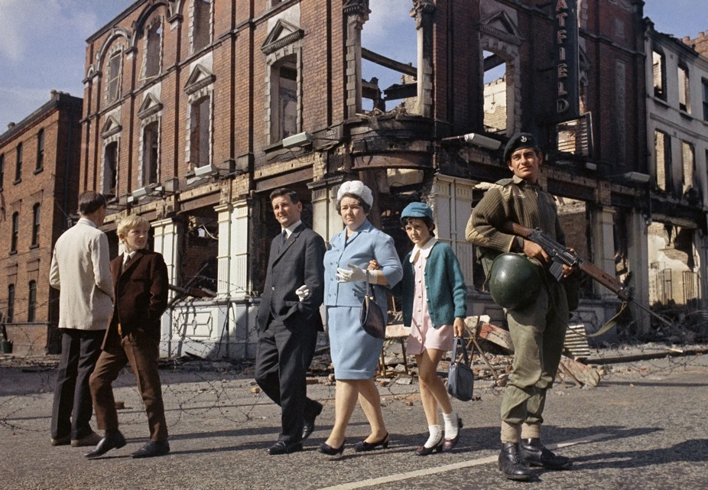
Figure 1: Local people walking past a British soldier on guard in Northern Ireland, August 1969.
Retrieved from: https://www.britannica.com/event/The-Troubles-Northern-Ireland-history/The-Sunningdale-Agreement-hunger-strikes-Bobby-Sands-and-the-Brighton-bombing

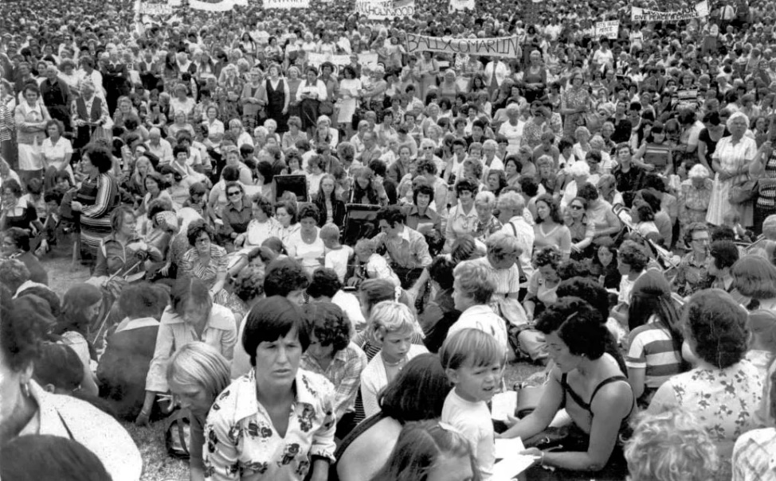
Figure 2: Protesters against ongoing violence in Northern Ireland gathering on Shankill Road, Belfast, Northern Ireland, August 1976.
Retrieved from: https://www.britannica.com/event/The-Troubles-Northern-Ireland-history/The-Sunningdale-Agreement-hunger-strikes-Bobby-Sands-and-the-Brighton-bombing
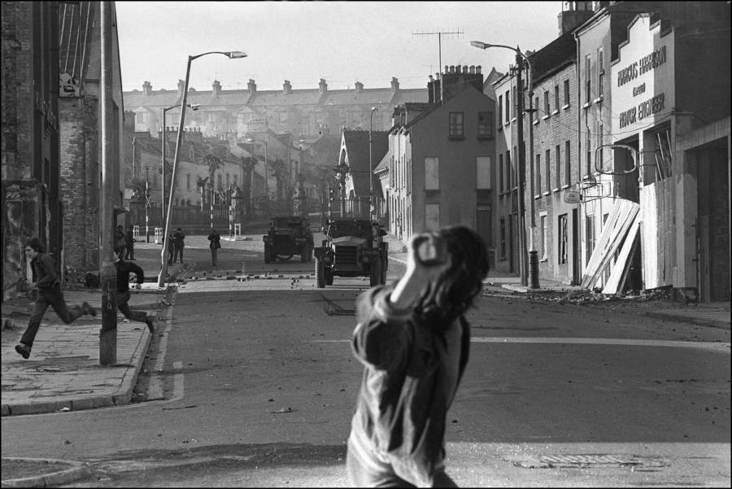
Figure 3: A young Catholic rioter throws a stone at a British armored jeep during a rally in Londonderry protesting the recent Bloody Sunday killings. March 2, 1972. (Photo: BOUI DE TOROUT)
Retrieved from: https://allthatsinteresting.com/the-troubles#40

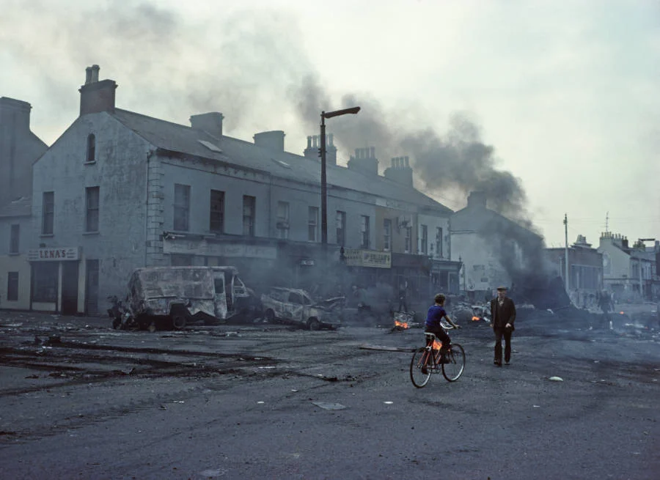
Figure 4: A young boy and an old man stand amid the destruction following a night of riots in the Falls Road in West Belfast. August 1976.
(Photo: Alan Le Garsmeur)
Retrieved from: https://allthatsinteresting.com/the-troubles#27

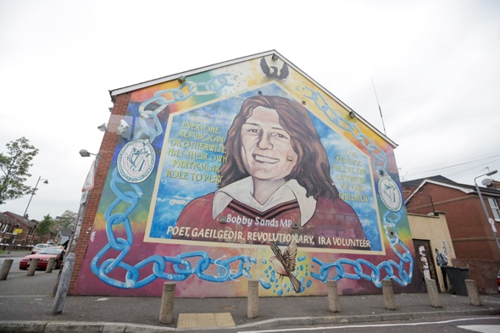
Figure 5: Bobby Sands
Retrieved from: https://wanderthemap.com/2014/01/the-troubles-of-belfast-black-cabs-murals-peace-walls/

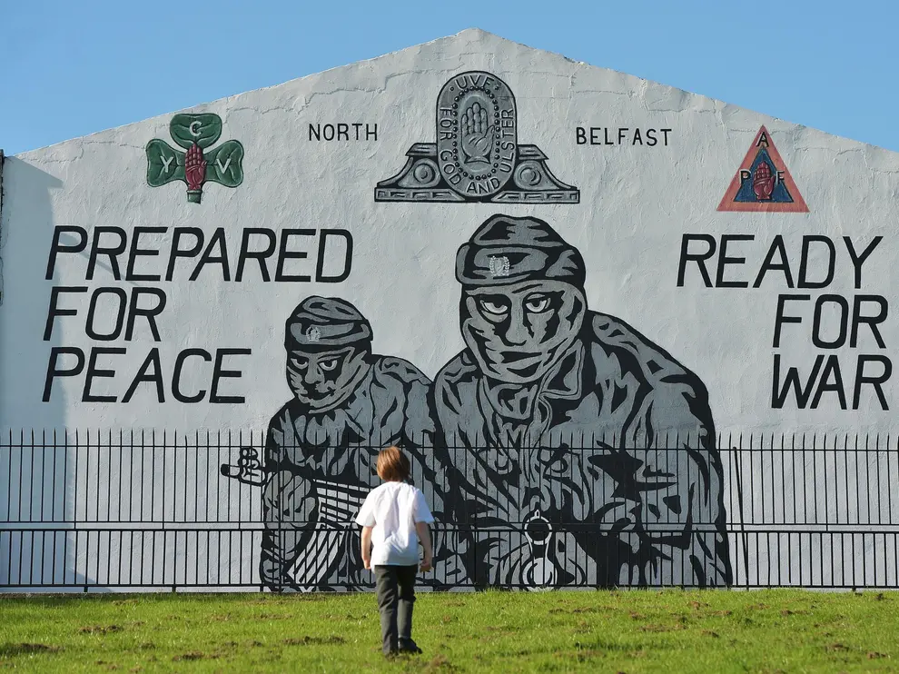
Figure 6: Wall (Getty Images)
Retrieved from: https://www.independent.co.uk/news/long_reads/good-friday-agreement-twenty-years-northern-ireland-brexit-peace-ira-blair-adams-mcguinness-paisley-major-mowlam-a8290746.html

RÉSUMÉ

Tato práce se zaměřuje na konflikt 20. století, který probíhal několik desetiletí v Severním Irsku. Jde především o zmapování skutečností, které vedly k tomu, že se z nenásilných protestů stal dlouhodobý ozbrojený a krvavý konflikt, který si vyžádal spoustu mrtvých na obou znepřátelených stranách.

