UNIVERZITA PALACKÉHO V OLOMOUCI

Pedagogická fakulta
Katedra anglického jazyka

Bc. HANA NĚMCOVÁ
II. ročník - navazující magisterské studium

Obor: Speciální pedagogika pro 2. stupeň základních škol a pro střední školy
Učitelství anglického jazyka pro 2. stupeň základních škol

Games in the process of teaching English

Diplomová práce

Vedoucí práce: Mgr. Josef Nevařil, Ph.D.
OLOMOUC 2019

Prohlašuji, že jsem tuto diplomovou práci vypracovala samostatně a uvedla úplný seznam použité a citované literatury.

V Olomouci dne

Bc. Hana Němcová

I would like to thank Mgr. Josef Nevařil, Ph.D. for his support, valuable advice, guidance and patience that he provided me throughout the whole writing process.

TABLE OF CONTENT

ABSTRACT 6

INTRODUCTION 7

THEORETICAL PART

- GAMES AS A PART OF FLT 9

- ROLE OF TEACHER 11

- CHOOSING COURSEBOOK 14
  - Coursebook or textbook 14
  - Aspects affecting the selection 14
  - The process of evaluation and selection 15

- LEARNERS 20
  - Impact of factors on learners 20
  - Impact of games on learners 23

- TEACHING BY GAMES 26

- GAMES´ DIVISION 31
  - Listening 32
  - Speaking 35
  - Reading 38
  - Writing 40
  - Vocabulary 43
  - Grammar 44

PRACTICAL PART

- METHODOLOGY OF RESEARCH 47
  - Research introduction 47
  - Question of the research 48
  - Methods and procedure of the research 48
    - Observation 48
    - Achievement test 49
    - Analysis 50
  - Organization of the research 50
  - Subjects of the research 51

- RESEARCH RESULTS 54
  - Efficacy of games when vocabulary learning 54
  - Teaching material focused on vocabulary learning 57

- ANALYSIS OF RESEARCH 59
  - Games efficacy 59
  - Incidence of games in textbooks and workbooks 61

CONCLUSION 63

BIBLIOGRAPHY 64

APPENDIX 67

RÉSUMÉ 68

ANOTATION 69

ABSTRACT
The main focus of this diploma thesis is the usage of games when teaching English language. In the theoretical part, there is dealt with definitions which are related to games. Next chapters are concerned with the role of teacher, as the one whose main task is to create good environment for learning and who should be able to evaluate and select the right textbook. As learners belong among the subjects of the teaching process, another chapter is dedicated to them. Finally, the thesis finds out the efficacy of games on learning process and whether the teaching material contains enough games, which are divided according to the practised skills.

INTRODUCTION
The research is based on my experience with teaching children at the age of 9 to 10. Actually, at the time I have been choosing the theme of my diploma thesis, I became the English language teacher for one year, which enabled me to observe the influence of games on pupils. As a beginning teacher, I felt the lack of exercises and other activities necessary for practising the language in textbook, as well as in workbook. This problem led me to creating various worksheets and games I could use in lessons. The reality made me to consider whether the games have real impact on pupils and help them to achieve better results than learning through exercises and to what extent are various games included into textbooks and workbooks designated for teaching English.
In the theoretical part of this thesis is dealt with the games and their division in general, as well as with the teacher and learners who constitute the process of teaching/learning. The practical part is then dedicated to the efficacy of games and analysis of chosen teaching material from the point of view of games incidence.
When working on games efficacy, there have some difficulties emerged in the practical part. Not only, that the pupils divided into three classes occurred in different parts of curriculum, into the process of learning took place various school activities, which partly complicated the pupils´ equalizing. The analysis of teaching material was complicated by the diverse definitions of games and comparatively intricate division of them based on the practised skills. Thus, for acquiring more relevant information I would recommend more extensive research to take place.

THEORETICAL PART

GAMES AS A PART OF FLT
Since the terms games and learning occur in this diploma thesis very often, it makes sense to state their definitions at the very beginning. When reading about teaching foreign languages, also terms such as approach, method and technique appear. For better understanding where games belong during the teaching/learning process, a while is dedicated to the definitions of these terms too.
According to Krashen (1989) when talking about gaining any language ability, two terms emerge that should be distinguished - learning and acquisition. As the author states, the main difference between them is the awareness of the ongoing process. Acquisition is a process taking place when we are unaware of its progress - everything connected to the "feel for language", whilst learning is "conscious knowledge". Krashen associates learning unlike acquisition with "grammar" and "rules" and as such acquisition becomes a central in gaining foreign language. Although there just have been pointed out the difference between learning and acquiring, for the needs of this writing these terms will be understood equal. (Krashen, 1989)
With the other terms deals Brown (1994) who refers to Edward Anthony (1963) as well as to Jack Richards and Theodore Rodgers (1982,1986). As Brown (1994) explains, Anthony distinguishes approach, method and technique. An approach is defined as a "set of assumptions dealing with the nature of language, learning and teaching". Method is a plan how systematically present language with regard to the approach, whereas technique is in conformity with both - an approach and a method, and by the term technique is meant a specific activity which is demonstrated in the classroom. (Brown, 1994)
Jack Richards and Theodore Rodgers (1982, 1986) in Brown (1994) are concerned with the Anthony´s terms and their definitions which they reformulated. They divide a method into three subordinate elements consisting of approach, design and procedure. By the words of Brown (1994) an approach deals with the "nature of language and language learning" , while design is related to the "classroom materials and activities." Procedure then is any technique or practice related to approach and design. (Brown, 1994)
Finally, there are another definitions in Brown (1994) he uses with regard to their current usage. The study dealing with the pedagogical practices is called methodology. By an approach he means "theoretical positions and beliefs about the nature of language", while method is a "set of classroom specifications for accomplishing linguistic objectives". The main definition concerning the purposes of this thesis is the one of technique described as "any of a wide variety of exercises, activities, or devices used in the language classroom for realizing lesson objectives." (Brown, 1994)
With regard to the definitions stated above, the games may be understood either as a design or more often as a technique. Curtain and Pesola (1988) consider distinguishing between games and game-like activities pointless, as a discovery has shown that students call each activity they enjoy a game. On top of that, the authors attach to the games the most important role during the language acquisition of young children. (Curtain, Pesola, 1988)
Sochorová (clanky.rvp.cz, 2011) deals with games and their usage during the process of learning. She introduces the Pedagogical dictionary authors´ (Průcha, Walterová, Mareš) definition of educational game as "an analogy of spontaneous children activities which observes educational aim (which is not always obvious for students). It can take place in a lecture room, gymnasium, playing area, in the middle of village or in the countryside. It has its own rules, requires governance during the process and final evaluation." (Sochorová, 2011)
For better understanding the role of games in the education, with this issue is concerned the following chapter, in which the games are looked at from the historical point of view. Other chapters are dealing with the educational games, concentrating mainly on their sorting, impact on the students as well as the role of the teacher.

ROLE OF TEACHER
The process of teaching might be sometimes very difficult for the fresh university graduate, as well as for anybody with little experience. Even highly experienced teacher may be sometimes surprised by any situation that can arise in the class or some information, exercise or activity in the textbook. These things just happen from time to time and it is just on the teacher´s ability to manage it.
Teachers, in most cases, work with some textbook and people should realised what is the purpose of these textbooks - to help teachers and students. But it is up to the teacher himself what he uses, omits or changes as Grapevine reminds in Cunningsworth (1995). The lessons are dependent on teacher´s personality and although he has a support in the chosen textbook, it is always him who mainly influences the way of teaching. (Cunningsworth, 1995)
Harmer (2007) points to the fact that to teach effectively, the teacher should be able to create, or to help with creating a good and friendly environment within the classroom. To this is connected the teacher´s attitude, which should be at the beginning rather directive and after some time it could be changed into more democratic. Nevertheless, each teacher chooses himself, whether to be more autocratic or democratic and regardless of the teacher´s choice, he always has to play various roles when teaching. (Harmer, 2007)
To name the exact roles the teacher takes up himself, a look into the work of Cunningsworth (1995) can be taken: "In general, coursebooks identify the main role of the teacher as that of a guide or facilitator and a monitor. Essentially, the teacher is seen as guiding learners through the learning process, with support from the coursebook, and monitoring student progress, correcting errors when this is useful for the learning process." (Cunningsworth, 1995)
Except these, Harmer (2007) mentions other roles of a teacher and describes them in detail. Perhaps the most common role the teacher acts, is controller. This is usually used when teaching from the front and it was usually used in the earlier years, nevertheless, it can always be a useful way how to learn in a nowadays, for example when giving students explanations. From the others, the teacher also can be in a role of prompter or participant. As a prompter he acts when the pupils need a little help, for example with forgotten word or with an idea how the pupil could continue in his writing. The role of participant can be used when he wants to be a part of some activity instead of being organiser, which can quite well enliven the activity. In some cases, usually when the pupils are assigned to do some task, they might need teacher´s help as an adviser, or rather resource. The teacher should be able to tell the pupil where s/he can find the required information, but he should also be careful not to let learners become too dependent on his help. The last roles mentioned by Harmer are tutor, organiser and performer. By tutoring is meant an acting when there are given tasks to learners like writing a piece of work when the teacher gives the students advice to what s/he should concentrate on. The disadvantage is that it is better done with smaller class or when the students are divided into smaller groups. Moreover, the teacher should take care not to omit any of the students. As already mentioned, the teacher should also be good at organising pupils. He should tell them what to do, put them into groups or pairs when needed, stop an activity and others. He just should organise the class, so the learners know what to do and in what way. This role is very important and the teacher performs it very often. The last role is the one of a performer. The teachers do not behave in the same way, some are more energetic, some are more humorous than others. Nevertheless, the teacher should not behave in the same way all the time, but he should be changing his behaviour according to what is the most suitable for the specific situation or activity in the class. For some activities, it is better when the teacher is energetic, another time it is necessary to perform for example supportively, commandingly or fairly. (Harmer, 2007)
These roles are important to know and each teacher should be well aware of their importance when teaching. Sometimes it is obvious what is, or should be, his role, sometimes it is less evident. But the teacher should behave in the way he can best lead students, especially when teaching through playing games when the pupils should precisely know what to do and in what way, to avoid senseless action and chaos.

CHOOSING COURSEBOOK
Probably everybody, who has ever been in the process of learning or teaching any foreign language, was using some textbook he was following. Of course, there exist other means helping with the process, nevertheless, textbooks are the basic element for many people. Thus, a teacher should be able to use effectively the textbook he works with, although not always he can influence its choosing. When a teacher starts at his new work, he probably does not look for a new coursebook at first, but he uses the one already approved by the school management. However, he should be able to evaluate textbook, either for the purpose of choosing textbook for teaching, or in case he does not like the chosen textbook, to be aware of the reasons he dislike it and to explain them.

  - Coursebook or textbook
Initially, it should be pointed out that there are two terms for studying material, as mentioned above. Either the term textbook or coursebook can be used. Grant (1987) clarifies the difference between these two terms. Whilst textbooks usually cover just some topics or skill areas, coursebooks are dedicated to all aspects of the language. Nevertheless, very often these terms are substituted one another. For the purpose of this thesis these terms will be considered to be equal. (Grant, 1987)

  - Aspects affecting the selection
The choice of the right textbook for learners should be influenced by various aspects, as Grant (1987) reminds. The teacher should take into consideration not only his own teaching style, but he should also be well aware of different learning styles of learners, as well as their reasons for learning. In his work, he also mentions Gerry Abbott in connection with a TENOR situation by which he describes Teaching English for No Obvious Reason. By this is meant learning English because of meeting the requirements of the education system. (Grant, 1987)
As this diploma thesis deals with the young English learners, probably most of pupils´ reasons for learning the foreign language is just the requirement of the education system or maybe also to please their parents.
Cunningsworth (1984) points out that the teacher has two possibilities. The first one is to choose one coursebook and just get through it, whilst the second one is to use parts of different textbooks and use them when needed. With using material from different textbooks is common their adapting, as well as using also producing teachers´ own supporting material. The teacher who uses the textbook should be careful not to use finishing units as learners´ particular aims. These should be objectives formulated by the teacher himself.
The same author mentions questions concerning the education the teacher should ask himself. All questions should be then answered with regard to specific group of learners, particularly their age, nationality, interests, size of class and others. (Cunningsworth, 1984)

  - The process of evaluation and selection
That choosing the best textbook is quite complicated process, can be learned from many authors who are concerned with this issue. To selecting is related also coursebook´s analysing and evaluating which makes the whole process complete.
Before the whole process of selecting the best textbook starts, the teacher should realize that the choice of the coursebook does not belong only to the teacher himself, Pinter (2006) alerts to. In the process of selection, Ministries of Education of countries are involved. On the basis of their list of recommended books the teachers then make their own choice. Otherwise he could just waste his time by selecting a textbook he would finally be forbidden to use. (Pinter, 2006)
The next thing the teacher should realise is that there are two different kinds of coursebooks between which he can choose. As Grant (1987) describes, it is possible to distinguish between two categories of textbooks, although sometimes their placement can be vague: the traditional textbooks and communicative ones. The traditional textbooks try to "get students to learn the language as a system." After acquiring the system, the students should be able to use it in any situation. Between the main disadvantages of this kind of textbooks belong their focus mainly on the grammar, reading and writing activities, usage of the first language and demand on accuracy. On the contrary, the communicative textbooks concentrate mainly on "creating opportunities for the students to use the language in the classroom, as a sort of "halfway house" before using it in real life." From the main characteristics of the communicative textbooks could be mentioned the effort to focus on students´ interests and practising of all skills - although sometimes they concentrate more on the skills connected to active language, usage of various activities and demand on fluency instead of accuracy. Nowadays, there is particularly tendency to concentrate on practical usage of the language rather than on the system, but it depends on the teacher which textbook he finally choose. (Grant, 1987)
When considering the evaluation, there are also various types according to the time when the evaluation is going on, as Cunningsworth (1995) explains. The first one is pre-use evaluation and according to the author, it is probably the most common type. As the teacher makes the evaluation without knowing the textbook and having any experience of it, it is very exacting. The second type is called in-use evaluation and as its name indicates, the evaluation takes place during its usage. This can be applied for example in case that the textbook is getting outdated and its substitution is under consideration. The third, and the very last type, is post-use evaluation and is very often used for example in short courses which are repeated, and thus the teacher makes a decision whether to use the same textbook for another course or to choose different teaching material. Which means that, in this case, the evaluation is going on after the course - thus retrospectively. (Cunningsworth, 1995)
Grant (1987) describes the evaluation as a process of three stages. The first stage is called initial, the second one is detailed evaluation and the last one is designated as in-use evaluation. During the initial stage it is very important not to act rashly, and although the teacher may be under pressure and he does not want to waste his time, he should be careful to avoid jumping to conclusions. Evaluating a textbook in a short time is very difficult and although the textbook might make a good first impression on the teacher, he should be careful not to make a wrong decision. (Grant, 1987) With the first impression of a coursebook deals also Cunningsworth (1995), who calls that state impressionistic overview. This early evaluation gives only a general image of the material and not always it helps to find any deficiencies, which could be the reason for omitting the inspected textbook. (Cunningsworth, 1995) To make this stage easier, Grant (1987) comes up with a test which may be instrumental in this process. It is called CATALYST test and each letter represents a criteria the teacher should take into consideration. The first question, the teacher should ask himself, is whether the textbook is communicative and thus. whether the students will be able to communicate when using it. The second letter represents the word aims, so the question is if the textbook meets the aims and objectives of the teacher and authorities. The letter T refers to the teachability of the textbook - it should be well arranged for the teacher and he should know his way around without difficulties - for example to the textbook´s organisation and simplicity with usage. A represents another material support designated for the needs of the teacher and students - literally the availability of Add-ons. Two next letters point to the right level of the textbook and to the impression the coursebook gives to the teacher as a whole. As well as the students´ interest is important and thus required to consider. The last question helping with the initial evaluation is dealing with the textbook being put to the test. The teacher should find out whether the coursebook has been already tested and if so, how did the test ended. Although the CATALYST test is quite extensive, there is one criteria omitted and that is cost. Naturally, for some people it belongs to the most important questions, for some it is not as much decisive, nevertheless, if the teacher chooses the textbook for group of students - regardless who pays for it - he probably is interested in this matter. (Grant, 1987)
Whereas Grant deals with another two stages of the process, Cunningsworth´s (1995) next stage is called in-depth evaluation. During this part, the teacher should focus on specific items in a coursebook and for that, he should create a checklist of a criteria according to his own priorities. This checklist includes the most important questions relating to various areas. The author recommends to use such questions which he considers to be dealt with in coursebooks with difficulties, such as the usage of the present perfect and articles - how are these themes taught. To get back to the already mentioned areas, there are eight areas stated by the author for the purpose of the evaluation and selection: aims and approaches, design and organization, language content, skills, topic, methodology, teachers´ books and the last one, practical considerations. However, the shortened version of the checklist might look also like that: aims and objectives, the learning/teaching situation, the learners, the teachers. These are just ideas how the checklist can look like, it depends only on the teacher himself - what questions are important for him and which areas are learners concerned. The combination of the impressionistic overview and in-depth evaluation should provide good basis for evaluation and thus for choosing the best coursebook for both, the teacher and learners. (Cunningsworth, 1995)
After using CATALYST test, there is a detailed evaluation on its turn, as Grant (1987) reminds. It consists of three-part questionnaire which includes three main areas of questions: the convenience of the coursebook for the learners, the teacher and of course, for the syllabus. Each part/area of the questionnaire contains ten questions the teacher should think about and he chooses to what extent are these questions appropriate - they either are fully appropriate - the answer is YES, they are partly true - PARTLY, or NO answer is possible. In spite of the fact, that the questionnaire can be used to the only one coursebook, it is better to apply at least to two textbooks for better comparison. The last part of the evaluation is called in-use. By this term is meant an evaluation applied during the process of the usage of the already chosen textbook. The reason for that is to be sure that it really "works in the classroom" and it should be done even on the assumption that the teacher does not plan to replace the textbook a short time after it. (Grant, 1987)
The choice of the best suitable textbook for the teacher and his students is, as already mentioned, mostly made by the teacher which points out to the importance of becoming conscious about it. He should be well aware of the possibilities he has. The whole process starts with the selection of textbooks, from which he can choose the best one. For this intention, the teacher takes several coursebooks and just scans the text roughly, not to waste his time. The few textbooks which passes to the next stage should be in about number of three or five for comparison. During the evaluation, he should realize all the aspects which are related to and thus have an influence on the process. Although, the selection can be made at various times, the choosing of the textbook before its usage is at the forefront in this thesis. It is on the teacher´s consideration, whether he will use already prepared criteria determined by authors or he can set questions he considers to be the most relevant alone. When choosing the textbook, he can also decide whether to use the whole textbook, parts of it, or even if he adapts some of the parts.

LEARNERS

  - Impact of factors on learners
Teaching students is a very complicated process into which a lot of diverse factors enter. Harmer (2007) presents four of these factors which influence the whole process of teaching - age, learner differences, language levels and motivation. As this thesis concentrates on children at the age of 9 and 11, mainly the factor of age and motivation is brought into focus.
According to Harmer (2007), younger learners have mainly the advantage of learning the right pronunciation and accent when imitating the teacher´s voice, whereas the older foreign language learners are better in many other aspects. Pinter (2006) agrees with Harmer and explains that this takes place on the ground of better sensitivity of children, taking a delight in the activity and being less anxious during the process of learning. As children have problems with their ability for abstract thought, it is important to focus on more concrete issues, sometimes even necessary, Harmer (2007) states. From other points should be mentioned also children´s ability to learn better rather by an indirect way, as well as the necessity of getting interested in any activity, as their attention span is much shorter when comparing to the attention span for example of adults. These needs and attributes of the learners place special demands on the teachers´ personality and their methods used while teaching this age group. (Harmer, 2007)
The process of teaching and learning is also connected with the very important factor of motivation, as Cunningsworth (1984) mentions. According to the author, the motivation affects whether the learners will be successful or not, which is also agreed with by Harmer (2007). He defines the motivation as "some kind of internal drive which pushes someone to do things in order to achieve something". There are two different kinds of motivation distinguished. The first one is influenced by factors coming from the outside and as such is called extrinsic motivation. The second one is called intrinsic and as the designation implies, it is on the contrary related to the learner´s individuality. (Harmer, 2007)
Brown (1994) introduces Edward´s Deci (1975:23) definition of intrinsic motivation: "Intrinsically motivated activities are ones for which there is no apparent reward except the activity itself. People seem to engage in the activities for their own sake and not because they lead to an extrinsic reward." (Brown, 1994)
Among others, with the motivation of young children deals Pinter (2006). She adverts to a teacher´s Marianne Nikolov study which result was that children´s motivation has been changing over time. At first, they are influenced by their own personality - their interests and preferences, simply the intrinsic motivation plays the lead role. It turns into the very first beginnings of extrinsic motivation as they are getting older, at the age of about 11 or 12. It follows that for very young children is very important to learn through activities they enjoy. (Pinter, 2006) Although Cunningsworth (1984) distinguishes between psychological and socio-cultural factors influencing the motivation, he also points to the necessity of using appealing materials and interesting activities the learners should carry out.
About distinguishing between extrinsic and intrinsic motivation people should be careful, as Finocchiaro (1989) reminds. In the author´s own words: "the motivation stems rather from positive learner and teacher attitudes which should permeate every stage of the learning process if it is to lead to pleasure and success in language acquisition." (Finocchiaro, 1989)
In view of the fact that the process of teaching is fairly intricate, as there has already been mentioned, in this process two another factors play an important part - one of them is the aim and the second one is learning style. When teaching pupils, the teacher should be well aware of the main aim - he must know what he wants pupils to learn from the lesson or chosen activity, as Scrivener (2011) notifies. Thinking about the aim of the next lesson is called planning, which is stated as one of the significant skills teachers need to acquire. The abilities the teacher focuses on for the purpose of learners´ acquiring are known as language skills. When planning a lesson, the teacher should be aware of the progress of learning process - how do people learn. (Scrivener, 2011)
Harmer (2007) explains, that although there are some people who tend to distinguish the language skills (reading, listening, speaking and writing) into two categories - termed as receptive and productive skills, the skills are rarely used separately. The skills of reading and listening belong to the category of receptive skills and the skills of speaking and writing belong to the productive skills. Usually, when using one of the skills it is necessary to apply one more. (Harmer, 2007) About language skills writes Cunningsworth (1984) who describes the communication as a process with skills involved and used in various combinations. The author explains on real life situations the usage of more skills at once - like leaving a message to somebody or writing an abstract of another writing. (Cunningsworth, 1984)
Grant (1987) alerts to learners different preference in the way of learning as their brains work differently and thus to the teaches´ ability taking this fact into consideration when teaching. In his publication, Harmer (2007) mentions two models for human´s perception of world. These are Neuro-linguistic programming and MI theory. The Neuro-Linguistic programming is about using various systems of which acronym is "VAKOG". That means Visual, Auditory, Kinaesthetic, Olfactory and Gustatory system that people use either the only one of them or more at once. The second model is called MI theory according to Multiple Intelligences, introduced by psychologist Howard Gardner who introduces seven intelligences people have, although some of these intelligences may be more salient: Musical/rhythmical, Verbal/linguistic, Visual/spatial, Bodily/kinaesthetic, Logical/mathematical, Intrapersonal and Interpersonal. To these intelligences have been added also Naturalistic intelligence and Emotional intelligence. (Harmer, 2007)
To emphasize the point, the teacher should be well aware of the pupils advantageous and disadvantageous concerning their age and motivation when learning a foreign language, as well as the importance while determining the constituent aims with regard to the application of particular skills. Furthermore, the teacher should also know about various ways by which the pupils may experience the world. That means, among others precautions, that a good teacher should be fastidious when choosing supporting materials and convenient activities.

  - Impact of games on learners
That the combination of teaching and games is not only successful, but also required by pupils themselves as well as by the majority of people is simple reality, especially nowadays. As explained in the next chapter, people were initially learning through games and thus it is, even at the present day, a natural way of learning for them originating from the beginning of human being. In this part, it is pointed to the games´ impact on pupils - what abilities exactly are influenced by using games.
With the question of plays´ benefits is concerned Flood and Hardy (gilleducation.ie, 2013) who comes up with five areas, together marked as PILES. By these areas are meant: physical, intellectual, language, emotional and social development. Another division they mention is according to Aistear, into these themes: wellbeing, identity and belonging, communicating, and the last one exploring and thinking. (Flood, Hardy, 2013)
The first area of development described by the authors is physical, or also called wellbeing. Here belong all games which develop motor skills of children and their health. The second group which can be improved is intellectual development - exploring and thinking. By playing games, children can explore things without any worries and thus acquire new knowledge all alone. They can learn concepts related to mathematics - such as ordering, sorting, measuring and many others, or even to develop practise reasoning and problem-solving skills by which children can deal with various problems of life. The next area which is influenced is language - communicating. The communication is developing during the all time spend with the game and one of the parts of the language development is extending vocabulary. As fourth, it can be talked about emotional development or according to Aistear´s division identity and belonging as well as communicating is included into this area. By playing games, children can learn how to deal with various situations and with their own emotions - the positive and the negative ones. They learn to perceive themselves, to cope with their feelings, cooperate with others and to become well aware of the diversity of our society. The last developed area is social and it includes identity and belonging and communicating according to Aistear. By words of the authors, this area deals with these skills: "the ability to interact effectively with others, learning and understanding the norms of the society in which the child lives and moral development." By these games children learn how to behave in everyday life: to help somebody, to be polite and patient, to accept rules and follow them, to share things or to be able to ask for food and pay for it. (Flood, Hardy, 2013)
From other authors dealing with the issue of games and their impact they have on pupils, should be mentioned Kaszkowiak (cometaresearch.org, 2017), reminding competences which are developed according to Wawrzeńczyk-Kulik. The first of described competences is teamwork, that is working in a team. Very useful and required skill by many employers in nowadays. Next skills, which can be developed and which have already been mentioned above, are communication and cooperation. With communication and cooperation is connected not only the ability to express own opinions and ideas, but also the ability to listen somebody as well as to deal with conflict situations - especially to accept or express criticism and find a solution. Another competence is time organisation and management, thus the ability to be good at planning work, mainly at time when there is need to make decisions under pressure. By words of the author, the last competence is "a range of other analytical skills, which include goal determination and critical thinking." Kaszkowiak (cometaresearch.org, 2017) also comes up with authors who talk about didactic games as about "an efficient method of developing persistence." From these authors she mentions Gabriela Kapica and Maria Noga. According to Kapica games have an influence on pupils´ "willpower, willingness to overcome difficulties and persistence," but games also often arouse the sense of optimism and self-faith. Noga´s concept of the influence of didactic games is described by these words: "they develop such character traits as regularity, persistence, self-discipline and feeling of justice. They teach how to take up tasks on one´s own and how to get on in a peer group." (Kaszkowiak, 2017)
From the chapter it is obvious, that into the process of learning enters factors and games (especially didactic games) which have a great impact on pupils. Among the factors belong motivation, age, aim and learning style. When taking into consideration games, they help to develop various skills, which are useful both in educational and everyday life. It is the teacher´s decision, whether he uses games from the textbooks in the way they were meant to be used, he modifies them or even omits them completely. Naturally, he can also put into the process of teaching games from other resources. Nevertheless, finally it is only up to the teacher himself to what extent he decides to involve games into the education.

TEACHING BY GAMES
To the fact that "learning is an active process" points Pinter (2006). She explains that children learn best when they are active and motivated, which is often through play. In her work she mentions child psychologists Jean Piaget who is connected with the term "constructivism" which is understood as active learning. This activity consists of process called "asimilation" and the one called "accommodation" which usage is dependent only on the child himself and by that process the "children construct knowledge". (Pinter, 2006)
What is the role of games in the education and how have games been changing in the course of time, explains Gray (psychologytoday.com, 2008) in his article. In the very beginning, people were hunting and gathering various plants and berries for living. Adults let the children to gain the needed knowledge through their own play and exploration. As the writer mentions their life was exciting, they did not work for long hours and according to anthropologists they "did not distinguish between work and play". But the hunter-gatherer way of life had change with the rise of agriculture. Whilst earlier people had been moving, with agriculture they remained to live at one place, had more children and those were supposed to help with farming or taking care of siblings. Additionally, the agriculture resulted also in hierarchical society with slaves and children used for work. But at fields there were at least some opportunities for children to play. This changed with the rise of industry when the only thing wanted from children was their obedience. Many of children died because of exhaustion, starvation or various diseases. When the industry became more automated, the situation changed again. An idea that children should be educated emerged and it had a lot of supporters - of course each of them had his own idea about what should children be taught. Even the best of them were still based on learning by heart - memorization, repetition and punishments were ordinary part of education. With the rise of schooling, children were even permitted to play for a while in some schools, although it was not a part of education. Finally, the education in the 19th and 20th centuries became more humane but still it is looked at to be children´s work and even at the present day it is distinguished between learning and playing. (Gray, 2008)
Flood and Hardy (gilleducation.ie, 2013) also write about child education and the role of play. They advert to the fact that even at the times of poverty, child labour and in spite of other unfavourable circumstances, children always wanted to play and found the way how to play. (Flood, Hardy, 2013)
To sum up the information, children play is a natural substance of their being and a fundamental part of the process of learning, and as such it should be paid more attention to it.
For young learners, games are a good way how to acquire foreign language as Curtain and Pesola (1988) mentions. These authors construe games as a method which can provide motivation and their usage during teaching/learning process improves not only learning, but also memory. (Curtain, Pesola, 1988)
Probably, a lot of people call John Amos Comenius to their mind when the term learning by play, is used. He was a pedagogue who is considered to be "the father of modern education", as is stated by McMahon (apuritansmind.com, 2019). Perhaps everybody knows at least some of his works, between the ones most well-known belong for example: The Great Didactic (Didactica magna), The Visible World in Pictures (Orbis pictus), School by Play (Schola Ludus) and many others. But we should consider whether we really know his works. Usually, we have learned about Comenius and his works at school, but not everybody has read them or at least any of them. To this fact points an article written by Jaromír Kopecký (ascestinaru.cz, 2015) which was printed already in 1992 in the journal of Czech language and literature. The author explains the real meaning of the work School by Play which has almost nothing in common with nowadays understanding of this term. According to the article, the School by Play emerged from another writing - Janua linguarum reserata which served as an exacting textbook written in Latin. The task of the School by Play was not to educate in a playful way, but stage adaptation, that is students´ energetic involvement in the activity. As Comenius wanted students not to learn by heart but to understand what they are learning, not only that he created School by Play, but also The Visible World in Pictures (Orbis pictus) for connecting the words with their meaning. (Kopecký, 2015)
With teaching children by using games, deal Khan and Rixon among others in Brumfit (1984). Khan explains why should teachers use games, what is the role of them and about what should teachers be careful with their usage. Khan presents the main characteristics of the game as "Activities governed by rules, which set up clearly defined goals. The achievement of these goals signals the end of the game... Games should lead to having fun... Games are for playing, and this element of play is crucial." From these statements it is obvious that the game used for teaching should be well and clearly defined, not only to satisfy the children´s need to play but also, for the teacher - to teach or to practise pupils something. These games tend to be either static or dynamic, Rixon reminds. Whilst the static are better for using in the classroom, dynamic ones are more suitable for playing outside or on a playground. Nevertheless, the teacher should realise that he can always adapt, or at least try to do so, any of the activities. But he has to be careful not to change it in a way the activity would not serve to what it was originally intended - for example to practise some grammar or vocabulary. When using games, the teacher should be well aware of these "pitfalls" which can happen if he is not careful. Firstly, it might happen that the teacher comes up with such an activity which takes too much time and does not provide such contribution to education as we thought. Secondly, ideas of children may be better than the teacher´s which, in such case, should be utilized by the teacher. But only in case that the primary intention of the game is not destroyed. Finally, the teacher should give a chance to activities which seem at first sight to be too simple and he would not even consider their usage formerly. (Brumfit, 1984)
That games can be divided either according to style or type, we can learn from Flood and Hardy (gilleducation.ie, 2013). There are styles of games: structured play and free play. Free play is the one which is not intervened by anybody. The children have materials and equipment, but the adults are not involved into the play, thus children get the information by the play alone, which should contribute to their better understanding of things. In the past, this was the main style of children´s play. The second style of game - the structured play - is "planned, guided and led by adults." The adult should be careful not to lose child´s interest and the activity should be manageable by the child himself, s/he should be able to do it alone or with adult´s help, otherwise the process of learning would not be happening. From types of play Flood and Hardy mention imaginative, construction, creative and physical type.
Imaginative play is sometimes called also role play and this game is dependent on child´s imagination, as its designation indicates. To this group belong pretend play (children imitate behaviour of adults and others when playing about events of daily life - like shopping, farming, play hospital, school and others), fantasy play ( children pretend to be somebody unreal, some superhero like Spiderman) and symbolic play (using real objects and pretending that they are something different).
With construction play there is often created some product. Children can use not only bought construction materials like Lego, but also materials which are not originally intended for construction like various boxes, tins, clothes and others.
Creative play is connected to music, art, dance and this sort of activities. The main task of the teacher is to provide materials and equipment needed and to be very sensitive when appraising the result - if it is judged at all. By using this type of play the adult can gain precious information about child´s emotion.
The last mentioned type is physical play and can be done outdoors as well as indoors. During this play can be used various equipment according to chosen activity and, as its designation implies, it is connected always with motion. Regrettably, children seem to spend less time by physical activity nowadays despite its healthy effect on people, which is probably caused by impacts of computers and TVs. (Flood, Hardy, 2013)
From the very beginning there emerges the main question what exactly is a game. Some authors have clear definition, in contrast to those whose definitions are rather vague or those who claims that there is no need for definition at all and they consider any kind of activity which children enjoy and which has its own aim, to be a game. Although, agreeing with the requirement of enjoyment, it seems that this constituent is quite misleading as children are very different and what is successful in one class does not need to have the success in another one. With the problem of game´s definition, another issue arises dealing with the games´ division. Games can be distinguished either according to their style or type. Nevertheless, even this depends on various authors and thus different dividing can be found. For the purposes of this thesis one another division has been chosen, which stems from developing the individual language skills and this is followed up in the next chapter. These skills have been already mentioned before, dealing with the differences in learning English with regard to the target group of learners: listening, reading, speaking, reading, writing, vocabulary and grammar.

GAMES´ DIVISION
As it was already indicated, there are various ways of dividing games, which depend on different authors´ conception. That during teaching foreign language is very important to concentrate on the individual skills pupils should acquire, is widespread belief by many authors. For the purpose of this thesis, there is dealt with the division according to skills which are practised and improved by using these games. To understand what kind of games are beneficial for pupils when learning language, these skills are brought into focus for a while.
When teaching language, some teachers may concentrate on the individual skills they want pupils to acquire. With this matter deal a lot of people, Harmer (2007) among them. He reminds four skills which are at the forefront. These are reading, writing, speaking and listening. The author points out to common division of these skills into two types: receptive and productive skills. Into receptive skills are involved reading and listening, whilst writing and speaking belong to the productive skills. With this division of skills is often connected the supposed activity involved. Thus receptive skills are considered to be passive, unlike productive skills which are regarded to be active. Nevertheless, the author emphasizes that this distinguishing is quite senseless, as during the usage of each of skills a person have to involve at least some activity. According to Hinkel in Harmer (2007), even the isolating receptive skills from productive ones is pointless because in real life people usually do not isolate skills during their usage. On the contrary, they use more than one skill at the same time and as such these skills should not be taught in isolation but as a whole. To that, is also connected input and output in the classroom. By the input is meant everything that is learned from what is "heard and seen". Whatever pupil produces, is then described as output. The input have an affiliation to the output. If a pupil produces an output and he/she gets a feedback, the pupil can learn from it and his/her own output becomes input. (Harmer, 2007)
Also Cunningsworth (1984) mentions the division of language skills into receptive and productive skills, but on top of that, he adds integration of skills and translation. The integration of skills he explains, among others, on the example of dictation and conversation participation, with the translation he comes up with the possibility of translating either into English or from the English language. (Cunningsworth, 1984)
With the question of teaching individual skills is concerned another author, Pinter (2006). Not only she describes the already mentioned listening, speaking, reading and writing, but she adds some others: vocabulary, grammar and learning to learn. (Pinter, 2006)
Teaching according to the skills is very important, especially in the elementary school. As Curtain and Pesola (1988) point out "these skills must be regarded as an integrated whole in the elementary school foreign language classroom." And if some of the skills are practised more than others, they also remind that "the total instructional program should include activities involving all four groups of skills." (Curtain, Pesola, 1988)
Because this issue is quite extensive, further there is dealt with each of skills separately for a while. Not only with the four skills which are emphasized most often, but also it is focused on two another areas which are necessary to develop: vocabulary and grammar.

  - Listening
That the main importance of listening skills lies in two reasons, explains Grant (1987). The first one is the bring for possible breakdown of communication if there is an absence of these skills. So, the person who has problem with listening will probably have also problem with the whole communication - if somebody does not understand the question he/she cannot produce the right answer. Because of this, there are an efforts to improve listening by putting better listening exercises - from native speakers - into the textbooks. By the second reason is the increased ability to produce language in the right way if the person has heard a pattern previously. (Grant, 1987)
From Curtain and Pesola (1988) we find out that until 1960s in the process of learning foreign languages the skill of reading took precedence over the skill of listening, as there was shared opinion that if a person wants to learn language well, he/she needs to acquire mainly the ability to speak. Now, listening skills are together with reading skills, considered to be the "basis for the development of all other skills". (Curtain, Pesola, 1988)
Within listening skills, there are some aims pupils should learn to acquire, Grant (1987) notifies to focus on: sound discrimination, stress and intonation, language signals and overall comprehension skills. Firstly, the pupils should be able to discriminate between sounds not to interchange words and in connected speech. Second ability the pupil should acquire is to recognise stress and intonation patterns and thus understand the meaning of spoken unit. The next mentioned ability or skill is devoted to recognising language signals, especially in these cases: a new idea emerges, the speaker gives examples about something what has been already talked, leaving one idea and recognition of an important point. The last of the skills belonging to listening skills, is overall comprehension skills when the pupil should understand and follow the main idea/s of any communication. (Grant, 1987)
Acquiring listening skills accompany some difficulties we should be well aware of, as Pinter (2006) alerts. One of the problems is usually the length of the listening text, which might be too long for pupils. Another aspect which can cause troubles is the speaker himself. If the speaker is somebody known by pupils and to whom they are accustomed, they probably will be more successful with listening than with listening for example recording. Among reasons why it is so, belong the speed of the teacher which can be adjusted to the pupils´ needs, the facial expressions as well as used gestures which might be helpful for pupils, and pupils´ respond during any part of listening according to their needs. (Pinter, 2006)
For developing listening skills there are some strategies the teacher can use. These strategies are described by Curtain and Pesola (1988). They mention TPR known as Total Physical Response, Gouin Series, Audio-Motor Unit, The Natural Approach, Descriptions, Demonstrations and Telling or Reading a Story. TPR is often used when introducing the language to children, but can be used also to adults. Pupils react to teacher´s commands through physical response, they are not forced to respond orally - it is up to them when they want to take turns. During this approach the teacher can use various commands involving response through either body and motor skills, manipulating materials and objects or even action relating to some indirect materials like maps, pictures and others. The only requirements for this approach to work, is that the teacher never embarrass pupils by his commands and that commands should be unpredictable. Gouin Series is a strategy similar to TPR. The teacher describes some action by short statements and at the beginning he/she accompany these statements with pantomime. The pupils then respond through pantomime, finally they imitate the statements. For this strategy it is good to use some aids like props and visuals. The next strategy - Audio-Motor Unit - is similar to both - TPR and Gouin Series. A series of commands related to some specific situation is prepared by the teacher and recorded on an audio tape - if it is possible by a native speaker. These commands are played and pupils join the teacher´s pantomime. Of course, commands can be later recombined. The Natural Approach has four levels which move pupils from easier to more difficult usage of the language. Firstly, they use just "yes" and "no" answers, their answers become more complex and finally, at the fourth level they answer with the entire sentence or action. The whole approach "moves students from a listening mode to a speaking mode." Among others it is based on right understanding of words, knowing right associations with the words and having physical contact with various objects and pictures. The strategy of Descriptions is, as its name indicates, based on teacher´s descriptions of an object or a picture to the accompaniment of gestures indicating the right meaning. The next strategy is called Demonstrations and it consists in giving instructions about task completion with usage various visual aids, but also pantomime. Very important is to use rephrasing to and then check pupils´ comprehension. The last strategy described by authors is Telling or Reading a Story. This can be done even from the children early youth and the aim of this strategy is to develop "associations between the language that is o heard and the meaning that language communicates; at this stage students are not expected to imitate the language, just to understand it." If we want to use this as an input for young children, the stories should meet these criteria: there should be already acquired vocabulary in the story, it should be predictable and its environment should be well known to the child. From others criteria it is good if there are used formulas and patterns - the story is repetitive, it inclines to dramatization and pantomime and if the story has a lot of illustrations. (Curtain, Pesola, 1988)

  - Speaking
About teaching speaking we can learn from Pinter (2006) who talks about great challenge in connection with language learners. To using this skill is related not only speaking, but also thinking - especially monitoring our speech and its correction - at the same time. The usage of these elements is necessary for speech to be fluent. From other things the pupil should learn, the author mentions "what is appropriate to say in certain situations, how to manage conversations, and how to interrupt and offer their own contributions." If teaching young learners, the teacher should realize at first what is realistic to expect of them, particularly, what they are able to manage. Because if they are not able to do some things in their mother tongue, they can hardly deal with them in foreign language. The author gives us advise to start with drilling patterns and dialogues when learning children. This should "prepare them to be able to talk about themselves and their world and to begin to interact with their friends in class and other speakers of the language." (Pinter, 2006)
That teaching speaking should be mainly connected with student-talk rather than teacher-talk, reminds Grant (1987). He compares the fact that pupils´ speech is often ignored to the attitude of teachers to listening skills. If the teacher wants pupils to acquire the speaking skill, he should focus on practising three types of speechwork which a good textbook should contain. These kinds are drills, communication practice exercises and natural language use. The first kind of speechwork - drills - focus on accuracy and these type of exercises are mainly mechanical. Their aim is to acquire some forms of the language so it can be later (after its automation) used in communication. According to what are drills concentrated on, there are various types, e.g. transformation drills (practising grammatical patterns), pronunciation drills (focus on pronunciation - not to confuse similar words), chain drills (the aim is to help pupils to put words together into right order). Second kind of speechwork are communication activities which develop fluency. They are used to enable pupils practising the communication itself and they can take place in pairs or groups. In textbooks there are various types of exercises focused on practising communication, there can be e.g. information-gap activities, half-dialogues, quizzes, problem solving activities, guided interviews and role play. The third and last kind of speechwork is called natural language use. By this speechwork is meant using language naturally, talking about various things pupils like or are somehow involved in. But it is more the concern of the teacher rather than the textbook and as the author alerts: " This kind of language use is so important that its use should depend on classroom opportunities rather than the syllabus or textbook." (Grant, 1987)
With creating good environment for communication agree also Curtain and Pesola (1988). They write, among other things, about conditions of the pupils´ beginning to speak - that they should be exposed to a rich language environment and the second condition - they "have something to say". To help pupils with their expressing, teachers often want them to learn various language patterns and phrases by heart. Authors acquaint us with an effective approach which lies in the usage of passwords and language ladders. Both - passwords and language ladders have in common being taught directly, one by one and posted on the wall accompanied with a visual aid. Unlike passwords, language ladder express one idea in different ways. They often express the idea or a need in "different registers, degrees of politeness, or social context." If the teacher wants to help pupils with acquiring oral skills, he can use several strategies for teaching oral skills. These strategies are teacher repetition, modeling, backward buildup and answer precedes question. The first strategy refers to pupils´ possible dependency on the teacher. If there is an activity which requires a response of a group or of a whole class, the teacher should not repeat a response with the pupils, because it may increase their dependency on him. By modeling is meant providing always the same model of the language - with the same natural speed as well as intonation. Not to change speed or intonation on the grounds of causing problems by wrong emphasis. The third strategy is called backward buildup and, as its name implies, it is based on learning some longer utterance in the opposite direction than usually - from the end to the beginning. This should be used only exceptionally, in specific situations and only if its learning is for pupils highly motivating. The last of the strategies is answer precedes question, which means, that pupils should learn first the answer to a question. After learning that, they can learn how to create the question itself - because the question without an answer lacks a sense, whilst an answer provides information and as such is more valuable to the hearer. But for teaching speaking in a foreign language is among already mentioned things pronunciation. The author warns teachers against direct teaching of the pronunciation as it seems to be very difficult issue to manage. As explanation he describes three problems which can emerge when teaching pronunciation directly. One of the problems is the difficulty for pupils to recognize which sounds (what word or phrase) are they supposed to say - they may have problem to distinguish the teacher´s command from the required sounds, as well as they might have problems with determining which part of the sounds should be in the centre of interest. Secondly, in some languages there are sounds which do not exist in other languages and the pupils have troubles even with their recognizing, let alone their imitation. The final mentioned problem is that problems caused by lack of success in pronunciation can lead also to lack of self-confidence and worries that can have a negative impact on learning the language not only in the area of speaking but in all areas and thus significantly affect the whole process. (Curtain, Pesola, 1988)
  - Reading
Grant (1987) describes reading as "a complex multi-skills process" with several objectives that teachers have if they want pupils to teach reading. Because the teacher does not know what his pupils would need to read, he should provide them different kinds of texts - not only stories and novels, but also newspapers, brochures, advertisements and others. The next thing the teacher should realise is that pupils should be able to read the text in different ways - to look some piece of information up, to know the main plot and others - and thus pupils should practise different reading skills. A lot of textbooks concentrate on developing basic comprehension skills. These are fundamental and as such the teacher should pay attention to them to be developed: plain sense reading, deductive reading and projective reading. By plain sense reading is meant simple understanding of a text - just reading lines. Deductive reading is little more complicated - the reader should understand what lies between the lines, he should draw deductions. The last of the skills is projective reading and is connected to "the ability to read beyond the lines". On the basis of this skill the reader should be able to connect the read text not only to real life, but also to his own experience, opinions, knowledge and imagination. For textbooks are important functions of their reading materials. These can be two: by the first function can be to achieve four aims (understanding common texts, extending own knowledge, recognizing reading purpose and adapting methods of reading, being a critical reader) whilst the second function is "to act as shop windows for language." The second function is connected to displaying various language items in the textbooks (for example vocabulary, idiom, etc.) from where they should be learned or remembered by pupils. (Grant, 1987)
With reading texts deals also Cunningsworth (1995) who talks about these different purposes: developing skills and strategies required for reading, introducing grammar items, enriching vocabulary, providing writing models, giving information and oral work stimulation. Another issue that the author mentions is the advantage of reading texts which is the reader´s control of the pace in contrast to listening and speaking which can be sometimes stressful. To that is also connected another important thing - to the content of textbooks should be paid attention too. The textbook should be of real interest, authentic (with respect to the level) and accompanied by activities helping with the reading process. But there are various types of reading material according to its writer (textbooks are dependent on the author´s interests and expectations) as well as depending on the experience of the learners. When choosing the textbook, the teacher should be well aware of these dimensions: topic, presentation, authenticity, genre, exercises and activities. While considering topic, the teacher should look at for example what kind of topics are included and whether they are interesting and culturally acceptable. Regarding the presentation there should be used different type-faces, formats and colour blocks. Texts should be in view of their language authentic and to the type or genre of text should be also paid attention. The authenticity of texts of course is influenced by the level of the language, but should be authentic as early as possible. The next important thing is the type or genre of text, which should be of a great range - not only that the textbook should include different text types (e.g. advertisements, poems, letters, interviews, extracts from novels etc.), but these texts should be chosen or adapted according to the learners´ progress as they get through the course. The last stated dimension is exercises and activities - which should encourage students to read with enjoyment and to understand the text. By using these exercises - e.g. pre-reading questions, post-reading comprehension questions, looking up specific information from text or finding key vocabulary items - students can acquire reading strategies such as prediction techniques, skim -reading and dealing with vocabulary. (Cunningsworth, 1995)
About the issue of teaching reading writes Pinter (2006) whose concern is why to teach reading and at what age. She points out to the fact that "there is no formula to follow or no single most effective technique to use when it comes to teaching native speaker children to read English." With regard to the previous statement it is obvious that there are problems with teaching reading in English as a foreign language. Teaching reading is then influenced by various factors: e.g. age of children, the level of English to which they are exposed, the first language background of children and the ability to read in their first language. Very often there exist conviction in foreign language context, that children should learn to read firstly in their mother tongue and to read in a foreign language they should after that. When children start to learn reading in their mother tongue, they expect to learn it in the second or foreign language, too. This is often supported by children´s interest and enthusiasm, from various reasons why to engage them into this process can be the need of some pupils for visual exposure to the language - as some pupils learn better if they can see the words written down or that they can learn better if they can use English also outside school - from home, which also goes for writing. (Pinter, 2006)
Authors Curtain and Pesola (1988) quote George Rathmell who agrees that teaching reading in foreign English to literate pupils should not be delayed, because its delaying can cause "diminishing returns after a dozen or so hours to instruction because students are prone to develop their own covert writing system." He also agrees with learning reading early because "delaying reading in the second language may also be very frustration to students whose learning styles are more visually oriented." (Curtain, Pesola, 1988)

  - Writing
With the statement that writing is the fourth skill which is needed to develop agrees Finocchiaro (1989), one of many authors, who deals with this issue too. She describes this skill as a process of several stages through which a teacher should lead pupils . This lasts for a long period of time and the process depends on many aspects - pupils´ age, interests, capacities and needs. One of many things the teacher should realise are possible differences between the writing system (such as alphabet) in the native language and in the foreign or second language. Writing is described as "written thinking" and according to the author the pupils should be lead to express themselves through it (they should write about their ideas, experiences, thoughts and feelings). But the whole process of writing should "have a content in harmony with their evolving interests," which can be achieved also by teacher´s support through providing pupils experiences, discussions, listening, watching films, reading and other. Regarding writing, there are two major types which should be learned: practical and creative. As their names indicates, the practical writing can be found in letters, outlines, summaries, notes etc. (simply in writings dealing with practical issues), whilst creative writing can be found in literature. When dealing with writing, there appear some general considerations mentioned by the author. Writing should be practiced in class either little or not at all - because it is time-consuming and the time should be rather devoted to activities pupils cannot do at home like listening or speaking. From writings which can be done at school there are named occasionally dictations and simple aural comprehension exercises. Through writing, already taught structural and lexical items should be strengthen and writings should be corrected as quickly as possible. The last mentioned issue points out to the fact that the correction of written work do not have to be displeasing task for the teacher. (Finocchiaro, 1989)
How do writing activities in coursebooks look like describes Cunningsworth (1995). According to the author the activities which task is to develop writing skills usually have a given model on the basis of which, as well as of additional information, the pupils produce something similar. To the task is also related the type of the writing, which differ a lot, another thing connected to this issue are conventions for the individual kind of writing influenced by the level and aims of the learners. (Cunningsworth, 1995)
With writing skills concerns also Grant (1987) who reminds two main objectives for teaching pupils to write. The first one is to learn them to "respond appropriately in writing in those situations that require it", whilst the second aim is to practise their knowledge through writing. Nevertheless, for the beginners the second aim - the practising of the language - is more applied than the first. Furthermore, some pupils feel a need to write things down to learn the language and in this case the teacher has to pay attention that pupils´ notes are written correctly. In textbooks we can find various exercises of different kinds. It is possible, that there are too many exercises of one kind, so it is up to the teacher whether he decides to get through all of them. If he does not want to do so, there are some possibilities. One of the possibilities is just to omit it. From others, he can alter the exercise to make it more relevant, make some changes so it becomes easier, modify the exercise to make it harder (so pupils have to think more about it) or to change the exercise to another kind. On the contrary, some textbooks do not have enough exercises, so the teacher has to create the exercise himself. To avoid difficulties, he should realise what makes a good writing exercise. First of all, the teacher should be careful about its level - the exercise should be appropriately demanding (not too hard, not too easy). The exercise should be relevant to the students as well as to the subject of the unit. The teacher should also pay attention to the grammar and vocabulary used in the exercise - pupils should be already acquainted with both of them and the exercise should not be too long. The last mentioned observation is that the writing should have some communicative purpose which can be one of these: functional, personal or imaginative. By functional purpose is meant a writing for a specific occasion, so the teacher should realise what pupils would need to express by writing in present or in future and to prepare them to it. Second purpose of the writing - called personal - is connected to some person without regard to the fact whether it is directed to somebody, or it is just about the writer alone. The third purpose can be imaginative and has nothing in common with functional or personal aim. In this case, writing is connected to pupils´ imagination and their main task is to use the language in an interesting context. (Grant, 1987)
Another author who is concerned with the issue of teaching writing is Pinter (2006). She deals with writing together with reading, as the development of these two skills is interconnected. In her work, she describes learning English as first language of young children in pre-school years and then at school to become aware of how children actually learn the language and thus to realize how to teach children who learn English as a foreign language. Firstly, children learn to recognize various short words in their environment like "PIZZA" and traffic signs. From their surrounding (when watching their family) they realize the connection between spoken and written word and that every spoken word can be expressed by written symbol, moreover they find out the purposes for reading and through it they start to build their relation to reading and writing. When children are at the age they start school attendance, they are usually able to write their name, or a name of some other member of their family, as well as some words like "mummy" or "daddy". These gained skills are very important for further reading and writing learning. Learning reading depends a lot on children oral skills (not only the knowledge of words but also phrases), as it is easier for them to predict what could follow in the text. Learning English has the disadvantage of having different pronunciation of words who in written form look similarly. Thus it is more complicated to teach children the right pronunciation and the whole process of learning to read and write takes more time than in another languages with more "shallow" ortography. When taking into consideration teaching regular aspects of the language system, there are used songs and rhymes for learning phonics. Writing is usually closely connected with the beginnings of learning reading as children want to write when they start to read. They usually start by drawings and pretending writing until they really begin to write individual letters and by the time words and even short texts (although without regard to the right spelling). At school, children learn to make words by connecting letters, use punctuation marks and start to write short texts (e.g. messages, invitations, cards). At the beginning of their learning they usually just do mechanical activities like copying words, whereas older learners already apply to freer writing (e.g. cartoon story, shopping lists, diaries). (Pinter, 2006)

  - Vocabulary
In the process of teaching pupils a foreign language should be involved also teaching vocabulary, by which the pupils should learn not only what the individual words mean but also how to use words. With the issue of teaching vocabulary deals Harmer (2007). For the purpose of new vocabulary introduction, as well as for its practising, there exist various activities the teacher can use. Another option is playing vocabulary games, which are usually well perceived by the pupils. The last mentioned possibility by the author is using dictionaries, which can be either reference or production. Reference dictionaries are used by pupils when they need to know the exact meaning of a word, its usage, spelling and pronunciation. The other way around, production dictionaries are used when it is desirable to find some word expressing a specific meaning. For the support of dictionary usage, there also exist various activities the teacher can choose from. (Harmer, 2007)
About teaching vocabulary writes also Pinter (2006), who concentrates on both young learners as well as the older ones. She points out to the efficiency of variability during presenting new vocabulary. For these purposes the teacher can use puppets, pictures, real objects, a technique called Total Physical Response and many others. From other things that have an influence on learning language the author mentions rhythm. Its good influence when learning new vocabulary was proved by an Indian researcher as far back as in 1999. Pinter also adverts to learning vocabulary with regard to grammar as parts of language system. According to her, teaching vocabulary should be interconnected with grammar, particularly when teaching young learners. On the grounds of that, teaching vocabulary is further engaged in the following section. (Pinter, 2006)

  - Grammar
With teaching this skill is dealing already mentioned author Harmer (2007). He reminds us that teaching grammar happens sometimes systematically according to the teacher´s plan, sometimes not exactly intentionally - appearing as a problem during some other activity for example reading or listening. When teaching grammar intentionally, the teacher usually uses a coursebook, according to which he teaches. For the purpose of teaching grammar we need either to introduce new grammar to pupils or they should be able to discover forms and usage (rules) themselves. This should be followed by practising - for all of these parts there are various activities and games the teacher can use, some of them are described by the author in his work in detail. The teacher should select the grammar book carefully. There are two types of grammar books some authors distinguish: descriptive and pedagogic grammars. The descriptive grammars contain everything about the language, while the second type is intended for teachers and students of the language. Generally, the teacher should think about the level of the pupils for which the grammar rules are designated. (Harmer, 2007)
On what should the teacher concentrate when considering the appropriateness of the grammar rules, suggests Swan (1994) in Harmer (2007). He introduces four characteristics: simplicity, truth, clarity and relevance. All of them with regard to the specific grammar rule ought to be explained. (Swan, 1994)
As already mentioned in the previous part of this thesis, Pinter (2006) concentrates on teaching grammar together with teaching vocabulary. She prefers teaching these two skills together, mainly when the learners are very young. According to the author, by practising various skills (like listening or reading), another skills are developed too - like vocabulary or grammar. Also, when speaking, pupils need not only to know grammar well, but they also should have a good vocabulary to become fluent speakers. With vocabulary are also connected collocations - typical combinations of words, which are dependent on grammar too. To teach grammar and vocabulary separately, recommends the author when the learners are older, mainly because its teaching earlier would be for children too boring. The right time for its separation is when the learners start to be interested in language analysis and they already have some knowledge of language system in their mother tongue. Nevertheless, when teaching these skills separately or together, for their acquisition, their frequent recycling is very important. (Pinter, 2006)

PRACTICAL PART

METHODOLOGY OF RESEARCH

  - Research introduction
For the purposes of this thesis, many steps had to be followed. At first, it was necessary to collect information and select vocabulary to verify games efficacy when learning language skills. The vocabulary was selected with regard to the chapters the learners were going through. Another part of the work was to realize the experiment with game on pupils at the age of 9 to 10. Other steps important for the thesis were to gain results of the game efficacy by comparing pupils´ tests results and to diagnose didactic games incidence in chosen textbooks and workbooks. Finally, the subject of this thesis was to depict the research results in the form of tables and graphs and on the basis of the ascertained data to draw conclusions.
As the second part of the research has been dealing with the textbooks and workbooks analysis, into focus were brought games connected to vocabulary learning. With the research devoted to games and their influence on pupils there were some problems. Firstly, pupils were not exactly at the same place in their textbooks. So when the school year started, each of the groups was concerned with different topic, thus also grammar, vocabulary and others. The second issue which was making the research harder, was my own lack of experience. From other problems, there could also be mentioned various holidays and special events the learners were involved in, and thus organizing their teaching was sometimes very difficult. Nevertheless, in spite of all problems, there were finally created at least similar conditions for all learners.

  - Questions of the research
This part of diploma thesis tries to answer these research questions:
- To what extent the usage of games in English language teaching increases efficiency of learning certain language skills?
- Do the textbooks and workbooks designated for English language teaching contain enough games for the purpose of learning certain language skill?

  - Methods and procedure of the research
The main method used for the purposes of this thesis is an observation. In order to find out what effect games have on pupils, the work focuses on vocabulary acquiring. From other methods there has been chosen non-standardized achievement test, which served as a comparison between the vocabulary gained through games and by common way. For the purpose of discovering the incidence of didactic games in chosen textbooks and workbooks, there has been performed an analysis.

    - Observation
For three units of the textbook, there was chosen extending vocabulary related to the units. Which words were used is stated in Appendix. Whereas ordinarily pupils practise the vocabulary when reading texts, during listening exercises, by filling in exercises, speaking and doing homework, in case of extra vocabulary, the words have been presented them through worksheet and practised only by games.
One of the games is known as "Who is the king?". The game starts by the whole class standing up. The teacher then chooses pairs - one by one - and gives them always one word to translate. The one who is faster from the pair stays to stand, whilst the one who does not know the answer or is just slower, sits down. The game ends by the only one pupil standing - that is the winner, the "king".
The second game is called "Tapping" and can be played either in pairs (with some rules´ modification) or as pupils of this research primarily played - in groups. During this game pupils make group at least of three (better of four) and they make a circle. Into the middle of the circle they put words (from one side they are in English and from another one they are in Czech language). One of the pupils chooses some word and says it in the opposite language than it is exposed. The one of the group who knows which of the words it is, should tap on the right word and he gets a point (a happy emoticon). Then it is his turn to choose another word (the one who is choosing the word is not allowed to point to the word). The game is limited by time and at the end everybody counts his points (emoticons). Thus there are more winners - in each group one, in some cases there can even be more than one winner in the group. The teacher´s task is to monitor the individual groups and in case it is necessary, he can either help pupils to play the game according to the rules (if they do not know the game yet well) or he can correct pupils´ pronunciation.

    - Achievement test
As already mentioned, another method used for the purposes of this thesis is non-standardized achievement test. According to Chráska (2016), these tests are those which "do not include all of the steps used for the preparation and verification in standardized tests. These tests are made by teachers themselves and thus they miss some parts - such as test standard or test guide." (Chráska, 2016)
During the whole school year, there were used for vocabulary results detection various tests - either in form of word search or translation from Czech to English and vice versa. For the research of game influence, which was taking place in the second term of the school year, there were used tests just in form of translation from Czech to English. For all tests the same evaluation principle was used, so the tests could be comparable to each other. Although the pupils were of the same age, when the new school year began the fact that some managed to get further in curriculum than others was revealed. Not only that the pupils had different language teachers, but also they were very different as whole groups - especially one group was more skilful than two others. So these are the reasons for diverse amount of tests between individual groups and thus usage of the percentage expression for test results.

    - Analysis
Three textbooks with their workbooks have been chosen for the analysis: Hello, kids!, Project and Chit Chat 2. These publications have been organized in a different way. For this thesis not only number of exercises have been ascertained, but also their concentration on different skills. Although the majority of tasks focus not only on practising one skill, but on more of them, for the purposes of this thesis, the exercises were sorted out according to their primary educational aim. The tasks were categorized into listening, speaking, reading, writing, vocabulary and grammar which is depicted by figures. On account of the extensive number of explored exercises, only those concentrated on learning vocabulary were followed with respect to what extent were these tasks practised by playful form.

  - Organization of the research
For the purpose of the research, pupils did not know about the research and they considered the extra vocabulary they were learning only as extending their knowledge, to which were used two games. Pupils were informed in advance about the fact, that knowing this extra vocabulary would not be taken into account when considering their grade at the end of the school year. This precaution was made to be sure that the pupils would not be learning the words only to improve their grades. Two possibilities have emerged - they probably would be learning the vocabulary only either because they like the language and they want to know more than others, or they remember the vocabulary thanks to the usage of games. As the research took place only in taught classes, any extra permission for that was needed. For general data protection regulation, there have been made necessary arrangements, so nobody could connect the individual results to particular pupils.
As the second part of the research is connected to textbook and workbook analysis, a focus has been put on three kinds of them, which were chosen on the basis of addressing the schools in the nearest surrounding.

  - Subjects of the research
The research connected to the influence of games has been done in three classes which attended pupils at the age of 9 and 10. As the research was time-consuming and also for the specific extending vocabulary, it was impossible to organize the research in another school or in more classes. For these reasons the research was made only in such restricted extent.
The research took place in three classes, these are marked with letters A, B and C, although because of GDPR, they are reciprocally substituted. The individual students then are marked by numbers, not according to their alphabetical order, but their order is given randomly. In second case, the subjects of the research are textbooks and workbooks which are used at schools in the surroundings. Six schools have been asked and on the basis of their answers these three textbooks and workbooks have been chosen for the analysis: Chit Chat by Paul Shipton, Hello, kids! by Marie Zahálková and Project by Tom Hutchinson. Each of them has different amount of units, as well as appendixes. Chit Chat textbook is divided into 12 units, it contains 4 reviews and 8 appendices which focus on different themes: Numbers, Dates, Christmas, New Year, Valentine´s Day, Pancake Tuesday, Saint George and UK. Its workbook has also 12 units and 4 reviews, on top of that there is a picture dictionary with 13 range of vocabulary. Hello, kids! contains 30 units in each - textbook and workbook with no other appendices. At the end of both - textbook and workbook - there is vocabulary. The last chosen teaching material - Project is very different from the previous. The textbook includes only 6 units which are rather extensive. Each of these units is divided into four sections marked as A, B, C and D, and there is always part focused on culture, English across the curriculum and project for pupils. Moreover, there is always revision part at the end of the unit. In the textbooks are also appendices like phonetic symbols, game, pronunciation exercises and others. Project workbook contains 6 units with progress check at the end of each of them, one revision unit and rehearsal for examination. The vocabulary is at the very end of the workbook, as well as grammar overview.

Description of subjects of the research according to the gender
In this research 35 pupils have been participated. From this number there were 17 girls which constitutes 49 % and 18 boys which accounts 51 %. The numbers of both genders was almost equal, as is shown in Figure 1.

Description of textbooks and workbooks according to the number of exercises
From the analysed textbooks, Chit Chat has the less amount of exercises - in both - textbook and workbook. Its textbook contains 103 tasks and workbook has 130 tasks. On the contrary, in the textbook Project there is the most exercises - three times as many as in the Chit Chat textbook - exactly 311. Hello, kids! then includes 130 tasks. Nevertheless, when concerning the workbooks, the difference is not as big. Chit Chat has the less exercises - 136, but the number of exercises in Project and Hello, kids! is more balanced (viz. Figure 2).

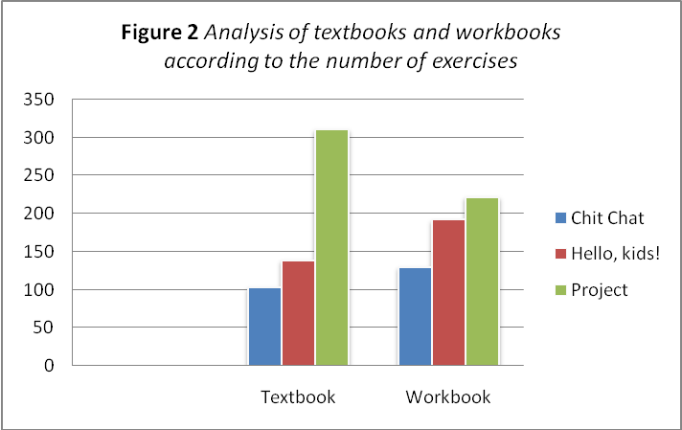

RESEARCH RESULTS

  - Efficacy of games when vocabulary learning
As already mentioned, unconsciously three classes of pupils marked by letters A, B and C took part in the research. For games´ efficacy determination there were tests written that focused on vocabulary learned in common way, as well as tests which concentrated on vocabulary learned through games. Whereas common tests detected the knowledge of vocabulary of three specific topics, in extra tests students were examined from extending vocabulary they were learning simultaneously and which concerned with determined topics. To what extent were pupils successful at common tests represents Figure 3, Table 1. In class A the average success at common tests was 87%, in class B it was 80 % and the average of class C was 81%.

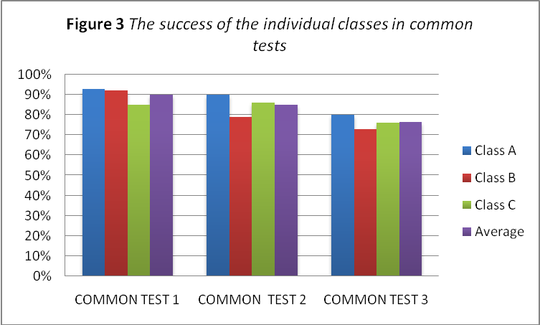

Table 1 The success of the individual classes in common tests
Class | Common test 1 | Common test 2 | Common test 3 | Average
A | 93% | 90% | 80% | 87%
B | 92% | 79% | 73% | 80%
C | 85% | 86% | 76% | 81%

Tests which verified pupils knowledge of extending vocabulary are marked as extra tests and they are also in total number of three. The success in all these extra tests of A class was 92%, the average in B class was 71% and in the class C it was 85% (viz. Figure 4, Table 2). To sum up the results of all classes in the individual extra tests, the most successful were pupils in the last test with 91%, following the extra test marked with number 2 in which pupils obtained 84% and in third place there was the first test with the average 73%. One of the reasons might be better familiarity with games pupils were playing to learn extending vocabulary. For better overview of the success of individual pupils in all tests there is presented Table 3.
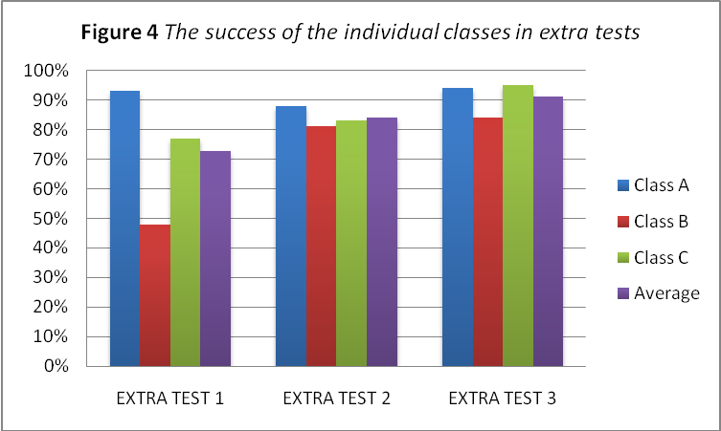

Table 2 The success of the individual classes in extra tests
Class | Common test 1 | Common test 2 | Common test 3 | Average
A | 93% | 88% | 94% | 92%
B | 48% | 81% | 84% | 71%
C | 77% | 83% | 95% | 85%
Table 3 Success of the individual pupils in common and extra tests focused on vocabulary
CLASS A
PUPIL | COMMON TEST 1 | COMMON TEST 2 | COMMON TEST 3 | AVERAGE | EXTRA TEST 1 | EXTRA TEST 2 | EXTRA TEST 3 | AVERAGE
1 | 100% | 95% | 95% | 97% | 80% | 85% | 100% | 88%
2 | 95% | 95% | 80% | 90% | 95% | 90% | 100% | 95%
3 | 100% | 95% | 80% | 92% | 100% | 95% | 100% | 98%
4 | 100% | 90% | 90% | 93% | 100% | 100% | 100% | 100%
5 | 80% | 70% | x | 75% | 70% | X | 55% | 63%
6 | 90% | 90% | 50% | 77% | 85% | 65% | 90% | 80%
7 | 80% | 85% | 85% | 83% | 100% | 90% | 100% | 97%
8 | 95% | 90% | 60% | 82% | 100% | 75% | 100% | 92%
9 | x | 80% | 85% | 83% | 90% | 90% | 85% | 88%
10 | 95% | 95% | 80% | 90% | 100% | 90% | 100% | 97%
11 | 95% | 100% | 90% | 95% | 100% | 95% | 100% | 98%
IN TOTAL | 93% | 90% | 80% | 87% | 93% | 88% | 94% | 91%
CLASS B
PUPIL | COMMON TEST 1 | COMMON TEST 2 | COMMON TEST 3 | AVERAGE | EXTRA TEST 1 | EXTRA TEST 2 | EXTRA TEST 3 | AVERAGE
12 | 80% | 95% | 50% | 75% | 30% | 85% | 90% | 68%
13 | 100% | 95% | 95% | 97% | x | 100% | 100% | 100%
14 | 95% | 95% | 85% | 92% | 30% | 100% | 95% | 75%
15 | 100% | 100% | 90% | 97% | 70% | 100% | x | 85%
16 | 85% | 60% | x | 73% | 35% | 30% | x | 33%
17 | x | 50% | 80% | 65% | 50% | 80% | 60% | 63%
18 | 100% | 80% | 95% | 92% | 100% | 100% | 95% | 98%
19 | 95% | 80% | 50% | 75% | x | 65% | 95% | 80%
20 | 90% | 80% | 75% | 82% | x | 90% | 80% | 85%
21 | 100% | 100% | 80% | 93% | 60% | 90% | 90% | 80%
22 | 70% | 30% | 30% | 43% | 10% | 50% | 50% | 37%
IN TOTAL | 92% | 79% | 73% | 80% | 48% | 81% | 84% | 73%
CLASS C
PUPIL | COMMON TEST 1 | COMMON TEST 2 | COMMON TEST 3 | AVERAGE | EXTRA TEST 1 | EXTRA TEST 2 | EXTRA TEST 3 | AVERAGE
23 | 100% | 95% | 95% | 97% | 70% | 100% | 90% | 87%
24 | 50% | x | 30% | 40% | x | 10% | 50% | 30%
25 | 50% | 50% | 25% | 42% | 20% | 20% | 90% | 43%
26 | 100% | x | 85% | 93% | 100% | 100% | 100% | 100%
27 | 100% | 100% | 85% | 95% | x | 100% | 100% | 100%
28 | 95% | 90% | 95% | 93% | 55% | 95% | 100% | 83%
29 | 100% | 95% | 85% | 93% | 100% | 100% | 100% | 100%
30 | 70% | 80% | 60% | 70% | x | 100% | 100% | 100%
31 | 95% | 95% | 95% | 95% | 55% | 100% | 100% | 85%
32 | 100% | 100% | 100% | 100% | 100% | 100% | 100% | 100%
33 | 100% | 100% | 85% | 95% | 90% | 90% | 100% | 93%
34 | 90% | 95% | 85% | 90% | 75% | x | 100% | 88%
35 | 50% | 50% | 60% | 53% | 100% | x | 100% | 100%
IN TOTAL | 85% | 86% | 76% | 81% | 77% | 83% | 95% | 85%
  - Teaching material focused on vocabulary learning
For analysing games in textbooks and workbooks, especially focusing on learning vocabulary, it was necessary to classify the main focus of exercises firstly. Thus, these were divided into six categories: listening, speaking, reading, writing, vocabulary and grammar. To make the overview clear, the results have been presented in three Figures (viz. Figure 5, Figure 6 and Figure 7) which deal with the individual textbooks and their workbooks.
As the Figure 5 indicates, from the total number of exercises in Chit Chat textbook, the most practised skill is reading, whereas in workbook it is vocabulary. The less practised skill is writing in textbook and in workbook it is speaking. By the analysis of textbook Hello, kids! came out the fact that practising the individual skills is comparatively balanced, apart from listening and writing (viz. Figure 6). Whereas in workbook exercises, the incomparably significant attention is paid to the vocabulary. Figure 7 reveals once again proportional balance in Project textbook exercises - except for writing which lightly falls behind. Nevertheless, in its workbook there is relatively extensive range of tasks´ incidence of the individual practised skills - the most exercises concentrate on grammar, the second most practised skill is vocabulary. Contrarily, the less practised skills in workbook are speaking and reading.
Although sometimes the results seem to be unexpected, the reason may be the fact, that each of the exercises is categorized only once according to its primary educational aim. Thus, even though a task focuses on more skills, it is classified as if the exercise practises only one skill.
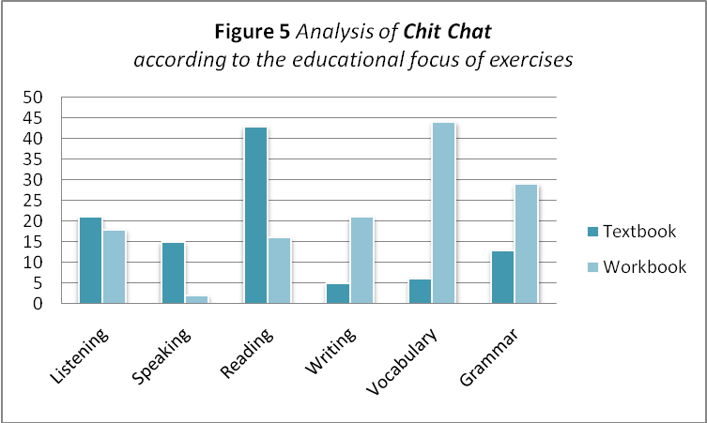
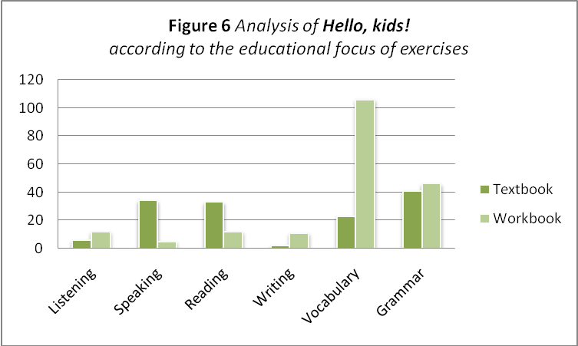
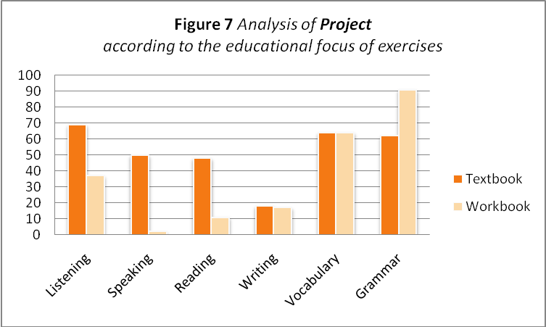

ANALYSIS OF RESEARCH RESULTS

  - Games efficacy
To what extent were classes successful exposes Figure 8, Table 3. From these data it is obvious that in Classes A and C where pupils more successful at extra tests than at common tests, when looking at their average values: 91% and 85% in extra tests. In both cases the difference made 4%. Whereas the class B achieved better results in common tests - altogether 80%, which means that pupils were in average about 7% less successful in extra tests. It should be noted that pupils of class A were overall more successful in various school subjects than two other classes when consulting with other teachers, and class B was quite behind others in curriculum which might to clarify the results. Furthermore, the reason for these results could be also insufficient motivation as the knowledge of extra vocabulary did not have an impact on pupils´ grades. As well as an important part in the results might have influenced the fact that some pupils could prefer different way in learning by which they involve different skills - e.g. writing. Certainly, these are not the only factors which could affect the results.
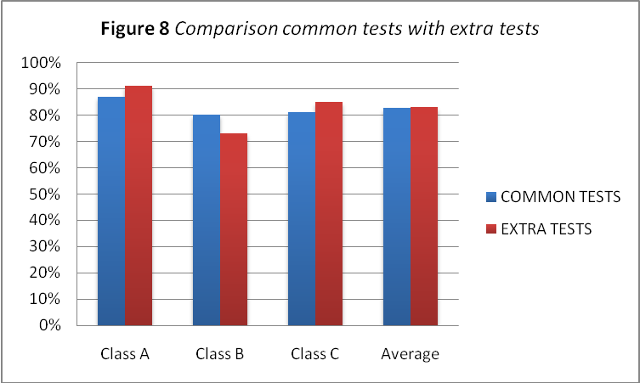
The success of the individual pupils at tests is demonstrated in Table 3, Figure 9. From total number of 35 pupils who took place in the research, 20 of them achieved better results (or at least the same) in extra tests, which means that 57 % of pupils were more successful from extending vocabulary learned by games. To compare the individual pupils with better results in extra tests from the point of view of individual classes, 9 pupils belonged to the A class, 7 pupils attended C class and only 4 of them were in the class B. Thus numbers of pupils who were more successful at common tests are 2 pupils in A class, 7 pupils in B class and in C class it is 6 pupils. The overview of success of individual pupils at tests is expressed by percents in Figure 9.

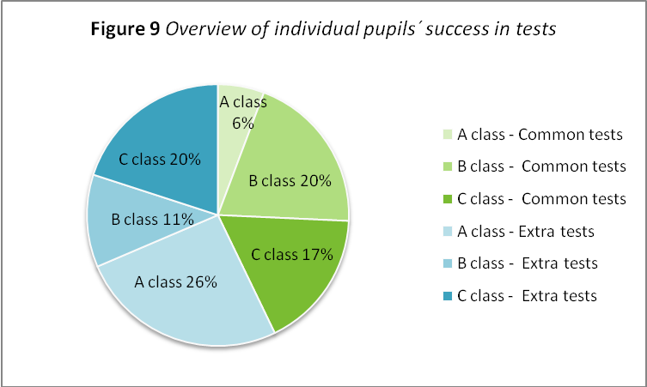

When comparing tests´ results from gender point of view, both girls and boys are more successful in extra tests than in common tests. Nevertheless, there is difference between their results according to which there are 31% of boys successful at extra tests, whereas girls are only 26% - thus there is 5% variance in favour of boys (viz. Figure 10).

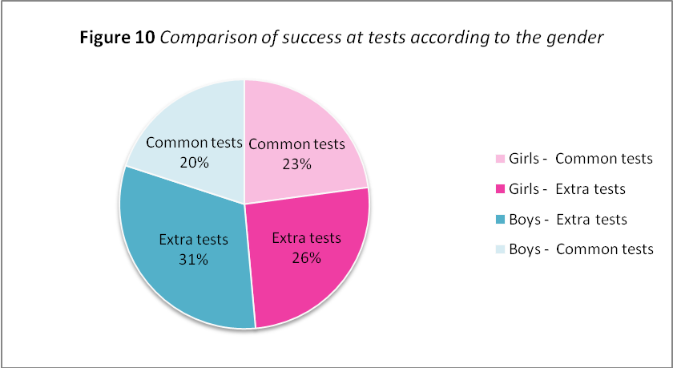.

  - Incidence of games in textbooks and workbooks
The analysis of textbooks and workbooks exposes the proportion of exercises in both ways - common form and playful form. Nevertheless, the conception of what is considered to be playful may be different, thus the results are probably slightly subjective. For the purposes of this thesis were into exercises presented in a playful way classified those similar to the exercises pupils enjoyed when learning English (in English lessons). These exercises include for example crosswords, anagrams, matching words to pictures, wordsearch, songs designated for learning new words and others.
As the Figure 11 demonstrates, most Chit Chat exercises focusing on vocabulary occur in workbook - 88 %. In a playful way are presented exercises in 52%.
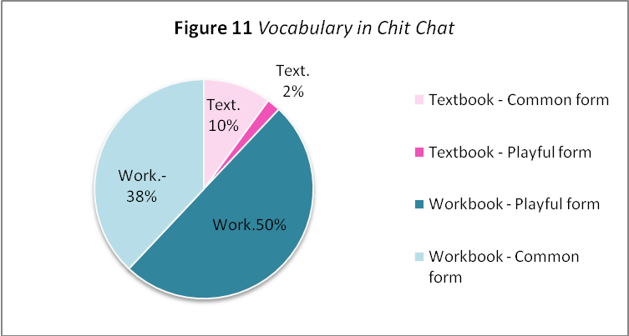
From Figure 12 it is obvious, that also in Hello, kids! the amount of exercises dedicated to vocabulary is bigger in workbook and the proportion is almost the same as in Chit Chat - for this time 82 %. Although, in contrast to Chit Chat, only 24 % is presented playfully.

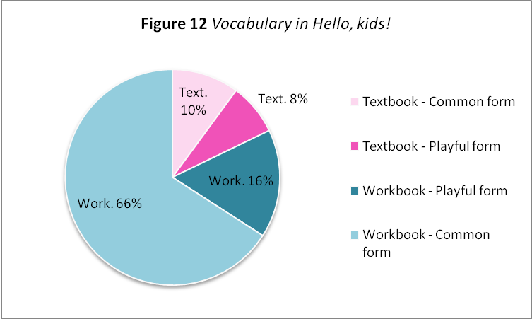

In comparison with preceding teaching material, the proportion of exercises in Project is comparatively balanced. The vocabulary is taught in both - workbook and textbook equally and the exercises are in 47 % of the cases presented in a playful way (viz. Figure 13).

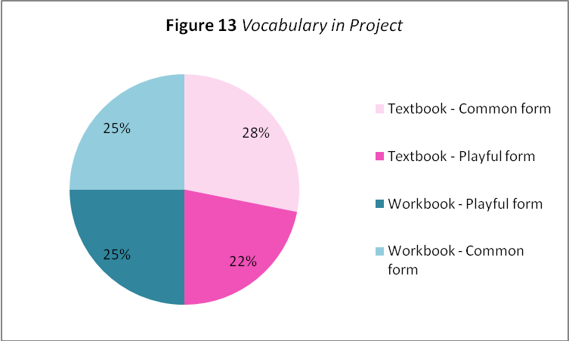

CONCLUSION
The aim of this thesis was to find the answers to the designated research questions which are connected to teaching English language. In order to ascertain to what extent the usage of games influence English language learning, tests have been taken and analysed. These tests were made in three classes and on the basis of the results it is obvious that two classes were more successful when learning by games, although the difference was not extensive.
The second research question was dealing with the content of English language teaching material. By the analysis of three textbooks and their workbooks, which were chosen on the ground of making an inquiry, the amount of games focusing on vocabulary learning was ascertained. The least incidence of games was in Hello, kids! with only 24% from the total amount of vocabulary oriented exercises. On the contrary, in Chit Chat 52 % of exercises were presented in a playful way. The last and the most balanced teaching material was Project, not only because of the same amount of vocabulary tasks in both - textbook and workbook, but also due to their almost equal division into playful and common exercises.
Nevertheless, with this issue arise circumstances which should be taken into consideration. An important part plays the motivation of learners, which can be based on their effort to please parents, which in case they do not get grades is not stimulated. Also the way of learning should be considered, as various pupils have diverse perception and thus prefer different way of receiving information, teaching only by games would not be the best choice.
As the results of tests could be considered negligible, the question of using games and to what extent, when teaching foreign language, emerges once again. Further, with the fact that tests were carried out only in a small amount of pupils a suggestion for another research is made.
BIBLIOGRAPHY
BOOK SOURCES
- BAUGH, Albert C. and CABLE, Thomas. A History of the English Language. London: Routledge, 1993. 444 p. ISBN 0415093791.
- BROWN, H. Douglas. Teaching by Principles: An Interactive Approach to Language Pedagogy. Englewood Cliffs, N. J.: Prentice Hall Regents, 1994. 467 p. ISBN 0133282201.
- BRUMFIT, Christopher, MOON, Jayne and TONGUE, Ray. Teaching English to Children: From Practice to Principle. London: Nelson English Language Teaching, 1984. 309 p. ISBN 0-17-556889-8.
- CHRÁSKA, Miroslav. Metody pedagogického výzkumu: Základy kvantitativního výzkumu. Praha: Grada, 2016. 254 s. ISBN 978-80-247-5326-3.
- CUNNINGSWORTH, Alan. Evaluating and Selecting EFL Teaching Materials. London: Heinemann Educational, 1984. 104 p. ISBN 0-435-28006-6.
- CUNNINGSWORTH, Alan. Choosing your Coursebook. Oxford: Heinemann, 1995. ISBN 0-435-24058-7.
- CURTAIN, Helena Anderson, and PESOLA, Carol Ann. Languages and Children - Making the Match: Foreign Language Instruction in the Elementary School. Boston: Addison-Wesley Publishing Company, 1988. ISBN 0-201-12290-1.
- FINOCCHIARO, Mary Bonomo. English as a second/foreign language: From Theory to Practice. New York: Regents, 1989. 143 p. ISBN 0-13-279738-0.
- GRANT, Neville. Making the most of your textbook. London: Longman, 1987. 128 p. ISBN 0-582-74624-8.
- HARMER, Jeremy. The Practice of English Language Teaching. Harlow: Longman, 2007. 448 p. ISBN 9781405853118.
- KRASHEN, Stephen D. Language Acquisition and Language Education: Extensions and Applications. New Jersey: Prentice Hall International, 1989. 146 p. ISBN 0-13-522764-X.
- PINTER, Annamaria. Teaching Young Language Learners. Oxford: Oxford University Press, 2006. 180 p. ISBN 0-19-442207-0.
- SCRIVENER, Jim. Learning Teaching. The Essential Guide to English Language Teaching. Oxford: Macmillan Education 2011. 416 p. ISBN 9780230729841.
- VACÍNOVÁ, Tereza. Dějiny vzdělávání od antiky po Komenského. Praha: Univerzita Jana Amose Komenského, 2009. 240 s. ISBN 978-80-86723-74-7.

ELECTRONIC SOURCES
- ASOCIACE ČEŠTINÁŘŮ, Škola hrou, nebo hraní si ve škole? Jaromír Kopecký o Komenského spisu Škola hrou. [online]. 8. 8. 2015. [quoted 2019-03-04]. Available on WWW:
<https://www.ascestinaru.cz/skola-hrou-nebo-hrani-si-ve-skole-jaromir-kopecky-o-komenskeho-spisu-skola-hrou/>
- APURITANSMIND, McMahon Matthew. A Bio on Jan Amos Comenius. [online]. [quoted 2019-03-29]. Available on WWW:
<http://www.apuritansmind.com/the-christian-walk/jan-amos-comenius-by-dr-c-matthew-mcmahon/ >
- COMETA RESEARCH, Kaszkowiak Natalia. Games as teaching method. [online]. 5. 4. 2017. [quoted 2019-03-09]. Available on WWW:
<http://cometaresearch.org/educationvet/didactic-games-as-teaching-method/>
- GILL EDUCATION, Flood Eilis and Hardy Catriona. Early Childhood Education & Play. [online]. 2013. [quoted 2019-02-22]. Available on WWW:
<https://www.gilleducation.ie/further-education-childcare/early-childhood-education-play>
- Metodický portál RVP, Sochorová Libuše. Didaktická hra a její význam ve vyučování. [online]. 26. 10. 2011. [quoted 2019-01-12]. Available on WWW:
<https://clanky.rvp.cz/clanek/o/z/13271/didakticka-hra-a-jeji-vyznam-ve-vyucovani.html/>
- PSYCHOLOGY TODAY, Gray Peter. A Brief History of Education. [online]. 20. 8. 2008. [quoted 2019-02-03]. Available on WWW:
<https://www.psychologytoday.com/us/blog/freedom-learn/200808/brief-history-education>

APPENDIX

VOCABULARY 1
- car park
- bench
- bridge
- harbour
- theatre
- street
- road
- tower
- town hall
- pavement

VOCABULARY 2
- camping
- take a photo
- lie
- take a sunbath
- airbed
- wave
- playground
- trip
- tent
- deckchair
VOCABULARY 3
- sand
- seashell
- lake
- mountains
- beach ball
- boat
- lifeguard
- beach umbrella
- sandcastle
- pond

RESUMÉ
Diplomová práce se zabývá využitím her při výuce anglického jazyka a analýzou učebního jazykového materiálu určeného pro žáky ve věku 9-10 let. V teoretické části jsou definovány pojmy týkající se výukového procesu, další kapitoly se zaměřují na roli učitele, analýzu učebního materiálu, osobnost žáka a rozdělení her podle dovednosti, která je procvičována. Praktická část pak zkoumá efektivitu her při výuce a výskyt her procvičujících slovní zásobu v učebnicích a pracovních sešitech. Výzkum byl proveden na 35 žácích ze 3 tříd 4. ročníku a podle zjištěných výsledků mělo 57 % žáků lepší výsledky při výuce anglického jazyka formou her. K analýze výukových materiálů byly vybrány 3 učebnice spolu s pracovními sešity. Z celkového množství cvičení byla pozornost zaměřena na ta, která se primárně týkala osvojování slovní zásoby. Analýzou bylo zjištěno, že z těchto cvičení bylo 24-52 % hravou formou.

ANOTATION
Jméno a příjmení: | Hana Němcová
Katedra: | Anglického jazyka PdF UP Olomouc
Vedoucí práce: | Mgr. Josef Nevařil, Ph.D.
Rok obhajoby: | 2020
Název práce: | Využití her při výuce anglického jazyka
Název v angličtině: | Games in the process of teaching English
Anotace práce: | Diplomová práce se zabývá výukou anglického jazyka s využitím her a analýzou učebního materiálu. V teoretické části jsou definovány pojmy týkající se výukového procesu. Zaměřuje se na roli učitele, analýzu učebního materiálu, osobnost žáka a rozdělení her. Praktická část prezentuje efektivitu her při výuce a výskyt her procvičujících slovní zásobu v učebnicích a pracovních sešitech.
Klíčová slova: | výuka anglického jazyka, hry, učební materiál, dovednosti, motivace
Anotace v angličtině: | The thesis deals with English language teaching with the usage of games and teaching material analysis. In the theoretical part, terms related to the teaching process are defined. It is concentrated on the role of teacher, teaching material analysis, learner´s personality and games´ division. The practical part presents games efficacy when teaching and the incidence of games practising vocabulary in textbooks and workbooks.
Klíčová slova v angličtině: | English language teaching, games, learning material, skills, motivation
Rozsah práce: | 68 s.
Jazyk práce: | Angličtina

