UNIVERZITA PALACKÉHO V OLOMOUCI
PEDAGOGICKÁ FAKULTA
Katedra anglického jazyka

Aleš Punčochář
III. ročník-prezenční studium

Obor: Anglický jazyk se zaměřením na vzdělávání — Základy technických věd a informačních technologií pro vzdělávání

The differences in pronunciation between Received Pronunciation and General American Pronunciation
(Rozdíly ve výslovnosti mezi Received Pronunciation a General American Pronunciation)
Bakalářská práce

Vedoucí písemné práce: Mgr. Jaroslava Ivanová, M.A.

Olomouc 2014

Prohlašuji, že jsem závěrečnou práci vypracoval samostatně a použil jen uvedených pramenů, literatury a elektronických zdrojů.
V Olomouci 26. 6. 2014
……………………..

Acknowledgement
I would like to thank Mgr. Jaroslava Ivanová, M.A. for her time, support, valuable information and her useful advices that encouraged me to continue. I would also like to thank my family and friends who supported me emotionally in such difficult times.
Aleš Punčochář
Table of content

ABSTRACT 1
INTRODUCTION 2
1. The reference accents 4
1.1. Received Pronunciation 4
1.1.1. The history of the RP label 5
1.1.2. Varieties of RP 5
1.1.3. The vowel system of RP 6
1.2. General American 7
1.2.1. History 7
1.2.2. The vowel system GA 7
2. Teaching pronunciation 9
2.1. Pronunciation in the Czech secondary education system 9
2.2. The aims of pronunciation teaching 10
2.3. Problems with pronunciation teaching 11
2.4. Different approaches towards teaching standard English accents 11
3. The differences between RP and GA 12
3.1. Differences in the vowel system of RP and GA 12
3.2. Differences in pronunciation 14
3.2.1. Rhotic Accent 14
3.2.2. Linking and intrusive /r/ 14
3.3. Differences in vowel pronunciation 15
3.3.1. The shift of Diphthong [əʊ] into [o] or [oʊ] 15
3.3.2. Change of Vowel [ɒ] 16
3.3.3. Change of [æ] 16
3.3.4. Yod-dropping 17
3.4. Differences in pronunciation of letter t 17
3.5. Differences in Stress 18
3.5.1. Words with French origin 19
3.5.2. Words with the ending –ate 20
3.5.3. Suffixes baring change of the main stress 20
3.5.4. Differences in sentence stress 21
3.6. Differences in Intonation 21
3.7. Differences in Articulation 21
4. Factors influencing pronunciation preferences 22
4.1. Geographical position 22
4.2. History 22
4.3. Traditional media 23
4.4. Exposure to the foreign language 24
5. The survey 26
5.1. The questionnaire 26
5.2. The respondent sample 26
5.3. The results of the survey 27
5.3.1. Questions 3-6 27
5.3.2. Evaluation questions 3-6 28
5.3.3. Questions 7-14 29
5.3.4. Evaluation of questions 7-14 32
5.3.5. Favoured pronunciation of common words 35
5.4. Conclusion of the survey 38
CONCLUSION 39
BIBLIOGRAPHY 40
APPENDIX: QUESTIONNAIRE 44
RÉSUMÉ 46
ANOTATION 47

ABSTRACT
The thesis describes the main features and differences between the two standard accents of English. The thesis also studies the pronunciation preferences of Czech secondary school students. The study is carried using the questionnaire method.

INTRODUCTION
I have chosen the topic of my bachelor thesis because of my never ending amazement of how much can a single language vary in so many different aspects. To document this I am now going to quote a famous Irish playwright G. B. Shaw.
“England and America are two countries divided by a common language.”
(Davies 2007, p. viii)
George Bernard Shaw
The English language has come a long way through the history and it definitely is not the language our ancestors knew and used. Furthermore since the colonization of America the language has begun evolving in its own way on the both coasts of the Atlantic ocean. The British and the Americans have developed their own sets of vocabulary, spelling and pronunciation and can be no longer considered to be speaking the exactly same language.
The first part of the thesis deals with the general differences between the two standard accents of the English language, namely Received pronunciation or BBC English and the General American pronunciation. The aim of the theoretical part of the thesis is to establish the two standard accents, describe their features and their short history. I will then move on to point out the main differences in pronunciation between the two standard accents. These differences are very crucial for the process of teaching pronunciation and every teacher of English language should be aware of them and should take them into account while teaching.
The second part of the thesis focuses on the preferences and influences of the secondary school students in the area of pronunciation. I am frequently asking myself a question whether pronunciation could really be taught or whether the teachers’ effort is usually put in vain by the colossal influence of media in today’s world. It is known that the secondary schools in the Czech Republic are using almost exclusively the Received pronunciation model for teaching, however, is it still what the students feel is natural for them? Would they choose differently given the chance? I will try to answer these questions by carrying out a survey which is conducted by a questionnaire method. The aim of the survey is to prove that the General American pronunciation model is on the rise despite the Received pronunciation being dominant in the Czech Republic educational system.
I hope that in the future I will be able to apply my findings and experience gained by working on this thesis in my career, be it the teacher or anything else.

The reference accents
In the first chapter I will be dealing with the reference accents for both of the major dialects of English, the British and the American one. However, it is very important to realize that the reference accents or models of pronunciation are not really, as is often assumed, based on features like intelligibility for example. One might be surprised that one of the factors is a huge influence of the English Language Teaching (ELT) and Language Testing industries which have an enormous influence on propagation of certain conclusions about which accents should be preferred over the others (Weisser 2005). Weisser also says that another factor is the prestige associated with them (2005). As mentioned earlier the field of teaching English is deeply connected with the reference accents. In this chapter I am also going to describe the expected outcomes for the students of Czech secondary schools in the area of pronunciation. Their pronunciation preferences will be the main focus of the second part of this thesis.

Received Pronunciation
In this chapter I am going to deal with the Received Pronunciation (henceforth RP) model of English pronunciation. First, I am going to describe what RP is I will shortly summarize its history and describe its varieties. Later on in this chapter I will describe the vowel system or RP witch will be eventually used in comparison with the vowel system of General American pronunciation model.
“Received Pronunciation / RP the accent which is generally used by news readers on national television in the UK. Sometimes called a ‘BBC accent’ or an ‘educated British accent’. An RP accent is not marked for a particular region of Britain, but is marked for relatively ‘high’ social class. It is thought, that only three per cent of the British population usually use RP” (Thomas, Wareing 1999, p. 195).
The label ‘received’ (‘generally accepted’) is rather misleading if we consider that not more than about 10 percent of the population of England could be considered as RP speakers. Professions typically associated with RP are for example diplomats, stockbrokers and BBC broadcasters (Wells, 1982a, p. 117-118). When it comes to the British Isles as a whole Robinson (2007) says that RP is losing its prestige in Wales and its presence within Scotland and Northern Ireland is rather negligible. He further claims that it should be in fact be considered an English accent rather than British. Robinson further states that RP beside being a living accent also functions as a theoretical linguistic concept on which phonemic transcriptions in dictionaries are based and it is used as one of the two major models for teaching English as a foreign language together with General American. The majority of RP speakers have spoken RP since their childhood and had not needed speech classes in order to acquire it. It is typically the case of people whose relatives where or are students at one of the public schools which are private and exclusive schools standing out of the British education system (Wells 1982a. p. 117-118). “RP is the speech variety used by those educated at public (i.e. private) schools and is not tied to any particular locality” (Romaine 1994, p. 20). This, however, does not change the fact that the Americans consider this accent as typically British.

The history of the RP label
The first person to label the accent as ‘received’ is considered to be A. J. Ellis in On Early English Pronunciation (1889), but Fisher (1993) traces the origin back to John Walker’s Critical Pronouncing Dictionary and Expositor of the English Language (1791). Since the earliest description RP has been considered a class accent, despite its regional origin, its usage has been widely spread among the educated all over England (Wyld 1914. p. 48).

Varieties of RP
RP like every other accent is not homogenous. There are several varieties of RP with the most prominent being what Wells (1986) calls “mainstream RP”. If we were to define it, we could do so negatively by recognizing two other types of RP, which are part of RP as a whole but distinct from mainstream RP. One of them being “U-RP”, the other “adoptive RP”. Wells also recognizes “Near-RP” which he describes as a “rather vague entity” consisting of accents which are very close to being RP yet still slightly different (ibid., p. 279).
“U-RP” stands for upper-crust RP suggesting it is closely bound to the people from the very upper crust of the social ladder, an example being an upper-class army officer. Wells, however, also talks about the difficulty with the separation of the stereotypes and reality because both U-RP and RP share an important social characteristic and that is they are both used by the upper class (ibid., p. 280-283).
“Adoptive RP” is what Wells calls the variety of RP spoken by speakers who did not speak RP as children. The most common reasons for a person to adopt or attempt to adopt RP is a change in the person’s social status for the better an individual can also take a job which requires him to speak RP such as an actor (ibid., p. 280-283).

The vowel system of RP
There are 19 vowels in the system not counting /ə/ which is restricted to weak syllables. Six of them are called the checked vowels and 13 of them are the free vowels. Checked vowels /ɪ, e, æ, ʌ, ɒ, ʊ/ are subject to the phonotactic constraint which means that they do not occur in a stressed monosyllable with no final consonant such as fit /fɪt/, rent /rent/ or cat /kæt/. Free vowels /i:, eɪ, aɪ, ɔɪ, əʊ, aʊ, u:, ɪə, eə, ɜ:, ɑ:, ʊə, ɔ:/ can occur without any checking consonants for example key /ki:/, fear /fɪə/ and snow /snəʊ/ but also they may occur before a checking consonant which is the case of the word keep /ki:p/. “The terms ‘checked and ‘free’ must be interpreted as applying to stressed syllables only” (Wells 1982a, p. 119).
The use of vowels in particular lexical items can be illustrated by listing their occurrence in the set of keywords. Each keyword stands for a large number of lexical items which behave the same way in respect if the occurrence of vowels in different accents (ibid., p. 120). This set of words will be later on used to describe the vowel system in General American pronunciation model in order to make a comparison of the two.
Kit ɪ Fleece i: Near i:
Dress e Face eɪ Square eə
Trap æ Palm ɑ: Start ɑ:
Lot ɒ Thought ɔ: North ɔ:
Strut ʌ Goat əʊ Force ɔ:
Foot ʊ Goose u: Cure ʊə
Bath ɑ: Price aɪ Happy ɪ
Cloth ɒ Choice ɔɪ lettER ə
Nurse ɜ: Mouth aʊ commA ə
Table 1: RP vowels and example words (ibid., p. 120)
Wells (ibid., p. 120) also mentions that words such as diary and sapphire can be and often are pronounced in RP with /aə/ or /a:/ therefore /ˈdɑ:rɪ, ˈsæfa:/. Wells (ibid., p. 120) also adds that: “It might be thought that this diphthong or monophthong ought to be included as a phoneme in the vowel system.” He states however that it can be treated as a phonemic sequence /aɪə/ rather than a separate phoneme (ibid., p. 120).
This set of words will be later on used to describe the vowel system in General American pronunciation model in order to make a comparison of the two.

General American
This chapter will be dealing with the General American (henceforth GA) model of pronunciation. It will shortly describe the history and it will focus on the vowel system of GA which will be later on compared with the vowel system of RP.
The majority of American speakers of English have an accent which is usually referred to as the General American (GA). It is the accent of the American English which is almost exclusively used on the international radio and television networks that is why it is sometimes called the “Network English” (Roach 2009, p. 163).
Wells says that GA is not a single clearly defined accent but the label rather suggest that GA comprises of accents which are not eastern or southern. (1982b, p. 470). Unlike RP which is spoken by a vast minority of the British, Wells claims that over two thirds of the American population do not have a recognizably eastern or southern accent and are in fact speakers of GA (1982a, p. 118).

History
American English has begun its own development with the first settlement in America. The English used in America and the English used in Britain began to slowly drift apart. Algeo describes the process as both of the accents slowly changed and became different from each other as well as from the original English which was their mutual ascendant (2001, p. xvii). Over time GA spread westwards with the new settlements being built extending to the midlands and western parts of the country.

The vowel system GA
The vowel system of GA consists of 15 vowels. There are also /ə/ and /ɚ/ which are restricted to weak syllables. As in RP there also vowels which are called checked and free. GA has five checked vowels which are /ɪ, ɛ, æ, ʌ, ʊ/ and ten free vowels /i, eɪ, aɪ, ɔɪ, aʊ, u, o, ɜ, ɑ, ɔ/ the same restriction applies as in RP based on the phonotactic distribution. The length of vowels in GA is, unlike in RP, not as important because the duration of the vowels depends on their phonetic environment (Wells 1982a, p. 120).
As with RP, I am going to illustrate the use of vowels on the same set of keywords.
Kit ɪ Fleece i Near ɪr
Dress ɛ Face eɪ Square ɛr
Trap æ Palm ɑ Start ɑr
Lot ɒ Thought ɔ North ɔr
Strut ʌ Goat o Force or
Foot ʊ Goose u Cure ʊr
Bath æ Price aɪ happY ɪ
Cloth ɔ Choice ɔɪ lettER ɚ
Nurse ɝ Mouth aʊ commA ə
Table 2: GA vowels and example words (ibid., p. 121-122)

Teaching pronunciation

Pronunciation in the Czech secondary education system
To finish this chapter I will now talk about the goals in the areas of pronunciation and language skills in general in secondary schools in the Czech Republic. I will deal with the secondary schools student’s preferences and influences on pronunciation more in depth in the second part of this thesis. It is worth noting that the Framework Education Programmes for either elementary or secondary education in the Czech Republic do not declare any of the English accents mandatory to be taught. However, Katalog požadavků zkoušek společné části maturitní zkoušky (2013) published by the Czech ministry of Education, Youth and Sports, states that the materials used for the secondary school leaving examination only contain recordings with “standard pronunciation” and “standard accent”. The expected outcomes for learners of foreign language on Czech secondary schools is set by the Framework Education Programme for Secondary General Education and is tested by the Czech secondary school leaving examination. According to the Katalog požadavků zkoušek společné části maturitní zkoušky (2013) for English language the skills necessary for passing the examination have been set to be corresponding with the B1 level of language skills established by the Common European Framework of Reference for languages: learning, teaching, assessment (2001) (henceforth CEFR) published by the Council of Europe.
The B1 level is comparable with the Cambridge Preliminary English Test (PET) and I will now proceed to describe the skills required in order to reach this level of English or foreign language in general.
Katalog požadavků zkoušek společné části maturitní zkoušky divides the requirements into three categories, namely:
- receptive communication skills
- productive communication skills and strategies
- interactive communication skills and strategies
The students are required to flexibly and accurately use common lexical resources, they have to be able to express themselves using variety of functions of communication and they have to be able to do so politely and they have to master the common grammatical resources (2013, p. 5-9). The requirements for pronunciation are set as follows: The communication is comprehensible even with the occasional occurrences of errors in pronunciation, accent or intonation. The speech is continuous and it is easy to follow. The influence of the mother tongue or any other tongue can be noticeable but it does not affect comprehensibility (ibid. p. 10).
The CEFR (2001, p. 34) refers to the B1 level as the “Threshold Level” and the speaker is categorised by two features. The first feature is the ability to maintain interaction and capability of getting his or her point across in a range of contexts. The second feature is the ability to cope with problems in everyday life.
The Cambridge English: Preliminary handbook for teachers sets the requirements as follows. In general the speaker has to be able to “convey basic meanings”, is able to cope with everyday situations and is able to talk about familiar, unfamiliar and abstract topics “which include ideas rather than concrete situations or events” (2012). The Cambridge English: Preliminary handbook for teachers also introduces a set of goals for the area of pronunciation. These are the following: The speaker has to be able to speak in a way that can be generally understood “even if the speaker has a strong or unfamiliar accent” (2012). The speaker has to be capable of pronouncing individual sounds such as pronounced vowels, diphthongs and consonants. The speaker has to be able to use stress correctly in order to emphasize stress on a syllable or a word and finally he has to be familiar with the basics of intonation (ibid.).

The aims of pronunciation teaching
Pronunciation is one of the core elements of learning or teaching a foreign language. It is so crucial because even though a person is familiar with grammar and vocabulary of a foreign language, without a proper pronunciation it is extremely difficult to communicate any ideas. Nevertheless it is often overlooked by teachers and the learners’ only option is learning by perception.
The currently dominant approach to language teaching is called the Communicative Approach (Celce-Murcia et al. 1996, p. 7). According to Celce-Murcia (ibid., p. 7) “The primary purpose of language is communication, using language to communicate should be central in all classroom language instruction.” Furthermore, this approach considers teaching of pronunciation very important and Celce-Murcia (ibid. p. 7) says that if a non-native speaker drops below a certain threshold level of pronunciation, he will “… have oral communication problems no matter how excellent and extensive their control of English grammar and vocabulary might be.” The basic goal for every student should therefore be that their “pronunciation will not detract from their ability to communicate” (ibid., p. 8).
The main focus should be put on speaker’s intelligibility and comprehensibility (Gilakjani 2012, p. 1). Derwing and Munro define intelligibility as “The extent to which a listener actually understands an utterance.” And comprehensibility as “A listener’s perception of how difficult it is to understand an utterance.” (2005, p. 385).

Problems with pronunciation teaching
Although pronunciation is a major part of any language and bad pronunciation often leads to misunderstandings, teachers tend not to spend much time teaching it.
Kelly (2001, p. 13) points out that there are two major problems with teaching pronunciation: “Firstly it tends to be neglected. And secondly when it is not neglected, it tends to be reactive to a particular problem that has arisen in the classroom rather than being strategically planned.”

Different approaches towards teaching standard English accents
There is of course a different approach to teaching the standard English accents. I am now talking about the concept of English lingua franca. Jenkins (2009, p. 200) defines it as “the common language or choice, among speakers who come from different linguacultural backgrounds.” Wells (2005, p. 4) says that “The Lingua Franca Core (LFC) approach can be represented – with oversimplification and rather unfairly – as saying that we should ignore the parts of English that non-native speakers tend to get wrong.”
Jenkins (2009, p. 203) suggests that because there are more non-native speakers of English than native ones, it is very vital to create a platform through which they could effectively communicate. She says that people should not learn a foreign language “in order to blend in with a particular group of its native speakers.”

The differences between RP and GA

Differences in the vowel system of RP and GA
For the purpose of comparing the two accents I will be further using the framework of the standard lexical sets introduced by Wells (ibid., p. 123).

RP GA keyword RP GA keyword
1. ɪ ɪ Kit 13. ɔ: ɔ Thought
2. e ɛ Dress 14. əʊ o Goat
3. æ æ Trap 15. u: u Goose
4. ɒ ɑ Lot 16. aɪ aɪ Price
5. ʌ ʌ Strut 17. ɔɪ ɔɪ Choice
6. ʊ ʊ Foot 18. aʊ aʊ Mouth
7. ɑ: æ Bath 19. ɪə¹ ɪr Near
8. ɒ ɔ Cloth 20. ɛə¹ ɛr Square
9. ɜ:¹ ɜr Nurse 21. ɑ:¹ ɑr Start
10. i: i Fleece 22. ɔ:¹ ɔr North
11. eɪ eɪ Face 23. ɔ:¹ or Force
12. ɑ: ɑ Palm 24. ʊə¹ ʊr Cure
¹ with /r/ following before a vowel only
Table 3: Comparison of the RP and GA vowels and example words (ibid., p. 123)
While comparing the pronunciation of words in the two accents we can often find a good match. If we look at words such as key or people compare the RP and GA ways of pronunciation we can see that for example RP /i:/ has the same pronunciation quality as /i/ in GA (ibid., p. 122).

RP GA
Sheep /ʃi:p/ /ʃip/
Key /ki:/ /ki/
Table 4: Comparison of the RP vowel /i:/ and GA vowel /i/ with example words (ibid., p.122)
There are cases however where there is no match. Let us take a look at words such as stop and dodge. In these words RP /ɒ/ has a GA equivalent in /ɑ/ (ibid., p. 122).
RP GA
Stop /stɒp/ /stɑp/
Dodge /dɒʤ/ /dɑʤ/
Table 5: Comparison of the RP vowel /ɒ/ and GA vowel /ɑ/ with example words (ibid., p.122)
However, if we look at words like cough and gone. We can see that the RP /ɒ/ suddenly matches with GA /ɔ/ (ibid., p.122).
RP GA
Cough /kɒf/ /kɔf/
Gone /gɒn/ /gɔn/
Table 6: Comparison of the RP vowel /ɒ/ and GA vowel /ɔ/ with example words (ibid., p.122)
There is also for example a match between the RP diphthong /ɪə/ and the GA sequence /ɪr/ which is caused by the presence or absence of /r/. This can be displayed on words such as beer and fear (ibid., p.122).
RP GA
Beer /bɪə/ /bɪ^{ə}r/
Fear /fɪə/ /fɪ^{ə}r/
Table 7: Comparison of the RP vowel /ɪə/ and GA sequence /ɪr/ with example words (ibid., p.122)
It has been shown by Wells that despite these complications it is possible to match the vowels in RP and GA for the vast majority of the English word stock (ibid., p. 122).

Differences in pronunciation
In this chapter I am going to deal with the main differences in pronunciation between RP and GE. I will be discussing the differences in pronunciation of certain vowels and consonants, changes of stress and the presence of the rhotic accent.

Rhotic Accent
The accents of English language in the world can be divided into two groups based on the criteria of the rhotic accent. They can be either rhotic or non-rhotic. We can decide whether an accent is rhotic or non-rhotic based on when the phoneme /r/ is pronounced. Speakers of the rhotic accents pronounce written /r/ regardless of its position in a word i. e. word-initially, word-medially and word-finally (Demirezen 2012, p. 2659). The presence of the rhotic accent is of the most noticeable differences between GA and RP.
Speakers of RP have a non-rhotic accent which means that they only pronounce /r/ when it occurs in pre-vocalic position, meaning that it precedes a vowel as in run /ræn/ or area /ˈeərɪə/, they do not pronounce it however when it is in post-vocalic position which means after a vowel of a syllable e. g. butter /ˈbʌtə/ (Huddleston, Pullum 2002, p. 13).
By contrast, speakers of GA have a rhotic accent. There are no such restrictions on the distribution of /r/. Words such as bear /be^{ə}r/ or floor /flɔr/ are pronounced with an /r/ sound after the vowel unlike in RP where the /r/ sound is missing (ibid., p. 14).

Linking and intrusive /r/
We can observer further difference between rhotic and non-rhotic accents when we consider the linking and intrusive /r/. I will make a demonstration on the words sure and surest. If we were to pronounce the words using RP, we would pronounce /ʃʊə/ and /ˈʃʊərəst/ while using GA it would sound like this /ʃʊ^{ə}r/ and /ˈʃʊərəst/. We can see that because RP is a non-rhotic accent the /r/ sound is missing for the word sure but when we pronounce surest the /r/ sound is there. This is the case of use of the linking /r/ (Roach 2009, p. 115). When the spelling of a word suggests a final /r/ and in the same time there is an addition of a suffix beginning with a vowel it makes the /r/ at the end of the base pre-vocalic (ibid., p. 115). While the pronunciation using GA is the same for surest it is not the case of linking r because the base sure has /r/ pronounced even when not followed by a vowel (Huddleston, Pullum 2002, p. 14).
RP speakers also frequently use /r/ in a suchlike manner to link words which are ending with a vowel, even though there is no justification from the spelling (Roach 2009, p. 115). We can see this on an example of Formula A. When pronouncing Formula using RP we say /ˈfɔ:mjələ/, using GA it sounds identical with the only difference being the replacement of /ɔ:/ with /ɔ/ i. e. /ˈfɔmjələ/. The addition of A, however, affects only the RP pronunciation i. e. /ˈfɔ:mjələr eɪ/ while the GA pronunciation of Formula remains unchanged /ˈfɔmjələ eɪ/ (ibid., p. 115). In the cases where there is no r in the spelling, an /r/ pronounced at the end of the word or the base of the word is called an intrusive /r/. Huddleston and Pullum say that while the usage of intrusive /r/ between word boundaries is very common they also suggest that the usage of intrusive /r/ within the boundaries of a single word, which is the case of thawing /ˈθɔ:^{r}ɪŋ/ for example, is rather rare and furthermore quite widely disapproved of (2002, p. 14).

Differences in vowel pronunciation

The shift of Diphthong [əʊ] into [o] or [oʊ]
This shift is also one of the most very distinguishing differences between RP and GA. Wells demonstrates the shift on one of the standard lexical sets, namely Goat. He also says that “The two accents agree substantially in the lexical incidence of this vowel.”(1982a, p. 146). We can therefore state that this shift is systematic. Wells also describes the GA /o/ as a “back half-close rounded monophthong or narrow closing diphthong /oʊ/ (ibid., p. 146). Roach describes the RP /əʊ/ as a closing diphthong because while producing the /əʊ/ sound we slide from a rather open vowel towards a closer one (2009, p. 18). A list of example words is in Table 8.
Word RP GA
Go /gəʊ/ /goʊ/
Oak /əʊk/ /oʊk/
Rogue /rəʊg/ /roʊg/
Component /kəmˈpəʊnənt/ /kəmˈpoʊnənt/
Table 8: Example words for the [əʊ] into [o] or [oʊ] shift.

Change of Vowel [ɒ]
The letter o has a large variety of possible different ways of pronunciation. To illustrate this I have chosen a few example words lot, love, corn, continue.
Word RP GA
Lot /lɒt/ /lɑt/
Love /lʌv/ /lʌv/
Corn /kɔ:n/ /kɔrn/
Continue /kənˈtɪnju:/ /kənˈtɪnju/
Table 9: examples of pronouncing words with letter o
The so-called “short o”, which tends to appear in stressed syllables with one letter o e. g. dog or model, has deviated in GA and is pronounced differently than in RP (Gómez, p. 5). Wells describes the /ɒ/ sound in RP as “typically a back, nearly open, weakly rounded vocoid” (1982a, p. 130). In GA it is usually pronounced as an open back unrounded long sound /ɑ/ as in lot /lɑt/ or as an open-mid back rounded long vowel /ɔ/ (Gómez, p. 5).
The above mentioned changes are the most frequent ones. However, I would also like to mention the possibility of the vowel /ɒ/ changing into /oʊ/. I will demonstrate this on the example of compost. In RP we pronounce /ˈkɒmpɒst/ and in GA it sounds like /ˈkɑmpoʊst/ (ibid., p. 7).

Change of [æ]
This change came about roughly around the time of the American Revolutionary War. Vowel /æ/ began to undergo a change in Southern English which was to be one of the major influences of RP (ibid., p. 7). Vowel /æ/ is front and at the same time not fully opened. While producing the sound lips are slightly spread (Roach 2009, p. 14). The change started by lengthening to /æ:/ and later on it lowered to the open back unrounded vowel /ɑ:/ in RP. This change however did not happen in GA creating a difference between the accents (Gómez, p. 7). Wells demonstrates this change on the lexical set Bath and says that words covered in this lexical set have a common feature of containing the stressed vowel /æ/ in GA but /ɑ:/ in RP (1982a, p. 133). The change of vowel happens only under certain set of conditions and it is inconsistent (Gómez, p. 7).
Gómez says that vowel /æ/ becomes /ɑ:/ when /æ/ is before sounds /s, f, θ/, when /æ/ is followed by consonant clusters such as /ns, nt, ntʃ, mpl/ and that the changes does not occur before other consonants (ibid., p. 7).

Yod-dropping
Yod-dropping in English is a specific kind of elision. Roach says that elision happens when there is a sound which under certain circumstances disappears (2009, p. 113). Yod-dropping is omission of sound /j/ before /u:/ and it made its way into English around the beginning of the twentieth century. It is named after the Hebrew letter yod, which corresponds with the sound /j/. Both RP and GA absorbed this change, however, GA uses it in more cases than RP (Gómez, p.8).
Gómez says that yod-dropping before /u:/ happens in the following circumstances both in GA and RP. It happens after the post-alveolar affricates /ʧ, ʤ/, after /r/ and after clusters formed by a consonant followed by /l/ (ibid., p.8).
Apart from these circumstances we can say that yod-dropping in GA, unlike in RP, also takes place in the following cases: after /s, z/, after /l/ and especially after /t, d, n/.
Word RP GA
Juice /ʤu:s/ /ʤus/
Assume /əˈsu:m/ /əˈsum/
Pollute /pəˈlju:t/ /pəˈlu:t/
Dew /dju:/ /du/
Table 10: Yod-dropping example words (Gómez, p.8)

Differences in pronunciation of letter t
In GA there are six different ways of pronouncing the letter t. I will start with the aspirated sound /t^{h}/. This way of pronunciation happens in two cases. Firstly when /t/ is the first sound of a word e. g. tempting /t^{h}emptɪŋ/ (the first /t/ sound) and secondly when it occurs in an inner stressed position e. g. potential /pəˈthenʃl/ (Gómez, p. 9). The second way is the de-aspirated sound /t/ which occurs when a syllable does not carry a stress. An example of this is again the word tempting /themptɪŋ/ (the second /t/ sound). It also occurs after /s/ such in stop /stɑp/ or at the end of syllables pet /pet/ (ibid., p. 9). The third way or pronouncing t is as a flapped sound /ɾ/ which consists of an alveolar flap instead of the aspirated /t^{h}/ or de-aspirated /t/. This occurs when t is in an intervocalic position as in water /ˈwɔtər/ and also when words are linked together in a prosodic unit such is the case of the sentence What is this? /wʌɾɪzˈðɪz/ (ibid., p. 9-10). The forth possibility is a glottal stop /ʔ/ which is a voiceless sound caused by the obstruction of air in the vocal tract (ibid., p. 10). Roach says that “We use the word glottis to refer to the opening between the vocal folds. If the vocal folds are apart we say that the glottis is open; if they are pressed together we say that the glottis is closed.” (2009, p. 23). The glottal stop is a substitution for the de-aspired /t/ sound at the end of some words such as put /puʔ/ or report /rɪˈpɔrʔ/ and it is also appearing while there is a stressed syllable which is followed by these pattern /t-vowel-n, tn/ as is the case of the word button /ˈbʌʔn/ (Gómez, p. 10). The fifth way is the glottalized stop /t^{ʔ}/. This allophone behaves on the basis of the same rules as the glottal stop does and it occurs as the stop /t/ and the glottal stop /ʔ/ are produced at the same time. The example of this is the word curtain /ˈkɜrt^{ʔ}n/ (ibid., p. 10). The last possibility is the complete omission of the /t/ sound in some circumstances. We omit the sound /t/ in cases where there is a pattern formed by a stressed vowel followed by /nt/. In this case the /t/ sound is not pronounced in some varieties of GA. We can therefore hear winter /ˈwɪnə/ (ibid., p. 10).
Gómez concludes that the aspirated and de-aspirated /t/ sounds appear in both RP and GA. He says the flap /t/ is never used in RP, but is instead pronounced as a de-aspirated /t/ or as a glottalized /t/ and that the glottal stops as well as the omission of the sound /t/ can be found in RP as well (ibid., p. 10).

Differences in Stress
Thus far I have been comparing RP and GA only in terms of change of vowels and consonants. There is also, however, the variation of usage of lexical-stress in both accents.
A study done by Thomas Berg tells us that there are approximately thousand words with different stress patter in RP and GA which is about one point seven percent of the items listed in the Wells’s Longman Pronunciation Dictionary (1990) (1999, p. 126). However small the percentage might seem I believe that a sample of a thousand words is still worth a closer examination. Berg says that in general, RP tends to place the main stress more leftward and states that approximately sixty percent of the sample words do indeed have main stress placed closer towards the left side than GA (ibid., p.128)
The main differences can be demonstrated on a few groups of words and some of suffixes which I will proceed to describe.

Words with French origin
In 1066, England was invaded by William of Normandy. The invasion lasted about four hundred years and its impact can be seen on English to this day. The Normans changed the language of government but they allowed the low- and middle-class citizen to speak English. This resulted in assimilation of many French words in the fields of political, social and diplomatic activity (Gómez, p. 10-11). In the later stages of the occupation more precisely between years 1250 and 1400, French has become widely spread among the majority of the population because a lot of Normans had permanently settle in England and effectively merged with the English population. The number of words absorbed by English therefore grew very rapidly (ibid., p. 11). GA unlike RP has adapted the French words in a different way. In the majority of cases GA seems to have respected the fixed accent of the French language, which is in general on the last syllable resulting in the difference there is today (ibid., p.11).
I will now compare a few words to display the difference in the placement of main stress. The first category of words are those which in RP have stress on the first syllable in RP and on the second syllable in GA e. g. adult /ˈædʌlt/ in RP and /əˈdʌlt/ in GA. The words which are placed in the second category are those which have the main stress placed on the second syllable in RP but on the last syllable in GA. I will demonstrate this on the example fiancée which sounds like this /fiˈɒnseɪ/ in RP but we using GA we pronounce /ˌfiɑnˈseɪ/. The last group comprises of words which have unlike the first two categories the main stress in GA placed on the first syllable and on the last syllable in RP such as address i. e. /ˈædres/ in GA and /əˈdres/ in RP (ibid., p. 11).

Words with the ending –ate
Berg says that even though the suffix –ate does not generally imply a stress difference but there are cases when it does and a pattern can be seen for disyllabic and trisyllabic words (1999, p. 133). In general, disyllabic verbs ending with –ate tent to have the main stress on the first syllable in GA and on the second syllable in RP. An example of this is the word dictate which is pronounced as /ˈdɪkteɪt/ in GA and /dɪkˈteɪt/ in RP (Gómez, p. 11). When we look at trisyllabic words however we can observer that RP stresses the initial syllable while GA has a tendency to place the main stress on the second syllable. I will provide an example to remonstrate which is pronounced as /ˈremənstreɪt/ in RP and /rɪˈmɑnstreɪt/ in GA (Berg 1999, p. 133).

Suffixes baring change of the main stress
There are several suffixes which are responsible of the stress variation in the two accents. The first I am going to mention is the inflectional suffix –ly. This applies, however, only to adjectives which end with –ary. While all the adjectival bases have the main stress in the same position when transformed into an adverb a pattern can be seen. The position of the main stress in the adverb remains unchanged in RP but in GA the main stress the stress is advanced to the second to last position in a word such is the case of necessary which we pronounce as /ˈnesəsəri/ in RP and /ˈnesəseri/ in GA but the adverbial form necessarily keeps the main stress on the first syllable in RP /ˈnɛsəsərɪli/ and the stress moves towards the right side in GA /ˌnɛsəˈsɛrɪli/ (ibid., p. 134). Another suffix which influences the position of the main stress is –ory. Words ended with the suffix –ory such as congratulatory carry the main stress always on the first or second syllable in GA with the majority of them carrying it on the first syllable. RP on the other hand tends to place the stress in these words further to the right side. The reason for this is that GA tends to preserve the stress pattern of the base of the word in the derivative form while RP has a tendency to alter it. This tendency will be demonstrated on the previously mention word congratulatory which is a derivational form of congratulate, its pronunciation is the same in RP and GA /kənˈɡrætjʊleɪt/ the shift can be seen in the derivational form which is /kənˌɡrætjʊˈleɪtəri/ for RP and /kənˈɡrætʃələtɔri/ for GA (ibid., p. 134). It is worth noting that there are also a few prefixes which sometimes vary the position the main stress with the example being –co as in worker and co-worker /ˈwɜːkə/ and /ˌkəʊˈwɜːkə/ in RP but /ˈwərkər/ and /ˈkoʊˌwərkər/ in GA. These cases are very rare however and there is not any pattern to be found (ibid., p. 134).

Differences in sentence stress
The field of differences in sentence stress is lacking empirical research. One area however in which differences have been noted is yes/no questions. RP has tendency to put light stress to the initial auxiliary verbs but GA does not stress the auxiliary at all (Celce-Murcia, Brinton, Goodwin 1996, p. 369).

Differences in Intonation
For the purpose of describing the differences in intonation I will be only considering neutral and unemotional RP and GA. The difference is very noticeable to such extent that speakers of both RP and GA seem to have developed a stereotyped perception of the other group. GA speakers have a tendency to see RP speakers as pretentious or even snobbish and also very mannered. To RP speakers GA appeals as rather monotonous and they perceive it as negative (ibid., p. 370). As an example I will use a sentence from Cruttenden (1986, p. 52) It’s not quite the right shade of blue.
RP: ˌIt’↗ s not ˈquite ˈtheˈ right ˈshade ˈof ↘ blue.
GA: It’s ↗ not ↘ quite the right shade of ↗ blueˌ.
As we can see the RP intonation begins “with a marked rise, than a gradual fall with a final glide down on the last syllable.” (Celce-Murcia, Brinton, Goodwin 1996, p. 370). The GA intonation however “begins with a much smaller rise-fall, maintaining a mid-level pitch with a marked rise-and-fall glide on the final syllable” (ibid., p. 370). We could also say that RP has a larger pitch range and tends to move slowly from high to low while GA “has a flat or slightly wavy mid-level until the final contour of the utterance” (ibid., p. 370).

Differences in Articulation
The last minor, however still notable, difference between RP and GA which I am going to mention is the difference in articulation. The differences are not mutual between the two accents and thus we cannot consider them to be systematic. Unlike RP, GA has a tendency to pronounce unstressed syllables (Gómez, p. 12). Darragh provides an example of this can by quoting Bernard Shaw who stated that “he could once recognize an American because he accented the third syllable of necessary.”(2000, p. 14). If we look at the pronunciation in RP /ˈnesəsəri/ and in GA /ˈnesəseri/ we can conclude that the GA pronunciation is more clearly articulated (Gómez, p. 12).

Factors influencing pronunciation preferences
It is undisputable that the choice of pronunciation model is made by every individual speaker of English. There are, however, several factors which can but at the same time do not necessarily have to influence everyone’s choice. One of the most crucial things which influences speaker’s choice is the speaker’s background and life experience. Imagine a person, who was born in the United States, has Czech roots and therefore attends a Czech secondary school where he is taught to use the RP pronunciation model. This person is very unlikely to master it. Quirk and Greenbaum also mention other factors which might play a role in an individual’s decision making process. It is worth noting that these factors might not even be considered consciously but that does not mean their influence is not present. The first one, although it does not apply to the Czech Republic, is whether or not, was the country a former British or a United States colony (1985, p. 7). The next factor is purely geographical and Quirk and Greenbaum (ibid. p.7) state that the proximity of a country to Britain or the United States also plays a role as well as “which of the two had most influenced its economic, cultural, or scientific development; and current commercial or political relations.” Considering all of these factors I will now set the default predispositions for the speakers of English in the Czech Republic.

Geographical position
The Czech Republic is situated in the middle of central Europe region and is therefore geographically closer to the United Kingdom. According to the Google Earth application the flight distance from Prague to London is approximately 1036 kilometres while between Prague and Boston which is the closest major American city on the east coast of the United States the distance is 6283 kilometres. We can therefore state that the geographical factor favours RP.

History
Historically the Czech Republic has developed good relations with both The United Kingdom and the United States of America (henceforth U.S.). It is worth mentioning that both countries have helped in developing both the independent Czechoslovak state and the Czech Republic.
According to the U.S. Department of State: Office of the Historian webpage (2010a) the United States have helped with the recognition of the first independent Czechoslovakian state. This was one of the points of President’s Woodrow Wilson’s Fourteen points, namely the tenth point which “called for free opportunity for the autonomous development of the peoples of Austria-Hungary.” (ibid., 2010a). Department of State: Diplomacy in Action Website (2010b) also states that the U.S. constitution was used by the first Czechoslovak president Tomáš Garrigue Masaryk as a model for the first Czechoslovak constitution. It is also worth mentioning that the U.S. government although encouraging political transformation in Czechoslovakia was initially against the idea of splitting the country into two independent states (ibid., 2010b). Currently the U.S. – Czech relations are considered to be good.
Although the relations between the United Kingdom and the Czech Republic are considered to be good at the moment there was a point in the history which Cashman (2008, p.2) calls “perhaps the greatest trauma of twentieth century Czechoslovak history – the Munich betrayal of 1938.” She also says that Czechoslovakia was the victim of the Munich treaty which was the cause of the policy of appeasement (ibid., p.2). The treaty was also nicely described by Winston Churchill who said: “Britain and France had to choose between war and dishonour. They chose dishonour. They will have war.” This however, did not stop about four thousand Czechoslovak soldiers and airman from joining the British forces to hold “the last line of defence between democracy and fascism.” (Darlington, 2010).
Although it may appear that the Czech republic may have slightly worse historical relations with the United Kingdom, both countries have stated many times the wounds from the past have healed long time ago. We can therefore declare that if we consider the historical factor, neither GA nor RP has the upper hand.

Traditional media
The role of the traditional media as a factor on pronunciation in the Czech Republic is, unlike in some of the states of the European Union, negligible. The main reason being, that the nation-wide television stations are almost exclusively producing content either of Czech origin or of foreign origin with dubbing.
It is worth mentioning that according to Hoffman in some states for example: Scandinavian countries or the countries of Benelux, the English language is playing a massive role in media. She claims that this is “due to their relatively small size and their dependence on international trade and collaboration” (2000, p.8). She says that their television channels mainly show English programmes in their original version rather than dubbed version (ibid. p. 8).
Based on the previously mentioned criteria we can conclude that the Czech learner of English is more likely to incline to the RP pronunciation model.

Exposure to the foreign language
Every learner of a foreign language has two ways of acquiring their accent. The first way is by drill and practise and the second way is by absorbing what they hear. Celce-Murcia (1996) says: “learners acquire language primarily from the input they receive”. There are two major sources of input for the Czech students, the first one being their teachers, coursebook package input including all CDs, CD ROMs, DVDs,etc., and the second one foreign media.
All the students who participated in the survey are taught the standard British accent. Their teachers are using the standard British accent and they are using literature published by Oxford University Press, namely Headway Pre-Intermediate (2013), Headway Intermediate (2013) and Maturita Excellence (2012).
When we look at the foreign media however, the situation is different. If we look at the distribution of content creators on the most popular video hosting site on the internet – YouTube, we find out that according to the UMPF survey (2011) there are approximately 32,1 million regular YouTube users in the United Kingdom. The latest statistics published by YouTube (2014) say that there are over 1 billion YouTube users in the world the and about 20 % of Internet traffic comes solely from the United States. We can assume that approximately one fifth of the users come from the United States, making the United States : United Kingdom user ratio about 6:1.
The situation is very similar with the film industry. According to the CSFD.cz (2014) search tool, there were 438 movies produced in the United States during the year 2013 while there were only 50 movies produced in the United Kingdom during the same year. Many of the American movies are starring British actors who are made to play American characters. This, however, does not change the fact that the general American accent is dominant because the British actors are very good at imitating the American accent.
To conclude, Czech students are exposed mainly to the General American accent in the foreign media.

The survey
The aim of the survey was to determine which of the standard English accents is favourable among the secondary school students and what influences their preference.
The secondary school students have been chosen as participants because their target level of English should be the B1 level at least. Their abilities should therefore allow them to use English not only in school, but also in their free time.
The hypothesis is that because of their free time activities students are more inclined to use the standard American pronunciation despite the use of the standard British accent in school.

The questionnaire
The questionnaire consisted of fourteen questions and an exercise (see Appendix 1) and it was written in English. Its aim was to find out which of the standard accents is favoured by the students as well as factors influencing their choice. All of the respondents study English language and they are taught the RP pronunciation model.
The questionnaire consists of three sections. The goal of the first section is to evaluate students’ opinion about their own level of pronunciation as well as their ability to distinguish between the two standard accents. The students were also asked which of the two accents they would prefer to be taught.
The aim of the second section is to discover the factors which influence their choice. The questions were aimed at their free time activities on the internet and watching TV shows and movies.
The third section of the questionnaire consists of an exercise. I have chosen seventeen commonly used words with pronunciation differences between RP and GA, in order to discover which pronunciation model students are actually using.

The respondent sample
Questions 1 and 2 provided the basic information about the respondents: their age and sex. The respondents were of four close age categories. Figure 1 shows the age categories represented in the respondent sample. Seventy-four percent of the respondents were women and twenty-six percent were men. All of the respondents are students of the Business Academy in Olomouc. All of the respondents study English language as their first foreign language. The questionnaire was handed to 60 students but only 57 questionnaires were filled in correctly. The students are from three separate classes and both their teachers stated that they are using the standard British accent.

Figure 1: Age categories of the respondent sample

The results of the survey
This chapter presents the results of the survey.

Questions 3-6
The aim of questions 3 – 6 is to discover respondents’ opinions about their own level of pronunciation, their ability to distinguish between the two standard accents and which accent would they prefer to be taught.
Question 3 – Ability to distinguish between RP and GA
From the 57 respondents 25 (43,8 %) admitted they are not able to distinguish between RP and GA and 32 (56,1 %) said that they are able to distinguish between RP and GA.
Question 4 – Which standard accent respondents prefer to be taught
The majority of the respondents (25, i. e. 43,9 %) would prefer to be taught the American standard accent, 23 respondents (23, i. e. 40,3 %) would prefer the British standard accent and 9 respondents said that it is not important for them which accent are they taught.

Question 5 – Respondents evaluation of their level of pronunciation compared to native speakers
The respondents rated their pronunciation on the scale from 1 (native-like) to 5 (insufficient). From the 57 respondents 6 (10,5 %) rated their pronunciation as commendable (2). The majority, 32 (56,1 %) rated their pronunciation as good (3). 17 respondents rated their skills as sufficient (4) and 2 respondents stated that their pronunciation is insufficient (5).
Question 6 – What the respondents think their teacher’s accent is
The majority (34, 59,6 %) of the respondents stated that their teacher has the standard British accent, 1 respondent (1,8 %) said that his teacher has standard American accent and 22 respondents (38,6 %) said that they do not know which accent their teacher uses.

Evaluation questions 3-6
The results show that the majority of the students are not able to distinguish between the two standard accents. Approximately 56% of the students admitted they are not able to distinguish between them. It is important to note, however, that when asked which accent their teacher uses, only 20 students out of 32, who said they are able to distinguish between RP and GA, answered that their teacher is, in fact, using the standard British accent. If we consider that both of their teachers are using the standard British accent, we can conclude that out of 57 students only 20 (35 %) were able to distinguish between the two standard accents. This fact suggests that there is a lack of awareness of the differences between RP and GA. The students seem to have very little knowledge about the RP and GA accents. It seems that there is a lack of strategic planning of pronunciation teaching and it is taught rather reactively as discussed in the chapter 3.3. Another interesting fact is that the students who cannot distinguish between the accents scored their level of pronunciation, on average, as 3,05 while the average score of the students who are able to distinguish the standard accents is 3,4. This can be accounted to the fact that the more knowledge students have about the accents the more they become critical about their pronunciation abilities. The overall results can be seen on Figure 2.
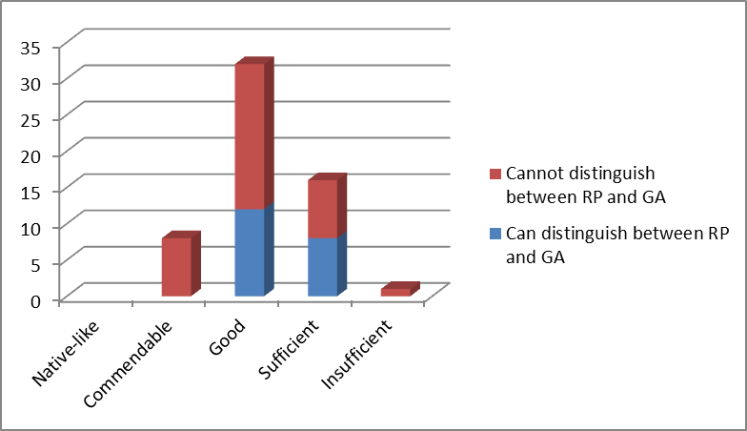
Figure 2: Students evaluation of their pronunciation skills
The students’ preferences about which accent would they prefer to be taught does not seem to be affected by their pronunciation level. This however, can be attributed to the small sample size. Overall results can be seen on Figure 3.
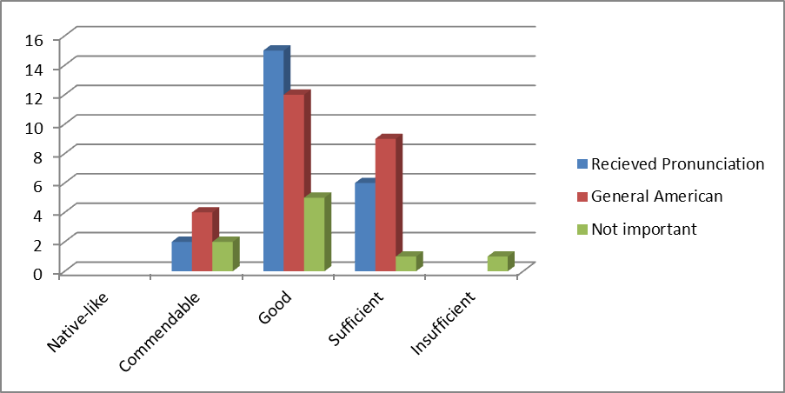
Figure 3: Preferences with regards to the level of pronunciation

Questions 7-14
Questions 7 – 12 are focused on what influences the students’ preferences. The students were asked about their on-line activities as well as whether they have ever been taught by a native speaker of English.

Question 7 – Being taught by a native speaker
Out of the 57 students 11 (19,3 %) said that they had been taught by a native speaker in the past and 46 (80,7 %) said that they had not been taught by a native speaker.
Question 8 – What nationality the native speaker was
From the 11 students who were taught by a native speaker 3 (27,3 %) were taught by a Brit, 6 (54,5 %) were taught by an American, 1 (9,1 %) was taught by an Australian and 1 (9,1 %) was taught by both British and American teachers.
Question 9 – Which accent the students encounter more frequently while online
The majority (36, 63,2 %) of the students said that the standard accent they encounter more frequently is American and 21 (46,8 %) said that the accent they encounter more frequently is British.
Question 10 – How much time the students spend online each week
I divided the answers into 4 groups, less than 1 hours, 1-10 hours, 11-20 hours and 20 or more hours a week. The majority of the students 28 (49,1 %) spend 1-10 hours online each week, 16 (28,1 %) students spend more than 20 hours online each week, 11 (19,3 %) students spend 11-20 hours online each week and 2 (3,5 %) students spend less than hour on-line each week. Results are displayed on Figure 3.
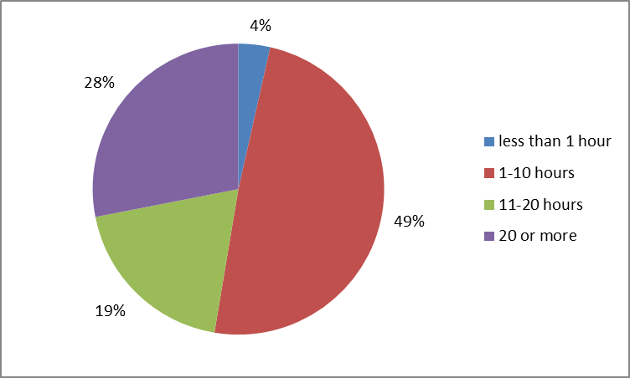
Figure 3: Students divided by time spent online in a week
Question 11 – Students’ watching TV shows or movies in English
The majority of the students (42, 73,7 %) stated that they watched TV shows or movies in English and 15 (26,3 %) students said they did not.
Question 12 – Extent of students’ watching British or American TV shows and movies
Out of 42 students who said they watched TV shows or movies in English, the majority (27, 64,3 %) said that they watched American TV shows or movies more often and 15 (35,7 %) said they watched British TV shows and movies more often.
Question 13 – Amount of time spend listening to English at school
43 (75,4 %) students said that they spent approximately 3 hours a week listening to English at school and 24 (24,6 %) of the students said that they spent 4 hours a week listening to English at school.
Question 14 – Amount of time spend listening to English at home
I divided the answers into 5 groups: 1 hours or less, 2-5 hours, 6-10 hours, 11-15 hours and 16 and more hours. The majority of the students 25 (43,9 %) spend 2-5 hours a week listening to English at home, 15 (26,3 %) of the students spend 1 hours or less, 12 (21,1 %) spend 6-10 hours, 4 (7 %) students spend 11-15 hours a week and 1 (2 %) student spends more than 16 hours a week listening to English at home. The results can be seen on Figure 4.
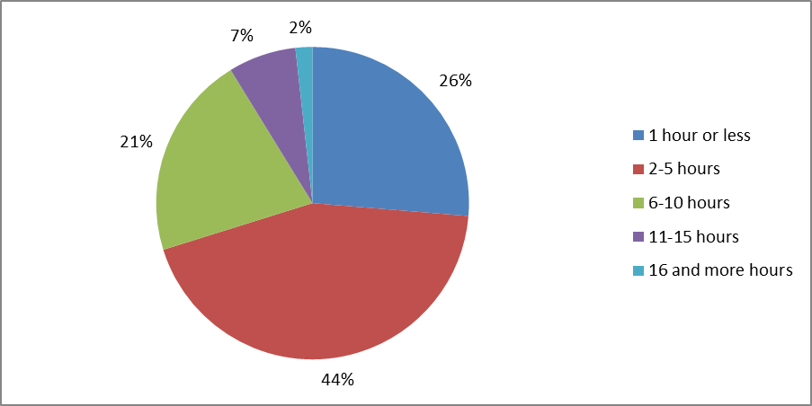
Figure 4: Students divided by the time spent listening to English at home

Evaluation of questions 7-14
The first factor I will mention is the native speaker factor. The results show that all but one student, who has been taught by an Australian, say they are able to distinguish between the two standard accents. The results show that all 4 students who have been taught by a British teacher said that their teacher at school is using the British accent. On the other hand, only 43 % of the students taught by an American teacher said that their teacher at school is using the British accent. The results can be seen on Figure 5.
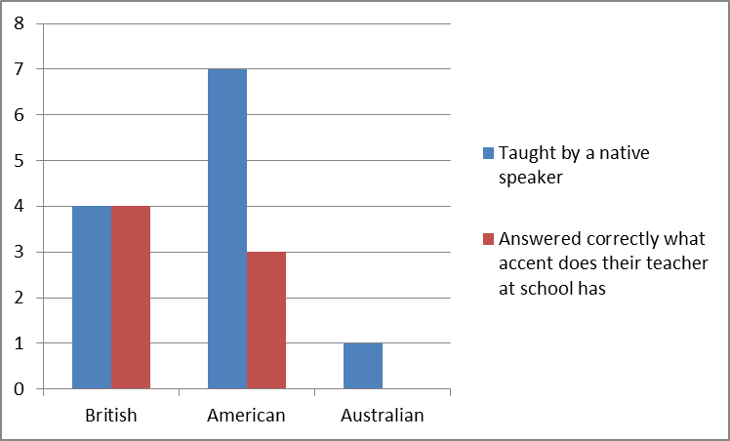
Figure 5: Ability to distinguish between RP and GA with regard to the native speaker factor
It is also worth noting that all the students who have been taught by British teachers would prefer to be taught the standard British pronunciation model and 4 out of 6 students who were taught by an American native speaker would prefer to be taught the standard American pronunciation. The fact that the 2 (33 %) students who despite being taught by an American teacher would prefer to be taught the standard British accent can be accounted to the fact that at the present they are being taught the standard British accent.
We can conclude that the students who have been taught by an American native speaker in the past have a strong tendency to perceive accents in general as General American. This fact again suggests a lack of strategic planning of pronunciation teaching in the classes.
Based on the results we can also say that a previous experience with a native speaker affects the students’ pronunciation preferences as shown on Figure 6.
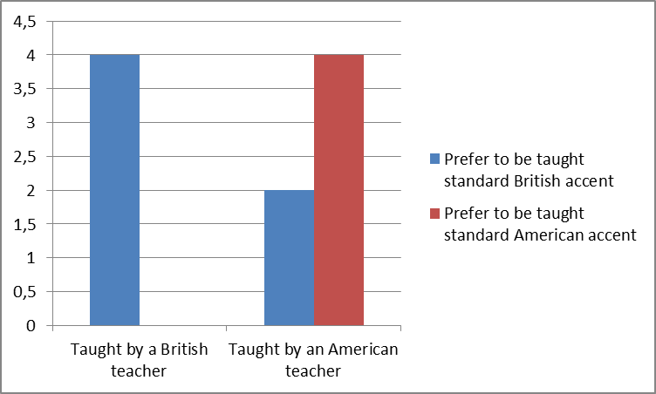
Figure 6: Preferable accent to be taught with regards to the previous experience with a native speaker
The next question was aimed at the students’ activities on social media. 63,2 % of the students said that they encountered the standard American accent more frequently and 36,8 %. It is interesting that the majority of the students who said they encounter the British accent more frequently also said that they would prefer to be taught the standard British accent. Students who said they would prefer to be taught the standard American accent however stated that they encounter the American accent more frequently.
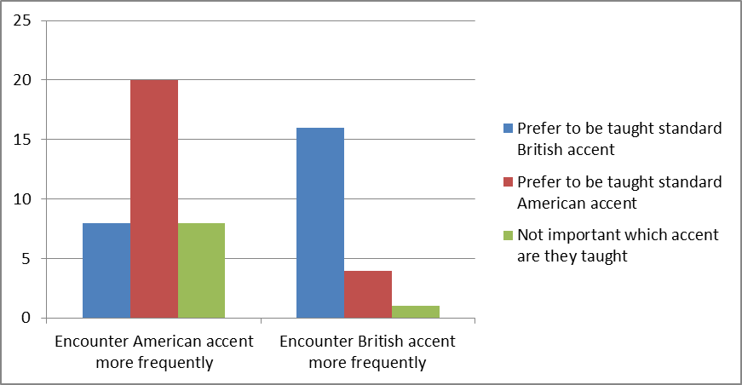
Figure 7: Preferable accent with regards to online activities
When we look at the amount of time the students spend online, we can see that there does not seem to be any connection with their preferable accent as seen on Figure 8.
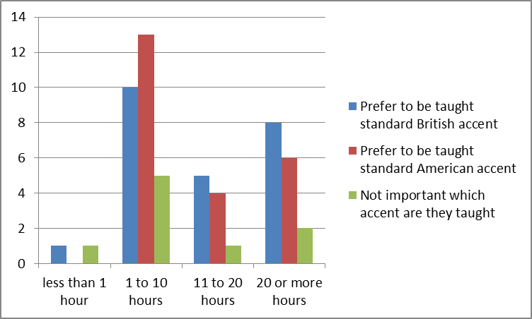
Figure 8: Preferable accent with regards to the amount of time spent online
When asked if they watch any TV shows or movies in English the majority of the students said they do. Out of 27 students who said they watch American TV shows and movies more often only 13 also stated that they would prefer to be taught the standard American accent while the majority of the 15 students who said they watch British TV shows and movies more often, the majority (12) said they would prefer to be taught the standard British accent.
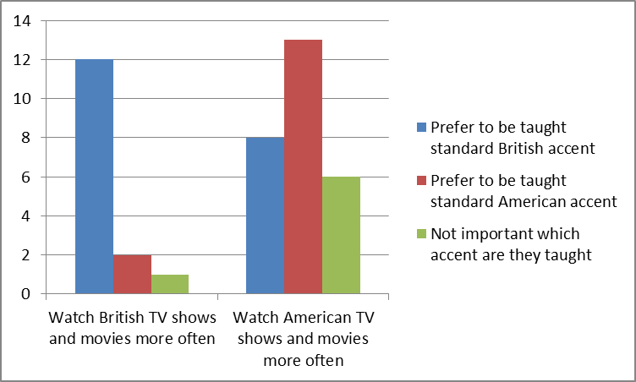
Figure 9: Preferable accent with regards to watching TV shows and movies
The aim of the last two questions is to determine whether the students are more exposed to English language at home or at school. It turns out that on average students spend 3,43 hours listening to English at school and 5,1 hours at home in a week. This suggests that students are more exposed to the General American accent as discussed in chapter 5.4. The results, however, are different than the initial assumption. If we compare the time which the students spend listening to English at home and their preferable accent, the results show that the students who would prefer to be taught the General American pronunciation and the students who would prefer the Received Pronunciation spend roughly the same time listening to English at home. The students who said it is not important which accent are they taught spend, in general, less time listening to English at home but the difference is too small to make a valid conclusion.
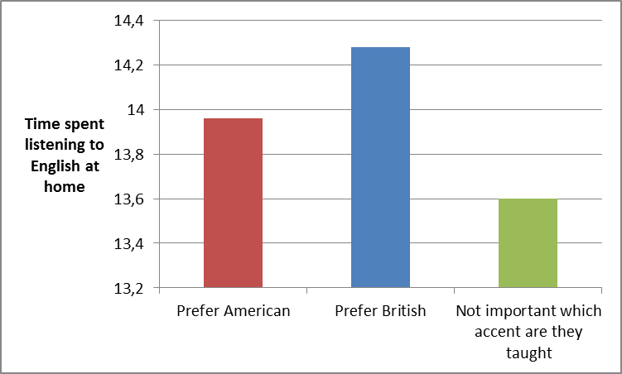
Figure 10: Preferable accent with regards to time spend listening to English at home

Favoured pronunciation of common words
The aim of the last part of the questionnaire was to determine which of the standard accents the students are actually using. The students were provided with 17 commonly used words whose pronunciation differs between the two standard accents. The overall result can be seen on Figure 11.
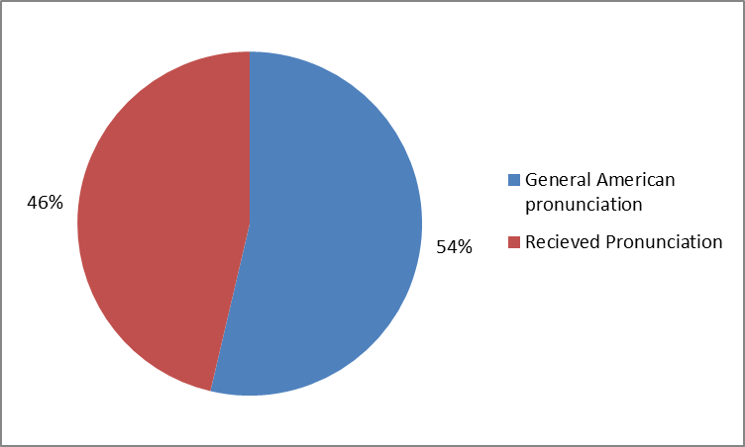
Figure 11: Preferable pronunciation model for the 17 commonly used words.
It is worth mentioning that only 4 students favoured the standard British accent for all of the chosen words and 2 students favoured exclusively the standard American accent.
As it turns out the students heavily favour the use of the rhotic accent. When we look at the words which differ in the pronunciation of the final /r/ sound the students tend to pronounce it.
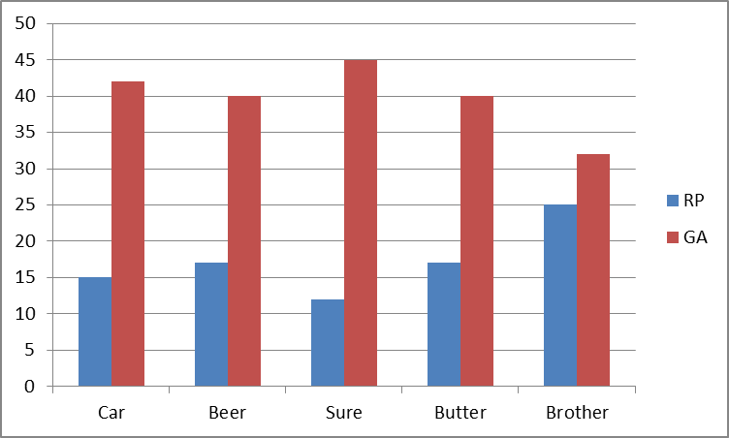
Figure 12: Use of the rhotic and non-rhotic accent in 5 words
The standard British accent was most notably favoured with the words which differ in the use of the /ɒ/ and /ɑ:/ sounds with the only exception being the word “Doctor”. See Figure 13.
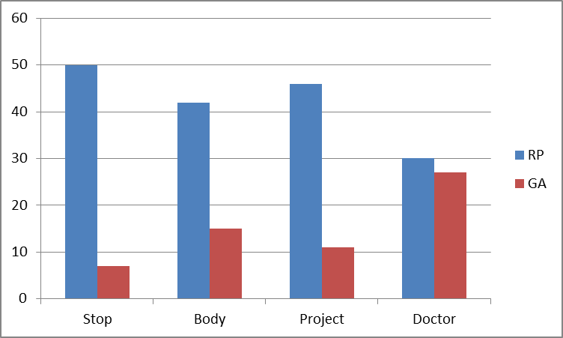
Figure 13: Preferences with the words which differ in the /ɒ/ and /ɑ:/ sounds
The differences between the favoured accents were minimal, almost even, with the rest of the words. We can therefore conclude that even though the students are taught the standard British accent there is a strong tendency towards using the standard American accent.
The results also show that the students’ actual pronunciation has no connection to the accent they would prefer to be taught. The students who prefer the standard American accent show a greater tendency to use it more often. This, however, can be attributed to the small size of the test sample. The results can be seen on Figure 14.
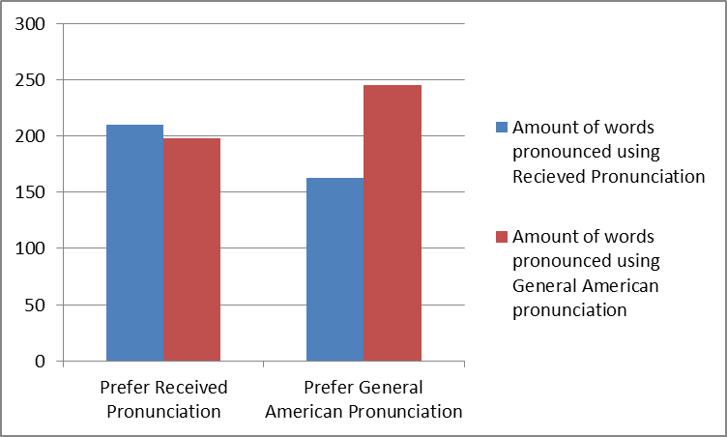
Figure 14: Pronunciation of the common words with regards to the favourable standard accent

Conclusion of the survey
The results of the survey show that students are, to some extent, influenced by both the use of English at school and in their free time. The previous experience with a native speaker also proved to have large influence on the students’ favourable accent. Even though many students said they favoured one of the accents the results show that they are using a mixture of both. The results also suggest that the approach to teaching pronunciation, namely the awareness of differences between RP and GA, is reactive rather than systematic.
The question remains whether it is important to push students towards one of the standard accents or if it is acceptable to embrace the idea of teaching English as lingua franca. I believe that students should have at least an elementary knowledge of the standard accents and the differences between them. The lack of knowledge about the standard accents is well documented by the fact that 74% of the students either admitted they cannot distinguish between the accents or were not able to say which accent their teacher is using. Another fact that shows the lack of knowledge is the inconsistency of chosen pronunciations in case of very common words.
The hypothesis has been confirmed because even though the majority of the students stated that they would prefer to be taught the standard British accent, the results show that they are using a mixture of both accents and the General American pronunciation of the chosen words is slightly more common.

CONCLUSION
This bachelor thesis dealt with the main features and differences between the two standard accents of English language and the pronunciation preferences of Czech secondary school students.
The theoretical part of the thesis described the main features, history and differences between Received Pronunciation and General American accents. Its purpose was to introduce the accents to the reader as well as introduce them to the problematic of pronunciation teaching, its importance and problems with it.
The practical part was aimed at the pronunciation preferences of Czech secondary school students and the factors that influence their choices. The main factors which affect the students’ preferences were the accent they are taught at school, previous experience with a native speaker and the exposure to English language in their free time.
The survey has proved that the dominance of the General American pronunciation on the internet and in movies and TV shows very much affects the students’ pronunciation of chosen words in spite of their standard pronunciation preferences. The survey has also shown that the pronunciation of the students does not vary with regard to their preferable standard accent. The accent which the students use consists of a mixture of the two accents under scrutiny.

BIBLIOGRAPHY
ALGEO, John et al. The Cambridge history of the English language : Volume 6. English in North America. 1. vyd. Cambridge : Cambridge University Press, 2001, 625 s. ISBN 0521264790.
CELCE-MURCIA, Marianne; BRINTON, Donna M. a GOODWIN, Janet M. Teaching pronunciation: A reference for teachers of English to speakers of other languages. 9. vyd. Cambridge : Cambridge University Press, 1996, 435 s. ISBN 0-521-40504-1
CENTRUM PRO ZJIŠŤOVÁNÍ VÝSLEDKŮ VZDĚLÁVÁNÍ. Katalog požadavků zkoušek společné části maturitní zkoušky : platný od školního roku 2014/2015 Anglický jazyk. Ministerstvo školství mládeže a tělovýchovy, 2013, 44 s.
COUNCIL OF EUROPE, Council for Cultural Co-operation. Common European framework of reference for languages learning, teaching, assessment. 1. vyd. Cambridge : Press Syndicate of the University of Cambridge, 2001, 260 s. ISBN 05-218-0313-6.
CRUTTENDEN, Alan. Intonation. 1. vyd. Cambridge : Cambridge University Press, 1986, 228 s. ISBN 0521260280
DARRAGH, Glenn. A to Zed, A to Zee : A Guide to the Differences Between British and American English. 1. vyd. Irun : Editorial Stanley, 2000, 116 s. ISBN 8478733469
DAVIES, Christopher. Divided by a Common Language : A Guide to British and American English. 3. vyd. Boston : Houghton Mifflin Harcourt, 2007. 256 s. ISBN 0547350287
FISHER, John Hurt. The History of Received Pronunciation. In GOEBEL, Ulrich a LEE, David (Eds.). The Ring of Words in Medieval Literature. Lewiston, N.Y.: Mellen, 1993: 41-61.
HOFFMANN, Charlotte. The Spread of English and the Growth of Multilingualism with English in Europe. In CENOZ, Jasone, JESSNER, Ulrike. English in Europe : The Acquisition of a Third Language. Buffalo : Multilingual Matters, 2000: 1-21
HUDDLESTON, Rodney, PULLUM, Geoffrey K. Cambridge grammar english language. Vyd. 1. London: Cambridge University Press, 2002, 1842 s. ISBN 05-214-3146-8.
KELLY, Gerald. How to Teach Pronunciation. 2. vyd. Harlow : Pearson Education Limited 2000, 2001, 154 s. ISBN 0582 429757
QUIRK, Randolph ,GREENBAUM, Sidney, LEECH, Geoffrey, SVARTVIK, Jan. A Comprehensive Grammar of the English Language. 1. vyd. New York : Longman Inc., 1985, 1779 s. ISBN 0-582-51734-6
ROACH, Peter. English phonetics and phonology : A practical course. 4. vyd. Cambridge : Cambridge University Press, 2009, 231 s. ISBN 978-0-521-88882-0.
ROMAINE, Suzanne. Language In Society : An introduction to sociolinguistics. 1. vyd. Oxford : Oxford University Press, 1994. 235 s. ISBN 0198751346
THOMAS, Linda, WAREING, Shân. Language, Society and Power. 1. vyd. London : Routledge, 1999. 240 s. ISBN 0-203-98163-4
WELLS, John Christopher. Accents of English 1 : An Introduction. 1. vyd. Cambridge : Cambridge University Press, 1982a. 300 s. ISBN 05212971921.
WELLS, John Christopher. Accents of English 2 : The British Isles. 2. vyd. Cambridge : Cambridge University Press, 1986, 279-465 s. ISBN 05-212-8540-2.
WELLS, John Christopher. Accents of English 3 : Beyond the British Isles. 1. vyd. Cambridge: Cambridge University Press, 1982b, 467-673 s. ISBN 05-212-8541-0.
WYLD, Henry Cecil Kennedy. The Growth of English : An Elementary Account of the Present Form of Our Language and Its Development. 4. vyd. London : John Murray, 1914. 206 s.
Cambridge English Preliminary : Preliminary English Test (PET) CEFR Level B1. 1. vyd. Cambridge : University of Cambridge, 2012, 51 s. ISBN 978-1-907870-20-0

Electronic Sources
BERG, Thomas. Stress variation in British and American English. World Englishes [online]. July 1999, vol. 18, no. 2, [cit. 2014-06-15]. Dostupný na World Wide Web: <http://onlinelibrary.wiley.com/store/10.1111/1467-971X.00128/asset/1467-971X.00128.pdf?v=1&t=hwc7ttpf&s=a2df01cacd23a25f12467d152839c0b0a3e8644>. ISSN 1467-971X
CASHMAN, Laura. Remembering 1948 and 1968: Reflections on Two Pivotal Years in Czech and Slovak History. EUROPE-ASIA STUDIES [online]. 2008, č. 10 [cit. 2014-06-20]. Dostupný na World Wide Web: <http://www.tandfonline.com/doi/pdf/10.1080/09668130802434281>. ISSN 1465-3427
CSFD.CZ. Podrobné vyhledávání [online]. 2014, last revision 2014. [cit. 2014-06-23]. Dostupné na World Wide Web: <http://www.csfd.cz/podrobne-vyhledavani/>
DARLINGTON, Roger. Czechoslovak airmen in the wartime Royal Air Force [online]. 2000, last revision 2000 [cit. 2014-06-20]. Dostupné na World Wide Web: <http://www.rogerdarlington.me.uk/czechsinraf.html>
DEMIREZEN, Mehmet. Which /r/ are you using as an English teacher? rhotic or non-rhotic?. Procedia - Social and Behavioral Sciences [online]. 2012, č. 46, [cit. 2014-06-12]. Dostupný na World Wide Web: <http://www.sciencedirect.com/science/article/pii/S1877042812016710/pdf?md5=cb65f11a88d3e29102928e05f3e1a5b9&pid=1-s2.0-S1877042812016710-main.pdf>. ISSN 1877-0428
DERWING, Tracey M., MUNRO, Murray J. Second Language Accent and Pronunciation Teaching : A Research-Based Approach. A Journal for Teachers of English to Speakers of Other Languages and of Standard English as a Second Dialect [online]. 2005, č. 3 [cit. 2014-06-19]. Dostupný na World Wide Web: <http://resourcesforteflteachers.pbworks.com/f/Second%20Language%20Accent%20and%20Pronunciation%20Training.pdf#page=17>. ISSN 1545-7249
GÓMEZ, Paco. British and American English pronunciation differences [online]. 2012, last revision 22th of May 2014 [cit. 2014-06-12] Dostupné na World Wide Web: http://www.ma.eui.upm.es/usuarios/Fmartin/Web/Idiomas/English/Br-Ame-pronun-diff.pdf>
GILAKJANI, Abbas Pourhosein. Goals of English Pronunciation Instruction. International Journal of Language Teaching and Research [online]. 2012, č. 1 [cit. 2014-06-19]. Dostupný na World Wide Web: <http://www.researchpub.org/journal/ijltr/number/vol1-no1-1.pdf> ISSN 2165-817X
JENKINS, Jennifer. English as a lingua franca : interpretations and attitudes. World Englishes [online]. 2009, č. 2 [cit. 2014-06-19]. Dostupný na World Wide Web: <http://onlinelibrary.wiley.com/store/10.1111/j.1467-971X.2009.01582.x/asset/j.1467-971X.2009.01582.x.pdf?v=1&t=hwm8pd3x&s=fe6010801b8a126c5979b1f3fb916c3b167754c0> ISSN 1467-971X
ROBINSON, Jonnie. Received Pronunciation [online]. 2007, last revision 14th of March 2007 [cit. 2014-06-11]. Dostupné na World Wide Web: <http://www.bl.uk/learning/langlit/sounds/find-out-more/received-pronunciation/>.
UMPF. Social media usage in the UK – The findings [online]. 2011, last revision 6th of September 2011 [cit. 2014-06-22]. Dostupné na World Wide Web: <http://www.umpf.co.uk/blog/social-media/social-media-usage-in-the-uk-the-findings/>.
U.S. DEPARTMENT OF STATE. Czechoslovakia - Countries - Office of the Historian [online] 2010a, last revision 2014 [cit. 2014-06-20]. Dostupné na World Wide Web: <http://history.state.gov/countries/czechoslovakia>
U.S. DEPARTMENT OF STATE. Diplomacy in Action – Slovakia (08/99) [online]. 2010b, last revision 2014 [cit. 2014-06-20]. Dostupné na World Wide Web: <http://www.state.gov/outofdate/bgn/slovakia/14657.htm>
WEISSER, Martin. The Reference Accents: RP/BBC & GenAm [online]. 2005, last revision 31st of January 2013 [cit. 2014-06-14]. Dostupné na World Wide Web: <http://martinweisser.org/courses/phonetics/reference/refAccents.html>
WELLS, John Christopher. Goals in teaching English pronunciation [online]. 2005, s. 1-11. [cit. 2014-6-18]. Dostupné na World Wide Web: <http://www.phon.ucl.ac.uk/home/wells>
YOUTUBE.COM. Statistics – YouTube [online]. 2014, last revision 2014 [cit. 2014-06-23]. Dostupné na World Wide Web: <https://www.youtube.com/yt/press/en-GB/statistics.html>

APPENDIX: QUESTIONNAIRE
1
Questionnaire
BACHELOR THESIS SURVEY / English with an Emphasis on Educational Aspects
Univerzita Palackého v Olomouci, Pedagogická fakulta
Hello, my name is Aleš Punčochář and I am a third year student of English with an Emphasis on Educational Aspects on the Palacký University. I would like to ask for your help with my thesis. This questionnaire is anonymous and all replies will be held securely and confidentially. No-one will be able to identify your response. Please note that for the purposes of the questionnaire I am only considering the standard pronunciation models of English, i. e. Received Pronunciation for British English and General American for American English. You have 5 minutes to fill in the questionnaire.

- Age:

- Sex:

- In your opinion, are you able to distinguish between British and American pronunciation?

- Given the chance, which of them would you choose to be taught?

- British
- American
- It is not important to me

- How would you rate the level of your pronunciation 1-5 (1 being comparable to a native speaker)

- What accent does your teacher have?

- British
- American
- I am not sure

- Have you ever been taught by a native speaker?

- If so what nationality was he/she? :
He used:
- British pronunciation
- American pronunciation
- I am not sure

- While online (youtube, social media, gaming) which dialect do you encounter more frequently?

- British
- American

- How much time do you spend online each week?

2

- Do you watch any TV shows or movies in English?

- Which of these do you watch more of?

- British
- American

How much time a week do you spend listening to English:
- At school:

- At home (TV shows, movies, internet):
How would you pronounce the following words:
- car | / kɑ: / | /kɑ:r /
- stop | / stɒp / | / stɑ:p /
- beer | / bɪə / | / bɪ^{ə}r /
- new | / nju: / | / nu: /
- sure | / ʃɔ: / | / ʃʊ^{ə}r /
- vase | / vɑ:z / | / veɪs /
- garage | / ˈgærɪʤ / | / gəˈrɑ:ʒ /
- schedule | / ˈʃedju:l / | / ˈskeʤu:l /
- slow | / sləʊ / | / slɒʊ /
- body | / bɒdi / | / bɑ:di /
- project | / ˈprɒʤekt / | / ˈprɑ:ʤekt /
- doctor | / ˈdɒktə / | / ˈdɑ:kt^{ə}r /
- with | / wɪð / | / wɪθ /
- zebra | / ˈzebrə / | / ˈzi:brə /
- adult | / ˈædʌlt / | / əˈdʌlt /
- butter | / ˈbʌtə / | / ˈbʌt^{ə}r /
- brother | / ˈbrʌðə / | / ˈbrʌð^{ə}r /

This is the end of the questionnaire and I would like to thank you for your cooperation!

RÉSUMÉ
Tato bakalářská práce popisuje základní znaky a rozdíly mezi dvěma standartními akcenty anglického jazyka, tj. americkou a britskou spisovnou výslovnost. Práce se také zabývá preferencemi českých studentů středních škol v oblasti anglické výslovnosti. Studie je realizována dotazníkovou metodou.

ANOTATION
Jméno a příjmení: | Aleš Punčochář
Katedra: | Katedra anglického jazyka PdF UP
Vedoucí práce: | Mgr. Jaroslava Ivanová, M.A.
Rok obhajoby: | 2014
Název práce: | Rozdíly ve výslovnosti mezi Received Pronunciation a General American Pronunciation
Název v angličtině: | The differences in pronunciation between Received Pronunciation and General American Pronunciation
Anotace práce: | Bakalářská práce popisuje a porovnává standartní americký a britský model výslovnosti anglického jazyka. Praktická část zjišťuje preference českých studentů středních škol v oblasti výslovnosti anglického jazyka.
Klíčová slova: | Received Pronunciation, General American pronunciation, Preference ve výslovnosti, čeští žáci na středních školách
Anotace v angličtině: | The bachelor thesis describes and compares standard American and British pronunciation models of English language. The practical part studies preferences of Czech secondary school students in the area of pronunciation of English language.
Klíčová slova v angličtině: | Received Pronunciation, General American pronunciation, Pronunciation preferences, Czech secondary-school students
Přílohy vázané v práci: | 1 příloha
Rozsah práce: | 47 stran
Jazyk práce: | Angličtina

Only movies with a trailer have been taken into account

