Appendix
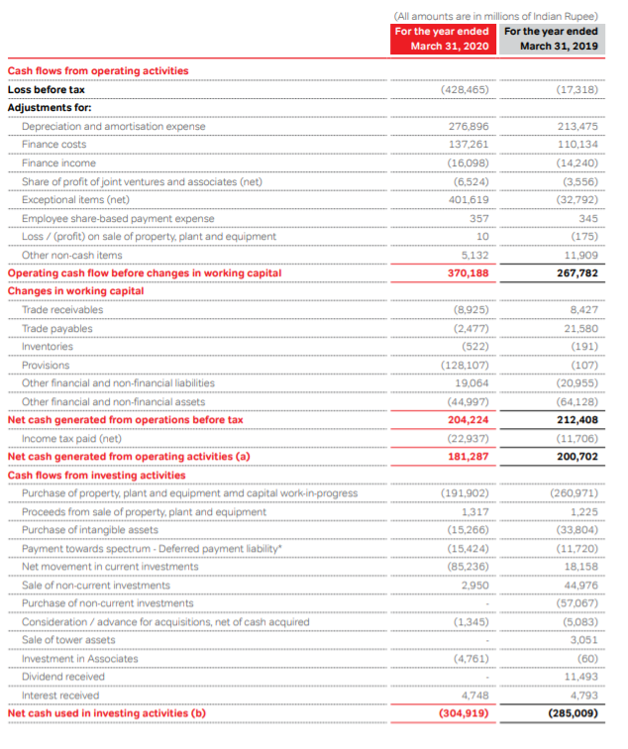Continued
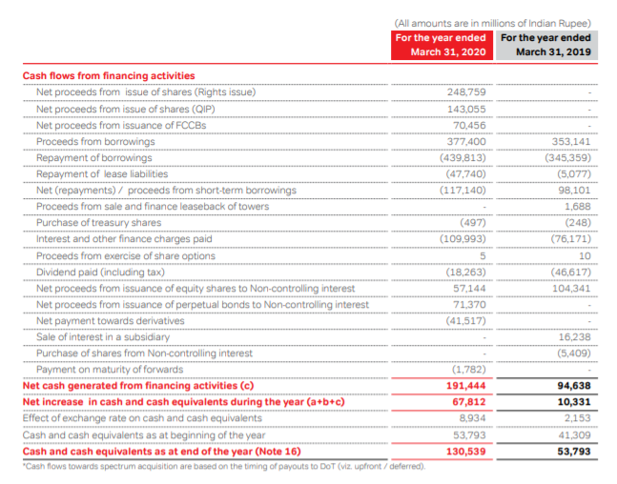
Figure 20: Analysis of Bharti Airtel Cash Flow Statements
Source: Bharti Annual report (2020)

Cash Flow Statement Analysis of Bharti Airtel
Vertical analysis of cash flow
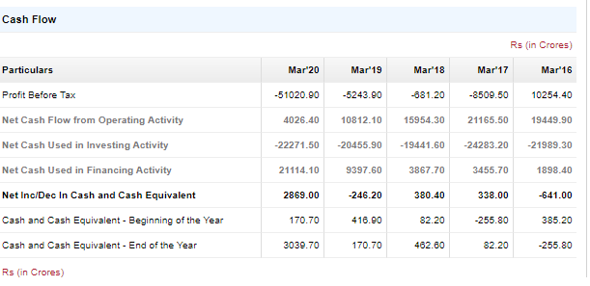
Figure 21 Vertical analysis of cash flow of Bharti Airtel
Source- The Economic Times, 2021
Horizontal analysis of cash flow
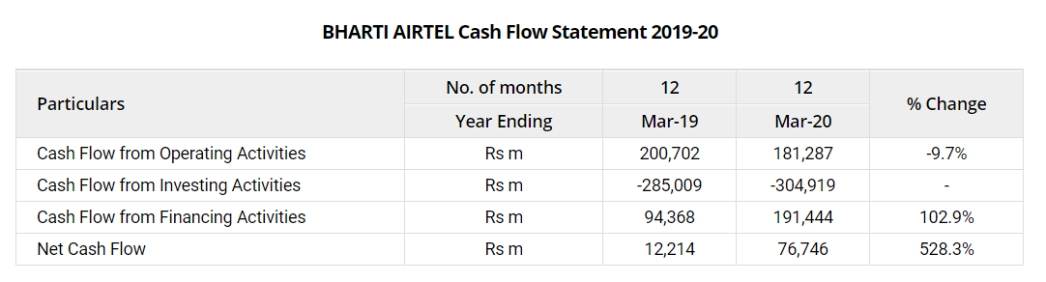
Figure 22 Horizontal analysis of cash flow of Bharti Airtel
Source- equitymaster, 2021

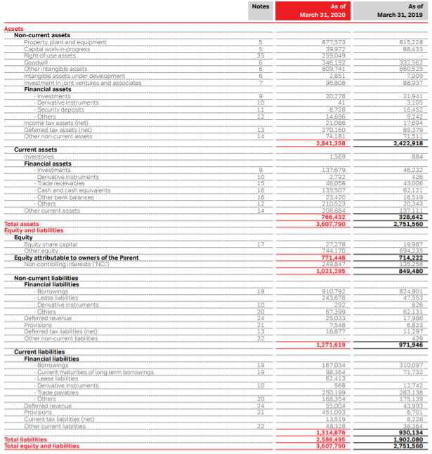
Figure 23: Balance Sheet of Bharti Airtel
Source: Airtel annual report (2020)

Balance Sheet Analysis of Bharti Airtel
Vertical analysis of balance sheet
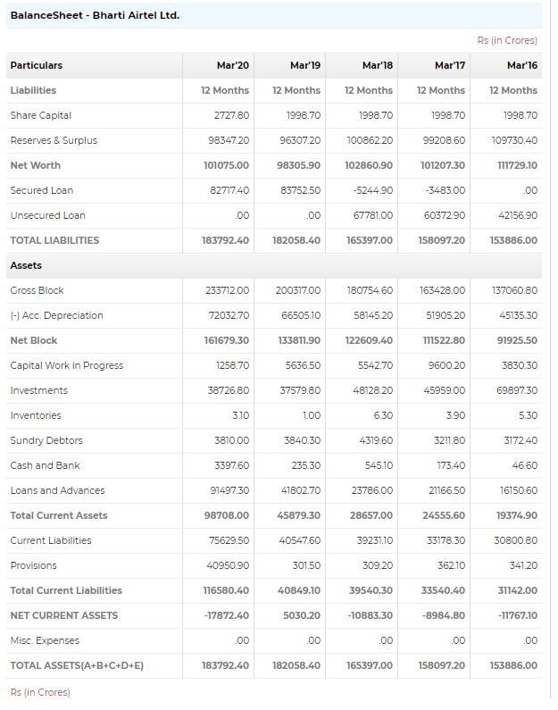
Figure 24 Vertical analysis of balance sheet of Bharti Airtel
Source- The Economic Times, 2021
Horizontal analysis of balance sheet
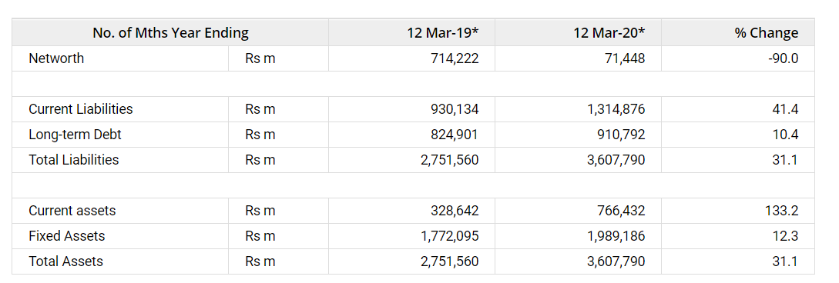
Figure 25 Horizontal analysis of balance sheet of Bharti Airtel
Source- equitymaster, 2021
- The company's current liabilities during FY20 stood at Rs 1,315 billion as compared to Rs 930 billion in FY19, thereby witnessing an increase of 41.4%.
- Long-term debt stood at Rs 911 billion as compared to Rs 825 billion during FY19, a growth of 10.4%.
- Current assets rose 133% and stood at Rs 766 billion, while fixed assets rose 12% and stood at Rs 1,989 billion in FY20.
- Overall, the total assets and liabilities for FY20 stood at Rs 3,608 billion as against Rs 2,752 billion during FY19, thereby witnessing a growth of 31%.

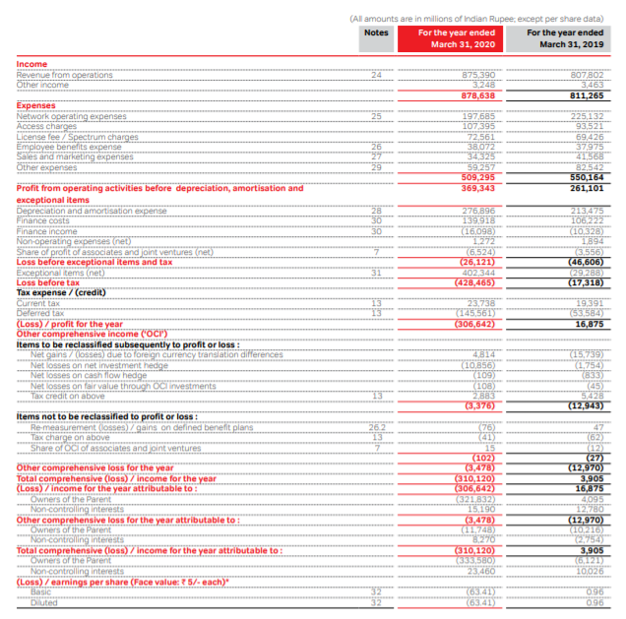
Figure 26 Bharti Airtel Income Statement
Source: Airtel annual report (2020)

Income Statement Analysis of Bharti Airtel
Vertical analysis of Income statement
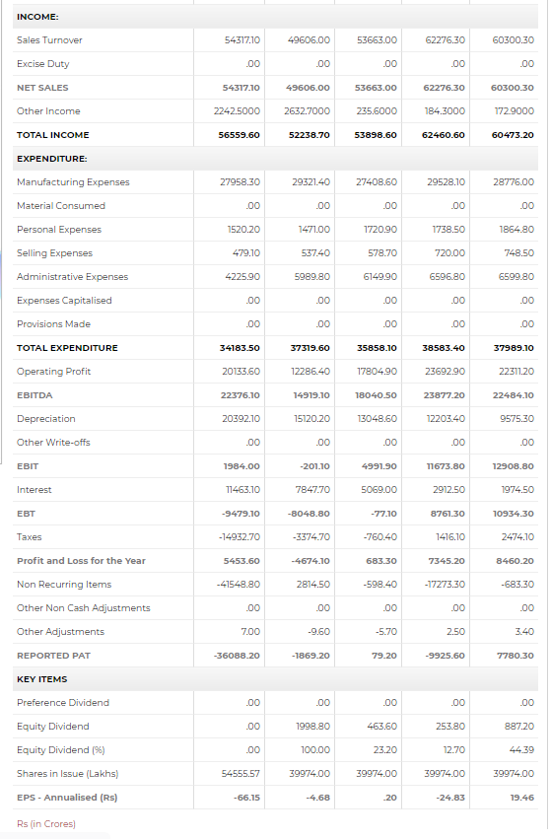
Figure 27 Vertical analysis of Income statement of Bharti Airtel
Source- The Economic Times, 2021
Horizontal analysis of Income statement

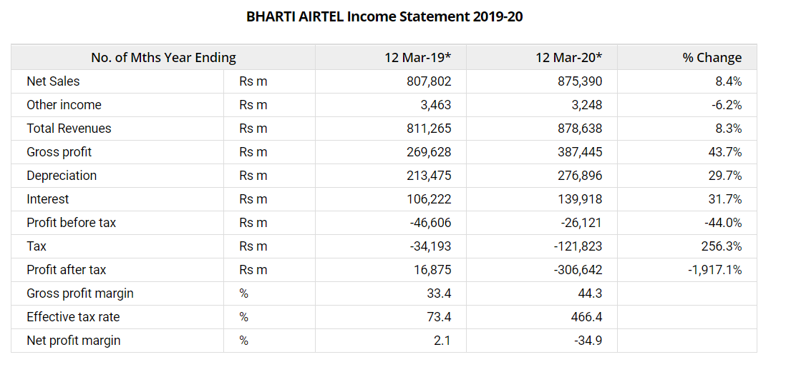
Figure 28 Horizontal analysis of Income statement Bharti Airtel
Source- equitymaster, 2021
- Operating income during the year rose 8.4% on a year-on-year (YoY) basis.
- The company's operating profit increased by 43.7% YoY during the fiscal. Operating profit margins witnessed a fall and down at 44.3% in FY20 as against 33.4% in FY19.
- Depreciation charges increased by 29.7% and finance costs increased by 31.7% YoY, respectively.
- Other income declined by 6.2% YoY.
- Net profit for the year declined by 1917.1% YoY.
- Net profit margins during the year declined from 2.1% in FY19 to 34.9% in FY20.

Balance Sheet Analysis of Reliance Jio

Vertical analysis of balance sheet
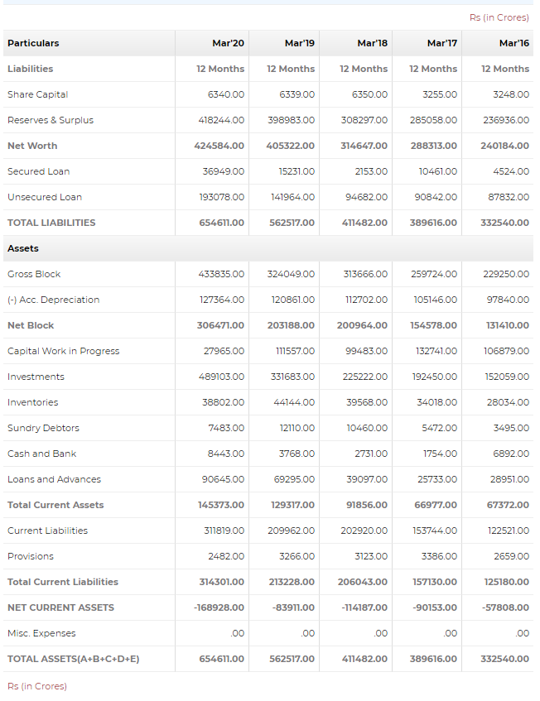
Figure 29 Vertical analysis of balance sheet Reliance Jio
Source- The Economics Times, 2021

Horizontal analysis of balance sheet
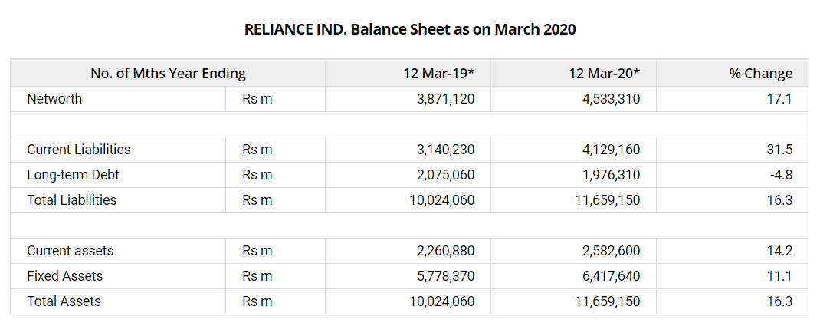
Figure 30 Horizontal analysis of balance sheet Reliance Jio
Source- Equtiymaster, 2021
- The company's current liabilities during FY20 stood at Rs 4,129 billion as compared to Rs 3,140 billion in FY19, thereby witnessing an increase of 31.5%.
- Long-term debt down at Rs 1,976 billion as compared to Rs 2,075 billion during FY19, a fall of 4.8%.
- Current assets rose 14% and stood at Rs 2,583 billion, while fixed assets rose 11% and stood at Rs 6,418 billion in FY20.
- Overall, the total assets and liabilities for FY20 stood at Rs 11,659 billion as against Rs 10,024 billion during FY19, thereby witnessing a growth of 16%.
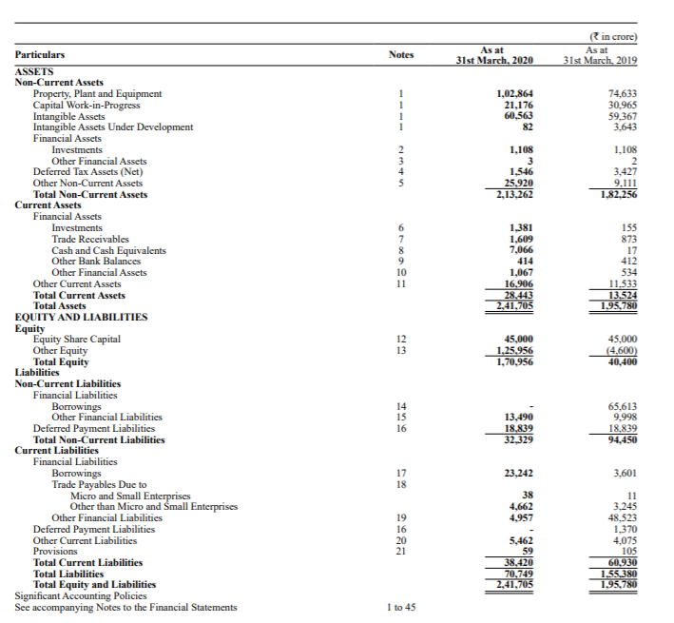
Figure 31: Balance Sheet of Reliance Jio
Source: Reliance Jio annual report (2020)

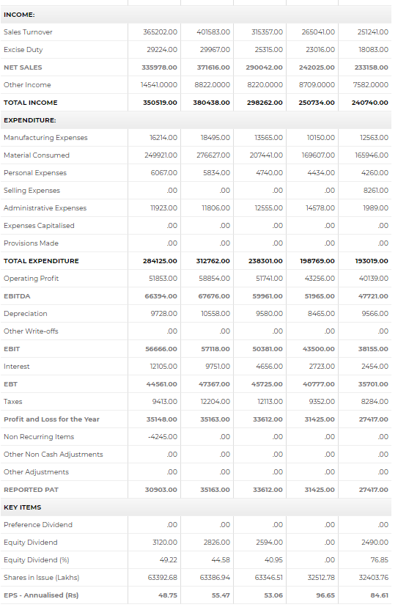
Figure 32 Vertical analysis of income statement Reliance Jio
Source- The Economic Times, 2021
Horizonal analysis of income statement
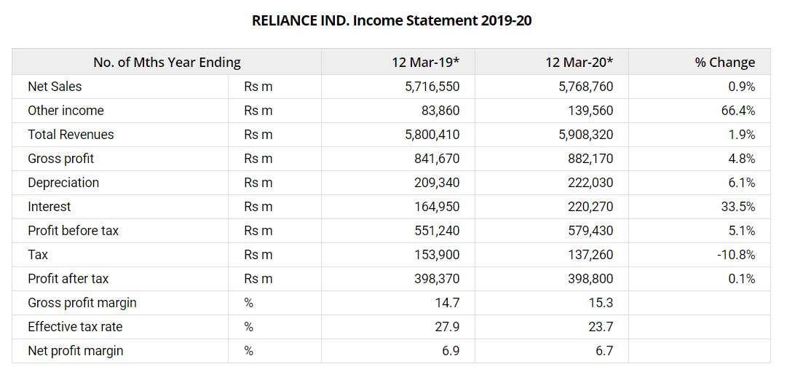
Figure 33 Horizontal analysis of income statement of Reliance Jio
Source- equitymaster, 2021
- Operating income during the year rose 0.9% on a year-on-year (YoY) basis.
- The company's operating profit increased by 4.8% YoY during the fiscal. Operating profit margins witnessed a fall and down at 15.3% in FY20 as against 14.7% in FY19.
- Depreciation charges increased by 6.1% and finance costs increased by 33.5% YoY, respectively.
- Other income grew by 66.4% YoY.
- Net profit for the year grew by 0.1% YoY.
- Net profit margins during the year declined from 6.9% in FY19 to 6.7% in FY20.

Cash Flow Statement Analysis of Reliance Jio
Vertical analysis of cash flow statement
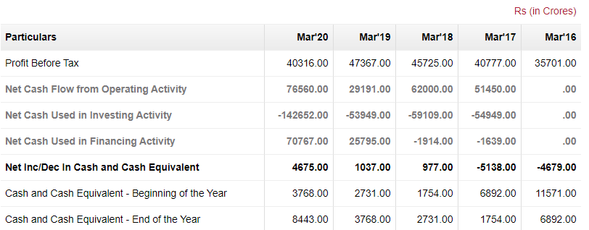
Figure 34 Vertical analysis of cash flow statement of Reliance Jio
Source- The Economic Times, 2021

Horizonal analysis of cash flow statement
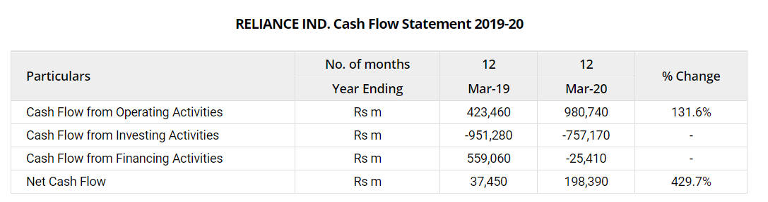
Figure 35 Horizontal analysis of cash flow statement of Reliance Jio
Source- equitymaster, 2021
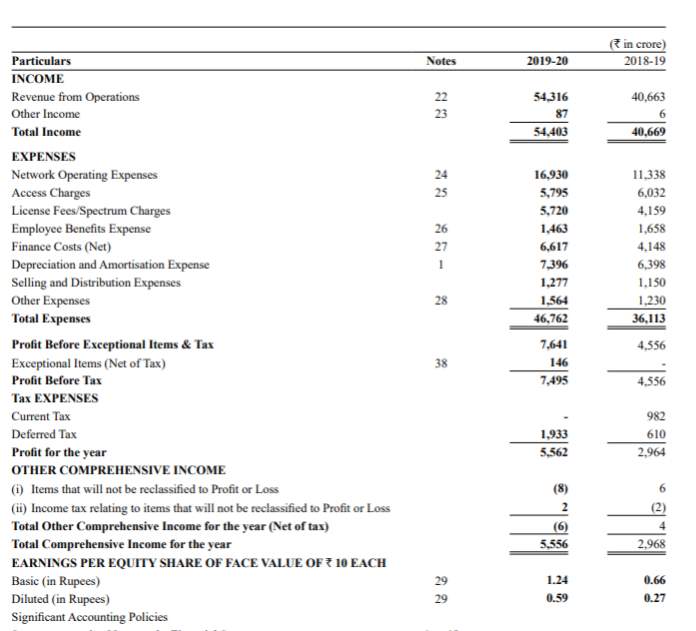
Figure 36: Reliance Jio Income Statement
Source: Reliance Jio annual report (2020)

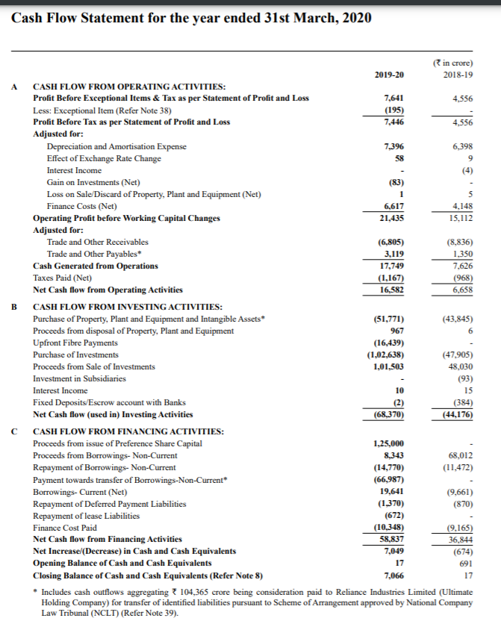
Figure 37: Analysis of Reliance Jio Cash Flow Statements
Source: Reliance Jio (2020)

