Appendix

Figure 1: Balance sheet of the company Detsky Mir for 2018 year
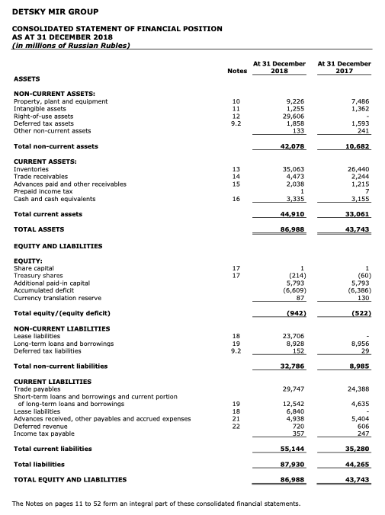

Figure 2: Income statement of the company Detsky Mir for 2018 year
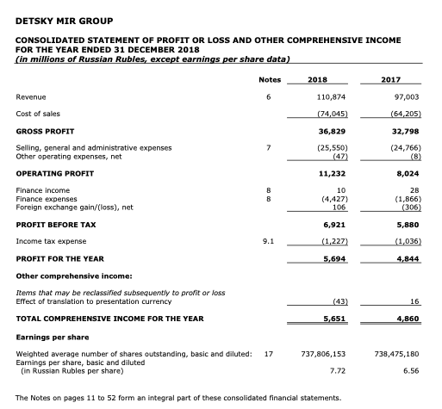

Figure 3: Statement of Cash Flows of the company Detsky Mir for 2018 year
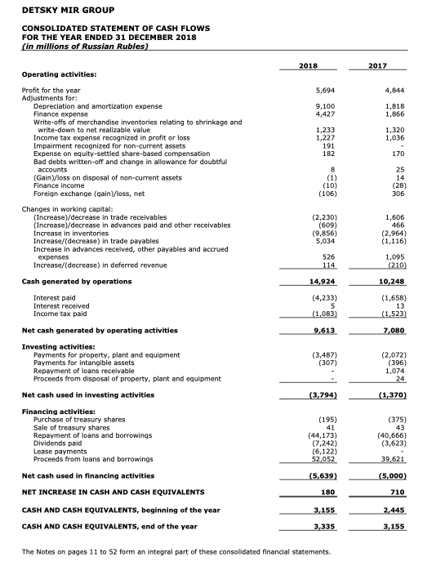

Figure 4: Balance sheet of the company Detsky Mir for 2019 year
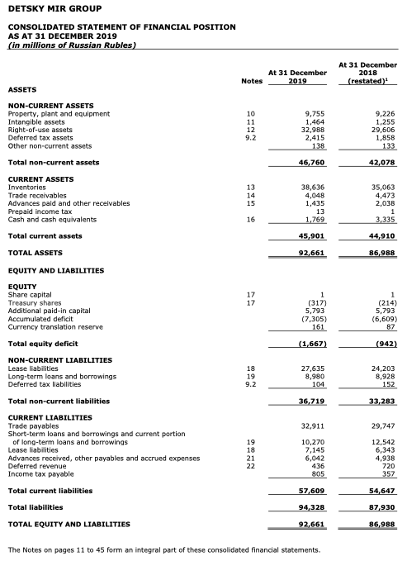

Figure 5: Income statement of the company Detsky Mir for 2019 year
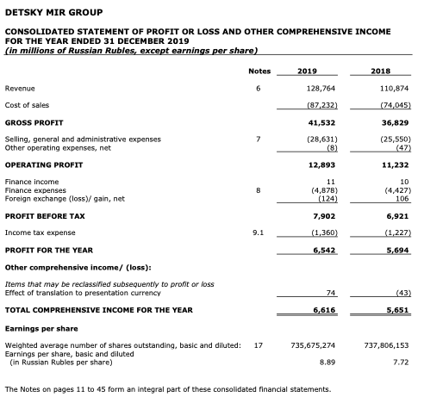

Figure 6: Statement of Cash Flows of the company Detsky Mir for 2019 year
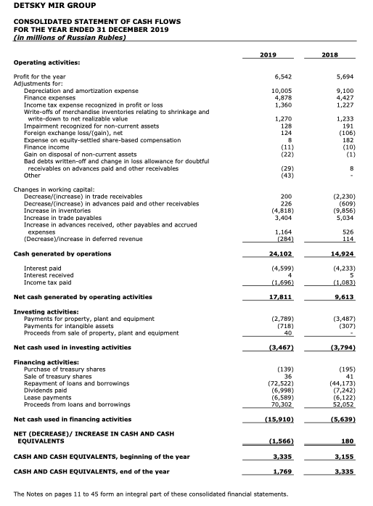

Figure 7: Balance sheet of the company Detsky Mir for 2020 year
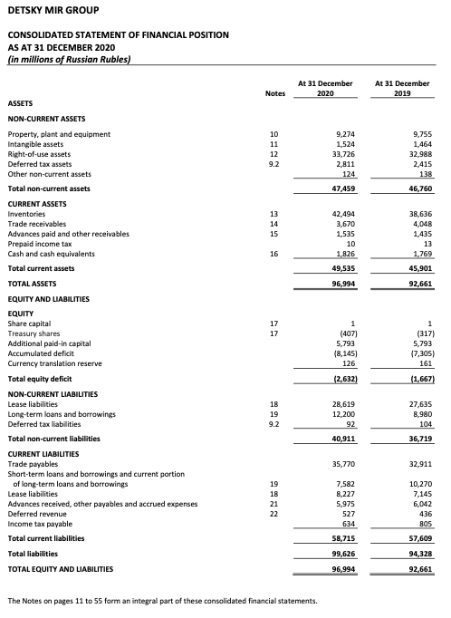

Figure 8: Income statement of the company Detsky Mir for 2020 year
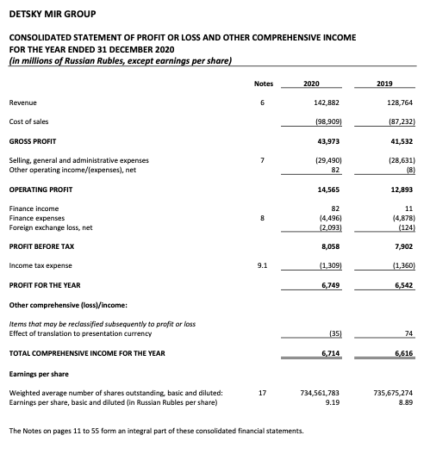

Figure 9: Statement of Cash Flows of the company Detsky Mir for 2020 year
